Evaluating the Role of Maturity Models in Enhancing Quality Assurance Standards for Indian Higher Education Institutions

Abstract
Education is expected to be the prime driving force behind the mission of “Rising India” as it enhances people’s productivity and creativity and promotes entrepreneurship and innovation in society. The study investigates the application of maturity models as tools for advancing quality assurance standards in Indian higher education institutions (HEIs). The research identifies their role in systematically assessing institutional development and ensuring compliance with accreditation benchmarks to evaluate these models. The study explores key frameworks, their stages of progression, and their effectiveness in addressing challenges unique to Indian HEIs. The National Assessment and Accreditation Council (NAAC) recently announced major reforms in its accreditation process based on the Dr K. Radhakrishnan Committee report to enhance the quality and credibility of Indian higher educational institutions. The most prominent feature of this reform is the introduction of the Maturity-Based Graded Accreditation process in India. Findings aim to provide insights into enhancing institutional performance, fostering continuous improvement, and aligning quality assurance practices with global standards. This research contributes to the discourse on quality enhancement and accreditation, supporting HEIs in achieving excellence and sustainability. The present paper analyses the different maturity models formulated at different points in time and tries to explore which one appears to be most suitable for the proposed Maturity-Based Graded Accreditation process of the NAAC.
Keywords: Academia, Policy, Higher Education, Accreditation, NAAC, University Grants Commission, Maturity Models
- Introduction
As the twenty-first century surges ahead, signs of India emerging as a global power are becoming louder and clearer. Goldman Sachs Research projects India to have the world’s second-largest economy by 2075, leaving behind the USA, and next only to China. This appears to agree with the Prime Minister’s Mission 2047— India’s march to become the third-largest economy in the world by 2047. “Incredible India” is now therefore turning out to be an “Inevitable India” (Newlines Institute for Strategy and Policy, The Rise of India as a World Power). The Economist has recently started a new weekly newsletter which it has named “Essential India,” stressing the essential role of this “vast and complicated country that will increasingly shape the future.” Education is expected to be the prime driving force behind this mission of “Rising India” as it enhances people’s productivity and creativity, and promotes entrepreneurship and innovation in society. It helps form personality and inculcate intellectual abilities among its learners.
Against this backdrop, to enhance the quality and credibility of Indian higher educational institutions, the National Assessment and Accreditation Council (NAAC) recently announced major reforms in its accreditation process based on the Dr K. Radhakrishnan Committee report. The most prominent feature of this reform is said to be the Maturity-Based Graded Accreditation. As stated in the “Major Reforms in Accreditation of Higher Education Institutions” press release (National Assessment and Accreditation Council, January 27, 2024):
Maturity-Based Graded Accreditation (Level 1 to 5) to encourage accredited Institutions to raise their bar, continuously improve, evolve in-depth or in-breadth in disciplines from ‘Level 1’ to ‘Level 4’ as Institutions of National Excellence, and then to ‘Level-5’ i.e. Institutions of Global Excellence for Multi-Disciplinary Research and Education. The levelled accreditation shall enable Indian institutions to significantly improve their quality and position themselves among global top institutions. (p. 1)
Established in 1994 under the University Grants Commission (UGC), the National Assessment and Accreditation Council (NAAC) in Bengaluru has long prioritized quality assurance in higher education. A significant upcoming change in its accreditation process promises a paradigm shift, outlining the Maturity Model’s role, its application in institutional accreditation, and the anticipated alterations it will bring to NAAC’s accreditation framework.
Quality as a concept originally belonged to economics. Here, it refers to “the subjective and objective attributes of a product or service which satisfy customers’ expectations and perceptions at the time of purchase and during the useable life by the product or service” (Zajda, Bacchus, and Kach 1995, p. 147). The rising concern about quality in higher education marks a fundamental shift in viewing education in our society—from a functional approach to an instrumental one. Functionalism is an approach that regards every object, idea, or system designed to serve a particular function and it is this function that defines its essence. On the other hand, instrumentalism is an approach that considers that every object, idea, or system is designed to serve a particular purpose and that it is its effectiveness in serving that intended purpose that defines its value. Traditionally, the education system was viewed as important because it prepares individuals for their future roles in society. Durkheim, Parsons, Davis, and Moore have been some of the prominent names representing the functional view of education. With the growing commercialisation of society, this functionalist view of education no longer remained a dominant role of education; and today the value of education lies in its ability to solve practical problems and achieve specific goals.
Quality in education, viewed in an instrumental sense, as Al-Haj Ibrahim (2014) “define[s] as specifying a mission and worthwhile learning objectives and enabling students to achieve them. Specifying worthwhile learning objectives involves articulating academic standards to meet (1) society’s expectations and the demands of government, business, and industry; (2) students’ aspirations; and (3) the requirements of professional institutions” (p. 106). The instrumental approach aims to make the outcome of higher education measurable so that its proper assessment can be exercised. To assess the quality of higher education it is necessary to specify the mission or objective of the institution and the probable outcomes of a programme of study. Such academic standards are specified by the universities in line with the different relevant regulations from time to time issued by the University Grants Commission as the regulatory body of the higher education system of India. In light of it, the quality assessment agency establishes criteria and indicators to judge the quality attained by the institution/programme concerned. Criteria are established determinants of the optimal level of education. Indicators are defined variables that reflect deviations in quality (Mainz et al., 1992). Quality assessment, signifying the “Assessment” component used in the name of the National Assessment and Accreditation Council (NAAC), is the data collection and analysis through which the degree of conformity to predetermined standards and criteria is judged.
Accreditation involves the periodic certification of institutions or programs to ensure they meet required standards and deliver quality education. In India, this is overseen by the National Assessment and Accreditation Council (NAAC) for universities and colleges, and the National Board of Accreditation (NBA) for technical and professional institutes. NAAC began its assessment and accreditation efforts in 1994, and over time, the process has evolved significantly to reflect changing quality standards, mirroring developments in the field of economics.
Economic models can be classified as static, comparative static, or dynamic based on the time element they consider. Static analysis provides a snapshot of an economy at a specific point in time, depicting the values of various macro variables. Comparative static analysis compares snapshots of the economy at different times to understand changes in variables over time. Dynamic analysis, on the other hand, focuses on the process and path a system takes to transition from one state to another over time.
When NAAC initiated assessment and accreditation in 1994, institutions had to submit their self-analysis report (SSR) according to NAAC guidelines. External experts appointed by NAAC reviewed these reports, seeking additional information when necessary. Peer teams conducted onsite visits to validate institutional claims. NAAC assigned grades based on the peer team’s qualitative report, criteria scores, and overall institutional score. Reviews occurred in a five-year cycle. This accreditation model was static, relying on the Self-Study Report for a snapshot of institutional strengths and weaknesses, without considering the institution’s developmental process.
The NAAC Executive Committee, in its meeting held on September 16, 2016, made it mandatory for all accredited institutions to submit every year the Annual Quality Assurance Report (AQAR). It is a criteria-wise comprehensive report on the institution’s activities and performance over the past year. The purpose of the AQAR is to provide the NAAC as well as the stakeholders with a clear and concise overview of the company’s performance and operations during the concerned year. In this period, the NAAC introduced several innovative changes like end-to-end automation, the introduction of Qualitative and Quantitative Metrics, Data Validation and Verification (DVV), Student Satisfaction Survey (SSS), Online Evaluation (70%), and Peer Evaluation (30%) et al. All these changes were in the way evaluation work is to be conducted. The assessment and accreditation remained grounded on the information provided in the SSR. DVV and SSS were to corroborate the claims made by the institution in its SSR and AQARs of the last five years. However, with the introduction of AQAR, the preparation of the Self-Study Report (SSR) of an institution, in a way, became the compilation of the five AQARs submitted by it during its evaluation period. Assessment, thus, became a comparison among five different snapshots of the state of critical variables, present at five different points of time, to know how consistently the institution has enhanced the quality of education during the period. It was a comparative static analysis.
The proposed Maturity-Based Graded Accreditation methodology is intended to make the accreditation process dynamic. The National Assessment and Accreditation Council (2024) aims “to encourage accredited Institutions to raise their bar, continuously improve, evolve in-depth or in-breadth in disciplines...” (p. 1). The purpose of the Maturity Model is to assess “Inputs, Processes, Outcomes and Impact” across the criteria of “(i) Curriculum (ii) Faculty Resources (iii) Learning and Teaching (iv) Research and Innovation (v) Co-curricular and extra-curricular activities (vi) Community Engagement, (vii) Green Initiatives (viii) Governance and Administration (ix) Infrastructure Development (x) Financial Resources and Management” (Report of The Overarching Committee, 2023, 31). It is proposed to implement a One Nation One Data (ONOD) platform to capture the common data used by all the agencies (AISHE, UGC, AICTE, NAAC, and NBA/NIRF); and two-way APIs shall be used by ONOD to manage the entire superset of data with a high level of integrity and security. Two-way APIs (Application Programming Interfaces) are tools for building such applications that allow two systems to communicate with each other, sending and receiving data in both directions. Hence, data annually uploaded, for example, on the AISHE or NIRF portal by the institutions of general education will now be believed to be used regularly by the NAAC to gauge the execution of the delivery system, seek out areas for improvement, establish a continuous improvement baseline, and then reassess performance periodically [every six years] (Report of The Overarching Committee, 2023, 30), to see if continuous improvements were implemented. Due to the introduction of two-way API, online review and validation of quantitative data shall now be minimal. Peer Data Validation (PDV) and “Stakeholder Crowdsourcing” methodology shall be used to validate data submitted by the institutions (Report of The Overarching Committee, 2023, 34). Besides, the proposed Maturity-Based Graded Accreditation methodology shall include qualitative Peer Experts Assessment (PEA), the formation of which shall be based on the maturity level for which the HEIs are assessed (Report of The Overarching Committee, 2023, 33). Accredited higher education institutions will be encouraged to raise their bar gradually from Level 1 to Level 4— to be termed “Institutions of National Excellence”— and thereafter to Level 5 to be known as the “Institutions of Global Excellence for Multi-Disciplinary Research and Education” (Report of The Overarching Committee, 2023, 29). To understand the Maturity Model, to know what constitutes its five different levels, and how it makes it a dynamic process of continuous improvement, a brief analysis of the maturity model follows.
In the case of human beings, maturity refers essentially to a level of mental development or wisdom that has a bearing on all areas of an individual’s life, right from their conduct to their relationship with others. One can make out an individual’s maturity level by some important traits exhibited by them in day-to-day life as well as in crucial moments. Similarly, in the case of an organisation maturity is defined as “being ripe or having reached the state of full natural or maximum development. Maturity is thus the quality or state of being mature. If we apply the concept of maturity to an organisation it might refer to a state where the organisation is in a perfect condition to achieve its objectives” (Webster, cited in Andersen and Jessen 2003, 457) for which it has the ability and willingness to act and an understanding of the impact of willingness and action. Based on the definition of maturity presented by different authors at different levels, Nascimento et al. classified them into three categories:
- Maturation time - Development of an initial state to a more advanced stage over the years. Here, it is implied the temporal notion of ageing (Souza & Voss, 2001; Fraser et al., 2002).
- Capability - Complete development or perfect condition of any process or activity (Urdang & Flexner, 1968), thus, ensuring their inclusion into a cycle of continuous improvement.
- Evolution - Lahti et al. (2009), argue that the concept of maturity in processes is related to the evolutionary concept, combining the environment adaptation and the good practices adoption.
Synthesising all these classes of definition, Nascimento et al. maintain that maturity denotes the use of metrics that drive organizational change from an early stage to a more advanced one, usually established into a maturity model. Maturity models are defined as a series of sequential levels, which together form an anticipated or desired logical path from an initial state to a final state of maturity (Pöppelbuß and Röglinger 2011). It represents different “tools used to evaluate the maturity capabilities of certain organisations and select the appropriate actions to bring the organisations to a higher level of maturity. Conceptually, these represent stages of growth of the capability, at the qualitative or quantitative level of the organisations in growth, to evaluate their progress relative to the defined maturity levels” (Proença and Borbinha, 2016, p. 1043). Simply put, it shows how capable an organization or system is of achieving continuous improvement from an initial state to a final state of maturity. Even so, it is worth highlighting that models based on stages do not follow a rigid social Darwinism, in which the evolution of the organization invariably happens in a positive and growing direction, and may occur, depending on various factors external or internal to the organization, involutions and returns to previous stages of maturity, producing setbacks during the succession of evolutionary stages (Silveira, 2009, p. 231). The maturity model was first introduced by Philip Crosby’s Quality Is Free published in 1980. He named his framework the Quality Management Maturity Grid and described it as a simple tool to identify where an organisation is in the quality management spectrum. His maturity grid is divided into five stages of growth. The lowest stage of maturity is called Uncertainty, then as quality management matures it goes through the stages of Awakening, Enlightenment, Wisdom, and finally to the highest level, Certainty. To know where the organisation stands today from the standpoint of quality, Crosby further put the quality management task into six categories: Management understanding of quality, Quality organisation status, Problem-solving, Cost of quality, Quality improvement actions, and Summary of quality posture. Hence, the grid is a simple 5 x 6 matrix that shows different stages of maturity of the company’s quality management against six different quality management categories. Through an impartial analysis of the present state of the organisation in the matter of all the six categories of quality management tasks, one can know where the organisation stands today, and “[t]hen all that is necessary is to refer to the following stage of the Grid to know what actions need to be taken for improvement” (Crosby, 1980, p. 25).
The Uncertainty stage in Crosby’s Quality Management Maturity Grid represents the initial phase of an organization’s quality management journey. Here are the key characteristics of this stage:
- It is a stage in which management remains confused and uncommitted on quality questions. Though they often talk about quality, however, they have no knowledge of quality as a positive management tool. They treat nonconformance as the result of not being tough towards the “bad guys.”
- Lack of proper understanding of the quality results in assigning it a very low priority. Other operational aspects take precedence, and quality-related activities are often neglected. Quality is treated here as the responsibility of one concerned department and others remain unconcerned and indifferent towards it.
- Due to the lack of any systematic approach, every problem is treated here as unique, even if encountered before. Such adhocism often multiplies the problems instead of solving one. Instead of probing the root cause that created the problem (i.e. what), here blame game (i.e. who) rules the roost.
- Personalities are the predominant factor in attacking and solving problems, here. Some intelligent and responsible people in the quality department may take the lead in methodically examining a situation and solving whatever problems exist. But that will remain as his/her endeavours as the rest of the management remains emphatic denial of the existence of any such quality problems in the organisation. Crosby maintains that “quality improvement will never be part of a company in the age of Uncertainty. These companies are somewhat like alcoholics, whose number one symptom is emphatic denial that the condition exists” (Crosby, 1980, p. 26).
- Meanwhile, if these torchbearers consistently maintain their efforts, there is a chance that they may get followers soon and a new beginning may ensue here. In the words of Crosby:
However, anyone bringing up the subject will receive an audience if for no other reason than that it will be something no one has considered before. This is the key to starting some action in this type of company. (Crosby, 1980, p. 26).
The Awakening stage represents the second stage of Crosby’s Quality Management Maturity Grid. The key characteristics are said to be as follows:
- Here management begins to realise the importance of quality management, but their sense of realisation is not so deep. As a result, they remain unwilling to devote time and money to the true pursuit of addressing quality issues. They fail to recognize that quality management takes more than understanding the technical aspects of a product or service.
- Management, even if recognises that the quality problem is there, fails to appreciate here that it can be addressed only with a holistic approach. They place a team, in Crosby’s words a “gang,” for this task and become complacent and unconcerned. Their indifference lies in their mistaken idea that there is “the need for someone who understands the product or service is greater than the need for someone who understands professional quality management” (Crosby, 1980, p. 27).
- The team assigned to the quality management task tries to assess the cost. However, their limited exposure to the task results in an underestimation of the cost involved. Such erroneous cost estimation often creates a false sense in organisations that ‘“things aren’t as bad as they seem because “we can prove it by the number.” However, as they will find out much later, they have been fooling themselves. They just don’t include everything they are supposed to include’” (Crosby, 1980, p. 27).
- The effectiveness of Awakening depends on the team pressed into the quality management task. If they make efforts and become successful in motivating the rest of the people to take quality issues seriously, awakenings will come to life and this may lead the organisation to the next higher stage. Such motivation can be created through placing motivating posters, organising contests, motivating speeches, and free lunches. If no such attempts are made, the organisation may regress to the earlier stage.
Successful motivational moves can lead the organisation to the third stage of the maturity grid, known as Enlightenment. The key features of this stage are as follows:
- Here, a realisation comes to the entire management group that quality matters and its indifference so far has been at the root of all the problems. To address the problem properly and effectively, a balanced, well-organised, and functional quality department is now created by the management which is equipped with sufficient power and resources to carry out all-out quality improvement moves.
- A clear-cut quality policy is formulated as well as a well-defined system is placed in the organisation which works like a roadmap and process for resolving quality issues. It helps make quality improvement a long-lasting phenomenon.
- Management becomes able to evaluate the cost of quality fairly now, though the scope of further improvement remains still desirable. Such realistic cost estimation enables the management to know which department has more effective methods to reduce costs than others. Those lagging are encouraged to work hard so that effective cost elimination in the organisation may be realised.
- Once such commitment to quality at the leadership level is enshrined in the organisation and employees get deeply involved in the task, it helps the organisation move into the next stage of the maturity grid.
In Crosby’s Quality Management Maturity Grid, the fourth stage is the Wisdom stage which represents the zenith of an organization’s quality management journey, reflecting the following features:
- At this stage quality improvement no longer remains a separate task. It aligns seamlessly with the overall business strategy and soon becomes a culture of the organisation entrenched in every aspect of its operation.
- To make the quality improvement exercise a sustained one in-depth, incisive reviews are continually made and problems are addressed proactively and on a ‘no mercy’ level.
- It “is the stage at which the company has the chance to make the changes permanent. Because of this, it may be the most critical of all the stages” (Crosby, 1980, p. 30).
- The cost of quality is now reported more accurately than any of the previous stages. It helps reduce waste, rework, and inefficiencies, because of which cost reduction becomes evident to all. The absolute number of dollars saved by paying attention to the cost of quality is usually far more than anyone expected. This works as an incentive that strengthens the commitment of the organisation to quality management.
With this attitude, system, and enthusiasm for sustained quality improvement, the organisation becomes able to attain the fifth and final stage of the grid, known as the Certainty stage. Its key features are as follows:
- Quality management now become the most fundamental part of the organisation. Quality honcho is now promoted and brought to the Board of Directors. They have mastered quality processes, and defects are virtually non-existent.
- Wisdom-stage organizations are committed to lifelong learning. They actively seek knowledge, stay updated on industry trends, and adapt their practices accordingly.
- The cost of quality is significantly brought down here. It has been effectively minimised to the point “where it consists almost entirely of the compensation for quality department members and the costs of proofing tests” (Crosby, 1980, p. 31).
The stage of Certainty reflects an unwavering commitment to excellence and a deep understanding that quality is not just a process—it is a way of life within the organization. As a result, very few organisations reach this ultimate stage of the quality management maturity grid. However, as mentioned earlier, Crosby’s Quality Management Maturity Grid (QMMG) represents a 5 x 6 matrix that shows different stages of a company’s journey towards quality maturity across six different categories of quality management activities, as shown below. The main characteristics of each stage described above can be found in this matrix as well:

Table 1. Quality Management Maturity Grid [Crosby, 1980, p. 32-33]
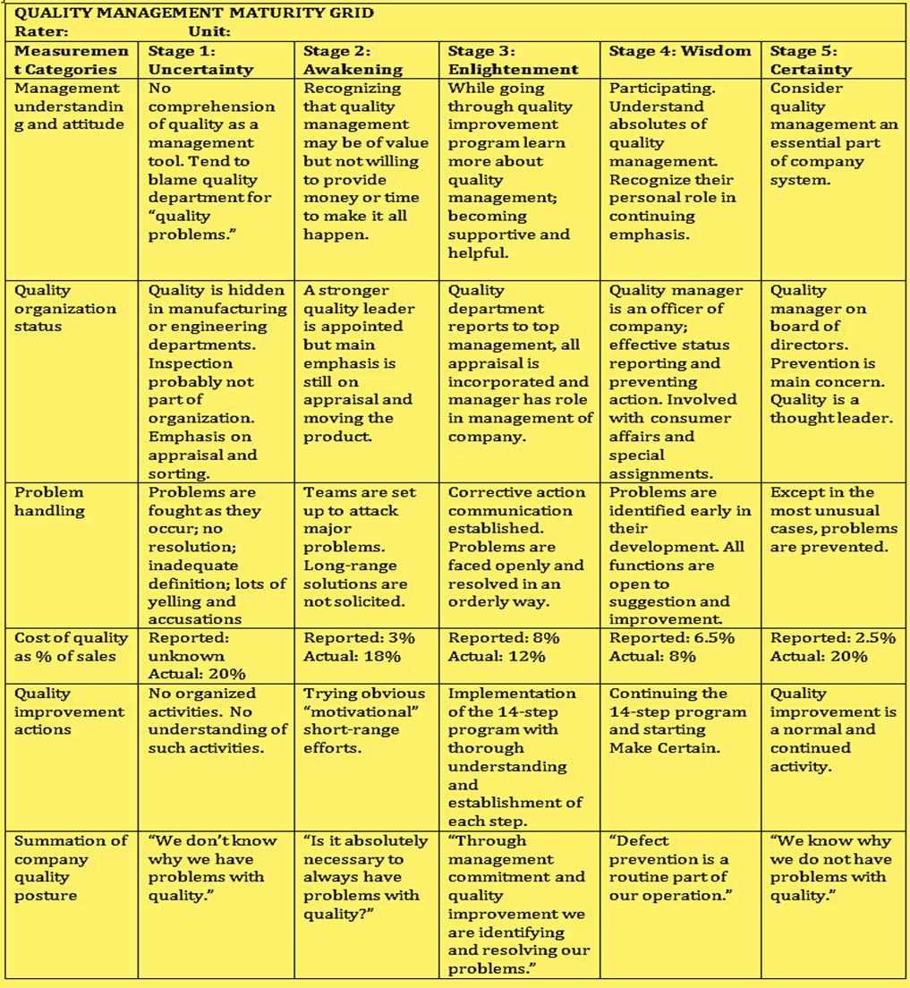
This grid can be used to know if an organisation is advancing in quality management tasks and where it stands today. For this Crosby suggested asking several people who are holding different positions in the organisation concerned to evaluate its performance impartially by assigning them each a copy of the grid. They are told to assess at which stage they think the organisation stands today about each of the six categories and to mark the matrix accordingly, i.e. Stage 1 Uncertainty gets a score of 1 for each of the six categories, Stage 2 Awakening gets 2 for each of the six categories, similarly Stage 3 gets 3 for each of the six categories and so on. Hence, after averaging marks awarded by each of the individual evaluators, the organisation can get a minimum score of 6 (six only) and a maximum of 30 (thirty only). If an organisation gets thirty, it is said to be in perfect condition in the matter of quality management and it is required to make efforts only to keep its status maintained there. On the other hand, if an organisation scored six only, it needs to use the grid as a route map for strategic quality management and plan its quality improvement initiatives in a way that keeps it moving steadily towards the right in the grid.
Philip Crosby’s quality management maturity grid was later used by the Software Engineering Institute (SEI) at Carnegie-Mellon University to develop a process maturity framework for software development processes in 1986 with assistance from the Mitre Corporation. It was a project sponsored by the U.S. Dept. of Defence. This framework initially came to be known as the Capability Maturity Model (CMM), which was later revised to integrate multiple versions of the CMM used in different domains. The webpage “CMMI - Capability Maturity Model Integration” discusses the consolidated version that was first released in 2000 and was named the Capability Maturity Model Integration (CMMI). The “CMMI V2.0 Adoption and Transition Guide” provided by the CMMI Institute discusses version 3.1 that has been recently released by the SEI in January 2024.
CMMI offers guidance to help an organisation improve its business process capabilities and quality across the organisation. Business process refers to the set of procedures to organize the sequence to transform inputs into outputs (Laudon and Laudon 2007). Capabilities are typically organizational-level skills, abilities, and knowledge embedded in people, processes, infrastructure, and technology that drive it to fulfil its mission and achieve measurable business results (CMMI Adoption Guidance, 2024, p. 7). An organization’s process capability helps to predict the possibility of a project to achieve proposed goals. Projects undertaken by organizations with low process capacity cause large variations in costs, time, features, and quality (Ibrahim et al. 2001). Process capability improvement is a systemic approach that helps organisations optimise the sequence of activities so that they may improve their results. CMMI includes multiple domains and views. CMMI defines a host of process areas. The organization can select the capability areas, process areas, and domains that are most pertinent to their business operations.
In CMMI there are five maturity levels numbered 1 through 5. It classifies organisations according to their ability to control their various processes and manage the quality. It describes an evolutionary method as well for improving an organisation from one that is underperformer and immature to one that is disciplined and mature or optimised, as is presented below:
- Level 1, Performed: At this stage, an organization operates without clear insight into its performance, latent capabilities, or reasons for underperformance. Processes are ad hoc and conducted without formal structure or concern.
- Level 2, Managed: In this stage, processes are managed with increased capability compared to Level 1. Organizational policies are established to direct processes, and activities are documented. Projects are planned, executed, monitored, and controlled. Resources are allocated appropriately, and responsibility and authority are assigned at every level. The organization reacts to issues by objectively evaluating work products and implementing corrective measures as needed.
- Level 3, Defined: Level 3 represents a shift from a project-centric to an organization-wide approach, laying the groundwork for enhanced quality and performance. Processes become standardized and deployed across the organization, leading to greater consistency and predictability. Data on process assets and measurements are collected for organizational learning and improvement.
- Level 4, Quantitatively Managed: Building upon data collection from Level 3, statistical methods are employed to monitor and control process quality. This ensures efficient operations with fewer defects and waste, enhancing management precision and predictability. Quantitative analysis facilitates accurate defect detection and concrete rectification.
- Level 5, Optimizing: At this pinnacle stage of the organization's quality management journey, the focus transcends mere problem-solving to encompass trend analysis, technical practice evaluation, and addressing root causes of process variation. Adaptation to evolving business needs is prioritized, fostering innovation, optimization, and continuous improvement. The organization proactively prevents known defects from recurring and anticipates and addresses potential issues beforehand. This agility in responding to market dynamics and customer demands confers a competitive edge.
According to Sally Godfrey (as cited in Bel and Forcada, 2008), the CMMI maturity model may thus be summarised as:
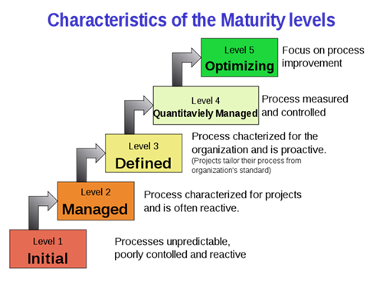
Figure 1. CMMI Maturity Model
The Capability Maturity Model (CMM) was developed by the SEI focusing mainly on process areas. Later in 1997, Harold Kerzner at the International Institute for Learning, NY applied CMM to the project management area and created the foundation for the Project Management Maturity Model (PMMM). Today, the PMMM has emerged as a valuable tool to assess and improve project management capabilities, ensuring project management maturity and impressive organizational growth. A project is a series of structured tasks, activities, and deliverables that are carefully executed to achieve a desired outcome. Project management is the practice of using knowledge, skills, tools, and techniques to complete a series of tasks to deliver value and achieve a desired outcome (Kerzner 2019, p. 41). Kerzner defines Project Management Maturity as:
Project management maturity is the ongoing process of periodically identifying, measuring, implementing, and reassessing continuous improvement opportunities in the project delivery system and supporting infrastructure such that the organization can improve its ability to meet its strategic goals and objectives. (Kerzner 2019, p. 112).
Highlighting the underlying features of the Project Management Maturity Model, Kerzner opined that, unlike the CCM or CMMI, the PMMM is significantly more behavioural than quantitative. It is so because, for the success of a project, it is people who matter most not the processes, as it is people who manage projects; processes function as supporting tools. An organisation can have a grand process of the world yet still not reach a level of maturity because the correct human behaviour is not in place. The PMMM assessments, therefore, focus on people interacting with other people rather than just processing.
The Project Management Maturity Model (PMMM) comprises five levels briefly described below. Each of the five levels represents a different degree of maturity in project management.
- Level 1—Common language: Organizations at this stage lack consistency and standardization in project management practices. There is a notable absence of clear definitions and understanding of project management terms and principles. This lack of common language hinders effective communication, collaboration, and planning. Work is typically carried out in an ad-hoc manner without adherence to formal processes or guidelines.
- Level 2—Common processes: At this stage, organizations recognize the value of structured project management practices for enhancing quality. They implement standardized processes, leading to greater consistency and repeatability in project outcomes. The benefits of standardized project management, such as cost reduction and shorter schedules, become evident, motivating further adoption. Employees are trained and motivated, fostering a shift in corporate culture towards standardized practices.
- Level 3—Singular methodology: At this stage, organizations integrate multiple processes into a single, cohesive project management approach, permeating project management support throughout all organizational layers. Each management level comprehends its role and provides necessary support, facilitating a smooth transition from line to project management through skill enhancement training. This synergistic approach simplifies tasks and boosts productivity.
- Level 4—Benchmarking: Utilizing evidence and data, benchmarking identifies areas requiring improvement. Organizations determine whom and what to benchmark, employing competitive and process benchmarking. Competitive benchmarking assesses competitiveness against rivals, while process benchmarking compares and analyzes business processes with industry best practices to enhance efficiency and competitiveness.
- Level 5—Continuous improvement: At this stage, benchmarking evolves into a continuous process to sustain competitive advantages and extend gains in other areas. The organization understands that achieving excellence in project management is an ongoing journey. Improvements are both internally and externally driven. Internal enhancements may focus on fostering a stronger corporate culture, implementing advanced software, and enhancing project management skills through education and training. External improvements may include enhancing customer relations, optimizing supply chain management, and effectively managing socio-political and legal matters.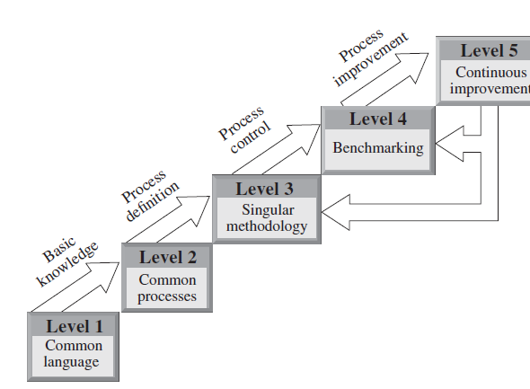
Figure 2. Different Levels of Project Management Maturity Model ³²
As is clear above, the never-ending cycle of benchmarking– continuous improvement–and singular methodology enhancement make maturity in project management a never-ending journey.
In a nutshell, these three models provide systematic and structured approaches for assessing and improving the quality of organizational practices. While the Quality Management Maturity Grid focuses on quality practices, CMMI covers broader process areas, and the PMMM specifically targets project management practices. Organizations can benefit from understanding and applying these models to enhance their overall effectiveness and maturity.
Since the CMMI model was launched, hundreds of maturity models have been proposed across multiple domains (Pulparambil and Baghdadi 2018, p. 11). In so far as the maturity model for higher education is concerned, Duarte and Paula (2013) have reviewed eight leading models framed specifically for the use of different types of higher educational institutions. Duarte and Martins (2013), have presented a comparison between all these educational maturity models in tabular form, as is shown below:
Table 2. Strengths and Weaknesses of the Educational Maturity Models (p. 40)
Model | Strength | Weaknesses | Focus
eMM  (Marshal &  Mitchel) | Suggests attributes for an entity to be positioned in a specific maturity  level;  Methodology is based on a known  and established reference model;  Defines processes and groups them in defined process areas;  Defines a set of good practices for  each process to obtain success;  Suggests an associated assessment  method;  Model has been continuously revised. | Focus on a specific entity | Online course
MRAIES  (Petri, Garcia  & Giraldo) | Process improvement is obtained in a staged, progressive way;  Methodology is based on a known  and established reference model;  Suggests attributes for an entity to  be positioned in a specific maturity  level. | Doesn’t present process areas;  Levels are based on ABET-specific requirements;  Doesn’t present maturity practices that encompass the various entities. | Higher  education  institution  management
ICTMMEI-DV  (Bass) | Improvement is obtained in a staged  progressive way;  Suggests attributes for an entity to  be positioned in a specific maturity  level. | Focus on a specific goal: provide guidance for ICT infrastructure planning in Educational  Institutions on Developing Countries;  Doesn’t present process areas;  Doesn’t present maturity practices that encompass the various entities. | ICT Equip.  and use
CMMI-ISC  (White et al.) | Process improvement is obtained in a staged progressive way;  Methodology is based on known and  established reference model;  Suggests attributes for an entity to be  positioned in a specific maturity level. | Focus on a specific entity: IS curriculum;  Doesn’t present maturity practices that encompass  the various entities;  Doesn’t suggest ways to evolve from a level to  another;  The model has not yet been validated. | IS Curriculum
OCDMM  (Neuhauser) | Process improvement is obtained in a staged, progressive way;  Methodology is based on a known  and established reference model;  Suggests a set of good practices for an entity to be positioned in a specific maturity level. | Focus on a specific entity: on-line course;  Doesn’t present maturity practices that encompass  the various entities;  Doesn’t suggest ways to evolve from a level to  another;  Model validation was obtained through  the application of questionnaires to faculty  representatives. | On-line course
LPMM  (Thompson) | Process improvement is obtained in a staged progressive way;  Methodology is based on a known  and established reference model;  Suggests attributes for an entity to be  positioned in a specific maturity level. | Focus on a specific entity: student learning skill;  Doesn’t present process areas;  Doesn’t present maturity practices that encompass  the various entities;  Doesn’t suggest ways to evolve from a level to  another;  The model has not yet been validated. | Student
ITIL-ITSMM  (Wang e  Zhang) | Suggests attributes for an entity to be  positioned in a specific maturity level.  Methodology is based on a known  and established reference model; | Focus on a specific entity: university IT services;  Doesn’t present process areas;  Doesn’t present maturity levels or dimensions;  Doesn’t present maturity practices that encompass  the various entities;  The model has not yet been validated. | IT services
CEMM  (Lutteroth et  al.) | Process improvement is obtained in a staged, progressive way;  Methodology is based on a known  and established reference model;  Suggests attributes for an entity to be  positioned in a specific maturity level. | Focus on a specific entity: computer science course;  Doesn’t present process areas.  Doesn’t present maturity practices that encompass  the various entities;  Doesn’t suggest ways to evolve from a level to  another;  The model has not yet been validated. | Computer  science course
CMMI -TQM  (Dounos &  Bohoris) | Process improvement is obtained in a staged, progressive way;  Methodology is based on a known  and established reference model;  Suggests attributes for an entity to be  positioned in a specific maturity level;  Suggests that the ways to evolve from a level to another should be based on benchmarking and Total Quality Management techniques. | Doesn’t present process areas;  Doesn’t present maturity practices that encompass  the various entities;  The model has not yet been validated. | Higher  education  institution  management

Later, in 2014, in a paper presented at the 9th International Conference on the Quality of Information and Communications Technology, Duarte and Paula argued that “CMMI is designed for generic services or industries, and does not respond to Academic Institutions needs and doesn’t give guidance for how to extend the model to specific areas like higher education” (Duarte, Duarte, and Martins 2014). They found the Business Process Maturity Model (BPMM) more suitable for academic institutions’ business processes holistic improvement. BPMM was originally developed by Nedbank Limited (South Africa) using the CMMI for improvement in business processes. It was later passed over to the Object Management Group (OMG) for further refinements. As BPMM has its origin in CMMI, both models bear many similarities. It too comprises five levels whose main features are summarised below:
Table 3. BPMM Maturity Level (Weilkiens et al. 2016)
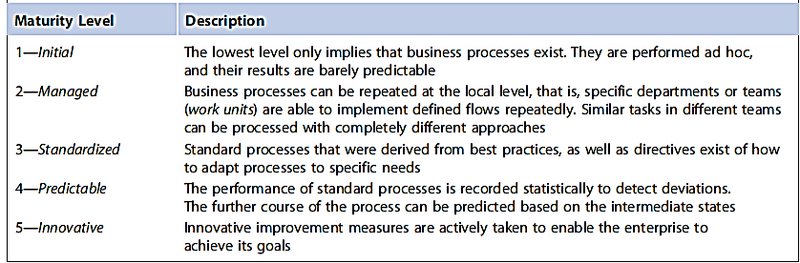
In a similar but bigger effort, Esteban Tocto-Cano et al. made a literature review of almost 27,289 relevant articles published in different peer-reviewed journals between 2007 and 2020 on the application of the maturity model in the case of universities. After excluding articles that had no relation to the object of study and duplicate articles, they finally selected a total of 23 articles that directly focused on evaluating maturity in university education domains which were registered in the Mendeley tool for bibliographic reference management. These 23 articles dealt with different areas or activities of the higher education field. Analysing their purpose, these articles were organized into the following nine categories:

Table 4. Categories of selected Maturity Models (Tocto-Cano et al. 2020, p. 6)
SN | Categories | Number of Articles
 | Maturity models oriented towards teaching. | 8
 | Maturity models oriented towards ICT. | 3
 | Maturity models oriented towards student monitoring. | 2
 | Maturity models for intellectual capital. | 1
 | Maturity models for E-Learning. | 3
 | Maturity models aimed at evaluating university entrepreneurship. | 1
 | Maturity model oriented to the employability of graduates. | 1
 | The maturity model is oriented to the strategic planning of universities. | 1
 | Maturity model for IT governance in university institutions. | 3
Total |  | 23
All the models referred to above were focussing on higher educational institutions/programmes, but none of them were concerned directly with the HEI accreditation process. The most remarkable attempt in this area was made jointly by Larrondo Petrie, Medina García, and Méndez Giraldo (2009) in the context of the Latin American and Caribbean Consortium of Engineering Institutions (LACCEI). They named their model the Engineering Teaching Capability Maturity Model (EECMM), which was developed based on the Integrated Capability Maturity Model (CMMI). It was stated to facilitate certification processes through the continued improvement of engineering institutions. Graphically, EECMM was presented as follows: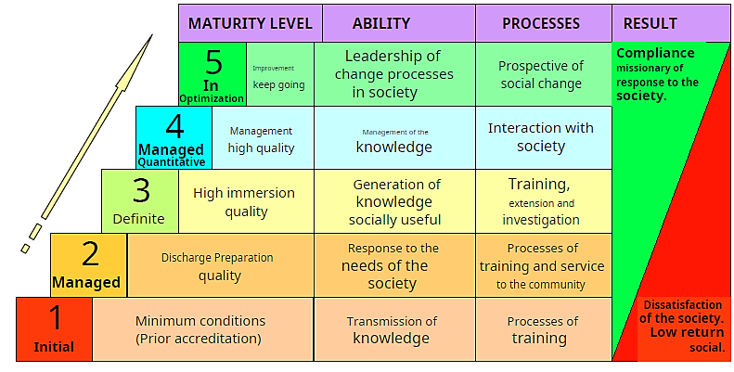
Table 5. EECMMI-Levels & Features
Like CMMI, this model (Larrondo Petrie, Medina García, & Méndez Giraldo 2009) also comprised five levels of maturity, characteristics of each level were described separately, as shown below:
- Level 1 – Initial: It represents the foundational stage for the institution. It encompasses the minimum conditions an institution must meet. At this level, the primary focus is on transmitting knowledge and adhering to basic training processes. It routinely discharges these activities, having no least concern for quality enhancement. As a result, dissatisfaction with society pervades here.
- Level 2 – Managed: This level pertains to an institution that, while meeting minimum quality standards, actively seeks higher quality standards. This commitment is evident in its administration. To achieve this, the institution engages in dialogue with users, and beneficiaries, responding to societal demands. Additionally, at this level, the institution extends beyond training to encompass other university actors and services.
- Level 3 – Defined: It represents an institution that not only adheres to training and extension processes but also demonstrates maturity and quality. At this level, the program engages in research, generating and assimilating new knowledge. For engineering institutions, this knowledge is applied, creating value for society.
- Level 4 - Quantitatively Managed: This level signifies that the institution has largely accomplished its mission. Now, it focuses on elevating its management processes to substantial quality standards. To achieve this, it must evolve into a systematic process that begins with data management and progresses toward knowledge management. This evolution enables better interaction with various stakeholders in society.
- Level 5 – Optimization: It signifies that the institution has fulfilled its original mission and now operates with a teleological objective known as vision. This vision revolves around continuous improvement across teaching and learning, training, community service, research, and self-management. The ultimate goal is to become a leader in the disciplinary field, wielding a ‘voice and vote’, and contributing to the larger interest of the society.
In a nutshell, the model states that as educational institutions progress through the levels of the maturity model, they align more closely with societal demands. This compliance can be comprehensive or specific to faculties, programs, or careers. Society expects relevant training for graduates to excel in their professional roles. Additionally, there is a demand for improved well-being through the social application of research knowledge and community expectations from university extensions.

Discussions
Maturity models provide a structured framework to evaluate and monitor the progression of institutions across various development stages. These models typically offer multiple levels of maturity, ranging from basic compliance to optimized processes, ensuring that HEIs progressively improve their organizational strategies and performance outcomes. Maturity models have emerged as effective tools in assessing and improving institutional processes, particularly in higher education. There is a pivotal role of maturity models in enhancing quality assurance standards for Indian higher education institutions (HEIs). The quality assurance of HEIs in India is crucial to maintaining academic integrity to foster innovation and align with global educational benchmarks.
In the Indian context, the accreditation process conducted by organizations such as the National Assessment and Accreditation Council (NAAC) plays a significant role in maintaining quality standards. However, given the diverse and dynamic landscape of Indian higher education, a one-size-fits-all approach to accreditation often falls short. This is where maturity models bridge the gap by offering customized pathways for institutions to assess their strengths, identify gaps, and enhance their quality metrics systematically. The application of maturity models in quality assurance involves several aspects:
- Diagnostics and Benchmarking: Maturity models enable HEIs to diagnose their current levels of development and compare them against standardized benchmarks. This diagnostic capability is especially useful for identifying specific areas requiring improvement, such as curriculum design, faculty development, research capabilities, and governance structures.
- Strategic Planning and Continuous Improvement: With a clear understanding of their maturity level, institutions can establish strategic plans for progression. These plans encourage continuous improvement rather than static compliance, fostering innovation and adaptability within the institution.
- Stakeholder Engagement: Maturity models emphasize engaging stakeholders, including students, faculty, and external evaluators, to create a collaborative environment for quality enhancement.
- Technology Integration: As Indian HEIs increasingly adopt digital tools for learning and administration, maturity models offer guidelines for effective technology integration to boost operational efficiency and academic delivery.
Studies have demonstrated that maturity models provide measurable improvements in accreditation outcomes, such as higher NAAC grades and better global rankings. They also enable institutions to address challenges like resource constraints, infrastructure disparities, and varying levels of faculty expertise by offering context-sensitive solutions. The maturity model approach aligns with India's National Education Policy (NEP) 2020, which emphasizes holistic development, sustainability, and global competitiveness in higher education. Indian HEIs can transition from basic compliance to excellence, ensuring they not only meet but exceed quality assurance requirements with the application of maturity models.
Maturity models are transformative frameworks to empower Indian higher education institutions to elevate their quality assurance standards systematically. These models offer a pathway for institutions to achieve excellence and sustainability through diagnostics, strategic planning, stakeholder collaboration, and technology integration thus contributing to the broader goals of national and global education systems.
Conclusion
All maturity models aim at graded improvement in the quality of work discharged by the organisation. However, quality is not a unidimensional concept. Simply put, quality denotes conformance to requirements. In the case of higher education, it is the requirements of its different stakeholders, like students, parents, and society at large. The entire exercise of the HEIs involves three ingredients: input, process, and output. A HEI uses the inputs available to it and transforms them into predefined learning outcomes, applying certain processes thereupon. According to Udam and Heidmets 2(013), the composition of all these three ingredients can be exemplified as:
- Inputs: for example, admission requirements, staff numbers and their qualifications, student selectivity rates, staff-student ratios, funding (per student), facilities (per student), number of study programmes, planned student qualifications;
- Processes: for example, a strategic mission, institutional purposes and educational objectives, correspondence of educational objectives/learning outcomes to qualification-level descriptors, curriculum and student learning assessment development, programmed and real study duration, study load, student support, the presence of effective internal feedback procedures, student feedback on course delivery, alumni feedback on strong and weak points of the study programme from the point of view of their early career;
- Outputs: for example, graduates’ knowledge, skills and competencies; graduation rates/drop-outs; time to degree; employment rates (in relevant job sectors).
Accreditation is a process of professional judgment that evaluates whether an educational institution or program meets specified standards of educational quality and certifies it accordingly. In India, the accreditation work of NAAC or NBA was initially more on inputs and processes. However, after ratifying the Washington Accord, the focus of accreditation work began to shift to the outcome. Today, the Outcome Based Education (OBE) paradigm has become the underlying paradigm followed by global accreditation agencies. The recently submitted Dr Radhakrishnan Committee Report added ‘impact’ as the fourth ingredient for the HIEs. It specifically states:
The parameters and related variables in current use (by AICTE, NAAC and NBA, and to a large extent by NIRF) are largely ‘input-centric’. Hence, a framework for addressing the four elements (Input-Process-Outcomes-Impact) of each attribute is addressed in this Report. (Department of Higher Education, Ministry of Education, Government of India, November 2023)
The Committee has suggested a broad framework for addressing all the four ingredients of higher education. Though the Report also emphasises graded maturity but does not suggest any specific model for it. NAAC is working on it and is expected to be in the public domain soon. However, analysis of the different models presented above shows that the Integrated Capability Maturity Model (CMMI) and the Business Process Maturity Model (BPMM) are the two prominent models that can be expected to form the base for the upcoming Maturity-Based Graded Accreditation of the NAAC. The Engineering Teaching Capability Maturity Model (EECMM) formulated by LACCEI is a similar effort in this direction.

COMPETING INTERESTS DISCLAIMER:
Authors have declared that they have no known competing financial interests OR non-financial interests OR personal relationships that could have appeared to influence the work reported in this paper.

References
Al-Haj Ibrahim, Hassan. “Quality Assurance and Accreditation in Education.” Open Journal of Education 2, no. 2 (2014): 106-110.
Andersen, Erling S., and Svein Arne Jessen. “Project Maturity in Organisations.” International Journal of Project Management 21, no. 6 (2003).
CMMI Adoption Guidance. Version 3.1. 2024. ISACA. Illinois, p. 7.
CMMI Institute. “CMMI V2.0 Adoption and Transition Guide.” Accessed N.d. https://cmmiinstitute.com/resource-files/public/cmmi-model-materials/cmmi-v2-0-adoption-and-transition-guide.
Crosby, Philip B. Quality Is Free. Penguin Books Ltd., England, 1980.
Department of Higher Education, Ministry of Education, Government of India. Report of The Overarching Committee. November 2023.
do Nascimento, A. P., de Oliveira, MPV, Ladeira, MB, and Filho, HZ. “Key Transition Points: The Climbing to Quality Management System Maturity.” Gestão & Produção 23, no. 2 (2016): 251. https://doi.org/10.1590/0104-530X2222-15.
Duarte, Duarte, and V. Martins, Paula. “A Maturity Model for Higher Education Institutions.” Journal of Tourism, Sustainability and Well-being, vol. 1, no. 1 (2013): 25-45.
Duarte, Duarte, and V. Martins, Paula. “Higher Education Business Process Improvement: Achieving BPMM Level 3.” In 2014 9th International Conference on the Quality of Information and Communications Technology, Guimaraes, Portugal, 2014, pp. 18-27. doi: 10.1109/QUATIC.2014.10.
Goldman Sachs. “How India Could Rise to the World’s Second Biggest Economy.” Accessed N.d. https://www.goldmansachs.com/intelligence/pages/how-india-could-rise-to-the-worlds-second-biggest-economy.html.
Ibrahim, L. et al. The Federal Aviation Administration Integrated Capability Maturity Model (FAA-iCMM), Version 2.0. Federal Aviation Administration. The USA, 2001.
Godfrey, Sally. 2008. Quoted in Bel, N., & Forcada, M. L. “A Maturity Model for Public Administration as Open Translation Data Providers.” ArXiv. Accessed from /abs/1607.01990.
Kerzner, Harold. Using the Project Management Maturity Model: Strategic Planning for Project Management. John Wiley & Sons, 2019.
Larrondo Petrie, E., Medina García, J., & Méndez Giraldo, G. (2009). “Registration and Accreditation Model of Education Institutions Superior based on the CMMI Model.” Accessed at: https://www.laccei.org/LACCEI2009-Venezuela/Papers/Acc116_LarrondoPetrie.pdf.
Laudon, Kenneth, and Jane Laudon. Management Information Systems: Managing the Digital Firm. 10th ed. New Jersey: Pearson Prentice Hall, 2007.
Mainz, J., Hammershøy, E. M., Worning, A. M., and Juul, S. “Quality Assessment, Quality Assurance and Quality Improvement in Health Care: Concepts and Terminology.” Ugeskrift for Laeger 154, no. 18 (1992): 1255-1260.
National Assessment and Accreditation Council. “Major Reforms in Accreditation of Higher Education Institutions.” Press Release, January 27, 2024. Accessed from https://www.ugc.gov.in/pdfnews/0821441_NAAC-Major-Reforms-in-Accreditation-Press-Release-27January-2024.pdf.
Newlines Institute for Strategy and Policy. “Introduction: Is the Rise of India as a Global Power Inevitable?” In The Rise of India as a World Power. Accessed N.d. https://anthologies.newlinesinstitute.org/the-rise-of-india-as-a-world-power/introduction-is-the-rise-of-india-as-a-global-power-inevitable/.
Plays-in-Business. “CMMI - Capability Maturity Model Integration.” Accessed N.d. https://www.plays-in-business.com/cmmi-capability-maturity-model-integration/#CMMI_v10.
Pöppelbuß, Jens, and Röglinger, Maximilian. “What Makes A Useful Maturity Model.” ECIS 2011 Proceedings, 2011. Accessed at: http://aisel.aisnet.org/ecis2011/28.
Proença, Diogo, and Borbinha, José. “Maturity Models for Information Systems - A State of the Art.” Procedia Computer Science 100 (2016).
Pulparambil, Supriya, and Youcef Baghdadi. “Service Oriented Architecture Maturity Models: A Systematic Literature Review.” Computer Standards & Interfaces 61 (2018).
Report of The Overarching Committee. Department of Higher Education, Ministry of Education, Government of India, 2023.
Silveira, V. N. S. “The Multistage Maturity Models: A Brief Account of their History, its Diffusion and its Application in People Management through the People Capability Maturity Model (P-CMM).” Revista de Administração Contemporânea 13, no. 2 (2009).
Tocto-Cano, Esteban, Paz Collado, J. Linkolk, and E. J. “A Systematic Review of the Application of Maturity Models in Universities.” Information 11, no. 10 (2020): 466. https://doi.org/10.3390/info11100466.
Udam, Maiki, and Mati Heidmets. “Conflicting Views on Quality: Interpretations of ‘A Good University’ by Representatives of the State, the Market and Academia.” Quality in Higher Education. 2013. DOI:10.1080/13538322.2013.774805.
Weilkiens, Tim, C. Weiss, A. Grass, and K. N. Duggen. OCEB 2 Certification Guide: Business Process Management - Fundamental Level. Morgan Kaufmann, 2016.
“What Is Project Management.” Project Management Institute. Accessed November 18, 2023. https://www.pmi.org/about/learn-about-pmi/what-is-project-management.
Zajda, Joseph I., M. K. Bacchus, and Nick Kach. Excellence and Quality in Education. Australia: J. Nicholas, 1995.

