Original Research Article

Tree diversity assessment, biomass estimation and carbon storage status of important sacred groves in the Shivalik foothills of Garhwal Himalaya, India.

Abstract:
Aim: This study aimed to assess tree diversity and estimate the above-ground biomass (AGB) and carbon storage status of four sacred groves (Sidh Peeths)
Place & duration: Sacred groves ware located in the Dehradun Valley, within the Shivalik foothills. Field investigations were carried during October 2024 to April 2025.
Study Design and methodology: Analysis of tree vegetation was done to assess the species diversity and distribution across four selected sacred groves. In each of these grove, ten quadrats of 10m×10m (100 m²) were randomly laid. Tree species were identified and parameters such as density, frequency, abundance was calculated using standard methods. Biomass and Carbon storage were estimated using species specific volume equations
Results: Tree species richness varied across the groves, ranging from 3 to 12 species, with Shorea robusta emerging as the dominant species in all sites. Tree density ranged between 650 and 860 trees per hectare. AGB was calculated by multiplying tree volume with wood density, followed by application of a biomass expansion factor. The estimated AGB ranged from 747.44 to 1571.25 Mg ha⁻¹, while carbon stock ranged from 470.89 to 989.89 Mg C Mg ha⁻¹.
Conclusions: Kalu Sidh (SG3) recorded the highest values for both AGB (1571.25 Mg ha⁻¹) and carbon storage 989.89 Mg ha⁻¹, likely due to its greater species richness and higher mean DBH. Shorea robusta contributed the largest share of AGB across all groves, with values ranging from 511.91 to 969.54 Mg ha⁻¹.
Graphical Abstract
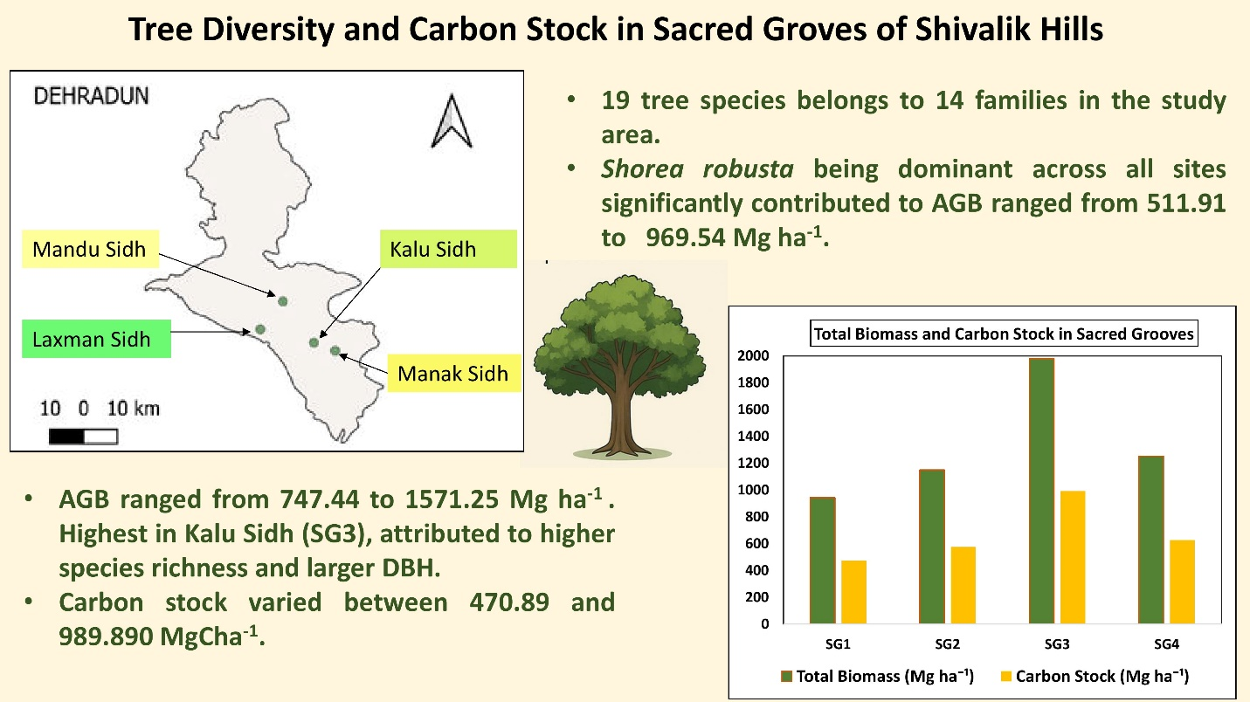
Key words: Biodiversity, Biomass, Sacred Grove, Carbon Storage, Shivalik foothills.
1. Introduction
Sacred groves are the oldest and most effective form of traditional in situ conservation, safeguarded through religious beliefs, cultural taboo, and community-based practices. (Gadgil and Varthak 1976; Hughes and Chandran 1998). In India Sacred Grove are known by many local names for example Sarna or Dev in Madhya Pradesh, Devarai in Maharashtra, Oranns in Rajasthan which reflects Indias rich culture and ecological diversity (Bhakat 1990). Although sacred groves accounts for significant cultural and ecological value, their documentation is still on process. So far, around 13,270 groves covering around 33,000 ha⁻¹ have been recorded which represents only 0.1% of India’s land area (Gokhale et al 1998). However latest estimates show that their actual number may range from 100,000 to 150,000 (Malhotra et al 2007; Waikhom et al 2018). These groves serve as important biodiversity hotspots, preserving number of rare endangered and endemic species, which or many are absent in neighboring disturbed forest ecosystem. (Khan et al 2008). Their sacred status has historically ensured the sustainable use of natural resources turning them into living repositories of ecological, cultural and medicinal wealth (Prashad and Raveendran 2012; Amirthalingam 2016). Sacred groves also serve as a gene pool which provides ecosystem services like climate regulation, soil and water conservation, and genetic diversity protection. They also support greater species richness and healthier ecosystem than nearby interfered forest areas (Bhagwat and Rutte 2006; Chandrashekara and Sankar 1998).
Vegetation especially trees play an important role in mitigating climate change by absorbing atmospheric Carbon dioxide (CO₂) through photosynthesis and storing it in biomass acting as a natural carbon sink (Wani and Qaisa 2014; Carpenter et al 2006). Forests sequester about 2.6 billion metric tons of CO₂ annually contributing its important role in climate regulation (Pan et al., 2011). Precise estimation of biomass and carbon are important for managing forest productivity and climate mitigation planning (Brown 1997; FAO 2011). Sacred grove a small, culturally protected forest patches harbors mature vegetation with high biomass, acting as localized carbon sinks (Khan et al., 2008) while supporting biodiversity and ecological resilience (Gadgil and Vartak 1976). Aboveground biomass holds the largest carbon pool, with roots and dead organic matter also contributing significantly the largest carbon pool, with roots and dead organic matter also contributing significantly (Gibbs et al 2007). Studying these groves provides a valuable insight for sustainable forest management while balancing carbon storage and biodiversity conservation.
2. Material and Methods
2.1 Study Area
This study was conducted in four important sacred groves of Dehradun Valley in Shivalik foothills of Garhwal Himalaya, Uttarakhand, India. Dehradun valley lies at an average elevation of 450- 700m has fertile alluvial soils and support natural and human habitation (Rawat 2005). Climate of this valley varies from subtropical to temperate with hot summers, a Monsson season from June to September with cool winters (Singh and Singh, 1992) with average rainfall of 2025.43 mm of which maximum rainfall occurs in month of July and August (Shahid and Josh, 2015).
The four sacred groves covered during this study were Mandu Sidh (30°22′16.8″ N, 77° 59′16.2″E) Laxman Sidh (30°14′52″ N, 78° 5′0.9″E) Kalu Sidh (30°13′25.37″ N, 78°8′ 58.33″E) and Manak Sidh (30°17′17.72″N, 77°55′3.2″E) (Fig.1) and are mostly dominated by the Moist Deciduous Forest.
According to the priest and devotees, during Treta Yug (or Second age or Silver Age of mankind in Hindu cosmology) Saint Shri Atri and his wife Anasuya were blessed with a special baby boy by the three gods Brahma, Vishnu, and Mahesh (Shiva) who together are known as the Trinity. This divine child was Lord Dattatreya, a unique form that carried the qualities of all three gods. As he grew, Dattatreya became wise, powerful, and full of knowledge. He learned from 24 different teachers, not just about humans, but got enlightened with elements of nature, and became skilled in many other aspects of life.
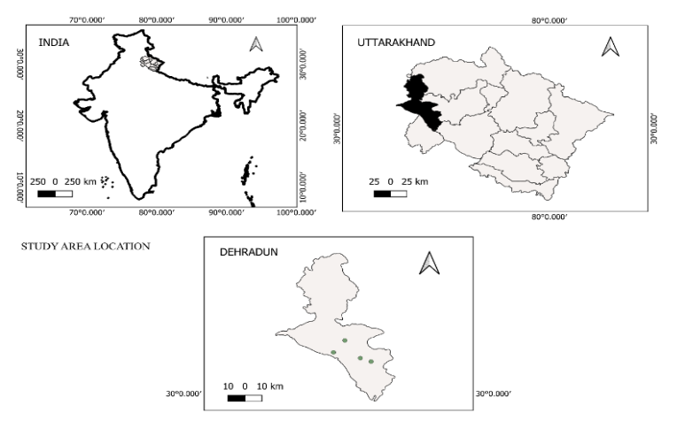
Figure 1: Location map of Study Area
2.2 Methodology
Analysis of tree vegetation was done to assess the species diversity and distribution across four selected sacred groves. In each of these grove, ten quadrats of 10m×10m (100 m²) were randomly laid with minimum distance of 100m between quadrat for proper representation of the grove and covering a total area of 1000 m² (0.1 ha). Tree with girth at breast height (GBH) > 10 cm were measured at 1.37m height (Parthasarathy and Kartikeyan 1997). GBH was converted to diameter at breast height (DBH by dividing by π (3.14). Data were analyzed using Microsoft Excel.
Tree species were identified and parameters such as density, frequency, abundance was calculated using standard methods (Mishra, 1968; Curtis and Mclntos 1950). Various Diversity indices including the Shannon- Wiener Index (Shannon and Weaver 1949), Margalef’s Richness Index (Margalef 1958), Simpson’s Dominance Index (Simpson 1949) and Pielou’s Evenness Index (Pielou 1996) were calculated. Important Value Index (IVI) was calculated by summing relative density, frequency and basal area (Philips 1959). Species dominance and distribution were visualized using dominance-diversity curve (Rank abundance curve).
Biomass and Carbon storage were estimated following Shahid and Joshi (2015), using species specific volume equations (FSI, 1996; Kaushal and Baishya 2021) and wood densities (Chave et al 2009). Stem biomass was calculated as Wood density × Volume and Above Ground Biomass was derived by multiplying the calculated stem biomass by Biomass Expansion Factor (Haripriya 2000). Below Ground Biomass (BGB) was estimated as 26% of AGB. Total Biomass (TB)= AGB +BGB, and carbon stock was estimated as 50% of TB. CO₂ equivalent was calculated by multiplying carbon stock with 3.67 (IPCC, 2006).
3. Results
3.1 Species richness and Diversity indices: A total of 19 tree species were assessed which represented 15 genera from 14 different family across all four sacred groves. Combretaceae was found to be most rich family with 4 species followed by Moraceae (2 species) while all other family represented only one species each. Kalu Siddh (SG3) had maximum species richness with 12 species while Manak Siddh (SG4) had the lowest with only three species (Table 1).
Table 1: Species distribution in each Sacred Grove.
Family | Total Species | Mandu Siddh (SG1) | Laxman Siddh (SG2) | Kalu Siddh (SG3) | Manak Siddh (SG4)
Dipterocarpaceae | 1 | 1 | 1 | 1 | 1
Combretaceae | 3 | 1 | 3 | 2 | 2
Moraceae | 2 | 2 | 0 | 0 | 0
Euphorbiaceae | 1 | 1 | 1 | 1 | 0
Phyllanthaceae | 1 | 1 | 1 | 0 | 0
Malvaceae | 1 | 1 | 0 | 0 | 0
Rubiaceae | 1 | 1 | 0 | 0 | 0
Myrtaceae | 1 | 1 | 1 | 1 | 0
Lauraceae | 1 | 0 | 1 | 0 | 0
Lythraceae | 1 | 0 | 0 | 1 | 0
Proteaceae | 1 | 0 | 0 | 1 | 0
Fabaceae | 1 | 0 | 0 | 1 | 0
Apocynaceae | 1 | 0 | 0 | 1 | 0
Rutaceae | 1 | 0 | 0 | 1 | 0

SG3 also showed the highest values for Shannon-Wiener Index (2.11) and Margalef index (2.86). Simpson Index for this site was 0.816 which indicates that the dominance by one single species is low or that the species are evenly distributed. Laxman Siddh (SG2) accounted 8 species with Shannon Index of 1.79. Mandu Siddh (SG1) showed moderate level of diversity with few species dominating the area. However, Manak Siddh (SG4) with lowest species richness recorded both the Shannon index and Simpson index of (0.13) and (0.045) respectively (Table 2).

Table 2: Diversity indices for four Sacred groves
Site | No. of Species | Simpson Index (1-D) | Shannon Index (H’) | Evenness (E) | Margalef Index
Mandu Siddh (SG1) | 9 | 0.520 | 1.247 | 0.567 | 1.916
Laxman Siddh (SG2) | 8 | 0.784 | 1.794 | 0.886 | 1.902
Kalu Siddh (SG3) | 12 | 0.816 | 2.108 | 0.833 | 2.864
Manak Siddh (SG4) | 3 | 0.045 | 0.127 | 0.115 | 0.673

Composition of species varied across all groves, except for Shorea robusta which showed highest abundance and frequency in all four groves. It had frequency of 100% in SG1, SG2 and SG4 with respective relative abundance value of 31.65%, 20.86%, and 80.7%. In SG3 Shorea robusta had frequency of 70% and relative abundance of 16.49%.
In SG1 following Shorea robusta, Ficus religiosa and Mallotus phillipinensis showed second highest frequency of 40% with relative abundance 7.19% and 10.79% respectively. Despite of Terminalia tomentosa having frequency of 10%, it had second highest relative abundance in SG1 with 14.39%. In SG2 Bridelia retusa showed frequency of 60% after Shorea robusta . In SG2 too, Terminalia tomentosa had second highest relative abundance of 17.65% with frequency of 50%. Species like Mallotus phillipinensis, Albizia procera and Terminalia bellerica showed low frequency of 30% each with Relative abundance ranging between 8-11% within these three species. In SG3 frequencies of species including Syzygium cumini, Albizzia procera, Adina cordifolia, Agele marmelos ranged from 10-20% which signifies that these species occurred occasionally in samples taken. Species like M. phillipinensis, Terminalia tomentosa, and Holarrhena pubescens had relative abundance lowest of all species with 4.67% each.
A rank abundance curve as plotted for all four sacred groves to visualize the species dominance and evenness. Species were ranked on X- axis based on abundance with the most abundant value near the origin. The Y-axis represents relative abundance. The length of curve reflects species richness, while its slope indicates evenness. (Figure 2).

Fig. 2 : Shorea robusta contributing 68% of the total abundance at Mandu Siddh (SG-1).

Fig.3: Laxman Sidh (SG2) dominance of Shorea robusta

Fig.4: Moderate dominance of 37% by Shorea robusta at Kalu Siddh (SG-3)

Fig 5: Extreme dominance by Shorea robusta at Manak Siddh (SG4).
Shorea robusta showed the highest value of IVI in all four Sacred Grove with value of 170.64, 110.29, 90.70, and 278.05 in SG1-SG4 respectively.
3.2 Basal Area and Tree Density: Tree densities varied lowest of 650 ± 35.35 trees ha⁻¹ in SG1 to highest of 860 ± 20.9 trees in SG4. In terms of Basal area, Kalu Siddh (SG3) accounted the highest basal area 116.84 ± 12.96 m² ha⁻¹ despite of moderate
tree density of 660 ± 15.48 trees ha⁻¹. This indicates that the site is dominated by large diameter trees and has mature stand structure. Laxman Siddh (SG2) and Mandu Siddh (SG1) resulted Basal area of 77.44 ± 6.863 m² ha⁻¹ and 66.7 ± 4.329 m² ha⁻¹ respectively. Manak Siddh (SG4) despite of having highest tree density showed moderate Basal Area value of 83.32 ± 10.43 m² ha⁻¹.
3.3 Biomass and Carbon Storage Status:
Mandu Siddh (SG1): The total above ground biomass (AGB) was 747.44 Mg ha⁻¹, with Shorea robusta contributing highest value of 519.01 Mg ha⁻¹ and Syzygium cumini the least 3.34 Mg ha⁻¹. Corresponding values of below ground biomass (BGB) were estimated at 134.94 Mg ha⁻¹ for Shorea robusta and 0.868 Mg ha⁻¹ for Syzygium cumini. This results in a total biomass of 653.95 Mg ha⁻¹ and 4.20 Mg ha⁻¹ for these two species respectively. The estimated Total Biomass from this sacred grove was estimated to be 941.8 Mg ha⁻¹ with corresponding value of total carbon and CO₂ equivalent to be 470.895 Mg ha⁻1 and 1728.18 Mg ha⁻¹ respectively (Table 3).

CO₂ Equivalent = 3.67 X Carbon Stock

Table 3: Species-wise Stand Density, Biomass, Carbon Stock, and CO₂ Equivalent (Mg ha⁻¹) of Mandu Siddh (SG1)
Species | Density  (Stems Mg ha⁻¹) | Relative Density (%) | AGB  (Mg ha⁻¹) | BGB  (Mg ha⁻¹) | TB  (Mg ha⁻¹⁾ | Carbon Stock (Mg ha⁻¹) | CO₂ Equivalent (Mg ha⁻¹)
Adina cordifolia | 20 | 3.07 | 50.155 | 13.029 | 63.14 | 31.54 | 115.9
Bombax ceiba | 10 | 1.53 | 4.76 | 1.24 | 4.20 | 3 | 11.01
Bridelia retusa | 60 | 9.23 | 6.92 | 1.79 | 8.72 | 4.36 | 16.01
Ficus benghalensis | 30 | 4.61 | 91.60 | 23.81 | 115.4 | 57.70 | 211.8
Ficus religiosa | 20 | 3.07 | 22.57 | 5.86 | 28.44 | 14.21 | 52.18
Mallotus philippinensis | 40 | 6.15 | 3.28 | 0.85 | 4.13 | 2.06 | 7.594
Shorea robusta | 440 | 67.69 | 519.01 | 134.94 | 654 | 326.97 | 1200
Syzygium cumini | 10 | 1.53 | 3.34 | 0.869 | 57.76 | 2.10 | 7.723
Terminalia tomentosa | 20 | 3.07 | 45.84 | 11.919 | 4.20 | 28.82 | 106
TOTAL | 650 | 100 | 747.44 | 194.33 | 941.8 | 470.895 | 1728.18

AGB= Above Ground Biomass, BGB= Below Ground Biomass, TB= Total Biomass.

Ficus Benghalensis recorded the highest mean AGB per individual of (30.53 ± 4.404 Mg), indicating the presence of large mature individuals despite their low frequency, meanwhile Mallotus philippinensis exhibited lowest mean AGB per individual (0.82 ± 0.26 Mg) (Table 4).

Table 4: Species-wise mean aboveground biomass (AGB), belowground biomass (BGB), total biomass (TB), Carbon Stock, and CO₂ Equivalent per individual tree (in Mg ± standard deviation), recorded in the Mandu Siddh (SG1)
Species | Mean Diameter per individual (cm±sd) | Mean AGB  per individual (Mg ± sd) | Mean BGB per individual (Mg ± sd) | Mean TB per individual (Mg ± sd) | Mean Carbon Stock per individual (Mg ± sd) | Mean CO₂ Equivalent per individual (Mg ± sd)
Adina cordifolia | 35.34±0.44 | 25.05 ±0.31 | 6.51±0.08 | 31.57±0.39 | 15.78±0.19 | 57.93±0.72
Bombax ceiba* | 43.31 | 4.76 | 1.24 | 6.00 | 3.00 | 11.01
Bridelia retusa | 18.83±3.69 | 1.15±0.43 | 0.29±0.11 | 1.45±0.55 | 0.72±0.27 | 2.28±1.36
Ficus benghalensis | 62.90±4.01 | 30.53±4.40 | 7.931±1.14 | 38.47±5.54 | 19.23±2.77 | 70.59±10.18
Ficus religiosa | 41.07±1.35 | 11.28±0.86 | 2.93±0.233 | 14.21±1.12 | 7.10±0.56 | 26.09±2.07
Mallotus philippinensis | 14.865±1.62 | 0.82±0.26 | 0.21±0.06 | 1.03±0.33 | 0.25±0.29 | 1.51±0.99
Shorea robusta | 34.99±7.29 | 11.7±7.09 | 3.06±1.84 | 14.86±8.93 | 7.43±4.46 | 27.27±16.401
Syzygium cumini* | 23.56 | 3.34 | 0.86 | 4.20 | 2.104 | 7.73
Terminalia tomentosa | 52.70±4.22 | 22.92±3.76 | 5.95±0.97 | 28.88±4.74 | 14.44±2.37 | 52.99±8.71
*Only one individual was recorded from the sampled area, ±: Standard deviation

Fig.6: Diameter class-wise distribution of tree abundance and aboveground biomass (AGB) in Mandu Siddh (SG1).

Tree abundance was highest in 31- 40 cm DBH class contributing highest AGB of 333.84 Mg ha⁻¹ of total 747.44 Mg ha⁻¹ of AGB (Fig. 6).
Laxman Siddh (SG2): Shorea robusta again contributed maximum AGB values of 511.91 Mg ha⁻¹ followed by Terminalia tomentosa 221.91 Mg ha⁻¹ to the total AGB value of the grove. (911.82 Mg). The total BGB value was estimated to be 273.07 Mg ha⁻¹ in which S. robusta contributed the highest (199.09Mg ha⁻¹) while Bridelia retusa the lowest (2.35 Mg ha⁻¹). The total biomass of the grove was calculated to be 1148.49 Mg ha⁻¹. The Carbon Stock of the grove amounted to 574.44 Mg ha⁻¹ with CO₂ equivalent of 2108.22 Mg ha⁻¹ (Table 5).
Table 5: Species-wise Stand Density, Biomass, Carbon Stock, and CO₂ Equivalent (Mg ha⁻¹) of Laxman Siddh (SG2)
Species | Density  (Stems Mg ha⁻¹) | Relative Density (%) | AGB  (Mg ha⁻¹) | BGB  (Mg ha⁻¹) | TB  (Mg ha⁻¹⁾ | Carbon Stock  (Mg ha⁻¹) | CO₂ Equivalent (Mg ha⁻¹)
Albizia procera | 40 | 5.97 | 51.97 | 13.51 | 65.49 | 32.74 | 120.17
Anogeissus latifolia | 60 | 8.95 | 56.58 | 14.71 | 71.29 | 35.64 | 130.82
Bridelia retusa | 90 | 13.43 | 9.05 | 2.35 | 11.41 | 5.70 | 20.93
Mallotus phillipinensis | 40 | 5.97 | 28.18 | 7.32 | 35.51 | 17.75 | 65.16
Shorea robusta | 260 | 38.80 | 511.91 | 133.09 | 645.01 | 322.507 | 1183.60
Syzygium cumini | 40 | 5.97 | 13.92 | 3.62 | 17.54 | 8.77 | 32.19
Terminalia tomentosa | 110 | 16.41 | 221.91 | 57.69 | 279.61 | 139.80 | 513.3
Terminalia bellerica | 30 | 4.47 | 18.25 | 4.74 | 23.00 | 11.50 | 42.21
TOTAL | 670 | 100 | 911.82 | 273.07 | 1148.89 | 574.44 | 2108.22

In terms of individual tree biomass contribution, Terminalia tomentosa had the highest mean AGB (20.17±18.30 Mg), followed by Shorea robusta (19.68±22.21 Mg) and Albizia procera (12.99±5.21 Mg). The lowest mean AGB per individual was reported by Bridelia retusa (1.00±0.42 Mg) which also resulted the lowest mean values per individual for all parameters like BGB, Total Biomass (TB), Total Carbon Stock (TC) and CO₂ equivalent (Table 6).

Table 6: Mean aboveground biomass (AGB), belowground biomass (BGB), total biomass (TB), Carbon Stock, and CO₂ Equivalent per individual tree (in Mg ± standard deviation) in Laxman Siddh (SG2)
Species | Mean Diameter per individual (cm±sd) | Mean AGB  per individual (Mg ± sd) | Mean BGB per individual (Mg ± sd) | Mean TB per individual (Mg ± sd) | Mean CARBON STOCK per individual (Mg ± sd) | Mean CO₂ Equivalent per individual (Mg ± sd)
Albizia procera | 23.5±4.20 | 12.99±5.21 | 3.37±1.35 | 16±6.56 | 8.18±3.28 | 30.04±12.05
Anogeissus latifolia | 30.64±9.11 | 9.43±6.67 | 2.45±1.73 | 11.88±8.40 | 5.94±4.20 | 21.80±15.42
Bridelia retusa | 17.47±3.72 | 1.00±0.42 | 0.26±0.10 | 1.26±0.53 | 0.63±0.26 | 2.32±0.97
Mallotus Phillipinensis | 38.26±22.24 | 7.04±4.92 | 1.83±1.28 | 8.87±6.20 | 4.43±3.10 | 16.29±11.38
Shorea robusta | 39.09±17.93 | 19.68±22.21 | 5.11±5.77 | 24.80±27.98 | 12.40±13.99 | 45.52±51.35
Syzygium cumini | 23.80±2.56 | 3.48±0.99 | 0.90±0.25 | 4.38±1.25 | 2.19±0.62 | 8.04±2.30
Terminalia tomentosa | 45.62±20.17 | 20.17±18.30 | 5.24±4.75 | 25.41±23.06 | 12.70±11.53 | 46.64±42.32
Terminalia bellerica | 31.92±41.15 | 6.08±2.12 | 1.58±0.55 | 7.66±2.68 | 3.83±1.34 | 14.07±4.91

Majority of trees (24 nos.) in SG2 belonged to diameter class 21-30 cm having AGB values of 137.36 Mg, while diameter class 70+ cm with only 8 individuals contributed maximum AGB values of 423.71 Mg. (Fig 7)

Fig. 7: Diameter class-wise distribution of tree abundance and aboveground biomass (AGB) in Laxman Siddh (SG2)
Kalu Siddh (SG4): The total AGB from this grove was 1571 Mg ha⁻¹ and BGB was 408.52 Mg ha⁻¹. Among AGB, Shorea robusta contributed the highest of 691.72 Mg ha⁻¹ followed by Terminalia tomentosa 208.74 Mg ha⁻¹ and Lagerstroemia parviflora 180.43 Mg ha⁻¹ with their corresponding BGB values of 179.86 Mg ha⁻¹, 54.27 Mg ha⁻¹ and 47.97 Mg ha⁻¹ respectively. On addition of AGB and BGB the Total Biomass from this grove was calculated to be 1979.76 Mg ha⁻¹, with Shorea robusta alone contributing 871.65 Mg ha⁻¹ to lowest that of Mallotus philippinensis with Total biomass value of 12.91 Mg ha⁻¹. The total carbon stock of the grove was estimated to be 989.89 Mg ha⁻¹ with CO₂ equivalent of 3632.86 Mg ha⁻¹ (Table 7).
Lagerstroemia parviflora had the highest mean AGB and BGB per individual with values of 92.15±0.89 Mg and 23.95±0.23 Mg respectively, while Mallotus philippinensis had the lowest Mean AGB per individual value of 2.56±1.21 Mg and mean BGB per individual value of 0.66±0.31 Mg. (Table 8).

Table 7: Species-wise Stand Density, Biomass, Carbon Stock, and CO₂ Equivalent (Mg ha⁻¹) of Kalu Siddh (SG3)
Species | Density (Stems Mg ha⁻¹) | Relative Densit (%) | AGB (Mg ha⁻¹) | BGB (Mg ha⁻¹) | TB (Mg ha⁻¹⁾ | Carbon Stock (Mg ha⁻¹) | CO2 Equivalent (Mg ha⁻¹)
Adina cordifolia | 30 | 4.54 | 107.10 | 27.84 | 134.94 | 67.47 | 247.63
Aegle marmelos | 30 | 4.54 | 58.65 | 15.25 | 73.911 | 36.95 | 135.62
Albizia procera | 20 | 3.03 | 50.63 | 13.16 | 63.79 | 31.89 | 117.06
Anogeissus latifolia | 40 | 6.06 | 141.55 | 36.80 | 178.353 | 89.17 | 327.27
Grevillea robusta | 60 | 9.09 | 21.25 | 5.52 | 26.78 | 13.39 | 49.14
Holarrhena antidysentrica | 20 | 3.03 | 31.28 | 8.13 | 39.41 | 19.70 | 72.32
Lagerstroemia parviflora | 20 | 3.03 | 184.30 | 47.97 | 232.22 | 116.11 | 426.13
Lagerstroemia speciosa | 60 | 9.09 | 18.99 | 4.93 | 23.93 | 11.96 | 43.91
Mallotus philippinensis | 40 | 6.06 | 10.25 | 2.66 | 12.91 | 6.45 | 23.705
Shorea robusta | 250 | 37.87 | 691.72 | 179.86 | 871.65 | 435.82 | 1599.48
Syzygium cumini | 50 | 7.57 | 46.66 | 12.13 | 58.79 | 29.39 | 107.89
Terminalia tomentosa | 40 | 6.06 | 208.74 | 54.27 | 263.02 | 131.51 | 482.64
Total | 660 | 100 | 1571.25 | 408.52 | 1979.76 | 989.89 | 3632.86

Table 8: Species-wise mean aboveground biomass (AGB), belowground biomass (BGB), total biomass (TB), Carbon Stock, and CO₂ Equivalent per individual tree (in Mg ± standard deviation), recorded in the Kalu Siddh (SG3)
Species | Mean Diameter per individual (cm±sd) | Mean AGB per individual (Mg ± sd) | Mean BGB per individual (Mg ± sd) | Mean TB per individual (Mg ± sd) | Mean CARBON STOCK per individual (Mg ± sd) | Mean CO₂ Equivalent per individual (Mg ± sd)
Adina cordifolia | 70.70±15.45 | 35.70±22.42 | 9.28±5.83 | 44.98±28.25 | 22.49±14.12 | 82.54±51.84
Aegle marmelos | 47.98±2.5 | 19.55±1.90 | 5.08±0.49 | 24.46±2.39 | 12.31±1.16 | 45.20±4.39
Albizia procera | 41.24±24.77 | 25.31±15.51 | 6.58±4.03 | 31.89±19.55 | 15.94±9.77 | 58.53±35.88
Anogeissus latifolia | 47.13±6.84 | 35.38±15.51 | 9.20±4.22 | 44.58±20.47 | 22.29±10.23 | 81.81±37.58
Grevillea robusta | 29.35±5.81 | 3.54±1.78 | 0.92±0.46 | 4.46±2.24 | 2.23±1.12 | 8.19±4.12
Holarrhena antidysentrica | 40.44±18.46 | 15.64±15.46 | 4.06±4.02 | 19.70±19.48 | 9.85±9.74 | 36.16±35.75
Lagerstroemia parviflora | 51.27±0.45 | 92.15±0.89 | 23.95±0.23 | 116.11±1.12 | 58.05±0.56 | 213±2.05
Lagerstroemia speciosa | 24.62±4.73 | 3.16±1.36 | 0.82±0.35 | 3.98±1.71 | 1.99±0.85 | 7.31±3.15
Mallotus philippinensis | 22.45±5.26 | 2.56±1.21 | 0.66±0.31 | 3.22±1.53 | 1.61±0.76 | 5.92±2.81
Shorea robusta | 46.19±18.69 | 27.67±27.43 | 7.19±7.13 | 34.86±34.57 | 17.43±17.28 | 63.97±63.43
Syzygium cumini | 34.96±10.54 | 9.33±6.67 | 2.42±1.73 | 11.75±8.40 | 5.87±4.20 | 21.57±15.42
Terminalia tomentosa | 76.15±23.64 | 52.18±32.23 | 13.56±8.38 | 65.75±40.61 | 32.87±20.30 | 120.66±74.53

The maximum contribution to AGB was by 13 individuals belonging to 70+ diameter class contributing 741.61 Mg ha⁻¹ of total 15771.25 Mg ha⁻¹, followed by 9 individuals from 60-70 diameter class with 374.90 Mg ha⁻¹. (Fig.8).

Fig.8: Diameter class-wise distribution of tree abundance and aboveground biomass (AGB) in Kalu Siddh (SG3)

Manak Siddh (SG4): Having total AGB of 993.95 Mg ha⁻¹, Shorea robusta contributed 969.54 Mg ha⁻¹ with Terminalia tomentosa and Terminalia arjuna contributing 19.216 Mg ha⁻¹ and 5.196 Mg ha⁻¹ respectively. Out of total 2781.11 Mg ha⁻¹ of CO₂ equivalent, Shorea robusta alone has CO₂ equivalent of 2241.68 Mg ha⁻¹ (Table 9).

Table 9: Species-wise Stand Density, Biomass, Carbon Stock, and CO₂ Equivalent Mg ha⁻¹) of Mank Siddh (SG4)
Species | Density (Stems Mg ha⁻¹) | Relative Density (%) | AGB (Mg ha⁻¹) | BGB (Mg ha⁻¹) | TB (Mg ha⁻¹⁾ | Carbon Stock (Mg ha⁻¹) | CO2 Equivalent (Mg ha⁻¹)
Shorea robusta | 840 | 97.67 | 969.54 | 252.82 | 1221.62 | 610.81 | 2241.68
Terminalia tomentosa | 10 | 1.62 | 19.216 | 4.99 | 24.21 | 12.10 | 44.42
Terminalia arjuna | 10 | 1.62 | 5.196 | 1.35 | 6.54 | 3.27 | 12.10
Total | 860 | 100 | 993.95 | 258.42 | 1252.38 | 626.19 | 2781.11

Fig. 9: Diameter class-wise distribution of tree abundance and aboveground biomass (AGB) in Manak Siddh (SG4)

Fig.10: Species wise contribution of Above Ground Biomass (AGB) in Mandu Siddh (SG1)

Fig. 11: Species wise contribution of Above Ground Biomass (AGB) in Laxman Siddh (SG2)

Fig.12: Species wise contribution of Above Ground Biomass (AGB) in Kalu Siddh (SG3)

Fig. 13: Species wise contribution of Above Ground Biomass (AGB) in Manak Siddh (SG4)
3.4 Statistical Analysis
3.4.1 Correlation and Regression Analysis
Correlation analysis revealed a strong positive relationship between DBH and AGB (r = 0.872, R² = 0.760) indicating that larger diameter trees contribute significantly to aboveground biomass (Figure 14). A perfect correlation (r = 1, R² = 1) was observed between AGB and TB (Total Biomass), confirming that TB is directly proportional to AGB due to the inclusion of belowground biomass (BGB) estimates.

Fig.14: Correlation between DBH and AGB
Similarly, DBH showed strong positive correlations with CO₂ equivalent (r = 0.872, R² = 0.760) (Figure 15) and Total Carbon Storage (TCS) (r = 0.877). A perfect correlation was also observed between TCS and CO₂ equivalent (r = 1, R² = 1).

Fig 15: Correlation between DBH and CO₂ equivalent
In contrast, a weak negative correlation was observed between tree density and AGB (r = -0.1, R² = 0.01) as well as between tree density and TCS. This suggests that sites with higher tree density might have a larger number of smaller trees contributing less to biomass and carbon storage. A very weak positive correlation was seen between Tree density and CO₂ equivalent (r = 0.188, R² = 0.357. Volume showed an extremely strong positive correlation with AGB (r = 0.993, R² = 0.987) confirming that stem volume is a strong predictor of biomass. Regression analysis between AGB and Volume resulted in an R² value of 0.9878, showing an almost perfect linear relationship, validating the use of volume as a proxy for biomass estimation. (Figure 16).

Fig 16: Relationship between Volume and AGB.
On the other hand, no significant linear relationship was observed between AGB and BEF or wood density. This could be attributed to the fact that BEF and Wood Density are species-specific constants and were not varying dynamically across individual trees, leading to non-linearity or absence of a clear pattern when correlated with AGB.
3.5 Principal Component Analysis (PCA)
Principal Component Analysis was carried out using grove-wise mean values of key variables (Mean DBH, Mean AGB, Mean TB, Mean TCS, CO₂ equivalent, Tree Density, and Mean Volume) using R studio software.
The scree plot (Figure 17) revealed that the first principal component (PC1) accounted for 80.2% of the total variance, while the second principal component (PC2) explained 14.3% of the variance. Together, PC1 and PC2 captured 94.5% of the variability in the dataset, indicating that two components were sufficient to summarize the data structure effectively. The PCA biplot (Figure 18) showed that Mean DBH, Mean Volume, Mean AGB, and Mean TB were strongly aligned along PC1, suggesting these variables are closely related and represent a common underlying factor, likely the tree biomass and size structure. In contrast, Tree Density was projected in a different direction, suggesting it varied independently from biomass-related variables.
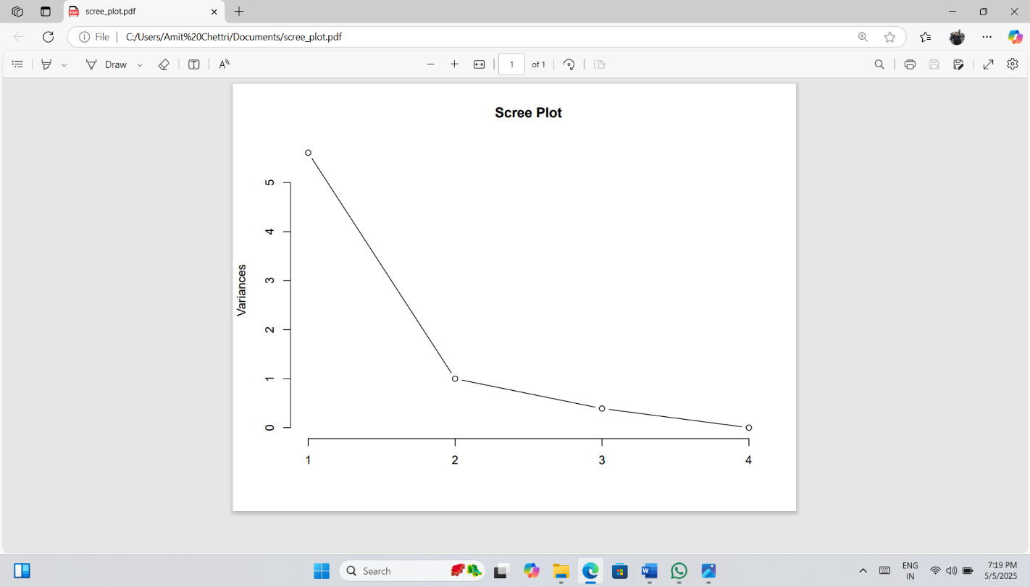

Fig. 17: variance explained by each principal component derived from stand structural variable across sacred groves.
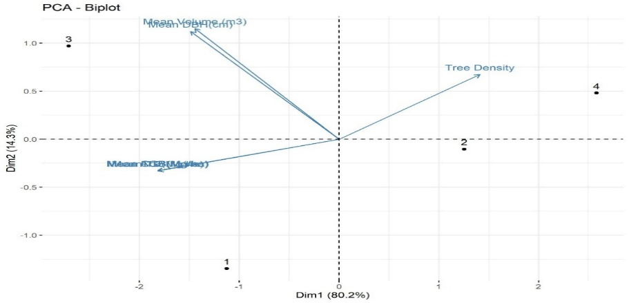
Fig.18: Principal component Analysis Biplot illustrating the relationship among stand structural variables across different sacred groves.
This result supports earlier correlation findings where tree density showed a weak negative correlation with biomass and carbon parameters.
3.6 Interpretation of Principal Components:
PC1 (80.2%): Represents tree size and biomass-related parameters (DBH, AGB, TB, Volume).
PC2 (14.3%): Represents variation related primarily to Tree Density.
PC3 and PC4: Captured negligible variation and were not considered important for further interpretation.
4. Discussion
The present study showed relatively low tree species diversity across all four sacred groves with species number ranging from just 3-12 per grove. This is comparatively low when measured against other studies, for example Pala et al. (2012) found 21 species in Chanderbadni Sacred Forest in the Garhwal Himalaya. Similarly, Dar et al (2019) in their study of 41 sacred groves in Central India reported 103 tree species 81 genera belonging to 37 families.
All groves in present study were dominated by S. robusta a climax species known to form near-monoculture and suppress the growth of other trees. It had the highest IVI in all groves ranging from 90.70 to 278.05. These values of IVI align with finding from Kongkham et al (2021), who reported a similarly dominant IVI for Shorea robusta from Shivalik Sal forests of Uttarakhand. Comparable values were also reported by Dutta and Devi (2013) in the tropical moist deciduous Sal forests of Assam who reported the IVI of Shorea robusta to be 125.3.
Tree density ranged between 650 and 680 tree ha⁻¹, aligning with values from Pala et al (2013) and Dar et al (2019) who reported tree densities to be 688 trees ha⁻¹ and 675 tree ha⁻¹ respectively. Khumbongmayum et al (2005) reported a broader range of 345 to 1202 trees ha⁻¹, while Kalita and Yumnam (2024) noted approximately 1000 trees ha⁻¹. In contrast, Kaushal and Baishya (2021) reported lower tree densities in F1 and F2 sites of the Dehradun Valley. These variations likely reflect differences in forest type, conservation status, disturbance levels, and sampling intensity.
Diversity indices also varied among the groves. Shannon’s Index ranged from 0.12 to 2.10, Simpson’s from 0.04 to 0.81, Evenness from 0.11 to 0.88 and Margalef Index from 0.67 to 2.86. These values are comparable to Pala et al., (2012) from Chanderbadni Sacred Forest but narrower than the ranges reported by study from Kaushal and Baishya (2021), possibly due to smaller grove size and more uniform vegetation in the present study.
The derived AGB from all four sacred grove in present study ranged from 747.44 to 1571.25 Mg ha⁻¹, while BGB ranged from 194.33 Mg ha⁻¹ to 408.52 Mg ha⁻¹. This resulted in values of Total Biomass (TB) ranging from 941.80 Mg ha⁻¹ and 1979.76 Mg ha⁻¹. These values are considerably higher than those reported in similar ecosystem for example, Shahid and Joshi (2015) reported much lower values of AGB which ranged from 268.57 Mg ha⁻¹ to 335.27 Mg ha⁻¹ in Dehradun valley. This suggests that the groves in this study have greater carbon storage potential.
The AGB value for SG1 closely aligns with that reported by Kalita and Yumnam (2024) in the moist deciduous forest of Assam where AGB, BGB, and TB were 782.19, 203.37, and 985.56 Mg ha⁻¹, respectively. In contrast, biomass values in SG2 and SG4 were comparatively lower than those reported by Kaushal and Baishya (2021) for their site F1, yet notably higher than the estimates by Dar et al (2019) from Central India. Furthermore, all four groves exhibited greater AGB and BGB values than those recorded by Pala et al., (2013) for Chanderbadni Sacred Grove (AGB: 895.70 Mg ha⁻¹; BGB: 247.62 Mg ha⁻¹).
SG3 stood out with highest AGB (1571.25 Mg ha⁻¹), surpassing other well-studied sacred groves like Pala et al (2013) reported 1224.91 Mg ha⁻¹ in Sem Mukhem Sacred Forest, while Waikhom et al (2018) recorded 1130 Mg ha⁻¹ in the largest sacred grove of Manipur. This is mainly due to its larger trees, higher tree volume (mean=2.32 m²) and highest average DBH (43.33 cm), including trees > 70 cm in diameter. Since the tree diameter strongly predicts AGB (Chave et al 2005), the dominance of large trees in SG3 explains its exceptional biomass and carbon stock.
Shorea robusta emerged as the principal biomass-contributing species, with AGB ranging from 511.91 to 991.72 Mg ha⁻¹, BGB from 133.09 to 252.82 Mg ha⁻¹, and TB from 645.01 to 1221.62 Mg ha⁻¹. These values are significantly higher than those reported by Kalita and Yumnam (2024) for the same species (AGB: 87.35 Mg ha⁻¹; BGB: 22.71 Mg ha⁻¹; TB: 110.06 Mg ha⁻¹), and Shahid and Joshi (2015), suggesting better growth conditions, conservation status, and stand structure in the present study sites.
The total carbon stock across the four sacred groves ranged from 470.89 to 989.89 Mg ha⁻¹, indicating substantial CO₂ equivalent. These values are markedly higher than those reported by Shahid and Joshi (2015), who recorded total carbon stocks of 169.20, 219.08, and 211.22 Mg ha⁻¹ across three forest ranges in the Dehradun Valley. Similarly, the carbon stocks in the present study exceed those reported by Salunkhe et al (2023) and Kalita and Yumnam (2024), further underscoring the carbon-rich nature of these sacred groves.
The elevated carbon values observed in these sites can be attributed primarily to the diverse species composition and structural complexity of the groves. Species composition plays a critical role in determining biomass accumulation and carbon storage, as highlighted by Kaushal and Baishya (2021). The presence of large, mature trees, particularly Shorea robusta significantly enhances carbon retention, given the species’ dominance and high biomass contribution.
The estimated CO₂ equivalent of the groves ranged from 1728.18 to 3632.86 Mg ha⁻¹, with the highest values recorded in SG3. This is in line with the CO₂ equivalents reported by Kalita and Yumnam (2024) for tropical moist deciduous forests in Assam. The exceptionally high CO₂ equivalent in SG3 is likely due to its rich species diversity and structural heterogeneity, leading to varying photosynthetic capacities and greater cumulative biomass. Moreover, trees in the >70 cm DBH class made a significant contribution to carbon storage, reinforcing the findings of Banik et al (2018), who emphasized the pivotal role of large-diameter trees in long-term carbon sequestration. The predominance of such trees in SG3 not only explains its superior carbon stock but also highlights the importance of conserving mature individuals to maintain and enhance forest carbon sinks.
5. Conclusions:
The present study highlights the ecological significance of four sacred groves in the Shivalik foothills of Garhwal Himalaya, demonstrating their vital role in conserving tree diversity and contributing to biomass and carbon storage. Shorea robusta was found to be the dominant species, while SG3 stood out with the highest above-ground biomass (1571.25 Mg ha-1), likely due to greater species richness and larger tree girth. Despite limitations, the study provides one of the first comprehensive ecological assessments of these groves, underscoring their dual value as both cultural heritage sites and natural carbon sinks. Integrating sacred groves into conservation and climate strategies is essential for promoting biodiversity and advancing sustainable development.
Ethics statement: All the needful ethics (field, lab and manuscript preparation related) were followed by authors during this study.
Declaration of Conflict of interest: The authors have no relevant financial or non-financial interests to disclose. The authors have no competing interests to declare that are relevant to the content of this article. All authors certify that they have no affiliations with or involvement in any organization or entity with any financial interest or non-financial interest in the subject matter or materials discussed in this manuscript. The authors have no financial or proprietary interests in any material discussed in this article.
References
Amirthalingam, M. (2016). Sacred Groves of India – An Overview. International Journal of Current Research in Biosciences and Plant Biology, 3(4), 64–74. https://doi.org/10.20546/ijcrbp.2016.304.011
Banik, B., Deb, D., Deb, S., & Datta, B. K. (2018). Assessment of biomass and carbon stock in Sal (Shorea robusta Gaertn.) forests under two management regimes in Tripura, Northeast India. Journal of Forest and Environmental Science, 34(3), 209–223. https://doi.org/10.7747/jfes.2018.34.3.209
Bhagwat, S. A., & Rutte, C. (2006). Sacred groves: potential for biodiversity management. Frontiers in Ecology and the Environment, 4(10), 519–524. https://doi.org/10.1890/1540-9295(2006)4[519:SGPFBM]2.0.CO;2
Bhakat, S. (1990). Sacred Groves in India. Geog Rev Ind 52(1):1–9.
Brown, S. (1997). Estimating Biomass and Biomass Change of Tropical Forests: a Primer. FAO Forestry Paper No. 134. Food and Agriculture Organization of the United Nations. http://www.fao.org/docrep/w4095e/w4095e00.htm
Carpenter, S. R., DeFries, R., Dietz, T., Mooney, H. A., Polasky, S., Reid, W. V., & Scholes, R. J. (2006). Millennium ecosystem assessment: Research needs. Science, 314(5797), 257–258. https://doi.org/10.1126/science.1131946
Chandrashekara, U. M., & Sankar, S. (1998). Ecology and management of sacred groves in Kerala, India. *Forest Ecology and Management*, *112*(1-2), 165–177. https://doi.org/10.1016/s0378-1127(98)00326-0
Chave, J., Andalo, C., Brown, S., Cairns, M. A., Chambers, J. Q., Eamus, D., Fölster, H., Fromard, F., Higuchi, N., Kira, T., Lescure, J. P., Nelson, B. W., Ogawa, H., Puig, H., Riéra, B., & Yamakura, T. (2005). Tree allometry and improved estimation of carbon stocks and balance in tropical forests. Oecologia, 145(1), 87–99. https://doi.org/10.1007/s00442-005-0100-x
Chave, J., Coomes, D., Jansen, S., Lewis, S. L., Swenson, N. G., & Zanne, A. E. (2009). Towards a worldwide wood economics spectrum. Ecology Letters, 12(4), 351-366. https://doi.org/10.1111/j.1461-0248.2009.01285.x
Curtis, J. T., & McIntosh, R. P. (1950). The interrelations of certain analytic and synthetic phytosociological characters. Ecology, 31(3), 434-455. https://doi.org/10.2307/1931497
Dar, J. A., Subashree, K., Raha, D., Kumar, A., Khare, P. K., & Khan, M. L. (2019). Tree diversity, biomass and carbon storage in sacred groves of Central India. Environmental Science and Pollution Research, 26(36), 37212–37227. https://doi.org/10.1007/s11356-019-06854-9
Dutta, G., & Devi, A. (2013). Plant diversity and community structure in tropical moist deciduous Sal (Shorea robusta Gaertn.) forest of Assam, northeast India. Journal of Environmental and Applied Bioresearch, 1, 1-6.
Food and Agriculture Organization of the United Nations. (2011). Forests and Climate Change: Working with countries to mitigate and adapt to climate change through sustainable forest management. https://www.fao.org/documents/card/en/c/a0f0e000-0000-4000-a000-000000000000/
F.S.I. (Forest Survey of India) (1996). Volume Equations of the forest Types of India, Nepal and Bhutan. Forest survey of India, Ministry of Environment and forest, Dehradun India, p 263.
Gadgil, M., & Vartak, V. D. (1976). The sacred groves of Western Ghats in India. Economic Botany, 30(2), 152–160. https://doi.org/10.1007/BF02862961
Gibbs, H. K., Brown, S., Niles, J. O., & Foley, J. A. (2007). Monitoring and estimating tropical forest carbon stocks: making REDD a reality. Environmental Research Letters, 2(4), 045023. https://doi.org/10.1088/1748-9326/2/4/045023
Gokhale, Y., Velankar, R., Subash Chandran, M.D., & Gadgil, M. (1998). Sacred woods, grasslands and water bodies as self-organized systems of conservation. In P.S. Ramakrishnan, K.G. Saxena, & U.M. Chandrashekara (Eds.), *Conserving the sacred for biodiversity management* (pp. 365-396). Oxford and IBH Publishing Co. New Delhi.
Haripriya, G. S. (2000). Estimates of Biomass in Indian Forests. Biomass and Bioenergy, 19, 245–254. https://doi.org/10.1016/S0961-9534(00)00040-4
Hughes, J. D., & Chandran, M. D. S. (1998). Sacred groves around the Earth: An overview. In P. S. Ramakrishnan, K. G. Saxena, & U. M. Chandrashekhara (Eds.), *Conserving the sacred for biodiversity management* (pp. 69–86). Oxford & IBH Publishing Co. Pvt. Ltd.
Intergovernmental Panel on Climate Change. (2006). 2006 IPCC guidelines for national greenhouse gas inventories (Vols. 1–5). IGES for IPCC. https://www.ipcc-nggip.iges.or.jp/public/2006gl/index.html
Kalita, P., & Yumnam, J. Y. (2024). Biomass and Carbon Stock of Trees in a Tropical Moist Deciduous Forest of Kamrup Metropolitan District, Assam, India. Environment and Ecology, 42(1A), 229-237. https://doi.org/10.60151/envec/XAPU4123
Kaushal, S., & Baishya, R. (2021). Stand structure and species diversity regulate biomass carbon stock under major Central Himalayan Forest types of India. Ecological Processes, 10(14). https://doi.org/10.1186/s13717-021-00283-8
Khan, M. L., Khumbongmayum, A. D., & Tripathi, R. S. (2008). The Sacred Groves and their significance in conserving biodiversity: An overview. Int J of Ecol and Env Sci, 34(3), 277–291. https://nieindia.org/Journal/Vol34No3/277-291.pdf
Kongkham, B., Khanduri, V. P., Rawat, D., Singh, B., Riyal, M., & Ahmad, T. (2021). Community structure, regeneration status, carbon sequestration potential and soil properties in Shivalik Sal forests of Uttarakhand, India. *Advances in Bioresearch*, *12*(4), 206–215. https://doi.org/10.15515/abr.0976-4585.12.4.206215
Malhotra, K.C., Gokhale,, Y., Chatterjee, S., Srivastava, S. (2007). Sacred groves in India. Aryan Books International, New Delhi, p 170, ISBN-13978-81-7305-323-8
Margalef, R. (1958). Information theory in ecology. General Systems, 3, 36–71. https://www.vliz.be/imis_doc/imis.php?module=ref&refid=139371
Pala, N. A., Negi, A. K., Vikrant, K. K., Gokhale, Y., & Todaria, N. P. (2013). Carbon storage in sacred groves- A Study from Chanderbadni sacred grove in Garhwal Himalaya, Uttarakhand, India. Journal of Biodiversity and Ecological Sciences, 3(2), 75-79.
Pala, N. A., Negi, A. K., Gokhale, Y., Aziem, S., Vikrant, K. K., & Todaria, N. P. (2013). Carbon stock estimation for tree species of Sem Mukhem sacred forest in Garhwal Himalaya, India. Journal of Forestry Research, 24(3), 457–460. https://doi.org/10.1007/s11676-013-0341-1
Pala, N.A., Kumar, M., Negi, A.K. (2012). Species composition and phytosociological status of Chandrerbadni sacred forest in Garhwal Himalaya, Uttarakhand, India. Int J of Biod and Cons 4(5): 207–215.
Pan, Y., Birdsey, R. A., Fang, J., Houghton, R., Kauppi, P. E., Kurz, W. A., Phillips, O. L., Shvidenko, A., Lewis, S. L., Canadell, J. G., Ciais, P., Jackson, R. B., Pacala, S. W., Shvidenko, A. D., Thorton, D. Z., Sitch, S. S., Myneni, R. B., & Liu, S. (2011). A large and persistent carbon sink in the world's forests. Science, 333(6045), 988–993. https://doi.org/10.1126/science.1201609
Phillips, E. A. (1959). Methods of vegetation study. Holt, Rinehart and Winston. https://cat.libraries.oregonstate.edu/record=b1000000~S1
Pielou, E. C. (1966). The measurement of diversity in different types of biological collections. Journal of Theoretical Biology, 13(1), 131–144. https://doi.org/10.1016/0022-5193(66)90013-0
Prashad, K. S., & Raveendran, K. (2012). Endemic Plant Diversity in Selected Sacred Groves of Kasaragod District, Kerala. International Journal of Plant, Animal and Environmental Sciences, 2(4), 240-244. https://www.ijpaes.com
Salunkhe, O. R., Valvi, G. R., Singh, S., Rane, G. M., Khan, M. L., Saxena, V., & Khare, P. K. (2023). Forest carbon stock and biomass estimation in West Central India using two allometric models. Carbon Research, 2(9), 1-10. https://doi.org/10.1007/s44246-023-00039-3
Shahid, M., & Joshi, S. P. (2015). Biomass and carbon stock assessment in moist deciduous forests of Doon Valley, Western Himalaya, India. *Taiwania*, *60*(2), 71–76. https://doi.org/10.6165/tai.2015.60.71
Shannon, C. E., & Weaver, W. (1949). The mathematical theory of communication. The University of Illinois Press. https://www.press.uillinois.edu/books/catalog/72sbc38725463.html
Simpson, E. H. (1949). Measurement of diversity. Nature, 163(4148), 688. https://doi.org/10.1038/163688a0
Singh, J.S., Singh, S.P. (1992). Forest of Himalaya: Structure, functioning and impact of man. Nainital: Gyanodaya Prakashan, p 294.
Waikhom, A. C., Nath, A. J., & Yadava, P. S. (2018). Aboveground biomass and carbon stock in the largest sacred grove of Manipur, Northeast India. Journal of Forestry Research, 29(2), 425–428. https://doi.org/10.1007/s11676-017-0439-y
Wani, S.P., Qaisa, S. (2014). Role of trees in carbon sequestration and their socio-environmental benefits. Agrof Syst 88(3): 555–568.

