Flood Hazard Zonation and Village Vulnerability Analysis in the
Shevisheh basin, Western Iran

Abstract
Flooding is one of the most destructive natural hazards, causing significant damage to settlements, infrastructure, and natural resources every year. Accurate identification of flood-prone areas and assessment of the vulnerability of human settlements are essential steps in risk management and preventive planning. The Shooysheh watershed in western Iran, due to its geomorphological characteristics, high precipitation, and physiographic conditions, exhibits a considerable potential for flood occurrence. In this study, to delineate flood-susceptible zones and evaluate the vulnerability of villages within the basin, a set of influential environmental and hydrological parameters—including annual average precipitation, distance from rivers, elevation, slope, vegetation density, and lithology—were selected, standardized, and incorporated into the modeling process. The Analytic Hierarchy Process (AHP) was applied for weighting the criteria, and the WLC and OWA multi-criteria decision-making methods were employed to integrate the layers. The results revealed that the southern parts of the watershed, characterized by low elevations, gentle slopes, and proximity to river channels, possess the highest flood potential. According to the OWA model, approximately 24% (about 473 km²) of the basin, and based on the WLC model, about 23.9% (470 km²) fall within the high and very high flood-susceptibility zones. Furthermore, the analysis of village distribution showed that—under the OWA model—87 villages (70.7%) and—under the WLC model—81 villages (65.9%) lie within the high and very high vulnerability classes. These findings highlight the urgent need for managerial and preventive measures to mitigate flood risk in the rural areas of the Shooysheh watershed. The outcomes of this research provide a practical tool for urban planning, disaster management, and sustainable development within the region.
Keywords: Flood, Hazard zonation, Village vulnerability, WLC, OWA, Shevisheh watershed

1. Introduction
Floods are among the most common and destructive natural hazards worldwide, and their high potential to damage the environment, infrastructure, and human life has made them a critical focus for disaster management and urban and rural planning (Lu & Run, 2011., Chen et al, 2019., Zhang et al, 2025). Flooding occurs when the volume of water from rainfall or snowmelt exceeds the watershed's capacity to absorb and convey it, leading to the accumulation of surface runoff. Multiple factors can intensify flood occurrence, including rainfall intensity and distribution, topography and slope, soil type and vegetation cover, population density, and human activities (Subraelu et al, 2023., Abedini & Sardashti, 2025).
One of the most significant contributors to natural hazards, including floods, is the increasing population and human intervention in nature (Negahban et al, 2019., Mohammadkhan et al, 2019., Gołębiowski et al, 2022., Shakti et al, 2023). Urban and rural expansion, land-use changes, vegetation removal, construction of runoff-control structures, and industrial activities can reduce a watershed’s natural capacity to manage surface water, thereby increasing flood severity (Ganjaeian, 2020). Moreover, population growth exposes more individuals and infrastructure to flood risk, amplifying economic and social impacts (Kundzewicz & Takeuchi, 1999., Jha & Afreen, 2020., Chen et al, 2021., Alharbi et al, 2023., Nouhou et al, 2025).
Floods not only cause direct destructive effects but also have indirect and long-term consequences on the environment and human life (Berthelot et al, 2014). These include soil erosion, reduced water quality, damage to agricultural production, population displacement, health risks, and decreased economic productivity (Geng et al, 2020., Mo et al, 2021., Sedighi et al, 2021., Yuan et al, 2024., Faraji mondared et al, 2025). Therefore, flooding is a complex hazard in which both natural and human-induced factors play critical roles in its occurrence and intensity (Parker, 2000., Hewawasam & Matsui, 2022., Li et al, 2024., Ju et al, 2025). Given these issues, identifying flood-prone areas and assessing the vulnerability of populations and infrastructure is of great importance. The use of multi-criteria models, spatial data, and precise mapping can provide an effective tool for flood prediction and disaster management, guiding preventive planning and minimizing potential damage (Merz et al, 2010., Petroselli et al, 2020., Lv et al, 2025). In conclusion, a thorough understanding of the factors influencing flood occurrence, particularly the impacts of human activities and population growth, is vital for designing preventive measures and protecting lives, the environment, and economic resources. Scientific studies in this field enable decision-makers to implement appropriate planning and smart management strategies, enhancing regional resilience against potential floods and reducing both economic and human losses (Jha et al, 2012., Liu et al, 2025).
Different regions have varying potentials for natural hazards, including floods, due to differences in geomorphology, geology, and hydroclimatic conditions (Salari et al, 2020., Negahban et al, 2021., Amani et al, 2025., Ganjaeian et al, 2025). Among the areas most vulnerable to such hazards is the Shevisheh watershed in western Iran. In watersheds like Shevisheh, the distribution of population, location of villages near rivers, and presence of low-lying areas significantly increase the vulnerability of people and infrastructure. Consequently, flooding not only damages homes and infrastructure but also threatens agricultural productivity, water and soil resources, causes population displacement, and poses public health risks.
Despite the importance of this issue, accurate data and scientific analyses regarding flood-prone areas and the vulnerability of villages in the Shevisheh watershed are limited. This lack of information hinders effective flood risk management and may lead to unplanned development in high-risk areas, increasing potential economic and human losses. Additionally, the absence of scientific analysis limits the optimization of natural resource management and preventive planning (Park & Lee, 2019., Idowu & Zhou, 2023).
Flooding in this watershed also produces indirect and long-term consequences. Direct impacts include infrastructure destruction, damage to farmlands and natural resources, reduced water quality, and threats to public health (Kim et al, 2016). Indirect impacts may include decreased agricultural productivity, increased economic costs, and reduced social and economic resilience of rural communities (Zhang et al, 2025). These outcomes underscore the necessity for scientific and practical studies to identify high-risk areas and implement preventive planning (Lee & Lin, 2021., Vilca-Campana et al, 2025). Therefore, it is essential to identify flood-prone areas, analyze village vulnerability, and assess spatial risk distribution within the watershed. Utilizing spatial data, accurate mapping, and multi-criteria decision-making models can provide effective tools for proactive management and mitigating potential damages. Without these measures, the Shevisheh watershed remains at high risk of flooding, and safeguarding the population and infrastructure will face serious challenges. Overall, this problem statement highlights that flooding, as a major natural hazard in this watershed, requires scientific analysis, precise prediction, and effective management actions to reduce potential damage and enhance the resilience of local communities.

2. Study Area
The study area of the present research encompasses the Shevisheh basin, located in western Iran (Figure 1). Covering approximately 1,969 square kilometers, this basin falls within the political boundaries of Kurdistan Province, including the counties of Sanandaj, Sarvabad, and Marivan. According to the hydrological basin classification of Iran, the Shevisheh basin is part of the Persian Gulf drainage basin. Topographically, the area is dominated by mountainous terrains and steep hillslopes, resulting in the formation of numerous deep valleys throughout the basin. From a climatic perspective, Shevisheh is considered one of the high-precipitation basins in Iran, with an average annual rainfall exceeding 700 millimeters. The combination of rugged terrain and substantial precipitation gives this basin significant hydrological and environmental importance.

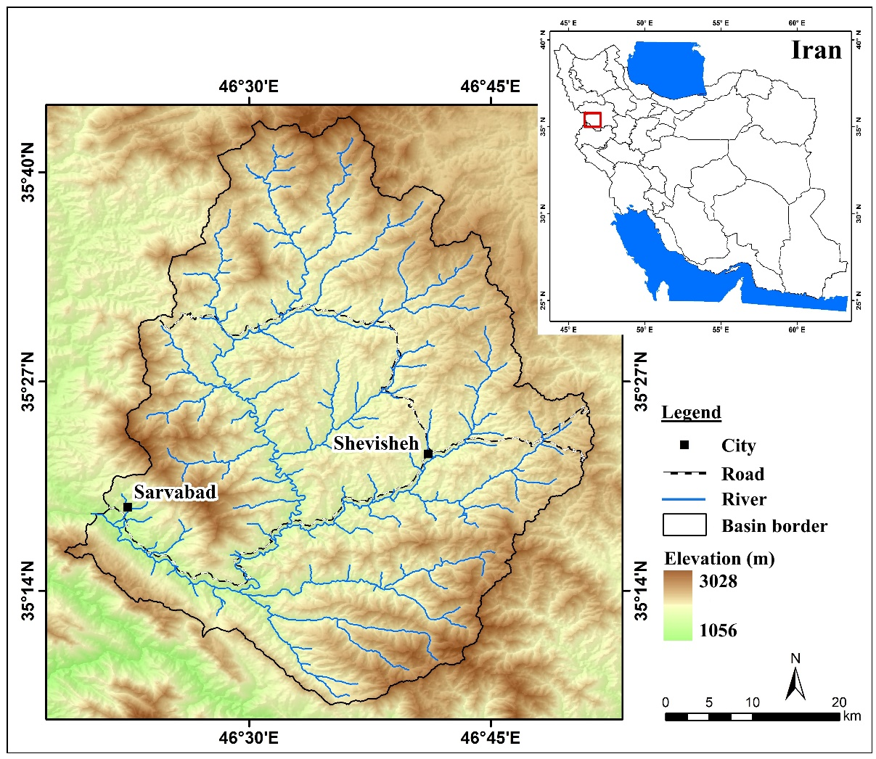
Figure 1. Location map of the study area

3. Materials and methods
To carry out the analysis, several datasets were used, including the 30-m SRTM Digital Elevation Model, the 1:100,000 geological map, and satellite-based data from MODIS and CHIRPS, in addition to basic raster and vector layers. The main tools employed were ArcGIS for layer preparation and standardization, TerrSet for implementing the WLC and OWA multicriteria models, and Expert Choice for parameter weighting using the AHP method. The following sections provide a detailed description of the research steps:
- Step 1 (Preparation of Spatial Layers): Initially, based on expert knowledge and literature review, six key parameters influencing flood susceptibility—distance to rivers, mean annual precipitation, elevation, slope, vegetation density, and lithology—were selected. The spatial layers for these parameters were then generated. MODIS and Google Earth Engine were used for vegetation density (Zahabnazouri et al, 2025), CHIRPS for rainfall, SRTM for slope, elevation, and river distance, and the geological map for lithology. This process produced a complete set of layers necessary for flood susceptibility analysis.
- Step 2 (Standardization of Layers): All layers were standardized in ArcGIS to a common scale ranging from 0 to 1. Areas with higher flood potential—such as low-lying zones, gentle slopes, regions near rivers, high-rainfall areas, sparse vegetation, and impermeable lithology—were assigned values close to 1. Conversely, regions with lower susceptibility were assigned values closer to 0.
- Step 3 (Parameter Weighting): Since the significance of the parameters varies, their weights were determined using the Analytic Hierarchy Process (AHP) in Expert Choice. The criteria were compared in pairs, and the resulting relative importance values were used to establish the final weight of each layer for the multicriteria analysis.
- Step 4 (Final Map Production and Analysis): In the final Step, the standardized and weighted layers were integrated in TerrSet using the Weighted Linear Combination (WLC) and Ordered Weighted Averaging (OWA) methods to produce the final flood susceptibility map of the Shevisheh basin. After generating the map, the vulnerability of villages within the basin to flood hazards was evaluated to identify high-risk areas.
The Weighted Linear Combination (WLC) method is one of the most widely used multi-criteria evaluation approaches in GIS. In this method, after assigning weights to the information layers, the criteria are combined linearly. The weight of each criterion has a direct influence on the final outcome, and areas with higher values represent greater potential regarding the phenomenon under investigation. Its main advantages include simplicity, transparency of calculations, and the ability to integrate a large number of criteria (Tabesh et al, 2020., Mosatfa et al, 2022., Solaimani et al, 2023). In contrast, the Ordered Weighted Averaging (OWA) method is a more flexible approach that, in addition to criterion weights, uses order-based weights. This provides the possibility to control the degree of risk-taking and the decision-maker’s attitude (conservative or optimistic). OWA can range between two extreme conditions—AND logic (strict) and OR logic (lenient)—and therefore produces more realistic results. For this reason, OWA is considered an effective tool in analyzing hazards such as flooding, which are characterized by significant uncertainty and variability (Xiao et al, 2017., Ganjaeian et al, 2021., Chen, 2022).

4. Results and Discussion
4.1. Description of the Parameters Used
The hydro-geomorphological characteristics of any region play a fundamental role in determining its development potential as well as its vulnerability to natural hazards (Hosseinzadeh et al, 2023., Rahimi et al, 2024). Assessing hydrological conditions is therefore essential in various planning processes, including physical development planning and the identification of areas susceptible to natural hazards such as flooding (Nayyeri et al, 2017., Salari et al, 2017., Ganjaeian et al, 2025). To identify and analyze flood-prone zones within the Shuisheh watershed, a set of environmental and hydrological parameters—those exerting the greatest influence on flood generation and intensification—were selected and examined. Each of these factors directly or indirectly affects runoff production, the rate of water accumulation, and the likelihood of flow overtopping, thus playing a decisive role in flood susceptibility modeling. The following sections provide a detailed explanation of these parameters and the procedures used for their standardization.
1) Distance from Rivers: Distance to rivers is one of the most fundamental factors influencing flood susceptibility, as areas located near river channels are constantly exposed to the risk of overflow and bank overtopping (Negahban et al, 2025). Proximity to the main flow path results in shorter runoff concentration times and higher levels of hazard. Therefore, during the standardization of the river-distance layer, areas located closest to the rivers—those with the highest likelihood of flooding—were assigned values close to 1 (Figure 2).

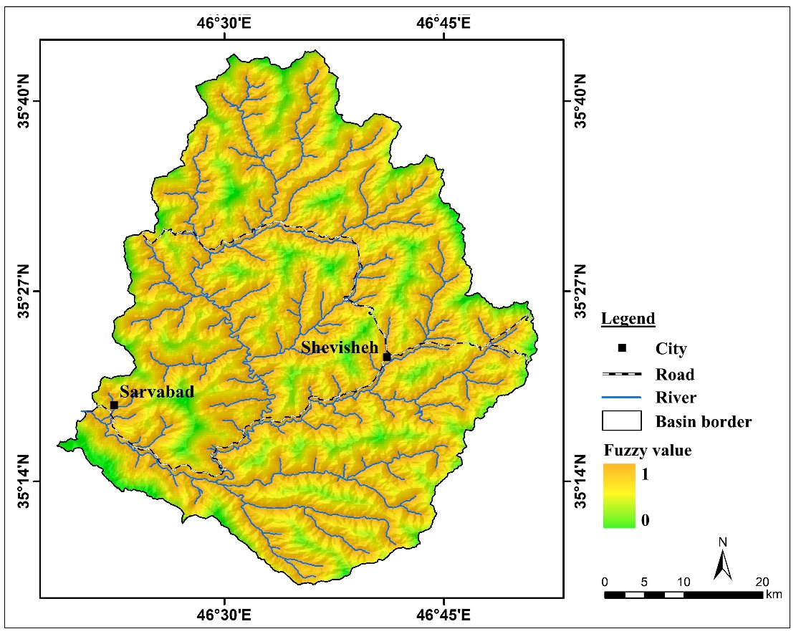
Figure 2. Standardized map of the river-distance layer of the Shevisheh basin

2) Mean Annual Precipitation: Precipitation is a primary driver of flood generation, and spatial variations in rainfall significantly affect the hydrological response of a basin. Due to the considerable elevation differences within the Shevisheh basin, rainfall distribution varies across different parts of the area, leading to differences in runoff production. Generally, zones receiving higher annual precipitation have greater flood potential. For this reason, in the standardization process, areas with higher rainfall were assigned values close to 1 (Figure 3).

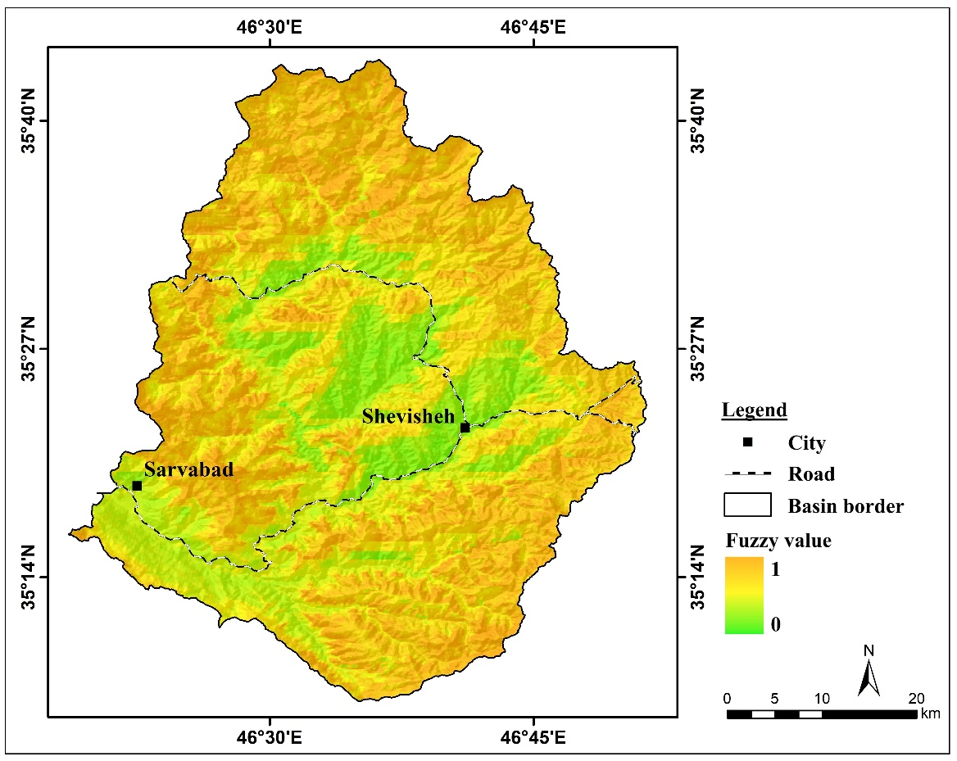
Figure 3. Standardized map of the mean annual precipitation layer of the Shevisheh basin

3) Elevation: Elevation directly influences runoff accumulation and flood occurrence. Low-lying areas, often located at the downstream sections of the basin, serve as collection points for surface flows and river discharge. Consequently, these regions exhibit a higher probability of flooding during intense rainfall events. Based on this principle, low-elevation zones were assigned values close to 1 in the elevation-standardization process (Figure 4).

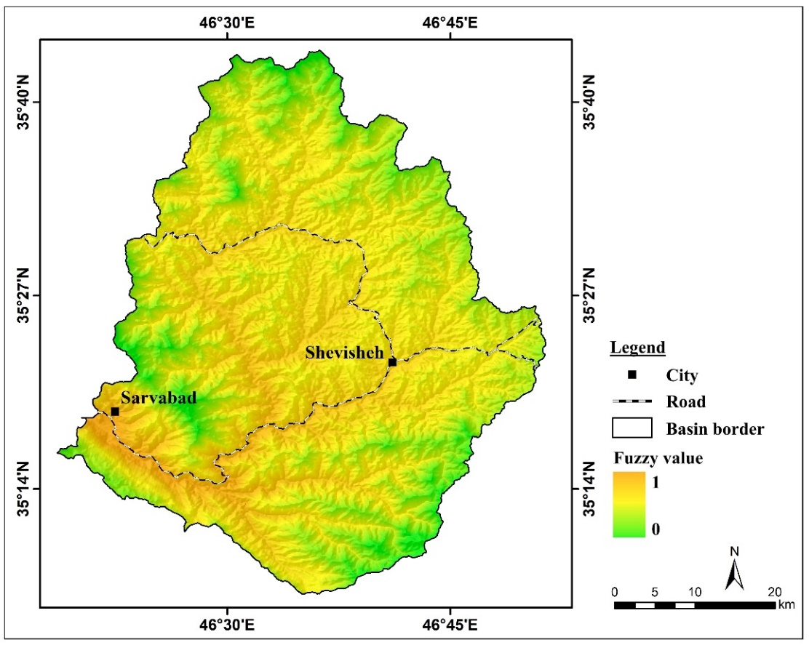
Figure 4. Standardized map of the elevation layer of the Shevisheh basin

4) Slope: Slope determines the velocity of surface runoff and is a critical factor in assessing flood susceptibility. Low-slope areas generally experience slower water movement and greater runoff accumulation, making them more prone to flooding (Safari Namivandi et al, 2024). Accordingly, in the standardization of the slope layer, low-slope regions were assigned values close to 1 due to their higher flood potential (Figure 5).

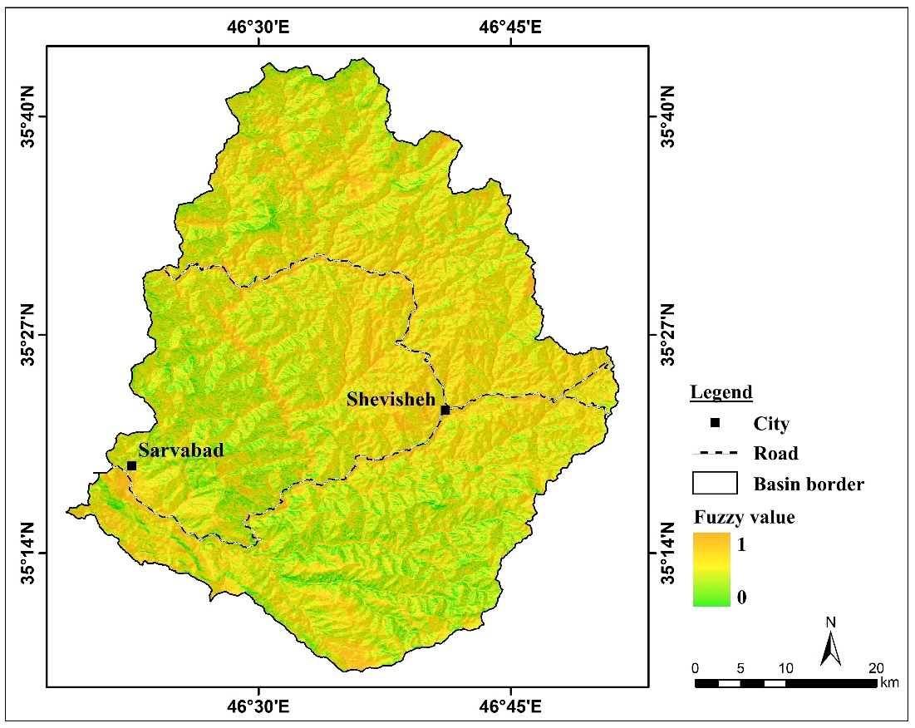
Figure 5. Standardized map of the slope layer of the Shevisheh basin

5) Vegetation Density: Vegetation plays an essential role in regulating runoff velocity, enhancing soil infiltration, and reducing surface erosion. In this study, vegetation density was derived using MODIS imagery and Google Earth Engine. The resulting map showed considerable spatial variation in vegetation cover across the basin. Since areas with sparse vegetation have lower infiltration capacity and generate more runoff, they were assigned values close to 1 during standardization (Figure 6).

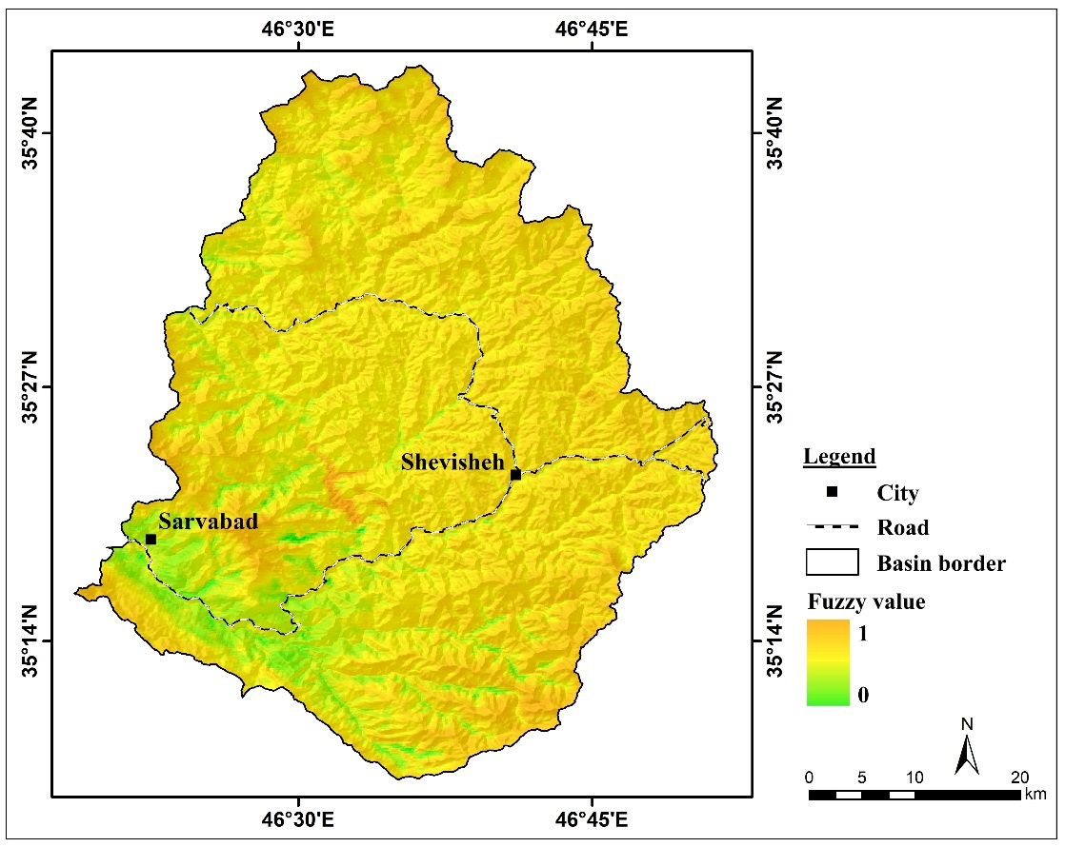
Figure 6. Standardized map of the vegetation density layer of the Shevisheh basin

6) Lithology: Lithology significantly affects soil permeability and, consequently, the volume of surface runoff. Permeable lithological units tend to reduce flood hazard by allowing higher infiltration rates, whereas impermeable units increase runoff and flood risk. In the study area, basaltic formations—due to their lower permeability and higher runoff potential—were assigned values close to 1, whereas limestone units, which contain numerous fractures and exhibit higher permeability, received values close to 0 (Figure 7).

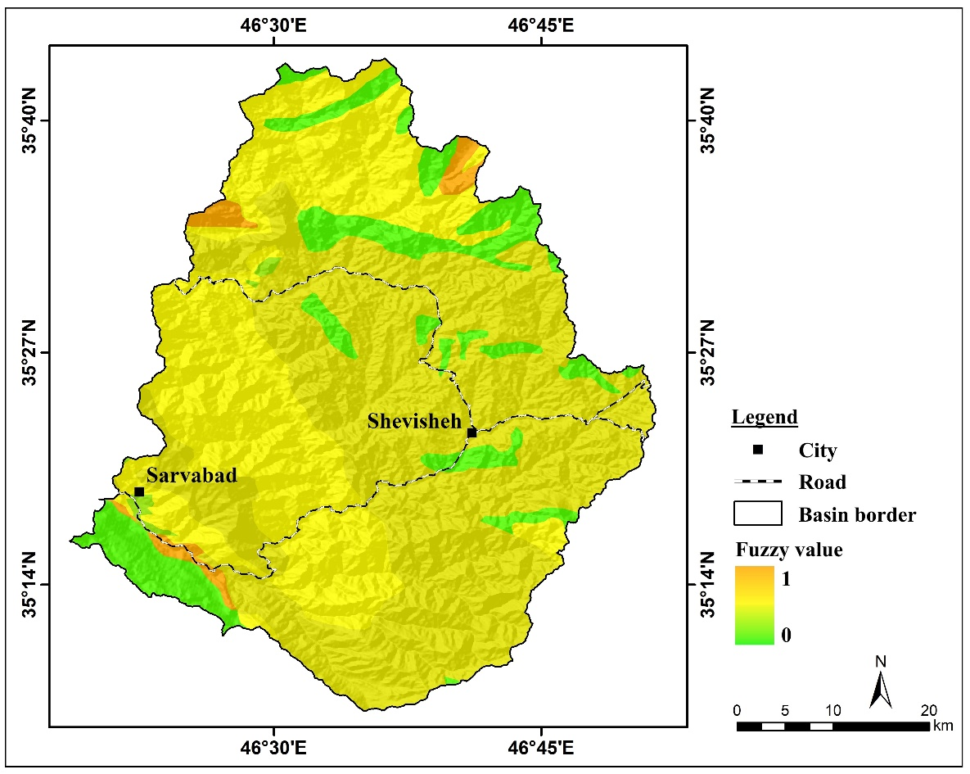
Figure 7. Standardized map of the lithology layer of the Shevisheh basin

4.2. Weighting of the parameters
Since the value and importance of the spatial layers are not equal, in this study the parameters were weighted using expert judgment and the Analytic Hierarchy Process (AHP). This procedure allows for determining the relative significance of each layer and its influence on flood occurrence. According to the results, the river-distance layer and the elevation layer hold the highest importance in flood susceptibility analysis, with weights of 0.275 and 0.218, respectively, while the other parameters were assigned weights accordingly for their integration in the final analysis (Table 1).

Table 1. Final weights of the parameters based on the AHP model
Row | Parameter | Weight
1 | Distance from River | 0.275
2 | Mean Annual Precipitation | 0.087
3 | Elevation | 0.218
4 | Slope | 0.173
5 | Vegetation Density | 0.138
6 | Lithology | 0.109

4.3. Identification of Flood-Prone Areas
After standardizing and weighting the spatial layers, the calculated weights were applied to each layer. The layers were then imported into TerrSet software and combined using the OWA and WLC methods. This process produced the final flood-prone areas map, which is classified into five flood-susceptibility classes, representing the level of flood risk in different parts of the basin (Figures 8 and 9).

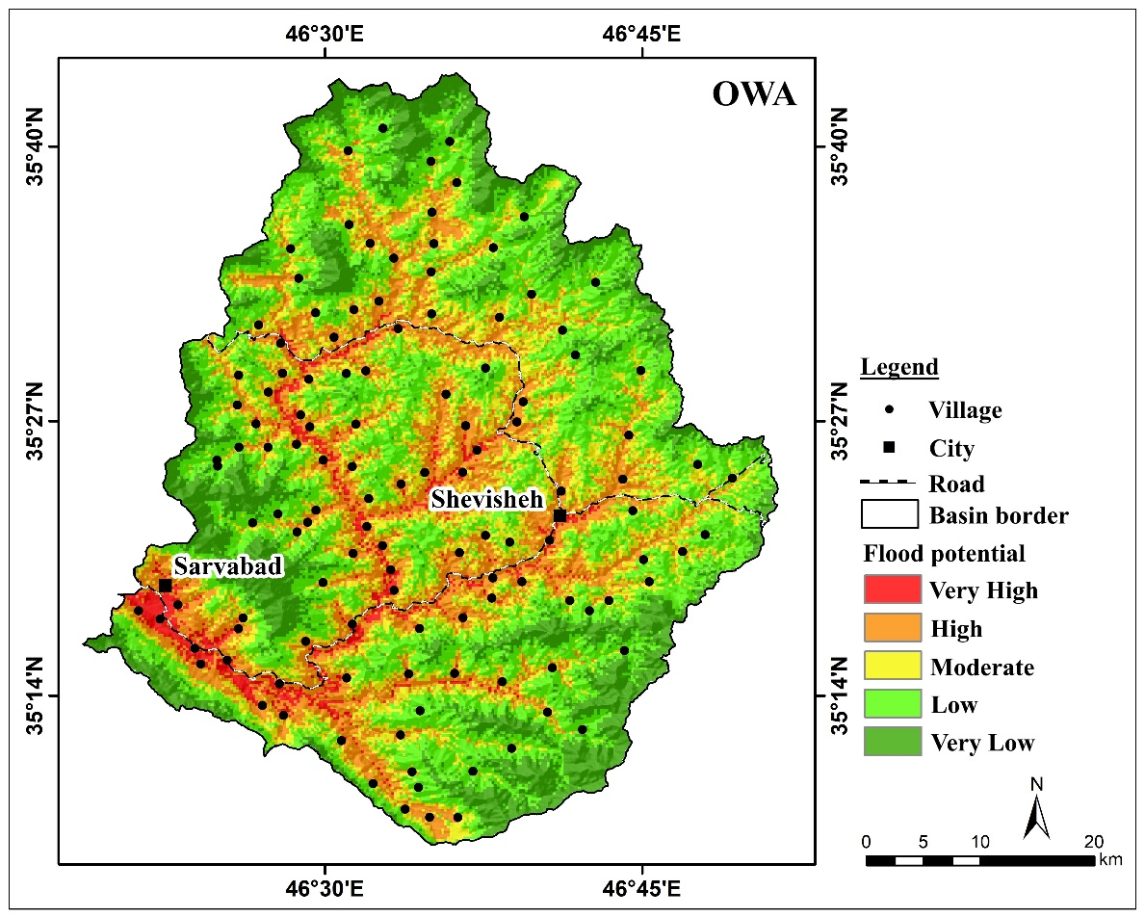
Figure 8: Final flood-prone areas map generated using the OWA method

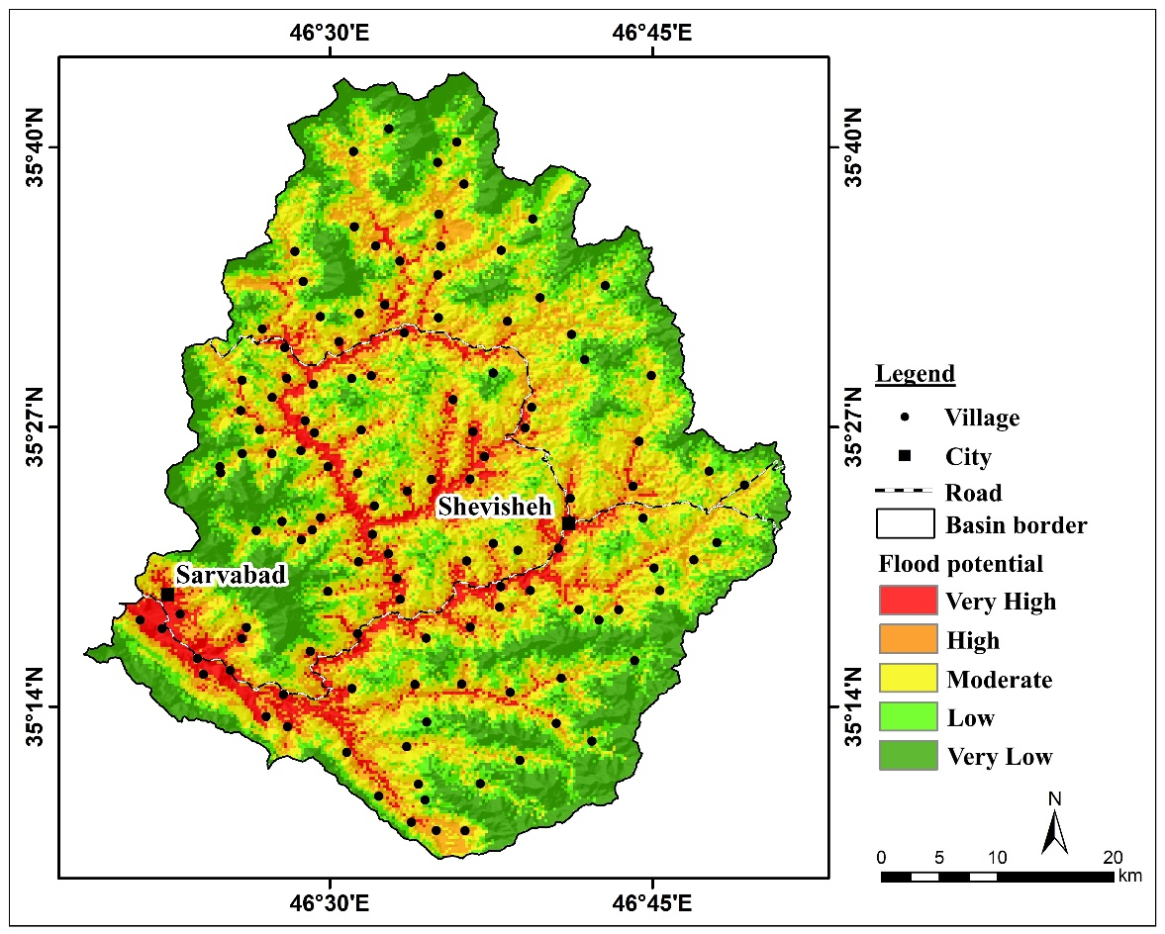
Figure 9: Final flood-prone areas map generated using the WLC method

The results of area calculation and percentage distribution of flood-susceptibility classes indicate that, according to the OWA method, approximately 473 km² (equivalent to 24% of the basin area) and, according to the WLC method, about 470 km² (equivalent to 23.9% of the basin area) fall into the highest flood-susceptibility class. These areas, mostly located in the southern part of the basin, are highly prone to flooding due to their low elevation, gentle slope, and proximity to rivers. Furthermore, the results show that according to the OWA method, approximately 1095 km² (equivalent to 55.6% of the basin area) and, according to the WLC method, about 804 km² (equivalent to 40.8% of the basin area) fall into the lowest flood-susceptibility class (Table 2 and Figure 10). These areas, characterized by higher elevation, steeper slopes, and greater distance from rivers, have a lower potential for flooding and are relatively safer compared to other parts of the basin.

Table 2: Area and percentage of each susceptibility class
Row | Class | OWA |  | WLC
Row | Class | Area (km²) | Percent area | Area (km²) | Percent area
1 | Very Low | 369 | 18.7 | 453 | 23
2 | Low | 726 | 36.9 | 351 | 17.8
3 | Moderate | 401 | 20.4 | 695 | 35.3
4 | High | 411 | 20.9 | 313 | 15.9
5 | Very High | 62 | 3.1 | 157 | 8
6 | Total | 1969 | 100 | 1969 | 100

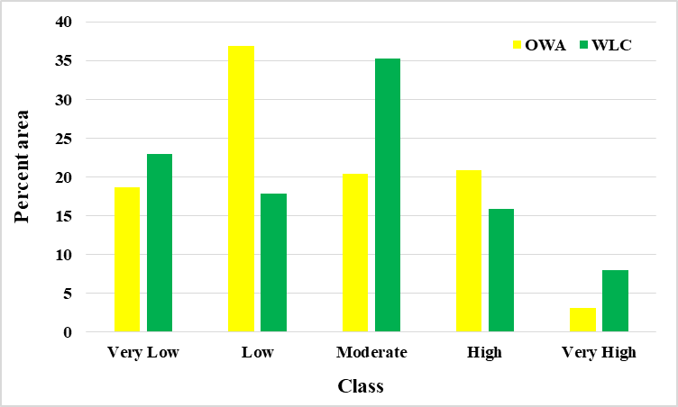
Figure 10: Percentage area chart of flood-susceptibility classes using the OWA and WLC methods

4.4. Assessment of Village Vulnerability to Flood Hazards in the Basin
In this section, the vulnerability of villages within the basin to flood hazards was evaluated by analyzing their distribution across flood-susceptibility classes. The analysis indicates that, according to the OWA model, 87 villages fall into the high and very high vulnerability classes, representing 70.8% of all villages in the basin. Similarly, according to the WLC model, 81 villages, equivalent to 65.9% of all villages, are classified within the high and very high vulnerability categories (Table 3 and Figure 11). These results highlight that a significant portion of villages in the basin is exposed to flood hazards. Therefore, the implementation of preventive measures and risk management strategies is essential to mitigate potential damages. Such measures may include improving early warning systems, designing runoff control structures, and optimizing land-use management within the basin.

Table 3: Number and percentage of villages in flood vulnerability potential classes
Row | Class | OWA |  | WLC
Row | Class | Number of villages | Percentage of villages | Number of villages | Percentage of villages
1 | Very Low | 1 | 0.8 | 1 | 0.8
2 | Low | 11 | 8.9 | 2 | 1.6
3 | Moderate | 24 | 19.5 | 39 | 31.7
4 | High | 67 | 54.5 | 44 | 35.8
5 | Very High | 20 | 16.3 | 37 | 30.1
6 | Total | 123 | 100 | 123 | 100

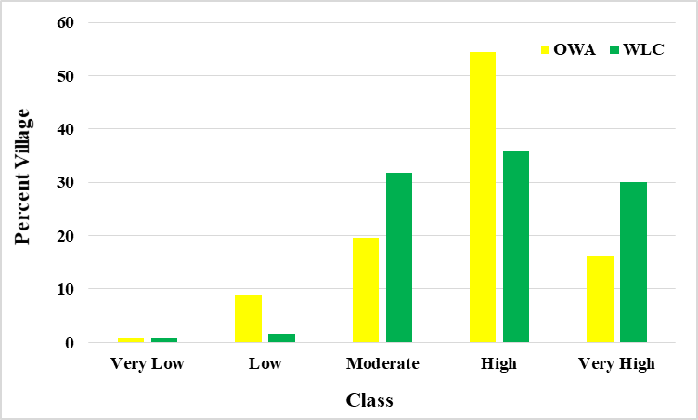
Figure 11: Percentage of villages in flood vulnerability potential classes

5. Conclusion
The results of this study indicate that the Shevisheh basin exhibits an uneven distribution of flood susceptibility, with the southern parts of the basin being the most at risk. According to the final flood-prone area maps, approximately 473 km² (24% of the basin area) using the OWA method and 470 km² (23.9% of the basin area) using the WLC method fall into the highest flood-susceptibility class. These areas are highly exposed due to their low elevation, gentle slopes, and proximity to rivers. In contrast, the elevated and steep regions of the basin, covering about 1095 km² (55.6% of the basin area) using OWA method and 804 km² (40.8% of the basin area) using WLC method, have low flood potential. The assessment of villages indicates that a significant number are highly vulnerable to flooding. According to the OWA model, 87 villages (70.8%) and according to the WLC model, 81 villages (65.9%) fall within the high and very high vulnerability classes. These findings highlight that a large portion of the rural population and infrastructure is at risk of flood damage.
Based on the results obtained, implementing preventive and management measures to reduce flood risks in the Shevisheh watershed is essential. First, it is recommended to establish early warning systems in high-risk areas and flood-prone villages to alert residents prior to flood events. Additionally, land-use management, including restricting construction along riverbanks and preserving existing vegetation cover, can help reduce surface runoff and increase soil infiltration. The construction of runoff control structures, such as channels, storage reservoirs, and levees, is also advised to manage surface flow and mitigate potential damage. Furthermore, educating the local community and raising awareness about safe practices during floods, along with planning for emergency evacuation and disaster management, is crucial. Implementing a combination of these measures can effectively reduce flood risk and enhance the resilience of both the watershed and the villages against future flood events.

Reference
- Abedini, M., & Sardashti, M. (2025). Flood Management Map Using New Random Forest Algorithm and Geographic Information System: Case Study: Kandovan-Chalus Axis. Journal of Hydrogeomorphology, 12(43), 33-17. https://doi.org/10.22034/hyd.2025.63601.1758
- Alharbi, T. (2023). Mapping of groundwater, flood, and drought potential zones in Neom, Saudi Arabia, using GIS and remote sensing techniques. *Water*, *15*(5), 966. https://doi.org/10.3390/w15050966
- Amani, K., Hosseini, S. M., Yamani, M., & Maghsoudi, M. (2025). Identification of Flood-Prone Areas in the Sefidrud River Basin Using Remote Sensing-Based Hydraulic Models and Geomorphological Evidences. Hydrogeomorphology https://doi.org/10.22034/hyd.2025.64251.1762
- Berthelot, J.-S., Saint-Laurent, D., Gervais-Beaulac, V., & Savoie, D. (2014). Assessing the Effects of Periodic Flooding on the Population Structure and Recruitment Rates of Riparian Tree Forests. Water, 6(9), 2614-2633. https://doi.org/10.3390/w6092614
- Chen, N., Yao, S., Wang, C., & Du, W. (2019). A method for urban flood risk assessment and zoning considering road environments and terrain. Sustainability, 11(10), 2734. https://doi.org/10.3390/su11102734
- Chen, Y. (2022). Flood hazard zone mapping incorporating geographic information system (GIS) and multi-criteria analysis (MCA) techniques. Journal of Hydrology. https://doi.org/10.1016/j.jhydrol.2022.128268
- Chen, Y., Ye, Z., Liu, H., Chen, R., Liu, Z., & Liu, H. (2021). A GIS-Based Approach for Flood Risk Zoning by Combining Social Vulnerability and Flood Susceptibility: A Case Study of Nanjing, China. International Journal of Environmental Research and Public Health https://doi.org/10.3390/ijerph182111597
- Faraji Mondared, A., Roostaei, S., & Mokhtari, D. (2023). Location of human phenomena in geographical space in the flood zone (case study of Pardisan region of Qom). Journal of Hydrogeomorphology, 9(33), 59-37. https://doi.org/10.22034/hyd.2022.51769.1642
- Ganjaeian, H. (2020). Geomorphological hazards of urban areas, study methods and control strategies. Entekhab Publication. https://www.gisoom.com/book/11628118
- Ganjaeian, H., Hosseini, S. J., Azeredo, G. A., Ebrahimi, A., Shahjamali, M., & Akbarian, M. (2025). Assessment of the physical development trends of residential areas in natural hazard-prone regions of Kurdistan Province, Western Iran. Journal of Geography, Environment and Earth Science International, 29(11), 220–239. https://doi.org/10.9734/jgeesi/2025/v29i11977
- Ganjaeian, H., Hosseini, S. J., Hamidi Kermanshahi, H., Shahjamali, M., Mirakhorli, A., & Zahabnazouri, S. (2025). Geospatial assessment of suitable areas for residential development along the Makran coastal strip, Southern Iran. Asian Journal of Geographical Research, 8(4), 247–264. https://doi.org/10.9734/ajgr/2025/v8i4333
- Ganjaeian, H., Nosrati, M., Ebrahimi, A., & Ghisarian, S. S. (2024). Assessing the vulnerability of rural areas against natural hazards (Case study: Villages of Oraman Region). Journal of Environmental Research in Mountainous Regions, 1(2), 57–70. https://doi.org/10.22034/ermr.2024.63510
- Ganjaeian, H., Rezaei Arefi, M., Peysoozi, T., & Emami, K. (2021). Zonning susceptible areas of landslide using WLC and OWA methods -A case study in Mountain cliff Khan, Iran. Sustainable Earth Trends, 1(2), 35–43. https://doi.org/10.52547/sustainearth.1.2.43
- Geng, Y., Zhu, B., & Zheng, X. (2020). Effect of Independent Variables on Urban Flood Models. Water, 12(12), 3442. https://doi.org/10.3390/w12123442
- Gołębiowski, T., Piwakowski, B., & Ćwiklik, M. (2022). Application of Complex Geophysical Methods for the Detection of Unconsolidated Zones in Flood Dikes. Remote Sensing, 14(3), 538. https://doi.org/10.3390/rs14030538
- Hewawasam, V., & Matsui, K. (2022). Traditional Water Governance Practices for Flood Mitigation in Ancient Sri Lanka. Climate, 10(5), 69. https://doi.org/10.3390/cli10050069
- Hosseinzadeh, M. M., Salehi Milani, A. R., & Rezaian Zarandini, F. (2023). Zoning of the sensitivity of the sub-basins of Nekarood basin to flooding, Neka-Mazandaran. Journal of Hydrogeomorphology, 10(34), 100-75. https://doi.org/10.22034/hyd.2023.52132.1646
- Idowu, D., & Zhou, W. (2023). Global Megacities and Frequent Floods: Correlation between Urban Expansion Patterns and Urban Flood Hazards. Sustainability, 15(3), 2514. https://doi.org/10.3390/su15032514
- Jha, A. K., Bloch, R., & Lamond, J. (2012). Cities and Flooding: A Guide to Integrated Urban Flood Risk Management for the 21st Century. World Bank. http://documents.worldbank.org/curated/en/325621468182673386
- Jha, M. K., & Afreen, S. (2020). Flooding Urban Landscapes: Analysis Using Combined Hydrodynamic and Hydrologic Modeling Approaches. Water, 12(7), 1986. https://doi.org/10.3390/w12071986
- Ju, Z., Fang, K., Wang, Y., Hu, B., Long, Y., Shi, Z., & Zhou, P. (2025). Effects of Flooding Duration on Plant Root Traits and Soil Erosion Resistance in Water-Level Fluctuation Zones: A Case Study from the Three Gorges Reservoir, China. Water, 17(17), 2531. https://doi.org/10.3390/w17172531
- Kim, H., Lee, D.-K., & Sung, S. (2016). Effect of Urban Green Spaces and Flooded Area Type on Flooding Probability. Sustainability, 8(2), 134. https://doi.org/10.3390/su8020134
- Kundzewicz, Z. W., & Takeuchi, K. (1999). Flood protection and management: Quo vadimus?. Hydrological Sciences Journal. https://doi.org/10.1080/02626669909492237
- Lee, Y.-J., & Lin, S.-Y. (2022). Effects of Perceptions of Climate Change and Flood Risk on Coping Behavior: A Case Study of Taipei, Taiwan. Sustainability, 14(1), 289. https://doi.org/10.3390/su14010289
- Li, H., Wang, Y., Ping, L., Li, N., & Zhao, P. (2024). Comprehensive Zoning Strategies for Flood Disasters in China. Water, 16(17), 2546. https://doi.org/10.3390/w16172546
- Liu, D., Zhang, J., Wang, X., Peng, J., Wang, R., Huang, X., Li, D., Shao, L., & Hao, Z. (2025). Synergizing Multi-Temporal Remote Sensing and Systemic Resilience for Rainstorm–Flood Risk Zoning in the Northern Qinling Foothills: A Geospatial Modeling Approach. Remote Sensing, 17(12), 2009. https://doi.org/10.3390/rs17122009
- Lu, X. X., & Ran, L. (2011). China flood havoc highlights poor urban planning. Natural Hazards, 56, 575–576. https://doi.org/10.1007/s11069-011-9720-0
- Lv, X., Lin, H., & Chen, Z. (2025). Prevention and Control Strategies for Rainwater and Flood Disasters in Traditional Villages: A Concentrated Contiguous Zone Approach. Buildings, 15(8), 1335. https://doi.org/10.3390/buildings15081335
- Merz, B., Kreibich, H., Schwarze, R., & Thieken, A. (2010). Assessment of economic flood damage. Natural Hazards and Earth System Sciences, 10(8), 1697–1724. https://doi.org/10.5194/nhess-10-1697-2010
- Mo, C., Zhu, C., Ruan, Y., Lei, X., Xing, Z., & Sun, G. (2021). Study on the Staged Operation of a Multi-Purpose Reservoir in Flood Season and Its Effect Evaluation. Water, 13(18), 2563. https://doi.org/10.3390/w13182563
- Mohammadkhan, S., Ganjaeian, H., Shahri, S., & Abbaszade, A. (2019). Predicting the trend of urban development toward hazardous areas using multi-temporal images (Case study: Marivan City). Scientific-Research Quarterly of Geographical Data (SEPEHR) https://doi.org/10.22131/sepehr.2019.36615
- Mosatfa, M., Shataee, S., & Mastouri, A. (2021). Spatio-temporal change detection of forest canopy cover density in the Golestan National Park, Iran. Environmental Resources Research, 9(2), 173-182. https://doi.org/10.22069/ijerr.2020.14943.1237
- Nayyeri, H., Salari, M., Ganjaian, H., & Amani, K. (2017). Geomorphological assessment of land suitability for the physical expansion of Sanandaj city applying restricted areas. Geographical Urban Planning Research (GUPR), 5(1), 127–145. https://doi.org/10.22059/jurbangeo.2017.63213
- Negahban, S., Ganjaeian, H., Ebrahimi, A., & Emami, K. (2019). Monitoring and predicting the trend of changes in residential areas using multi-timed images (Case study: Songhor city). Journal of the Earth and Space Physics, 45(2), 343–354. https://doi.org/10.22059/jesphys.2019.275076.1007084
- Negahban, S., Ganjaeian, H., Ebrahimi, A., & Gheysarian, S. S. (2024). Analysis of the Roles of Environmental Factors in the Occurrence of Floods Using the Google Earth Engine System (Case Study: West of Golestan Province). Geography and Environmental Planning, 35(4), 1-18. https://doi.org/10.22108/gep.2024.142342.1659
- Negahban, S., Ganjaeiyan, H., Feraydooni Kordestani, M., & Cheshmeh Sefidi, Z. (2019). Assessing the physical development of cities and extending to geomorphological prohibited areas Using LCM (Case Study: Sanandaj City). Journal of Natural Environmental Hazards, 8(20), 39–52. https://doi.org/10.22111/jneh.2018.21943.1317
- Negahban, S., Peysoozi, T., Ganjaeian, H., & Norozi, M. (2021). Identify areas prone to landslide and vertical displacement using Radar images (Case study: Lavasan urban area and urban margin). Journal of Geography and Environmental Hazards, 10(3), 1–18. https://doi.org/10.22067/geoeh.2021.71728.1094
- Nouhou, Y. D., Otache, M. Y., Illiassou, S. A., Okunola, O. H., Okhimamhe, A. A., & Nguyen, T. T. (2025). Flood Risk Assessment and Zoning for Niamey and Lokoja Metropolises in Niger and Nigeria. Hydrology, 12(1), 17. https://doi.org/10.3390/hydrology12010017
- Park, K., & Lee, M.-H. (2019). The Development and Application of the Urban Flood Risk Assessment Model for Reflecting upon Urban Planning Elements. Water, 11(5), 920. https://doi.org/10.3390/w11050920
- Parker, D. J. (2000). Floods. Routledge. https://www.routledge.com/Floods/Parker/p/book/9780415172387
- Petroselli, A., Florek, J., Młyński, D., Książek, L., & Wałęga, A. (2020). New Insights on Flood Mapping Procedure: Two Case Studies in Poland. Sustainability, 12(20), 8454. https://doi.org/10.3390/su12208454
- Rahimi, N., Khaleghi, S., & Salehipour Milani, A. (2024). The effect of floods on river morphology changes (case study: Sadij River, Hormozgan Province). Journal of Hydrogeomorphology, 11(38), 160-141. https://doi.org/10.22034/hyd.2024.59641.1717
- Safari namivandi, M., Ganjaeian, H., Nosrati, M., & Mohammadian, K. (2024). Identification of flooded areas and analysis of factors influencing its occurrence (Case study: Southeast of Sistan and Baluchestan province). Quantitative Geomorphological Research, 13(2), 181-194. https://doi.org/10.22034/gmpj.2024.449586.1494
- Salari, M., Nayeri, H., Amani, K., & Ganjaeian, H. (2017). Locating suitable directions for Kamyaran urban development through a hazardology approach based on the application of geomorphologically restricted areas. Environmental Management Hazards, 4(4), 419–436. https://doi.org/10.22059/jhsci.2018.252694.341
- Salari, M., Nayyeri, H., Ganjaeian, H., & Amani, K. (2020). Assessment and prediction of the process of expansion of residential areas with a geomorphological approach and environmental management (Case study: Paveh City). Quantitative Geomorphological Research, 9(1), 86–101. https://doi.org/10.22034/gmpj.2020.109536
- Sedighi, T., Varga, L., Hosseinian-Far, A., & Daneshkhah, A. (2021). Economic Evaluation of Mental Health Effects of Flooding Using Bayesian Networks. International Journal of Environmental Research and Public Health, 18(14), 7467. https://doi.org/10.3390/ijerph18147467
- Shakti, P. C., Hirano, K., & Iwanami, K. (2023). Developing Flood Risk Zones during an Extreme Rain Event from the Perspective of Social Insurance Management. Sustainability, 15(6), 4909 https://doi.org/10.3390/su15064909
- Solaimani, K., Shokrian, F., & Darvishi, S. (2023). An Assessment of the Integrated Multi-Criteria and New Models Efficiency in Watershed Flood Mapping. Water Resources Management, 37, 403–425. https://doi.org/10.1007/s11269-022-03380-1
- Subraelu, P., Ahmed, A., Ebraheem, A. A., Sherif, M., Mirza, S. B., Ridouane, F. L., & Sefelnasr, A. (2023). Risk Assessment and Mapping of Flash Flood Vulnerable Zones in Arid Region, Fujairah City, UAE-Using Remote Sensing and GIS-Based Analysis. Water, 15(15), 2802. https://doi.org/10.3390/w15152802
- Tabesh, S., Noori khanyourdi, M., Dousti, M., & Ganjaeain, H. (2020). Presenting the proposed model for the location of sports places using the integrated model of WLC and AHP. Sport Management and Development. https://doi.org/10.22124/jsmd.2020.4096
- Vilca-Campana, K., Carrasco-Valencia, L., Iruri-Ramos, C., Cárdenas-Pillco, B., Escudero, A., & Chanove-Manrique, A. (2025). Improving Urban Flood Resilience: Urban Flood Risk Mitigation Assessment Using a Geospatial Model in the Urban Section of a River Corridor. Water, 17(7), 1047. https://doi.org/10.3390/w17071047
- Xiao, Y., Yi, S., & Tang, Z. (2017). Integrated flood hazard assessment based on spatial ordered weighted averaging method considering spatial heterogeneity of risk preference. The Science of The Total Environment, 599, 1034-1046. https://doi.org/10.1016/j.scitotenv.2017.04.218
- Yuan, H., Peng, Z., Yang, J., Liu, J., Zhao, H., Ning, S., Xu, X., A., R., & Li, H. (2024). Effects of Alternative Stress of Drought–Flood on Summer Maize Growth and Yield. Water, 16(19), 2742. https://doi.org/10.3390/w16192742
- Zahabnazouri, S., Belmont, P., David, S., Wigand, P. E., Elia, M., & Capolongo, D. (2025). Detecting Burn Severity and Vegetation Recovery After Fire Using dNBR and dNDVI Indices: Insight from the Bosco Difesa Grande, Gravina in Southern Italy. Sensors, 25(10), 3097. https://doi.org/10.3390/s25103097
- Zahabnazouri, S., Belmont, P., David, S. R., Wigand, P. E., & Capolongo, D. (2025). Geomorphic impacts of wildfire on soil erosion: pre- and post-fire RUSLE modeling in Bosco Difesa Grande, Southern Italy, using Google Earth Engine. Geomorphology https://doi.org/10.1016/j.geomorph.2025.110109
- Zhang, Z., Li, Q., Liu, C., & Chen, Y. (2025). A Study on the Zoning Method of Flash Flood Control for Mountainous Cities: A Case Study of Yunnan Province. Applied Sciences, 15(9), 4781. https://doi.org/10.3390/app15094781
- Zhong, Z., Wang, X., He, Y., Cai, S., & Tong, H. (2025). Exceptional Backwater Effects on Wedge Storages and Flood Stages in a Large River-Type Reservoir: HEC-RAS Modeling of Feilaixia Gorge in the North River, South China. Water, 17(10), 1447. https://doi.org/10.3390/w17101447

