Original Research Article

Geology-Driven Variability of Urban Terrestrial Gamma Radiation and Soil Contamination Index UCSI: Evidence from Carborne Surveys in Peninsular Malaysia

.
ABSTRACT

Aims:This study aims to evaluate geology-driven variability in terrestrial gamma radiation (TGR) and urban soil radioactivity in major cities of Peninsular Malaysia, and to determine whether underlying lithology continues to influence radiation levels despite extensive urban modification. A secondary aim is to quantify the Urban Soil Contamination Index (USCI) to assess anthropogenic contributions to radiological variability.
Study Design: A cross-sectional environmental radiation survey integrating carborne gamma measurements, soil radioactivity analyses, and geological mapping.
Place and Duration of Study: Surveys were conducted across 13 major urban areas in Peninsular Malaysia between December 2023 and October 2024.
Methodology: A systematic carborne survey was performed with a spatial resolution of ~1.5 km² per measurement, yielding 9,754 TGR dose-rate records. Calibration followed IEC and IAEA protocols using a Ludlum Model 19 Micro R Meter, supported by HPGe spectrometry. A total of 120 surface soil samples were analysed for activity concentrations of the ²³⁸U and ²³²Th decay series and ⁴⁰K. USCI values were calculated from radionuclide ratios (U/K, Th/K, Th/U) to characterise anthropogenic alteration in superficial urban soils.
Results: Urban TGR ranged from 47–371 nGy h⁻¹, with the lowest means in Kangar and Kuala Terengganu and the highest in Ipoh, Seremban and Melaka. Soil radionuclide concentrations varied widely: ²³⁸U (27–347 Bq kg⁻¹), ²³²Th (27–590 Bq kg⁻¹), and ⁴⁰K (61–1857 Bq kg⁻¹), reflecting mixed geological and anthropogenic sources. USCI values (0.05–4.50) indicate substantial contamination from construction materials, industrial particulates and urban fill. Overall, integrating geological mapping with the spatial distribution of urban TGR measurements reinforces the conclusion that underlying lithology remains the dominant factor controlling terrestrial gamma radiation fields in Peninsular Malaysia. Urbanisation amplifies existing geological signatures but does not override them. While granite-dominated provinces consistently show high TGR values, anomalies in cities such as Klang Valley, Kuantan and Kota Bharu highlight the growing role of urban development in modifying local radiological environments.
Conclusion: Geology exerts primary control over urban TGR, while anthropogenic processes strongly influence soil radioactivity and contamination intensity. These integrated results provide updated baseline data essential for urban radiological protection, geoscientific assessment and environmental planning across rapidly developing Malaysian cities.

Keywords: Terrestrial gamma radiation; Carborne gamma spectrometry; Geological controls; Soil contamination; Natural radionuclides; Urban radioactivity; Peninsular Malaysia

1. INTRODUCTION

Ionizing radiation from natural sources represents the largest contributor to human exposure worldwide, accounting for nearly 80% of the global annual effective dose according to UNSCEAR (2000), BEIR VII (2006) and ICRP Publication 103 (2007). Among these sources, terrestrial gamma radiation (TGR) arising from primordial radionuclides, principally ²³⁸U, ²³²Th and ⁴⁰K; is one of the most significant pathways of external exposure to the public (UNSCEAR 2000; Quindos et al., 1994; Steinhäusler 1992). Numerous studies have demonstrated that TGR exhibits strong variability controlled by geological formations, mineralogical composition, weathering processes and the distribution of granitic, volcanic, sedimentary or metamorphic terrains (Tzortzis et al., 2003; Grasty & LaMarre, 2004; Huy & Luyen, 2006; Mora et al., 2007; Bituh et al., 2009; Kapdan et al., 2012; Ramli et al., 2003; Ramli et al., 2005; Sanusi et al., 2014; Sanusi et al., 2017a; Sanusi et al., 2021; Pálsson et al., 2013; Kleinschmidt & Watson, 2015; Mares et al., 1984).
Although TGR is fundamentally geological (UNSCEAR 2000), its behaviour in urban landscapes is far more complex. Urbanization modifies natural surfaces through the replacement of soils with asphalt, concrete, building materials, reclamation fill, and imported landscaping soils. These alterations introduce both shielding effects and anthropogenic contributions that can obscure or amplify natural radiation levels (UNSCEAR 2000; Tondel et al., 2011; IAEA Safety Series No. 115, 1996; García-Talavera et al., 2008; Suarez et al., 1995; Sanusi et al., 2017a). Yet, despite these modifications, several authors have shown that subsurface geological boundaries often continue to influence TGR, even when the natural surface has been partly or fully replaced, because gamma rays originate from the upper 30 cm of soil and rock (UNSCEAR 2000), many of which remain geologically intact beneath engineered structures.
Urban soil itself may also accumulate radionuclides due to weathering, industrial activity, building rubble, atmospheric deposition, traffic, and the use of imported fill. Studies across Europe, Asia and the Middle East have documented notable changes in soil U, Th and K activity concentrations following urban development (Poje et al., 2012; Kapdan et al., 2012; Tzortzis et al., 2003). These variations can in turn affect TGR, but such integrated comparisons between urban soil activity, TGR patterns, and underlying geology remain limited in Southeast Asia and entirely absent for Peninsular Malaysia.
Globally, national and regional TGR monitoring programs have been carried out in Finland (Pálsson et al., 2013), Spain (Suárez et al., 2000), Croatia (Bituh et al., 2009), Greece (Tzortzis et al., 2003), Vietnam (Huy & Luyen, 2006), Canada and the United States, by Grasty and LaMarre (2004); the United Kingdom, by the study of Chernyavskiy et al. (2016); and European countries, as reported in the European Atlas of Radiation Map by Cinelli et al. (2019); Cyprus (Tzortzis, 2003); Austria (Wallova et al., 2012); Nigeria (Jibiri, 2007); Brunei (Lai et al., 1999); Oman (Goddard, 2002); Hong Kong (Tso and Li, 1992); Switzerland (Buchli and Burkart, 1989); Costa Rica (Mora et al., 2007); Syria (Aissa and Jubeli, 1997); Sweden (Kock and Samuelsson, 2011); Russia (Ramzaev et al., 2006); Egypt (Ibrahim et al., 1993); Iran (Kardan et al., 2017); Lebanon (El Samad et al., 2013); Pakistan (Tufail et al., 2006); Brazil (Yoshimura et al., 2004); and Spain (Quindos et al., 1994). According to UNSCEAR (2000), several locations have been identified as having high natural radiation dose rates, including Ramsar, Iran – 105,000 nGy y⁻¹; Guarapari Beach, Brazil – 90,000 nGy y⁻¹; the volcanic rock geological region in southwestern France – 10,000 nGy y⁻¹; tin and rare earth mineralization sites in Sichuan, China – 9,140 nGy y⁻¹; the Oligocene–Miocene volcanic rock region in central Big Baku and Sumgayit City, Azerbaijan – 8,770 nGy y⁻¹ (UNSCEAR, 2000; 2008); heavy mineral (monazite) deposits in Erasama and Chhatrapur along the Orissa coast, India – 5,000 nGy y⁻¹ (Mohanty et al., 2004); monazite deposits in Chavara along the Kerala coast, India – 3,767 nGy y⁻¹ (Ramasamy et al., 2013); and San Vicente, Philippines – 1,558 nGy y⁻¹ (UNSCEAR, 2000; 2008). These efforts highlight the importance of TGR surveys for environmental radiological assessment, land-use planning, public exposure estimation, and emergency preparedness. However, in Malaysia, previous studies have been geographically limited, focused mainly on natural terrains, mining areas, beach sands, monazite-rich granites, and localized geological provinces (Ramli et al., 2003; 2005; Sanusi et al., 2014; 2017b; 2021). Comprehensive urban TGR datasets capable of resolving fine-scale variability across multiple geological units are still lacking.
Carborne gamma-ray surveys are widely used in Europe, Japan and North America offer a powerful method to obtain continuous, high-density TGR measurements across large urban domains (Grasty & LaMarre 2004; Mora et al., 2007). These techniques enable the detection of abrupt changes in gamma flux across geological boundaries, lithological transitions, reclaimed zones, and built surfaces, making them especially suitable for understanding how geology continues to shape radiation fields in modified city environments. Despite their advantages, carborne surveys have rarely been applied, and no study has combined such data with urban soil radionuclide measurements and detailed geological mapping to quantify the degree of geological control beneath urbanized landscapes.
The interplay between geology, urban soil contamination and TGR therefore remains poorly understood in Malaysia. This knowledge gap is significant because public radiation exposure assessments often assume uniformity in urban environments, ignoring the potential influence of concealed geological structures and heterogeneous soil compositions. The absence of integrated datasets also limits the ability to evaluate long-term radiological trends in rapidly developing cities.
The present study addresses these gaps by combining carborne TGR surveys, urban soil radioactivity measurements, and regional geology across multiple cities in Peninsular Malaysia. The objective is to determine whether underlying geology still exerts a measurable influence on TGR within heavily modified urban terrains and to evaluate how soil radioactivity contributes to observed gamma radiation variability. By providing the first integrated, geology-driven interpretation of urban TGR patterns in Malaysia, this study enhances understanding of natural radiation behaviour under altered environments and contributes essential baseline data for radiological protection, urban geoscience and environmental planning.

2. material and methods

2.1. Selection of Survey Areas and Soil Sampling
This study employed a systematic carborne survey approach to measure terrestrial gamma radiation (TGR) dose rates across major urban centers in Peninsular Malaysia. Urban areas were selected based on a stratified geographical zoning to ensure representation of the southern, western, northern, and eastern regions as shown in Fig. 1. The survey was conducted from 19 December 2023 to 30 October 2024.
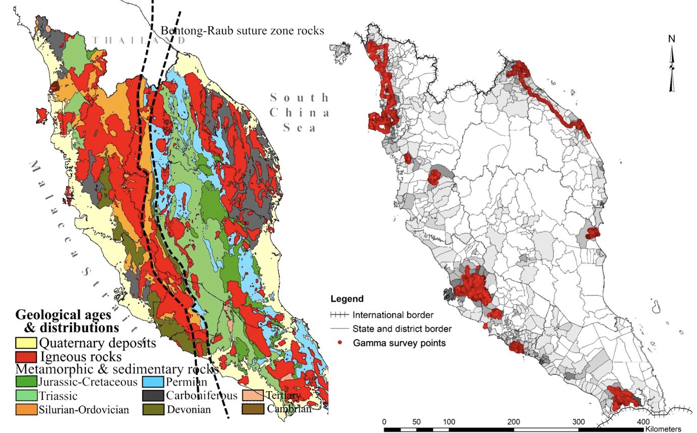

Fig. 1. (left) Geological distribution of Peninsular Malaysia (Digitised from data published by Department of Geosciences and Mineral Malaysia, 2002; Hutchison and Tan, 2009) and (right) spatial distribution gamma survey points from the carborne survey.

In the southern zone, measurements covered big cities and urbanization of Johor Bahru (2,300 km²), Bandar Hilir Melaka (303 km²), Seremban (960 km²), and Port Dickson. In the western coastal zone, surveys were carried out across Petaling, Hulu Langat, Klang, Gombak (371 km² combined), Kuala Lumpur (212 km²), Putrajaya (25 km²), and the Greater Kinta Valley cities of Ipoh, Taiping, and Batu Gajah (120 km² combined). In the northern region, the survey included Penang Island (142 km²), the Penang–Kedah corridor (120 km²), Alor Setar (82 km²), and Perlis (29 km²). Meanwhile, the eastern zone comprised Kota Bharu (390 km²), Kuala Terengganu (227 km²), and Kuantan (359 km²).
A spatial resolution of approximately one measurement point every 1.5 km² was targeted, ensuring consistent sampling density across all urban landscapes. The TGR measurements were collected using mobile gamma detectors mounted inside a vehicle, which logged radiation data continuously while traversing road networks. A GPS navigation system provided precise geolocation of each measurement point.
A total of 120 surface soil samples were collected to quantify the specific activity concentrations of ²³⁸U and ²³²Th series radionuclides, as well as ⁴⁰K. The samples were collected from accessible open soil patches within the survey areas. Soil availability was limited due to extensive surface sealing from urban development, as documented by the Department of Agriculture Peninsular Malaysia (2002). Despite these constraints, sampling locations were spread across all major geological formations underlying the cities to capture lithological variability. Soil sampling was conducted concurrently with radiation surveys to ensure spatial correspondence between soil radioactivity and TGR measurements.

2.2. Carborne Survey of Terrestrial Gamma Radiation
2.2.1. Instruments and Measurements
The terrestrial gamma radiation survey utilized the Atomtex AT6101C Backpack Radiation Detector (Fig. 2), factory-calibrated according to manufacturer specifications (Atomtex, 2024). The gamma detection system incorporated BDKG-11M NaI(Tl) scintillation detectors (Ø63 × 63 mm) with an operational range of 0.03–150 μSv h⁻¹ and an energy resolution of 7.5% at 662 keV (¹³⁷Cs). The detector was coupled with a GPS receiver and data logger to synchronize real-time dose rate readings with geographic coordinates.
Measurements were taken while the survey vehicle moved at speeds between 80 and 110 km h⁻¹ along major road networks, enabling continuous acquisition of gamma dose rate data. The system was mounted inside a vehicle in a fixed orientation to ensure consistent geometry relative to ground radiation sources. Elevated TGR readings were revisited on foot using handheld gamma survey meters to confirm ground-level radiation anomalies. Data cleaning was performed by removing duplicate coordinates produced by the 3 Hz sampling frequency.
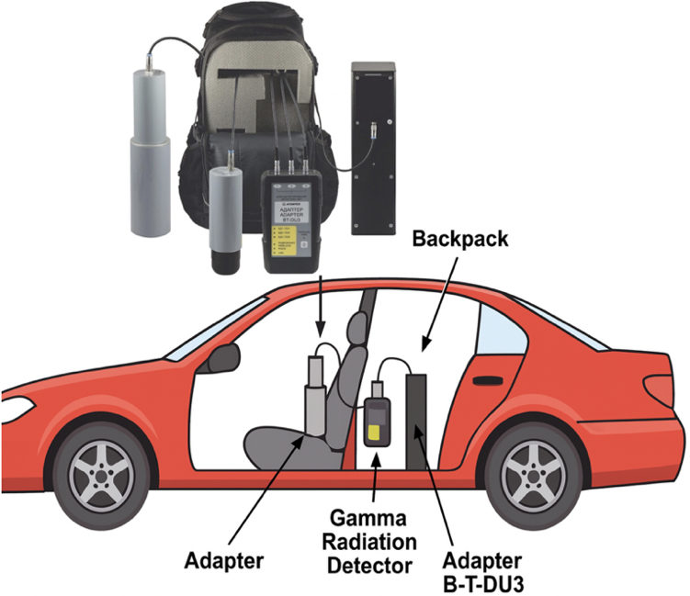
Fig. 2. Setup of the car-borne gamma radiation survey using a conventional 2-wheel-drive vehicle, and (b) the Atomtex AT6101C backpack radiation detector system

2.2.2. Calibration of Gamma Dose Rate Measurements
To ensure accuracy in low-level environmental gamma measurements, the TGR dose rate data were corrected using the Ludlum Model 19 Micro R Meter (Ludlum, 1993) and supported by HPGe gamma spectroscopy validations. The Ludlum 19 covers the relevant energy range of primordial gamma emitters and the anthropogenic radionuclide ¹³⁷Cs. Its energy response was calibrated using multi-nuclide standards including ²⁴¹Am, ⁵⁷Co, ¹³³Ba, ¹³⁷Cs, and ⁶⁰Co (Ludlum, 1993).
Instrument calibration was performed at the Secondary Standard Dosimetry Laboratory (SSDL), Malaysian Nuclear Agency, following IEC 1017-1:1990 (IEC 1017, 1990), the National Physical Laboratory (BCRU, 1981), and IAEA Safety Standard GSG-10 guidelines (IAEA, 2018). Calibration was completed over exposure ranges of 0–5000 μR h⁻¹, 0–500 μR h⁻¹, and 0–250 μR h⁻¹. The calibrated dose rate was computed using Eq. 1 (Sanusi et al., 2017a):
D = B × J × C_{f} × 8.7 nGy μR⁻¹ h⁻¹ (1)
where D is the calibrated absorbed dose rate (nGy h⁻¹), B is the instrument reading (μR h⁻¹), J is the correction factor for each exposure range (1.00, 1.03, 0.96), and C_{f} is the calibration factor derived from ¹³⁷Cs (662 keV) and 60Co (1250 keV). The resulting averaged C_{f} was 1.22 ± 0.27, consistent with the acceptable range of 0.8–1.2 suggested by ISO/IEC standards (Alamares and Caseria, 1995).
Zero-background validation for instrument self-contamination was performed inside an underground lead bunker at Universiti Teknologi Malaysia, confirming negligible internal background contributions. Cosmic response validation of the survey meter on a fiberglass boat 3 km offshore revealed inconsistent readings (0 to 0.625 μR h⁻¹), indicating weak cosmic photon detection and no hadronic muon response. Manual subtraction of cosmic background (~1.25 μR h⁻¹) was applied during fieldwork; this value is consistent with sea-level cosmic dose rates at mid-northern latitudes (3.67 μR h⁻¹) (BCRU, 1981; UNSCEAR, 2000). Some background may also originate from gamma emissions in the fiberglass hull and trace U and Th in seawater.
2.3. Soil Radioactivity Measurements Using HPGe Gamma Spectrometry
Soil radioactivity measurements were performed using an ORTEC GEM Series P-type coaxial HPGe detector (GEM20-76-LB-C-SMPCFG-SV-LB-76) with 33% relative efficiency and 1.8 keV FWHM resolution at 1332 keV, equipped with a Mobius cryocooling system. The system was operated over the 40 keV to multi-MeV energy range using the GAMMAVISION 8 software for spectral acquisition and analysis.
Energy and efficiency calibrations were conducted using multi-nuclide standards in a sand matrix consisting of ²¹⁰Pb, ²⁴¹Am, ¹⁰⁹Cd, ⁵⁷Co, ^{123m}Te, ⁵¹Cr, ¹¹³Sn, ⁸⁵Sr, ¹³⁷Cs, ⁸⁸Y, and ⁶⁰Co (Eckert & Ziegler Isotope Products, 1232-2). For ²³⁸U, gamma peaks from ²¹⁴Pb (295, 352 keV) and ²¹⁴Bi (609, 1120, 1764 keV) were used, assuming secular equilibrium. For ²³²Th, peaks from ²¹²Pb (238 keV), ²²⁸Ac (911, 969 keV), and ²⁰⁸Tl (583, 2614 keV) were used. For 40K, peak from gamma energy 1460 keV was used. The activity concentrations were calculated using the absolute efficiency method:
A_{i} = N_{i} / (t × Br(γ)_{i} × m × ε_{i}
where A is activity (Bq kg⁻¹) for nuclide i, N is net peak counts, t is live time, Br(γ) is gamma branching ratio, m is sample mass, and ε is the photopeak efficiency interpolated at 661.9 keV.

3. results and discussion

3.1 Measured TGR Dose Rate in Urban Environments
A total of 9,754 terrestrial gamma radiation (TGR) measurements were collected across 13 major urban areas in Peninsular Malaysia. The combined histogram (Figure 1) shows a unimodal distribution with a broad spread ranging from 47 to 371 nGy h⁻¹, reflecting significant spatial variability in gamma dose rates among cities. The aggregated distribution exhibits slight negative skewness (–0.213) and near-normal kurtosis (0.044), consistent with the near-linear trend observed in the normal probability plot, indicating that urban TGR values are approximately normally distributed at large sample sizes.
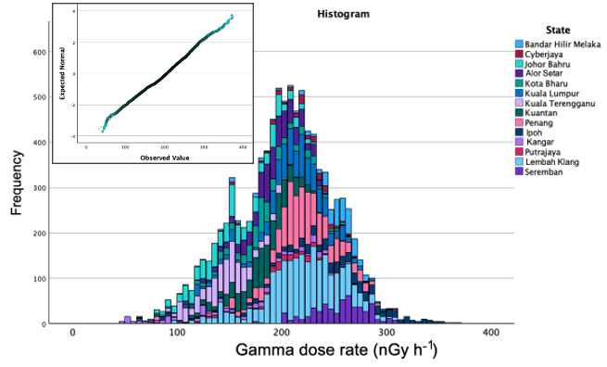
Fig. 3. Histogram of terrestrial gamma radiation (TGR) measured across major urban areas in Peninsular Malaysia, showing the combined distribution for all cities. The inset normal probability plot illustrates that the aggregated TGR values follow an approximately normal distribution at large sample size.
Urban TGR levels differed markedly between cities (Table 1). The lowest mean dose rate was recorded in Kangar (93 ± 6 nGy h⁻¹), followed by Kuala Terengganu (146 ± 1 nGy h⁻¹) and Johor Bahru (157 ± 1 nGy h⁻¹). In contrast, the highest mean values occurred in Ipoh (295 ± 1 nGy h⁻¹), Seremban (254 ± 1 nGy h⁻¹), and Melaka (244 ± 2 nGy h⁻¹). These high-TGR cities also exhibited relatively broad ranges extending beyond 300 nGy h⁻¹, particularly Ipoh (81–371 nGy h⁻¹), suggesting the influence of lithologically enriched geological formations.

Table 1. Descriptive statistics of terrestrial radiation measurement data in major urban areas of Peninsular Malaysia.

City | Terrestrial gamma radiation (nSv h^{–1})
City | n | Mean ± standard  error | Confident interval of mean  (95%) | Range | Skewness | Kurtosis
Johor Bahru | 807 | 157±1 | 154 – 160 | 67 – 281 | 0.33 | -0.24
Melaka | 390 | 244±2 | 241 – 247 | 103 – 307 | -1.75 | 2.91
Seremban | 528 | 254±1 | 252 – 256 | 135 – 334 | -0.55 | 0.60
Lembah Klang (Selangor) | 2184 | 218±2 | 216 – 219 | 79 – 360 | -0.478 | 0.645
Kuala Lumpur | 916 | 210±1 | 207 – 212 | 105 – 302 | -0.654 | 0.624
Putrajaya | 142 | 200±3 | 194 – 205 | 116 – 292 | -0.706 | 0.485
Ipoh | 522 | 295±1 | 276 – 321 | 81 – 371 | -0.683 | 0.509
Penang | 1218 | 220±3 | 218 – 222 | 82 – 326 | -0.510 | 2.305
Alor Setar | 716 | 161±2 | 187 – 191 | 65 – 263 | -0.856 | 1.606
Kangar | 268 | 93±6 | 147 – 162 | 46 – 270 | -0.072 | -1.173
Kota Bharu | 498 | 181±1 | 179 – 184 | 89 – 279 | -0.146 | 0.399
Kuala Terengganu | 744 | 146±1 | 143 – 147 | 42 – 217 | -0.149 | 0.187
Kuantan | 821 | 178±1 | 176 – 180 | 55 – 259 | -1.145 | 2.186
Total | 9754 | 202±1 | 201 – 204 | 47 – 371 | -0.213 | 0.044

Most cities exhibited slight negative skewness, indicating that the upper tail of the distribution contains fewer extreme high-radiation values relative to the bulk of measurements. Melaka showed strong negative skewness (–1.75) and a high kurtosis value (2.91), implying a distribution dominated by higher mid-range values with occasional extreme low points. Cities such as Penang and Kuantan also showed elevated kurtosis (2.31 and 2.19), indicating sharper peaks and heavier tails relative to a normal distribution.
Lembah Klang or Selangor cities, with the largest dataset (n = 2184), displayed a mean TGR of 218 ± 2 nGy h⁻¹ and a wide range of 79–360 nGy h⁻¹. Kuala Lumpur and Putrajaya showed similar mean levels (210 ± 1 nGy h⁻¹ and 200 ± 3 nGy h⁻¹, respectively), consistent with their shared backbone-dominated geological provinces. The histogram (Fig. 1) also reveals substantial overlap between cities, demonstrating that although distinct mean differences exist, inter-city TGR distributions are not mutually exclusive due to complex urban modifications and mixed lithological inputs.
Overall, the results show that urban TGR across Peninsular Malaysia varies significantly between cities, with patterns reflecting combined geological influence, anthropogenic modification, and land-use characteristics. The clear separation of mean values across cities supports the hypothesis that underlying geology continues to shape urban gamma radiation fields despite the presence of modified surfaces.

3.2 Measured Activities of ²³⁸U and ²³²Th decay series and ⁴⁰K in Urban Soil
Activity concentrations of ²³⁸U and ²³²Th decay series and ⁴⁰K in urban surface soils varied considerably across the major cities of Peninsular Malaysia (Table 2). ²³⁸U activity ranged from 27 ± 1 to 347 ± 24 Bq kg⁻¹, ²³²Th from 27 ± 2 to 590 ± 18 Bq kg⁻¹, and ⁴⁰K from 61 ± 4 to 1857 ± 221 Bq kg⁻¹. The highest overall ²³⁸U concentrations were recorded in Selangor–Kuala Lumpur and Ipoh, while the lowest were observed in Alor Setar and Kota Bharu. ²³²Th exhibited a broader dynamic range with elevated values particularly in Ipoh (up to 590 ± 18 Bq kg⁻¹) and Kangar (415 ± 17 Bq kg⁻¹), reflecting the influence of disturbed superficial soils or miscellaneous materials. ⁴⁰K concentrations were most variable, spanning more than an order of magnitude and reaching maxima exceeding 1800 Bq kg⁻¹ in Seremban and above 1300 Bq kg⁻¹ in Melaka and Johor Bahru. These elevated ⁴⁰K levels are associated with urban soils containing miscellaneous fragments, building debris or mixed fill materials.
Johor Bahru soils displayed moderate ²³⁸U (47–171 Bq kg⁻¹) and ²³²Th (64–257 Bq kg⁻¹) concentrations but exhibited extremely heterogeneous ⁴⁰K levels (172–1200 Bq kg⁻¹), suggesting mixture of natural sediments with construction-derived materials. Melaka soils showed relatively high ²³⁸U (60–157 Bq kg⁻¹) and ²³²Th (105–200 Bq kg⁻¹) concentrations with consistently elevated ⁴⁰K, including values exceeding 1300 Bq kg⁻¹. Seremban soils contained some of the highest radionuclide activities measured, including ²³⁸U up to 314 ± 3 Bq kg⁻¹, ²³²Th up to 171 ± 24 Bq kg⁻¹, and ⁴⁰K peaking at 1857 ± 221 Bq kg⁻¹, consistent with its neighbour (Selangor) and broad-K contents in urban soil.
In Selangor and Kuala Lumpur, ²³⁸U ranged widely from 67 to 347 Bq kg⁻¹, while ²³²Th ranged from 61 to 341 Bq kg⁻¹. ⁴⁰K levels were also diverse (131–1107 Bq kg⁻¹), reflecting variable soil profiles and extensive use of imported fill across the Klang Valley. Ipoh soils were dominated by high ²³⁸U (260–346 Bq kg⁻¹) and Th (210–590 Bq kg⁻¹), characteristic of the region’s geological background. Penang exhibited moderate to high activities across all radionuclides, with ²³⁸U up to 307 ± 1 Bq kg⁻¹, ²³²Th up to 258 ± 6 Bq kg⁻¹, and ⁴⁰K up to 985 ± 7 Bq kg⁻¹.

Table 2. Descriptive statistics of ²³⁸U and ²³²Th decay series activity concentrations in soil samples from selected cities in Malaysia.
City | n | ²³⁸U (Bq/kg) Mean ± SE | 95% CI | ²³²Th (Bq/kg) Mean ± SE | 95% CI | ⁴⁰K (Bq/kg) Mean ± SE | 95% CI
Johor Bahru | 10 | 91.1 ± 12.2 | 66.9 – 115.3 | 139.0 ± 18.3 | 102.9 – 175.1 | 472.2 ± 111.8 | 252.0 – 692.4
Melaka | 6 | 101.2 ± 15.4 | 68.7 – 133.7 | 152.0 ± 15.1 | 120.3 – 183.7 | 616.5 ± 170.2 | 279.9 – 953.1
Seremban | 8 | 161.4 ± 26.1 | 108.2 – 214.6 | 127.5 ± 14.6 | 97.7 – 157.3 | 940.3 ± 152.6 | 641.3 – 1239.3
Selangor & Kuala Lumpur | 20 | 167.3 ± 21.1 | 125.7 – 208.9 | 160.0 ± 15.7 | 128.9 – 191.1 | 537.9 ± 72.3 | 395.0 – 680.8
Ipoh | 8 | 308.3 ± 15.2 | 278.5 – 338.1 | 341.3 ± 45.6 | 250.6 – 432.0 | 506.5 ± 95.7 | 318.1 – 695.0
Penang | 10 | 140.7 ± 29.9 | 79.3 – 202.1 | 188.6 ± 18.1 | 151.7 – 225.5 | 533.3 ± 79.9 | 375.9 – 690.7
Alor Setar | 13 | 154.8 ± 22.1 | 110.7 – 198.9 | 122.0 ± 11.3 | 99.2 – 144.8 | 372.8 ± 49.8 | 274.6 – 471.0
Kangar | 4 | 212.3 ± 32.5 | 146.7 – 277.9 | 228.8 ± 71.3 | 82.5 – 375.1 | 390.3 ± 151.7 | 65.5 – 715.1
Kuantan | 8 | 125.1 ± 21.7 | 81.2 – 169.0 | 149.1 ± 27.9 | 92.3 – 205.9 | 619.0 ± 103.8 | 414.5 – 823.5
Kota Bharu | 10 | 137.3 ± 21.3 | 95.3 – 179.3 | 124.5 ± 16.4 | 91.5 – 157.5 | 333.7 ± 36.0 | 263.2 – 404.2
Kuala Terengganu | 10 | 181.4 ± 16.9 | 148.2 – 214.6 | 186.0 ± 20.7 | 145.3 – 226.7 | 301.5 ± 35.5 | 232.0 – 371.0

Northern cities showed more heterogeneous patterns. Alor Setar soils generally had low to moderate ²³⁸U (37–285 Bq kg⁻¹) and ²³²Th (65–172 Bq kg⁻¹) but variable ⁴⁰K. Kangar showed markedly high ²³²Th (up to 415 ± 17 Bq kg⁻¹), indicative of local geological influence. Kuantan displayed moderate ²³⁸U and ²³²Th but very high ⁴⁰K in some samples (up to 1121 ± 204 Bq kg⁻¹). Kota Bharu and Kuala Terengganu soils were lower in ²³⁸U and ²³²Th relative to other provinces, though some samples exhibited high ⁴⁰K, likely influenced by mixed new soil development and urban soil modification.
Overall, the urban soils studied reveal substantial geologically driven variability, with granitic provinces (Ipoh, Seremban, parts of Penang, Selangor–Kuala Lumpur) showing systematically higher ²³⁸U and ²³²Th decay series and ⁴⁰K activities compared to coastal-sedimentary-dominated regions (Kota Bharu, Kuala Terengganu, Johor Bahru). The wide range of activity concentrations also reflects the influence of anthropogenic materials, particularly in rapidly urbanising areas where construction fill and mixed soils are common.

3.3 Geological Variability of TGR Dose Rates in Urban Environment
The spatial patterns of terrestrial gamma radiation (TGR) across Peninsular Malaysia show strong correspondence with the peninsula’s underlying geological framework. When the TGR measurements are mapped against the geological formations (Fig. 1), the highest-dose cities are Ipoh, Seremban, Melaka, and Penang which is cluster primarily within or adjacent to extensive igneous provinces (Department of Geosciences and Mineral Malaysia, 2002), particularly the granitic bodies of the Sibumasu tectonic block (Metcalfe, 2011). These granites, ranging from Devonian to Triassic in age, are well known for their elevated concentrations of U–Th–K-bearing minerals (Agocs and Paton, 1958) such as monazite, zircon, allanite, and K-feldspar (Hewson, 1996), which collectively produce stronger terrestrial gamma fields (Sanusi et al., 2021). This geological control is reflected in the consistently high mean TGR values recorded in these regions, frequently exceeding 240 nGy h⁻¹, with Ipoh reaching 295 ± 1 nGy h⁻¹.
Cities located within metamorphic and sedimentary belts; including Kangar, Kedah (Alor Setar), and Kuala Terengganu (Department of Geosciences and Mineral Malaysia, 2002) show significantly lower dose rates (<150 nGy h⁻¹). These regions correspond to early Paleozoic and Permian formations (Silurian–Ordovician, Devonian, Carboniferous) (Department of Geosciences and Mineral Malaysia, 2002) that characteristically have lower concentrations of radionuclide-bearing minerals (Schlumberger, 1982). The Quaternary alluvial plains along the east coast further contribute to the homogeneously low readings in Kuala Terengganu and surrounding districts (Sanusi et al., 2014).
The geological map illustrates that many high-TGR cities lie either directly on, or in close proximity to, the Bentong–Raub Suture Zone; a major lithospheric boundary dividing the Sibumasu Block from the Sukhothai Arc terranes (Department of Geosciences and Mineral Malaysia, 2002). This suture zone is associated with intense tectono-metamorphic activity and abundant intrusive granitic bodies (Hutchison and Tan, 2009). Penang, Ipoh, Seremban, and parts of Melaka align geographically with this intruded corridor, which explains the broad TGR ranges and elevated kurtosis values observed in these cities (Ramli et al., 2005; Norbani et al., 2014). Ipoh, in particular, sits at the confluence of Triassic granite intrusions and high-grade metamorphic belts (Department of Geosciences and Mineral Malaysia, 2002), producing a wide radiation range (81–371 nGy h⁻¹), as shown in Table 1.
The distribution of gamma survey points (Fig. 1) further highlights concentration of measurements in densely urbanised regions such as. western region of Klang Valley (Klang and Shah Alam), Butterworth and Seberang Perai, Johor Bahru, and Kuantan. These areas, although not uniformly underlain by granitic bedrock (Hutchison and Tan, 2009), show elevated TGR levels (~180 nGy h⁻¹ and above). This phenomenon is consistent with the main influence of urbanisation and anthropogenic materials. Klang Valley, for example, is dominated by meta-sedimentary formations rather than granite, yet exhibits mean TGR levels of 210–218 nGy h⁻¹. This can be attributed to extensive land modification, imported construction materials with higher U and Th radionuclide contents (Azlina et al., 2025) and densely paved surfaces, which collectively elevate radiation intensities by up to 30–40% above natural soil levels (Sanusi et al., 2017a), as indicated by previous national surveys.
The quartile distribution patterns support this interpretation. Cities situated on uniform lithologies—such as Kangar, Kuala Terengganu, and parts of Selangor—show compact quartile ranges, reflecting restricted TGR variability. In contrast, cities spanning mixed lithologies or granite–sediment transitions (Hutchison and Tan, 2009), such as Ipoh, Melaka, Penang, and Johor Bahru, show wider quartile distributions and heavier distribution tails. The statistical behaviour (negative skewness and elevated kurtosis) in cities such as Melaka and Penang corresponds to the heterogeneous geology visible in the map, where granite exposures and metamorphic belts intermix with younger volcanic and sedimentary units.
Overall, integrating geological mapping with the spatial distribution of urban TGR measurements reinforces the conclusion that underlying lithology remains the dominant factor controlling terrestrial gamma radiation fields in Peninsular Malaysia. Urbanisation amplifies existing geological signatures but does not override them. While granite-dominated provinces consistently show high TGR values, anomalies in cities such as Klang Valley, Kuantan, and Kota Bharu highlight the growing role of urban development in modifying local radiological environments.
The average TGR level of 202 ± 1 nGy h⁻¹ across the surveyed cities is substantially higher than the UNSCEAR global average of 59 nGy h⁻¹ and more than double the national baseline measured in the late 1990s (Omar et al., 1991; UNSCEAR, 2000). Given the rapid expansion of urban infrastructure and the concentration of the Malaysian population in these high-TGR zones, updated national assessments and revised public exposure models are warranted. The current findings place several Malaysian cities within the lower range of global high natural background radiation (HNBR) regions, underscoring the importance of ongoing monitoring and improved geological–radiological mapping for urban planning and public health evaluation.

3.4 Variation of ²³⁸U and ²³²Th decay series and ⁴⁰K and Contamination Index (USCI) of Urban Soil

The violin plots in Fig. 4 show that the activity concentrations of ²³⁸U, ²³²Th and ⁴⁰K in the upper 0–7 cm of urban soils exhibit substantial variability, reflecting the dominant influence of anthropogenic modification rather than contributions from natural soil materials, which account for less than 5% of the sampled matrix. The broad distribution of ⁴⁰K, accompanied by pronounced high-activity tails, is consistent with its abundance in urban construction materials (Chong and Ahmad, 1982; Ibrahim, 1999; Yasir et al. 2007) such as cement, concrete aggregates, ceramics, asphalt mixtures and quarry-derived dusts (Sanusi et al., 2017a). These materials are widely used throughout Malaysian cities and frequently contribute potassium-rich particulates (Baha et al. 2025) that accumulate in roadside sediments, landscaping soils, reclaimed areas and compacted fill layers. In contrast, the distributions of ²³⁸U and ²³²Th, although narrower, also display asymmetric shapes with elevated tails that indicate the presence of U–Th-bearing inputs typically linked to construction dust, ceramic and granite-aggregate residues, industrial emissions, vehicular particulate matter and waste-derived fine materials deposited on urban surfaces. Because these materials dominate the composition of superficial urban soils (Sanusi et al., 2017a), the observed radionuclide distributions primarily represent human-driven environmental alterations rather than signatures of underlying geology.
The descriptive statistics of the Urban Soil Contamination Index (USCI) further reinforce the strong anthropogenic control on radionuclide variability. Minimum USCI values between approximately 0.05 and 0.20 correspond to locations where the soil surface remains close to natural equilibrium conditions, while the lower quartile (Q1), ranging from about 0.30 to 0.60, represents slightly altered urban surfaces with minor particulate accumulation. The median USCI, typically between 0.80 and 1.20, indicates that moderate alteration is characteristic of most urban soils in the studied cities, consistent with regular exposure to construction dust, vehicular emissions and general surface disturbance. The mean value of around 1.00 represents the typical behaviour of anthropogenically influenced urban soils in Malaysia. The third quartile (Q3), spanning approximately 1.50 to 2.00, signifies soils that are noticeably disturbed, often associated with intense construction, roadworks, surface sealing or landscaping modifications. Maximum USCI values between 3.50 and 4.50 correspond to highly contaminated sites where strong anthropogenic or construction-related inputs dominate the soil matrix. The moderate standard deviation of approximately 0.70 to 1.00 reflects the heterogeneous nature of urban modification processes across different cities and land-use types.
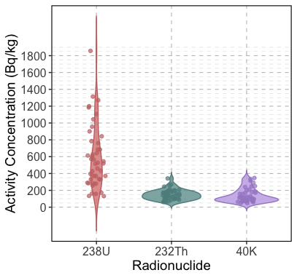

Fig. 4. Violin plots of ²³⁸U and ²³²Th decay series and ⁴⁰K in urban surface soils

The regression relationships in Fig. 5 provide additional insight into the geochemical behaviour of U, Th and K under urban contamination. The strong positive correlations between USCI and both U/K and Th/K ratios, supported by significant polynomial and exponential model fits, indicate that even small increases in uranium or thorium relative to potassium can markedly elevate contamination intensity. This pattern reflects the tendency for uranium-bearing particulates; originating from construction materials (Trevisi et al., 2012), combustion residues, industrial dusts and phosphate-rich landscaping products that accumulated rapidly in superficial urban soils and to be more mobile under the oxidizing conditions common in urban environments. The Th/K–USCI relationship also increases positively, although with slightly weaker dependence, consistent with thorium’s lower mobility and stronger particle-bound behaviour, whereby Th enrichment tends to result from direct deposition of solid materials rather than diffusive processes (Hail, 1976). In contrast, the Th/U ratio shows no meaningful correlation with USCI, indicating that the relative fractionation between thorium and uranium remains largely independent of contamination intensity. This behaviour demonstrates that Th/U acts as a conservative indicator reflecting the differing mobility of U and Th in disturbed urban soils, rather than serving as a direct proxy for overall contamination.
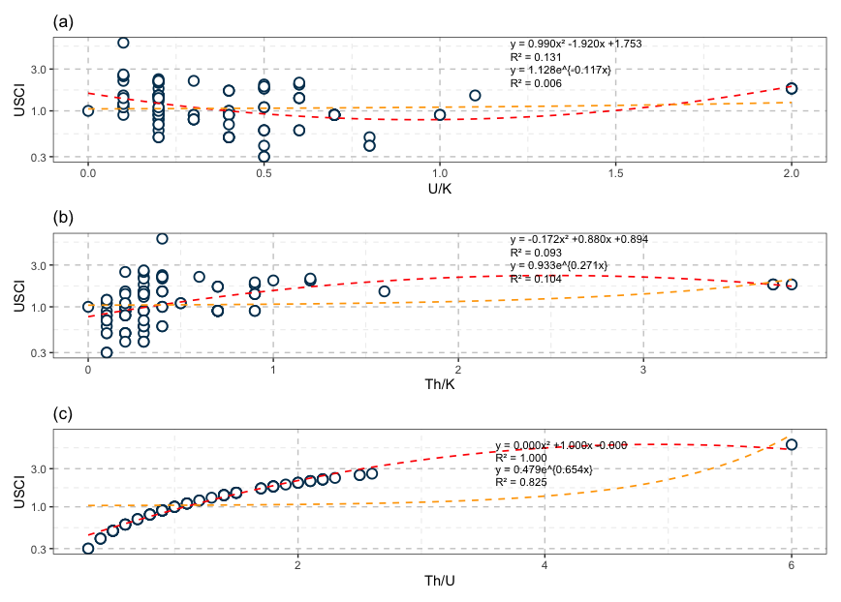

Fig. 5. Relationships between Urban Soil Contamination Index (USCI) and radiogenic element ratios: U/K, Th/K, and Th/U. Polynomial and exponential regression models are shown for each ratio

Overall, the combined distributions of ²³⁸U, ²³²Th, ⁴⁰K and USCI, along with their ratio-based relationships, demonstrate that urban surface soils in Peninsular Malaysia are overwhelmingly shaped by anthropogenic processes. The upper soil layer primarily reflects accumulated construction materials, industrial particulates, vehicular emissions, land reclamation debris and surface disturbance rather than natural parent soil. The strong nonlinear responses of U/K and Th/K to USCI highlight the sensitivity of urban soils to small but persistent inputs of radiogenic particulates, while the stability of Th/U underscores the role of material-specific mobility rather than contamination magnitude. These findings underline the need for continuous radiological monitoring of urban soils, especially in rapidly developing city centres where construction intensity, road traffic and land modification activities can shift radiological baselines within relatively short timeframes.

4. Conclusion

This study provides the first integrated assessment of geology-controlled terrestrial gamma radiation (TGR) and anthropogenic modification of urban soils across major cities in Peninsular Malaysia. The combined carborne TGR dataset and HPGe-based soil radioactivity analyses demonstrate that underlying lithology remains the primary driver of spatial radiation variability, with granitic provinces consistently exhibiting the highest gamma fields. Urbanisation amplifies these geological signatures through extensive land modification and the incorporation of radionuclide-bearing construction materials, yet it does not fully override the influence of bedrock geology. The elevated TGR levels observed in Klang Valley, Kuantan, and Kota Bharu reflect the growing radiological contribution from urban development, even in areas not traditionally associated with high natural radioactivity.
Surface soils across the cities are dominated by anthropogenic inputs, with activity concentrations of ²³⁸U, ²³²Th and ⁴⁰K showing wide variability linked to construction dust, imported fill, road particulates and mixed industrial residues. The Urban Soil Contamination Index (USCI) effectively captures contamination intensity, revealing that most urban soils fall within moderately to highly altered classes, with maximum values indicating strong anthropogenic enrichment. Nonlinear increases in U/K and Th/K with USCI underscore the sensitivity of urban soils to small but persistent inputs of radiogenic materials, while the stable Th/U ratio reflects contrasting mobility between ²³⁸U and ²³²Th in disturbed environments.
Overall, this study confirms that both geology and urbanisation jointly shape the radiological characteristics of Malaysian cities. The findings provide updated baseline information essential for urban radiological protection, land-use planning and geoscientific assessment. Continued monitoring is recommended, particularly in rapidly developing zones where construction activities and surface modification can shift radiation baselines over relatively short periods.

DISCLAIMER (ARTIFICIAL INTELLIGENCE)

Author(s) hereby declare that NO generative AI technologies such as Large Language Models (ChatGPT, COPILOT, etc) and text-to-image generators have been used during writing or editing of this manuscript.

REFERENCE
- Aissa, M., & Jubeli, Y. M. (1997). Carborne gamma-ray spectrometric survey of an area east of Homs, central Syria. Applied Radiation and Isotopes, 48(1), 135–142. https://doi.org/10.1016/S0969-8043(96)00064-4 .
- Murakami, H., & Takahashi, F. (Eds.). (1995). Proceedings of the IAEA/RCA Workshop on Calibration of Dosimeters & Survey Instruments for Photons. Japan Atomic Energy Research Institute. https://www.inis.iaea.org/search/search.aspx?orig_q=RN:28002052 .
- Atomtex. (2025). Portable spectrometers AT6101C/AT6101CM. https://atomtex.com
- Baha, A., Hashim, S., Sanusi, M. S. M., & Engku Chik, E. M. F. (2025). Radiological impact of natural radioactivity in Malaysian building bricks. Radiation Physics and Chemistry. https://doi.org/10.1016/j.radphyschem.2025.113159
- National Research Council. (2006). Health Risks from Exposure to Low Levels of Ionizing Radiation: BEIR VII Phase 2. The National Academies Press. https://doi.org/10.17226/11340 .
- Spiers, F. W., Gibson, J. A. B., & Thompson, I. M. G. (1981). A guide to the measurement of environmental gamma-ray dose rate. British Committee on Radiation Units and Measurements, National Physical Laboratory.
- Bituh, T., Marovic, G., Petrinec, B., Sencar, J., & Franulovic, I. (2009). Natural radioactivity of 226Ra and 228Ra in thermal and mineral waters in Croatia. Radiation Protection Dosimetry, 133(2), 119–123. https://doi.org/10.1093/rpd/ncp033 .
- Buchli, R., & Burkart, W. (1989). Correlation among terrestrial γ radiation, indoor air ^222Rn, and tap water ^222Rn in Switzerland. Health Physics, 57(5), 753–759. https://doi.org/10.1097/00004032-198911000-00008 .
- Chernyavskiy, P., Kendall, G. M., Wakeford, R., & Little, M. P. (2016). Spatial prediction of naturally occurring gamma radiation in Great Britain. Journal of Environmental Radioactivity, 164, 300–311. https://doi.org/10.1016/j.jenvrad.2016.07.029 .
- Chong, C. S., & Ahmad, G. U. (1982). Gamma activity of some building materials in West Malaysia. Health Physics, 43(2), 272.
- Cinelli, G., Tollefsen, T., Bossew, P., Gruber, V., Bogucarskis, K., De Felice, L., & De Cort, M. (2019). Digital version of the European Atlas of natural radiation. Journal of Environmental Radioactivity, 196, 240–252. https://doi.org/10.1016/j.jenvrad.2018.02.008 .
- Department of Agriculture Malaysia. (2002). Map of Soil Types in Peninsular Malaysia. Kuala Lumpur.
- Minerals and Geoscience Department Malaysia. (2004). *Geological Map of Peninsular Malaysia (8th Edition, Scale 1:750,000)*.
- El Samad, O., Baydoun, R., Nsouli, B., & Darwish, T. (2013). Determination of natural and artificial radioactivity in soil at North Lebanon province. Journal of Environmental Radioactivity, 125, 36–39. https://doi.org/10.1016/j.jenvrad.2013.02.010 .
- García-Talavera, M., Martínez, M., Matarranz, J. L. M., & Ramos, L. (2008). Setting radon-specific release criteria and demonstrating compliance for land affected by NORM. Applied Radiation and Isotopes, 66(11), 1567–1571. https://doi.org/10.1016/j.apradiso.2007.10.018 .
- Goddard, C. C. (2002). Measurement of outdoor terrestrial gamma radiation in the Sultanate of Oman. Health Physics, 82(6), 869–874. https://doi.org/10.1097/00004032-200206000-00016 .
- Grasty, R. L., & LaMarre, J. R. (2004). The annual effective dose from natural sources of ionising radiation in Canada. Radiation Protection Dosimetry. https://doi.org/10.1093/rpd/nch022 .
- Hails, J. R. (1976). Placer deposits. In Supergene and Surficial Ore Deposits: Textures and Fabrics (Vol. 3). Elsevier.
- Hutchison, C. S., & Tan, D. N. K. (2009). Geology of Peninsular Malaysia. University of Malaya & Geological Society of Malaysia.
- Huy, N. Q., & Luyen, T. V. (2006). Study on external exposure doses from terrestrial radioactivity in Southern Vietnam. Radiation Protection Dosimetry, 118(3), 331–336. https://doi.org/10.1093/rpd/nci341 .
- International Atomic Energy Agency. (1996). International Basic Safety Standards for Protection Against Ionizing Radiation and for the Safety of Radiation Sources (Safety Series No. 115). Vienna. https://www.iaea.org/publications/7000/international-basic-safety-standards-for-protection-against-ionizing-radiation-and-for-the-safety-of-radiation-sources .
- IAEA. (2018). Prospective Radiological Environmental Impact Assessment for Facilities and Activities (Safety Standards Series No. GSG-10). Vienna. https://www.iaea.org/publications/11290/prospective-radiological-environmental-impact-assessment-for-facilities-and-activities .
- ICRP. (2007). The 2007 Recommendations of the International Commission on Radiological Protection: ICRP Publication 103. *Annals of the ICRP, 37*(2-4), 1-332. https://doi.org/10.1016/j.icrp.2007.10.003 .
- Ibrahim, N. (1999). Natural activities of 238U, 232Th and 40K in building materials. Journal of Environmental Radioactivity, 43, 255–258. https://doi.org/10.1016/S0265-931X(98)00033-2 .
- Ibrahiem, N. M., Abd el Ghani, A. H., Shawky, S. M., Ashraf, E. M., & Farouk, M. A. (1993). Measurement of radioactivity levels in soil in the Nile Delta and middle Egypt. Health Physics, 64(6), 620–627. https://doi.org/10.1097/00004032-199306000-00007 .
- Jibiri, N. N. (2001). Assessment of health risk levels associated with terrestrial gamma radiation dose rates in Nigeria. Environment International, 27(1), 21–26. https://doi.org/10.1016/s0160-4120(01)00039-3 .
- Kapdan, E., Varinlioglu, A., & Karahan, G. (2012). Outdoor radioactivity and health risks in Balikesir, Northwestern Turkey. Radiation Protection Dosimetry, 148(3), 301–309. https://doi.org/10.1093/rpd/ncr038 .
- Kardan, M. R., Fathabdi, N., Attarilar, A., Esmaeili-Gheshlaghi, M. T., Karimi, M., Najafi, A., & Hosseini, S. S. (2017). A national survey of natural radionuclides in soils and terrestrial radiation exposure in Iran. Journal of Environmental Radioactivity, 178–179, 168–176. https://doi.org/10.1016/j.jenvrad.2017.08.010 .
- Kleinschmidt, R., & Watson, D. (2016). Terrestrial gamma radiation baseline mapping using ultra low density sampling methods. Journal of Environmental Radioactivity. https://doi.org/10.1016/j.jenvrad.2015.05.008 .
- Kock, P., & Samuelsson, C. (2011). Comparison of airborne and terrestrial gamma spectrometry measurements - evaluation of three areas in southern Sweden. Journal of Environmental Radioactivity, 102(6), 605–613. https://doi.org/10.1016/j.jenvrad.2011.03.010 .
- Lai, K. K., Hu, S. J., Minato, S., Kodaira, K., & Tan, K. S. (1999). Terrestrial gamma ray dose rates of Brunei Darussalam. Applied Radiation and Isotopes, 50(3), 599–608. https://doi.org/10.1016/s0969-8043(98)00080-3 .
- Ludlum Measurements, Inc. (1993). *Instruction manual: Ludlum Model 19 Micro R Meter*. Ludlum Measurements, Inc. https://www.ludlums.com/products/model-19-micror-survey-meter .
- Mares, S. (1984). Introduction to applied geophysics. Kluwer Academic Publishers. https://doi.org/10.1007/978-94-015-7684-0 .
- Mohanty, A. K., Sengupta, D., Das, S. K., Vijayan, V., & Saha, S. K. (2004). Natural Radioactivity in the Newly Discovered High Background Radiation Area on the Eastern Coast of Orissa, India. Radiation Measurements, 38(2), 153–165. https://doi.org/10.1016/j.radmeas.2003.08.003 .
- Mora, P., Picado, E., & Minato, S. (2007). Natural radiation doses for cosmic and terrestrial components in Costa Rica. Applied Radiation and Isotopes. https://doi.org/10.1016/j.apradiso.2006.06.001 .
- Norbani, N. E., Salim, N. A. A., Saat, A., Hamzah, Z., Ramli, A. T., Idris, W. M. R. W., Jaafar, M. Z., Bradley, D. A., & Abdul Rahman, A. T. (2014). Terrestrial gamma radiation dose rates (TGRD) from surface soil in Negeri Sembilan, Malaysia. Radiation Physics and Chemistry, 104, 112–117. https://doi.org/10.1016/j.radphyschem.2014.04.005 .
- Omar, M., Ibrahim, M. Y., Hasan, A., Mahmood, C. S., Mooi, L. H., Ahmad, Z., & Sharifuddin, M. (1991). Radiation level and environmental radioactivity in Malaysia. MINT Internal Report, 1–13.
- Pálsson, S. E., Howard, B. J., Bergan, T. D., Paatero, J., Isaksson, M., & Nielsen, S. P. (2013). A simple model to estimate deposition based on a statistical reassessment of global fallout data. Journal of Environmental Radioactivity, 121, 75–86. https://doi.org/10.1016/j.jenvrad.2012.03.006 .
- Poje, M., Vuković, B., Radolić, V., Miklavčić, I., Faj, D., Varga Pajtler, M., & Planinić, J. (2012). Mapping of cosmic radiation dose in Croatia. Journal of Environmental Radioactivity, 103, 30–33. https://doi.org/10.1016/j.jenvrad.2011.08.016 .
- Quindós, L. S., Fernández, P. L., Soto, J., Ródenas, C., & Gómez, J. (1994). Natural radioactivity in Spanish soils. Health Physics, 66(2), 194–200. https://doi.org/10.1097/00004032-199402000-00010 .
- Quindós Poncela, L. S., Fernández, P. L., Gómez Arozamena, J., Sainz, C., Fernández, J. A., Suarez Mahou, E., Martin Matarranz, J. L., & Cascón, M. C. (2004). Natural gamma radiation map (MARNA) and indoor radon levels in Spain. Environment International, 29(8), 1091–1096. https://doi.org/10.1016/S0160-4120(03)00102-8 .
- Ramli, A. T., Abdul Rahman, A. T., & Lee, M. H. (2003). Statistical prediction of terrestrial gamma radiation dose rate based on geological features and soil types in Kota Tinggi district, Malaysia. Applied Radiation and Isotopes, 59(5–6), 393–405. https://doi.org/10.1016/j.apradiso.2003.08.003 .
- Ramli, A. T., Sahrone, S., & Wagiran, H. (2005). Terrestrial gamma radiation dose study to determine the baseline for environmental radiological health practices in Melaka state, Malaysia. Journal of Radiological Protection, 25(4), 435–450 https://doi.org/10.1088/0952-4746/25/4/006 .
- Ramzaev, V., Yonehara, H., Hille, R., Barkovsky, A., Mishine, A., Sahoo, S. K., Kurotaki, K., & Uchiyama, M. (2006). Gamma-dose rates from terrestrial and Chernobyl radionuclides inside and outside settlements in the Bryansk Region, Russia in 1996-2003. Journal of Environmental Radioactivity, 85, 205–227. https://doi.org/10.1016/j.jenvrad.2004.04.014 .
- Ramasamy, V., Sundarrajan, M., Paramasivam, K., Meenakshisundaram, V., & Suresh, G. (2013). Assessment of spatial distribution and radiological hazardous nature of radionuclides in high background radiation area, Kerala, India. Applied Radiation and Isotopes, 73, 21–31. https://doi.org/10.1016/j.apradiso.2012.11.014 .
- Sanusi, M. S. M., Ramli, A. T., Basri, N. A., Heryanshah, A., Said, M. N., Lee, M. H., Wagiran, H., & Saleh, M. A. (2017). Thorium distribution in the soils of Peninsular Malaysia and its implications for Th resource estimation. Ore Geology Reviews, 80, 522–535. https://doi.org/10.1016/j.oregeorev.2016.07.021 .
- Sanusi, M. S. M., Ramli, A. T., Hassan, W. M. S. W., Lee, M. H., Izham, A., Said, M. N., Wagiran, H., & Heryanshah, A. (2017). Assessment of impact of urbanisation on background radiation exposure and human health risk estimation in Kuala Lumpur, Malaysia. Environment International, 104, 91-101. https://doi.org/10.1016/j.envint.2017.01.009 .
- Sanusi, M. S. M., Ramli, A. T., Gabdo, H. T., Garba, N. N., Heryanshah, A., Wagiran, H., & Said, M. N. (2014). Isodose mapping of terrestrial gamma radiation dose rate of Selangor state, Kuala Lumpur and Putrajaya, Malaysia. Journal of Environmental Radioactivity, 135, 67–74. https://doi.org/10.1016/j.jenvrad.2014.04.004 .
- Sanusi, M. S. M., Ramli, A. T., Hashim, S., & Lee, M. H. (2021). Radiological hazard associated with amang processing industry in Peninsular Malaysia and its environmental impacts. Ecotoxicology and Environmental Safety, 208, 111727. https://doi.org/10.1016/j.ecoenv.2020.111727 .
- Schlumberger. (1982). Natural Gamma Ray Spectrometry: Essentials of N.G.S. Interpretation. Schlumberger. https://books.google.com/books/about/Natural_Gamma_Ray_Spectrometry.html?id=y_0xAQAAIAAJ .
- Suarez, E., & Fernández, J. (1995). Use of uranium airborne survey data in radiometric mapping of Spain. Environmental and uranium geology (IAEA-TECDOC-827). https://www.iaea.org/publications/5000/environmental-and-uranium-geology-proceedings-of-a-technical-committee-meeting-held-in-vienna-25-28-september-1995 .
- Steinhäusler, F., & Lettner, H. (1992). Radiometric survey in Namibia. Radiation Protection Dosimetry, 45(1–4), 553–555. https://doi.org/10.1093/rpd/45.1-4.553 .
- Tondel, M., Lindgren, P., Hellström, L., Löfman, O., & Fredrikson, M. (2011). Risk of malignancies in relation to terrestrial gamma radiation in a Swedish population cohort. Science of the Total Environment, 409(3), 471–477. https://doi.org/10.1016/j.scitotenv.2010.10.052 .
- Trevisi, R., Risica, S., D’Alessandro, M., Paradiso, D., & Nuccetelli, C. (2012). Natural radioactivity in building materials in the European Union: a database and an estimate of radiological significance. Journal of Environmental Radioactivity, 105, 11–20 https://doi.org/10.1016/j.jenvrad.2011.10.001 .
- Tso, M. Y., & Li, C. (1992). Terrestrial gamma radiation dose in Hong Kong. Health Physics, 62(1). https://doi.org/10.1097/00004032-199201000-00010 .
- Tufail, M., Akhtar, N., & Waqas, M. (2006). Measurement of terrestrial radiation for assessment of gamma dose from cultivated and barren saline soils of Faisalabad in Pakistan. Radiation Measurements, 41(4), 443–451. https://doi.org/10.1016/j.radmeas.2005.10.007 .
- Tzortzis, M., Tsertos, H., Christofides, S., & Christodoulides, G. (2003). Gamma radiation measurements and dose rates in commercially-used natural tiling rocks (granites). Journal of Environmental Radioactivity, 70, 223–235. https://doi.org/10.1016/S0265-931X(03)00106-1 .
- Tzortzis, M., Tsertos, H., Christofides, S., & Christodoulides, G. (2003). Gamma-ray measurements of naturally occurring radioactive samples from Cyprus characteristic geological rocks. Radiation Measurements, 37, 221–229. https://doi.org/10.1016/s1350-4487(03)00028-3 .
- United Nations Scientific Committee on the Effects of Atomic Radiation. (2000). Sources and effects of ionizing radiation. Annex B: Exposures from natural radiation sources (UNSCEAR 2000 Report, Vol. I). United Nations. https://www.unscear.org/unscear/en/publications/2000_1.html .
- United Nations Scientific Committee on the Effects of Atomic Radiation. (2010). *Sources and effects of ionizing radiation. UNSCEAR 2008 report to the General Assembly with scientific annexes*. United Nations. https://www.unscear.org/unscear/en/publications/2008_report.html .
- Wallova, G., Kandler, N., & Wallner, G. (2012). Monitoring of radionuclides in soil and bone samples from Austria. Journal of Environmental Radioactivity, 107, 44–50. https://doi.org/10.1016/j.jenvrad.2011.12.007 .
- Yasir, S. M., Majid, A. A., Yahaya, R., Bahari, I., & Chooi, K. T. (2007). Water quality and sediment from amang processing. Malaysian Journal of Analytical Sciences, 11, 370–378.
- Yoshimura, E. M., Otsubo, S. M., & Oliveira, R. E. R. (2004). Gamma ray contribution to the ambient dose rate in the city of São Paulo, Brazil. Radiation Measurements. https://doi.org/10.1016/s1350-4487(03)00283-x .

