Air Pollution and Its Impact on Public Health Research in India: Mapping Themes, Trends, and Knowledge Gaps

Abstract
Air pollution poses a significant threat to public health in India, contributing to rising cases of respiratory and cardiovascular diseases. Despite the growing research interest in this domain, a comprehensive understanding of thematic patterns, collaboration structures, and evolving research priorities remains limited. This study addresses this knowledge gap through a bibliometric analysis of 1816 publications retrieved from the Web of Science and Scopus databases between 1990 and 2024. Using mapping techniques, the study explores trends in publication output, leading contributors, collaboration networks, and thematic evolution. The major findings reveal a steady and substantial growth in scientific production, particularly after 2010, reflecting increased policy relevance and interdisciplinary engagement. India emerges as the dominant contributor and a central hub of international collaboration, particularly with the USA, the UK, and China. Thematic evolution indicates a clear intellectual progression from early environmental exploration to specialized, health-oriented, and risk-based studies. Recent years show a focus on indoor air pollution, mortality, and COVID-19-related research. The findings denote the integration of environmental science and public health, highlighting both maturity and diversification within the field. The study’s implications emphasize the need for enhanced interdisciplinary collaboration, integration of indoor–outdoor pollution assessments, and adoption of AI-driven analytical approaches to strengthen evidence-based policymaking and sustainable health interventions in India.
Keywords; Air pollution, public health, Air Quality, India, Research Trends, Bibliometric Analysis
1. Introduction
Air pollution refers to the contamination of the indoor or outdoor environment by any chemical, physical, or biological agent that modifies the natural characteristics of the atmosphere. Common sources include motor vehicles, industrial facilities, household combustion devices, and natural events such as wildfires (World Health Organization, 2023). Globally, air pollution remains a critical environmental health concern, with more than 90% of the world’s population exposed to annual average fine Particulate Matter (PM₂.₅) concentrations that exceed the World Health Organization’s (WHO) guideline of 5 µg/m³ (Lou et al., 2023). In the Indian context, air quality remains among the poorest worldwide. According to the 2024 Air Quality Life Index (AQLI) report, the population-weighted annual average PM₂.₅ concentration in India was approximately 41.4 µg/m³ over eight times higher than the WHO standard and virtually all of India’s 1.4 billion residents live in areas exceeding safe limits (Greenstone et al., 2024).
These alarming statistics emphasize the urgent need for stringent air quality management policies and effective mitigation strategies to reduce public health risks associated with chronic exposure to air pollution. The Air Quality Index (AQI) is a standardized system that translates measured concentrations of major air pollutants into a single, easy-to-understand numerical scale to indicate how clean or polluted the air is, and the associated health effects that might be of concern for the public (U.S. Environmental Protection Agency, 2022). According to the Central Pollution Control Board (CPCB), the National Air Quality Index (NAQI) provides a simple, composite measure of air quality by converting complex air quality data of multiple pollutants such as PM₁₀, PM₂.₅, NO₂, SO₂, CO, O₃, NH₃, and Pb into a single number and color-coded category, facilitating easy communication of air quality status and health advisories to the public (Central Pollution Control Board, 2014).
Public health is the science and art of preventing disease, prolonging life, and promoting health through organized efforts and informed choices of society, organizations, public and private sectors, communities, and individuals (World Health Organization, 2022). This field operates under multiple conceptual frameworks emphasizing the integration of various disciplines and approaches. Public health research aims not only to understand health issues but also to develop interventions and policies that promote health equity and prevent diseases across diverse populations (Kindig & Stoddart, 2003).
The impact of the air pollution on public health has been a significant focus of research, particularly as growing evidence elucidates the health risks associated with various air pollutants (Cohen et al., 2017). One major concern is that while the AQI serves as a readily understandable tool for the general public, its single-pollutant focus can obscure the cumulative effects of multiple pollutants that often coexist in urban environments (Gurjar et al., 2016; U.S. Environmental Protection Agency, 2022).
In terms of health outcomes, various studies have linked poor air quality, as indicated by AQI levels, directly to increased incidences of cardiovascular and respiratory diseases. Fann et al. calculated that exposure to particulate matter (PM2.5) and ozone significantly contributes to health burdens in the U.S., illustrating how poor air quality can impact life expectancy and overall health (Fann et al., 2011). Consistent with these findings, Zhang et al. emphasize the acute cardiovascular effects of high AQI levels, revealing a complex interplay between air quality and health risks in population (Zhang et al., 2024).
Bibliometric analysis in this area helps to map the intellectual structure of specific research domains by quantitatively assessing the relationships and productivity of various scholarly works. This method allows researchers to identify influential articles, prominent authors, and adaptive trends in publication practices over time, which is crucial for understanding the evolution of a subject area (Kalsoom & Zámečník, 2023; Wang et al., 2024). The methodological rigor of bibliometric analysis strengthens its applicability across various fields, allowing researchers to assess complex patterns and dynamics influencing the scientific community (Hamidah et al., 2021).
A significant knowledge gap exists in understanding the overall research landscape linking air pollution and public health in India. While numerous studies have explored pollutant exposure and disease-specific outcomes, there is no comprehensive bibliometric synthesis that maps how research themes, collaborations, and trends have evolved over time. This gap limits the ability to identify emerging areas, influential contributors, and underexplored domains. Bibliometric analysis serves as a vital tool for evaluating the impact of research contributions. Through methods such as co-citation analysis and author collaboration mapping, researchers can ascertain the significance of individual works and their influence on subsequent studies (Bai et al., 2023). Hence, the present bibliometric study aims to systematically analyse existing literature to reveal research patterns, thematic evolution, and knowledge gaps, thereby guiding future investigations and policy initiatives focused on mitigating the public health impacts of air pollution in India.
1.1 Need and significance
Air pollution poses a major public health challenge in India, contributing to rising cases of respiratory and cardiovascular diseases, premature deaths, and reduced life expectancy (IQAir, 2025). Rapid urbanization, industrial growth, and household fuel use have intensified exposure levels, making scientific assessment essential for policy and health interventions. Although research in this field is expanding, existing studies are dispersed across disciplines and lack a consolidated understanding of thematic evolution and knowledge gaps. A bibliometric analysis offers an evidence-based approach to systematically map research patterns, influential works, and emerging priorities in air pollution and health research in India. The findings will support strengthened research agendas and more effective public health strategies to tackle pollution-related disease burden in the country.
1.2 Objectives
- To analyse publication trends in the air pollution and public health research
- To identify the most influential contributions in this domain, including leading authors, highly cited publications, key institutions, and contributing countries
- To examine patterns of scholarly collaboration through co-authorship networks at the author, institutional, and country levels
- To map the intellectual and conceptual structure of air pollution and public health research using co-citation and co-word analyses, highlighting dominant themes and emerging research areas
2. Method
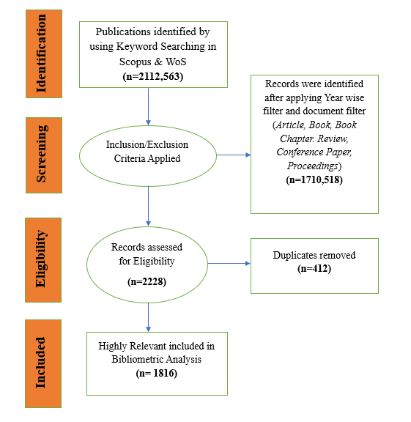
This study employed a bibliometric research design, which uses quantitative techniques to analyse patterns of scientific publication and map the intellectual and conceptual structure of a research field (Donthu et al., 2021). The bibliometric analysis of literature related to this domain, reveals a focused yet steadily expanding body of scholarly work addressing most consequential works in the field of social work. Bibliometric analysis is a robust quantitative method used to assess the structure, performance, and thematic evolution of a scientific field by applying statistical and network-based tools (Adarsh & Sulthana, 2025). A total of 1816 documents were retrieved from distinct sources, including peer-reviewed journal articles, book chapters, conference proceedings, and reviews, capturing the interdisciplinary and evolving nature of research on this topic (Fig.1).
Figure.1 Methodology flow chart
The data collection stage involves extracting relevant research articles from selected databases using well-defined search queries. The search query has been used for extracting documents from Scopus and web of science is listed below;
( ( "ambient air pollution" OR "outdoor air pollution" OR "indoor air pollution" OR "household air pollution" OR "PM2.5" OR "PM10" OR "black carbon" OR "particulate matter" OR "NO2" OR "nitrogen dioxide" OR "SO2" OR "sulphur dioxide" OR "ozone" OR "O3" OR "cooking smoke" OR "biomass fuel" OR "solid fuel" ) AND ( "exposure" OR "level" OR "concentration" OR "effect" ) ) AND TITLE-ABS-KEY ( "public health" OR "health impact" OR "mortality" OR "morbidity" OR "disease burden" OR "health risk*" OR "respiratory disease*" OR "cardiovascular disease*" OR "lung disease*" OR "asthma" OR "COPD" OR "hypertension" OR "stroke" OR "diabetes" OR "premature death" OR "life expectancy" ) AND TITLE-ABS-KEY ( "India" OR "Indian" OR "Delhi" OR "New Delhi" OR "Mumbai" OR "Kolkata" OR "Chennai" OR "Bangalore" OR "Hyderabad" OR "Ahmedabad" OR "Pune" OR "Kanpur" OR "Lucknow" OR "Jaipur" OR "Patna" OR "Bhopal" OR "Nagpur" OR "Varanasi" OR "Amritsar" OR "Ludhiana" OR "Faridabad" OR "Ghaziabad" OR "Noida" OR "Gurugram" OR "Indore" OR "Visakhapatnam" OR "Thiruvananthapuram" )
2.1 Data Analysis
The analysis was conducted using specialized bibliometric tools, Biblioshiny (an R-based bibliometric package) (Aria and Cuccurullo, 2017). The following techniques were applied:
- Descriptive Analysis: This involved the identification of publication trends, prominent journals, influential authors, and citation metrics.
- Co-occurrence Analysis: Keywords were analysed to visualize the thematic structure of the research field using network maps.
- Thematic Mapping: Themes were classified based on relevance and development degree using a two-dimensional analysis, categorizing topics into Basic Themes, Motor Themes, Niche Themes, and Emerging or Declining Themes.
- Thematic Evolution Analysis: Temporal changes in research focus were mapped using Sankey diagrams to trace the progression of topics over different time periods.
- Factorial Analysis: Applied to identify underlying structures within the data by performing multiple correspondence analysis, thereby revealing thematic clusters.
- Collaboration Network Analysis: Country-level collaboration networks were assessed to identify leading research hubs and international partnerships
3. Result and Discussions
3.1 Annual Scientific Production
The annual growth of publications provides a clear picture of how research on air pollution and public health in India has evolved over time. Between 1990 and 2024, a total of 1,974 research publications were identified, reflecting a remarkable transformation from a scarcely studied topic to one of the most active areas of environmental health research in the country. During the early 1990s, scientific output was minimal, with only three publications recorded in 1990 (Fig.2), and a sporadic pattern of one or two papers appearing annually throughout the decade. This limited productivity can be attributed to the nascent stage of environmental awareness and weak research infrastructure in India during that period, when concerns about air quality had not yet become part of the mainstream public health discourse.
A gradual increase in research activity began to emerge in the early 2000s, when the number of publications rose from seven in 2000 to seventeen in 2004. This period marked the beginning of a transitional phase, during which the link between environmental degradation and human health started receiving attention from both scientific institutions and government agencies. Between 2005 and 2009, the publication output stabilized at an average of about 22 articles per year, indicating that the research community was beginning to consolidate knowledge and methods for investigating air quality and its health implications.
From 2010 onwards, the pace of publication growth accelerated sharply, mirroring the increasing policy relevance of air quality management and the growing availability of monitoring data. The number of studies rose from 37 in 2010 to 52 in 2012, reflecting expanding interdisciplinary collaborations among environmental scientists, epidemiologists, and geographers. The release of global and national reports, such as the Global Burden of Disease studies and the establishment of the National Air Quality Index (NAQI) in India, further intensified scientific engagement with the issue. By 2015, annual output reached 70 publications, representing a clear turning point in the national research trajectory.
The most dramatic expansion occurred between 2018 and 2024, when publication counts more than doubled from 106 to 232.The years 2020 and 2021 also witnessed a surge in air quality research driven by the COVID-19 pandemic, during which lockdown-induced changes in emission patterns provided unique opportunities to study pollution dynamics and their effects on respiratory health. The continuing upward trajectory after 2021 signifies the institutional maturity of this research field.
The progressive increase in annual scientific production underscores the evolution of air pollution research in India from a fragmented discipline to a coherent, policy-oriented scientific domain. This trend reflects a deepening awareness of air pollution as not merely an environmental problem but a multidimensional public health challenge central to India’s sustainable development goals.
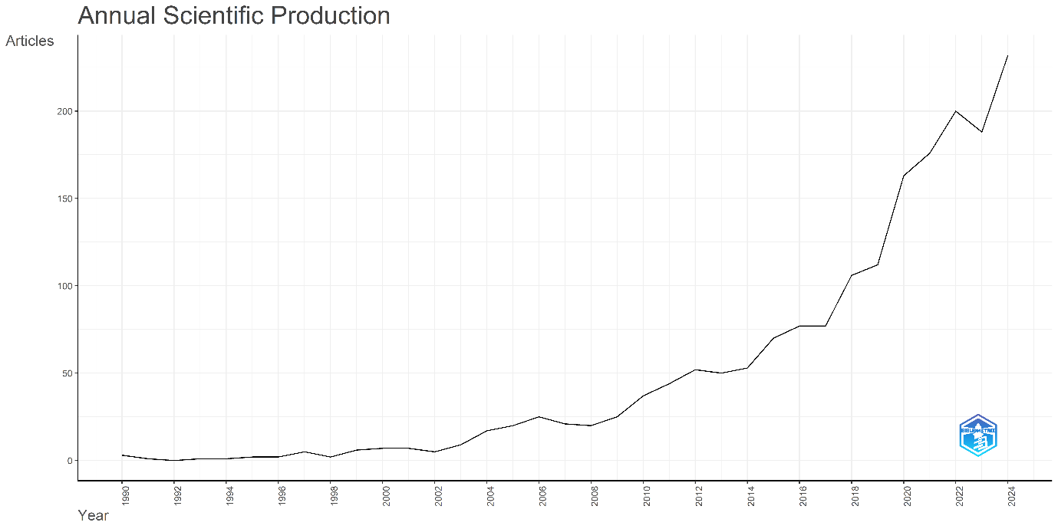
Figure.2 Annual Scientific Production has been prepared using Biblioshiny (Aria and Cuccurullo, 2017).
3.2 Average Citations Per Year
The trend in average citations per article reflects the academic influence and visibility of research on air pollution and public health in India over time. During the early 1990s, a few pioneering studies achieved notable citation impacts, such as 67 citations per article in 1991 and 65.5 in 1996, indicating the significance of early foundational research despite limited publication volume.
In the early 2000s, citation impact increased substantially, reaching its highest point in 2000 with an average of 159.14 citations per article, followed by consistently strong values through 2004. This phase marked the growing recognition of air pollution as a key public health issue, reflected in the wide citation of multidisciplinary studies on exposure assessment and disease burden.
Between 2005 and 2014, the citation pattern stabilized, generally ranging between 40 and 70 citations per article, showing a balance between increasing research output and sustained scholarly relevance. The year 2015 recorded a major spike, with 116.61 citations per article, corresponding to heightened national and international focus on air quality and health risk assessments.
In the recent decade (2016–2024), average citations gradually declined, moving from 54.75 in 2017 to 2.80 in 2024. This decline primarily reflects the recency effect, as newer publications have had less time to accumulate citations. Nonetheless, the consistent citation levels in the late 2010s indicate that the field has matured, with a broader and more stable body of literature supporting ongoing policy and academic discussions. The citation trend demonstrates that while early studies achieved high impact due to novelty and limited competition, recent years have witnessed steady productivity with moderate citation performance, reflecting the evolution of a robust and diversified research landscape on air pollution and health in India.
3.3 Most Relevant Sources
An examination of the most relevant publication sources reveals the principal journals that have contributed substantially to the advancement of air pollution and public health research in India. The analysis indicates that the field is dominated by high-impact, interdisciplinary environmental science journals with strong international readership. The top contributing source is Science of the Total Environment, publishing 82 articles, followed closely by Atmospheric Environment with 76 articles. Both journals have long served as leading platforms for studies addressing pollutant exposure, emission modeling, and health risk assessment.
Environmental Monitoring and Assessment ranks third with 60 publications, reflecting its focus on environmental indicators and surveillance systems critical for understanding India’s air quality dynamics. Other prominent outlets include Environmental Science and Pollution Research (47 articles) and Environment International (34 articles), both of which feature a blend of regional and global perspectives on pollution-health linkages.
Specialized journals such as Environmental Research (33 articles), Aerosol and Air Quality Research (31 articles), and Chemosphere (31 articles) highlight the growing emphasis on aerosol composition, toxicology, and exposure modeling. Similarly, the International Journal of Environmental Research and Public Health (31 articles) underscore the integration of environmental and public health dimensions in contemporary research. Rounding out the top ten is Environmental Pollution with 30 publications, emphasizing mechanistic and epidemiological studies that connect pollutant concentrations with health outcomes.
The distribution of sources suggests a strong interdisciplinary character, bridging environmental sciences, public health, and atmospheric studies. The predominance of international journals in this list also reflects India’s increasing engagement with the global scientific community and the growing visibility of its research contributions on air quality and health impacts.
3.4 Core Sources by Bradford’s Law
The distribution of journals illustrated by Bradford’s Law provides a bibliometric perspective on how research output is concentrated among a few high-impact sources libraries (Bradford, 1934). As shown in the (Fig.3), the core zone highlighted in grey comprises journals that collectively account for the majority of publications within this research domain. These core sources include Science of the Total Environment, Atmospheric Environment, Environmental Monitoring and Assessment, Environmental Science and Pollution Research, and Environment International, among others.
The steep decline in article frequency beyond the core zone reflects a typical Bradford distribution, where a limited number of journals contribute a disproportionately high share of publications, while numerous other journals publish only a few relevant articles. This concentration underscores the central role of leading international environmental journals in disseminating research on air pollution and health impacts in India.
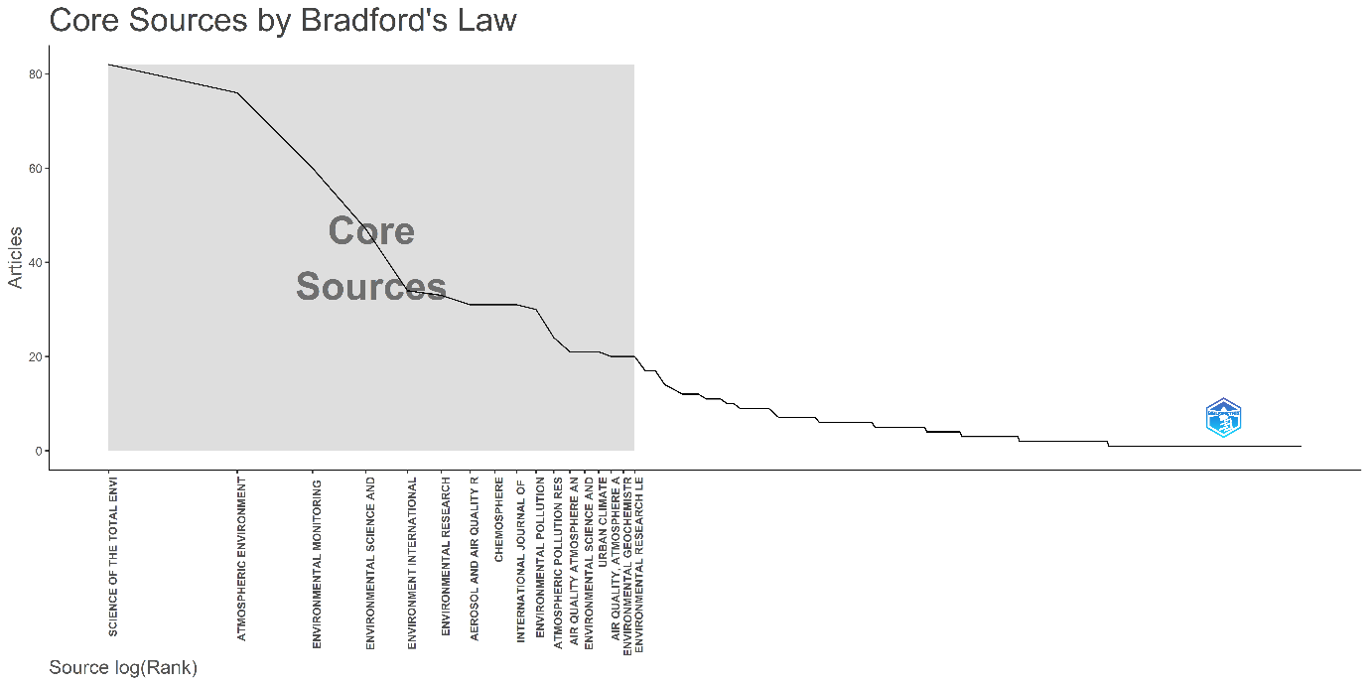
Figure.3 Core Sources by Bradfords law has been prepared using Biblioshiny (Aria and Cuccurullo, 2017).
The Bradford’s Law analysis confirms that a small cluster of journals serves as the intellectual nucleus of air pollution research, shaping the field’s conceptual evolution and methodological standards. This pattern also highlights the increasing institutional alignment of Indian researchers with global publication platforms, reinforcing the growing internationalization of environmental health scholarship in the country.
3.5 Sources’ Local Impact
An evaluation of the local impact of publication sources provides deeper insight into the influence and citation performance of journals that have contributed significantly to air pollution and public health research in India. Among the identified sources, Science of the Total Environment exhibits the highest local impact, with an h-index of 39, 4,526 total citations (TC), and 82 publications (NP) since 1997. Its strong performance highlights the journal’s centrality in publishing multidisciplinary environmental studies addressing pollution exposure and human health impacts.
Atmospheric Environment follows closely with an h-index of 37 and the highest total citations (4,973) among all sources, reflecting its pivotal role in advancing atmospheric modeling, emission analysis, and urban air quality studies. The journal’s sustained contribution since 1999 underscores its status as a cornerstone in the field. Environment International ranks third in impact, with an h-index of 24 and 1,929 citations, emphasizing its prominence as a venue for global-scale health risk assessment and exposure-response studies.
Environmental Monitoring and Assessment (h-index 21, TC 1,756) demonstrates steady contributions since 1999, particularly in research focusing on pollution surveillance, environmental indicators, and regional monitoring systems. Similarly, Environmental Science and Pollution Research, with the same h-index (21) but more recent coverage beginning in 2013, reflects the growing engagement of Indian researchers with this rapidly expanding open-access platform.
Among more specialized journals, Aerosol and Air Quality Research and Environmental Research both show an h-index of 18, with 1,064 and 1,600 citations, respectively. Their inclusion illustrates the increasing interest in aerosol chemistry, toxicology, and exposure pathways. Chemosphere and Environmental Pollution each record an h-index of 17, with over 900 total citations, indicating their significant but more focused influence in pollution toxicology and chemical exposure assessment. Meanwhile, Atmospheric Chemistry and Physics (h-index 16, TC 1,245) reflects the integration of advanced atmospheric modeling and climate-related air quality research into the Indian context.
The analysis reveals that high-impact international journals serve as the principal channels for disseminating Indian air pollution research. The combination of strong citation performance and sustained publication history indicates a well-established and globally recognized research base. These findings reaffirm that India’s scholarly output in air pollution and health studies has increasingly aligned with global scientific standards, both in methodological sophistication and in its visibility across top-tier journals.
3.6 Most Relevant Authors
The analysis of most relevant authors highlights the key researchers who have made substantial contributions to air pollution and public health research in India. The results reveal that the field is characterized by a diverse network of prolific scholars, many of whom have played influential roles in shaping the national research agenda on air quality monitoring, exposure assessment, and health impact analysis.
Among the top contributors, Kumar R leads the list with 70 publications and a fractionalized count of 12.15, reflecting extensive involvement in multi-authored collaborative studies. Close behind, Kumar A has produced 64 articles (fractionalized 13.75), indicating strong research productivity. Similarly, Kumar S and Kumar P, with 41 and 39 publications respectively, represent a new generation of active contributors. Other highly productive researchers include Sharma S and Singh S, each with 38 publications, and Singh A with 37, collectively illustrating the expanding participation of Indian scholars in multi-institutional air quality studies.
The author productivity pattern suggests a core group of experts driving interdisciplinary collaboration across environmental science, public health, and atmospheric research. The recurrence of multiple authors with common surnames such as Kumar, Singh, and Sharma also indicates a widespread research engagement across numerous institutions rather than dominance by a single group. This diversity reflects the broad-based and collaborative nature of air pollution research in India, where scientists from environmental, medical, and policy backgrounds are collectively advancing knowledge toward cleaner air and improved public health outcomes.
3.7 Author Productivity through Lotka’s Law
Lotka’s Law, proposed by Alfred J. Lotka (1926), describes the distribution of scientific productivity among authors. It states that the number of authors producing n papers is inversely proportional to the square of n. The distribution of author productivity, analysed through Lotka’s Law, reveals that the majority of contributors in air pollution and public health research in India have authored only a small number of papers, while a limited group of highly active authors account for a significant share of total publications. The curve shows a steep decline (Fig.4), indicating that a large proportion of authors have written only one or two documents, whereas only a few have produced more than ten.
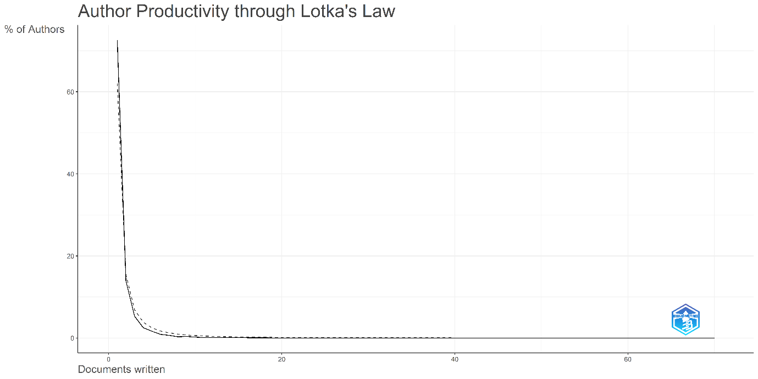
Figure.4 Authors Productivity through Lotkas Law has been prepared using Biblioshiny (Aria and Cuccurullo, 2017).
This pattern conforms closely to Lotka’s classical inverse-square principle of scientific productivity, where the number of authors publishing n papers is approximately proportional to 1/n² of those publishing a single paper. The observed trend demonstrates that the research field is broad-based and inclusive, with contributions from a wide pool of scholars, while a small core group of experts such as those identified in the previous section drives a substantial portion of the cumulative output.
In essence, the Lotka’s Law distribution indicates the collaborative and expanding nature of the field, where numerous occasional contributors support a strong foundation of established researchers, collectively strengthening the knowledge base on air pollution and health impacts in India.
3.8 Most Relevant Affiliations
The institutional analysis identifies leading contributors to air pollution and public health research in India. The Indian Institute of Technology (IIT) System ranks first with 159 publications, followed by the Council of Scientific and Industrial Research (CSIR) with 65 publications. IIT Delhi appears both within the IIT System (64 publications) and as an independent entity (46 publications), highlighting its strong research presence. Other major contributors include the University of Delhi (54 publications) and the Academy of Scientific and Innovative Research (AcSIR) (38 publications). International affiliations such as the University of California (64 publications), Emory University (41 publications), and Harvard University (39 publications) also feature prominently. The institutional distribution highlights a robust collaborative structure linking India’s premier technological and scientific institutions with leading global universities. This pattern reflects a strong foundation of domestic expertise complemented by international cooperation, driving the production of high-quality, policy-relevant research on air pollution and its public health implications.
3.9 Corresponding Author’s Countries
The analysis of corresponding author affiliations provides a clear view of the global productivity and collaboration landscape in air pollution and public health research related to India. The distribution reveals a significant imbalance in scientific output among the top contributing nations. India leads by a considerable margin, followed by the United States and China, while the remaining countries show comparatively lower levels of publication activity. This uneven distribution underscores the fact that while certain countries dominate in terms of total output, their levels of international collaboration vary substantially.
India’s dominance is evident, with 1,005 publications credited to corresponding authors based in the country. However, the Multiple Country Publication (MCP) ratio of only 5.6% indicates that the majority of these studies are conducted through domestic collaborations rather than international partnerships (Fig.5). This pattern suggests that Indian research on air pollution remains primarily nationally driven, possibly reflecting domestic funding priorities, institutional networks, and the applied policy focus of much of this work. While the volume of research is impressive, the relatively low MCP ratio points to a need for broader international collaboration to enhance data integration, methodological exchange, and cross-comparative studies.
The United States, with 220 publications and an MCP ratio of 27.3%, occupies the second position in overall output. This indicates a moderate level of international engagement, consistent with the USA’s established tradition of global research partnerships and its strong institutional capacity in environmental health and atmospheric science. China, ranking third with 88 publications and an MCP ratio of 25%, reflects an upward trajectory both in terms of output and collaboration. China’s growing involvement in joint research projects signals an expanding international footprint and a strategic effort to integrate with the global scientific community addressing transboundary pollution and health impacts.
Several European countries including Germany (57.1%), Netherlands (57.1%), Spain (46.2%), Austria (37.5%), Norway (42.9%), and Canada (35%) exhibit notably high MCP ratios, indicating a strong culture of international collaboration. This pattern can be attributed to EU research frameworks, cross-border funding mechanisms, and a long-standing tradition of interdisciplinary cooperation within European and transatlantic networks. These nations, despite having fewer total publications than India or the USA, contribute significantly to internationally co-authored papers, suggesting a qualitative focus on knowledge exchange and joint capacity building. In contrast, Switzerland (0%) stands as an exception among European contributors, showing no international collaborations in this dataset, possibly due to the self-contained nature of its research projects.
The United Kingdom also exhibits a balanced pattern, with 48 publications and a 31.2% MCP ratio, reflecting both substantial domestic research and strong participation in global collaborative initiatives. Other contributing countries such as Australia, Iran, Japan, Pakistan, Korea, and Singapore display relatively lower publication outputs. Among these, Iran (5.6%) and Pakistan (9.1%) demonstrate collaboration ratios similar to India, highlighting a continued reliance on national research networks with limited external engagement.
The geographic distribution of corresponding authors indicates that while India remains the epicenter of research activity, much of this work is still conducted through domestic institutional frameworks. In contrast, Western and East Asian nations exhibit smaller but more collaboratively integrated research networks. Strengthening India’s participation in international collaborations could therefore enhance data comparability, methodological innovation, and policy relevance in addressing the shared global challenge of air pollution and public health.
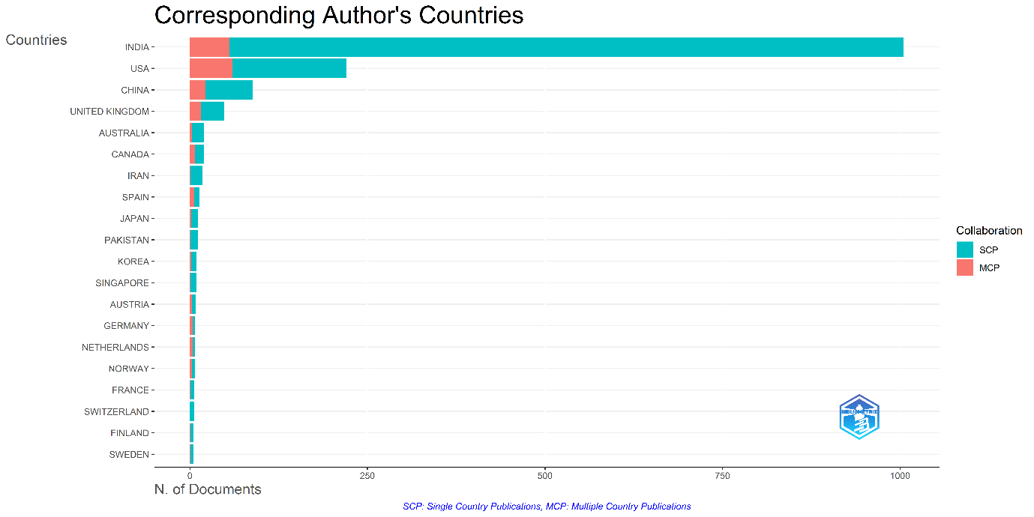
Figure.5 Corresponding Authors Countries has been prepared using Biblioshiny (Aria and Cuccurullo, 2017).
3.10 Countries’ Scientific Production
The distribution of scientific production by country reveals that research on air pollution and public health in India is dominated by a few nations, with India leading by a significant margin. A total of 1,695 publications originate from Indian authors or institutions, reflecting the country’s strong national engagement with environmental health issues. This dominance highlights India’s growing scientific capacity and the prioritization of air quality management and health risk research within its academic and policy frameworks.
The United States ranks second with 646 publications, illustrating its active participation both as a collaborator and as an independent contributor to studies. The strong presence of the USA underscores its long-standing involvement in epidemiological modeling, satellite-based air quality studies, and joint research initiatives with Indian institutions. China, occupying the third position with 206 publications, demonstrates increasing attention toward regional pollution linkages and transboundary air quality dynamics, reflecting a shared environmental concern across Asia.
Among other contributors, the United Kingdom (124), Japan (62), Canada (58), and Australia (44) show consistent engagement, often through multinational research collaborations and comparative analyses involving urban air quality and health outcomes. Iran (44) and Pakistan (28) represent regional participants with emerging research footprints, contributing to the growing South and West Asian research network. Germany (24), though producing fewer publications, is noted for its participation in high-impact collaborative studies.
The pattern of scientific production indicates that while India accounts for the majority of research output, there is a robust network of international contributors supporting comparative and collaborative studies. This distribution reflects both India’s national research leadership and the global scientific community’s recognition of air pollution and health as shared transnational challenges requiring interdisciplinary and international cooperation.
3.11 Most Cited Countries
An analysis of the most cited countries reveals significant variation in the global influence and citation performance of research related to air pollution and public health in India. India ranks first in total citations, with 25,129 citations and an average of 25 citations per article, reflecting its dominance in research volume and growing recognition in international scholarship (Fig.6). However, the relatively modest average citation rate compared to some other nations suggests that while India leads in output, there remains scope for enhancing the global visibility and citation impact of its studies through broader international engagement.
The United States follows with 14,273 total citations and an average of 64.9 citations per article, underscoring its strong influence in shaping the research. The United Kingdom and Germany exhibit particularly high average citation rates 75.5 and 752.1 citations per article, respectively indicating that although their publication counts are lower, their studies tend to be highly influential and widely referenced. The exceptionally high average for Germany reflects the presence of a few landmark collaborative studies that have achieved substantial international recognition.
China also features prominently with 2,438 citations and an average of 27.7 per article, consistent with its growing research engagement. Other countries such as Canada (42.5), Spain (62.6), and Iran (37.6) demonstrate strong citation performance relative to their publication volume. Interestingly, Kenya and Georgia show extraordinarily high average citation rates 733.0 and 312.5 respectively likely due to a small number of highly cited collaborative papers rather than sustained publication activity. These cases highlight how select high-impact studies can significantly elevate a country’s citation profile even with limited output.
The citation analysis reflects a dual structure of influence: countries such as India and the USA dominate through volume and breadth of research, while others like Germany and the UK achieve impact through depth and selectivity. This pattern underscores the diverse modes of scholarly contribution shaping the global understanding of air pollution and its health impacts in the Indian context.
Figure.6 Most Cited Countries has been prepared using Microsoft Excel 2023
3.12 Most Global Cited Documents
The analysis of most cited papers highlights the key studies that have significantly influenced air pollution and public health research. The paper by Lelieveld et al. (2015, Nature), with 4,507 citations, is the most impactful, providing global estimates of mortality linked to ambient air pollution. Troeger et al. (2018, The Lancet Infectious Diseases), cited 1,327 times, examined pollution-related disease burden.
In the Indian context, Mahato et al. (2020, Science of the Total Environment) received 885 citations for analysing air quality changes during the COVID-19 lockdown. Apte et al. (2015, Environmental Science & Technology) (840 citations) and Dandona et al. (2017, The Lancet) (687 citations) contributed to studies on exposure and health outcomes in India. Other notable works include Chakaya et al. (2021), focusing on respiratory health (733 citations), Stracher (2004) on coal combustion (620 citations), and Lelieveld et al. (2019) on atmospheric pollution and mortality (604 citations).
3.19 Most Cited Papers
An analysis of the most cited papers reveals the foundational and highly influential works that have significantly shaped research on air pollution and public health, particularly in the Indian and global context. The paper by Lelieveld et al. (2015, Nature), with 4,507 citations, stands as the most impactful contribution in the dataset. This landmark study quantified the global burden of disease attributable to ambient air pollution, establishing a scientific benchmark for subsequent environmental health assessments.
The second most cited work, Troeger et al. (2018, The Lancet Infectious Diseases), with 1,327 citations, focuses on disease burden estimation and health outcomes linked to air pollution exposure. Similarly, Mahato et al. (2020, Science of the Total Environment), cited 885 times, gained prominence for its timely analysis of air quality improvements during the COVID-19 lockdown in India, highlighting short-term environmental responses to reduced anthropogenic activity.
Other highly cited studies include Apte et al. (2015, Environmental Science & Technology) with 840 citations, which examined air quality and health risks across Indian cities, and Chakaya et al. (2021, International Journal of Infectious Diseases), with 733 citations, emphasizing respiratory infections and environmental determinants.
Dandona et al. (2017, The Lancet), cited 687 times, contributes to the Global Burden of Disease (GBD) framework, providing detailed evidence on India’s air pollution-related health challenges. Stracher (2004, International Journal of Coal Geology), with 620 citations, explores coal combustion and its environmental effects, while Alberg et al. (2013, Chest) and Lelieveld et al. (2019, Proceedings of the National Academy of Sciences) continue this focus on airborne pollutants and mortality. Finally, Troeger et al. (2017, The Lancet Infectious Diseases), with 598 citations, adds further depth to the epidemiological assessment of pollution-linked diseases.
Collectively, these works form the intellectual backbone of the research field, spanning global burden estimation, pollutant characterization, epidemiological modeling, and policy-relevant environmental analyses. Their continued citation frequency underscores their lasting influence on scientific inquiry and environmental health policymaking in India and beyond.
3.12 Most Frequent Words
The analysis of word frequency provides insight into the dominant research themes and conceptual emphasis within the literature on air pollution and public health in India. The most recurrent term, “India” (870 occurrences), reflects the strong geographical and national focus of the research corpus (Fig.7), emphasizing the country-specific nature of studies dealing with urban air quality, emission patterns, and health impacts.
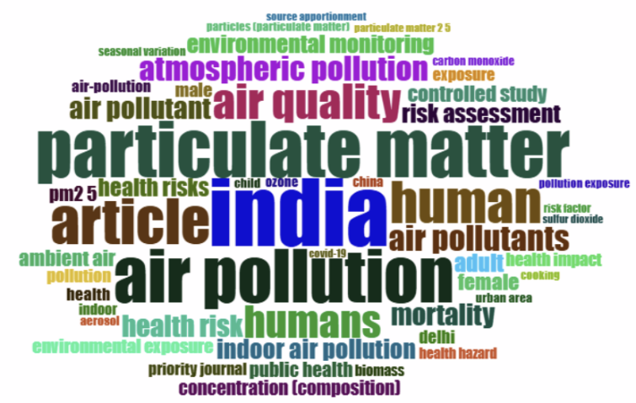
The prominence of “particulate matter” (718 occurrences) and “air pollution” (684 occurrences) confirms that PM₂.₅ and PM₁₀ remain central to both environmental and health-oriented investigations. These terms underscore the predominance of studies focused on exposure assessment, concentration trends, and disease burden estimation. Similarly, frequent appearance of “air quality” (455 occurrences) points to sustained interest in monitoring, standards compliance, and spatial variation analysis across Indian cities and regions.
Figure.7 Most Frequent word has been prepared using Biblioshiny (Aria and Cuccurullo, 2017).
The repeated use of “human” (539) and “humans” (418) highlights the health-centric dimension of the literature, indicating a strong alignment between environmental science and public health research. This is further supported by the occurrence of “air pollutants” (331), “atmospheric pollution” (320), and “air pollutant” (283), suggesting an emphasis on pollutant-specific studies involving chemical composition, sources, and exposure-response relationships.
Collectively, these frequently used terms reveal that the field is dominated by empirical, health-focused, and India-centered research, with particulate pollution emerging as the unifying theme. The prevalence of human-centered keywords also indicates that air pollution is increasingly being framed not merely as an environmental problem but as a critical determinant of population health and quality of life.
3.13 Trend Topics
The temporal evolution of research themes, as revealed by the trend topics analysis, illustrates how the focus of air pollution and public health research in India has changed over time. Based on keyword frequency from the merged Web of Science and Scopus datasets, the visualization captures a dynamic shift in scholarly priorities, moving from broader environmental perspectives to more specific, data-driven, and health-oriented research areas. While the absence of cited reference data limits impact assessment, the patterns observed nonetheless provide a clear indication of thematic evolution within the field.
Overall, three major phases can be distinguished. The most recent or emerging trends, visible from 2018 onward, revolve around particulate matter (PM₂.₅), COVID-19, deep learning, and water pollutants. The surge in PM₂.₅-related studies reflects the intensifying global and national concern over fine particulate exposure and its implications for mortality, morbidity, and urban air quality management. The appearance of COVID-19 as a keyword in the latest years underscores the significant realignment of research priorities prompted by the pandemic, which spurred extensive inquiry into the interactions between air quality, respiratory health, and viral transmission dynamics. The concurrent rise of deep learning signals the growing incorporation of artificial intelligence and machine learning methods into environmental health research, particularly for pollution prediction, spatial modeling, and data-driven decision-making.
The mid-range trends, spanning approximately 2010 to 2018, are characterized by increased attention to indoor air pollution, smoke, air pollution, health risks, and adult health. During this period, the literature expanded significantly in both scope and depth, reflecting an awareness of household air pollution as a major contributor to disease burden in India and other developing regions. Keywords such as “China,” “India,” and “human” gained prominence, highlighting a comparative and population-based approach to environmental health studies. This phase also witnessed an upsurge in interdisciplinary research connecting epidemiology, environmental science, and public policy.
The earlier period, before 2010, was dominated by broader and foundational topics such as environmental degradation, medical geography, Asia, and developing countries. These themes reflect the formative stage of research, when air pollution was primarily addressed as part of the wider discourse on environmental change and socio-economic development. The emphasis during this time was on regional characterization and conceptual linkages rather than on specific pollutants or health endpoints, setting the groundwork for more targeted research in subsequent decades.
A closer look at thematic transitions reveals a clear shift from generalized environmental perspectives to focused, issue-driven investigations. Terms like environmental degradation and medical geography have gradually given way to PM₂.₅, health risks, and COVID-19, reflecting the growing urgency of addressing immediate public health challenges. The rise of deep learning and other computational keywords further illustrates the methodological evolution of the field from reliance on statistical analysis and basic modeling to the adoption of advanced AI-driven analytical frameworks. This shift signifies the increasing integration of data science, environmental monitoring, and public health research in recent years.
The trend analysis also highlights the geographic orientation of the research landscape. Frequent occurrences of Asia, South Asia, China, and India confirm a strong regional focus, shaped by the severe air pollution challenges faced by these areas. Moreover, the progression of keywords points toward an increasingly interdisciplinary character, where environmental, medical, and technological domains intersect to address complex and evolving challenges.
In summary, the trend topics analysis reveals a clear transformation in the intellectual trajectory of air pollution and public health research. The field has evolved from exploratory environmental studies into a sophisticated, technology-assisted, and health-centered research domain. This progression reflects not only changing global and regional priorities but also the growing methodological maturity and interdisciplinary depth of Indian and international contributions in this area.
3.14 Co-occurrence Network
The keyword co-occurrence network provides a structural representation of the conceptual organization within the literature on air pollution and public health research in India. The network was developed using a merged dataset from Web of Science (WoS) and Scopus, offering a broad and comprehensive view of the research landscape. Although the absence of cited reference data limits citation-based interpretation, the co-occurrence structure itself effectively reveals thematic linkages and knowledge communities within the field.
The network was constructed using all keywords extracted from article titles and abstracts, with normalization based on association strength. This normalization ensures that the connections (edges) between keywords represent the relative strength of co-occurrence, rather than simple frequency counts. Clustering was performed using the Walktrap algorithm, which detects communities of keywords that co-occur frequently within the same body of literature. Each colour in the visualization represents a distinct research community or thematic cluster(Fig.8), while parameters such as node size, edge weight, and transparency (alpha) were optimized to enhance interpretability. Larger nodes denote highly connected keywords those central to multiple research themes whereas thicker edges indicate stronger conceptual associations.
The overall structure of the network reveals a moderately dense configuration, dominated by a central interconnected cluster and one secondary but distinct sub-cluster. The primary (red) cluster occupies the core of the network, indicating that the majority of research shares a common conceptual foundation, while smaller peripheral nodes reflect more specialized or emerging themes.
The red cluster, located at the center-right of the network, represents the dominant thematic core of the field. It revolves around the terms “air pollution,” “particulate matter,” and “India,” which serve as the principal nodes connecting to related concepts such as air quality, health impact, air pollutants, atmospheric pollution, and particulate matter 2.5 (PM₂.₅). This cluster highlights the focus on ambient air pollution, pollutant characterization, and health impact assessment, particularly within the Indian context. The inclusion of terms like health risk, mortality, and exposure suggests a strong emphasis on epidemiological and risk-based studies, while the appearance of source apportionment indicates research aimed at identifying pollution sources. The presence of COVID-19 in this cluster reflects a recent thematic expansion, as scholars examined the interactions between air quality and pandemic-related health dynamics.
The green cluster, positioned toward the lower portion of the network, concentrates on indoor and household air pollution and its effects on human health. Key terms such as human, humans, indoor, biomass, cooking, risk factor, adult, child, female, and male indicate a strong focus on exposure studies and demographic-specific health assessments. The appearance of controlled study implies that this cluster includes intervention-based or experimental research, often exploring cooking smoke and biomass fuel combustion as primary sources of indoor pollution. This theme highlights the continued significance of household energy use and gendered exposure patterns in India’s air pollution burden, with particular implications for rural and peri-urban populations.
A smaller number of blue nodes appear more isolated from the main network, representing keywords such as air-pollution and PM₂.₅ that are treated independently in certain publications. Their separation suggests either early works that examined these topics in isolation or studies focusing narrowly on pollutant measurement without explicit health linkages. Although less connected, these nodes provide important historical context, illustrating the evolution from pollutant-centric to health-integrated research frameworks.
At the conceptual level, several highly connected nodes stand out as key anchors of the network. The prominence of “India” confirms the strong geographic concentration of the research corpus, while “air pollution” and “particulate matter” represent the core conceptual axis around which most studies are organized. The frequent appearance of “human” and “article” further reinforces that the literature is heavily centered on human health outcomes, rather than purely environmental monitoring.
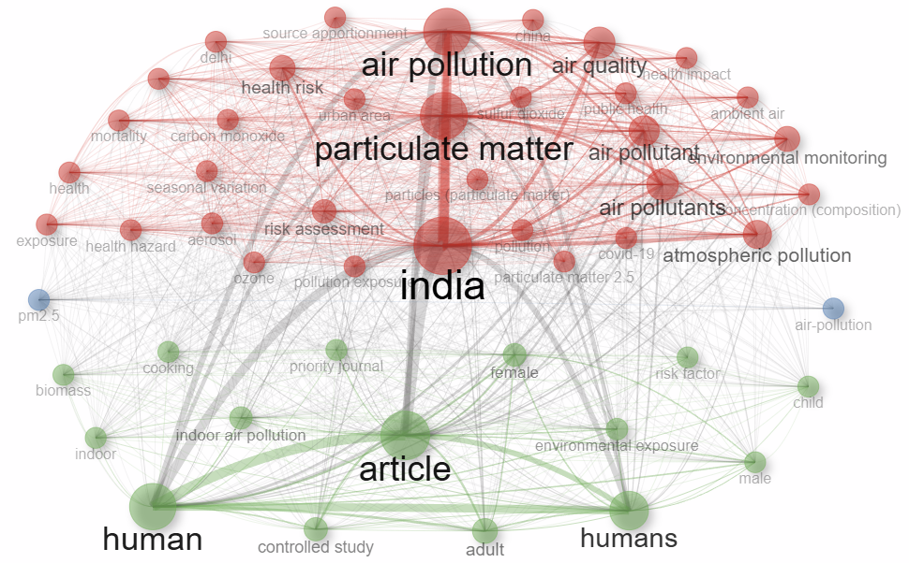
Figure.8 Co Occurrence Network of Keywords has been prepared using Biblioshiny (Aria and Cuccurullo, 2017).
The co-occurrence network reveals a mature and thematically cohesive research field, dominated by interrelated studies on ambient and indoor air pollution, exposure, and health effects. The dense connections among air quality, particulate matter, and health risk indicate an integrated research approach that combines environmental monitoring with epidemiological modeling. Meanwhile, the existence of separate clusters for indoor pollution and demographic health studies underscores the diversity of research perspectives addressing different exposure environments.
The co-occurrence analysis demonstrates that the Indian research landscape on air pollution is both health-oriented and regionally grounded, with expanding methodological diversity and thematic convergence. Future research could build on this foundation by fostering stronger interdisciplinary integration linking environmental monitoring, public health data, and computational modeling to provide more comprehensive insights into pollution’s health impacts across varied socio-economic and geographic contexts.
3.15 Thematic Map
The strategic thematic map provides a comprehensive visualization of the conceptual structure and maturity of research on air pollution and public health in India, derived from the keyword co-occurrence network. Each cluster on the map represents a distinct research theme, positioned according to two key bibliometric parameters centrality and density. The X-axis (centrality) reflects a theme’s importance or influence within the overall research network, while the Y-axis (density) indicates the internal development and coherence of that theme.
Based on these parameters, the map is divided into four quadrants, each corresponding to a different category of themes (Fig.9). Motor themes (upper-right quadrant) are both highly central and well-developed, representing the intellectual engines driving the field. Basic themes (lower-right quadrant) are conceptually central but still developing, often serving as foundational areas requiring deeper exploration. Niche themes (upper-left quadrant) are well-defined and specialized but less connected to the broader research landscape; while emerging or declining themes (lower-left quadrant) represent either newly evolving topics or areas losing academic momentum.
The motor theme identified in this analysis is health risk, located in the upper-right quadrant. This theme represents the most developed and influential research direction, integrating studies on risk assessment, environmental monitoring, and exposure evaluation. The consistent appearance of keywords such as health risk, risk assessment, and environmental monitoring reflects a strong emphasis on evaluating the adverse health effects of air pollutants and developing methodological tools for quantifying these risks. As a core area of research, the health risk cluster continues to evolve, shaping both scientific understanding and policy interventions in environmental health.
In the basic theme category, India emerges as a central yet still-developing area positioned in the lower-right quadrant. The frequent association of the keywords India, air pollution, and article indicates that India is the geographic and contextual nucleus of the field. Research under this theme typically examines urban air quality, pollution exposure, and public health outcomes in the Indian context, often emphasizing region-specific challenges and policy implications. Although well-integrated into the broader literature, this theme continues to expand, suggesting opportunities for greater methodological depth and comparative regional studies.
At the center of the map lies particulate matter, which serves as the core and integrative theme of the entire research network. Bridging both axes, this cluster is characterized by high centrality and moderate-to-high density, reflecting its multidimensional relevance across atmospheric science, health risk assessment, and environmental policy. The frequent co-occurrence of terms such as particulate matter, air quality, and atmospheric pollution underscores the prominence of PM-related studies as the foundation of contemporary air pollution research. Its position at the heart of the map highlights its role as the conceptual anchor connecting nearly all other thematic areas.
The niche theme, represented by indoor air pollution, is situated in the upper-left quadrant. This cluster is characterized by strong internal development but limited linkage to the wider research network. The dominant keywords indoor air pollution, adult, and female suggest a specialized focus on household exposure, gendered health impacts, and biomass fuel combustion. Research in this theme often examines vulnerable populations, particularly women and children, and investigates the effects of cooking smoke and solid fuel use on respiratory and cardiovascular health. Despite its relatively isolated position, this area remains crucial for understanding the indoor component of India’s air pollution burden and holds potential for stronger integration with the broader “health risk” cluster.
The PM₂.₅ cluster occupies the lower-left quadrant, representing an emerging or transitional theme. Although PM₂.₅ is one of the most frequently discussed pollutants in recent years, the theme currently exhibits low centrality and density, indicating that it is either in a phase of thematic consolidation or transitioning toward integration with the main particulate matter cluster. The associated keywords PM₂.₅, air pollution, and PM₁₀ highlight a focus on fine particulate exposure, measurement techniques, and source-specific analyses. As data availability and modeling technologies continue to advance, this theme is expected to become more prominent and interconnected within the overall research structure.
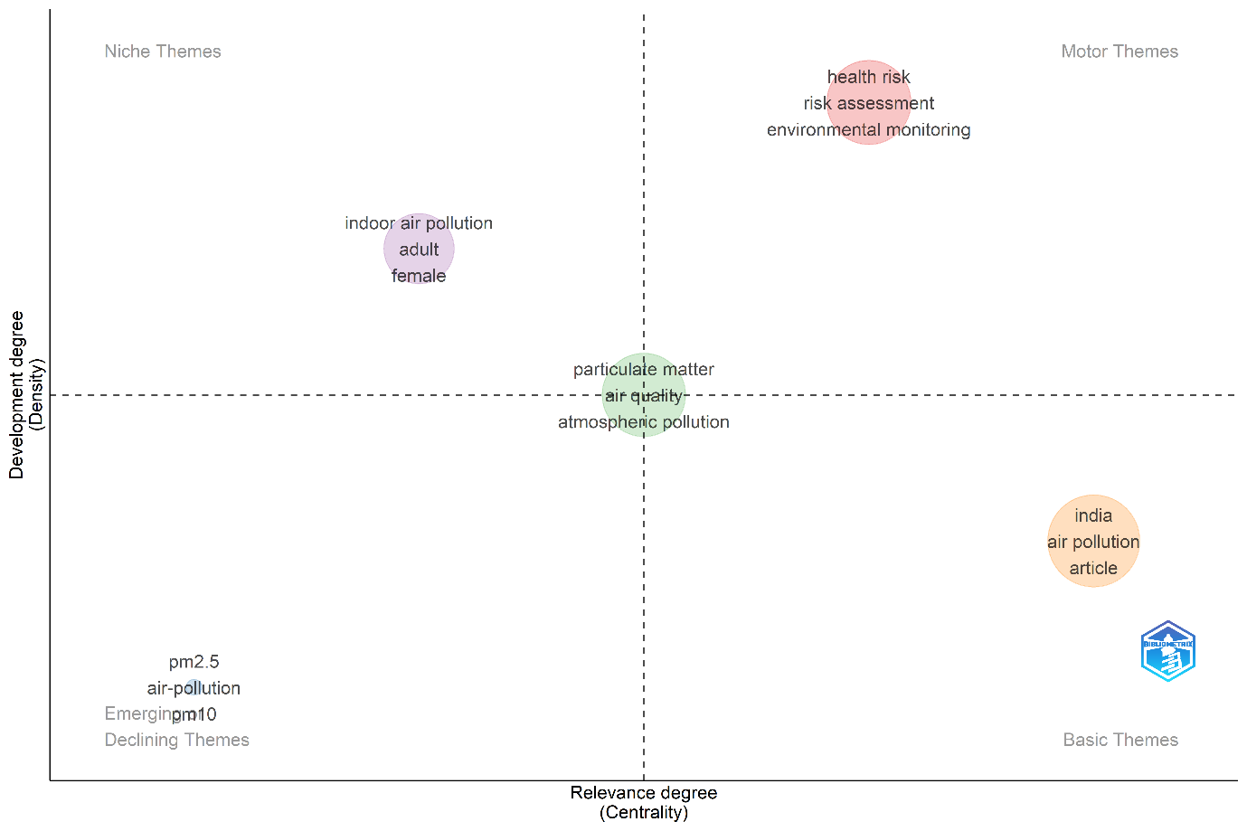
Figure.9 Thematic Map has been prepared using Biblioshiny (Aria and Cuccurullo, 2017).
The thematic map delineates a well-organized research landscape characterized by both maturity and diversification. Health risk and particulate matter form the intellectual and conceptual core of the field, while India-centered studies provide the geographical context for much of the research. Indoor air pollution emerges as a highly specialized yet policy-relevant niche, and PM₂.₅ studies signify an evolving frontier poised for further development. This thematic configuration underscores the interdisciplinary and dynamic nature of air pollution and public health research in India, offering clear pathways for future exploration particularly in integrating indoor and ambient air quality studies and enhancing methodological innovation in exposure and risk analysis.
3.16 Thematic Evolution
The thematic evolution analysis provides a longitudinal perspective on how the research focus in air pollution and public health studies in India has evolved over the past three decades. Using a merged dataset from Web of Science (WoS) and Scopus, the analysis traces how key topics have emerged, matured, or declined over successive time periods. The use of single-word keywords (ngrams: 1) without stemming introduces further variability, as different forms of the same concept (e.g., “pollute” vs. “pollution”) are treated as distinct entities. Despite these caveats, the thematic evolution map offers valuable insight into the intellectual trajectory and conceptual development of the field.
In the early phase (1990–1999), research on air pollution was characterized by broad and exploratory themes. Keywords such as “article,” “demography,” “environmental impact,” “gas emissions,” “indoor,” and “medical geography” dominated this period, reflecting the formative stage of the field (Fig.10). The focus was primarily on understanding environmental degradation, emission patterns, and their general implications for population and regional health. Themes like “developing country” and “India” indicate that even in this initial phase, the regional context of developing economies was an important framing device for the literature. However, the research landscape was relatively diffuse, lacking the specificity that would characterize later decades.
During the second period (2000–2009), the field began to exhibit greater conceptual and methodological refinement. The emergence of keywords such as “air analysis,” “air quality index,” “airborne pollutants,” “benzo(a)pyrene,” “tropospheric ozone,” “sulfate,” and “pollution” marked a shift from general environmental concerns to pollutant-specific studies. The increasing prominence of “human” and “India” highlighted the beginning of a transition toward population-focused health research and national-scale monitoring initiatives. This period also saw the introduction of quantitative approaches to measure pollution exposure and concentration-response relationships, establishing the methodological foundations for the subsequent decade.
The third period (2010–2019) represents a major phase of thematic consolidation and expansion. The keywords “India,” “particulate matter,” “air pollution,” and “PM₂.₅” dominated the research landscape, indicating a decisive shift toward fine particulate matter studies and health risk assessment. The concentration of studies in this period reflects growing awareness of urban air quality crises, particularly in major Indian cities, and the integration of epidemiological and geospatial approaches. Themes such as “human” and “health risk” gained prominence, demonstrating a closer alignment between environmental science and public health disciplines. This period also witnessed an increase in comparative and transnational research collaborations, as global institutions began addressing India’s pollution challenge within broader regional frameworks.
The most recent period (2020–2024) is marked by both continuity and innovation. Core themes such as “India,” “particulate matter,” and “air pollution” remain dominant, underscoring their enduring relevance as motor themes in the field. However, new topics like “indoor air pollution,” “mortality,” “risk assessment,” and “COVID-19” have emerged, reflecting a heightened focus on health outcomes and risk quantification. The appearance of “PM₂.₅” as a recurring but lower-centrality theme suggests a maturing area of inquiry that is transitioning toward integration with broader air quality and health frameworks. The inclusion of pandemic-related studies also indicates the field’s responsiveness to contemporary global challenges, with researchers investigating the interactions between air quality, respiratory health, and infectious disease dynamics.
Across these four temporal phases, the strategic thematic maps reveal that early research (1990–1999) was dominated by broad and foundational themes like “air pollution,” “India,” and “developing country,” functioning as initial motor themes. During the 2000s, the field diversified into pollutant-specific and methodological clusters, particularly focusing on “PM₁₀,” “sulphate,” and “air quality index.” By the 2010s, these evolved into central and mature themes, with “India,” “particulate matter,” and “air pollution” forming the core of the research network. The 2020s introduced new layers of complexity, as themes like “health risk,” “risk assessment,” and “mortality” emerged as the leading edge of inquiry, while topics such as “PM₂.₅” oscillated between emerging and consolidating positions.
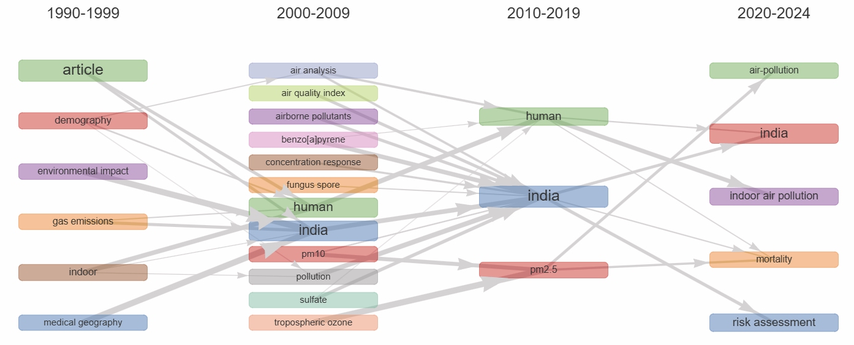
Figure.10 Thematic Evolution has been prepared using Biblioshiny (Aria and Cuccurullo, 2017).
Taken together, the thematic evolution reflects a clear trajectory from general environmental investigation toward specialized, health-centered, and data-driven research. The field has evolved from early descriptive studies of pollution and population impacts to sophisticated analyses integrating epidemiology, atmospheric modeling, and risk assessment. The consistent presence of “India” across all phases underscores its role as both a geographical anchor and a global research focus within the air pollution literature. Furthermore, the growing prominence of health outcomes and risk assessment in recent years illustrates the increasing policy relevance and interdisciplinary depth of the field.
The thematic evolution analysis demonstrates how research on air pollution and public health in India has matured from broad environmental awareness (1990s) to pollutant-specific focus (2000s), population-centered health assessments (2010s), and finally to risk evaluation and integrated health frameworks (2020s). This chronological progression signifies not only the intellectual development of the field but also its responsiveness to emerging public health challenges and technological innovations. Continued research integrating indoor and outdoor pollution dynamics, health risk modeling, and AI-based exposure analysis is likely to define the next stage of this evolving research domain.
3.17 Factorial Analysis
The factorial analysis, based on Multiple Correspondence Analysis (MCA) of merged keywords from the Web of Science (WoS) and Scopus datasets, provides a multidimensional view of the conceptual structure of air pollution and public health research in India. By examining the spatial distribution of keywords within the factorial space, this analysis identifies key research themes, their relationships, and the conceptual boundaries that define the field. The map was constructed using a minimum degree threshold of 109 to ensure that only the most significant and frequently co-occurring terms were included, thereby capturing the dominant intellectual structure of the research corpus.
The overall structure of the factorial map reveals two principal dimensions that together explain the majority of variance in the data. Dimension 1 (79.56%) captures the primary axis of thematic differentiation, while Dimension 2 (14.17%) represents a secondary but meaningful layer of conceptual variation (Fig.11). The high explanatory power of the first dimension indicates a clear and dominant thematic separation across the field. The spatial arrangement of keywords reflects their degree of co-occurrence terms positioned closer together are more likely to appear within the same publications, signifying strong conceptual or methodological associations.
Four distinct clusters emerge from the factorial configuration, each representing a specific thematic domain within the broader air pollution research landscape.
The first cluster, located in the top-left quadrant, represents the theme of indoor environment and demographics. This area is characterized by keywords such as female, cooking, adult, indoor, child, and biomass, collectively indicating a body of research focused on indoor air quality and household exposure patterns. The emphasis on biomass fuel use and cooking activities highlights studies addressing household energy practices and their health implications, particularly for women and children—the most vulnerable demographic groups in rural and peri-urban areas. The inclusion of human and article underscores that these investigations often rely on empirical and epidemiological methods, emphasizing human-centered health outcomes. This cluster represents a well-established line of research on household air pollution and demographic health disparities.
The second cluster, extending across the right side of the map, captures the dominant theme of outdoor air pollution. Key terms such as air-pollution, PM₂.₅, mortality, exposure, pollution, COVID-19, and source apportionment define this region of the factorial space. This cluster reflects studies that focus on ambient air quality, pollutant concentrations, and exposure-related mortality. The inclusion of COVID-19 signifies a recent thematic extension, highlighting how the pandemic reshaped environmental health research by linking air pollution exposure to viral transmission dynamics and respiratory vulnerability. The presence of source apportionment further indicates growing interest in identifying and quantifying pollutant sources, aligning with policy-oriented studies aimed at mitigating urban air quality problems. Collectively, this cluster represents the mainstream research trajectory in India’s air pollution scholarship centered on PM₂.₅, health risks, and urban exposure modeling.
The third cluster, positioned near the bottom center, reflects a strong regional and contextual focus, particularly on India and Delhi. Keywords such as India, Delhi, air quality, atmospheric pollution, particulate matter, health, and public health dominate this region, indicating a significant body of literature devoted to the spatial and temporal analysis of pollution within Indian metropolitan areas. The recurrence of Delhi highlights its role as a symbolic and empirical epicenter of India’s air pollution crisis, with studies frequently investigating seasonal variation, pollutant accumulation, and health outcomes in the city. This cluster demonstrates how regional specificity shapes the scientific narrative Delhi serving as both a case study and a benchmark for broader discussions on urban environmental governance and health policy.
The fourth cluster, located in the bottom-left quadrant, represents the theme of risk assessment and environmental monitoring. This area includes terms such as air pollutants, environmental monitoring, risk assessment, carbon monoxide, and urban area. The cluster’s proximity to the India–Delhi grouping indicates a thematic overlap, suggesting that many risk assessment and monitoring studies are geographically concentrated in major Indian cities. This research stream emphasizes quantitative measurement, environmental surveillance, and urban-scale modeling key methodological pillars for assessing the impact of air pollutants on population health and exposure variability.
From a structural perspective, the keywords furthest from the origin contribute most strongly to defining the dimensions of the factorial space. Notably, “air-pollution” and “female” anchor the opposing ends of the two main dimensions. This contrast reflects a conceptual polarity between outdoor, population-level studies and indoor, gendered exposure research. The first dimension (Dim 1) thus differentiates ambient pollution and mortality-oriented studies from household exposure and demographic-focused investigations, while the second dimension (Dim 2) introduces variation based on methodological orientation and subject specificity.
The analysis provides a holistic representation of the thematic structure of air pollution research in India. It demonstrates that the field is organized around two dominant axes: (1) the type of environment indoor versus outdoor pollution, and (2) the focus of inquiry population-level risk assessment versus demographic health exposure. The presence of well-defined clusters suggests that the research domain is both diversified and interconnected, with emerging cross-links between traditionally distinct themes, such as household air quality and urban pollution modeling.
The factorial analysis underscores the dual character of India’s air pollution research landscape anchored between human-centered indoor studies and environmental health-oriented outdoor analyses. This balance reflects the field’s interdisciplinary nature, bridging public health, atmospheric science, and social demography. As the literature continues to expand, future research could benefit from integrating these dimensions through comparative, multi-scalar studies that examine how indoor and outdoor pollution interact across different social and spatial contexts. Such an approach would not only advance theoretical understanding but also strengthen the empirical basis for policy design and intervention planning in India’s ongoing battle against air pollution.
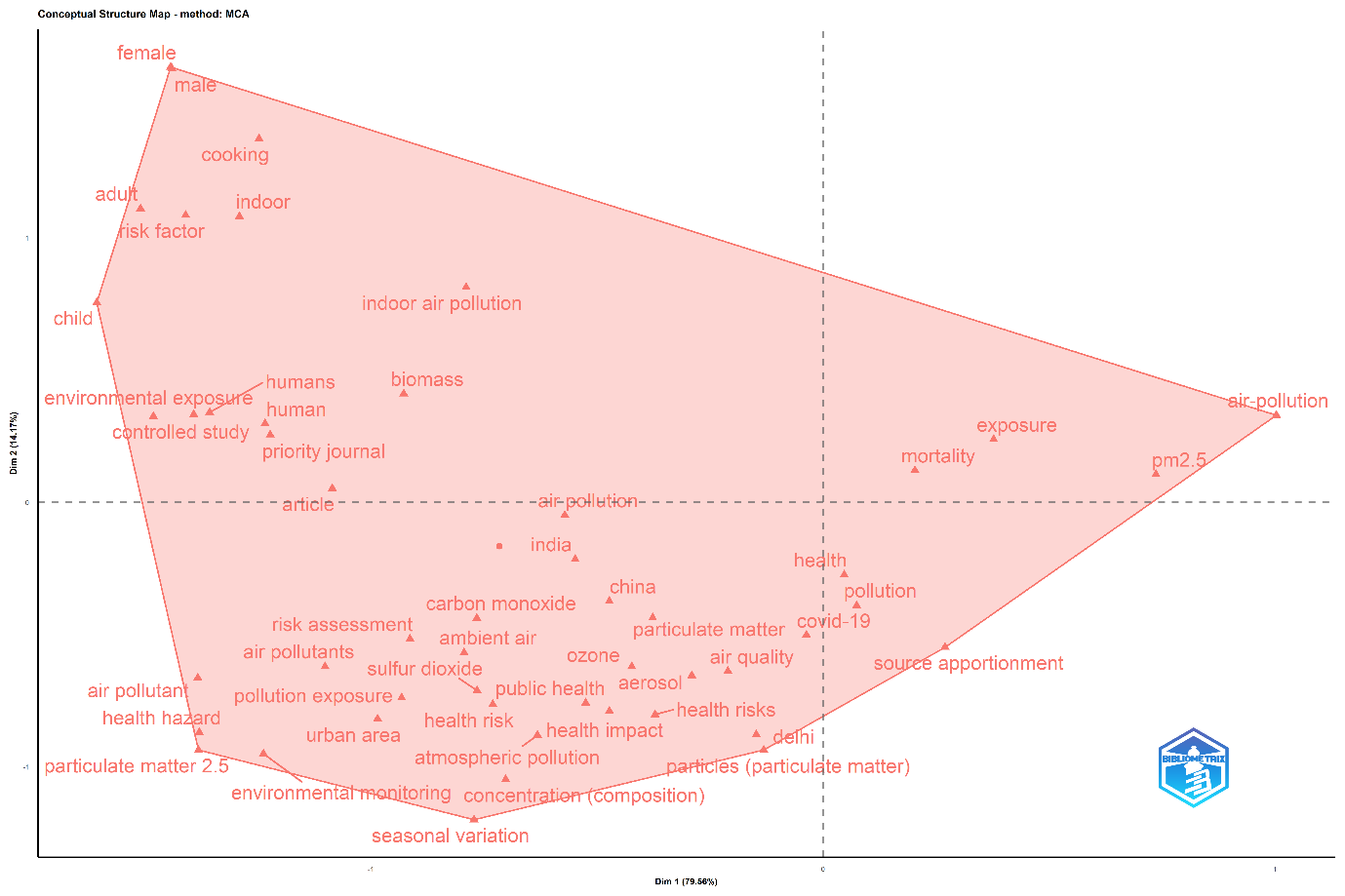
Figure.11 Factorial Analysis has been prepared using Biblioshiny (Aria and Cuccurullo, 2017).
3.18 Collaboration Network of Countries
The international collaboration network highlights how countries engage in joint research on air pollution and public health, revealing regional patterns and key hubs of activity. The network shows distinct clusters (communities) identified using the Walktrap algorithm, with node size representing centrality and edge thickness indicating collaboration strength.
The red community is the largest and most active, centered on India, which collaborates frequently with the USA, United Kingdom, Germany, Korea, Canada, Australia, and several European and Asian countries (Fig.12). India’s position at the network’s core underscores its key role as a global research hub, with dense interconnections reflecting strong international engagement. The green community includes African and developing nations such as Nigeria, Malawi, and Egypt, along with Brazil, Colombia, Ireland, and Bangladesh. This cluster likely reflects South–South and development-focused collaborations on environmental health and sustainability.
The blue community comprises Nordic countries (Finland, Sweden, Norway) alongside South Africa, Nepal, the Czech Republic, and Chile, suggesting multiregional cooperation in climate and air quality research. The purple community, represented primarily by Turkey, appears more isolated, indicating limited collaboration or connections outside the main research clusters.
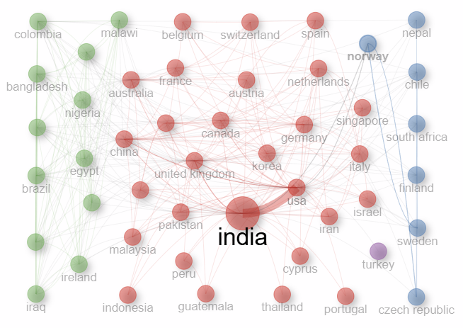
The network reveals a globally connected but regionally structured research system. India stands out as the central hub, linking developed and developing nations, while other clusters highlight emerging regional alliances. Strengthening collaboration among peripheral countries could further enhance global research cohesion and knowledge sharing in air pollution and health studies.
Figure.12 Collaboration Network of countries has been prepared using Biblioshiny (Aria and Cuccurullo, 2017).
4. Limitations
The main limitations of this bibliometric study include its reliance on data from the Web of Science and Scopus databases, which may exclude relevant publications indexed elsewhere. Additionally, variations in keyword usage and author affiliations could lead to overlaps or omissions in thematic mapping. The absence of cited reference data limits deeper citation-based insights, while the focus on English-language publications may underrepresent regional research contributions.
5. Conclusion
The steady growth in research output from 1990 to 2024 highlights India’s growing recognition of air pollution as a major public health issue. The dominance of India in publication output highlights its strong national commitment to addressing air pollution and public health challenges. However, the continued need for broader international collaborations remains essential to enhance comparative insights, integrate diverse methodologies, and develop globally relevant solutions. The keyword co-occurrence analysis shows that research on air pollution and public health in India is well-developed and health-focused, with “air pollution,” “particulate matter,” and “India” as core themes. A secondary cluster highlights indoor pollution and demographic-specific studies. The thematic evolution shows a clear shift from general environmental studies to health-focused and risk-oriented research. Future studies should integrate indoor–outdoor pollution dynamics and AI-driven modeling to strengthen evidence-based policymaking. This bibliometric study maps the evolution, trends, and collaborations in this field, emphasizing India’s central role and the global relevance of its research efforts.
6. Implication and Future directions
The findings of this study have important implications for guiding future research and policy development in India. The growing body of literature highlights the need to strengthen interdisciplinary collaboration between environmental science, public health, and data analytics. Future research should focus on integrating indoor and outdoor air pollution studies, employing advanced modelling and AI-driven tools for exposure and health risk assessment, and expanding longitudinal and intervention-based studies. Strengthening international collaborations and incorporating localized data can further enhance evidence-based policymaking and support sustainable strategies to mitigate the public health impacts of air pollution.
Declaration of Interest Statement
Ethics Approval
This study is based solely on secondary bibliometric data extracted from publicly accessible academic databases and does not involve human subjects or personal information. Therefore, ethical approval and informed consent were not required, and the study adheres to accepted standards for research using secondary data.
Availability of Data and Materials
All bibliometric data used in this study were retrieved from the Scopus and web of science database. Data can be accessed by individuals or institutions with appropriate database subscription rights. Processed datasets and analytical scripts will be made available by the authors upon reasonable request.
Ethics Approval and Consent to Participate
This research did not involve human participants, and no primary data collection was undertaken. As the study analyses secondary bibliographic sources, ethical approval and participant consent were not required.
References
Adarsh T., and Haneena Sulthana K.P. (2025). Trends and insights in Nature-Based Solutions: bibliometric study. International Journal of Disaster Studies and Climate Resilience 1(1):22–34. https://doi.org/10.64866/j.ijdscr.2025.10003
Aria, M., & Cuccurullo, C. (2017). Bibliometrix: An R-tool for comprehensive science mapping analysis. Journal of Infometrics, 11(4), 959–975. https://doi.org/10.1016/j.joi.2017.08.007
Bai, M., Zhang, J., Chen, D., Lu, M., Li, J., Zhang, Z., … & Niu, X. (2023). Insights into research on myocardial ischemia/reperfusion injury from 2012 to 2021: a bibliometric analysis. European Journal of Medical Research, 28(1). https://doi.org/10.1186/s40001-022-00967-7
Bradford, S. C. (1934). Sources of information on specific subjects. Engineering: An Illustrated Weekly Journal, 137, 85–86. https://cir.nii.ac.jp/crid/1570854175272181632
Central Pollution Control Board. (2014). National Air Quality Index. Ministry of Environment, Forests and Climate Change, Government of India. http://cpcb.nic.in/AQI-FINAL-BOOK.pdf
Cohen, A. J., Brauer, M., Burnett, R., Anderson, H. R., Frostad, J., Estep, K., ... & Forouzanfar, M. H. (2017). Estimates and 25-year trends of the global burden of disease attributable to ambient air pollution: An analysis of data from the Global Burden of Diseases Study 2015. The Lancet, 389(10082), 1907–1918. https://doi.org/10.1016/S0140-6736(17)30505-6
Donthu, N., Kumar, S., Mukherjee, D., Pandey, N., & Lim, W. M. (2021). How to conduct a bibliometric analysis: An overview and guidelines. Journal of Business Research, 133, 285–296. https://doi.org/10.1016/j.jbusres.2021.04.070
Fann, N., Lamson, A., Anenberg, S., Wesson, K., Risley, D., & Hubbell, B. (2011). Estimating the national public health burden associated with exposure to ambient pm2.5 and ozone. Risk Analysis, 32(1), 81-95. https://doi.org/10.1111/j.1539-6924.2011.01630.x
Greenstone, M., Ganguly, T., Hasenkopf, C., Sharma, N., & Gautam, H. C. (2024). The Air Quality Life Index® 2024 Annual Update – India View. EPIC-India. https://aqli.epic.uchicago.edu/wp-content/uploads/2024/08/AQLI-2024-Report_English.pdf
Gurjar, B. R., Jain, A., Sharma, A., Agarwal, A., Gupta, P., Nagpure, A. S., & Lelieveld, J. (2016). Human health risks in megacities due to air pollution. Atmospheric Environment, 142, 475–495. https://doi.org/10.1016/j.atmosenv.2010.08.011
Hamidah, I., Pawinanto, R., Mulyanti, B., & Yunas, J. (2021). A bibliometric analysis of micro electro mechanical system energy harvester research. Heliyon, 7(3), e06406. https://doi.org/10.1016/j.heliyon.2021.e06406
IQAir. (2025). World air quality report 2024. IQAir. https://www.iqair.com/world-most-polluted-countries https://www.iqair.com/world-most-polluted-countries
Kalsoom, G. and Zámečník, R. (2023). Servant leadership knowledge structures: a bibliometric review. ECMLG, 19(1), 471-479. https://doi.org/10.34190/ecmlg.19.1.1674

Kindig, D., & Stoddart, G. (2003). What is population health? American Journal of Public Health, 93(3), 380–383. https://doi.org/10.2105/AJPH.93.3.380

Lotka, A. J. (1926). The frequency distribution of scientific productivity. Journal of the Washington Academy of Sciences, 16(12), 317–323. http://www.jstor.org/stable/24529203

Lou, J., et al. (2023). Global exposure to air pollution: >90% of the world’s population exposed to PM₂.₅ above WHO guideline. Environmental Science & Technology Letters. https://doi.org/10.1021/acs.estlett.2c00203

U.S. Environmental Protection Agency. (2022). Technical assistance document for the reporting of daily air quality – the Air Quality Index (AQI). U.S. Environmental Protection Agency. https://www.airnow.gov/sites/default/files/2024-05/Technical_Assistance_Document_for_the_Reporting_of_Daily_Air_Quality-the_Air_Quality_Index-AQI.pdf

Wang, J., Wang, S., Li, Q., Liu, F., Wan, Y., & Liang, H. (2024). Bibliometric and visual analysis of single-cell multiomics in neurodegenerative disease arrest studies. Frontiers in Neurology, 15. https://doi.org/10.3389/fneur.2024.1450663

World Health Organization. (2022). Public health. World Health Organization. https://www.who.int/ https://www.who.int/publications/i/item/9789240051157

World Health Organization. (2023). Ambient (outdoor) air pollution – Fact sheet. https://www.who.int/news-room/fact-sheets/detail/ambient-(outdoor)-air-quality-and-health

Zhang, M., Bai, Y., Hu, J., Ni, Y., & Zeng, Q. (2024). An improved air health index based on short-term cardiovascular effects in tianjin, china. International Journal of Public Health, 69. https://doi.org/10.3389/ijph.2024.1607214

