Short Research Article

Flora of the Wetlands: A Documentation of Lower to Higher Plant Groups from Gautam Buddha Nagar, UP, India

ABSTRACT
Documenting macrophytes and algal assemblages in freshwater wetlands is essential for assessing ecosystem health and understanding ecological dynamics. This study represents a pioneering effort to document both macrophytes and algal assemblages in several local water bodies within the Gautam Buddha Nagar district of western Uttar Pradesh. The study identified 35 higher plants, spanning 30 genera and 22 families, while lower plants were represented by 50 genera from 33 families and five major algal phylum: Charophyta, Cyanophyta, Chlorophyta, Euglenophyta, and Heterokontophyta. Among the higher plants, six species were submerged, seven were free-floating or floating-leaved, and 22 were emergent. Poaceae exhibited the highest species diversity with seven species, followed by Araceae with three species. Field observations during the study identified five major invasive species invading the wetlands, namely, Alternanthera philoxeroides, Eichhornia crassipes, Pistia stratiotes, Phragmites karka, and Typha domingensis.
The algal communities exhibited clear seasonal variation. For example, Anabaena, Arthrospira, Cylindrospermum, Lyngbya, Microcystis, and Synechococcus species (blue-green algae) were dominant during the summer months. In December, diatoms dominated the water bodies at Bodaki, Beel Akbarpur, and Chithara. By February, Stigeoclonium taxa became prominent in Chithara, while Chlorococcum, Cosmarium, Scenedesmus, and Oedogonium species dominated Beel Akbarpur. Agricultural fields in the region were primarily dominated by Spirogyra species, and the most common diatoms observed were long chains of Fragilaria. The overall assessment indicates that some water bodies suffer from excessive algal growth, particularly Microcystis, which contributes to odor issues and renders the water unsuitable for domestic use. One key recommendation is community-based conservation and management, as local communities continuously interact with these ecosystems.

Keywords: Algae, Macrophytes, Noxious aquatic weeds, Water quality indicator, Wetlands.

1. INTRODUCTION

Biodiversity documentation plays a crucial role in the conservation of both flora and fauna. Documenting algae and macrophytes in urban and peri-urban freshwater bodies is critical for understanding, managing, and conserving these ecosystems. This documentation provides valuable insights into water quality, ecosystem health, biodiversity, and the impacts of urbanization and climate change. Conducting extensive surveys across various habitat types at regular intervals is essential for accurately documenting species in a given area. However, the lack of knowledge about the species present, along with difficulties in taxonomic identification, complicates the assessment of plant and algal diversity. Proper documentation provides baseline data that is critical for wetland conservation, restoration, and monitoring. Macrophytes and algae are especially important due to their pivotal roles in nutrient cycling, habitat structure, and carbon sequestration.
A research team from SNU (Shiv Nadar University), Dadri, Greater Noida, Gautam Buddha Nagar, has undertaken an effort to document macrophytes and algal assemblages from the surrounding wetlands, as well as within the university campus. The presence of several natural and man-made wetlands in Beel Akbarpur, Bodaki, and Chithara creates a unique ecosystem in this peri-urban setting. Since algal studies are often neglected, this motivated the team to explore the species growing in local water bodies near SNU campus. The biodiversity documentation of Chithara Village Panchayat in Gautam Buddha Nagar, Uttar Pradesh, where no such attempts was made before to prepare the Biodiversity Register, as mandated by the Biological Diversity Act (2002), gave an opportunity to the team to accomplish a detailed floristic analysis of Chithara.
Ponds are vital social-ecological systems where ecological processes and the activities of humans are closely linked. Ponds are crucial nodes in the local hydrological cycle and provide essential habitats for numerous plant and animal species, enhancing biodiversity. Ecologically, ponds play a vital role in nutrient cycling, water filtration, and climate regulation. Socially, ponds are crucial resources for nearby communities, offering water for domestic use, agriculture, and recreation. They also hold cultural, historical, and spiritual significance, often serving as communal gathering spots and sites of traditional practices.
Freshwater algae and macrophytes are indispensable components of aquatic ecosystems. They support biodiversity by creating habitats, improving water quality, and sustaining complex food webs, making them essential for the conservation and sustainability of freshwater ecosystems. Wetlands, often referred to as "nature’s kidneys" and "nature’s supermarket," are among the most important ecosystems on Earth. They provide food, water, and protection against floods and storm surges, supporting millions of people (Keddy, 2010; Mitsch and Gooselink, 2015). The ecological significance of wetlands includes their roles in the global carbon cycle, hydrological cycle, nutrient cycling, and trophic interactions, while also maintaining high species diversity. The importance of wetlands has been recognized globally, leading to conservation laws and their inclusion in management plans. Preserving algal biodiversity is particularly important for sustaining ecosystem functions, especially in the face of regional and global environmental changes (Cardinale et al., 2006; Cardinale et al., 2012). For over a century, algae have played a key role in environmental assessments of water bodies and are now widely utilized across the globe. In aquatic ecosystem evaluations, the species composition, biomass, and other characteristics of algal assemblages are analyzed to identify potential threats to drinking water, fisheries, and recreational water use (Stevenson, 2014). Over the years, the ecological preferences of algal species have been documented and refined, resulting in comprehensive lists of algal taxa and their associated environmental conditions (Sladecek, 1973; Lowe, 1974; Van Dam, 1994; Stevenson and Smol, 2003; Potapova and Carlisle, 2011).
Macrophytes (aquatic plants) and algae serve as bioindicators of water quality, reflecting nutrient levels, pollution, and habitat conditions. Monitoring the health of aquatic ecosystems is becoming increasingly challenging due to population pressures and rising freshwater demand. With limited freshwater resources and growing consumption, conserving these habitats—particularly peri-urban and urban wetlands—is essential for ensuring a sustainable future. Urban and peri-urban freshwater bodies play a crucial role in advancing Sustainable Development Goals (SDGs), particularly those related to clean water (SDG 6), sustainable cities (SDG 11) and climate action (SDG 13). These ecosystems support biodiversity, provide essential ecosystem services, and contribute significantly to urban resilience.
GB Nagar is equipped with a number of small to large-sized wetlands. Some prominent ones include Surajpur, Hasanpur, Beel Akbarpur and Shahpur Khurd wetlands (Ansari and Ram, 2016). Except for the Surajpur wetland (Ansari et al., 2016), most of the wetlands in the district are not surveyed for their biodiversity. In this paper, we present a survey of local wetlands and water bodies, using algae and macrophytes as ecological indicators to assess their health.
2. material and methods
2.1 Study area
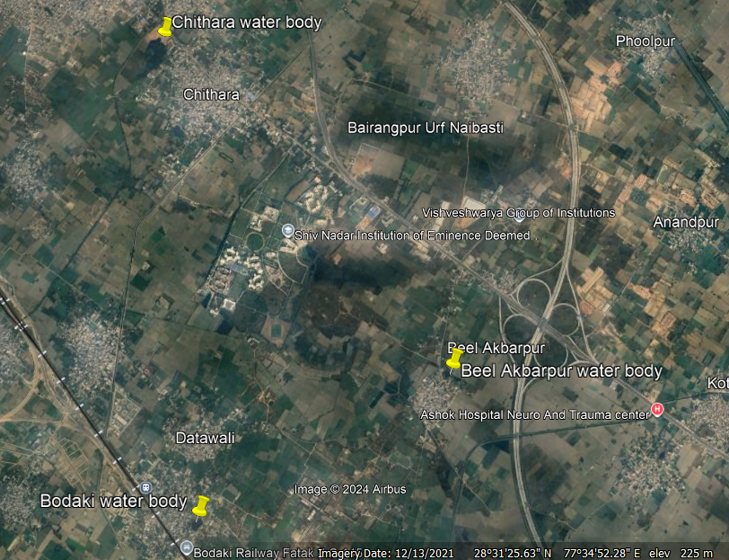
The study area, encompassing Chithara (including SNU campus), Bodaki and Beel Akbarpur villages within the district of Gautam Buddha Nagar in western Uttar Pradesh, lies in the eastern part of Delhi NCR. The district is home to approximately 4,153 ha of wetland area, both natural as well as man-made. Many of them are spectacular (like Surajpur bird sanctuary) habitats to birds, amphibians and reptiles and several herbivores. Along with rivers and streams (24.87%), natural wetlands include lakes/ponds (17.29%), waterlogged areas (6.65%), and oxbow lakes (Murthy et al., 2013). Man-made wetlands include waterlogged areas, reservoirs, and tanks/ponds.

Fig. 1. Google map showing study sites: Chithara, Beel Akbarpur and Bodaki
All the villages included in this study are adjacent to each other and Dadri is nearest town for major economic activities. Chithara has a total geographical area of 770.78 hectares, while Bodaki and Beel Akbarpur cover 115 and 362.19 hectares area, respectively. Delhi is approximately 40 km away from Chithara. Surrounded by numerous man-made and natural wetlands, agricultural fields, and wild plant growth, the study sites boast rich biodiversity including phytoplanktons. Therefore, documenting phytoplankton assemblages is crucial for monitoring the health of these water bodies. Beel Akbarpur features various water bodies such as ponds, fish culture ponds, and agricultural fields, alongside a bird sanctuary. Samples were taken from various water bodies identified on Google Maps in December 2021 and April 2022 (Fig. 1). The general appearance of water bodies consisting Chithara, Bil Akbarbar and Bodaki is shown in Fig. 2.
The climate of the study area is typically monsoonal, characterized by three distinct seasons: summer (March to mid-June), rainy (mid-June to September), and winter (October to February). The hottest month is June, with an average temperature of 32.85ºC, followed by May at 31.9ºC. January is the coldest month, with an average temperature of 14.2ºC, followed by December at 15.4ºC (Joshi 2008-2009). The monsoon typically begins in the last week of June and continues until September, with maximum rainfall occurring during this period. Generally, August sees the highest rainfall, followed by July. The soil in the study area is fertile alluvial soil typical of the Wheat-Rice agriculture system in the southwestern plains of the Upper Gangetic Plain. The water pH ranges from 6.5-9.2. Dissolved oxygen (DO) ranges from 4-10 mg/l.

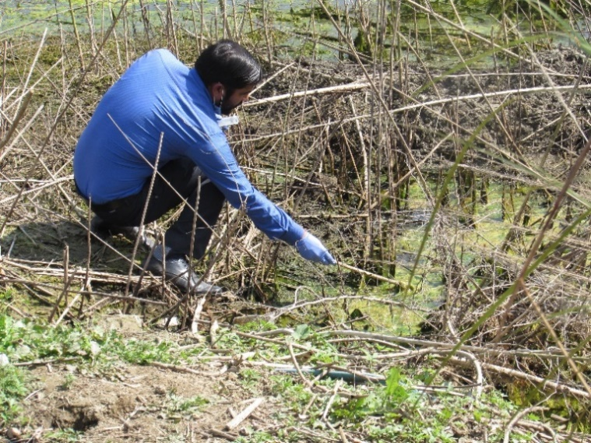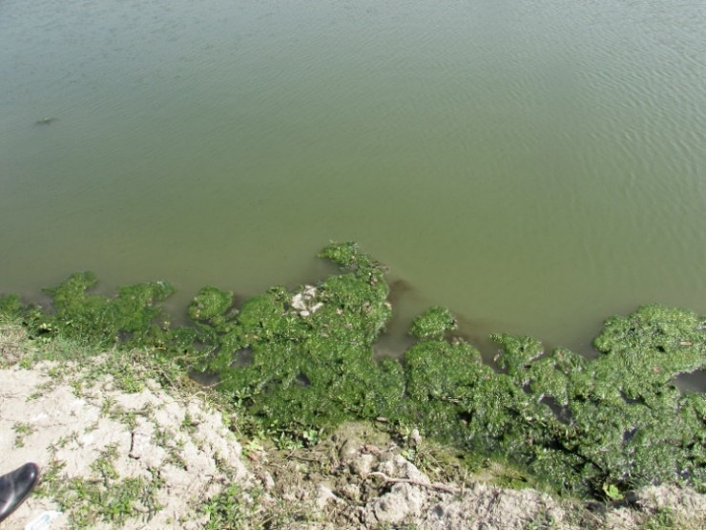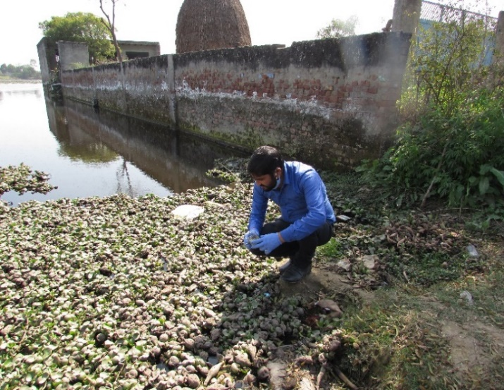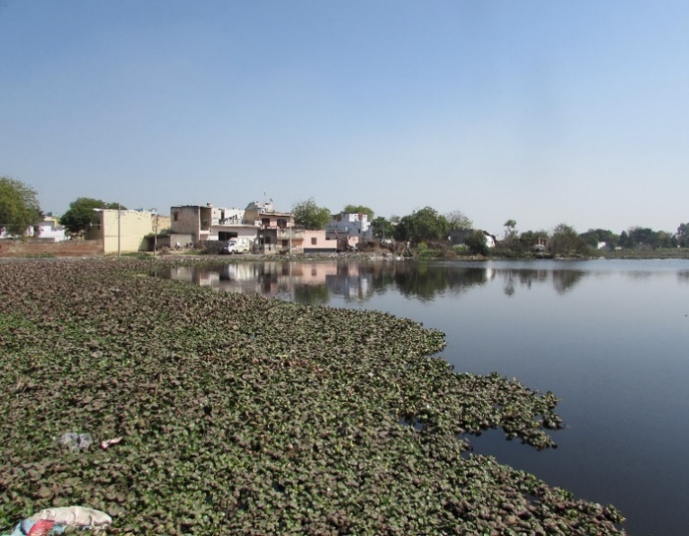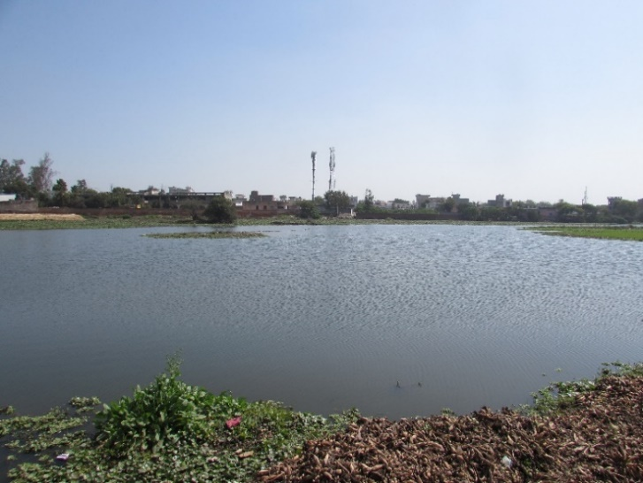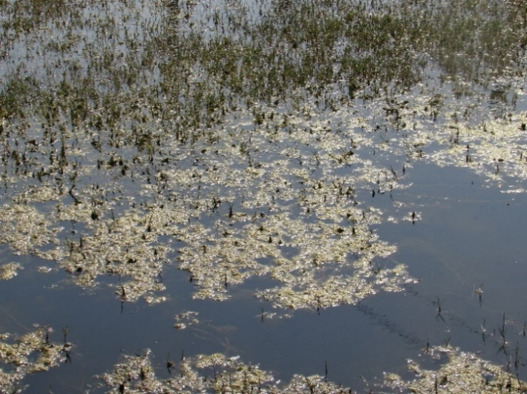
C) Bodaki water bodies
A) Chithara water bodies
B) Beel Akbarpur water bodies
Fig. 2. General appearance of water bodies: A) Chithara; B) Beel Akbarpur; C) Bodaki

2.1.1 METHODOLOGY
For algal documentation, only two sampling months are considered here, December, 2021 and April 2022. Algal samples were mainly collected by scooping. Plant parts as well as floating, submerged, macrophytes were also collected. Slides (from live samples) were prepared using glycerin gel and identification was done by means of Nikon (Ci series) microscope at 20X, 40X magnification. For few 100x, oil immersion was used. Community composition was followed by the slide transect method of sample count. Identification was mainly based on Deshikachary (1959), Karthick et al,. (2013), online resources like Algae Base, etc.
For macrophytes documentation, the wetlands in the study sites were surveyed frequently throughout the year, covering different seasons, and all the macrophytes were documented. Photographs were taken in the field, and plant collections were made for identification purposes. The plants were identified following available floras (Duthie, 1960; Maheshwari, 1966; Vardhana, 2007), and BSI herbaria. The taxonomic identity of the plant specimens was verified by POWO (Plants of the World Online, 2024).
3. results and discussion

Overall, lower plants constitute 50 genera of 33 families and of 5 major phylum (Table 1). Five major algal divisions were identified (Charophyta, Chlorophyta, Cyanobacteria, Euglenophyta and Heterokontophyta), among which algal genera of Chlorophyta were dominated in all the study sites (Table 1). Among the study sites, Beel Akbarpur water bodies have maximum number of species that represent different families. There is habitat diversity such as natural water bodies, rice fields, manmade water bodies and different types of macrophytes (floating, submerged, emergent macrophytes), because of that algal diversity is also high.
Among BGA, Anabaena, Arthrospira and Synechococcus were present in all the study sites. Microcystis was documented only from one fish culture pond of Beel Akbarpur. Cosmarium, Scenedesmus, Closterium, Chlorococcum, Oedogonium, Selenastrum, Spirogyra, Stauridium sp. were common Chlorophyta in all the study sites (Table 1). Long chain of Fragilaria was dominated in Bodaki and this waterbody was dominated by water hyacinth. Nitzschia sp. was one of the common diatom genera in all the study sites which infer polluted water (Smol, 2008). Aulacoseria granulata was found in Chithara water body. Gomphonema, Navicula, Cymbella, Pinnularia were common in all the study sites. Dominance of algal species such as Oscillatoria, Stigeoclonium, Pinnularia, Nitzschia, Cyclotella, indicated sewage contamination (Palmer, 1969; Dokulil, 2003). All of these bodies of water are receiving domestic sewage and or agricultural runoff, and the presence of certain algae confirms organic pollution.
Light, temperature, nutrients and disturbances play an important role in the growth of different algal species. The algal abundance and community composition would change along with the change in the environmental variables such as pH, nutrient (phosphorus, nitrogen, etc.), etc. Due to excessive algal growth or ‘algal bloom’ (Fig. 2B) aquatic system may experience changes in the appearance, and odor issue, and summer kill or fish kill. Excessive algal growth negatively affects the other aquatic organism such as fish, especially during the summer months, due to low amount of dissolved oxygen; fish kill event is common in many water bodies in India. Among all the study sites, Beel Akbarpur mainly witnessed thick mat of algae. These aquatic systems are relatively shallow that of Chithara or Bodaki. The microscopic images of selected algal genus from the study sites are provided in Fig. 3.
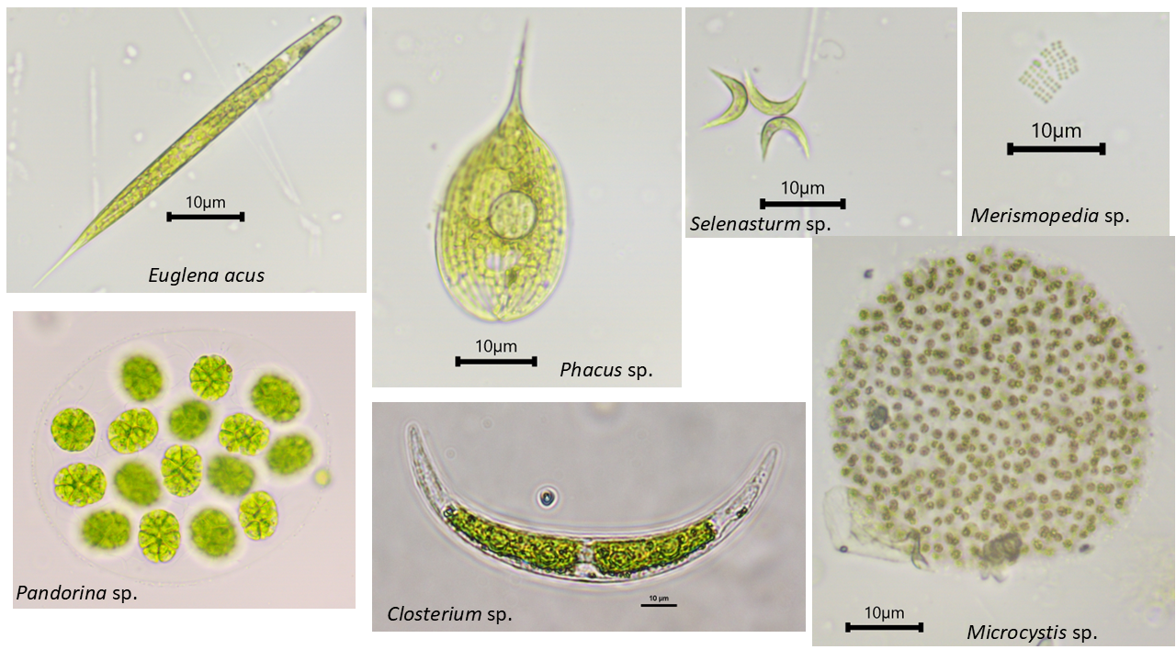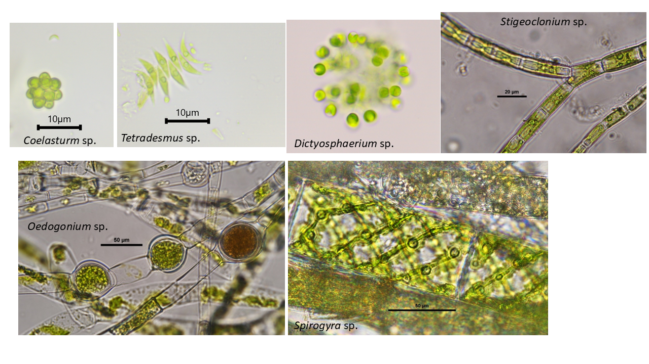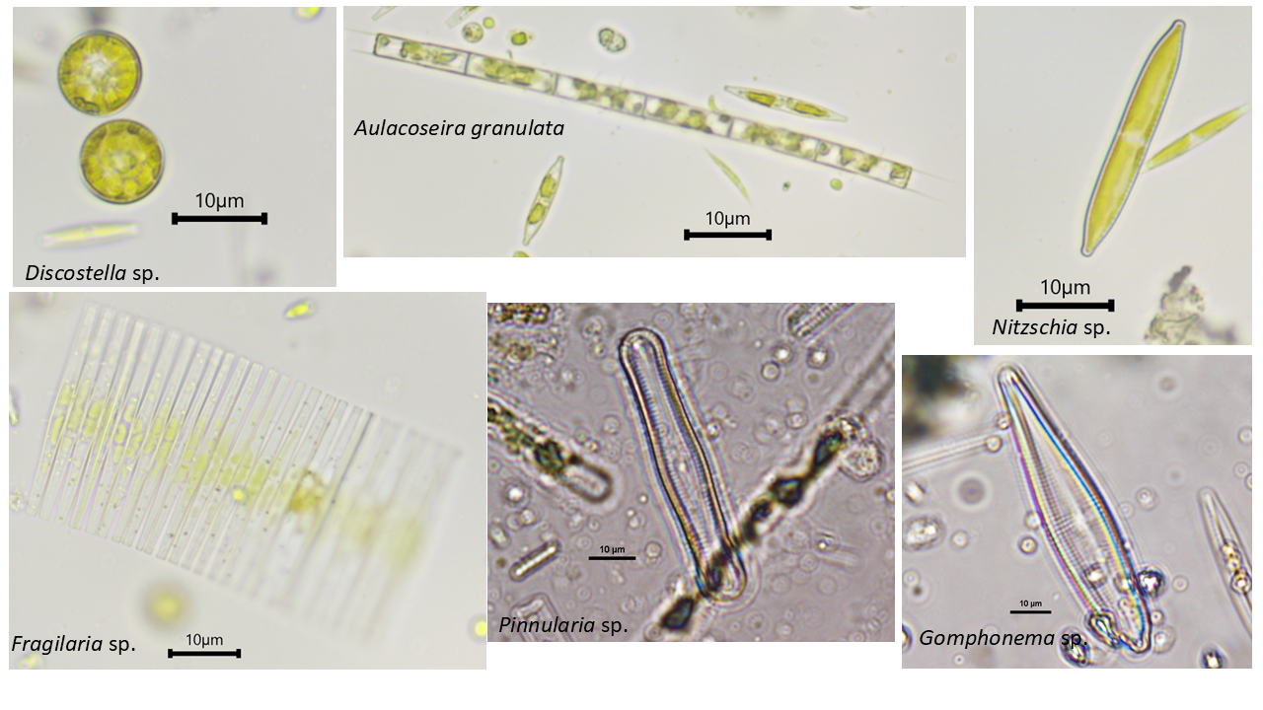
Fig. 3. Microscopic images of selected algal genus from the study sites
All these water bodies are constantly receiving domestic discharge which are enriched with nutrients such as phosphorus and nitrogen. These cluster of water bodies are also surrounded by agricultural fields and receiving agricultural runoff. The presence of certain algae is an important indicator of water quality (Table 2). For e.g., Euglena and Scenedesmus indicate high level of pollution (Palmer, 1969) (Table 3). Different algal genera indicate the trophic status of aquatic systems (Reynolds, 1997). Certain genera found at these study sites suggest eutrophic conditions, such as Anabaena, Eudorina, Pandorina, Staurastrum, Fragilaria, Chlorella, Monoraphidium, Cylindrospermum, Euglena, Pediastrum, and Scenedesmus (Table 4).
With respect to macrophytes documentation, altogether 35 higher plants belonging to 30 genera and 22 families were recorded from all the study sites (Table 5). Out of 35 higher plants, six were submerged, seven were free-floating to floating-leaved, and 22 were emergent plants (Fig. 4). With 7 species, Poaceae was most dominant followed by Araceae (3 species); overall, five additional families each had two species, and the remaining 15 families each had one species.
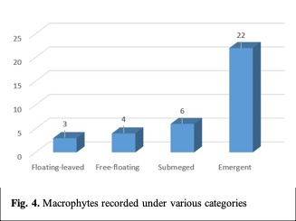
In Chithara village panchayat including SNU campus, all 35 plants were recorded, however, Bodaki and Beel Akbarpur comprise 20 and 14 species, respectively. Overall, 12 species were common to all sites. Among the list, several plants such as Ampelopteris prolifera, Ipomoea carnea, Ipomoea aquatica, Marsilea quadrifolia, Nymphaea pubescens, Ranunculus sceleratus, Saccharum bengalense, S. spontaneum, Salix tetrasperma, etc. are known for their medicinal values in traditional system of medicines (Sharma, 2018).

Major noxious weeds of wetlands
The field observation during the study suggests that five major noxious weeds of wetlands were Alternanthera philoxeroides, Eichhornia crassipes, Pistia stratioites, Phragmites karka and Typha domingensis (Fig. 5).
1. Alternanthera philoxeroides (Common name: Alligator Weed)
Alligator Weed is a perennial aquatic alien plant, floating at the water surface. The plant forms dense masses in the wetlands. All the wetlands of the study sites are highly susceptible to the aggressive growth of this weed. It is among the most notorious weeds, reproducing through vegetative reproduction, and has become major threats to wetlands. The plant has the capability to colonize in aquatic, sub-aquatic, to even terrestrial habitats. It was observed in most of the wetlands during the study. However, the wetland on SNU campus in Chithara, showed dense growth of Alternanthera covering the whole surface.

2. Eichhornia crassipes (Common name: Water Hyacinth)
Water Hyacinth is a free-floating herb that floats on the water surface. The native of tropical America, Water Hyacinth is generally regarded as the most troublesome weed of freshwater system including wetlands in Africa, Australia, India and many other countries. It grows best in shallow aquatic ecosystems mostly in lentic water bodies. The water hyacinth infestation was seen covering entire water bodies in some wetlands in the study area, causing a severe risk to the flora and fauna of the wetlands. However, if it is utilized positively, it has some beneficial attributes like production of paper and fertilizer, generation of biogas, and in phytoremediation in cleaning of wastewater. However, it also creates a microhabitat to several macrophytes. Several wetlands in Chithara and Bodaki were found with aggressive growth of Water Hyacinth.
3. Pistia stratioites (Water Cabbage)
Water Cabbage, a free-floating aquatic herb, is generally found growing gregariously in wetlands, ponds, ditches, and other aquatic bodies. Due to its attractive look, P. stratioites is often grown as an ornamental in aquaria and gardens. Once established, it covers the whole surface of the water, stops oxygen diffusion, and causes fish and other aquatic life to be in danger. It is found throughout the tropics and subtropics. Beel Akbarpur and Chithara show dense mats of Water Cabbage in several wetlands.

4. Phragmites karka (Common name: Tall Reed)
The tall reed, Phragmites karka is an emergent macrophyte. It is a large perennial grass with elongated creeping rhizome. It is a common wetland grass found throughout India. The plant shows aggressive growth through their creeping rhizome and is considered one of the most productive species of wetland ecosystems. The plant is capable of removing potentially harmful heavy metals from aquatic systems, and due to this, it is assumed to be promising for sustainable use in municipal wastewater or sewage treatment following the horizontal subsurface flow constructed wetlands.

5. Typha domingensis (Common name: Southern Cattail)
It is a 2-3 m high rhizomatous herb with long leaves; abundant in marshy areas, along the bank of wetland. The plant spreads rapidly through the underground fleshy stems (rhizomes) and forms monodominant vegetation.
T. domingensis, an emergent macrophyte, has a great ecological role in the environment and has been found to be effective in removing heavy metals such as PB, Cu, Zn, etc., in polluted water. Plant has capacity to accumulate heavy metals in different parts, and therefore, it is used for phytoremediation of industrial effluent contaminating ecosystems. Plant has also been used beneficially in treating heavy metal contaminants present in municipal wastewater.

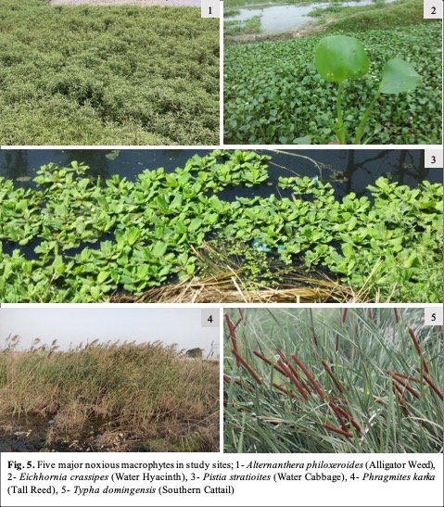

Table 1. List of algae growing in water bodies of study sites

SN | Name of algae (genus) | Family | Habitat distribution | Occurrence
 |  |  |  | Chithara | Beel Akbarpur | Bodaki
1 | Anabaena sp. | Aphanizomenonaceae | Water column
2 | Arthrospira sp. | Microcoleaceae | Water column
3 | Cylindrospermum sp. | Aphanizomenonaceae | Water column | -
4 | Lyngbya sp. | Microcoleaceae | Water column | -
5 | Microcystis sp. | Microcystaceae | Water column | - |  | -
6 | Merismopedia sp. | Microcystaceae | Water column |  |  | -
7 | Synechococcus sp. | Synechococcaceae | Water column
8 | Ankistrodesmus falcatus | Selenastraceae | Water column | -
9 | Chlamydomonas sp. | Chlamydomonadaceae | Water column |  |  | -
10 | Chlorella sp. | Chlorellaceae | Water column | - |  | -
11 | Chlorococcum sp. | Chlorococcaceae | Water column | - |  | -
12 | Closterium sp. (4 diff. species) | Desmidiaceae | Water column
13 | Cosmarium sp. | Desmidiaceae | Water column
14 | Desmodesmus communis | Scenedesmaceae | Water column
15 | Dictyosphaerium sp. | Chlorellaceae | Water column |  |  | -
16 | Eudorina sp. | Volvocaceae | Water column |  | - | -
17 | Euglena acus | Euglenaceae | Water column | -
18 | Gloeocystis sp. | Radiococcaceae | Water column
19 | Micractinium sp. | Chlorellaceae | Water column | - |  | -
20 | Monoraphidium sp. | Selenastraceae | Water column |  |  | -
21 | Mougeotia sp. | Zygnemataceae | Water column, bloom forming | - |  | -
22 | Nannochloropsis sp. | Monodopsidaceae | Water column |  |  | -
23 | Oedogonium sp. | Oedogoniaceae | Attached on submerged leaf |  |  | -
24 | Pandorina sp. | Volvocaceae | Water column
25 | Phacus sp. | Phacaceae | Water column | - |  | -
26 | Pediastrum boryanum | Hydrodictyaceae | Water column
27 | Scenedesmus arcuatus | Scenedesmaceae | Water column
28 | Scenedesmus quadricula | Scenedesmaceae | Water column
29 | Scenedesmus obliquus | Scenedesmaceae | Water column
30 | Scenedesmus dimorphus | Scenedesmaceae | Water column
31 | Tetradesmus sp. | Scenedesmaceae | Water column |  |  | -
32 | Selenastrum sp. | Selenastraceae | Water column
33 | Spirogyra sp. (9 diff. species) | Spirogyraceae | Floating, attached on macrophytes
34 | Stauridium tetras | Hydrodictyaceae | Water column
35 | Stigeoclonium sp. | Fritschiellaceae | Submerged leaf |  | - | -
36 | Achnanthes sp. | Achnanthaceae | Submerged leaf | - |  | -
37 | Amphora sp. | Catenulaceae | Submerged leaf |  | - | -
38 | Aulacoseira granulata | Aulacoseiraceae | Water column |  |  | -
39 | Craticula sp. | Stauroneidaceae | Submerged leaf | - |  | -
40 | Cymbella sp. (6 diff. species) | Cymbellaceae | Submerged leaf
41 | Cyclotella sp. | Stephanodiscaceae | Water column |  | - | -
42 | Discostella sp. | Stephanodiscaceae | Water column | - |  | -
43 | Fragilaria sp. | Fragilariaceae | Water column
44 | Gomphonema sp. | Gomphonemataceae | Submerged leaf
45 | Navicula sp. | Naviculaceae | Submerged leaf
46 | Small naviculoids | Naviculaceae | Submerged leaf | -
47 | Nitzschia (10 diff. species) | Bacillariaceae | Water column, Submerged leaf
48 | Pinnularia sp. | Pinnulariaceae | Submerged leaf
49 | Rhopalodia sp. | Rhopalodiaceae | Submerged leaf | -
50 | Chara sp. | Characeae | Submerged | - |  | -

Table 2. List of some water quality indicator algal species found in study sites
Name of algae | As ecological indicator | Image
Anabaena sp. | Anabaena is common freshwater BGA, found in rice fields, temporary pools, ponds, etc. Generally found in phosphorus rich water. This BGA produces neurotoxins like, anatoxin, which causes respiratory arrest, liver and gastro-intestinal damage and severe dermatitis. Some Anabaena species may cause death of live stocks and wildlife. | 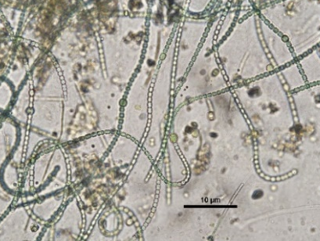
Lyngbya sp. | It found in freshwater, marine water and on soil. Lyngbya releases some toxins (like debromoaplysiatoxin, aplysiatoxin and Lyngbya toxin). Contact with these toxins can cause irritations, which may lead to dermatitis. | 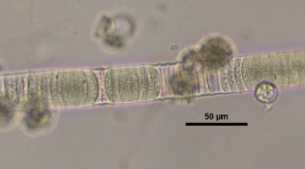
Ankistrodesmus falcatus | Common in different types of freshwater bodies but a good indicator of nutrient-rich condition. | 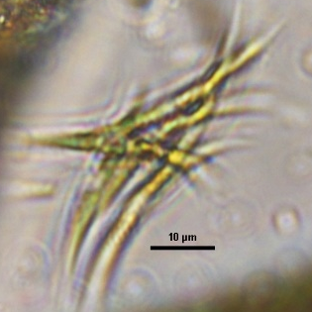
Closterium sp. | Closterium mainly found in acidic water and some species thrive in nutrient-rich hard water | 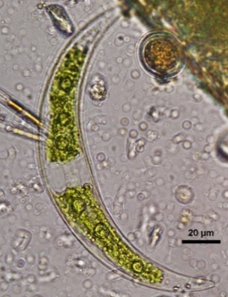
Stigeoclonium sp. | Both epiphytic and periphytic in nature, found in ponds, pools, tanks, reservoirs, etc. It is also found in sewage channels and heavy metal tolerant. Usually attached on submerged rocks, or aquatic plants. It can clog irrigation canals. | 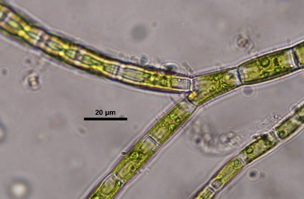
Fragilaria sp. | Cosmopolitan, from plankton to benthos. Found in mesotrophic to eutrophic water bodies. | 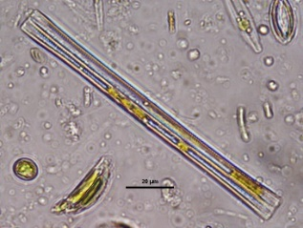

Table 3. Algal genera included in the Palmer, 1969 pollution index
SN | Genera index | Pollution index value
1 | Ankistrodesmus | 2
2 | Chlamydomonas | 4
3 | Chlorella | 3
4 | Closterium | 1
5 | Cyclotella | 1
6 | Euglena | 5
7 | Gomphonema | 1
8 | Navicula | 3
9 | Nitzschia | 3
10 | Phacus | 2
11 | Scenedesmus | 4
12 | Stigeoclonium | 2

Table 4. Association of freshwater algae with trophic status (modified from Reynolds 1997)

SN | Trophic status | Name of the genus
1 | Eutrophic | Anabaena sp.
2 | Eutrophic | Eudorina sp., Pandorina sp.
3 | Eutrophic | Staurastrum sp., Fragilaria sp.
4 | Eutrophic | Chlorella sp., Monoraphidium sp.
5 | Eutrophic | Cylindrospermum sp. Euglena sp.
6 | Eutrophic | Pediastrum sp., Scenedesmus sp.
7 | Meso-eutrophic | Ceratium sp., Microcystis sp.
8 | Oligo-mesotrophic | Cosmarium sp.,
9 | Oligo-mesotrophic | Ceratium sp.

Table 5. List of macrophytes growing along wetlands in study sites

SN | Name of plant species | Family | Habitat distribution | Occurrence
 |  |  |  | Chithara | Beel Akbarpur | Bodaki
1 | Alternanthera philoxeroides (Mart.) Griseb. | Amaranthaceae | Bank of the  wetland
2 | Ammannia baccifera L. | Lythraceae | Bank of the  wetland |  |  | -
3 | Ampelopteris prolifera (Retz.) Copel. | Thelypteridaceae | Bank of the  wetland |  | -
4 | Azolla pinnata R.Br. | Salviniaceae | Floats on water surface |  | - | -
5 | Ceratophyllum demersum L. | Ceratophyllaceae | Submerged in the water |  | -
6 | Cyperus alopecuroides Rottb. | Cyperaceae | Bank of the  wetland
7 | Echinochloa colonum (L.) Link | Poaceae | Bank of the  wetland |  | -
8 | Eichhornia crassipes (Mart.) Solms | Pontederiaceae | Floats on water surface |  | -
9 | Eriochloa procera (Retz.) C.E.Hubb. | Poaceae | Bank of the  wetland |  | -
10 | Fimbristylis sp. | Cyperaceae | Along the side or wet area of the wetland
11 | Gonostegia pentandra (Roxb.) Miq. | Urticaceae | Bank of the  wetland |  | - | -
12 | Hydrilla verticillata (L.f.) Royle | Hydrocharitaceae | Submerged in water
13 | Ipomoea aquatica Forssk. | Convolvulaceae | Floating at the surface of water
14 | Ipomoea carnea Jacq. | Convolvulaceae | Bank of the  wetland |  | -
15 | Lemna perpusilla Torr. | Araceae | Free-floating at the surface of water
16 | Ludwigia hyssopifolia (G.Don) Exell | Onagraceae | Edges of the wetland |  | - | -
17 | Ludwigia octovalvis (Jacq.) P.H.Raven | Onagraceae | Edges of the wetland |  |  | -
18 | Marsilea quadrifolia L. | Marsileaceae | Shallow water and in muddy areas along the wetland |  | - | -
19 | Nymphaea pubescens Willd. | Nymphaeaceae | Rooted macrophyte, floats on water surface |  | -
20 | Nymphoides cristata (Roxb.) Kuntze | Menyanthaceae | Rooted macrophyte, float on water surface |  | - | -
21 | Paspalum distichum L. | Poaceae | Bank of the  wetland
22 | Paspalum scrobiculatum L. | Poaceae | Bank of the  wetland
23 | Persicaria lanigera (R.Br.) Soják | Polygonaceae | Edges of the wetland |  |  | -
24 | Phragmites karka (Retz.) Trin. ex Steud. | Poaceae | Bank of the  wetland |  | - | -
25 | Pistia stratiotes L. | Araceae | Floating on water surface
26 | Potamogeton crispus L. | Potamogetonaceae | Submerged in water |  | - | -
27 | Ranunculus sceleratus L. | Ranunculaceae | Edges of the wetland
28 | Saccharum bengalense Retz. | Poaceae | Edges of the wetland |  | - | -
29 | Saccharum spontaneum L. | Poaceae | Edges of the wetland |  | -
30 | Salix tetrasperma Roxb. | Salicaceae | Bank of the  wetland |  | - | -
31 | Spirodela polyrhiza (L.) Schleid. | Araceae | Floating on water surface
32 | Stuckenia pectinata (L.) Börner | Potamogetonaceae | Submerged in water |  | - | -
33 | Typha domingensis Pers. | Typhaceae | Bank of the  wetland
34 | Utricularia stellaris L.f. | Lentibulariaceae | Stolon floating under the surface of water |  | - | -
35 | Vallisneria spiralis L. | Hydrocharitaceae | Submerged in water |  | - | -

Conclusion
Wetland ecosystems support a wide range of species, including fish, amphibians, reptiles, and migratory birds. However, freshwater biodiversity in Indian wetlands faces threats from pollution, urbanization, agricultural runoff, invasive species, and climate change. Conservation efforts are essential to maintain the ecological balance of these wetlands. Strategies include restoring wetland hydrology, preventing pollution, controlling invasive species, and promoting sustainable land-use practices. Community engagement, along with scientific monitoring and policy interventions, can ensure long-term conservation and sustainable management of freshwater biodiversity in these ecosystems. The rapid growth of aquatic macrophytes in wetlands may cause many environmental problems. However, opposite to this, aquatic plants have a beneficial role in their natural ecosystem and in wastewater treatment, besides providing raw material for the industrial production of paper pulp and biofuel and removing heavy metals. Hence, it is important to balance between harmful and beneficial aspects and achieve sustainable use of aquatic plants.

References

Ansari, N.A. & Ram, J. (2016). Satellite Wetlands and Its Avifaunal Diversity in an Urban Landscape Gautam Budh Nagar, National Capital Region, India. Global Journal of Environmental Research, 10(1), 01-13.
Ansari, N.A., Khan, A.A. & Ram, J. (2016). Vascular plants of Surajpur wetland, National Capital Region, India. Indian Journal of Plant Sciences, 5(1), 54-69.
Cardinale, B.J. et al. (2006). Effects of biodiversity on the functioning of trophic groups and ecosystems. Nature, 443, 989-992.
Cardinale, B.J. et al. (2012). Biodiversity loss and its impact on humanity. Nature, 486, 59-67.
Deshikachary, T.V. 1959. Cyanophyta. In: Monograph in Algae. New Delhi: I.C.A.R. Pages 686.
Dokulil, M.T. 2003. Algae as ecological bio-indicators, p. 285-327. In: Markert B.A., Breure A.M. and Zechmeister H.G. (Eds.). Bioindicators and Biomonitors. Elsevier Science Ltd.
Duthie, J.F. 1960. Flora of the upper Gangetic Plain and of the adjacent Siwalik and Sub-Himalayan tracts. Reprint Edition, Botanical Survey of India, Calcutta.
Joshi B.C. 2008-2009. District brochure of Gautam Budh Nagar, UP. Central Ground Water Board, Ministry of Water Resources, Government of India. Pages 22.
Karthick, B., Hamilton, P.B., & Kociolek J.P. (2013). An illustrated guide to common diatoms of Peninsular India. Gubbi: Gubbi Labs. Pages 206.
Keddy, P.A. 2010. Wetland ecology: Principles and conservation. 2nd edition. Cambridge University Press, Cambridge, UK. Pages 514.
Lowe, R.L. 1974. Environmental Requirements and Pollution Tolerance of Freshwater Diatoms. US Environmental Protection Agency, EPA-670/4-74-005. Cincinnati, Ohio. Pages 340.
Maheshwari, J.K. 1966. Illustrations of the Flora of Delhi. CSIR, New Delhi, India. Pages 282.
Mitsch, W.J., and Gosselink, J.G. 2015. Wetlands. 5th Edition. John Wiley and Sons Inc. Hoboken, New Jersey. Pages 752.
Murthy T.V.R., Patel J.G., Panigrahy S., and Parihar J.S. 2013. National Wetland Atlas: Wetlands of International Importance under Ramsar Convention, SAC/EPSA/ABHG/NWIA/ATLAS/38/2013, Space Applications Centre (ISRO), Ahmedabad, India. Pages 230.
Palmer, C.M. 1969. A composite rating of algae tolerating organic pollution. J. Phycol. 5: 78-82.
Potapova, M., and Carlisle, D.M. 2011. Development and application of indices to assess the condition of algal assemblages in U.S. streams and rivers. Open-File Report 2011–1126, U.S. Geological Survey. Pages 40.
POWO, 2024. Plants of the World Online. Facilitated by the Royal Botanic Gardens, Kew. Published on the Internet.
Reynolds, C.S. 1997. Vegetation processes in the pelagic. A model for ecosystem theory. In: Kinne, O. (Ed.). Excellence in Ecology 9. Ecology Institute, Oldenburg, Germany. Pages 371.
Sharma, J.K., Tripathi, A.K., and Ahmad, M. 2018. Illustrated Flora: Part of Western Uttar Pradesh and Delhi NCR, India. Siya Publishing House and Shiv Nadar University. Pages 606.
Sladecek, V. 1973. System of water quality from the biological point of view. Archiv f€ur Hydrobiologie und Ergebnisse Limnologie, no. 7. Pages 218.
Smol, J.P. 2008. Pollution of lakes and rivers: A paleolimnological perspective, 2nd Edition. Oxford University Press, New York. Pages 394.
Stevenson, J. (2014). Ecological assessment with algae: a review and synthesis. Journal of Phycology, 50, 437-461.
Stevenson, R.J., and Smol, J.P. 2003. Use of algae in environmental Assessments in fresh water algae of North America, p. 775–804. In: Freshwater Algae of North America. Elsevier Inc., Amsterdam.
Van Dam, H., Mertens, A. & Sinkeldam, J.A. (1994). Coded checklist and ecological indicator values of freshwater diatoms from the Netherlands. Netherland Journal of Aquatic Ecology, 28, 117-133.
Vardhana, R. 2007. Flora of Ghaziabad District. Shree Publishers & Distributors, New Delhi. Pages 639.

