Monitoring of microplastic contamination in middle stretch of Sutlej River, Punjab, India

ABSTRACT
Aims: The study was conducted to evaluate microplastic (MP) concentrations in water from the Sutlej River in Punjab, India
Study design: The Microplastic was screened by following National Oceanic and Atmospheric Administration (NOAA) NOAA laboratory protocol
Place and Duration of Study: For the comparative assessment of the MP pollution samples have been collected on a bimonthly basis from September 2024 to February 2025 from selected sampling station of river Sutlej
Methodology: 54 Samples were collected and processed on a hot plate for 30 to 40 minutes at 50°C. after immediately followed by wet peroxidation using Fe (II) solution and 30% H₂O₂ to dissolve the remaining organic matter. Following density separation was carried out with NaCl and ZnCl₂ solution
Results: Fibre, fragment, film, granules, beads, foam and honeycomb shaped MPs were identified from the Sutlej River stretch. Fibers were the most dominant shape, comprising 52.80% of the total MPs Microscopic study revealed that the most abundant MPs were in the 0.1 to 0.5 mm size range (33.02%). blue coloured particles were the most dominant, accounting for 33.10%. Through surface morphological analysis using FE-SEM, degradation features such as pits, grooves, cracks, sharp edges and fractured surfaces were observed. Among identified MP-polymers using Attenuated Total Reflection–Fourier Transform Infrared (ATR-FTIR), polypropylene (PP) (50%) was the most abundant type observed. Water from Walipur Kalan contained 29.7% more MPs than Phillaur because of continuous influx of polluted water influx from Buddha Nullah. Based on the risk index, the Sutlej River was classified as moderately polluted, with a Pollution Load Index (PLI) of 5.645 (PLI > 1), Hazard Index (HI) was 20.824 and Pollution Risk Index (PRI) was 107 indicating significant contamination.
Conclusion: The need for focused management strategies was highlighted by identifying untreated wastewater releases from domestic and industrial sources as likely sources of contamination.
Keywords Microplastics. Pollution. polymer. Sutlej Rivers. Biomagnification

Graphical Abstract
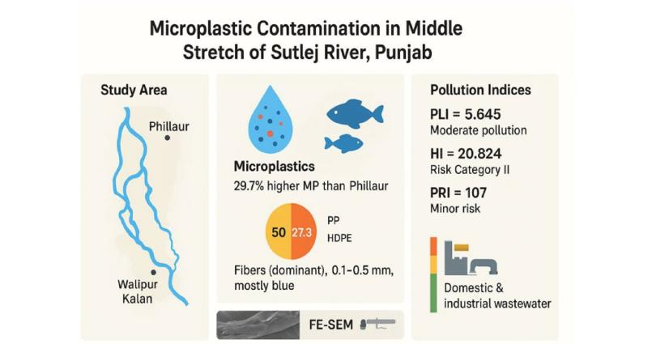
1.INTRODUCTION
Environmental challenges such as global warming, biodiversity loss, sea level rise, ocean acidification, climate change, and air and water pollution have pre-existed so far. Plastic pollution was raising issue since it takes a long time to decay. Due to their unique features like low weight, durability and superior cost-to-performance ratio, they were utilized in day-to-day lives as well as in all commercial works (Phuong et al., 2016). From $990.64 billion in 2022 to $1066.84 billion in 2023, the global market for plastic goods grew at a compound annual growth rate of 7.7% (Mallick & Vairakannu, 2023). Plastics account for at least 85% of all marine waste. Although packaging makes up 36% of the total production, only less than 9% of plastics are recycled. while remaining being buried (46%), burned (17%), scattered as litter (22%), or only partially collected for recycling (15%) (Yinuo, 2023).
The MP can be categorized into two types based on their source, primary MPs (< 5 mm), which are known as microbeads as they were utilized firmly in variety of the products such as cosmetic products and scrubs etc. on the other hand secondary MP were produced after from the large plastic due to physical, chemical and biological processes (Kernchen et al., 2022). Each plastic has its own physical, chemical, and mechanical properties that interact together to affect the fragmentation process (Randhawa, 2025). As they are quite minute, MPs can easily spread throughout the environment and can lead to widespread contamination. Additionally, their strength and durability also have long-term effects on the environment (Born & Brüll, 2022).
The size and density of plastics determine how they are transported and accumulated in water (Nizzetto et al., 2016). MPs possess a high surface area-to-volume ratio, extremely small size, and a density lower than that of water, which together contribute to their neutral buoyancy in aquatic environments. The large surface area of MPs provides an advantage to the microorganism to colonise and transverse to a new environment, which causes havoc for the species inhabited (Arias-Andres et al., 2018). They have a potent ability to adsorb the hazardous pollutants and toxic compounds from the surrounding environment, like heavy metals (Hartmann et al., 2018).This was coupled with the wind action that tends to disperse them from one location to another location (Mathalon & Hill, 2014). Finally, they reach into the oceans; as a result, 100 million MPs and 51 trillion nano plastics have settled on the surface of the ocean (Agamuthu et al., 2019).
MP pollution in marine environments was well documented but less concentrated in freshwater and estuary ecosystems (Li et al., 2018). Rivers are the main pathways for marine MP pollution transporting 70–80% of inadequately managed plastic waste into the oceans each year, which ultimately act as the final sinks for this persistent environmental contaminant (Talbot & Chang, 2022). Due to this, seawater is expected to get a large quantity and variety of MPs (Klein et al., 2018). Many freshwater lakes and rivers were located near densely populated areas, which were heavily contaminated due to the direct discharge of untreated wastewater and garbage (Lebreton & Andrady, 2019).
The aim of the study was assess the MP pollution in water from selected sites on middle stretch of one of major River of Indus River system, Sutlej River (Punjab, India) addressing the gaps and also understanding their sources as well as the distribution pattern from upstream to downstream. The work related to the assessment of the MPs in freshwater system is scanty and no work has been reported in River Sutlej stretch in Punjab. Data base from this study may serve as the foundation for prevention and treatment of MPs pollution in the future.
2 MATERIALS AND METHODS
2.1 Study area
The present study was carried on the two selected sites on the middle of Sutlej River. Site A- River Sutlej stretch at Phillaur near Ladowal Toll Plaza (31° 0’12” N and 75° 47’14” E) with 3 sampling station i.e. substations A₁ (less impacted area), A₂ (religiously impacted area), and A₃ (slum impacted area) which were separated by 250 m. Site B - Walipur Kalan, where Buddha Nullah meets with River Sutlej (30° 59’52” N and 75° 39’2” E) with 3 sampling station i.e. substations B₁ (pre-confluence), B₂ (confluence), and B₃ (post-confluence) (Fig.1). The sampling site as well as substations were identified based on the diverse anthropogenic activities and environmental concerns, which include industrial pollution, religious impacts, and anthropogenic factors.
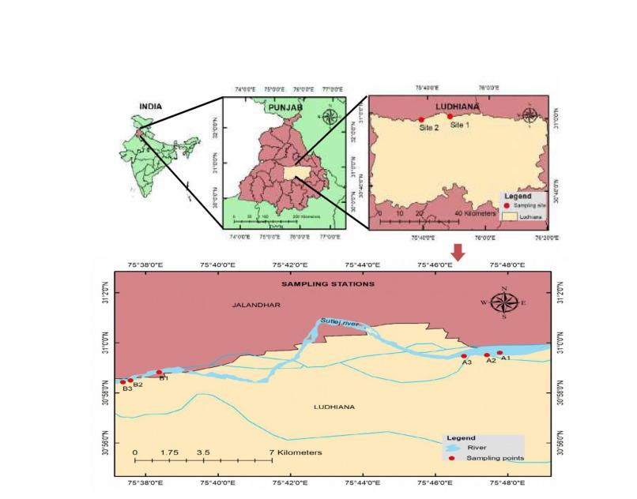
Fig.1. Selected sampling sites along with the sampling stations on Sutlej River
2.2 Sample collection
For the comparative assessment of the MP pollution, a total of 54 samples have been collected on a bimonthly basis from September 2024 to February 2025 using grab sampling method with net of 333-μm mesh by following the protocol of Haque et al. (2024). At a particular site, a plankton net had been suspended one foot below the water surface for five minutes, and the collected water sample containing MPs had been stored in a glass container for further analysis. The speed of the water flow is calculated with the help of a velocimeter.
The calculation of the sample volume collected was based on the procedure explained by Haque et al. (2024). Time-averaged velocity (V) of the river was recorded using a velocimeter at least two minutes prior to submerging the plankton net. The Velocity flow rate (Q) (m³/s) was calculated Q = A*V, where, v = Velocity per meter (m/s), A=Area of the plankton net entrance (A=πr²) (m²). Volume of water passing (V) = Q* t where, t=Time of the immersion of the net inside the water (t=5 min).The number of MPs (MPs/L) was calculated subsequently in relation to the volume of water.
2.3 Sample preparation
Along with the MP particles, several organic and other non-plastic materials were also present in the water samples, which were separated with a 5-mm steel mesh screen by following NOAA laboratory protocol (Masura et al., 2015). After separation the water sample was carefully transferred into a 500 ml beaker and covered with aluminium foil. The prepared sample was processed on a hot plate for 30 to 40 minutes at 50°C. The process was immediately followed by wet peroxidation using 20 ml of Fe (II) solution and 30 ml of 30% H₂O₂ to dissolve the remaining organic matter. This procedure was repeated until no organic matter remained (Sambandam et al., 2022). Following this, the NaCl solution (1.2 g/mL of NaCl in distilled water) was added and manually stirred for 3 minutes, then the ZnCl₂ solution (1.5 g/mL) was added and left without disturbing for 22-24 hrs by covering with the aluminium foil. After density separation, the digested solution was passed through a 125 μm scientific sieve, and the residue was collected in petri dishes using ultra-pure water.
2.4 Quality assurance and quality control
For analysing the MPs, it is very essential and important to check quality assurance as well as quality control due to MPs are omnipresent (Di Giacinto et al., 2023). The probability of occurring contamination will be higher. To overcome the problem of contamination, necessary precautionary measures were taken. Throughout the process, plasticware was not used. During the collection of the water samples, only glass bottles were used, and also fish samples were wrapped in aluminium foil. During the whole process, like rinsing of the glassware, washing, segregation, etc. only deionized water was used, which is 100 % pure with no impurities. Before and after, the sieve was washed thrice to eliminate the unwanted particles to settle on the surface. The digestion was continued by closing the glassware with glass petri dishes, which prevent the entry of MPs from the environment. Proper dressed with cotton lab coats, gloves, mask & headgear were used to prevent contamination. As per scientific procedure, an experimental blank was used to find the level of contamination from environment at least from every 3 samples (Nuelle et al., 2014; Min et al., 2023). In this case, the experimental blank was de-ionized water of 200 ml to which left at the working area to find the contamination of MP from the environment because they were ubiquitous (Di Giacinto et al., 2023). The quality assurance was executed while working with both water & fish samples. During the analysis of fish as well as water samples, the MPs found in the blank were deducted, and the remaining MPs have been counted and analysed.
2.5 Quantitative analysis of microplastic
The MPs were identified, counted and categorized into different sizes, shapes and colours under a stereo zoom microscope (Model No.: - LEICA S 6D) with a digital camera. These identified particles were separated and once again studied clearly with a Nikon microscope. To measure the MPs accurately, the IMAGE J software (version 2.0.0) was used. A hot needle test was performed on the suspected particles to confirm whether they were plastic or non-plastic material to reduce the possibility of misidentification (Beckingham et al., 2023).
2.6 Qualitative analysis of microplastic
Selective MP particles were cleaned, rinsed and transferred to microscopic slides under a stereo optical microscope for further study with Field Emission Scanning Electron Microscopy (FE-SEM) (Model No: JSM IT-800 HL) to study the sample morphology as well as any other particle sticking to the MPs, and the higher resolution images were captured. Attenuated Total Reflectance Fourier Transform Infrared Spectroscopy (ATR-FTIR) (Model No: Spectrum 3, Perkin Elmer) was used to identify the types of polymers present in the water samples, such as high and low density polyethylene (HDPE, LDPE), polypropylene (PP), poly ethylene terephthalate (PET) and polystyrene (PS) (Radhakrishnan et al., 2024). For each sample, 24 scans were averaged at a resolution of 4 cm⁻¹ with a wavenumber range of 400-4000 cm⁻¹. The obtained spectral data was cross-referenced with established reference spectra (Jung et al., 2018). Alternatively, spectra were compared by using the online free software Open Specy (Cowger et al., 2021). Similarity of ≥75% was considered for conformation of different MP-polymer.
2.7 Risk assessment of the Sutlej River
Risk evaluations began by considering the MP-quantity, shape, size, colour, and type of the polymer. However, there was no standard method for assessing the dangers of MP contamination, but Kabir et al. (2021) and Xu et al. (2022) was fallowed for the risk assessment of plastic pollution in Sutlej River was carried out.
Cf_{i} (Contamination Factor) in the Sutlej River of Punjab is calculated as fallows
Cf_{i} = C_{i} / C_{oi}
Where C_{i} is the abundance of the MP in the particular site, C_{oi} is the minimum abundance value for MP which includes all the sites or least concentration throughout the study.
2.7.1 The Pollution Load Index (PLI) is calculated as the fallowing, if PLI >1 is considered as polluted (Tomlinson et al., 1980).
PLI_{i} = $\sqrt{ Cf }$
2.7.2 The Pollution Load Index of the zone (PLI _{zone} ) is the study of the MP pollution over all. Study area can be calculated by using the fallowing equation.
PLI _{zone} = $\sqrt[n]{ PLI 1 * PLI 2* PLI ……….. PLI (n)}$
Where n is number of samples
In contrast, PLI studies were entirely dependent on the quantity of MPs in selected station or site. However, PLI alone can’t represent the danger related to various polymer levels with varying hazard toxicity scores. So Potential Ecological Risk Index (PRI) was used to determine the danger due to abundance of different polymer (Hakanson et al., 1980). PLI and HI were utilized to find the Potential Ecological Risk Index.
2.7.3 Hazard Indication (HI) calculated with the fallowing equation.
HI = ∑[(P_{i} /C_{i}) ∗ S]
‘Pi’ - number of specific polymer types collected at each sampling location; S’ - hazard scores of polymers of MPs obtained from Lithner et al. (2011); C_{i -} abundance of the MP in the particular site.
H_{zone =} $\sqrt[n]{H1 *H 2*H3………………H (n)}$
2.7.4 Potential Ecological Risk Index (PRI) is the combination of both Pollution Load Index and Hazard Indication.
PRI = $\sqrt[n]{(PLI*H1 )*(PL2*H2 )*(PL3*H3 )………………(PLn*Hn ) }$
2.8 Statistical analysis
MPs concentration in each sample have been calculated using the ratio between MPs number and the total volume of water (L) for water samples. Statistical differences in terms of MPs concentrations between sampled locations have been tested using independent-samples Kruskal-Walli’s test and one-way ANOVA followed by a post-hoc Tukey test. p-values smaller than 0.05 has been considered statistically significant differences. The statistical tests were performed using SPSS version 20.0.
3 RESULTS AND DISCUSSION
3.1 Microplastic abundance in the water samples
Among the total MPs recovered, 45.64% extracted from sampling sites in Phillaur, whereas Walipur Kalan exhibited a higher contribution of 54.36%. The abundance of MPs ranged from 3.63 to 18.96 MPs/L (Table 1). Water in various sampling months with mean concentration value of 9.99 MPs/L. Among the sub stations of Phillaur, the highest and lowest number recorded was 17.7 and 3.63 MPs/L at A₃ and A₁, respectively. Among the of sub stations of Walipur Kalan, the highest and lowest recorded was 18.96 and 6.45 MPs/L at B₁ and B₂, respectively. Samples of Walipur Kalan had accumulated 29.7% more MPs than Phillaur although the mean ± SD values of abundance of MP/L didn’t differ significantly between the sites and among the sampling sites (p > 0.05).
In present study mean concentration of 9.99 MPs/L. MPs were detected in all water samples collected from the selected sampling stations, which highlights the significant and persistent nature of MP pollution within the Sutlej River system. Sampling station B₂ recorded the highest number of MPs in almost all sampling months, mainly because the polluted water from the Buddha Nullah carrying plastic debris, domestic sewage, and industrial effluents from the city of Ludhiana confluences with the Sutlej River, making it a significant point source of MPs and causing a perceptible rise in pollution at this site (Goyal, 2024). It was also observed that downstream of the river Sutlej, there has been an abrupt increase in the MP concentration in all the sampling months. Inadequate waste management along with a lack of effective policies contributes to the increment of the MP in the aquatic ecosystem and fauna (Honorato-Zimmer et al., 2024). In comparison with the other MP study in Indian rivers, the Sutlej River exhibits lower levels than the Mahanadi and Ganga River systems, with 15.1 ± 5.4 items/L and 17 to 36 particles/L (Singh et al., 2024; Patidar et al., 2023). However, the present study surpassed the MP concentrations in the coastal rivers Chapora and Zuari of Goa (0.25 MPs/L; 0.26 MPs/L) (Kalangutkar et al., 2024). Similarly, Sekar & Sundaram (2023) also found less MP concentration (3.9 items/L) in the Godavari River.

Table1. Microplastic abundance in water samples from selected sampling sites in Sutlej River
Sampling  month | Sampling site
Sampling  month | Phillaur |  |  | Walipur Kalan
Sampling  month | A₁ | A₂ | A₃ | B₁ | B₂ | B₃
September | 3.63 | 6.1 | 8.8 | 6.45 | 7.81 | 8.18
November | 14.2 | 15.8 | 17.7 | 15.1 | 18.96 | 16.5
February | 7.3 | 9.2 | 9.46 | 12.2 | 13 | 11.6
Average | 8.38 ª ±5.36 | 10.36 ª ±4.95 | 11.98 ª ±4.95 | 11.25 ª ±4.4 | 13.25 ª ±5.5 | 12.09 ª ±4.1
Values (Mean ± standard deviation) with different alphabetical superscripts (a, b, c...) differ significantly between the sites (in a row) (P < 0.05).
3.2 Overall morphometric profiling of microplastic based on size, shape and colour screened from the water samples
In present study on Sutlej River identified different type of MP shapes including fibre, fragment, film, granules, beads, foam and honeycomb etc as shown in the fig.2. Fibers were the most dominant shape, comprising 52.80% of the total. Films and fragments follow at 22.98% and 14.10%, respectively. Other shapes, such as granules (4.67%), flakes (3.04%), beads (2.02%), honeycomb (0.23%) and foam (0.16%), were present in much least proportions, while foam was completely absent (Fig.3).Microscopic study revealed that the most abundant MPs were in the 0.1 to 0.5 mm size range (33.02%), followed by 0.5 to 1 mm (21.73%), 1 to 1.5 mm (14.34%), 1.5 to 2 mm (10.90%) and < 0.1 mm (10.12%), with the least abundant size being 2 to 5 mm (9.89%) (Fig.4).Among the observed colours of MP, blue coloured particles were the most dominant, accounting for 33.10%, followed by transparent particles at 22.74%. Other colours like red (13.40%), yellow (11.29%) and violet (8.96%) were present in moderate amounts. while orange, brown, black and green each accumulated < 5% (Fig.5).
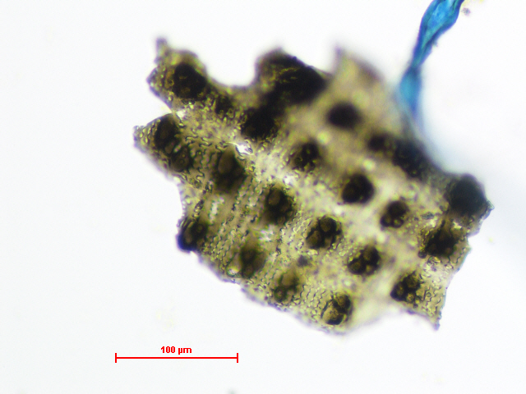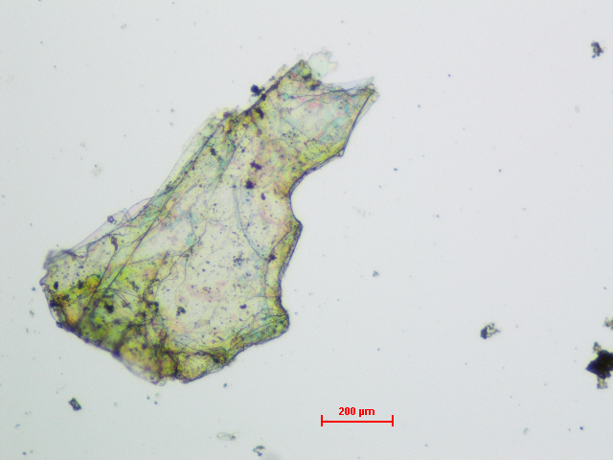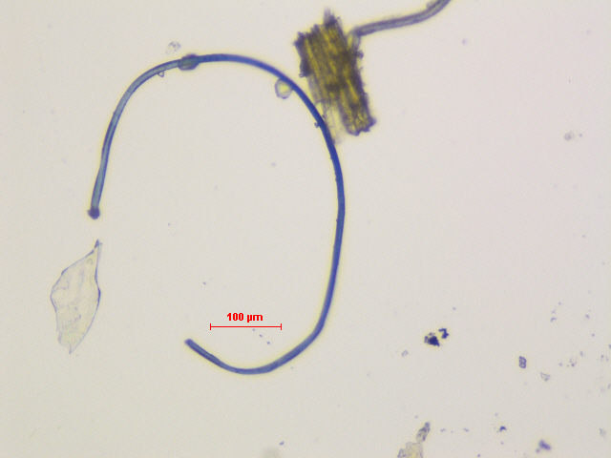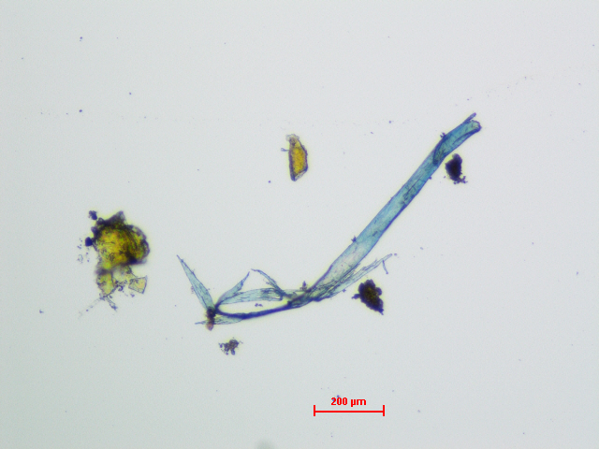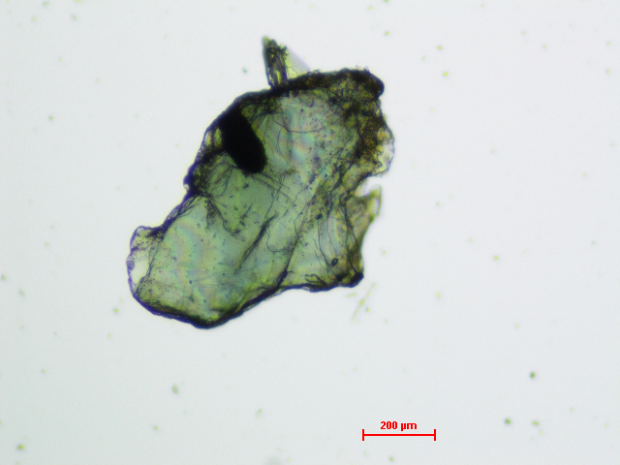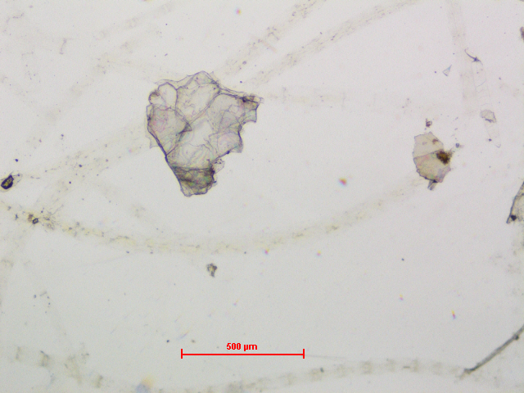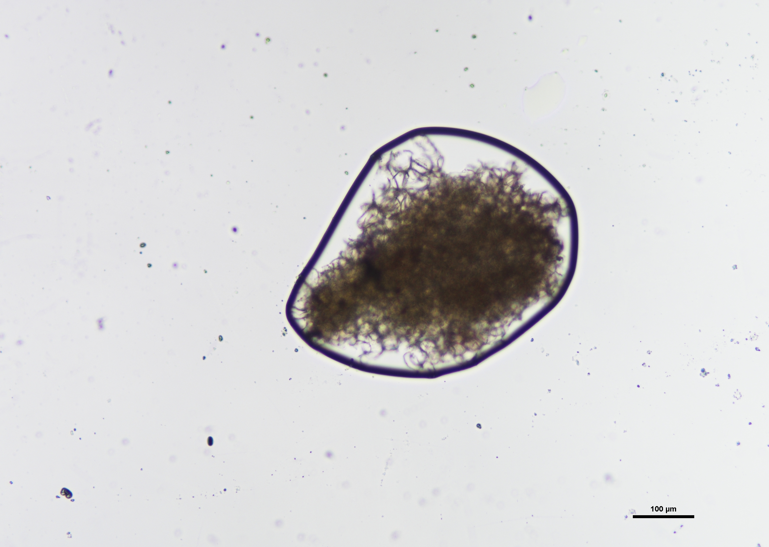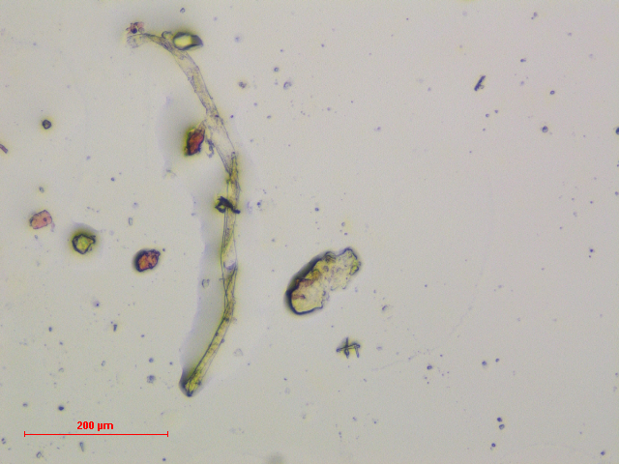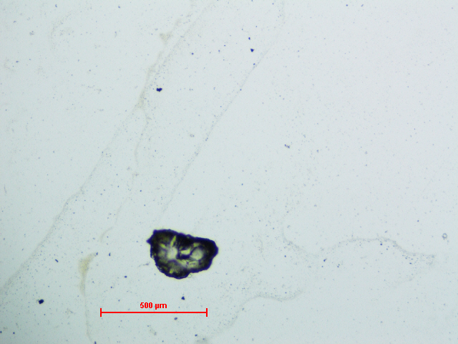
a
b
c
d
e
g
h
i
f
Fig.2. Different shapes of MP available in the river Sutlej: (a) Fibers; (b) fragments; (c,d) film;(e) foam;(f) beads;(g) granules ;(h) flakes ;(i) honeycomb.

Fig. 3. Overall assessment of microplastics based on shape (%) in the water samples

Fig. 4. Overall assessment of microplastics based on size (%) in the water samples

Fig.5. Overall assessment of microplastics based on colour (%) in the water samples
3.3 Assessment of microplastics (MP/L) based on Size, shape and colour in the water samples collected from the selected stations of the sampling sites
Across the different MP size range, the highest abundance size was 0.1–0.5 mm range, station A₂ showed the maximum (4.48 MP/L) and B₃ the minimum (3.25 MP/L). In the 0.5–1 mm range, A₃ had the highest (3.36 MP/L) and B₂ the lowest (1.87 MP/L). In the 1–1.5 mm size class, the highest was found at A₃ (2.59 MP/L), whereas the lowest was at A₁ (1.24 MP/L). The 1.5–2 mm particles were most abundant at B₃ (1.84 MP/L) and least at A₁ (0.56 MP/L). The <0.1 mm particles highest abundance recorded at station B₂ (2.80 MP/L), while the lowest occurred at A₃ (0.16 MP/L). In the largest size class, 2–5 mm, B₂ recorded the highest concentration (1.90 MP/L) and A₂ the lowest (0.40 MP/L). The mean ± SD values didn’t differ significantly between stations (p > 0.05) but exhibited significant differences within the station (p < 0.05).
This highlights the secondary MP formation processes through high fragmentation rates as observed similarly in various aquatic ecosystems, which were accidentally ingested by aquatic animals and then biomagnified through the food chain. Such variance exemplified the intricate web of relationships that exists among environmental processes, river dynamics, and pollution sources (Xiao et al., 2023; Allen et al., 2022). Similar studies reported that higher abundance of MPs <1 mm in the Mahanadi River (Patidar et al., 2023) and Zandvlei Estuary (Samuels et al., 2024). The larger-sized MPs displayed fewer indications of physical or chemical degradation, suggesting their greater persistence in the aquatic environment (Zbyszewski et al., 2014).
Table 2. Abundance of various size of MP/L in water samples collected from sampling station
Sampling Station | MP-SIZE
Sampling Station | <0.1mm | 0.1 - 0.5 mm | 0.5 - 1mm | 1 - 1.5 mm | 1.5 - 2 mm | 2 - 5 mm
A₁ | 0.42 ^{a,1}±0.74 | 3.39 ^{a,1}±2.49 | 2.22 ^{a,1}±1.35 | 1.24 ^{a,1}±0.76 | 0.56 ^{a,1}±0.30 | 0.59 ^{a,1}±0.44
A₂ | 0.42 ^{a,2}±0.52 | 4.48 ^{a,1}±2.66 | 2.67 ^{a,12}±1.60 | 1.36 ^{a,12}±0.37 | 1.01 ^{a,12}±0.23 | 0.40 ^{a,2}±0.35
A₃ | 0.16 ^{a,2}±0.08 | 3.94 ^{a,1}±0.57 | 3.36 ^{a,12}±1.96 | 2.59 ^{a,12}±2.24 | 1.15 ^{a,12}±0.56 | 0.68 ^{a,12}±0.40
B₁ | 1.24 ^{a,1}±0.19 | 3.59 ^{a,1}±1.59 | 2.15 ^{a,1}±1.43 | 1.63 ^{a,1}±0.70 | 1.40^{a,1}±1.00 | 1.27 ^{a,1}±0.59
B₂ | 2.80 ^{a,1}±0.91 | 3.71 ^{a,1}±2.21 | 1.87 ^{a,1}±1.51 | 1.34 ^{a,1}±0.41 | 1.64 ^{a,1}±0.60 | 1.90 ^{a,1}±0.91
B₃ | 1.56 ^{a,1}±0.36 | 3.25 ^{a,1}±1.39 | 2.5 ^{a,1}±1.12 | 1.58 ^{a,1}±0.67 | 1.84 ^{a,1}±1.18 | 1.37 ^{a,1}±0.54
Values are expressed as the mean±SD. The mean values in the same column with different letters differ significantly (P<0.05)
MPs of various shapes were detected such as fibers, fragments, films, granules, beads, foam, flakes and honeycomb. Among the different MP shapes, fibres were most abundant at station A₃ (7.00 MP/L) and least at A₁ (4.75 MP/L). Fragments exhibited the highest concentration at B₂ (2.25 MP/L) and the lowest at A₁ (0.68 MP/L), while films peaked at A₃ (3.13 MP/L) and were lowest at A₁ (2.25 MP/L). Foam was detected only in A₂ (0.04 MP/L) and B₁ (0.03 MP/L). Beads were most common at B₁ (0.43 MP/L) and least at A₂ (0.17 MP/L), whereas granules were highest at B₃ (0.92 MP/L) and lowest at A₁ (0.20 MP/L), with A₃ exhibited no granules. Flakes accumulated maximum at A₃ (0.71 MP/L) and a minimum at B₃ (0.07 MP/L). Honey comb particles were present only in B₁ and B₂ (0.06 each MP/L) and were least at A₃ (0.03 MP/L). The mean ± SD values didn’t differ significantly between stations (p > 0.05) except for flakes, but exhibited significant differences within the station (p < 0.05).
Our findings on MP shapes aligned with previous MP studies, which found fibers as the dominant shape in the Chapora and Zuari rivers (Kalangutkar et al., 2024), the Udyavara estuary (Unnikrishnan et al., 2023), and the Mahanadi River (Patidar et al., 2023). Maximum secondary MPs were obtained, which can be linked to their origin. The high fiber abundance may be attributed to the fact that it takes a long period to degrade and reach the aquatic environment through the sewage system as well as surface runoff (Saha et al., 2021; Hoellein et al., 2017). Films, which are extremely thin sheets, might be produced by degradation of plastic bags (Syakti et al., 2018).

Table 3. Abundance of various shape of MP/L in water samples collected from sampling station
Sampling station | MP- Shape
Sampling station | Fibre | Fragment | Film | Foam | Beads | Granules | Flakes | Honey comb
A₁ | 4.75 ^{a,1}±3.14 | 0.68 ^{a,2}±0.41 | 2.25 ^{a,12}±1.27 | NA* | 0.41 ^{a,2}±0.54 | 0.20 ^{a,2}±0.07 | 0.13 ^{ab,2}±0.13 | NA*
A₂ | 5.47 ^{a,1}±2.15 | 1.56 ^{a,2}±0.86 | 2.36 ^{a,2}±1.68 | 0.04 ^{a,2}±0.08 | 0.17 ^{a,2}±0.29 | 0.16 ^{a,2}±0.14 | 0.60 ^{ab,2}±0.44 | NA*
A₃ | 7.00 ^{a,1}±4.1 | 1.14 ^{a,2}±0.25 | 3.13 ^{a,12}±1.18 | NA* | NA* | NA* | 0.71 ^{a,2}±0.18 | 0.03 ^{a,2}±0.06
B₁ | 5.49 ^{a,1}±2.09 | 1.60 ^{a,2}±0.6 | 2.52 ^{a,2}±1.04 | 0.03 ^{a,2}±0.05 | 0.43 ^{a,2}±0.14 | 0.85 ^{a,2}±0.61 | 0.28 ^{ab,2}±0.16 | 0.06 ^{a,2}±0.10
B₂ | 6.95 ^{a,1}±3.58 | 2.25 ^{a,2}±1.31 | 2.69 ^{a,2}±1.18 | NA* | 0.26 ^{a,2}±0.31 | 0.91 ^{a,2}±0.31 | 0.16 ^{ab,2}±0.16 | 0.06 ^{a,2}±0.10
B₃ | 6.13 ^{a,1}±1.56 | 1.81 ^{a,23}±0.67 | 2.98 ^{a,2}± 1.52 | NA* | 0.19 ^{a,3}±0.20 | 0.92 ^{a,23}±0.69 | 0.07 ^{b,3}±0.12 | NA*
The description about the statistical analysis is provided in Table 3
Among the observed MP colours, blue particles were most abundant at station B₂ (4.75 MP/L) and least at A₁ (3.13 MP/L). Transparent MPs most abundant at B₃ (3.37 MP/L) and were lowest at A₃ (1.90 MP/L). Red MPs were highest at B₂ (2.08 MP/L) and lowest at A₁ (0.71 MP/L), while yellow MPs reached their maximum at B₂ (1.82 MP/L) and minimum at A₁ (0.82 MP/L). Green particles were most common at A₃ (0.78 MP/L) and least at B₂ (0.03 MP/L), being absent in B₁ and B₃. Black MPs showed the highest value at A₃ (0.90 MP/L) and the lowest at B₁ and B₂ (0.06 MP/L). Brown MPs were most abundant at B₂ (0.61 MP/L) and least at A₂ (0.18 MP/L). Violet MPs highest at B₁ (1.43 MP/L) and were lowest at A₁ (0.55 MP/L). Orange MPs were most frequent at A₃ (0.20 MP/L) and least at B₁ (0.12 MP/L), with no occurrence in A₂ or B₂. Multi-coloured MPs were detected only at B₂ (0.03 MP/L). The mean ± SD values differed significantly between stations and within the station (p < 0.05).
Blue particles were found predominant in the U-Taphao River of Thailand (Pradit et al., 2023). Zhao et al. (2014) and Yan et al. (2019) found that blue and transparent MPs were common in the Yangtze Estuary and Pearl River Estuary in China. Blue, red, black and transparent MPs were found abundant in the Jiaojiang, Oujiang and Minjiang estuaries (Zhao et al., 2015), while blue, pink and grey particles were found in the Changjiang Estuary (Xu et al., 2018). Because marketing firms utilize various dyes and pigments to make plastic products attractive, which leach slowly and release pollutants into the environment (Gewert et al., 2015).
Table 4. Abundance of various shape of MP/L in water samples collected sites and sampling station
MP-Colour | Sampling station
MP-Colour | A₁ | A₂ | A₃ | B₁ | B₂ |  | B₃
Blue | 3.13 ^{a,1}±2.04 | 3.43 ^{a,1}±2.48 | 3.63 ^{a,1}±3.26 | 3.72 ^{a,1}±1.99 |  | 4.75 ^{a,1}±2.61 |  | 4.59 ^{a,1}±2.05
Transparent | 2.15 ^{a,1}±2.11 | 2.45 ^{ab,1}±1.86 | 1.90 ^{a,1}±0.71 | 2.82 ^{a,1}±0.84 |  | 2.52 ^{ab,1}±0.10 |  | 3.37 ^{ab,1}±1.88
Red | 0.71 ^{a,1}±0.35 | 1.25 ^{ab,1}±0.10 | 1.45 ^{a,1}±0.96 | 1.49 ^{ab,1}±0.74 |  | 2.08 ^{ab,1}±0.88 |  | 1.65 ^{bc,1}±0.22
Yellow | 0.82 ^{a,1}±0.61 | 1.21 ^{ab,1}±0.64 | 1.35 ^{a,1}±1.04 | 1.51 ^{ab,1}±0.60 |  | 1.82 ^{ab,1}±0.73 |  | 1.12 ^{bc,1}±0.55
Green | 0.19 ^{a,1}±0.17 | 0.63 ^{ab,1}±0.20 | 0.78 ^{a,1}±0.68 | NA* |  | 0.03 ^{b,1}±0.05 |  | NA*
Black | 0.34 ^{a,23}±0.21 | 0.64 ^{ab,12}±0.12 | 0.90 ^{a,1}±0.42 | 0.06 ^{b,3}±0.10 |  | 0.06 ^{b,3}±0.10 |  | 0.12 ^{c,3}±0.10
Brown | 0.39 ^{a,1}±0.59 | 0.18 ^{b,1}±0.17 | 0.51 ^{a,1}±0.44 | 0.12 ^{b,1}±0.11 |  | 0.61 ^{b,1}±0.54 |  | 0.19 ^{c,1}±0.20
Violet | 0.55 ^{a,1}±0.64 | 0.57 ^{ab,1}±0.50 | 1.29 ^{a,1}±0.21 | 1.43 ^{ab,1}±0.64 |  | 1.36 ^{b,1}±1.25 |  | 0.89 ^{bc,1}±0.70
Orange | 0.13 ^{a,1}±0.23 | NA* | 0.20 ^{a,1}±0.18 | 0.12 ^{b,1}±0.11 |  | NA* |  | 0.18 ^{c,1}±0.17
Multi colour | NA* | NA* | NA* | NA* |  | 0.03 ^{b,1}±0.05 |  | NA*

The description about the statistical analysis is provided in Table 3
3.4 Surface Morphological characteristics of MPs found in water samples
In present study, MP-fibres revealed the longitudinal striations, breakage and splitting, which were signs of mechanical stress and prolonged exposure to the environment (Fig.6.a) (Militký et al.,2024). MP-fragments displayed angular, irregular forms with pits, sharp edges and fractured surfaces due to advanced physical and photo-oxidative deterioration (Fig.6.b) (Babaei et al.,2023). Film-type MPs were thin, pliable and often folded, usually originating from deteriorated plastic bags or packaging (Fig. 6.c) (Wright et al., 2020; Di et al., 2019). The primary causes of weathering damage were UV radiation and oxygen depletion (Liu et al., 2022). MP-Granules were rough, irregular, or smooth surface particles (Fig. 6.d). Despite being less common, honeycomb-patterned MPs were distinct in that they exhibited lattice-like and structured surface patterns (Fig.6.e), which might have resulted from the breakdown of composite materials. MPs with flake forms often had a flat, plate-like appearance with uneven edges and delaminated layers (Fig.6.f), and they frequently showed surface roughness, peeling and fragmentation. Wind-assisted transport and photolytic deterioration may cause foamed PS to fracture as shown in (Fig.6.g) (Turner, 2020). MP-beads were rod or filamentous structures with adhesive surface (Fig.6.h)
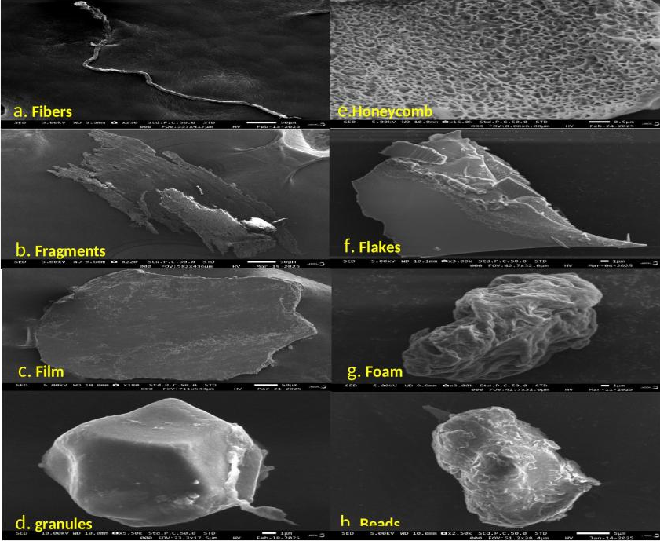
Fig.6. FE-SEM analysis of different MP found in water samples of Sutlej River.
3.5 Qualitative analysis of MPs using ATR-FTIR spectroscopy
In the present study 54 MPs selected from the water sample were analysed and identified polymers in the Sutlej River were polypropylene (PP) was abundant (50%), followed by high-density polyethylene (HDPE) (27.3%), polyethylene terephthalate (PET) (9.1%), and polystyrene (PS) (4.5%). Spectral identification of MP-Polypropylene (PP), revealed the peaks at 2921.60 cm⁻¹ and 2852.43 cm⁻¹ corresponding to the stretch vibrations of CH₂ and CH₃ groups, which was typical features of aliphatic hydrocarbons. The presence of peaks at 1324.56 cm⁻¹ and in the range of 873.67–779.91 cm⁻¹ confirms the presence of methyl bending and rocking modes, indicating a branched structure consistent with polypropylene (Fig.7). The spectral identification of MP-HDPE revealed the noticeable absorption bands at 2915.86 cm⁻¹ and 2848.23 cm⁻¹ correspond to asymmetric and symmetric stretching vibrations of methylene (–CH₂) C–H bonds, indicative of saturated hydrocarbon chains typical of polyolefins (Fig.8). Additionally, the bands at 729.47 cm⁻¹ and 719.11 cm⁻¹ are linked to CH₂ rocking vibrations, which indicate its crystalline structure. PET: The strong absorption at 1713.00 cm⁻¹ is due to the C=O stretching vibration of ester or carboxylic acid groups, a hallmark of polyester materials. The accompanying C–O stretching bands at 1237.02 cm⁻¹ and 1093.65 cm⁻¹ further support the presence of ester linkages typical Polyethylene terephthalate (PET) (Fig.9). The band at 3025.65 cm⁻¹ corresponds to the aromatic C-H stretching vibration, while the peak at 2852.03 cm⁻¹ was associated with the symmetric stretching of CH₂ groups, strong absorptions at 1601.45 cm⁻¹ and 1492.96 cm⁻¹ were attributed to aromatic ring stretching vibrations suggesting the presence of alkyl side chains of polystyrene (PS) (Fig.10).
In Phillaur near Kaasabaad village, PP and HDPE polymers were found abundantly in the water samples, which was one of the point sources of MP pollution in the Sutlej River. In Budha Nallah PE, PP and PET were detected in high concentrations. PE and PP polymers were observed globally in fresh as well as marine waters (Suaria et al., 2016; Eriksen et al., 2014). Numerous plastic items, including bottles, synthetic clothes, packaging, fishing gear and others, were found to be abandoned during fieldwork. These materials break down over time due to fragmentation and inadequate waste management, greatly increasing the amount of MP contamination in the aquatic environment (Michielssen et al., 2016).

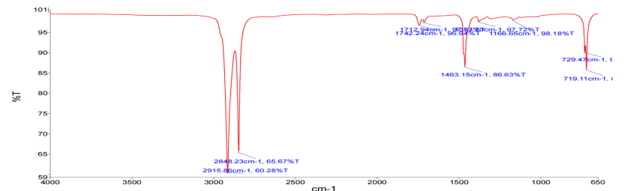
Fig.7 FTIR spectrum of High-Density Polyethylene in water samples
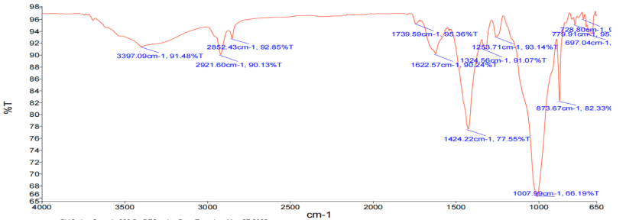Fig.8 FTIR spectrum of polypropylene in water samples
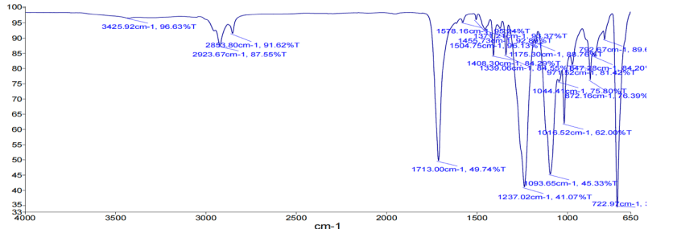
Fig.9 FTIR spectrum of Polyethylene terephthalate in water samples
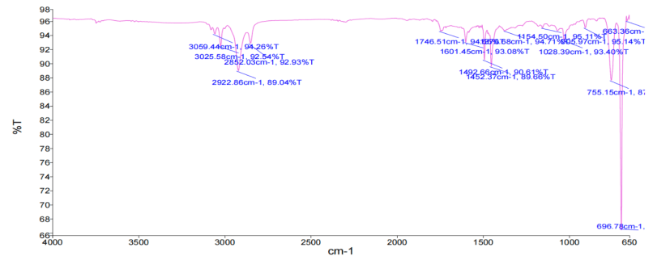
Fig.10 FTIR spectrum of Polystyrene in water samples
3.6 Pollution risk assessment of the Sutlej River
The pollution load index of the sampling site Phillaur and Wallipur Kalan was 2.84 and 3.35 (Table 5), PLI of the total zone was 5.645 (PLI > 1) indicated significant MP pollution at both sites as well as total zone of Sutlej River. Although the river's overall Hazard Index (HI) of 20.824 placed it in risk category II, indicating moderate sub-lethal effects on aquatic life, the HI at Phillaur and Wallipur Kalan was below 10 (5.6 and 8.08, respectively), indicating low but existing ecological risk (risk category I). The Pollution Risk Index (PRI) values were also in the minor risk category (Phillaur: 15.9; Wallipur Kalan: 27; zone: 107).
In the present study, PLI values at Phillaur and Wallipur Kalan were >1, indicating significant MP pollution in the Sutlej River. This suggests that poor plastic disposal, urban runoff and textile waste are the likely causes of the contamination (Talang et al., 2024). PLI values were similar in the Udyavara Estuary, Limbe-Idenau, and Goa rivers, but Changjiang Bay (18.4) and parts of the Indian coast had much higher levels, reaching hazard level II (Ranjani et al., 2021). Although the river's overall Hazard Index (HI) reached risk category II, indicating moderate sub-lethal effects on aquatic life (Jeong et al., 2024). The Pollution Risk Index (PRI) values were also in the minor risk category. Similar findings were found for the Raquette River and the Jajroud River in Tehran (Haque et al., 2024). The primary reason for MP pollution was industrial discharges, fiber shedding from textile industries, urban runoff carrying synthetic and domestic waste, and fragmentation of improperly discarded plastic waste (Chan et al., 2023).
Table 5 Pollution risk assessment studies of the selected sampling stations of the river Sutlej.
Risk categories | Pollution Load Index (PLI) | Hazard index  (HI) | Pollution Risk Index  (PRI)
Phillaur | 2.84 (polluted) | 5.6 (Cat- I ) | 15.904 (minor )
Wallipur Kalan | 3.35 (polluted) | 8.08 (Cat- I ) | 27 (minor )
zone | 5.645 (polluted) | 20.824 (Cat-II ) | 107 (Minor )

5.CONCLUSION
Microplastics were traced in all the water samples collected during the sampling period in the Sutlej River stretch in Punjab. Various sources has been identified for the occurrence of MP contamination in the selected stretch of river Sutlej like industries, surface runoff, sewage waste discharge and fishing activities. The most common MP form found was fibers fallowed by films and fragments, which were probably associated with the discharge of domestic sewage and textile industry without proper treatment. The majority of MPs were 0.1–0.5 mm fallowed by 0.5-1.0mm size range which represents that most of the macro plastic which were abandoned or reached the aquatic environment were undergone high fragmentation rate and diluted in the aquatic ecosystem. Blue coloured MPs were dominant fallowed by transparent, red and yellow, signifies different source of contamination. Furthermore, the significant MP-degradation was observed through FE-SEM analysis for the most of the MP suggests a prolonged residence time within the river system. In terms of pollution risk due to MPs contamination, the Sutlej River can be rated as a moderate risk category. The observed PLI _{zone} was 5.645 (>1), HI _{zone} was 20.824 falls under risk category II and PRI _{zone} was 107 which was placed under minor risk category. This shows the immense raise of the MP pollution which effect the aquatic animals but also human too. The higher possibilities of bioaccumulation and biomagnification of MPs through food chain cannot be overlooked. Results of this investigation offer significant perspectives for formulating focused tactics to mitigate MP contamination in the Sutlej River stretch in Punjab.

CONSENT TO PARTICIPATE All the authors participated in the research programme and contributed significantly

CONSENT TO PUBLISH The authors declared that they full consent to publish the article in the journal.

COMPETING INTERESTS The authors declared that they don't have any competing interest among them and institute for conducting the experiment.
Ethical consideration The study approval was obtained from the competent authority of the University.
Data Availability Statement Data will be available from the corresponding author on reasonable request.

REFERENCES
Agamuthu P, Mehran SB, Norkhairah A, Norkhairiyah A (2019) Marine debris: A review of impacts and global initiatives. Waste Manag Res 37:987–1002.https://doi.org/10.1177/0734242X19845041
Allen D, Allen S, Abbasi S, Baker A, Bergmann M, Brahney J, Butler T, Duce RA, Eckhardt S, Evangeliou N, Jickells T (2022) Microplastics and nanoplastics in the marine-atmosphere environment. Nat Rev Earth Environ 3(6):393-405. https://doi.org/10.1038/s43017-022-00292-x
Arias-Andres M, Klümper U, Rojas-Jimenez K, Grossart HP (2018) Microplastic pollution increases gene exchange in aquatic ecosystems. Environ Pollut 237:253-61. https://doi.org/10.1016/j.envpol.2018.02.058
Babaei P, Nikravan A, Meral A, Kibar B, Güllü G (2023) A first assessment of microplastic contamination in the snow of Ankara, Turkey. Environ Sci Pollut Res30(47):103690-702. https://doi.org/10.1007/s11356-023-29594-3
Beckingham B, Apintiloaiei A, Moore C, Brandes J (2023) Hot or not: Systematic review and laboratory evaluation of the hot needle test for microplastic identification. Microplast Nanoplast 3(1):8. https://doi.org/10.1186/s43591-023-00056-4
Born MP, Brüll C (2022) From model to nature—a review on the transferability of marine (micro-)plastic fragmentation studies. Sci Total Environ 811:151389. https://doi.org/10.1016/j.scitotenv.2021.151389
Chan CK, Fang JK, Fei B, Kan CW (2023) Microfibres release from textile industry wastewater effluents are underestimated: mitigation actions that need to be prioritised. Fibers 11(12):105. https://doi.org/10.1021/acssuschemeng.9b06635
Cowger W, Steinmetz Z, Gray A, Munno K, Lynch J, Hapich H, Primpke S, De Frond H, Rochman C, Herodotou O (2021) Microplastic spectral classification needs an open source community: Open Specy to the rescue! Anal Chem 93(21):7543-8. https://doi.org/10.1021/acs.analchem.1c00123
Di M, Liu X, Wang W, Wang J (2019) Pollution in drinking water source areas: microplastics in the Danjiangkou Reservoir, China. Environ Toxicol Pharmacol 65:82-9. https://doi.org/10.1016/j.etap.2018.12.009
Eriksen M, Lebreton LC, Carson HS, Thiel M, Moore CJ, Borerro JC, Galgani F, Ryan PG, Reisser J (2014) Plastic pollution in the world’s oceans: more than 5 trillion plastic pieces weighing over 250,000 tons afloat at sea. PLoS One 9(12):e111913. https://doi.org/10.1371/journal.pone.0111913
Goyal, D. (2024). ‘Brazenly playing with lives of people’: Police complaint filed against PPCB officials for Buddha Nullah pollution; activists seek immediate FIR. The Indian Express.
Hakanson L (1980) An ecological risk index for aquatic pollution control. A sedimentological approach. Water Res 14(8):975-1001. https://doi.org/10.1016/0043-1354(80)90143-8
Haque A, Holsen TM, Baki AB (2024) Distribution and risk assessment of microplastic pollution in a rural river system near a wastewater treatment plant, hydro-dam and river confluence. Sci Rep 14(1):6006. https://doi.org/10.1038/s41598-024-56730-x
Hartmann NB, Rist S, Bodin J, Jensen LH, Schmidt SN, Mayer P, Meibom A, Baun A (2017) Microplastics as vectors for environmental contaminants: exploring sorption, desorption, and transfer to biota. Integr Environ Assess Manag 13(3):488-93. https://doi.org/10.1002/ieam.1904
Hoellein TJ, McCormick AR, Hittie J, London MG, Scott JW, Kelly JJ (2017) Longitudinal patterns of microplastic concentration and bacterial assemblages in surface and benthic habitats of an urban river. Freshw Sci 36(3):491-507.
Honorato-Zimmer D, Escobar-Sánchez G, Deakin K, De Veer D, Galloway T, Guevara-Torrejón V, Howard J, Jones J, Lewis C, Ribeiro F, Savage G (2024) Macrolitter and microplastics along the East Pacific coasts—A homemade problem needing local solutions. Mar Pollut Bull 203:116440. https://doi.org/10.1016/j.marpolbul.2024.116440
Jeong E, Lee JY, Redwan M (2024) Animal exposure to microplastics and health effects: A review. Emerg Contam 10(4):100369. https://doi.org/10.1016/j.emcon.2024.100369
Jung MR, Horgen FD, Orski SV, Rodriguez V, Beers KL, Balazs GH, Jones TT, Work TM, Brignac KC, Royer SJ, Hyrenbach KD (2018) Validation of ATR FT-IR to identify polymers of plastic marine debris, including those ingested by marine organisms. Mar Pollut Bull 127:704-16. https://doi.org/10.1016/j.marpolbul.2017.12.061
Kabir AE, Sekine M, Imai T, Yamamoto K, Kanno A, Higuchi T (2021) Assessing small-scale freshwater microplastics pollution, land-use, source-to-sink conduits, and pollution risks: Perspectives from Japanese rivers polluted with microplastics. Sci Total Environ 768:144655. https://doi.org/10.1016/j.scitotenv.2020.144655
Kalangutkar N, Mhapsekar S, MM A, Pednekar P (2024) Microplastic pollution in the surface waters of the Zuari River, Goa, India. Environ Monit Assess 196(11):1007. https://doi.org/10.1007/s10661-024-13181-1
Kalangutkar N, Mhapsekar S, Redkar P, Valsan G, Warrier AK (2024) Microplastic pollution in the Chapora River, Goa, Southwest India: Spatial distribution and risk assessment. Environ Monit Assess 196(5):409. https://doi.org/10.1007/s10661-024-12587-1
Kernchen S, Löder MG, Fischer F, Fischer D, Moses SR, Georgi C, Nölscher AC, Held A, Laforsch C (2022) Airborne microplastic concentrations and deposition across the Weser River catchment. Sci Total Environ 818:151812. https://doi.org/10.1016/j.scitotenv.2021.151812
Klein S, Dimzon IK, Eubeler J, Knepper TP (2018) Analysis, occurrence, and degradation of microplastics in the aqueous environment. In: Freshwater Microplastics: Emerging Environmental Contaminants, (Vol. 58, pp. 51-67). Springer International Publishing.
Lebreton L, Andrady A (2019) Future scenarios of global plastic waste generation and disposal. Palgrave Commun 5(1):1-1. https://doi.org/10.1057/s41599-018-0212-7
Li J, Liu H, Chen JP (2018) Microplastics in freshwater systems: a review on occurrence, environmental effects, and methods for microplastics detection. https://doi.org/10.1016/j.watres.2017.12.056
Lithner D, Larsson Å, Dave G (2011) Environmental and health hazard ranking and assessment of plastic polymers based on chemical composition. Sci Total Environ 409(18):3309-24. https://doi.org/10.1016/j.scitotenv.2011.04.038
Liu S, Junaid M, Liao H, Liu X, Wu Y, Wang J (2022) Eco-corona formation and associated ecotoxicological impacts of nanoplastics in the environment. Sci Total Environ 836:155703. https://doi.org/10.1016/j.scitotenv.2022.155703
Mallick R, Vairakannu P (2023) CO₂ plasma gasification of bakelite-based electrical switch waste feedstock. J Clean Prod 423:138813. https://doi.org/10.1016/j.jclepro.2023.138813
Masura J, Baker J, Foster G, Arthur C (2015) Laboratory methods for the analysis of microplastics in the marine environment: recommendations for quantifying synthetic particles in waters and sediments
Mathalon A, Hill P (2014) Microplastic fibers in the intertidal ecosystem surrounding Halifax Harbor, Nova Scotia. Mar Pollut Bull 81(1):69-79. https://doi.org/10.1016/j.marpolbul.2014.02.018
Michielssen MR, Michielssen ER, Ni J, Duhaime MB (2016) Fate of microplastics and other small anthropogenic litter 2(6):1064-73. https://doi.org/10.1039/C6EW00207B
Militký J, Novotná J, Wiener J, Křemenáková D, Venkataraman M (2024) Microplastics and fibrous fragments generated during the production and maintenance of textiles. Fibers 12(7):51. https://doi.org/10.3390/fib12070051
Min, R., Ma, K., Zhang, H., Zhang, J., Yang, S., Zhou, T., Zhang, G. (2023). Distribution and risk assessment of microplastics in Liujiaxia Reservoir on the upper Yellow River. Chemosphere, 320, 138031.
Nuelle, M.T., Dekiff, J.H., Remy, D., Fries, E. (2014). A new analytical approach for monitoring microplastics in marine sediments. Environmental Pollution, 184, 161-169.
Nizzetto L, Bussi G, Futter MN, Butterfield D, Whitehead PG (2016) A theoretical assessment of microplastic transport in river catchments and their retention by soils and river sediments. Environmental Science: Processes & Impacts 18(8):1050-9. https://doi.org/10.1039/C6EM00206D
Patidar K, Ambade B, Verma SK, Mohammad F (2023) Microplastic contamination in water and sediments of Mahanadi River, India: An assessment of ecological risk along rural-urban area. J Environ Manag 348:119363. https://doi.org/10.1016/j.jenvman.2023.119363
Phuong NN, Zalouk-Vergnoux A, Poirier L, Kamari A, Châtel A, Mouneyrac C, Lagarde F (2016) Is there any consistency between the microplastics found in the field and those used in laboratory experiments? Environ Pollut 211:111-23. https://doi.org/10.1016/j.envpol.2015.12.035
Pradit S, Noppradit P, Sengloyluan K, Suwanno P, Tanrattanakul V, Sornplang K, Nuthammachot N, Jitkaew P, Nitiratsuwan T (2023) Occurrence of microplastics in river water in southern Thailand. J Mar Sci Eng 11(1):90. https://doi.org/10.3390/jmse11010090
Radhakrishnan NK, Sangeetha J, Alabhai JM, Jayasree P (2024) Accumulation of microplastics in bivalves within the Chandragiri River in South-Western India. Anthropocene Coasts 7(1):5. https://doi.org/10.1007/s44218-024-00038-w
Rajan K, Khudsar FA, Kumar R (2023) Urbanization and population resources affect microplastic concentration in surface water of the River Ganga. J Hazard Mater Adv 11:100342. https://doi.org/10.1016/j.hazadv.2023.100342
Randhawa KS (2025) A review on microplastic contamination in freshwater bodies, especially in Indian rivers with experimental insights on polyamide degradation. Pigment & Resin Technol https://doi.org/10.1108/PRT-10-2024-0110
Ranjani M, Veerasingam S, Venkatachalapathy R, Mugilarasan M, Bagaev A, Mukhanov V, Vethamony PJ (2021) Assessment of potential ecological risk of microplastics in the coastal sediments of India: A meta-analysis. Mar Pollut Bull 163:111969. https://doi.org/10.1016/j.marpolbul.2021.111969
Saha M, Naik A, Desai A, Nanajkar M, Rathore C, Kumar M, Gupta P (2021) Microplastics in seafood as an emerging threat to marine environment: A case study in Goa, west coast of India. Chemosphere 270:129359. https://doi.org/10.1016/j.chemosphere.2020.129359
Sambandam M, Dhineka K, Sivadas SK, Kaviarasan T, Begum M, Hoehn D, Sivyer D, Mishra P, Murthy MVR (2022) Occurrence, characterization, and source delineation of microplastics in the coastal waters and shelf sediments of the central east coast of India, Bay of Bengal. Chemosphere 303:135135. https://doi.org/10.1016/j.chemosphere.2022.135135
Samuels W, Awe AA, Sparks C (2024) Microplastic pollution and risk assessment in surface water and sediments of the Zandvlei Catchment and estuary, Cape Town, South Africa. Environ Pollut 342:122987. https://doi.org/10.1016/j.envpol.2023.122987
Singh PK, Singh A, Tripathi K, Basniwal RK, Chauhan R, Chauhan A (2024) Insights into the seasonal variation, distribution, composition and dynamics of microplastics in the Ganga River ecosystem of Varanasi City, Uttar Pradesh, India. Environ Monit Assess 196(11):1134. https://doi.org/10.1007/s10661-024-13307-5
Suaria G, Avio CG, Mineo A, Lattin GL, Magaldi MG, Belmonte G, Moore CJ, Regoli F, Aliani S (2016) The Mediterranean Plastic Soup: synthetic polymers in Mediterranean surface waters. Sci Rep 6(1):37551. https://doi.org/10.1038/srep37551
Syakti AD, Hidayati NV, Jaya YV, Siregar SH, Yude R, Asia L, Wong-Wah-Chung P, Doumenq P (2018) Simultaneous grading of microplastic size sampling in the Small Islands of Bintan water, Indonesia. Mar Pollut Bull 137:593-600. https://doi.org/10.1016/j.marpolbul.2018.11.005
Talang RPN, Polruang S, Sirivithayapakorn S (2024) Influencing factors of microplastic generation and microplastic contamination in urban freshwater. Heliyon 10(9). https://doi.org/10.1016/j.heliyon.2024.e30021
Tomlinson DL, Wilson JG, Harris CR, Jeffrey DW (1980) Problems in the assessment of heavy-metal levels in estuaries and the formation of a pollution index. Helgoländer Meeresunters 33(1):566-75. https://doi.org/10.1007/BF02414780
Turner A (2020) Foamed polystyrene in the marine environment: Sources, additives, transport, behavior, and impacts. Environ Sci Technol 54(17):10411-20. https://doi.org/10.1021/acs.est.0c03221
Unnikrishnan V, Valsan G, Amrutha K, Sebastian JG, Rangel-Buitrago N, Khaleel R, Chandran T, Reshma SR, Warrier AK (2023) A baseline study of microplastic pollution in a Southern Indian Estuary. Mar Pollut Bull 186:114468. https://doi.org/10.1016/j.marpolbul.2022.114468
Wright SL, Ulke J, Font A, Chan KL, Kelly FJ (2020) Atmospheric microplastic deposition in an urban environment and an evaluation of transport. Environ Int 136:105411. https://doi.org/10.1016/j.envint.2019.105411
Xiao S, Cui Y, Brahney J, Mahowald NM, Li Q (2023) Long-distance atmospheric transport of microplastic fibres influenced by their shapes. Nat Geosci 16(10):863-70. https://doi.org/10.1038/s41561-023-01264-6
Xu D, Gao B, Wan X, Peng W, Zhang B (2022) Influence of catastrophic flood on microplastics organization in surface water of the Three Gorges Reservoir, China. Water Res 211:118018. https://doi.org/10.1016/j.watres.2021.118018
Xu P, Peng G, Su L, Gao Y, Gao L, Li D (2018) Microplastic risk assessment in surface waters: A case study in the Changjiang Estuary, China. Mar Pollut Bull 133:647-54. https://doi.org/10.1016/j.marpolbul.2018.06.020
Yan M, Nie H, Xu K, He Y, Hu Y, Huang Y, Wang J. Microplastic abundance, distribution and composition in the Pearl River along Guangzhou city and Pearl River estuary, China. Chemosphere 217, 879-886. https://doi.org/10.1016/j.chemosphere.2018.11.093
Yinuo. (2023). Fast Facts – What is Plastic Pollution? United Nations SustainableDevelopment.
Zaki MR, Ying PX, Zainuddin AH, Razak MR, Aris AZ (2021) Occurrence, abundance, and distribution of microplastics pollution: evidence from surface tropical water of Klang River estuary, Malaysia. Environ Geochem Health 43(9):3733-48. https://doi.org/10.1007/s10653-021-00872-8
Zbyszewski M, Corcoran PL, Hockin A (2014) Comparison of the distribution and degradation of plastic debris along shorelines of the Great Lakes, North America. J Great Lakes Res 40(2):288-99. https://doi.org/10.1016/j.jglr.2014.02.012
Zhao S, Zhu L, Li D (2015) Microplastic in three urban estuaries, China. Environ Pollut 206:597-604. https://doi.org/10.1016/j.envpol.2015.08.027
Zhao S, Zhu L, Wang T, Li D (2014) Suspended microplastics in the surface water of the Yangtze Estuary System, China: first observations on occurrence, distribution. Mar Pollut Bull 86(1-2):562-8. https://doi.org/10.1016/j.marpolbul.2014.06.032

