LOST IN THE GLOW: HOW LIGHT POLLUTION DISRUPTS POLLINATOR BEHAVIOR

ABSTRACT
Artificial light at night (ALAN) has become a widespread environmental pollutant that disrupts natural light-dark cycles and threatens ecological balance, leading to the phenomenon of pollinators being “lost in the glow.” While artificial lighting supports human development, it negatively impacts nocturnal biodiversity, especially insect pollinators and the plants that rely on them. ALAN alters the behaviour, navigation and activity patterns of nocturnal pollinators such as moths, beetles and flies. The reduction in their visitation rates and pollen transfer efficiency diminishes fruit and seed production in nocturnally blooming plants, ultimately weakening pollination networks and overall ecosystem resilience. The effects of ALAN are significantly influenced by the colour and intensity of artificial light, with white and green lights being more disruptive than warmer hues. Present study reviews evidence of declining diversity and populations among nocturnal pollinators, highlighting how ALAN interferes with their reproductive behaviour. Effective mitigation strategies include using low-intensity, warm-coloured, well-directed lighting, as well as minimising unnecessary nighttime illumination. Additionally, promoting public awareness, enforcing lighting regulations, and integrating ecological light management into urban and agricultural planning are essential for preserving nocturnal pollinators and maintaining the ecological integrity of pollination-dependent ecosystems.
Keywords: Artificial light, night, pollinator, reproductive behaviour, ALAN
INTRODUCTION
The use of artificial light at night (ALAN) has significantly increased since the onset of urbanization and industrialization. Once limited to urban areas, artificial illumination has now spread to rural, suburban and even remote natural landscapes. Satellite data shows that the Earth’s artificially lit surface continues to expand by approximately 2–6 % annually (Gaston et al., 2013; Owens et al., 2020). While nighttime lighting improves human safety, transportation and productivity, it inadvertently disrupts natural biological and ecological processes that have evolved under consistent day-night cycles for millions of years. Light pollution is now recognized as one of the most rapidly increasing environmental stressors worldwide. This issue is often overlooked compared to other pollutants such as chemicals, plastics and noise, yet it significantly impacts pollinators. Light pollution alters the natural photoperiod, affecting physiological rhythms, animal behaviour, and ecosystem dynamics. Even low levels of artificial light can disrupt circadian rhythms, migration patterns, and feeding behaviours in various species, particularly among nocturnal organisms (Gaston et al., 2013). Pollinators are the essential species that sustain biodiversity and ecosystem stability. Approximately 87.5% of flowering plants and about 75% of global crop species depend on pollinators for reproduction and fruit development (Owens et al., 2020). While diurnal pollinators such as bees and butterflies receive most attention, nocturnal pollinators including moths, beetles, bats and flies play equally vital but often underappreciated roles in maintaining ecological balance. Light pollution mainly impacts pollinators by causing behavioural disorientation, circadian disruption, and leading to habitat fragmentation. Nocturnal insects are naturally drawn to light, which causes them to congregate around artificial light instead of visiting flowers. This behaviour results in energy depletion, heightened susceptibility to predators, and reduced reproductive success. Additionally, ALAN disrupts essential plant physiological processes, including the timing of flower opening, scent emission and nectar secretion (Gaston et al., 2013). This study aims to review how the pollinators gradually lose their natural behaviours in response to human-made light. Knowing how artificial light affects pollination dynamics is not only an ecological issue; it is also a larger sustainability concern that links biodiversity, agricultural productivity, and human welfare.
METHODOLOGY
This review followed a structured, literature-based methodology as outlined by Kumar (2025) for data collection and synthesis in biological and ecological sciences. Relevant information regarding the effects of artificial light at night (ALAN) on nocturnal pollinators was gathered from peer-reviewed journals and scientific databases, including Web of Science, Scopus, Google Scholar, and ScienceDirect. The literature search utilised specific keywords such as “artificial light at night”, “light pollution”, “nocturnal pollinators”, and “moth pollination”. Studies were selected based on their focus on the ecological and behavioural impacts of ALAN on nocturnal pollinators, as well as pollination efficiency and mitigation strategies. Publications not related to pollination ecology were excluded from the selection process. All retrieved studies were critically analysed and summarised. The information was thematically synthesized into major areas, including the behavioural responses of nocturnal pollinators, the consequences for plant reproductive success, and potential mitigation measures. Data interpretation followed the methodological rigour recommended by Kumar (2025), ensuring accuracy, reproducibility and a comprehensive integration of ecological, environmental, and technological perspectives.

RESULTS AND DISCUSSION
Moths (Lepidoptera) play a crucial role in nocturnal pollination networks, alongside diurnal pollinators. They service night-blooming plants such as Datura metel, Ipomoea alba, Luffa acutangula, and Lagenaria siceraria. These plants have evolved specific traits, including pale-coloured petals, strong fragrances and the production of nectar in the late evening, to attract night-flying insects (Macgregor et al., 2014). In addition, bats and nocturnal bees also contribute to the pollination of economically and culturally important crops like Agave, Mango, Banana, and Guava. Disruption of nocturnal pollinator activity can have far-reaching consequences for plant reproduction, food production, and overall ecosystem resilience. Recent studies have shown significant declines in insect biomass, species diversity, and pollination efficiency in areas with illuminated landscapes (Boyes et al., 2021; Knop et al., 2017). Unlike pesticides or habitat destruction, light pollution does not directly kill organisms; instead, it interferes with their natural behaviours and ecological timing. Artificial lights, particularly those that emit short wavelengths (such as blue and white LEDs), can attract or repel insects, alter their flight paths, and disrupt natural foraging rhythms (Boom et al., 2020). This phenomenon leads to changes in flower visitation patterns, ultimately hampering pollination success. Experimental evidence showed that ALAN significantly reduces nocturnal pollination rates. Meadows illuminated at night experienced 62% fewer visits from nocturnal pollinators, resulting in approximately a 13% decrease in fruit set (Knop et al., 2017). Additionally, a study demonstrated that the colour of light plays an important role: red light is less disruptive, but white and green lights have a more pronounced negative effect on nocturnal pollination (Boom et al., 2020). Furthermore, it has been observed that light pollution has a significant role in the global decline of insects, interacting with other factors such as habitat fragmentation, pesticide exposure, and climate change (Owens et al., 2020). In the Indian subcontinent, the rapid growth of rural electrification and urban expansion has been observed. Studies have shown that nocturnal insect populations in agroecosystems near artificial lights experience significant reductions. Economically and aesthetically important crops such as Luffa acutangula, Lagenaria siceraria and Datura metel, which depend on night-flying moths for pollination, exhibit lower fruit set and seed yields in areas with illumination (Patil 2021; Padhiyar et al., 2023).
Mechanisms of pollination disruption by light pollution
Artificial lighting distracts nocturnal insects from visiting flowers, leading to reduced visitation rates and increased mortality due to exhaustion and predation (Padhiyar et al., 2023). Moths, which typically pollinate species such as Datura, Ipomoea, and Luffa species, are attracted to streetlights, resulting in incomplete pollination. This exposure to light at night interferes with insects’ circadian rhythms, suppressing their normal foraging and mating activities (Singh, 2024). This misalignment can affect the timing of flower opening and scent emission, further reducing pollination efficiency. Gaston et al. (2013) reported that even low-intensity light alters hormonal cycles in insects and plants, impacting nectar production and energy metabolism of pollinators. Such physiological disruptions can impair reproduction in both pollinators and plants. Table 1 presents information on the pollinators affected by light pollution and their population-level impacts, while Table 2 lists the pollinators along with the respective plant species influenced by artificial light at night.
Case studies of light pollution impact on pollination
Field evidence from temperate ecosystems: Empirical research from temperate ecosystems provides some of the earliest quantitative evidence linking artificial light at night (ALAN) to pollination decline. Knop and his team (2017) demonstrated that meadows exposed to artificial lighting experienced approximately 62% fewer nocturnal flower visits compared to naturally dark sites, leading to an estimated 13% reduction in fruit set. This experiment was among the first to reveal that light pollution, even without habitat loss or chemical exposure, can significantly disrupt ecosystem services. The reduction in pollinator visitation under illuminated conditions highlights how ALAN interferes with the natural nocturnal activity patterns of moths and other pollinators that play essential roles in maintaining floral reproduction and genetic diversity. These findings suggest that light pollution operates as an ecological filter, selectively excluding light-sensitive species from illuminated habitats, thereby diminishing pollination efficiency across entire landscapes.
Effects of light spectrum: The spectral quality of light has emerged as a critical determinant of how pollinators respond to artificial illumination. Boom and his team (2020) found that white and green light wavelengths drastically reduced nocturnal insect visitation and pollen transfer in Silene latifolia, whereas red light proved to be least disruptive to pollinator behaviour. Their study revealed that insects, particularly moths, exhibit wavelength-specific sensitivities due to the structure of their compound eyes, which are adapted for low-intensity and narrow-spectrum moonlight. Short-wavelength (blue and green) LEDs mimic twilight signals and thus cause confusion, drawing insects away from flowers and altering natural foraging routes. These findings have strong implications for lighting technology and urban planning demonstrating that the type of light used, not merely its intensity, can determine the severity of ecological disruption. Hence, spectral management of artificial light presents an achievable mitigation pathway to preserve nocturnal pollination services.
Indian agricultural case studies: Field-based observations from India provide vital evidence of how light pollution impacts nocturnal pollination in tropical agroecosystems. Patil (2021) recorded a marked decline in nocturnal insect diversity in Luffa acutangula (ridge gourd) fields located near artificial light sources, particularly those exposed to high-intensity LED lamps. Reduced abundance of nocturnal moths directly correlated with lower rates of pollination and fruit yield in these fields. Similarly, Subhakar and Sreedevi (2015) observed that Lagenaria siceraria (bottle gourd) plots exposed to nearby illumination exhibited significantly reduced fruit set compared to unlit control areas. Both studies highlight the vulnerability of night-blooming crop systems which depend on moths, beetles, and bats for effective pollination to the expanding footprint of rural electrification. The increasing presence of roadside and peri-urban lighting around farmlands may thus represent an emerging but under-recognized threat to crop productivity and farmer livelihoods. These Indian case studies also highlight the importance of integrating light management into agroecological planning, particularly during flowering seasons.
Long-Term Observations
Longitudinal studies reveal that the impacts of ALAN on pollination extend beyond short-term behavioural changes, manifesting as long-term ecological decline. Boyes and his colleagues (2021) reported a significant and consistent decline in moth populations along illuminated roadsides in the United Kingdom, linking chronic light exposure to reduced abundance and diversity of nocturnal insects. Over time, these declines lead to measurable reductions in pollination activity for both wild and cultivated plants, weakening local biodiversity and ecosystem resilience. The authors emphasized that the cumulative effects of persistent illumination create “pollination deserts,” where pollinator presence and activity become chronically suppressed. Such findings underscore the need for continuous monitoring of nocturnal insect populations, as the ecological consequences of ALAN may unfold gradually, becoming evident only after years of subtle degradation. Collectively, these case studies—from experimental meadows in Europe to agricultural fields in India demonstrate a consistent global pattern: artificial light disrupts the delicate synchrony between nocturnal pollinators and flowering plants, leading to both ecological and economic consequences. The convergence of evidence across climatic zones, ecosystems, and plant species confirms that light pollution represents a pervasive and multifaceted threat to the integrity of pollination networks worldwide (Knop et al., 2017; Boom et al., 2020; Subhakar and Sreedevi, 2015; Patil, 2021; Boyes et al., 2021).
Reduction in nocturnal pollinator diversity: Nocturnal moths (Noctuidae), scarab beetles, and nocturnal flies are among the most adversely affected groups under artificial light at night (ALAN) exposure (Patil, 2021; Padhiyar et al., 2023). Artificial lighting acts simultaneously as both a trap and a barrier for these insects attracting them toward illuminated zones while simultaneously fragmenting their natural habitats. This behavioural disorientation leads to decreased foraging efficiency, energy depletion, and elevated mortality, as individuals are often captured by predators or perish from exhaustion after circling lights for prolonged periods. Over time, these effects contribute to the spatial isolation of nocturnal pollinator populations and reduced connectivity between foraging and breeding habitats. Riaz et al. (2020) demonstrated that prolonged exposure to light pollution shifts community composition, where light-tolerant generalist species increasingly replace light-sensitive specialists. This process, known as biotic homogenization, results in a loss of functional diversity diminishing ecosystem stability and resilience. Such community restructuring implies that even if overall insect numbers remain superficially stable, the ecological functions once performed by diverse specialist taxa are lost, thereby weakening pollination networks and their capacity to recover from disturbance. The decline in nocturnal pollinator diversity directly affects both natural ecosystems and agricultural productivity. Species belonging to the families Noctuidae and Sphingidae are primary pollinators of several night-blooming crops and wild plants, including Luffa acutangula and Lagenaria siceraria. In illuminated agroecosystems, studies have shown significant decreases in moth abundance, leading to lower flower visitation rates, reduced pollen transfer, and diminished fruit and seed set (Subhakar and Sreedevi, 2015; Patil, 2021). Over successive cropping seasons, such pollination deficits can translate into measurable yield losses, particularly for crops that depend exclusively on nocturnal pollinators. Beyond quantitative reductions, ALAN also disrupts temporal and spatial synchronization between flowers and their pollinators. Many nocturnal insects rely on subtle light cues, temperature drops, and scent emission peaks that occur during twilight or early night hours. Artificial lighting alters these natural cues, shifting the timing of pollinator activity or discouraging visits altogether. The combined impact of behavioural displacement, community simplification, and reproductive failure represents a profound threat to nocturnal pollination networks, ultimately contributing to the global decline in insect-mediated ecosystem services (Patil, 2021; Riaz et al., 2020; Padhiyar et al., 2023).
Ecological Imbalance and Decline in Ecosystem Services
The disruption of nocturnal pollination networks by artificial light at night (ALAN) triggers cascading effects that extend far beyond individual species, influencing entire trophic relationships and ecosystem functionality. The reduction in nocturnal insect abundance and diversity weakens the foundational level of food webs, as these insects serve as a critical food source for higher trophic groups such as bats, night-active birds, spiders, and amphibians. Consequently, diminished insect populations translate into reduced prey availability, forcing predators to alter their feeding behaviour or shift their foraging ranges, which can in turn lead to further ecological imbalances and energetic inefficiencies within the ecosystem (Owens et al., 2020; Singh, 2024). Plants that depend on specific nocturnal pollinators, such as moths and beetles, face increasing reproductive challenges under illuminated environments. Reduced floral visitation, incomplete pollen transfer, and disrupted synchronization between flower opening and pollinator activity collectively result in partial or failed pollination. These processes directly manifest as smaller fruit sizes, lower seed set, and decreased genetic variability among plant populations (Riaz et al., 2020). Over generations, such genetic bottlenecks can reduce the adaptability of plant species to environmental stressors, thereby compromising long-term ecosystem resilience. Owens et al. (2020) highlighted that these declines not only affect biodiversity but also undermine vital ecosystem services that sustain human livelihoods. The decline in nocturnal pollination directly contributes to reduced agricultural productivity, particularly in crops reliant on night-flying pollinators. Moreover, the breakdown of these pollination services affects the stability of ecosystem processes such as nutrient cycling, seed dispersal, and habitat regeneration. Singh (2024) further emphasized that as nocturnal insects vanish from illuminated regions, the ecological roles they fulfill remain unoccupied, leading to functional voids that destabilize the balance between primary producers and consumers. At the socio-ecological level, the implications of pollinator decline extend to food security and cultural resilience. Meza and his team (2025) warned that the loss of nocturnal pollinators due to expanding ALAN directly threatens indigenous food sovereignty, especially for culturally significant and nutritionally important crops like Agave, Squash, and Maize. These crops are traditionally pollinated by nocturnal bats and moths, and their reproductive failure can jeopardize both subsistence agriculture and traditional food systems. Such outcomes reveal that the ecological impacts of light pollution are deeply intertwined with human well-being and traditional ecological knowledge systems. Over time, the continuous suppression of nocturnal pollination networks under ALAN can trigger a broader decline in ecosystem productivity and service delivery. As pollination efficiency declines, fewer seeds germinate, resulting in reduced plant recruitment and altered community structure. This ripple effect ultimately diminishes overall ecosystem stability and carbon sequestration potential. Therefore, mitigating light pollution is not merely a conservation concern but a crucial step toward maintaining ecological integrity, agricultural sustainability, and the interconnected web of life that depends on natural nocturnal rhythms (Owens et al., 2020; Singh, 2024; Riaz et al., 2020; Meza et al., 2025). Figure 1 illustrated representative nocturnal pollinators and visitors associated with commonly occurring plant species, emphasizing their ecological significance in maintaining nighttime pollination networks and ecosystem functionality.
Table 1: Observed effects of light pollution on pollinators and their ecological consequences
Pollinator Group | Observed Effects of Light Pollution | Ecological Consequences | Source(s)
Moths  (Lepidoptera) | Significant population decline near streetlights; reduced nocturnal visitation and altered flight activity patterns. | Reduced nocturnal pollination efficiency and plant reproductive success. | Macgregor et al., (2014); Boyes et al., (2021); Owens et al., (2020)
Bees  (Hymenoptera) | Disruption of circadian rhythms and foraging behaviour under artificial night lighting. | Decreased pollination of diurnal plants and reduced colony health. | Giavi et al., (2021); Guenat and Dallimer (2023); Singh (2024)
Hoverflies (Syrphidae) | Reduced abundance and altered diurnal activity patterns near illuminated habitats. | Lower pollination rates in urban and semi-natural ecosystems. | Gaston et al., (2013); Giavi et al., (2021)
Butterflies  (Diurnal Lepidoptera) | Indirect decline due to reduced habitat quality and disruption of metamorphic cycles. | Population declines in illuminated habitats contribute to reduced plant-pollinator diversity. | Boyes et al., (2021); Riaz et al., (2020)
Beetles  (Coleoptera, esp. Scarabaeidae, Nitidulidae) | Attracted to lights, leading to mortality and altered pollination behaviour. | Decrease in floral visitation, affecting pollination networks. | Owens et al., (2020); Padhiyar et al., (2023)
Nocturnal Flies (Diptera) | Behavioural disorientation and decline in abundance under LED and white lights. | Loss of nocturnal pollination functions in agricultural landscapes. | Gaston et al., (2013); Knop et al., (2017)
Wasps  (Vespidae) | Altered foraging activity due to extended photoperiods; competition with nocturnal pollinators. | Disruption in diurnal pollination balance. | Giavi et al., (2021); Guenat and Dallimer (2023)
Bats  (Chiroptera) | Avoidance of illuminated areas reduces pollination of nocturnal flowering plants. | Fragmentation of nocturnal pollination networks and loss of ecosystem services. | Knop et al., (2017); Owens et al., (2020)

Table 2: Effect of light pollution on pollinator and plant species
Pollinator | Plant Species | Impact | Source(s)
Noctuid moths (Owlet moths;  Family Noctuidae) | Silene latifolia | White and green artificial light reduced moth visits and pollen transfer; red light is the least disruptive | Boom et al., (2020); Knop et al., (2017)
Sphingid moths (Hawk moths;  Family Sphingidae) | Datura metel, Ipomoea alba | Diversion of moths to streetlights; fewer visits to night-blooming flowers | Padhiyar et al., (2023); Gaston et al., (2013)
Noctuid moths  (Family Noctuidae)  Pyralid moths  (Family Pyralidae) | Luffa acutangula | Reduces moth abundance and fruit yield | Patil (2021); Subhakar and Sreedevi (2015)
Scarabaeid beetles (Scarab beetle;  Family Scarabaeidae) | Lagenaria siceraria | Lowered seed set and pollination rate under high illumination | Subhakar and Sreedevi (2015)
Moths and beetles (General nocturnal guild) | Wild meadow flowers | Significant decline in fruit set due to reduced night pollination | Knop et al., (2017)
Moths  (Order Lepidoptera;  Family Noctuidae and Geometridae) | Wild meadow ecosystems | Reduced pollination potential and ecosystem service | Boyes et al., (2021); Owens et al., (2020)
Diurnal bees and hoverflies  (Family Apoidea and Syrphidae) | General meadow plants (Ranunculus, Trifolium, etc.) | ALAN indirectly affects diurnal pollination by altering flower phenology | Giavi et al., (2021)
Butterflies and bees | Urban flowering plants | Reduction in pollinator diversity and flower–pollinator synchronisation | Riaz et al., (2020); Singh (2024)
Bats  (Order Chiroptera; Family Pteropodidae and Phyllostomidae) | Agave spp., Parkia timoriana, Ceiba pentandra | Nocturnal bats are deterred by ALAN, leading to lower fruit set in night-blooming trees | Meza et al., (2025); Singh et al., (2024)
Nocturnal bees  (Megalopta genalis  Family Helictidae) | Tropical shrubs and small trees | Reduced pollen transfer and increased competition with diurnal bees | Owens et al., (2020); Guenat and Dallimer (2023)
Hoverflies and bees (Diurnal) | Grassland flowering plants | ALAN disrupted daily rhythms of both plants and pollinators | Giavi et al., (2021); Gaston et al., (2013)
Mixed nocturnal pollinators (Moths, Beetles, Flies) | Parkia timoriana | Reduced nocturnal activity lowers reproductive success | Singh et al., (2024)
General insect assemblage (Moths, Beetles, Diptera) | Agricultural and wild plants | Artificial lighting acts as a barrier and a trap, reducing ecosystem connectivity | Boyes et al., (2021); Owens et al., (2020); Gaston et al., (2013)
Indigenous pollinator guilds (Moths, Bats, Beetles) | Agave, Squash, Maize and other crops | Increasing ALAN challenges Indigenous crop pollination and food security | Meza et al., (2025)

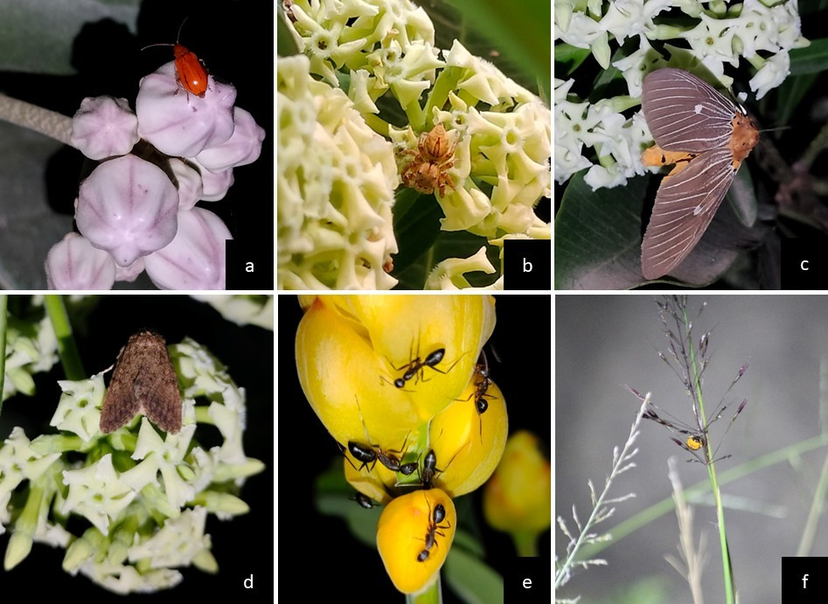
Figure 1: Night pollinators and visitors on different flowering plant species: a) Aulacophora femoralis on Calotropis gigantea b) Spider on Alstonia scholaris c) Asota caricae, tropical tiger moth on Alstonia scholaris d) Tethea albicosta on Alstonia scholaris e) Carpenter ant on Senna alata f) Photinus pyralis or Common eastern firefly on Chrysopogon aciculatus
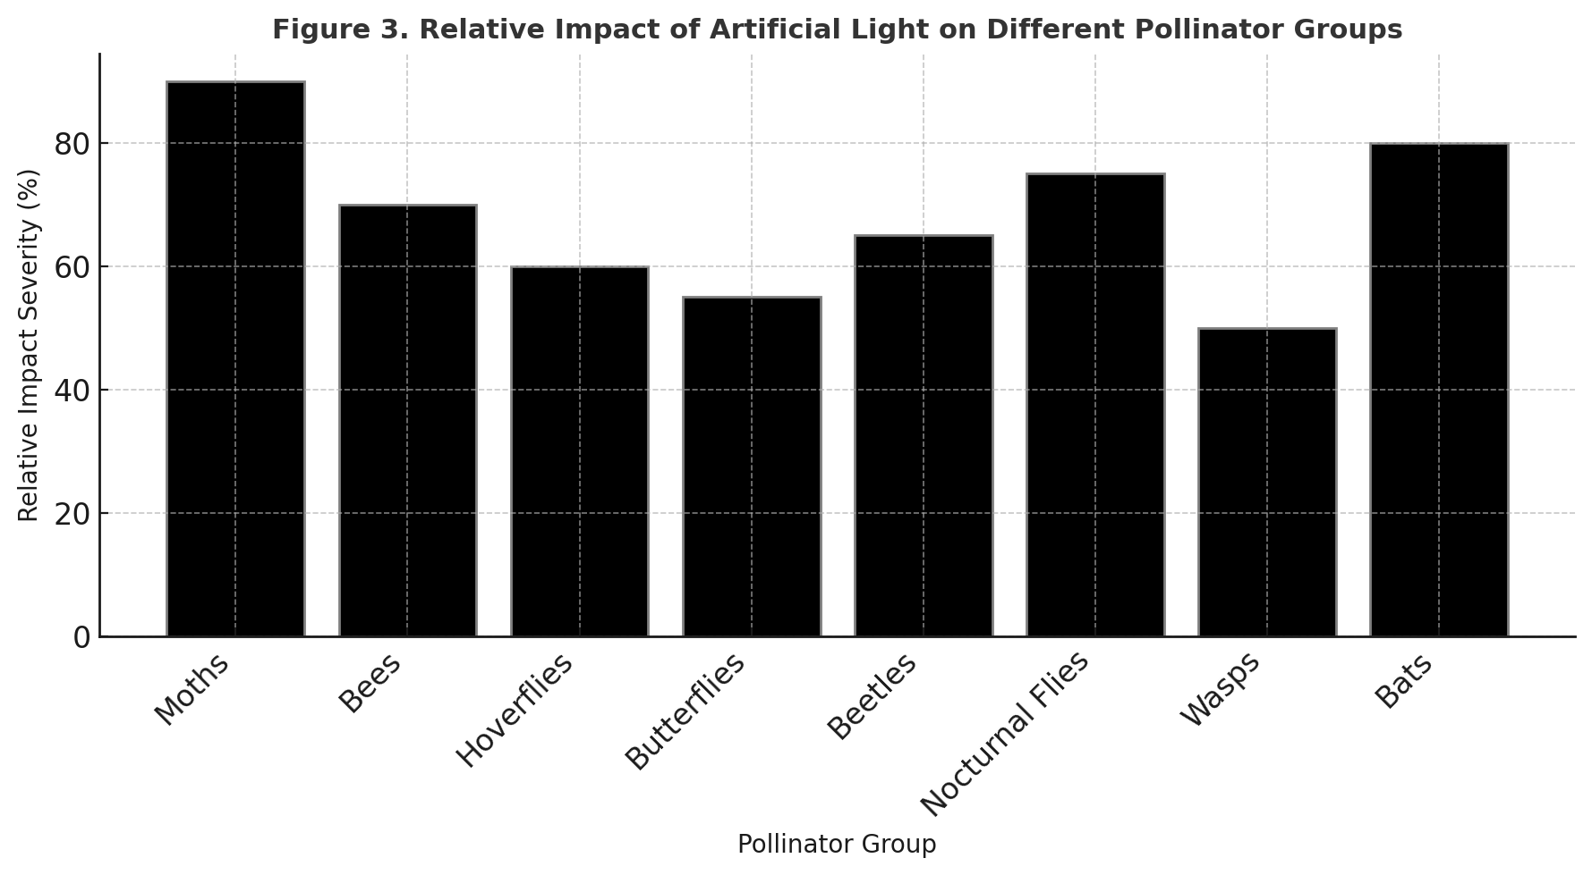
Figure 2: Relative Impact of Artificial Light on Different Pollinator Groups
Mitigation strategies
- Replace bright white or blue-rich LED lighting with low-intensity, warm-coloured (red spectrum) lights that have minimal impact on nocturnal pollinators and visitors.
- Implement directional lighting using shielded or full cut-off fixtures to prevent light spill into natural habitats.
- Establish pollinator-friendly dark zones within and around protected areas, agricultural landscapes, and ecological corridors.
- Create buffer zones between illuminated urban areas and pollinator-rich ecosystems to reduce light intrusion.
- Employ motion sensors, dimmers, and timers to restrict artificial lighting to periods when it is strictly necessary.
- Adopt “lights-off” schedules during peak pollination activity, particularly from dusk to early night.
- Preserve nocturnal foraging habitats by restoring native vegetation and minimising light exposure near flowering plants.
- Develop urban green belts and vegetative barriers to reduce light diffusion into sensitive areas.
- Conduct public awareness campaigns to highlight the ecological importance of nocturnal pollinators.
- Enforce light pollution management policies through local ordinances and integration into urban planning regulations.
- Establish long-term monitoring programs to track pollinator abundance, diversity and behavioural changes under different lighting conditions.
- Support interdisciplinary research linking ecology, lighting technology and environmental planning to develop adaptive mitigation strategies.
- Collaborate with farmers to minimise artificial lighting near croplands during flowering periods.
- Promote pollinator-friendly agricultural practices through controlled light exposure and habitat conservation measures.

CONCLUSION
Artificial light at night has emerged as a significant global pollutant, causing major disruptions to nocturnal ecosystems. It affects insect behaviour, reduces pollination efficiency and leads to cascading ecological imbalances. Research from both global and Indian studies shows a notable decline in nocturnal pollinator diversity, which in turn results in decreased plant reproductive success due to light pollution. There is an urgent need for sustainable mitigation strategies, including the control of spectrum and placement of artificial lightning, community awareness initiatives, and the integration of light management into policy frameworks. Preserving nocturnal darkness is crucial not only for conserving biodiversity but also for maintaining the integrity of agricultural and ecological systems that depend on insect-mediated pollination.
REFERENCES
Boom MP, Spoelstra, Biere A, Knop E and Visser ME. (2020). Pollination and fruit infestation under artificial light at night:light colour matters. Scientific Reports. 10:18389. DOI: 10.1038/s41598-020-75471-1
Boyes DH, Evans DM, Fox R, Parsons MS and Pocock MJO. (2021). Street lighting has detrimental impacts on local insect populations. Science advances. 7: eabi8322. 1-8.
Gaston KJ, Bennie J, Davies TW and John Hopkins J. (2013). The ecological impacts of nighttime light pollution: a mechanistic appraisal. Biological Reviews. 88: 912-927.
Giavi S, Fontaine C and Knop E. (2021). Impact of artificial light at night on diurnal plant-pollinator interactions. Nature Communications. 12(1690): 1-5.
Guenat S and Dallimer M. (2023). A global meta-analysis reveals contrasting impacts of air, light, and noise pollution on pollination. Ecology and Evolution. 13:e9990. DOI: 10.1002/ece3.9990
Knop E, Zoller L, Ryser R, Gerpe C, Horler M and Fontaine C. (2017). Artificial light at night as a new threat to pollination. Macmillan Publishers Limited. DOI: 10.1038/nature23288
Kumar S. (2025). Data collection from literature for biological sciences, medicinal plants research, ethnobotany, and pharmacology: a methodological overview. Journal of Biodiversity and Conservation 9(2): 167-169.
Macgregor CJ, Pocock MJO, Fox R and Evans DM. (2014). Pollination by nocturnal Lepidoptera, and the effects of light pollution: a review. Ecological Entomology. 1-11. DOI: 10.1111/een.12174
Meza A, Venkatesan A and Barentine JC. (2025). Impacts of Rising Light Pollution on Pollinators and Indigenous Food Sovereignty. American Astronomical Society. 9(106): 1-4.
Owens ACS, Cochard P, Durrant J, Farnworth B, Perkin EK and Seymoure B. (2020). Light pollution is a driver of insect declines. Biological Conservation. 241(108259). 1-9. DOI: 10.1016/j.biocon.2019.108259
Padhiyar DH, Chaudhary DV and Thakar PK. (2023). Impact of Light Pollution on Insects. Agriculture & Food: E-Newsletter. 5(2): 15-17.
Patil AH. (2021). Nocturnal insect pollinator diversity and species richness in Ridge gourd, Luffa acutangular. Journal of Applied and Natural Science. 13(2): 643-649.
Riaz J, Razzaq H, Amjad T, Anjum A, Afzal T, Fatima F, Fatima N and Malik MF. (2020). Pollution and pollinators: A review. Pure and Applied Biology. 9(3): 2049-2058.
Singh KB, Kumar KS, Kumar S, Khanduri VP and Phom HP. (2024). Nocturnal pollinators significantly contribute to tree bean (Parkia timoriana (DC.) Merr.) reproductive success compared to diurnal pollinators. Journal for Nature Conservation. 82(126742). DOI: 10.1016/j.jnc.2024.126742
Singh SP. (2024). A Perception in Human Habitats and Effects on Insects: The Growing Concern about Increased Urban Lighting and Diminishing Insects. Agri Articles. 4(4): 690-691.
Subhakar G and Sreedevi K. (2015). Nocturnal insect pollinator diversity in bottle gourd and ridge gourd in southern Andhra Pradesh. Current Biotica. 9(2): 137-144.

