Hydrological Assessment through Cross-Sectional Water Discharge Estimation in the Jamuna River of Assam, India

Abstract: Jamuna River, a tributary of the Kopili River in Karbi Anglong and Hojai districts of Assam. Through field-based data collected from three key cross-sections in Jamuna river, viz. from Manja (upstream), Bokolia (midstream) and Doboka (downstream); and subsequent estimation of water discharge using observed velocity, depth and channel width. This paper reveals the spatial variability in the hydrological characteristics of the Jamuna River of Assam. The analysis shows a clear longitudinal increase in discharge volume from upstream to downstream, indicating cumulative catchment contributions, with variations in geomorphology of the region and land use changes. This work offers important implications for watershed management, especially in the light of increasing anthropogenic pressures and climate-induced hydrological variability in the region. The study also emphasizes the value of field-based hydrological assessments in complementing satellite and GIS-based models to develop grounded and location-specific management strategies.
Keywords: Cross-Sectional Water Discharge; Hydrological Assessment; flow meter; Jamuna Watershed.

1. INTRODUCTION
In region like Assam, water is one of the most vital natural resource for sustaining life and ecosystem services; studying river hydrology is important for knowing the water demand (Garg et al., 2017) and sustainable water management of a particular area (Gogoi & Jain, 2020; Nasrin & Barman, 2025). The Jamuna River, which flows through East Karbi Anglong and Hojai districts of Assam, forms an extensive floodplain region (Das& Goswami, 2003; Phukan et al., 2012); supporting people’s livelihood and agriculture. Despite its regional significance, no study has been conducted to understand its hydrological behavior based on primary field data, therefore no discharge and velocity data is available for this river, not even in the government records.
In the river related studies, the estimation of water discharge is one of the most fundamental hydrological parameters and it needs equipments like flow meter or current meter to collect it in different cross sections of the river. It helps to determine river flow capacity, sediment transport potential, flood forecasting and overall watershed dynamics (Gogoi & Jain, 2020). While satellite-based DEM data and GIS analysis provide a broad-scale understanding of it and field-based cross-sectional analysis helps in real-time flow estimation.
This paper presents a cross-sectional analysis of water discharge in the Jamuna River across three representative zones, viz., upstream (Manja), midstream (Bokolia) and downstream (Doboka). By evaluating the variations in depth, velocity and channel width across these points, the paper aims to assess spatial variations in hydrological behavior and interpret them in the context of geomorphological and anthropogenic influences within the watershed.

2. STUDY AREA
The study area, Jamuna watershed of Assam, can be divided into the upstream zone with hilly terrain and sparse settlements with dense vegetation; the mid stream zone has moderate slope and moderate concentration of settlements can be seen; and the downstream zone has alluvial plain and settlement concentration is high (Nasrin & Barman, 2025) with small urban market places. The downstream zone is suitable for various agricultural crops and fish farming; numbers of fisheries were there in this zone producing fish commercially. Communities living in this zone are mostly farmers and they mainly practice rice, vegetable and jute cultivation.
The Jamuna river is a tributary of Kopili River. The Jamuna watershed is located in the East Karbi Anglong and Hojai district of Assam. It extends from 25°41ʹ N to 26°27ʹ N latitude and from 92°44ʹ E to 93°40ʹ E longitude (Nasrin & Barman, 2025) (Figure 1). The Jamuna River originates near Khumbaman hills in East Karbi Anglong and joins with Kopili river near Jamunamukh town. Total area of the Jamuna watershed is about 3900 sq. km (Borah & Deka, 2019; Borah & Deka, 2020; Nasrin & Barman, 2025). The Jamuna River flows through varied terrain including tribal-inhabited uplands, agricultural mid-valleys and the flood-prone alluvial plains of Hojai before merging with the Kopili River. The total length of the river is approximately 175.92 kilometers and it traverses through ecologically sensitive and socioeconomically diverse zones (Dutt, 1979; Nasrin & Barman, 2025).
- Manja (Upstream survey location): Characterized by forest, high relief and steep slopes. The terrain here is rugged with relatively low anthropogenic interference and low population density.
- Bokolia (Midstream survey location): Represents the transitional zone with mixed land use, moderate slope and increasing human activity in the form of agriculture and settlement.
- Doboka (Downstream survey location): Situated in the low-lying plains with wider valleys, intensive agricultural activity with lots of fisheries and population density is higher here. The river channel is broader and deeper due to the cumulative effects of upstream discharge.

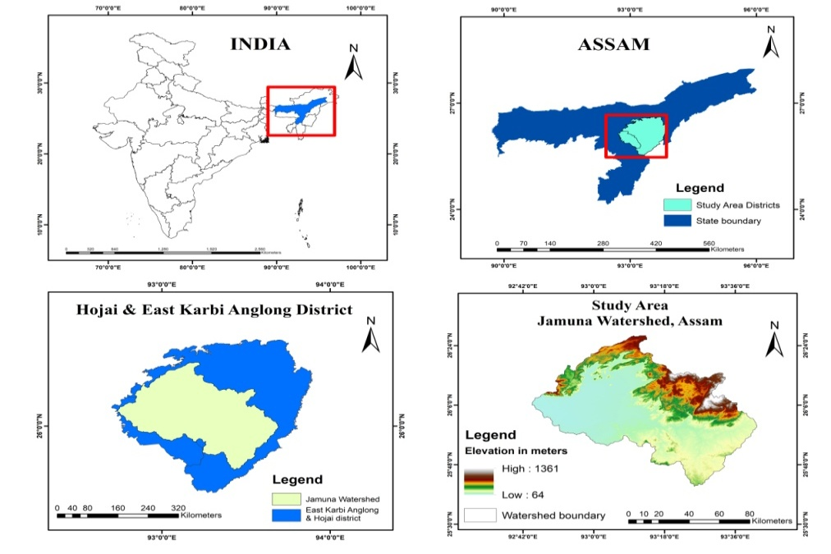
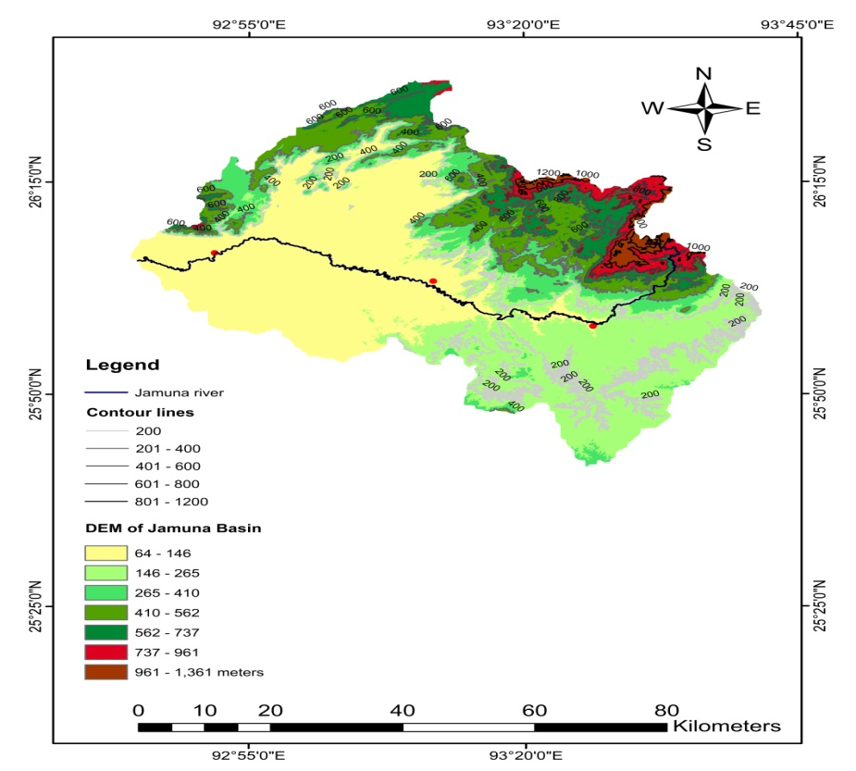
Selected Locations | Elevation
Manja | 147 m
Bokolia | 102 m
Doboka | 72 m

Manja
Doboka
Bokolia
Fig. 1. Location map of Jamuna watershed, Assam.

3. METHODOLOGY

3.1 Field Data Collection
Hydrological fieldwork was conducted on 15th January 2025 to collect depth, width and velocity data from multiple across-sections in the Jamuna River. The equipment used included:
- Current meter or flow meter reading for velocity
- Graduated poles for depth measurement
- Measuring tapes for width
- GPS for location
Each cross-section was divided into 3 sub-sections (ai), with corresponding velocity (Vi) and depth (di) measurements taken.
The data collection with the help of Flow meter is shown in Figure 2 in the upstream of Jamuna River, near Manja.

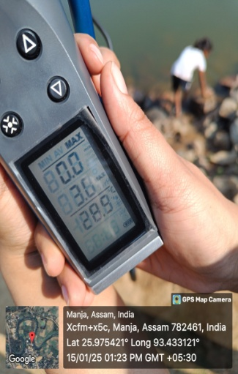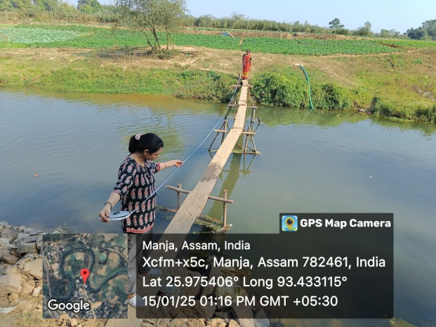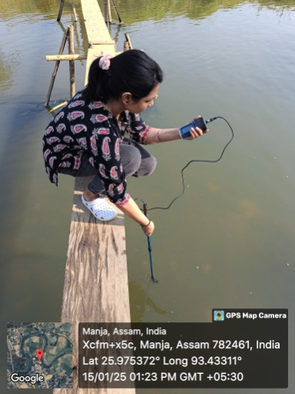

Fig. 2. Photos of data collection in upstream

3.2 Discharge Calculation
The discharge (Q) at each cross-section, calculated using the following formula:
Q_{A}=V_{A}×d_{A}×W_{A}
where,
V_{A} is average velocity (m/s)
d_{A} is average depth (m)
W_{A} average width of the channel (m)
The final average velocity and depth were computed by averaging all sub-section values. All calculations were performed manually to validate and simplify real-world field-based assessments (Ward, 2000) and the velocity and discharge table were made.

4. RESULTS

4.1 Cross-Section A - Manja (Upstream Zone)
Average Velocity: 0.225 m/s
Average Depth: 1.27 m
Channel Width: 14.93 m
Calculated Discharge: 4.199 m³/s
This headwater zone exhibits low discharge due to reduced surface runoff, high forest permeability and low land disturbance; although the data collection was done in winter. The low velocity and narrow channel width match the early-stage fluvial characteristics (Chow, 1959). The river has scenic high waterfalls in Longvoko (near Manja, Karbi Anglong), but the velocity and discharge drastically changed in Manja because of the dam constructed just a few kilometers above of Manja. These small dams help in water distribution to the agricultural fields but the river water and sediment discharge got affected and it makes the river dried up during winters.

4.2 Cross-Section B – Bokolia (Midstream Zone)
Average Velocity: 0.45 m/s
Average Depth: 1.82 m
Channel Width: 19.812 m
Calculated Discharge: 16.22 m³/s
The discharge increase in this transitional zone is attributed to cumulative lateral inflows, surface drainage and moderate anthropogenic activities and presence of a dam lowering the water velocity.

4.3 Cross-Section C – Doboka (Downstream Zone)
Average Velocity: 0.5 m/s
Average Depth: 3.56 m
Channel Width: 24.38 m
Calculated Discharge: 42.12 m³/s
Doboka records the highest discharge due to the cumulative upstream flow, broader valley and agricultural run-off. It is a typical depositional zone of sediments, also susceptible to annual extensive flooding (Singh, 2003; Ward & Robinson, 2000).

5. DISCUSSION

5.1 Longitudinal profile of the River

The Longitudinal profile of the Jamuna River is derived with the help of Aster DEM in ArcGIS software (Nasrin & Barman, 2025) and the profile helps us to know about the river’s erosional and depositional dynamics across its course. In the Longitudinal profile of Jamuna river, the upper course (right side of the graph) shows a steep gradient, indicating the river originates in hilly or mountainous terrain, the middle and lower course (left side of the graph in Figure 3), becomes progressively flatter, indicating the river flows through gentler slopes or plains of Hojai district.

5.1.1 Upper Course of Jamuna: Steep elevation gain from around 200 meters to over 1,300 meters, signifying a high-energy zone; dominated by vertical erosion, with rapids and waterfalls and narrow valleys. Due to high erosion rates this upper course is a sediment source zone.

5.1.2 Middle Course of Jamuna: This part has moderate slopes and fluctuating altitudes. It is a transition zone where the river starts meandering and depositing finer sediments; supporting agricultural activities in the banks. The presence of short knick points indicates structural or lithological controls and presence of a dam affects its natural flow here.

5.1.3 Lower Course of Jamuna: The lower course of Jamuna has a very gentle gradient; the elevation is around 90 meters indicating a low-energy zone where lateral erosion dominates the area and floodplains and meanders are common here with the formation of natural levees due to deposition; and natural wetlands, point bars, ox-bow lakes can be seen in here.

5.2 Longitudinal Discharge Variation
From the upstream (4.199 m³/s) to downstream (42.12 m³/s), discharge shows a tenfold increase. This trend reflects the expansion of contributing area, change in slope and lithology, increased anthropogenic influence in the downstream (Subramanya, 2013).

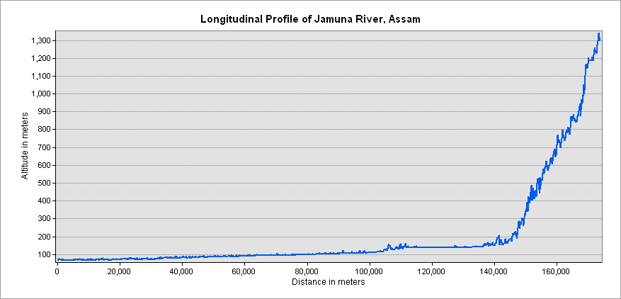
Fig. 3. Longitudinal profile of Jamuna river, Assam.

5.2 Role of Terrain and Land Use
The role of prevailing terrain conditions is very important in terms of the hydrological pattern of a particular river; and the terrain condition is ever changing due to various anthropogenic activities. Mostly agriculture and constructional activities changes the terrain characteristics and its impacts can be seen directly and indirectly in the hydrological behaviours of a river. The upstream zone's of Jamuna watershed has hilly forest areas; and the forest cover reduces runoff (Dogan, 2022; Costa et al. 2023); while the midstream zones experiencing agricultural expansion and deforestation (Welde 2017; Shiferaw, 2025); which elevates the discharge. The downstream areas mostly Doboka and Jamunamukh (parts of Hojai district), with gentle slope and increasing construction and settlement stress, affecting the natural flow of the river (Besha 2024; Liu et al. 2025) and also increasing flood risk (Das & Goswami, 2003).
This study was conducted during the dry season (winters); the discharge may rise significantly in the monsoon season. Many villages of Doboka and Jamunamukh are inundated by flood every year by the Kopili and Jamuna River. The lower part of the Jamuna watershed area is a confluence zone of three rivers viz., Kopili, Jamuna and Nikhari noi (Sharma & Bharali, 2017; Nasrin & Barman, 2025); this low lying zone is good for fishing and agriculture, mostly rice and vegetable production.

5.3 Rainfall Variability in Jamuna watershed
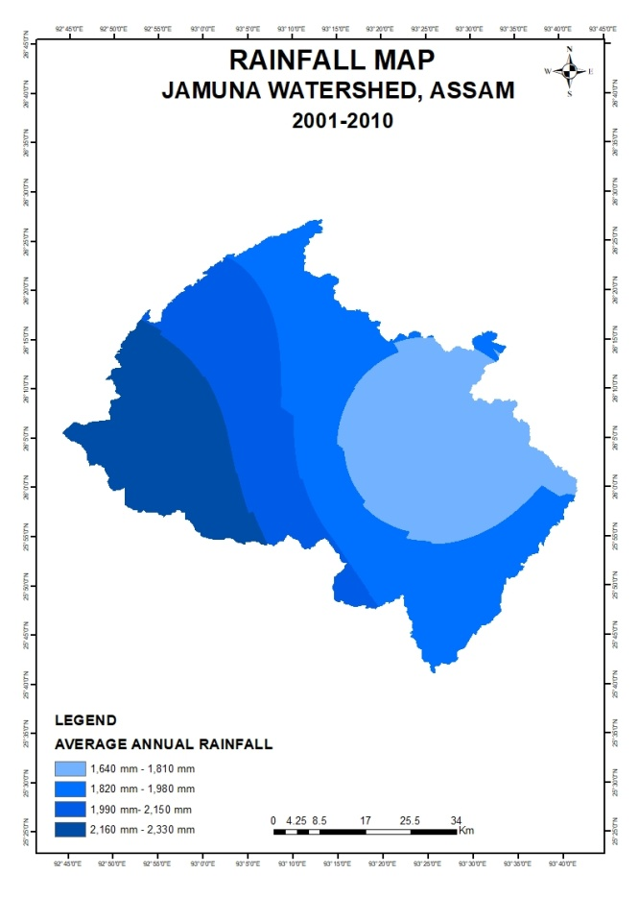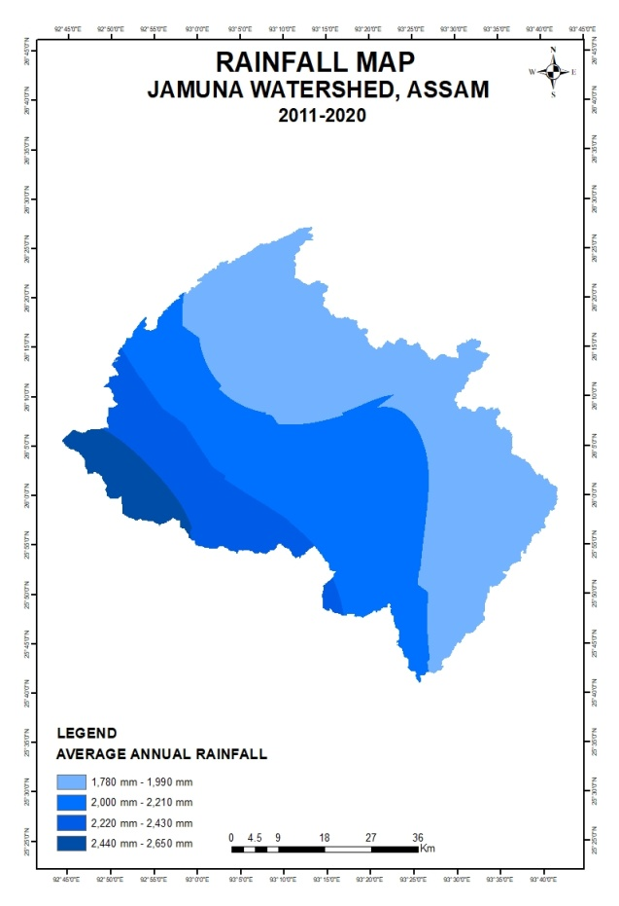
Fig. 4 Rainfall map (2001-2010) Fig. 5 Rainfall map (2011-2020)

Rainfall plays the most important role in the pattern of discharge and hydrological conditions of the basin. The decadal rainfall distribution maps of the Jamuna watershed in Figure 4 and Figure 5, shows a clear spatio-temporal variation in the basin over the last two decades. The rainfall maps show a progressive increase in average annual precipitation in the Jamuna watershed. The old map (2001-2010) shows a dominance of the lower rainfall classes (1,640-2,330 mm); but the 2011–2020 maps indicates a north central shift into moderately higher classes (1,780-2,650 mm). The mid to downstream zone of the watershed show more rainfall, while the Diphu, Manja side shows smaller relative change.
The comparative analysis of the two rainfall maps shows a slight spatial shift in the rainfall concentration in the basin. This indicates the regional climatic changes and land-cover alterations with forest depletion due to Jhum cultivation in the upstream zones and agricultural expansion in the downstream zone. The rainfall variations and the observed discharge pattern from 4.19 m³/s in the upstream section to 42.12 m³/s downstream suggests that cumulative rainfall and catchment response in downstream make the overall flow regime. The seasonal rainfall in monsoon intensifies the processes; the rainfall and discharge relationship reflects the hydrological system and sediment deposition in lower reach intensify the flood risk due to gentle slope in the floodplains.
In the recent two decades, a marginal shift in average rainfall in the watershed can be seen. The spatial rainfall variability combined with anthropogenic and topographic controls, determines the hydro-geomorphological dynamics of the Jamuna River and its seasonal discharge behaviour.

5.4 Hydro-Geomorphological Integration
The overall hydrological behaviour of the Jamuna River reflects a close interaction of terrain, rainfall variability, land-use pattern and human interventions (Aboelnour 2021; Guo 2023). The steep gradient and high forest cover in the upper course regulate runoff and sustain the base flow during the pre-monsoon period. The midstream is the transitional zone; it is affected by deforestation, agricultural techniques and structural modifications, resulting irregular flow dynamics and localized channel adjustments. The lower course has very gentle slope and higher cumulative rainfall (Dwarakish & Ganasri 2015); which supports large-scale discharge accumulation and also very frequent floodplain inundation too.
The rainfall maps (figure 4, 5) indicate a gradual spatial shift in the upper catchment zones; and in downstream areas continue to receive higher mean precipitation but the area experiencing this is reducing and it has effects on the local farmers; but the flood potential near Doboka and Jamunamukh is prevails for many reasons and one of the most important is the confluence of three rivers- Jamuna, Nikhari noi and Kopili river, with low land zones nearby. Together, these hydrological and geomorphological responses shows a system in transition, from a stable, forest dominated headwater zone to a human-modified floodplain (downstream zone) with hydrological variability. This integrated interpretation shows that the Jamuna watershed’s water regime is not solely controlled by rainfall amount, but majorly it is controlled by rainfall. The other influences include the slope pattern, land use, vegetation cover and structures on the channels like dams etc which affects the natural flow inside the basin.

5.6 Implications for Watershed Management

It is important to maintain the natural balance of a watershed with its wetland settings, inlet and outlet systems for water availability and sustainability for the future generations. In this study we are suggesting a few implications for different parts of the basin. The upstream zones needs to implement the following measures for the future sustainability concerns-
- To encourage community-led forest conservation
- To maintain natural vegetative buffer zones in the basin
- Reduce land clearing on hill slopes for Jhum cultivation

The midstream zone needs to focus on-
- Need for sustainable farming and check dams
- Need to introduce land-use zoning to reduce runoff
- Monitor sediment flows

The downstream zone needs to focus on-
- Strengthening the embankments
- Check on unregulated sand mining in the river
- Focus on drainage infrastructure and garbage disposal methods in the small market places

6. CONCLUSION
In this work the cross sectional discharge data were collected of Jamuna river of Assam; these data helps to know about the hydrological characteristics of the river. Although various small dams, sluice gates are there, affecting the natural flow of the river; and also affects the fish availability in those locations which were once known for fishing. The results of cross sectional discharge data shows spatial variability in river discharge; that is controlled by the topography, land use and land cover settings and other geo-hydro-anthropogenic factors. The two decades of rainfall patterns also showing a slight shift due to changes in regional climate and various human activities. This study also helps in understanding the river behavior, water availability during winters and agriculture, livelihood practices which is related to the river in various ways.

Multidisciplinary Domains

This research covers the domains: (a) Geography, (b) Hydrology
Declaration on AI Usage
The authors declare that the article has been prepared without the use of any AI tools.

References
Aboelnour, M. A., Tank, J. L., Hamlet, A. F., Bertassello, L. E., & Ren, D. (2021). Impacts of watershed physical properties and land-use on streamflow using multiple regression models at 130 sites. Science of The Total Environment, 754, 142092. https://doi.org/10.1016/j.scitotenv.2020.142092
Besha, K. Z., Tadele, G., Gebrehiwot, S. G., & Haile, G. G. (2024). Effects of land use/land cover change on hydrological components of a watershed using multivariate statistics. Hydrology Research, 55(2), 83–98. https://doi.org/10.2166/nh.99967
Borah, H., & Deka, S. (2019). Hypsometric analysis of Jamuna watershed, Assam with application of Geographical Information System. Journal of Emerging Technologies and Innovative Research, 6(6), 676–684. https://doi.org/10.1729/Journal.21724
Borah, H., & Deka, S. (2020). Morphometric analysis for prioritization of sub-watersheds of Jamuna River watershed, Assam, India using remote sensing and GIS technique. International Journal of Control and Automation, 13(2s), 18–26. https://doi.org/10.9790/0990-0403013649
Chow, V. T. (1959). Open-Channel Hydraulics. McGraw-Hill: New York, NY, USA.
Costa, R. C. A., Santos, R. M. B., Fernandes, L. F. S., Carvalho de Melo, M., Valera, C. A., Valle Junior, R. F. d., Silva, M. M. A. P. d. M., Pacheco, F. A. L., & Pissarra, T. C. T. (2023). Hydrologic response to land use and land cover change scenarios: An example from the Paraopeba River Basin based on the SWAT model. Water, 15(8), 1451. https://doi.org/10.3390/w15081451
Das, P. J., & Goswami, D. C. (2003). Hydrological impacts of small rivers in Assam. NEHU Journal of Science and Technology, 1(2), 35–47.
Dogan, F. N. (2022). Effect of land use change on hydrology of forested watersheds. Ecological Processes, 11, 59. https://doi.org/10.1002/eco.2367
Dutt, K. N. (1979). Gazetteer of India, Assam State. U. M. & N. C. Hills District (Karbi Anglong and North Cachar Hills Districts). Government of Assam: Guwahati, India.
Dwarakish, G. S., & Ganasri, B. P. (2015). Impact of land use change on hydrological systems: A review. Cogent Engineering, 2, 1115691. https://doi.org/10.1080/23311941.2015.1115691
Garg, V., Singh, V. P., & Raj, V. (2017). Development of Water Resources in India. Springer: Cham, Switzerland.
Gogoi, M., & Jain, V. (2020). River basin hydrology and sustainable water management in Northeast India. Environmental Earth Sciences, 79(5), 1–14. https://doi.org/10.1007/s12665-020-08976-9
Guo, Q., Zhao, F., Zhang, L., & Liu, S. (2023). Impacts of climate and land-use changes on water yields – A global meta-analysis. Journal of Hydrology: Regional Studies, 45, 101062. https://doi.org/10.1016/j.ejrh.2022.101062
Liu, H., Yan, H., & Guan, M. (2025). Evaluating the effects of topography and land-use change on hydrological signatures: A comparative study of two adjacent watersheds. Hydrology and Earth System Sciences, 29, 2109–2132. https://doi.org/10.5194/hess-29-2109-2025
Nasrin, M., & Barman, B. (2025). Digital terrain analysis to understand watershed characterization using ASTER DEM: A case study of Jamuna watershed of Assam, India. International Journal for Innovative Research in Technology, 11(9).
Phukan, M., Goswami, D. C., & Das, P. J. (2012). Riverine hazards and floodplain management in Assam. Current Science, 103(3), 288–294.
Sharma, C., & Bharali, B. (2017). River basin studies and water resource challenges in Northeast India. Asian Journal of Water, Environment and Pollution, 14(1), 67–75.
Shiferaw, N., Wondie, A., Assefa, Y., & Choi, Y. (2025). Land use dynamics and their impact on hydrology and water quality in the Gap-Cheon watershed. Environmental Science and Pollution Research. https://doi.org/10.1007/s11356-025-35946-y
Singh, V. P. (2003). Hydrology and Water Resources. Springer: Dordrecht, The Netherlands.
Subramanya, K. (2013). Engineering Hydrology (4th ed.). Tata McGraw-Hill: New Delhi, India.
Ward, R. C., & Robinson, M. (2000). Principles of Hydrology. McGraw-Hill: London, UK.
Welde, K., Girmay, G., & Gebresamuel, G. (2017). Effect of land use–land cover dynamics on hydrological response – A case study of the Iida-Swamp watershed, Japan. Journal of Environmental Management, 187, 247–258. https://doi.org/10.1016/j.jenvman.2016.11.046

