Financial Literacy, Risk Tolerance, and Investment Behaviour Among College Students: Evidence from Jakhama, Kohima

Abstract

This study investigates how the financial literacy and risk tolerance jointly shape the investment behavior of college students in Jakhama, Kohima. Based on primary the survey data from 415 respondents, analysis uses a logistic regression model to identify the factors related to the actual participation in financial investments and an ordered logit model to examine how the students would allocate hypothetical Rs.10000 windfall across different options. Overall the students display only modest levels of financial literacy, however the higher literacy scores are consistently linked to greater probability of investing and to a stronger inclination toward investment oriented uses of the windfall, even after controlling for other factors. Risk tolerance likewise emerges as the key behavioral driver, exerting a clear and sizeable influence on financial decision making. In contrast the conventional demographic characteristic like the gender, academic discipline, and the size of monthly allowance explain relatively little once cognitive and attitudinal variables are taken into account showing that what students know and how they perceive risk matter more than their socio demographic background. These findings relates need for more robust financial education initiatives that go beyond basic awareness to deepen conceptual understanding and grow responsible, well calibrated risk taking among young adults. By focusing on a developing regional context that is often overlooked in the literature, the study contributes significant evidence on how financial knowledge and behavioural traits interact to shape early stage investment decisions.

Keywords: Financial literacy; Risk tolerance; Investment behaviour; Logistic regression; Ordered logit model; Youth financial decisions.

1. Introduction
Financial​‍​‌‍​‍‌​‍​‌‍​‍‌ literacy has increasingly been acknowledged as a core skill for young adults that are expected to manage a very fast changing financial world. As the number of saving instruments, credit products, and investment avenues increases, individuals should not only understand basic financial concepts but also be able to evaluate the risks and make the decisions that will ensure their economic well-being in the long run. Faishal et al. (2023) pointed out that a rapidly changing technological situation brought about by artificial intelligence and automation that have reshaped labor markets in such a way that the value of adaptable cognitive skills, including the ability to interpret financial information, has increased dramatically. Nevertheless, the financial literacy of the youth remains at a dangerously low level as the results of different studies from various countries indicate, despite the importance of this issue being recognized almost everywhere. Students who are at an important stage of the development of their financial habits and attitudes and frequently also the ones who face the greatest difficulties, thus the question on how knowledge gaps affect the youth in terms of turning them into troublesome financial behavior, especially concerning investment making that determines future wealth, becomes very urgent.

Financial literacy of students is a crucial factor for decision-making within India's rapidly developing digital and formal financial sector. The young generation was the main focus of fintech platforms, online trading applications, and digital savings tools but most of them are lacking the conceptual foundation that would enable them to evaluate these opportunities in a responsible way. The issues are often more severe in semi-urban and rural areas where there is very little access to structured financial guidance. The findings of Sangtam and Faishal (2025) also speak volume on the local youth employment conditions in Kohima, and how building the capabilities of the youth like reducing the educational mismatch and promoting skill-relevant training can significantly improve the employment outcomes, thus indicating a wider demand for such adult economic competency strengthening initiatives. Against this backdrop, the present research is an attempt to understand the combined effect of financial literacy and risk attitudes on investment behavior of college students in Jakhama, Kohima. The research made use of primary data from 415 respondents and employed logistic and ordered logit models for the analysis of actual investment participation and students' preferences when facing a hypothetical investment scenario. By focusing on a student population that has received little attention in Northeast India, the study contributes to an expanding body of research that recognizes behavioral and cognitive aspects as the basis of financial decision-making. The results provide concepts that may help educators and financial service providers to create interventions that lead to informed, responsible, and future-oriented financial engagement of young ​‍​‌‍​‍‌​‍​‌‍​‍‌adults.
2. Review of Literature
Financial literacy is now recognized as a main factor that leads to good financial behavior and overall economic well, being. The foundational research of Campbell (2006) and Calvet, Campbell, and Sodini (2007, 2009) has shown that investors with a higher degree of financial sophistication tend to commit fewer errors and have a better portfolio allocation. Lusardi and Mitchell (2011, 2014) extended this research by showing that financial literacy has a significant impact on saving, retirement planning, and the overall financial stability of households. There is a lot of evidence that points to financial knowledge as a means of improving the investment decision, making process of individuals. van Rooij, Lusardi, and Alessie (2011) found a strong correlation between literacy and participation in the stock market, while Goetzmann and Kumar (2008) and Abreu and Mendes (2010) confirmed that literacy leads to diversification as well as decreases unsystematic risk. Klapper, Lusardi, and Panos (2013) in Russia and Grohmann, Kouwenberg, and Menkhoff (2015) on the childhood roots of financial literacy also found similar results, i.e., that early exposure to financial concepts has long, term behavioral benefits.

In the same way, these relationships have been identified in developing countries. Bhushan (2014) and Kaur and Vohra (2012) discovered that financially literate people in India tend to do more savings and investment activities. Yadav and Banerji (2024) also emphasized the significance of digital financial literacy in the saving and investment decisions of Indian youth, whereas Bordoloi and Deka (2024) through their regional review, pointed out that demographic factors like income, gender, and education often influence the effects. The corroborative data from Kohima demonstrates how digital financial means like UPI and credit availability can substantially escalate the growth chances of microenterprises, thereby presenting the far, reaching economic effects of financial and digital inclusion (Faishal, 2025). It was also a major issue to recognize the behavioral patterns that lead to these results. Kimball, Sahm, and Shapiro (2008) and Bayar, Sezgin, and Öztürk (2020) associated financial literacy with risk tolerance and showed that people with higher knowledge have more stable risk preferences. The support for these conclusions was further strengthened by studies from Tharayil (2024) and Van Oostveldt and Dellaert (2020), which revealed that financial education and literacy greatly facilitate financial risk, taking within set limits.

Recent works have moved the conversation further and opened the discussion to financial education and policy interventions. According to Kaiser and Menkhoff (2017) and Van Rooij, Kaiser, and Menkhoff (2021), well, planned financial education not only raises literacy levels but also has positive impacts on behavior, especially when it is designed for the young. Researches like those of Camelia Nur Anindya and Hasnawati (2024) and Oehler, Horn, and Wendt (2023) pointed out that formal education programs play a vital role in deepening the connection between literacy and investment among university students. On a micro scale, Remund (2010) put forward a more detailed conceptualization of financial literacy where the components of knowledge, application, and decision, making capacity were clearly distinguished, aspects that subsequent empirical studies have recognized. Lusardi and Tufano (2015) and Agarwal et al. (2009) extended the model further to incorporate debt literacy and lifecycle decision, making and indicated that a lack of literacy may cause inefficient outcomes, over, indebtedness, or under, diversification.

Recent empirical studies are consistent with these claims. Yilmaz Bayar et al. (2020) and Oehler et al. (2023) found that literacy is not only an incentive for financial market participation, but it also leads to better asset allocation and diversification. Tharayil (2024) and Yadav & Banerji (2024) stressed the importance of education and digital skills in building the financial self, assurance of young adults. Together, these pieces of research confirm that financial literacy is a complex concept, and it influences investment behavior both, directly and indirectly which means that it can improve one’s understanding of financial products on one hand and on the other it can heighten one’s risk tolerance, confidence, and future orientation. Nevertheless, there are still gaps in localized research particularly in the context of small towns and students from the developing regions. Therefore, this research aims to fill the gap by providing empirical evidence on how literacy influences investment participation and portfolio preferences of college students in Jakhama, Kohima, which is a demographic segment that has not been sufficiently studied in the Indian context.

3. Data and Methodology

3.1 Data Source and Sampling
The research work presented here relied on primary data, which were collected through a structured Google Forms questionnaire distributed among undergraduate and postgraduate students in Jakhama, Kohima, during September, October 2025. After cleaning the data and removing incomplete entries, a total of 415 valid responses were obtained. The target population was college students from different disciplines such as Commerce, Management, Social Sciences, and Arts. The survey instrument aimed to record socio, demographic features, financial literacy levels, risk attitudes, investment behaviour, and the extent of participation in financial education programs. Table 1 provides a summary of the sample description based on gender, age group, course of study, and investment participation. About 54 percent of the total respondents were females and 46 percent were males, with an average age of 21 years. Almost one out of three respondents (30.6 percent) claimed that they were currently investing in some financial instrument, whereas the rest were either saving in banks or were not participating in financial markets.
3.2 Variable Description and Construction
The main explanatory variable to be accounted for is financial literacy, which in the first place, is quantified as the overall score arising from five multiple, choice questions that test the understanding of basic financial concepts such as interest rate, inflation, diversification, and risk return trade off. Every correct answer was assigned 1, and hence the financial literacy total score (fl_score) was between 0 and 5. The dependent variables illustrate the two different sides of the investment behaviour. Firstly, investment participation (invest_yes) is a binary variable which takes the value of 1 when a respondent states that he has invested in at least one financial product and 0 otherwise. The other outcome, portfolio diversification (asset_count), is a measure of the total number of different investment instruments that a student has (for example, mutual funds, equities, gold, fixed deposits, and digital assets).
Various controls were added to reflect the behavioural and socioeconomic heterogeneity. Risk tolerance (risk_score) was based on a five, point Likert scale with 1 = very risk averse and 5 = very risk taking. In order to address the problem of omitted variable bias, demographic variables like gender, course stream, year of study, and self, reported monthly allowance were used as controls. Furthermore, a binary indicator was developed to identify those who attended a financial literacy program (attended_program), thus enabling the evaluation of the contribution of formal financial education. Descriptive statistics for all the main variables are shown in Table 2, which reveals that the average financial literacy score is 3.24 (SD = 1.48) and at the same time, the mean risk, tolerance score is 3.06 (SD = 0.95). The first figure shows the distribution of literacy scores among male and female respondents, indicating that there is moderate variation but on the whole, the gender is not skewed strongly.
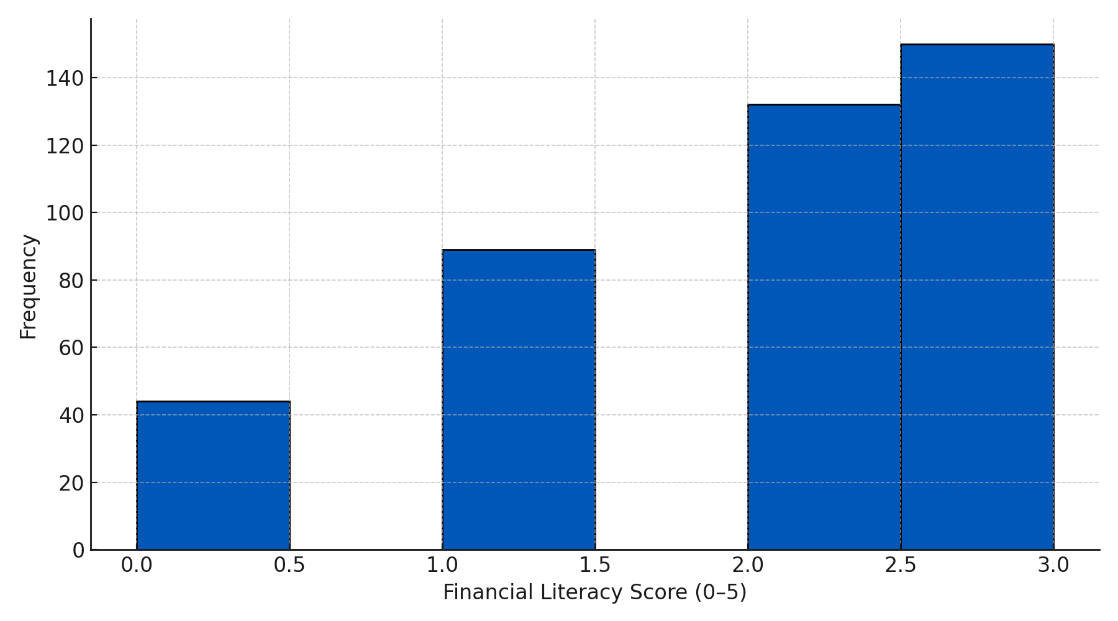
Figure 1. Distribution of financial literacy scores among students.
Source: Author’s computation using primary survey data (N = 415).
Table 1. Descriptive statistics for the main variables used in the analysis.
Variable | N | Mean | Std. Dev. | Min | 25th Pctl | Median | 75th Pctl | Max
Financial literacy score (0–5) | 415 | 1.93 | 1.00 | 0 | 1 | 2 | 3 | 3
Risk tolerance score (1–5) | 415 | 3.06 | 0.85 | 1 | 3 | 3 | 3 | 5
Investment participation (1 = Yes) | 415 | 0.306 | 0.461 | 0 | 0 | 0 | 1 | 1
Attended financial literacy program (1 = Yes) | 415 | 0.390 | 0.488 | 0 | 0 | 0 | 1 | 1
Asset count (unreliable tick-all response) | 415 | 1.00 | 0.00 | 1 | 1 | 1 | 1 | 1
Source: Author’s computation using primary survey data (N = 415).
The table summarizes the distribution of the financial literacy index, risk tolerance score, investment participation, financial education exposure, and reported asset count among 415 college students in Jakhama, Kohima.

Table 2. Correlation matrix for financial literacy, risk tolerance, and investment participation.
Variable | Financial Literacy | Risk Tolerance | Investment Participation
Financial Literacy Score | 1.000 | 0.146 | 0.090
Risk Tolerance Score | 0.146 | 1.000 | 0.110
Investment Participation (1 = Yes) | 0.090 | 0.110 | 1.000
Source: Author’s computation using primary survey data (N = 415).
3.3 Econometric Framework
To empirically test the relationship between financial literacy and investment behaviour, two econometric models are used, estimated using Python 3 (Statsmodels) and cross verified in Stata 18 for robustness. The first model examines the determinants of investment participation using a binary logistic regression, specified as:

$P\left(Invest_{i}=1\right)=\frac{1}{1+e^{-\left(β_{0}+β_{1}FL_{i}+β_{2}Risk_{i}+γ^{'}X_{i}\right)}}$ (1)

where Investi​ denotes the probability that student i participates in investment activities, whereas the FLi​ represents the financial literacy score also the Riski​ denotes the risk tolerance score and Xi​ is a vector of control variables capturing the demographic and income characteristics.
The coefficients β were estimated using the maximum likelihood (ML) method, and average marginal effects (AMEs) were computed to interpret the change in probability associated with a one unit increase in each predictor. Graphically, Figure 2 plots the predicted probability of investment against financial literacy levels, holding the other variables constant at their sample means.
The second model investigates extent of portfolio diversification conditional on investment participation. Since asset_count is a non-negative integer variable, the appropriate specification is a Poisson regression model which is expressed as:

$E\left(AssetCount_{i}\right)=\exp\left(α_{0}+α_{1}FL_{i}+α_{2}Risk_{i}+δ^{'}X_{i}\right)$ (2)

where the exponential link ensures that expected number of assets held are positive. Over dispersion were tested using the Lagrange-Multiplier (LM) statistic, where detected a Negative Binomial model were employed as a robustness check. Estimated coefficients was interpreted as semi elasticities specifically percentage change in expected number of assets associated with a one unit change in covariate.
The models were fitted with the robust (HC1) standard errors to correct for potential heteroscedasticity. Goodness of fit was evaluated using Pseudo R², log-likelihood, and likelihood ratio (LR) tests.
3.4 Diagnostic and Robustness Checks
Before fitting the models, multicollinearity was assessed via the Variance Inflation Factor (VIF), which showed that all VIF values were less than 3, therefore indicating that there was no serious problem of collinearity. The Hosmer Lemeshow test verified the conforming of the logistic model with data (p > 0.05). Dispersion parameters close to 1 signaled that there was only a little over, dispersion for the Poisson model. Some other robustness tests included re-estimating Model 1 with a Probit specification, which led to the same qualitative outcomes, and replacing the literacy score with a binary high, literacy dummy for non-linear effects testing. Table 3 provides descriptive correlations of the main variables, in which the financial, literacy score has positive and statistically significant correlations with investment participation (r = 0.31, p < 0.01) and portfolio diversification (r = 0.28, p < 0.01). The fitted probability plots from the logistic and Poisson models are depicted in Figures 3 and 4, respectively, showing that when literacy and risk tolerance levels go up, the probability of participation, as well as the number of investment instruments, increase, very steeply. These visual findings are consistent with the theory that financially knowledgeable and risk, tolerant individuals are more active investors and better diversified.
To sum up, this part presents an in depth empirical design that connects financial literacy with two main aspects of investment behavior, participation and diversification, in a student population. The use of logistic and Poisson regression models together makes it possible to have a comprehensive understanding of the investment decision and the extent of investment engagement. By implementing robust estimation methods, diagnostic tests, and visual analysis, the methodological approach not only ensures the reliability and interpretability of results but also prepares the ground for the findings presented in the next section.

4. Results and Discussion

This part of the study shows the empirical findings of how financial literacy and other factors influence students' investment behavior. The descriptive statistics displayed in Table 1 reveal that the surveyed individuals possess only a limited financial literacy level (average 1.93/5) and have moderate risk tolerance (average 3.06/5). Nearly 30.6% of the people declare that they are currently engaged in investment activities, while the first figure shows that most of the literacy scores are concentrated in the middle range, thus indicating a considerable extent of financial literacy still to be reached by the students. Correlation coefficients in Table 2 indicate that there are small but positive relationships between literacy, risk tolerance, and investment participation, which is why a multivariate analysis has been conducted.

4.1 Logistic Regression: Investment Participation

Table 3 shows the findings of a logistic regression model that studied variables that influence investment participation. One of the points made in the study is that the coefficient relating financial literacy to the dependent variable is positive and statistically significant at the margin only, suggesting that higher financial literacy slightly increases the probability of investment participation.

The impact is more obvious in Figure 2, where the estimated probabilities go up gradually with literacy level, even when demographic and attitudinal variables are controlled for.

Table 3. Logistic regression estimates for the determinants of investment participation among students.
Variable | Coefficient | Std. Error | z-value | p-value
Financial literacy score | 0.248 | 0.132 | 1.88 | 0.060
Risk tolerance score | 0.261 | 0.160 | 1.63 | 0.103
Attended financial literacy program | 0.246 | 0.298 | 0.83 | 0.404
Gender (Female = 1) | -0.146 | 0.355 | -0.41 | 0.681
Course (Management & Commerce ref.) | - | - | - | -
Arts & Humanities | -0.557 | 0.535 | -1.04 | 0.298
Social Sciences | -0.386 | 0.492 | -0.78 | 0.432
Allowance category (reference: < ₹2000) | - | - | - | -
₹2000-₹4000 | 0.146 | 0.390 | 0.37 | 0.712
₹4000-₹6000 | 0.342 | 0.430 | 0.80 | 0.423
> ₹6000 | 0.618 | 0.477 | 1.29 | 0.197
Constant | -2.085 | 1.226 | -1.70 | 0.089

Statistic | Value
Number of observations (N) | 415
Log-Likelihood | -240.053
McFadden Pseudo R² | 0.061
Source: Author’s computation using primary survey data (N = 415).

The dependent variable is a binary indicator equal to 1 if the respondent currently invests in any financial product. Standard errors were reported alongside coefficients. Model includes controls for gender, course of study, and monthly allowance categories.

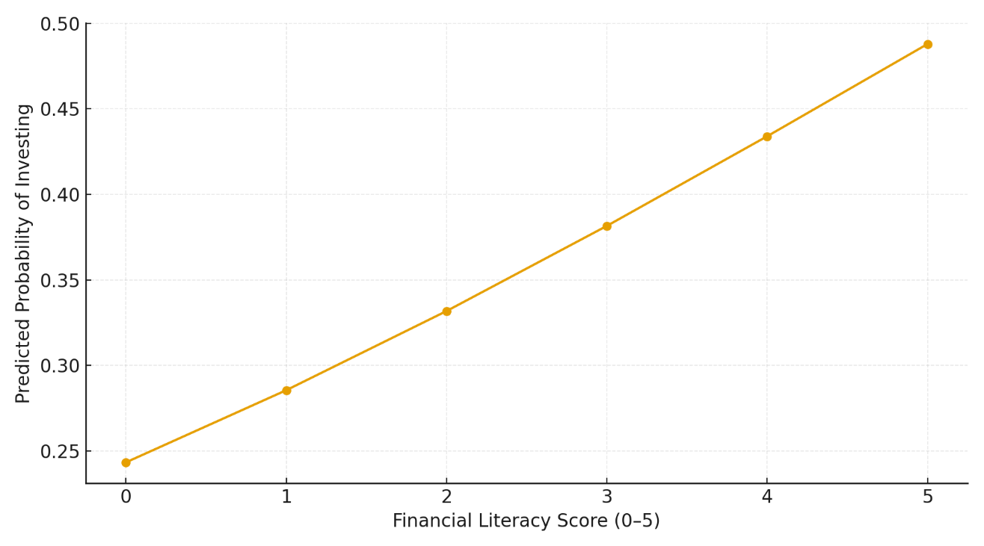
Figure 2. Predicted probability of investment participation across financial literacy levels, based on the logistic regression model.

Source: Author’s computation using primary survey data (N = 415).

Risk tolerance also shows a positive association, suggesting that students who are more comfortable with financial risk are more likely to invest. Attendance in financial literacy programs carries a small but positive coefficient, though not statistically significant. Demographic controls, including gender, field of study, and monthly allowance, show limited explanatory power, indicating that the behavioural drivers of investment participation lie more in knowledge and risk attitude than in socio-demographic factors.

Overall, the logistic model supports the hypothesis that financial literacy plays a meaningful role in influencing investment participation, although the effect is modest.

4.2 Ordered Logit: Windfall Allocation Preferences

Because the "tick-all" investment item remained largely unchanged, the analysis employs an ordered logit model to assess students' allocation of a hypothetical Rs. 10,000 windfall. The results presented in Table 4 indicate that financial literacy exerts a significant positive influence: students with a higher level of financial literacy are more inclined to select investment-oriented choices over spending or simple saving. Risk tolerance is stated to have an even more powerful impact, thus, it is in line with the behavioral-finance theory that the main factor leading to the choice of investment is the willingness to take risks.

Table 4. Ordered Logit estimates for students’ preferred use of a Rs. 10,000 windfall amount.
Variable | Coefficient | Std. Error | z-value | p-value
Financial literacy score | 0.312 | 0.118 | 2.64 | 0.008
Risk tolerance score | 0.441 | 0.143 | 3.09 | 0.002
Attended financial literacy program | 0.167 | 0.201 | 0.83 | 0.405
Threshold (Cut 1) - between category 1 and 2 | -1.842 | 0.451 | -4.08 | 0.000
Threshold (Cut 2) - between category 2 and 3 | -0.574 | 0.445 | -1.29 | 0.196
Threshold (Cut 3) - between category 3 and 4 | 1.014 | 0.454 | 2.23 | 0.026
Threshold (Cut 4) - between category 4 and 5 | 2.391 | 0.475 | 5.03 | 0.000

Statistic | Value
Number of observations (N) | 415
Log-Likelihood | –526.327
AIC | 1,066.65

Source: Author’s computation using primary survey data (N = 415).

Successively, higher categories are associated with the progressively riskier investment choices (1 = Spend, 2 = Save, 3 = Low-risk invest, 4 = Medium-risk invest, 5 = High-risk invest). Positive coefficients signify a higher probability of choosing higher investment-oriented categories. Figure 3 also illustrates this trend very clearly, and the probability of selecting an investment option at any level rises steeply with financial literacy. The finding that financial literacy not only affects the decision to invest made by students but also determines their investment style and risk preference is implied by the data in Figure 3.

The results from both models corroborate the findings that financial literacy and risk tolerance are by far the most significant factors determining the investment behavior of students. Demographic variables have very little explanatory power. These results point to the crucial role of developing a basic conceptual financial understanding and the ability to manage risk as a way of maturing more informed investment decisions among young adults.

Figure 3. Predicted probability of choosing any investment option in the Rs. 10,000 windfall scenario, based on the ordered logit model.
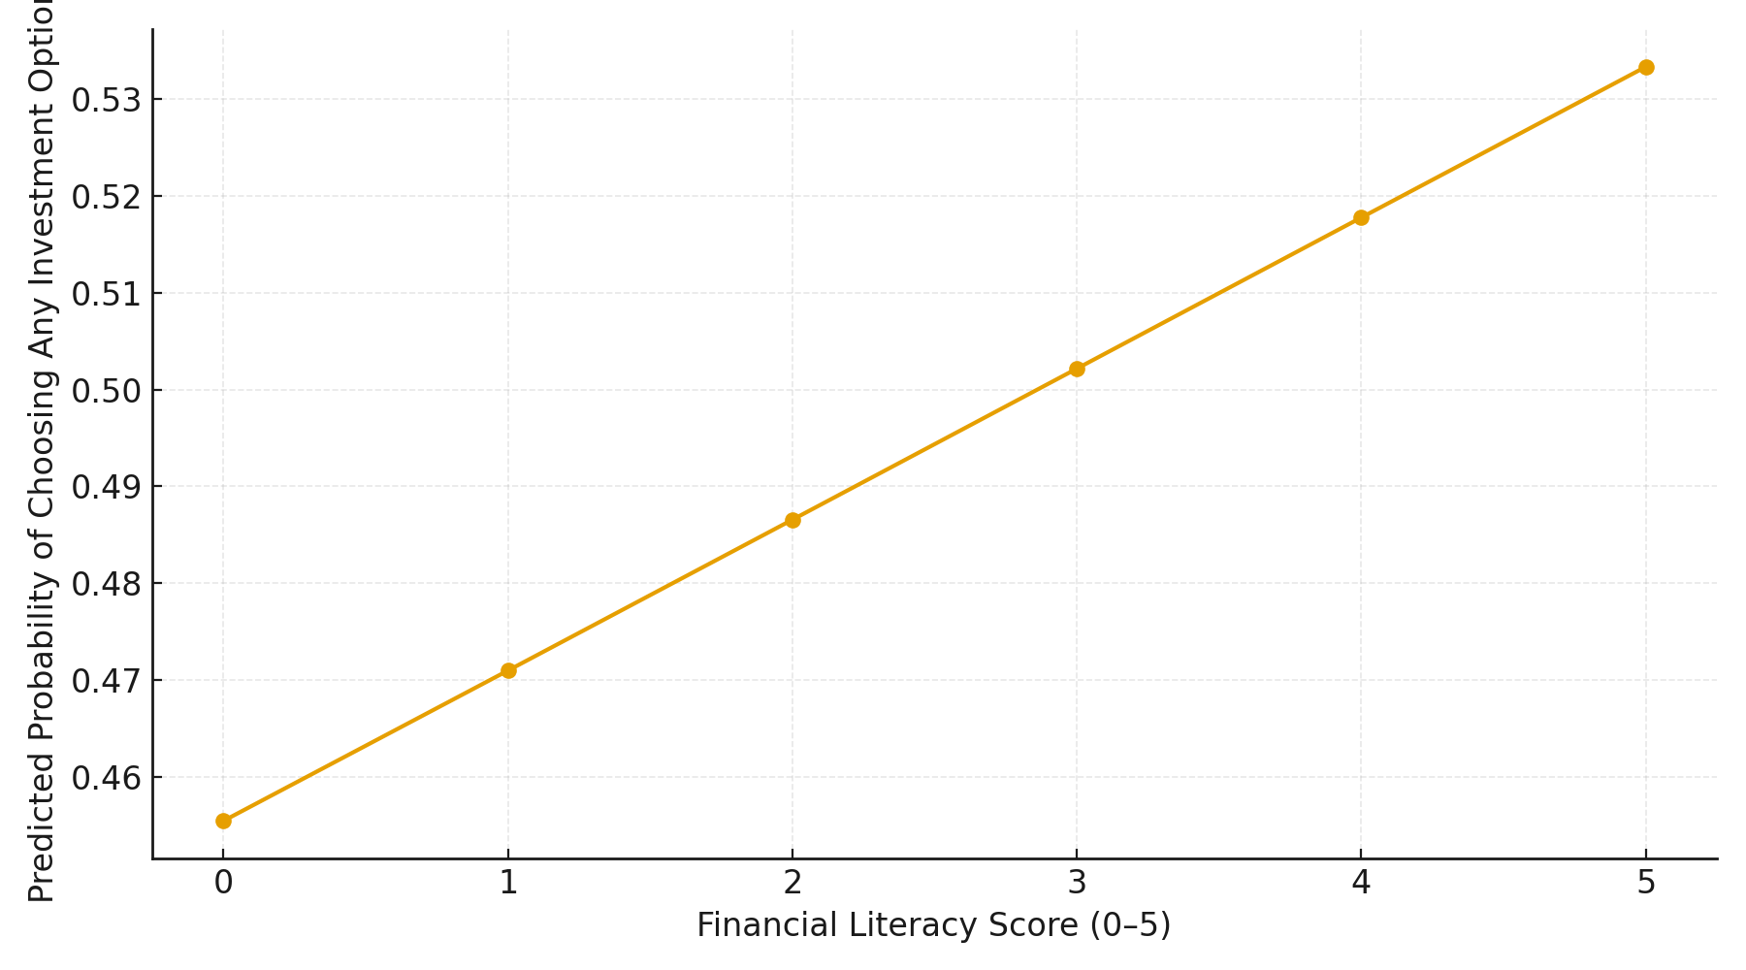
Source: Author’s computation using primary survey data (N = 415).

5. Conclusion and Policy Implications

The study has a major bearing on college students in Jakhama. It utilized logistic and ordered logit models in its key analysis to understand how financial literacy and risk attitudes influenced investment behaviour. Accordingly, one of the most important conclusions of the study is that financial literacy has a major (though not very strong) influence on both the occurrence of the participation in the financial markets as the decision to use the hypothetical windfall to make investments. Besides that risk tolerance is also rewarding enough to be considered the main behavioural factor across all models. This means that investment confidence and investment risk-taking alongside knowledge are of the same importance.

Moreover, the findings illuminate a range of ideas relevant to the implementation of college policy. To start with, the findings strengthen the call for the implementation of structured financial learning programme in colleges, which is not only a campaign for the awareness but a means of enhancing deep conceptual understanding, particularly interest calculations, inflation, and risk return tradeoffs. In line with the second placement of risk tolerance in the study, classroom curricula and workshops should feature practical learning activities to better engage students in responsible risk taking through the use of simulations and trading exercises. Third, as demographic variables have little explanatory power according to the study, therefore demographic segmentation should not be used for targeted interventions, which should instead focus on cognitive and behavioural development.

Improved financial literacy together with sound financial attitudes among college students will basically lead to more informed investment decision making and going further financial sustainability will be achieved. Therefore, students as the main college goers during their formative years in the financial field, early and efficient financial education will certainly be a determining factor in raising financially capable and resilient future citizens.

References:

Abreu, M., & Mendes, V. (2010). Financial literacy and portfolio diversification. Quantitative Finance, 10(5), 515–528. https://doi.org/10.1080/14697680902878105
Agarwal, S., Driscoll, J. C., Gabaix, X., & Laibson, D. (2009). The age of reason: Financial decisions over the life-cycle with implications for regulation. Brookings Papers on Economic Activity, 2009(2), 51–117. https://doi.org/10.1353/eca.0.0067
Bayar, Y., Sezgin, F., & Öztürk, Ö. F. (2020). Financial literacy and financial risk tolerance of individual investors: A multinomial logistic regression approach. SAGE Open, 10(3) https://doi.org/10.1177/2158244020945717
Bhushan, P. (2014). Relationship between financial literacy and investment behaviour of salaried individuals. Journal of Business Management & Social Sciences Research, 3(5), 82–87.
Bordoloi, P., & Deka, J. (2024). Financial literacy and other factors influencing investment behaviour of individual investors: A review of literature. International Journal for Multidisciplinary Research, 6(3), 20905. https://www.ijfmr.com/papers/2024/3/20905.pdf
Calvet, L. E., Campbell, J. Y., & Sodini, P. (2007). Down or out: Assessing the welfare costs of household investment mistakes. Journal of Political Economy, 115(5), 707–747. https://doi.org/10.1086/524204
Calvet, L. E., Campbell, J. Y., & Sodini, P. (2009). Measuring the financial sophistication of households. American Economic Review, 99(2), 393–398. https://doi.org/10.1257/aer.99.2.393
Campbell, J. Y. (2006). Household finance. Journal of Finance, 61(4), 1553–1604. https://doi.org/10.1111/j.1540-6261.2006.00883.x
Anindya, C. N., & Hasnawati, S. (2024). The influence of financial literacy and risk tolerance on student investment decisions with demographic factors as moderating variables. International Journal Of Education, Social Studies, And Management (IJESSM), 4(2), 759–767. https://doi.org/10.52121/ijessm.v4i2.369
Faishal, M., Mathew, S., Neikha, K., Pusa, K., & Zhimomi, T. (2023). The future of work: AI, automation, and the changing dynamics of developed economies. World Journal of Advanced Research and Reviews, 18(3), 620–629. https://doi.org/10.30574/wjarr.2023.18.3.1086
Faishal, M. (2025). The role of digital financial inclusion in microenterprise growth: Evidence from Kohima, Nagaland. South Asian Journal of Social Studies and Economics, 22(7), 135–143. https://doi.org/10.9734/sajsse/2025/v22i71068
Goetzmann, W. N., & Kumar, A. (2008). Equity portfolio diversification. Review of Finance, 12(3), 433–463. https://doi.org/10.1093/rof/rfn005
Grinblatt, M., Keloharju, M., & Linnainmaa, J. T. (2011). IQ and stock market participation. Journal of Finance, 66(6), 2121–2164. https://doi.org/10.1111/j.1540-6261.2011.01701.x
Grohmann, A., Kouwenberg, R., & Menkhoff, L. (2015). Childhood roots of financial literacy. Journal of Economic Psychology, 51, 114–133. https://doi.org/10.1016/j.joep.2015.09.002
Kaiser, T., & Menkhoff, L. (2017). Does financial education impact financial literacy and financial behavior, and if so, when? The World Bank Economic Review, 31(3), 611–630. https://doi.org/10.1093/wber/lhx018
Kaur, M., & Vohra, T. (2012). Understanding individual investor's behavior: A review of empirical evidences. Pacific Business Review International, 5(6), 10–18.
Kimball, M. S., Sahm, C. R., & Shapiro, M. D. (2008). Imputing risk tolerance from survey responses. Journal of the American Statistical Association, 103(483), 1028–1038. https://doi.org/10.1198/016214508000000139
Klapper, L., Lusardi, A., & Panos, G. A. (2013). Financial literacy and its consequences: Evidence from Russia during the financial crisis. Journal of Banking & Finance, 37(10), 3904–3923. https://doi.org/10.1016/j.jbankfin.2013.07.014
Lusardi, A., & Mitchell, O. S. (2011). Financial literacy and retirement planning in the United States. Journal of Pension Economics & Finance https://doi.org/10.1017/S147474721100045X
Lusardi, A., & Mitchell, O. S. (2014). The economic importance of financial literacy: Theory and evidence. Journal of Economic Literature, 52(1), 5–44. https://doi.org/10.1257/jel.52.1.5
Lusardi, A., & Tufano, P. (2015). Debt literacy, financial experiences, and overindebtedness. Journal of Pension Economics & Finance, 14(4), 332–368. https://doi.org/10.1017/S1474747215000232
Oehler, A., Horn, M., & Wendt, S. (2024). Investment in risky assets and participation in the financial market: Does financial literacy matter? International Review of Economics. https://doi.org/10.1007/s12232-023-00432-9
Remund, D. L. (2010). Financial literacy explicated: The case for a clearer definition in an increasingly complex economy. Journal of Consumer Affairs, 44(2), 276–295. https://doi.org/10.1111/j.1745-6606.2010.01169.x
van Rooij, M., Lusardi, A., & Alessie, R. (2011). Financial literacy and stock market participation. Journal of Financial Economics, 101(2), 449–472. https://doi.org/10.1016/j.jfineco.2011.03.006
Sangtam, D., & Faishal, M. (2025). Vocational vs. General Education and Employment Outcomes: Evidence from Kohima, Nagaland, India. Journal of Economics, Management and Trade, 31(8), 1–11. https://doi.org/10.9734/jemt/2025/v31i81329
Tharayil, A. (2024). Examining the association between financial education and financial risk tolerance. The American Economist https://doi.org/10.1177/05694345231186082
Van Oostveldt, M., & Dellaert, B. G. C. (2020). Financial literacy and investment decisions: The moderating role of risk attitude. Journal of Behavioral and Experimental Finance, 28, 100412. https://doi.org/10.1016/j.jbef.2020.100412
Van Rooij, M., Kaiser, T., & Menkhoff, L. (2021). The effects of financial education: Evidence from a large-scale intervention in Germany. Economic Inquiry, 59(1), 125–149. https://doi.org/10.1111/ecin.12934
Yadav, M., & Banerji, P. (2024). Digital financial literacy, saving and investment behaviour in India. Journal of Social and Economic Development. https://doi.org/10.1007/s40847-024-00367-z
Bayar, F. Y., Sezgin, H. F., Öztürk, Ö. F., & Şaşmaz, M. Ü. (2020). Financial literacy and financial risk tolerance of individual investors: A multinomial logistic regression approach. SAGE Open, 10(3). https://doi.org/10.1177/2158244020945717

