Case Report
Hypocalcemic Dilated Cardiomyopathy Following Total Thyroidectomy:
A Reversible Complication of Secondary Hypoparathyroidism

.
ABSTRACT

Aims: To highlight a rare, reversible cause of heart failure and emphasize the diagnostic importance of metabolic screening in patients with unexplained dilated cardiomyopathy, particularly those with a history of thyroid surgery.
Introduction: Severe hypocalcemia is an uncommon but treatable cause of myocardial dysfunction and dilated cardiomyopathy (DCM), most frequently occurring in the setting of post-thyroidectomy hypoparathyroidism. The condition is often underrecognized, as clinical presentation may be dominated by neuromuscular or seizure activity, overshadowing cardiac involvement. Early metabolic correction can lead to complete recovery of cardiac function.
Case Presentation: A 42-year-old woman with a history of total thyroidectomy presented with acute decompensated heart failure (NYHA class IV), recurrent seizures, and neuromuscular symptoms. Investigations revealed profound hypocalcemia (4.2 mg/dL), low parathyroid hormone levels, and severe biventricular systolic dysfunction (LVEF 18%) without evidence of coronary artery disease or myocardial fibrosis on cardiac MRI. Initiation of high-dose calcium and vitamin D supplementation, alongside cautious heart failure therapy, resulted in progressive normalization of ventricular function, with LVEF recovering to 50% at three-month follow-up.
Discussion: This case illustrates the critical role of calcium in myocardial excitation-contraction coupling and the potential for complete reversibility of hypocalcemia-induced cardiomyopathy. The diagnosis should be considered in any patient with unexplained systolic dysfunction, especially with a history of neck surgery. Key diagnostic clues include prolonged QTc interval on ECG, global hypokinesia on echocardiography, and the absence of alternative etiologies. Management hinges on aggressive correction of calcium and vitamin D deficiency, which can obviate the need for long-term heart failure therapy.
Conclusion: Hypocalcemic DCM is a reversible entity that demands a high index of suspicion. Routine measurement of calcium, phosphate, and parathyroid hormone levels is essential in the evaluation of non-ischemic cardiomyopathy, particularly in post-thyroidectomy patients. Timely diagnosis and metabolic correction can prevent irreversible myocardial damage and restore normal cardiac performance

Keywords: hypocalcemia, dilated cardiomyopathy, hypoparathyroidism, thyroidectomy, heart failure, reversible cardiomyopathy.
- INTRODUCTION

Calcium plays an essential role in myocardial excitation–contraction coupling, acting as a trigger for sarcoplasmic reticulum calcium release and determining the strength of ventricular contraction. Severe or chronic calcium deficiency disrupts this fundamental mechanism, leading to impaired contractility and, in rare instances, a reversible form of dilated cardiomyopathy (Válek et al., 2020). While neuromuscular manifestations such as paresthesia and seizures are well-recognized, cardiac involvement remains an underappreciated and often overlooked complication, particularly in the setting of post-thyroidectomy hypoparathyroidism (Bansal et al., 2014). The pathophysiology involves direct impairment of calcium handling, leading to adverse myocardial remodeling (Pepe et al., 2020). Crucially, unlike most etiologies of non-ischemic cardiomyopathy, hypocalcemia-induced cardiac dysfunction is potentially fully reversible with timely metabolic correction (Jung et al., 2013; Mutlu et al., 2022). Early recognition is therefore vital to prevent irreversible myocardial damage and progressive heart failure. This report describes a case of severe hypocalcemic cardiomyopathy following total thyroidectomy, highlighting the diagnostic challenges and the dramatic reversibility of myocardial dysfunction with appropriate therapy.

2. CASE PRESENTATION

A 42-year-old woman was admitted to the cardiology intensive care unit with acute decompensated heart failure, presenting with progressive dyspnea (New York Heart Association class IV), orthopnea, and bilateral lower-limb edema. Her past medical history was notable for a total thyroidectomy performed eight years earlier for a multinodular goiter. She reported poor long-term adherence to prescribed levothyroxine and calcium supplementation. She had a history of recurrent hospital admissions for acute pulmonary edema, generalized seizures, and transient right-arm weakness.
Physical examination revealed global signs of congestive heart failure. A resting 12-lead electrocardiogram (ECG) showed sinus rhythm with low limb lead voltages, T-wave inversion in the anterolateral leads, and a markedly prolonged corrected QT interval (QTc 564 ms), raising concern for an underlying metabolic or structural etiology (Figure 1).

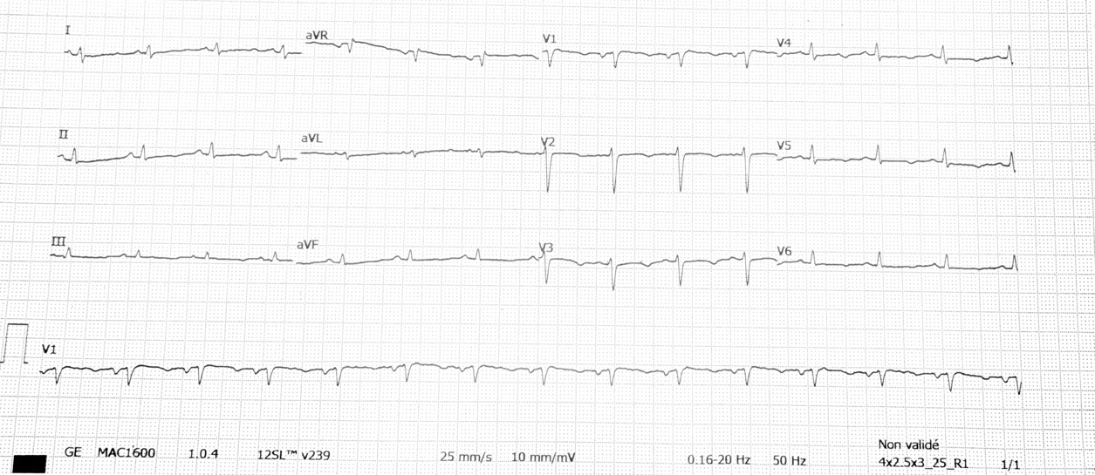
Figure 1: Resting 12-lead ECG on admission showing sinus rhythm with low limb lead voltage, deep T-wave inversions in the anterolateral leads (V3–V6), and a critically prolonged corrected QT interval (QTc 564 ms).

Transthoracic echocardiography and subsequent cardiac magnetic resonance imaging (MRI) demonstrated severe biventricular dilation with a left ventricular end-diastolic diameter of 68 mm, severe global systolic dysfunction (left ventricular ejection fraction [LVEF] 18–20%), left atrial enlargement, mild functional mitral regurgitation, and a circumferential pericardial effusion. Coronary angiography excluded significant obstructive coronary artery disease. Late gadolinium enhancement (LGE) sequences on cardiac MRI showed no evidence of myocardial fibrosis (Figure 2), arguing against an ischemic or infiltrative cardiomyopathy.

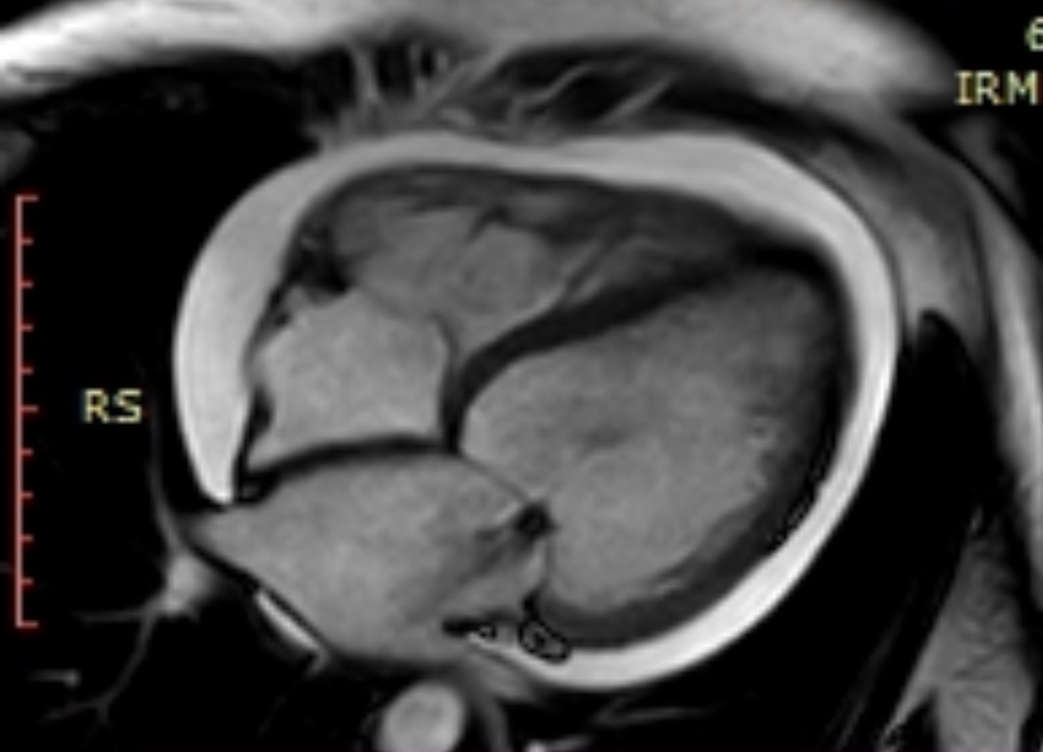
68mm

Figure 2: Cardiac Magnetic Resonance Imaging at Presentation. Four-chamber cine steady-state free precession (SSFP) image demonstrating severe biventricular dilation at 68mm, global hypokinesia, mild functional mitral regurgitation (indicated by red arrow), and a circumferential pericardial effusion.

The definitive diagnostic clue emerged from laboratory investigations, which revealed profound hypocalcemia (serum calcium 4.2 mg/dl), hyperphosphatemia, and a suppressed parathyroid hormone (PTH) level. These findings confirmed the diagnosis of iatrogenic hypoparathyroidism as the cause of her hypocalcemic dilated cardiomyopathy.
Management was initiated with high-dose oral calcium and vitamin D supplementation to correct the metabolic deficit, alongside a cautious up-titration of standard guideline-directed heart failure therapy. This targeted approach resulted in rapid improvements in clinical and paraclinical outcomes. The patient’s symptoms regressed, and the QTC interval normalized on follow-up ECG. Serial echocardiograms showed significant recovery of systolic function and chamber dimensions: the left ventricular end-diastolic diameter decreased to 53 mm, LVEF improved to 30% at hospital discharge, and reached 50% with complete resolution of mitral regurgitation at the three-month follow-up (Figure 3).
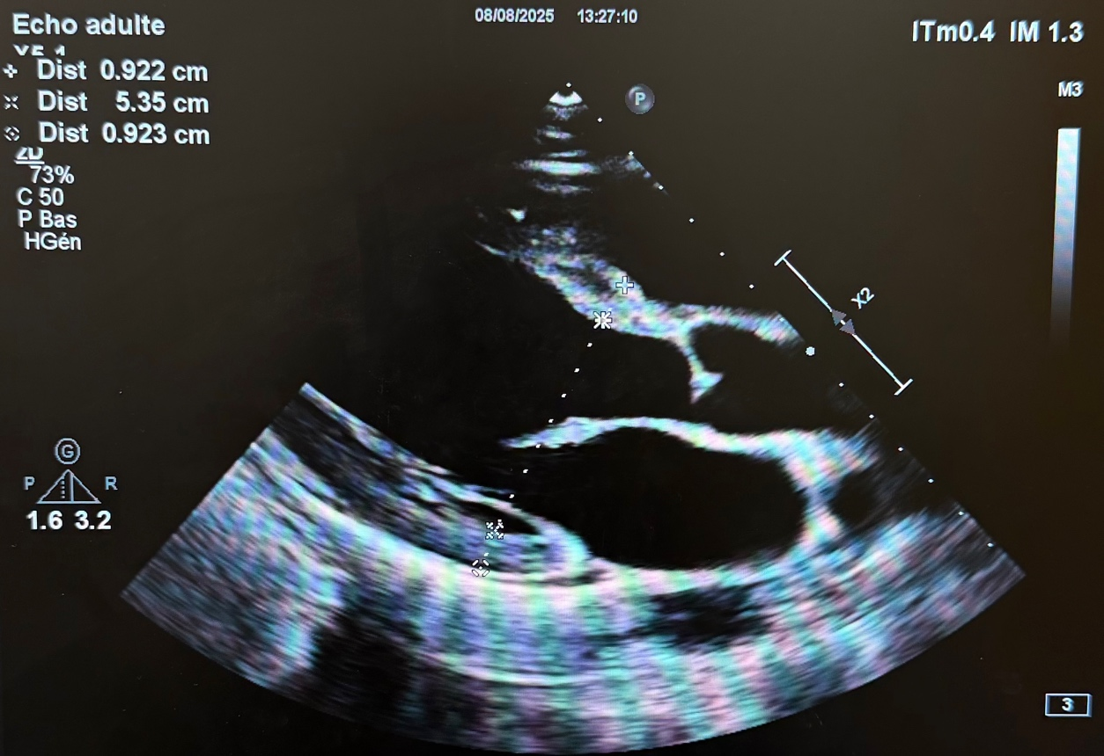
Figure 3: Follow-up Echocardiography at Three Months. Two-dimensional parasternal long-axis view at three-month follow-up showing significant recovery of left ventricular size (left ventricular end-diastolic diameter 53 mm) and preserved global systolic function.
This trajectory underscored the profound and rapid reversibility of myocardial dysfunction upon correction of the underlying hypocalcemia.
3. Discussion

This case powerfully illustrates a critical blind spot in cardiology: the failure to recognize hypocalcemia as a reversible cause of severe heart failure. Our patient's journey, featuring two prior hospitalizations for acute pulmonary edema and seizures before definitive diagnosis, exposes systematic gaps in evaluating patients with non-ischemic cardiomyopathy. The profound recovery from a left ventricular ejection fraction (LVEF) of 18% to 50% within three months of metabolic correction demonstrates both the dramatic potential for reversal and the cost of diagnostic delay.
The pathophysiology is direct: calcium is fundamental to excitation-contraction coupling. Severe deficiency impairs intracellular calcium transients, depressing actin-myosin cross-bridge formation and contractility (Bansal et al., 2014). Chronic hypocalcemia may also trigger adverse remodeling through altered gene expression (Pepe et al., 2020). The clinical presentation is often misleading, as seen here, with dramatic neurological symptoms (seizures, tetany) overshadowing insidious cardiac decline. This necessitates a paradigm shift: in any patient with a history of thyroid/parathyroid surgery, neurological symptoms must trigger immediate cardiac and metabolic evaluation.
Diagnosis hinges on connecting simple clues. The prolonged QTc interval on ECG is a classic, often-overlooked marker of hypocalcemia. While imaging (echocardiography, cardiac MRI) effectively excludes other etiologies and quantifies dysfunction, blood tests, specifically serum calcium, phosphate, and parathyroid hormone (PTH) levels, establish the diagnosis. Our patient’s profound hypocalcemia (4.2 mg/dL) with suppressed PTH confirmed iatrogenic hypoparathyroidism as the root cause.
Management is uniquely dual-track and collaborative. The cornerstone is the aggressive metabolic correction of calcium and vitamin D deficiency, which must be managed carefully in consultation with endocrinology to avoid complications of overcorrection. Concurrently, standard guideline-directed heart failure therapy provides essential symptomatic and hemodynamic support. Crucially, as demonstrated here and in the literature (Jung et al., 2013; Mutlu et al., 2022), heart failure medications often serve as a temporary bridge; the goal is their eventual withdrawal upon cardiac recovery, unlike in other cardiomyopathies.
The literature is unequivocal about the time-sensitive nature of this reversibility. Case series consistently show that early intervention leads to complete or near-complete recovery of ventricular function, while delayed management risks permanent remodeling (Válek et al., 2020). Our patient's two missed prior admissions represent critical lost opportunities to enact a cure.
Key Clinical Messages:
- Think Metabolically in Unexplained Cardiomyopathy: Hypocalcemic DCM must be a primary consideration in any new-onset systolic dysfunction, especially with a history of neck surgery or neurological symptoms.
- Screen Routinely and Early: Serum calcium, phosphate, and PTH levels should be mandatory first-line tests in the workup of non-ischemic dilated cardiomyopathy.
- ECG is a Key Gatekeeper: A prolonged QTc interval in this context is a red flag demanding immediate metabolic investigation.
- Embrace a Collaborative, Two-Pronged Treatment: Cure requires simultaneous metabolic correction (in consultation with endocrinology) and supportive heart failure therapy, with the understanding that the latter may be transient.
- Time is Myocardium: Early diagnosis and correction prevent irreversible fibrosis and offer the potential for a complete cure, transforming a life-long heart failure prognosis into a reversible metabolic episode.
4. Conclusion

Hypocalcemia-induced dilated cardiomyopathy stands as a powerful testament to the principle that not all heart failure is irreversible. This case underscores that a life-threatening, globally dysfunctional ventricle can be a direct consequence of a simple, correctable metabolic defect, iatrogenic hypoparathyroidism. The dramatic recovery of cardiac function observed here is not an anomaly but a reproducible outcome when the diagnosis is made promptly.
The central lesson is the critical importance of systematic metabolic screening in the initial evaluation of any unexplained dilated cardiomyopathy. A history of thyroidectomy should immediately raise suspicion, and laboratory assessment of calcium, phosphate, and parathyroid hormone levels must be considered mandatory. Relying solely on advanced cardiac imaging without this basic metabolic workup can lead to dangerous diagnostic delays and missed opportunities for a cure.
Ultimately, hypocalcemic cardiomyopathy challenges the diagnostic routine. It compels clinicians to synthesize disparate clues, neurological symptoms, a prolonged QTc interval, and a history of neck surgery into a coherent picture. Early recognition and targeted metabolic correction are not just beneficial; they are curative, preventing irreversible myocardial damage and restoring normal cardiac performance.

Consent

All authors declare that written informed consent was obtained from the patient for publication of this case report and the accompanying images. A copy of the written consent is available for review by the Editorial Office/Chief Editor/Editorial Board members of this journal.

Ethical approval

This case report describes a single, anonymous patient and did not require institutional ethical approval per our institution's policies. All procedures were conducted in accordance with the 1964 Declaration of Helsinki and its later amendments.

DISCLAIMER (ARTIFICIAL INTELLIGENCE)

The authors hereby declare that no generative artificial intelligence tools (ChatGPT, Copilot, etc.) were used in the writing, editing, or production of this manuscript.

References

- Válek, M., Roblová, L., Raška, I. Jr., Schaffelhoferová, D., & Paleček, T. (2020). Hypocalcaemic cardiomyopathy: a description of two cases and a literature review. ESC Heart Fail. https://doi.org/10.1002/ehf2.12693
- Bansal, B., Bansal, M., Bajpai, P., & Garewal, H. K. (2014). Hypocalcemic cardiomyopathy—Different mechanisms in adult and pediatric cases. J Clin Endocrinol Metab, 99(8), 2627–2632. https://doi.org/10.1210/jc.2013-3352
- Parepa, I., Mazilu, L., Suceveanu, A., Voinea, C., & Tica, I. (2019). HYPOCALCEMIC CARDIOMYOPATHY - A RARE HEART FAILURE ETIOLOGY IN ADULT. Acta Endocrinologica (Bucharest), 15(1), 107-112. https://doi.org/10.4183/aeb.2019.107
- Rangel, I., Barbosa, G., de Sousa, C., Almeida, P. B., Campelo, M., Pinho, T., & Maciel, M. J. (2012). Hipocalcemia como causa reversível de insuficiência cardíaca. Revista Portuguesa de Cardiologia. https://doi.org/10.1016/j.repc.2011.09.016
- Pepe, J., Colangelo, L., Biamonte, F. et al. Diagnosis and management of hypocalcemia. Endocrine 69, 485–495 (2020). https://doi.org/10.1007/s12020-020-02324-2.
- Mutlu, U., Cakmak, R., Sonsöz, M. R., Karaayvaz, E. B., Uzum, A. K., Tanakol, R., & Aral, F. (2022). A rare cause of dilated cardiomyopathy: hypocalcemia. Arch Endocrinol Metab, 66(4), 582-586. https://doi.org/10.20945/2359-3997000000474
- Bashour, T., Basha, H. S., & Cheng, T. O. (1980). Hypocalcemic cardiomyopathy. Chest, 78(4), 663-665. https://doi.org/10.1378/chest.78.4.663
- Jung, Y. J., Kim, S. E., Hong, J. Y., Lee, J. H., Park, D. G., Han, K. R., & Oh, D. J. (2013). Reversible dilated cardiomyopathy caused by idiopathic hypoparathyroidism. Korean Journal of Internal Medicine, 28(5), 605–608. https://doi.org/10.3904/kjim.2013.28.5.605
- Benzarouel D, Hasni K, Ashab H, El Hattaoui M. Une cause réversible de la cardiomyopathie dilatée : l’hypocalcémie, Annales de Cardiologie et d’Angéiologie,2014, https://doi.org/10.1016/j.ancard.2012.04.003.
- Fabi, M., Gesuete, V., Petrucci, R., & Ragni, L. (2013). Dilated cardiomyopathy due to hypocalcaemic rickets: is it always a reversible condition? Cardiology in the Young, 23(5), 769-772. https://doi.org/10.1017/S1047951112001850

Definitions, Acronyms, Abbreviations

CAD: Coronary Artery Disease
DCM: Dilated Cardiomyopathy
ECG: Electrocardiogram
HF: Heart Failure
LGE: Late Gadolinium Enhancement
LV: Left Ventricle / Left Ventricular
LVEF: Left Ventricular Ejection Fraction
MRI: Magnetic Resonance Imaging
NYHA: New York Heart Association
PTH: Parathyroid Hormone
QTc: Corrected QT Interval

