Case report
Two Babies, One Failing Heart: A Case of Peripartum Cardiomyopathy after Twin Delivery

Abstract:
Background:
Peripartum cardiomyopathy (PPCM) is a rare but potentially life-threatening cause of heart failure occurring toward the end of pregnancy or in the months following delivery. Early recognition is essential to optimize outcomes.
Case Presentation:
We report the case of a 43-year-old woman, G4P3, with no known cardiovascular history, who presented 23 days postpartum after a twin pregnancy complicated by preeclampsia. She developed paroxysmal nocturnal dyspnea, orthopnea, and neurological symptoms including headache, blurred vision, and tinnitus. Physical examination revealed stable hemodynamics. ECG demonstrated complete left bundle branch block with secondary repolarization abnormalities. Laboratory evaluation showed a high level of prolactin without any inflammatory, metabolic, or infectious abnormalities. Transthoracic echocardiography revealed a dilated, non-hypertrophied left ventricle with global severe hypokinesia, spontaneous contrast, and a markedly reduced LVEF of 25–30%. Cardiac MRI excluded alternative etiologies and showed no late gadolinium enhancement.
Conclusion:
This case illustrates a typical yet severe manifestation of PPCM in the early postpartum period, occurring after a twin pregnancy—a circumstance that likely amplified the patient’s hemodynamic burden and precipitated ventricular dysfunction. It highlights the need for clinicians to remain vigilant when managing high-risk pregnancies, where early recognition of PPCM can meaningfully alter the clinical course.
Keywords:
Peripartum cardiomyopathy; Twin pregnancy; Preeclampsia; Postpartum heart failure; Echocardiography; Cardiac magnetic resonance imaging.
Introduction:
Peripartum cardiomyopathy (PPCM) is a rare but serious form of heart failure that occurs towards the end of pregnancy or shortly after delivery. Its incidence varies worldwide but it remains a major cause of maternal morbidity and mortality. Although several risk factors, including multiple gestation, have been identified, the underlying mechanisms are not fully understood. Recent data suggest a potential genetic contribution, but evidence remains inconsistent.
Twin gestations impose an additional hemodynamic and cardiovascular load on the maternal heart, which may contribute to the increased incidence of early postpartum cardiovascular complications. This excessive circulatory demand, combined with pregnancy-related hormonal and inflammatory changes, may act as a trigger for the development of peripartum cardiomyopathy in predisposed women.(1)
Case presentation:
We describe the case of a 43-year-old woman, gravida 4 para 3, with no prior cardiovascular history. Her pregnancy was notable for a twin gestation complicated by pre-eclampsia, leading to a cesarean delivery 23 days before presentation. She was admitted for sudden onset of paroxysmal nocturnal dyspnea and orthopnea, accompanied by persistent headaches, blurred vision, and tinnitus—symptoms raising concern for both residual hypertensive disease and acute cardiac decompensation.
On admission, the patient was alert, oriented, and hemodynamically stable, with no signs of peripheral hypoperfusion. Cardiovascular and respiratory examinations were unremarkable except for mild tachycardia. The electrocardiogram revealed a complete left bundle branch block with secondary repolarization abnormalities (Figure 1). Laboratory evaluation showed no inflammatory, metabolic, or endocrine disturbances. Infectious serologies were negative. Notably, serum prolactin levels were elevated, a finding occasionally observed in peripartum cardiomyopathy and thought to play a role in its pathophysiology.
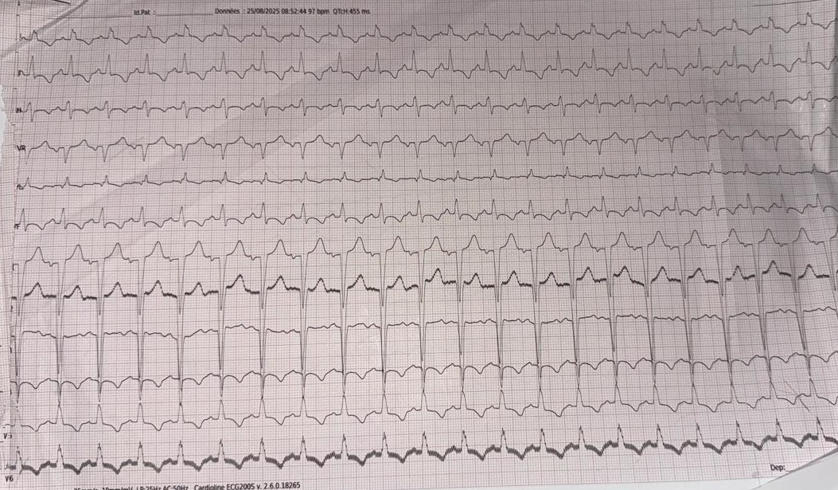
Figure 1: Electrocardiography

Transthoracic echocardiography demonstrated a dilated, non-hypertrophic left ventricle with severe global hypokinesia. Spontaneous echo contrast was present, suggesting low-flow conditions and an increased thromboembolic risk. The left ventricular ejection fraction was markedly reduced at 25–30%, consistent with severe systolic dysfunction (Figure 2).
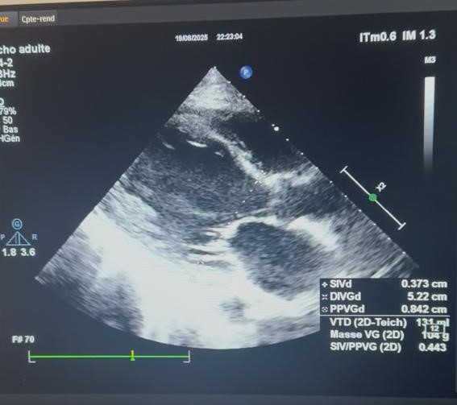
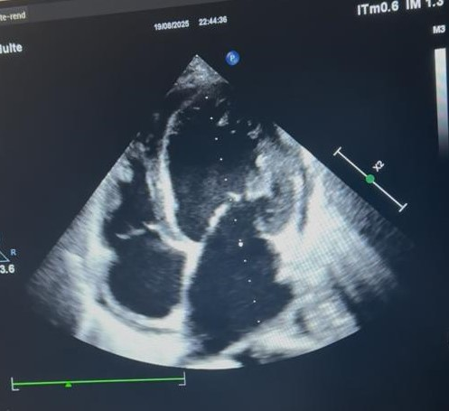
Figure 2: Transthoracic echocardiography (TTE)
To further investigate the etiology, cardiac magnetic resonance imaging was performed. It revealed no late gadolinium enhancement, excluding myocarditis, ischemic scarring, or infiltrative disease (Figure 3). Taken together, the clinical context, severe left ventricular dysfunction, absence of alternative etiologies, and recent twin pregnancy strongly supported the diagnosis of peripartum cardiomyopathy.
The patient was initiated on guideline-directed medical therapy for acute heart failure, including intravenous diuretics for decongestion and beta-blocker therapy once hemodynamic stability was confirmed. Angiotensin-converting enzyme inhibitors were introduced cautiously in the postpartum setting. Given the presence of spontaneous echo contrast and severe left ventricular dysfunction, anticoagulation was started to prevent thromboembolic complications.

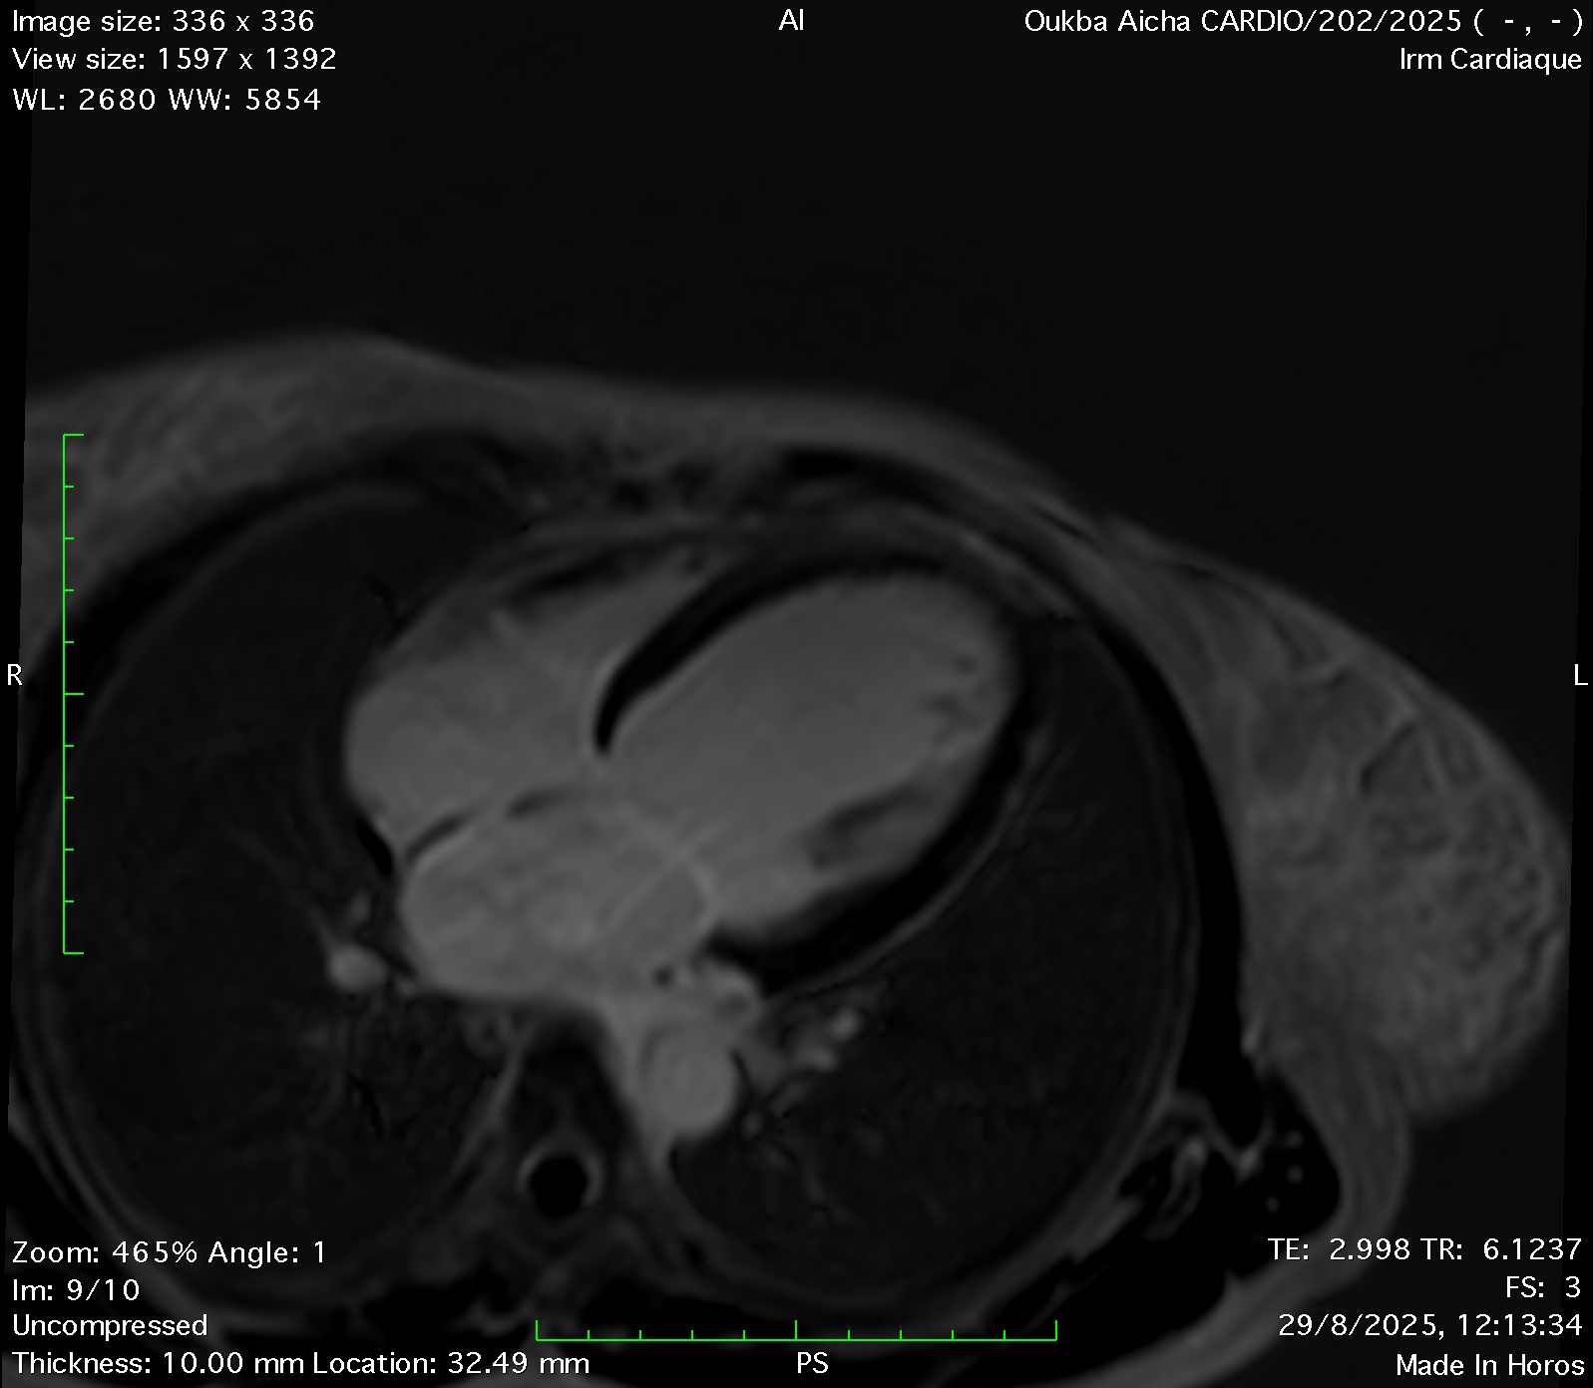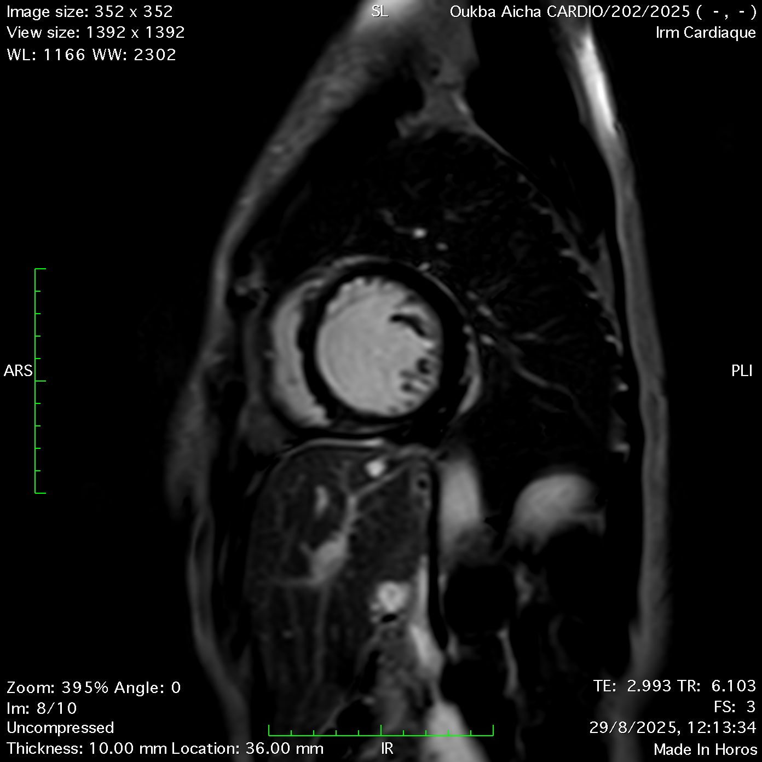
Short-axis LGE sequences acquired 10 minutes after gadolinium injection showed no late enhancement of the left ventricular walls
Four-chamber LGE sequences acquired 10 minutes after gadolinium injection showed no late enhancement of the left ventricular walls
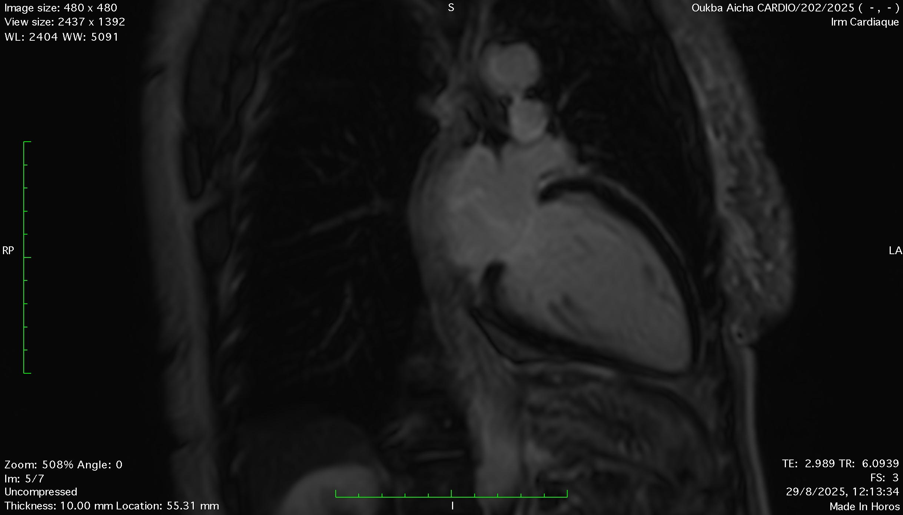
Two-chamber LGE sequences acquired 10 minutes after gadolinium injection showed no late enhancement of the left ventricular walls
Figure 3: Magnetic Resonance Imaging

Discussion:
Peripartum cardiomyopathy (PPCM) is a potentially life-threatening form of heart failure characterized by a left ventricular ejection fraction (LVEF) below 45% in the absence of any other identifiable cause. It typically develops towards the end of pregnancy or within the months following delivery, miscarriage, or pregnancy termination. This definition does not specify a strict time frame, Unlike the NHLBI definition, which restricts onset to the last month of pregnancy or within five weeks postpartum.(2)(3)
PPCM is a diagnosis of exclusion that demands early recognition and urgent management. Its incidence is approximately 1 in 2,000 births worldwide, though rates vary significantly across regions, ethnic groups, and socioeconomic conditions.(4)
Peripartum cardiomyopathy (PPCM) is now understood through a “two-hit” model rather than a single infectious cause. A genetic predisposition, particularly mutations in the TTN gene, represents the first vulnerability. The second “hit” occurs during late pregnancy, when hormonal, inflammatory, and hemodynamic stress can precipitate myocardial injury. Major risk factors include Black ethnicity, preeclampsia, hypertension, multiple gestations, advanced maternal age, previous malignancy, and low socioeconomic status. (5)(6)
Oxidative stress plays a central role in the pathogenesis of PPCM, as affected women show increased markers of inflammation and apoptosis with an imbalance between reactive oxygen species and antioxidant defenses. Experimental models implicate reduced STAT3 activity and excessive prolactin cleavage into a toxic 16 kDa fragment as key mechanisms, supported by the observed benefits of bromocriptine therapy and elevated oxidative stress markers such as oxidized LDL.(7)(8)
In our patient, the twin pregnancy and late gestational stress likely served as key triggers for PPCM. The increased hemodynamic load, elevated anti-angiogenic factors, and higher risk of pre-eclampsia associated with multiple gestation may have contributed to endothelial and myocardial injury. These mechanisms align with the “second hit” of the proposed model and may explain the acute onset of heart failure observed shortly after delivery.
The most frequent manifestations of PPCM include peripheral edema, exertional dyspnea, orthopnea, and paroxysmal nocturnal dyspnea, while arrhythmias, thromboembolism, and cardiogenic shock are less common. ECG findings are often nonspecific, typically showing sinus tachycardia. Elevated NT-proBNP levels can support the diagnosis, but echocardiography remains the cornerstone for evaluating left ventricular function, typically revealing moderate to severe systolic impairment with an LVEF below 45%.(9)
Cardiac MRI is particularly useful in PPCM for its precise assessment of ventricular volumes and tissue characterization. It can identify myocardial edema or fibrosis through late gadolinium enhancement (LGE), findings that help distinguish PPCM from myocarditis or ischemic cardiomyopathy. Moreover, the extent of LGE has prognostic value, as its absence is generally associated with a greater likelihood of left ventricular recovery.(10)
PPCM is a diagnosis of exclusion and must be distinguished from pre-existing cardiomyopathies, which can become symptomatic during pregnancy because of increased hemodynamic demands. Unlike these underlying conditions—often revealed in the second trimester—PPCM more commonly presents in the early postpartum period, although some overlap in timing may occur.
The management of peripartum cardiomyopathy follows standard heart failure (HF) principles while accounting for pregnancy- and postpartum-specific considerations. During pregnancy, therapeutic options are limited due to fetotoxicity of several HF drugs; treatment focuses on symptom relief with cautious use of diuretics for pulmonary or peripheral congestion and pregnancy-safe vasodilators such as hydralazine or nitrates. β1-selective beta-blockers (particularly metoprolol) may be used with appropriate fetal monitoring, whereas ACE inhibitors, ARBs, MRAs, neprilysin inhibitors, and SGLT2 inhibitors are contraindicated until after delivery.
In the postpartum period, comprehensive guideline-directed HF therapy can be initiated unless breastfeeding is essential, in which case ARBs and SGLT2 inhibitors should be avoided. Anticoagulation is recommended in patients with severe LV dysfunction (LVEF < 35%), documented LV thrombus, or when bromocriptine is prescribed, given the increased thromboembolic risk. (11) (12)
Bromocriptine, a prolactin-suppression therapy targeting a key pathogenic pathway, has shown promise in improving outcomes in moderate to severe PPCM and may be considered on a case-by-case basis, with concomitant low-molecular-weight heparin prophylaxis. Additional investigational therapies—such as angiogenic pathway modulators or immunosuppressive strategies—may be considered in select patients. For refractory cases or persistent cardiogenic shock despite optimal medical therapy, mechanical circulatory support or heart transplantation may be required. Optimal management relies on a multidisciplinary team experienced in high-risk obstetrics and advanced HF to ensure individualized and coordinated care.(2)
Although many women with postpartum cardiomyopathy experience substantial recovery, the clinical course remains unpredictable, with some developing persistent ventricular dysfunction or serious complications such as arrhythmias, worsening heart failure, or thromboembolic events. These considerations highlight the need for continued vigilance and timely management to improve outcomes in affected patients.
Healthcare professionals should view twin pregnancies—particularly those accompanied by hypertensive disorders—as a high-risk setting for maternal cardiovascular complications during the first postpartum year. Consequently, women who deliver twins warrant closer postnatal surveillance, including structured cardiovascular monitoring and, when necessary, earlier preventive intervention. (13)
Conclusion:
This case highlights how twin pregnancy can significantly amplify maternal hemodynamic stress and precipitate serious cardiovascular complications such as PPCM. Given the absence of specific diagnostic tests and the reliance on clinical suspicion supported by echocardiography, early recognition remains essential. Strengthening awareness among clinicians and ensuring timely evaluation may help improve outcomes for women facing this rare but potentially life-threatening condition.
1. Wander, G., van der Zande, J. A., Canpolat, U., Bouchardy, J., Furenäs, E., Agata, B. D., et al. (2025). Twin pregnancies in women with heart disease are complicated by high risk of heart failure: data from the EORP ROPAC Registry. Heart. https://doi.org/10.1136/heartjnl-2025-326281
2. De Backer, J., Haugaa, K. H., Hasselberg, N. E., de Hosson, M., Brida, M., Castelletti, S., Cauldwell, M., Cerbai, E., Crotti, L., de Groot, N. M. S., Estensen, M.-E., Goossens, E. S., Haring, B., Kurpas, D., McEniery, C. M., Peters, S. A. E., Rakisheva, A., Sambola, A., Schlager, O., ... ESC Scientific Document Group. (2025). 2025 ESC Guidelines for the management of cardiovascular disease and pregnancy: Developed by the task force on the management of cardiovascular disease and pregnancy of the European Society of Cardiology (ESC) Endorsed by the European Society of Gynecology (ESG). European Heart Journal, ehaf193. https://doi.org/10.1093/eurheartj/ehaf193
3. Matemvu, Z., Likapa, H., Makin, M. S., & Hossain, O. (2023). Five cases of Peripartum Cardiomyopathy in Malawi. *Malawi Medical Journal*, *35*(3), 196–200. https://doi.org/10.4314/mmj.v35i3.10
4. Arany, Z. (2024). Peripartum Cardiomyopathy. New England Journal of Medicine, 390(2), 154–164. https://doi.org/10.1056/NEJMra2306667
5. Jose, T., Maiti, G. D., Gupta, S., & Kundu, P. (2023). Early-onset peri-partum cardiomyopathy in a twin gestation: A rare presentation. Med J Armed Forces India, 79(3), 348–351. https://doi.org/10.1016/j.mjafi.2021.05.015
6. Lasica, R., Asanin, M., Vukmirovic, J., Maslac, L., Savic, L., Zdravkovic, M., et al. (2024). What Do We Know about Peripartum Cardiomyopathy? Yesterday, Today, Tomorrow. *International Journal of Molecular Sciences*, *25*(19), 10559. https://doi.org/10.3390/ijms251910559
7. Iorgoveanu, C., Zaghloul, A., & Ashwath, M. (2021). Peripartum cardiomyopathy: a review. Heart Failure Reviews, 26(6), 1287–1296. https://doi.org/10.1007/s10741-020-10061-x
8. Hilfiker-Kleiner, D., & Sliwa, K. (2014). Pathophysiology and epidemiology of peripartum cardiomyopathy. Nature Reviews Cardiology, 11(6), 364–370. https://doi.org/10.1038/nrcardio.2014.37
9. Jayte, M., Mohamud, A., & Dubad, F. (2024). Postpartum cardiomyopathy with congestive heart failure: A case report. SAGE Open Medical Case Reports. https://doi.org/10.1177/2050313X241263761
10. Bala, R., Mehta, S., Roy, V. C., Kaur, G., & de Marvao, A. (2023). Peripartum cardiomyopathy: A review. Revista Portuguesa de Cardiologia, 42(11), 917–924. https://doi.org/10.1016/j.repc.2023.01.029
11. Davis, M. B., Arany, Z., McNamara, D. M., Goland, S., & Elkayam, U. (2020). Peripartum Cardiomyopathy: JACC State-of-the-Art Review. J Am Coll Cardiol. https://doi.org/10.1016/j.jacc.2019.11.014
12. Arany, Z. (2024). Peripartum Cardiomyopathy. New England Journal of Medicine. https://doi.org/10.1056/NEJMra2306667
13. European Society of Cardiology. (2025). Mothers of twins face a higher risk of heart disease in the year after birth. https://www.escardio.org/The-ESC/Press-Office/Press-releases/mothers-of-twins-face-a-higher-risk-of-heart-disease-in-the-year-after-birth

