Case report

Sequential Pulmonary Embolism Followed by Acute Aortic Dissection: A Rare but Lethal Association

.
ABSTRACT

Aim: To report an unusual case of bilateral pulmonary embolism complicated shortly thereafter by an extensive type A aortic dissection, and to emphasize the diagnostic value of multimodal bedside imaging in differentiating overlapping cardiovascular emergencies.

Background: Pulmonary embolism (PE) and acute aortic dissection (AAD) are two life‑threatening cardiovascular emergencies. Their coexistence is exceptionally rare and diagnostically challenging. We report a case of a patient initially admitted for high‑risk intermediate PE who subsequently developed an acute type A dissection, illustrating the need for vigilance and rapid multimodal imaging.
Case Summary: A 78‑year‑old woman was admitted with bilateral proximal PE associated with extensive femoropopliteal deep vein thrombosis. Initial echocardiography revealed a mildly dilated ascending aorta (40 mm), and CT pulmonary angiography confirmed bilateral PE. The patient remained hemodynamically stable throughout hospitalization. Shortly before discharge, she developed sudden hemodynamic collapse. Bedside echocardiography showed hypovolemia, new pericardial effusion, aortic regurgitation, and suspected intimal flap. Transesophageal echocardiography confirmed an aortic flap extending from the sinuses of Valsalva to the descending aorta. Thoracic CT angiography further delineated an extensive type A dissection. Given the patient's condition and family decision, no surgical intervention was undertaken, and the patient died shortly thereafter.
Conclusion: Although rare, sequential occurrence of PE and AAD is possible and must be recognized promptly. This case highlights the essential role of bedside multimodal imaging in the rapid evaluation of shock.
Take‑home Message: Do not exclude the possibility of multiple simultaneous cardiovascular emergencies—one life‑threatening condition may hide another.

Keywords: Pulmonary embolism, acute aortic dissection, cardiovascular emergencies, transoesophageal echocardiography, intensive care unit.

1. INTRODUCTION

Pulmonary embolism (PE) and acute aortic dissection (AAD) are among the most severe cardiovascular emergencies, each carrying a high risk of morbidity and mortality if not rapidly diagnosed and managed. Although both conditions may present with nonspecific symptoms such as dyspnea, chest pain, or hemodynamic instability, their coexistence is extremely rare and poses significant diagnostic and therapeutic dilemmas. Most reported cases describe diagnostic confusion—where one condition mimics the other—rather than true sequential or concomitant presentation.
We report an uncommon case of a patient first admitted for bilateral PE, who subsequently developed a catastrophic type A aortic dissection during hospitalization. This case emphasizes the importance of maintaining a high index of suspicion when new symptoms arise in a patient already diagnosed with a major cardiovascular emergency, and underlines the crucial role of bedside multimodal imaging in intensive cardiac care.

2. presentation of case

A 78‑year‑old woman with no significant cardiac history was admitted for acute dyspnea and presyncope. Evaluation revealed bilateral femoropopliteal deep venous thrombosis and a bilateral proximal pulmonary embolism confirmed by CT pulmonary angiography. Initial transthoracic echocardiography (TTE) demonstrated a mildly dilated ascending aorta at 40 mm, without signs of acute aortic syndrome. The patient remained hemodynamically stable and was managed with anticoagulation.
Shortly before discharge, she developed sudden hypotension and clinical signs of shock. A bedside TTE was immediately performed, revealing hypovolemia, a new pericardial effusion, significant aortic regurgitation, and visual suspicion of an intimal flap within the ascending aorta. Emergency transesophageal echocardiography (TEE) confirmed a flap originating at the sinuses of Valsalva and extending to the thoracic aorta (figure 1, 2). A subsequent thoracic CT angiography corroborated the diagnosis of extensive type A aortic dissection involving the ascending aorta, arch, and descending aorta to the renal arteries.
Given the patient's fragile clinical state and the family's decision, no surgical repair was attempted. The patient died shortly after.
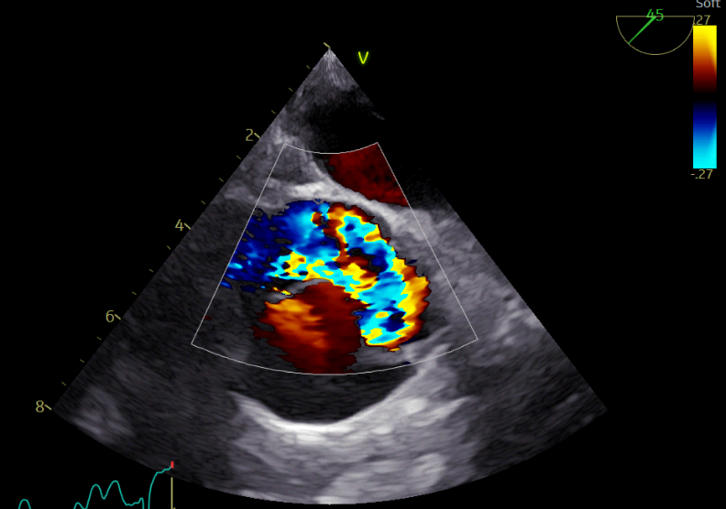
Fig 1 : Transverse view of the ascending aorta with color Doppler showing the intimal flap.

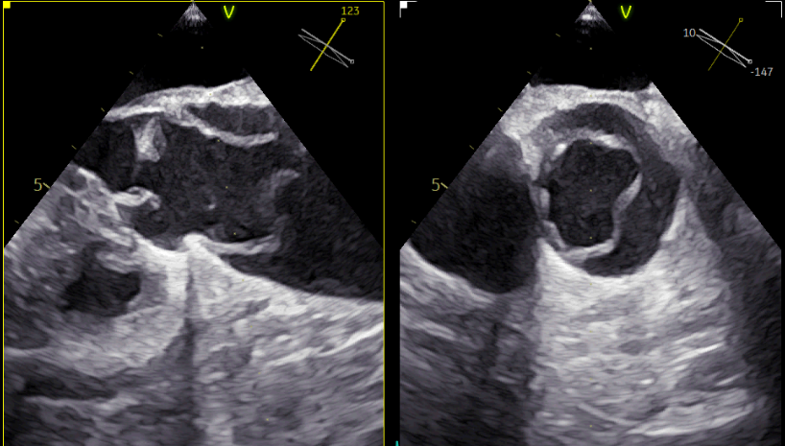
Fig. 2: Visualization of the intimal flap on multiplane transesophageal echocardiography (TEE)

4. DISCUSSION
The coexistence of acute pulmonary embolism (PE) and aortic dissection (AD) represents a rare but clinically challenging scenario, as both conditions are independently life-threatening and may produce overlapping hemodynamic or respiratory manifestations. Our case illustrates a particularly uncommon sequence: a stable intermediate-high-risk PE initially confirmed by CT pulmonary angiography, followed days later by the abrupt onset of cardiogenic shock caused by an unsuspected type A aortic dissection. This scenario emphasizes the importance of maintaining diagnostic vigilance even when a plausible cause of instability has already been identified.
Several publications have documented that AD and PE can coexist, although infrequently (Jolobe OMP, 2023; Chaulagai B,2021; Ouédraogo S, 2022). The combination presents a diagnostic dilemma because the management of one condition—especially systemic anticoagulation for PE—may be detrimental or contraindicated in the presence of an acute aortic dissection. Reported cases reinforce that clinicians must consider the possibility of dual or sequential life-threatening pathologies, particularly when new or unexplained clinical deterioration occurs.
In the peri-acute setting, both diseases may share nonspecific features such as hypotension, tachycardia, syncope, right ventricular strain, or respiratory distress. Moreover, AD may occasionally mimic PE, either through compression of the pulmonary artery, intramural hematoma propagation, or imaging artifacts (Gartly R, 2023; Rovčanin Delić E, 2025; Roque D, 2019). Such presentations constitute a significant clinical trap, often delaying diagnosis. In contrast to these masquerading scenarios, our patient developed two distinct conditions in sequence, underscoring the critical need to avoid diagnostic anchoring when evaluating unstable patients in intensive care.
The rapid deterioration of our patient highlights the essential role of multimodal bedside imaging in intensive cardiovascular care. Point-of-care transthoracic echocardiography (TTE) enabled immediate recognition of pericardial effusion, acute aortic regurgitation, and hemodynamic compromise—promptly redirecting the diagnostic approach. Subsequently, transesophageal echocardiography (TEE) provided definitive visualization of the intimal flap and the full proximal extent of the dissection, consistent with prior reports emphasizing the diagnostic superiority of TEE in acute AD, especially in hemodynamically unstable patients (6,7). Bedside imaging therefore proved indispensable in rapidly distinguishing cardiogenic, obstructive, and hypovolemic causes of shock, allowing swift correction of the initial diagnosis and preventing inappropriate escalation of anticoagulation.
Although rare, the sequential occurrence of PE and AD in this case also underscores the complexity of thrombotic-inflammatory interactions and the potential coexistence of multiple vascular emergencies in elderly patients. In this setting, the absence of chest pain—which is common in older individuals—further complicates detection and reinforces the value of systematic bedside echocardiography in all unexplained hemodynamic deteriorations.
Taken together, this case demonstrates that maintaining a broad differential diagnosis, avoiding premature closure, and relying on integrated multimodal imaging at the bedside are essential to the optimal management of cardiovascular shock. Early echocardiography combined with rapid cross-sectional imaging can significantly improve diagnostic accuracy, especially in scenarios where two life-threatening conditions may overlap or appear sequentially. (Evangelista A, 2018; Nienaber CA, 1999).

4. Conclusion

This case illustrates that pulmonary embolism and acute aortic dissection, although individually rare, can occur sequentially in the same patient and lead to catastrophic outcomes. Clinicians should maintain a high index of suspicion when new symptoms arise in patients already hospitalized for a cardiovascular emergency. Multimodal bedside imaging remains a cornerstone in the rapid evaluation of hemodynamic collapse, allowing timely differentiation between overlapping or coexisting conditions. Early recognition is essential, as one life‑threatening condition may mask another.

Consent

All authors declare that oral consent was obtained from the patient’s relatives for publication of this case report and accompanying images with the complete protection of privacy.

References

1. Jolobe, O. M. P. (2023). Correspondence: The co-existence of type A aortic dissection and pulmonary embolism. British Journal of Cardiology, 30(4), 125. https://doi.org/10.5837/bjc.2023.039
2. Chaulagai, B., Acharya, D., Poudel, S., & Puri, P. (2021). Simultaneous Aortic Dissection and Pulmonary Embolism: A Therapeutic Dilemma. Cureus, 13(1):e12952. https://doi.org/10.7759/cureus.12952
3. Gartly, R., Kalgaonkar, S., & Isles, C. (2023). Aortic dissection masquerading as pulmonary embolism: A case series. Acquaint Publications.
4. Rovčanin Delić, E., Lehmkuhl, L., Ciubotaru, D., & Barth, S. (2025). Type A acute aortic dissection mimicking pulmonary embolism: intramural hematoma of the pulmonary arteries causing right heart pressure overload and hemoptysis. Med Glas (Zenica), 22(1), 33-37. https://doi.org/10.17392/1897-22-01 .
5. Roque D, Costa S, Ferreira R, et al. Concomitant pulmonary embolism and aortic dissection: a case report. Rev Port Cardiol. 2020;39(4):235.e1–235.e5.
doi:10.1016/j.repc.2019.10.009.
6. Evangelista, A., Isselbacher, E. M., Bossone, E., Gleason, T. G., Di Eusanio, M., Sechtem, U., Ehrlich, M. P., Trimarchi, S., Braverman, A. C., Myrmel, T., Harris, K. M., Hutchinson, S., O'Gara, P., Suzuki, T., Nienaber, C. A., & Eagle, K. A. (2018). Insights From the International Registry of Acute Aortic Dissection: A 20-Year Experience of Collaborative Clinical Research. Circulation, 137(17), 1846–1860. https://doi.org/10.1161/CIRCULATIONAHA.117.031264
7. Nienaber CA, von Kodolitsch Y, Nicolas V, et al. The role of transesophageal echocardiography in acute aortic syndromes. Eur Heart J. 1999;20(21):1616–1631.
doi:10.1053/euhj.1999.1591.
8. Ouédraogo S, Napon C, Nebie LV, et al. Aortic dissection associated with pulmonary embolism: difficulty in management—a case report. Tropical Cardiology. 2022;170.

