Case report
Inferior Vena Cava Agenesis: An Unusual Cause of Free-Floating Right Auricle and Severe Pulmonary Embolism Treated with Tenecteplase

.

ABSTRACT

Inferior vena cava agenesis (IVCA) is a rare congenital malformation. The pulmonary embolism remains much less described in association with this anatomical anomaly. No case of severe pulmonary embolism with IVCA has reported. We report a case of a 56-year-old patient with agenesis of the IVC who presented a shock due to a severe pulmonary embolism and was treated successfully with Tenecteplase. At present, Tenecteplase is not approved for use in acute PE. In patients with severe pulmonary embolism, if the rtPA is not available, the physicians should take action beyond the guidelines to save a life.

Keywords: Inferior vena cava agenesis; thrombolysis; Tenecteplase; Pulmonary Embolism

1. INTRODUCTION

Inferior vena cava agenesis (IVCA) is a rare and underreported congenital malformation. Despite its low frequency, IVCA and all vena cava malformations are known to cause deep vein thrombosis [ 1]. Nevertheless, the pulmonary embolism remains much less described in association with this anatomical anomaly [2]. Moreover, until today, no case of inferior vena cave agenesis with severe pulmonary embolism has been reported. We report a case of a patient with agenesis of the inferior vena with azygous continuation, who presented with a severe pulmonary embolism and was treated successfully with Tenecteplase.

2. CASE PRESENTATION

A 56-year-old patient with insulin-dependent diabetes as a cardiovascular risk factor. He had no major risk factor for venous thromboembolic disease. He was admitted with a 24 hours history of syncope repeated 3 times in the same hour with profuse sweating, without prodromes, without sign of convulsion or notion of loss of urine.
On physical examination, patient in shock: hemodynamically unstable with systolic blood pressure at 85mmHg, tachycardia at 120bpm, polypnea at 33 cycles per minute with hypoxemia on room air (SaO2: 86%).
The ECG performed in first intention found a sinus tachycardia at 125 beats per minute, a right axial deviation with incomplete right bundle block. A trans-thoracic echocardiography was then performed showing a floating right auricle thrombus (Figure 1), a dilated right ventricle in severe dysfunction with paradoxical septum, and pulmonary artery systolic pressure is 62 mmHg. The global contractility of the left ventricle remained nevertheless preserved with a left ventricular ejection fraction (LVEF) at 50%, the whole evoking a severe pulmonary embolism. A thoracic angioscanner was performed showing a massive bilateral pulmonary embolism (Figure 2a), a situs inversus in the proximal abdomen, and anomaly of venous return with agenesis of the inferior vena cave with Azygos continuation (Figure 2b).
The patient immediately received thrombolytic therapy, tenecteplase (recombinant tissue plasminogen activator) at dose-weight, followed by unfractionated heparin. Clinically, the patient improved markedly with hemodynamic and respiratory stability. A trans-thoracic echocardiogram performed 24 hours later showed complete disappearance of the right heart thrombus with improvement in right ventricular function and a decrease in pulmonary artery systolic pressure to 36 mmHg. The follow-up angioscanner performed 48 hours after thrombolysis showed improvement compared with the initial images. The patient underwent a Doppler ultrasound of the lower limbs which came back without abnormalities. In addition, etiologic assessment looking for a thrombophilic background has been done and came back negative. The patient was then discharged from the hospital on the 8th day after stabilization of his INR (international normalized ratio) under oral anticoagulation with regular follow-up in the outpatient department. Follow up at 3 and 6 months revealed no new thrombotic episode.

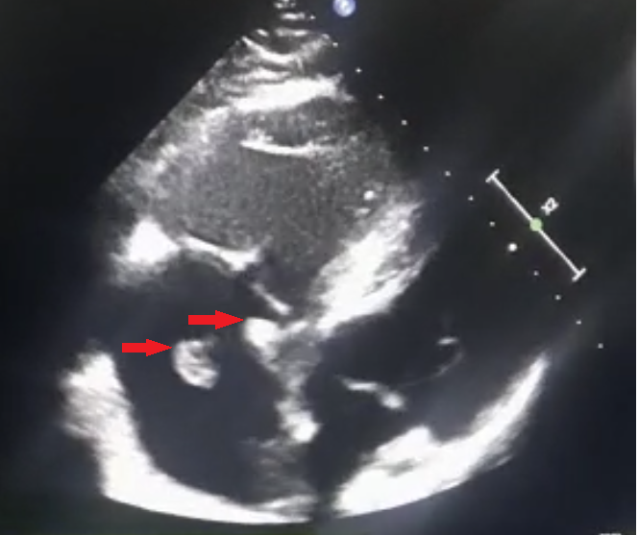

Fig. 1. Transthoracic echocardiography showing multiple mobile thrombi in the right atrium (Red arrows).
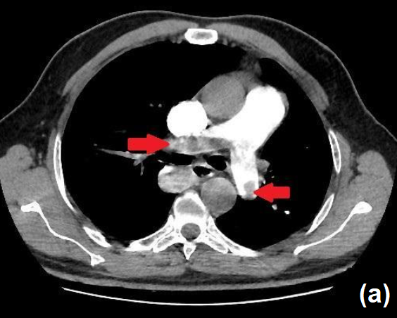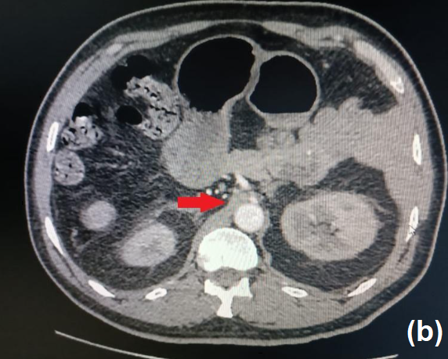

Fig. 2. (a). Thoracic angioscanner revealing a massive bilateral pulmonary embolism
(b). Thoracic angioscanner revealing agenesis of the inferior vena cave with Azygos continuation.

3. discussion

The IVCA is recognized as one of the entities responsible for deep vein thrombosis (DVT) [1].
The evolution of DVT on the IVCA rarely leads to pulmonary embolism [2]. Any cases of Inferior Vena Cava Agenesis with Free-floating right heart and severe pulmonary embolism have been reported in the literature

Free-floating right heart thrombus is a severe form of thromboembolic disease that usually coexists with a massive pulmonary embolism (PE) and substantially increased risk of mortality compared to the presence of pulmonary thromboembolism alone [3]. A right atrial thrombus and a massive PE with presentation of shock (either a systolic blood pressure of less than 90 mmHg or a pressure drop of at least 40 mmHg that lasts 15 minutes or longer), thrombolytic therapy is recommended as first-line therapy In the absence of contraindications, [4].
Accelerated i.v. administration of recombinant tissue-type plasminogen activator (rtPA; 100 mg over 2 h) is preferable to prolonged infusions of first-generation thrombolytic agents (streptokinase and urokinase). UFH may be administered during continuous infusion of alteplase, but must be discontinued during infusion of streptokinase or urokinase. Tenecteplase [5] has also been investigated, at present, Tenecteplase is not approved for use in acute PE.
In our case report, the patient does not have the typical presentation given his age.
In our case report, faced with a high-risk pulmonary embolism, and the unavailability of rtPA, the patient received systemic thrombolytic treatment with Tenecteplase. The Doppler ultrasound of the lower limbs - which was only performed in a second phase, after stabilization of the patient did not find DVT, raising the question of the presence of DVT before the administration of Tenecteplase.

4. Conclusion

The presence of congenital IVC anomalies should be considered, when pulmonary embolism develops in patients with no apparent risk factor. In patients with severe pulmonary embolism, if the rtPA is not available, the physicians should take action beyond the guidelines to save a life.

Consent (where ever applicable)

As per international standard or university standard, patient(s) written consent has been collected and preserved by the author(s).

Ethical approval (where ever applicable)

It is not applicable.

References

1. Kim S, Kunkel S, Browske K. Absent Inferior Vena Cava Leading to Recurrent Lower Extremity Deep Vein Thrombosis in a United States Marine. Mil Med. 2018 Jan 1;183(1-2):e172-e174. doi: 10.1093/milmed/usx041. PMID: 29401342.
2. Oblitas CM, García-García A, Galeano-Valle F, Palacios-Bermejo A, Ojeda-García R, Echenagusía-Boyra M, Álvarez-Luque A, Del-Toro-Cervera J, Demelo-Rodríguez P. Long-term anticoagulant treatment in patients with inferior vena cava agenesis and deep vein thrombosis. Thromb Res. 2020 Dec;196:305-307. doi: 10.1016/j.thromres.2020.09.009. Epub 2020 Sep 6. PMID: 32977127.

3. Pasqui E, de Donato G, Camarri S, Molinari R, Cascinelli I, Pelini V, Abate L, Palasciano G. Case Report: Inferior Vena Cava Agenesia in a Young Male Patient Presenting With Bilateral Iliac Veins Thrombosis. Front Surg. 2022 Mar 22;9:832336. doi: 10.3389/fsurg.2022.832336. PMID: 35392062; PMCID: PMC8980272.

4. The European Cooperative Study on the clinical significance of right heart thrombi. European Working Group on Echocardiography. Eur Heart J. 1989 Dec;10(12):1046-59. doi: 10.1093/oxfordjournals.eurheartj.a059427. PMID: 2606115.

5. Kline JA, Nordenholz KE, Courtney DM, Kabrhel C, Jones AE, Rondina MT, Diercks DB, Klinger JR, Hernandez J. Treatment of submassive pulmonary embolism with tenecteplase or placebo: cardiopulmonary outcomes at 3 months: multicenter double-blind, placebo-controlled randomized trial. J Thromb Haemost. 2014 Apr;12(4):459-68. doi: 10.1111/jth.12521. PMID: 24484241.

