Case report

Early Fabry Cardiomyopathy Revealed by Routine MRI Screening in a Young Athlete

.
ABSTRACT

AIMS:
To report an incidental cardiac magnetic resonance (CMR) finding suggestive of early cardiac Fabry disease in an asymptomatic high-level football player undergoing routine cardiovascular screening.
PRESENTATION OF CASE:
A young elite male football player presented for a systematic cardiovascular assessment as part of a routine health evaluation. Clinical examination, ECG, and transthoracic echocardiography were normal. Cardiac MRI revealed preserved biventricular size and systolic function, no valvular disease, and no myocardial edema. Native T1 mapping demonstrated markedly reduced values in the basal lateral wall (610ms), and two small intramyocardial nodules were identified in the mid-inferolateral wall on late gadolinium enhancement imaging. These CMR abnormalities strongly suggested early cardiac involvement in Fabry disease. An α-galactosidase A activity assay and iron profile were recommended to confirm the diagnosis.
DISCUSSION:
Fabry disease is a rare X-linked lysosomal storage disorder that may initially present with isolated cardiac abnormalities. Reduced native T1 values, together with mid-wall late gadolinium enhancement, represent early and sensitive imaging markers of sphingolipid storage. In athletes, differentiating infiltrative cardiomyopathy from physiological remodeling is crucial, as early Fabry involvement can be clinically silent yet progressive.
CONCLUSION:
This case highlights the importance of advanced CMR screening in competitive athletes. Early identification of suspected Fabry disease allows timely diagnostic confirmation, initiation of targeted therapy, and appropriate guidance for sports participation.

Keywords: Cardiac MRI; Fabry disease; T1 mapping; Late gadolinium enhancement; Athlete screening; Infiltrative cardiomyopathy

- INTRODUCTION

Fabry disease is a rare X-linked lysosomal storage disorder caused by deficient α-galactosidase A activity, leading to progressive accumulation of glycosphingolipids in multiple organs, including the kidneys, nervous system, and cardiovascular system (Desnick et al., 2003). Cardiac involvement is frequent and may represent the earliest or even the only manifestation of the disease, presenting as left ventricular hypertrophy, conduction abnormalities, arrhythmias, or myocardial fibrosis (Desnick et al., 2003; Weidemann et al., 2013). Cardiac magnetic resonance (CMR) plays a central role in the early detection of Fabry cardiomyopathy. Native T1 mapping is one of the most sensitive markers of intracellular sphingolipid accumulation, identifying myocardial involvement before structural changes or hypertrophy become evident (Sado et al., 2013). Late gadolinium enhancement (LGE) appears at a later stage and reflects irreversible replacement fibrosis, typically located in the basal inferolateral wall and associated with worse prognosis (Nordin et al., 2016; Hanneman et al., 2020). In competitive athletes, distinguishing pathological infiltrative cardiomyopathy from physiological remodeling (“athlete’s heart”) is essential. Athletic cardiac adaptation may induce mild concentric hypertrophy and increased left ventricular mass but does not produce low native T1 values nor mid-wall fibrosis (Turco et al., 2018). Current ESC sports cardiology guidelines emphasize the need to carefully evaluate any structural or tissue abnormality in athletes, given the potential implications for performance and sudden cardiac death risk (Pelliccia et al., 2021). We report the case of a young asymptomatic professional football player in whom routine pre-participation CMR screening revealed abnormalities strongly suggestive of early cardiac Fabry disease.

2. CASE PRESENTATION

A 20-year-old asymptomatic male was referred for a routine cardiovascular evaluation prior to joining a professional football team. He reported no chest pain, palpitations, syncope, or exercise intolerance. Physical examination was normal. Resting electrocardiogram showed a normal sinus rhythm without conduction abnormalities. Transthoracic echocardiography demonstrated preserved left ventricular systolic function and normal chamber dimensions, with a discrete posterior wall thickness of 11 mm and no valvular disease or regional wall motion abnormalities.
For further assessment, a cardiac magnetic resonance (CMR) examination was performed. Cine-SSFP sequences of good quality showed normal left ventricular volumes, with an end-diastolic volume of 147 mL (indexed 91 mL/m²) and a left ventricular ejection fraction of 61%. The left ventricular mass was 93 g (62 g/m²). No segmental or global contractile abnormalities were observed. The ventricular walls were of normal thickness except for a basal lateral thickness of 10 mm. The right ventricle also showed normal size and systolic function, without hypertrophy, dilatation, or regional dysfunction. The pulmonary infundibulum was not dilated, and no valvulopathy or pericardial effusion was noted.
T2-STIR imaging revealed no myocardial edema. Native T1 mapping showed a septal value of 920 ms (normal range <1050 ms at 1.5T), but a significantly reduced native T1 value of 610 ms in the basal lateral segment, strongly suggestive of sphingolipid myocardial storage (Figure 1). T2 mapping was homogeneous throughout the myocardium. After gadolinium administration, late gadolinium enhancement sequences identified two small intramyocardial nodules in the mid-inferolateral wall, displaying a mid-wall non-ischemic pattern compatible with early fibrotic involvement (Figure 2). No ischemic scar, diffuse enhancement, or ventricular aneurysm was detected (Figure 3).
Based on these imaging characteristics, a biochemical evaluation was conducted. The patient had reduced α-galactosidase A enzymatic activity and elevated lyso-Gb3 levels, confirming the diagnosis of early cardiac Fabry disease. Iron studies were normal, excluding myocardial iron overload. The patient was referred for genetic confirmation and specialized metabolic follow-up.
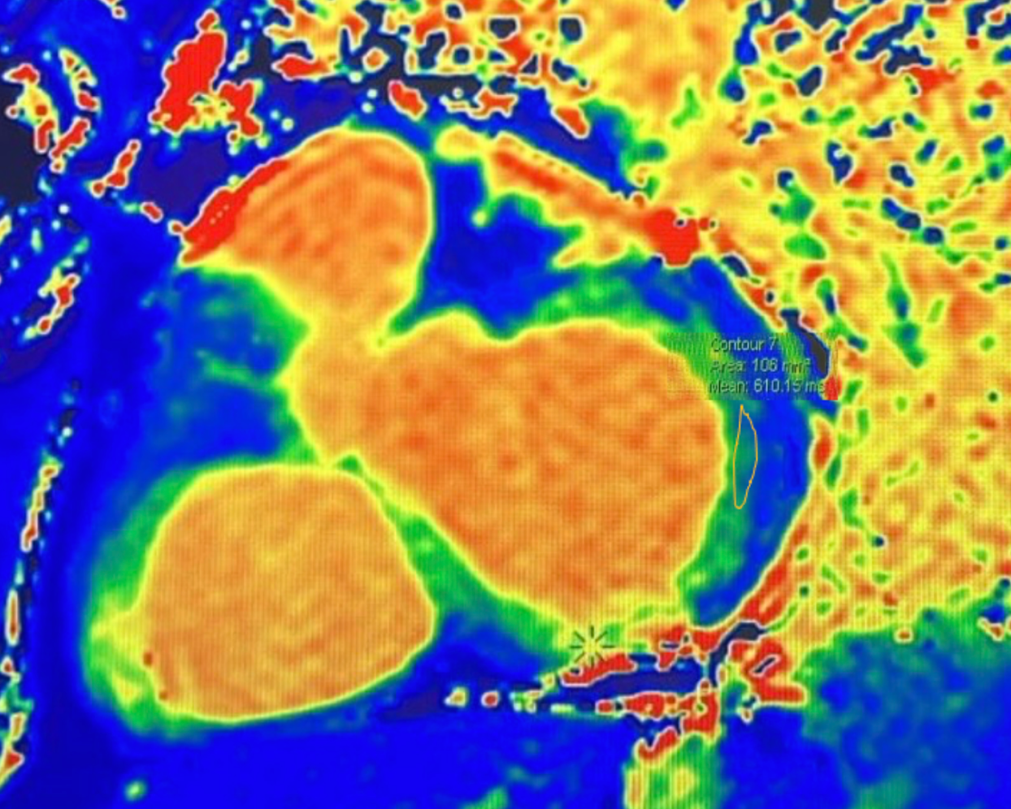
Figure 1. Native T1 mapping showing markedly reduced T1 values (610 ms) in the basal lateral myocardium (yellow ROI), consistent with early glycosphingolipid storage in Fabry disease.
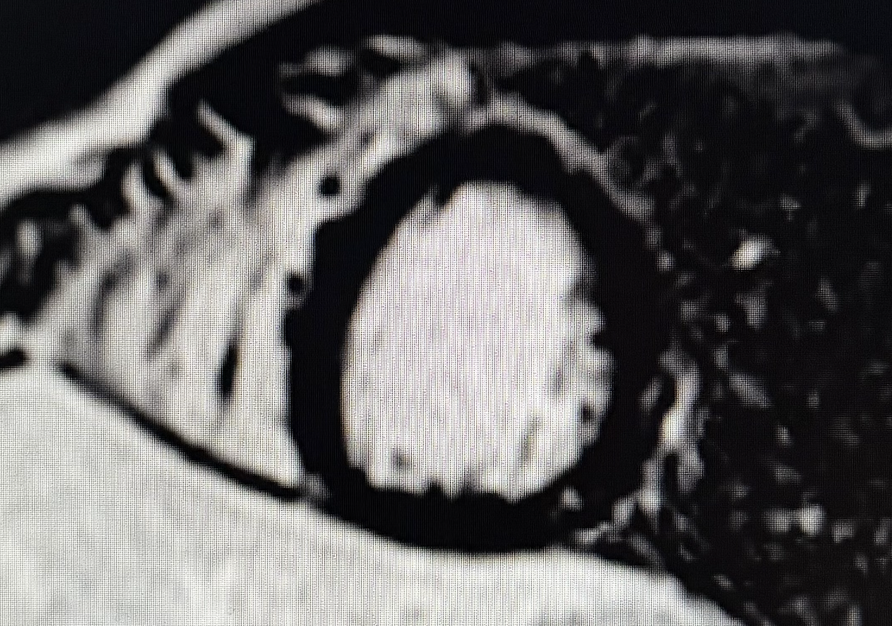

Figure 2. Short-axis mid-LV late gadolinium enhancement sequence demonstrating two small mid-wall intramyocardial nodules in the mid-inferolateral wall, showing a non-ischemic pattern compatible with early focal fibrosis.

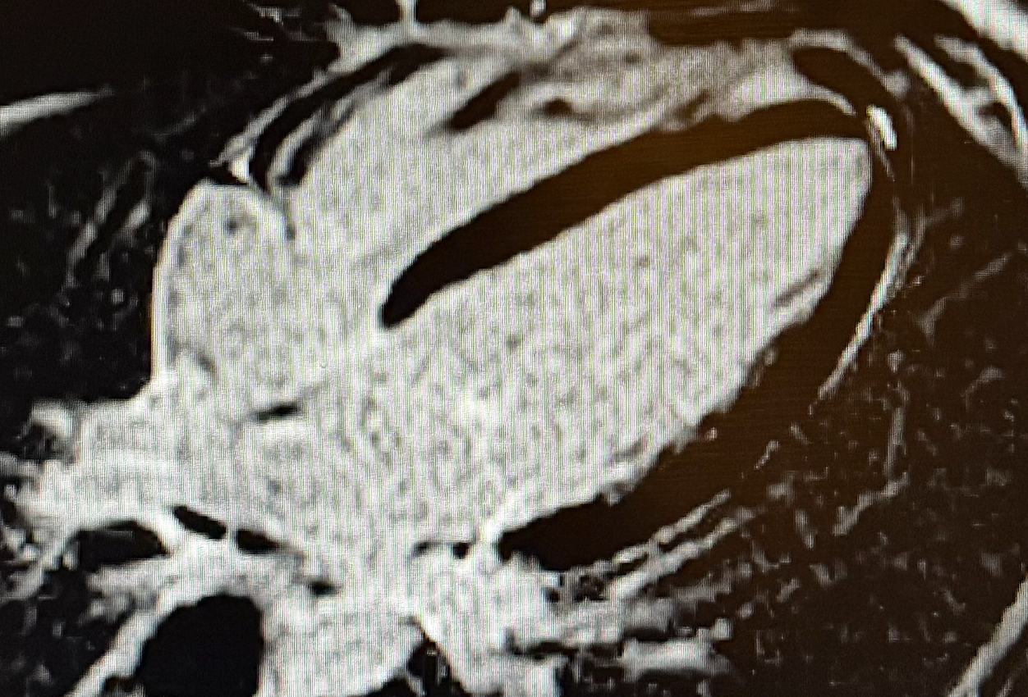

Figure 3. Four-chamber late gadolinium enhancement image showing absence of additional myocardial fibrosis, no ischemic or infarct-related scar, and a mild posterior wall hypertrophy measuring 10 mm.

3. Discussion

Fabry disease is a progressive multisystem disorder in which cardiac involvement is a major determinant of prognosis (Desnick et al., 2003; Weidemann et al., 2013). Glycosphingolipid accumulation in cardiomyocytes and conduction tissue leads to progressive hypertrophy, fibrosis, arrhythmias, and ultimately heart failure. Early recognition is crucial, especially in young athletes whose cardiac performance and safety depend on optimal myocardial integrity. In our patient, markedly reduced native T1 values indicated early sphingolipid storage, while the presence of two small mid-wall inferolateral LGE foci reflected early irreversible fibrosis. Even minimal LGE in Fabry disease has been associated with arrhythmic events and disease progression (Nordin et al., 2016; Hanneman et al., 2020). In competitive athletes, high-intensity effort increases myocardial oxygen demand and catecholamine release, which may potentiate arrhythmogenic risk in the presence of underlying myocardial disease (Pelliccia et al., 2021). Importantly, disease-modifying therapies exist. Enzyme replacement therapy (ERT) and the oral pharmacological chaperone migalastat have been shown to slow or reverse hypertrophy, stabilize myocardial function, and reduce arrhythmia burden when initiated before extensive fibrosis develops (Aquaro et al., 2022). In this case, early therapeutic intervention is expected to improve the long-term prognosis significantly and may allow continued participation in competitive sports under close monitoring. This case also underscores the importance of comprehensive cardiovascular screening in elite athletes. While echocardiography may remain normal in early disease, CMR is the most sensitive non-invasive tool for detecting intracellular storage and early fibrosis (Ponsiglione et al., 2022). Sports cardiology guidelines recommend performing CMR whenever findings appear atypical for an athlete’s heart or when an infiltrative or genetic cardiomyopathy is suspected (Pelliccia et al., 2021). Early diagnosis allows appropriate counselling regarding safe sports participation. Athletes with controlled disease, absence of malignant LGE patterns, and no arrhythmias may continue training under strict supervision. Conversely, progression of fibrosis or arrhythmogenic features may require modification of training intensity or temporary restriction (Pelliccia et al., 2021). In summary, this case highlights the pivotal role of CMR in distinguishing Fabry cardiomyopathy from physiological athletic remodeling. It underscores the prognostic importance of early detection in a young competitive athlete. The combination of reduced native T1 values and focal LGE warrants immediate metabolic evaluation, timely therapeutic initiation, and long-term multidisciplinary follow-up.

4. Conclusion

This case demonstrates the decisive value of advanced cardiac magnetic resonance imaging in identifying early cardiac involvement in Fabry disease, even in asymptomatic athletes. The combination of markedly reduced native T1 values and discrete mid-wall late gadolinium enhancement revealed subtle sphingolipid storage and focal fibrosis, enabling timely metabolic and genetic confirmation.
Early recognition is significant in competitive athletes, as initial myocardial changes may have prognostic and arrhythmogenic implications that directly affect performance and long-term safety. Initiating disease-modifying therapy at this stage offers the best opportunity to prevent progression and reduce fibrosis-related complications.
This report underscores the importance of comprehensive cardiovascular assessment in high-level athletes. It highlights the critical role of CMR when imaging findings cannot be fully explained by physiological remodeling.

Consent

All authors declare that written informed consent was obtained from the patient for publication of this case report and the accompanying images. A copy of the written consent is available for review by the Editorial Office/Chief Editor/Editorial Board members of this journal.

Ethical approval

This case report describes a single, anonymous patient and did not require institutional ethical approval per our institution's policies. All procedures were conducted in accordance with the 1964 Declaration of Helsinki and its later amendments.

DISCLAIMER (ARTIFICIAL INTELLIGENCE)

The authors hereby declare that no generative artificial intelligence tools (ChatGPT, Copilot, etc.) were used in the writing, editing or production of this manuscript

References

- Desnick RJ, Brady R, Barranger J, Collins AJ, Germain DP, Goldman M, et al. Fabry disease: guidelines for diagnosis, management, and enzyme replacement therapy. Ann Intern Med. 2003;138(4):338–46. doi:10.7326/0003-4819-138-4-200302180-00014
- Weidemann F, Niemann M, Störk S, Breunig F, Beer M, Sommer C, et al. Long-term outcome of enzyme replacement therapy in advanced Fabry disease: evidence for disease progression towards serious complications. J Intern Med. 2013;274(4):331–41. doi:10.1111/joim.12077
- Sado DM, White SK, Piechnik SK, Banypersad SM, Treibel T, Captur G, et al. Identification and assessment of Anderson–Fabry disease by cardiovascular magnetic resonance noncontrast myocardial T1 mapping. Circ Cardiovasc Imaging. 2013;6(3):392–8. doi:10.1161/CIRCIMAGING.112.976381
- Nordin S, Kozor R, Bulluck H, Baig S, Carr-White G, Rakhit D, et al. Cardiac Fabry disease with late gadolinium enhancement is a chronic inflammatory cardiomyopathy. J Am Coll Cardiol. 2016;68(15):1707–8. doi:10.1016/j.jacc.2016.07.741
- Hanneman K, Karur GR, Wasim S, Morel CF, Iwanochko RM, Wintersperger BJ. Left ventricular hypertrophy and late gadolinium enhancement at cardiac MRI are associated with adverse cardiac events in Fabry disease. Radiology. 2020;294(1):42–9. doi:10.1148/radiol.2019191385
- Turco A, Olivotto I, Torlasco C, Grigoratos C, Sinagra G, Masci PG, et al. The demanding grey zone: sport indices by CMR to differentiate hypertrophic cardiomyopathy from athlete’s heart. PLoS One. 2018;13(11):e0208015. doi:10.1371/journal.pone.0208015
- Pelliccia A, Sharma S, Gati S, Bäck M, Börjesson M, Caselli S, et al. 2020 ESC Guidelines on sports cardiology and exercise in patients with cardiovascular disease. Eur Heart J. 2021;42(1):17–96. doi:10.1093/eurheartj/ehaa605
- Aquaro GD, Sormani P, De Marchi D, Pepi M, Barison A, Dellegrottaglie S, et al. Cardiac magnetic resonance in Fabry disease: state of the art. Diagnostics. 2022;12(11):2652. doi:10.3390/diagnostics12112652
- Ponsiglione A, Cavaliere C, Italiano G, Capasso R, Russo L, Brunetti ND, et al. Cardiovascular magnetic resonance native T1 mapping in Anderson–Fabry disease: a systematic review and meta-analysis. J Cardiovasc Magn Reson. 2022;24(1):60. doi:10.1186/s12968-022-00859-z

Definitions, Acronyms, Abbreviations

CMR : Cardiac Magnetic Resonance
LV : Left Ventricle
LGE : Late Gadolinium Enhancement
T1 mapping : Quantitative myocardial relaxation time mapping used to assess tissue composition
ERT : Enzyme Replacement Therapy
Gb3 : Globotriaosylceramide
RV : Right Ventricle
LVH : Left Ventricular Hypertrophy
SSFP : Steady-State Free Precession (cine MRI sequence)
STIR : Short Tau Inversion Recovery (edema-sensitive sequence)

