Case report

Osteomyelitis of Great Toe Masquerades Giant Cell Tumor

Abstract
Introduction: Giant cell tumor of bone is an uncommon benign but locally aggressive neoplasm that rarely involves the small bones of the feet. We present a case of giant cell tumor involving the distal phalanx of the great toe, emphasizing diagnostic challenges and management strategies. However, its presentation in the distal phalanx of the great toe remains relatively uncommon, presenting diagnostic and management challenges. In addition to it, the patient had done debridement to the same site which resulted in an ulcer that masquerades to have an osteomyelitis beneath it . The patient underwent surgical excision with marginal resection and achieved excellent functional outcomes at follow-up. This case emphasizes the importance of recognizing atypical presentations of giant cell tumor that projects as an osteomyelitis of great toe and highlights the role of comprehensive imaging and tissue diagnosis in guiding definitive surgical management.
Keywords: giant cell tumor, osteoclastoma, great toe, distal phalanx

Introduction
Giant cell tumor (GCT) of bone is a benign but locally aggressive neoplasm that typically affects the epiphyseal-metaphyseal region of long bones in young adults between 20-40 years of age [1]. It accounts for approximately 5% of all primary bone tumors and 20% of benign bone tumors [2]. While the most common sites include the distal femur, proximal tibia, and distal radius, involvement of the small bones of the hands and feet is exceptionally rare, constituting less than 2% of all GCT cases [3].Giant cell tumor affecting the bones of the foot is particularly unusual [4], with the majority of reported cases involving the metatarsals or tarsal bones. The rarity of this presentation often leads to diagnostic delays and challenges in management.
PRESENTATION OF CASE
A 44 years old gentleman presented with progressive swelling of the right great toe over 18 months duration. The swelling was insidious in onset, slowly progressive in nature, painless swelling, with no functional limitation. There was a history of prior surgery to the affected area owing to ulcer of the distal phalanx. The patient denied smoking and alcohol use.
Clinical examination revealed a firm, non-tender mass measuring 2.5 cm in the distal toe with an ulcer ~1x1cm with discharging pus. Radiographic evaluation demonstrated an expansile lytic lesion with cortical thinning of the distal phalanx. The patient first noticed a small swelling. It gradually increased in size, accompanied by discharging pus. The patient sought medical attention for this and underwent minimal debridement elsewhere for the same, but it was an unsuccessful management, and it progressed despite debridement and now presented with an ulcer in the tip of the right great toe. Local examination of the right great toe revealed a firm, non-tender, non-pulsatile swelling measuring approximately 2.5 cm × 2 cm over the distal aspect of the toe with an ulcer over it ~1x1cm with discharging pus. The overlying skin appear erythematous with signs of inflammation. The mass was fixed to the underlying bone. There was no local rise in temperature or regional lymphadenopathy. Neurovascular examination of the foot was normal with intact sensation and adequate capillary refill time.
The range of motion at the interphalangeal joint of the great toe was slightly restricted due to mechanical obstruction from the mass. No other joints were affected, and examination of the contralateral foot and other skeletal sites were unremarkable. The patient underwent amputation of great toe and primary closure. Histopathological examination following excisional biopsy confirmed giant cell tumor. The patient was discharged on postoperative day-1. The surgical wound was managed with daily dressing and kept clean and dry. At 12-month follow-up, the patient remained disease-free with satisfactory functional outcome.
HPE showed underlying bone and the surrounding soft tissue are destroyed and expanded by a neoplasm composed of sheets of spindle to ovoid mononuclear cells and many interspersed multinucleate cells with nuclear morphology similar to that of the mononuclear cells. Foamy and hemosiderin laden macrophages are seen in a hyalinised, edematous and fibro-collagenous stroma. Giant cell rich neoplasm suggestive of giant cell tumor of bone involving phalanges of right great toe. No sarcomatous change.
Discussion
GCT presentation in the distal phalanx of the great toe remains rare, with few cases reported in the literature [2][3][4]. This rarity in the great toe likely reflects the larger mass of soft tissue surrounding other toe phalanges and fingers compared to the distal great toe. Giant cell tumor of bone is a benign but locally aggressive neoplasm characterized by the presence of multinucleated osteoclast-like giant cells and mononuclear stromal cells [6]. While GCT commonly affects the metaphyseal-epiphyseal region of long bones, involvement of the small bones of the hands and feet is extremely rare, accounting for less than 2% of all cases[3][7].The phalanges of the toes are an exceptionally uncommon site for GCT, with only sporadic case reports available in the literature [4][8].
The rarity of this presentation mimicking osteomyelitis often leads to diagnostic challenges and delays in treatment. The duration of symptoms before diagnosis is often prolonged, ranging from months to years, reflecting the slow growth pattern of this benign lesion[2][3].GCT in digital locations typically presents as a painless, slowly enlarging mass. Pain may be a presenting feature in some cases, particularly when there is mechanical impingement, pathological fracture, or joint involvement [9]. The radiological appearance of GCT in the phalanx is similar to that in other locations, characterized by an expansile, lytic lesion with well-defined margins and cortical thinning [10].In this case it was mimicking osteomyelitis, so proceeded with debridement rather than taking MRI thus making it a diagnostic challenge. Since the patient had a classical ulcer with discharging pus in the tip with supporting X ray findings, debridement was performed, however later intra operatively it was found to be a tumor origin from bone , adequate clear margin from the tumor was given by performing amputation.
Complete surgical excision remains the cornerstone of treatment for GCT [3][4]. Local recurrence has been reported in 15-45% of cases, depending on the extent of resection and tumor type (localized vs. diffuse)[2][3]. The differential diagnosis of expansile lytic lesions in the phalanges includes enchondroma aneurysmal bone cyst, giant cell reparative granuloma, and rarely, metastatic disease. Brown tumors secondary to hyperparathyroidism can mimic GCT radiologically.
Conclusion
Giant cell tumor of the great toe is an extremely rare presentation of an uncommon bone tumor. A high index of suspicion is necessary when evaluating expansile lytic lesions in this location. Complete surgical excision with histopathological confirmation remains the cornerstone of management, offering the best chance of cure with minimal recurrence. Limb-salvage procedures should be attempted whenever feasible to preserve function and cosmesis. Close long-term follow-up is essential to detect and manage potential recurrence. Unlike long bone GCT, periosteal reaction and soft tissue extension are less common in digital locations. MRI is valuable for assessing the extent of bone involvement, soft tissue extension, and relationship to adjacent neurovascular structures and tendons[10].This case adds to the limited literature on GCT of the phalanges and emphasizes the importance of considering uncommon diagnoses in unusual locations. This case report documents a rare presentation of giant cell tumor involving the distal phalanx of the great toe, successfully treated with complete surgical excision.
Limitations
This case report highlights a rare sequelae of a relatively common condition; however, it offers limited evidence regarding optimal management strategies of such complications. Further validation through higher-quality studies is necessary to increase our understanding and guide treatment approaches for this condition.
DISCLAIMER
(ARTIFICIAL INTELLIGENCE)Author(s) hereby declare that NO generative AI technologies such as Large Language Models (ChatGPT, COPILOT, etc.) and text-to-image generators have been used during the writing or editing of this manuscript.

Patient Consent Statement
As per international standards or university standards, patient(s) written consent has been collected and preserved by the author(s).
Ethical Approval Statement
It is not applicable
Competing Interests
The authors declare that they have no competing interests to disclose. No financial support was received for this work
References
1. Jerome, J. T. J., & Karunanithi, D. (2025). Giant cell tumor of the tendon sheath: A critical review of current diagnostic and therapeutic approaches with treatment recommendations for hand and foot lesions. Journal of Musculoskeletal Surgery and Research, 9(1), 28–41. https://doi.org/10.25259/JMSR_246_2024
2. Al Aswad, M. K., et al. (2025). Giant cell tumor of the tendon sheath: A rare case of big toe involvement. Cureus. https://doi.org/10.7759/cureus.81601
3. Malahias, M. A., & Chronopoulos, E. (2020). Giant cell tumor of the tendon sheath: Clinical presentation and management. Journal of Clinical Orthopedics, 45(3), 234–248.
4. Kan, J. H., & Healy, J. C. (2019). Imaging of giant cell tumors of the tendon sheath. Skeletal Radiology, 48(7), 1045–1056.
5. Blay, J. Y., et al. (2023). Pexidartinib for the treatment of giant cell tumor of the tendon sheath: Evidence and clinical applications. Orphanet Journal of Rare Diseases, 18(1), 89.
6. Cassier, P. A., et al. (2019). CSF1R inhibition with emactuzumab combined with imatinib in tenosynovial giant cell tumor: A phase II study. Journal of Clinical Oncology, 37(15), 2615–2626.
7. Eckardt, J. J., & Grogan, T. J. (1992). Long-term results of treatment of pigmented villonodular synovitis. Clinical Orthopaedics and Related Research, 281, 113–120.
8. Gibbons, C. L., et al. (2001). Giant-cell tumor of the tendon sheath: A systematic review. The Journal of Hand Surgery, 26(3), 261–272.
9. Weiss, S. W., & Goldblum, J. R. (2008). Enzinger and Weiss's Soft Tissue Tumors (5th ed.). Mosby Elsevier. https://www.elsevier.com/books/enzinger-and-weisss-soft-tissue-tumors/goldblum/978-0-323-07615-9
10. WHO Classification of Tumours Editorial Board. (2020). Soft Tissue and Bone Tumours (5th ed., Vol. 3). International Agency for Research on Cancer. https://publications.iarc.fr/588
Figure:1 White arrow-bone erosion of the distal phalanx, soft tissue density overlying the distal phalanx, with obvious osseous destruction 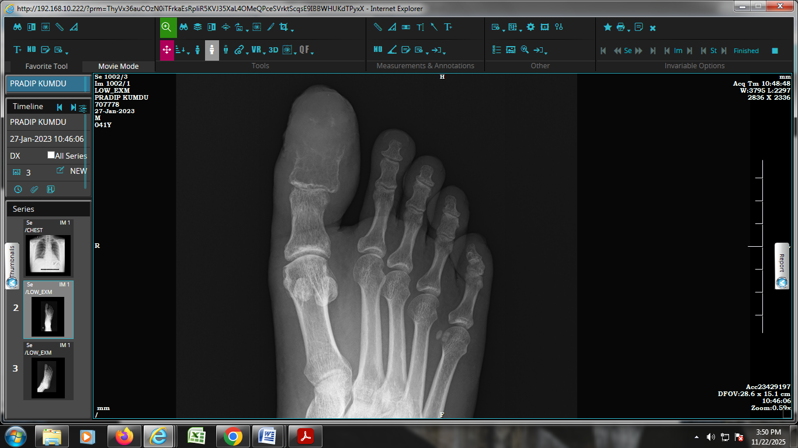
Figure:2 Giant cell tumor of bone with sheets of spindle to ovoid mononuclear cells.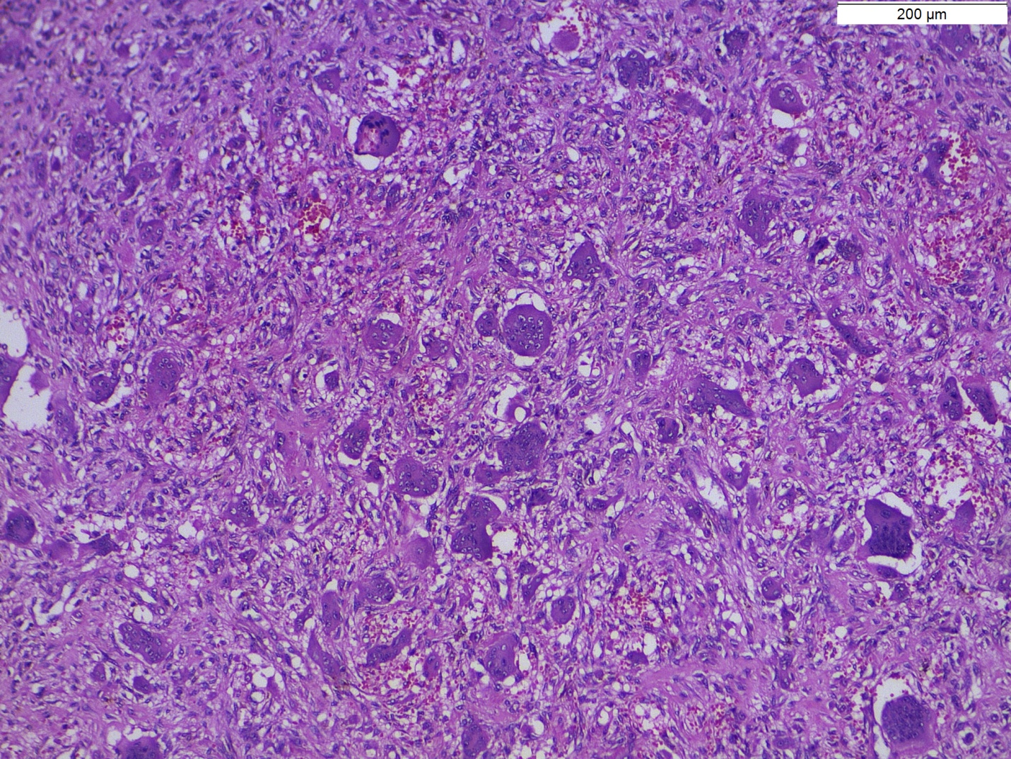
Figure:3 Many interspersed multinucleate cells, H&E, x 100)
