Case report
Congenital Arteriovenous Malformation of hand and forearm: Integrating Clinical staging, Vascular Imaging, and Treatment outcomes in rare anomaly

Abstract:
Congenital Arteriovenous malformations (AVMs) of hand are very rarest of anomaly which are rarely encountered to any surgeons. AVMs are generally seen in brain followed by which are hand. It constitutes an abnormal vascular connection between arterial and venous drainage. Treatment options can be beta blockers, embolization,sclerotherepy in an effort to reduce its size. In our case report we had an 11 year old female child coming to us with pain and swelling over right hand which was confirmed to be AVM on MRI following which patient underwent angio embolization to control its size followed by excision of tumor. Main corner stone of management was to control bleeding site from feeding vessels.
Keywords: Arteriovenous malformations, Angio embolization,
Introduction: Arteriovenous malformations originate at 4th to 10th weeks of intra uterine life due to persistence of primitive arteriovenous shunts. They are vascular anomalies having rich abnormal vascular networks in which arterial flow is directly connected with venous channels. Though they occur in any part of the body, upper limb; hand, commonly affected, after head and neck region. AVM of the hand is generally small, but can cause pain, discomfort, disability and occasionally bleeding, hence necessitating the intervention. [1]
This presentation (but not the underlying condition) is sometimes precipitated by trauma, which produces a wound which then fails to heal due to a combination of venous hypertension and pulp ischaemia secondary to the steal effect of the arteriovenous shunts. [2]
Arteriovenous malformations were categorized according to Schobinger clinical staging: 27 percent in stage I (quiescence), 38 percent in stage II (expansion), and 38 percent in stage III (destruction). There was a single patient with stage IV malformation (decompensation). Stage I lesions remained stable for long periods. Expansion (stage II) was usually followed by pain, bleeding, and ulceration (stage III). [3]
MRI provides essential insight into lesion extent and guides surgical planning, which remains the primary treatment modality for symptomatic AVMs causing nerve compression. Although recurrence is a common risk, especially in paediatric patients, careful excision and follow-up are key to reducing this risk and ensuring better long-term outcomes. [4]
Case Report: An 11 year old female came with chief complaints of pain and swelling over right hand over thumb region and over forearm since infancy.
Swellings were initially first observed at around 5 to 6 months of age which were initially small in size not painful then gradually progressed to increase in size.
History of pain over swelling over hand for 2 year, which increases on movement of hand.
History of inability and pain while closing thumb finger for 1 and half year.
History of ulceration over swelling for 6months.
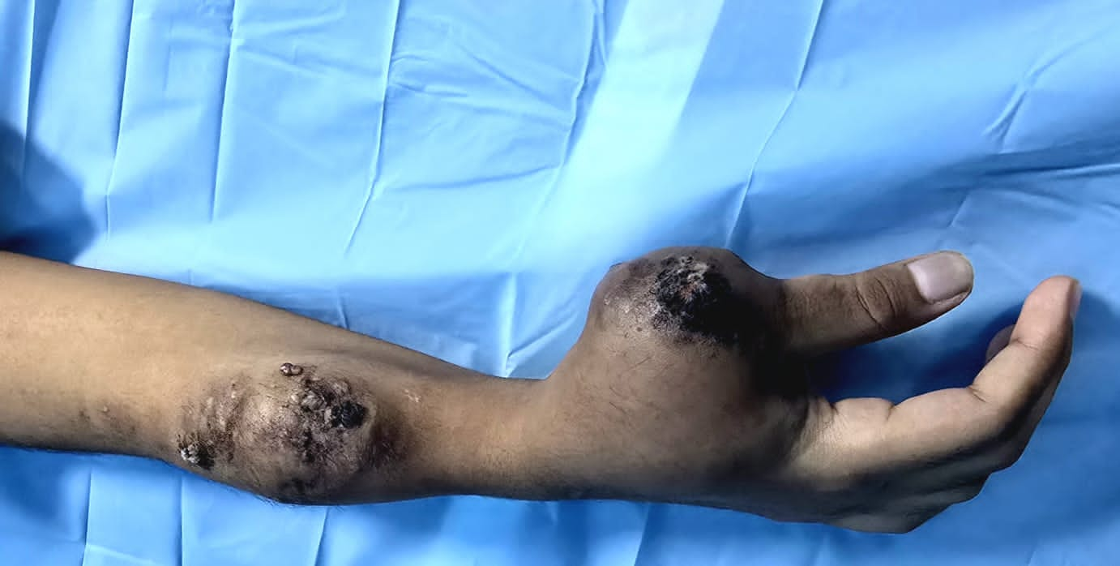
Fig 1: Tumor over hand
Patient underwent MRI of hand and forearm which revealed high flow vascular malformation as Arteriovenous malformation. Had undergone arterial angio embolization of arterial feeder vessel under fluoroscopy guidance in 3 sittings, 2 weeks prior to plan surgery.
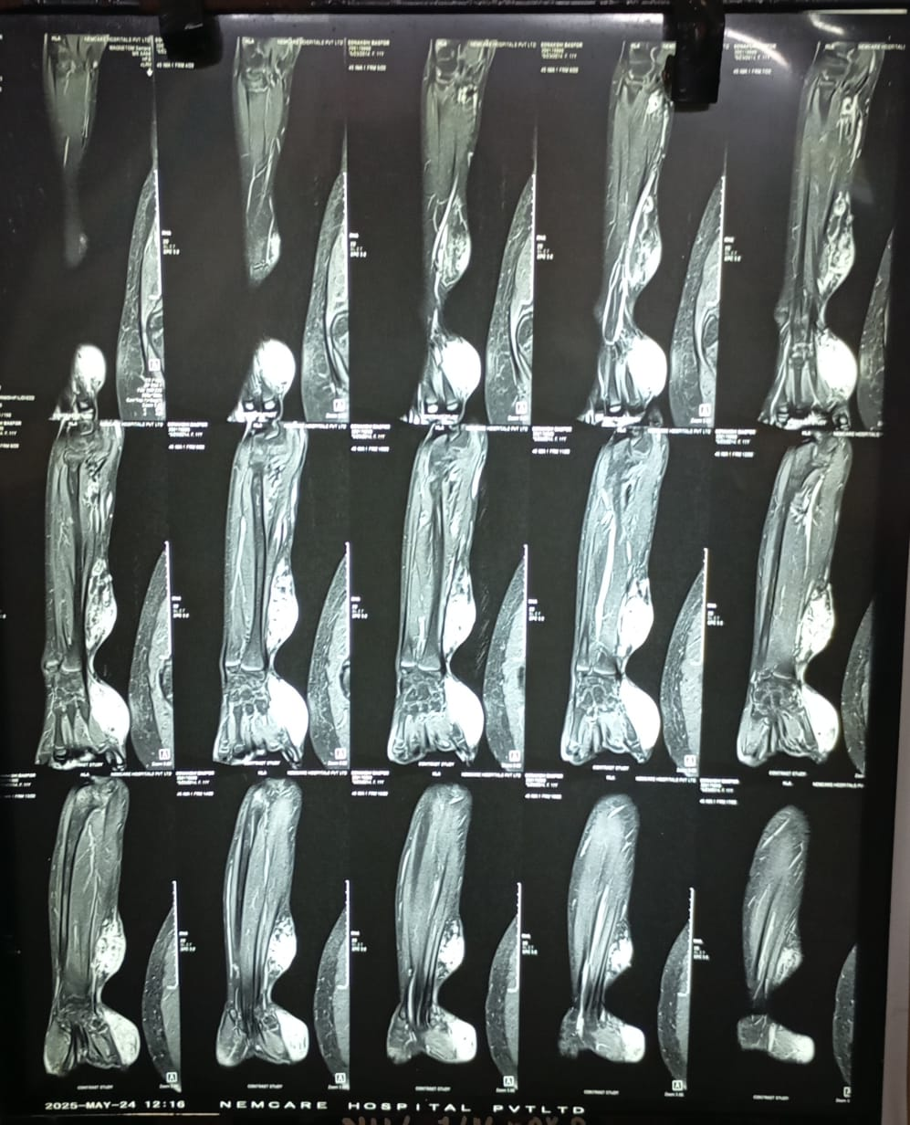
Fig 2: Showing Coronal section MRI of hand with AV malformations

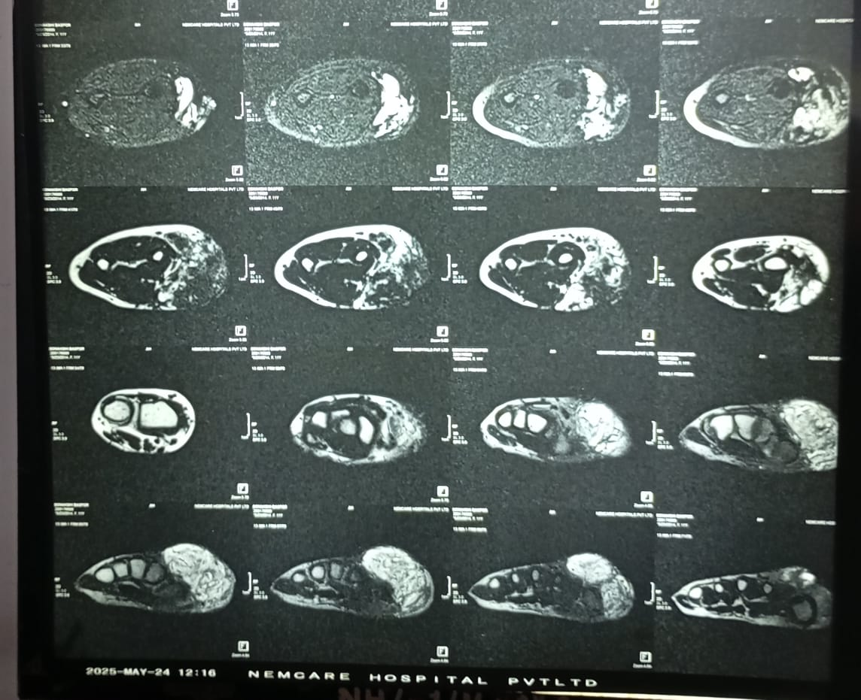
Fig 3: showing Cross sectional MRI of AV malformation

Fig 4: Coronal section MRI of hand showing AV malformations
Patient underwent complete R0 excision of both tumors of Right forearm and hand. 5*4 cm vascular swelling was excised from Right forearm and 6*5 cm lesion excised from right thumb. Both swellings had multiple collaterals which were ligated.
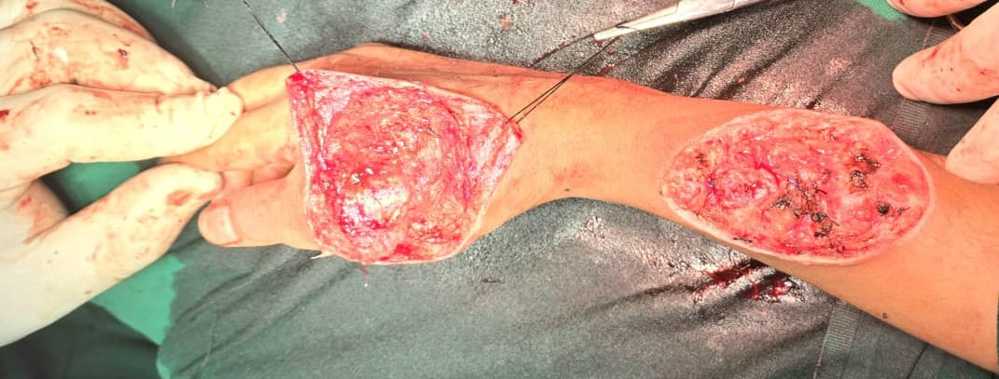
Fig 5: Dissected area after tumor removal
Dissected bed of hand and forearm after complete tumor excision

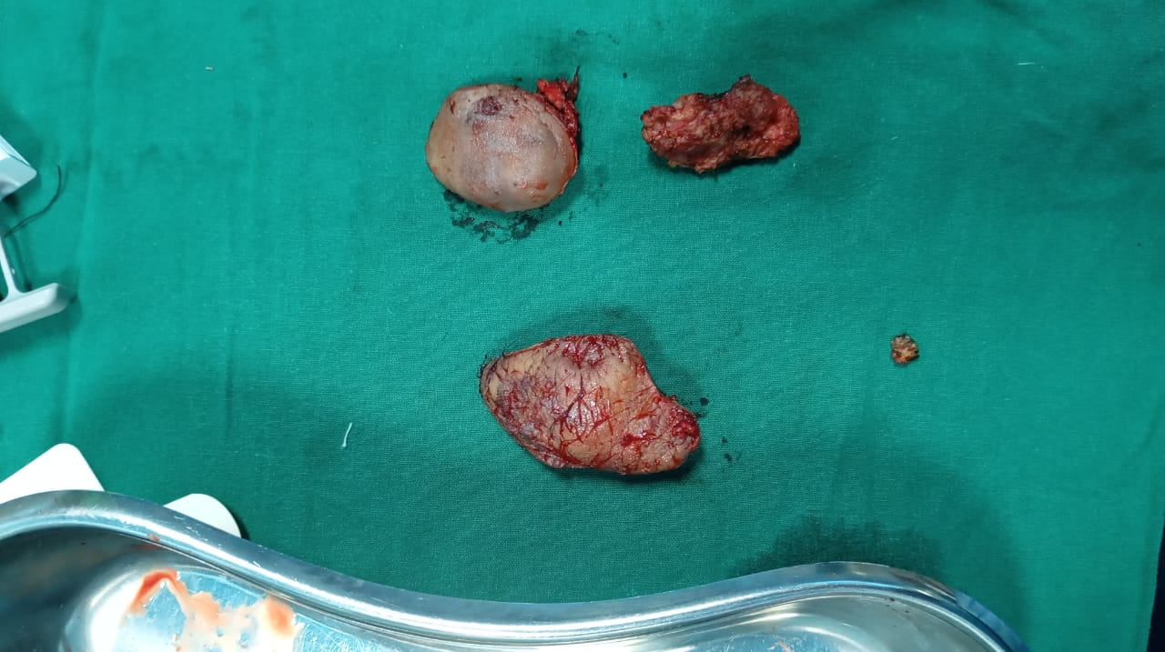
Fig 6: Specimen of tumor
Specimen are sent for Histopathological examination for confirmation of diagnosis.
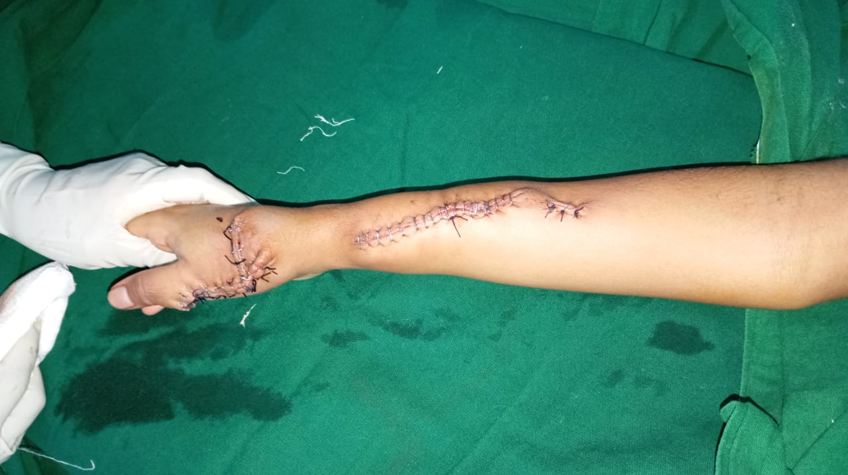

Fig 7: Immediate post op
While closing the defect we used both skin staplers and Vicryl sutures. Reconstruction was done in such a manner to avoid any further contracture. Sutures and stapler are removed after 20 days post op with normal return of activity of hand and forearm.

Result:
Both specimens are sent for histopathological examination for confirmation of diagnosis. Specimens were suggestive of Arṭeriovenous malformation, benign etiology.
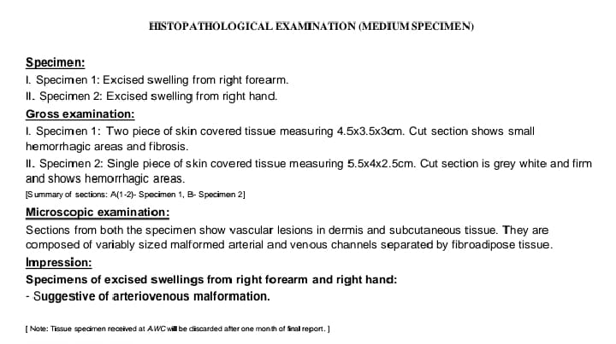
Fig 8: HPE report
Patient is reviewed after 3 months where patient had no further swelling with healthy scar tissue with no contracture and normal function of hand and forearm.
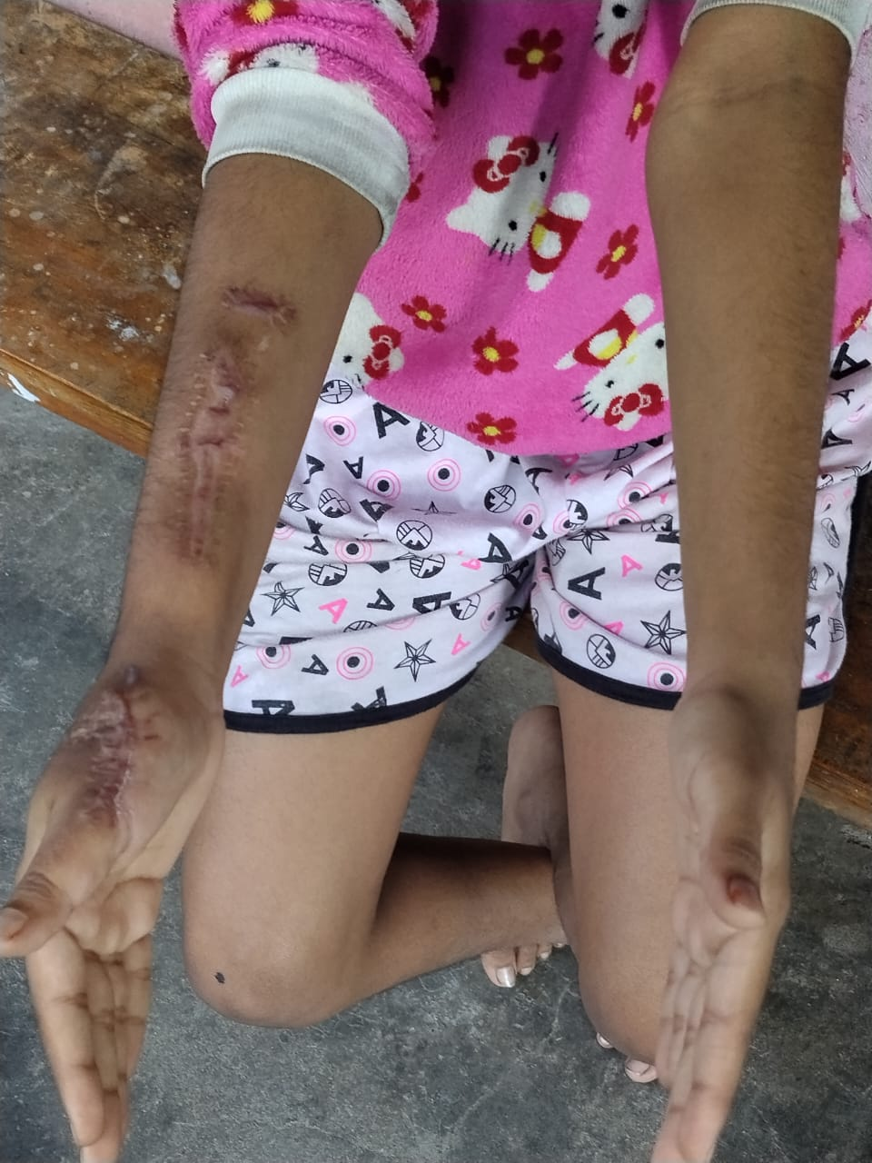
Fig 9: Hand in Neutral Position during follow up

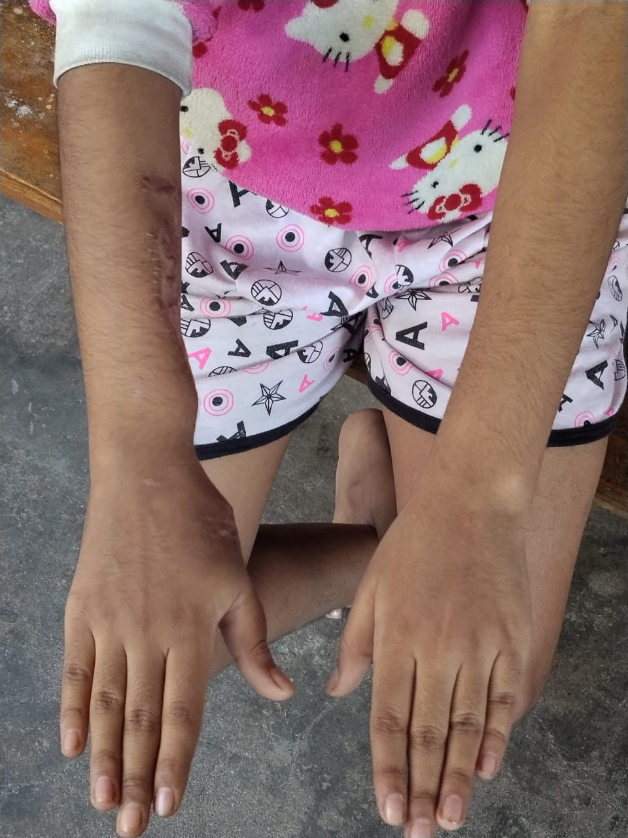
Fig 10: Hand in prone position during follow up

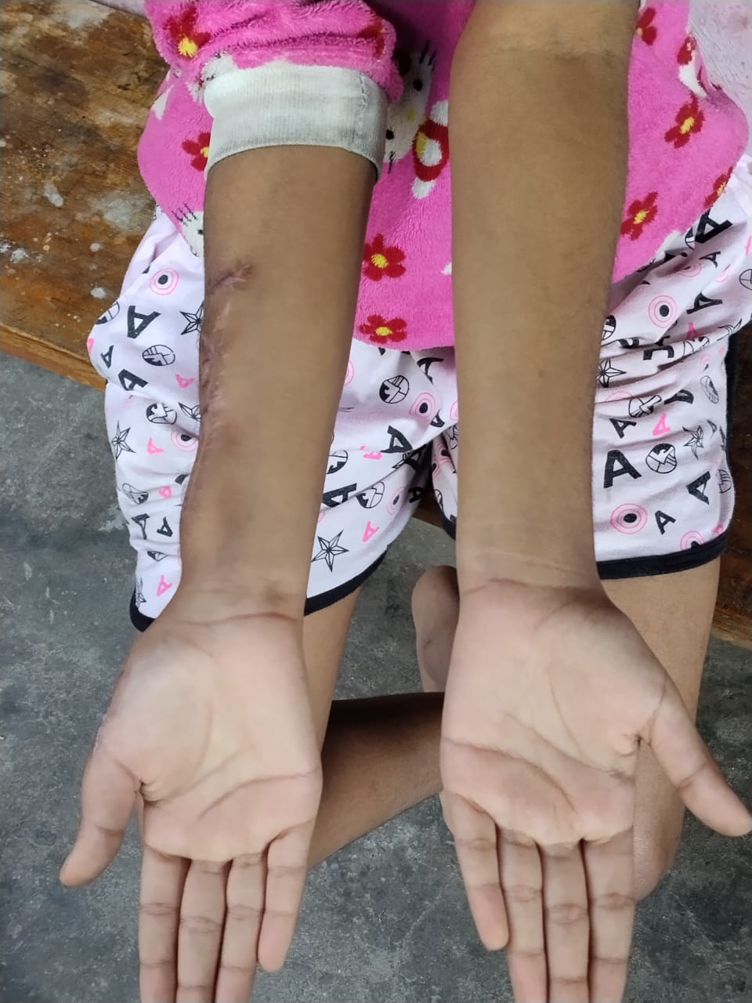
Fig 11: Hand in supine position during follow up

Discussion:
The presenting symptoms of AV malformation over hand can be cosmetic disfigurement, obstruction to vital structures of the upper limb and impairment of the function, pain, ulceration, bleeding, and nerve palsy [1]
In our case also patient had disfigurement of hand and forearm along with pain while doing daily activities.
Schobinger classification of arteriovenous malformations stages are:Stage Clinical Findings I (Quiescence) Skin warmth, discoloration II (Expansion) Enlargement, pulsation, bruit III (Destruction) Pain, ulceration, bleeding IV (Decompensation) Cardiac failure due to volume overload .[3]
In our case patient presented with Schobinger Stage III
AVM treatment, and especially embolo/sclerotherapy, is a long-term prospect, and it carries a potential risk for serious complications. After every treatment, the lesions must be revaluated and new treatment plans must be made by the members of a multidisciplinary team. [5]
After confirming high flow vascular lesion with MRI we did angio embolization of major feeding vessel. This is crucial as to reduce the risk of bleeding during definitive surgery.
Upper extremity is a rare location of hemangiomas and other vascular malformations requiring surgery. Surgical treatment of hemangiomas and AVMs of the upper extremities is doubtlessly an arduous task, which calls for great microsurgical skills. [6]
Surgeons should consider several important points during the surgical treatment of AVM. The first is that the nidus of AVM should be completely removed for achieving a complete cure of AVM. The remnant AVM may grow and get bigger than before treatment within a short period of time. Surgical treatment of AVM is a challenging issue for vascular surgeons. To minimise the complications related with surgery, a multidisciplinary team approach should be considered. [7]
During the procedure after marking the skin for incision we tried to develop the plane for separation of tumour from the muscle layer beneath. Intricate microsurgery with Ligation of major feeding vessels along with ligation of other small vessel were done following which resection of both the segments were done keeping the muscle below intact. While closure of defect over forehand both the edges are approximated with silk suture and closed with skin staplers. Precautions were taken to raise flaps sideways preserving vascularity to reduce chance of closure due to tension. Over hand swelling after excision closure were done in VY plasty manner.

Conclusion:
Congenital Arteriovenous malformation of Hand is very rarely encountered even in practice of busy surgeon. Diagnosis remain crucial on basis of imaging finding as MRI and MRI angiography. Multidisciplinary approach in managing the lesion with angio embolization of feeding vessel followed by surgery not only reduces hemorrhagic complication during surgery also allows in developing better planes and better resection margin.
References:
1. | Aihole, J. S. (2024). A case of arteriovenous malformation of the hand and its outcome. International Journal of Surgery Case Reports, 120, 109806. https://doi.org/10.1016/j.ijscr.2024.109806
2. | Shokrollahi, K., Hiew, L. Y., Robinson, M., Evans, R. M., Jackson, J. E., & Laing, J. H. E. (2004). Arteriovenous malformation of the hand: challenges in diagnosis and management. J Surg, 2(1), 50–51. https://doi.org/10.1016/s1743-9191(06)60028-9
3. | Shokrollahi, K., Hiew, L. Y., Robinson, M., Evans, R. M., Jackson, J. E., & Laing, J. H. E. (2004). Arteriovenous malformation of the hand: challenges in diagnosis and management. J Surg, 2(1), 50–51. https://doi.org/10.1016/s1743-9191(06)60028-9
4. | Kothari, A., Chaudhari, A., Gupta, D., & Altaf, W. (2025). Successful management of a rare case of arteriovenous malformation of the forearm in a 15-year-old girl: A case report. J Orthop Case Rep, 15(4), 132–5. https://doi.org/10.13107/jocr.2025.v15.i04.5472
5. | Park, U. J., Do, Y. S., Park, K. B., Park, H. S., Kim, Y. W., Lee, B. B., & Kim, D. I. (2012). Treatment of arteriovenous malformations involving the hand. Annals of Vascular Surgery, 26(5), 643–648. https://doi.org/10.1016/j.avsg.2011.08.016
6. | Jabłecki, J., Elsaftawy, A., Kaczmarzyk, J., & Kaczmarzyk, L. (2013). Surgical treatment of hemangiomas and arteriovenous malformations in upper extermity. Polski Przegląd Chirurgiczny, 85(3), 107–113. https://doi.org/10.2478/pjs-2013-0019
7. | Kim, J. Y., Kim, D. I., Do, Y. S., Lee, B. B., Kim, Y. W., Shin, S. W., et al. (2006). Surgical treatment for congenital arteriovenous malformation: 10 years' experience. European Journal of Vascular and Endovascular Surgery, 32(1), 101–106. https://doi.org/10.1016/j.ejvs.2006.01.004

