Case report
Monofocal nonbacterial osteitis of the distal radius in children: case report

Abstract
Introduction:
Bacterial chronic osteitis is a rare inflammatory disease in children that can mimic certain tumor lesions, particularly eosinophilic granuloma. Forms localized to a single site, particularly at the lower end of the radius, are uncommon and make diagnosis difficult.
Observation:
A 7-year-old girl was referred for chronic pain in her right forearm. X-rays showed a metaphyseal cystic lesion of the lower end of the radius, associated with significant thinning of the cortex. Magnetic resonance imaging initially suggested an eosinophilic granuloma due to a well-defined lesion, with hypersignal on water-sensitive sequences and hyposignal on T1-weighted sequences, without collection or soft tissue invasion.
This suspicion of a tumor led to a bone biopsy. The examination revealed a weakened cortex containing a clear, non-hematic fluid. The pathological study revealed non-specific inflammatory osteitis, and microbiological samples were negative, leading to a diagnosis of chronic non-bacterial osteitis.
Treatment with anti-inflammatory drugs led to rapid improvement. Radiology showed gradual filling of the lesion, with complete healing after one year.
Conclusion:
This observation illustrates a monofocal form of chronic non-bacterial osteitis mimicking an eosinophilic granuloma on imaging. Biopsy remains essential to rule out a tumor or infectious lesion. The prognosis is favorable with anti-inflammatory treatment.
Keywords: Chronic nonbacterial osteitis, monofocal, child, distal radius, case report.
Introduction
Chronic nonbacterial osteitis is a rare inflammatory bone condition in children, characterized by persistent pain in the absence of any identified infection [1]. Its pathophysiology involves an abnormality in the regulation of bone inflammation, as recently highlighted in several studies on the immune mechanisms of this disease [2].
Monofocal forms are less common than multiple forms and pose a diagnostic problem due to their ability to mimic tumor or infectious lesions [3]. Modern imaging improves diagnostic evaluation, but isolated presentations can be confusing, particularly with eosinophilic granuloma [4].
In this context, bone biopsy remains essential to confirm the non-bacterial nature and rule out a tumor or actual infection [5].
We present the case of chronic nonbacterial monofocal osteitis of the distal radius in a 7-year-old child, an unusual location that illustrates the diagnostic difficulties encountered in this entity.
Case presentation
A 7-year-old girl was brought in for consultation for pain in her right wrist that had been developing for more than four months. The pain was intermittent, worsened by movement, and developed in the absence of fever. The initial clinical examination revealed tenderness on palpation of the outer edge of the lower end of the right forearm, with no swelling, redness, or local heat. Examination of the other osteoarticular segments revealed no tender points, suggesting a monofocal form of the condition.
An X-ray of the right wrist showed a lytic lesion of the metaphysis of the radius, located on its outer and anterior side, associated with marked thinning of the outer cortex, without aggressive periosteal reaction. The infectious disease tests were negative.
Magnetic resonance imaging was performed. It initially suggested an eosinophilic granuloma and, secondarily, a Brodie's abscess, due to a well-defined lesion with high signal intensity on water-sensitive sequences and low signal intensity on T1-weighted sequences, without soft tissue invasion.
Given the persistence of symptoms, the radiological appearance, and the suspected lesion, a bone biopsy was decided upon. The examination revealed a thinned and fragile cortex containing a clear, non-hematic fluid. The pathological study concluded that it was a non-specific inflammatory osteitis, and the microbiological samples were sterile, leading to a diagnosis of chronic monofocal non-bacterial osteitis.
The patient was treated with anti-inflammatory drugs. The outcome was favorable, with the pain gradually disappearing. Radiological monitoring showed gradual filling of the lesion, resulting in clear restoration of the cortical bone. At six months, the pain had completely disappeared and recovery was complete.
Discussion
Chronic nonbacterial osteitis is a rare inflammatory condition in children whose clinical presentation is often misleading. Monofocal forms represent a specific subgroup that is less common but more difficult to diagnose because they readily mimic a bone tumor or a true chronic infection [1,2].
In our observation, the monofocal presentation at the lower end of the radius, associated with intermittent pain that had been developing for several months, corresponds to the characteristics described in several recent studies. Triaille et al. point out that isolated forms can be confused with eosinophilic granuloma or Brodie's abscess due to well-defined lytic images and variable cortical involvement [3]. Magnetic resonance imaging in our case did indeed suggest these two differential diagnoses, supporting the conclusions of Arnoldi et al. on the difficulty of radiological interpretation in isolated metaphyseal lesions [4].
The negative infectious assessment is a key factor in the diagnosis of non-bacterial inflammatory osteitis. However, due to the monofocal nature and cortical thinning, bone biopsy remains imperative to rule out a malignant tumor or eosinophilic granuloma, as recommended in the work of Winter and colleagues [5]. Histological analysis of our patient showed non-specific inflammatory osteitis without germs, which corresponds to the observations of Reiser et al., who report an almost constant absence of microorganisms in samples from these patients [6].
In terms of treatment, recent studies confirm that anti-inflammatory drugs are the first-line treatment, with a favorable response rate in the majority of monofocal cases [7,8]. In our observation, the gradual disappearance of pain and complete radiological healing within a few months are consistent with the results of several pediatric cohorts published in recent years. Roberts et al. described a similar progression, marked by complete regression of bone lesions in children treated early [9].
Radiological monitoring plays an essential role in confirming healing. Loconte et al. showed that complete bone remodeling is observed in the majority of children after proper treatment, particularly in monofocal forms [10].
Thus, comparison with other studies shows that this case fits fully within the usual progression pattern of chronic monofocal nonbacterial osteitis:
• intermittent pain without fever,
• suggestive but non-specific imaging,
• frequent suspicion of eosinophilic granuloma,
• need for biopsy,
• favorable outcome with anti-inflammatory treatment.
This table confirms the importance of recognizing this condition in order to avoid inappropriate treatment or concerns about a possible bone tumor.
Table 1 : Monofocal Pediatric Bone Lesions: Comparative Review of Recent Studies and a New Distal Radius Case
Study | Mean age | Common locations | Monofocal presentation | Main differential diagnosis | Treatment | Outcome
Reiser et al., 2023 | 10 years | Long bones, pelvis | 21% | Bone tumor | Anti-inflammatory medication | Improvement in 80%
Triaille et al., 2024 | 9 years | Clavicle, tibia | 18% | Eosinophilic granuloma | Anti-inflammatory medication ± immunomodulators | Partial or complete remission
Arnoldi et al., 2024 | 11 years | Long bone metaphyses | 25% | Brodie abscess | Anti-inflammatory medication | Radiological regression in >70%
Loconte et al., 2025 | 8 years | Tibia, femur | 32% | Infectious osteomyelitis | Anti-inflammatory medication | Complete bone remodeling in most cases
Our case | 7 years | Distal radius | Yes (monofocal) | Eosinophilic granuloma or Brodie abscess | Anti-inflammatory medication | Complete healing at 6 months

Conclusion
Chronic nonbacterial monofocal osteitis remains a rare cause of prolonged bone pain in children and can mimic a tumor or infectious lesion, as in our observation where imaging initially suggested an eosinophilic granuloma or Brodie's abscess. Diagnostic confirmation relies on bone biopsy, which is essential in isolated forms to rule out a tumor and confirm the sterile inflammatory nature of the lesion [1,2]. Treatment with anti-inflammatory drugs leads to a favorable outcome in most cases, with clinical regression and progressive bone remodeling, as observed in our patient [3–5].
Early recognition of this entity, although rare, avoids misdiagnosis and ensures appropriate management.

Clinical message
The monofocal form of chronic nonbacterial osteitis poses a real diagnostic challenge, as it can closely mimic the radiological appearance of a bone tumor or eosinophilic granuloma in children. When faced with a metaphyseal cystic lesion with cortical thinning and imaging suggestive of a tumor, bone biopsy remains the decisive step in establishing an accurate diagnosis. Proper recognition of this entity avoids inappropriate treatments and ensures a favorable outcome with anti-inflammatory therapy.

Consent
Written informed consent was obtained from the patient’s parents for publication of this case report and the accompanying images. A copy of the signed consent form is available for review by the Editor-in-Chief of this journal upon request.

Ethical Approval
Ethical approval was not required for this single case report, as per the institutional policy of the Centre Hospitalier Universitaire Mohammed VI, Tanger, provided that informed consent for publication was obtained.

References
1 Reiser, C., Jandlhauser, L., Klotsche, J., Hospach, A., Berendes, R., Schnabel, A., Jansson, A. F., Hufnagel, M., Grösch, N., Niewerth, M., Minden, K., & Girschick, H. (2023). Long-term follow-up of children with chronic non-bacterial osteomyelitis—assessment of disease activity, risk factors, and outcome. Arthritis Research & Therapy, 25(1), 228. https://doi.org/10.1186/s13075-023-03195-4
2 Roberts, E., Charras, A., Hahn, G., & Hedrich, C. M. (2024). An improved understanding of pediatric chronic nonbacterial osteomyelitis pathophysiology informs current and future treatment. Journal of Bone and Mineral Research, 39(11), 1523–1538. https://doi.org/10.1093/jbmr/zjae141
3 Triaille, C., De Bruycker, J.-J., Miron, M.-C., Lecouvet, F. E., Girschick, H. J., & Wouters, C. (2024). Update on the diagnosis and treatment of CNO in children: a clinician's perspective. European Journal of Pediatrics. https://doi.org/10.1007/s00431-024-05823-w
4 Arnoldi AP, Hildebrandt L, et al. Whole-body magnetic resonance imaging in children with chronic non-bacterial osteomyelitis: diagnostic performance and follow-up. Pediatric Radiology. 2024;54:78–90.
5 Winter S, Schnabel A, Roderick MR, et al. Expert consensus recommendations for diagnosis and management of paediatric chronic non-bacterial osteomyelitis. Annals of the Rheumatic Diseases. 2024; Online ahead of print.
6 Reiser M, Jandhauser L, et al. Microbiological findings in chronic non-bacterial osteomyelitis: analysis of a paediatric cohort. Pediatric Rheumatology. 2023;21:15.
7 Schnabel, A., Range, U., Hahn, G., Berner, R., & Hedrich, C. M. (2017). Treatment Response and Longterm Outcomes in Children with Chronic Nonbacterial Osteomyelitis. *The Journal of Rheumatology*, *44*(7), 1058–1065. https://doi.org/10.3899/jrheum.161255
8 Hedrich CM, Hofmann SR. Management strategies in chronic non-bacterial osteomyelitis: current evidence and therapeutic perspectives. Seminars in Arthritis and Rheumatism. 2024;63:152325.
9 Roberts AR, Sen ES. Clinical patterns and long-term evolution of non-bacterial osteitis in childhood. Current Opinion in Pediatrics. 2024;36(6):678–686.
10 Loconte F, Albano D, et al. Chronic non-bacterial osteomyelitis in a tertiary paediatric centre: a retrospective analysis of clinical presentation and outcomes. Children.

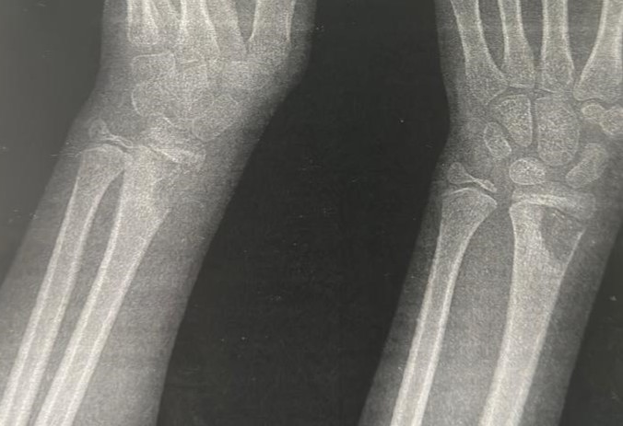
Fig 1 : Monofocal Distal Radius Osteolytic Lesion in a Child: Case Report and Comparison With Recent Pediatric Series

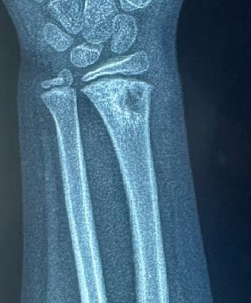
Fig 2 : Solitary Distal Radius Bone Lesion in a Child: Radiographic Features and Review of Recent Evidence
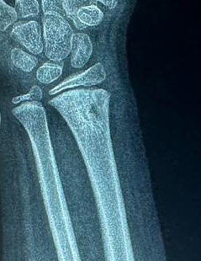
Fig 3 : Monofocal Distal Radius Osteolytic Lesion in a Child: A Case Report
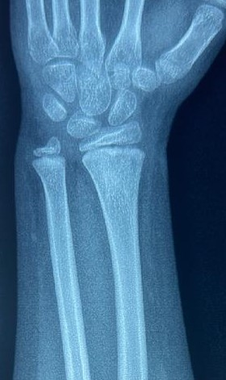
Fig 4 : Radiograph of the Carpus and Distal Radius/Ulna
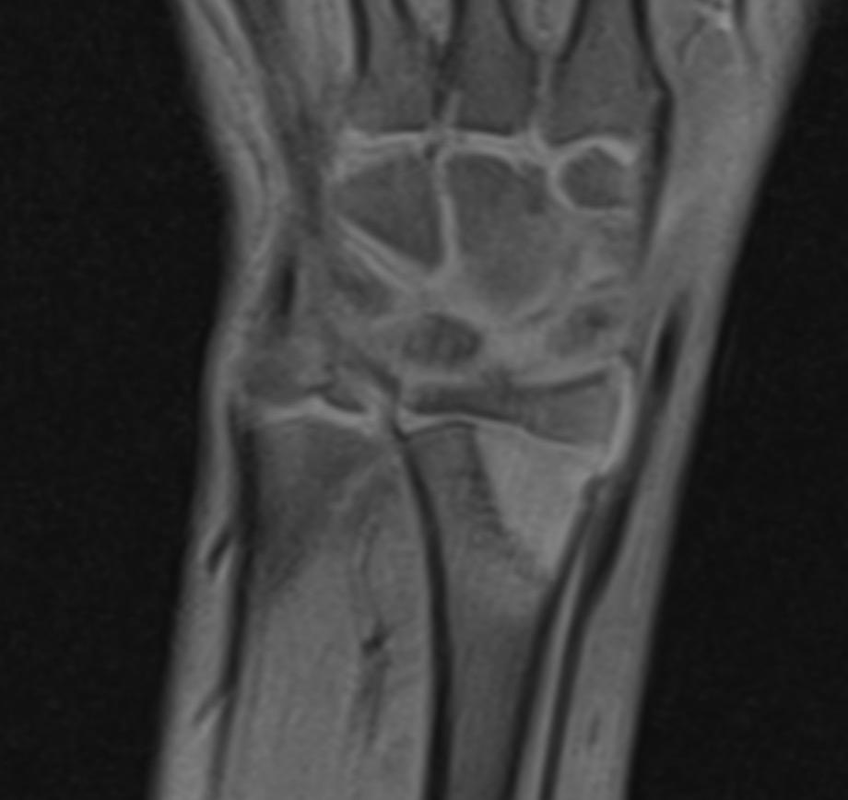
Fig 5 : MRI of the Carpus and Distal Forearm
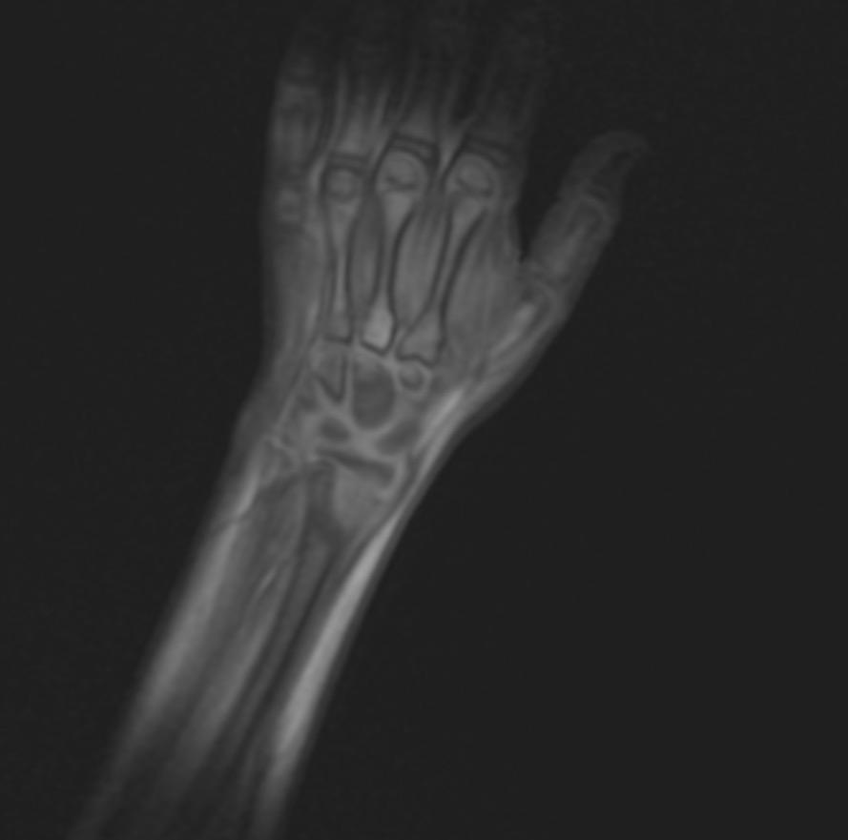
Fig 6 : High-Resolution MR Imaging of the Wrist Joint

