Case report

A case of giant carotid body paraganglioma

Abstract:

Carotid body paraganglioma is one of the most prevalent jugular paragangliomas that affects the carotid body chemoreceptors. We present the case of a 59-year-old woman who complained of an important, painless swelling in her right neck, that had been increasing in volume progressively from 7 years ago. Examination showed a pulsating mass located in the bifurcation of the right common carotid artery. The mass was well-defined hypervascular. The patient underwent surgical excision (Shamblin Grade-III) by means of neck exposure, and the tumor was fully dissected. The follow-up was without any complications. After 3 years, the patient has no recurrences.

Keywords: Paraganglioma, Carotid, chemoreceptor, extensive.

Introduction:

Paragangliomas are a family of parasympathetic and sympathetic paraganglial tumors. [1] Pheochromocytomas and abdominal paragangliomas are the two most common forms of sympathetic paragangliomas. Nonetheless, the head and neck area is where parasympathetic paragangliomas are most commonly found. The carotid body is the quintessential parasympathetic paraganglion. It is a tiny, oval structure located on either side of the neck in the semi-adventitia of the common carotid artery, where it splits into internal and external carotid arteries. The third brachial arch mesoderm and neural crest lineage derived from ectoderma are the sources of it. [2,3,4] The tumor is known as a carotid body paraganglioma (CBP) because it starts from paraganglionic cells inside it. Other terms for CBPs that are used in the literature include nonchromaffin tumors, glomus tumors, carotid body tumors, and chemodectomas. [5] It accounts for less than 0.5 percent of all body tumors, and is followed by jugulotympanic, vagal, and laryngeal paragangliomas, which are found in the head and neck region. [6]

There are two types of CBPs: familial and sporadic. [7] Unless the regional neurovascular compartment is involved, the majority of CBPs are asymptomatic in the early stages, appearing as a slowly expanding, painless lesion. [4] Because larger CBPs involve carotid vessels and X-XII cranial nerves, they can cause symptoms like dysphagia, odynophagia, hoarseness of voice.

CASE REPORT

We report the case of a 59 years old female patient, with no particular medical history, presenting to our department with a right latero-cervical swelling. The history of the disease goes back to 3 years ago, with the apparition of a right latero-cervical swelling, that had been increasing in volume progressively, and was marked by an intermittent hoarsness 3 months ago.
Medical examination showed a non-tender, barely movable, 8 cm-sized mass in the right side of her neck. Blood pressure, pulse rate was within the normal range. Nasofibroscopy revealed a reduced mobility of the right vocal cord.
The patient had an early consultation in the first month following the start of the swelling, and was diagnosed with a small carotid body paraganglioma, but refused surgery.

CT scan imaging and 3D reconstruction (Fig 1,2) showed the presence of a well-limited, roughly oval, heterodense mass in the right posterior cervical region, between the internal jugular vein and the carotid artery, with an intense, rapid and diffuse enhancement after injection. The mass was measuring 72 x 56 x 53 mm, and was insinuating between the right and external carotid arteries, which are encompassed in places but remain permeable. It was classed type III of Shamblin classification.

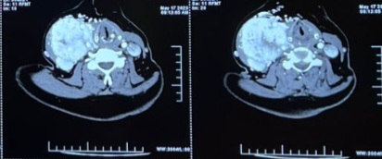

Fig 1: Axial image showing the extent of the paraganglioma

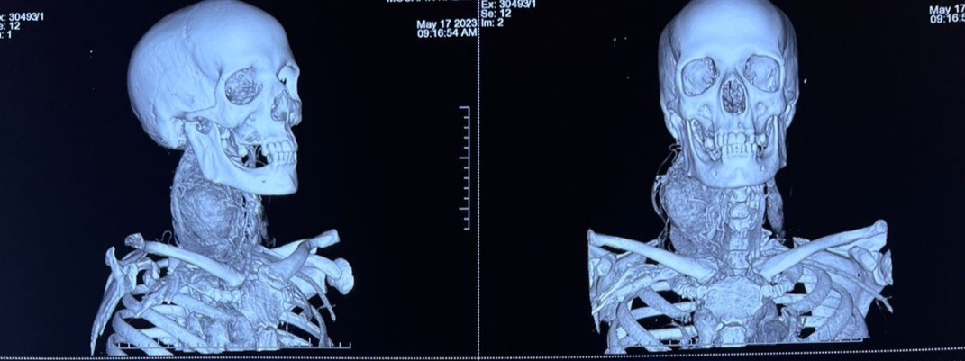

Fig 2: 3D images showing the localization of the paraganglioma between the internal and external carotid arteries

The patient underwent wide excision of the tumor. It was attached to both internal and external carotid arteries wall, and to the bifurcation of the common carotid artery. The dissection caused a small lesion on the wall of the internal carotid artery, which has been repaired. The vagus and hypoglossal nerve were preserved.

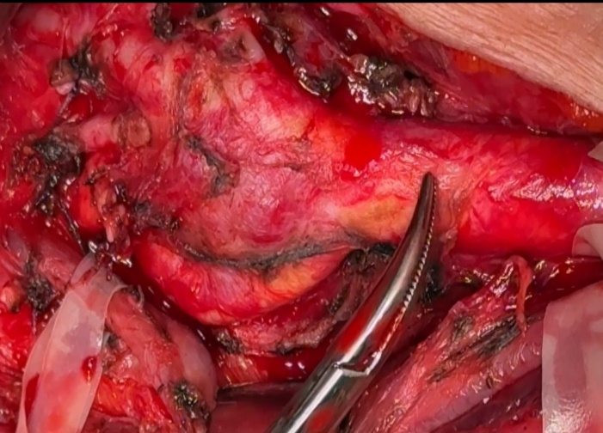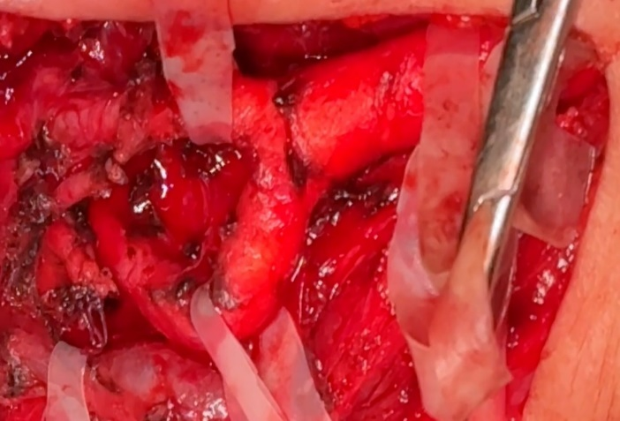
Fig 3 : Surgery images before and after the excision

The immediate follow-up didn’t show any sign of brain infraction.

The patient has been on follow up for 2 years and showed no sign of recurrence.

Discussion:

CBP, or carotid body paraganglioma, is uncommon and typically benign. However, due to the uncertain potential for malignancy, total surgical resection is advised. Because resection can be technically challenging or cause neurovascular complications, particularly for large and Shamblin group 3 tumors, early excision is also required [8].

It is very difficult to detect small tumors early because they have poor clinical symptoms when they are small. Hoarseness, vocal cord paralysis, dysphasia, Horner's syndrome, a thrill, cerebral ischemia, are examples of neurovascular symptoms and indicators of a large tumor.

CBP manifests as a nontender, slowly growing mass located anterior to the SCM. The internal and external carotid arteries may be encased and splayed by the growing tumor without becoming narrowed. Although small CBP show no signs, symptoms like dysphagia, hoarseness of voice may appear with an increase in size because of their close proximity to nearby nerves and vessels.

Additionally, some patients may present with headaches, sweating, and hypertension due to the vasoactive catecholamines that CBP produces. CBPs are more common in women than in men, and they are most frequently observed in the third to sixth decade of life. [9-11].

It is unknown what specifically causes CBPs. Nonetheless, it has been proposed that a genetic predisposition and chronic hypoxia may be contributing factors. Cirrhosis, cyanotic heart disease, cystic fibrosis, are among the illnesses that cause chronic hypoxia. Carotid body chemoreceptor cells overwork to compensate for the decreased oxygen levels when exposed to chronic hypoxic stimulation. This leads to the cell’s hypertrophy, adaptive diffuse physiological hyperplasia, and ultimately pathological (focal) hyperplasia and/or the development of neoplasms. Twenty genetic mutations have been found to date to be the cause of CBPs [12-14].

Most authors concur that the presence of metastases is the only indication of malignancy, and the histological appearance of a CBP is not a reliable indicator of malignancy [8]. Due to the lesion's high vascularity, needle biopsy should not be used to confirm the diagnosis. Magnetic resonance imaging and contrast-enhanced CT scans are helpful methods for detecting CBP [15]. When the diagnosis is not clear, selective embolization combined with angiography can be used [16]. The risk in embolization is the multitude of vessels supplying the tumor, and a superselective embolization is challenging [17].

Dissection in surgery requires paying attention to the superior pole of the tumor and the carotid bifurcation. In the carotid bifurcation's posterior face, where the glomus artery begins, CBP removal is most challenging. The most critical post-operative complication is cerebral vascular insufficiency, so maintaining cerebral blood flow is crucial, and vascular reconstruction needs to be taken into account before surgery [18].

CONCLUSION:

Even with the advancement of endovascular and surgical therapies, massive carotid body paragangliomas can still cause pre- and post-operative complications. As soon as a carotid body paraganglioma is discovered, it should be removed. Because the tumor will grow and may create a number of difficulties, even if it is not pathologically malignant, and it will get too challenging for a surgeon to remove without complications.

ETHICAL APPROVAL:
Ethical approval was provided by the authors institution.

Written informed consent was obtained from the patient for publication of this case report and accompanying images.

REFERENCES:

- Huan L, Jetly R, Kandil E. Paraganglioma of the organ of Zuckerkandl. J La State Med Soc. 2012;164:26–30. [PubMed] [Google Scholar]
- Klöppel G. Tumors of the adrenal medulla and the paraganglia. Pathologe. 2003;24:280–6. doi: 10.1007/s00292-003-0635-8. [DOI] [PubMed] [Google Scholar]
- Von Haller A. Elementa Physiologiae Corporis Humani. Lib X/6-Nervi. Tom. 4., Sec. 41. Lausanne: Fr. Grasset; 1762. Nervus sympathicus manimus, velintercostalis nervus: Ganglion cervical superius; pp. 254–7. [Google Scholar]
- Naik SM, Shenoy AM, Nanjundappa, Halkud R, Chavan P, Sidappa K, et al. Paragangliomas of the carotid body: Current management protocols and review of literature. Indian J Surg Oncol. 2013;4:305–12. doi: 10.1007/s13193-013-0249-4. [DOI] [PMC free article] [PubMed] [Google Scholar]
- Barnes L, Eveson JW, Reichert P, Sidransky D. Pathology and Genetics of head and Neck Tumours. Ch. 8. Lyon: IARC Press; 2005. World Health Organisation classification of tumours: Tumours of the paraganglionic system; p. 364. [Google Scholar]
- Albsoul NM, Alsmady MM, Al-Aardah MI. Carotid body paraganglioma management and outcome. Eur J Sci Res. 2009;37:567–74. [Google Scholar]
- Cano Megías M, Rodriguez Puyol D, Fernández Rodríguez L, Sención Martinez GL, Martínez Miguel P. Pheochromocytoma-paraganglioma: Biochemical and genetic diagnosis. Nefrologia. 2016;36:481–8. doi: 10.1016/j.nefro.2016.03.010.

- Dimakakos PB, Kotsis TE. Carotid body paraganglioma: review and surgical management. Eur J Plast Surg. 2001;24:58–65.

- Von Haller A. Elementa Physiologiae Corporis Humani. Lib X/6-Nervi. Tom. 4., Sec. 41. Lausanne: Fr. Grasset; 1762. Nervus sympathicus manimus, velintercostalis nervus: Ganglion cervical superius; pp. 254–7

- Wang BY, Zagzag D, Nonaka D. Surgical Pathology of Head and Neck by Leon Barnes. 3rd ed. Ch. 12. USA: Informa Healthcare; Tumors of nervous system; pp. 718–20.
- Williams MD, Tischler AS. Update from the 4th edition of the World Health Organization classification of head and neck tumours: Paragangliomas. Head Neck Pathol. 2017;11:88–95. doi: 10.1007/s12105-017-0786-1.
- Baysal BE, Myers EN. Etiopathogenesis and clinical presentation of carotid body tumors. Microsc Res Tech. 2002;59:256–61. doi: 10.1002/jemt.10200.
- 16.Wieneke JA, Smith A. Paraganglioma: Carotid body tumor. Head Neck Pathol. 2009;3:303–6. doi: 10.1007/s12105-009-0130-5.
- 17.Lam AK. Update on paragangliomas and pheochromocytomas. Turk Patoloji Derg. 2015;31(Suppl 1):105–12. doi: 10.5146/tjpath.2015.01318.
- Carroll W, Stenson K, Stringer S. Malignant carotid body tumor. Head Neck. 2004;26:301–306. doi: 10.1002/hed.20017.
- Van den Berg R. Imaging and management of head and neck paragangliomas. Eur Radiol. 2005;15:1310–1318. doi: 10.1007/s00330-005-2743-8.
- Persky MS, Setton A, Niimi Y, Hartman J, Frank D, Berenstein A. Combined endovascular and surgical treatment of head and neck paragangliomas: a team approach. Head Neck. 2002;24:423–431. doi: 10.1002/hed.10068.
- Park SJ, Kim YS, Cho HR, Kwon TW. Huge carotid body paragznglioma. J Korean Surg Soc. 2011 Oct;81(4):291-294.

