Case report
Simultaneous Lichtenstein and Mayo Hernioplasty Under Spinal Anesthesia: A Case Report

Abstract
The lifetime risk for inguinal hernia is significantly higher in males (27%) than in females (3%). The condition is prevalent among the elderly, with an incidence of approximately 13 per 1,000 individuals, and its global occurrence has risen by 36% over the past three decades. Umbilical hernias represent the third most frequent anterior abdominal wall defect, demonstrating an adult prevalence of 5-12%.
Keywords: Inguinal hernia, umbilical hernia, polypropylene mesh, Lichtenstein repair, Mayo repair, simultaneous repair.

Introduction.
Inguinal hernias demonstrate a profound male predilection, with lifetime risks of 27% for men versus 3% for women [1]. Pathogenically, these hernias arise from the protrusion of abdominal contents through acquired or inherent weaknesses in the anterolateral abdominal wall. Risk profiles encompassing male sex, advanced age, high BMI, COPD, and family history underscore a combined genetic, environmental, and behavioral etiology [2,3]. The disease burden is considerable, with an incidence of 13 per 1,000 elderly individuals [4], and has escalated globally by 36% between 1990 and 2019 (from 23.92 to 32.53 million cases) [5,6].
Umbilical hernias, resulting from a patent umbilical ring, rank as the third most prevalent anterior abdominal wall hernia, with an adult prevalence of 5-12% [7,8]. Their risk factors align closely with inguinal hernias, including male sex, age >50, obesity (BMI >30 kg/m²), and multiparity [9].
Polypropylene (PP) mesh is foundational to contemporary hernia repair, leveraging its non-absorbability, high tensile strength, and favorable biocompatibility to reinforce the abdominal wall [10]. Its manufacturing in various forms—including monofilament or multifilament and lightweight or heavyweight configurations—affords versatility for different surgical techniques [11,12].
The primary goal of modern hernia surgery is the reduction of recurrence, a frequent drawback of primary suture repair, particularly in umbilical hernias. The advent of tension-free mesh-based techniques, exemplified by the Lichtenstein repair for inguinal and the Mayo repair for umbilical defects, has substantially improved clinical outcomes [13-15].
The concomitant presentation of inguinal and umbilical hernias, however, poses a surgical strategy challenge: staged repairs versus a single-stage procedure. This case report evaluates the latter approach, performed under spinal anesthesia, and affirms its safety and efficacy.
Case Report
A 62-year-old male presented for elective repair of a right inguinal hernia with a one-year history of progressive, non-incarcerated enlargement. During preoperative evaluation, he reported incidental exertional pain in the umbilical region, which was diagnosed as a separate, reducible umbilical hernia with no history of complications. His medical history was non-contributory, and systemic examination was unremarkable. Local examination confirmed a 4*2*2 cm reducible right inguinal mass with a positive cough impulse and a separate 3*3*2 cm reducible umbilical protrusion, both without signs of incarceration or skin changes. The surgical plan was to perform a simultaneous Lichtenstein hernioplasty for the inguinal defect and a Mayo repair for the umbilical hernia under spinal anesthesia.

Surgical Technique

On March 24, 2022, the patient was placed in the Trendelenburg position under spinal anesthesia, and the operative field was prepared and draped in a sterile fashion.

Lichtenstein Inguinal Hernioplasty: An 8 cm skin incision was created parallel to the right inguinal ligament. The external oblique aponeurosis was incised to expose the spermatic cord (Figure 1). Dissection revealed a 4*2*2 cm indirect hernial sac within the cord structures, which was meticulously mobilized to its neck and reduced en masse into the preperitoneal space. An 6x11 cm Parietex™ polypropylene mesh was trimmed and positioned to reinforce the posterior wall of the inguinal canal. It was fixed with interrupted Dacron sutures to the pubic tubercle, conjoint tendon, and inguinal ligament (Figure 2). The external oblique aponeurosis was re-approximated over the cord, followed by a layered closure of the wound.

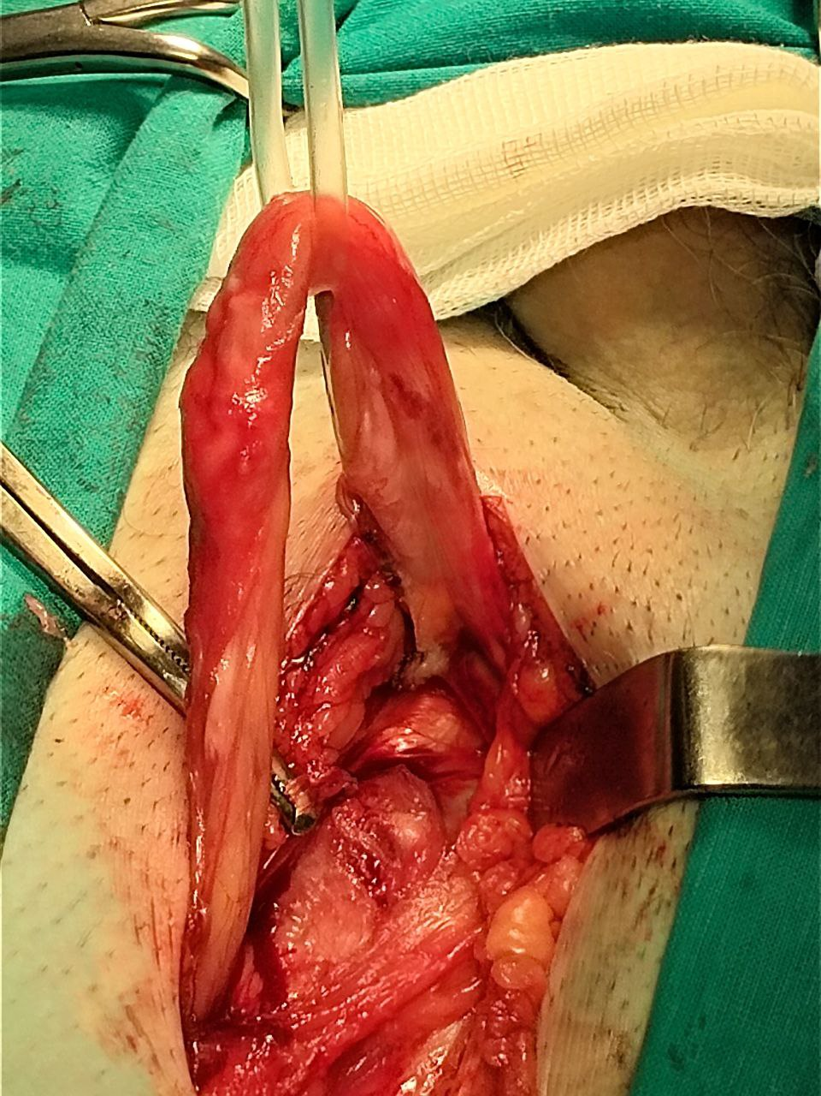

Figure 1. The Spermatic cord was isolated and elevated.

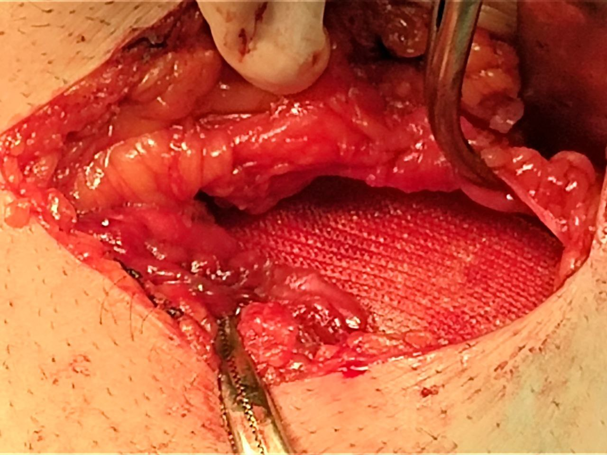

Figure 2. Reconstructing the inguinal canal's posterior wall using a 6x11 cm Parietex™ polypropylene mesh.

Mayo Umbilical Hernioplasty: A distinct 6 cm vertical supra-umbilical incision was made. The hernia sac was identified, dissected free, and reduced. The fascial defect was closed with horizontal mattress sutures. To provide additional reinforcement, a 6x11 cm Parietex™ polypropylene mesh was positioned in an underlay fashion deep to the fascial closure and secured with interrupted sutures. Closure of the subcutaneous tissue and skin completed the procedure.

The total operative time was 80 minutes. Meticulous hemostasis was maintained throughout the dual procedures.

Postoperative Outcome

The patient's immediate postoperative recovery was uncomplicated, with pain adequately managed using oral analgesics. He was discharged on the sixth postoperative day in a stable condition. Follow-up assessments were conducted monthly for the initial six months and biannually thereafter. At the 36-month follow-up, the patient was entirely asymptomatic, with no clinical signs of recurrence, chronic groin pain, or surgical site infection at either location.

Discussion

This report demonstrates that the simultaneous repair of concomitant inguinal and umbilical hernias is a surgically viable and resource-efficient approach. The cumulative operative time of 80 minutes for both procedures underscore a significant reduction in operational burden and patient exposure to a single anesthetic and surgical event.

The successful outcome was facilitated by several key factors. The use of spinal anesthesia was instrumental, providing optimal surgical conditions and profound relaxation while circumventing the polypharmacy and airway-related risks inherent to general anesthesia. This makes it an advantageous option, particularly for patients with significant comorbidities [10]. Furthermore, the application of polypropylene mesh in both locations enabled a tension-free reconstruction. Its well-established profile promotes vigorous fibroblastic proliferation and solid tissue integration, forming the cornerstone for a durable repair with low long-term recurrence, as evidenced by the complication-free 36-month follow-up [5, 6].

A potential criticism of a simultaneous approach is the theoretical increase in infective risk from multiple incisions. However, this was successfully mitigated by maintaining two discrete surgical fields, rigorous aseptic protocol, and standard prophylactic antibiotics. The absence of any surgical site infection in this case confirms that this risk is manageable with meticulous surgical technique.

It is crucial to acknowledge the inherent limitation of this study as a single case report. While the results are promising, they necessitate validation through larger, comparative studies or randomized controlled trials. Future research should aim to definitively establish the superiority of this simultaneous strategy over staged repairs by evaluating long-term recurrence, chronic pain, cost-effectiveness, and patient-reported quality-of-life metrics.

Conclusion
In conclusion, the single-stage, mesh-based repair of concurrent inguinal and umbilical hernias under spinal anesthesia is a validated and highly advantageous approach. It consolidates patient care, offering the triple benefit of a single anesthetic administration, a condensed recovery timeline, and more efficient use of surgical resources. This strategy establishes a new standard for managing such presentations, providing excellent long-term results while aligning with the principles of value-based, patient-focused care.

Consent

Patient’s informed written consent was taken to publish his case for academic purpose.

Ethical approval

As per international standards or university standards written ethical approval has been collected and preserved by the authors.

Disclaimer (Artificial intelligence)

Authors hereby declare that NO generative AI technologies such as Large Language Models (ChatGPT, COPILOT, etc.) and text-to-image generators have been used during the writing or editing of this manuscript.
References
1. Agarwal PK. Study of Demographics, Clinical Profile and Risk Factors of Inguinal Hernia: A Public Health Problem in Elderly Males. Cureus. 2023;15(4): e38053. https://doi.org/10.7759/cureus.38053
2. Sung H, He B, Song Z, et al. Current understanding of abdominal bulge with a novel classification: A retrospective study. Asian Journal of Surgery. Published online March 1, 2025. https://doi.org/10.1016/j.asjsur.2025.01.032
3. Mekhaeel MSF, Protasov AV, Salem SM. A Case Report of a Successful Bilateral Lichtenstein Repair Using Elastic Tacks. Cureus. Published online June 6, 2025. https://doi.org/10.7759/cureus.85475
4. Spector SA, Rosenthal RA. Abdominal Wall Hernia in the Elderly. Springer eBooks. Published online January 1, 2001:662-674. https://doi.org/10.1007/978-1-4757-3432-4_47
5. Mekhaeel M, Kashyzadeh KR, Protasov A, Salem S, Al Tekreeti WK, Mohareb A. AI-Based Evaluation of Polypropylene and Polyester Meshes in Lichtenstein Hernia Repair. Archiv Euromedica. 2025;15(2). https://doi.org/10.35630/2025/15/2.208
6. Wang F, Ma B, Ma Q, Liu X. Global, regional, and national burden of inguinal, femoral, and abdominal hernias: a systematic analysis of prevalence, incidence, deaths, and DALYs with projections to 2030. International journal of surgery. Published online January 23, 2024. https://doi.org/10.1097/js9.0000000000001071
7. Yang XF, Liu JL. Acute incarcerated external abdominal hernia. Annals of translational medicine. 2014;2(11):110. https://doi.org/10.3978/j.issn.2305-5839.2014.11.05
8. Ramos-Morales PE, Alvarez-Lozada LA, Arrambide-Garza FJ, et al. Prevalence of Umbilical Hernias by Computed Tomography. Journal of Surgical Research. 2024; 302:33-39. https://doi.org/10.1016/j.jss.2024.07.014
9. Haskins IN. Hernia Formation. Surgical Clinics of North America. 2023;103(5):835-846. https://doi.org/10.1016/j.suc.2023.04.020
10. Saha T, Wang X, Padhye R, Houshyar S. A review of recent developments of polypropylene surgical mesh for hernia repair. OpenNano. 2022; 7:100046. https://doi.org/10.1016/j.onano.2022.100046
11. Mekhaeel Mekhaeel, Salem S, Andrey Protasov. DEVELOPMENT OF MESH IMPLANTS MATERIALS THROGH HISTORY REGARDING THEIR CHARACTERISTICS. REVIEW STUDY. International Journal of Medical Reviews and Case Reports. 2024;(0):1-1. https://doi.org/10.5455/ijmrcr.172-1718440458
12. Bellón JM, Rodríguez M, García-Honduvilla N, Pascual G, Gómez Gil V, Buján J. Peritoneal Effects of Prosthetic Meshes Used to Repair Abdominal Wall Defects: Monitoring Adhesions by Sequential Laparoscopy. Journal of Laparoendoscopic & Advanced Surgical Techniques. 2007;17(2):160-166. https://doi.org/10.1089/lap.2006.0028
13. A. Protasov, Mekhaeel Shehata Fakhry Mekhaeel, A. Dzhabiev, A. Kulakova, E. Ibragimov. Modern methods of surgical treatment of inguinal hernia. Journal of Modern Science. 2021;25(1)(1):35. https://doi.org/10.37882/2223–2966.2021.08.27
14. A. Protasov, E. Ibragimov, A. Dzhabiev, Mekhaeel Shehata Fakhry Mekhaeel, E. Mirzoev. COMPARATIVE STUDY OF ONLAY AND INLAY METHODS FOR UMBILICAL HERNIAS. Journal of Modern Science. 2020(12):225-227. https://doi.org/10.37882/2223–2966.2020.12.30
15. Protasov, A. V., Mekhaeel, M. S. F., Salem, S. M. A. E., & Persov, M. Y. (2025). HERNIA BETWEEN TOPOGRAPHY AND SURGERY. PEOPLES’ FRIENDSHIP UNIVERSITY OF RUSSIA . January 1, 2025

