Case Report
“NECROTISING SIALOMETAPLASIA OF THE PALATE MIMICKING MALIGNANCY : A REPORT OF TWO CASES AND REVIEW OF DIAGNOSTIC CHALLENGES ”

Abstract:

Necrotizing sialometaplasia (NSM) is an infrequent, benign, and self-limiting inflammatory condition of the salivary glands. Owing to its close clinical and histological resemblance to malignant salivary gland tumors, it often creates significant diagnostic and therapeutic challenges. The hard palate is the most common site, although other regions containing salivary tissue may also be affected. We present two cases of palatal NSM with contrasting presentations and management approaches. In the first case, a 42-year-old man with a submucosal palatal swelling underwent surgical excision following a diagnosis of malignancy on cytology. Histopathology subsequently confirmed NSM. The second case involved a 73-year-old woman with diabetes mellitus who presented with a painful ulcer on the palate; biopsy confirmed NSM, and she was successfully managed with conservative therapy. These cases highlight the importance of recognizing NSM in the differential diagnosis of palatal lesions to prevent unnecessary aggressive interventions.

Keywords :

Necrotizing sialometaplasia ; Palatal ulcer ; Salivary gland pathology ; Benign mimic of malignancy ; Diagnostic pitfall

Introduction :

Necrotizing sialometaplasia (NSM) is an uncommon non-neoplastic inflammatory lesion of the salivary glands, first documented by Abrams and colleagues in 1973 ¹. Although histologically benign, NSM can clinically and microscopically imitate malignant tumors such as squamous cell carcinoma or mucoepidermoid carcinoma ^{2,3} . This close resemblance often leads to misdiagnosis and, consequently, unnecessary radical surgical treatment.

The pathogenesis of NSM is considered ischemic in nature, where vascular compromise leads to coagulative necrosis of salivary gland acini and subsequent squamous metaplasia of ducts⁴ . Contributing factors include local trauma, smoking, alcohol consumption, denture irritation, infections, surgery, radiation, systemic diseases such as diabetes mellitus or sickle cell disease, and immunosuppression ^{5,6}. While approximately 80% of cases occur in the hard palate, lesions have been described in other intraoral and extraoral sites, including the tongue, retromolar region, nasal cavity, larynx, and even extra-salivary tissues such as the lungs and breast ^{7,8}.

Given its potential for clinical misinterpretation as malignancy, awareness of NSM’s diagnostic features is essential for optimal patient management. We report two palatal cases that illustrate the diagnostic dilemma and emphasize the importance of clinicopathological correlation.Case Reports :

Case 1

A 42-year-old male presented with a painless swelling on the hard palate. Clinical examination revealed a 3x3cm, smooth, firm, submucosal lesion without ulceration. Fine-needle aspiration cytology (FNAC) suggested a malignant salivary gland neoplasm. A CT paranasal sinus was done to rule out any bony erosion or defect if present at the base of the swelling. Coronal cuts of CT PNS shows normal bony surface with no evidence of osteolysis (Fig-01) .Based on this preliminary impression, the patient underwent wide local excision with a 1 cm margin. Reconstruction was achieved using a palatal rotation flap based on the greater palatine artery.

Histopathological evaluation of the resected specimen, however, revealed preservation of the lobular architecture, with areas of coagulative necrosis, squamous metaplasia of ducts and acini, and an inflammatory infiltrate predominantly composed of neutrophils. No cytological atypia or evidence of malignant transformation was observed. These findings were diagnostic of necrotizing sialometaplasia. The patient remained disease-free on follow-up.

Case 2

A 73-year-old female with a history of diabetes mellitus presented with severe oral pain, difficulty in mastication and swallowing, and insomnia for two weeks. Intraoral examination revealed an ulcerative lesion measuring about 3x4cm on the left hard palate (Fig-02), and an incisional biopsy confirmed necrotizing sialometaplasia, characterized by pseudoepitheliomatous hyperplasia, squamous metaplasia of ducts, preservation of lobular architecture, mucin extravasation, and associated inflammation. Previous treatment with broad-spectrum antibiotics and antifungals had been ineffective.

She was managed conservatively with strict glycemic control, topical analgesics and anesthetics (choline salicylate and lignocaine), topical steroids (triamcinolone acetonide), topical antibacterial gel (metronidazole), chlorhexidine mouthwash, systemic analgesics (tramadol), and a tapering course of oral prednisolone 40mg over 10 days . The patient experienced significant symptomatic relief, and the lesion completely resolved over the following weeks (Fig-03), demonstrating the self-limiting nature of necrotizing sialometaplasia and highlighting the importance of accurate diagnosis to prevent unnecessary invasive treatment

Discussion :

Necrotizing sialometaplasia, though rare, is a well-recognized mimic of salivary gland malignancy. The condition is considered ischemic in origin, as shown experimentally by Standish and Shafer, who reproduced the lesion in rats by ligating the palatal blood supply ⁴. Anneroth and Hansen described the pathological evolution of NSM in five stages: infarction, sequestration, ulceration, reparative phase, and healing ⁹.

Histologically, Carlson outlined five diagnostic hallmarks¹⁰ :
- pseudoepitheliomatous hyperplasia of the overlying epithelium
- squamous metaplasia of salivary ducts and acini
- preservation of lobular architecture
- coagulative necrosis of lobules with mucin spillage
-secondary inflammatory response.
These features allow differentiation from squamous cell carcinoma or mucoepidermoid carcinoma, which show cellular atypia, invasion, and architectural distortion.

The primary diagnostic challenge arises from the lesion’s ability to present either as a submucosal mass (as in case 1) or as an ulcer (as in case 2). In both scenarios, malignancy is a strong clinical consideration, particularly squamous cell carcinoma. Other differential diagnoses include nicotinic stomatitis, minor salivary gland tumors, and Crohn’s disease involving the oral mucosa ^{12,13}.

Management is usually conservative, NSM is a self-limiting condition, its strong clinical and histological resemblance to malignancy often necessitates biopsy for confirmation. Once diagnosed, the management strategy focuses on symptom relief, elimination of predisposing factors, and prevention of secondary infection. Treatment options can be categorized as follows:

Table 1: Summary of Medical Management of Necrotising Sialometaplasia (NSM)

Management Approach | Interventions | Remarks/Considerations
Conservative / Supportive | • Reassurance and patient education ^{6,11}  • Analgesics and NSAIDs (ibuprofen, diclofenac) ¹¹.  • Antibiotics (only if secondary infection suspected) ¹²  • Topical anesthetic rinses (lidocaine, benzydamine)  • Oral hygiene with chlorhexidine mouthwash¹¹ | First-line approach;  lesion usually resolves spontaneously in 4–10 weeks
Corticosteroid Therapy | • Topical or systemic corticosteroids(short tapering course) ¹² | Reserved for severe pain or extensive lesions;  use cautiously in diabetics due to risk of hyperglycemia ¹³
Adjunctive Therapies | • Photobiomodulation (Low-Level Laser Therapy, LLLT) ¹¹  • Conservative debridement or laser excision (rare cases) | LLLT shown to accelerate healing and reduce pain; surgery only when malignancy cannot be excluded
Systemic Disease Management | • Diabetes control (glycemic monitoring, adjustment of medication, diet/lifestyle modification)¹³  • Address risk factors: smoking, alcohol, denture irritation, local trauma ^{4,11} | Essential for healing and recurrence prevention; coordinate with endocrinologist in diabetic patients

Diabetes mellitus is an important systemic factor influencing the onset, progression, and healing of necrotizing sialometaplasia (NSM). Chronic hyperglycemia induces microvascular alterations that impair tissue perfusion, promote ischemia, and delay wound healing, which are central to the pathogenesis of NSM ^{4,13} . Clinically, diabetic patients with palatal ulcers, such as those observed in NSM, tend to experience more painful and persistent lesions, which are slower to resolve and more prone to secondary infection ^{11,12} .Achieving and maintaining optimal glycemic control is therefore fundamental, not only to ensure resolution of NSM but also to prevent recurrence and support the effectiveness of adjunctive therapies.In the second case described, effective lesion resolution was achieved only after a combination of local therapy and strict diabetes control, emphasizing the pivotal role of systemic disease management in favorable clinical outcomes

The two contrasting cases presented here highlight the importance of accurate diagnosis. In case 1, surgical excision was warranted based on cytology report. In contrast, case 2 was successfully managed with biopsy confirmation, conservative therapy, and systemic control of diabetes. These cases underscore that while NSM is self-limiting, misdiagnosis can expose patients to overtreatment, morbidity, and psychological distress
Based on extensive literature review as mentioned above , this is our proposed management flowchart for NSM , which will guide clinicians for appropriate treatment .
Flow chart 1: Necrotizing Sialometaplasia: Diagnostic and Management Algorithm
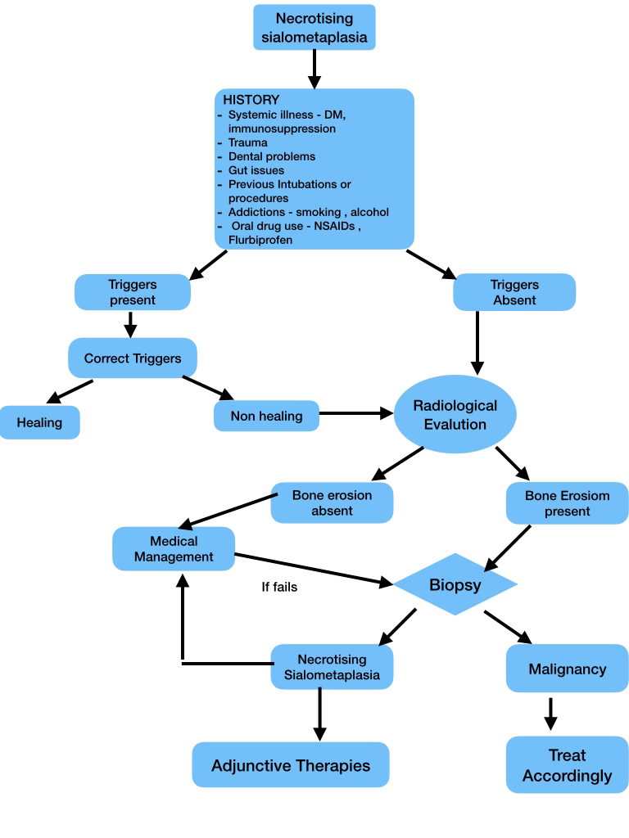

Conclusion :

Necrotizing sialometaplasia is a benign, self-limiting condition that closely simulates malignant salivary gland tumors both clinically and histologically. Biopsy remains the diagnostic gold standard and is essential for avoiding unnecessary radical surgery. Increased awareness among clinicians and pathologists can help prevent overtreatment and reduce morbidity.

Competing Interest:

The Authors declare that there is no conflict of interests regarding the publication of this paper.

References :

1. Abrams AM, Melrose RJ, Howell FV. Necrotizing sialometaplasia. A disease simulating malignancy. Cancer. 1973;32(1):130–135.
2. Seifert G, Donath K. Necrotizing sialometaplasia of the salivary glands: a histological study of 14 cases. J Oral Pathol. 1977;6(2):64–71.
3. Brannon RB, Fowler CB, Hartman KS. Necrotizing sialometaplasia. A clinicopathologic study of sixty-nine cases and review of the literature. Oral Surg Oral Med Oral Pathol. 1991;72(3):317–325.
4. Standish SM, Shafer WG. Experimental production of necrotizing sialometaplasia in the rat. Oral Surg Oral Med Oral Pathol. 1971;31(6):784–790.
5. Anneroth G, Hansen LS. Necrotizing sialometaplasia. The relationship of its pathogenesis to its clinical characteristics. Int J Oral Surg. 1982;11(5):283–291.
6. Neville BW, Damm DD, Allen CM, Chi AC. Oral and Maxillofacial Pathology. 4th ed. Elsevier; 2016.
7. Imbery TA, Edwards PA. Necrotizing sialometaplasia: literature review and case reports. J Am Dent Assoc. 1996;127(7):1087–1092.
8. Jensen JL, Reibel J. Necrotizing sialometaplasia affecting extraoral sites: review of the literature. Oral Surg Oral Med Oral Pathol. 1987;63(5):602–606.
9. Anneroth G, Hansen LS. Necrotizing sialometaplasia: histologic evolution of 31 cases. J Oral Pathol. 1982;11(5):283–291.
10. Carlson DL. Necrotizing sialometaplasia: a practical approach to diagnosis. Arch Pathol Lab Med. 2009;133(5):692–698.
11. Lee T, Wong WL, Li WY, Ng SH. Necrotizing sialometaplasia of the palate mimicking carcinoma: a report of 2 cases. Hong Kong Med J. 2007;13(5):394–397
12. Kaplan I, Anavi Y, Hirshberg A. Necrotizing sialometaplasia: a clinicopathologic study of 46 cases and review of the literature. Oral Surg Oral Med Oral Pathol Oral Radiol Endod. 2005;99(5):620–628
13. American Diabetes Association. Standards of Medical Care in Diabetes—2023. Diabetes Care. 2023;46(Suppl. 1):S1–S300

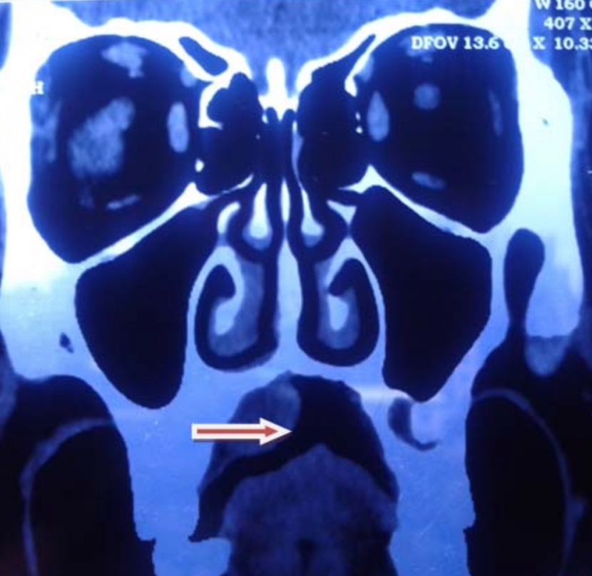
Fig-01- CT PNS of Case 01, showing lesion over right side of palate without any bony erosion.

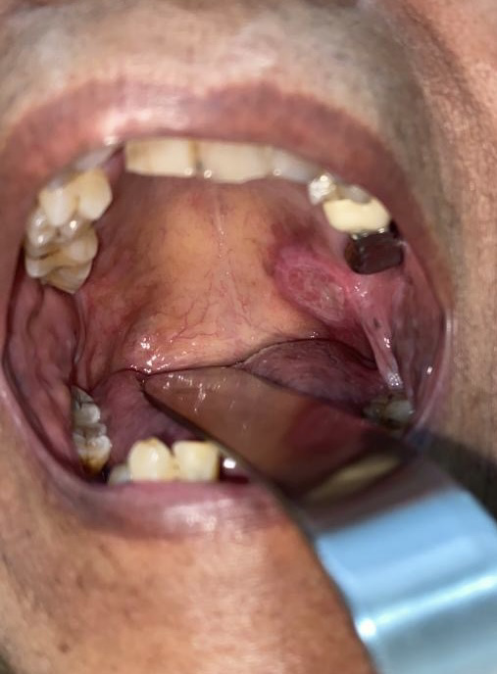
Fig-02 - Case -02, Ulcerative lesion over left side of palate.
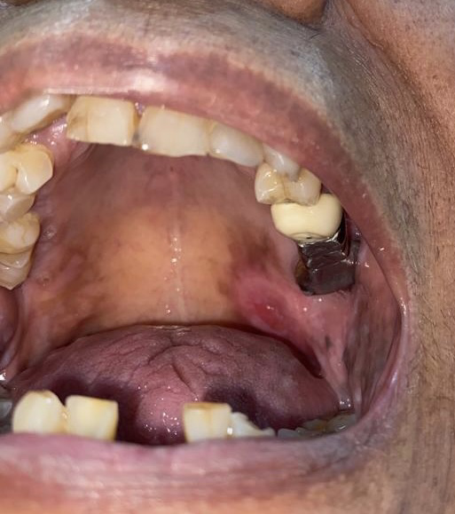

Fig-03 - Case 02- Lesion resolves post medical treatment

