Case report

Primary Mesenteric Leiomyosarcoma Presenting as a Migrating Intra‑Abdominal Mass: Case Report and Comprehensive Literature Review

Abstract
Aim: To report a rare case of primary mesenteric leiomyosarcoma presenting as a migrating intra‑abdominal mass and review contemporary literature on its diagnosis and management.
Presentation of Case: A 74‑year‑old male presented with a painless, mobile abdominal swelling. Contrast‑enhanced computed tomography (CECT) revealed a heterogeneously enhancing soft tissue lesion in the anterior pararenal space. Exploratory laparotomy revealed a 15 × 15 cm mass in the jejunal mesentery, 80 cm from the duodenojejunal flexure. The lesion was resected en bloc with a 40 cm segment of jejunum, followed by end‑to‑end anastomosis. Histopathology and immunohistochemistry confirmed leiomyosarcoma (SMA+, H‑Caldesmon+, CD117−). A small hepatic nodule showed metastatic deposits. Postoperative PET‑CT demonstrated no residual disease, and adjuvant chemotherapy was initiated.
Discussion: Primary mesenteric leiomyosarcoma is an exceedingly uncommon tumour arising from smooth‑muscle elements of the mesenteric vessels. Because of the expansile nature of the mesentery, tumours often remain clinically silent until large, resulting in delayed diagnosis. Imaging, histopathology, and immunohistochemistry are essential for diagnosis, and surgical excision with negative margins remains the cornerstone of treatment. Adjuvant therapy may improve control in high‑risk cases.
Conclusion: Mesenteric leiomyosarcoma poses a diagnostic and therapeutic challenge due to its rarity and aggressive behaviour. Early recognition, complete resection, and long‑term surveillance are crucial for improving patient outcomes.
Keywords: Mesenteric leiomyosarcoma, Smooth muscle tumour, Jejunal mesentery, Case report, Abdominal mass, Rare malignancy

1. Introduction
Leiomyosarcoma (LMS) is a malignant neoplasm arising from smooth muscle cells and accounts for approximately 10–20% of all soft tissue sarcomas. While common primary sites include the uterus, retroperitoneum, large blood vessels, and gastrointestinal tract, primary mesenteric LMS remains exceedingly rare. Mesenteric LMS represents a diagnostic challenge because it lacks specific clinical features and often attains a considerable size before detection. Fewer than 80 cases have been described in the literature, with most presenting as large abdominal masses that mimic other intra‑abdominal pathologies such as gastrointestinal stromal tumour (GIST), liposarcoma, or desmoid tumours. The mesentery’s expansile capacity allows these tumours to grow silently until they reach a significant size or cause compression symptoms (Koufopoulos et al., 2022; Ahmed et al., 2020). Histologically, LMS demonstrates fascicles of spindle‑shaped cells with eosinophilic cytoplasm, pleomorphic nuclei, and varying degrees of mitotic activity. Immunohistochemistry (IHC) remains essential in differentiating LMS from morphologically similar entities such as GIST, as LMS is typically positive for smooth muscle actin (SMA), desmin, and h‑caldesmon, and negative for CD117 and DOG1. Here we report a case of primary mesenteric LMS in a 74‑year‑old man and review the recent literature regarding diagnostic approaches, pathogenesis, treatment modalities, and prognostic outcomes.

2. Case Presentation
A 74‑year‑old male presented with a slowly enlarging, painless abdominal swelling for one year, without weight loss, vomiting, or bowel disturbances. His medical history included systemic hypertension controlled with regular medication. On physical examination, a firm, mobile, non‑tender intra‑abdominal mass measuring approximately 7.5 × 7 cm was palpable in the left lumbar and iliac regions. There was no organomegaly or ascites. Routine laboratory investigations were within normal limits.
CECT abdomen revealed a well‑circumscribed, heterogeneously enhancing soft‑tissue lesion (7.2 × 9.3 cm) located in the anterior pararenal space, displacing adjacent bowel loops. Exploratory laparotomy identified a large 15 × 15 cm lobulated tumour arising from the jejunal mesentery, 80 cm distal to the duodenojejunal flexure. The lesion was resected en bloc with approximately 40 cm of jejunum, and primary end‑to‑end anastomosis was performed. In addition, a small (0.5 cm) subcapsular hepatic nodule was excised. The postoperative recovery was uneventful.
Histopathological analysis revealed spindle‑shaped tumour cells with elongated nuclei, eosinophilic cytoplasm, nuclear atypia, and frequent mitoses (10/10 HPF). Areas of necrosis and haemorrhage were present. Resection margins were free of tumour. The liver nodule demonstrated metastatic deposits with similar morphology. Immunohistochemistry was positive for SMA and h‑caldesmon and negative for CD117 and DOG1, confirming leiomyosarcoma. Postoperative PET‑CT showed no residual disease. The patient was started on adjuvant chemotherapy with doxorubicin and ifosfamide and remains under follow‑up at 12 months with no evidence of recurrence.

3. Discussion
Primary mesenteric leiomyosarcoma (LMS) is an exceedingly rare malignancy derived from the smooth muscle cells of the mesenteric vessels or the muscularis propria of the mesentery. It accounts for less than 1% of all soft tissue sarcomas and represents a minute fraction of intra-abdominal mesenchymal tumours. Fewer than 80 well-documented cases have been reported worldwide, with the majority occurring in adults between the fifth and seventh decades of life and showing no clear sex predilection (Affas et al., 2020; Koufopoulos et al., 2022). Because of the mesentery’s expansile and mobile nature, tumours can enlarge substantially before producing symptoms, leading to delayed clinical detection. Reported incidences vary, but population-based extrapolations suggest a frequency of roughly 1 in 350,000 individuals (Singh et al., 2021).
Clinical presentation and radiology:
Most patients present with a gradually enlarging, painless abdominal mass or nonspecific symptoms such as abdominal fullness, altered bowel habits, or weight loss. Pain and intestinal obstruction are uncommon initial manifestations, and gastrointestinal bleeding is rare. Because the mesentery allows considerable space for expansion, even large lesions may remain asymptomatic until they compress adjacent organs or vascular structures. Imaging plays a pivotal role in delineating the lesion and evaluating resectability. On contrast-enhanced CT, mesenteric LMS appears as a large, lobulated, heterogeneously enhancing mass, often with areas of central necrosis, cystic degeneration, or haemorrhage. MRI provides superior soft-tissue contrast, demonstrating heterogeneous T2 hyperintensity and early arterial enhancement with washout. Features that favor LMS over GIST include the absence of exophytic bowel growth, lack of continuity with the bowel wall, and infiltrative margins rather than a discrete submucosal mass (Dalal et al., 2017). PET-CT may help identify distant metastases, particularly in the liver and lungs, and evaluate treatment response.
Differential diagnosis:
Radiologically and histologically, primary mesenteric LMS must be distinguished from other spindle-cell neoplasms, including gastrointestinal stromal tumour (GIST), desmoid-type fibromatosis, fibrosarcoma, and metastatic spindle-cell carcinoma. GIST, the most common mimicker, typically expresses CD117 (c-KIT) and DOG1, whereas LMS is negative for these markers. Desmoid tumours show nuclear β-catenin positivity and lack malignant cytologic features. Fibrosarcoma and malignant peripheral nerve sheath tumours (MPNST) may overlap morphologically but differ immunophenotypically, lacking SMA and desmin expression.
Pathogenesis and molecular profile:
Molecular studies indicate that LMSs exhibit complex chromosomal rearrangements and copy-number alterations rather than specific translocations seen in other sarcomas. Inactivation of tumour suppressor genes RB1, PTEN, and TP53 has been implicated in tumorigenesis (Koufopoulos et al., 2022). RB1 loss disrupts cell-cycle control at the G1–S checkpoint, PTEN deletion leads to unchecked PI3K/AKT pathway activation, and TP53 mutations promote genomic instability. High-throughput sequencing has identified frequent alterations in ATRX, MYOCD, and MED12 in extra-uterine LMS, suggesting potential therapeutic targets (Mäkinen et al., 2022). Epigenetic dysregulation through DNA hypermethylation and aberrant microRNA expression also appears to contribute to LMS pathobiology.
Histopathology and immunohistochemistry:
Macroscopically, mesenteric LMSs are typically large, well-circumscribed yet unencapsulated masses with areas of necrosis and haemorrhage. Microscopically, they are composed of intersecting fascicles of spindle-shaped cells with blunt (“cigar-shaped”) nuclei and eosinophilic cytoplasm. Mitoses exceeding 10 per 10 high-power fields, nuclear pleomorphism, and tumour necrosis signify a high-grade lesion and correlate with aggressive behavior and poor prognosis. Immunohistochemically, LMS demonstrates strong positivity for smooth muscle actin (SMA), desmin, and h-caldesmon, confirming smooth-muscle differentiation. The absence of CD117, CD34, and DOG1 helps exclude GIST. The immunophenotype observed in the present case (SMA +, h-caldesmon +, CD117 −) was fully consistent with a classic LMS.
Management:
Radical surgical excision with negative (R0) margins remains the cornerstone of management and offers the only potential cure. Because of proximity to mesenteric vessels and small bowel loops, complete resection can be technically demanding. En bloc resection of the involved bowel segment and adjacent structures is often necessary to ensure oncologically safe margins. Intraoperative frozen-section analysis can guide margin adequacy.
For high-grade tumours, large lesions, or those with metastasis, adjuvant chemotherapy is commonly employed. Standard first-line therapy includes doxorubicin alone or in combination with ifosfamide. Alternative regimens such as gemcitabine–docetaxel or trabectedin have demonstrated activity in recurrent or refractory cases (Deshmukh et al., 2021; Italiano et al., 2022). Pazopanib, a multi-target tyrosine kinase inhibitor, has shown benefit in metastatic soft-tissue sarcomas and may be considered in unresectable mesenteric LMS, though specific evidence is limited. Recently, immunotherapeutic strategies targeting PD-1/PD-L1 pathways have shown modest benefit in soft-tissue sarcomas, but further trials are needed to define their role in LMS (Toulmonde et al., 2023).
Radiotherapy is generally reserved for cases with close or positive margins, or when re-resection is not feasible. The small-bowel radiosensitivity often limits its application, but modern intensity-modulated radiation therapy (IMRT) allows for better organ sparing. Palliative radiotherapy can be considered for symptomatic control of unresectable or metastatic disease.
Follow-up and prognosis:
Despite advances in multimodal therapy, the prognosis for mesenteric LMS remains guarded. Reported five-year survival rates range between 20–30%, reflecting a high rate of local recurrence and distant metastasis (Varghese et al., 2016). Recurrences typically occur within two years of surgery, emphasizing the need for vigilant postoperative surveillance. Follow-up protocols generally recommend CT or MRI of the abdomen and pelvis every 3–6 months for the first two years and annually thereafter. Factors associated with poor prognosis include large tumour size (>10 cm), high mitotic index, tumour necrosis, vascular invasion, positive margins, and presence of hepatic or pulmonary metastasis at diagnosis.
Recent case compilations (Ahmed et al., 2020; Singh et al., 2021; Deshmukh et al., 2021; Koufopoulos et al., 2022) confirm that tumour size and margin status are the most reliable predictors of survival. Interestingly, isolated reports describe long-term survival exceeding five years following complete resection and adjuvant chemotherapy, even in cases with limited metastases, suggesting that aggressive surgical management can be justified in selected patients.
Our experience and implications:
In the present case, the tumour measured 15 cm and displayed metastatic spread to the liver. Despite these adverse prognostic features, the patient achieved disease-free survival at one year following R0 resection and adjuvant doxorubicin-based chemotherapy. This favorable short-term outcome underscores the value of prompt surgical intervention and highlights the importance of individualized, multidisciplinary care involving surgeons, medical oncologists, radiologists, and pathologists.
From a clinical perspective, primary mesenteric LMS should be considered in the differential diagnosis of large, mobile intra-abdominal masses that are radiologically separate from bowel loops and show no GIST markers on IHC. With the increasing accessibility of molecular diagnostics, future research may identify actionable mutations enabling targeted therapy.
In summary, primary mesenteric leiomyosarcoma represents one of the rarest and most challenging abdominal malignancies. Its insidious onset, diagnostic ambiguity, and aggressive nature necessitate high clinical suspicion, meticulous pathologic confirmation, and radical surgical excision. The integration of adjuvant systemic therapy and diligent follow-up remains essential to optimize long-term survival outcomes.

4. Conclusion
Primary mesenteric leiomyosarcoma is an extremely rare and aggressive malignancy that often presents late due to non‑specific symptoms. Diagnosis requires correlation between imaging and histopathology with immunohistochemistry for confirmation. Surgical resection with negative margins offers the best chance for cure. Adjuvant chemotherapy may be indicated in high‑grade or metastatic disease. Given the propensity for recurrence and metastasis, long‑term surveillance with serial imaging is essential. This case emphasises the importance of maintaining a high index of suspicion for mesenteric tumours and the role of a multidisciplinary team in achieving optimal outcomes.

Patient Consent
Written informed consent was obtained from the patient for publication of this case report and accompanying images.

References
1. Ahmed M, Babar J, Khan H, et al. Leiomyosarcoma of ileal mesentery in a middle‑age female: a rare case report. Egypt J Radiol Nucl Med. 2020;51:243.
2. Singh V, Aggarwal L, Hazrah P, et al. Pleomorphic leiomyosarcoma of colonic mesentery: an unusual cause of lower GI bleed – case report and literature review. Int Surg J. 2021;8(2):754‑756.
3. Deshmukh SP, Jain M, Chharchhodawala T. Mesenteric leiomyosarcoma in a pregnant woman: a case report and review of literature. Indian J Cancer. 2021;58(2):267‑272.
4. Affas S, Ayas MF, Mendes JM, Hadid T. Primary leiomyosarcoma of the mesentery: case report and review of literature. Cureus. 2020;12(10):e10777.
5. Koufopoulos N, et al. DOG1‑positive primary mesenteric leiomyosarcoma: report of a case and review of the literature. Appl Immunohistochem Mol Morphol. 2022.
6. Varghese M, Bruland O, Wiedswang AM, et al. Metastatic mesenteric dedifferentiated leiomyosarcoma: a case report and literature review. Clin Sarcoma Res. 2016;6:2.
7. Dalal V, Kaur M, Menia R, Siraj F, Bhatnagar A, Agrawal U. Primary leiomyosarcoma of the mesentery: A case report. Iran J Med Sci. 2017;42(5):505‑508.
8. Fletcher CDM, Bridge JA, Hogendoorn PCW, Mertens F, eds. WHO Classification of Tumours of Soft Tissue and Bone. 5th ed. Lyon: IARC Press; 2020.

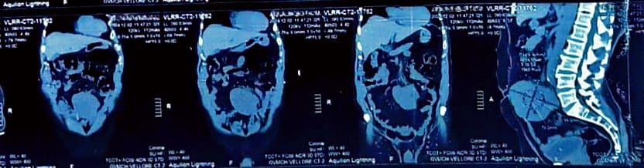
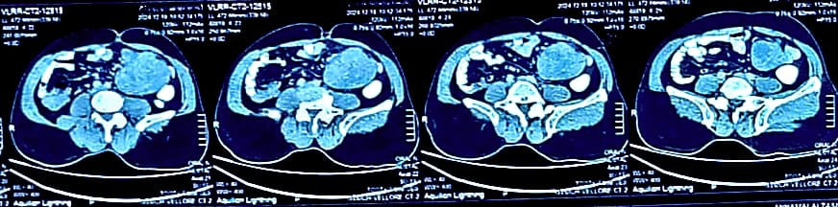
Fig 1: CONTRAST ENHANCED CT ABDOMEN

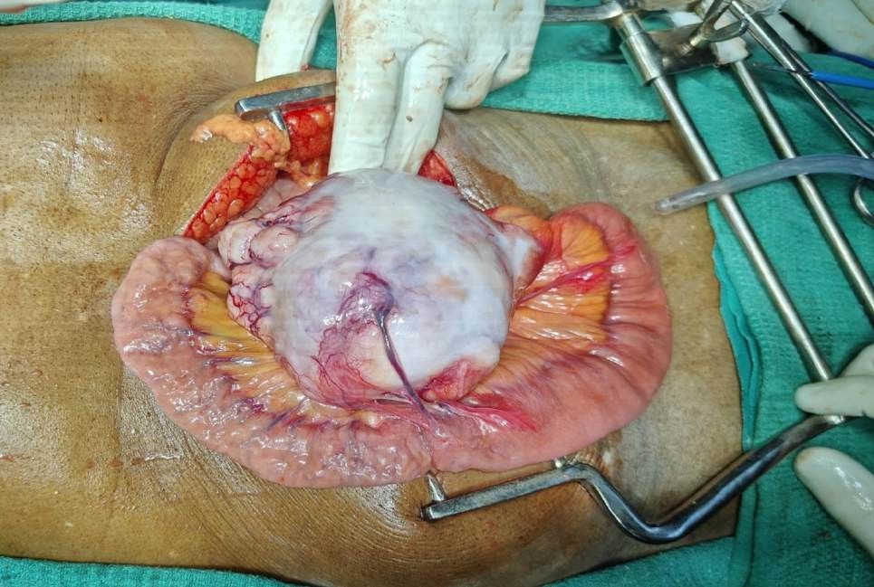
Fig 2: INTRA-OPERATIVE FINDING

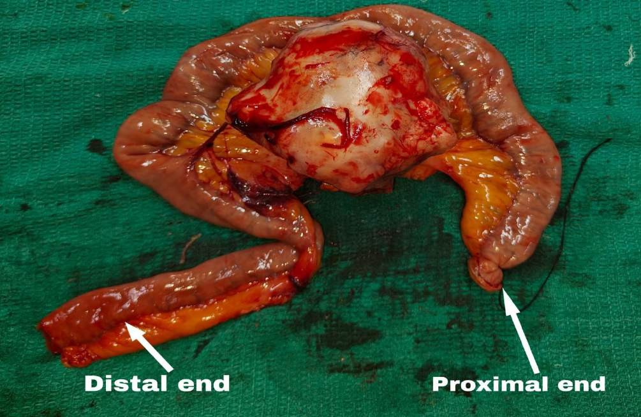
Fig 3: SPECIMEN
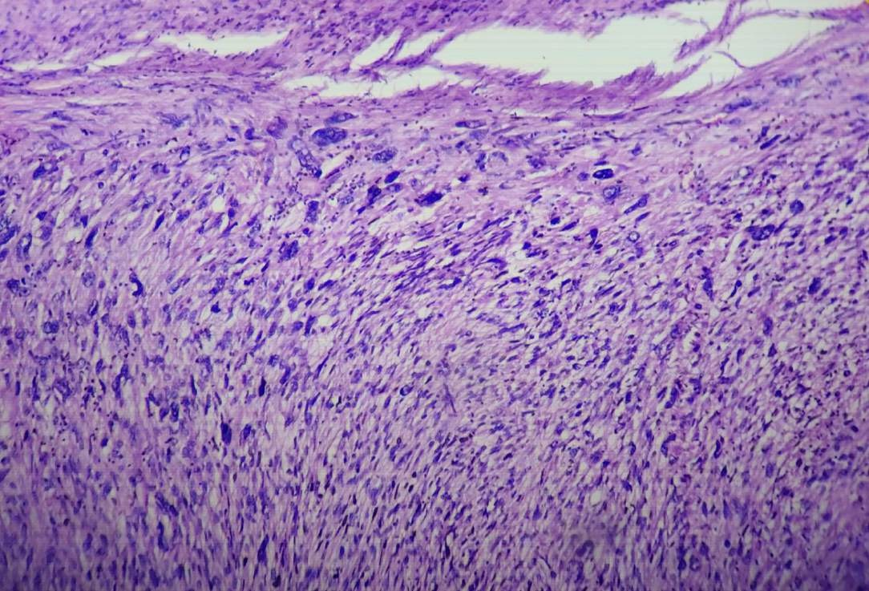
Fig 4: HISTOPATHOLOGY AND IMMUNOHISTOCHEMISTRY
[Diagnosis: Leiomyosarcoma; SMA: Positive; H-caldesmon: Positive; Ki-67 index: 11%; CD117: Negative; Liver nodule: Metastatic deposit]
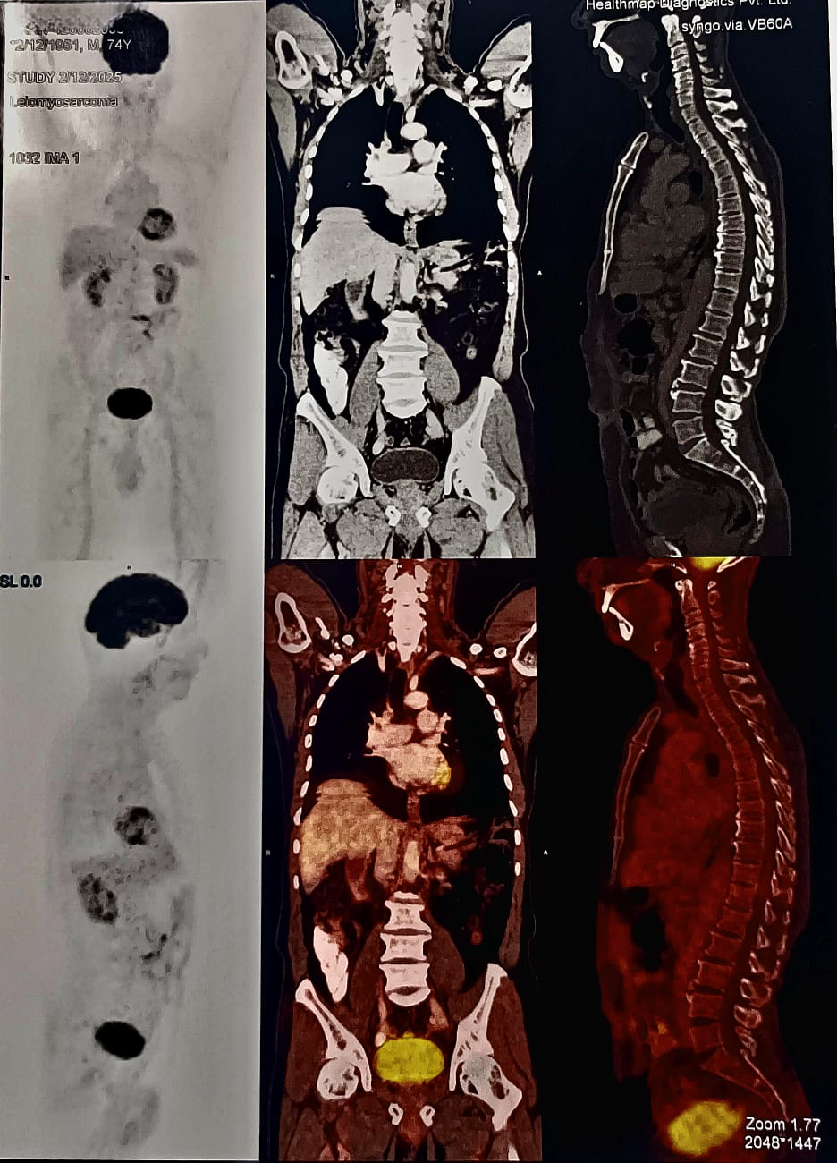

Fig 5 : Post Operative Findings
[PET-CT revealed no residual disease. The patient has completed adjuvant chemotherapy and remains under follow-up]

