Case report
Hypokalemic periodic paralysis secondary to distal renal tubular acidosis in a middle-aged diabetic female with Sjögren’s syndrome

.
ABSTRACT
Hypokalemia periodic paralysis (HPP) in this patient presented as episodes of muscle weakness along with low serum potassium levels. In this case, the condition is linked to be secondary to an underlying renal abnormality. We report a case of a 54-year-old diabetic woman who presented with a sudden onset of weakness in both lower limbs, difficulty lifting her neck and legs, giddiness, dry mouth, dry eyes, poor appetite, constipation, and vomiting. Blood tests revealed severe hypokalemia, non-anion gap metabolic acidosis and alkaline urine, indicating dRTA. The ECG showed first-degree AV block with ST-T changes. Despite potassium supplementation, her potassium levels remained low, suggesting renal potassium loss. The combination of metabolic acidosis and sicca symptoms supported a diagnosis of distal renal tubular acidosis, possibly associated with Sjögren’s syndrome. This case showed an association between persistent hypokalaemia, neuromuscular weakness, and sicca symptoms, which pointed toward an underlying autoimmune-related renal disorder.

Keywords: Hypokalemia, Periodic Paralysis, Sjögren’s Syndrome, Distal Renal Tubular Acidosis.

1. INTRODUCTION

Hypokalemia periodic paralysis (HPP) is an uncommon neuromuscular disorder characterised by brief episodes of skeletal muscle weakness in severe cases, which can cause respiratory arrest and even death. The changes in serum potassium levels determine muscle weakness, which can be either primary or secondary. Most primary causes are genetic with an autosomal dominant inheritance pattern. Secondary causes(acquired) may be linked to loss of potassium from the kidneys [1].Distal Renal Tubular Acidosis (dRTA), being the secondary cause of HPP, is defined as the failure of the kidneys to acidify the urine when the glomerular filtration rate is normal. It can be characterised by normal anion gap, hyperchloremic metabolic acidosis and decreased hydrogen levels. Type 1 and Type 2 are the manifestations of Hypokalemia. Whereas RTA Type 4 is the manifestation of Hyperkalaemia [2]. Sjögren’s syndrome is an autoimmune disorder characterised by sicca symptoms and manifested by extra-glandular involvement, including type 1 dRTA leading to severe loss of serum potassium levels, thereby resulting in Hypokalemia Periodic Paralysis [3,4]
Here we report a 54-year-old Female Diabetic patient with HPP who presented to the emergency department with Muscle weakness, sicca and was subsequently diagnosed with DRTA (type 1) and manifested the features of Sjogren’s syndrome.

2. Presentation of Case

A 54-year-old woman presented to the emergency department at PESU Institute of Medical Sciences and Research with acute onset of weakness in both lower limbs, inability to lift her neck and legs, giddiness, symptoms of sicca (dry mouth and dry eyes), loss of appetite, constipation (bowel movements once a week) for the past week, and a single episode of vomiting since yesterday. There was no history of fever, diarrhea, recent illness, or drug ingestion. She had a remote history of epilepsy (last episode six years ago) and was a known case of Type 2 Diabetes Mellitus (HbA1c 6.1%) for four years, currently off medication for 2-3 days. The patient had no alcohol or smoking use.
On examination, her vital signs were: blood pressure of 130/90 mmHg, pulse of 82 bpm, temperature of 98.8◦C, breathing of 27/minute and SpO2 96% (on O2). Ocular examination revealed dry eyes. Muscle power was (3/5) in both lower limbs, 4/5 on the upper limb, affecting both proximal and distal groups of muscles.
The laboratory results are summarized in Table 1.

Table 1.Laboratory results

Test Type | Patient Value | Units | Reference Range | Comments
ABG pH | 7.34 | – | 7.35 (low)– 7.45(high) | Low
pCO₂ | 33 | mmHg | 32 – 48 | Low
HCO₃ | 8.90 | mmol/L | 22 – 26 | Low
Base Excess | -8 | mmol/L | -2 to +2 | Low
Potassium (ABG) | 1.2 | mmol/L | 3.5 – 5.1 | Critically Low
Calcium (ABG) | 1.32 | mmol/L | 1.12 – 1.32 | Low-Normal
Hemoglobin | 11.7 | g/dL | 12 – 15 | Slightly Low
PCV | 38.6 | % | 36 – 46 | Normal
WBC Count | 16,500 | /mm³ | 4,000 – 10,000 | High
GRBS (RBS) | 248 | mg/dL | 140 – 180 (post-meal) | High
Platelets | 349,000 | /mm³ | 150,000 – 450,000 | Normal
Serum Creatinine | 1.02 | mg/dL | 0.45 –0.75 | Borderline
Urea | 31 | mg/dL | 15– 40 | Normal
Serum Potassium | 1.5 | mmol/L | 3.5 – 5.1 | Critically Low
Serum Sodium | 135 | mmol/L | 135 – 145 | Normal
Serum Chloride | 116 | mmol/L | 98 – 107 | High
Urine pH | 7 | - | 5.0-9.0 (<5.5 in acidosis) | High → dRTA
Urine Sodium | 113 | mmol/L | 15-237 | Normal
Urine Potassium | 32.1 | mmol/L | 22-164 | Normal range—but inappropriate loss in hypokalaemia
Urine Chloride | 134 | mmol/L | 18-209 | Normal/High

Liver, Thyroid levels, and viral serology (HBV, HCV, HIV) were unremarkable. The electrocardiogram (ECG) showed first-degree AV block and ST-T abnormalities, are presented in (Figure 1) suggesting hypokalemia. ECG changes were consistent with severe hypokalemia.

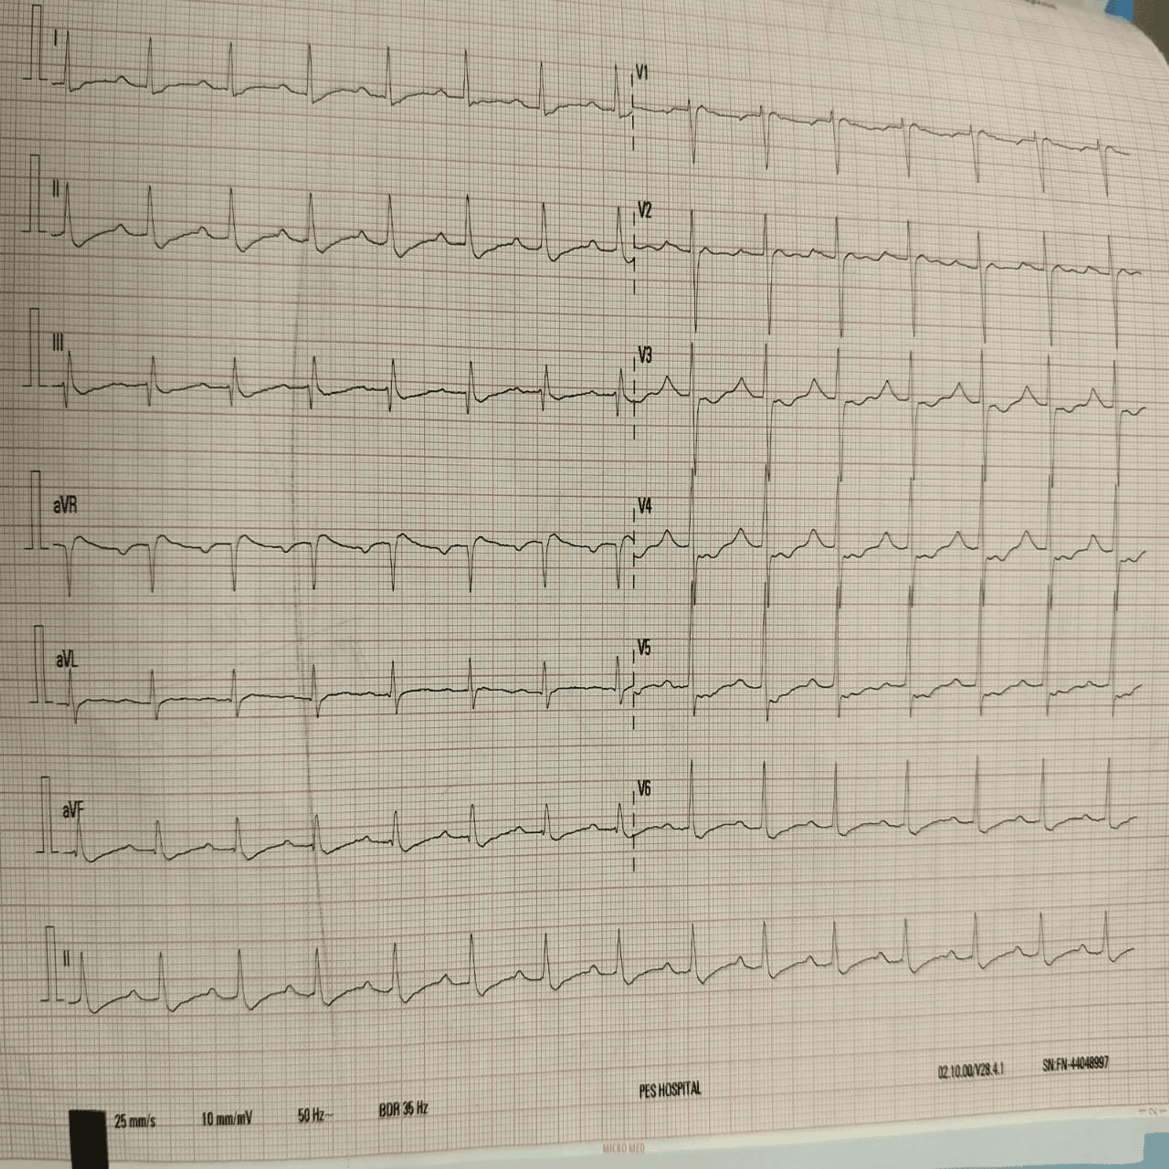

Fig. 1. ECG suggestive of 1st-degree AV block with ST-T wave abnormality.

Based on non-anion gap metabolic acidosis with alkaline urine and hypokalemia, a diagnosis of hypokalemia periodic paralysis with a secondary cause of dRTA associated with metabolic acidosis was made. Persistent hypokalemia with metabolic acidosis in a diabetic female with sicca symptoms is an unusual presentation, indicating secondary distal renal tubular acidosis (dRTA) linked to Sjögren’s syndrome. This unusual combination of metabolic and autoimmune features contributes to the unique character of the case.
She was treated with intravenous potassium chloride infusion (KCL), Injection of magnesium sulphate, and sodium bicarbonate oral tablet. During follow up the patient, despite aggressive potassium replacement, marked hypokalemia persisted over several days (1.5, 2.2, 2.3, 3.1, 3.0, 3.3, 3.4mmol/L), indicating renal potassium wasting. The patient was managed with the initial treatment of parenteral infusion of potassium chloride and oral supplementation of sodium bicarbonate. It was observed that clinical findings were marginally improved. The patient was discharged on oral potassium supplementation, multivitamins, moxifloxacin and a lubricating eye drop and oral hypoglycemic agents, with advice for follow-up in medicine and ophthalmology OPDs.

3. DISCUSSION

Hypokalemia paralysis may rarely result from distal renal tubular acidosis (dRTA), particularly when it occurs secondary to autoimmune conditions like Sjögren’s syndrome [5]. In this case, the presence of persistent hypokalemia along with non-anion gap metabolic acidosis and alkaline urine indicates a defect in distal tubular acid secretion [6]. The coexistence of sicca symptoms (dry eyes and dry mouth) with a positive Schirmer test provided strong clinical evidence of an autoimmune process, most likely Sjögren’s syndrome. The urine potassium of 32 mmol/L confirmed ongoing renal potassium wasting and the absence of gastrointestinal potassium losses, supporting a diagnosis of secondary distal renal tubular acidosis (dRTA), most probably due to autoimmune origin related to Sjögren’s syndrome, clinically suspected. However, immunological confirmation with anti-SSA and anti-SSB antibodies was not performed due to financial constraints; however, the clinical findings were strongly suggestive of autoimmune dRTA [5, 7]
Hypokalemia periodic paralysis typically results from an intracellular potassium shift (e.g., familial HPP, thyrotoxic HPP). In contrast, in dRTA, hypokalemia arises from renal potassium wasting due to defective hydrogen ion secretion, resulting in metabolic acidosis and compensatory renal potassium loss [8]. This mechanism explains the persistence of hypokalemia despite adequate potassium replacement therapy.
In this patient, persistent hypokalemia primarily presented with neuromuscular weakness with ECG alterations of first-degree AV block and ST-T changes reflecting cardiac effects of severe hypokalemia [9]. The slow and incomplete correction of hypokalemia despite adequate supplementation indicated an underlying tubular defect rather than a simple potassium deficit. Early diagnosis of autoimmune-related renal tubular acidosis is essential to prevent complications and guide therapy for long-term management.
Treatment primarily focused on intravenous potassium chloride infusion to correct hypokalemia, oral sodium bicarbonate to correct metabolic acidosis. MgSO₄ infusion was administered to help stabilize potassium levels and allow more effective potassium repletion, as intracellular magnesium deficiency can contribute to refractory hypokalemia [7]. Initial management of Sjögren’s dry eye disease involves the use of ocular lubricants [10]. The patient was prescribed ocular lubricants (Lubrex and Meferon eye drops) to relieve sicca symptoms, a hallmark feature of Sjögren’s syndrome.
This report highlights the importance of evaluating secondary causes of hypokalemia paralysis, especially in middle aged female patient with sicca manifestations, combination of autoimmune dRTA, hypokalemia-induced paralysis, diabetes mellitus and ECG alterations contributes to making this case both rare and educationally significant.

4. Conclusion

The case emphasizes the importance of identifying secondary causes of hypokalaemia paralysis. The coexistence of persistent hypokalaemia, non-anion gap metabolic acidosis, and sicca symptoms pointed toward dRTA associated with Sjogren’s syndrome. Early diagnosis and management of electrolyte disturbances are essential to prevent recurrence and long-term complications.

Consent

Written informed consent for publication of their clinical details and/or clinical images was obtained from the patient

DISCLAIMER (ARTIFICIAL INTELLIGENCE)
Author(s) hereby declare that any use of ai assistance was limited to language editing and authors retain full responsibility for the accuracy and integrity of the manuscript.
Abbreviations
HPP-hypokalaemia periodic paralysis
dRTA-distal renal tubular acidosis
ECG-electrocardiogram

References

- Amaranath L, StatPearls. Hypokalemic Periodic Paralysis [Internet]. Treasure Island (FL): StatPearls Publishing; 2025 [cited 2025 Nov 10]. Available from: https://share.google/MR6n2vSKhfOBKdtKI. https://www.ncbi.nlm.nih.gov/books/NBK559178/.
- Venance SL, Cannon SC, Fialho D, et al.: The primary periodic paralyses: diagnosis, pathogenesis and treatment. Brain. 2006, 129:8-17. 10.1093/brain/awh639
- Kishor A, Rejy AM, John C, Lakshmi R, Reji K: Primary Sjögren’s syndrome unveiling type 1 renal tubular acidosis: a rare case report of hypokalemic periodic paralysis from a developing country. Int J Med Pharm Case Rep. 2025, 18:48-52. 10.9734/ijmpcr/2025/v18i2421
- Mondal R, Aheteshamuddin M, Kumar P, Rohith A: Primary Sjogren’s Syndrome Presenting as Life-Threatening Hypokalemic Paralysis: A Diagnostic Challenge. Int J Pharm Sci. 2025, 3:1281-1284. 10.5281/zenodo.14878541
- Sedhain A, Acharya K, Sharma A, Khan A, Adhikari S. Renal Tubular Acidosis and Hypokalemic Paralysis as a First Presentation of Primary Sjögren's Syndrome. Case Rep Nephrol. 2018:9847826. 10.1155/2018/9847826
- Vallés PG, Batlle D: Hypokalemic Distal Renal Tubular Acidosis. Adv Chronic Kidney Dis. 2018, 25:303-320. 10.1053/j.ackd.2018.05.003
- Giglio S, Montini G, Trepiccione F, Gambaro G, Emma F: Distal renal tubular acidosis: a systematic approach from diagnosis to treatment. J Nephrol. 2021, 34:2073-2083. 10.1007/s40620-021-01032-y
- Soleimani M, Rastegar A: Pathophysiology of renal tubular acidosis: Core curriculum 2016. Am J Kidney Dis. 2016, 68:488-498. 10.1053/j.ajkd.2016.03.422 PubMed +1
- Wang X, Han D, Li G: Electrocardiographic manifestations in severe hypokalemia. J Int Med Res. 2020, 48:300060518811058. 10.1177/0300060518811058
- Wu KY, Chen WT, Chu-Bédard YK, Patel G, Tran SD: Management of Sjogren's Dry Eye Disease—Advances in Ocular Drug Delivery Offering a New Hope. Pharmaceutics. 2022, 15:147. 10.3390/pharmaceutics15010147

