Case report

Cecal Volvulus: A Case Report

Abstract
Introduction: Cecal volvulus, defined as torsion of the cecum, terminal ileum, and ascending colon around their mesenteric axis, is a rare but serious cause of acute intestinal obstruction. Because symptoms are often nonspecific, diagnosis may be delayed. Abdominal CT scan has become the key diagnostic tool, and surgery remains the treatment of choice.
Case report: We report the case of a 59-year-old man with type 2 diabetes and a history of cholecystectomy, admitted for abdominal pain evolving over 24 hours, associated with vomiting, cessation of stool and gas passage, and mild rectal bleeding. The CT scan revealed a distended cecum with the characteristic whirl sign. Surgical exploration found an organo-axial cecal volvulus with two clockwise twists, without evidence of bowel ischemia. A right ileo-hemicolectomy with manual ileocolic anastomosis was performed. Postoperative recovery was uneventful, and the patient was discharged in good condition.
Conclusion: Early diagnosis using CT scan and prompt surgical management are crucial. Right ileo-hemicolectomy provides definitive treatment, preventing recurrence and complications.
Keywords: cecal volvulus, acute intestinal obstruction, abdominal CT scan, right ileo-hemicolectomy, digestive surgery

Introduction
Cecal volvulus refers to the torsion of the cecum, terminal ileum, and ascending colon around their mesenteric axis, leading to acute colonic obstruction. Although rare (1–3% of mechanical obstructions and up to 40% of colonic volvulus cases), it can quickly become life-threatening if diagnosis is delayed [1].
Clinical presentation is nonspecific: abdominal pain, distension, nausea, vomiting, and constipation. This lack of specificity often delays diagnosis, increasing the risk of ischemia or perforation. Abdominal CT scan is the gold standard, allowing visualization of cecal distension, the characteristic “whirl sign”, and assessment of bowel viability [2–4].
Surgical treatment is required. Cecopexy or cecostomy carry a high risk of recurrence, whereas right ileo-hemicolectomy with primary anastomosis provides a definitive solution [5].

Case Report
A 59-year-old man with type 2 diabetes and a history of right subcostal cholecystectomy presented with diffuse abdominal pain evolving for 24 hours. The pain was associated with vomiting, cessation of stool and gas passage, and mild rectal bleeding.
On admission, he was conscious and hemodynamically and respiratorily stable (BP 130/70 mmHg, HR 86 bpm, RR 18/min, T° 36.7°C). Abdominal examination revealed diffuse tympanic distension without guarding or palpable mass.

Imaging
Abdominal CT scan showed:
- Distension of the transverse colon (76 mm),
- Thickening of the left colon (7 mm),
- Pelvic and right parietocolic peritoneal effusion,
- No evidence of pneumatosis or pneumoperitoneum.
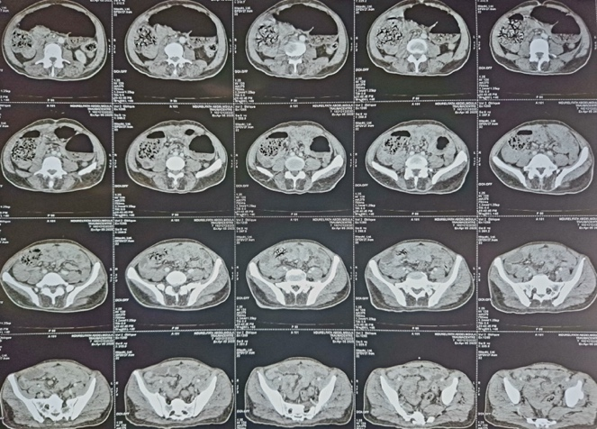
Figure 1: Abdominal CT scan showing cecal distension and the characteristic whirl sign.

Operative Findings and Procedure
A midline laparotomy was performed. Surgical exploration revealed an organo-axial cecal volvulus with two clockwise twists, without bowel ischemia, purulent effusion, or associated lesions.
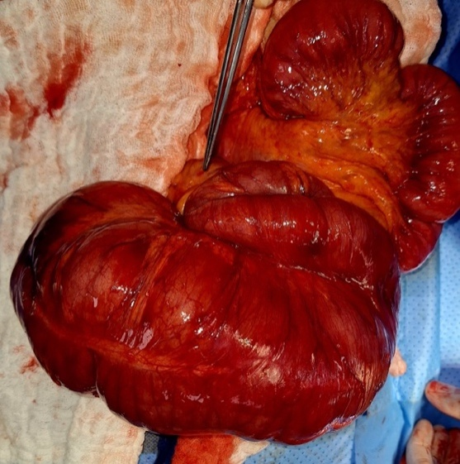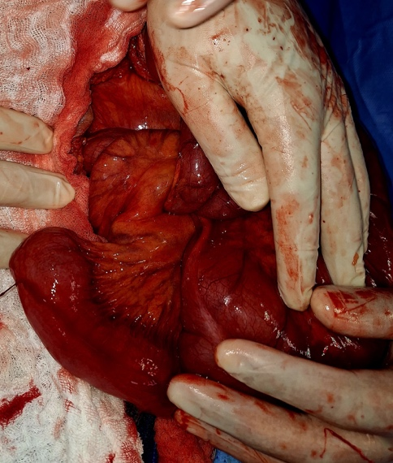
Figure 2: Intraoperative view of the organo-axial cecal volvulus.
The procedure consisted of:
- Right ileo-hemicolectomy with vascular control,
- Manual end-to-side ileocolic anastomosis,
- Peritoneal lavage,
- Drainage of the Douglas pouch and retro-anastomotic area.
Histopathological examination showed:
- Edematous and congestive changes of the colonic mucosa secondary to volvulus,
- No signs of malignancy or specific lesions,
- Appendix with fibrous obliteration.
Postoperative recovery was uneventful, with resumption of oral intake on day 4 and discharge on day 7.

Discussion
Cecal volvulus is rare but potentially severe due to the risk of ischemia and perforation, especially since its clinical presentation is nonspecific, often delaying diagnosis [2,3].
It results from torsion of the right colon around its mesenteric axis, possible only if the proximal colon is mobile. Excessive cecal mobility is due to incomplete embryologic intestinal rotation or a failure of the ascending colon to fuse with the posterior parietal peritoneum [7,8].
Two main types of cecal volvulus are described:
- Rotation of the colon around its axis, with the cecum remaining in the lower right abdominal quadrant,
- Cecal bascule with rotation, placing the cecum in the upper left quadrant [6,9,10].
Diagnosis is difficult due to variable pain intensity and nonspecific signs [8]. It usually presents as an acute or subacute intestinal obstruction. Plain abdominal X-ray can be useful but has low sensitivity [6]. CT scan is highly effective for diagnosis and for identifying complications such as ischemia or perforation [9].
Colonoscopy may demonstrate the volvulus and associated ischemic colonic wall changes [11,12]. Endoscopic detorsion may be attempted in the absence of severe ischemia but carries a significant risk of perforation [13].
Treatment aims to relieve obstruction (by detorsion when feasible), manage complications, and prevent recurrence [14].
Right hemicolectomy with primary anastomosis is recommended by several teams even in the absence of colonic necrosis, as it eliminates the risk of recurrence [15,16]. Cecostomy, though effective in preventing recurrence, has a high risk of wound infection and fistula formation requiring later closure. Infectious complications are less frequent with cecopexy, but recurrence rates are higher [15].
A laparoscopic approach [17] is rarely used in emergency settings due to cecal distension and difficult exposure. It may be feasible after successful endoscopic detorsion and decompression.
This case highlights the importance of prompt radiologic diagnosis and appropriate surgical management to prevent complications and recurrence.

Conclusion
Cecal volvulus should always be considered in the differential diagnosis of acute colonic obstruction. Abdominal CT scan plays a central role in diagnosis and surgical planning. Right ileo-hemicolectomy remains the treatment of choice, providing definitive management and minimizing the risk of recurrence.

Références
- Consorti ET, Liu TH. Diagnosis and treatment of cecal volvulus. Postgrad Med J. 2005;81:772–776.
- Madiba TE, Thomson SR. The management of cecal volvulus. Dis Colon Rectum. 2002;45:264–267.
- Ballantyne GH, et al. Volvulus of the cecum: incidence and management. Am J Surg. 1985;149:603–606.
- Rosenblat JM, et al. CT imaging in cecal volvulus: the whirl sign and bowel viability. Radiographics. 2000;20:849–857.
- Rabinovici R, Simansky DA, Kaplan O, et al. Cecal volvulus: diagnosis and management. Dis Colon Rectum. 1990;33:765–769.
- Pirró N, Merad A, Sielezneff I, Sastre B, Di Marino V. Volvulus du cæcum, bases anatomiques et physiopathologie: à propos de 8 cas consécutifs. Morphologie. 2006; 90(1): 197- 20. PubMed | Google Scholar
- Berger JA, Leersum MV, Plaisier PW. Cecal volvulus: Case report and overview of the literature. European Journal of Radiology Extra. 2005; 55(4): 101-103. PubMed | Google Scholar
- O'Mara CS, Wilson TH Jr Stonesifer GL, Stonesifer GL, Cameron JL. Cecal volvulus: analysis of 50 patients with long-term follow-up. Ann Surg. 1979; 189(6): 724- 731. PubMed | Google Scholar
- Moore CJ, Corl FM, Fishman EK. CT of caecal volvulus: unravelling the image. AJR Am J Roentgenol. 2001; 177(1): 95-98. PubMed | Google Scholar
- Perret RS, Kunberger LE. Case 4: Caecal volvulus. AJR Am J Roentgenol. 1998 Sep; 171(3): 855-60.PubMed | Google scholar.
- Montes H,Wolf J. Caecal volvulus in pregnancy. American Journal of Roentgenology. 2001; 177(1): 95-
- PubMed | Google Scholar 9. Neil DA, Reasbeck PG, Reasbeck JC, Effeney DJ. Cecal volvulus: ten years experience in an australian teaching hospital. Ann R Coll Surg Engl. 1987; 69(2): 283- 285. PubMed | Google Scholar
- Friedman JD, Odland MD, Burbrick MP. Experience with colonic volvulus. Dis Colon Rectum. 1989; 32(1): 409- 416. PubMed | Google Scholar
- Breda R, Mathieu L, Mlynski A, Montagliani L, Duverger V. Volvulus du cæcum. J Chir (Paris). 2006; 143(1): 330- 2. PubMed | Google Scholar
- 12. Sedik A, Bar EA, Ismail M. Caecal volvulus: Case report and review of literature. Saudi Surg J. 2015; 3(2): 47- 9. PubMed | Google Scholar Google Scholar
- Meyers JR, Heifetz CJ, Baue Æ. Caecal volvulus: a lesion requiring resection . Arch Surg. 1972; 104(6): 594- 599. PubMed | Google Scholar 16. Rabinovici R, Simasky DA, Kaplan O, Mavor E, Manny J. Caecal volvulus . Dis Colon Rectum. 1990 sep; 33(9): 765- 769. PubMed | Google Scholar
- Shoop SA, Sackier JM. Laparoscopic caecopexy for caecal volvulus: case report and a review of the literature. Sure Endosc. 1993Sep-Oct; 7(5): 450-454. PubMed | Google Scholar

