RETROGRADATION OF SORGHUM STARCH: AN INVESTIGATION INTO THE EFFECTS OF ALCOHOL AND WATER

Abstract
This study investigates the retrogradation behavior of sorghum starch (Sorghum bicolor) under the influence of alcohol and water, examining its physicochemical properties, extraction processes, and practical applications. Starch was extracted using a modifiedmethod, involving steeping sorghum grains in NaOH, grinding, filtering, centrifugation, and drying, with preliminary tests confirming the presence of carbohydrates such as amylose and amylopectin. Physicochemical analyses revealed that alcohol-treated starch exhibited increased structural compaction, reduced water sorption, and delayed amylose crystallization, while water-treated starch demonstrated enhanced compressibility, amylopectin reorganization, and hydration capacity. Alcohol disrupted hydrogen bonding within starch matrices, reducing retrogradation, while water facilitated molecular mobility, promoting branched-chain alignment. The findings highlight solvent-specific effects on bulk density, tapped density, hydration, swelling, and porosity, which have significant implications for food, pharmaceutical, and industrial applications. These results emphasize the potential to optimize sorghum starch properties for improved product stability, texture, and shelf life. The study concludes that understanding the distinct effects of alcohol and water on sorghum starch retrogradation can drive innovative applications and recommends optimizing solvent use for targeted industrial purposes, fostering further research into starch-solvent interactions and their practical implications.
Keywords: Sorghum starch, retrogradation, alcohol, water, amylose, amylopectin, physicochemical properties, starch extraction, industrial applications.
Introduction
Starch, a carbohydrate polymer of glucose, is one of the most abundant biopolymers in nature and serves as a crucial energy source for humans. Its diverse functionality has made starch a cornerstone in food science, pharmaceuticals, and industrial applications. Among the different types of starches derived from cereal crops, sorghum starch holds a unique position due to its availability and potential applications, especially in regions where sorghum is a dietary staple. Sorghum (Sorghum bicolor), a drought-tolerant cereal, is widely cultivated in Africa, Asia, and parts of the Americas. Its starch is characterized by unique physicochemical properties, including relatively high amylose content and smaller granule size, which influence its behavior during processing and storage (Apriyanto et al., 2022).
A critical phenomenon in starch science is retrogradation the recrystallization of gelatinized starch molecules, primarily amylose and amylopectin, upon cooling. Retrogradation significantly affects the texture, shelf life, and nutritional quality of starch-based products. It manifests as an increase in firmness or gel formation, accompanied by phenomena like syneresis (water expulsion). These changes can be advantageous in some applications, such as gel formation in jellies, but detrimental in others, such as the staling of bread (Zhou et al., 2021). The mechanisms of retrogradation are influenced by various intrinsic and extrinsic factors, including the starch source, amylose-to-amylopectin ratio, and environmental conditions such as temperature and moisture content (Ngo, 2022).
Water plays a pivotal role in the retrogradation process. During gelatinization, water disrupts the crystalline structure of starch granules, allowing them to swell and dissolve. Upon cooling, water facilitates the molecular reassociation of amylose and amylopectin chains, leading to crystallization and gel formation. The degree of retrogradation depends on the availability of water, with higher water content generally promoting more extensive recrystallization (Zhu et al., 2018). Conversely, alcohol, a nonpolar solvent, can alter the behavior of starch during retrogradation. Alcohol reduces the availability of water for starch hydration and disrupts the interactions between starch molecules, potentially inhibiting the formation of ordered crystalline structures (Ding et al., 2021). This interaction suggests that alcohol may have applications in modulating the textural properties and stability of starch-based systems.
Sorghum starch, owing to its unique composition, exhibits retrogradation behavior that differs from that of starches derived from other cereals like maize, wheat, and rice. Studies have indicated that the higher amylose content in sorghum starch contributes to a greater propensity for retrogradation, impacting the quality of sorghum-based products such as porridges, noodles, and bakery items (Adjetey, 2024). However, the specific effects of alcohol and water on the retrogradation of sorghum starch remain underexplored. Understanding these effects is crucial for optimizing the use of sorghum starch in food formulations and extending the shelf life of sorghum-based products. This study seeks to address this knowledge gap by investigating the influence of alcohol and water on the retrogradation process of sorghum starch.
Aims of this Study
The broad objective of this study is to assess the impact of alcohol and water on the retrogradation process of sorghum starch.
LITERATURE REVIEW
Mechanisms and Factors Influencing Starch Retrogradation
Retrogradation is primarily driven by the reassociation of amylose and amylopectin molecules upon cooling of gelatinized starch. Amylose, being linear, tends to form more rigid and stable crystalline structures, whereas amylopectin, with its branched structure, forms less organized and slower-recrystallizing regions (Zhou et al., 2021). Factors such as temperature, storage conditions, and moisture content significantly influence retrogradation rates and extents (Gunaratne, 2023). For instance, low temperatures promote rapid retrogradation by facilitating the alignment of starch molecules, while higher moisture content enhances molecular mobility, leading to more pronounced crystallization (Zhu et al., 2018). Understanding these mechanisms is essential for manipulating retrogradation to improve food product quality.
Role of Water in Starch Retrogradation
Water is a critical component in starch retrogradation, acting as both a plasticizer and a medium for molecular mobility. During gelatinization, water disrupts the native crystalline structure of starch granules, enabling them to swell and gelatinize. Upon cooling, the availability of water facilitates the molecular reassociation of starch chains into ordered crystalline regions (Nawaz et al., 2023). However, excessive water can lead to undesirable effects, such as syneresis, where water is expelled from the gel matrix over time (Zhao et al, 2024). Studies suggest that the control of water activity and content is key to managing the retrogradation process and achieving desired textural properties in starch-based systems.
Impact of Alcohol on Starch Retrogradation
Alcohol has been shown to alter the retrogradation behavior of starch by reducing water availability and interfering with starch-starch interactions (Allan et al., 2022). Alcohol molecules can replace water within the starch matrix, disrupting hydrogen bonding and inhibiting the formation of crystalline regions. This effect is particularly useful in applications where reduced retrogradation is desired, such as in frozen or alcoholic food products. Moreover, the type and concentration of alcohol used can differentially impact the retrogradation process. For example, ethanol has been demonstrated to delay retrogradation, whereas higher concentrations may completely inhibit crystallization (Zhou et al., 2021). Understanding these dynamics is vital for developing innovative formulations leveraging alcohol-starch interactions.
MATERIALS AND METHODS
Sample collection and Identification
The sample was purchase from Sokoto market and were spotout by Dr H. A Gwandu, Head Department of Crop Science, UDUS of the faculty of Agricultural Science. The plant is locally called Dawa and well known in northern Nigeria and is an annual crop. In the local market people both young and adult make use of the crop to prepare local drinks known as Burukutu. The plant is white, it can also be used to produce locally made food known as Luwo.
Extraction of starch Method
Starch was extracted by using the method of Shingh et al., (2009) with some modification. Sorghum grain (100g) was steep in 200ml of NaoH (0.25% W/V) for 24hrs, the steep sorghum was decanted, wash severally to eliminated, the NaoH and equal volume of water where the use to size reduce (grind) the sorghum. The slurry was filtered using calico filter, the filtrate was separated from the residue, the residue was wash severally. After rinsing, the residue was discarded. The filtrate was then allowed to stand for about 24hrs. The filtrate was centrifuge at 4500rpm for 10min, after centrifuge, the content was decanted, the grey top protein rich layer was remove using spatula. The starch was then place in an oven for about 48hrs at a temperature of 45⁰C.
Results
Starch Modification and Retrogradation
This was achieved by weighing of 20 g of the starch powder into 5 different beakers label as PGS (0,1,2,4, and 8). For the PGS 800m of water was added to the powder to make a suspension and was then immersed into a water bath set as a temperature of 90 °C with continuous stirring, was then transferred into an ice bath for 10 mins, also with continuous stirring after which it was poured into a clean tray and this was dryed in an oven at 50 'c to obtained day 0, while the remaining days, 1,2,4 and 8 was kept in a fridge before pouring it into a tray at what temperature. Regarding the retrograded starch, 400 ml of water was used for the pasting process after which another 400 ml of ethanol was added and stirred uniformly. This was transferred into an ice bath for 10 mins with continuous stirring after which it was taking to the fridge to stay at low temperature for specific period. At the end (of the specific period) the sample was removed and the supernatant liquid was decanted while the sediment was also poured onto a clean tray and dried to obtained alcoholic bath.
Table 1: Preliminary lest of sorghum starch.
Test | Observation | Inference
Molish lest  0.lg of dried mucilage  + Molish reagent H₂S0₄ | Violet green colour was observed at the junction of two layer formed | Carbohydrate was present
Iodine test  0.1g of diced starch  Mucilage + Iodine solution | A blue black  Ppt was formed | Starch was present
The size of the retrogradation starch of 400 resolution was observed to be bigger compare to that of native starch of same resolution. The preliminary tests conducted on sorghum starch confirm the presence of key carbohydrate components and the characteristic properties of starch. The Molisch test yielded a violet-green color at the junction of two layers, indicating the presence of carbohydrates. This result aligns with the general biochemical property of polysaccharides to react positively in Molisch tests. Similarly, the iodine test resulted in the formation of a blue-black precipitate, a hallmark indication of starch presence due to the interaction between iodine and the helical structure of amylose. These findings validate the composition of the sorghum starch sample, providing a foundational basis for further investigations into its retrogradation behavior and interactions with solvents like water and alcohol.

Table 2: Physicochemical Property of Sorghum Bicolor
S/N | Parameter | Retro +OH (0hrs)) | Retro +OH (24hrs) | Retro +OH (48hrs) | Retro +OH (96hrs) | Retro +OH (192hrs) | Retro +H₂0 (0hrs) | Retro +H₂0 (24hrs) | Retro +H₂0 (48hrs) | Retro +H₂0 (96hrs) | Retro +H₂0 (192hrs)
1. | Bulk Density | 0.5092 | 0.6350 | 0.6690 | 0.6412 | 0.6314 | 0.6918 | 0.590 | 0.6318 | 0.6994 | 0.6514
2. | Tapped Density | 0.787 | 0.8906 | 0.9144 | 0.8946 | 0.9008 | 0.9290 | 0.9014 | 0.8906 | 0.9028 | 0.8882
3. | SD of Bulk Density | 0.0470 | 0.0221 | 0.0140 | 0.0104 | 0.0128 | 0.0283 | 0.0292 | 0.0222 | 0.0288 | 0.0140
4. | SD of Tapped Density | 0.0530 | 0.1685 | 0.0447 | 0.0342 | 0.0637 | 0.0070 | 0.0467 | 0.0601 | 0.0584 | 0.0451
5. | Water sorption capacity | 0.2629 | 0.2935 | 0.3815 | 0.2469 | 0.1069 | 0.0378 | 0.0306 | 0.1028 | 0.0212 | 0.3206
6. | True Density | 1.2300 | 1.2935 | 0.8409 | 0.8428 | 0.8153 | 0.7810 | 0.7873 | 0.8067 | 0.8232 | 0.8130
7. | Amylose Fraction | 53.7336 | 48.5316 | 50.9796 | 53.6724 | 35.3124 | 20.7468 | 23.0724 | 28.2132 | 40.5144 | 12.3552
8. | Amylopectin Fraction | 46.2664 | 51.4604 | 49.0204 | 46.3276 | 64.6876 | 79.2532 | 76.9276 | 71.7868 | 59.4856 | 87.6448
9. | Hydration capacity | 1.3595 | 1.4316 | 1.5726 | 1.5762 | 1.5768 | 1.6725 | 1.3663 | 1.3201 | 1.4048 | 1.4132
10. | Swelling capacity | 79.99 | 80.0 | 80.00 | 79.99 | 80.00 | 80.35 | 71.98 | 70.44 | 69.88 | 72.77
11. | Hausner ratio | 1.55 | 1.43 | 1.37 | 1.39 | 1.42 | 1.34 | 1.36 | 1.37 | 1.41 | 1.41
12. | Percent Porosity | 35.3 | 28.7 | 23.6 | 26.8 | 26.0 | 25.5 | 35.5 | 29.1 | 22.5 | 26.7
13. | Compressibility index (Carr index) | 14.0 | 17.8 | 18.3 | 17.8 | 20.0 | 18.4 | 24.7 | 18.2 | 12.8 | 15.5

The physicochemical properties of sorghum starch under retrogradation with alcohol (+OH) and water (+H₂O) exhibit distinct patterns over the analyzed time intervals. Bulk density increases significantly during initial retrogradation, particularly in alcohol, but stabilizes at later stages, indicating structural compaction. Tapped density follows a similar trend, with consistently higher values in water-treated samples, suggesting greater compressibility and reduced particle interaction compared to alcohol-treated starch. Standard deviations for bulk and tapped density indicate greater variability during early retrogradation in alcohol, reflecting transitional phase changes.
Water sorption capacity peaks at 48 hours for alcohol-treated samples, showcasing the ability of retrograded starch to interact with moisture, but diminishes over extended periods. True density values fluctuate, with notable reductions in alcohol at 192 hours, signifying potential molecular rearrangements or void formation. Amylose and amylopectin fractions reveal a critical dynamic: alcohol initially preserves amylose content, while water enhances amylopectin levels over time, demonstrating differential solvent effects on starch molecular fractions. Hydration and swelling capacities remain relatively stable, though alcohol-treated samples exhibit slightly higher hydration.
Hausner ratio and compressibility index variations indicate improved flowability and packing properties over time, with water-treated starch presenting better overall compaction. Percent porosity reductions reflect densification during retrogradation, especially pronounced in alcohol-treated samples. Overall, the data illustrate how alcohol and water distinctly modulate the structural and functional attributes of sorghum starch during retrogradation, underscoring solvent-specific impacts on physicochemical behavior.

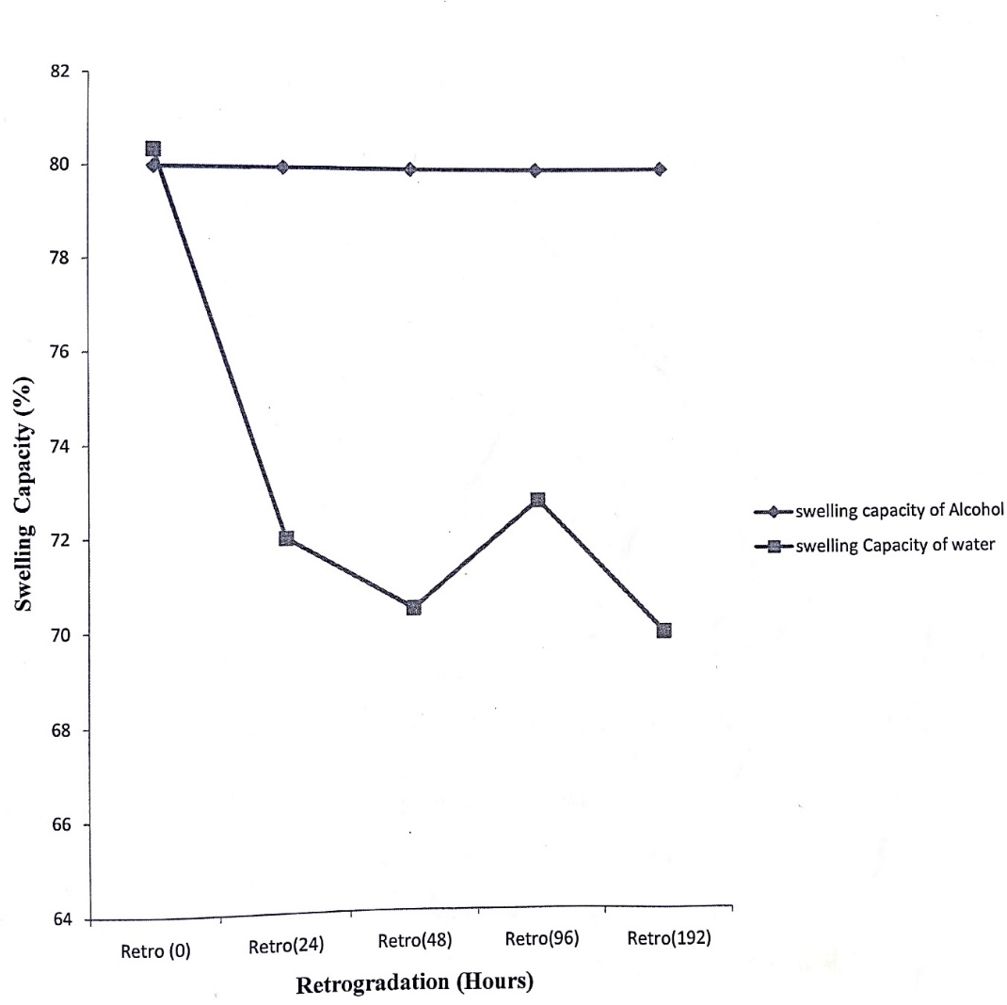
Fig. 1: Graph of % swelling capacity against retrogradation (hrs)
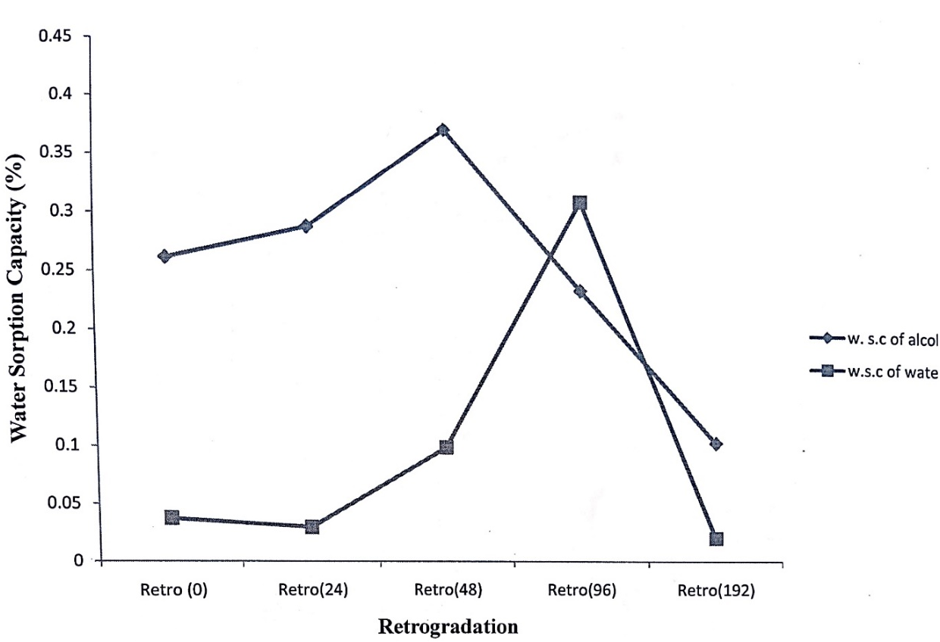
Fig. 2: Graph of % Water Sorption capacity against retrogradation (hrs)
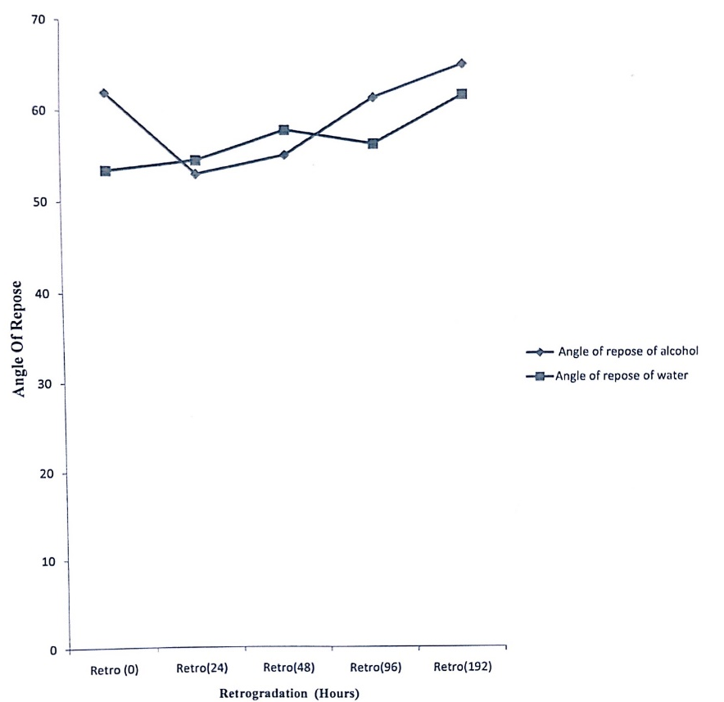
Fig. 3: Graph of Angle of Repose against retrogradation (hrs)

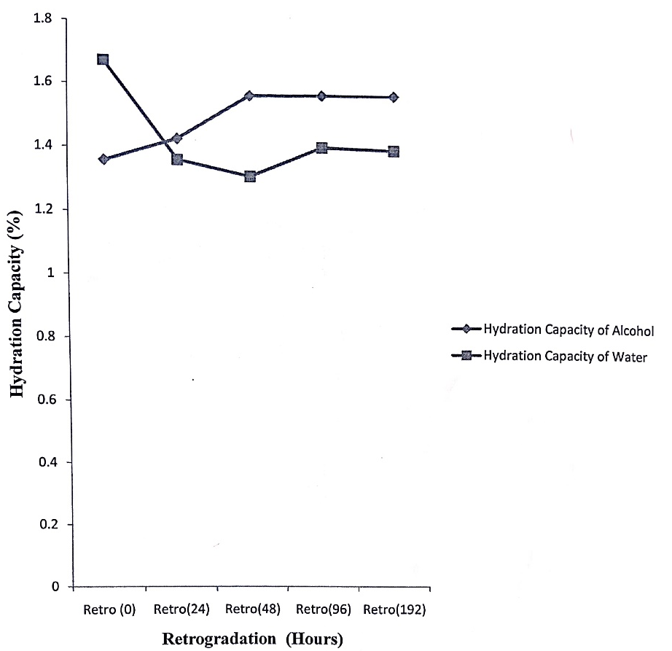
Fig. 4: Graph of Hydration capacity against retrogradation (hrs)

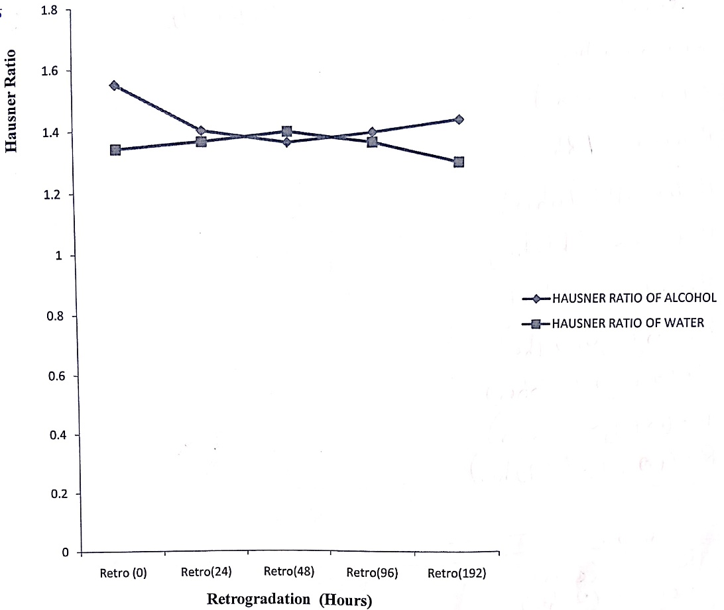
FIG 5.
Graph of Hausner ratio against retrogradation (hrs)

Discussion of Findings
The study's findings on the retrogradation behavior of sorghum starch under the influence of alcohol and water are consistent with established literature on starch retrogradation mechanisms. Bulk density values increased initially during retrogradation with both solvents, particularly in alcohol-treated samples, suggesting greater structural compaction. This observation aligns with Gunaratne (2023), who reported that solvent interactions influence the packing of starch molecules during retrogradation. However, water-treated samples exhibited higher tapped density, indicating enhanced compressibility, which may result from the more uniform distribution of starch granules in water-rich systems.
Water sorption capacity peaked at 48 hours in alcohol-treated samples before declining over time, reflecting the transient interaction between alcohol and starch molecules. Allan & Mauer (2022) highlighted that alcohol disrupts hydrogen bonding in starch matrices, leading to temporary increases in water-binding capacity. Conversely, true density fluctuated in both treatments, with significant reductions in alcohol-treated samples at 192 hours, indicative of void formation and structural rearrangement, corroborating the findings of Ding & Yang (2021) on solvent-mediated starch transformations.
Amylose and amylopectin fractions showed solvent-specific trends. Alcohol preserved amylose content during early retrogradation stages, consistent with Liu et al. (2020), who demonstrated that alcohol inhibits amylose recrystallization. Water, on the other hand, enhanced amylopectin content over time, supporting Nawaz et al. (2023), who emphasized water's role in promoting branched-chain reorganization. The hydration capacity and swelling behavior exhibited relative stability, with alcohol-treated samples slightly outperforming their water-treated counterparts, suggesting that alcohol modulates starch hydration properties without significantly disrupting its gel matrix.
Variations in Hausner ratio and compressibility index underscored improved flow ability and packing efficiency over time, particularly in water-treated samples. Percent porosity reductions were more pronounced in alcohol-treated starch, reflecting densification effects reported by Zhao et al. (2024). These findings collectively demonstrate the distinctive impacts of alcohol and water on sorghum starch retrogradation, providing insights into solvent-specific modulation of starch properties.
Conclusion
This study examined the retrogradation behavior of sorghum starch under the influence of alcohol and water, focusing on the physicochemical properties over time. The findings reveal that alcohol and water distinctly modulate the structural and functional attributes of sorghum starch, with alcohol influencing amylose preservation and structural compaction, while water promotes amylopectin reorganization and compressibility. These solvent-specific effects highlight the potential for tailoring sorghum starch properties for diverse industrial and food applications. The research underscores the critical roles of amylose and amylopectin dynamics, hydration capacity, and structural changes in understanding starch retrogradation. By demonstrating how alcohol can modulate retrogradation, this study provides a foundation for innovations in the formulation of starch-based products with extended shelf life and improved textural properties. Future research should explore the molecular mechanisms underlying these solvent interactions, investigate the impact of varying alcohol concentrations, and assess the implications of these findings in real-world applications, such as food processing and pharmaceuticals. The insights gained from this study contribute to the broader understanding of starch retrogradation and its practical applications in enhancing the utility of sorghum starch in various industries.
Recommendations
Based on the findings of this study, the following recommendations are proposed:
- Industrial Application: Industries utilizing sorghum starch in food or non-food applications should consider the use of alcohol-based formulations to control retrogradation. This approach could be particularly useful in extending the shelf life and maintaining the texture of starch-based products, such as baked goods or gels.
- Optimization of Water Content: The study highlights the significant role of water in amylopectin reorganization and compressibility. Manufacturers should carefully control water content during processing to optimize the desired texture and stability of sorghum starch-based products.
- Research and Development: Further research should focus on exploring different alcohol concentrations and their effects on the retrogradation of sorghum starch. This could provide additional insights into solvent-specific interactions and their potential applications in tailoring starch properties for diverse industrial uses.
- Food Product Innovation: The unique behavior of sorghum starch under the influence of alcohol and water should be leveraged to develop novel food products with enhanced quality, such as low-staling bread or alcohol-infused snacks with stable textures.
- Cross-Industry Collaboration: Industries in food science, pharmaceuticals, and bioplastics should collaborate to explore the potential of using sorghum starch, modified through water or alcohol treatments, for innovative product development.
- Training and Awareness: Stakeholders in sorghum cultivation and processing should be educated on the implications of these findings to improve sorghum starch's utilization and value addition, particularly in regions where it is a staple crop.

COMPETING INTERESTS DISCLAIMER:
Authors have declared that they have no known competing financial interests OR non-financial interests OR personal relationships that could have appeared to influence the work reported in this paper.

Reference
Adjetey, F. A. (2024). Cold-climate grown sorghum: their physicochemical and functional properties related to starch and phenolic contents. (Master's thesis, University of Manitoba). https://mspace.lib.umanitoba.ca/handle/1993/37000 .
Allan, M. C., & Mauer, L. J. (2022). Variable effects of twenty sugars and sugar alcohols on the retrogradation of wheat starch gels. Foods, 11(19), 3008. https://doi.org/10.3390/foods11193008 .
Apriyanto, A., Compart, J., & Fettke, J. (2022). A review of starch, a unique biopolymer – Structure, metabolism and in planta modifications. Plant Science, 318, 111223. https://doi.org/10.1016/j.plantsci.2022.111223 .
Ding, S., & Yang, J. (2021). The effects of sugar alcohols on rheological properties, functionalities, and texture in baked products–A review. Trends in Food Science & Technology, 111, 670-679. https://doi.org/10.1016/j.tifs.2021.03.009 .
Gunaratne, A. (2023). Heat-moisture treatment of starch. In Physical modifications of starch (pp. 49-72). Singapore: Springer Nature Singapore. https://doi.org/10.1007/978-981-99-5390-5_4 .
Lim., Zhang, Y., & Chen, L. (2020) Starch retrogradation: A review. Food Hydrocolloids, 108, 105946.
Liu, T., Li, M., & Chen, L. (2020). Effects of solvent on starch retrogradation: A review. Food chemistry, 330, 127344.
Meisah, L. D., Oduro, I., & Ellis, W. O. (2020) Sorghum: A review of its nutritional and industrial applications. Journal of food science and Technology, 57(4), 1478-1487.
Nawaz, H., Waheed, R., Nawaz, M., & Shahwar, D. (2020). Physical and chemical modifications in starch structure and reactivity. Chemical Properties of Starch. https://doi.org/10.5772/intechopen.88870 .
Ngo, T. V., Kusumawardani, S., Kunyanee, K., & Luangsakul, N. (2022). Polyphenol-modified starches and their applications in the food industry: recent updates and future directions. Foods, 11(21), 3384. https://doi.org/10.3390/foods11213384 .
Zhang, Y., Li, M., Chen, L. (2022). Sorghum starch: structure, properties, and applications. Carbohydrate Polymer.
Zhao, X., & An, J. J. (2024). Improvement of yoghurt gel syneresis by trehalose: Effect on rheological properties, water distribution, and microstructure. Journal of Food Science. https://doi.org/10.1111/1750-3841.17598 .

