Computational and Experimental Evaluation of S3-Aminopropyl Thiosulforic Acid from Pterocarpus santalinoides as a Modulator of Antioxidant Enzymes in Cadmium-Induced Oxidative Stress

ABSTRACT

Cadmium (Cd) is an environmental toxicant that exerts oxidative stress by disrupting antioxidant defense mechanisms, causing damage to vital organs including the liver and kidney. This study presents a computational and experimental evaluation of S3-aminopropyl thiosulforic acid, a sulfur-containing bioactive compound identified from Pterocarpus santalinoides, as a potential modulator of antioxidant enzymes under cadmium-induced oxidative stress. Molecular docking was carried out to assess the binding affinity of S3-aminopropyl thiosulforic acid, against superoxide dismutase (SOD), catalase (CAT), and Glutathione peroxidase (GPx), while the in vivo studies assessed enzyme modulation in cadmium-exposed Wistar rats treated with P. santalinoides powder. Docking revealed that S3-aminopropyl thiosulforic acid demonstrated moderate binding affinities between -3.8 to -4.8 kcal/mol with the active residues of SOD, CAT and GPx, suggesting possible stabilization and protection of enzymatic activity. ADMET analysis indicated favorable pharmacokinetic properties and nontoxic profiles of S3-aminopropyl thiosulforic acid. Experimentally, cadmium exposure significantly decreased (p < 0.05) the hepatic SOD, CAT, and GPx activities, which were markedly restored toward the respective control levels by P. santalinoides treatment. The restoration correlated with the predicted molecular interactions, suggesting that the bioactives of P. santalinoides modulate antioxidant systems by preventing cadmium-induced inactivation of enzymes and possibly by cadmium chelation and upregulation of the antioxidant response pathways. This integrated computational and biochemical evidence demonstrates the strong antioxidant modulatory potential of Pterocarpus santalinoides against cadmium toxicity. These findings therefore suggest its promise as a natural protective agent or nutraceutical in the prevention of heavy metal-induced oxidative stress.

Keywords: [Cadmuim toxicity, Pterocarpus santalinoids, Superoxide dismutase, Catalase, Glutathione Peroxidase}

1. INTRODUCTION
Cadmium is a highly toxic environmental pollutant without any known biological function, widely distributed through the processes of mining, smelting, manufacturing batteries, and incineration of wastes [1–4]. Human exposure occurs mainly through the intake of contaminated food and water, cigarette smoking, and occupational contact [5,6]. Absorbed cadmium accumulates in vital organs such as the liver and kidneys, inducing progressive and often irreversible cellular damage [7–9]. Due to the chronic nature of cadmium toxicity and a remarkably long biological half-life that may reach several decades, this is an important public health concern worldwide [2,3,10].
Cadmium exercises its toxicity primarily through the generation of ROS, disruption of antioxidant defense systems, and binding to sulfhydryl groups of biomolecules [8,9,11]. This oxidative insult results in the lipid peroxidation, protein oxidation, and DNA damage, thus compromising the cellular metabolism and promoting apoptosis [12,13]. In mammals, the kidney is a major target of cadmium-induced damage, and renal tubular dysfunction forms one of the hallmarks of chronic exposure [14–17]. At the molecular level, cadmium interferes with mitochondrial function, impairs the electron transport chain, and triggers the release of cytochrome c, thus initiating the apoptotic cascades [16–18]. Besides, the displacement of essential metal cofactors like zinc and copper from antioxidant enzymes such as superoxide dismutase (SOD), catalase (CAT), and glutathione peroxidase (GPx) results in a reduced enzymatic activity and increased oxidative stress [24,25]. These antioxidant enzymes are crucial for neutralizing ROS and maintaining cellular redox balance, and their inhibition is closely related to cadmium-induced pathophysiology [7,25].
Thus, mitigation of cadmium toxicity has been of great interest to a number of scientists, especially with regard to naturally-derived antioxidants that may help restore redox homeostasis. Plant bioactive compounds, including flavonoids, phenolics, and terpenoids, have been reported to have the capacity to scavenge free radicals, chelate toxic metals, and enhance endogenous antioxidant enzyme activities [2,7]. In this respect, one of the most promising plants is Pterocarpus santalinoides (Fabaceae), also known as red sandalwood and locally referred to as “nturukpa” in southeast Nigeria, a tree with interesting medicinal and nutritional perspectives [26,27]. The species is traditionally used for diarrhea, inflammation, fever, and microbial infections [21]. Furthermore, pharmacological research has established its antioxidant, anti-diarrheal, antipyretic, and hepatoprotective properties [19–22]. Phytochemical studies have established the presence in this species of phenolics, flavonoids, saponins, tannins, and alkaloids as responsible for its bioactivity [19,20].
Recent advances in the field of computational biochemistry have provided critical tools to study molecular interactions between bioactive phytoconstituents and biological targets. In particular, molecular docking allows the in-silico prediction of ligand–enzyme binding affinity and helps explain mechanisms of enzyme modulation in oxidative stress [7, 24]. Integration of such computational predictions with experimental validation offers a formidable approach toward delineating the mechanistic basis of phytochemical bioactivity and offers insights into potential nutraceutical or therapeutic applications.
The present study has thus been designed to assess the antioxidant potential of Pterocarpus santalinoides through both computational and experimental approaches. Molecular docking of selected phytoconstituent identified from the GC–MS profile of P. santalinoides, S3-aminopropyl thiosulforic acid, was thus conducted against critical antioxidant enzymes, namely SOD, CAT, and GPx, which are disrupted in cadmium toxicity. An in vivo study was also conducted to examine the modulatory effects of P. santalinoides powder on the activities of the aforementioned enzymes during cadmium-induced oxidative stress in Wistar rats. This integrated study provides mechanistic and biochemical evidence for the protective role of P. santalinoides against cadmium-mediated oxidative damage and underscores its potential as a functional food source of natural antioxidants.

2. material and methods
2.1 Chemicals and Reagents
All chemicals and reagents used in this study were of analytical grade. Cadmium chloride used was purchased from Merck, Germany. Assay kits for SOD, CAT, GPx and GR were obtained from Randox Laboratories Ltd, Crumlin, UK, and used following the manufacturer’s specifications. Other reagents included Tris-HCl buffer, phosphate buffer solution (PBS). All other analytical grade chemicals and reagents were purchased from Sigma-Aldrich Chemie, Germany.
2.2 Sample Collection and Preparation
Fresh leaves of Pterocarpus santalinoides were collected from the University of Cross River State (UNICROSS) Farm, Calabar South Local Government Area, Cross River State, Nigeria. Authentication of the plant was done by a taxonomist in the Department of Plant and Animal Science, Faculty of Biological Sciences, University of Cross River State, Nigeria. A voucher specimen with the number BOT/FG/2015/52A was given. S3-aminopropyl thiosulforic acid identified from the GC–MS profile of Pterocarpus santalinoides was selected for computational analysis [28]. The chemical structure of the selected ligand was retrieved from the PubChem database in SDF format and converted to PDB format using Open Babel (v3.1.1) for docking studies.
  - Target Proteins
Three key antioxidant enzymes—superoxide dismutase (SOD), catalase (CAT), and glutathione peroxidase (GPx)—were selected as protein targets, owing to their central roles in reactive oxygen species detoxification and their susceptibility to cadmium interference. The 3D crystal structures of these enzymes were obtained from the Protein Data Bank (PDB), ensuring high-resolution entries: Human SOD1 (PDB ID: 1XSO), Human Erythrocytes Catalase (PDB ID: 2XQ1), GPx (PDB ID: 2F8A). All protein structures were refined by removing water molecules, ligands, and heteroatoms, and polar hydrogens were added using Discovery Studio Visualizer 2021.
2.4 Molecular Docking Procedure
Molecular docking was conducted using AutoDock Vina integrated within PyRx 0.9.8 to predict ligand–enzyme interactions. The active site residues were identified based on literature reports and through CASTp 3.0 pocket prediction analysis. Docking grids were defined to encompass the catalytic site of each enzyme. The binding affinities (ΔG, kcal/mol) were recorded, and the best-scoring conformations were analyzed for hydrogen bonding, hydrophobic interactions, and metal-coordinating residues. Visualization and interaction analysis were performed using Biovia Discovery Studio Visualizer and PyMOL 2.5. Pharmacokinetic and toxicity properties of the docked compounds were predicted using SwissADME and ProTox-3.0 web servers to assess parameters such as Lipinski’s rule of five, gastrointestinal absorption, blood–brain barrier permeability, and toxicity class.
2.5. Experimental Design and Procedures
A total of twenty-five (25) adult albino Wistar rats weighing 150–220 g were used in the study. The animals were randomly assigned to five (5) groups of five rats each. Oxidative stress was induced by oral administration of cadmium chloride (CdCl₂) at a dose of 5 mg/kg body weight. A powdered form of the leaves of Pterocarpus santalinoides was mixed into standard rat feed and given daily starting after cadmium chloride exposure for three (3) weeks as seen in Table 1.

Table 1: Experimental Design
S/N | Groups | Number of Animals | Treatment
1 | Pterocarpus santalinoides (PS1) | 5 Wistar rats | Administered Cadmium Chloride solution (5mg/kg) and fed diets incorporated with 10g of Pterocarpus santalinoides leaves.
2 | Pterocarpus santalinoides (PS2) | 5 Wistar rats | Administered Cadmium Chloride solution (5mg/kg) and fed diets incorporated with 20g of Pterocarpus santalinoides leaves.
3 | Pterocarpus santalinoides (PS3) | 5 Wistar rats | Administered Cadmium Chloride solution (5mg/kg) and fed diets incorporated with 30g of Pterocarpus santalinoides leaves.
4 | Negative control | 5 Wistar rats | Administered Cadmium Chloride solution (5mg/kg) and fed normal rat diets.
5 | Normal control | 5 Wistar rats | Fed normal rat diet and water only.

2.6 Preparing the Tissue
Twenty-four hours following the final treatment, the animals were killed, and the liver organs were harvested, cleaned with ice-cold physiological saline, patted dry, and weighed. A glass homogenizer was used to homogenize the tissues in 0.1 M phosphate buffer (pH 7.4). To estimate the antioxidant enzyme activities, the homogenates were centrifuged at 10,000 × g for 15 minutes at 4°C. The supernatants were then collected.
2.7. Measurement of Superoxide Dismutase
(SOD) Activity SOD activity was measured using a Randox assay kit (Randox Laboratories Ltd, Crumlin, UK) according to McCord and Fridovich [29] and based on the inhibition of the reduction of nitroblue tetrazolium (NBT) by the superoxide radicals produced by the xanthine-xanthine oxidase system. Enzyme activity was read spectrophotometrically at 505 nm and expressed as U/mg protein.
2.8. Measurement of Glutathione Peroxidase (GPx) Activity
GPx activity was measured using a Randox GPx assay kit according to Paglia and Valentine [30]. GPx catalyzes the oxidation of reduced glutathione (GSH) by cumene hydroperoxide, together with the oxidation of NADPH to NADP⁺ in the presence of glutathione reductase. The reduction in absorbance at 340 nm was recorded, and GPx activity was reported in U/mg protein.
2.9. Determination of Catalase Activity (CAT).
Catalase (CAT) activity in liver homogenates was assessed via a spectrophotometric technique following Aebi [31].
2.10 Statistical Analysis
Data obtained were expressed as mean ± standard deviation (SD) for each experimental group. Statistical analysis was carried out using GraphPad Prism version 9.0 (GraphPad Software, San Diego, USA). Differences between groups were analyzed using one-way analysis of variance (ANOVA) followed by Tukey’s post hoc test for multiple comparisons. A p-value less than 0.05 (p < 0.05) was considered statistically significant.

3. results and discussion

Bioactive compound S3-aminopropyl thiosulforic acid of Pterocarpus santalinoides was subjected to molecular docking against the antioxidant enzymes superoxide dismutase (SOD), catalase (CAT), and glutathione peroxidase (GPx). The docking results, as tabulated in Table 2, showed moderate binding affinities ranging from –3.8 to –4.8 kcal/mol, which is indicative of a spontaneous and thermodynamically favorable interaction within the enzymes’ active sites. The strongest affinity was seen for the SOD complex at –4.8 kcal/mol, while for CAT it was –4.1 kcal/mol and for GPx –3.8 kcal/mol. Binding poses revealed multiple hydrogen-bond and electrostatic interactions with key catalytic residues: ASN51, VAL7, VAL146, and CYS144 for SOD; LYS46, THR20, ASP44, GLY22, and PHE45 for CAT; and LEU46, ASN84, GLU83, and LYS112 for GPx. The polar interactions indicate that the compound sits comfortably within hydrophilic regions of enzyme pockets and, as such, could stabilize their structures and reduce their vulnerability to cadmium-induced inactivation. The thiosulforic functional group in the ligand can participate in thiol-metal exchange and chelation reactions, mimicking the antioxidant behavior of endogenous thiols such as glutathione (GSH) [32].

Table 2: Molecular Interactions of the respective antioxidant enzymes with aminopropyl thiosulforic acid at their active sites.
Ligand /Protein Complex | Binding affinity (kcal/mol) | Type of interaction | Amino acid residue
SOD + Cd + S3-aminopropyl thiosulforic acid | -4.8 | Conventional Hydrogen  Conventional Hydrogen Bond  Conventional Hydrogen Bond | ASN B: 51  VAL B: 7, 146  CYS B: 144
CAT + Cd + S3-aminopropyl thiosulforic acid | -4.1 | Conventional Hydrogen Bond  Carbon Hydrogen Bond  Conventional Hydrogen Bond  Conventional Hydrogen Bond  Conventional Hydrogen Bond | LYS A: 46  THR A: 20  ASP A: 44  GLY A: 22  PHE A:45
GPx + Cd + S3-aminopropyl thiosulforic acid | -3.8 | Conventional Hydrogen Bond  Conventional Hydrogen Bond  Conventional Hydrogen Bond  Unfavourable Donor-Donor | LEU A: 46  ASN B: 84, 77  GLU B: 83  LYS B: 112

By this means, S3-aminopropyl thiosulforic acid may impede the substitution of essential cofactors, including Cu/Zn, Fe, or Se, in SOD, CAT, and GPx, respectively, by Cd²⁺ ions. These findings are in agreement with the reports that thiol-containing compounds protect enzymes from heavy-metal interference by coordinating metal ions and preserving catalytic integrity [33]. Thus, according to computational results, this phytoconstituent stabilizes antioxidant enzymes and diminishes the degradation of the same enzymes under cadmium stress. S3-aminopropyl thiosulforic acid displays an overall favorable ADMET profile with good solubility, acceptable oral absorption, low CNS penetration, and minimal mutagenic/carcinogenic risk. However, predicted hepatotoxic and dermal irritant potentials necessitate cautious in vivo validation and dosage optimization.

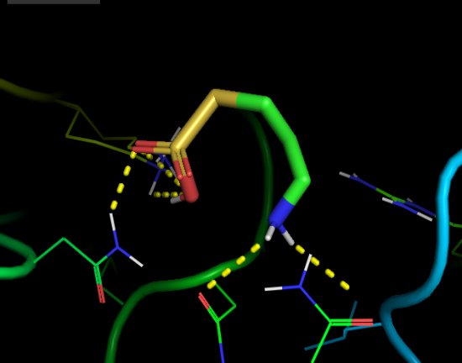
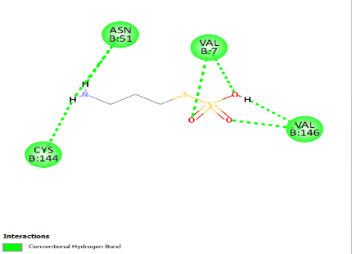
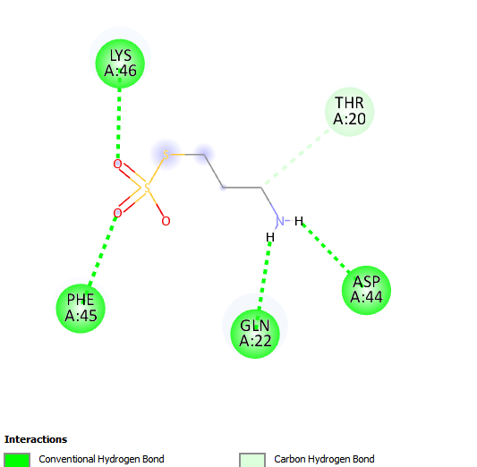
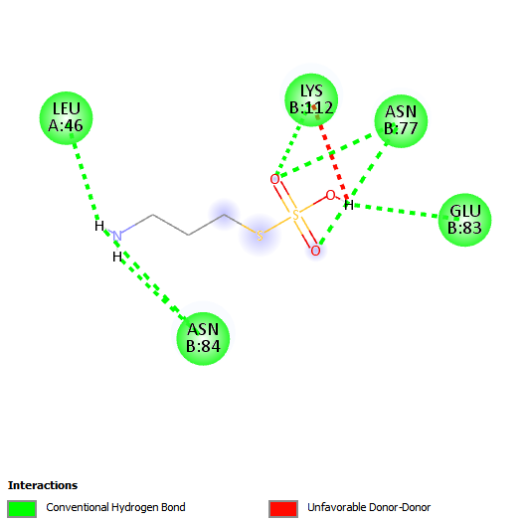
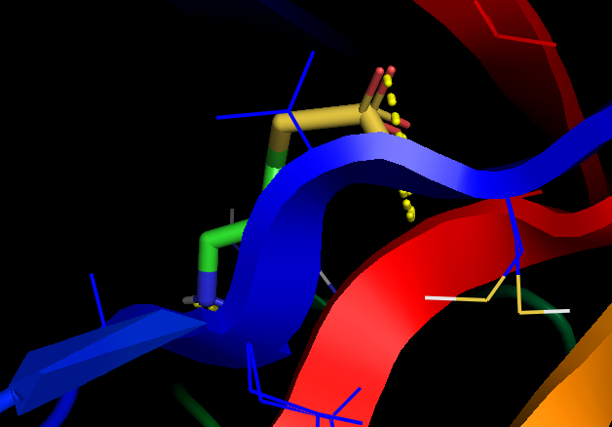
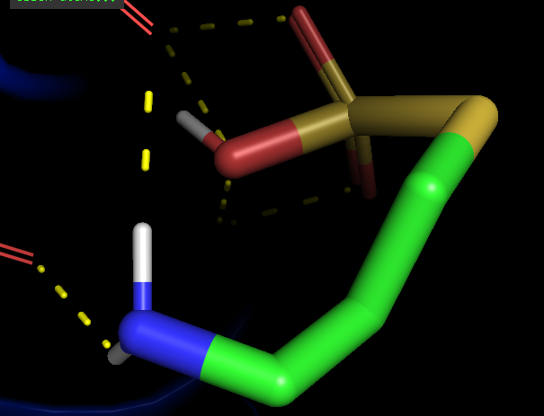
SOD
vs
S3-aminopropyl thiosulforic acid
CAT
vs
S3-aminopropyl
thiosulforic acid
GPX
vs
S3-aminopropyl thiosulforic acid

FIG. 1: 2D and 3D structures showing interactions between SOD, CAT and GPx with S3-aminopropyl thiosulforic acid

Table 3. ADMET and Toxicity Profile of S3-Aminopropyl Thiosulforic Acid Predicted by ADMETlab 3.0 and ProTox-3.0
ADMET Parameter | Predicted Value | Interpretation | Scientific Comment / Implication | Source
Molecular weight (g/mol) | 171.0 | Within optimal range (100–600) | Favors oral bioavailability and membrane permeability | ADMETlab 3.0
logP | −1.12 | Hydrophilic nature | Suggests good aqueous solubility, low lipid accumulation | ADMETlab 3.0
TPSA (Å²) | 86.05 | Within range (0–140) | Supports efficient absorption and transport | ADMETlab 3.0
H-bond donors / acceptors | 3 / 4 | Within Lipinski’s limits | Indicates favorable interaction with biological targets | ADMETlab 3.0
QED (drug-likeness) | 0.487 | Moderate | Acceptable chemical attractiveness for lead optimization | ADMETlab 3.0
Synthetic accessibility (SAscore) | 4.0 | Easy to synthesize | Indicates feasible chemical synthesis and scalability | ADMETlab 3.0
Golden Triangle rule | Satisfied | Desirable | Predicts good ADMET behavior and pharmacokinetics | ADMETlab 3.0
Caco-2 permeability (log unit) | −5.856 | Low | Suggests limited passive diffusion; may rely on transporters | ADMETlab 3.0
MDCK permeability | −5.099 | Low–moderate | Moderate absorption potential across epithelial layers | ADMETlab 3.0
Human intestinal absorption (HIA) | 0.719 | Moderate | Acceptable intestinal uptake; possible oral efficacy | ADMETlab 3.0
Plasma protein binding (PPB, %) | 12.6 | Low binding | 83.9% remains unbound; high systemic availability | ADMETlab 3.0
BBB penetration (probability) | 0.324 | Low | Minimal CNS exposure; reduced neurotoxicity risk | ADMETlab 3.0
CYP2C9 substrate | 0.396 | Active substrate | Undergoes phase I metabolism via CYP2C9 pathway | ADMETlab 3.0
CYP inhibition (1A2, 2C19, 2D6, 3A4) | 0.0 | Inactive | Low potential for drug–drug interactions | ADMETlab 3.0
HLM stability | 0.0 | Stable | Indicates good metabolic stability in the liver | ADMETlab 3.0
Plasma clearance (mL/min/kg) | 5.63 | Moderate | Suggests moderate systemic elimination | ADMETlab 3.0
Half-life (T₁/₂, h) | 1.29 | Short | Low risk of accumulation; suitable for acute therapy | ADMETlab 3.0
Drug-induced liver injury (DILI) | 1.0 | Positive | Indicates possible hepatotoxicity at higher doses | ADMETlab 3.0
Human hepatotoxicity | 0.963 | High | Consistent with DILI prediction; monitor liver biomarkers | ADMETlab 3.0
Nephrotoxicity | 0.584 | Moderate | Mild renal toxicity potential; requires dose optimization | ADMETlab 3.0
Neurotoxicity | 0.03 | Negligible | Low CNS toxicity risk | ADMETlab 3.0
Hematotoxicity | 0.527 | Moderate | Potential for hematological effects under prolonged use | ADMETlab 3.0
AMES mutagenicity | 0.393 | Negative | Low mutagenic potential | ADMETlab 3.0
Carcinogenicity | 0.009 | Non-carcinogenic | Safe regarding tumorigenic risk | ADMETlab 3.0
hERG inhibition | 0.0 | Inactive | Negligible cardiotoxicity | ADMETlab 3.0
Skin sensitization | 1.0 | Positive | Possible dermal irritation on contact | ADMETlab 3.0
Eye irritation / corrosion | 1.0 | Positive | Potential irritant; requires formulation control | ADMETlab 3.0
Estrogen receptor activity (ER) | 0.99 | Active | May modulate hormonal antioxidant responses | ProTox-3.0
Aromatase activity | 1.0 | Active | Suggests influence on steroid metabolism | ProTox-3.0
Mutagenicity / Cytotoxicity | Inactive (≥0.9) | Safe | No significant cytotoxic or genotoxic risk | ProTox-3.0
Environmental LC₅₀ (fathead minnow) | 3.20 | Moderate toxicity | Biologically degradable; avoid aquatic accumulation | ADMETlab 3.0
Bioconcentration factor (BCF) | 0.199 | Low | Minimal environmental persistence | ADMETlab 3.0

Table 4: Effect of Powdered Pterocarpus santalinoides on Antioxidant Enzymes in Cadmium Induced Oxidative Stress in Wistar rats.
Groups | SOD (U/mg) | CAT (U/mg) | GPx (U/mg)
PS1 | 10.2 ± 1.0 ª | 14.2 ± 1.0 ª | 10.4 ± 1.0 ª
PS2 | 12.4 ±1.2 ª | 16.1 ± 1.1 ª | 12.2 ± 0.8 ª
PS3 | 14.3 ± 1.1ª | 22.2 ± 1.4 ª | 13.1 ± 1.1 ª
Negative Control | 7.3 ± 0.6^{b} | 10.1 ± 1.1 ^{b} | 7.2 ± 0.6 ^{b}
Normal Control | 16.4 ± 1.1 ª | 23.2 ± 1.5 ª | 13.4 ± 1.2 ª
Values are presented as mean ± SD (n = 5). Values with different superscripts in the same column are significantly different (p < 0.05).

Experimental results, as shown in Table 4, indicated that exposure to cadmium caused a significant (p < 0.05) decrease in hepatic antioxidant enzyme activities compared with the normal control. SOD activity declined from 16.4 ± 1.1 U/mg in controls to 7.3 ± 0.6 U/mg in Cd-treated rats. Consequently, CAT and GPx activities were reduced from 23.2 ± 1.5 U/mg and 13.4 ± 1.2 U/mg to 10.1 ± 1.1 U/mg and 7.2 ± 0.6 U/mg, respectively. Administration of P. santalinoides powder restored the activities of these enzymes significantly in a dose-dependent manner. Thus, the PS3 group shows near-normal levels of SOD at 14.3 ± 1.1 U/mg, CAT at 22.2 ± 1.4 U/mg, and GPx at 13.1 ± 1.1 U/mg, showing the efficiency of P. santalinoides in countering Cd-induced oxidative inhibition. These biochemical findings are in consonance with earlier reports on the strong antioxidant and hepatoprotective potential of P. santalinoides leaf and stem extracts in chemically-induced oxidative stress [34]. This protective action might also be credited to the sulfur-containing phytochemicals that possess both radical-scavenging and metal-chelating abilities [35].

The concordance between the molecular docking and biochemical results further reinforces the protective mechanism of S3-aminopropyl thiosulforic acid. The moderate docking affinities and extensive hydrogen-bond networks suggest that the ligand binds favorably to SOD, CAT, and GPx active sites, shielding them from Cd²⁺-induced conformational distortion. This molecular protection translates into enhanced enzyme activity in vivo, a fact experimentally observed. This integrative computational-experimental correlation supports a dual mechanism: enzyme stabilization through direct binding and metal chelation reducing Cd²⁺ bioavailability. These findings demonstrate that P. santalinoides bioactives can function as natural antioxidants with complementary biochemical and physicochemical defense roles against cadmium toxicity
Recovery of antioxidant enzymes could thus be the result of several complementary ways. First, the thiosulforic acid moiety of this compound has a high affinity for metal ions, and thus cadmium chelation may occur, decreasing its interaction with sulfhydrylcontaining enzymes [36]. Second, hydrogen bonding interactions that were seen in the docking models probably stabilize enzyme tertiary structures and protect catalytic residues.
These findings collectively support the ethnomedicinal use of P. santalinoides as a detoxification and antioxidant agent and place S3-aminopropyl thiosulforic acid into position as a nutraceutical candidate against the toxicity of heavy metals.

4. Conclusion
This study showed that S3-aminopropyl thiosulforic acid, a sulfur-containing phytoconstituent of Pterocarpus santalinoides, efficiently modulates antioxidant defense systems disrupted by cadmium-induced oxidative stress. The computational analyses disclosed favorable binding interactions of the compound with important antioxidant enzymes—SOD, CAT, and GPx—signifying potential stabilization of their catalytic structures and protection against Cd²⁺ interference. ADMET evaluation confirmed its pharmacological suitability and low predicted toxicity, while experimental validation showed that treatment with P. santalinoides significantly restored the activities of these enzymes in Cd-exposed rats. These findings collectively indicate that S3-aminopropyl thiosulforic acid may mitigate cadmium toxicity through mechanisms involving metal chelation, free radical scavenging, and upregulation of antioxidant responses. Overall, the study establishes the compound as a promising natural antioxidant modulator and supports the potential therapeutic relevance of P. santalinoides in preventing heavy metal–induced oxidative damage.

Ethical approval (where ever applicable)

Experimental procedures were carried out following Institutional and National guidelines for care and use of laboratory animals. Experimental protocol was reviewed and approved by the Animal Ethics Committee of the Department of Plant and Animal Science, University of Cross River State, Nigeria (Approval NO: UNICROSS/PSB/ETH/2025/006). Every effort was made to minimize animal suffering.

COMPETING INTERESTS DISCLAIMER:
Authors have declared that they have no known competing financial interests OR non-financial interests OR personal relationships that could have appeared to influence the work reported in this paper.

References

- Hayat, M.T.; Nauman, M.; Nazir, N.; Ali, S.; Bangash, N. (2019). Environmental hazards of cadmium: Past, present, and future. In Cadmium Toxicity and Tolerance in Plants; Elsevier: Amsterdam, The Netherlands. 163–183.
- Wang, M.; Chen, Z.; Song, W.; Hong, D.; Huang, L.; Li, Y. (2021). A review on cadmium exposure in the population and intervention strategies against cadmium toxicity. Bull. Environ. Contam. Toxicol, 106, 65–74.
- Elinder, C.-G. (2019). Cadmium: Uses, occurrence, and intake. In Cadmium and Health; CRC Press: Boca Raton, FL, USA, pp. 23–64.
- Shakya, P.R.; Shrestha, P.; Tamrakar, C.S.; Bhattarai, P.K. (2006). Studies and determination of heavy metals in waste tyres and their impacts on the environment. Pak. J. Anal. Environ. Chem., 7, 7.
- Kim, H.; Lee, H.J.; Hwang, J.-Y.; Ha, E.-H.; Park, H.; Ha, M.; Kim, J.H.; Hong, Y.-C.; Chang, N. (2010). Blood cadmium concentrations of male cigarette smokers are inversely associated with fruit consumption. J. Nutr., 140, 1133–1138.
- Satarug, S.; Haswell-Elkins, M.R.; Moore, M.R. (2000). Safe levels of cadmium intake to prevent renal toxicity in human subjects. Br. J. Nutr., 84, 791–802.
- Charkiewicz, A.E.; Omeljaniuk, W.J.; Nowak, K.; Garley, M.; Nikliński, J. (2023). Cadmium toxicity and health effects—A brief summary. Molecules, 28, 6620.
- Bhattacharyya, M.; Wilson, A.; Rajan, S.; Jonah, M. (2000). Biochemical pathways in cadmium toxicity. Mol. Biol. Toxicol. Met., 34–74.
- Sabolić, I.; Breljak, D.; Škarica, M.; Herak-Kramberger, C.M. (2010). Role of metallothionein in cadmium traffic and toxicity in kidneys and other mammalian organs. Biometals, 23, 897–926.
- Tomza-Marciniak, A.; Pilarczyk, B.; Marciniak, A.; Udała, J.; Bąkowska, M.; Pilarczyk, R. (2019). Cadmium, Cd. In Mammals and Birds as Bioindicators of Trace Element Contaminations in Terrestrial Environments; Springer: Berlin/Heidelberg, Germany,pp. 483–532.
- Prozialeck, W.C.; Edwards, J.R. (2010). Early biomarkers of cadmium exposure and nephrotoxicity. Biometals, 23, 793–809.
- Gerhardsson, L.; Skerfving, S. (2023). Concepts on biological markers and biomonitoring for metal toxicity. In Toxicology of Metals, Volume I; CRC Press: Boca Raton, FL, USA, pp. 81–107.
- Bernard, A. (2004). Renal dysfunction induced by cadmium: Biomarkers of critical effects. Biometals, 17, 519–523.
- Huang, M.; Choi, S.J.; Kim, D.W.; Kim, N.Y.; Bae, H.S.; Yu, S.D.; Kim, D.S.; Kim, H.; Choi, B.S.; Yu, I.J. (2013). Evaluation of factors associated with cadmium exposure and kidney function in the general population. Environ. Toxicol., 28, 563–570.
- Noonan, C.W.; Sarasua, S.M.; Campagna, D.; Kathman, S.J.; Lybarger, J.A.; Mueller, P.W. (2002). Effects of exposure to low levels of environmental cadmium on renal biomarkers. Environ. Health Perspect., 110, 151–155.
- Gobe, G.; Crane, D. (2010). Mitochondria, reactive oxygen species and cadmium toxicity in the kidney. Toxicol. Lett., 198, 49–55.
- Hernández-Cruz, E.Y.; Amador-Martínez, I.; Aranda-Rivera, A.K.; Cruz-Gregorio, A.; Chaverri, J.P. (2022). Renal damage induced by cadmium and its possible therapy by mitochondrial transplantation. Chem. Biol. Interact., 361, 109961.
- Bossy-Wetzel, E.; Green, D.R. (2022). Caspases induce cytochrome c release from mitochondria by activating cytosolic factors. J. Biol. Chem.
- Anowi, C.F.; Okonkwo, C.; Agbata, C.A.; Ezeoka, E. (2012). Preliminary phytochemical screening, evaluation of acute toxicity and antipyretic activity of methanolic extract of Pterocarpus santalinoides (Fabaceae). Int. J. Pharm. Phytopharmacol. Res., 1(6), 343–346.
- Okagbare, N.G.; Llodigwe, E.E.; Ajaghaku, D.L.; Esimone, C.O. (2011). Acute and sub-chronic toxicities of ethanol leaf extract of Pterocarpus santalinoides in experimental animals. J. Pharm. Biomed. Sci., 12(18), 239–292.
- Okpo, S.O.; Ching, F.P.; Ekeleme, I.C. (2011). Evaluation of the anti-diarrhoeal activity of the aqueous extract from leaves of Pterocarpus santalinoides. Res. J. Pharm. Biol. Chem. Sci., 2(3), 590–597.
- Ajayi, I.A.; Oladeji, O.S.; Aghanu, V.N. (2010). Short-term toxicological evaluation of Pterocarpus santalinoides in albino rats. Food Sci. Qual. Manag., 16, 10–11.
- Peana, M. (2023). Biological effects of human exposure to environmental cadmium. Biomolecules, 13, 36.
- Prozialeck, W.C.; Edwards, J.R. (2012). Mechanisms of cadmium-induced proximal tubule injury: new insights with implications for biomonitoring and therapeutic interventions. J. Pharmacol. Exp. Ther., 343, 2–12.
- Yan, L.J.; Allen, D.C.( 2021). Cadmium-induced kidney injury: oxidative damage as a unifying mechanism. Biomolecules, 11, 1575.
- Prado, D. Pterocarpus santalinoides. In: 2008 IUCN Red List of Threatened Species. Available online: www.iucnredlist.org (accessed on 12 February 2009).
- World Agroforestry Centre (WAC). Agroforestry Tree Database: Pterocarpus santalinoides. Downloaded on 12 February 2009.
- Olatunji, G. A., Ezeonu, C. S., & Uche, C. U. (2021). Gas chromatography–mass spectrometry and Fourier infrared spectroscopy characterization of the bioactive components of methanolic plant extract of Pterocarpus santalinoides. Journal of the Chemical Society of Nigeria, 46(1), 122–129. Retrieved from https://journals.chemsociety.org.ng/index.php/jcsn/article/view/940
- McCord, J. M., & Fridovich, I. (1969). Superoxide dismutase. An enzymic function for erythrocuprein (hemocuprein). Journal of Biological Chemistry, 244(22), 6049-6055.
- Paglia, D. E., & Valentine, W. N. (1967). Studies on the quantitative and qualitative characterization of erythrocyte glutathione peroxidase. Journal of Laboratory and Clinical Medicine, 70(1), 158-169.
- Aebi, H. (1984). Catalase in vitro. Methods in Enzymology, 105, 121–126. https://doi.org/10.1016/S0076-6879(84)05016-3
- Smirnoff, N. (2018). Ascorbic acid metabolism and functions: A comparison of plants and mammals. Free Radical Biology and Medicine, 122, 116–129. https://doi.org/10.1016/j.freeradbiomed.2018.03.033
- Flora, S. J. S., Mittal, M., & Mehta, A. (2008). Heavy metal-induced oxidative stress & its possible reversal by chelation therapy. Indian Journal of Medical Research, 128(4), 501–523.
- Ihedioha, T. E., Asuzu, I. U., Anaga, A. O., & Ihedioha, J. I. (2019). Hepatoprotective and antioxidant activities of Pterocarpus santalinoides methanol leaf extract. (Conference paper / proceedings). Nigerian Society for Animal Production — Proceedings.
- Forman, H. J., Zhang, H., & Rinna, A. (2009). Glutathione: Overview of its protective roles, measurement, and biosynthesis. Molecular Aspects of Medicine, 30(1–2), 1–12. https://doi.org/10.1016/j.mam.2008.08.006
- Chung, S. M., Moon, J. S., Yoon, J. S., Won, K. C., & Lee, H. W. (2019). Sex-specific effects of blood cadmium on thyroid hormones and thyroid function status: Korean nationwide cross-sectional study. Journal of Trace Elements in Medicine and Biology, 53, 55–61. https://doi.org/10.1016/j.jtemb.2019.02.012

