ROLE OF ECHOCARDIOGRAPHY IN CANINE CARDIAC DIAGNOSIS: A REVIEW

Abstract
Cardiac disorders represent a major health challenge in both humans and companion animals, particularly dogs. Modern diagnostic imaging has transformed clinical evaluation by enabling rapid, non-invasive visualization of internal structures. Among available modalities, ultrasonography is the most widely applied tool in veterinary cardiology due to its safety, accessibility, and ability to generate real-time, high-resolution images of cardiac anatomy and function. Echocardiography, in particular, has become the cornerstone of cardiac assessment, complementing physical examination, electrocardiography, and radiography. Using 2D, M-mode, and Doppler techniques, it allows for detailed measurement of chamber dimensions, myocardial performance, blood flow characteristics, and valvular function. These capabilities support the accurate diagnosis and staging of both congenital conditions, such as patent ductus arteriosus, subaortic stenosis, and ventricular septal defects, as well as acquired diseases, including degenerative valve disease, cardiomyopathies, and pericardial disorders. Although echocardiography requires significant technical skill, ongoing advancements continue to improve its clinical value. This review highlights the principles, modalities, and diagnostic importance of echocardiography in canine cardiology, emphasizing its critical role in guiding prognosis and therapeutic decision-making.
Keywords: Echocardiography, Canine cardiology, Veterinary, Diagnostic, Modes
- Introduction
Cardiac disease is a critical global health issue affecting humans and animals, specifically domestic dogs. (Roth et al., 2020). Cardiac imaging is today an indispensable tool for diagnosis and monitoring patient evolution. Medical imaging is the visualization of body parts, tissues, or organs, for use in clinical diagnosis, treatment, and disease monitoring. Modern imaging modalities represent an enormous resource that enables rapid, non-invasive visualizations in living animals for clinical and research purposes. (Yitbarek & Dagnaw, 2022).
  - Diagnostic imaging modalities
There are different types of imaging modalities available right now in the veterinary field, like Radiography, Ultrasonography, Endoscopy, Computed Tomography, and Magnetic Resonance Imaging (MRI) (Abdikhoshimovich et al., 2023).
    - Radiography
Radiography can be used to identify cardiomegaly, which is an indicator of cardiac disease. Subjective assessment of cardiac size in dogs is complicated by the wide variation in conformation. Although radiography can provide an approximate idea of which cardiac chambers are enlarged, this can vary, subject to error. Radiography does not provide any information on valve function, systolic function, or diastolic function. (Buchanan, 2000).
    - Ultrasonography
Ultrasonography is a form of imaging that is fast, accurate, safe, non-invasive, and painless. It uses high-frequency sound waves and their echoes to look at the tissues and organs inside the body. It provides unique information about the structure of soft tissues and enables the evaluation of the motion pattern of certain organs and structures. In addition, Doppler techniques allow mapping of the velocity and flow patterns of blood within the heart and vessels. (Plummer, 1989).
    - Computed Tomography
A cardiac computed tomography (CT) is a procedure that utilizes multiple X-ray beams from different angles to acquire high-quality, three-dimensional (3D) images of your heart, along with your great vessels and surrounding structures. (Kasban, 2015).
    - Magnetic Resonance Imaging
Magnetic resonance imaging (MRI) is capable of producing images in any anatomical plane, visualizing and analysing a variety of tissue characteristics, as well as quantifying blood flow and metabolic functions. (Kasban, 2015).
  - Echocardiography
Echocardiography is an ultrasound of the heart that permits non-invasive visualization of the internal anatomy of the heart. It visualises the inside structure of the heart, including the aorta, ventricles, atria, auricular appendages, and cardiac valves. (Sinha et al., 2022). Echocardiography or Cardiac ultrasonography is widely used for the non-invasive evaluation of cardiovascular diseases and is arguably the most significant advance in cardiac diagnosis witnessed over the last 50 years. Cardiac ultrasonography (US) studies complement auscultation, electrocardiography, and thoracic radiography and represent the clinical gold standard for the diagnosis and staging of most congenital and acquired heart diseases. (Boon, 2011).
Echocardiography provides the measurement of the size and shape of the heart, its pumping capacity, any damage to cardiac tissues, and assessment of heart valve configuration and motion. (Mohamed et al., 2010). Echocardiography also provides a space relationship between structures, cardiac movements, the blood flow features, and information on hemodynamic status, extent of disease process, and precise diagnosis of cardiac alterations, as well as a follow-up of therapy, and to determine the prognosis through direct vision of cardiac chambers. (Gugjoo et al., 2014)
Due to its ability to distinguish between fluid and soft tissues (unlike conventional radiography) to define spatial relationships between structures and to detect quantitative motion, echocardiographic examination must be considered as part of a thorough cardiovascular examination and diagnosis. (Dave et al., 2018)
- Principle
Sound is a mechanical vibration of particles in a medium around an equilibrium position. Sonic waves require a medium of a molecular nature to propagate. The highest frequency audible to the human ear is 20,000 cycles per second or 20 kilohertz (KHz). Sound waves above this frequency are described as Ultrasound. Unlike electromagnetic waves, ultrasound cannot travel across a vacuum.
Basically, the ultrasound machine has a pulse generator, a transducer, and an oscilloscope. The transducer has a lead zirconate crystal, which has piezo-electric properties and can expand and contract in response to electrical pulses. This rapid motion or oscillation of the crystal produces sound waves beyond the 20,000 cycles per second hearing range of the human ear. After transmission, the acoustical energy of the reflected sound is reconverted into electrical impulses for data analysis, since the same crystal generates electrical currents when exposed to high-frequency reflected waves. Every 300 microseconds, the crystal receives a 10-microsecond pulse of electrical energy and produces vibrations transmitted as ultrasound. During the 290 microseconds remaining in the cycle, the transducer acts as a receiver for the reflected echoes.
Echoes appear as dots of light whose brightness varies with the intensity of the reflected waves and appear on the oscilloscope. The dots of the recording oscilloscope are registered in linear traces. (Hassani, 1974). In the examination of the heart with pulsed ultrasound, the American Institute of Ultrasound in Medicine decided to use the term “Echocardiography”.
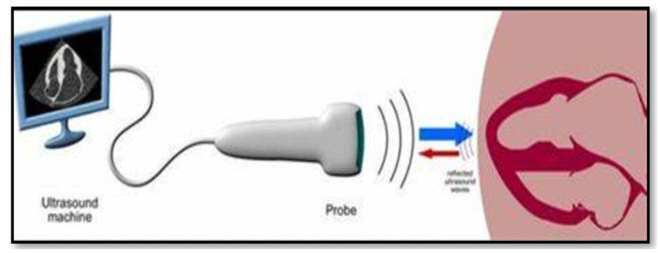
Fig 1- Examination of the heart with pulsed ultrasound
- History
- 1794 - Lazzaro Spallanzani discovered an Ultrasound wave.
- 1911-2001 - Inge Edler is known as the Father of Echocardiography.
- 1956 - Shigeo Satomura discovered the Doppler method to measure cardiac motion.
- 1971 - Nicolaas (Klaas) Bom and Charles Lancee first performed real-time 2D (linear array) cardiac scans (‘Multiscan’).
- 1974 - Bjorn Angelsen constructed a pulsed Doppler system for recording aortic blood flow.
- 1976 - Lee Frazin introduced single-element transesophageal echocardiography.
- 2008 - Lissa Sugeng discovered Real-time ‘live’ 3D transesophageal imaging

- Anatomy and Physiology of the Heart
  - Location
The canine heart is ovoid. It forms an angle of about 45 degrees with the sternum, with the base facing craniodorsally and the blunt apex resting near the junction of the sternum and the diaphragm, a little to the left of midline in the thoracic cavity. The heart is placed obliquely at the level between the third rib and to sixth intercostal space.
  - Layers of the Heart Walls
The heart wall consists of three layers enclosed in the pericardium:
- Epicardium - the outer layer of the wall of the heart, which is formed by the visceral layer of the serous pericardium.
- Myocardium - the muscular middle layer of the wall of the heart, which has excitable tissue and the conducting system.
- Endocardium – the innermost layer of the heart, which includes valves.
  - Heart Chambers
The heart is subdivided by septa into right and left halves, and a constriction subdivides each half of the organ into two cavities; the upper cavity is called the atrium, the lower the ventricle. Four chambers of the heart include the right atrium (atrium dextrum), right ventricle (ventriculus dexter), left atrium (atrium sinistrum), and left ventricle (ventriculus sinister).
  - Heart Valves
Atrioventricular valves between the atria and ventricles, which include the Tricuspid valve (Right side of the heart) and the Mitral valve/bicuspid valve (left side of the heart)
Semilunar valves, which are located in the outflow tracts of the ventricles which include the aortic valve (left side heart) and pulmonary valve (right side heart).
    - Tricuspid valve
The right atrioventricular or tricuspid valve separates the right ventricle and atrium. As its name indicates, the tricuspid valve is composed of three leaflets, called the septal, parietal, and angular leaflets.
    - Mitral valve
The left atrioventricular or mitral valve separates the left ventricle and left atrium. The mitral valve is larger than the right atrioventricular or tricuspid valve in comparison. The mitral valve is bicuspid and includes two leaflets (septal and parietal).
    - Semilunar valves
Blood exiting the right and left ventricles is controlled by the pulmonary and aortic semilunar valves, respectively. The pulmonary and aortic valves have a similar morphology and consist of three semilunar leaflets. The pulmonary valve has right, left, and septal semilunar leaflets; whereas the aortic valve has right, left, and intermediate (noncoronary) semilunar leaflets.
The papillary muscles are pillar-like muscles located in the ventricles of the heart. The papillary muscles contract to prevent the valves from inverting or prolapsing when the heart pumps blood. The papillary muscles make up about 10 % of the total heart mass. They connect to the atrioventricular valves (mitral and tricuspid) via the chordae tendineae, which are thin strings of tissue. Small fibrous bands, called the chordae tendineae, arise from papillary muscles along the ventricular wall and extend to the atrioventricular valves to prevent valvular prolapse during systole when the left and right ventricular pressures are increased.
  - Blood Flow in the Heart
One‐way passage of blood through the different chambers of the heart is controlled by four valves, all synchronized to open and close at distinct intervals during each cardiac cycle. The heart is the driving force (pump) of the circulatory system. Through coordinated extrinsic and intrinsic neurogenic stimuli and muscular contractions, the heart pushes blood through a closed network of blood vessels to provide the body with a continuous supply of oxygen and nutrients. Blood circulates in the four chambers of the heart.
The cranial and caudal vena cava bring deoxygenated blood to the heart at the level of the right atrium. The right atrium pushes blood through the tricuspid valve during atrial systole (ventricular end diastole) into the right ventricle. During ventricular systole, the right ventricle pushes the deoxygenated blood into the main pulmonary artery through the pulmonary valve. Blood continues through the pulmonary arteries into a fine network of pulmonary capillary beds surrounding the alveoli. Here, blood becomes oxygenated and enters the left atrium via the pulmonary veins. It then moves into the left ventricle through the mitral valve during ventricular diastole. Through the aorta, oxygenated blood goes out of the heart to different body parts from the right ventricle.
- Indications of Echocardiography
Echocardiography is indicated for identifying the cause of disease and for confirming congenital conditions related to the heart.
Echocardiography helps in the detection of the cause of
Heart murmur
Syncope
Stunted growth in a puppy
Exercise intolerance
Cyanosis
Arrhythmias
It is useful for the evaluation of cardiac diseases, like
Pleural effusion
Screening of cardiac masses
Thromboembolism
Cardiomyopathy (DCM, HCM)
- Equipment and Technique
  - Equipment
Echocardiographic examination requires an ultrasonography machine with a cardiac probe and a ‘cutout’ table for proper restraining and lying of the animal. The cutout table has a cut that allows the cardiologist to lightly place the probe in contact with the chest wall.
Transducer: Cardiac Probe/ Phased array probe/ Sector transducer
The phased array (or sector array) transducer is commonly branded as the “cardiac probe” and has a frequency range from 1-5 MHz. It has a similar frequency range as the curvilinear probe but has a smaller and flatter footprint. The advantage of this probe is that piezoelectric crystals are layered and packed in the centre of the probe, making it easier to get in between small spaces, such as the ribs. The frequency of the transducer should be selected based on the body weight of the animal.
Table 1-Frequency of the transducer based on body weight
Body Weight | Frequency of the transducer
< 5 kg | 8-12 MHz
5 to 40 kg | 4-8 MHz
>40 kg | 2-4 MHz
(Abduch et al., 2014)
  - Cardinal Transducer Movements
Handling the ultrasound probe and proper movement are essential to obtain optimal ultrasound images. There are traditionally 4 basic movements that are performed when scanning with ultrasound they are sliding, rocking, tilting (fanning), and rotating.
    - Sliding
Sliding involves moving the entire probe in a specific direction to find a better imaging window. This is usually used to find the best window, move to different areas of the body, or follow a specific structure.
    - Tilting (Fanning)
Tilting the ultrasound probe involves moving the transducer from side to side along the short axis of the probe. It is commonly also called “Fanning” as well. Tilting will allow visualization of multiple cross-sectional images of a structure of interest.
    - Rotating
Rotating the ultrasound probe involves turning the transducer in a clockwise or counterclockwise direction along its central axis. Rotation is most commonly used to switch between the long and short axes of a specific structure, such as a vessel, heart, etc.
    - Rocking
Rocking the ultrasound probe involves “rocking” the ultrasound probe either towards or away from the probe indicator along the long axis.
Fig. 2- The rocking mechanism of the ultrasound probe
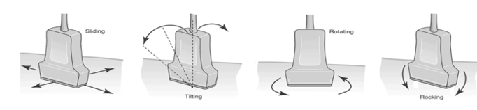
  - Ultrasonographic tissue appearance
The appearance of tissues depends on the acoustic impedance. This is based on their density and the velocity of sound in the tissue. The ultrasonographic appearance may be described as dark (anechoic), grey (hypoechoic), or white (hyperechoic). It may also be isoechoic (echotexture similar to some other adjacent structure or organ). An image having a varying mixture of descriptions is referred to as having heterogeneous echogenicity. (Lamb, 2004).
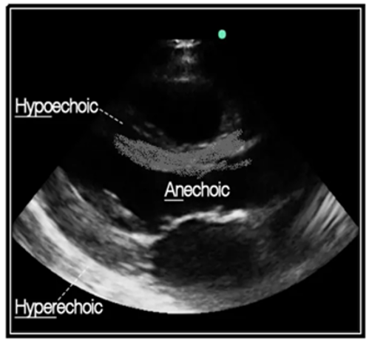
Fig. 3- The ultrasonographic appearance of tissues based on the acoustic impedance
  - Technique
    - Restraining
For Echocardiography, gentle restraining of the animal is required. Sedation is not typically necessary for echocardiography examinations. The majority of animals do not need to be sedated or anesthetized for an echocardiogram. Dogs getting an echocardiogram lie on a padded table with a cutout that allows the ultrasound probe to contact their chest wall. Veterinary technicians gently restrain pets for about 20 minutes in a dark room during the examination.
    - Positioning
The animal should be restrained in lateral recumbency with the forelimb pulled far forward on a cutout table. Recumbency will be left or right according to examination.
    - Site Preparation
Hair clipping on the thorax between the 3rd to 6th rib is required for long-haired dog breeds. Most animals do not need to be shaved for an echocardiogram. A small amount of alcohol is used to separate the hair on the chest wall, and water-soluble ultrasound gel is used to provide contact with the ultrasound probe. Occasionally, dogs or cats may need to have a small section of hair shaved to provide optimal imaging of their heart if their coat is very thick.
- Echocardiographic Modalities
B-Mode or 2-Dimensional Echocardiography
M-Mode or 1-Dimensional Echocardiography
Doppler Echocardiography (M. et al., 2014)
  - B-mode or Two-Dimensional Echocardiography
The 2DE is the most frequently recorded and easiest to understand cardiac examination. It provides a two-dimensional view of the heart. It gives a greyscale image to assess cardiac, valvular, and great vessel anatomy, size, and subjective movement. The various 2D images are defined by these identifiers: (1) transducer location (right or left, parasternal/intercostal, apical, subcostal/subxiphoid); (2) plane of the ultrasonography cut (long axis, short-axis, apical, or angled); (3) the number of chambers or great vessels imaged (2-, 3-, 4- or 5-chamber views); and other tomographic characteristics (Thomas et al., 1993).
The different views of B-mode include,
- Right Parasternal View
  - Long Axis (LA)
    - Four chamber view
    - Five-chamber view
  - Short Axis (SA)
    - Papillary muscle view
    - Mitral valve view
    - Aortic root view
    - Pulmonary trunk view
- Left Apical View
    - Four chamber view
    - Five-chamber view
    - Two-chamber view
- Left Parasternal View
  - Long Axis (LA)
    - LV and RV view
    - RA Appendage view
    - Aortic root view
    - RV and LV outflow tract
  - Short Axis (SA)
    - RV inflow tract view
    - RV inflow and outflow tract
    - Pulmonary trunk view
    - Right Parasternal Long Axis View
Canine and feline long-axis and short-axis images are routinely obtained from the right side. Right parasternal view, obtained at right-sided recumbency of animal on cutout table. Usually, there are two or more rib spaces available for right parasternal (RPS) views, including a cranial location, corresponding typically to the fourth intercostal space, and a more caudal location at the fifth. Location of the transducer at the 3rd to 5th intercostal space for small dogs and at the 4th to 6th intercostal space for large dogs.
      - Four Chamber View
The typical starting point is at the fourth (or fifth) intercostal space, dorsal to the sternum and below the costochondral junction. To obtain a parasternal, 4-chamber image of the atria and ventricles, feel the apex beat on the 3rd to 6th intercostal space. Approximately 30-degree clockwise rotation is initially applied, followed by mild to moderate dorsal and caudal angulation of the central ultrasound beam. The image is optimized for the left ventricle inlet and the mitral valve leaflets by completely excluding the aortic valve (AV), visualizing the atrial septum and fossa ovalis, and recognizing the right pulmonary venous ostium adjacent to the septum. Long-axis 4-chamber image demonstrates the RA and RV in the near field and LA and LV in the far field. The atrial and ventricular septa are roughly perpendicular to the central ultrasonic beam. The mitral and tricuspid valve anatomy can be evaluated in this plane with fine-plane imaging.
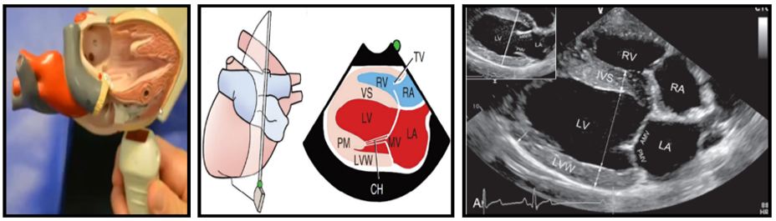
CH = chordae tendineae; PM = papillary muscle; MV = mitral valve; VS = ventricular septum; RV = right ventricle; LV = left ventricle; RA = right atrium; LA = left atrium
Fig. 4- Four-chamber view of the heart
      - Five Chamber View
Clockwise rotation of the transducer (or a slight cranial tilt of the axial US beam) produces a long-axis image that is optimized for the Left Ventricular Outflow Tract, including the ascending aorta. It is also known as “Left Ventricular Outflow Tract View”. The long-axis LV outflow view is obtained from the 4-chamber long-axis view by applying clockwise rotation (or cranial tilt) of the transducer face. Only the proximal aorta is usually visualized.
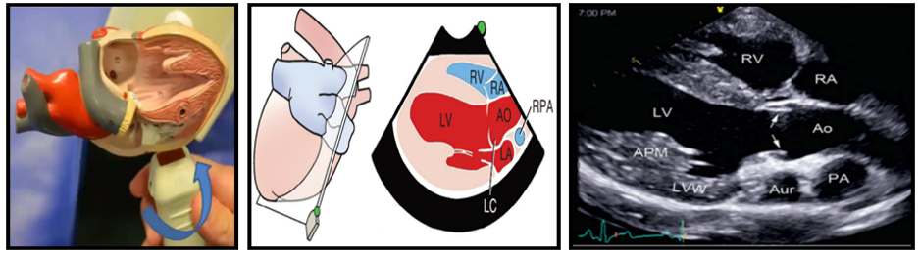
Ao = Aorta; RPA = right pulmonary artery; LC = left cusp (leaflet) of the aortic valve.
Fig 5- Five-chamber view of the heart
    - Right Parasternal Short Axis View
Nearly orthogonal to the long-axis tomograms are a series of right parasternal, short-axis images. These are located by turning the transducer approximately 90 degrees (clockwise) from the 4-chamber, long-axis plane. The typical levels of interrogation include low (ventral) ventricular, papillary muscle, chordal, mitral, and aortic/LA. These images are acquired by beginning with the transducer oriented slightly ventrally, gradually sweeping the sector dorsally, and eventually applying additional clockwise rotation once the subaortic level is reached.
      - Papillary Muscle View
One of the most important of all 2D images is obtained in short-axis at the “high” papillary muscle level. In this view, both LV papillary muscles project into the LV cavity, creating a lumen with a broad-based “toadstool” or “mushroom” contour. In the near field, the RV appears as a relatively small crescent. The posterior (dorsocaudal) papillary muscle is normally closest to the transducer in dogs.
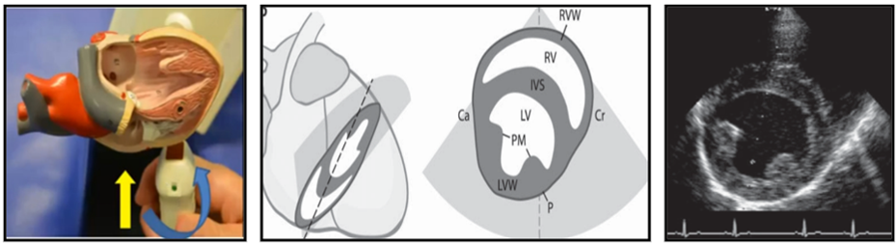
Fig. 6- Papillary muscle view
      - Mitral Valve View
The image is acquired during atrial contraction with the valves in a partially-opened position. In this view, both leaflets of the mitral valve create an image like “Fish-Mouth”. Slightly tilting of probe cranially from the papillary muscle view. The image is acquired during atrial contraction with the valves in a partially-opened position. The anterior mitral valve (AMV) (upper arrows) and posterior mitral valve (PMV) (lower arrows) can be seen. The left ventricle outflow tract (LVOT) is between the septum and the AMV leaflet. Right ventricular papillary muscles are also evident (arrowheads). Inset: The AMV leaflet is fully opened in early diastole (arrow). The mitral valve orifice (MVO) is contained within the circumference of the opened leaflets. The PMV is adjacent to the walls and not easily visualised.
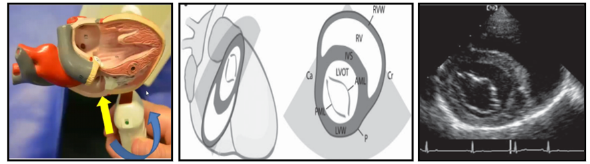
Fig 7-Image at the mitral level of a normal dog illustrating the “fish-mouth” view. AML = anterior mitral leaflet; PML = posterior mitral leaflet.

      - Aortic Root View
Tilting of the probe cranially from the mitral valve view. In this view aortic valve appears as a sign of “Mercedes”. The aortic valve leaflets are closed in diastole and open during systole. The right coronary (RC), left coronary (LC), and non-coronary (NC) cusps of the aortic (Ao) valve may be visible.
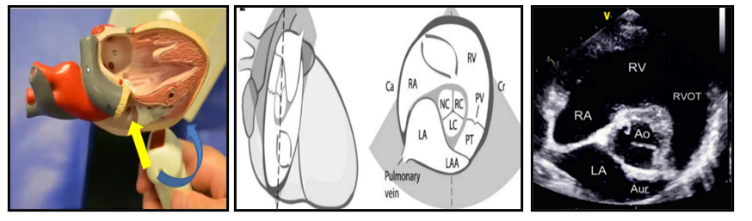
Fig 8-Image at the aortic valve level recorded from a normal dog.
      - Pulmonary Trunk View
Tilting of the probe towards the pulmonary artery for this view. This View is helpful for the diagnosis of pulmonic stenosis. This view is optimized for the pulmonary valve (arrows), main pulmonary artery, and left and right branches.
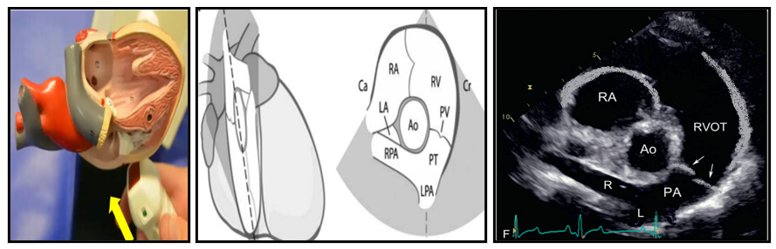
Fig 9-Image at the pulmonary valve level obtained from a normal dog.
    - Left Apical View
After the patient has been turned to the other side, a series of caudal, cranial, and specialized left-sided images is obtained. The left apical (caudal intercostal) imaging planes include the 2-chamber view (showing the LA and LV), 3-chamber view—also called the apical long-axis image (showing the LA, LV, and ascending aorta), 4-chamber view (showing both atria and ventricles), and 5-chamber view (a 4-chamber view that includes the AV and supravalvular aorta). These image planes are used for estimating LV and RV size and function, and for recording Doppler flow studies across the atrioventricular valves and LVOT. (Thomas et al., 1993).
      - Left apical Four-chamber View
Left apical images are obtained with the transducer placed caudoventrally at or slightly caudal to the palpable apical impulse. The apical 4-chamber view can be considered the “home base” for obtaining subsequent caudal images. The anterior and posterior mitral valve leaflets are evident.
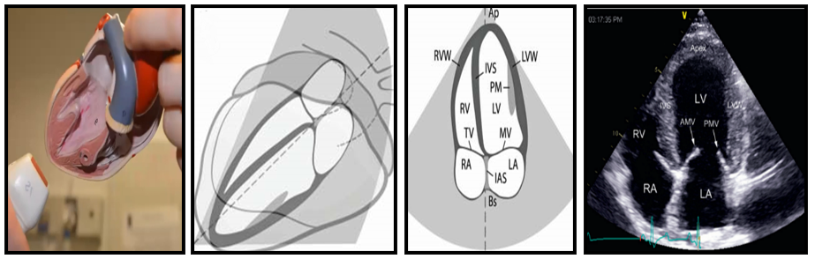
Fig 10-Apical (or left caudal) four-chamber image obtained from a normal dog.
      - Left apical Five-chamber View
Gently tilting the transducer cranially opens the LVOT, AV, and proximal aorta to create a five-chamber view. This view is usually the best apical plane for aligning to aortic blood flow. Aortic root and aortic valves (AV) are evident.
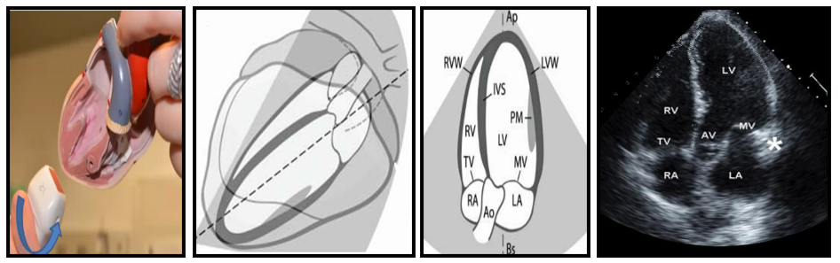
Fig 11-Apical (or left caudal) five-chamber image obtained from a normal dog.
      - Left apical Two chamber View
This is achieved by rotating the transducer ≈75-80 degrees clockwise from the 4-chamber view, sliding the transducer even more ventrally, and tilting the transducer craniodorsally with the hand assuming a “hitchhiking” position and the thumb pointed at the patient’s head. This helps visualize the valves and blood flow by the Doppler method.
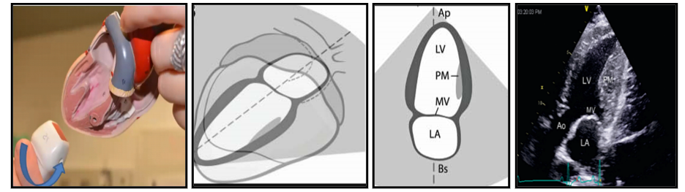
Fig 12- Left apical two-chamber image obtained from a normal dog
    - Left Parasternal Long Axis View
Various standard and off-angle long-axis images can be obtained from the cranial intercostal positions along the left thorax. A series of three cranial long-axis images can be obtained from a single transducer location. With the transducer rotated ≈90 degrees cranially (and the reference notch directed toward the patient’s nose), the beam is centred near the AV, and the LVOT and ascending aorta are identified in long-axis projection. The transducer is positioned near the left cranial border of the heart. Dorsal-ventral angulation yields the series of LAx images. Variable angulation in the caudal-cranial direction may be necessary, as suggested by the figure.
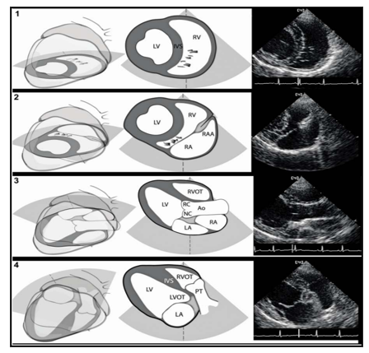
Fig 13-Left parasternal LAx scanning technique
1: LPS LAx view at the RV. 2: LPS LAx view at the RAA. 3: LPS LAx view at the Ao. RC and NC refer to the right coronary and non-coronary portions of the aorta sinus of Valsalva. 4: LPS LAx view at the RVOT, PT, and LV inflow tract.
    - Left Parasternal Short Axis View
The transducer is positioned near the left cranial border of the heart. Cranial-caudal yields the series of SAx images. The transducer is positioned near the left cranial border of the heart. Cranial-caudal yields the series of SAx images. Variable angulation in the dorsal-ventral direction may be necessary, as suggested by the figure.
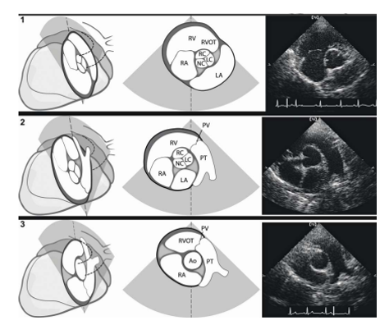
Fig 14-Left parasternal SAx scanning technique
1: LPS SAx view at the RV inflow tract. The right coronary (RC), left coronary (LC), and non-coronary (NC) cusps of the Ao valve may be visible. 2: LPS SAx view at the RV inflow-outflow tracts. Both the inflow and outflow tracts of the right heart may be visible with subtle angulation and twist adjustments. The RC, LC, and NC cusps of the Ao valve may be visible. 3: LPS SAx view of the pulmonary trunk (PT). Division of the PT into the right and left main pulmonary arteries is seen in the far field.
  - M-mode or One-Dimensional Echocardiography
M-mode refers to motion mode. This type of image displays cardiac structures in an axial plane. M-mode images are obtained from the real-time long-axis left ventricular outflow plane or by placing a cursor over the structures we want to see. The cursor represents one beam of sound. This imaging method is referred to as an "Ice pick" view of the heart. M-mode examination in animals has been preferred almost exclusively from the right parasternal window. The majority of M-mode dimensional recordings are made from the RPS transducer position. (Bonagura et al., 1985)
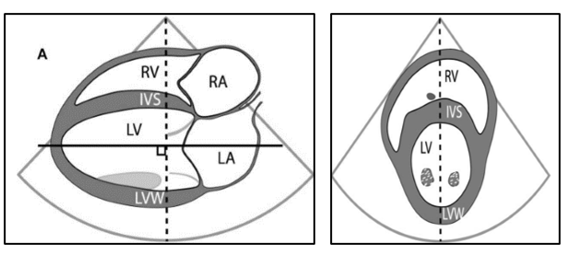
Fig 15-Pictorial image of Right parasternal long and short axis view for M-mode Echocardiography
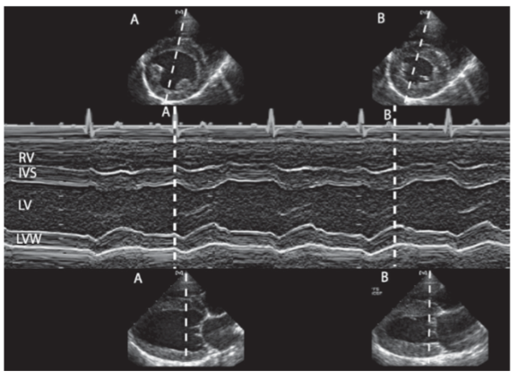
Fig 16-M-mode at the LV level.
The M-mode recording (middle tier) is generated from the selected scan line shown in the RPS SAx (top tier) and LAx (bottom tier) images. Time marker A is at the end of diastole, coinciding with the onset of the QRS complex of the electrocardiogram. Time marker B is at end systole, which coincides with the minimum LV dimension near the end of the electrocardiographic T wave.
    - Indications of M-mode
- The M-mode is useful for quantifying cardiac wall thickness, ventricular luminal size, and left ventricular function.
- Measurement of left ventricular internal dimensions at end-diastole (LVIDA) and end-systole (LVIDS) is taken for the trailing edge of the septal wall to the leading edge of the left ventricular free wall. End-diastolic and end-systolic measurements of thickness of the interventricular septum (IVSD, IVSS) and left ventricular posterior wall (LVPWD, LVPWS) are made using the trailing edge to the leading edge.
- The level of the aortic valve (Aov) is used for measurement of the aortic root (Ao) and left atrial (LA) dimensions. The aortic root is measured at end diastole, and the left atrium is measured at its maximal upward excursion near the end of systole.
- Measurement of fractional shortening as a part of systolic function assessment.
- Diastole: |  |  | - Systole:
RV lumen | : RVIDd |  | RV lumen | : RVIDs
Septum | : IVSd |  | Septum | : IVSs
LV Lumen | : LVIDd |  | LV Lumen | : LVIDs
LV Wall | : LVWd |  | LV Wall | : LVWs
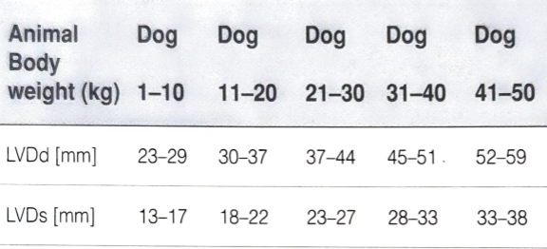
Table 2-M-mode measurements of the dog depending on body weight
(M. et al., 2014)
    - Cardiac indices Measurements
The most important cardiac indices include Fractional shortening and Ejection fraction
- Fractional Shortening (FS%)
Fractional shortening is the reduction of the length of the end-diastolic diameter that occurs by the end of systole. It is calculated by measuring the change (percent reduction) in left ventricular diameter during systole.
FS (%) = LVDD - LVSD / LVDD x 100
Left ventricular diastolic dimension (LVDD)
Left ventricular systolic dimension (LVSD) (Kayar et al., 2006)
- Ejection fraction (EF% %)
Ejection fraction (EF) measures the amount of blood pumped out of the heart’s lower chambers, or ventricles. It’s the percentage of blood that leaves your left ventricle when the heart contracts.
EF (%) = EDV- ESV / EDV
End diastolic volume (EDV), LVDD, EDV = LVDD³
End systolic volume (ESV), LVSD, ESV = LVSD³ (Bonagura et al., 1985)
Table 3- Measurement of cardiac indices
Condition | FS% | EF%
Normal | ≈ 28% to 45% | 50% to 70%
Severe myocardial systolic failure | Below 20% | Below 40%
Hyperdynamic LV function | Above 55% | Above 75%
  - Doppler Echocardiography
Doppler echocardiography is a non-invasive means of evaluating blood flow velocity and direction within the heart and great vessels. The first description of the physical principles used in Doppler echocardiography was made by the Austrian mathematician Johann Christian Doppler in the 19th century.
Doppler Effect: When the observer moves towards the source, the frequency of the sound waves increases it leading to a higher pitch. Conversely, if it moves away from the source, the frequency of sound waves decreases and leads to a lower pitch. (Satomura, 2005).
    - Colour-flow Doppler echocardiography:
It is a form of pulsed wave Doppler echocardiography in which a colour picture of blood flow is superimposed upon an M-mode of a 2-D echocardiography image. Blood flow velocity, direction, and turbulence are all displayed with different colour-flow maps. Blood flow towards the transducer is normally coded in red, and flow away from the transducer is normally coded in blue. The higher the velocity of blood flow, the lighter the shade of red or blue in most instances. With turbulent blood flow, green is coded over the red or blue colours. A mosaic pattern is produced in areas of high-velocity turbulent blood flow.
Fig. 17- Doppler Echocardiography indicating colour mapping
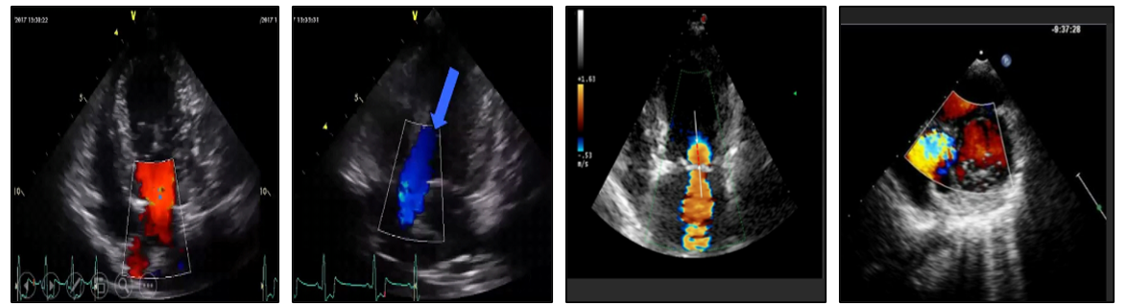
- Colour Mapping:
Red | : Towards transducer
Blue | : Away from the transducer
Dark color | : Slower flow
Enhanced color | : Faster flow
Bright blue/yellow | : Turbulence
    - Pulse-wave Doppler echocardiography:
It is used to localize flow accurately to a specific area within the heart or great vessel, but it cannot resolve peak velocities associated with fast blood flow. It can measure blood flow velocity & direction at a certain position. There is a distinction between laminar & turbulent flow. It cannot measure high velocities.
Fig. 18- Doppler echocardiography indicating pulse-wave
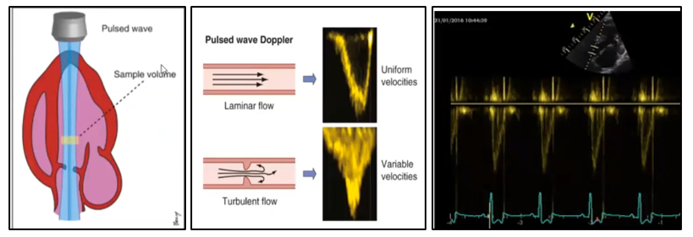
    - Continuous-wave Doppler echocardiography:
It is used to accurately determine the peak flow velocity in situations of high-velocity blood flow. Blood flow velocity & direction over the entire cursor line, not at a specific location. It cannot distinguish between laminar and turbulent flow.
Fig. 19- Doppler echocardiography indicating continuous wave
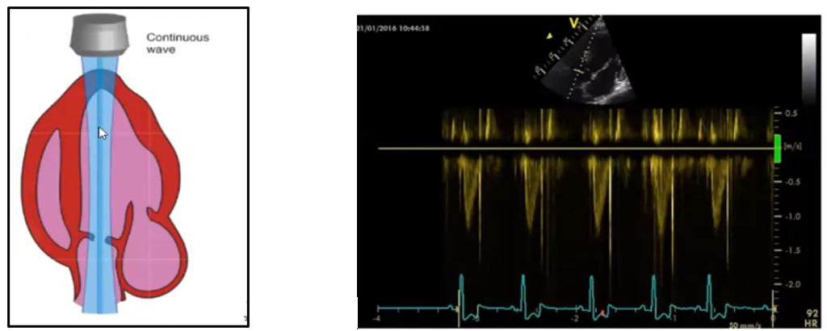
- Echocardiography as a Diagnostic Tool in Various Diseases
Heart disease in dogs is either congenital (present at birth) or acquired (occurs later in life). Congenital anomalies of the cardiovascular system are defects present at birth and often lead to perinatal death in dogs. The most common congenital heart defects in dogs are patent ductus arteriosus (PDA), subaortic stenosis (SAS), pulmonic stenosis, and ventricular septal defect (VSD). Other heart conditions develop as the dog ages. Roughly 95 % of dog heart disease is acquired, usually as a result of general wear and tear on the heart, but occasionally through injury or infection. The most common acquired heart diseases are Degenerative Valve Disease, Cardiomyopathy, Pericardial disease, and Myocarditis (Bonagura & Herring, 1985)
  - Aortic Stenosis
Sub-valvular aortic stenosis (SAS) is one of the most common congenital heart defects of dogs. The disease is characterized by obstruction of the left ventricular outflow tract, resulting in pressure overload on the left ventricle.
Eason et al. (2017) studied 554 cases of heart disease, 12 % represented congenital heart diseases, of which 45 % (30) cases of aortic stenosis were identified by echocardiography.
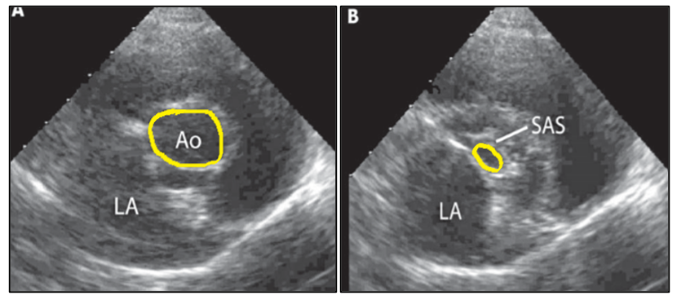
Fig 20-Right parasternal short-axis view at the level of the aorta
- Normal B. Sub valvular Aortic Stenosis
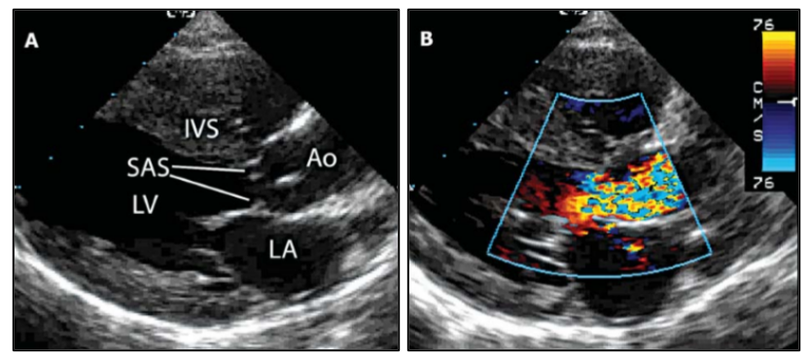
Fig 21-RPS long axis five chamber view with Colour Flow Doppler
(Mosaic Pattern of blood flow)
(Eason et al., 2021)
  - Pulmonic Stenosis
Pulmonic stenosis (PS) is one of the most common congenital heart diseases in dogs, leading to right ventricular (RV) pressure overload, myocardial remodelling, and potential RV dysfunction.
Oliveira et al. (2011) used echocardiography to diagnose pulmonic stenosis in 313 canines out of 976 cases of congenital cardiac disorders.
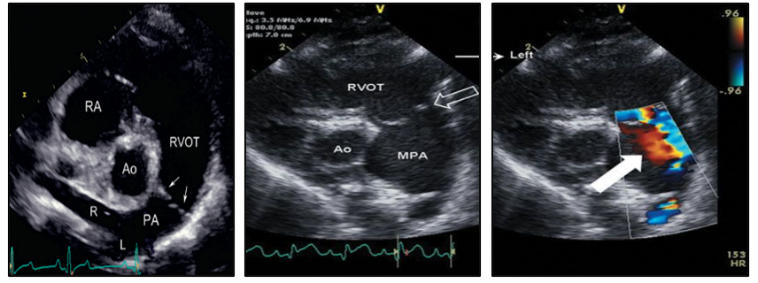
Fig 22-RPS Short axis Pulmonary Trunk View with normal and pulmonic stenosis with colour flow doppler
(Oliveira et al., 2011)

  - Atrial Septal Defect
Atrial septal defect (ASD) is characterized by communication between the two atria owing to a defect in the interatrial septum.
ASD in dogs and cats at the Cardiology Unit of Alfort (2001–2005) using echocardiography combined with colour Doppler mode. ASD was diagnosed in 156 animals and represented 37.7% of all canine and feline CHDs (n=414) (Chetboul et al., 2006).
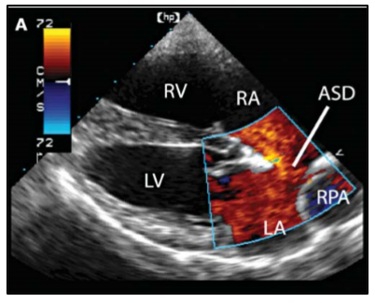
Fig 23-RPS long axis four chamber view with Colour Flow Doppler
(Chetboul et al., 2006)

  - Ventricular Septal Defect
Ventricular septal defect (VSD) is a common congenital disease in cats and also occurs in dogs. VSD occurs due to incomplete formation of the interventricular septum. VSD may cause a loud systolic murmur (grade 3/6 or higher), heard best over the right thorax.
Bomassi et al. (2015) found that 53 out of 109 (48.5 %) dogs had a ventricular septal defect at the Cardiology Unit of Alfort, France.
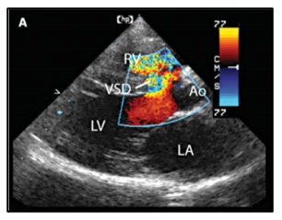
Fig 24-RPS long axis five chamber view with Colour Flow Doppler
(Bomassi et al., 2015)
  - Dilated Cardiomyopathy
Canine dilated cardiomyopathy (DCM) is a primary acquired disease of cardiac muscle that results in a decreased ability of the heart to generate pressure to pump blood through the vascular system.
Freid et al. (2021) studied 75 dogs with DCM by M-mode echocardiography at Tufts University's Foster Hospital, USA.
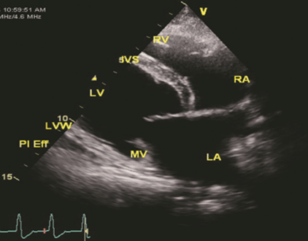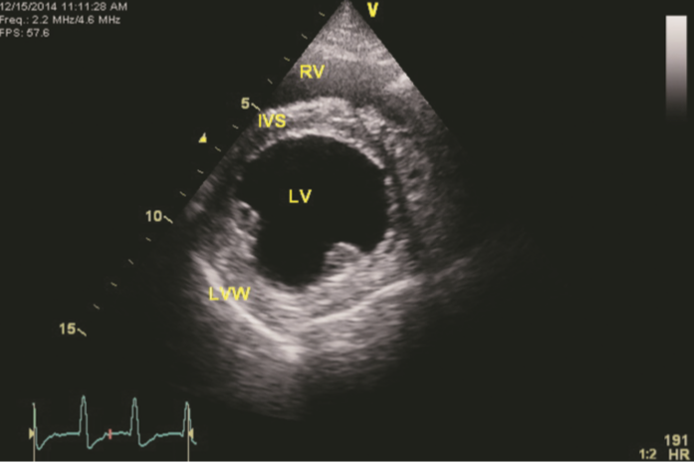
RPS Long axis 4 chamber view RPS short axis Papillary muscle view
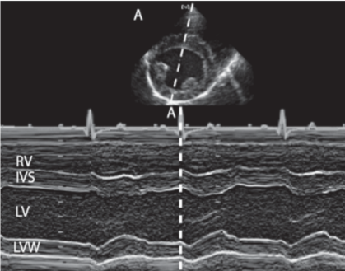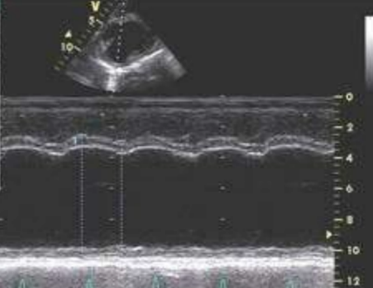
Normal M-Mode Echocardiography in DCM
(Freid et al., 2021)
Fig 25- Results of the Canine dilated cardiomyopathy conducted on dogs
  - Hypertrophic Cardiomyopathy
Hypertrophic Cardiomyopathy (HCM) is an acquired disease of the heart. HCM is characterized by primary concentric left ventricular hypertrophy due to an inherent myocardial disorder, hormonal stimulation (such as hyperthyroidism or acromegaly), infiltration of the myocardium (eg, lymphoma), or other noncardiac disease.
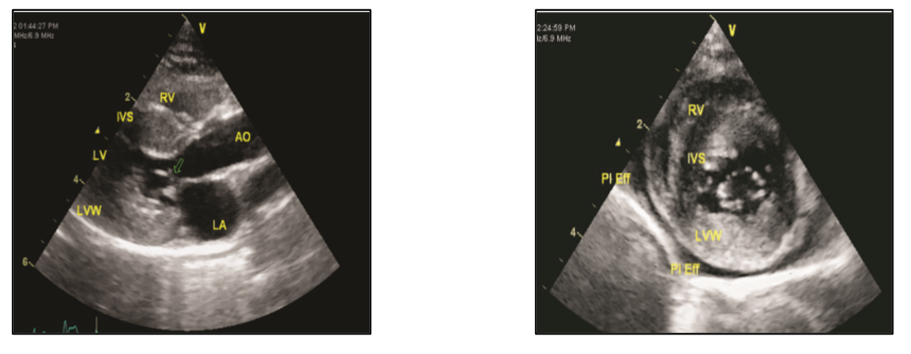

Fig 26-RPS Long axis 5 chamber view Fig27- RPS Short axis Papillary muscle view
Karsten et al. (2022) evaluated 68 cases of HCM in dogs with M-mode and 2-Dimension echocardiography.
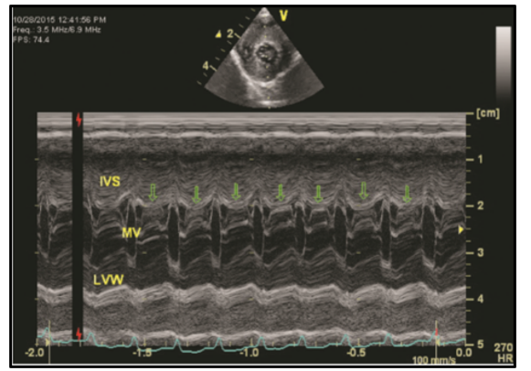
(Schober et al., 2022)
Fig. 28- Results of the Hypertrophic Cardiomyopathy in dogs
  - Mitral Valve Disease
Canine degenerative mitral valve disease (MVD) is a common heart condition that affects small to medium-sized dogs as they age. The mitral valve undergoes degenerative changes such as thickening and prolapse. These changes prevent the valve from closing properly, which causes the valve to leak (mitral regurgitation). Myxomatous mitral valve disease (MMVD) accounts for 75–80% of heart diseases in dogs and is more prevalent in small and elderly dogs.
Kim et al. (2017) diagnosed mitral valve degeneration in 168 small breeds of dogs by echocardiography at the College of Veterinary Medicine, Korea.
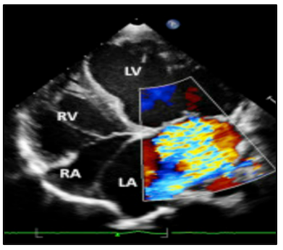
Fig 29-Left apical 4-chamber view with Colour Flow Doppler
(Kim et al., 2017)
  - Left Atrial Dilatation
In addition to mitral valve disease, left atrial dilation can occur with left-to-right pulmonary overcirculation, causing volume overload, but this is less common. In the lateral view, dilation of the left atrium in the dog causes a change in the shape of the dorsocaudal aspect of the cardiac silhouette.
Chronic and hemodynamically significant mitral regurgitation can cause LA and LV volume overload, leading to subsequent LA and LV enlargement. The severity of LA and LV remodelling can be assessed by the LA to aortic root ratio (LA/Ao) (Suh et al., 2021).
Safian et al. (2022) measured left atrial (LA) sizes and LA/Ao ratio in 36 dogs by 2D echocardiography.
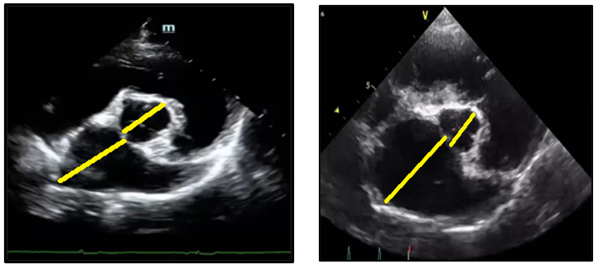
Fig 30-RPS Short Axis Aortic root view
(Safian et al., 2022)
- Limitations of Echocardiography
- The disadvantage is that it is user-dependent and requires extensive practice to master.
- Extremes in body sizes (obesity and cachexia) limit the acoustic windows and degrade the image quality of Trans-Thoracic Echocardiography (TTE). TTE is also limited in its views of structures.
- Main drawbacks are the limitations of echocardiography (Doppler and M-mode) angle dependency, and its inability to differentiate the velocity generated.
- Poor image quality could cause underestimation in obese and heavy patients.
- Echocardiography is a live imaging technique, unable to diagnose with images.
- Size and measurements vary according to body weight and breeds.
- Conclusions
Echocardiography is a non-invasive modality used for a structural and functional view of the heart. Cardiac ultrasound is used to diagnose congenital and acquired heart diseases. For Echocardiography, B-mode, M-mode, and Doppler-mode are commonly used. Echocardiography starts with the assessment of the 4-chamber view in 2D-mode, ends with M-mode, and includes Doppler mode. Abnormalities of the heart can be identified by using reference values (considering body weight or breed). Diagnosis is confirmed by systematic echocardiographic examination.
- Future prospects
Two-dimensional echocardiography has many limitations compared to three-dimensional echocardiography. Three-dimensional echocardiography is a promising technique and should be used routinely for better diagnosis of cardiac diseases. Three-dimensional transesophageal echocardiography is a better choice for the qualitative assessment of valves.
Artificial intelligence (AI) is changing the landscape of echocardiography, providing complementary tools to physicians to enhance patient care.
- References
- Abdikhoshimovich, K. J., Olimdjanovich, A. O., Pilania, H. & Kawale, K. V. (2023). Applications of Physics in Diagnostic Imaging. European Journal of Medical Genetics and Clinical Biology, 1(1), 4–13. https://doi.org/10.61796/jmgcb.v1i1.150
- Abduch, M. C. D., Assad, R. S., Mathias Jr, W., & Aiello, V. D. (2014). The Echocardiography in the Cardiovascular Laboratory: A Guide to Research with Animals. Arquivos Brasileiros de Cardiologia, 102(1), 97–103. https://doi.org/10.5935/abc.20130239
- Bomassi, E., Misbach, C., Tissier, R., Gouni, V., Trehiou-Sechi, E., Petit, A. M., Desmyter, A., Damoiseaux, C., Pouchelon, J.L. & Chetboul, V. (2015). Signalment, clinical features, echocardiographic findings, and outcome of dogs and cats with ventricular septal defects: 109 cases (1992-2013). Journal of the American Veterinary Medical Association, 247(2), 166–175 https://doi.org/10.2460/javma.247.2.166.
- Bonagura, J. D. & Herring, D. S. (1985). Echocardiography. Acquired heart disease. The Veterinary Clinics of North America. Small Animal Practice, 15(6), 1209–1224. https://doi.org/10.1016/s0195-5616(85)50366-6
- Bonagura, J. D., O’Grady, M. R. & Herring, D. S. (1985). Echocardiography: Principles of Interpretation. Veterinary Clinics of North America: Small Animal Practice, 15(6), 1177–1194. https://doi.org/10.1016/s0195-5616(85)50364-2
- Boon, J. A. (2011). Veterinary Echocardiography, 2nd ed. (pp. 46-59). John Wiley & Sons, Colorado, USA. https://www.wiley-vch.de/en/books/veterinary-echocardiography-978-0-8138-2385-0
- Buchanan, J. W. (2000). Vertebral scale system to measure heart size in radiographs. The Veterinary Clinics of North America. Small Animal Practice, 30(2), 379–393. https://doi.org/10.1016/S0195-5616(00)50027-8
- Chetboul, V., Charles, V., Nicolle, A., Sampedrano, C. C., Gouni, V., Pouchelon, J.-L. & Tissier, R. (2006). Retrospective Study of 156 Atrial Septal Defects in Dogs and Cats (2001-2005). Journal of Veterinary Medicine Series A, 53(4), 179–184. https://doi.org/10.1111/j.1439-0442.2006.00813.x
- Dave, J. K., Mcdonald, M. E., Mehrotra, P., Kohut, A. R., Eisenbrey, J. R. & Forsberg, F. (2018). Recent Technological Advancements in Cardiac Ultrasound Imaging. Ultrasonics, 84, 329–340. https://doi.org/10.1016/j.ultras.2017.11.013
- Eason, B. D., Fine-Ferreira, D. M., Leeder, D., Stauthammer, C., Lamb, K. & Tobias, A. (2021). Natural history of subaortic stenosis in 166 dogs (1999–2011). Journal of Veterinary Cardiology, 37, 71–80. https://doi.org/10.1016/j.jvc.2021.08.005
- Freid, K. J., Freeman, L. M., Rush, J. E., Cunningham, S. M., Davis, M. S., Karlin, E. T., & Yang, V. K. (2021). Retrospective study of dilated cardiomyopathy in dogs. Journal of Veterinary Internal Medicine, 35(1), 58–67. https://doi.org/10.1111/jvim.15972
- Gugjoo, M. B., Hoque, M., Saxena, A. C., Shamsuz Z., M. M., & Dey, S. (2014). Reference values of M-mode echocardiographic parameters and indices in conscious Labrador Retriever dogs. Iranian Journal of Veterinary Research, 15(4), 341–346. https://doi.org/10.22099/ijvr.2014.2589
- Hassani, S. (1974). Principles of ultrasonography. Journal of the National Medical Association, 66(3), 205–207. https://www.ncbi.nlm.nih.gov/pmc/articles/PMC2609158/
- Kasban, H. (2015). A Comparative Study of Medical Imaging Techniques. International Journal of Information Science and Intelligent Systems, (4), 37–58. https://www.researchgate.net/publication/274060000_A_Comparative_Study_of_Medical_Imaging_Techniques/fulltext/551121110cf21e141b59111a/A-Comparative-Study-of-Medical-Imaging-Techniques.pdf
- Kayar, A., Gonul, R., Or, M. E. & Uysal, A. (2006). M-mode echocardiographic parameters and indices in the normal German shepherd dog. Veterinary Radiology & Ultrasound, 47(5), 482–486. https://doi.org/10.1111/j.1740-8261.2006.00166.x
- Kim, H.T., Han, S.M., Song, W.J., Kim, B., Choi, M., Yoon, J., & Youn, H.Y. (2017). Retrospective study of degenerative mitral valve disease in small-breed dogs: Survival and prognostic variables. Journal of Veterinary Science, 18(3), 369–376. https://doi.org/10.4142/jvs.2017.18.3.369
- Lamb, C. R. (2004). Small Animal Radiology and Ultrasonography. A diagnostic atlas and text. In R., L. Burk & D. A. Feeney (3rd ed), (pp. 67-79). Saunders. https://www.ncbi.nlm.nih.gov/pmc/articles/PMC1764000/pdf/vetrec00070-0066.pdf
- M., B. G., Saxena, A., C. Hoque M., Zama & M., M. S. (2014). M-mode echocardiographic study in dogs. African Journal of Agricultural Research, 9(3), 387–396. https://doi.org/10.5897/AJAR2013.7867
- Mohamed, A. A., Arifi, A. A. & Omran, A. (2010). The basics of echocardiography. Journal of the Saudi Heart Association, 22(2), 71–76. https://doi.org/10.1016/j.jsha.2010.02.011
- Oliveira, P., Domenech, O., Silva, J., Vannini, S., Bussadori, R. & Bussadori, C. (2011). Retrospective Review of Congenital Heart Disease in 976 Dogs. Journal of Veterinary Internal Medicine, 25(3), 477–483. https://doi.org/10.1111/j.1939-1676.2011.0711.x
- Plummer, D. (1989). Principles of emergency ultrasound and echocardiography. Annals of Emergency Medicine, 18(12), 1291–1297. https://doi.org/10.1016/s0196-0644(89)80262-8
- Roth, G. A., Mensah, G. A., & Fuster, V. (2020). The Global Burden of Cardiovascular Diseases and Risks. Journal of the American College of Cardiology, 76(25), 2980–2981. https://doi.org/10.1016/j.jacc.2020.11.021
- Safian, A. M., Menciotti, G., Lahmers, S. M., Jeong, H., Franchini, A., & Borgarelli, M. (2022). Performance of Different Echocardiographic Measurements of Left Atrial Size in Dogs by Observers with Different Levels of Experience, 12(5), 625. https://doi.org/10.3390/ani12050625
- Satomura, S. (2005). Ultrasonic Doppler Method for the Inspection of Cardiac Functions. The Journal of the Acoustical Society of America, 29(11), 1181–1185. https://doi.org/10.1121/1.1908737
- Schober, K. E., Fox, P. R., Abbott, J., Cote, E., Luis‐Fuentes, V., Matos, J. N., Stern, J. A., Visser, L., Scollan, K. F., Chetboul, V., Schrope, D., Glaus, T., Santilli, R., Pariaut, R., Stepien, R., Arqued‐Soubeyran, V., Toaldo, M. B., Estrada, A., MacDonald, K., Rush, J. (2022). Retrospective evaluation of hypertrophic cardiomyopathy in 68 dogs. Journal of Veterinary Internal Medicine, 36(3), 865–876. https://doi.org/10.1111/jvim.16402
- Sinha, B. K., Uditi, & Rathore, A. (2022). Non-invasive cardiovascular imaging techniques. In I. Qamar & P. K. Maurya (Eds.), Cardiovascular toxicity and therapeutic modalities targeting cardio-oncology (pp. 113–141). Academic Press.
- Suh, S.I., Lu, T.L., Choi, R., Hyun, C., Suh, S.I., Lu, T.L., Choi, R., & Hyun, C. (2021). Echocardiographic Features in Canine Myxomatous Mitral Valve Disease: An Animal Model for Human Mitral Valve Prolapse. In M. S. Firstenberg & U. Lakshmanadoss https://doi.org/10.5772/intechopen.91819
- (Eds.), Advanced Concepts in Endocarditis - 2021 (pp. 31-60). Intech Open. https://doi.org/10.5772/intechopen.96909
- Thomas, W. P., Gaber, C. E., Jacobs, G. J., Kaplan, P. M., Lombard, C. W., Vet, M., Moise, N. S., & Moses, B. L. (1993). Recommendations for Standards in Transthoracic Two-Dimensional Echocardiography in the Dog and Cat. Journal of Veterinary Internal Medicine, 7(4), 247–252. https://doi.org/10.1111/j.1939-1676.1993.tb01015.x
- Yitbarek, D. & Dagnaw, G. G. (2022). Application of Advanced Imaging Modalities in Veterinary Medicine: A Review. Veterinary Medicine: Research and Reports, 13, 117–130. https://doi.org/10.2147/VMRR.S367040

