Case Report

Intrathoracic Kidney with Bochdalek Hernia Revealed by Pneumonia: A Case Report

.
ABSTRACT

Aims: To describe a rare presentation of intrathoracic renal ectopia associated with a right-sided Bochdalek hernia, incidentally identified during evaluation for acute respiratory symptoms, and to highlight its potential impact when combined with underlying pulmonary disease.
Presentation of Case: A 70-year-old male, chronic smoker, was admitted for dyspnea and fever. Thoracic CT (Computed Tomography) revealed right-sided pleuropneumopathy in emphysematous lungs and incidentally identified a right intrathoracic ectopic kidney associated with a homolateral Bochdalek hernia. Renal morphology and function were normal, and the patient reported no abdominal or urinary symptoms.
Discussion: Intrathoracic renal ectopia is a rare congenital anomaly, occurring in less than 5% of ectopic kidney cases. It is frequently associated with a Bochdalek hernia due to pleuroperitoneal membrane fusion failure. Typically asymptomatic, it is often discovered incidentally during thoracic imaging. Its intrathoracic position may reduce ipsilateral lung volume, and while renal function usually remains preserved, respiratory function may be further impaired in the presence of underlying lung disease. In this case, the coexistence of emphysema, pneumonia, and reduced thoracic space likely contributed to respiratory compromise. Standard radiography may suggest a thoracic mass, but definitive diagnosis relies on CT, ultrasound, or MRI.
Conclusion: Intrathoracic kidney with Bochdalek hernia is usually asymptomatic but may become clinically relevant when associated with pulmonary disease due to reduced respiratory capacity. Awareness of this entity helps prevent misdiagnosis and supports accurate assessment of thoracic symptoms.

Keywords: Ectopic Kidney, Thoracic Diseases, Congenital Abnormalities, Bochdalek Hernia, Dyspnea, Computed Tomography

1. INTRODUCTION

The intrathoracic kidney, a very rare localization, has a prevalence of 1 in 10,000 cases and constitutes less than 5% of all renal ectopias (Hosseinabadi et al., 2019).
The intrathoracic position reduces lung volume, but respiratory function usually remains preserved, which explains the absence of clear clinical symptoms (Rattan et al., 2009).
Often diagnosed early in childhood, it is rarely associated with homolateral Bochdalek's hernia, and frequently remains incidental (Rattan et al., 2009; Al Eraky et al., 2022). Standard radiology has no specificity and shows an indistinct opacity. Ultrasound, CT, and MRI can provide diagnostic confirmation (Kian et al., 2022; Rattan et al., 2009).
We present a 70-year-old patient, chronic smoker, admitted for febrile dyspnea, in whom a thoracic CT scan shows pneumonia on an emphysematous lung and intrathoracic renal ectopy associated with a Bochdalek hernia on the same side. It has rarely been described that chronic lung disease, progressing towards destruction of the lung parenchyma, reveals intrathoracic renal ectopy. Although the diagnosis is incidental, the prognosis of lung disease may worsen because the ectopy already reduces functional lung parenchyma.
2. PREsENTATION OF CASE

A 70-year-old male of North African origin was admitted to hospital with a diagnosis of febrile dyspnoea. The subject had a documented history of chronic tobacco use and was from a low socio-economic background. The patient and his relatives did not report any significant past medical or surgical history. The patient exhibited symptoms of dyspnoea, characterised as chronic and exertional. However, recent observations revealed that this condition had deteriorated acutely, coinciding with the presence of fever, productive cough, and localised right-sided chest pain.
On initial assessment, the patient exhibited signs of respiratory distress while maintaining stable hemodynamic parameters, adequate peripheral oxygen saturation, and a full Glasgow Coma Scale score. Laboratory investigations revealed marked leucocytosis (22,850/mm³) with normal haemoglobin levels and preserved renal function.
A thoraco-abdominal contrast-enhanced CT scan was performed, revealing several findings. Pulmonary window images revealed advanced emphysematous changes, characterised by the destruction of alveolar architecture and reduced parenchymal density (as shown in Fig. 1).
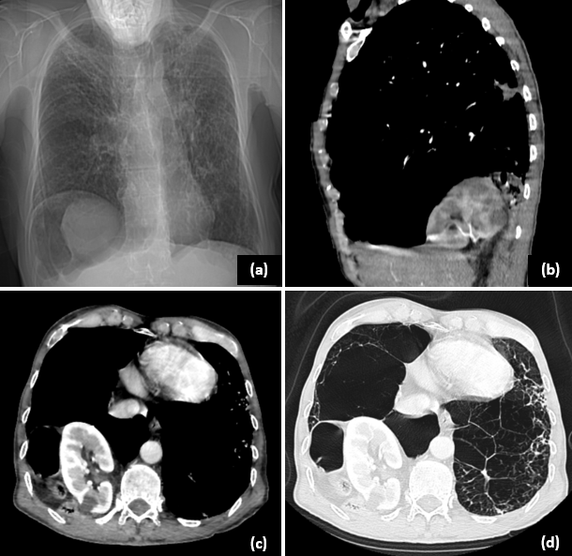
Fig. 1. Topogram showing a right basithoracic opacity (a). Contrast-enhanced thoracic CT in mediastinal window on sagittal (b) and axial (c) sections confirms a right intrathoracic kidney within a Bochdalek hernia. The axial lung window (d) demonstrates severe emphysematous changes with reduced right lung volume adjacent to the ectopic kidney.
Additionally, focal areas of parenchymal consolidation and a small right-sided pleural effusion were identified. Unexpectedly, the imaging also revealed a right-sided intrathoracic renal ectopia associated with a posterior diaphragmatic defect consistent with a Bochdalek hernia (as shown in Fig. 1 and Fig. 2).
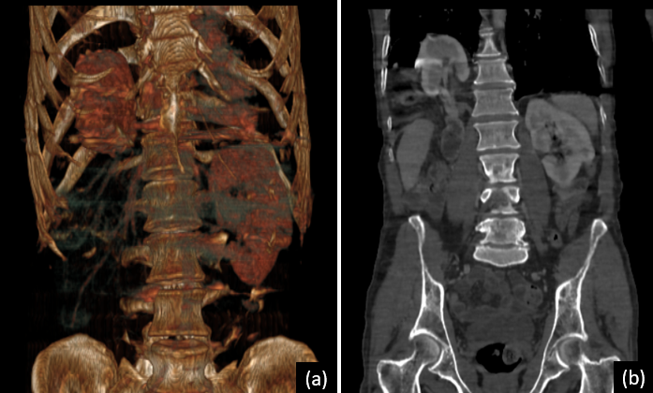
Fig. 2: Volume rendering image (a) and coronal section (b) of a thoraco-abdominal CT scan, demonstrating intrathoracic kidney ectopia with vascular pedicle angulation.
During the arterial phase of contrast enhancement, the right renal artery was observed to arise abnormally from the distal thoracic aorta (as shown in Fig. 3).
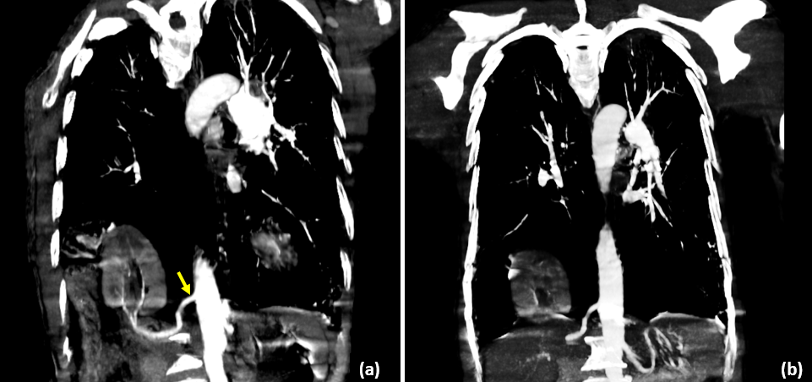
Fig. 3: Oblique (a) and coronal (b) sections in arterial phase showing a Bochdalek hernia containing the right kidney, with plication of the renal artery arising from the proximal part of the abdominal aorta, before the origin of the celiac trunk (yellow arrow).
This series of findings underscores the clinical and diagnostic intricacy of the case. The concomitant presence of chronic pulmonary disease, undiagnosed congenital diaphragmatic hernia, and renal ectopia, which was only discovered incidentally, suggests the possibility of a long-standing underlying condition that has been compounded by restricted access to healthcare and socio-economic disadvantage. The emphysematous changes, in particular, explain the baseline chronic dyspnoea and impaired respiratory reserve, while the intrathoracic renal position likely imposed additional restrictive effects on lung function.
The acute infectious episode appears to have precipitated a decompensation that led to the discovery of these congenital anomalies. The aberrant vascular anatomy, including the thoracic origin of the renal artery, further highlights the embryological complexity of the case. Collectively, these elements reflect a rare and multifaceted clinical presentation, necessitating integrated diagnostic reasoning.
The patient received conservative care involving antibiotic therapy and oxygen supplementation, resulting in marked clinical improvement. In view of the absence of any immediate complications and the incidental nature of the congenital findings, a decision was taken to pursue a course of therapeutic abstention with regard to the renal ectopia and diaphragmatic hernia. This case demonstrates the significance of thorough imaging in identifying silent congenital anomalies, particularly in patients exhibiting atypical or unexplained respiratory deterioration.

3. DIScUSSION

Intrathoracic renal ectopia is an exceptionally rare entity, accounting for less than 5% of all renal ectopias and occurring in approximately 1 in 10,000 ectopic kidneys, with a slight male predominance and a typical left-sided location (Kian B et al., 2022).
Association of the intrathoracic kidney with a Bochdalek hernia is rare and has been reported in approximately 0.25% of cases (Carrasco A et al., 2018) (Al Eraky et al., 2022).
In our case, the patient was also male but presented with a right-sided diaphragmatic defect, highlighting an atypical laterality compared with the predominant left-sided presentation described in the literature. (Panda et al., 2009).
The aetiology of this malformation remains uncertain. However, several embryological hypotheses have been proposed, including aberrant renal development during the embryonic period or the persistence of a pleuroperitoneal communication during diaphragmatic development, both of which may allow renal ascent into the thoracic cavity (Gunadi et al., 2020).

This anomaly is classified into four groups defined by Pfister-Goedeke and Brunier. There is ectopy with intact diaphragm, with diaphragmatic eventration, with congenital or acquired diaphragmatic hernia, and with traumatic rupture of the diaphragm (Carrasco A et al., 2018). Our present case corresponds to the variant associated with congenital posterolateral herniation.
The intrathoracic displacement of abdominal organs inevitably affects the development of the lung parenchyma (Peri et al., 2021). And sometimes, it can have an impact on respiratory function, especially in the paediatric population (Rattan KN et al., 2009) (Taha et al., 2024)
However, in adults, the condition is often asymptomatic, and renal function is typically preserved (Maibom SL et al., 2019). Consistent with the literature, our patient exhibited normal renal function and no urological symptoms despite the ectopic kidney occupying a substantial portion of the right hemithorax.

Radiological evaluation plays a central role in the diagnosis of this anomaly. Chest radiography usually reveals a nonspecific thoracic opacity, necessitating further assessment through cross-sectional imaging. Although ultrasound may be contributive, especially in children, its utility is limited when the ectopic kidney is located high in the thorax. For a formal diagnosis, CT scans and MRI are the modalities of choice (Rattan et al., 2009).

The significance of this case lies in the rare interplay between an intrathoracic ectopic kidney, and a congenital diaphragmatic defect., and the right-sided anomaly. In our patient, the acute infectious episode likely precipitated a decompensation that revealed both the ectopia and the diaphragmatic defect. It is imperative to emphasise the necessity to adapt the therapeutic approach to this uncommon condition, and to consider renal ectopy as a differential diagnosis.

Given the absence of complications, the stability of renal function, and the incidental nature of the findings, conservative management was deemed appropriate. This approach is supported in the literature, which recommends intervention only in cases of obstruction, recurrent infection, vascular compromise, or symptomatic mass effect. This case reinforces the diagnostic value of cross-sectional imaging in uncovering silent congenital anomalies and underscores the need to consider thoracic kidney in the differential diagnosis of atypical intrathoracic opacities.

4. Conclusion

Intrathoracic kidney with Bochdalek hernia is usually asymptomatic but may become clinically relevant when associated with pulmonary diseases due to respiratory limit capacity.
Awareness of this entity helps avoid misdiagnosis and supports appropriate assessment of thoracic symptoms.

Abbreviations
MRI: Magnetic Resonance Imaging.
CT: Computer Tomodensitometry.

Consent

Written informed consent was obtained from the patient for publication of this case report and accompanying images. A copy of the written consent is available upon request.
Ethical approval

Not applicable.

References

- Hosseinabadi, F., Hekmatnia, A., Hekmatnia, F., & Lotfiazar, A. (2019). Ectopic intrathoracic kidney along with right anterior diaphragmatic hernia. Iran J Pediatr, 29(4), e89043. https://doi.org/10.5812/ijp.89043 .
- Rattan, K. N., Rohilla, S., Narang, R., Rattan, S. K., Maggu, S., & Dhaulakhandi, D. B. (2009). Thoracic kidney associated with congenital diaphragmatic hernia. Congenital Anomalies (Kyoto), 49(3), 118–120. https://doi.org/10.1111/j.1741-4520.2009.00237.x .
- Al Eraky, M., Hassan, L., Abou Zaid, A., & Arabi, H. (2022). Congenital intrathoracic ectopic kidney in association with Bochdalek hernia. Cureus, 14(2), e22674. https://doi.org/10.7759/cureus.22674 .
- Kian, B., Kayedi, M., & Teimouri, A. (2022). Intrathoracic kidney: A rare presentation of ectopic kidney. Radiology Case Reports, 17(8), 2795–2797. https://doi.org/10.1016/j.radcr.2022.05.036 .
- Carrasco, A., & Castro, R. (2018). Right diaphragmatic eventration with an intrathoracic kidney: Case report and review of the literature. Case Reports in Surgery. https://doi.org/10.1155/2018/2631391 .
- Panda, B., Rosenberg, V., Cornfeld, D., & Stiller, R. (2009). Prenatal diagnosis of ectopic intrathoracic kidney in a fetus with a left diaphragmatic hernia. Journal of Clinical Ultrasound. https://doi.org/10.1002/jcu.20503 .
- Gunadi, Balela, N., Marcellus, Fauzi, A. R., & Dwihantoro, A. (2020). Eventration of right diaphragm with an intrathoracic ectopic kidney: A case report. Annals of Medicine and Surgery, 57, 179–182. https://doi.org/10.1016/j.amsu.2020.07.034 .
- Peri, V., Jiang, M., & Kabir, T. (2021). Dyspnea caused by Bochdalek hernia associated with intrathoracic kidney. Clinical Gastroenterology and Hepatology, 19(8), A21. https://doi.org/10.1016/j.cgh.2020.04.051 .
- Taha, I. A. A., Ibrahim, M. Y., Helali, M., Taha, S. M. E., Alshareif, B. A., Altayeib, H., Idriss, R., & Abdalgadir, E. S. (2024). Intrathoracic ectopic kidney with pulmonary sequestration: clinical and surgical insights: a case report. Journal of Surgical Case Reports, 2024(12), rjae757. https://doi.org/10.1093/jscr/rjae757 .
- Maibom, S. L., Ryom, P., & Schou-Jensen, K. (2019). Left sided flank pain due to Bochdalek hernia with intrathoracic kidney. Scand J Urol, 53(1), 79–80. https://doi.org/10.1080/21681805.2018.1545798 .

