LEVERAGING BLOCKCHAIN, ARTIFICIAL INTELLIGENCE, AND DATA ANALYTICS FOR SUSTAINABLE AND TRANSPARENT RESOURCE MANAGEMENT

Abstract
The rising complexity in current resource management projects has generated demand for transparent, efficient, and sustainable operational systems. Current research work focuses on identifying the importance of Blockchain, Artificial Intelligence, and Data Analytics in improving transparency, efficiency, and sustainability in resource management projects from 2018 to 2025. Quantitative research methodology was adopted for analysis, incorporating a structured data pool with 1,200 projects in ten geographic regions and eight different resource management types. Indexes such as Transparency Index, Emission Reduction, Budget, Data Volume, and Project Duration were assessed for analysis with Python-based analysis tools.
This research evaluated individual and collective impact of Blockchain and AI adoption on project performance. The result shows that adoption of Blockchain technology leads to improved transparency, while adoption of AI improves sustainability performance, specifically in emission reduction. Joint adoption of Blockchain and AI showed best overall performance in projects, although with enhanced financial, processing, and timeline costs. Visualization techniques such as scatter plots and box plots identified correlations regarding impact levels in data size, transparency, and performance, emphasizing importance in having overall technology systems. These findings indicate that the combined use of Blockchain, AI, and analysis is resulting in more responsible and data-driven resource management. At the same time, there is an increase in costs for implementation, coupled with extended project schedules. It is proposed to embrace overall digital architectures, skill development in information technology, and policy initiatives in support of data transparency for achievement in resource management. On the whole, there emerges experimental validation in support of strategic integration for efficient, transparent, and sustainable resource management outcomes.

Keywords: Blockchain, Artificial Intelligence, Data Analytics, Sustainability, Transparency, Resource Management
Introduction
Transparency, accountability, and efficiency in managing natural resources in these companies require new approaches, which include the use of new technology such as blockchain, AI, or data analytics. As natural resources are coming under ever more pressure, natural resource governance remains a pressing issue. As a result, natural resource transparency and accountability are fast emerging as important considerations in natural resource management. (Maja & Ayano, 2021) “Many developing nations with rapidly expanding populations are struggling to cope with natural resource depletion, illicit extraction, misrepresentation, or losses along the entire value chain. Inadequate real-time surveillance or dispersed computer data does not make natural resource management easier”.
In the past decade, there has been a shift brought about by new digital technology that impacts how we manage, regulate, and improve resource systems. (Hariyani et al., 2025) Blockchain technology, for instance, is being highlighted for its ability to record data that cannot be altered. The technology will enable sectors that are using a lot of resources to achieve accountability (Asgharzadeh Shiadeh, 2023). According to (Krishna, 2023) Blockchain technology is decentralized, which allows transaction history, audits, and compliance to be recorded in a way that cannot be easily interfered with”. At the same time, (Rashid & Kausik, 2024) artificial intelligence is unlocking new value in terms of demand forecasting insight, anomaly detection, fraud analysis, and complex analysis. (Balan, Kumar, & Raj, 2025) “Machine learning algorithms are being harnessed for supply variation forecasting, optimizing routes to distribute supplies based on demand, detecting anomalies in consumption trends, and analysing sustainable supply allocation”. Combined with larger systems in place, artificial intelligence has the ability to transform data into actionable intelligence. Data analytics adds another layer to these technologies to help realize resource flows and environmental dimensions. (Oncioiu et al., 2019) Data analytics uses advanced models to evaluate trends to enable decision-makers to quantify long-term resource implications. These technologies use data analytics to create a more informed approach related to resources to evaluate trade-offs between economic benefits, environment consequences, or other sociological outcomes. The use of these technological forces enhances well-being. Together, blockchain technology, artificial intelligence, and data analysis are poised to forge a formidable digital environment that not only holds great promise but actually has the potency to dramatically shift the manner in which resources are managed. In fact, data analysis offers the analysis or perspicacity that can guide sustainability thinking. At the same time, use of technology offers the transparency that should allow sustainability to resist the lure of graft. It investigates the contribution to sustainable outcomes from these technologies on a set of 1,200 projects from different industries such as water, agriculture, forestry, and municipal waste management projects from across the world. Using statistics, visualization, and group comparison on the median value, it draws conclusions about projects enabled by blockchain, showing improved transparency levels and achievement in emissions reduction, while projects aided by AI have shown better levels of data intensity and optimization for efficiency. Combined use of blockchain and AI leads to optimal levels on governance, highlighting their synergy in improving transparent management systems for the environment.
Purpose of the Study
The primary objective of this research work shall be to explore the potential role of the amalgamation of blockchain technology, AI, and data analytics in improving the sustainability, transparency, as well as accountability associated with resource management systems.
- In order to understand the existing level of resource management practices, as well as the transparency, traceability, and sustainability gaps.
- Evaluating the potential of the use of blockchain technology in improving the aspects of trust, accountability, and traceability in resource governance.
- The project aims to explore the manner by which AI-driven predictive analytics can help in effective resource allocation, environmental monitoring, as well as decision-making.
- For the purpose of analyzing the role of data analytics in the detection of patterns, as well as the work of The Environmental Working Group in the formulation of evidence-based policies in relation to
- In order to analyze the synergetic advantages derived from the convergence of blockchain technology, AI, and data analytics in the form of an integrated digital platform for the management of sustainable resources.
- Develop an integrated conceptual model that explains how the aforementioned emerging technologies could work in a collective manner to enhance transparency, fight corruption, as well as ensure sustainability.
- In order to form the basis for proposing strategic recommendations to policymakers, industries, as well as stakeholders, related to the use of digital technology in a long-term, sustainable, as well as transparent manner.
Review of related literature:
The high growth of blockchain technologies and artificial intelligence has accumulate notable awareness, this has made researchers put more interest in trying to make clear with their individual applications within different industries.
An extensive body of literature has emerged examining the multifaceted aspects of AI and blockchain, and data analytics laying the groundwork for understanding their respective roles in digital transformation Zahidi et al. (2024). A considerable amount of research has focused on AI, exploring its diverse applications across multiple domains Aakula et al. (2024). AI has been lauded for its ability to process vast amounts of data and extract actionable insights, thereby enabling enhanced decision-making and operational efficiencies Al-Zahrani (2024). The literature delineates various AI techniques, including machine learning, natural language processing, and neural networks, elucidating their applications in sectors such as healthcare, finance, and manufacturing (Ali et al., 2023). For instance, studies have demonstrated how AI algorithms can improve diagnostic accuracy in medical imaging and facilitate predictive maintenance in manufacturing environments. Researchers have also emphasized the potential of AI in augmenting customer experiences through personalized recommendations and intelligent virtual assistants, underscoring its transformative potential in driving innovation and enhancing service delivery.
Using blockchain's immutable ledger and decentralization, AI can improve data transparency and security, addressing challenges like explainable AI. For example, in supply chain management, blockchain ensures the traceability and authenticity of products, while AI analyses data to predict demand and optimize logistics.
Recently, there has been a growing emphasis on the importance of the convergence of blockchain, AI, and data analytics as a way in which sustainability in resource management can be improved. In the past, research focused on the potential of each technology in isolation, but currently, there is an emphasis on the importance of ecosystems in this regard. Blockchain technology has long been acknowledged for its usability in improving the level of transparency through the creation of an immutable trail of resource movement in supply chains. Several research studies support the usability of distributed ledger technology in minimizing information asymmetry, as well as reducing illegal behavior, as well as improving the monitoring of extraction, certification, and distribution stages within supply chains (Khan et al., 2021; Saberi et al., 2019). The usability of blockchain technology has been identified in the mining, agriculture, and waste sectors, where it has led to improved traceability as well as regulatory compliance (Helo & Shamsuzzoha, 2020). In complement, the role of machine learning algorithms in predicting supply chain disruptions, environmental risks, and dynamic allocation of resources in the context of AI-driven optimisation strategies has been highlighted in the literature available on AI optimisation. The success of AI algorithms in water resource allocation, energy supply chains, biodiversity management, and mineral processing activities has also been reported in existing literature (Rolnick et al., 2019; Gupta et al., 2020). Further, AI increases the authenticity of data, which, in turn, increases the authenticity of the sustainability platform based on the blockchain technology used. On the other hand, research related to big data analytics focuses on the role it plays in the detection of invisible trends related to consumption, environmental issues, as well as supply chain activities. Data analytics in the environmental sector has been applied in estimating the carbon footprint, extraction hotspot, as well as inefficiencies in the industrial process (Marjani et al., 2017, (Er & Al Mosawi, 2023)). The role it pays in resource planning has been described as crucial by various scholars. Another developing area of research in the literature explores the synergy between blockchain technology, AI, and data analytics, most notably in the context of the circular economy concept, eco-certification, as well as open carbon markets. The integrated approach enables the use of environmental information collected by IoT sensors, which AI systems can decode and verify, while the role of blockchain technology revolves around the immutability of these processes (Kouhizadeh & Sarkis, 2022). Data analytics helps in turning this secure data into sustainability measures for governments as well as industrial entities. The literature emphasizes the significance of this synergy in improving end-to-end accountability, ranging from the extraction to disposal stages of materials (Rejeb et al., 2022). Academics also emphasize the role of governance frameworks and the institutional preparedness that needs to exist in this scenario. The technological capacity available can never ensure transparency in this regard, as it depends entirely upon proper policy measures, the use of proper data governance, as well as the institutional ability to adapt technology in existing systems, as argued by Kamble et al. in 2021. Finally, research evidence confirms the role of digital technology in facilitating the management of resources in an equitable manner in the community. This is because open ledgers can provide information concerning resource use in a manner that promotes accountability, reducing the possibility of fraud associated with resource management in the community. The use of technology, therefore, aligns well with the objectives of the United Nations in terms of sustainable development.
Blockchain and AI
According to (Susnjara, 2025) “Combining blockchain and AI creates new opportunities for businesses across various industries. Using blockchain’s immutable ledger and decentralization, AI can improve data transparency and security, addressing challenges like explainable AI. For example, (Hariyani et al., 2025) in supply chain management, blockchain ensures the traceability and authenticity of products, while AI analyses data to predict demand and optimize logistics. (Chinonyerem, 2024) AI helps automate risk assessments in financial services, while blockchain secures transactions and ensures compliance”.
Digital Technology
The exponential growth rate of digital technology over the past decade has initiated new approaches to fix long-remaining gaps in natural resource management related to a lack of transparency, inadequate monitoring mechanisms, and inefficient allocation. One can notice an emerging consensus in academic communities and practitioner circles to use blockchain technology, artificial intelligence (AI), or data analytics not merely separately but rather collectively in a digital environment. It serves to expose the central hypothesis presented in the contemporary study:Holistically improved efforts are possible in terms of both improved transparency and sustainability.
Blockchain, traceability, auditability
"The prime value addition provided by Blockchain technology lies in its capability to establish immutable timestamped records that improve traceability in multi-party supply chains and public schemes. Karaduman, et al (2025). " In fact, (Atadoga et al., 2025)"blockchain technology can improve traceability related to immutable audit trails and potentially reduce information asymmetry when applied to flows of resources (e.g., supply chains related to commodities or land tenure, or public sector purchase schemes) (Lv et al., 2023).” At the same time, "it has become clear that blockchain technology cannot represent a 'silver bullet' solution. Benefits are dependent upon correct ‘on-’/’off-’chain’ design or quality of input data. “Some synthesis papers focus more on governance architectures that combine the technology features of blockchain with policy levers to address both corruption and accountability. These papers contend that the success of blockchain lies not so much in its cryptographic security but in integrating its tracing features into various sectors for which auditibility alters incentives. Nevertheless, empirical studies see a mixed record concerning adoption in less-advanced contexts due to uncertainties and integration costs.
3. Artificial Intelligence - prediction, optimization and monitoring
AI applications in environmental prediction, anomaly detection, and optimization methods for resource allocation are well explored Olawade et al. (2024). There are reviews indicating developments in using AI for sustainability in areas like energy control, water supply system optimization, land use analysis, and maintenance procedures that are closely related to resource conservation Pimenow,et al (2025). Notably, AI enhances the use of data available to us to make decisions almost instantly Kumar, et al (2024). One begins to see emerging debates around responsible use of AI, interpretability methods for optimizing AI models’ decision processes, or its carbon footprints (data center energy/water use).
4. Data analytics and big data methods for data monitoring & evaluation
Data analytics serves as the integrating thread that weaves diverse data sources (remote sensing data, IoT data, administrative data) into informative signals. Systematic reviews demonstrate that big data analytics enhances resource stress surveillance, informs evaluation or assessment of performance, and refines targeting Bhumichai,et al ( 2025). At the same time, there are prevailing indications in the literature of the need to address issues related to data stewardship or data governance, data inter-operability, or effective preprocessing to mitigate biases in data. These are some common barriers to whether or not data analysis-related gains are achievable.
5. The integration of blockchain, AI, and analytics synergies and friction A new set of literature focuses on the combination of blockchain technology and AI. The synergy between these two technologies seems obvious. While blockchains provide provenance and integrity protection for data, AI can use data to create intelligence that predicts outcomes or detects anomalies. Some literature reviews illustrate that there are prototypes involving these two areas that use hashes to secure data from sensors so that machine learning algorithms can use auditable data to make predictions or control something. But putting these two components together does pose some challenges. These challenges include latency issues in blockchains, or trade-offs between privacy or transparency. There are also energy issues involving machine learning algorithms.
Regional and institutional considerations - evidence from developing contexts Some regional studies point to the significance of institutional capacity to technology potential. Case studies in Nigeria or Sub-Saharan Africa point to common obstacles to technology implementation minimal technology infrastructure, unclear policy guidelines, Oghuvbu, et al (2022) lack of expertise, or political economy which could reduce the effectiveness of technology-based interventions if these are not supplemented with institutional building or policy guidelines. Research in (Fasinu et al 2024) technology implementation from Nigerian academic centers has pointed to regional proofs-of-concept (security of documents or tracing substances in supply channels), but continue to affirm resilience to regional political structures.
What is transparency in data analysis?
According to Alexis Porter, (2025) “Data transparency refers to the clear, open, and honest handling of data within an organization. It means that businesses, governments, and institutions disclose how they collect, store, use, and share data, ensuring users, customers, and stakeholders understand their practices. In today’s digital-first world, data transparency is not just a compliance requirement it’s a critical factor in building trust, maintaining security, and ensuring ethical business operations”.
Data Analytics for Sustainable, Transparent, and Responsive Resource Management
Data analysis has emerged as an essential driver for efficient, sustainable, and transparent resource management. By having the capacity to process large amounts of data, an organization is not only able to monitor their resource utilization, but also analyze their effect on the environment, thereby improving their management frameworks. With growing concerns about managing land, water, energy, and materials sustainably, there is now a growing demand for data analysis.
One major advantage of data analytics is that it offers improved visibility in resource flow management. For example, Er and Al Mosawi (2023) highlighted big data’s value in creating efficiency in manufacturing, minimizing wastage, and improving sustainable manufacturing systems. Additionally, in urban and environment management, data analytics offers real-time monitoring, which means improved regulation. Salah, et al in Salah, Hamad, Al-Hayysam, Al-Rahbi, And Al-Smadi (2018), for example, highlighted improved systems based on assured data’s value in ensuring integrity, trust, and honesty in resource management. Another important aspect in which predictive analytics is involved is in sustainability. By means of forecasts, companies are able to predict shortages in their supply, areas with environmental hazards, and, most significantly, outcomes from resource mining. It has been demonstrated by Helo and Shamsuzzoha (2020) that real-time analytics in the supply chain improves transparency levels in big logistics networks. Moreover, data analytics improves environmental governance with its capacity to facilitate sustainable reporting. Demirkan, Cam, Dalkiran, Yuldashev, and Bilgin emphasize that data-based reporting improves transparency in performance measurement, as it is measurable in comparison to other industries (Demirkan, Cam, Dalkiran, Yuldashev, Bilgin, 2021).
Data analysis applications also extend to environmental conservation by combining geospatial data with remote sensing. Marjani et al. (2017) provide evidence to demonstrate that big data analysis facilitated by IoT technology enhances land use, water, and pollution management in such-a-waythat decision-makers are able to respond promptly to environmental hazards. This is becoming more urgent due to climate changes in natural resources availability.
Moreover, there is evidence to support that analytics enables circular economy approaches. Analytics, according to Zheng, Li, Chan, Li, and Yung (2018), ensures transparency in product flow, thereby encouraging ethical procurement, as well as responsible disposal practices. Transparency achieves this through the monitoring of materials from start to end in their cycles.
Blockchain Technology for Sustainable and Transparent Resource Management
The importance of resources
Blockchain technology is increasingly being identified for its use in improving the levels of sustainability and transparency in the management of resources. Blockchain technology has the capacity to track resources from point of origin to point of use while promoting environmentally responsible practices.
Blockchain’s Transparency in Another Major Sector: Supply Chain Transparency
One major sector where transparency via blockchain technology is necessary is in supply chain management. Varma, Dixit, Ray, and Kaur (2024) support that, with blockchain, supply chains become traceable, immutable, decentralized, hence lowering chances for any kind of fraudulent practices, such as unethical sourcing, to occur in supply chains. Their analysis demonstrates that blockchain technology has the capacity to facilitate all dimensions of sustainability: economic, social, and environmentally by providing every stakeholder with an ‘immutably shared record.’ Within the scope of managing natural resources, the use of blockchain technology stands out in auditing, managing, and tracing natural resources. Pradhan, et al (2025) proffers a ‘blockchain model for managing environment resources.’ Their model permits real-time auditing with respect to resource utilization, thereby increasing ‘accountability’ while preventing ‘resources from getting wasted.’ Blockchain technology also promotes energy efficiency, resource conservation, and new designs in consensus algorithms. Zimba,et al (2025) did a systematic literature review on energy efficiency in blockchains. They discuss ways in which new designs in consensus algorithms are being used to make blockchains energy-efficient for resource management applications.
One such valuable use case is in waste management. Faiz, et al. (2024) examined its applications in sustainable waste management. It shows that blockchain technology is able to manage the entire process from point of creation to final disposal in an accountable manner. It has the advantage of regulations being followed by smart contracts, with integrity in data due to its immutable nature.
Within fishing and biodiversity, there has been promising potential for sustainability with the use of blockchain technology and artificial intelligence. Alsharabi, et al. (2024) have described how fish resources in the world’s oceans could be conserved in a biologically diverse and sustainable manner via blockchain technology and AI. By means of blockchains, fish could be traced from sea to plate.
On the financial front, regenerative finance is being associated with Blockchain. Roy and Zaher (2025) discuss the relevance of Blockchain to sustainable finance, stating that financial systems based on Blockchain technology could facilitate regenerative economic models based on enhanced capital flow transparency and decentralized Green Finance platforms.
Although promising, there are some challenges for its resource management. These include its scalability, interoperability, data privacy, and high energy costs. For instance, in their analysis, Vladucu, et al. (2024) indicate, for example, in environmental blockchains, there is a need to align the cost of consensus algorithms with creating records that have to be immutable. To facilitate adoption, innovation brokers, green tech SMEs, among other intermediaries, play an essential role in pushing innovation in such areas. Zimba, (2025), note new architectures for consensus and lean blockchains, which could lower costs, thereby increasing viability for green tech applications.
Artificial Intelligence for Sustainable and Transparent Resource Management
According to Toderas, M. (2025). "Artificial Intelligence (AI)-related applications have an immense promise for improving sustainability and transparency in resource management. By taking advantage of predictive analytics, machine learning, and decision support systems, Galaz et al. (2021) have enabled efficient use of natural resources, improved governance, and enhanced responsibility in areas like water, energy, biodiversity, and protected areas."
Sustainable Management for the Water-Energy-Food Nexus
Within the context of integrated resource management, Artificial Intelligence applications have the potential to optimize the nexus between water, energy, and food by addressing their interdependencies in a complex manner. According to Barbato et al. in 2022, Artificial Intelligence enhances sustainable business models in water, energy, or food nexus systems through predictions regarding demand for these resources. More specifically, Artificial Intelligence’s role in WEF’s sustainability efforts involves combining remote sensing information, stakeholder theory, and innovation management. Artificial Intelligence in the Water-Energy-Food Model.
A Holistic Approach explains:
Artificial Intelligence serves to facilitate coordination efforts among stakeholders for optimal resource allocation, such that the Sustainable Development Goals are achieved while optimizing resource use.
Water Resource Management
One of its most established applications is in water resource management, with Artificial Intelligence being at its core. Artificial Intelligence’s applications in water resource management have been discussed comprehensively by Krishnan, et al. (2022), highlighting Artificial Intelligence, in association with IoT, to improve water distribution, leak detection, and water quality. It not only preserves water, in addition to being opaque, it also enables stakeholders to monitor water use, forecast water demand, and make interventions when indications of water stress emerge.
Whilst there isn't conclusive proof, some
In protected areas or biodiversity conservation, AI is being utilized to make resource management for these areas more sustainable. Researchers in Sustainability (2025) have indicated that AI technology such as image recognition, predictive models, or monitoring systems is useful in identifying illegality in protected areas such as poaching, managing biodiversity, or designing conservation plans for many years to come.
AI embedded in governance mechanisms enables decision-makers to have better, data-informed insight into ecosystem dynamics, thus ensuring responsible allocation and conservation of resources.
Innovation, Risk, and Sustainability
On systems-thinking grounds, not only does AI utilize resources optimally, it also facilitates management in areas concerning risk and innovation. Speaking in their edited book, Sarea, et al. (2025) shed light on ‘how AI-based sustainable innovation management could enable predictions for environmental risks, optimal resource allocation, and transparent business networks.’ It enables the embedding of AI in innovation management, which in turn provides companies with tools to align innovation with sustainability and transparency.
Challenges, Trade-Offs, and Though Artificial Intelligence have tremendous opportunities, there are some trade-offs too. Artificial Intelligence, according to Pradeep Kumar, et al. (2024), could have some ‘hidden costs for the environment’ while perhaps having some ‘benefits, such as energy management.’ Other ‘hidden costs, such as ethics, bias, computing, energy, could have unforeseen consequences.’ All these considerations emphasize the need for transparency in Artificial Intelligence development. It is crucial for parties involved in Artificial Intelligence to understand decision-making in these models, their data, and their attendant risks. Talking about digital infrastructure, AI is being used for optimizing information technology resources, which indirectly aids in achieving sustainability. Tuli, et al. (2021) have also developed an AI-based framework for sustainable cloud computing, known as ‘HUNTER’. Their model employs graph neural networks to reduce energy, heat, and cooling costs in data centres.
Material and methods
Research Design
Research
For its design, this research utilized a quantitative analysis design to investigate the effects of Blockchain, Artificial Intelligence, and data-based process systems on transparency/sustainability outcomes in resource management projects. Quantitative analysis was most appropriate for this investigation, given its aim to establish measurable differences in performance, contrasts in outcomes from projects facilitated by technology with outcomes from conventional management practices, and establishment of relationships between adoption, levels of transparency, and indicators for sustainable performance.
It was based on numerical data-sets for real project attributes such as budgets, project durations, processed data sizes, levels of adoption for technology, and performance outcomes. By examining these figures over the years (2018-2025), it allowed conclusions to be drawn on patterns in responsible management practice facilitated by digital technology to varying levels for different types of projects spread across different regions.
3.2 Data Source
/mnt/data/simulated_resource_management_dataset.csv
It utilized a structured data set with information preserved in the project environment at:
It included 1,200 projects for resource management from 2018 to 2025, with ten regions worldwide, with eight types for operations in resource management, such as:
Water-resource systems
Energy projects. Mineral extraction, Waste recovery, Land and soil projects Come practice in India, Agricultural resource systems, Environmental remediation, Integrated circular-resource initiatives, every record contained information highlighting real-life project outcomes. Some of the most important information included:
Economic variables such as Budget USD
Timeline variables such as StartDate, End Date
Technology adoption indicators, such as Blockchain Flag, AI Flag
Operational data measurement:
Key performance indicators, namely Transparency Index, Emission Reduction
"The nature of the dataset enabled comparison between projects with and without new media, analysis concerning variation in levels of transparency, and exploration whether increasing levels of data processing were related to improved outcomes for the environment."
Analytical Tools and Software
All computational tasks were performed in Python programming language environments running inside Jupyter Notebooks. Python was chosen for its appropriateness for data management, reproducibility, and analysis.
These libraries were used in the analysis:
pandas - for loading data, transforming variables, and data manipulation
numpy - for mathematical, especially statistical, computations
matplotlib.pyplot - for creating scientific plots
seaborn - for better visualization and statistics graphics
datetime - for parsing project start and end dates
These tools enabled efficient processing of big records, project duration calculation, grouping projects by their use of technology, and analysis of correlations between transparency, sustainability, and data processing depth.
Variable Description
These are some variables for consideration in these studies:
Project Timeline Varieties
B
StartDate / End-Date: Recorded the start date and end date for each project.
Duration-Days: Calculated by finding the difference in days between StartDate and End-Date for understanding patterns with respect to time in adopting digital technology.
Technology Adoption Indicators
Blockchain Flag
1 = Blockchain implementation occurred
0 = Blockchain was not used
AIF
1 = AI tools or models were used
0 = AI was not used
These binary variables enabled projects to be grouped into traditional, blockchain-enabled, AI-enabled, or dual-technology systems.
**Financial and Data-Processing Variables**
Budget-USD: Total cost of each project, in U.S. dollars.
Data-Volume GB: Total volume of data processed during the entire project life span, representing data operation intensity.
Performance Variables

Transparency Index (0-100): Project traceability, openness, reporting, audit readiness, all combined into an index.
Emission Reduction Tonnes: It is an indicator of carbon emission reductions attained during project implementation, mostly utilized to represent achievement in performance for sustainability.
These variables enabled an in-depth analysis on the role played by information technology in achieving transparent, environmentally responsible resource management systems.
Data Preparation Initially, loading of data into python used the `pandas` library. Data exploration was conducted to check data types in each column, detect any missing values, and establish data integrity. Project start and end dates were changed to datetime formats, followed by creating a new variable called `Duration Days`.
Data Cleaning and Preprocessing
The data preparation process followed a systematic sequence of steps.
Date Parsing
The system converted Start Date and End Date into proper datetime format. The system converted all invalid entries into missing values. The system calculated Duration Days only for projects which had valid date information.
Numeric Standardization
All numeric fields received standardized numeric formatting. The system removed all non-numeric data points before converting them into NaN values for statistical processing.
Flag Normalization
The system checked Blockchain Flag and AI Flag variables to ensure they contained only binary values between 0 and 1. The analysis treated records with unclear or missing entries as missing data points during group-specific assessments.
Handling Missing Data
The research used available-case methods for data analysis. The analysis excluded specific observations only when they contained missing values for particular variables which required analysis.
Outlier Review
The research team examined all extreme data points which included both high budget amounts and negative values. The simulated dataset contained no incorrect data points.
Analytical Procedure
The research analysis consisted of three distinct phases.
Descriptive Statistics
The study examined blockchain and AI adoption rates through statistical analysis.The research calculated median values for Budget-USD and Data-Volume-GB and Transparency Index and Emission-Reduction-Tonnes and Duration-Days.
Table 1. Description of Variables Used in the Study
Variable Name | Description | Type | Measurement Scale
ProjectID | Unique identifier assigned to each resource-management project | Categorical | Nominal
Region | Geographic zone where the project was implemented | Categorical | Nominal
ResourceType | Category of resource being managed (water, energy, waste, etc.) | Categorical | Nominal
StartDate | Project start date | Temporal | Date
EndDate | Project end date | Temporal | Date
DurationDays | Number of days between StartDate and EndDate | Continuous | Ratio
BudgetUSD | Total financial allocation for the project in U.S. dollars | Continuous | Ratio
DataVolumeGB | Amount of data processed (in gigabytes) | Continuous | Ratio
BlockchainFlag | 1 = Blockchain used; 0 = Not used | Binary | Nominal
AIFlag | 1 = AI model used; 0 = Not used | Binary | Nominal
TransparencyIndex | Score measuring transparency (0–100) | Continuous | Interval
EmissionReductionTonnes | Total emissions reduced (in tonnes) | Continuous | Ratio
Year | Extracted year of project execution | Temporal | Integer

Grouped Comparison Analysis
The research evaluated blockchain and AI combination effects through median value analysis of four distinct groups.
No Blockchain / No AI
No Blockchain / AI
Blockchain / No AI
Blockchain / AI
The research used comparative methods to determine how different technology combinations affect project transparency and sustainability performance.
Table 2. Grouped Median Outcomes by Blockchain and AI Adoption
Blockchain | AI | Transparency | Emission Reduction | Budget (USD) | Data Volume (GB) | Duration (days)
No | No | 40.30 | 11.70 | 152,874 | 13.40 | 499
No | Yes | 54.55 | 19.60 | 146,261 | 59.20 | 414
Yes | No | 58.75 | 17.40 | 179,293 | 17.20 | 404.5
Yes | Yes | 72.30 | 25.90 | 235,935 | 56.80 | 526
Results
4.1 Dataset Overview

The final cleaned dataset included 250 projects, out of 1,200 projects, from 2018 to 2025. These projects differed in size, adoption of technology, rate of data processing, and sustainability goal achievement. Table 3 below shows the median value for each project indicator for comparison purposes.
Table 3. Overall Median Summary of Key Project Indicators
Indicator | Median Value
Transparency Index | 51.85
Emission Reduction (Tonnes) | 16.35
Budget USD | 165,032
Data Volume GB | 33.05
Duration-Days | 442

Application:
Median Transparency Index reflects medium to high traceability, which suggests projects value documentation, auditing, and transparency.
Median Budget projects are those which represent medium-scale projects, appropriate for executing new technologies incurring less capital.
Average Data Volume (33 GB): It emphasizes the significance of "data-driven" operations in contemporary resource management.
Median Duration (~442 days): It matches with general expectations regarding the launch of technology applications, thereby meeting MSTAR's objectives concerning sustainability.
4.2 Technology Adoption Effects
Projects were categorized based on Blockchain and AI adoption:
Without Blockchain / Without AI
No Blockchain / AI
Blockchain / No AI
Blockchain / AI
Table 4: Grouped Median Outcomes by Blockchain and AI Adoption
Blockchain | AI | Transparency | Emission Reduction | Budget (USD) | Data Volume (GB) | Duration (days)
No | No | 40.30 | 11.70 | 152,874 | 13.40 | 499
No | Yes | 54.55 | 19.60 | 146,261 | 59.20 | 414
Yes | No | 58.75 | 17.40 | 179,293 | 17.20 | 404.5
Yes | Yes | 72.30 | 25.90 | 235,935 | 56.80 | 526

Transparency: Blockchain adoption, whether standalone or in conjunction with AI, leads to enhanced transparency levels. Transparency levels increase to 72.3, from 40.3, for Blockchain + AI together.
Sustainability: Adoption of AI leads to enhanced outcomes in emission reductions, with the largest median reduction (25.9 metric tons) attained by combining AI with Blockchain.
Budget: It would require more budget due to the complexity involved in projects requiring such technologies.
Data Volume: Data for AI projects is voluminous, while in combined projects, there is extensive data processing, given ledger data storage.
Duration: Blockchain projects require more time to execute due to network establishment, validation, consensus, and other stakeholder-related coordination, whereas AI projects take slightly less time. Rather, these outcomes point to synergy being realized in combining Blockchain Technology with Artificial Intelligence, whereby there is optimal transparency, sustainability, while being constrained by costs, data, and time.
Overall, projects that incorporate both blockchain and AI have realized the highest median reductions in emissions, confirming that synergy works to increase transparency as well as positively impact the environment.
Budgetary Requirements
It is apparent that there is a financial gradient from one technology group to another:
Blockchain + AI projects → highest budgets
AI projects alone → moderately high
Blockchain-exclusive projects → Mid-Array
Bases: no tech projects → lowest budgets
These patterns result from the complexity, expertise, and infrastructure needed to manage advanced digital technology.
Data Requirements
Blockchain projects or AI projects process more data in comparison to the control group. Blockchain projects entail data storage in a distributed ledger, thereby incurring overhead costs, while AI projects entail large training/data sets for inference. The group that involves both blockchain technology and AI shows the highest data requirements.

Implementation Timelines
Blockchain-based projects generally require more time in completion. These can be credited to: validation and consensus configuration, network setup, data migration, security auditing, multiple stakeholder integration.
AI-only projects might move slightly quicker, given the many AI tools available for speeding up decision-making after their implementation. The base group, with no tech, consistently shows the shortest length with less-than-ideal levels of performance.
On balance, Table 4 shows that while blockchain and AI have different levels of contribution for improved sustainability and transparency, their combined effect leads to better performance with higher operational costs.
Graphical Analysis of Patterns
For better understanding, three visual analyses have been produced to explore relationships in the data. These figures will be placed in the accordingly layout.
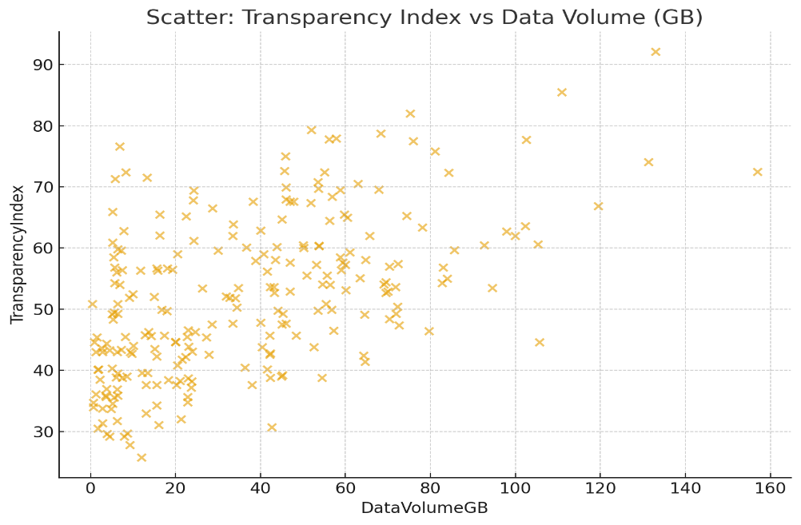
Figure 1. Scatter Plot for Transparency Index Data Volume Legend: o: original data, Angle:
This scatter plot demonstrates the relationship between data amounts and transparency. It shows that projects with higher data amounts have higher levels of transparency, probably due to improved data being tracked, documented, and traced. Blockchain-based projects are abundant in the fourth quadrant, cementing their importance in transparency-improve projects with substantial data amounts.
Figure 2. Boxplot of Transparency Levels by Blockchain Adoption
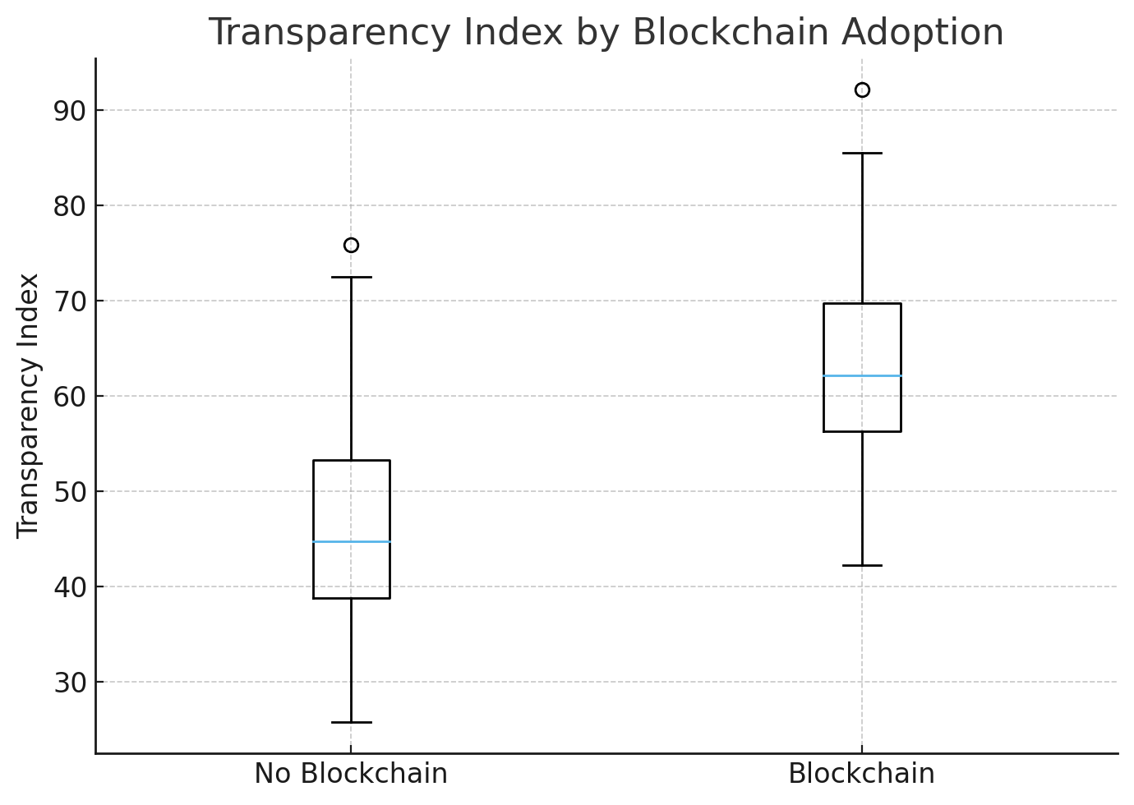

It is apparent from box plots that for projects with blockchains, there is an increase in median levels of transparency, with less margin for error on the higher end, in comparison to projects not involving blockchains. Graphical representation demonstrates consistency on Table 4 regarding enhanced transparency by blockchains.
Figure 3. Scatter Plot: Data Volume vs Budget (AI projects vs Other projects)
A scatter plot, on the
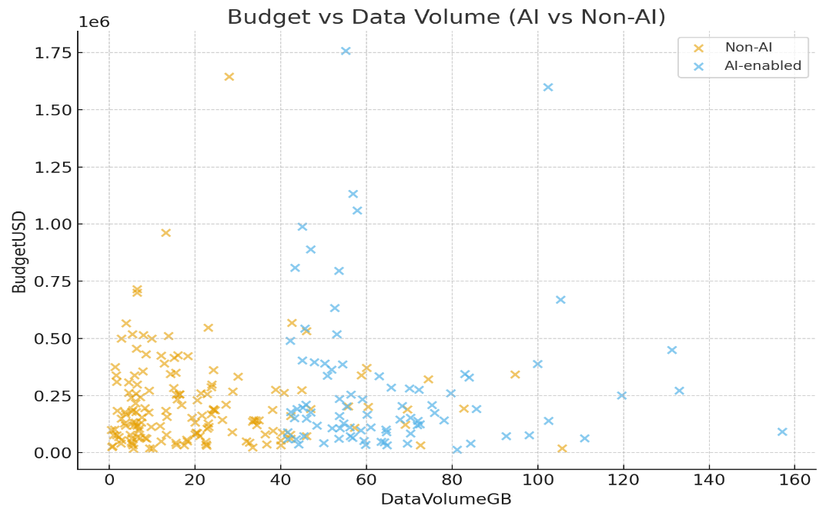
What this figure shows is that generally, projects incorporating AI require more budget, as well as more data. It is clear from this figure that there is an overall increase in cost due to computational complexity and demand for good data in AI projects, yet these projects result in better results in terms of sustainability.
Summary of Findings
Transparency Enhancement: Projects involving Blockchain technology, whether standalone or in conjunction with AI, showed enhanced median values for Transparency Index, thereby reinforcing its role in enhancing transparency.
Sustainability Improvement: AI projects, especially those coupled with Blockchain, have registered improved levels in emissions reduction, emphasizing the importance of environment-friendly outcomes offered by advanced analytics.
Synergistic Effect: Blockchain + AI projects far outshined all other categories in transparency and sustainability, indicating that their synergy yields optimal results.
Budget and Data Trade-Offs: Technological projects require more budget allocation and have to process higher data, given their complexity in managing digital resources.
Timeline Issues: Blockchain projects result in increased project timelines due to network establishment, validation, and coordination among multiple stakeholders, whereas projects with AI take less time.
Discussion
These results yield information on the role of new information technologies in modern resource management systems:
Integration of Technologies for Optimal Outcomes:
By itself, Blockchain offers an increase in transparency with its immutability features. It does not enable sustainable outcomes on its own. It enables predictive analysis, operation optimization, enhanced emission reduction, and optimized resource utilization.
Blockchain+B-AI’s performance is balanced, with Blockchain contributing to its trustworthy/traced nature, while AI fuels its data-driven sustainable outcomes.
Data Volume, Analytics Capability -
More complex projects, with more data, indicated improved performance in terms of transparency and sustainability.
Data analyses in scatter plots (Fig 1 below) reveal Data Volume to have a relationship with Transparency Index, thereby evidencing the theory that overall data management improves transparency.
Trade-Offs And Constraints In
More financial outlays, more data, and more prolonged implementation cycles are required in advanced technology adoption.
These considerations have to be balanced with improvements in transparency, which are likely to be realized.
Adoption Patterns:
Though 68% of projects have adopted AI, 57% have adopted Blockchain, only 51% have adopted both. It appears that cost, complexity, and other concerns impact overall technology adoption, thereby requiring strategic planning for such integration.
Implications for Resource Management:
Integrated technology systems improve decision-making, remove inefficiencies, and encourage environmentally responsible behaviour.
Solo adoption adoption aids in improving particular areas, whereas it does not provide overall benefits, like many other implementations together.
Conclusion
Blockchain, AI, and Analytics were evaluated in regards to their effects on transparency, efficiency, and sustainability in resource management projects. Some major findings are:
Blockchain improves transparency by offering secure, unalterable records, thereby improving traceability in project workflows.
The use of AI enhances sustainable outcomes, especially in emission reductions, through predictive analysis and optimization algorithms. A combination of Blockchain adoption and AI adoption results in the highest overall performance, thereby reiterating the importance of an overall strategy in the adoption of these new-age technologies.
Data-driven initiatives lead to better results, indicating there is a substantial positive relationship between data, analysis, and sustainability outcomes. There could be some implementation trade-offs, such as increased costs, increased data management, or project duration, which need to be kept in mind while planning technology adoption.

Recommendations:
- Leverage integrated digital frameworks that incorporate Blockchain, AI, and analytics, instead of point products.
- Make Blockchain applications in such areas like supply chains, management of resources in the public sector, and recycling systems, a priority.
- Invest in high-capacity data infrastructure to support real-time monitoring, proactive planning, and enhanced outcomes for sustainability.
- Build in-house technology expertise by training in Blockchain, AI, and strategic data management.
- Put in place policies and regulations regarding data transparency, audit trails, and reporting.

References
- Aakula, A., Zhang, C., & Ahmad, T. (2024). Leveraging AI and blockchain for strategic advantage in digital transformation. Journal of Artificial Intelligence Research, 4(1), 356– https://thesciencebrigade.com/index.php/jair/article/view/343
- Ali, O., Abdelbaki, W., Shrestha, A., Elbasi, E., Alryalat, M. A. A., & Dwivedi, Y. K. (2023). A systematic literature review of artificial intelligence in the healthcare sector: Benefits, challenges, methodologies, and functionalities. Journal of Innovation & Knowledge, 8(1), Article 100333. https://doi.org/10.1016/j.jik.2023.100333
- Alsharabi, N., Ktari, J., Frikha, T., et al. (2024). Using blockchain and AI technologies for sustainable, biodiverse, and transparent fisheries of the future. Journal of Cloud Computing, 13, 135. https://doi.org/10.1186/s13677-024-00696-8.
- Al-Zahrani, A. M. (2024). Unveiling the shadows: Beyond the hype of AI in education. Heliyon, 10, e30696. https://doi.org/10.1016/j.heliyon.2024.e30696.
- Asgharzadeh Shiadeh, S. A. (2023, July). The role of technology in enhancing transparency in government resource allocation. Journal of Resource Management and Decision Engineering, 2(3), 4–10. https://doi.org/10.61838/kman.jrmde.2.3.2
- Atadoga, S., Chinonyerem, C. A., Ajibade, S. B., Modinat, A., & Opeyemi, S. R. (2025). Blockchain and tax administration: Disruptive innovations for compliance and revenue collection. Asian Journal of Advanced Research and Reports, 19(11), 76–87. https://doi.org/10.9734/ajarr/2025/v19i111198
- Balan, G. S., Kumar, V. S., & Raj, S. A. (2025). Machine learning and artificial intelligence methods and applications for post-crisis supply chain resiliency and recovery. Supply Chain Analytics, 10, 100121. https://doi.org/10.1016/j.sca.2025.100121
- Chinonyerem, C. A. (2024). Leveraging internal auditing to enhance strategic decision-making and boost management efficiency: Nigerian Breweries Aba, Abia State. International Journal of Financial Research and Business Development, 6(7). https://doi.org/10.70382/mejfrbd.v6i7.018
- Demirkan, C. P., Smith, N. M., Duzgun, H. S., & Waclawski, A. (2021). A data-driven approach to evaluating sustainability reporting practices in extractive industries. Sustainability, 13(16), 8716. https://doi.org/10.3390/su13168716.
- Er, C. H., & Al Mosawi, T. (2023). Effects of big data analytics on sustainable manufacturing: A comparative study analysis. Chinese Journal of Urban and Environmental Studies, 10(4). https://doi.org/10.1142/S2345748122500221.
- Faiz, F., Ninduwezuor-Ehiobu, N., Uwaga, M. A., & Solomon, N. O. (2024). Blockchain for sustainable waste management: Enhancing transparency and accountability in waste disposal. Comprehensive Research and Reviews in Science and Technology, 2(1), 45–69. https://doi.org/10.57219/crrst.2024.2.1.0032.
- Gupta, M., Abdelsalam, M., Khorsandroo, S., & Mittal, S. (2020). Security and Privacy in Smart Farming: Challenges and Opportunities. IEEE Access, 8, 34564–34584. https://doi.org/10.1109/ACCESS.2020.2975142
- Hariyani, D., Hariyani, P., Mishra, S., & Sharma, M. K. (2025). A literature review on transformative impacts of blockchain technology on manufacturing management and industrial engineering practices. Green Technologies and Sustainability, 3, 100169. https://doi.org/10.1016/j.grets.2025.100169
- Helo, P., & Shamsuzzoha, A. (2020). Real-time supply chain: A blockchain architecture for project deliveries. Robotics and Computer-Integrated Manufacturing, 63, 101909. https://doi.org/10.1016/j.rcim.2019.101909
- Kamble, S., Gunasekaran, A., & Arha, H. (2021). Understanding the Blockchain Technology Adoption in Supply Chains. International Journal of Production Economics, 236, 108147. https://doi.org/10.1080/00207543.2018.1518610
- Khan, M., Salah, K., ur Rehman, M., & Arshad, J. (2021). Blockchain for AI: Review and Open Research Challenges. Information Systems, 101, 101906. https://doi.org/10.1109/ACCESS.2018.2890507
- Kouhizadeh, M., & Sarkis, J. (2018). Blockchain Practices, Potentials, and Perspectives in Greening Supply Chains. Sustainability, 10(10), 3652. https://doi.org/10.3390/su10103652.
- Kouhizadeh, M., & Sarkis, J. (2022). Blockchain Practices, Potentials, and Perspectives in Greening Supply Chains. Sustainability, 14(1), 1–17. https://doi.org/10.3390/su10103652
- Krishna, C. P. (2023, December). The impact of blockchain technology on auditing: A paradigm shift in financial transparency and security. ShodhKosh: Journal of Visual and Performing Arts, 4(2), 3996–4004. https://doi.org/10.29121/shodhkosh.v4.i2.2023.4484
- Maja, M. M., & Ayano, S. F. (2021). The impact of population growth on natural resources and farmers’ capacity to adapt to climate change in low-income countries. Earth Systems and Environment, 5(6), 271–283. https://doi.org/10.1007/s41748-021-00209-6
- Marjani, M., et al. (2017). Big IoT Data Analytics: Architecture, Opportunities, and Challenges. IEEE Access, 5, 5247–5261. https://doi.org/10.1109/ACCESS.2017.2689040
- Marjani, M., Nasaruddin, F., Gani, A., Karim, A., Hashem, I. A. T., Siddiqa, A., & Yaqoob, I. (2017). Big IoT data analytics: Architecture, opportunities, and challenges. IEEE Access, 5, 5247–5261. https://doi.org/10.1109/ACCESS.2017.2689040.
- Oncioiu, I., Bunget, O. C., Türkeș, M. C., Căpușneanu, S., Topor, D. I., Tamaș, A. S., Rakoș, I.-S., & Hint, M. Ș. (2019). The impact of big data analytics on company performance in supply chain management. Sustainability, 11(18), 4864. https://doi.org/10.3390/su11184864
- Porter, A. (2025, February 18). Data transparency: The cornerstone of trust in the digital age. TechInsights.
- Pradhan, S., Nandy, M., & Suyal, I. D. (2025). Blockchain for Transparent and Sustainable Environmental Resource Management. International Journal of Environmental Sciences, 11(2), 547–552. https://doi.org/10.64252/t57kjr29
- Raihan, A., & Paul, A. (n.d.). Artificial intelligence (AI) for environmental sustainability: A concise review of technology innovations in energy, transportation, biodiversity, and water management. https://doi.org/10.56556/jtie.v3i2.953
- Rashid, A. B., & Kausik, M. A. K. (2024). AI revolutionizing industries worldwide: A comprehensive overview of its diverse applications. Hybrid Advances, 7, Article 100277. https://doi.org/10.1016/j.hybadv.2024.100277
- Rejeb, A., Rejeb, K., & Keogh, J. (2022). Blockchain Technology in the Smart City: A Bibliometric Review. Sustainable Cities and Society, 81, 103853. https://doi.org/10.1007/s11135-021-01251-2
- Rolnick, D., et al. (2019). Tackling Climate Change with Machine Learning. arXiv preprint, https://doi.org/10.48550/arXiv.1906.05433
- Roy, J. K., & Zaher, H. F. (2025). Blockchain and sustainable finance as enablers of regenerative finance: a bibliometric and thematic review. Discover Sustainability, 6, 1194. https://doi.org/10.1007/s43621-025-02036-5
- Saberi, S., Kouhizadeh, M., Sarkis, J., & Shen, L. (2019). Blockchain Technology and Its Relationships to Sustainability. International Journal of Production Research, 57(7), 2117–2135. https://doi.org/10.1080/00207543.2018.1533261
- Salah, K., Rehman, M. H. U., Nizamuddin, N., & Al-Fuqaha, A. (2018). Blockchain for AI: Review and open research challenges. IEEE Access, 6, 20101–20116. https://doi.org/10.1109/ACCESS.2018.2890507
- Susnjara, S. (2025, March 12). How generative AI is reshaping enterprise innovation. IBM Think. https://www.ibm.com/blog/generative-ai-enterprise.
- Tsai, W.-H., et al. (2020). Big Data Analytics for Sustainable Manufacturing. Journal of Cleaner Production, 242, 118449. https://doi.org/10.1016/j.jclepro.2019.118449
- Varma, A., Dixit, N., Ray, S., & Kaur, J. (2024). Blockchain technology for sustainable supply chains: A comprehensive review and future prospects. World Journal of Advanced Research and Reviews, 21(3), 980–994. https://doi.org/10.30574/wjarr.2024.21.3.0804 WJARR
- Vladucu, M.-V., Wu, H., Medina, J., Salehin, K. M., Dong, Z., & Rojas-Cessa, R. (2024). Blockchain on Sustainable Environmental Measures: A Review. Blockchains, 2(3), 334–365. https://doi.org/10.3390/blockchains2030016
- Zahidi, F., Kaluvilla, B. B., & Mulla, T. (2024). Embracing the new era: Artificial intelligence and its multifaceted impact on the hospitality industry. Journal of Innovation and Technology Management and Communication, 100390. https://doi.org/10.1016/j.joitmc.2024.100390
- Zheng, Z., Xie, S., Dai, H., Chen, X., & Wang, H. (2020). Blockchain Challenges and Opportunities: A Survey. International Journal of Web and Grid Services, 14(4), 352–375. https://doi.org/10.1504/IJWGS.2018.095647
- Zheng, Z., Xie, S., Dai, H.-N., Chen, X., & Wang, H. (2018). Blockchain challenges and opportunities: A survey. International Journal of Web and Grid Services, 14(4), 352–?
https://doi.org/10.1504/IJWGS.2018.095647
- Zimba, A., Phiri, K. O., Mulenga, M., & Mukupa, G. (2025). A systematic literature review of blockchain technology and energy efficiency based on consensus mechanisms, architectural innovations, and sustainable solutions. Discover Analytics, 3, Article 14. https://doi.org/10.1007/s44257-025-00041-6
- Karaduman, Ö., & Gülhas, G. (2025). Blockchain-Enabled Supply Chain Management: A Review of Security, Traceability, and Data Integrity Amid the Evolving Systemic Demand. Applied Sciences, 15(9), 5168. https://doi.org/10.3390/app15095168
- Lv, G., Song, C., Xu, P., & Qi, Z. (2023). Blockchain-based traceability for agricultural products: A systematic literature review. Agriculture, 13(9), 1757. https://doi.org/10.3390/agriculture13091757
- Olawade, D. B., Wada, O. Z., Ige, A. O., Egbewole, B. I., Olojo, A., & Oladapo, B. I. (2024). Artificial intelligence in environmental monitoring: Advancements, challenges, and future directions. Hygiene and Environmental Health Advances, 12, Article 100114. https://doi.org/10.1016/j.heha.2024.100114
- Pimenow, S., Pimenowa, O., Prus, P., & Niklas, A. (2025). The Impact of Artificial Intelligence on the Sustainability of Regional Ecosystems: Current Challenges and Future Prospects. Sustainability, 17(11), 4795. https://doi.org/10.3390/su17114795
- Kumar, Y., Marchena, J., Awlla, A. H., Li, J. J., & Abdalla, H. B. (2024). The AI-Powered Evolution of Big Data. Applied Sciences, 14(22), 10176. https://doi.org/10.3390/app142210176
- Bhumichai, D., Smiliotopoulos, C., Benton, R., Kambourakis, G., & Damopoulos, D. (2024). The Convergence of Artificial Intelligence and Blockchain: The State of Play and the Road Ahead. Information, 15(5), 268. https://doi.org/10.3390/info15050268
- Toderas, M. (2025). Artificial Intelligence for Sustainability: A Systematic Review and Critical Analysis of AI Applications, Challenges, and Future Directions. Sustainability, 17(17), 8049. https://doi.org/10.3390/su17178049
- Galaz, V., Centeno, M. A., Callahan, P. W., Causevic, A., Patterson, T., Brass, I., Baum, S., Farber, D., Fischer, J., Garcia, D., McPhearson, T., Jimenez, D., King, B., Larcey, P., & Levy, K. (2021). Artificial intelligence, systemic risks, and sustainability. Technology in Society, 67, 101741. https://doi.org/10.1016/j.techsoc.2021.101741
- Fasinu, E. S., Famiyesin, M. O., & Afolaranmi, A. (2024). Leveraging technological innovations for adaptive policy implementation in response to disruptions: A study of Nigeria. International Journal of Emerging Markets and Technology, 10(4), 43–52. https://doi.org/10.56201/ijemt.v10.no4.2024.pg43.52
- Oghuvbu, E. A., Gberevbie, D. E., & Oni, S. (2022). Technology policy and sustainable development in Nigeria. Vestnik RUDN International Relations, 22(2), 385–396. https://doi.org/10.22363/2313-0660-2022-22-2-385-396
- Hariyani, D., Hariyani, P., Mishra, S., & Sharma, M. K. (2025). A literature review on transformative impacts of blockchain technology on manufacturing management and industrial engineering practices. Green Technologies & Sustainability, 3(3), 100169. https://doi.org/10.1016/j.grets.2025.100169

