Original Research Article

Selection of Optimal 6-Benzylaminopurine (BAP) and 1-Naphthaleneacetic Acid (NAA) Combination for In Vitro Propagation of ‘Solanum tuberosum L. cv. Cardinal’ Under Nepalese Laboratory Conditions

ABSTRACT
Potato (Solanum Tuberosum L.) is an important crop in nutritional security and income generation. Despite its importance, Nepal's average productivity is only about 14.7 t/ha, which is significantly lower than the global average of 21 t/ha. This study evaluated the effects of different concentrations of 6-benzylaminopurine (BAP) and 1-naphthaleneacetic acid (NAA) on the in vitro propagation of the widely cultivated ‘Cardinal’ variety under Nepalese laboratory conditions. Shoot initiation was achieved on full-strength MS medium with 0.5 mg/L BAP + 0.01 mg/L NAA, while maximum leaf production occurred at the same concentration. Node proliferation was highest on 1.5 mg/L BAP + 0.1 mg/L NAA, and rooting was most effective with 0.25 mg/L BAP + 0.3 mg/L NAA. Although distinct combinations favored individual traits, the study identifies 1.5 mg/L BAP + 0.1 mg/L NAA as the overall optimal medium for rapid shoot and node proliferation, the most critical step for generating uniform, pathogen-free mother plants. This genotype-specific protocol for the ‘Cardinal’ variety has not previously been found under local laboratory conditions in Nepal. The outcomes offer an economically viable, optimal hormonal concentration that is adapted according to the physiological response of the Cardinal variety in limited-resource environments, which can be applicable for the large-scale production of high-quality, pathogen-free plantlets for pre-basic seed tuber production.
Keywords: Potato, Tissue culture, Hormones, Apical meristem, Culture media

INTRODUCTION
Potato (Solanum tuberosum L.) is the world's third most significant food crop, after rice and wheat; it is the staple diet for 1.3 billion people (Beals, 2019; Devaux et al., 2021). It is produced in over 350 million tons annually(Dongyu, 2022), which demonstrates its significant contribution to the food supply. Potatoes offer high nutrients at a low price in comparison to many other vegetables. The ‘Cardinal’ potato (Solanum tuberosum L.) is a tetraploid table potato that was originally bred in the Netherlands by F. Brands and was introduced in 1972 (Van Berloo et al., 2007). The red skin pigmentation of ‘Cardinal’ is associated with anthocyanin accumulation, which gives antioxidant properties(Ben Jeddou et al., 2021). Agronomic studies report good yields (27–35 t/ha) comparable to high-yielding cultivars such as Diamant and Granola (Eaton et al., 2017; Howlader & Hoque, 2018)
Traditional tuber propagation has low yield, high disease risk, and declining seed quality. The in vitro propagation method has the merit of producing virus-free plants, which reduces the risk of pathogen growth and ensures larger crop yields and better-quality tubers regardless of the seasons in a very short period (de MORAIS et al., 2018; Khan & Rabbani, 2001; Pradana et al., 2021; Singh et al., 2019; Smith & Drew, 1990). Tissue culture's adaptability and efficacy make it a viable approach in modern plant science and agriculture, providing solutions to a wide range of propagation and disease management issues (Akin-Idowu et al., 2009). This is especially important in locations where potato diseases are common, since it helps to ensure food production and increase food (P. Singh, 2012; Umaro, 2022).
Apical meristem culture has also been successfully used to eliminate viruses and rapidly propagate disease-free clones (Ramgareeb et al., 2010; Wang & Hu, 1982). Consequently, micropropagation has become a cornerstone of seed potato programs in many countries, which is necessary to fulfill the growing demand for seed potatoes, especially in developing nations, where food security is a serious problem (Donnelly et al., 2003; Sajid et al., 2024).
Plant growth regulators (PGRs) are vital for in vitro multiplication of potato (Solanum tuberosum). Cytokinins like 6-benzylaminopurine (BAP) and kinetin stimulate shoot growth, while auxins such as indole-3-butyric acid (IBA) and naphthaleneacetic acid (NAA) promote root induction (Hajare et al., 2021; Modawi & Khalafalla, n.d.). Excessive BAP, although able to induce microtuberization, can delay tuber development and inhibit root growth (Borna et al., 2019; Suharjo et al., 2019; Tuwo et al., 2022). Similarly, high NAA concentrations increase apical dominance by encouraging apical bud growth over axillary buds (Abeuova et al., 2020; Hajare et al., 2021). Conversely, the right combinations of BAP and NAA significantly boost shoot multiplication compared to single-hormone treatments, leading to higher propagation efficiency (Babadjanova et al., 2023; (Bode) XHULAJ & GIXHARI, 2018; Dhital et al., 2012).
Although protocols for in vitro propagation of potato exist, cultivar-specific optimization of PGR concentrations is essential, as responses vary significantly among genotypes. For instance, optimal concentrations of BAP and NAA differ across varieties like Gudiene, Belete, and G × N15 (Arab et al., 2014; Hajare et al., 2021). These findings highlight the importance of developing cultivar-specific protocols to ensure successful propagation outcomes. The ‘Cardinal’ variety’s in vitro response under Nepali conditions remains uncharacterized. This study aimed to identify the optimal BAP and NAA concentrations for efficient in vitro propagation of the ‘Cardinal’ potato, thereby providing a reliable protocol for producing pathogen-free mother plants suitable for pre-basic seed tuber production in Nepal.

MATERIALS AND METHODS

Description of research site
The research was conducted in the central laboratory and the Horticulture department laboratory of the Institute of Agriculture and Animal Science (IAAS), Paklihawa Campus, Bhairahawa, Nepal. The location is situated at 27ᵒ28'48.77" N and 83ᵒ26'51.61' E. The potato tuber of the cardinal variety developed at the Potato Crop Development Centre, Nigale, Sindhupalchowk, was chosen as a source plant for acquiring the apical meristem for the experiment.

Surface sterilization and stock solution preparation
The central lab was sterilized with 5% sodium hypochlorite, and all research equipment was thoroughly cleaned and dried in a hot air oven at 80°C for one hour. For a 1 N HCl stock solution, 83.5 mL of 37% HCl was diluted to 1 liter, with 8.35 mL used to prepare 100 mL. To make a 1 N NaOH stock, 40 g of NaOH was dissolved in 250 mL of water and diluted to 1 liter. Plant growth regulators (BAP, NAA, and IBA) were prepared by dissolving 50 mg of each in NaOH dropwise until a clear solution formed, then diluting to 50 mL to achieve a final concentration of 1 mg/mL.
For phase 1: A packet of MS media (Himedia) was mixed with distilled water to make 100 mL of 10x strength stock solution, and 0.5 mg/L BAP + 0.01mg/L 1-Naphthalene Acetic (NAA) was combined with the prepared MS media, resulting in 1000 mL of media.
For phase 2: A similar stock solution of MS media was prepared, and 7 different concentrations of BAP and 1-Naphthalene Acetic (NAA) were used to make 2000 ml of media (Table 1).

Table 1: Composition of media used in different treatment combinations of 6-benzylaminopurine (BAP) and 1-Naphthalene Acetic Acid (NAA) for in vitro culture
Treatments | Media composition
1 | MS media (Control)
2 | MS Media +1mg/L BAP + 0.1 mg/L NAA
3 | MS Media +0.5mg/L BAP + 0.2 mg/L NAA
4 | MS Media +0.25mg/L BAP + 0.3 mg/LNAA
5 | MS Media +1.5mg/L BAP + 0.1 mg/L NAA
6 | MS Media +2mg/L BAP + 0.01 mg/L NAA
7 | MS Media +2.5mg/L BAP + 0.25mg/L NAA
8 | MS Media +0.5mg/L BAP + 0.01 mg/L NAA
The pH of the medium was adjusted to 5.8 with Hydrochloric Acid (HCl) or Sodium Hydroxide (NaOH), and the pH meter was calibrated using buffer solutions 4.0 and 7.0 as standards. After pH correction, 8 g of agar was added to the medium, which was then cooked on a hot plate. Following that, 30 mL of the produced medium was placed into culture jars and sterilized in an autoclave at 121°C, 15 psi for 25-30 minutes. The laminar airflow cabinet had been sterilized with 70% ethanol before any additional aseptic activities.

Explant preparation
Potato tubers were grown in a semi-dark environment at 35-37°C for 2-3 weeks. Fresh sprouts were surface sterilized by washing them in tap water for 10 minutes, then treated with 70% ethanol for 30 seconds, 2% sodium hypochlorite for 5-7 minutes, and then washed three times with double-distilled water. Meristem cells (0.3-0.5 mm) were excised in a sterile laminar air flow cabinet and injected into a liquid MS medium containing varying concentrations of the appropriate phases.

Shoot proliferation and rooting
Following shoot establishment, subculture was conducted over 24 days using single-node segments with up to two leaves per node. During the subculture, eight treatments (different concentrations of BAP and NAA, including control) were replicated twice; each replication included five explants, totaling 80 explants (8 treatments × 2 replications × 5 explants = 7\80 explants). Data on the number of leaves, nodes, and roots were collected on days 6, 11, 14, and 24. Meristem cultures grew in a sterile environment at 23±2°C, with 80-90% relative humidity, a 14-hour photoperiod, and moderate light intensity. The pathogen-free status of the explants was confirmed through visual observation, as laboratory limitations prevented access to virus-detection instruments and reagents.
  - Data analysis and experimental design
The experiment was arranged in a Completely Randomized Design (CRD). Data was collected using MS Excel (2016) and processed and analyzed with R Studio software (4.3.1). Before conducting ANOVA, the data were tested for normality using the Shapiro-Wilk test and for homogeneity of variances using Levene’s test. These tests were performed in R to ensure the validity of ANOVA assumptions. The processed data were evaluated using a one-way ANOVA (Analysis of Variance) table, and the mean across treatments was determined using DMRT (Duncan's Multiple Range Test) at a 5% level of significance.

RESULTS AND DISCUSSION

Effect of different concentrations of 6-benzylaminopurine (BAP) and 1-Naphthalene Acetic Acid (NAA) on leaves, roots, and nodes of cardinal varieties of potato

Effect of different concentrations of 6-benzylaminopurine (BAP) and 1-Naphthalene Acetic Acid (NAA) on leaves of cardinal varieties of potato
Various concentrations of BAP and NAA had a statistically significant effect on the leaf number of the Cardinal variety (Table 2). The maximum number of leaves was observed in MS Media +1.5mg/L BAP + 0.1 mg/L NAA, and a minimum number of leaves was observed in MS Media +2.5mg/L BAP + 0.25mg/L NAA ( Figure 1 Figure 2). According to research, lower concentrations of BAP (usually about 1-2 mg/L) tend to be optimum for producing a larger number of shoots and improving shoot proliferation (Dilshad et al., 2021; Hajare et al., 2021). Multiple studies on Solanum tuberosum report that a high cytokinin: low auxin ratio, specifically ~1–2 mg/L BAP with ~0.1 mg/L NAA, optimizes shoot proliferation; leaf number generally tracks shoot vigor. For example, 2.0 mg/L BAP + 0.1 mg/L NAA produced the largest number of axillary shoots per main shoot in potato, a direct proxy for more leaves (Ghaffoor et al., 2003) Similarly, in Brassica oleracea, (Ahmad & Spoor, 1998) found that low auxin levels combined with increased cytokinin concentrations stimulate shoot morphogenesis, which is compatible with our findings on the efficacy of certain BAP and NAA levels. Conversely, higher concentrations of BAP (more than 4 mg/L) might cause a decrease in shoot quantity and overall growth vigor, most likely due to the inhibitory effects of excessive cytokinin on plant development (Arab et al., 2014; Gunther & Fermino Junior, 2021). This effect is corroborated by data that showed a reduction in shoot growth and an increase in callus development at increased BAP levels (Arab et al., 2014).

Table 2: Effect of different concentrations of 6-benzylaminopurine (BAP) and 1-Naphthalene Acetic Acid (NAA) on leaves of cardinal varieties of potato
Treatment | No of Leaves  (6th Day) | No. of Leaves  (11th Day) | No of Leaves  (14th Day) |  | No of Leaves  (24th Day)
MS Media  (Control) | 2.00 ± 0.42 c | 2.67 ± 0.47 c | 3.00 ± 0.47 c |  | 3.50 ± 0.52 c
MS Media + 1mg/L BAP + 0.1 mg/L NAA | 3.75 ± 0.42 ^{ab} | 4.42 ± 0.47 ^{bc} | 4.75 ± 0.47 ^{ab} | 6.42 ± 0.52 ^{bc}
MS Media +0.5mg/L BAP + 0.2 mg/L NAA | 3.75 ± 0.42 ^{ab} | 4.42 ± 0.47 ^{bc} | 5.42 ± 0.47^{abc} |  | 5.50 ± 0.52^{bc}
MS Media +0.25mg/L BAP + 0.3 mg/LNAA | 3.17 ± 0.42 ^{b} | 3.25 ± 0.47 ^{c} | 3.83±0.47^{bc} |  | 3.93 ± 0.52 ^{c}
MS Media +1.5mg/L BAP + 0.1 mg/L NAA | 3.42 ± 0.42 ^{ab} | 4.96 ± 0.47 ^{ab} | 6.67 ± 0.47 ^{ab} |  | 8.92 ± 0.52 ^{b}
MS Media +2mg/L BAP + 0.01 mg/L NAA | 6.17 ± 0.42 ª | 7.00 ± 0.47 ª | 7.25 ± 0.47 ª |  | 7.45 ± 0.52 ^{bc}
MS Media +2.5mg/L BAP + 0.25mg/L NAA | 1.42 ± 0.42 ^{b}
  2.42 ± 0.47^{c}
  2.42 ± 0.47^{c}
  2.45 ± 0.47^{c}
MS Media +0.5mg/L BAP + 0.01 mg/L NAA
  3.83 ± 0.42^{ab}
  3.90 ± 0.42 ^{ab}
  4.00 ± 0.42^{ab}
  4.83 ± 0.42^{ab}
LSD | 2.58 | 2.58 | 3.83 |  | 4.39
SEM | 0.42 | 0.47 | 0.47 |  | 0.52
CV | 8.08 | 8.84 | 14.97 |  | 18.15
Grand Mean | 3.44 | 4.13 | 4.67 |  | 5.38
F- value | 3.91* | 4.22** | 3.14* |  | 15.80***
Significance levels: NS = not significant; * = p < 0.05; ** = p < 0.01; *** = p < 0.001

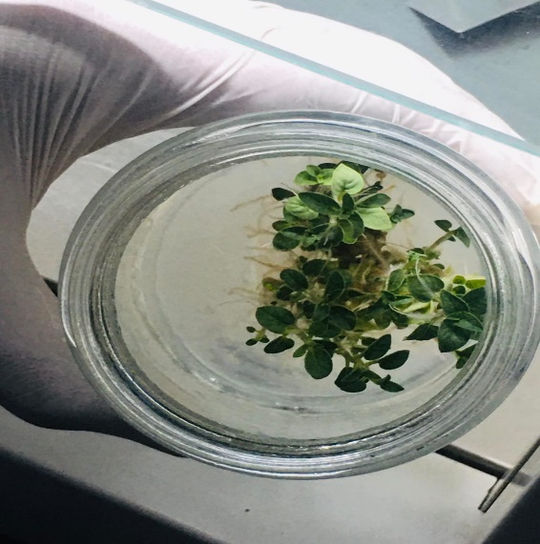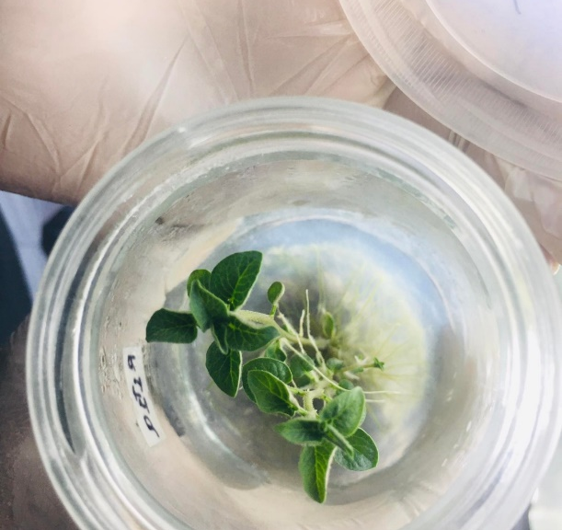
A
B
Figure 1: Representative in vitro shoots of Solanum tuberosum var. Cardinal showing differential leaf formation under varying concentrations of 6-benzylaminopurine (BAP) and 1-Naphthalene Acetic Acid (NAA) on Day 24. (A) Maximum leaf proliferation under MS medium supplemented with 0.5 mg/L BAP + 0.01 mg/L NAA. (B) Minimum leaf development under MS medium supplemented with 2.5 mg/L BAP + 0.25 mg/L NAA.

Figure 2: Effect of different concentrations of 6-benzylaminopurine (BAP) and 1-Naphthalene Acetic Acid (NAA) on leaves of cardinal varieties of potato

Effect of different concentrations of 6-benzylaminopurine (BAP) and 1-Naphthalene Acetic Acid (NAA) on the nodes of cardinal varieties of potato
Various concentrations of BAP and NAA had a statistically significant effect on the node number of the Cardinal variety (Table 3). The maximum number of nodes was observed in MS Media +1.5mg/L BAP + 0.1 mg/L 1-Naphthalene Acetic Acid (NAA), and a minimum number of nodes was observed in MS Media +2.5mg/L BAP + 0.25mg/L NAA (Figure 3, Figure 4). High BAP and NAA concentrations can negatively impact node proliferation due to hyper-hydricity, a condition characterized by excessive tissue hydration and abnormal physiological conditions, potentially leading to abnormal callus development. Moreover, in Eustoma grandiflorum (Raf.), the greater concentrations of cytokinin (N6-Benzyladenine (BA) and kinetin) resulted in good shoot development but large percentages of hyperhydrated shoots(Paek & Hahn, 2000). Research on Alstroemeria showed that the greater concentrations of plant growth regulators such as BAP and NAA can have a negative impact on micropropagation outcomes, such as node proliferation. The study found that supplementing MS medium with moderate doses of BAP (0.5-1.5 mg/L) and NAA (0.2-1.0 mg/L) improved shoot and root growth(Seyyed Rahim Seyyedyousefi, 2013; Yoong et al., 2017).This was most likely owing to cytokinin-induced imbalances that influenced cell division and elongation.

Table 3: Effect of different concentrations of 6-benzylaminopurine (BAP) and 1-Naphthalene Acetic Acid (NAA) on nodes of cardinal varieties of potato
Treatments | No. of Nodes (6th Day) |  | No. of Nodes (11th Day) |  | No. of Nodes (14th Day) |  | No. of Nodes (24th Day)
MS (Control) |  | 0.67 ± 0.25 b |  | 0.83 ± 0.26 b |  | 0.75 ± 0.26 c |  | 0.83 ± 0.25 cd
MS + 1 mg/L BAP + 0.1 mg/L NAA | 1.33 ± 0.25 ^{ab} |  | 1.33 ± 0.26 ª |  | 1.35 ± 0.26 ^{ab} |  | 1.58 ± 0.25^{abc}
MS + 0.5 mg/L BAP + 0.2 mg/L NAA | 1.75 ± 0.25 ª |  | 1.83 ± 0.26 ª |  | 2.00 ± 0.26 ª |  | 2.33 ± 0.25^{bc}
MS + 0.25 mg/L BAP + 0.3 mg/L NAA | 1.17 ± 0.25 ^{ab} |  | 1.58 ± 0.26 ^{ab} |  | 1.83 ± 0.26 ^{bc} |  | 1.97 ± 0.25 ^{cd}
MS + 1.5 mg/L BAP + 0.1 mg/L NAA | 1.75 ± 0.25 ª |  | 1.92 ± 0.26 ª |  | 2.00 ± 0.26 ª |  | 2.88 ± 0.25 ª
MS + 2 mg/L BAP + 0.01 mg/L NAA | 1.58 ± 0.25 ª |  | 1.84 ± 0.26 ª |  | 1.88 ± 0.26 ^{ab} |  | 1.92 ± 0.25 ^{bc}
MS + 2.5 mg/L BAP + 0.25 mg/L NAA | 0.33 ± 0.25 ^{b} |  | 0.33 ± 0.26 ^{b} |  | 0.77 ± 0.26 ^{c} |  | 0.83 ± 0.25 ^{d}
MS + 0.5 mg/L BAP + 0.01 mg/L NAA | 1.08 ± 0.25 ^{ab} |  | 1.56 ± 0.26 ª |  | 2.11 ± 0.26 ª |  | 2.42 ± 0.25 ^{ab}
LSD (0.05) | 0.94 |  | 0.91 |  | 0.94 |  | 0.89
SEM | 0.25 |  | 0.26 |  | 0.26 |  | 0.25
CV (%) | 6.82 |  | 5.76 |  | 4.68 |  | 4.54
Grand Mean | 1.21 |  | 1.40 |  | 1.59 |  | 1.85
F-values | 2.81* |  | 3.25* |  | 5.26** |  | 6.81***
Significance levels: NS = not significant; * = p < 0.05; ** = p < 0.01; *** = p < 0.001
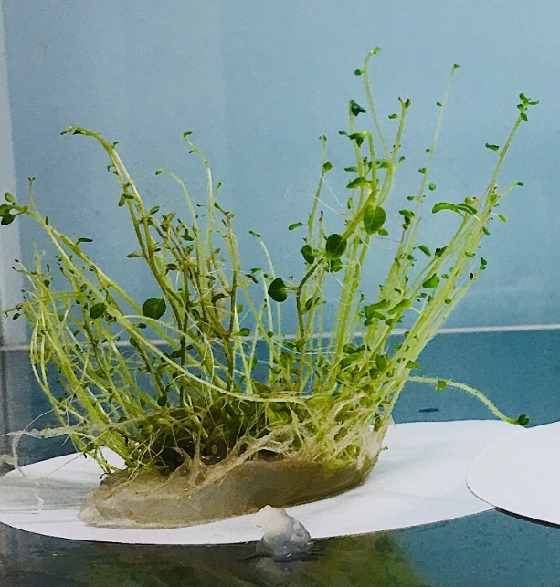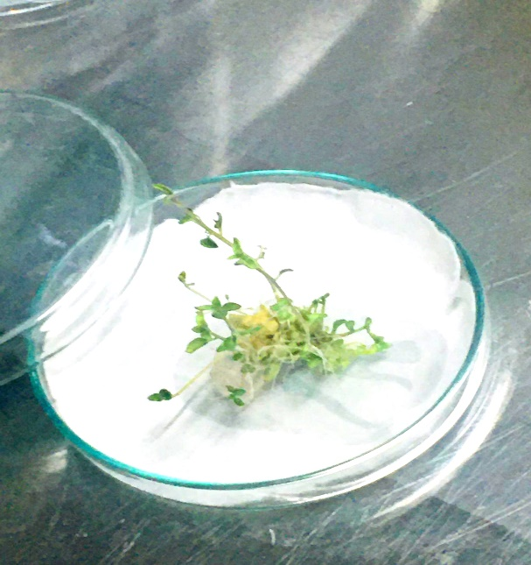
B
A

Figure 3: Representative in vitro shoot of Solanum tuberosum var. cardinal showing shoot proliferation and node formation under different concentrations of BAP and NAA on day 24. (A) Maximum node proliferation under MS medium supplemented with 1.5 mg/L BAP + 0.1 mg/L NAA. (B) Minimal shoot development under MS medium supplemented with 2.5 mg/L BAP + 0.25 mg/L NAA.

Figure 4: Effect of different concentrations of 6-benzylaminopurine (BAP) and 1-Naphthalene Acetic Acid (NAA) on the nodes of cardinal varieties of potato

Effect of different concentrations of 6-benzylaminopurine (BAP) and 1-Naphthalene Acetic Acid (NAA) on the root of cardinal varieties of potato
Different concentrations of BAP and NAA had a statistically significant influence on the root number of the Cardinal variety (Table 4). The highest number of roots was found in MS Media + 0.25 mg/L BAP + 0.3 mg/L 1-Naphthalene Acetic Acid (NAA), and minimum rooting occurred in MS media with 2.5 mg/L BAP and 0.25 mg/L NAA (Figure 5, Figure 6). Most potato micropropagation studies report the best rooting on hormone-free or low-cytokinin media. Studies show that rooting is reduced by BAP and improves when BAP is minimized or absent. For example, hormone-free MS sometimes outperformed BAP/NAA mixes, and other cultivar studies routinely root on IBA with little or no cytokinin (A Abido & A jabal, n.d.; Chandana Javvadi Scholar et al., n.d.). Previous research found that a balanced administration of cytokinins and auxins improved root and shoot proliferation in a variety of plant species (George et al., n.d.). If the auxin-cytokinin ratio is not properly controlled, it might result in inferior root development. For instance, extremely high and low doses of growth regulators can disturb the endogenous hormone balance required for adventitious root development, resulting in unsatisfactory rooting results (Quan et al., 2022; Sun et al., 2023).
Table 4: Effect of different concentrations of 6-benzylaminopurine (BAP) and 1-Naphthalene Acetic Acid (NAA) on the roots of cardinal varieties of potato
Treatment | No of Roots  (6th Day) | No. of Roots  (11th Day) | No of Roots  (14th Day) | No. of Roots (24th Day)
MS Media  (Control) | 0.08 ± 0.19 b | 0.08 ± 0.21 b |  | 0.8 ± 0.19 b
  0.57 ± 0.19 b
MS Media + 1mg/L BAP + 0.1 mg/L NAA |  |  |  | 0.55 ± 0.25 b
  0.17 ± 0.21 b
  0.17 ± 0.21 b
  0.25 ± 0.21 b
MS Media +0.5mg/L BAP + 0.2 mg/L NAA |  |  |  | 4.23 ± 0.19 b
  0.5 ± 0.19 b
  1.5 ± 0.19 b
  2.83 ± 0.19 b
MS Media +0.25mg/L BAP + 0.3 mg/LNAA |  |  |  | 4.83 ± 0.19 b
  4.17 ± 0.19 b
  4.25 ± 0.19 b
  4.27 ± 0.19 b
MS Media +1.5mg/L BAP + 0.1 mg/L NAA |  |  |  | 1.00 ± 0.19 b
  0.75 ± 0.19 b
  0.75 ± 0.19 b
  0.79 ± 0.19 b
MS Media +2mg/L BAP + 0.01 mg/L NAA |  |  |  | 0.80 ± 0.19 b
  0.08 ± 0.19 b
  0.08 ± 0.19 b
  0.57 ± 0.19 b
MS Media +2.5mg/L BAP + 0.25mg/L NAA |  |  |  | 0.09 ± 0.19 a
  0.08 ± 0.19 a
  0.08 ± 0.19 a
  0.08 ± 0.19 a
MS Media +0.5mg/L BAP + 0.01 mg/L NAA |  |  |  | 0.25 ± 0.25 a
  0.08 ± 0.19 b
  0.08 ± 0.21 b
  0.17 ± 0.25 b
LSD | 1.89 | 2.07 | 2.66 | 2.75
SEM | 0.19 | 0.21 | 0.25 | 0.25
CV | 16.14 | 15.29 | 13.94 | 14.88
Grand Mean | 0.77 | 0.92 | 1.16 | 1.49
F- value | 5.29** | 6.73*** | 5.45** | 6.95***

Significance levels: NS = not significant; * = p < 0.05; ** = p < 0.01; *** = p < 0.001

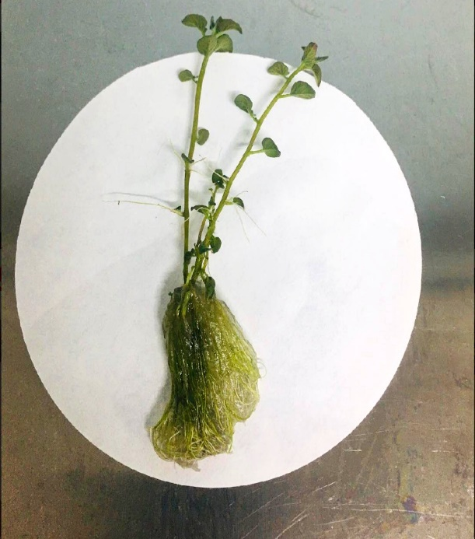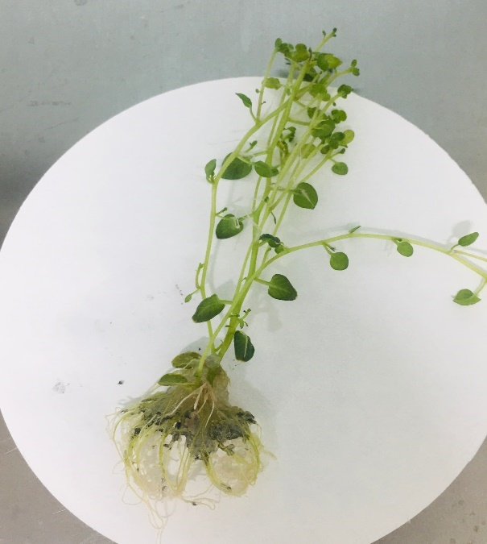
B
A
Figure 5: Representative In vitro root development of Solanum tuberosum var. Cardinal under different concentrations of BAP and NAA on day 24. (A) Maximum root proliferation under MS medium supplemented with 0.25 mg/L BAP + 0.3 mg/L NAA. (B) Minimal root development under MS medium supplemented with 2.5 mg/L BAP + 0.25 mg/L NAA.

Figure 6: Effect of different concentrations of 6-benzylaminopurine (BAP) and NAA on the roots of cardinal varieties of potato

CONCLUSION
The ideal amounts of BAP and NAA for shoot proliferation were found to be 0.5 mg/L BAP + 0.01 mg/L NAA, which produced the most leaves, and 1.5 mg/L BAP + 0.1 mg/L NAA, which maximized node growth. For rooting, 0.25 mg/L BAP + 0.3 mg/L NAA was the most effective combination. While distinct hormonal combinations maximized individual traits, the combination of 1.5 mg/L BAP + 0.1 mg/L NAA is recommended as the overall optimal medium for large-scale multiplication of pathogen-free mother plants intended for pre-basic seed tuber production. This concentration provided the highest shoot and node proliferation, thereby ensuring rapid multiplication, a critical step for generating sufficient, uniform mother stock. Rooting can be subsequently achieved through transfer to a suitable auxin-rich and less or no cytokinin medium before acclimatization. This cost-effective, reproducible protocol uses standard reagents and techniques that can be implemented in small-scale laboratories without specialized equipment, making it well-suited for decentralized tissue culture efforts. It also contributes a scalable foundation for disease-free seed potato production through genotype-specific hormonal optimization. Future research should explore genotype-specific responses and optimize these techniques for large-scale commercial application.

DISCLOSURE STATEMENT
The author(s) reported no potential conflicts of interest. The author(s) affirm that this research is original and not generated by artificial intelligence. ChatGPT (OpenAI, GPT-5, August 2025 version) was used solely for refining the English language in the manuscript to improve clarity and grammar, as the author(s) are non-native English speakers. All research design, data collection, analysis, and interpretation were conducted entirely by the author(s).

DATA AVAILABILITY STATEMENT
The data supporting this study’s findings are available from the corresponding author on reasonable request.

REFERENCE
- A Abido, A. I., & A jabal, A. A. (n.d.). In vitro Propagation and Ex vitro Acclimatization of Potato (Solanum tuberosum L.) Using Nodal Cutting Explants. J. Adv. Agric. Res. (Fac. Agric. Saba Basha), 108(1), 2016.
- Abeuova, L. S., Kali, B. R., Rakhimzhanova, A. O., Bekkuzhina, S. S., & Manabayeva, S. A. (2020). High frequency direct shoot regeneration from Kazakh commercial potato cultivars. PeerJ. https://doi.org/10.7717/peerj.9447
- Ahmad, S., & Spoor, W. (1999). Effects of NAA and BAP on Callus Culture and Plant Regeneration in Curly Kale (Brassica oleraces L.). Pakistan Journal of Biological Sciences https://doi.org/10.3923/pjbs.1999.109.112
- Akin-Idowu, P. E., Ibitoye, D. O., & Ademoyegun, O. T. (2009). Tissue culture as a plant production technique for horticultural crops. African Journal of Biotechnology, 8(16), 3782–3788. https://doi.org/10.5897/AJB2009.000-9374
- Arab, M. M., Yadollahi, A., Shojaeiyan, A., Shokri, S., & Ghojah, S. M. (2014). Effects of nutrient media, different cytokinin types and their concentrations on in vitro multiplication of G × N15 (hybrid of almond × peach) vegetative rootstock. Journal of Genetic Engineering and Biotechnology, 12(2), 81–87. https://doi.org/10.1016/j.jgeb.2014.10.001
- Babadjanova, F. I., Ubaydullaeva, K. A., Asrorov, A. M., Rakhmanov, B. K., Abdullaev, A. N., Bolkiev, A. A., Abdullaev, S. A., Eshmurzaev, J. B., & Buriev, Z. T. (2023). Improvement of callogenesis and somatic embryogenesis by selecting optimal hormonal balance in Sarnav and Desiree potato varieties. Agriculture (Pol’nohospodárstvo), 69(1), 40–46. https://doi.org/10.2478/agri-2023-0004
- Beals, K. A. (2019). Potatoes, Nutrition and Health. American Journal of Potato Research, 96(2), 102–110. https://doi.org/10.1007/S12230-018-09705-4
- Ben Jeddou, K., Kammoun, M., Hellström, J., Gutiérrez-Quequezana, L., Rokka, V. M., Gargouri-Bouzid, R., Ellouze-Chaabouni, S., & Nouri-Ellouz, O. (2021). Profiling beneficial phytochemicals in a potato somatic hybrid for tuber peels processing: phenolic acids and anthocyanins composition. Food Science & Nutrition, 9(3), 1388–1398. https://doi.org/10.1002/fsn3.2100
- Xhulaj, D. (B.), & Gixhari, B. (2018). IN VITRO MICROPROPAGATION OF POTATO (Solanum tuberosum L). CULTIVARS. Agriculture & Forestry, 64(4). https://doi.org/10.17707/AGRICULTFOREST.64.4.12
- Borna, R. S., Hoque, M. I., & Sarker, R. H. (2019). In vitro Microtuber Induction and Regeneration of Plantlets from Microtuber Discs of Cultivated Potato (Solanum tuberosum L.). Plant Tissue Culture and Biotechnology, 29(1), 63–72. https://doi.org/10.3329/ptcb.v29i1.41979
- Javvadi, L. C., Patro, T. K., Suneetha, D. R., Kumari, K. U., Rao, M. P., Gladis, B., Sekhar, V., & Supriya, N. V. S. (2024). Standardization of in vitro rooting and ex vitro hardening for in vitro propagation of potato (Solanum tuberosum L.) variety Kufri Surya. International Journal of Advanced Biochemistry Research. https://doi.org/10.33545/26174693.2024.v8.i9Sr.2441
- de Morais, T. P., Asmar, S. A., Silva, H. F. de J., Luz, J. M. Q., & de Melo, B. (2018). Application of tissue culture techniques in Potato. Bioscience Journal, 34(4), 952–969. https://doi.org/10.14393/BJ-V34N1A2018-38775
- Devaux, A., Goffart, J. P., Kromann, P., Andrade-Piedra, J., Polar, V., & Hareau, G. (2021). The Potato of the Future: Opportunities and Challenges in Sustainable Agri-food Systems. Potato Research, 64(4), 681–720. https://doi.org/10.1007/s11540-021-09501-4
- Dhital, S. P., Lim, H. T., & Manandhar, H. K. (2012). Direct and Efficient Plant Regeneration from Different Explants Sources of Potato Cultivars as Influenced by Plant Growth Regulators. Nepal Journal of Science and Technology https://doi.org/10.3126/njst.v12i0.6471
- Dilshad, E., Asif, A., Arooj, H., Khan, S. H., & Bakhtiar, S. M. (2021). Impact of BAP on in Vitro Regeneration of Potato (Solanum Tuberosum L.). Current Trends in OMICS. https://doi.org/10.32350/cto.12.04
- Dongyu, Q. (2022). Role and Potential of Potato in Global Food Security. Food and Agriculture Organization of the United Nations (FAO). https://www.fao.org/knowledge/resources/details/en/c/1560000/
- Donnelly, D. J., Coleman, W. K., & Coleman, S. E. (2003). Potato microtuber production and performance: A review. American Journal of Potato Research, 80(2), 103–115. https://doi.org/10.1007/BF02870209
- Eaton, T. E., Azad, A. K., Kabir, H., & Siddiq, A. B. (2017). Evaluation of Six Modern Varieties of Potatoes for Yield, Plant Growth Parameters and Resistance to Insects and Diseases. Agricultural Sciences, 8(11), 1315–1326. https://doi.org/10.4236/as.2017.811095
- George, E. F., Hall, M. A., & De Klerk, G.-J. (2008). *Plant propagation by tissue culture, Volume 1: The background*. Springer. https://doi.org/10.1007/978-1-4020-5005-3
- Ghaffoor, A., Shah, G. B., & Waseem, K. (2003). In vitro Response of Potato (Solanum tuberosum L.) to Various Growth Regulators. Biotechnology (Faisalabad), 2(3), 191–197. https://doi.org/10.3923/biotech.2003.191.197
- Gunther, K., & Fermino Junior, P. C. P. (2021). Physiological responses of 6-benzylaminopurine on multiplication and indolebutyric acid on in vitro rooting of Eucalyptus dunnii Maiden. Scientia Naturalis https://doi.org/10.29327/269504.3.5-13
- Hajare, S. T., Chauhan, N. M., & Kassa, G. (2021). Effect of Growth Regulators on In Vitro Micropropagation of Potato (Solanum tuberosum L.) Gudiene and Belete Varieties from Ethiopia. The Scientific World Journal. https://doi.org/10.1155/2021/5928769
- Howlader, O., & Hoque, M. (2018). Growth analysis and yield performance of four potato (Solanum tuberosum L.) Varieties. Bangladesh Journal of Agricultural Research, 43(2), 267–280. https://doi.org/10.3329/bjar.v43i2.37330
- Khan, S. A. K. U., & Rabbani, M. G. (2001). Effect of Different Media Additives on In vitro Culture of Potato (Solanum tuberosum). Khulna University Studies. https://doi.org/10.53808/KUS.2001.3.1.0128-L
- Elaleem, K. G., Modawi, R. S., & Khalafalla, M. M. (2009). Effect of Cultivar and Growth Regulator on In vitro Micropropagation of Potato (Solanum tuberosum L). American-Eurasian Journal of Sustainable Agriculture, 3(3), 487–492. http://www.aensiweb.com/old/aejsa/aejsa/2009/487-492.pdf
- Singh, P., Agnihotri, R. K., Bhadauria, S., Vamil, R., & Sharma, R. (2012). Comparative study of potato cultivation through micropropagation and conventional farming methods. African Journal of Biotechnology, 11(48), 10882-10887. https://doi.org/10.5897/AJB12.584
- Paek, K. Y., & Hahn, E. J. (2000). Cytokinins, auxins and activated charcoal affect organogenesis and anatomical characteristics of shoot-tip cultures of Lisianthus [Eustoma grandiflorum (Raf.) Shinn]. In Vitro Cellular and Developmental Biology - Plant, 36(2), 128–132. https://doi.org/10.1007/s11627-000-0026-2
- Pradana, O. C. P., Maulida, D., & Zaini, A. H. (2022). Effect of Potassium Dihydrogen Orthophosphate and Sucrose Concentration on Potato Growth and Development by In Vitro. IOP Conference Series: Earth and Environmental Science, 1012(1). https://doi.org/10.1088/1755-1315/1012/1/012055
- Quan, J., Ni, R., Wang, Y., Sun, J., Ma, M., & Bi, H. (2022). Effects of Different Growth Regulators on the Rooting of Catalpa bignonioides Softwood Cuttings. Life, 12(8). https://doi.org/10.3390/LIFE12081231
- Ramgareeb, S., Snyman, S. J., van Antwerpen, T., & Rutherford, R. S. (2010). Elimination of virus and rapid propagation of disease-free sugarcane (Saccharum spp. cultivar NCo376) using apical meristem culture. Plant Cell, Tissue and Organ Culture, 100(2), 175–181. https://doi.org/10.1007/S11240-009-9634-7
- Sajid, T., Khan, J., Abbas, Z., Sultan, H. M., Mazhar, M., Zubair, M., Dilshad, M., & Kareem, K. (2024). Targeting Cancers: Uncovering the Potential Roles of Potato Tissue Culture as Anti-Cancer Agents — A Secondary Publication. Proceedings of Anticancer Research, 8(3), 36–50. https://doi.org/10.26689/PAR.V8I3.6756
- Seyyedyousefi, S. R., Kaviani, B., & Dehkaei, N. P. (2013). The effect of different concentrations of NAA and BAP on micropropagation of Alstroemeria. European Journal of Experimental Biology, 3(5), 133–136. https://www.primescholars.com/abstract/the-effect-of-different-concentrations-of-naa-and-bap-on-micropropagation-of-alstroemeria-91452.html
- Singh, R. K., Buckseth, T., Tiwari, J. K., Sharma, A. K., Singh, V., Kumar, D., Venkataslam, E. P., Singh, R. K., Sdawarti, M. J., Challam, C., & Chakrabarti, S. K. (2019). Seed potato (Solanum tuberosum) production systems in India: A chronological outlook. Indian Journal of Agricultural Sciences, 89(4), 578–587. https://doi.org/10.56093/ijas.v89i4.88839
- Smith, M. K., & Drew, R. A. (1990). Current applications of tissue culture in plant propagation and improvement. Australian Journal of Plant Physiology, 17(3), 267–289. https://doi.org/10.1071/PP9900267
- Suharjo, U. K. J., Hasanudin, H., Pamekas, T., Pujiwati, H., & Vanturini, A. (2019). Promoting Tuber Formation In Vitro with Benzyl Amino Purine and Paclobutrazol at Different Concentrations. Akta Agrosia, 22(1), 29–35. https://doi.org/10.31186/AA.22.1.29-35
- Sun, J., Li, H., Chen, H., Wang, T., Quan, J., & Bi, H. (2023). The effect of hormone types, concentrations, and treatment times on the rooting traits of Morus ‘Yueshenda 10’ softwood cuttings. Life, 13(4). https://doi.org/10.3390/life13041032
- Tuwo, M., Tambaru, E., & Izzah, N. (2022). In vitro seed germination of local red pummelo (Citrus maxima (Burm.) Merr.) from Pangkep Regency, South Sulawesi. IOP Conference Series: Earth and Environmental Science, 1107(1). https://doi.org/10.1088/1755-1315/1107/1/012119
- Umaro, S. M. (2022). Role of Tissue Culture as Applied in Seed Potato Multiplication to Improve Food Security: A Review. International Journal of Food Science and Agriculture, 6(2), 169–174. https://doi.org/10.26855/ijfsa.2022.06.006
- Van Berloo, R., Hutten, R. C. B., Van Eck, H. J., & Visser, R. G. F. (2007). An online potato pedigree database resource. Potato Research, 50(1), 45–57. https://doi.org/10.1007/s11540-007-9028-3
- Wang, P. J., & Hu, C. Y. (1982). In vitro mass tuberization and virus-free seed-potato production in Taiwan. American Potato Journal, 59(1), 33–37. https://doi.org/10.1007/BF02854881
- Yoong, L. D., Kwame, K. T., & Chaw, L. (2019). Effects of different combination concentrations of BAP and NAA on types of explants and its regeneration. International Journal of Agricultural Sciences, 9(1), 1–5. https://internationalscholarsjournals.org/journal/ijas/article/abstract/effects-of-different-combination-concentrations-of-bap-and-naa-on-types-of-explants-and-its-regeneration
