Hydrogeochemical Characterisation and Water Quality Assessment of Streams Impacted by Agricultural Runoff in Uyo, Akwa Ibom State, Nigeria

Abstract
Agricultural runoff is a major driver of nutrient enrichment, heavy-metal loading, and hydrogeochemical alteration in freshwater ecosystems across humid tropical regions. This study assessed the impact of agricultural activities on the water quality of three streams (S1–S3) located within the Uyo Agricultural Zone of Akwa Ibom State, Nigeria. Hydrochemical parameters, nutrient concentrations, and heavy metals were analysed during wet and dry seasons using standard field measurements, spectrophotometry, and flame atomic absorption spectrophotometry. Nitrate (12–18 mg/L), phosphate (2.5–3.8 mg/L), and ammonium (1.8–2.5 mg/L) showed clear spatial variation, with peak values at S2—the stream closest to major farmlands. Lead concentrations exceeded WHO limits at S1 and S2, while Cd, Hg, As, and Cr remained within permissible thresholds. Slightly acidic pH (6.5–6.9), moderate dissolved oxygen (4.8–5.2 mg/L), elevated turbidity (10–15 NTU), and TDS (430–500 mg/L) indicated the influence of sediment wash-off and agrochemical inputs. Seasonal comparisons revealed higher nitrate and Pb levels during the wet season, reflecting rainfall-driven mobilisation of contaminants. Overall, the findings demonstrate that agricultural runoff significantly alters hydrogeochemical conditions in the streams of Uyo, underscoring the need for improved land-use practices, erosion control, and watershed protection to safeguard ecological integrity and public health.
Keywords: agricultural runoff, heavy metals, hydrogeochemistry, water quality, seasonal variation

1.0 Introduction
Agricultural runoff is widely recognised as one of the most pervasive non-point sources of water contamination, releasing excessive nutrients, suspended sediments, pesticides, hydrocarbons, and trace metals into freshwater systems. These inputs alter hydrogeochemical processes, degrade aquatic ecosystems, and elevate risks to human and environmental health. Globally, the intensification of agriculture—particularly fertiliser application and pesticide use—has accelerated nutrient enrichment and contaminant delivery to streams, wetlands, and riverine environments. The situation is more pronounced in developing regions, where rapid agricultural expansion often occurs without adequate environmental controls, thereby increasing the vulnerability of surface waters to anthropogenic pressures (Ibe, 2023; Kwok, 2023).
Runoff generated from fertilised farmland is a major transport pathway for nitrates, phosphates, ammonium, and agrochemical residues. These nutrient-rich discharges stimulate excessive primary productivity, oxygen depletion, and ecosystem imbalance, contributing to eutrophication and long-term ecological degradation (Ekpe et al., 2025). In addition to nutrients, agricultural landscapes frequently serve as secondary reservoirs for heavy metals such as Pb, Cd, As, and Hg, introduced through contaminated soils, irrigation return flows, atmospheric deposition, and agrochemical formulations. These metals are of global toxicological concern because they are persistent, bioaccumulative, and capable of magnifying through aquatic food webs (ATSDR, 1997; Stewart et al., 2000). Similar concerns extend to persistent organic pollutants (POPs), which undergo long-range atmospheric transport and accumulate in aquatic organisms (Kallenborn et al., 2015; Wania et al., 2006).
In Nigeria, particularly within the Niger Delta and other agricultural belts, recent assessments have documented increasing nutrient loads, heavy metals, hydrocarbons, and pesticide residues in surface waters influenced by farming and mixed land-use activities (Aghanwa et al., 2025; Ekpe et al., 2025; Umueni et al., 2025). These contaminants have been detected not only in water but also in sediments and aquatic biota, highlighting the risks of bioaccumulation and potential food-chain transfer (Eyenubo et al., 2024; Ernesto et al., 2021; Okpoji et al., 2025; Onoja et al., 2025). For instance, studies across Niger Delta water bodies show that even low-level, chronic contamination from metals and hydrocarbons can significantly impair aquatic ecosystems and pose health risks to dependent communities (Ekwere et al., 2025; John et al., 2025).
The complexity of water quality degradation in Nigerian agricultural environments is further compounded by interactions with other pollution sources, including oil exploration, artisanal refining, and gas flaring. Atmospheric deposition of soot, particulate-bound metals, and volatile organic compounds (VOCs) contributes additional chemical loads to surface waters, creating a multi-pollutant environment where agricultural contaminants interact with petroleum-derived pollutants (Aghanwa et al., 2025; Okpoji et al., 2025). These interactions influence hydrogeochemical properties such as pH, dissolved solids, turbidity, and ionic balance, and are increasingly reported in rivers, estuaries, and streams across the region (Okagbare et al., 2025; Okpoji et al., 2025).
Hydrogeochemical assessment provides an essential framework for understanding such complex interactions. Key parameters—pH, dissolved oxygen, turbidity, and total dissolved solids—offer insight into the combined effects of natural processes (e.g., mineral dissolution, soil–water interactions) and anthropogenic activities such as fertiliser application, land-use change, and contaminant loading (Lawal, 2023; Oghenekohwiroro & Osaro, 2017). When measured alongside nutrient and metal concentrations, these indicators allow researchers to identify pollution sources, evaluate seasonal shifts, and assess ecological and public-health risks.
Therefore, this study aims to evaluate the hydrogeochemical characteristics and overall water quality of streams impacted by agricultural runoff within the Uyo Agricultural Zone, Akwa Ibom State, Nigeria, by assessing nutrient levels, heavy‐metal concentrations, physicochemical parameters, and seasonal variations to determine the extent of anthropogenic influence and its implications for ecological and public health.

2.0 Materials and Methods

2.1 Study Area
The study was conducted in three streams—S1, S2, and S3—located within Uyo Agricultural Zone, Akwa Ibom State, Nigeria, specifically within the coordinates 5°00′–5°05′ N and 7°55′–8°00′ E. The streams drain an agriculturally dominated watershed situated around Nsukara, Nwaniba, and Use Offot communities, areas characterised by intensive mixed farming involving cassava, maize, vegetables, poultry, and piggery operations. These activities contribute significantly to agrochemical input and nutrient wash-off into adjacent surface-water bodies.
The region lies in the humid tropical rainforest belt of southern Nigeria and experiences a bimodal climatic pattern, with a pronounced rainy season (March–October) and a relatively short dry season (November–February). Annual rainfall ranges from 2,200 to 2,800 mm, and peak precipitation enhances overland flow, soil erosion, and hydrological connectivity between farmlands and receiving streams. The streams serve surrounding rural households for domestic activities, livestock watering, and limited irrigation, making their quality particularly important for public and ecological health.
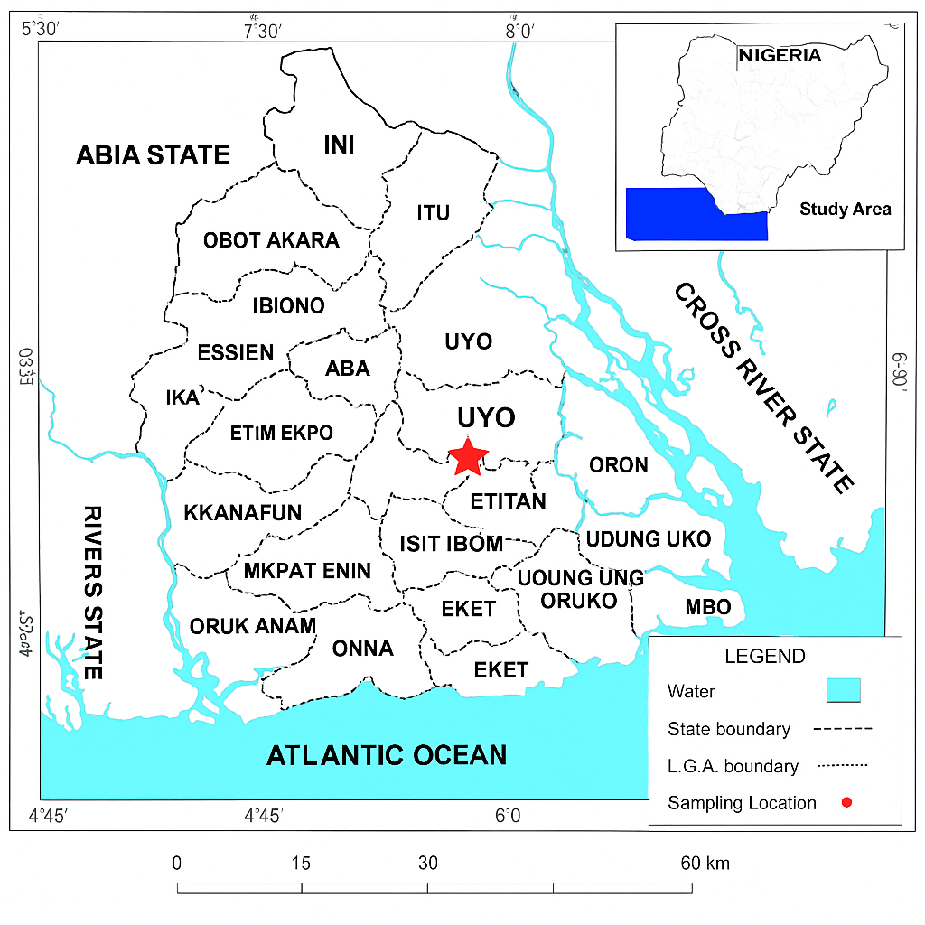
Fig. 1: Map of the sampling location

2.2 Sampling Strategy
A purposive sampling design was adopted to select the three streams based on their proximity to farmlands and visible evidence of agricultural runoff. Sampling was conducted during both wet and dry seasons to capture seasonal variations in hydrochemical inputs. At each site, water samples were collected midstream at a depth of 20–30 cm using pre-cleaned 1 L polyethene bottles that had been soaked in nitric acid and rinsed with deionised water. Before final collection, each bottle was rinsed with stream water to minimise external contamination. Samples intended for nutrient and physicochemical analyses were transported unacidified, while samples designated for heavy-metal analysis were immediately acidified to pH < 2 with ultrapure nitric acid.

2.3 Physicochemical Analysis
In situ measurements of key hydrochemical parameters were carried out at each sampling point using calibrated portable meters. pH was measured with a Hanna HI 9811 meter, dissolved oxygen (DO) was determined using a YSI Pro20 DO meter, turbidity was assessed with a Hach 2100P turbidimeter, and total dissolved solids (TDS) were measured using a Jenway 4510 meter. All instruments were calibrated daily according to manufacturer guidelines to ensure analytical accuracy and stability.

2.4 Nutrient Determination
Nutrient concentrations, including nitrate, phosphate, and ammonium, were analysed following approved spectrophotometric procedures outlined by APHA (2017). Nitrate was determined using the cadmium reduction method, phosphate using the ascorbic acid method, and ammonium using the phenate method. Absorbance readings were obtained using a UV–Visible spectrophotometer, and analyte concentrations were calculated from calibration curves prepared using analytical-grade standard solutions. All nutrient analyses were conducted within 24 hours of sampling to prevent chemical alteration.

2.5 Heavy-Metal Analysis
Heavy-metal concentrations (Pb, Cd, Hg, As, and Cr) were determined using flame atomic absorption spectrophotometry (AAS) with a PerkinElmer AAnalyst instrument. Prior to analysis, water samples were subjected to nitric-acid digestion on a hot plate at 80–90°C until the volume was reduced by approximately half. The digested samples were cooled, filtered, and diluted back to their original volume with deionised water. Calibration standards were prepared from certified metal-stock solutions, and instrument performance was verified using reagent blanks, duplicate samples, and spiked recoveries to ensure analytical reliability.

2.6 Seasonal Variation Assessment
Seasonal influences on water quality were examined by comparing wet-season and dry-season concentrations of nutrients, metals, and dissolved oxygen. This assessment provided insight into the role of rainfall intensity and hydrological changes in the mobilisation and transport of contaminants into the streams.

2.7 Quality Assurance and Quality Control
Comprehensive quality assurance and quality control measures were implemented throughout the sampling and analytical procedures. All bottles and laboratory glassware were soaked in 10% nitric acid for 24 hours, rinsed with deionised water, and dried before use. Field and laboratory blanks accompanied each analytical batch to detect contamination. Instrument calibration was conducted using multi-point standard curves with coefficients of determination (R²) maintained above 0.995. Duplicate measurements were taken for at least 10% of samples, and recovery values for spiked samples were maintained within the acceptable range of 85–115%. All measured concentrations were compared with the WHO (2022) guideline values to assess compliance and potential health risks.

3.0 Results

3.1 Nutrient Concentrations in the Streams
Nutrient levels varied across the three sampling locations, reflecting differing degrees of agricultural influence. Nitrate concentrations ranged from 12 to 18 mg/L, with the highest value recorded at Site S2 (18 mg/L), indicating stronger fertiliser input and runoff intensity. Phosphate followed a similar spatial trend, with values between 2.5 and 3.8 mg/L, again peaking at S2. Ammonium concentrations ranged from 1.8 to 2.5 mg/L and were lowest at Site S3. The S2 consistently exhibited the highest concentrations of all measured nutrients, while S3 recorded the lowest, suggesting dilution downstream and reduced exposure to direct runoff.

Table 1: Nutrients in Streams (mg/L)
Site | Nitrate | Phosphate | Ammonium | WHO Standard
S1 | 15 | 3.2 | 2.0 | NO₃: 50, PO₄: 5
S2 | 18 | 3.8 | 2.5 | -
S3 | 12 | 2.5 | 1.8 | -

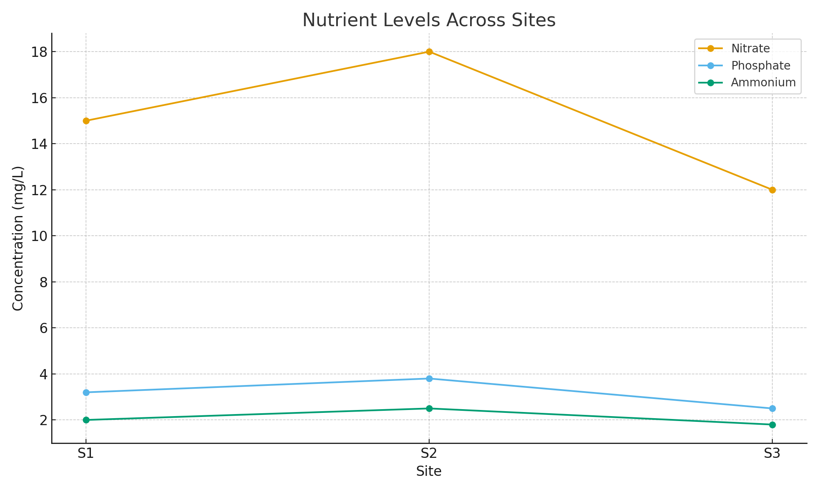Figure 2: Nutrient concentrations across sites S1, S2, and S3.

3.2 Heavy-Metal Concentrations

Heavy metals were detected at all locations, with varying degrees of compliance with WHO standards. Lead concentrations (10–15 µg/L) exceeded permissible limits at Sites S1 (12 µg/L) and S2 (15 µg/L), indicating contamination likely associated with agrochemical residues or soil particles mobilised during runoff. Cadmium concentrations ranged between 1.5 and 2.0 µg/L and remained within acceptable limits. Mercury values (1.0–1.5 µg/L), arsenic values (8–11 µg/L), and chromium concentrations (12–18 µg/L) were also within WHO thresholds for drinking water.

Table 2: Heavy Metals concentrations (µg/L)
Site | Pb | Cd | Hg | As | Cr | WHO Standard
S1 | 12 | 1.8 | 1.2 | 9 | 15 | Pb 10, Cd 3, Hg 6, As 10, Cr 50
S2 | 15 | 2.0 | 1.5 | 11 | 18 | -
S3 | 10 | 1.5 | 1.0 | 8 | 12 | -

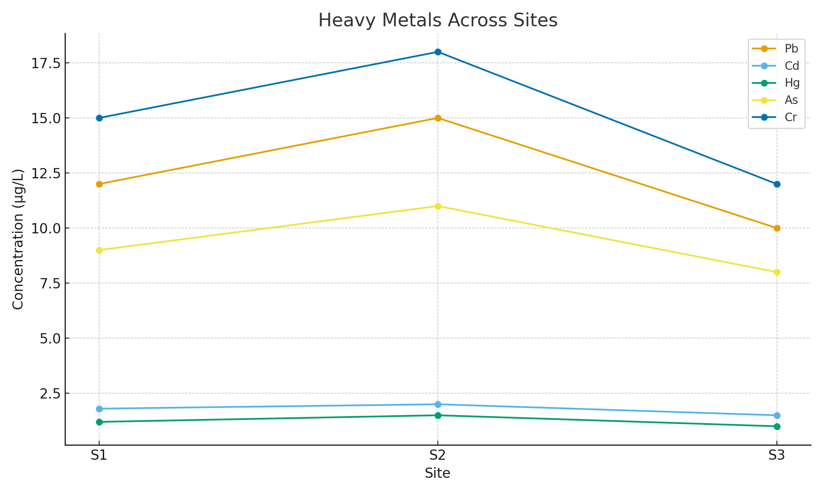
Figure 3: Metal concentrations across the sampling sites.

3.3 Physicochemical Water Quality

The physicochemical characteristics of the streams showed noticeable spatial differences. pH values ranged from 6.5 to 6.9, indicating slightly acidic conditions typical of regions influenced by organic matter decomposition and nutrient loading. Dissolved oxygen levels varied from 4.8 to 5.2 mg/L, with the lowest value recorded at S2, suggesting enhanced microbial activity and elevated organic content. Turbidity levels (10–15 NTU) exceeded natural background levels for undisturbed streams and were highest at S2, consistent with sediment wash-off during runoff. Total dissolved solids ranged from 430 to 500 mg/L, with S2 again showing the highest concentration.

Table 3: Water Quality Parameters
Site | pH | DO (mg/L) | Turbidity (NTU) | TDS (mg/L)
S1 | 6.8 | 5.0 | 12 | 450
S2 | 6.5 | 4.8 | 15 | 500
S3 | 6.9 | 5.2 | 10 | 430

3.4 Seasonal Variation in Water Quality
Seasonal comparisons revealed marked differences between wet and dry periods. Nitrate concentrations increased from 13 mg/L during the dry season to 17 mg/L in the wet season, reflecting rainfall-induced mobilisation of fertiliser residues. Lead concentrations also increased from 12 µg/L in the dry season to 14 µg/L in the wet season, while dissolved oxygen decreased from 5.2 mg/L to 4.9 mg/L due to increased organic matter input and reduced light penetration.
Table 4: Seasonal Variation (Nutrients and Metals)
Parameter | Wet Season | Dry Season
Nitrate (mg/L) | 17 | 13
Pb (µg/L) | 14 | 12
DO (mg/L) | 4.9 | 5.2

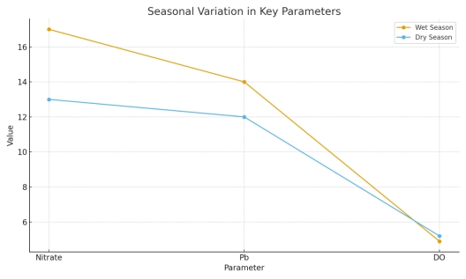
Figure 4: Comparison of wet and dry season variations in nitrate, lead, and dissolved oxygen.

4.0 Discussion
The results of this study demonstrate that streams receiving agricultural runoff exhibit measurable alterations in nutrient levels, heavy-metal concentrations, and hydrogeochemical characteristics. Nutrient enrichment was evident across all sampling locations, with Site S2 showing the highest concentrations of nitrate, phosphate, and ammonium as presented in Table 1. These patterns are typical of farmlands with intensive fertiliser application, where rainfall and irrigation activities facilitate the transport of nitrogen- and phosphorus-based agrochemicals into surface waters. Similar observations have been reported in irrigation and agricultural catchments across Rivers State, where runoff mobilises both organic and inorganic nutrient fractions into adjoining streams (Ekpe et al., 2025). The elevated nutrient concentrations, although still below WHO limits, indicate progressive nutrient loading that can contribute to eutrophication and altered ecological structure if unmanaged.
Heavy-metal concentrations further underscore the influence of anthropogenic inputs, particularly agricultural and mixed land-use activities. Table 2 shows that Pb levels exceeded WHO permissible limits at Sites S1 and S2, suggesting contamination from fertiliser components, farm machinery emissions, or soil particles enriched with lead residues. This trend aligns with the documented metal burdens in surface waters of the Niger Delta, where agricultural runoff often coexists with atmospheric deposition from industrial activities such as gas flaring (Aghanwa et al., 2025). The presence of Cd, Hg, As, and Cr at all sites, even below guideline values, reflects chronic low-level contamination that can accumulate over time, posing long-term ecological risks. Several studies have demonstrated the bioaccumulative potential of trace metals in aquatic organisms, showing that even low concentrations in water bodies can result in significant tissue accumulation in fish and crustaceans (Eyenubo et al., 2024; Okpoji et al., 2025). Similar risks have been reported in international studies examining persistent contaminants such as PCBs and PBDEs in fish, where bioaccumulation patterns reflect prolonged exposure to low-level environmental contamination (Ernesto et al., 2021; Stewart et al., 2000).
Hydrochemical indicators from Table 3 further highlight the impact of runoff on stream quality. Slightly acidic pH values (6.5–6.9) are consistent with waters influenced by organic acids, decomposing vegetation, and nutrient–metal interactions, which are common in agricultural and oil-impacted landscapes. Comparable hydrochemical conditions have been reported in Niger Delta water systems, where organic matter input and contaminant influx contribute to acidity and altered ionic composition (Okpoji et al., 2025; Okagbare et al., 2025). Dissolved oxygen levels were lowest at Site S2, indicating increased microbial activity and organic loading, likely associated with fertiliser-rich runoff and sediment influx. Turbidity and TDS were also highest at Site S2, pointing to soil erosion and particulate transport from farmlands. These findings are consistent with studies showing that agricultural runoff often carries sediments, metals, hydrocarbons, and agrochemical residues that influence water clarity, ionic strength, and overall hydrochemical stability (Umueni et al., 2025; Okpoji et al., 2025).
Seasonal variations presented in Table 4 further reinforce the role of rainfall in pollutant mobilisation. Nitrate and Pb concentrations were higher in the wet season, which aligns with the established hydrological pattern where rainfall accelerates the transport of soluble nutrients, soil particles, and metal-bound sediments into aquatic systems. This increased flushing effect has been widely documented in tropical agricultural regions and in polluted Niger Delta waterways where wet-season inflows elevate contaminant concentrations (Aghanwa et al., 2025; Ekpe et al., 2025). Lower dissolved oxygen in the wet season reflects higher organic input, increased turbidity, and reduced light penetration, all of which diminish aquatic oxygenation. Similar seasonal DO reductions have been reported in contaminated rivers of the Niger Delta, where hydrocarbon and nutrient influx compromise oxygen availability and alter community structure (Okpoji et al., 2025; Umueni et al., 2025).
Although this study focused on nutrients and metals, the trends observed mirror those associated with broader categories of persistent contaminants such as polycyclic aromatic hydrocarbons (PAHs) and PCBs, which are known to undergo long-range atmospheric deposition and accumulate in aquatic environments (ATSDR, 1997; Kallenborn et al., 2015; Wania et al., 2006). Agricultural watersheds in developing regions often experience overlapping pollution stressors, including pesticide residues, industrial emissions, and petroleum hydrocarbons, which complicate aquatic ecosystem responses (John et al., 2025; Lawal, 2023). The contamination patterns observed in this study, particularly the detectable levels of multiple metals and the consistent nutrient presence, are characteristic of systems exposed to chronic, diffuse pollution sources.
The hydrogeochemical and contaminant patterns documented reflect a multi-source pollution environment where agricultural runoff interacts with atmospheric deposition, catchment geology, and land-use pressures. Similar complexities have been highlighted in environmental assessments across the Niger Delta, where the interplay between agricultural, industrial, and domestic activities challenges remediation and management strategies (Ibe, 2023; Kwok, 2023; Okpoji et al., 2025). The presence of metals, elevated turbidity, and nutrient enrichment suggests that continued monitoring and integrated watershed management interventions are essential to prevent further degradation.

Conclusion
This study demonstrates that agricultural runoff significantly influences the hydrogeochemical characteristics and overall water quality of streams within the study area. Nutrient enrichment was evident across all sampling locations, with Site S2 showing consistently higher concentrations of nitrate, phosphate, and ammonium due to its proximity to intensive farming operations and active runoff pathways. Although nutrient levels remained below WHO (2022) guideline values, their spatial and seasonal patterns suggest increasing nutrient loading that, if unmanaged, may predispose the streams to eutrophication and long-term ecological alteration.
Heavy metals were present in all streams, with Pb concentrations exceeding WHO limits at Sites S1 and S2, indicating contamination linked to agrochemical residues, eroded soils, and atmospheric deposition. While Cd, Hg, As, and Cr remained within permissible limits, their persistent detection underscores the presence of chronic low-level metal pollution capable of accumulating in sediments and aquatic organisms over time.
Physicochemical indicators—including slightly acidic pH, moderate dissolved oxygen, elevated turbidity, and increased TDS—further reflect the influence of agricultural activities and sediment wash-off on stream-water chemistry. Seasonal variation highlighted the critical role of rainfall in mobilising nutrients, metals, and particulates, with wet-season conditions showing higher contaminant concentrations and reduced oxygen availability. Collectively, these findings reveal a system undergoing progressive degradation driven by diffuse agricultural pollution. Without intervention, continued nutrient and metal loading may compromise ecological integrity, reduce water quality, and pose health risks to communities dependent on these streams. Strengthening watershed management through improved fertiliser practices, erosion control, riparian buffer establishment, and regular water-quality monitoring is essential to safeguard both ecosystem function and public health in the region.
References
Agency for Toxic Substances and Disease Registry (ATSDR). (1997). Toxicological Profile for Polychlorinated Biphenyls (PCBs). Public Health Service, U.S. Department of Health and Human Services, Atlanta, GA. https://www.atsdr.cdc.gov/toxprofiles/tp17-p.pdf
Aghanwa, C. I., Umueni, U. E., Etukudo, N. J., Amachree, J. B., Okpoji, A. U., Ejeka, C. J., & Ekwere, I. O. (2025). Atmospheric deposition of soot and heavy metals from gas flaring into surface waters of Ebocha, Rivers State, Nigeria. Asian Journal of Environment & Ecology, 24(11), 137–147. https://hal.science/hal-05364672/
Ekpe, J. E., Okpoji, A. U., Ekwere, I. O., Anarada, C. J., Ewuola, A. A., Ufuoma, V. O., Okpanachi, C. B., Okonkwo, C. O., & Obunezi, O. A. (2025). Physico-chemical transport of pesticides and nutrients in irrigation water and their fate in agro-ecosystems of Rivers State, Nigeria. Palgo Journal of Agriculture, 9(2), 30–37. https://doi.org/10.5281/zenodo.17148360
Ekwere, I. O., Okpoji, A. U., Igwegbe, K. C., Okonkwo, C. O., Yekeen, A. A., Obunezi, O. C., Okpanachi, C. B., Garuba, M. H., Ogini, O. R., & Odibo, U. E. (2025). Nutritional–Toxicological Trade-Off: Comparative study of polycyclic aromatic hydrocarbons in smoked and oven-dried Nile tilapia (Oreochromis niloticus). Journal of Environment, Climate, and Ecology, 2(2), 90–97. https://doi.org/10.69739/jece.v2i2.952
Ekwere, I. O., Okpoji, A. U., Ufuoma, V. O., Akinola, A. E., Raymond, C. A., Clement, R. O., Alaekwe, I. O., Etesin, M. O., & Edodi, I. O. (2025). Nutritional evaluation of Nile tilapia (Oreochromis niloticus) processed by different drying methods in Akwa Ibom State, Nigeria. Journal of Sustainable Research and Development, 1(2), 11–17. https://doi.org/10.69739/jsrd.v1i2.1033
Ernesto, O. Z. A. B., Dioselina, O. F. H., Marina, R. R. O., Hector, M., & Miguel. (2021). Bioaccumulation of PCBs and PBDEs in fish from a tropical Lake Chapala, Mexico. Toxics, 9(1). https://doi.org/10.3390/toxics9100241
Eyenubo, O. B., Peretomode, V. O., Egharevba, F., Osakwe, S. A., & Avwioro, O. G. (2024). Polychlorinated biphenyls (PCBs) in sediments and fish from dredged tributaries and creeks of River Ethiope, South-South Nigeria: Sources, risk assessment and bioaccumulation. Journal of the Nigerian Society of Physical Science, 6, 1951. https://journal.nsps.org.ng/index.php/jnsps/article/view/1951
IARC (International Agency for Research on Cancer). (2015). Agents Classified by the IARC Monographs, Volumes 1–112. https://www.focus.it/site_stored/imgs/0004/030/classificationsalphaorder.pdf
Ibe, U. (2023). Challenges in environmental remediation in complex regions: Case study of the Niger Delta. Journal of Toxic Substance Management, 12(3), 204–219.
John, E. E., Emah, O. A., Ifiok, O. E., Okpoji, A. U., Iyam, O. E., Henderson, O. O., Akinola, A. E., Gloria, N. A., & Charles, N. O. (2025). Health risk implications of polycyclic aromatic hydrocarbons in smoked and dried fish consumed in Nigeria. Journal of Medical Science, Biology, and Chemistry, 2(2), 192–199. https://doi.org/10.69739/jmsbc.v2i2.1045
Kallenborn, R., Hung, H., & Brorström-Lundén, E. (2015). Atmospheric long-range transport of persistent organic pollutants (POPs) into polar regions. In Comprehensive Analytical Chemistry (Vol. 67, p. 411). Elsevier. https://doi.org/10.1016/B978-0-444-63299-9.00013-2
Kwok, F. (2023). Enhancing global cooperation in environmental governance. Global Environmental Politics, 21(1), 77–92.
Lawal, A. (2023). Management strategies for PCBs in the Niger Delta: Achievements and challenges. Environmental Management Review, 29(1), 45–59.
Oghenekohwiroro, E., & Osaro, I. (2017). Assessment of the levels of polychlorinated biphenyls (PCBs) in Oroodo River sediment, Agbor, Delta State, Nigeria. Annals of Chemistry, 28, 25. https://intapi.sciendo.com/pdf/10.1515/auoc-2017-0005
Okagbare, U. V., Umueni, U. E., Ekpe, J. E., Etukudo, N. J., Okpoji, A. U., Okoye, P. I., Ekwere, I. O., Etesin, M. U., Okpanachi, C. B., & Okafor, C. A. (2025). Geophysical and hydrochemical assessment of groundwater vulnerability to oil pollution in Yenagoa, Bayelsa State, Nigeria. Journal of Environment, Climate, and Ecology, 2(2), 138–146. https://doi.org/10.69739/jece.v2i2.1078
Okpoji, A. U., Anarado, C. O., Mmuta, E. C., Ekwere, I. O., Alaekwe, I. O., Odibo, U. E., Igwegbe, K. C., Eboj-Ajoku, I. O., & Obunezi, O. C. (2025). Toxicological evaluation of Pb, Cd, As, and Hg in blue crab from oil-polluted creeks in the Niger Delta. Journal of Life Science and Public Health, 1(1), 24–31. https://doi.org/10.69739/jlsph.v1i1.879
Okpoji, A. U., Chinyere, U. E., Nwokoye, J. N., Ezekwuemen, O. I., Alaekwe, I. O., Odidika, C. C., Owughara, C. N., Enyi, C. M., & Kolawole, O. O. (2025). Environmental assessment of heavy metals and hydrocarbon pollution in surface waters of oil-bearing communities in Andoni, Rivers State, Nigeria. International Journal of Modern Science and Research Technology, 3(8), 22–30. https://www.ijmsrt.com/articles/view/environmental-assessment-of-heavy-metals-and-hydrocarbon-pollution-in-surface-waters-of-oil-bearing-communities-in-andoni-rivers-state-nigeria
Okpoji, A. U., Eboh-Ajoku, I. O., Mmuta, E. C., Ndubuisi, J. O., Alaekwe, I. O., Odibo, U. E., Nwoka, N. G., Okafor, C. A., & Obunezi, O. C. (2025). Integrated environmental risk assessment of BTEX and PAHs in water and sediment samples from the Bonny River, Nigeria. ISA Journal of Multidisciplinary (ISAJM), 2(4), 14–21. https://doi.org/10.5281/zenodo.16921896
Okpoji, A. U., Ekwere, I. O., Igwegbe, K. C., Anarado, C. J. O., Ogbonna, C., Ewuola, A. A., Odibo, U. E., & Garuba, M. H. (2025). Volatile organic compounds from gas flaring and their atmospheric implications in the Niger Delta. Journal of Life Science and Public Health, 1(1), 32–39. https://doi.org/10.69739/jlsph.v1i1.962
Okpoji, A. U., Etesin, M. U., Ekwere, I. O., Martins, N. P., Okpanachi, C. B., Adisa, O. J., & Okonkwo, C. C. (2025). Geochemical speciation and ecological risk of heavy metals in estuarine sediments of the Qua Iboe River, Nigeria. Asian Journal of Chemical Sciences, 15(6), 20–31. https://doi.org/10.9734/ajocs/2025/v15i6402
Okpoji, A. U., Ndubuisi, J. O., Eboh-Ajoku, I. O., Emem, J. A., Ekwere, I. O., Alaekwe, I. O., Odibo, U. E., Igwegbe, K. C., Onoja, C. R., Warder, A. B., & InyangAbia, A. J. (2025). Trematode infections and histopathological effects in Chrysichthys nigrodigitatus from the polluted Andoni River, Niger Delta, Nigeria. Journal of Agriculture, Aquaculture, and Animal Science, 2(2), 66–72. https://doi.org/10.69739/jaaas.v2i2.882
Okpoji, A. U., Ogbaji, H. O., Hassan, D. H., Orji-Azuka, L. N., Rasheed, H. O., Ohaturuonye, S. O., Ejeka, J. C., Okpanachi, C. B., & Ekwere, I. O. (2025). Physico-chemical transport of volatile organic compounds (VOCs) from gas flaring into surface waters of Ogoniland, Rivers State, Nigeria. Asian Journal of Physical and Chemical Sciences, 13(4), 151–159. https://doi.org/10.9734/ajopacs/2025/v13i4271
Okpoji, A. U., Ugwanyi, G. C., Etesin, U. M., Ugwuanyi, G. C., Okpanachi, C. B., Ewuola, A. A., Mojisola, K. M., & Ezekwueme, O. I. (2025). Solar-enhanced photocatalytic degradation of pharmaceutical residues in wastewater using Fe-, Cu-, and Zn-doped TiO₂ nanomaterials. Journal of Environment, Climate, and Ecology, 2(2), 56–62. https://doi.org/10.69739/jece.v2i2.961
Onoja, C. R., Ogbaji, H. O., Edodi, I. O., Mmuta, E. C., Igwegbe, K. C., Ogini, O. R., Odibo, U. E., Ewuola, A. A., Mahmoud, A. B., & Okpoji, A. U. (2025). Heavy metal contamination and health risk assessment of smoked-dried fish sold in Eke-Awka market, Anambra State, Nigeria. Journal of Sustainable Research and Development, 1(2), 18–25. https://doi.org/10.69739/jsrd.v1i2.1044
Stewart, P., Reihman, J., Lonky, E., Darvill, T., & Pagano, J. (2000). Prenatal PCB exposure and neonatal behavioural assessment scale (NBAS) performance. Neurotoxicology and Teratology, 22(1), 21–29. https://doi.org/10.1016/S0892-0362(99)00056-2
Umueni, U. E., Etukudo, N. J., Okoye, P. I., Okpoji, A. U., Eze, V. C., Aningo, G. N., Ekwere, I. O., & Garuba, M. H. (2025). Geochemical and ecological risk assessment of petroleum hydrocarbons in sediments of the Forcados River, Delta State. Asian Journal of Geographical Research, 8(4), 287–298. https://doi.org/10.9734/ajgr/2025/v8i4337
USEPA (United States Environmental Protection Agency). (2011). Regional Screening Level (RSL) Table for Chemical Contamination at Superfund Sites. https://pubchem.ncbi.nlm.nih.gov/source/22050
Wania, F., Bereik, K., Persson, N. J., & McLachlan, M. S. (2006). A fugacity-based dynamic multi-compartmental mass balance model of the fate of persistent organic pollutants. Environmental Modelling & Software, 21, 868. https://www.et-fine.com/10.1016/j.envsoft.2005.04.003
World Bank. (2014). Life expectancy data.

