Policy Interventions and Community-Based Initiatives for Enhancing Food Security and Resilience in Rural Tigray

Abstract
This research examines the interaction between governmental interventions and community-based efforts in enhancing food security and resilience in rural Tigray. Using mixed methods, including ethnography, surveys, interviews, and secondary data analysis, the study assessed the contributions of external and local initiatives to household adaptive capacity. Findings reveal significant variation in program participation: women-led savings and credit groups had the highest involvement (46%), followed by seed-sharing cooperatives (39%), while conventional grain banks had the lowest (16%). Government support, such as food aid (61%) and the Productive Safety Net Programme (52%), was crucial in the short term but insufficient for sustained resilience. Communities like Beleso and parts of Agazi, which relied on strong local initiatives, experienced better recovery (63%) and food security (48%) than Guahgot, which depended mainly on external aid (42% and 28%). Overall, community-driven measures, reinforced by policy support, are essential for lasting resilience.

Keyterms: Policy Interventions, Community-Based Initiatives , Food Security , Rural Tigray

1. Background to the Study

Food insecurity, which is characterized as limited or unpredictable access to enough nourishing food for a healthy life, affects around 2 billion people worldwide, particularly in Asia, Latin America, and Africa (FAO, 2019). More than 92% of people battle hunger in Sub-Saharan Africa, the region with the worst food insecurity (Icheria, 2012). In Ethiopia, roughly 20.5% of families face food insecurity, with rural regions bearing a disproportionate impact (Tefera & Tefera, 2014). This challenge is compounded by climate change, socio-economic disparities, and political instability, which affect agricultural output and availability to food (IPCC, 2022).
Rural Ethiopia confronts major problems, particularly in places like Tigray, where dependence on subsistence farming and limited resources leave populations susceptible to food insecurity. Climate variability, including droughts and floods, affects agricultural yields and worsens poverty, since many rural people resort to coping tactics including selling assets or lowering food consumption (Negash & Alemu, 2013). Despite attempts like climate-smart agriculture, problems such as poor infrastructure and limited finance restrict development (Mekonnen & Gebremedhin, 2020).
The socio-political environment further compounds food insecurity in Ethiopia. Policy reforms focusing on rural infrastructure, agricultural services, and market access are essential, as are strategies to address land tenure instability and gender inequality (IFPRI, 2021; Taye et al., 2023). Additionally, global economic crises, including the COVID-19 pandemic, have heightened food scarcity by inflating prices and destabilizing supply chains, particularly for food imports like wheat (USAID, 2023). Tigray, heavily reliant on subsistence farming, is particularly vulnerable to these stresses. The region's communities often resort to drastic measures, such as selling household items or withdrawing children from school, to survive (Birara et al., 2015). This ethnographical account aims to explore the availability of resources and their impact on food security in rural Tigray, shedding light on local coping mechanisms and resilience strategies.

3.Empirical Research: A Review
Review Almost 29% of people globally suffered food insecurity in 2021, with sub-Saharan Africa carrying a disproportionate share of the burden. Repeated droughts, increasing food prices, and violence intensify the situation in Ethiopia, particularly in Tigray, where over 20 million people suffer from extreme food insecurity. While novel solutions like small-scale irrigation and climate-smart agriculture (CSA) help decrease food poverty, obstacles such as restricted technological availability and poor institutional support continue. Addressing structural concerns like land tenure and market access is vital for long-term solutions (SIPRI, 2020; FSIN, 2023; Gebeyanesh et al., 2023).
Food insecurity is defined by FAO as a situation when people do not have regular access to sufficient, safe, and nutritious food. There are four factors that prevent it, these are stability, use, accessibility and availability. The problem is especially widespread in sub-Saharan Africa, where grim poverty, environmental degradation and economic instability worsen vulnerability to food insecurity (FAO, 2022). Food insecurity in Tigray leads to severe hunger and malnutrition, but with a cyclical impact worsened by periodic droughts, political turmoil, and the loss of agricultural infrastructure (WFP, 2021). Food insecurity in Tigray is influenced by numerous connected variables. Climate change plays a key effect, with erratic rainfall patterns and periodic droughts adversely hurting agricultural production, lowering both food crops and cattle.
The continuous fighting and political instability in the area further worsen the situation, since the displacement of farmers and the loss of essential infrastructure restrict food production and limit access to markets (Mengisteab, 2019). The crisis is also exacerbated by socioeconomic and economic issues; high rates of poverty, restricted market access, and poor infrastructure make it hard for rural communities—particularly smallholder farmers to obtain the resources required to increase productivity and enhance food security (Hagos et al., 2022). A Viewpoint from Anthropology on Food Insecurity From an anthropological viewpoint, food insecurity is a product of various social, economic, and cultural variables rather than simply a shortage of food.
The allocation of food and resources is determined by social status, power dynamics, and cultural beliefs. In Tigray, the political past and continuing wars have changed agricultural systems and resource distribution, which complicates food security further. Ethnographic approaches aid in understanding how communities manage with food shortage, utilizing traditional knowledge and local food systems to adapt to environmental and socioeconomic changes (Gebrehiwot & van der Veen, 2021). Conclusion addressing food poverty in Tigray needs a multi-faceted strategy that incorporates climatic resilience, conflict settlement, and sustainable farming techniques. Policies should encourage adaptable agricultural practices, boost market access, and solve socio-political problems. Anthropological insights into local food systems and coping strategies might influence the creation of context-specific treatments that correspond with the cultural and social demands of impacted populations. Sustainable resource management and competent governance will be important in creating resilience against future food crises.

4.Theoretical Frameworks: A Review

This research takes an interdisciplinary approach that mixes ecological, social, and economic systems to analyse resource availability and its influence on food security in rural Tigray, Ethiopia. Climate change, economic inequality, and unsustainable agriculture systems are important worldwide drivers to food insecurity. Yaro’s (2004) method exposes threats from ecological and socio-economic causes but fails to address persistent imbalances in resource allocation and policy-making. In contrast, Peng’s (2018) sociotype ecological paradigm stresses the relationship between social systems and ecological repercussions, advocating for community-specific solutions. Dryland (2020) intensifies gender inequities, underlining the need for gender-sensitive methods in tackling food poverty, notably in Africa. Livelihood diversification, as examined by Bailey (2016) and Kasie (2018), is a vital method in rural settings, allowing people cope to environmental unpredictability and economic limits.

However, Pelletier (2016) disputes resilience theories, arguing for context-specific solutions that include historical and socio-political aspects. In the setting of rural Tigray, Ethiopia, this research blends Ecosystem Theory, the Sustainable Livelihood Framework (SLF), and Resilience Theory to analyse the multiple concerns of food security. Ecosystem Theory underlines the necessity of sustaining balance in human-environment connections, particularly in vulnerable ecosystems like Tigray, where sustainable land management practices are important to combating soil degradation and resource depletion (Varyvoda, 2022).

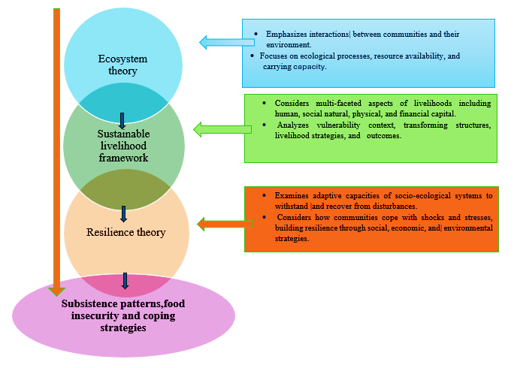

Figure.1: Theoretical Diagram that Illustrates the Interplay between Ecosystem Theory, Sustainable Livelihood Framework and Resilience Theory

SLF explores how rural people harness natural, financial, and social capital to cope with environmental pressures such as drought and market instability. Resilience Theory, on the other hand, underlines the requirement of adaptive strategies like climate-smart agriculture and community-based resource management to help communities bounce back from calamities. These integrated frameworks present a full strategy for studying subsistence patterns and food insecurity in Tigray. By addressing underlying vulnerabilities and integrating sustainable practices, the project intends to offer culturally informed and structurally transformational interventions that promote food security and resilience in the area.
5. Conceptual Framework of the Study

This study developed a conceptual framework that integrates political economics and cultural ecology theories to examine subsistence practices, food insecurity, and adaptive mechanisms in rural Tigray. The framework focuses on the relationship between traditional agricultural techniques, socio-cultural components, and external influences. In rural Tigray, traditional farming techniques, which relied on rainfall and were impacted by socio-cultural variables such as social networks, land tenure, and resource availability, were crucial to subsistence patterns and agricultural productivity, directly effecting food security. External forces, including political instability, economic policies, and climate change, intensified food insecurity by increasing socio-economic inequality and environmental stress. Households responded with coping techniques, such as moving, diversifying subsistence activities, and leaning on social support networks, which reinforced their resistance to harsh conditions. The theme of resilience was crucial to this strategy, underlining a household’s potential to tolerate and recover from both short-term food shortages and long-term environmental and socio-economic changes. By incorporating these components, the framework explored how conventional farming practices, external restrictions, and socio-cultural factors affected food security and coping strategies. Through this technique, the study tried to reveal insights into the efficiency of both traditional and current coping strategies. The findings were designed to inform interventions aimed at enhancing food security and community resilience in rural Tigray, embracing local customs and socio-cultural features, finally contributing to sustainable living in the region.
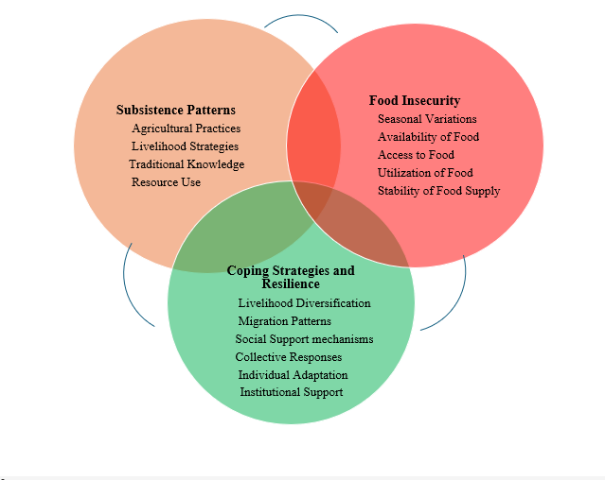

Figure 2: Conceptual framework of the Study

6. Study Area and the Villages

6.1. Location of the Study Area

Located in Ethiopia's northernmost area, the Tigray region is one of the regional states with important administrative significance of the country. The Eastern Zone, located in the eastern part of the region shares boundaries with the Southeastern Zone to the south, the Central Zone to the west, the Afar Region to the east, and Eritrea to the north. The Eastern Zone is home to Mount Asimba, its tallest peak at 3,250 meters, offering a spectacular natural landmark. This area encompasses significant towns such as Adigrat, Zalambessa, Edagahamus, Fireweini, Hawzen, and Wukro, with Adigrat serving as the administrative seat. The zone has 18 woredas (districts): 11 rural and 7 urban. These woredas are separated into 157 kebelles and 559 kushets, constituting a complicated administrative system. The rural woredas represent 61.1% of the zone, while urban woredas account for 38.9%. Agriculture, animal husbandry, and modest commerce persist as the principal socioeconomic activity, reflecting the traditional lifestyles of the population (CSAPFTR, 2023).

However, food insecurity remains a substantial concern, with many families depending on safety net services to satisfy basic necessities. The Eastern Zone is not simply an administrative subdivision but also a hotspot of cultural richness. The area is renowned for its ancient cultural heritage sites and traditions, which contribute to its distinctive character.
In the Eastern Zone, the woredas of Ganta Afeshum, Subha Saesie, and Tsaeda Emba are notable for their interrelated topographical and agro ecological characteristics. These woredas constitute a continuous region where the study tabias are tightly connected, supporting a similar social and economic dynamic. While all three woredas display similar agro ecological features, such as dependence on mixed farming and cattle husbandry, Ganta Afeshum and Subha Saesie are largely highland locations with milder weather and steep terrains. These highlands are characterized by terraced agriculture, the production of barley and wheat, and specific environmental concerns such soil erosion. In contrast, Tsaeda Emba mixes these highland elements with somewhat more moderate heights, supporting a varied variety of crops and grazing pastures. This connection has affected the livelihoods, cultural practices, and communal relationships of the people throughout various woredas (ADCS, 2022).

The study focuses on three tabias of the three woredas: Guahgot from Ganta Afeshum, Beleso from Subha Saesie, and Agazi from Tsaeda Emba, each selected for their representativeness of rural Tigray families. These tabias reflect the region's subsistence practices, including small-scale farming and cattle husbandry, which are affected by the highland agroecology and restricted resources. They also underscore the persisting issues of food insecurity, as people usually rely on seasonal agricultural outputs and safety net programs to preserve their livelihoods. Coping methods such as community labor-sharing, crop diversification, and dependence on remittances are widely recognised throughout these groups. The home will serve as the major unit of study, giving a thorough lens through which to investigate the interaction of socioeconomic, environmental, and cultural elements. Employing ethnography as the principal study approach provides for an in-depth knowledge of these processes, documenting the lived experiences and adaptation methods of rural households in Tigray (CSAPFTR, 2023).
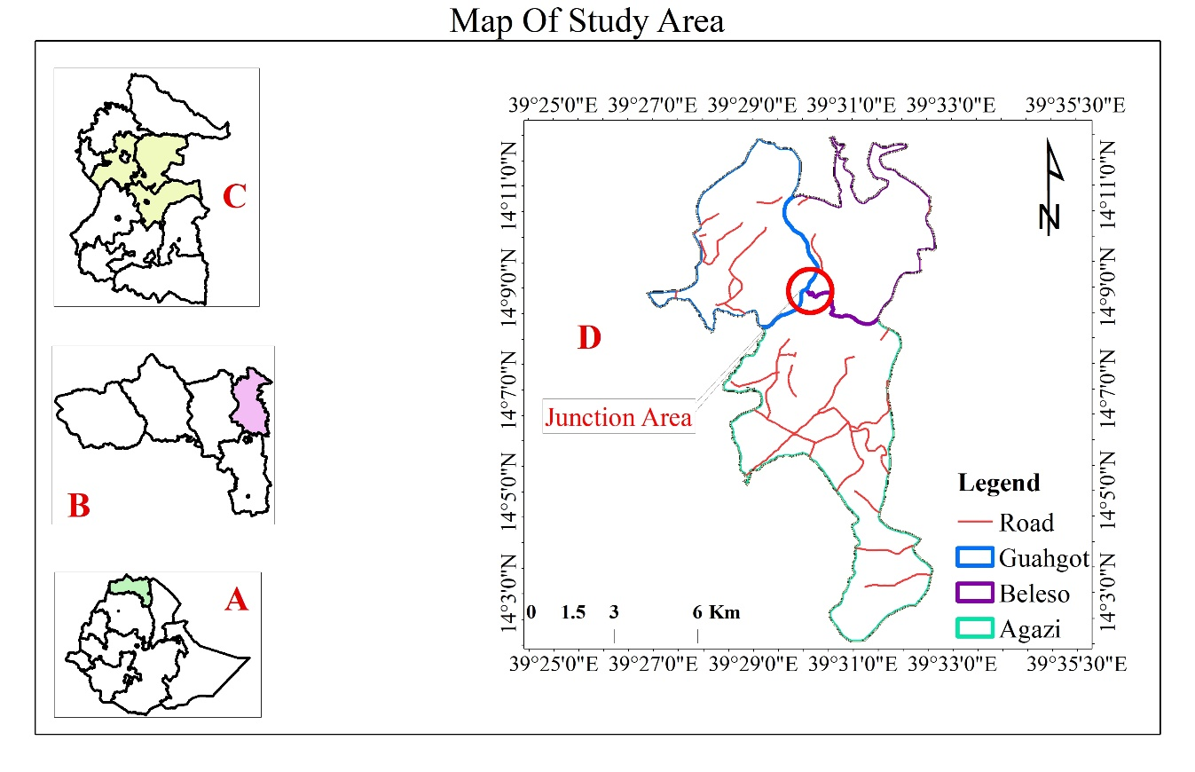
Source: Developed from ArcGIS 10.8, 2024

Figure 3: Map of the study area

6.2 Demographic Composition

According to the 2007 Census conducted by the Central Statistical Agency of Ethiopia, the population of the Eastern Zone was documented as 755,343, consisting of 359,638 men and 395,705 women. 19.34% resided in cities, with most being part of the Tigray ethnic group. Tigrinya was the main language used by 96% of the people. The population was primarily composed of Orthodox Christians, accounting for 95.73%, with Muslims following at 2.4% and Catholics at 1.79%. The population in 1994 was 584,946, mostly consisting of Tigrayans. Only 9% of the population had electricity available, with 88.2 kilometers of roads per 1000 square kilometers. The majority of rural households possessed half a hectare of land and seven-tenths of a livestock animal. A high number of individuals were employed in non-agricultural sectors, while a considerable portion of kids went to school. The region was not threatened by the tsetse fly but was exposed to a drought risk of 573.

7. Research Methodology

7.1 Research Design

The approach employed in this study will be mixed methods. The study will be anthropological, primarily focusing on conducting ethnographic research mainly grounded in a qualitative approach, while quantitative methods will also be utilized. The ethnographic technique is an essential element of anthropological research design since it allows for a profound comprehension of cultural and social contexts (Gürcüm, 2015). The method of long-term immersion in a culture and participant observation is considered the fundamental approach in anthropological studies (Sergiu, 2011). Therefore, the study will employ an ethnographic methodology to provide holistic anthropological understanding, accompanied by a quantitative approach. The ethnographic research approach will be crucial for comprehending subsistence patterns, food insecurity, and coping strategies in rural Tigray as it is a comprehensive approach. Furthermore, it will facilitate a complete understanding of the cultural, social, and economic elements that impact these phenomena in the study area. By employing the ethnographic approach, the study will explore and comprehend the sociocultural dynamics of the study tabias, where the household is considered as the unit of study. Consequently, the peasant households will be studied in their natural habitat. Long-term and intensive fieldwork will be conducted in the study areas by employing both etic and emic approaches.

The study design will utilize a descriptive research design to describe the phenomenon related to subsistence patterns, food insecurity, and coping strategies in the study tabias. Descriptive research, particularly in the form of qualitative description, is a valuable method in ethnographic studies, providing a comprehensive summary of events in everyday terms (Sandelowski, 2000). In the context of ethnographic research, this method can be applied to various stages, including the ethnographic interview, where it helps in asking descriptive, structural, and contrast questions (Spradley, 1979).

The study is confined to three rural woredas of Gantafeshum, Subha Sa’esie and Tsaeda Emba Woredas (districts) out of the 11 rural woredas in eastern Tigray region. The Woredas and the villages will be selected purposively in consultation with officials of the Eastern zone. The selected woredas will be considered as a representative of the Eastern zone particularly in terms of agro-ecological diversities and subsistence aspects. Gantafeshum, Subha Sa’esie and Tsaeda Emba Woredas consists of 45 tabias where three of them (Guahgot, Beleso and Agazi) will be selected for the ethnographic study because of various key qualities such as rich socio-history, originality and Agro ecological zone. There is also a rich oral history in Beleso, Agazi, Guahgot. Additionally, the tibias are easily accessible, facilitating regular connection with neighborhood woredas and minimizing logistical obstacles. Preliminary visits to the areas also gave useful information into the research environment and its appropriateness for the ethnographic study, assuring practical feasibility and supporting ethical standards of community engagement and consent.

7.2. Sample Size and Sampling Technique

A combination of probability and non-probability sampling techniques employed to select the sample population. Probability sampling, specifically stratified random sampling, used to collect data from different Tabias in Eastern Tigray. These techniques are instrumental in minimizing bias, especially when accounting for the heterogeneity of socio-economic factors (e.g., household family size) and agroecological zone strata within each Tabia (Beleso, Guahgot, and Agazi) of the study area.

Using these methods, the sampling frame organized into relatively homogeneous strata. Then, respondents will be selected through simple random sampling within each stratum, proportional to the quota size. This approach ensures fair representation of the various household sizes in the study area. The sample size applied on the population to be studied, and the selection based on a list of formally registered residents in each Tabia, as provided by the wereda municipal administration. The sample size chosen considered representative of the total population.
The non-probability sampling technique will be used to select three rural woredas from 11 rural woredas and three tabias out of 45 tabias in three rural woredas and key informants, including the woreda administrator, Tabia administrators, and development agents (DAs), through purposive sampling.
The sample size will be determined using the formula developed by Kothar (2004), assuming 95% confidence level and D = 0.5:
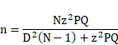
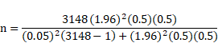
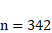
n- Sample
N - Household unit variables
P- Expected prevalence or proportion (in proportion of one; 50%)
Q - (1-P)
D – Allowable error 0.05 significance
Z – Standardize normal variable and valued that corresponds to 95% degree of confidence, which is conventional, Z value is 1.96.
A total of 342 household heads constituted the sample unit or sample size. Using a simple random sampling technique, 342 representative household heads selected from the study area, as the issue being studied is prevalent across the study area.

Table 1. Sample size and sampling technique
No. | Tabia | Households size in each Tabias | Sample taken or proportional allocation (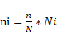)
1 | Agazi | 1035 | 112
2 | Beleso | 728 | 79
3 | Guahgot | 1385 | 151
Total |  | 3148 | 342

1. Data Collection
In order to improve food security and resilience in rural Tigray, this research looks at how community-based projects and policy interventions interact. A multifaceted approach to data collecting forms the foundation of the study process. Together with regional development plans, this entails a thorough examination of pertinent national and regional policies, such as Ethiopia's Food Security Strategy. In order to get primary data on locally driven programs, key informant interviews—such as those with government officials and NGO managers—as well as community-level surveys and focus groups will be conducted. An examination of secondary sources, including program reviews and scholarly research, is added to this.
The research focuses on two primary domains: the effects of governmental interventions, including institutional support and land tenure changes, and the function of community-based initiatives, including traditional social networks and farmer cooperatives. The study seeks to evaluate the impact of these integrated methods on food security indicators—namely availability, access, stability, and utilization—and their role in enhancing family and community resilience to diverse shocks, such as drought and violence.

3. Data Analysis Techniques
The research used a blend of qualitative and quantitative data analysis methodologies. Thematic analysis was used to discern main policy topics, including safety nets and resilience-building mechanisms, and to evaluate community-based policies and their perceived efficacy. Comparative analysis was used to analyze variations in results between areas with strong local efforts and those that mostly depend on external funding. Where survey data was available, descriptive statistical methods were applied to describe the number and kind of community initiatives, as well as participation rates in government programs. A SWOT (Strengths, Weaknesses, Opportunities, and Threats) study was also done to provide a full picture of both policy changes and community-led projects.

Ethnographic Narrative: Thematic Analysis of Policy and Community Strategies
The daily lives of agricultural families are carved with tales of adversity in the untamed and drought-prone regions of Beleso, Agazi, and Guahgot. A multi-layered understanding of the relationship between policy frameworks and indigenous resilience methods in the face of chronic food insecurity is revealed via in-depth interviews with community elders, local agricultural officials, and NGO coordinators.
From the lens of government and policy actors, safety net programs—most notably the Productive Safety Net Programme (PSNP)—are repeatedly highlighted as critical buffers during lean seasons. As one rural development officer in Agazi put it, “PSNP is not just food or cash. It’s how people stay on their land during the worst droughts.” Yet, even among policymakers, there is growing recognition that such interventions often stop short of long-term transformation. Many officers acknowledge the limits of centralized delivery, echoing the sentiment that “resilience isn’t distributed in sacks of grain.”
This perspective is mirrored—though with more skepticism—by community members themselves. Focus Group Discussions (FGDs) revealed that while food aid and cash transfers offer momentary relief, they do not equip households with the tools to rebuild or innovate. In Beleso, a widowed mother of five described the frustration: “They give us food, but they don’t teach us how to feed ourselves when the rains fail again.”
In contrast, community-based methods were typically talked about with pride and ownership. an Across all three communities, respondents referred to savings groups—often launched and led by women—as crucial for everyday resilience. These associations not only enabled members to save modest sums and obtain loans in times of need but also fostered social relationships and trust. In Guahgot, members of a seed-sharing cooperative recounted how, during the recent planting season, they pooled indigenous kinds resistant to variable rainfall. “We didn’t wait for the government to bring improved seeds—we used what we had, and it worked,” one farmer stated.

Another frequent topic was the resurrection of ancient customs like Debo (labor sharing), particularly during times of sickness or harvest bottlenecks. However, several community elders voiced worry that such practices are fading under the strain of migration and individual survival choices. This breakdown of community standards was considered as both a social and existential hazard.
It's interesting to note that NGOs often supported community-led initiatives like small-scale irrigation cooperatives or training programs for climate adaptation, acting as a bridge. However, opinions differed even here. An foreign NGO's program coordinator said that when external financing ceased, these kinds of programs often failed due to a lack of local leadership. "We've discovered that the projects that people believe belong to them from the beginning are the best ones," she said.
The perceived effectiveness of community-driven programs was significantly connected to autonomy, cultural relevance, and demonstrable impact. Households were more encouraged to join in activities when they saw clear returns—such as higher yields from water-user associations or shorter famine spells due to grain banks. In contrast, policy measures that lacked consistency or openness were viewed with mistrust or tiredness.

Result and discussion

Table 2: Community-Based Initiatives Identified Across Study Sites

Initiative Type | No. of Communities Involved | Avg. Household Participation Rate (%)
Women-led savings & credit groups | 3 | 46%
Seed-sharing cooperatives | 2 | 39%
Water-user associations (irrigation) | 2 | 28%
Labor-exchange schemes (“Debo”) | 1 | 21%
Traditional grain banks | 1 | 16%
The results demonstrate considerable differences in the adoption and household involvement percentages of several community-based programs. Women-led savings and credit clubs emerged as the most extensively implemented intervention, including three communities with an average household involvement rate of 46%. This conclusion corresponds with larger research stressing the transformational significance of women’s economic cooperatives in boosting family resilience and financial inclusion, especially in rural and resource-constrained contexts (Allen & Panetta, 2010; Dejene, 2019). Seed-sharing cooperatives were also quite well-represented, with two communities participating and an average rate of 39%. Such programs are crucial for sustaining agrobiodiversity, enhancing seed security, and encouraging climate-resilient agricultural practices (Coomes et al., 2015).
Conversely, the participation percentages of labor-exchange programs like Debo and water-user organizations were lower, at 28% and 21%, respectively. These tactics are crucial for managing shared resources and enabling group labor for agricultural production, but their low adoption rates may be due to institutional flaws, a lack of resources, or changing labor dynamics in rural areas that have recently experienced conflict (Bekele & Hailemariam, 2020; Ostrom, 2010). The lowest participation rate was 16% for traditional grain banks, indicating that consumers may be becoming less dependent on these institutions as a result of sustainability issues, storage losses, or a rising preference for market-based alternatives (Ng’ang’a et al., 2016).

Table 3: Participation in Government and NGO Programs (Across 342 Households)

Program Type | % of Households Participating
Productive Safety Net Programme (PSNP) | 52%
Agricultural extension services | 34%
Food aid (emergency distributions) | 61%
Climate adaptation trainings (NGOs) | 18%
The participation statistics reveal that government and NGO initiatives have a crucial role in developing household coping methods and resilience results. Food assistance programs, mostly in the form of emergency handouts, reached the biggest percentage of families, with a participation rate of 61%. This emphasizes the persistent dependence of rural families on direct assistance operations in environments of recurring shocks and post-conflict vulnerability. However, although food assistance offers immediate consumption support, academics emphasize that its sustainability is limited, and over-dependence may hamper long-term self-reliance and adaptive capability (Barrett, 2020; Maxwell & Maes, 2010).
The Productive Safety Net Programme (PSNP), Ethiopia’s primary social protection system, covered 52% of assessed families, showing its important role in decreasing chronic food insecurity via regular payments and public works. Previous research have shown that PSNP participation may stabilize household spending and prevent asset depletion, while its influence is typically modulated by program design and local implementation ability (Berhane et al., 2014; Hoddinott et al., 2012). an Agricultural extension services reached 34% of households, suggesting a modest but significant pathway for knowledge transfer, capacity development, and better production. Yet, participation rates imply that hurdles such as access, trust, and gender inclusion may hinder widespread use (Davis et al., 2010).
Climate adaptation trainings conducted by NGOs reported the lowest participation percentage at 18%. This restricted reach may indicate budget restrictions, project-based delivery, or lack of incorporation with local institutions. Nevertheless, such activities remain vital for increasing climate resilience and developing adaptation practices among smallholder farmers (Adimassu et al., 2016). The results together show that although food assistance and safety nets meet urgent needs, more focus is necessary on extending agricultural extension and climate adaptation measures to establish sustainable, long-term resilience.

Table 4 : Resilience and Food Security Outcomes by Community Type

Community Type | % Reporting Recovery from Shock | % Food Secure (last season)
Strong local initiatives (Beleso, parts of Agazi) | 63% | 48%
Reliant mainly on external support (Guahgot, others) | 42% | 28%
The results show considerable disparities in food security and resilience outcomes across areas that rely heavily on outside assistance and those that have robust local efforts. 63% of families reported recovering from recent shocks, and 48% were food secure in the previous season in areas with locally led efforts, such Beleso and sections of Agazi. Accordingly, grassroots initiatives that capitalize on social capital, local expertise, and community solidarity, such women-led savings organizations, seed-sharing cooperatives, and collective work plans, enhance adaptive ability (Aldrich & Meyer, 2015; Pretty, 2003). According to Béné et al. (2016), these locally based organizations often promote quicker recovery, lessen reliance on outside assistance, and improve the durability of coping strategies.
Communities like Guahgot, on the other hand, which mostly depend on outside assistance, reported far worse results, with just 42% of families recovering from shocks and 28% attaining seasonal food security. These results show that when externally driven initiatives are not well incorporated into local organizations, they might have negative effects. According to Devereux and Sabates-Wheeler (2004) and Barrett (2020), although emergency food assistance and government safety nets provide vital short-term relief, their potential to ensure long-term resilience is often limited by concerns about sustainability, community ownership, and institutional reliance.
Overall, the data imply that communities with strong local efforts likely to be more resilient and food secure than those depending on foreign aid. This underlines the necessity of developing community-led institutions while supplementing them with government and NGO initiatives that are participatory, flexible, and context-specific.Building resilience thus requires balancing external support with investments in local capacity and social infrastructure, ensuring that interventions do not erode but rather reinforce community self-reliance (Folke, 2016).

SWOT Analysis: Policy vs. Community-Based Approaches
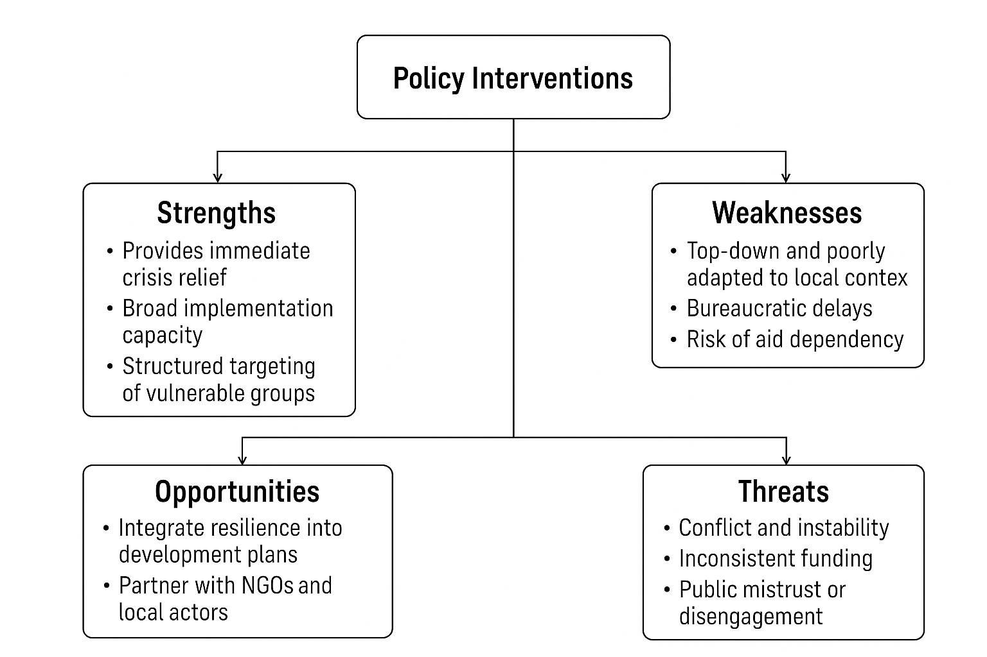
Figure 4. Policy Interventions (e.g., PSNP, food aid, extension services)

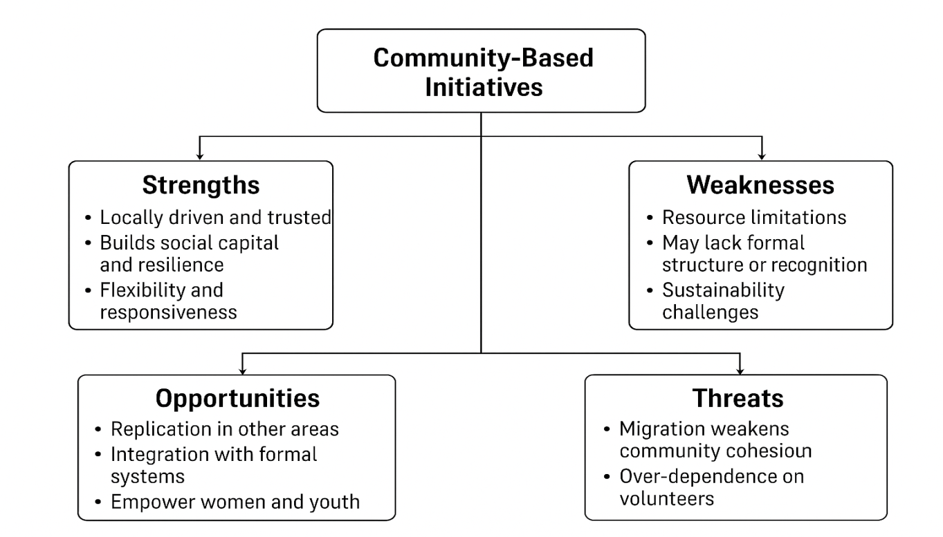

Figure 5.Community-Based Initiatives (e.g., women-led savings groups, seed banks)

Conclusion
The research finds that food security and resilience results in rural Tigray differ significantly across groups, highlighting those that prioritize internal, community-driven activities vs those who depend mostly on external assistance. Government and NGO programs like food assistance, PSNP, and agricultural extension are important safety nets and ways to get help right now, but their long-term effects are restricted by problems with sustainability, limited coverage, and poor interaction with local institutions. In contrast, grassroots efforts—including women-led savings clubs, seed-sharing cooperatives, and collective labor systems—demonstrated better and more durable benefits to resilience by creating ownership, social cohesiveness, and adaptive ability. Ultimately, communities that rely on locally driven initiatives report stronger recovery from shocks and higher food security results than those depending on external help. This underlines the significance of building indigenous institutions and incorporating foreign initiatives inside local cultural and social contexts.

Recommendations
Strengthen Community-Based Institutions: Support women-led savings organizations, seed-sharing cooperatives, and traditional labor-sharing systems as essential foundations of resilience and self-reliance.

Integrate External Support with Local Structures: Ensure government and NGO interventions, such as PSNP and food aid, complement rather than replace community activities, promoting participatory and context-specific methods.

Expand Agricultural Extension and Climate Adaptation Programs: Increase coverage, accessibility, and inclusivity of agricultural services and climate adaptation trainings to create long-term resilience.

Promote Sustainability of Aid Programs: Shift from dependency on emergency food aid to capacity-building initiatives that support autonomy and long-term food security.
Enhance Policy-Community Linkages: Design policies that use local knowledge, cultural practices, and social capital to promote program ownership, sustainability, and effectiveness.

Invest in Social Infrastructure: Develop methods that enhance social cohesiveness, trust, and local resource management to minimize susceptibility to shocks and guarantee resilience against future crises.

COMPETING INTERESTS DISCLAIMER:
Authors have declared that they have no known competing financial interests OR non-financial interests OR personal relationships that could have appeared to influence the work reported in this paper.

References
- Adimassu, Z., Langan, S., & Johnston, R. (2016). Climate-smart agriculture: Integrating mitigation and adaptation in Ethiopia. Climate and Development, 8(5), 437–446. https://doi.org/10.1080/17565529.2015.1042000
- Aldrich, D. P., & Meyer, M. A. (2015). Social capital and community resilience. American Behavioral Scientist, 59(2), 254–269. https://doi.org/10.1177/0002764214550299
- Allen, H., & Panetta, D. (2010). Savings Groups: What Are They? The SEEP Network. https://www.findevgateway.org/publication/savings-groups-what-are-they-2010-06-01
- Barrett, C. B. (2021). Overcoming Global Food Security Challenges Through Science and Solidarity. American Journal of Agricultural Economics https://doi.org/10.1111/ajae.12160
- Bekele, W., & Hailemariam, A. (2020). Community-based natural resource management and rural livelihoods: Evidence from Ethiopia. Environment, Development and Sustainability. https://doi.org/10.1007/s10668-018-0291-2
- Béné, C., Newsham, A., Davies, M., Ulrichs, M., & Godfrey-Wood, R. (2014). Review article: Resilience, poverty and development. Journal of International Development, 26(5), 598–623. https://doi.org/10.1002/jid.2992
- Berhane, G., Gilligan, D. O., Hoddinott, J., Kumar, N., & Taffesse, A. S. (2014). Can social protection work in Africa? The impact of Ethiopia’s Productive Safety Net Programme. Economic Development and Cultural Change, 63(1), 1–26. https://doi.org/10.1086/677753
- Coomes, O. T., McGuire, S. J., Garine, E., Caillon, S., McKey, D., Demeulenaere, E., Jarvis, D., Aistara, G., Barnaud, A., Clouvel, P., Emperaire, L., Louafi, S., Martin, P., Massol, F., Pautasso, M., Violon, C., & Wencelius, J. (2015). Farmer seed networks make a limited contribution to agriculture? Four common misconceptions. Food Policy, 56, 41–50. https://doi.org/10.1016/j.foodpol.2015.07.008
- Davis, K. E., Swanson, B., Amudavi, D., Mekonnen, D. A., Flohrs, A., Riese, J., Lamb, C., & Zerfu, E. (2010). In-depth assessment of the public agricultural extension system of Ethiopia and recommendations for improvement (IFPRI Discussion Paper 1041). International Food Policy Research Institute. https://hdl.handle.net/10568/154552
- Dejene, M. (2019). The role of women in savings and credit cooperatives in rural Ethiopia. Journal of Co-operative Organization and Management, 7(2), 100–108. https://doi.org/10.1016/j.jcom.2019.100089
- Devereux, S., & Sabates-Wheeler, R. (2004). Transformative social protection. IDS Working Paper 232. https://opendocs.ids.ac.uk/opendocs/handle/20.500.12413/3700
- Folke, C. (2016). Resilience (republished). Ecology and Society, 21(4), 44. https://doi.org/10.5751/ES-09088-210444
- Hoddinott, J., Berhane, G., Gilligan, D. O., Kumar, N., & Taffesse, A. S. (2012). The impact of Ethiopia’s Productive Safety Net Programme and related transfers on agricultural productivity. Journal of African Economies. https://doi.org/10.1093/jae/ejs016
- Maxwell, D., & Maes, J. (2010). Protracted crises and chronic poverty in humanitarian responses: Policy implications. Disasters, 34(S2), S79–S103. https://doi.org/10.1111/j.1467-7717.2010.01152.x
- Ng’ang’a, S. K., Kibugi, R., & Muthee, A. (2016). Grain banks as a food security strategy: Lessons from East Africa. Food Security, 8(3), 583–596. https://doi.org/10.1007/s12571-016-0584-1
- Ostrom, E. (1990). Governing the commons: The evolution of institutions for collective action. Cambridge University Press. https://www.cambridge.org/core/books/governing-the-commons/F22000A0112217240122172401221724
- Pretty, J. (2003). Social capital and the collective management of resources. Science, 302(5652), 1912–1914. https://doi.org/10.1126/science.1090847

