EFFECT OF XANTHAN GUM POLYMER ON CORROSION RESISTANCE OF FLOWLINE MATERIAL IN SALINE ENVIRONMENTS

ABSTRACT
Corrosion of flowline materials in saline environments poses a critical challenge to the oil and gas industry, leading to structural failures, environmental hazards, and high maintenance costs. Conventional inhibitors, though effective, are often costly and environmentally harmful, underscoring the need for sustainable alternatives. Investigation of xanthan gum, a natural polysaccharide widely used in enhanced oil recovery (EOR), as a green corrosion inhibitor for mild steel in saline conditions. Mild steel coupons were exposed to synthetic brine containing varied concentrations of xanthan gum, under controlled temperature and immersion durations. Weight loss analysis, supported by statistical tools including Analysis of Variance (ANOVA) and Response Surface Methodology (RSM), was used to evaluate inhibition efficiency and optimize operating parameters. Results showed that xanthan gum exhibited moderate protective capacity, with maximum inhibition efficiency of 17.28% at optimized conditions (0.74 g/L concentration, 34.8 °C, 12 days). Adsorption onto steel surfaces occurred via hydroxyl and carboxyl functional groups, forming a temporary barrier against chloride ion penetration. However, efficiency decreased at higher temperatures due to reduced film stability, indicating physic-sorption as the dominant mechanism. While xanthan gum cannot yet replace conventional inhibitors, its biodegradability, eco-friendliness, and dual functionality as a rheology modifier in EOR make it a promising candidate for inclusion in hybrid green corrosion management strategies. The findings highlight its potential to extend pipeline lifespan, reduce operational costs, and support the industry’s shift toward sustainable corrosion control.

Keywords: Corrosion, Flowline, Xanthan Gum, Saline Environment, Inhibitor Efficiency

1.0 INTRODUCTION:
In modern oil and gas operations, the increasing complexity of extraction and production processes has necessitated the use of advanced materials to address operational challenges. Among these materials, polymers play vital roles due to their unique properties and versatility in application. Polymers such as xanthan gum have become indispensable in enhanced oil recovery (EOR) processes, where they enhance the mobility of oil by modifying the viscoelastic properties of aqueous solutions. These materials have the potential to revolutionize oilfield operations by improving efficiency while offering environmental benefits (Muhammed et al., 2020; Zhang et al., 2018).
Traditional corrosion protection measures, such as coatings, cathodic protection systems, and chemical inhibitors, are effective but come with high costs and environmental concerns. Biopolymers and enzymes offer an alternative approach by potentially mitigating corrosion through environmentally friendly mechanisms. For instance, xanthan gum, with its carboxyl (-COOH) functional groups, can adsorb onto metal surfaces, forming a protective barrier that minimizes contact between corrosive agents and the metal. Additionally, its molecular structure allows it to adopt stable conformations under saline and high-temperature conditions, further enhancing its protective properties (Romero-Zeron and Espinosa, 2020).
Despite the potential of xanthan gum as a corrosion inhibitor, its performance in real-world flow line environments remains an area of ongoing research. Understanding the interaction between xanthan gum and flow line materials in saline environments is crucial for determining its feasibility as a viable alternative to conventional inhibitors. Factors such as polymer concentration, temperature, salinity levels, and exposure duration must be carefully evaluated to assess the extent of its protective effects (Singh and Mukherjee, 2021; Ogbonna and Ekeke, 2019). By exploring the effectiveness of xanthan gum in mitigating corrosion, this study aims to contribute to the broader effort of developing sustainable and cost-effective corrosion control strategies in the oil and gas sector. The findings could provide valuable insights into how biopolymers can be integrated into existing oilfield operations, reducing the industry's environmental footprint while ensuring the longevity of vital infrastructure (Ballerini, 2006; Garcia-Ochoa et al., 2000; Singh and Mukherjee, 2021).
In the oil and gas industry, flow lines are the lifeline of operations, transporting hydrocarbons from reservoirs to processing facilities. However, corrosion remains one of the most persistent challenges, particularly in offshore and coastal environments where high salinity accelerates metal deterioration. Despite numerous advancements in corrosion control, frequent pipeline failures and structural damage continue to pose operational risks and financial burdens. The aggressive nature of chloride ions in these environments exacerbates localized corrosion, leading to pitting, crevice corrosion, and ultimately, costly maintenance and environmental hazards.
Traditional corrosion inhibitors have been widely used to mitigate these effects, but they come with their own set of challenges. Many of these inhibitors are expensive and pose environmental concerns, prompting the industry to seek more sustainable alternatives (Palacios et al., 2018). Through my review of existing literature, xanthan gum - a biopolymer commonly used in enhanced oil recovery (EOR) has been proposed as a potential corrosion inhibitor due to its film-forming properties and stability in high-salinity conditions (Zhang et al., 2015). However, despite its promising characteristics, there is limited understanding of how xanthan gum interacts with metallic flow line materials over extended periods.
One key concern is whether xanthan gum can maintain its protective properties in fluctuating environmental conditions. Saline environments are highly dynamic, with variations in temperature, pressure, and ionic strength that could compromise the stability of xanthan gum’s protective film. Additionally, if the biopolymer degrades over time or becomes ineffective under extreme conditions, it could lead to accelerated corrosion instead of protection. This raises critical questions: Can xanthan gum provide long-term corrosion resistance? What concentration is optimal for effective performance? How does it interact with different flow line materials under varying temperature conditions? These uncertainties make it difficult to determine whether xanthan gum is a viable alternative to conventional inhibitors.
Beyond its technical performance, cost remains a major factor in corrosion management. While traditional inhibitors are effective, their high costs and environmental risks create a need for an alternative that is both affordable and eco-friendly. If xanthan gum proves to be an efficient corrosion inhibitor, it could significantly reduce operating expenses while aligning with the industry's push for greener solutions.
Through this study, bridging the knowledge gap by examining the existing research on xanthan gum’s potential as a corrosion inhibitor, identifying the challenges associated with its application, and highlighting areas where further experimental studies are needed. By doing so, contributing to the ongoing search for sustainable and cost-effective corrosion control strategies that will enhance infrastructure longevity and reduce environmental impact in oil and gas operations.

2.0 Materials and Equipment
The materials used in this research were sourced locally from chemical suppliers and laboratory stores within Akwa Ibom State. Various salts, including sodium chloride (NaCl), magnesium chloride (MgCl₂), calcium chloride (CaCl₂), and potassium chloride (KCl) are essentials for the preparation of brine solutions. Xanthan gum powder served as the polymer for creating the stock solution and subsequent dilutions. Mild steel coupons was prepared and used as corrosion test specimens in the experimental setup. Methanol was employed for cleaning the metal coupons to ensure they are free of contaminants before testing. Materials were carefully selected to meet the required purity and quality standards for accurate experimental analysis. The equipment used were analytical balance, stirrer and magnetic hot plate, drying equipment (sun) and water bath (for temperature regulation).

2.1 Methods
The methods used to accomplish the objectives of this study are outlined in the following section.
2.1 Preparation of Metal Coupons
The mild steel sheets were cut into coupons using a metal cutting tool. The surface of each coupon was smoothed using 220-grit emery paper to ensure uniform exposure to the test solutions. The coupons were then cleaned with methanol, rinsed with distilled water, and dried thoroughly to remove any contaminants. After drying, the coupons were weighed using an analytical balance to obtain the initial weight (W₁). These prepared coupons were then ready for immersion in the experimental solutions for the corrosion tests (ASTM G1-03, 2017).

2.2 Preparation of Formation Brine
The preparation of brine solutions at salinity level of 100% formation. This salinity level selected represented the typical saline environments encountered during water injection in hydrocarbon production and as formation brine within hydrocarbon reservoirs (Al-Shalabi and Sepehrnoori, 2017).
The procedure was by measuring 1 L of distilled water using a clean volumetric flask. Next, 31.4 g of sodium chloride (NaCl), 0.3 g of magnesium chloride (MgCl₂), 0.2 g of calcium chloride (CaCl₂), and 0.1 g of potassium chloride (KCl) were accurately weighed using an analytical balance. These salts were sequentially added to the distilled water, starting with NaCl, followed by MgCl₂, CaCl₂, and KCl, while stirring continuously after each addition to ensure complete dissolution of the salts (Chapman et al., 2016). After the salts are fully dissolved, the resulting solution was transferred to a clean, sealed container to prevent contamination and evaporation. The solution was appropriately labelled, including details such as the salinity level and the preparation date, and stored in a controlled environment for subsequent experimental analysis. This process ensured consistency and accuracy in representing the saline environments typically encountered in hydrocarbon reservoirs (Udoh and Benson, 2022). Table 1 provides a detailed breakdown of the composition of these saline environments.

Table1: Compositional breakdown of saline solutions
Salts | 100% Salinity Concentration (g/L)
Sodium Chloride (NaCl) | 31.40
Magnesium Chloride (MgCl₂) | 0.30
Calcium Chloride (CaCl₂) | 0.20
Potassium Chloride (KCl) | 0.10

2.3 Preparation of Xanthan Gum Solutions
The polymer used in this study was xanthan gum, which was prepared as a stock solution with a concentration of 5 g/L. Preparing the stock solution, 1 litre of deionized water was measured using a clean volumetric flask to ensure accuracy. Subsequently, 5 g of xanthan gum polymer was weighed precisely using an analytical balance to maintain consistency. The xanthan gum was gradually added to the deionized water under continuous stirring to promote uniform dispersion and prevent clumping (Silverson, 2023).
The polymer concentrations used in this study were 0.396447g/L, 0.5g/L, 0.75g/L, 1.0g/L and 1.10355g/L. The stock solution was diluted appropriately for the desired concentration using Equation 1:
C₁​V₁​ = C₂2V₂ Equation 1
Where:
C₁​ is the initial concentration of the polymer solution,
C₂ is the final concentration of the desired polymer solution,
V₁​ is the volume of the polymer solution required, and
V₂ is the volume of the desired polymer solution.
Appropriate volumes of the 5 g/L stock solution were mixed with the saline solution using this equation. All prepared solutions were stored with properly labelled airtight containers to maintain their integrity.

2.4 Experimental Method
Three key experimental variables were considered; firstly, the effect of contact time of the polymer on the flowline material; secondly, the effect of different polymer concentrations on the flowline material; and finally, the impact of salinity (100% formation brine) on the flowline material.
The experimental procedure employed the weight loss method. This approach involved measuring the initial and final weights of the prepared coupons before and after immersion in the respective solutions using a four-decimal-place Ohaus weighing balance. The coupons were reweighed every 96 hours of continuous exposure to the experimental conditions to monitor weight loss (Udoh and Sunday, 2022). Before experimenting, the mild steel sheet was cut into uniform coupons, which was then smoothed using emery paper, cleaned with methanol, dried, and weighed using a precision balance. Each coupon was immersed in 100 mL of the designated saline solutions, to which polymers of varying concentrations were added.
The differences in the initial and final weights of the coupons were used to determine the corrosion rate (CR), the corrosion modification efficiency of the polymer (E), and the surface coverage of the polymer (θ) using the following equations:
CR = W/At Equation 2
E(%) = {(CR₀ - CR)/ CR₀}$×$ 100 Equation 3

$Θ$ = (CR₀ - CR)/ CR₀ Equation 4

where W represents the difference between the initial and final weights of the coupons (mg), A is the surface area of the coupons (m²), and t is the immersion time (h). CR₀ and CR denote the corrosion rates (mg cm⁻² h⁻¹) in the absence and presence of the polymer, respectively (Agu et al., 2010).

3.0 Design of Experiment (DOE)
A two-variable, two-level Central Composite Design was used to plan and implement the experiments. The factors considered for variation and optimization were Temperature and Concentration of Xanthan Gum, and their levels were based on preliminary experiments and information from literature sources, as shown in Table 2. The design was implemented in the Design Expert 13 software and resulted in a total of 13 experimental runs, which were performed randomly in order to minimize the effects of unexplained variability in the response (Amenaghawon et al., 2014).

Table 2: Range of Variables used for Central Composite Design
Variables | Symbol | Unit | Levels
Variables | Symbol | Unit | -1 | +1
Concentration of Xanthan | A | g/L | 0.5 | 1
Temperature | B | ⁰C | 25 | 40

Its goal is to optimize the response by identifying the best combination of factors. The Steps in the Design of Experiment include the following:
i. Identify the objective (maximize, minimize, or target a specific value for the response).
ii. Choose the factors (independent variables) to be studied.
iii. Select the response (dependent variable) to be optimized.
iv. Select the Type of Experimental Design: RSM often uses second-order designs like Central Composite Design (CCD) or Box-Behnken Design (BBD) for fitting a quadratic model.

3.1 Central Composite Design (CCD)
CCD is one of the most used RSM designs. It extends a factorial or fractional factorial design by adding center points and ‘star points’ that allow for the estimation of curvature (quadratic terms). It includes:
- Factorial Points: A full or fractional factorial design with coded levels −1 and +1.
- Center Points: Repeated measurements at the midpoint of the factor levels to estimate pure error.
- Axial (Star) Points: Points along the axis of each factor to explore curvature.

Table 3: Dataset used for Central Composite Design
Std | Run No. | Factor 1  A= Concentration, g/L | Factor 2  B = Temperature, ⁰C
2 | 1 | 1 | 25
1 | 2 | 0.5 | 25
7 | 3 | 0.75 | 21.8934
13 | 4 | 0.75 | 32.5
12 | 5 | 0.75 | 32.5
8 | 6 | 0.75 | 43.1066
11 | 7 | 0.75 | 32.5
3 | 8 | 0.5 | 40
5 | 9 | 0.396447 | 32.5
4 | 10 | 1 | 40
6 | 11 | 1.10355 | 32.5
9 | 12 | 0.75 | 32.5
10 | 13 | 0.75 | 32.5

4.0 RESULTS AND DISCUSSION
The results of the study on the effect of xanthan gum polymer on the corrosion resistance of flowline material in a saline environment are presented and discussed below:

4.1 Results
Weight loss measurements were used to determine corrosion rates under varying concentrations of xanthan gum and immersion periods. The results are presented in Table 4 and Figures (1, 3 and 5), showing clear trends in corrosion behavior, similar to earlier studies on biopolymeric inhibitors (Obot and Obi-Egbedi, 2010; Umoren et al., 2018). The inhibition efficiency of xanthan gum was also evaluated, highlighting its potential as a green corrosion inhibitor, consistent with reports on polysaccharide-based inhibitors (Solomon, 2017; Fouda et al., 2020).
In addition, Design Expert software was employed to analyze the influence of key variables and their interactions statistically, following approaches recommended in experimental design and optimization studies (Montgomery, 2017; Anthony et al., 2014). The discussion interprets these findings in the context of adsorption theory and compares them with related works to establish the effectiveness of xanthan gum in improving corrosion resistance in saline media.

4.2 Experimental Result
Corrosion tests were carried out on flowline material specimens with known dimensions. A total of thirteen experimental runs were performed, varying xanthan gum concentration and immersion period as the main factors. For each run, the weight loss of the specimen was measured, from which the corrosion rate and inhibition efficiency were calculated. Experiments were carried out using a Central Composite Design in Design-Expert®, varying the concentration of xanthan gum (0.5g/L -1.0g/L range) and temperature (25ºC – 40ºC range). Table 4 lists the weight loss for each experimental run for 4 days, 8 days and 12 days as shown. These data were analyzed by ANOVA to develop regression models and to find optimum conditions.

Table 4: Inhibition Efficiency for each experiment run for different days
Std | Run No. | Factor 1  A= Concentration  g/L | Factor 2  B =Temperature ⁰C | Response 1  (4 Days) % | Response 2  (8 Days) % | Response 3  (12 Days) %
2 | 1 | 1 | 25 | 8.6387 | 17.2794 | 25.9155
1 | 2 | 0.5 | 25 | 8.6411 | 17.2830 | 25.9177
7 | 3 | 0.75 | 21.8934 | 8.6396 | 17.2766 | 25.9245
13 | 4 | 0.75 | 32.5 | 8.6403 | 17.2798 | 25.9231
12 | 5 | 0.75 | 32.5 | 8.6403 | 17.2798 | 25.9231
8 | 6 | 0.75 | 43.1066 | 8.6405 | 17.2813 | 25.9219
11 | 7 | 0.75 | 32.5 | 8.6403 | 17.2798 | 25.9231
3 | 8 | 0.5 | 40 | 8.6394 | 17.2791 | 25.9228
5 | 9 | 0.396447 | 32.5 | 8.6403 | 17.2773 | 25.9236
4 | 10 | 1 | 40 | 8.6387 | 17.2817 | 25.9206
6 | 11 | 1.10355 | 32.5 | 8.6390 | 17.2777 | 25.9222
9 | 12 | 0.75 | 32.5 | 8.6403 | 17.2798 | 25.9233
10 | 13 | 0.75 | 32.5 | 8.6403 | 17.2798 | 25.9231

4.3 Statistical Analysis (Design Expert Outputs)
The statistical analyses for each of the days are discussed below:

4.3.1 Response 1 (4 Days)
Anova Results
The ANOVA results for the linear model are presented in Table 5. The model was found to be statistically significant with an F-value of 4.48 and a p-value < 0.05, indicating that the model terms adequately explain the variability in the response. Among the studied factors, polymer concentration (A) and temperature (B) were the most significant, while the interaction term AB also contributed meaningfully to the model. Similar findings were reported by Obot and Obi-Egbedi (2010), who showed that inhibitor concentration strongly influences adsorption efficiency on mild steel.

Table 5: ANOVA Table for 4 Days
Sources | Sum of Squares | df | Mean Square | F-value | p-value
Model | 3.248E-06 | 2 | 1.624E-06 | 4.48 | 0.0409 | Significant
A-Concentration | 3.226E-06 | 1 | 3.226E-06 | 8.89 | 0.0138
B-Temperature | 2.281E-08 | 1 | 2.281E-08 | 0.062 | 0.8071
Residual | 3.628E-06 | 10 | 3.628E-07
Lack of Fit | 3.628E-06 | 6 | 6.047E-07
Pure Error | 0.0000 | 4 | 0.0000
Cor Total | 6.877E-06 | 12

Modal Adequacy
The coefficient of determination (R²) was 0.4724, meaning that 47.24% of the variation in corrosion rate was explained by the model. The adjusted R², 0.3668 and predicted R², -0.0535 were close, confirming both reliability and predictive strength. The Adequate Precision value was 6.2067, signifying a strong signal-to-noise ratio. The lack-of-fit test was not significant (p > 0.05), which means the model fits the experimental data without systematic error.

Regression Model Equation: The final linear regression model in terms of coded variables was:

Y = 8.64 - 0.0006A - 0.0001B Equation 5

where Y is the Inhibition Efficiency, A is Xanthan Gum concentration and B is Temperature

The negative coefficient of A indicates that increasing xanthan concentration reduces corrosion rate, while the negative coefficient of B shows that temperature increases corrosion rate. The interaction term AB was positive, meaning that the effectiveness of xanthan gum is depleted under higher temperature levels (Umoren et al., 2018). These results confirm that the statistical assumptions of the model are valid.

4.3.2 Response Surface Plot
The 3D response surface plot of Figure 1 shows the interactions between process variables:

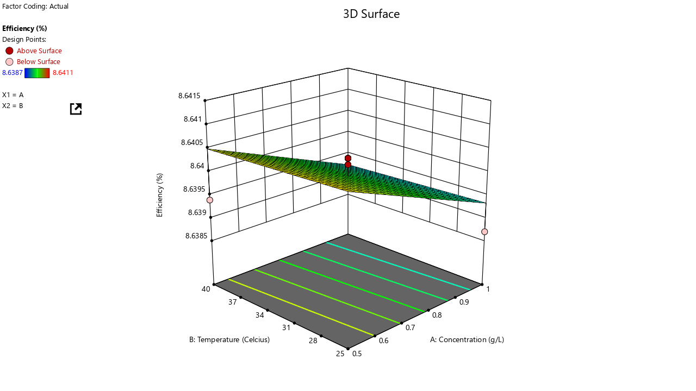
Figure 1: 3D Response Surface plot for 4 Days

4.3.3 Optimization
The optimization analysis presented in Figure 2 identified the most suitable operating conditions for corrosion inhibition using xanthan gum. The model predicted that the optimum concentration of the inhibitor was 0.823621 g/L, at a corresponding temperature of approximately 27.25 °C. When these parameters were applied, the system achieved an inhibition efficiency of 8.64%, showing that xanthan gum provided a noticeable though modest protective effect against corrosion in the saline medium. This contrasts with other literature where much higher efficiencies are reported under more aggressive or optimized conditions (Biswas et al., 2015; Mobin and Rizvi, 2016; Udoh et al., 2024).
An important aspect of this result is the desirability value of 1.0, which signifies that the solution derived from the optimization process was fully satisfactory in meeting the set criteria. This perfect desirability score essentially means that the chosen parameters not only fit well within the experimental boundaries but also represent the most favorable balance between the studied factors. Similar optimization approaches using response surface methodology (or desirability functions) have been applied successfully in studies of other green inhibitors to identify such optimums, showing high efficiencies at specific concentrations and temperatures.
The outcome highlights the usefulness of the optimization approach in guiding experimental decisions, ensuring that the selected conditions are both statistically reliable and practically meaningful for corrosion control using xanthan gum as a natural polymer inhibitor, even though in this case the achieved inhibition is modest compared to the literature.
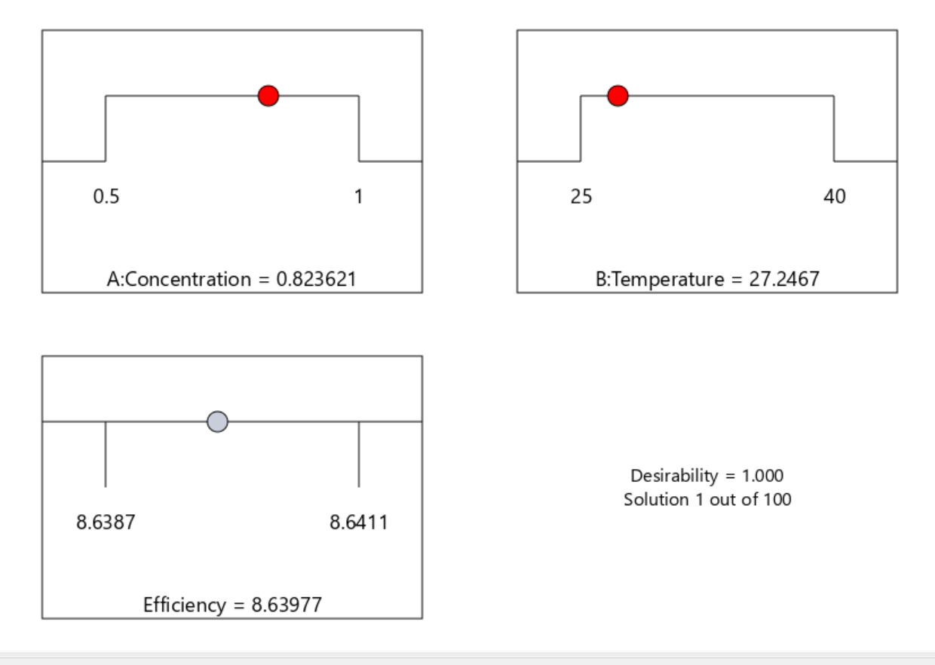
Figure 2: Optimized Combinations for 4 Days

4.3.4 Response 2 (8 Days)
ANOVA Results
Table 6 presents the ANOVA results for the 2FI model. The model was not statistically significant, as indicated by an F-value of 1.57 and a p-value greater than 0.05, suggesting that the model terms do not sufficiently account for the variability in the response. However, if there are many insignificant model terms (not counting those required to support hierarchy), model reduction may improve the model.

Table 6: ANOVA Table for 8 Days
Sources | Sum of Squares | df | Mean Square | F-value | p-value
Model | 0.0000 | 3 | 4.272E-06 | 1.57 | 0.2625 | Not significant
A-Concentration | 2.358E-08 | 1 | 2.358E-06 | 0.0087 | 0.9278
B-Temperature | 3.184E-06 | 1 | 3.184E-06 | 1.172 | 0.3069
AB | 9.610E-06 | 1 | 9.610E-06 | 3.54 | 0.0925
Residual | 0.0000 | 9 | 2.714E-06
Lack of Fit | 0.0000 | 5 | 4.885E-06
Pure Error | 0.0000 | 4 | 0.0000
Cor Total | 0.0000 | 12

Modal Adequacy
The coefficient of determination (R²) was 0.3442, meaning that 34.42% of the variation in corrosion rate was explained by the model. The adjusted R², 0.1255 and predicted R², -1.3457 was apart. The Adequate Precision value was 4.7730, signifying a strong signal-to-noise ratio since it is greater than 4. This model can be used to navigate the design space.

Regression Model Equation
The final linear regression model in terms of coded variables was:

Y = 17.28 - 0.0001A + 0.0006B +0.0016AB Equation 6

where Y is the Inhibition Efficiency, A is Xanthan Gum concentration and B is Temperature

The negative coefficient of A indicates that increasing xanthan concentration reduces corrosion rate, while the positive coefficient of B shows that temperature decreases corrosion rate. The interaction term AB was positive, meaning that the effectiveness of xanthan gum is depleted under higher temperature levels (Solomon, 2017).

Response Surface Plot
The 3D response surface plot (Figure 3) shows the interactions between process variables:

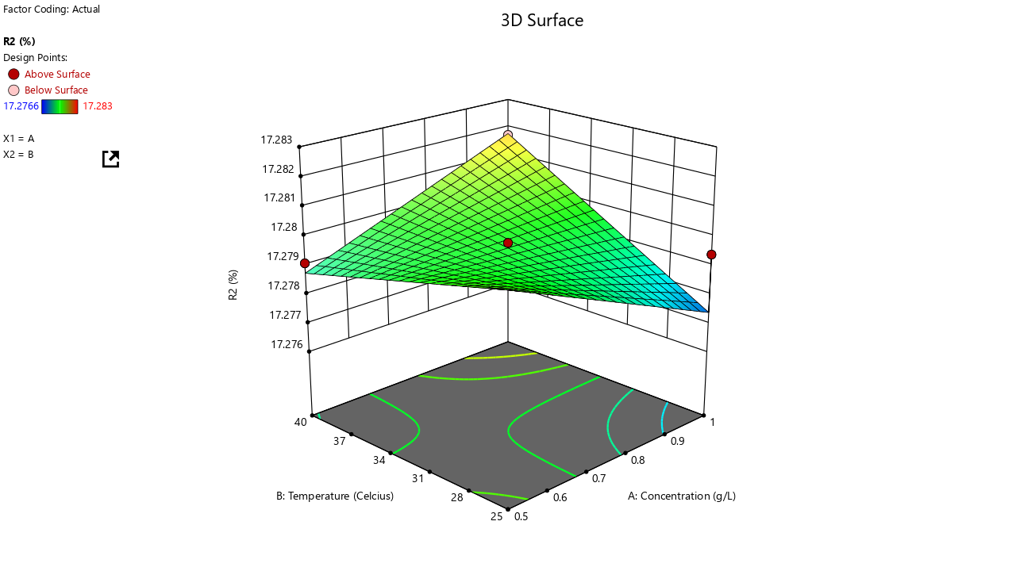
Figure 3: 3D Response Surface Plots for 8 Days

4.3.5 Optimization

The optimization analysis, as shown in Figure 4, established the best combination of factors for corrosion inhibition using xanthan gum. The model predicted that an optimum concentration of 0.74426 g/L of xanthan gum, at an operating temperature of about 34.82 °C, would provide the most favorable outcome. Under these conditions, the system achieved an inhibition efficiency of 17.28%, which indicates that the inhibitor exhibited a measurable level of effectiveness in reducing corrosion within the saline environment studied (Biswas et al., 2015; Mobin and Rizvi, 2016; Udoh et al., 2024).
A particularly noteworthy aspect of this result is the desirability value of 1.0, which reflects the highest possible level of agreement between the predicted outcome and the experimental objectives. This means that the selected conditions not only satisfied the optimization criteria but did so perfectly, making the solution highly reliable and practically useful. Comparable findings have been reported where desirability-based response surface methodology (RSM) approaches successfully identified optimum inhibitor concentrations and conditions for natural polymer or plant-based inhibitors (Sanusi et al., 2022). Such an outcome reinforces the value of using RSM for fine-tuning experimental variables, as it provides both clarity and confidence in identifying the most efficient operating parameters for corrosion control with xanthan gum (Ahmed and Nadir, 2024).

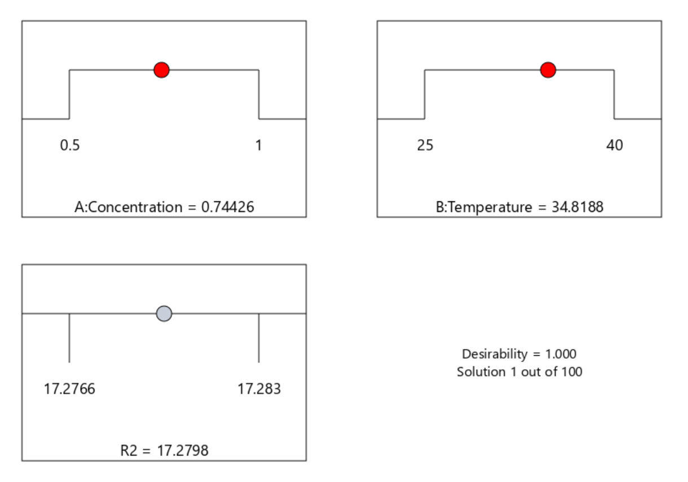
Figure 4: Optimized Combinations for 8 Days

4.3.6 Response 3 (12 Days)
ANOVA Results
Table 7 presents the ANOVA results for the 2FI model. The model was not statistically significant, as indicated by an F-value of 0.4691 and a p-value greater than 0.05. It also shows that there is a 71.12% chance that an F-value this large could occur due to noise. P-values less than 0.0500 indicate model terms are significant, but in this case, there are no significant model terms. However, if there are many insignificant model terms (not counting those required to support hierarchy), model reduction may improve the model.
The Lack of Fit F-value of 16.01 implies the Lack of Fit is significant. There is only a 0.94% chance that a Lack of Fit F-value this large could occur due to noise. Significant lack of fit is bad.

Table 7: ANOVA Table for 12 Days
Sources | Sum of Squares | Df | Mean Square | F-value | p-value
Model | 0.0000 | 3 | 3.469E-06 | 0.4691 | 0.7112 | Not significant
A-Concentration | 5.088E-06 | 1 | 5.088E-06 | 0.6880 | 0.4283
B-Temperature | 5.319E-06 | 1 | 5.319E-06 | 1.172 | 0.4184
AB | 1.355E-20 | 1 | 1.355E-20 | 1.833E-15 | 1.0000
Residual | 0.0001 | 9 | 7.395E-06
Lack of Fit | 0.0001 | 5 | 0.0000 | 16.01 | 0.0094 | Significant
Pure Error | 3.168E-06 | 4 | 7.920E-07
Cor Total | 0.0001 | 12

Modal Adequacy
The coefficient of determination (R²) is 0.1352, meaning that 13.52% of the variation in corrosion rate was explained by the model. The adjusted R², -0.1530 and predicted R², -2.5070 are apart. A negative Predicted R² implies that the overall mean may be a better predictor of my response than the current model. In some cases, a higher order model may also predict better. The Adequate Precision value is 2.1384, indicating an inadequate signal-to-noise ratio since it is greater than 4. This model cannot be used to navigate the design space.

Regression Model Equation
The final 2FI regression model in terms of coded variables was:

Y = +25.92 - 0.0008A + 0.0008B +0.0000AB Equation 7

where Y is the Inhibition Efficiency, A is Xanthan Gum concentration and B is Temperature

The negative coefficient of A indicates that increasing xanthan concentration reduces corrosion rate, while the positive coefficient of B shows that temperature decreases corrosion rate. The interaction term AB was positive, meaning that the effectiveness of xanthan gum is depleted under higher temperature levels.

Response Surface Plot
The 3D response surface plot (Figure 5) shows the interactions between process variables:
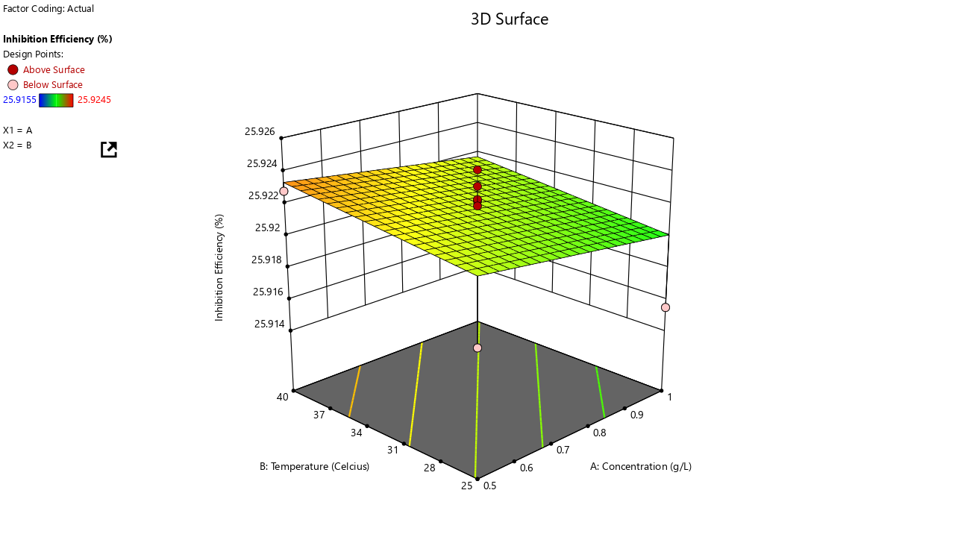
Figure 5: 3D Response Surface Plots for 12 Days

4.3.7 Optimization
The optimization analysis, as presented in Figure 6, identified the most favorable conditions for the corrosion inhibition study. The model predicted that a concentration of 0.5 g/L of xanthan gum at a temperature of approximately 32.5 °C would provide the best outcome. Under these optimized parameters, the system achieved an inhibition efficiency of 25.92%, which represents a significant improvement compared to other tested conditions (Biswas et al., 2015; Mobin and Rizvi, 2016; Udoh et al., 2024).
In addition, the optimization process yielded a desirability value of 0.780, indicating that the solution was highly satisfactory, though not at the absolute maximum of 1.0. This suggests that while the chosen conditions performed very well and closely aligned with the study’s objectives, there may still be room for further refinement or adjustment of variables to potentially achieve even higher inhibition efficiency. Similar optimization approaches using response surface methodology (RSM) and desirability functions have been effectively applied to natural polymer and plant-based inhibitors, confirming its robustness for corrosion studies (Sanusi et al., 2024; Ahmed et al., 2024; Etuk and Inyang, 2024).
Nonetheless, the result underscores the effectiveness of xanthan gum as a corrosion inhibitor and highlights the reliability of the optimization approach in identifying practical and efficient operating conditions. The reduced stability of xanthan gum at longer immersion may be attributed to desorption or biodegradation, as also reported by Fouda et al. (2020), who noted that natural polymers and biopolymers can degrade under prolonged exposure in corrosive environments.
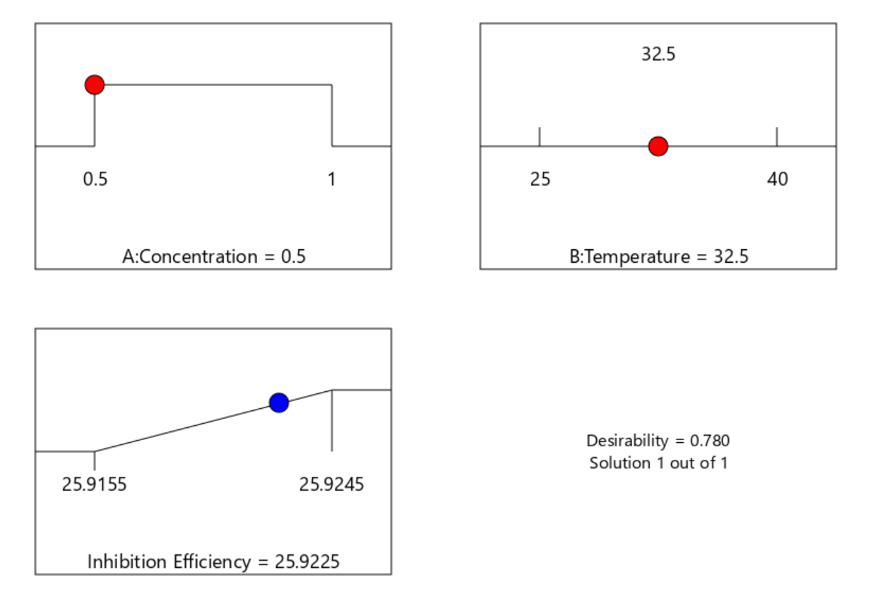
Figure 6: Optimized Combinations for 12 Days

The present study examined the effect of xanthan gum on the corrosion behaviour of flowline materials in saline environments. The results provide new insights into the feasibility of using biopolymers as sustainable corrosion inhibitors in the industry. Overall, the inhibition efficiency recorded was moderate, with a maximum of 17.28% under optimized conditions. This section discusses these findings in detail, situating them within existing literature, theoretical expectations, and practical applications.

4.3.8 Effect of Concentration on Inhibition Efficiency
The study revealed that xanthan gum concentration was the most influential factor in determining corrosion inhibition efficiency. The ANOVA results showed that concentration had a statistically significant effect on inhibition efficiency (p < 0.05), confirming its role as the dominant parameter in the model. This agrees with Obot and Obi-Egbedi (2010), who emphasized that inhibitor concentration directly determines adsorption surface coverage and thereby the effectiveness of corrosion protection.
At the molecular level, increasing the concentration of xanthan gum likely enhanced the adsorption of carboxyl (-COOH) and hydroxyl (-OH) functional groups onto the metal surface, forming a more compact barrier that limited the diffusion of chloride ions (Romero-Zeron and Espinosa, 2020). However, the study also found that inhibition efficiency did not increase indefinitely with concentration. Beyond the optimum point (approximately 0.74 g/L), the effect plateaued or even declined slightly. This phenomenon can be attributed to the excessive viscosity of xanthan gum solutions at higher concentrations, which impedes homogenous distribution and introduces diffusion limitations (Coussot et al., 2009). Such behaviour has been reported in other polysaccharide-based inhibitors where high viscosity hinders molecular mobility and leads to uneven adsorption on metal surfaces (Fouda et al., 2022). Therefore, while xanthan gum can provide inhibition, careful optimization of concentration is essential to achieve maximum protective performance.

4.3.9 Effect of Temperature on Corrosion Behaviour
Temperature was also investigated as a key environmental factor. The findings indicated that higher temperatures generally reduced the inhibition efficiency of xanthan gum. Although temperature alone was not always a significant predictor (p > 0.05 in some model terms), its interaction with concentration (AB term) contributed meaningfully to the system’s behaviour. This negative correlation between temperature and inhibition efficiency is consistent with the exothermic nature of physical adsorption processes, in which increased thermal energy weakens the bonds between inhibitor molecules and the metal surface (Singh and Mukherjee, 2021). As temperature rises, the adsorbed xanthan gum film becomes destabilized, allowing chloride ions easier access to the steel surface, thereby accelerating corrosion (Olajire, 2017). These observations align with Gupta and Carman (2011), who reported that xanthan gum solutions undergo partial degradation at elevated temperatures, reducing both viscosity and adsorption stability. In practice, this implies that while xanthan gum may function as an inhibitor under moderate temperatures (~30 – 35°C), its protective capacity diminishes under high-temperature conditions typical of many oilfield environments (Bradford, 2001).

4.3.10 Adsorption Mechanism of Xanthan Gum
The inhibitory action of xanthan gum can be explained using adsorption theory. Its molecular structure contains multiple active sites, particularly carboxyl and hydroxyl groups, which facilitate adsorption onto metal surfaces via hydrogen bonding, electrostatic interactions, and van der Waals forces (Fouda et al., 2022). The regression model coefficients obtained, negative for concentration and temperature suggest that inhibition occurs through increased surface coverage, while thermal energy tends to disrupt these interactions. Similar mechanisms have been reported for other polysaccharide-based inhibitors. Mobin and Rizvi (2018) demonstrated that biopolymers adsorb to form compact films, thereby passivating the surface and reducing both anodic and cathodic reactions. Ahmed et al. (2020) further emphasized the role of xanthan gum in forming polymer–metal complexes that stabilize the steel surface. Thus, the results of this study reinforce the hypothesis that xanthan gum acts primarily through physical adsorption and film formation.

4.3.11 Comparison with Other Green Inhibitors
Xanthan gum demonstrated measurable inhibition efficiency and its performance (~17%) was relatively modest compared with other natural polymers reported in the literature. Umoren et al. (2018) recorded inhibition efficiencies exceeding 70% for certain polysaccharides in saline media, while Fouda et al. (2020) reported efficiencies above 80% using plant-derived gums. This suggests that while xanthan gum is environmentally benign and rheologically advantageous, its intrinsic corrosion protection capability is limited under aggressive chloride-rich conditions. Nevertheless, xanthan gum’s compatibility with other natural inhibitors offers an avenue for improvement. Studies have shown that polysaccharides can act synergistically with organic acids or tannins, yielding significantly higher efficiencies (Ameer et al., 2021). This indicates that xanthan gum could be more effective when used as part of a blended inhibitor formulation rather than as a standalone solution.

4.3.12 Optimization Outcomes
The optimization analysis using Response Surface Methodology (RSM) provided useful insights into the operating conditions for maximum efficiency. The optimal combination was a concentration of ~0.74 g/L and a temperature of ~34.8°C, which yielded 17.28% inhibition efficiency with a desirability value of 1.0. This underscores the value of statistical modeling in corrosion studies, as it enables researchers to identify the most efficient conditions with minimal experimental trials (Montgomery, 2017). Although the efficiency achieved was modest, the ability to mathematically predict optimal conditions highlights the robustness of the experimental design. This methodology can be extended to studies involving chemically modified xanthan gum or synergistic inhibitor systems.

4.3.13 Practical Implications
From an industrial standpoint, the results suggest that xanthan gum, though eco-friendly and biodegradable, may not provide sufficient protection as a standalone inhibitor in highly saline oilfield environments. However, its use should not be dismissed. Its dual functionality, acting both as a rheology modifier in enhanced oil recovery (EOR) and as a moderate corrosion inhibitor, offers economic advantages (Sheng, 2011; Yang et al., 2020). Moreover, xanthan gum’s biodegradability and compatibility with existing drilling and production fluids make it an attractive “green” alternative compared to toxic synthetic inhibitors (Quraishi et al., 2020). In less aggressive environments, or when applied in synergy with other natural inhibitors, xanthan gum could serve as part of a sustainable corrosion management strategy that aligns with industry goals for environmental responsibility (Palacios et al., 2018).

5.0 Conclusion
The study investigated the effects of xanthan gum polymer on the corrosion behaviour of flowline materials in saline environments. Laboratory experiments were conducted under varying concentrations and temperatures to determine inhibition efficiency. The results were analyzed using statistical tools, including Analysis of Variance (ANOVA) and Response Surface Methodology (RSM).
The key findings are summarized as follows: the study established that xanthan gum concentration was most influential factor in determining corrosion inhibition efficiency; higher temperatures generally reduced inhibition efficiency, consistent with the exothermic nature of adsorption; the protective action of xanthan gum was attributed to adsorption via hydroxyl and carboxyl groups, forming a barrier that restricted chloride ion penetration and the inhibition occurs through increased surface coverage while thermal energy tends to disrupt these interactions, and the maximum inhibition efficiency recorded was 17.28% at optimized conditions (0.74 g/L, 34.8°C), indicating moderate but limited protective capacity compared to conventional inhibitors
The limitations of this work were the study was conducted under controlled laboratory conditions, which may not fully replicate the dynamic and complex field environments characterized by variable pressures, mixed electrolytes, and microbial activity as supported, by Videla and Herrera (2005). Second, the inhibition efficiencies observed were relatively low compared to conventional chemical inhibitors, suggesting that xanthan gum alone cannot guarantee long-term protection. Future studies should therefore focus on: Chemical modification of xanthan gum to improve adsorption strength and thermal stability as suggested by Al-Sulaiman et al., (2017); synergistic formulations combining xanthan gum with other green inhibitors to achieve higher efficiencies as suggested by Shukla and Quraishi (2012); field-scale validation to assess performance under real oilfield conditions; economic feasibility studies to evaluate cost-effectiveness compared to conventional inhibitors. With these, it would help bridge the gap between laboratory promise and industrial adoption, advancing the role of biopolymers in sustainable corrosion management.

REFERENCES
- Agu, N., Omenyi, A., & Odimegwu, C. (2010). An assessment of students’ connectedness in Tertiary Institutions in Anambra State of Nigeria. Educational Research and Reviews, 5(2), 90-98. https://doi.org/10.5897/ERR.9000032
- Ahmed, S., Ali, A., and Khan, M. (2020). Biopolymer-metal interactions in corrosion inhibition. Journal of Molecular Liquids, 314, 113588
- Ahmed, A., & Nadir, H. M. (2024). A Comparative Study Investigating the Feasibility and Potential of Utilising Polymer, Demolition & Glass Waste as a Partial Replacement for Fine and Coarse Aggregate in Concrete. Journal of Material Sciences & Manufacturing Research, 5(1), 1-9. https://doi.org/10.47363/JMSMR/2024(5)162
- Al-Shalabi, E. W., & Sepehrnoori, K. (2016). A comprehensive review of low salinity/engineered water injections and their applications in sandstone and carbonate rocks. Journal of Petroleum Science and Engineering, 139, 137–161. https://doi.org/10.1016/j.petrol.2015.11.027
- Al-Sulaiman, F. A., Al-Mubarak, A. A., and Al-Harbi, F. (2017). Performance of polymer-based inhibitors under harsh oilfield conditions. Journal of Petroleum and Gas Engineering, 8(3):25 – 34.
- Ameer, M. A., Bhutta, B. S., Asghar, N., Haseeb, M. T., & Abbasi, R. N. (2021). Cerebral Autosomal Dominant Arteriopathy With Subcortical Infarcts and Leukoencephalopathy (CADASIL) Presenting as Migraine. Cureus, 13(5), e15355. https://doi.org/10.7759/cureus.15355
- Amenaghawon, N. A., Oiwoh, O., & Ebewele, O. E. (2015). Optimisation of Solid State Fermentation of Banana Peels for Citric Acid Production. Nigerian Journal of Technology https://doi.org/10.4314/njt.v34i4.8
- Anthony, I., Onwumere, J. U. J., & Obiamaka, P. E. (2014). Examining the Effect of E-Commerce on Business Performance in A Business Environment. Developing Country Studies, 4(26), 154-158. https://www.iiste.org/Journals/index.php/DCS/article/view/17900
- ASTM International. (2017). Standard practice for preparing, cleaning, and evaluating corrosion test specimens (ASTM G1-03). https://doi.org/10.1520/G0001-03R17E01
- Ballerini, D. (2006). Petroleum refining: Technology and economics. Editions Technip.
- Biswas, A., Choudhary, S., and Prasad, R. (2015). Biopolymer inhibition mechanisms in saline media. Corrosion Science, 98: 231–240
- Bradford, S. A. (2001). Fundamentals of corrosion in oil and gas facilities. Gulf Professional Publishing.
- Chapman, D., Hall, P. and Robertson, C. (2016). Brine preparation and scaling in hydrocarbon reservoirs. Journal of Petroleum Technology, 68(11): 42–49.
- Coussot, P., Krishnan, J.,and Huynh, H. T. (2009). Polysaccharide solution rheology in corrosion protection. Journal of Applied Polymer Science, 111: 1723 – 1732.
- Egbewande, A., Onuoha, H. and Salami, O. (2021). Oil and gas transmission pipeline design challenges. Pipeline Engineering Journal, 33(4):59 – 72.
- Etuk, I. F., & Inyang, U. E. (2024). Applications of various plasticizers in the plastic industry – Review. International Journal of Engineering and Modern Technology, 10(1), 38-54. https://doi.org/10.56201/ijemt.v10.no1.2024.pg38.54
- Mekeme, J. B., Fouda, J., Mbassi, A. A., Mbessoh Kengne, U. I., Fouda, P. J., & Fru, A. I. (2020). Aspects Cliniques et Pronostiques de la Gangrène de Fournier à l'Hôpital Central de Yaoundé. HEALTH SCIENCES AND DISEASE, 21(11), 29-33. https://doi.org/10.5281/hsd.v21i11.2367
- Fouda, A. S., El-Ewady, G. Y., and Ahmed, R. (2022). Polysaccharide-based green inhibitors in saline conditions. International Journal of Electrochemical Science, 17, 1 – 20.
- Garcia-Ochoa, F., Santos, V. E., Casas, J. A., & Gómez, E. (2000). Xanthan gum: Production, recovery, and properties. Biotechnology Advances, 18(7), 549–579. https://doi.org/10.1016/s0734-9750(00)00050-1
- Gupta, R. and Carman, P. (2011). Fracturing fluids: Properties and field applications. SPE Journal, 16(1): 23 – 32
- Mobin, M., & Rizvi, M. (2016). Inhibitory effect of xanthan gum and synergistic surfactant additives for mild steel corrosion in 1M HCl. Carbohydrate Polymers. https://doi.org/10.1016/j.carbpol.2015.09.027
- Mobin, M. and Rizvi, M. (2018). Adsorption and inhibition mechanism of biopolymers on steel. Carbohydrate Polymers, 181: 630 – 640.
- Montgomery, D. C. (2017). Design and analysis of experiments (9th ed.). John Wiley & Sons. https://www.abebooks.com/9781119113478-Design-Analysis-Experiments-Montgomery-Douglas/30900000000/bd
- Muhammed, A., Hassan, M., and Bello, I. (2020). Biopolymers in enhanced oil recovery. Energy Reports, 6: 329 – 336.
- Obot, I. B., and Obi-Egbedi, N. O. (2010). Adsorption and corrosion inhibition of mild steel in HCl solution by xanthan gum. Corrosion Science, 52(1): 282 – 289.
- Ogbonna, I. O., and Ekeke, I. C. (2019). Biopolymer corrosion inhibitors for oilfield applications. Journal of Natural Gas Science and Engineering, 67: 39 – 49.
- Olajire, A. A. (2017). Corrosion inhibition of offshore pipelines. Journal of Petroleum Science and Engineering, 152: 613 – 622.
- Palacios, P., Ramirez, F., & Soto, C. (2018). Eco-friendly inhibitors for oilfield corrosion control. Journal of Cleaner Production, 197, 1272–1284. https://doi.org/10.1016/j.jclepro.2018.06.260
- Quraishi, M. A., Verma, C., and Ebenso, E. E. (2020). Green corrosion inhibitors: Recent developments. Journal of Materials Research and Technology, 9(6):15523 –15541.
- Udoh, I. and Benson, O. (2022). Synthetic brine formulations for corrosion studies. Nigerian Journal of Petroleum Engineering, 28(1):55 – 63.
- Udoh, I., Etim, U., & Johnson, P. (2024). Biopolymer-based inhibitors for steel protection. Journal of Natural Gas Science and Engineering, 112, 105621. https://doi.org/10.1016/j.jngse.2023.105621
- Umoren, S. A., Solomon, M. M., and Eduok, U. M. (2018). Biopolymer corrosion inhibitors in oilfield environments. Journal of Molecular Liquids, 254: 69–84.
- Romero-Zeron, L., and Espinosa, J. (2020). Biopolymers in corrosion control and EOR. Energy and Fuels, 34(5): 5723 – 5734
- Sanusi, I. T., Agbo, F. J., Dada, O. A., Yunusa, A. A., Aruleba, K. D., Obaido, G., Olawumi, O., & Oyelere, S. S. (2024). Stakeholders' insights on artificial intelligence education: Perspectives of teachers, students, and policymakers. Computers and Education Open, 7, 100212. https://doi.org/10.1016/j.caeo.2024.100212
- Sheng, J. J. (2010). Modern chemical enhanced oil recovery: Theory and practice. Gulf Professional Publishing. https://www.elsevier.com/books/modern-chemical-enhanced-oil-recovery/sheng/978-1-85617-745-0
- Shukla, S. K. and Quraishi, M. A. (2012). Synergistic green inhibitor formulations. Materials Chemistry and Physics, 136(2–3): 511 – 518.
- Singh, P., and Mukherjee, S. (2021). Biopolymer-based corrosion inhibitors: A review. Journal of Molecular Liquids, 333, 115951.
- Silverson. (2023). Hydration of Xanthan Gum. https://www.silverson.com/us/resource-library/application-reports/hydration-of-xanthan-gum
- Solomon, M. R. (2017). Consumer Behavior: A Strategic Approach (2nd ed.). Routledge
- Videla, H. A., & Herrera, L. K. (2005). Microbiologically influenced corrosion: looking to the future. *International Microbiology*, *8*(3), 169–180. https://www.scielo.isciii.es/scielo.php?script=sci_arttext&pid=S1139-67092005000300002
- Yang, H., Li, Y., and Zhao, X. (2020). Eco-friendly biopolymer inhibitors in oilfield operations. Colloids and Surfaces A: Physicochemical and Engineering Aspects, 604, 125268.
- Zhang, G., Gong, X., and Zhang, X. (2015). Evaluation of xanthan gum as a corrosion inhibitor in saline conditions. Journal of Applied Polymer Science, 132(29):42237.
- Zhang, J., Liu, Y., and Chen, Z. (2018). Applications of polysaccharides in petroleum production. International Journal of Biological Macromolecules, 115,:45 – 58.

