Original Research Article

GERMPLASM EXPLORATION, MORPHOLOGICAL CHARACTERIZATION AND IN-VIVO CONSERVATION OF MURRAYA PANICULATA USING ECO-GEOGRAPHIC SURVEY

ABSTRACT

Murraya paniculata L. a widely grown ornamental species, exhibits significant phenotypic variation across diverse Agro-ecological regions. This study aimed to explore morphological diversity in leaves, flowers, and fruits of M. paniculata in Sri Lanka and establish a field gene bank for long-term conservation. A total of 13 districts representing varied climatic conditions were surveyed, and plant accessions were collected using multi-stage sampling. Morphological characterization was conducted onsite and in the laboratory over two years using 24 qualitative and quantitative traits. Geographical distribution was mapped using GIS, and ten-year climatic data were obtained from the Department of Meteorology. Correlation analysis and Principal Component Analysis (PCA) were used to examine relationships between morphological traits and climatic/geographic factors. Leaf, flower, and fruit traits showed significant associations with precipitation, temperature, and latitude. PCA revealed that petal length, petal width, leaf length, leaf width, petiole length, and internode length accounted for 84.75% of the total variation. Accessions from regions with higher precipitation and lower temperatures exhibited longer, lanceolate leaves and larger, elliptic to oblong petals, while smaller, ovate/obovate leaves and petals were common in drier, warmer regions. All accessions were successfully established in a field gene bank. The study demonstrates that morphological variation in M. paniculata is strongly influenced by climatic and geographic factors, highlighting its high phenotypic plasticity. These findings provide valuable insights for plant breeders, horticulturists, and researchers, filling critical knowledge gaps in the diversity and conservation of this ornamental species.
Keywords: Murraya paniculata, morphological variation, eco-geographic survey, phenotypic plasticity, field gene bank, Sri Lanka

1 INTRODUCTION
The international trade in floriculture products, including potted flowers, cut foliage, and bedding plants, plays a significant role in the economies of many countries. The high demand for floriculture crops is largely driven by their multiple uses, particularly in industrialized nations, where flowers are cultivated for ornamental purposes, as gifts, and as symbols of respect during ceremonies and funerals. In Sri Lanka, the floriculture export sector began gaining prominence in the early 1970s and is now recognized as a high-income agricultural sector with considerable potential to contribute to the socio economic development of the country. Alongside widely cultivated species, the utilization of under-explored and underutilized crops is gradually increasing worldwide, offering opportunities for diversification and value addition in agriculture. Sri Lanka hosts numerous beneficial underutilized agricultural species that remain largely unexplored.
Murraya paniculata L. (Rutaceae), commonly known as Orange Jessamine and locally as Etteria, is an evergreen shrub native to South Asia, Southeast Asia, and Australia. It is widely grown in home gardens and commercial plantations for its highly fragrant, attractive white flowers. Beyond its ornamental value, M. paniculata is used in Ayurveda for its medicinal properties, and its flowers are employed in the cosmetic industry. The plant is hardy and adaptable to a wide range of soil and environmental conditions. In Sri Lanka, it blooms predominantly from April to August and is distributed across wet and dry zones, commonly at lower elevations and occasionally at higher altitudes. While the shrub can grow up to 25–30 m in natural conditions, it is generally maintained at about 10 m through regular pruning in cultivation.
Germplasm conservation strengthens global efforts to ensure future food security by capturing natural and existing crop diversity, and developing new crops for agriculture. It is also essential for allied sectors like forestry, horticulture and increasingly, for the restoration of degraded lands to take care of ecosystem services within the landscape. Preservation of genetic diversity in plants requires effective application of storage technologies. (Thakur et al., 2024). There are two distinct methods of plant germplasm conservation such as in-situ and ex-situ. In-situ conservation involves conservation in the natural habitats of wilderness areas, reserves, protected areas and within traditional framing systems. Ex-situ conservation involves removal of the plant genetic resources from their natural habitat and placing them under artificial storage conditions (Withers and Engelmann, 1998). Ex-situ conservation provides the opportunity to study the biology of and to understand the threats to endangered species recovery programs, which would involve restoration and reintroduction. It also has the advantage of preserving plant material and making it available for research purposes, without damaging the natural populations (Temitope, 2013).
Despite its ecological, ornamental, and economic potential, limited information exists regarding the morphological traits, chemical composition, ecological adaptability, phenotypic plasticity, and geographical distribution of M. paniculata. Unlocking this knowledge is essential for plant breeders, botanists, floriculturists, and industries such as perfumery and pharmaceuticals. Additionally, these species contribute to ecosystem services by providing habitat and food for pollinators, including bees and butterflies, and hold cultural significance in some regions. Conserving and studying these underutilized ornamental plants can enhance the floriculture industry and support biodiversity conservation.

2 MATERIALS AND METHODS

The study was designed to explore germplasm, characterize morphological variation, and conserve Murraya paniculata L. Using an eco-geographic approach. The research comprised three main components of an eco-geographical survey, morphological characterization, and establishment of a field gene bank for in-vivo conservation.

2.1 ECO-GEOGRAPHICAL SURVEY OF MURRAYA PANICULATE L.
The eco-geographical survey aimed to identify locations in Sri Lanka, where M. paniculata is prevalent and to collect detailed geographical and climatic information from each site. The survey was conducted across 13 districts Ratnapura, Polonnaruwa, Gampaha, Hambantota, Kalutara, Colombo, Galle, Kandy, Matara,Monaragala, Kurunegala, Ampara, and Anuradhapura representing all three agro-ecological zones and capturing the climatic and geographical diversity of the country. Within each district, divisional secretariat and grama niladhari divisions were used as base areas for data collection. Plants within each grama niladhari division were surveyed using a multi-stage sampling technique to ensure representative coverage of the local populations.

2.2 COLLECTION OF GEOGRAPHICAL AND CLIMATIC DATA
At each site, geographical coordinates (latitude and longitude) were recorded using a geographical positioning system (GPS) device to facilitate precise spatial mapping. Climatic data including average temperature, rainfall, and relative humidity over the past ten years were obtained from the department of meteorology as secondary data. This information enabled the analysis of relationships between environmental factors and morphological traits.

2.3 MORPHOLOGICAL CHARACTERIZATION
Morphological characterization was performed for M. paniculata, this component comprised two main steps: the development of species-specific descriptors and subsequent characterization using these descriptors.

2.4 DEVELOPMENT OF SPECIES-SPECIFIC DESCRIPTORS
As no standardized descriptors existed for the selected ornamental specie, new descriptors were developed using both field survey data and botanical literature, including the international biodiversity crop descriptor list and the flora of ceylon (volumes iii & iv). Descriptors were organized into four major categories:
- Passport category – Including accession details and collection descriptors.
- Management category – Encompassing plant or seed management and multiplication/regeneration descriptors.
- Environment and site category – Including site characterization and evaluation descriptors.
- Characterization category – Covering specific evaluation descriptors for leaves, flowers, and fruits.

2.5 MORPHOLOGICAL CHARACTERIZATION
Morphological characterization was conducted in two stages:
- Onsite non-destructive characterization – Visual observations of plant traits were recorded in the field at each collection site.
- Laboratory-based destructive characterization – Detailed measurements of specific traits were conducted in the laboratory for more precise assessment.
For each species, a set of 24 qualitative and quantitative traits related to leaves, flowers, and fruits was evaluated using the species-specific descriptors developed for this study.

2.6 ESTABLISHMENT OF FIELD GENE BANK
All collected accessions of M. paniculata were propagated and established in a dedicated field gene bank for in-vivo conservation. The field gene bank was designed to maintain genetic diversity, facilitate long-term preservation, and provide material for future research and breeding programs.
3 RESULTS AND DISCUSSION

Morphological characterization of M. paniculata

3.1 TYPICAL MORPHOLOGICAL CHARACTERS
Evergreen leaves are dark green and pinnately compound with three to nine leaflets and arranged along the rachis. The flowers are white and have a citrus like fragrance which is more distinct in the night time attracting many insects. It flowers profusely and flowers remain for 3 to 4 days. Usually, the shrubs bloom profusely producing clusters of flowers during the months April to July of the year. In the remaining months few flowers may be produced individually in some shrubs. Fruits have one or two seeds.

3.2 MORPHOLOGICAL VARIATIONS OF QUALITATIVE CHARACTERISTICS AT DIFFERENT LOCATIONS
M. paniculata showed a vast variation in plant morphology depending on the habitat. Smaller leaflets were more frequently observed in dry environments of Anuradhapura, Pollonnaruwa and Ampara districts because the smaller size reduces the hydraulic vulnerability of leaves and makes the plants more tolerant to drought (Scoffoni et al., 2011). Longer leaflets were more frequently observed in wet environments of Rathnapura, Kalutara, Colombo and Galle districts. Leaflet shape was extremely variable among populations and between plants. The leaflet shape varied from obovate, ovate, elliptic to lanceolate. Leaflet apex varied from acute, rectus, acuminate and obtuse to round. The shape of the leaflet base varied from acute, cunate, obtuse to rounded. Leaflet arrangement was alternate to sub-opposite and color was dark green to light green with a margin of entire to undulate. Variations of leaf size and shape can lead to changes in carbon, water and energy exchange of plants with their environment, thereby influencing plant photosynthetic rates (Malhado et al., 2009). Boarder leaves could increase thickness of their boundary layers, and thus prevent leaves from wind cooling and reduce water vapor exchange (Givish and Vermeij, 1976). Plant living in cool regions trend to have leaves with smaller leaf length/width ratios (boarder leaves) to maintain thicker boundary layers and higher leaf temperature for photosynthesis. In warm and humid regions, leaves tend to have higher leaf length/width ratios (elliptic leaves) to avoid overheating during day time (Wright et al., 2017).
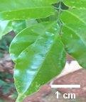
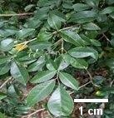
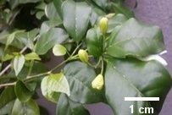
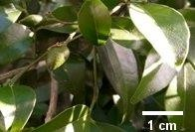
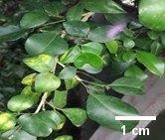
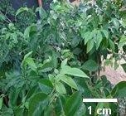
M. paniculata showed a vast variation in plant morphology depending on the habitat. Smaller leaflets were more frequently observed in dry environments of Anuradhapura, Pollonnaruwa and Ampara districts (Figure 1), because the smaller size reduces the hydraulic vulnerability of leaves and makes the plants more tolerant to drought (Scoffoni et al., 2011). Longer leaflets were more frequently observed in wet environments of Rathnapura, Kalutara, Colombo and Galle districts. Leaflet shape was extremely variable among populations and between plants. The leaflet shape varied from obovate, ovate, and elliptic to lanceolate. Leaflet apex varied from acute, rectus, acuminate and obtuse to round. The shape of leaflet base varied from acute, cunate, obtuse to rounded. Leaflet arrangement was alternate to sub-opposite and color was dark green to light green with a margin of entire to undulate.
A
B
C
E
F
D

Figure 1: Variation in leaflet shape of M. paniculata among 249 accessions collected from different districts: A-Broadly elliptic (Rathnapura), B-Oval to oblong (Anuradhapura), C-Oval (Pollonnaruwa), D-Narrowly elliptic (Colombo), E-Ovate to lanceolate (Kalutara), F-Oblong to lanceolate (Galle)

3.3 FLORAL VARIATIONS OF M. PANICULATA
The petal shape was elliptic, oblong or obovate. In longer petal with elliptic and oblong shapes were more frequently found in Rathnapura, Galle, Kalutara and Colombo districts. Smaller petals with ovate shapes were more frequently found in Hambantota, Pollonnaruwa and Ampara districts (Figures 2). Thermal stress can influence the size of flowers (Teixido et al., 2016). Water availability and temperature found that elevated temperatures alone reduced multiple traits contributing to overall flower size (Descamps et al., 2021). Higher temperatures induced larger flowers in the annual crop cucurbita pepo (cucurbitaceae), although these effects fluctuated with seasonality (Lopez et al., 2022). Increasing temperatures can alter flower size through phenotypic plasticity. Drought stress augments the cost of large floral displays with many or large flowers because of increased transpiration, leading to plants that produce fewer, smaller flowers (Teixido et al., 2016). Leptosiphon bicolor (polemoniaceae) experiences significantly reduced flower size in response to drought even after controlling for developmental rate. Galen et al., (1999) proposed that drought favors the evolution of smaller flowers through selection, and subsequent studies (Galen. 2000) have supported this prediction. Indeed, under drought stress, sinapis arvensis (brassicaceae) produces fewer, smaller flowers that are visited less frequently by pollinators than well-watered individuals (Kuppler et al., 2021). In some environments, plants that have evolved drought escape strategies flower earlier and exhibit reduced correlated traits, such as vegetative biomass and flower size (Franks. 2011).

H
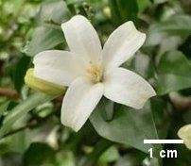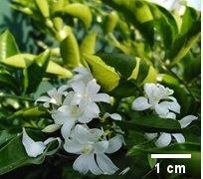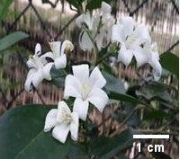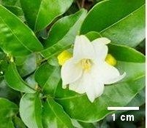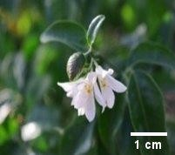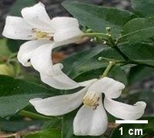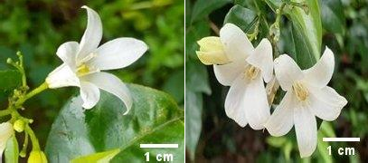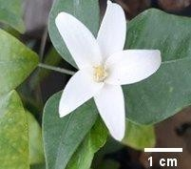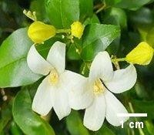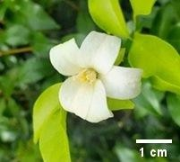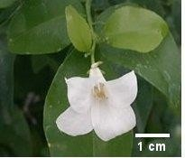
A
B
C
D
E
F
G
H
I
J
K
L
Figure 2: Variation of M. paniculata in petal shape among 249 accessions
A-ovate petals (Anuradapura), B-ovate petals (Hambantota), C-broadly ovate petals (Anuradapura), D-misshapen petals (Pollonnruwa), E-narrowly oblong petals (Kalutara), F- oblong petals (Gampaha), G/H-elliptic petals (Balangoda), I-narrow oblong petals (Panadura), J- oblong petals (Matara), K- narrowly ovate petals (Pollonnaruwa), L- broadly ovate petals (Ampara)

3.4 FRUITS VARIATIONS OF M. PANICULATA
M. paniculata fruits showed a vast morphological variation at different Agro ecological locations in Sri Lanka. Fruit shape varied to elliptic, oval to obovate shapes. The highest number of elliptic shapes fruits were recorded from wet ones of Kalutara, Galle, Colombo and Gampaha districts in Sri Lanka. The highest number of oval to obovate shape fruits were recorded in dry ones of Ampara, Anuradapura, Polonnaruwa and Hambantota districts in Sri Lanka (Figures 3). The fruit phenotypic and quantitative traits varied between the geographical provinces (Zhang et al., 2019). Differences in geographical scale distribution of plants let to a variation of fruit characters (Liang et al., 2015). Moreover, tree species with a wide geographical distribution exhibit considerable character variations as an adaptation to survive varying environment (Munasinghe and Wansapala, 2015). Zhang et al., (2017) showed that the fatty acid composition of c.oleifera fruit varied along a geographical gradient. The variation in fruit phenotypic diversity is closely associated with environmental conditions (sun et al., 2017). Sarikhani et al. (2014) indicated that the improvement of plant fruit heritability is related to the interaction between environment and plant genes. Therefore, changes in the local environment would lead to obvious interactions with plant genes, which could further lead to the improvement of the plant adaptability (Li et al., 2022). Sun et al., (2017) suggested that the phenotypic variations of acorns was significantly correlated with geographical matrices but had very low correlation with geographical differences. The phenotypic variation of plants shows its adaptation to different environmental pressures (Ayala et al., 2020). The variation in fruit morphology has been used to determine the pattern of fruit geographic distribution and its response to climate change (Zhang et al., 2017). Morphological variation of c. Oleifera fruits divided the shape of c. Oleifera fruit into four categories, including olive, egg, spherical, and orange shapes, and found a significant positive correlation between the fruit length and width (Gao et al., 2022). Zhong et al. (2015) showed that the fruit width of C. oleifera was positively correlated with relative humidity and negatively correlated with temperature.
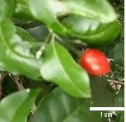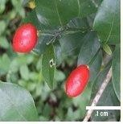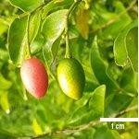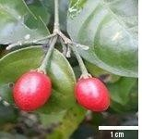
A
B
C
D
Figure 3: Close up of M. paniculata oval shape mature and immature fruits

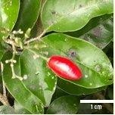
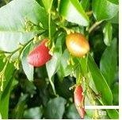
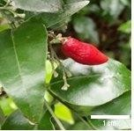
Figure 4: close up of M. paniculata elliptic shape fruits
A
B
C

3.5 QUANTITATIVE VARIATIONS IN LEAFLET AND FLORAL MORPHOLOGY

The mean leaflet length (LL), leaflet width (LW) internode length (IL), petiole length (PeL), were recorded as 11.93 ± 2.85 cm, 10.23 ± 2.45 cm ,5.84 ± 2.29 cm, 3.52 ± 0.64 cm, 1.02 ± 0.29 cm, 3.49 ± 1.47 cm respectively (Table 1).
Table 1: Results of the descriptive analysis of M. paniculata leaf and floral characteristics: LL- leaflet length, LW- leaflet width, IL- internode length, PL- petal length, PW- petal width, PeL- petiole length
Variable | Mean | Standard deviation | Coefficient of  Variance (%)
Leaflet length (LL) | 11.937 | 2.856 | 23.93
Leaflet width (LW) | 10.238 | 2.454 | 23.76
Internode length (IL) | 5.840 | 2.291 | 39.23
Petal length (PL) | 3.5288 | 0.6464 | 18.32
Petal width (PW) | 1.0267 | 0.2903 | 28.22
Petiole length (PeL) | 3.4903 | 1.4745 | 42.25

3.6 CORRELATION ANALYSIS OF QUANTITATIVE CHARACTERISTICS
The correlation coefficient was observed among six different quantitative characters of 249 accessions (Table 2). PW positively correlated with PL (+0.565). LW positively correlated with LL (+0.883) and PeL positively correlated with LL (+0.472) and LW (+0.338). IL positively correlated with LL (+0.463), LW (+0.300) and PeL (+0.553) (Table 2). The significant correlation among the characters will provide plant breeders an understanding on manipulation of such characters.
Table 2: the correlation of quantitative traits according to Pearson’s correlation coefficient evaluated in Murraya paniculata germplasm collections, LL- Leaf Length, LW- Leaflet Width, IL- Internode Length, PL- Petal Length, PW- Petal Width, PeL- Petiole Length

Variable | Pl | Pw | Ll | Lw | Pel
Petal width (PW) | 0.565*
Leaflet length (LL) | 0.281 | 0.173
Leaflet width (LW) | 0.274 | 0.136 | 0.883*
Petiole length (PeL) | 0.079 | 0.231 | 0.472* | 0.338*
Internode length (IL) | 0.138 | 0.257 | 0.463* | 0.300 | 0.553*
*correlation is significant at the 0.01 level

3.7 RELATIONSHIP OF MORPHOLOGICAL TRAITS WITH CLIMATE AND GEOGRAPHY OF M. PANICULATA
The effects of climate factors (rainfall and temperature) and geographic factors (latitude) on petal length, leaf width, petiole length and internode length were evaluated for 250 accessions of Murraya paniculata using multiple regression analysis. Petal length was positively influenced by both climate factors, rainfall and temperature as well as latitude. Internode length showed a positive relationship with rainfall and temperature but not with latitude. Furthermore, leaf width and petiole length were positively affected only by temperature (Table 3). This result could possibly be due to the expansion of photosynthetic capacity and activation of cell elongating hormones under the conditions of higher temperature and solar radiations. These performances could be due to the increased vegetative growth occurred due to the availability of soil moisture under rainy conditions. Previous studies indicate that the variations in leaf size and shape of fossil leaves strongly affected by climate (Parkhurst and Loucks, 1972). Leaf size of p. Perfoliatum is strongly affected with precipitation (Wilf et al., 1998).
Table 3: multiple regression analysis showing the effect of M. paniculata morphological traits with climate and geographical factors: LL- Leaflet Length, LW- Leaflet Width, IL- Internode Length, PL- Petal Length, PW- Petal Width, PeL- Petiole Length

Variable | Rainfall | Temperature |  |  | Latitude
 | P-value | R2 | P-value | R2 | P-value | R2
Petal Length  (PL) | 0.000 | 0.723* | 0.004 |  | 0.000 | 0.854*
Leaf Width (LW) | 0.591 |  | 0.000 | 0.845* | 0.118
Petiole Length  (PeL) | 0.956 |  | 0.038 |  | 0.284
Internode length (IL) | 0.000 | 0.778* | 0.026 |  | 0.303
* p< 0.05

3.8 PRINCIPAL COMPONENT ANALYSIS
The principal component analysis was carried out with six quantitative morphological characteristics of 249 accessions. Results revealed that there were 3 principal components explaining 84.75% of the total variation of the 6 variables OF PL, PW, LL, LW, PeL, IL (Table 4). Component 1 explains 46.3% of the variation, component 2 explains 21.9% and Component 3 explain 16.5%. The remaining three components explain only 15.3% (Figure 4).
Table 4: Eigen values of the correlation matrix and their contribution to total variation of results M. Paniculata germplasm collections

 | Component  1 | Component  2 | Component  3 | Component  4 | Component  5 | Component  6
Eigen value | 2.779 | 1.311 | 0.991 | 0.451 | 0.368 | 0.097
Proportion | 0.463 | 0.219 | 0.165 | 0.075 | 0.061 | 0.016
Cumulative | 0.463 | 0.682 | 0.847 | 0.922 | 0.984 | 1.000
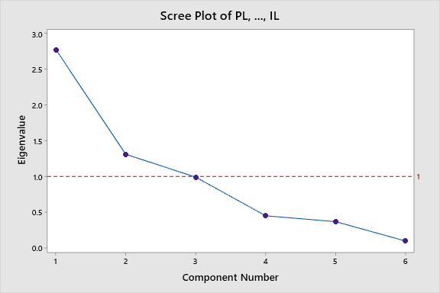
Figure 5: Scree plot of principal component analysis of M. paniculata

- CONCLUSION

The observations showed that morphological characters of leaves, flowers, and fruits of m. Paniculata was highly correlated with climatic factors of precipitation, temperature, and latitude. The technique of the geographical information system (GIS) provided the accurate information about the location of plants and the documented climatic data over ten years by the meteorological department supported to predict the climatic situations in the areas. Climate and geographic factors could account for a considerable fraction of phenotypic plasticity. The descriptors developed for three species would be useful in future research activities. The field gene bank comprised 249 in M. paniculata would serve as a gene pool for future research works.

References

Adebayo, I.A., Abdul Rahman, N., & Shamsudin, N. (2020). Floriculture and its socio-economic importance: A review. International Journal of Horticultural Science and Technology, 7(2), 101–112.
Descamps, C., Quinet, M., Baijot, A., & Jacquemart, A.L. (2021). Impact of heat stress on floral traits, pollination, and seed production in flowering plants. Environmental and Experimental Botany, 182, 104–109.
Franks, S. J. (2011). Plasticity and evolution in drought avoidance and escape in the annual plant Brassica rapa. New Phytologist, 190(1), 249–257. https://doi.org/10.1111/j.1469-8137.2010.03603.x.
Galen, C. (2000). High and dry: Drought stress, sex-allocation trade-offs, and selection on flower size in the alpine wildflower Polemonium viscosum. The American Naturalist, 156(1), 72–83. https://doi.org/10.1086/303373
Galen, C., Shykoff, J.A., & Plowright, R.C. (1999). Consequences of floral variation for pollination behaviour of bumble bees. Canadian Journal of Botany, 77(5), 713–718.
Givnish, T. J., & Vermeij, G. J. (1976). Sizes and Shapes of Liane Leaves. The American Naturalist, 110(975), 743–778. https://doi.org/10.1086/283102
Kuppler, J., Wieland, J., Junker, R.R., & Ayasse, M. (2021). Drought-induced reduction in flower size and abundance correlates with reduced flower visits by bumble bees. AoB Plants. https://doi.org/10.1093/aobpla/plab001
Lopez, M.R., Hernandez, R., & Kubota, C. (2022). Seasonal temperature effects on flower development and size in Cucurbita pepo. Horticulture Research, 9, uhac012.
Madushani, W.G.C. (2021). Morphological and eco-geographical variation of ornamental plant species in Sri Lanka. Unpublished thesis, University of Colombo Institute of Agro-Technology and Rural Sciences.
Malhado, A.C.M., Ladle, R.J., Todd, P.A., Malhado, F.C., Neto, A.O.A., & Correia, R.A. (2009). Measuring leaf shape with the landmarks-based method: A case study in the Brazilian Cerrado. Annals of Botany, 104(5), 875–884.
Padmini, S. M. P. C., & Kodagoda, T. D. (2017). Present status and future scope of floriculture industry in Sri Lanka and its potential in women empowerment. Sri Lanka Journal of Social Sciences, 40(1), 31–40. https://doi.org/10.4038/sljss.v40i1.7499
Scoffoni, C., Rawls, M., McKown, A., Cochard, H., & Sack, L. (2011). Decline of leaf hydraulic conductance with dehydration: Relationship to leaf size and venation architecture. Plant Physiology, 156(2), 832–843. https://doi.org/10.1104/pp.111.173856
Teixido, A.L., Barrio, M., & Valladares, F. (2016). Flower size and longevity adjustment under environmental stress. Proceedings of the Royal Society B, 283(1824), 20160075.
Wright, I. J., Dong, N., Maire, V., Prentice, I. C., Westoby, M., Díaz, S., Gallagher, R. V., Jacobs, B. F., Kooyman, R., Law, E. A., Leishman, M. R., Niinemets, Ü., Reich, P. B., Sack, L., Villar, R., Wang, H., & Wilf, P. (2017). Global climatic drivers of leaf size. Science, 357(6354), 917–921. https://doi.org/10.1126/science.aal4760 .
Xia, Y., Deng, X., Zhou, P., Shima, K., & Teixeira da Silva, J. A. (2006). The world floriculture industry: Dynamics of production and markets. In J. A. Teixeira da Silva (Ed.), Floriculture, Ornamental and Plant Biotechnology: Advances and Topical Issues Vol IV (pp. 336-347). Global Science Books. https://www.globalsciencebooks.info/Journals/GSB/PDF/2006/FOB_IV_1.pdf

