EFFECT OF GARDEN EGG (Solanum melongena) ON MALE REPRODUCTIVE CHARACTERISTICS ON ADULT MALE WISTAR RAT

ABSTRACT

BACKGROUND: The male reproductive characteristicslike sperm count and sperm motility play an important role in male fertility. Some fruits and vegetables consumed help improve male reproductive characteristics and they include; cucumber, garden egg, guava, bell peppers, kiwis, bananas (medium size) and also oranges.Male infertility is a condition that affects millions of men worldwide, where a man has a low sperm count or abnormal sperm function, which makes it difficult for him to impregnate a woman. This study seeks to investigate the effect of Solanum melongena (Garden Egg) on Male Reproductive Parameters in Adult Male Wistar Rat. Twelve (12) male rats were used for the present study. Animals were grouped into control, low and high dose garden egg. The extract was administered orally for a duration of 21 days. Twenty four (24) hours after the last day administration, animals were sacrificed. The testes and epididymis were harvested and used for histological studies; semen was collected for semen analysis. Data were expressed as mean ± SEM. The mean difference between the tested groups and the control was tested using a one-way ANOVA. Values were considered statistically significant when P is ≤ 0.05. Consumption of ethanolic extract of garden egg significantly reduced sperm count, viability and morphology, it may likely decrease the chances of fertility in experimental animals.

KEYWORDS: Semen analysis, Testes, Epididymis.

INTRODUCTION

The male reproductive system is made up of both internal(vas deferens, ejaculatory duct, urethra, seminal vesicle, prostate gland and bulbourethral glands) and external parts(penis, scrotum, testicles and epididymis) (Bhasin et al., 2022). The organs that make up the male reproductive systems functions in the production, maintenance and transportation of sperm cells and semen (Clevenland clinic, 2023).
The male reproductive characteristics e.g sperm count and sperm motility plays an important role in male fertility. Decreased sperm count, decreased motility and increased abnormal sperm cells are usually associated with decreased fertility rate (Irvine et al., 1996).
Semen analysis measures the quantity and quality of semen and sperm, its result shows how many sperm are released, as well as how they are shaped and how well they move. Some fruits and vegetables are consumed to help improve the male reproductive characteristics and they include; cucumber, guava, bell peppers, kiwis, bananas (medium size) and also oranges (CNY fertility, 2022).

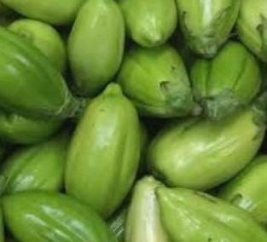
FIG I: Garden Eggs

The Solanum melongena (garden egg) is a common traditional vegetable in tropical Africa, that is grown mainly for its leaves and fruits and has a bitter-sweet taste.The leaves of this garden egg are eaten as a leaf vegetable and are actually more nutritious than the fruit and just like other vegetables contains essential nutrients such as vitamins and minerals in a good quantity which play an important role in human health improvement(Nwaorgu et al.,2021).
METHODS
Acclimatization of Animals
The rats were acclimatized for a period of two weeks (14 days) 12h light/dark cycle before the commencement of the experiment. The rats had unlimited and unrestricted access to water before and during the experiment. Rats were fed with standard rat feed.

Plant Identification
Solanum melongena(Garden egg) used for this study was obtained from Rivers State University farm. The fruit was identified by a botanist in the Department of plants science and biotechnology, Rivers State University. Voucher number RSUpb0152 was given to solanum melongena (Garden egg).

Ethanolic Extraction Of Solanum melongena (Garden egg)
About 2500 grams of grinded garden egg sample was extracted by complete soaking in 5 litres of absolute ethanol for 48 hours with intermittent agitation and gyration, a process known as cold maceration. After 48 hours the solution was filtered twice; first with a chess cloth to remove large leaf particles and then with filter paper to remove finely ground particles. The collected filtrate (extract) was concentrated using a thermo-regulated water bath at mild temperatures (from 35-40⸰C) until complete dryness was achieved, leaving a paste (crude extract).
Method of LD50 Determination
LD50 is the amount of a substance that will cause mortality in half of the test population. The Lorke’s method was used. This procedure involved two phases.
Phase 1
At this phase, 9 mouse were used. Animals were grouped into three groups, with each group containing 3 animals. Group 1 received 500mg/kg, group 2 received 1000mg/kg, group 3 received 2000g/kg. After waiting for 24 hours, no animal death was recorded.
Phase 2
9 mice were used. Animals were grouped into 3 groups each containing 3 animals. Group 4 received 2000mg/kg, group 5 received 4000mg/kg and group 6 received 5000mg/kg.
Since no animal died at 5000mg/kg, the dosage calculation for low and high doses were 1/10 x 5000mg/kg and 3/10 x 5000mg/kg respectively.

Animal Grouping and Administration of Extract
The rats were randomly divided into Three (3) groups with 4 rats each as follows:
- Group 1: Distilled water orally per day for 14 days.
- Group 2: Low dose of Solanum melongena (Garden egg) extracts orally per day for 14 days.
- Group 3: High dose of Solanum melongena (Garden egg) extracts orally per day for 14 days.

Duration of Study
This study was conducted for the period of 21 days in the animal house in accordance with the guidelines involving animals as recommended by research ethics committee of Rivers State University pending approval.

Semen Analysis
Semen Collection
The testis together with the epididymis was excised. The distal epididymis was then cut open to expose the semen for collection by applying a little pressure on the caudal epididymis to squeeze the semen into a microscope slide. Two drops of 2.9% sodium citrate were added and the slide was covered with a cover slip for examination and evaluation under the microscope.
The sperm cells were classified into non-motile, sluggish, or actively motile. The percentage of motile sperm cells was calculated by dividing the number of motile sperm cells by the total number of counted sperm following the method described by Osuchukwu (2016). The sperm count was carried out using the Neubauer Hemocytometer.
Sperm Motility
Semen was squeezed from the caudal epididymis onto a pre-warmed microscope slide (27⸰C) and two drops of warm 2.9% sodium citrate were added, the slide was then covered with a warm cover slip and was then covered with a warm cover slip and examined under the microscope using x400 magnification. Ten fields of the microscope were randomly selected and the sperm motility of 10 sperms was assessed on each field. Therefore, the motility of 100 sperms was assessed randomly. Sperms were labeled as motile, sluggish, or immotile. The percentage of motile sperm cells was defined as the number of motile sperms divided by the total number of counted sperms (i.e 100).
Sperm Viability (Life/Dead Ratio)
This was done by adding two drops of warm Eosin/Nigrosin stain to the semen on a pre-warmed slide, a uniform smear was then made and dried with air, the stained slide was immediately examined under the microscope using x400 magnification. The live sperm cells were unstained while the dead sperm cells absorbed the stain. The stained and unstained sperm were counted and the percentage was calculated.
Sperm Morphology
This was done by adding two drops of warm Walls and Ewas stain (Eosin/Nigrosin stain can also be used) to the semen on a prewarmed slide, a uniform smear was then made and air-dried; the stained slide was immediately examined under the microscope using x400 magnification.
Five fields of the microscope were randomly selected and the types and number of abnormal spermatozoa were evaluated from the total number of spermatozoa was expressed as a percentage of the total number of spermatozoa.
Sperm Count
This was done by removing the caudal epididymis from the right testes and blotting with filter paper. The caudal epididymis was immersed in 5ml forml-saline in a graduated test-tube and the volume of fluid displaced was taken as the volume of the epididymis. The caudal epididymis and the 5ml formol-saline were then poured into a mortar and homogenized into a suspension from which the sperm count was carried out using the improved Neubauer hemocytometer under the microscope.

Histological Processing and Analysis
Routine tissue processing was carried out using manual method of tissue processing. The processed tissue embedded in paraffin wax in the tissue embedded and trimmed using a rotary microscope and sectioned. The sectioned tissues were attached to slides and subsequently dewaxed in xylene and stained in hematoxylin and eosin, for display of the tissue architecture. The stained slides were examined under the light microscope at x10 magnification. Before the tissue processing was carried out the tissues were fixed in 10% formal saline. They were dehydrated in ascending grades of alcohol (70%,90%, absolute I,II and III ) for 2 hours each respectively. They were cleared in xylene I and xylene II for 2 hours. They were impregnated in molten paraffin wax for 2 hours. They were embedded in paraffin wax for 2 hours. Tissue blocks were sectioned into serial sections of 5um thick using rotary microtome. Sections were floated in water preheated at 45°C. Sections were floated out using clean grease frosted end glass slide. Slides were dried on the hot plate. Slides were ready for staining.
Staining Method
This was done using hematoxylin and eosin staining technique. Hematoxylin is a basic dye that stains the nucleus of the cell which is acidic while eosin is an acidic dye that stains the cytoplasm which is basic thereby providing a contrast between the nucleus and cytoplasm. Sections were dewaxed in 2 changes of xylene. Sections were hydrated in descending grades of alcohol starting with changes of obsolete alcohol then 90%, 70% and 50%.Sections were flooded with hematoxylin for 20 minutes and rinsed in water. Sections were differentiated in 1% acid alcohol briefly and rinsed in water. Sections were blued in Scott’s tap water for 20 minutes. Section were flooded with 1% eosin in 3 minutes and rinsed in water. Sections were hydrated in ascending grades of alcohol (50%,70%,90%,absolute I and II).Sections were cleared in two changes of xylene and mounted in DPX. The stained slides were viewed microscopically using x10 and x40 objectives respectively and photomicrographs were taken.

Statistical Analysis

Data was expressed as mean± SEM. Mean differences between the control and the other groups were tested using one way analysis of variance (ANOVA). Values were considered statistically significant when p is less than or equal to 0.005(p≤0.005). The difference between the sample mean was evaluated using Bonferoni post-hoc test.

ETHICAL APPROVAL:
Ethical approval was obtained from Research Ethics Committee Faculty of Basic Medical Sciences, College of Medical Sciences, Rivers State University.
Results
Table 1:The effect of Solanum Melongena (Garden Egg) ethanol extract on the semen analysis
of adult male Wistar rats.

Groups | Volume | Ph | Viability | Normal | Abnormal | Active | Sluggish | Dead | Sperm Cells Count
LD  Mean ± S.E.M | 0.133 ±0.031 | 8±0 | 68.33±4.36 | 63.33±4.40 | 36.67±4.41 | 60±5.77 | 10±0 | 30±5.77 | 400 ±115.17
HD  Mean ± S.E.M | 0.107±0.043 | 8±0 | 75±2.89 | 75.00±2.89 | 25±2.89 | 73.33±4.38 | 10±0 | 16.67±4.41 | 383.33±123.13
Control  Mean ± S.E.M | 0.267±0.038 | 8±0 | 78.33±2.06 | 78.33±4.41 | 21.67±4.41 | 73.33±4.38 | 10±0 | 16.67±4.41 | 466±86.18
F | 0.423 | 0.0 | 19.013 | 18.012 | 12.673 | 0.003 | 9.763 | 15.909 | 13.12
P-Value | 0.703 | 0.0 | 0.002 | 0.003 | 0.001 | 0.260 | 0.0070 | 0.0075 | 0.0005

Table 2:The effect of Garden Egg on FSH, LH & Testosterone
 | Control  Mean ± SD | GLD  Mean ± SD | GHD  Mean ± SD | F | P
FSH | 0.63 ± 0.05 | 1.06 ± 0.06 | 0.95 ± 0.04 | 64 | 0.001
LH | 0.70 ± 0.05 | 1.22 ± 0.04 | 1.20 ± 0.02 | 69 | 0.001
Testosterone | 1.16 ± 0.06 | 1.32 ± 0.09 | 1.43 ± 0.18 | 67 | 0.001

Key: GLD- Garden Egg Low Dose(500mg/kg)
GHD- Garden Egg High Dose(1500mg/kg)
Garden egg increased the concentration of LH, FSH and Testosterone significantly.

Table 3: The Effect of Garden Egg on Liver Function
 | Control  Mean ± SD | GLD  Mean ± SD | GHD  Mean ± SD | F | P
AST | 35.00 ± 2.00 | 21.00 ± 1.41 | 14.00 ± 1.41 | 8.70 | 0.05
ALT | 31.67 ± 2.06 | 24.50 ± 2.12 | 21.50 ± 0.71 | 11.6 | 0.035
ALP | 38.33 ± 2.55 | 23.50 ± 2.12 | 26.50 ± 2.12 | 55.27 | 0.001
TP | 73.00 ± 2.00 | 76.50 ± 2.12 | 74.00 ± 2.83 | 1.46 | 0.34
ALB | 44.00 ± 1.00 | 48.00 ± 1.41 | 44.50 ± 2.21 | 4.92 | 0.08
TB | 7.07 ± 1.44 | 4.60 ± 0.14 | 4.10 ± 0.14 | 6.19 | 0.06

Key: GLD- Garden Egg Low Dose(500mg/kg)
GHD- Garden Egg High Dose(1500mg/kg)
Garden egg reduced AST, ALT and ALP significantly.

Table 4:The Effect of Garden Egg on Kidney Function
 | Control  Mean ± SD | GLD  Mean ± SD | GHD  Mean ± SD | F | P
CB | 4.57 ± 0.64 | 2.75 ± 0.071 | 2.35 ± 0.21 | 16.27 | 0.01
K | 4.60 ± 0.26 | 4.95 ± 0.21 | 4.35 ± 0.21 | 3.17 | 0.15
Na | 145.67 ± 4.16 | 151.00 ± 5.66 | 140.5 ± 3.54 | 2.79 | 0.18
Ur | 4.77 ± 0.25 | 3.70 ± 0.14 | 4.00 ± 0.14 | 18.37 | 0.01
CR | 96.33 ± 5.13 | 76.50 ± 2.12 | 82.50 ± 3.52 | 14.98 | 0.01
CL | 82.67 ± 5.73 | 89.50 ± 3.53 | 70.00 ± 2.82 | 4.56 | 0.09
HC03 | 22.67 ± 2.08 | 26.00 ± 2.82 | 26.00 ± 1.41 | 2.04 | 0.25

Key: GLD- Garden Egg Low Dose(500mg/kg)
GHD- Garden Egg High Dose(1500mg/kg)

HISTOLOGY OF TESTES

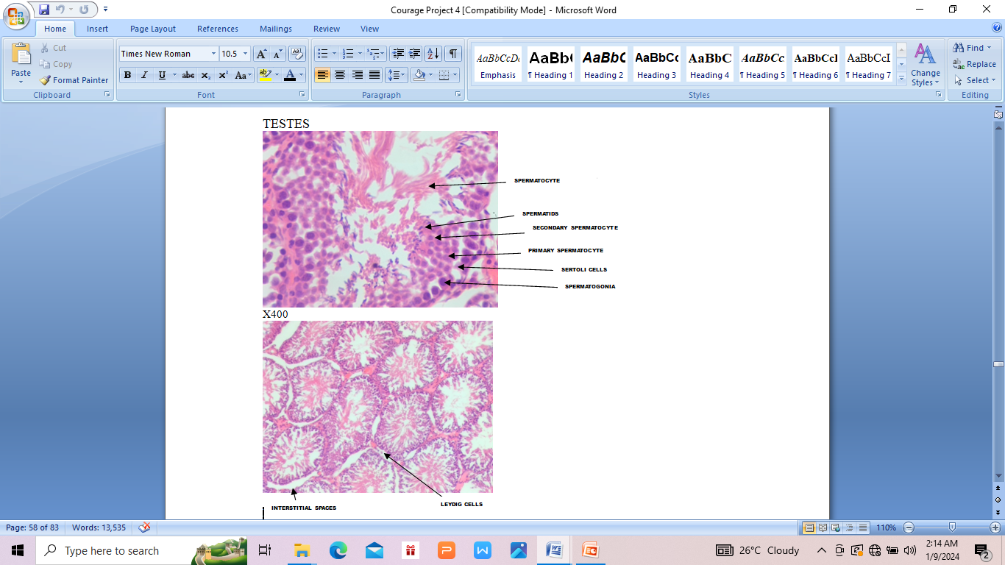

PLATE 1: Photomicrograph showing section of testicular tissue. Group 1(Control group). Section showed normal histology of the testis. No abnormality is seen.
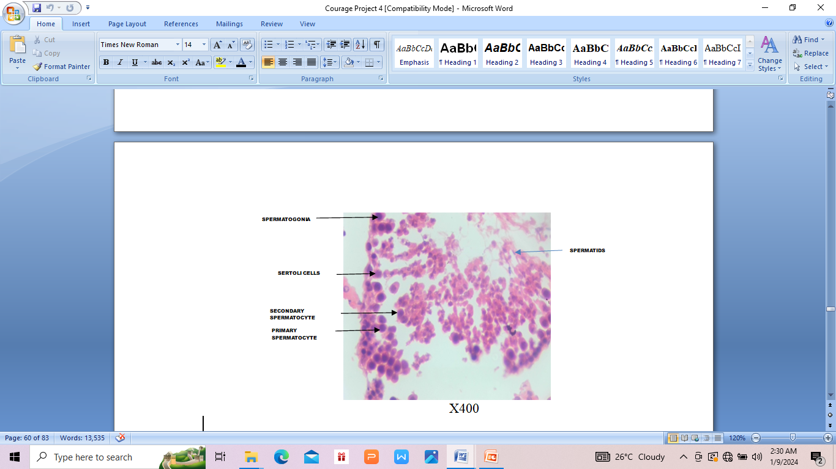

PLATE 2: Photomicrograph showing section of testicular tissue. Group 2 (Low Dose (500mg/kg) Garden egg). Section showed seminiferous tubules with interstitial space that is reduced and stroma cells. Leydig cells are also diminished (higher secondary and large spermatogonia). Within the seminiferous tubules are reduced spermatids.

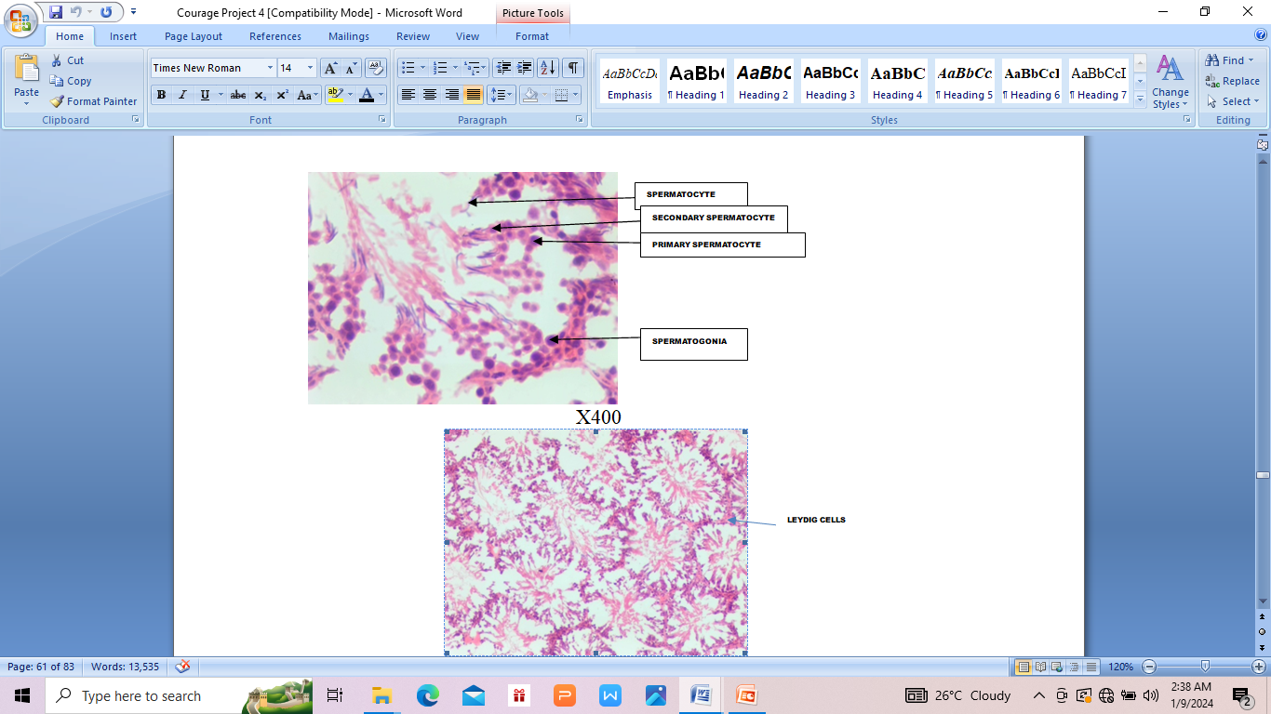

PLATE 3: Photomicrograph showing section of testicular tissue. Group 3(High Dose (1500mg/kg) Garden egg). Histologic sections of reduced spermatogonia, spermatocyte and reduced space between primary and secondary spermatocytes

HISTOLOGY OF EPIDIDYMIS
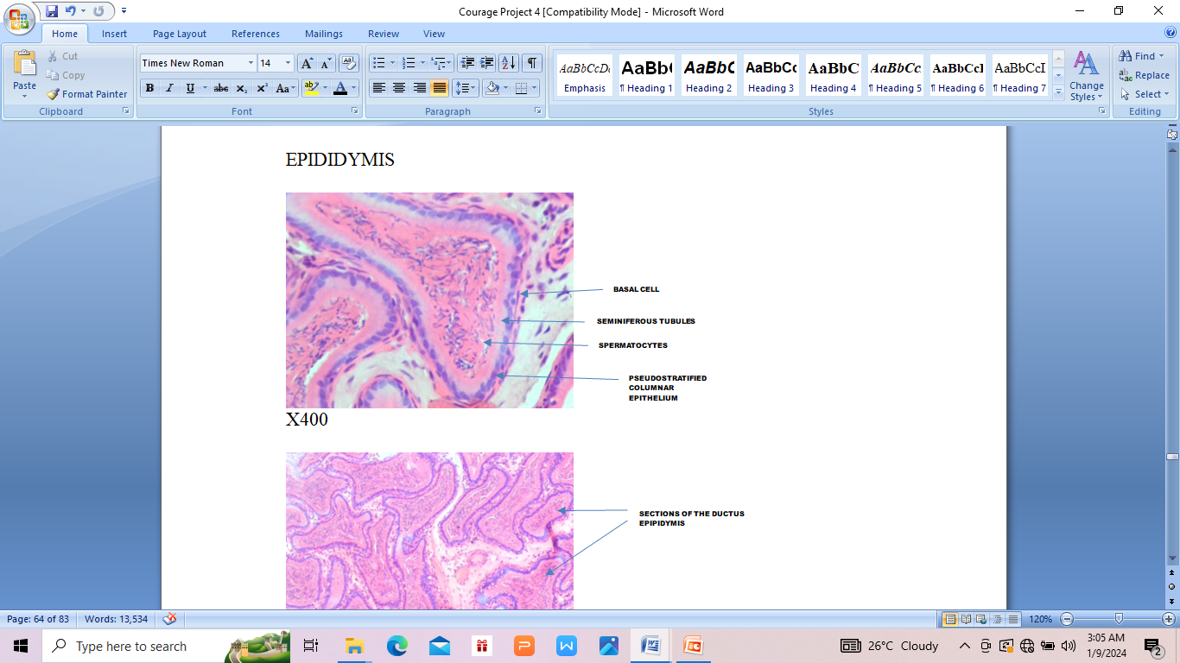
PLATE 4: Photomicrograph showing section of epididymal tissue. (CONTROL GROUP). Section from the epididymis show tubules lined by pseudostratified columnar cells most of which have a cytoplasmic blue hue within which are few cells with pyknotic nuclei and clear vacuole. The lumen contains abundant/ heavy spermatids.

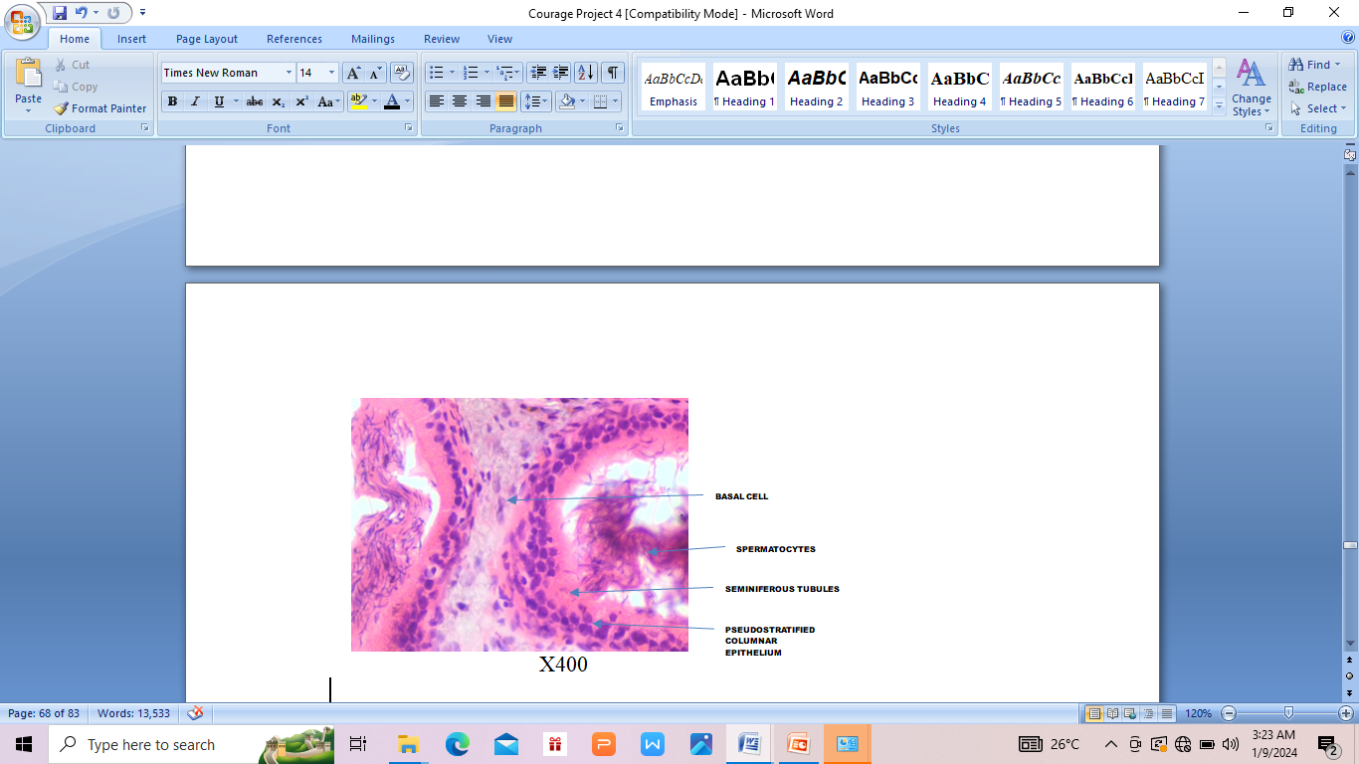
PLATE 5: Photomicrograph showing section of epididymal tissue. Low Dose 500mg/kg Garden Egg. Sections from the epididymal tubule show widened interstitial spaces containing mild inflammatory cells. The tubules are lined by pseudostratified columnar epithelium. Congested blood vessels.

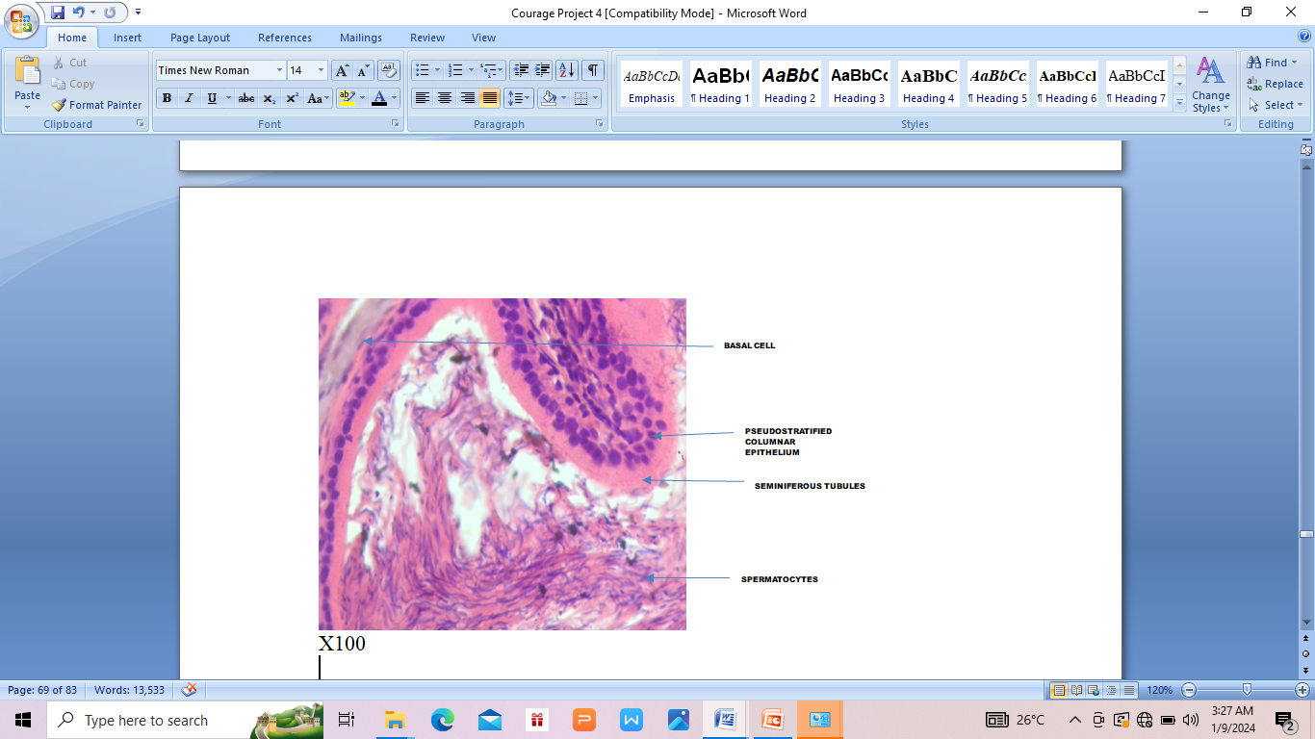
PLATE 6: Photomicrograph showing section of epididymal tissue. High Dose 1500mg/kg Garden Egg. Sections of the epididymis showing epididymal tubule lined by pseudostratified columnar and the lumen containing matured spermatids. The interstitium is histologically normal and contain congested blood vessels

DISCUSSION
In the present study, ethanolic extract of garden egg significantly reduced sperm count. This implies that garden egg may inhibit spermatogenesis. This agrees with saba et al., (2009). They stated that plant extract of L. breviflora is capable of inhibiting spermatogenesis because it reduced sperm count.
It was also observed that ethanolic extract of garden egg decreased sperm viability, suggesting that it may have a toxic effect of the epididymis. This agrees with Godwin et al., (2021). They reported that U. chamae treatment may have a toxic effect on epididymis because it reduced sperm viability. Sperm abnormalities affect the ability of a sperm to swim and fertilize the ova (Selen et al., 2003). In the present study abnormal sperm morphology increased in garden egg group when compared to control. This suggest that garden eggs may likely cause infertility. This agrees with Selen et al., (2003) who reported that abnormal sperm morphology cause male infertility. A reduction in morphologically normal sperm cells and an increase in morphologically abnormal sperm cells observed in animals fed with Garden Egg suggest that Garden Egg would likely impact negatively on the normal sexual functions of animals. This agrees with Alabi et al (2013), who stated that Musa paradisiaca would definitely negatively impact the normal sexual functions of the animals thereby reducing their ability to fertilize an ovum successfully.

Histological studies of the testis of animals treated with garden egg revealed a reduction in the spermatogonia. This implies that the level of testosterone may be reduced. This agrees with Mclachian et al., 1996. They reported that reduction in testosterone level disrupts spermatogenesis and reduces fertility parameters.

Garden egg reduced AST, ALT and ALP significantly. This implies that the plant extract is not toxic, and safe for the liver, thus long time consumption is safe. This agrees with Okpara et al., (2022), they reported that AST, ALT and ALP are measures of liver injury. They also reported that plant extract capable of increasing these parameters can cause liver injury.

Garden egg reduced CB,Ur, CR were reduced significantly in the present study. This implies that the plant extract is safe for the glomerulus and renal function. This agrees with Reuben et al., (2022), they reported that increase in these parameters cause impaired glomerular function and tubular function.
Garden eggs increased FSH, LH and testosterone levels.

CONCLUSION

Consumption of garden egg significantly reduced sperm count, viability and morphology, it may likely decrease the chances of fertility and so it is said to be toxic and it’s toxicity could be as a result of the presence of steroid in the pytochemical of garden egg. Steroids leads to low or absent sperm counts and shrunken testicles.

RECOMMENDATION

Further studies should be carried out on the effect of garden egg on sexual behavior.
Garden egg should be consumed at a reduced quantity.

REFERNCES
- Bhasin, S. and Jameson, J. (2022). Disorders of the Testes and Male Reproductive System. In: Loscalzo J, Fauci A, Kasper D, et al., eds. Harrisons Principles of Internal Medicine. 21st ed. McGraw Hill;.
- Irvine S, CawoodE, RichardsonD, MacDonaldE, Aitken J. Evidence of deteriorating semen quality in the United Kingdom: birth cohort study in 557 men in Scotland over 11 years, Br Med J, 1996, vol. 312 (pg. 467-471).
- Nguyen, H, (2021). “Improving Sperm Motility for Assisted Reproductive Technologies. “Journal of Assisted Reproduction and Genetics, 38(7), 1591-1603.
- Agarwal, A., Mulgund, A., Hamada, A., (2015). A unique view on male infertility around the globe. Reprod Bio Endo. ; 13:37-46.
- Sankeshwari, R. M., A. V., Bhat, K., &Hullanti, K. (2018). Soxhelt versus cold maceration: Which methods gives better antimicrobial activity to licorice extract against Strptococcusmutans?.Journal of Scientific Society, 45 (2), 67.
- Obinna VC, Kagbo HD, Afieroho OE, Agu GO. Haematological profile of albino rats exposed to polar leaf extracts of portulaca oleracea oleracea Linn. Clin Phytosci 2019.
- Sati L and Huszar G. “Sperm motitily and viability: Overview of the cellular and physiological aspects that support these functions”. EMJ Reproductive 1.1 (2015): 74-80.

