EFFECT OF BREADFRUIT SEEDS (Artocarpus altilis) ON MALE REPRODUCTIVE CHARACTERISTICS ON ADULT MALE WISTAR RAT

ABSTRACT

Male reproductive characteristics, such as sperm quality, quantity and motility, are important factors in male fertility. Low sperm count, poor sperm motility and abnormal sperm morphology are all associated with reduced fertility. Other factors that can affect male reproductive characteristics and fertility include genetics, lifestyle factors, age and exposure to environmental toxins. This study seeks to investigate the effect of breadfruit seed ( artocarpus altilis)on Male Reproductive Parameters in Adult Male Wistar Rat. Twelve (12) male rats were used for the present study. Animals were grouped into control, low and high dose garden egg. The extract was administered orally for duration of 21 days. Twenty four (24) hours after the last day administration, animals were sacrificed. The testes and epididymis were harvested and used for histological studies; semen was collected for semen analysis. Data were expressed as mean ± SEM. The mean difference between the tested groups and the control was tested using a one-way ANOVA. Values were considered statistically significant when P is ≤ 0.05. Consumption of ethanolic extract of garden egg significantly reduced sperm count, viability and morphology, it may likely decrease the chances of fertility in experimental animals.

KEYWORDS: Semen analysis, Testes, Epididymis.

INTRODUCTION

Male reproductive parameters such as sperm quality, quantity and motility, are important factors in male fertility (Agarwal et al.,2015).Low sperm count, poor sperm motility and abnormal sperm morphology are all associated with reduced fertility (Esteves et al., 2018). Other factors that can affect male reproductive parameters and fertility include genetics, lifestyle factors, age and exposure to environmental toxins (World Health Organisation,2010). Understanding the relationship between male reproductive characteristics and fertility is important in developing effective treatments and interventions for male infertility (Zhang et al., 2016). Infertility has significant negative impacts on the life’s of infertile couples which has led to divorce and social stigma (Victor, et al., 2023) . Some fruits and vegetables are consumed to help improve the male reproductive characteristics and they include; cucumber, guava, bell peppers, kiwis, bananas (medium size) and also oranges (CNY fertility, 2022).

Fig 1-BREADFRUIT SEEDS (Artocarpus altilis)

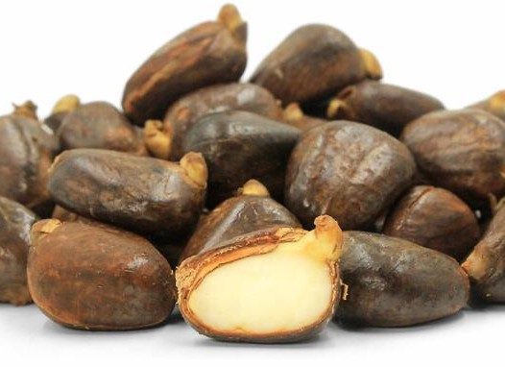

Breadfruit seed is grown in some 90 countries throughout South and Southeast Asia, the Pacific Ocean, Central America and Africa(“Breadfruit species”. Ntbg.org. National Tropical Botanical Garden, 2017). In addition to the fruit serving as a staple food in many cultures, sturdy timber of breadfruit has been used for outriggers, ships, and houses in the tropics.

MATERIALS
Reagents:10% formalin, Chloroform, Alcohol, Parrafin wax, Xylene, Haematoxylin stain, Eosin stain, Dibutyl phythalate xylene (DPX), Distilled water.
Equipments:
Beakers, measuring cylinder, conical flask, separating funnel, Buchner, blender, spatula, chess cloth, filter papers, generic water bath, Toption digital electronic balance.
Rat cages, Feeding bowl, Water can, Syringe, Microtome, Embedding machine, Glass slides, Water bath, Dissecting tools, Staining rack, Tissue cassette, Forceps, Hot plate, Brush, Rotary evaporators, Vacuum ovens, Ethanol, Dissection kits, Solvent reservoir, Solvent controller, Pump, Gas tank, Valve, Oven, Extraction cell and collection vessel.

STUDY LOCATION
This experiment was carried out in the animal house of Human Anatomy department, Rivers State University, Nigeria.

METHODS
ACCLIMATIZATION OF ANIMALS
The rats were acclimatized for a period of two weeks (14 days) 12h light/dark cycle before the commencement of the experiment. The rats had unlimited and unrestricted access to water before and during the experiment. Rats were fed with standard rat feed.

PLANT IDENTIFICATION OF PLANT EXTRACT
Artocarpus altilis (Breadfruit seeds) Rivers State University farm. The fruits were identified by a botanist and assigned a voucher number, Rivers State University. Voucher number RSUpb0150 was given to Artocarpus altilis (Breadfruit seeds).

EXTRACTION OF PLANT EXTRACT
Ethanolic Extraction of Artocarpus altilis (Breadfruit seeds)
About 2500 grams of grinded breadfruit seed sample was extracted by complete soaking in 5 litres of absolute ethanol for 48 hours with intermittent agitation and gyration, a process known as cold maceration. After 48 hours the solution was filtered twice; first with a chess cloth to remove large leaf particles and then with filter paper to remove finely ground particles. The collected filtrate (extract) was concentrated using a thermo-regulated water bath at mild temperatures (from 35-40⸰C) until complete dryness was achieved, leaving a paste (crude extract).

METHOD OF LD50 DETERMINATION
LD50 is the amount of a substance that will cause mortality in half of the test population. The Lorke’s method was used. This procedure involved two phases.
Phase 1
At this phase, 9 mouse were used. Animals were grouped into three groups, with each group containing 3 animals. Group 1 received 500mg/kg, group 2 received 1000mg/kg, group 3 received 2000g/kg. After waiting for 24 hours, no animal death was recorded.
Phase 2
9 mouse were used. Animals were grouped into 3 groups each containing 3 animals. Group 4 received 2000mg/kg, group 5 received 4000mg/kg and group 6 received 5000mg/kg.
Since no animal died at 5000mg/kg, the dosage calculation for low and high doses were 1/10 x 5000mg/kg and 3/10 x 5000mg/kg respectively.

ANIMAL GROUPING AND ADMINISTRATION OF EXTRACT
The rats were randomly divided into Three (3) groups with 4 rats each as follows:
Group 1: Distilled water orally per day for 14 days.
Group 2: Low dose of Artocarpus altilis (Breadfruit seeds) extracts orally per day for 14 days.
Group 3: High dose of Artocarpus altilis (Breadfruit seeds) extracts orally per day for 14 days.

DURATION OF STUDY
This study was conducted for the period of 21 days in the animal house in accordance with the guidelines involving animals as recommended by research ethics committee of Rivers State University pending approval.

SEMEN ANALYSIS
SEMEN COLLECTION
The testis together with the epididymis was excised. The distal epididymis was then cut open to expose the semen for collection by applying a little pressure on the caudal epididymis to squeeze the semen into a microscope slide. Two drops of 2.9% sodium citrate were added and the slide was covered with a cover slip for examination and evaluation under the microscope.
The sperm cells were classified into non-motile, sluggish, or actively motile. The percentage of motile sperm cells was calculated by dividing the number of motile sperm cells by the total number of counted sperm following the method described by Osuchukwu (2016). The sperm count was carried out using the Neubauer Haemocytometer.
SPERM MOTILITY
Semen was squeezed from the caudal epididymis onto a pre-warmed microscope slide (27⸰C) and two drops of warm 2.9% sodium citrate were added, the slide was then covered with a warm cover slip and was then covered with a warm cover slip and examined under the microscope using x400 magnification. Ten fields of the microscope were randomly selected and the sperm motility of 10 sperms was assessed on each field. Therefore, the motility of 100 sperms was assessed randomly. Sperms were labeled as motile, sluggish, or immotile. The percentage of motile sperm cells was defined as the number of motile sperms divided by the total number of counted sperms (i.e 100).
SPERM VIABILITY (Life/dead ratio)
This was done by adding two drops of warm Eosin/Nigrosin stain to the semen on a pre-warmed slide, a uniform smear was then made and dried with air, the stained slide was immediately examined under the microscope using x400 magnification. The live sperm cells were unstained while the dead sperm cells absorbed the stain. The stained and unstained sperm were counted and the percentage was calculated.
SPERM MORPHOLOGY
This was done by adding two drops of warm Walls and Ewas stain (Eosin/Nigrosin stain can also be used) to the semen on a prewarmed slide, a uniform smear was then made and air-dried; the stained slide was immediately examined under the microscope using x400 magnification.
Five fields of the microscope were randomly selected and the types and number of abnormal spermatozoa were evaluated from the total number of spermatozoa was expressed as a percentage of the total number of spermatozoa.
SPERM COUNT
This was done by removing the caudal epididymis from the right testes and blotting with filter paper. The caudal epididymis was immersed in 5ml forml-saline in a graduated test-tube and the volume of fluid displaced was taken as the volume of the epididymis. The caudal epididymis and the 5ml formol-saline were then poured into a mortar and homogenized into a suspension from which the sperm count was carried out using the improved Neubauer haemocytometer under the microscope.

HISTOLOGICAL PROCESSING AND ANALYSIS
Routine tissue processing was carried out using manual method of tissue processing. The processed tissue embedded in paraffin wax in the tissue embedded and trimmed using a rotary microscope and sectioned. The sectioned tissues were attached to slides and subsequently dewaxed in xylene and stained in haematoxylin and eosin, for display of te tissue architecture. The stained slides were examined under the light microscope at x10 magnification.

THE PROCEDURES OF THE MANUAL TISSUE PROCESSING INCLUDING H AND E STAINING METHOD
Before the tissue processing was carried out the tissues were fixed in 10% formal saline. They were dehydrated in ascending grades of alcohol (70%,90%, absolute I,II and III ) for 2 hours each respectively. They were cleared in xylene I and xylene II for 2 hours. They were impregnated in molten paraffin wax for 2 hours. They were embedded in paraffin wax for 2 hours. Tissue blocks were sectioned into serial sections of 5um thick using rotary microtome. Sections were floated in water preheated at 45°C. Sections were floated out using clean grease frosted end glass slide. Slides were dried on the hot plate. Slides were ready for staining.
STAINING METHOD
This was done using hematoxylin and eosin staining technique.
PRINCIPLE
Hematoxylin is a basic dye that stains the nucleus of the cell which is acidic while eosin is an acidic dye that stains the cytoplasm which is basic thereby providing a contrast between the nucleus and cytoplasm.
PROCEDURE
Sections were dewaxed in 2 changes of xylene. Sections were hydrated in descending grades of alcohol starting with changes of obsolete alcohol then 90%, 70% and 50%.Sections were flooded with hematoxylin for 20 minutes and rinsed in water. Sections were differentiated in 1% acid alcohol briefly and rinsed in water. Sections were blued in Scott’s tap water for 0.20 minutes. Section were flooded with 1% eosin in 3 minutes and rinsed in water. Sections were hydrated in ascending grades of alcohol (50%,70%,90%,absolute I and II).Sections were cleared in two changes of xylene and mounted in DPX. The stained slides were viewed microscopically using x10 and x40 objectives respectively and photomicrographs were taken.

STATISTICAL ANALYSIS:

Data was expressed as mean± SEM. Mean differences between the control and the other groups were tested using one way analysis of variance (ANOVA). Values were considered statistically significant when p is less than or equal to 0.005(p≤0.005). The difference between the sample mean was evaluated using Bonferoni post-hoc test.

ETHICAL APPROVAL:
Ethical approval was obtained from Research Ethics Committee Faculty of Basic Medical Sciences, College of Medical Sciences, Rivers State University.

RESULTS
Table 1: The effect of Artocarpus altilis (Bread Fruit) seeds ethanol extract of semen analysis of Adult Male Wistar Rats

Groups | Volume | pH | Viability | Normal | Abnormal | Active | Sluggish | Dead | Sperm Cells Count
LD  Mean ± S.E.M | 0.35±0.050 | 8±0 | 82.5±2.50* | 82.5±2.50* | 17.0 ± 2.50* | 75 ± 5 | 10 ± 0 | 8.5 ± 2.5* | 550 ± 50*
HD  Mean ± S.E.M | 0.35±0.100 | 8±0 | 85±2.50* | 87.5±2.50* | 16.5 ± 2.50 | 75 ± 5 | 10 ± 0 | 7.5 ± 5.5* | 625 ± 24*
Control  Mean ± S.E.M | 0.35±0.050 | 8±0 | 82±2.50* | 82.5±2.50* | 17.67 ± 2.50 | 80 ± 0 | 10 ± 0 | 10 ± 0* | 550 ± 50*
F | 0.273 | 0 | 16.013 | 19.012 | 14.673 | 5.543 | 0 | 15.567 | 15.567
P-Value | 0.809 | 0.0 | 0.02 | 0.002 | 0.005 | 0.090 | 0.0 | 0.003 | 0.003

Table 2:The effect of Artocarpus altilis (Bread Fruit) seeds ethanol extract on LH & Testosterone
 | Control  Mean ± SD | Mean ± SD  Low  (500 mg/kg) | Mean ± SD  High  (1500 mg/kg) | F | P
FSH | 0.6300±0.06292 | 0.5500±0.2828 | 0.5550±0.6364 | 1.975 | 0.25
LH | 0.7000±0.5000 | 0.6300±0.2828 | 0.6800±0.1414 | 1.990 | 0.25
Testosterone | 1.1567±0.6028 | 1.3750±0.3536 | 1.4100±0.2828 | 20.730 | 0.008

Testosterone level increased significantly.

Table 3: The Effect of Artocarpus altilis (Bread Fruit) seeds ethanol extract on Liver Function
 | Control  Mean ± SD | Mean ± SD | Mean ± SD | F | P
AST | 35.0000±8.00000 | 15.0000±1.41421 | 21.0000±1.41421 | 8.052 | 0.040
ALT | 31.6667±3.05505 | 20.0000±1.41421 | 24.0000±1.41421 | 15.546 | 0.013
ALP | 38.333±5.50757 | 33.0000±1.41421 | 30.5000±2.12132 | 11.799 | 0.021
TP | 73.000±2.0000 | 72.0000±1.41421 | 70.5000±2.12132 | 1.03 | 0.434
ALB | 44.0000±1.0000 | 43.5000±2.12132 | 42.5000±0.70711 | 0.776 | 0.519
T.B | 7.0667±1.43643 | 4.1500±0.49497 | 4.4500±0.35355 | 5.876 | 0.064
C.B | 4.5667±0.64291 | 2.3000±0.42426 | 2.3500±0.21213 | 16.387 | 0.012

AST, ALT, ALP and C.B reduced significantly.

Table 4:The Effect of Artocarpus altilis (Bread Fruit) seeds ethanol extract on Kidney Function
 | Control  Mean ± SD | Mean ± SD | Mean ± SD | F | P
K | 4.6000±0.26468 | 4.1500±0.07071 | 4.6500±0.21213 | 3.366 | 0.140
Na | 145.6667±4.16333 | 138.000±1.41421 | 71.7350±99.36972 | 1.462 | 0.334
Ur | 4.7667±0.25166 | 5.1500±0.21313 | 4.600±14142 | 3.366 | 0.139
CR | 96.3333±5.13160 | 106.5000±4.94975 | 95.5000±3.53553 | 3.876 | 0.116

HISTOLOGY OF TESTES
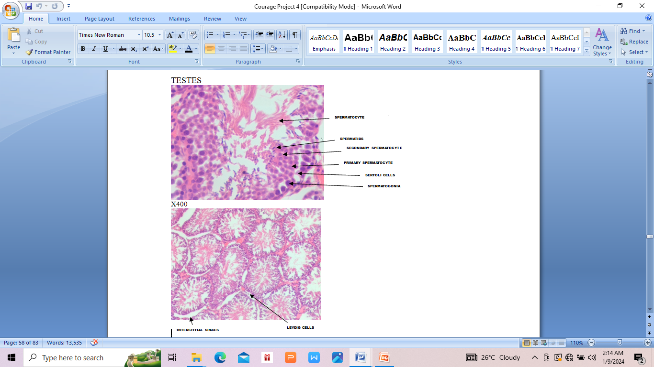
PLATE 1: Photomicrograph showing section of testicular tissue. Group 1(Control group). Section showed normal histology of the testis. No abnormality was seen.
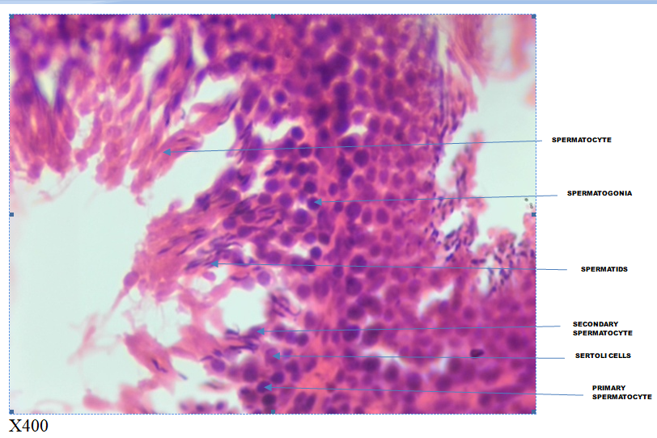
PLATE 2: Photomicrograph showing section of testicular tissue. Low Dose (500mg/kg) Breadfruit seeds. Normal testis histologically appears better. Within the seminiferous tubules are seen Leydig cells.

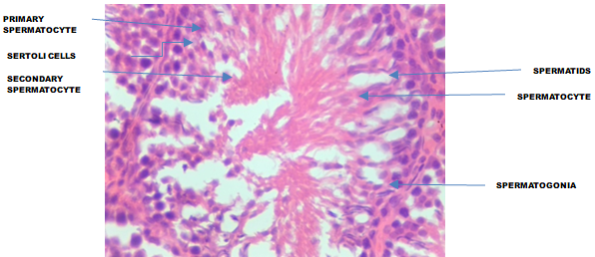
PLATE 3: Photomicrograph showing section of testicular tissue. High Dose (1500mg/kg) Breadfruit seeds. Section from testicular tissue show numerous seminiferous tubules containing spermatogonia, 1º and 2º spermatocyte and spermatid. Other supporting cells are sparse. Seminiferous tubule shows normal cells.

HISTOLOGY OF EPIDIDYMIS
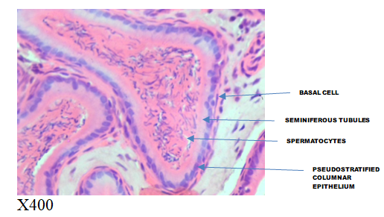
PLATE 4: Photomicrograph showing section of epididymal tissue. (CONTROL GROUP). Section from the epididymis show tubules lined by pseudostratified columnar cells most of which have a cytoplasmic blue hue within which are few cells with pyknotic nuclei and clear vacuole. The lumen contains abundant/ heavy spermatids.

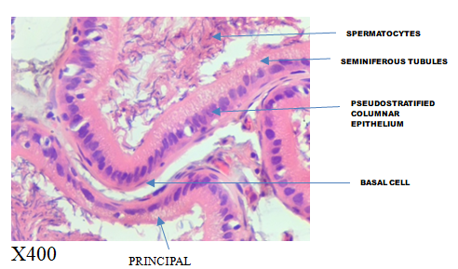
PLATE 5: Photomicrograph showing section of epididymal tissue.( Low Dose (500mg/kg) Breadfruit seeds). Sections show widened interstitial spaces with pyknotic cells and clear cytoplasmic vacuoles. The tubules contain pseudostratified columnar epithelium. The lumen of the tubule contains spermatids with increased count.

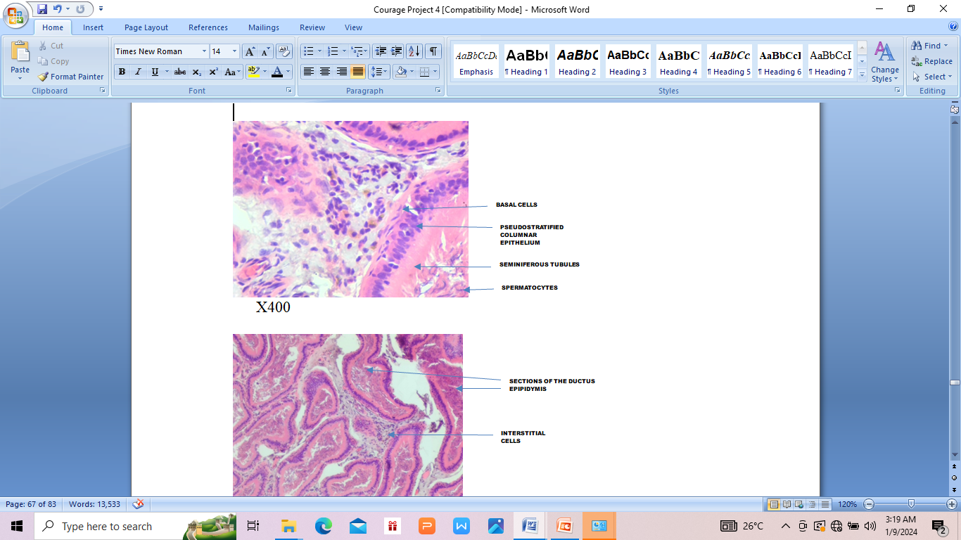
PLATE 6: Photomicrograph showing section of epididymal tissue. (High Dose (1500mg/kg) Breadfruit seeds). Histologic sections show widened interstitial space with moderate inflammatory cells. Within the interstitial space, the tubules are lined by columnar epithelial cells.

DISCUSSION
In the present study, a significant increase in sperm count and sperm viability was observed in animals treated with breadfruit. This suggests that Breadfruit may improve the fertility of male rats. This agrees with Sati et al. (2015), who stated that plant extracts capable of increasing sperm motility and liveability can improve fertility of male rats.
The marked rise seen in sperm count of animals that consumed breadfruit seed implies that it can be used in the management of male fertility. This agrees with Obinna et al. (2019), who reported that p. oleracea can be used in the management of male fertility because it increased sperm count.

Widened interstitial spaces were also observed in the histological studies of the epididymis of animals that were treated with breadfruit seeds. This implies that breadfruit seed may likely increase the rate of fertility in adult male Wistar rats. This study was not in agreement with Orheruata (2019), they reported that low and high doses of M.priens will likely cause anti fertility because it caused a spermatogenic arrest.

Histological studies of the testis treated with breadfruit seed revealed normal spermatogonia and spermatids. This implies that breadfruit seed supports fertility in adult male wistar rats. This study was not in agreement with Orhruata (2019), they reported that low and high doses of M. prulens will likely cause anti fertility because it caused a spermatogenic arrest.

ALT, AST, and ALP values decreased significantly implying that the plant extract may not be toxic to the liver

CONCLUSION
Breadfruit seed may improve the chances of fertility because it increased testosterone level, sperm count, viability in experimental animals.
REFERENCES
- Bhasin, S. and Jameson, J. (2022). Disorders of the Testes and Male Reproductive System. In: Loscalzo J, Fauci A, Kasper D, eds. Harrisons Principles of Internal Medicine. 21st ed. McGraw Hill;.
- Irvine S, Cawood E, Richardson D, MacDonald E, Aitken J. Evidence of deteriorating semen quality in the United Kingdom: birth cohort study in 557 men in Scotland over 11 years, Br Med J, 1996, vol. 312 (pg. 467-471).
- Nguyen, H, (2021). “Improving Sperm Motility for Assisted Reproductive Technologies. “Journal of Assisted Reproduction and Genetics, 38(7), 1591-1603.
- Agarwal, A., Mulgund, A., Hamada, A., (2015). A unique view on male infertility around the globe. Reprod Bio Endo. ; 13:37-46.
- Sankeshwari, R. M., A. V., Bhat, K., & Hullanti, K. (2018). Soxhelt versus cold maceration: Which methods gives better antimicrobial activity to licorice extract against Strptococcus mutans?. Journal of Scientific Society, 45 (2), 67.
- Obinna VC, Kagbo HD, Afieroho OE, Agu GO. Haematological profile of albino rats exposed to polar leaf extracts of portulaca oleracea oleracea Linn. Clin Phytosci 2019.
- Sati L and Huszar G. “Sperm motitily and viability: Overview of the cellular and physiological aspects that support these functions”. EMJ Reproductive 1.1 (2015): 74-80.

