Acute Lymphoblasic Leukemia presented with Paraparesis: an unusual presentation and a rare case in a child

.
ABSTRACT

Acute Lymphoblastic leukemia (ALL) remains the most commonly encountered paediatric malignancy and having a good prognosis. It’s imperative for clinicians to be aware of its unusual presentations. In this article, we present a three-year-old girl who presented with paraparesis, subsequently diagnosed to be a case of B cell ALL, successfully treated with chemotherapy. By excluding all other causes, the neurological diagnosis of non-compressive myelopathy due to paraneoplastic syndrome was considered.

Keywords: Acute Lymphoblastic leukemia, paraparesis, non-compressive myelopathy, paraneoplastic syndrome

1. INTRODUCTION

Acute Lymphoblastic leukemia (ALL) is the most common childhood malignancy below 15 years of age with a peak incidence being one to four years ^{[1]}. Clinically children with ALL typically presents with nonspecific manifestations like fever, lethargy, arthralgia, bleeding diathesis and pallor requiring recurrent blood transfusions. However, it can present with various atypical presentations, paraparesis being one of them ^{[6]}. in this article, we describe a case of B-ALL presenting clinically as non-compressive myelopathy resulting in paraparesis, provisionally diagnosed as a paraneoplastic syndrome (PNS).

2. CASE REPORT :

A three-year-old girl born out of non-consanguineous marriage with normal developmental history presented with two-month history of intermittent fever, accompanied by insidious onset weakness in bilateral (B/L) lower limbs without any weakness of the upper limb or bowel bladder involvement. Her weakness progressively deteriorated over next two months such that she became bedridden one week prior to admission. There was no history of preceding trauma, diarrhoea, seizure, drug intake or any band like sensation. She received two units of red blood in past two weeks.
General Examination was notable for moderate pallor and B/L cervical lymphadenopathy. Neurological Examination revealed normal higher mental function, no cranial nerve involvement and no signs of meningeal irritation. Lower limb neurological examination revealed paraparesis (power 1/5 in B/L lower limbs), hypotonia, preserved deep tendon reflexes and an extensor plantar reflex with normal sensory function. Upper limb Examination was within normal limit. There was no spinal deformity or tenderness. Gait and coordination couldn’t be tested. Clinically a diagnosis of subacute non-compressive myelopathy was made.
Her peripheral blood smear examination shows, normocytic normochromic anemia, thrombocytopenia and leukocytosis with 70% atypical cells. Further Bone marrow aspiration (BMA) revealed acute leukemia and immunophenotyping confirmed to be a case of B-ALL (Figure 1). Metabolic (like Vit B12 deficiency), vascular (e.g. spinal dural arterio-venous malformation), Neoplastic (like astrocytoma, intra vascular lymphoma), infectious (like HIV), inflammatory /autoimmune (e.g. connective tissue disorders) and paraneoplastic etiology were considered for myelopathy and relevant investigations were done (enlisted in Table 1).
The patient was treated with Chemotherapy as per Berlin-Frankfurt-Munster study group (BFM 2002) childhood ALL protocol standard risk arm (consisting high dose oral steroids, intravenous daunorubicin, vincristine, l-asparaginase and intrathecal methotrexate) along with limb physiotherapy and other supportive care. Her paraparesis and other symptoms gradually improved. Her post induction BMA was in morphological remission and minimal residual disease by flowcytometry was negative . Simultaneously, her lower limb power improved to 4+/5. Subsequently she was given consolidation with High dose Methotrexate. Currently she is on maintenance therapy and having no residual weakness in lower limbs.

3. discussion

With an estimated 6000 new cases per year ocurring in U.S. alone and having an age adjusted incidence of 1.38 per 100,000 individuals annually, ALL is one of the most commonly encountered hematological malignancy ^{[2]}. 75-80% of ALL are of B cell origin, BCP ALL being the most common ^{c}. Moreover, there has been steady increase in pediatric ALL incidence since 1975, despite significant improvement in overall survival over decades, exceeding 90% in some clinical trials ^{[4]}. However, treatment outcomes in low- and middle-income countries like India are still suboptimal ^{[5]}. In a systemic review of 41 studies over 30 years about unusual presentations of childhood ALL, musculo-skeletal symptoms were found to be the most common atypical initial presentation (34.2%) followed by neurological impairment (14.6%) ^{[7]}. Most cases of paraparesis in ALL are due to spinal cord compression, either extradural or intradural ^{[8]}. There are only few case reports non compressive myelopathy in ALL ^{[9,10]}.
Paraneoplastic syndromes, though uncommon, encompasses a vast group of disorders of various systems, often precedes the symptoms of underlying cancer and neurological disorders are one of the most commonly encountered entity ^{[11]}.The neurological sequelae is presumed to be triggered by immune response to underlying leukemia ^{[1]}.Though the adult PNS has recommended diagnostic criteria which include presence of onconeural antibodies, paediatric PNS symptoms are often atypical and may not meet classical syndromic criteria ^{[l,13]}.For example onconeural antibodies are present in less half of the cases in adult PNS, even lower positivity rates are reported in children ^{[14]}.In our case we couldn’t rule out presence of onconeural antibodies due to financial constraints. However, other potential diagnoses being unlikely based on the clinical course and diagnostic work ups, and the fact that successful leukemia treatment (that includes immunosuppressive therapy with high dose steroids) has alleviated the neurological symptoms without any recurrence, we consider the neurological of diagnoses of PNS.
4. Conclusion

Though ALL is a common childhood malignancy, its presentation is often variable and atypical. Moreover, PNS is an overlooked entity due to its rarity and diagnostic challenge. Physicians should be highly vigilant in picking up PNS cases, as it often presents before the onset of cancer symptoms and thereby hastens early diagnosis and treatment. Timely initiation of proper chemotherapy not only holds a favourable ALL prognosis, but also influences rapid PNS recovery.

Consent (where ever applicable)

All authors declare that ‘written informed consent was obtained from the patient (or other approved parties) for publication of this case report and accompanying images. A copy of the written consent is available for review by the Editorial office/Chief Editor/Editorial Board members of this journal

Ethical approval (where ever applicable)

Informed consent for chemotherapy and publication as per format have been taken from patient.
References

- Brown, P., Inaba, H., Annesley, C., Beck, J., Colace, S., Dallas, M., DeSantes, K., Kelly, K., Kitko, C., Lacayo, N., Larrier, N., Maese, L., Mahadeo, K., et al. (2020). Pediatric Acute Lymphoblastic Leukemia, Version 2.2020, NCCN Clinical Practice Guidelines in Oncology. J Natl Compr Canc Netw, 18(1), 81-112. https://doi.org/10.6004/jnccn.2020.0001

2. National Cancer Institute. (2025). Childhood Acute Lymphoblastic Leukemia Treatment (PDQ®)-Health Professional Version. https://www.cancer.gov/types/leukemia/hp/child-all-treatment-pdq

3. Gökbuget, N., Boissel, N., Chiaretti, S., Dombret, H., Doubek, M., Fielding, A., Foà, R., et al. (2024). Management of ALL in adults: 2024 ELN recommendations from a European expert panel. Blood, 143(19), 1903–1930. https://doi.org/10.1182/blood.2023023568

4. Pui, C. H. (2020). Precision medicine in acute lymphoblastic leukemia. Frontiers in Medicine, 14(6), 689-700. https://doi.org/10.1007/s11684-020-0759-8 ,

5. Abdelmabood, S., Fouda, A. E., Boujettif, F., & Mansour, A. (2020). Treatment outcomes of children with acute lymphoblastic leukemia in a middle-income developing country: high mortalities, early relapses, and poor survival. Jornal de Pediatria, 96(1), 108-116. https://doi.org/10.1016/j.jped.2018.07.013

6. Maheshwari G. Unusual presentations of acute lymphoblastic leukemia in children: a study of 9 patients. J Glob Oncol 2018;4:87s.

7. Shakibazad, N., Haghpanah, S., & Shahriari, M. (2016). Unusual presentations of acute lymphoblastic leukemia in children: A systematic review. Journal of Hematology & Thromboembolic Diseases, 4(Suppl 5), 37. https://doi.org/10.4172/2329-8790.C1.002
8. Graber, J. J., & Nolan, C. P. (2010). Myelopathies in patients with cancer. Archives of Neurology, 67(3), 298–304. https://doi.org/10.1001/archneurol.2010.20

9. Yavuz, H., & Çakır, M. (2001). Transverse myelopathy: an initial presentation of acute leukemia. Pediatric Neurology, 24(5), 382–384. https://doi.org/10.1016/s0887-8994(01)00258-2
10. Shukla, A., Verma, S. P., Verma, D. P., & Yadav, G. (2020). Non-compressive myelopathy: an unusual presentation of a patient with acute B lymphoblastic leukaemia. BMJ Case Reports https://doi.org/10.1136/bcr-2020-235754

11. Ma, G. M., Chow, J. S., & Taylor, G. A. (2019). Review of paraneoplastic syndromes in children. Pediatric Radiology, 49, 534–550. https://doi.org/10.1007/s00247-019-04371-y

12. Pelosof, L. C., & Gerber, D. E. (2010). Paraneoplastic syndromes: an approach to diagnosis and treatment. Mayo Clinic Proceedings, 85(9), 838–854. https://doi.org/10.4065/mcp.2010.0099

13. Graus, F., Delattre, J. Y., Antoine, J. C., Dalmau, J., Giometto, B., Grisold, W., Honnorat, J., Sillevis Smitt, P. A. E., Vedeler, C. A., Verschuuren, J. J. G. M., Vincent, A., & Voltz, R. (2004). Recommended diagnostic criteria for paraneoplastic neurological syndromes. Journal of Neurology, Neurosurgery & Psychiatry, 75(8), 1135–1140. https://doi.org/10.1136/jnnp.2003.034447 .

14. Alavi, S. (2013). Paraneoplastic neurologic syndromes in children: A review article. Iranian Journal of Child Neurology, 7(3), 6–14. https://doi.org/10.22037/ijcn.v7i3.4958

Definitions, Acronyms, Abbreviations
Here is the Definitions section. This is an optional section.
Term: Definition for the term

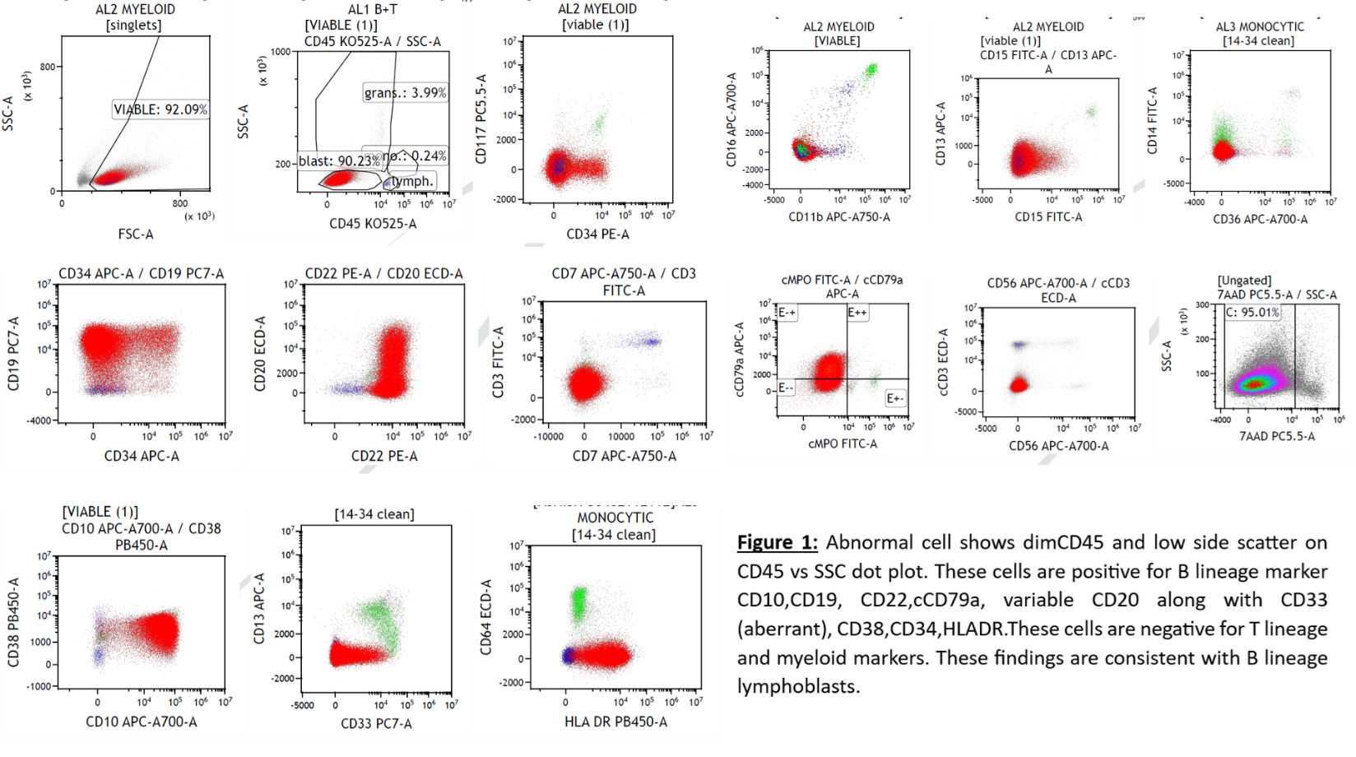 Figure 1: Abnormal cell shows dimCD45 and low side scatter on CD45 vs SSC dot plot. These cells are positive for B lineage marker CD10,CD19, CD22,cCD79a, variable CD20 along with CD33 (aberrant), CD38,CD34,HLADR.These cells are negative for T lineage and myeloid markers. These findings are consistent with B lineage lymphoblasts.

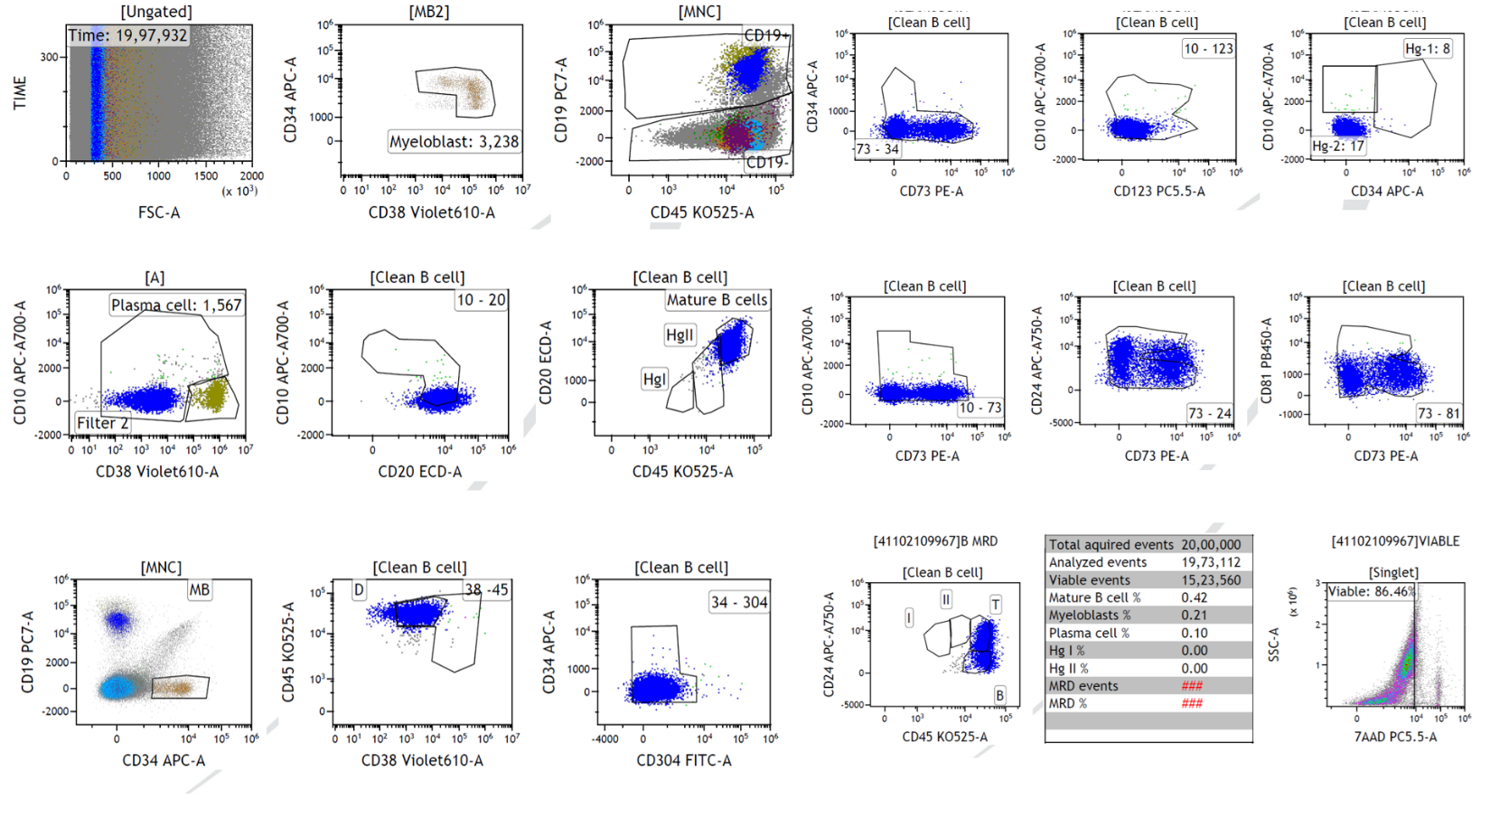 Figure 2 : Flow cytometric immunophenotypic analysis of the bone marrow sample was done on CD 19/side scatter plots which does not show evidence of Minimal Residual Disease (Limit of quantification: 0.0033 % ; on the basis of analyzed viable events)

Table 1: Investigation details of the case and Report there of
MRI Brain | No Abnormality Detected
MRI LS Spine | No Abnormality Detected
MRI dorsal spine | No Abnormality Detected
CSF study | No immature cell, biochemical parameter normal
Neurotropic Panel for viral infection from CSF | NAD
NCS, EMG | no axonal delay / no sign of demayelination
Electrolytes(Potassium, calcium ,magnesium ,sodium) | Normal in range
BMA ,BMBx | Acute leukaemia, 86 % Blast.
ALL FISH PANEL | positive for t(12:21) ETV 6 RUNX1 POSITIVE
CYTOGENETICS | 46XX , deri 7 ,add 7 ,det 7, del12 , +21
IPT done from BMA showed | dim CD45 and low side scatter on CD45 vs SSC dot plot. Positive for B lineage marker CD10, CD19, CD22, cCD79a, variable CD20 along with CD33 (aberrant),CD38, CD34, HLADR ; and Negative for T lineage and myeloid markers.
Post Induction Chemotherapy BMA + MRD | Morphological remission (2% blasts) and MRD by FCM below detection limit

