SUSTAINABLE BLUE FOOD INNOVATION: DEVELOPMENT OF GLUTEN-FREE BAKERY PRODUCTS ENRICHED WITH RED SEAWEED (GRACILARIA SPP)

Abstract
Indonesia relies on imported wheat and faces nutritional issues with local gluten-free Modified Cassava Flour (Mocaf), which has low crude protein (1.0%–3.0%) and dietary fiber (1.9%–3.4%). This study aimed to enhance bakery products by adding sustainable red seaweed (Gracilaria spp.), naturally rich in protein (10%–47%) and dietary fiber (10%–31%). Gluten-free bread was made with red seaweed powder at five substitution levels: 0% (control), 2%, 4%, 6%, and 8% (w/w). Analyses measured fiber and moisture through AOAC methods, and sensory evaluation with 20 participants assessed consumer acceptance. Results showed that higher substitution increased water content (3.6% to 6.4%) and crude fiber (18.9% to 22.3%) significantly (p < 0.05). Sensory traits, such as color, taste, and texture, were also affected (p < 0.05). High levels, such as 8%, reduced sensory appeal due to dark color (score 2.5) and poor taste (score 2.9), even though fiber content was maximized. Using the Composite Performance Index (CPI), 4% substitution (P2) was identified as the best option (CPI 38.48), offering high fiber (21.58%) and acceptable sensory qualities, showing that Gracilaria-enriched Mocaf can support local sustainable food innovations.
KEYWORDS: Gluten-free, Red-Seaweed, Mocaf Flour, Dietary Fiber
Introduction
The drive for global food security increasingly emphasizes building resilient food systems that can lower climate risks and address common nutritional gaps, as Sarasi et al. (2025) note. Wheat flour consumption in Indonesia has risen, driven by changing lifestyles among younger people who frequently eat it. This growth is also due to the convenience, ready-to-eat nature, and long shelf life of wheat-based products (Dalal & Bobade, 2018). Indonesia does not produce much wheat domestically and relies instead on imports, which are not sustainable. Supply disruptions could cause shortages in the country (Pandin et al., 2022). Traditionally, baked goods like bread are made from flour containing gluten, mainly from cereals such as wheat, barley, and rye (Monthe et al., 2018).
Cassava (Manihot esculenta) is widely available in tropical regions, including Indonesia, making it a key crop (Sarasi et al., 2025). Its derived products, such as Modified Cassava Flour (Mocaf), play a vital role in promoting local food sovereignty by decreasing dependence on imported flours for both traditional snacks and modern baked goods (Putri et al., 2024). Its gluten-free nature makes it allergen-free and suitable for individuals with celiac disease (Silvana et al., 2014). Furthermore, the global food industry is rapidly shifting towards healthier, allergen-free options. The gluten-free bakery segment is growing significantly, with a market size of USD 1.95 billion in 2024, expected to rise to USD 2.15 billion in 2025, and potentially reaching USD 5.29 billion by 2034. This growth is driven by a compound annual growth rate of 10.5% from 2025 to 2034 (Towards FnB, 2025; SkyQuest Technology, 2025).
While Mocaf has potential as a gluten-free starch base, it faces a key nutritional obstacle limiting its use as a health-focused ingredient. Its crude protein content is very low, ranging from 1.0% to 3.0% (Oktaviani & Nugraha, 2025). Additionally, Mocaf is deficient in dietary fiber, with content ranging from 1.9% to 3.4%. Since consumers favor high-fiber options, this low fiber level makes it less ideal for nutritionally balanced products (Oluwakemisola, 2025; Oktaviani & Nugraha, 2025). Besides the low fiber and protein content, Oluwakemisola (2025) also noted that Mocaf's ash content is markedly low, suggesting a low mineral density.
Red seaweed (Gracilaria spp.) is a valuable nutritional supplement that can improve Mocaf and address its main deficiencies. It is high in protein, with crude protein content between 10% and 47% on a dry weight basis, and contains substantial dietary fiber ranging from 10.38% to 31.1% (Norziah & Ching, 2000). In addition to macro nutrients, red seaweed provides important hydrocolloids such as agar and carrageenan. When added to gluten-free Mocaf, these hydrocolloids boost viscoelasticity and overall acceptability (Azzahra et al, 2025; Shauli & Salomon, 2025). The hydrocolloids from red seaweed can also reduce reliance on refined gums such as methylcellulose and guar gum, which are often used in gluten-free bread production (Azzahra et al., 2025).
Recent research indicates that adding seaweed significantly alters the physicochemical characteristics of mocaf flour, primarily due to its additional fiber and moisture. The experiment incorporated ground red seaweed at 0%, 2%, 4%, 6%, and 8% levels to assess fiber and moisture content and to explore the sensory qualities of baked bread.
Method and Materials
Materials
Fresh red seaweed (Gracilaria sp.) was collected from Demak, Central Java, Indonesia, thoroughly washed to remove salts and sand, and then sun-dried to constant weight, minimizing energy input during material preparation. The dried biomass was pulverized and passed through a 60-mesh sieve to yield a homogeneous powder, which was stored in airtight containers at room temperature until utilized for product formulation. The primary gluten-free base, Mocaf (Modified Cassava Flour), along with supplementary ingredients such as baking powder, sugar, salt, margarine, and egg, were sourced from local Indomart supermarkets in Semarang, Indonesia.
Formulation of Gluten-Free Bread
A standardized gluten-free bread recipe using Mocaf as the base flour was developed. Red seaweed powder was added to the Mocaf at four different replacement levels based on the total flour weight (Mocaf + Seaweed): 2%, 4%, 6%, and 8% (w/w). A control sample without seaweed addition (0%) was also prepared.
Fiber content
The crude fiber content was determined using the AOAC (2005) standard acid/alkaline digestion method, which initially removes lipids. Ten grams of dried, ground bread were first extracted with an organic solvent in a Soxhlet apparatus for at least 6 hours to obtain a fat-free residue. Then, 50 cc of 1.25% H2SO4 was added and heated for 30 minutes, followed by washing and refluxing with 50 cc of 3.25% NaOH for another 30 minutes. The insoluble fiber residue was filtered, washed, dried at 105°C to record the initial dry weight (W1), and then incinerated in a muffle furnace to measure the ash weight (W2). The difference (W1 - W2) represented the crude fiber content, expressed as a percentage of the original sample weight, according to equation 1.
$$Crude fiber\left(\%\right)=\frac{W1-W2}{sample weight (G)}x100 (1)$$
W1=weight of crucible + dried residue
W2-Weight of crucible + +ash
Moisture Content
The moisture content was measured by oven drying. An empty crucible (A) was placed in the oven and dried at 105°C for 30 minutes. It was then cooled in a desiccator for 15 minutes before adding 5 g of the sample (B). The sample and crucible were dried again at 105°C for 6 hours. Afterward, they were cooled in a desiccator for 15 minutes and weighed until a constant weight (C) was reached. This process was repeated for all samples according to AOAC (2005) guidelines. The results were calculated using Equation 2 below.
$$Mc\%=\frac{\left(B-C\right)}{C-A}*100 (2)$$
A: mass of the empty dried crucible
B: weight of crucible + initial sample
C=Weight of cup + dry sample
Sensory Analysis
A panel of 20 students was selected to evaluate the bread samples, assessing color, aroma, taste, texture, and overall liking. They used a 9-point hedonic scale, from 1 (dislike extremely) to 9 (like extremely). The samples were randomly coded with four numbers and presented in a randomized order. Water was provided for palate cleansing between samples.

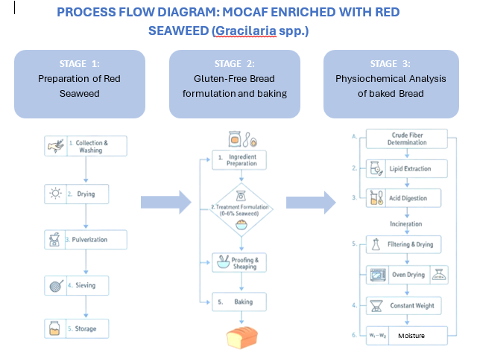

Figure 1.Flowchart of the Mocaf Bread Enriched with Red Seaweed
Statistical Analysis
All physicochemical analyses, moisture, and fiber content were performed in triplicate, with data expressed as the mean ± standard deviation (SD). The results from these analyses were analyzed using one-way ANOVA. When a significant difference ($p < 0.05$) was found, Duncan's Multiple Range Test was employed as a post-hoc test to compare the means across different seaweed incorporation ratios. For the nonparametric sensory evaluation data (Hedonic scores), the Friedman test was used to assess overall differences among samples. If this test indicated significance, pairwise comparisons between the control, seaweed-enriched samples, and various seaweed ratios were conducted using the Wilcoxon Signed-Rank Test. All statistical analyses were conducted with a significance threshold of p < 0.05.

Results and Discussion
Fiber Content
The primary objective of substituting mocaf flour with red seaweed was to increase the cookies' dietary fiber content, leveraging red seaweed's well-established nutritional profile. The mean fiber content results (Figure 1) indicated a numerical increase across the treatments compared to the control (P0), ranging from 18.94% to 22.27 % (P4)
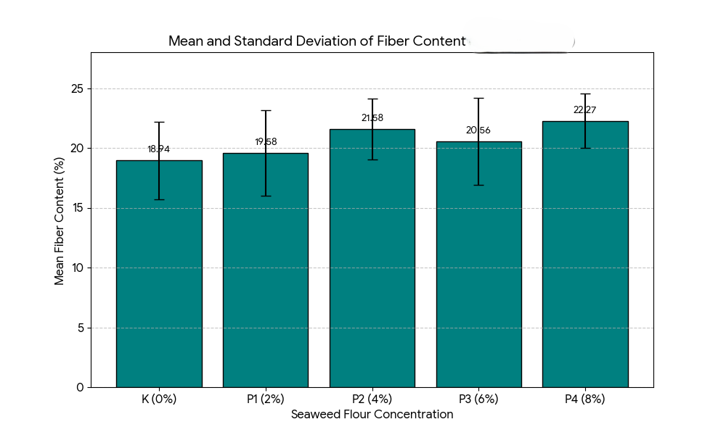
Figure 2: Mean and standard deviation of Fiber Content
Despite the visible increase in mean values, ANOVA determined that this variation was not statistically significant across the five treatment groups.
Table 1: A summary of ANOVA results
Source | Sum of squares (SS) | Degree of freedom(df) | Mean square(MS) | F | Sig
Treatment | 43.686 | 4 | 10.922 | 1.127 | 0.372
Error | 193.757 | 20 | 9.688
Total | 237.443 | 24

The ANOVA test showed that replacing seaweed flour did not significantly affect the fiber content of mocaf flour (p-value = 0.372), which is above the 0.05 threshold. Although the average fiber content increased, the differences in seaweed flour substitution were not statistically significant across treatments. The fiber increase aligns with the natural composition of Red seaweed, as seen in other varieties such as brown seaweed. These are well-known as rich sources of dietary fiber, mainly composed of non-digestible polysaccharides, which enhance the nutritional profile of processed foods (Soewondo et al., 2024; Savitri & Rosida, 2025).
While aiming to maximize fiber content, it is crucial to balance this with quality aspects. Research indicates that extremely high fiber levels can negatively influence the physical properties of final products, often resulting in tougher textures that are less appealing (Susanto et al., 2016). Ingredients such as red seaweed, known for their high water-holding capacity, can alter dough characteristics and produce less desirable textures. Nevertheless, red seaweed's ability to provide both soluble and insoluble fiber makes it a valuable component for creating innovative, nutritionally fortified bakery items (Hajare et al., 2024).
Moisture Content
The water content of the Mocaf-baked bread is represented in Figure 2 below. The mean water content of the mocaf flour substituted with red seaweed flour ranged from 3.6% at P0 to 6.4% at P4(8% substitution). A clear numerical trend with increasing water content as the red seaweed flour increased, conversely, as the mocaf flour decreased.
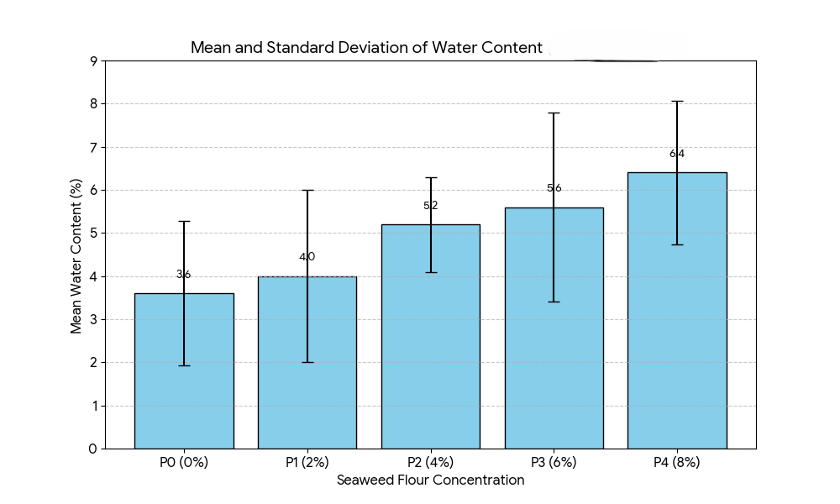
Figure 3: mean and standard deviation of percentage water content
The statistical analysis (ANOVA) showed that substituting red seaweed flour did not significantly affect the water content of the Mocaf bread (p-value = 0.142; >0.05). This indicated that variation in the substitution of red seaweed flour in the Mocaf bread did not significantly affect the water content. The inherent properties of red seaweed well support the observations. Red seaweed is rich in hydrophilic polysaccharides such as agar, alginates, and carrageens (Jayakody et al., 2022). These compounds possess a remarkable capacity to bind and absorb water due to their numerous hydroxyl groups, effectively increasing the dough's water-holding capacity and, consequently, the final product's moisture content (Mamat et al., 2013; Pereira, 2018).
Sensory Analysis
Texture
In the study, sensory testing was conducted on the texture of mocaf bread substituted with red seaweed flour at various concentrations. Texture was an important sensory parameter in assessing Mocaf bread quality, as it influences consumer perceptions of crispiness and chewability.
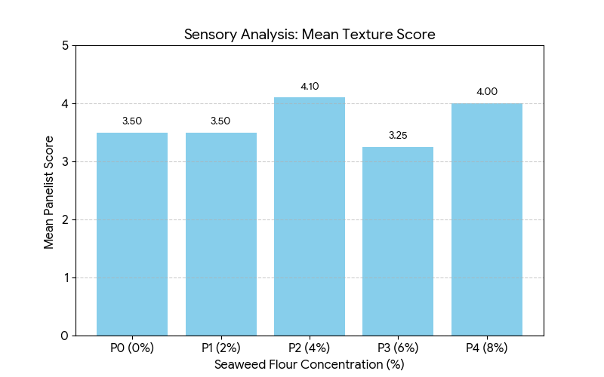
Figure 4.Average Results for texture sensory text
The Friedman test showed a p-value of 0.006 (<0.05), indicating that substituting mocaf flour with seaweed flour significantly affects the texture of mocaf bread. This implies that varying levels of seaweed flour substitution result in noticeable differences in texture, perceptible to panelists. Additionally, Wilcoxon tests confirmed significant differences among treatments, reinforcing the idea that ingredient composition profoundly influences cookie texture.
These results confirm that incorporating alternative ingredients, such as seaweed flour, affects not only nutritional value but also significant sensory qualities, particularly texture. As BSN (2006) explains, texture describes the physical characteristics of food, such as elasticity, brittleness, and hardness, which are vital for consumer acceptance. Dough made with seaweed fiber typically becomes denser, reducing brittleness because the fibers absorb more water, restricting gluten formation during mixing and baking (AOAC, 2005). Susanto et al. (2016) observed that adding dietary fiber influences texture, with higher fiber levels generally resulting in firmer products. According to Sudarmadji et al. (1997), the interaction between water content and dietary fiber determines a product's structure and crispiness.
Taste
Taste was the most important sensory attribute, as it directly influences consumers' decision to like or reject a food product, thereby determining consumer acceptance. In this study, various concentrations of mocaf flour substituted with red seaweed were used to assess their effect on panelists' preference levels.
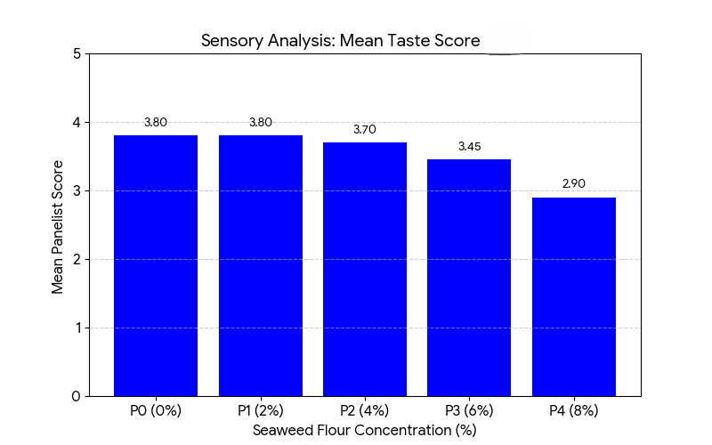
Figure 5: Average Taste results from Sensory tests
The analysis used the Friedman test, which showed a p-value of 0.013 (<0.05), indicating that substituting mocaf flour with red seaweed flour significantly affected the taste of mocaf bread. Differences in treatment levels of substitution resulted in differences in taste characteristics perceived by the panelists, such as the natural savory taste of seaweed, the potential for a mild fishy taste, and changes in sweetness due to complex ingredient interactions. A further Wilcoxon test also strengthens the finding of a real difference in responses to taste attributes.

Flavor is shaped not only by the primary ingredients but also by factors like water content, sugar, fat, and dietary fiber. Red seaweed contains compounds such as polysaccharides, minerals, and amino acids that can influence flavor in specific ways (AOAC 2005). Replacing it with red seaweed introduces a distinct marine flavor. In small amounts, it can enhance the flavor profile, but if it becomes too prominent, it can reduce overall liking (BSN, 2006). Oktaviana et al. (2017) also found that substituting the main ingredient with alternatives, such as mung beans, significantly alters the cookie's taste. Like seaweed, mung beans have a distinctive flavor which may or may not be acceptable depending on the level used and panelist preferences. As discussed in Chapter II, a key challenge in food innovation with local ingredients is ensuring that compositional changes do not compromise taste, which is vital for consumer acceptance (BSN, 2006). This study's findings reinforced the need for a balanced substitution ratio to maintain a pleasant, acceptable flavor.
The substitution of Mocaf flour with seaweed flour in Mocaf bread formulations was found to affect taste, since good taste remains the main priority for consumers when choosing food products, regardless of their nutritional benefits.
Color
Color draws consumers' attention and often signals the quality of a food product. Appealing colors can enhance visual appeal and strengthen perceptions of quality. In this study, sensory tests were conducted on the color of mocaf bread with varying levels of red seaweed substitution to assess the impact of the ingredient substitution.
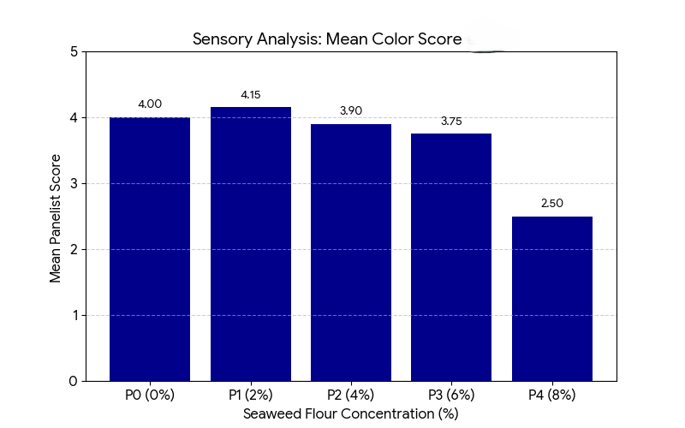
Figure 6: Average color response from the sensory panel
The analysis employed the Friedman test, yielding a p-value of 0.000 (<0.05), which indicates a highly significant effect of replacing Mocaf flour with seaweed flour on cookie color. Treatments with varying levels of seaweed flour substitution showed noticeable differences in cookie color. Specifically, increasing the proportion of red seaweed flour made the mocaf bread darker, demonstrating that ingredient formulation directly impacts visual appearance. Wilcoxon tests further confirmed significant differences between treatments, highlighting that ingredient variations genuinely affected the bread's color. Panelists consistently observed color differences among treatments, which influenced consumers' visual perception.
Conceptually, product color is influenced by several factors, including the type of raw material, the baking process, and the chemical compounds in the ingredients. Red Seaweed contains natural pigments that give the product its color (AOAC, 2005). This pigment can be a major cause of discoloration in cookies, especially when used in higher quantities.
Oktaviana et al. (2017) demonstrated that using alternative raw materials in cake or cookie formulations can result in more distinctive colors, depending on the ingredients, as shown by color variations with green beans. Their findings also suggest that the darker hue from red seaweed flour in Mocaf bread is acceptable to consumers, provided it is not too pronounced. Consequently, careful ingredient selection is essential to maintain the product's visual appeal. According to BSN (2006) principles, attractive coloration is crucial for creating a positive consumer impression. Overall, substituting Mocaf flour with red seaweed flour markedly alters the bread's color, an important consideration for developing food products that are both tasty and visually enticing.
Best Treatment
The determination of the best treatment for the mocaf cookies substituted with seaweed flour involved testing fiber and water content and conducting sensory analysis (color, texture, and taste), all of which are summarized in .
Table 2:Transformation Results and CPI Alternative Index Value
Concentration (%) | Fiber Content (%) | Water Content (%) | Color Score | Texture Score | Taste Score | Alternative Index Value (CPI | Ranking
0 | 18.94 | 3.6 | 4 | 3.5 | 3.8 | 33.84 | 5
2 | 19.58 | 4 | 4.15 | 3.5 | 3.8 | 35.03 | 4
4 | 21.58 | 5.2 | 3.9 | 4.1 | 3.7 | 38.48 | 1
6 | 20.56 | 5.6 | 3.75 | 3.25 | 3.45 | 36.61 | 3
8 | 22.27 | 6.4 | 2.5 | 4 | 2.9 | 38.07 | 2

Based on Table 2, the results of the Composite Performance Index (CPI) calculation method indicate that treatment P2 (96% mocaf flour and 4% red seaweed flour) was selected as the best formulation, with the highest alternative value of 38.48. This proves that P2 can provide an optimal balance between chemical content and
Conclusion
Research results indicated that the water content of the cookies increased from 3.6% in PO to 6.4% in P4 with the addition of seaweed flour. ANOVA revealed that the treatment significantly affected water content (p < 0.05), and the Duncan test showed that P4 differed significantly from PO and PI. Fiber content rose from 18.9% in PO to 22.3% in P4, with P4 having the highest value. The treatment had a significant effect (p < 0.05), as shown by ANOVA, and the Duncan test confirmed P2 and P4 differed significantly from PO. The highest color sensory score was in P1 (4.15), while P4 had the lowest (2.5). Taste remained stable in PO-P2 (3.7-3.8) but decreased in P4 (2.9). Texture was best in P2 (4.1) and lowest in P3 (3.25). Friedman's test showed treatment had a significant effect (p < 0.05), and the Wilcoxon test revealed significant differences, especially in P2 and P4. Overall, P2 (4% seaweed flour) was the most favorable, offering high fiber content, a balanced water content, and acceptable sensory qualities (color, taste, texture).

References
- Monthe, O. C., Grosmaire, L., Nguimbou, R. M., Dahdouh, L., Ricci, J., Tran, T., & Ndjouenkeu, R. (2019). Rheological and textural properties of gluten-free doughs and breads based on fermented cassava, sweet potato and sorghum mixed flours. LWT - Food Science and Technology, 101, 575–582. https://doi.org/10.1016/j.lwt.2018.11.051
- Pandin, M. G. R., Waloejo, C. S., Sunyowati, D., & Rizkyah, I. (2022). The potential of Mocaf (modified cassava flour) as a disaster emergency food. IOP Conference Series: Earth and Environmental Science, 995(1), 012006. https://doi.org/10.1088/1755-1315/995/1/012006 .
- Sarasi, V., Yulianti, D., & Saefulhadjar, D. (2025). Mocaf Flour for Food Security, Stunting Alleviation, and Creative Economy: A System Thinking Approach. Jurnal Pengelolaan Sumberdaya Alam Dan Lingkungan (Journal of Natural Resources and Environmental Management) https://doi.org/10.29244/jpsl.15.5.821
- Dalal, S. D., & Bobade, H. P. (2018). Applications of composite flour in the development of bakery products. INTERNATIONAL JOURNAL OF AGRICULTURAL ENGINEERING, 11(Special), 65–69. https://doi.org/10.15740/HAS/IJAE/11.Sp.Issue/65-69
- Putri, G. E., Yulia, C., & Yogha, S. (2024). Acceptability of Mocaf Flour-Based Puff Pastries. Media Pendidikan Gizi Dan Kuliner. https://doi.org/10.17509/mpgk.v16i2.83029
- Sabbatini, S. B., Sánchez, H. D., de la Torre, M. A., & Osella, C. A. (2014). Design of a Premix for Making Gluten-Free Noodles. International Journal of Nutrition and Food Sciences. https://doi.org/10.11648/j.ijnfs.20140305.29
- Towards FnB. (2025). Gluten-Free Bakery Market Grows on Health Trends and Innovation in Alternative Flours. https://www.towardsfnb.com/insights/gluten-free-bakery-market
- SkyQuest Technology. (2025). Gluten-Free Bakery Market Size, Share |Growth Report [2032]. https://www.skyquestt.com/report/gluten-free-bakery-market
- Mordor Intelligence. (2025). Gluten-Free Bakery Market Size, Growth & Outlook 2025 – 2030. https://www.mordorintelligence.com/industry-reports/global-gluten-free-bread-products-cookies-snacks-market-industry
- Oktaviani, O., & Nugraha, M. H. W. A. (2025). Physicochemical and Organoleptic Characteristics of Cookies Made from Mocaf and Purple Sweet Potato Flour with The Addition of Robusta Coffee Powder. Jurnal Ilmu Pertanian Indonesia, 30(3), 555–567. https://doi.org/10.18343/jipi.30.3.555
- Oluwakemisola, D. P. (2025). Development of Gluten-Free Bread using cassava and sorghum flour blends. Asian Journal of Science Technology Engineering and Art, 3(4), 1451–1466. https://doi.org/10.58578/ajstea.v3i4.7273
- Norziah, M. H., & Ching, C. Y. (2000). Nutritional composition of edible seaweed Gracilaria changgi. Food Chemistry, 68(1), 69–76. https://doi.org/10.1016/s0308-8146(99)00161-2
- Azzahra, Y., Azima, F., & Bahar, R. (2025). Physicochemical, Functional Properties, and Sensory Characteristics of Seaweed and Palm Fruit Flours as Dietary Fiber Sources in Tapioca-based Boba Pearls. Journal of Global Innovations in Agricultural Sciences, 14(1), 131–138. https://doi.org/10.22194/JGIAS/26.1 .
- Shauli, L., & Salomon, E. (2025). Effects of light addition and water inlet spray on growth rates and agar yields of the red seaweed Gracilaria cornea grown in a land-based maricultural system. Frontiers in Marine Science, 12, 1640877. https://doi.org/10.3389/fmars.2025.1640877
- Khoirunnida, F. L., Harijono, H., Hu, S., & Lin, J. (2024). Physicochemical characteristics of Mocaf Flour and Rice Flour-Based Gluten-Free Cookies. International Journal of Current Science Research and Review, 07(12). https://doi.org/10.47191/ijcsrr/v7-i12-28
- Savitri, D. M., & Dedin Finatsiyatul Rosida. (2025). Nutritional Content of Dry Noodles Made from Mocaf Flour and Porang Flour and the Addition of Seaweed Extract. AJARCDE (Asian Journal of Applied Research for Community Development and Empowerment), 9(2), 471–475. https://doi.org/10.29165/ajarcde.v9i2.756
- Soewondo, G. A., Basuki, E., & Cicilia, S. (2024). The Effect of Mocaf and Seaweed Pulp (E. cottonii) Ratio on the Characteristics of Brownie Chips. Pro Food, 9(2), 109–121. https://doi.org/10.29303/profood.v9i2.326
- Hajare, R. B., Pagarkar, A. U., Desai, A. S., Koli, J. M., Shingare, P. E., Gopan, S., Satam, S. B., & Sawant, A. N. (2024). Seaweed-enriched Cookies: A nutritional and functional perspective. Asian Journal of Biotechnology and Bioresource Technology, 10(4), 124–132. https://doi.org/10.9734/ajb2t/2024/v10i4225
- Susanto, W., Hartati, & Wibowo, S (2016). The effect of adding dietary fiber on the sensory properties of cookies. Journal of Food Technology and Industry, 27(1), 122-129
- Jayakody, M.M., Vanniarachchy, M.P.G. & Wijesekara, I. Seaweed-derived alginate, agar, and carrageenan-based edible coatings and films for the food industry: a review. Food Measure 16, 1195–1227 (2022). https://doi.org/10.1007/s11694-021-01277-y
- Pereira, L. (2018). Biological and therapeutic properties of the seaweed polysaccharides. International Biology Review, 2(2). https://doi.org/10.18103/ibr.v2i2.1762
- Mamat, H., Matanjun, P., Ibrahim, S. et al. The effect of seaweed composite flour on the textural properties of dough and bread. J Appl Phycol 26, 1057–1062 (2014). https://doi.org/10.1007/s10811-013-0082-8
- Sudarmadji, S., Haryono, B., & Suhardi (1997). Analytical Procedures for Food and Agricultural Materials. Yogyakarta: Liberty
- BSN.(2006). Indonesian National Standard (SNI) 01-2346-2006: Guidelines for Organoleptic and/or Sensory Testing. Jakarta: National Standardization Agency

