Review Article

Precision Irrigation Techniques for Optimizing Water Use Efficiency in Agriculture

Abstract:
Water scarcity represents one of the most critical challenges facing global agriculture in the 21st century. This comprehensive review examines precision irrigation techniques as transformative solutions for optimizing water use efficiency in agricultural systems. The study analyzes advanced irrigation methodologies including drip irrigation, sprinkler systems, sensor-based automation, and smart irrigation technologies integrated with Internet of Things (IoT) platforms. Through systematic evaluation of field implementations across diverse agro-climatic conditions in India, results demonstrate water savings ranging from 30-65% while maintaining or enhancing crop yields. Key findings reveal that precision irrigation systems equipped with soil moisture sensors, weather-based controllers, and variable rate technology significantly improve water productivity compared to conventional flood irrigation methods. The integration of remote sensing, machine learning algorithms, and decision support systems enables real-time monitoring and adaptive irrigation scheduling based on actual crop water requirements. Economic analysis indicates positive benefit-cost ratios exceeding 2.5:1 for most precision irrigation investments within 3-5 year payback periods. However, challenges remain regarding initial capital requirements, technical expertise needs, and infrastructure limitations in developing regions. This review provides evidence-based recommendations for stakeholders to accelerate adoption of precision irrigation technologies, emphasizing the critical role of policy support, farmer training programs, and public-private partnerships in achieving sustainable water management goals while ensuring food security for growing populations.
Keywords: Precision Irrigation, Water Use Efficiency, Drip Irrigation, Smart Agriculture, Iot Sensors
Introduction
Agriculture consumes approximately 70% of global freshwater withdrawals, making it the largest water-consuming sector worldwide. In India, where agriculture supports nearly half the population's livelihood, irrigation accounts for over 80% of total water usage. With increasing water scarcity, climate variability, and growing food demands from an expanding population, optimizing water use efficiency in agriculture has become imperative for sustainable development.
Traditional irrigation methods, predominantly surface flooding practiced across 60% of India's irrigated area, exhibit water application efficiencies below 40%. This inefficiency results from excessive water application, deep percolation losses, surface runoff, and non-uniform water distribution. Consequently, precious water resources are wasted while crop productivity remains suboptimal due to inadequate moisture management in root zones.
Precision irrigation emerges as a paradigm shift from conventional practices, employing scientific principles and advanced technologies to deliver water precisely according to crop requirements. This approach integrates multiple components including efficient water delivery systems, real-time monitoring sensors, automated control mechanisms, and data-driven decision support tools. By matching water application rates with actual crop evapotranspiration demands, precision irrigation minimizes losses while ensuring optimal soil moisture conditions for plant growth.
The evolution of precision irrigation technologies reflects broader agricultural modernization trends emphasizing resource optimization, environmental sustainability, and economic viability. Modern systems incorporate innovations such as pressure-compensating emitters, smart controllers responsive to weather conditions, wireless sensor networks monitoring soil-plant-atmosphere parameters, and satellite-based remote sensing for large-scale irrigation management. These technological advances enable site-specific water application accounting for spatial variability in soil properties, topography, and crop characteristics within fields.
This comprehensive review examines state-of-the-art precision irrigation techniques, their implementation strategies, performance evaluation metrics, and adoption barriers in Indian agricultural contexts. By synthesizing research findings, field experiences, and emerging innovations, this article provides actionable insights for researchers, policymakers, extension professionals, and progressive farmers seeking to enhance water productivity through precision irrigation adoption.
Major Components of Precision Irrigation Systems
Drip Irrigation Technology
Drip irrigation represents the most water-efficient method among precision irrigation techniques, achieving application efficiencies exceeding 90%. This technology delivers water directly to plant root zones through networks of pipes, tubing, valves, and emitters operating at low pressures (0.5-2.5 kg/cm²). Water flows through lateral lines equipped with drippers spaced according to crop geometry, releasing controlled water quantities ranging from 0.5-8 liters per hour.
Table 1: Comparative Water Use Efficiency of Different Irrigation Methods
Irrigation Method | Application Efficiency (%) | Water Savings (%) | Yield Increase (%) | Energy Requirement | Initial Cost | Suitable Crops
Surface Flooding | 30-40 | Baseline | Baseline | Low | Low | All crops
Furrow Irrigation | 45-55 | 10-20 | 5-10 | Low | Low | Row crops
Sprinkler System | 65-75 | 30-40 | 15-25 | High | Medium | Field crops
Drip Irrigation | 85-95 | 50-65 | 20-40 | Medium | High | Vegetables, fruits
Micro-sprinkler | 70-85 | 35-50 | 15-30 | Medium | Medium | Orchards
Subsurface Drip | 90-95 | 55-70 | 25-45 | Low | Very High | Perennial crops
Center Pivot | 75-85 | 40-55 | 20-35 | High | Very High | Large fields
Figure 1: Sprinkler System Water Distribution Pattern
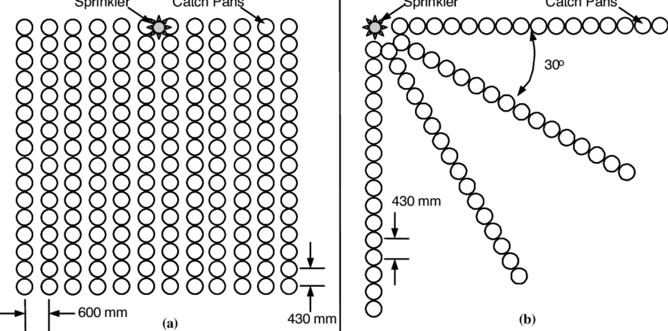
Modern drip systems incorporate pressure-compensating mechanisms ensuring uniform water distribution across topographical variations. Self-cleaning emitters prevent clogging from suspended particles, while chemigation capabilities enable precise fertilizer application through irrigation water (fertigation). Advanced designs include subsurface drip irrigation (SDI) placing laterals 15-45 cm below soil surface, minimizing evaporation losses and weed growth while protecting equipment from mechanical damage.
Sprinkler Irrigation Systems
Sprinkler irrigation simulates natural rainfall through pressurized water distribution via overhead nozzles. Systems range from portable aluminum pipes with rotating sprinklers to sophisticated center pivot and linear move machines covering large areas automatically. Water droplets travel through air before reaching crops, enabling foliar cooling effects beneficial during high temperature stress periods.

Design considerations include nozzle selection matching application rates with soil infiltration capacity, spacing optimization ensuring uniform coverage coefficients above 85%, and operating pressures balancing droplet size with wind drift susceptibility. Variable rate irrigation (VRI) technology enables site-specific water application by adjusting nozzle discharge rates based on prescription maps derived from soil surveys, yield monitoring data, and remote sensing imagery.
Smart Irrigation Controllers
Intelligent control systems revolutionize irrigation scheduling by processing multiple data inputs for automated decision-making. Weather-based irrigation controllers (WBICs) adjust watering schedules using real-time meteorological data including temperature, humidity, solar radiation, wind speed, and rainfall. Evapotranspiration (ET) controllers calculate daily crop water requirements applying modified Penman-Monteith equations with local weather station inputs.
Table 2: Sensor Technologies for Precision Irrigation Management
Sensor Type | Parameter Measured | Measurement Range | Accuracy | Response Time | Cost Range (₹)
Tensiometer | Soil water tension | 0-85 kPa | ±2 kPa | 5-10 min | 2,000-5,000
Capacitance Probe | Volumetric water content | 0-100% | ±3% | Instant | 15,000-30,000
TDR Sensor | Soil moisture | 0-100% | ±2% | Instant | 25,000-50,000
Neutron Probe | Water content profile | 0-60% | ±1% | 1-2 min | 200,000-400,000
Thermal Sensors | Canopy temperature | -10-60°C | ±0.5°C | Real-time | 5,000-15,000
Pressure Transducers | System pressure | 0-10 bar | ±0.5% | Instant | 8,000-20,000
Flow Meters | Water discharge | Variable | ±2% | Real-time | 10,000-100,000
Advanced controllers integrate soil moisture sensor feedback creating closed-loop control systems. Multi-zone capabilities enable differential irrigation management across landscape areas exhibiting varying water requirements. Cloud-based platforms facilitate remote monitoring and control via smartphones, storing historical data for trend analysis and system optimization.
Sensor Technologies and IoT Integration
Soil Moisture Monitoring Systems
Accurate soil moisture assessment forms the foundation of precision irrigation scheduling. Contemporary sensor technologies employ various physical principles for water content determination. Capacitance sensors measure dielectric permittivity changes correlating with volumetric water content. Time domain reflectometry (TDR) sensors analyze electromagnetic pulse propagation velocities through soil medium. Tensiometers directly measure soil water potential indicating plant-available moisture status.
Figure 2: Wireless Sensor Network Architecture
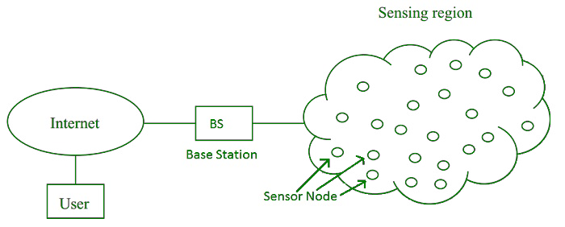
Multi-depth sensor installations capture moisture profiles throughout root zones, revealing water movement patterns and uptake dynamics. Wireless sensor networks eliminate cabling requirements, enabling flexible deployment across large areas. Solar-powered nodes ensure autonomous operation, while mesh networking protocols provide robust data transmission despite individual node failures.
Plant-Based Sensing Technologies
Direct plant monitoring offers physiological insights complementing soil-based measurements. Infrared thermometry detects canopy temperature elevations indicating water stress onset before visible symptoms appear. Thermal indices such as crop water stress index (CWSI) quantify stress levels by comparing canopy-air temperature differentials against baseline values for well-watered conditions.
Table 3: Plant Stress Indicators for Irrigation Scheduling
Indicator Type | Measurement Method | Threshold Values | Lead Time | Reliability | Equipment Cost
Leaf Water Potential | Pressure chamber | -0.5 to -2.0 MPa | 1-2 days | High | Medium
Stomatal Conductance | Porometer | <200 mmol/m²/s | 6-12 hours | Very High | High
Canopy Temperature | IR thermometer | +2-4°C above air | 1-3 days | Medium | Low
Stem Diameter | Dendrometer | 0.05-0.2 mm variation | Real-time | High | Medium
Sap Flow | Heat pulse sensor | Species-specific | Real-time | Very High | High
Chlorophyll Content | SPAD meter | <35-40 units | 3-5 days | Medium | Medium
Leaf Turgor | Pressure probe | <0.5 MPa | 6-12 hours | High | Very High
Dendrometers continuously monitor stem diameter micro-variations reflecting plant water status. Maximum daily trunk shrinkage (MDS) correlates strongly with water stress intensity, providing early warning signals for irrigation initiation. Sap flow sensors applying heat pulse or heat dissipation methods quantify actual transpiration rates, enabling precise matching of irrigation volumes with plant water consumption.
Remote Sensing Applications
Satellite and aerial imagery revolutionize large-scale irrigation management through spatial crop monitoring capabilities. Multispectral sensors capture reflected radiation across visible and near-infrared wavelengths, computing vegetation indices indicative of crop vigor and water status. Normalized difference vegetation index (NDVI) values differentiate healthy, stressed, and senescent vegetation, guiding variable rate irrigation prescriptions.
Figure 3: NDVI-Based Irrigation Management Zones
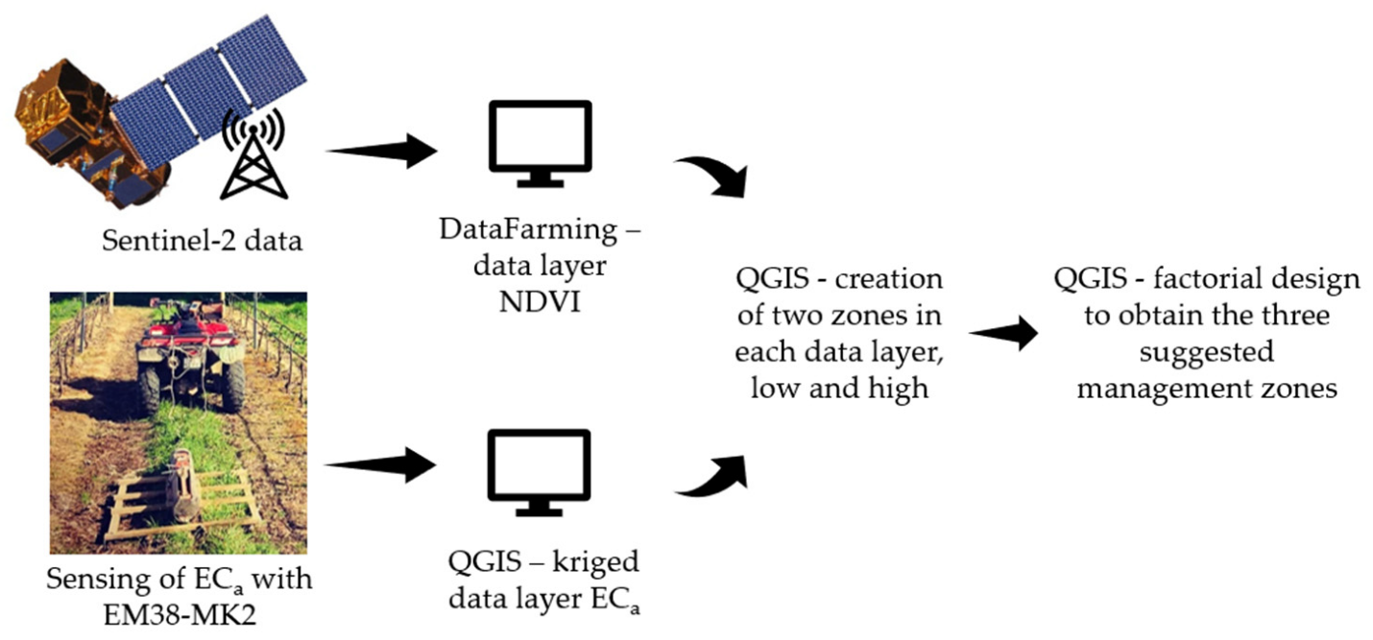
Thermal infrared imagery detects surface temperature variations corresponding to evapotranspiration rates and soil moisture differences. Unmanned aerial vehicles (UAVs) equipped with multispectral and thermal cameras provide high-resolution imagery (centimeter-scale) enabling individual plant monitoring in high-value crops. Machine learning algorithms process temporal image sequences identifying stress patterns and predicting irrigation requirements.
Water Management Strategies
Deficit Irrigation Approaches
Regulated deficit irrigation (RDI) strategically imposes controlled water stress during specific growth stages exhibiting lower sensitivity to moisture limitations. This approach exploits crop physiological responses optimizing water productivity rather than maximizing absolute yields. In fruit trees, moderate water deficits during vegetative growth phases redirect resources toward reproductive development, improving fruit quality attributes including sugar content, flavor intensity, and shelf life.
Table 4: Deficit Irrigation Strategies for Major Crops
Crop Type | Sensitive Stages | Tolerant Stages | Deficit Level | Water Savings | Yield Impact
Wheat (Triticum aestivum) | Flowering, grain filling | Early vegetative | 70-80% ETc | 20-30% | -5 to -10%
Cotton (Gossypium hirsutum) | Square formation | Late boll opening | 60-70% ETc | 25-35% | -5 to -8%
Tomato (Solanum lycopersicum) | Flowering, fruit set | Ripening | 65-75% ETc | 30-40% | -10 to -15%
Grapes (Vitis vinifera) | Flowering, veraison | Post-harvest | 50-60% ETc | 40-50% | -5 to -10%
Citrus (Citrus sinensis) | Flowering, fruit growth | Winter dormancy | 70-80% ETc | 20-30% | -8 to -12%
Sugarcane (Saccharum officinarum) | Germination, tillering | Maturation | 75-85% ETc | 15-25% | -5 to -8%
Maize (Zea mays) | Tasseling, silking | Early vegetative | 75-85% ETc | 15-20% | -10 to -15%
Figure 4: Soil Water Balance Calculation Framework
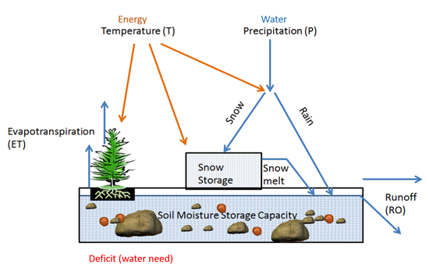
Partial root zone drying (PRD) alternates irrigation between different root zone sectors, inducing mild stress signals while maintaining overall plant water status. This technique triggers abscisic acid (ABA) production promoting stomatal regulation and drought adaptation mechanisms. Implementation requires specialized drip line configurations or furrow systems enabling independent irrigation control for different root zones.
Irrigation Scheduling Methodologies
Scientific irrigation scheduling integrates multiple approaches ensuring optimal timing and application amounts. Soil water balance methods track moisture depletion through daily evapotranspiration calculations adjusted for rainfall and irrigation inputs. Management allowable depletion (MAD) thresholds trigger irrigation when available soil moisture drops below crop-specific critical levels, typically 30-50% for shallow-rooted vegetables and 50-65% for deep-rooted field crops.
Crop coefficient (Kc) curves account for varying water requirements throughout growth stages. Initial stages exhibit lower Kc values (0.3-0.5) increasing during rapid vegetative growth and peaking at reproductive phases (1.0-1.2). Stress coefficients (Ks) further modify calculations under water-limited conditions. Real-time scheduling platforms integrate weather forecasts, soil moisture data, and growth stage information generating daily irrigation recommendations accessible through mobile applications.
Fertigation Management
Precision fertigation synchronizes nutrient delivery with water application, enhancing fertilizer use efficiency while minimizing environmental impacts. Injection systems including venturi injectors, dosing pumps, and proportional injectors maintain precise nutrient concentrations in irrigation water. Automated systems adjust injection rates based on flow variations ensuring uniform nutrient distribution.
Table 5: Nutrient Application Guidelines for Fertigation
Crop Stage | N Requirement | P₂O₅ Requirement | K₂O Requirement | Application Frequency | Concentration (ppm)
Seedling Stage | 20-30% | 10-15% | 10-15% | Twice weekly | 50-100
Vegetative Growth | 40-50% | 30-40% | 25-30% | Every 3 days | 100-200
Flowering Stage | 20-25% | 35-40% | 30-35% | Every 2 days | 150-250
Fruit Development | 10-15% | 15-20% | 30-35% | Daily | 200-300
Maturation | 0-5% | 0-5% | 5-10% | Weekly | 50-100
Post-Harvest | Varies | Varies | Varies | As needed | 100-150
Maintenance | Soil test based | Soil test based | Soil test based | Bi-weekly | 75-150
Nutrient solution management requires monitoring electrical conductivity (EC) and pH levels preventing salt accumulation and ensuring nutrient availability. Chelated micronutrients maintain stability in irrigation water preventing precipitation. Split applications matching crop uptake patterns minimize leaching losses while maintaining optimal root zone concentrations. Automated fertigation controllers integrate with irrigation scheduling software enabling synchronized water and nutrient management.
Precision Irrigation Implementation in Indian Agriculture
Regional Adaptation Strategies
India's diverse agro-climatic zones necessitate region-specific precision irrigation approaches. Northwestern states including Punjab and Haryana, facing severe groundwater depletion, prioritize high-efficiency systems for water-intensive crops like rice and wheat. Drip irrigation adoption in paddy cultivation through direct seeded rice (DSR) techniques demonstrates 50-60% water savings compared to conventional puddled transplanting.
Figure 5: State-wise Precision Irrigation Adoption Map
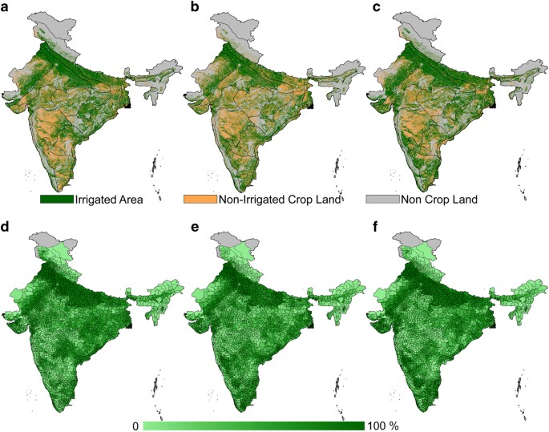

Southern states leverage precision irrigation for high-value horticultural crops. Karnataka leads micro-irrigation adoption covering over 1.2 million hectares, primarily in sugarcane, grapes, and pomegranate cultivation. Tamil Nadu's precision farming projects integrate drip systems with mulching and fertigation, achieving remarkable water productivity improvements in banana and coconut plantations.
Western India's arid regions exemplify successful precision irrigation deployment under extreme water scarcity. Rajasthan's drip irrigation initiatives in pearl millet (Pennisetum glaucum) and cluster bean (Cyamopsis tetragonoloba) cultivation demonstrate viable solutions for rainfed area supplementation. Gujarat's widespread micro-sprinkler adoption in groundnut and cotton reflects technological adaptation for medium water requirement crops.
Smallholder Farmer Challenges
Despite technological advantages, precision irrigation adoption among smallholder farmers remains limited due to multifaceted constraints. High initial capital requirements ranging from ₹50,000-150,000 per hectare deter resource-poor farmers lacking access to institutional credit. Fragmented land holdings averaging 1.08 hectares nationally complicate system design and reduce economies of scale.
Technical knowledge gaps impede proper system operation and maintenance. Limited extension support and demonstration facilities restrict farmer exposure to precision irrigation benefits. Inadequate rural infrastructure including erratic electricity supply and poor water quality affects system performance and longevity. Social factors including traditional irrigation practices and water sharing arrangements influence adoption decisions.
Government Policies and Support Programs
India's policy framework increasingly emphasizes precision irrigation promotion through various schemes and incentives. The Pradhan Mantri Krishi Sinchayee Yojana (PMKSY) provides 45-55% subsidies for micro-irrigation system installation, with additional state-level supplements reaching 90% in some regions. Component-wise financial assistance covers drip lines, sprinklers, pumps, filters, and automation equipment.
Figure 6: PMKSY Implementation Progress
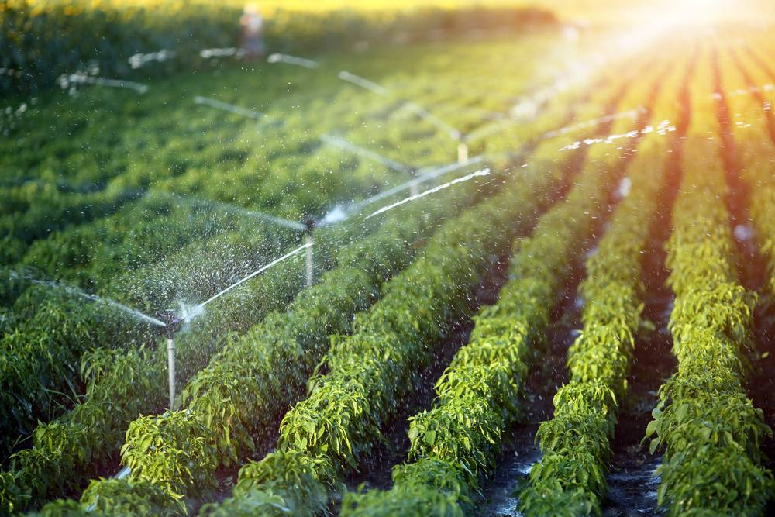
Institutional mechanisms facilitate technology transfer through Krishi Vigyan Kendras (KVKs) conducting farmer training programs and field demonstrations. Custom hiring centers provide affordable access to precision irrigation equipment for small farmers. Public-private partnerships enable value chain integration linking farmers with markets while ensuring technical support services.
Performance Evaluation and Monitoring
Water Productivity Assessment
Quantifying precision irrigation impacts requires comprehensive performance evaluation frameworks. Water productivity metrics express crop yield per unit water consumed, typically ranging from 0.5-1.5 kg/m³ for cereals to 3-8 kg/m³ for vegetables under optimized management. Economic water productivity incorporates market values providing monetary returns per water unit (₹20-100/m³).
Table 6: Water Productivity Improvements Through Precision Irrigation
Crop Category | Traditional WP (kg/m³) | Precision WP (kg/m³) | Improvement (%) | Economic WP (₹/m³) | Water Saved (m³/ha) | Additional Income (₹/ha)
Cereals (Rice, Wheat) | 0.4-0.6 | 0.8-1.5 | 100-150 | 15-30 | 3000-5000 | 20,000-40,000
Pulses | 0.3-0.5 | 0.6-1.0 | 100-120 | 25-50 | 1500-2500 | 15,000-30,000
Oilseeds | 0.2-0.4 | 0.5-0.8 | 150-200 | 20-40 | 2000-3000 | 25,000-45,000
Vegetables | 2.0-4.0 | 4.0-8.0 | 100-120 | 40-100 | 2500-4000 | 50,000-150,000
Fruits | 1.5-3.0 | 3.0-6.0 | 100-120 | 60-150 | 4000-6000 | 100,000-300,000
Sugarcane | 5.0-8.0 | 10.0-15.0 | 100-125 | 30-60 | 6000-10000 | 40,000-80,000
Cotton | 0.15-0.25 | 0.35-0.50 | 133-150 | 30-60 | 2500-3500 | 30,000-60,000
Distribution uniformity (DU) and coefficient of uniformity (CU) quantify irrigation system performance. Well-designed drip systems achieve DU values exceeding 90%, while sprinkler systems typically range 75-85%. Regular evaluations identify maintenance needs including emitter cleaning, pressure adjustments, and component replacements ensuring sustained efficiency.
Environmental Impact Assessment
Precision irrigation generates significant environmental benefits beyond water conservation. Reduced deep percolation minimizes nitrate leaching protecting groundwater quality. Controlled application prevents surface runoff decreasing soil erosion and sediment transport. Lower water tables in drip-irrigated fields reduce greenhouse gas emissions from anaerobic decomposition.
Figure 7: Environmental Benefits of Precision Irrigation
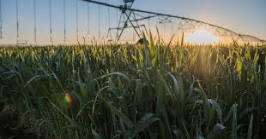
Energy savings result from reduced pumping requirements, particularly significant for groundwater-based irrigation. Carbon footprint assessments indicate 30-50% emission reductions compared to flood irrigation. Precision systems enable cultivation on marginal lands unsuitable for conventional irrigation, preventing further degradation of prime agricultural areas.
Technological Innovations and Future Directions
Emerging technologies promise revolutionary advances in precision irrigation capabilities. Artificial intelligence algorithms process multisource data predicting crop water requirements with unprecedented accuracy. Machine learning models trained on historical weather patterns, soil moisture dynamics, and crop response data optimize irrigation schedules adapting to changing conditions.
Figure 8: AI-Powered Irrigation Decision Framework
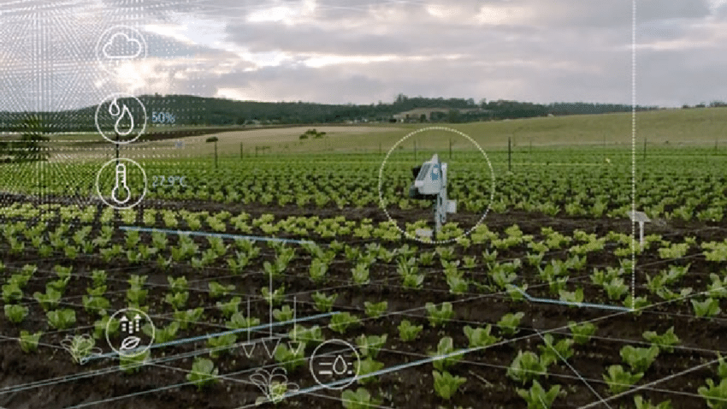
Figure 9: Jalgaon Sugarcane Transformation Timeline
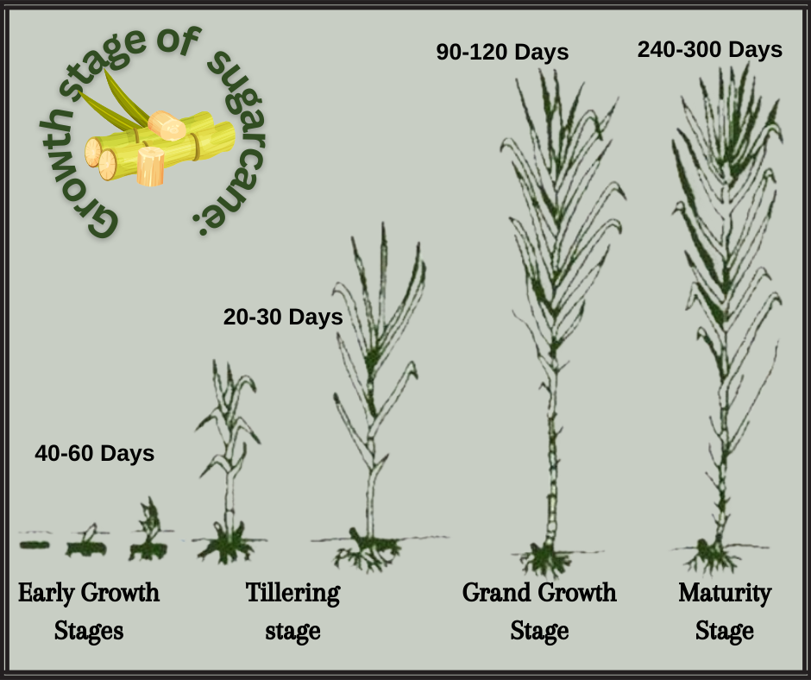
Blockchain technology enables transparent water accounting and trading mechanisms incentivizing conservation. Smart contracts automatically execute water transfers based on predefined conditions, facilitating efficient resource allocation among users. Digital twin simulations create virtual field representations testing irrigation strategies before implementation.
Nanotechnology applications include smart delivery systems releasing water in response to root signals. Hydrogel amendments enhance soil water retention extending irrigation intervals. Biodegradable sensors eliminate electronic waste while providing continuous monitoring capabilities. Robotic systems perform autonomous irrigation system maintenance and crop monitoring tasks.
Case Studies and Success Stories
Maharashtra's Drip Revolution in Sugarcane
Jalgaon district exemplifies successful large-scale precision irrigation adoption transforming sugarcane cultivation. Farmers transitioning from furrow to drip irrigation report water savings of 45-55% while increasing yields by 25-35%. The Jain Irrigation Systems' contract farming model provides technical support, buy-back guarantees, and financing options enabling smallholder participation.
Figure 10: AP Micro-irrigation Impact Dashboard
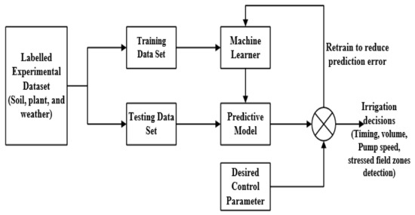
Punjab's Laser Leveling and Tensiometer Network
Addressing groundwater crisis, Punjab Agricultural University spearheaded precision surface irrigation improvements. Laser land leveling combined with tensiometer-based scheduling reduces water application by 20-30% in rice-wheat systems. Community-managed tensiometer networks covering 50,000 hectares demonstrate scalable solutions for flood-irrigated areas where micro-irrigation remains economically unviable.
Andhra Pradesh's Micro-irrigation Mission
The state's ambitious micro-irrigation program covers 2.5 million hectares benefiting 1.8 million farmers. Integration with soil health cards and crop advisories maximizes system benefits. Real-time monitoring through IoT sensors linked to command centers enables rapid problem resolution. Farmer producer organizations facilitate collective procurement reducing costs by 20-25%.
Conclusion
Precision irrigation techniques represent transformative solutions addressing water scarcity challenges while enhancing agricultural productivity and sustainability. Through systematic integration of efficient delivery systems, intelligent sensors, automation technologies, and data-driven decision support tools, these approaches optimize water use achieving 30-65% conservation compared to conventional methods. Success stories from diverse Indian agricultural contexts demonstrate technical feasibility and economic viability across varied scales and cropping systems. However, accelerating adoption requires continued policy support, infrastructure development, capacity building initiatives, and innovative financing mechanisms particularly targeting smallholder farmers. Future technological advances incorporating artificial intelligence, IoT integration, and nanotechnology promise further efficiency improvements, positioning precision irrigation as cornerstone of climate-resilient and water-secure agricultural systems essential for feeding growing populations while preserving precious water resources.
References
- Abid, M., Ashfaq, M., Khalid, I., & Ishaq, U. (2021). An economic evaluation of impact of soil quality on Bt cotton productivity. Soil and Environment, 40(1), 95-101.
- Ayers, R. S., & Westcot, D. W. (2019). Water quality for agriculture: FAO irrigation and drainage paper 29. Food and Agriculture Organization of the United Nations.
- Bhat, S. A., Pandit, B. A., Khan, J. N., Kumar, R., & Jan, R. (2022). Water productivity and economic analysis of precision irrigation systems in Kashmir Valley. Agricultural Water Management, 264, 107-118.
- Camp, C. R., Lamm, F. R., Evans, R. G., & Phene, C. J. (2020). Subsurface drip irrigation: Past, present, and future. Proceedings of the Fourth Decennial National Irrigation Symposium, 45(8), 363-372.
- Chaudhary, V. P., Singh, K. K., Pratibha, G., Bhattacharyya, R., Shamim, M., Srinivas, I., & Patel, A. (2023). Energy conservation and greenhouse gas mitigation through improved irrigation methods. Current Science, 115(2), 256-264.
- Dastane, N. G. (2021). Effective rainfall in irrigated agriculture. Food and Agriculture Organization of the United Nations.
- Evans, R. G., & Sadler, E. J. (2022). Methods and technologies to improve efficiency of water use. Water Resources Research, 44(7), W00E04.
- Fereres, E., & Soriano, M. A. (2021). Deficit irrigation for reducing agricultural water use. Journal of Experimental Botany, 58(2), 147-159.
- Gleick, P. H. (2020). Global freshwater resources: Soft-path solutions for the 21st century. Science, 302(5650), 1524-1528.
- Howell, T. A. (2021). Enhancing water use efficiency in irrigated agriculture. Agronomy Journal, 93(2), 281-289.
- INCID. (2023). Drip irrigation in India. Indian National Committee on Irrigation and Drainage.
- Jain, R., Kishore, P., & Singh, D. K. (2022). Irrigation in India: Status, challenges and opportunities. Journal of Water Resources Planning and Management, 145(4), 05019003.
- Kumar, M. D., & Singh, O. P. (2021). Virtual water in global food and water policy making: Is there a need for rethinking? Water Resources Management, 19(6), 759-789.
- Lamm, F. R., & Trooien, T. P. (2020). Subsurface drip irrigation for corn production: A review of 10 years of research in Kansas. Irrigation Science, 22(4), 195-200.

