Seasonal Stress Induces Oxidative Imbalance, Hematological Changes, and Modulation of Key Metabolic Enzymes in Yorkshire Pigs
Abstract
Climate change driven heat stress increasingly challenges livestock and contributes to substantial production losses. Therefore, a comprehensive evaluation of the impact of seasonal stress is essential to understand these physiological disruptions and to develop strategies that can mitigate heat induced production losses. This study evaluated the impact of winter, spring and summer seasons on oxidative stress parameters, hematological and biochemical parameters in Yorkshire pigs reared under intensive production. A total of 24 healthy pigs (12 growers and 12 finishers) were monitored, and blood samples were collected during each season for analysis. Oxidative stress assessment revealed markedly elevated activity of glutathione reductase, significantly low reduced glutathione levels and further elevated malondialdehyde levels during summer season. This confirms oxidative stress with enhanced lipid peroxidation compromising the integrity of the cells. Hematological results showed significantly lower hemoglobin and packed cell volume during winter and summer, with the decline more evident in summer. Total leukocyte count decreased significantly in summer, accompanied by elevated neutrophil percentage, reduced lymphocyte percentage and an increased neutrophil-to-lymphocyte ratio, likely associated with compromised membrane integrity under seasonal stress. Metabolic enzymes, including alanine transaminase, aspartate transaminase, gamma glutamyl transferase and lactate dehydrogenase, recorded significantly higher activities during summer, suggesting heat induced metabolic strain and potential tissue leakage. These findings demonstrate that seasonal stress, particularly summer heat, leads to marked oxidative imbalance and hemato-biochemical alterations in Yorkshire pigs. Understanding these physiological responses is essential for developing management strategies to mitigate the adverse effects of thermal stress on pig health and productivity.
INTRODUCTION
Animal husbandry plays an important role in development of the country especially for the rural community. India, with the highest livestock population, possesses 11.54% of the total world livestock population (Singh, 2020). Different hereditary traits of pigs like high feed conversion efficiency, high fecundity, short generation interval and early maturation contribute to the greater potential to help farmers see a faster rate of economic return as compared to other livestock species (Legault, 1985). Different factors affecting the development of livestock includes climate, health, diseases and nutrition, among which, climate plays the most significant factor (Cheng et al., 2022). The global climate change has accelerated due to different human activities in the recent years leading to drastic changes in the atmospheric temperature and humidity. Climate change affects the livestock production with a rise in livestock diseases, environmental stress and biodiversity loss and by competition for natural resources, quantity and quality of feeds (Cheng et al., 2022).
The Thermo-Neutral Zone (TNZ) is the ambient temperature range in which animals maintain physiological functions with minimal energy expenditure (Mount, 1968). In pigs, the TNZ is narrow (18–25°C), making them highly susceptible to heat stress due to their limited sweating ability and thick subcutaneous fat (EFSA, 2020; Mayorga, 2019). Acclimatization to the extreme weather can inflict different behavioural, physiological and metabolically adaptive responses aimed at maintaining their homeostasis; which causes stress to the animals thus leading to decrease in the health status (Bernabucci et al., 2010). Exposure to temperatures beyond the TNZ disrupts homeostasis and triggers behavioural and physiological adaptations such as wallowing, reduced gut blood flow, elevated body temperature and respiration rate that ultimately impair growth, metabolism and production (Silva et al., 2009; Ross et al., 2015; Teixeira et al., 2021).
With the rapid progression of global warming and climate change, there is an urgent need for a comprehensive understanding of the physico-biochemical changes that occur in animals exposed to heat stress. Adaptation to heat stress results in increased production of reactive oxygen species (ROS), often exceeding the neutralizing capacity of endogenous antioxidants (Mujahid et al., 2005). This imbalance leads to ROS accumulation, which damages cell membranes and intracellular components, ultimately causing oxidative stress. Oxidative stress compromises cellular integrity by altering membrane permeability and disrupting normal physiological functions. Therefore, the aim of this study was to evaluate seasonal variations in oxidative stress markers, hematological parameters and metabolic enzymes in grower and finisher pigs during winter, spring and summer.
MATERIALS AND METHOD
Experimental animals: A total of 24 healthy Yorkshire pigs divided into 12 grower pigs (3 – 4 months old), 6 males and 6 females and 12 finisher pigs (6 – 7 months old), 6 males and 6 females reared under intensive system supplied with normal diets and ad libitum water were selected from a local pig farm in Ludhiana, Punjab.
Blood samples and plasma separation: 4 ml of blood were collected in heparinized and EDTA blood collection vials from all the experimental animals in the morning hours, during Winter (December to January), Spring (February to March) and Summer (April to May). Plasma separation was done by centrifuging the blood samples in Remi R-8C Laboratory Centrifuge at 3000 rpm for 15 minutes. The plasma was then collected, aliquoted and stored at -20°C until biochemical parameters were estimated.
Oxidative stress parameters: Erythrocytic malondialdehyde (MDA) for lipid peroxidation was determined by the method described in Placer et al. (1966) which depends on formation of thiobarbituric acid reactive substances. Glutathione reductase activity was estimated following protocol previously mentioned (Krohne-Ehrich et al., 1977). Whole blood reduced GSH was determined by the method described in Ellman (1959) which depends on oxidation of reduced GSH by the sulfhydryl reagent DTNB to form yellow derivative 5’-thio-2-nitrobenzoic acid.
Hematological parameters: Hemoglobin (Hb) level was estimated as previously mentioned (Dacie & Lewis, 1975). Packed Cell Volume (PCV) was estimated following microhematocrit method, Differential Leukocyte Count (DLC) was done using Giemsa staining technique and Total Leukocyte Count (TLC) using hemocytometer method.
Metabolic enzymes: The plasma level of alkaline phosphatase (ALP), alanine aminotransferase (ALT), aspartate aminotransferase (AST), gamma glutamyltransferase (GGT) and lactate dehydrogenase (LDH) were determined using Erba Mannheim on the semi-automatic chemistry analyser (Merck).
Statistical analysis: Statistical analyses for all the parameters were done by three-way analysis of variance (ANOVA) test in Statistical Package for Social Sciences (SPSS) software (version 26). The level of significance was set at p < 0.05 and the results were given as mean ± standard error.
RESULTS
Oxidative stress parameters
The levels of MDA and GSH, and the activity of glutathione reductase were determined to analyse the seasonal effect on the oxidative stress. The level of MDA in all groups was significantly higher (p < 0.05) in summer season as compared to winter and spring seasons and that of winter season was significantly higher (p < 0.05) than spring season (3.48 to 3.67 nmol/mg vs 2.24 to 2.51 nmol/mg vs 1.41 to 1.61 nmol/mg) (Fig. 1A, Table 1).
We observed highest level of GSH in spring season while it was lowest in summer season. In all the groups, the mean value of GSH was significantly lower (p < 0.05) in summer as compared to winter and spring seasons and winter also showed significantly lower (p < 0.05) values compared to spring season (9.182 to 9.628 μmol/L vs 6.484 to 6.777 μmol/L vs 5.235 to 5.601 μmol/L) (Fig. 1B, Table 1).
Glutathione reductase activity was highest during summer season, followed by winter season and lowest during spring season (9.567 to 10.027 IU/min vs 6.9 to 7.259 IU/min vs 4.883 to 5.002 IU/min) (Fig. 1C, Table 1). In all the groups, glutathione reductase activity was significantly higher (p < 0.05) in summer season as compared to winter and spring seasons (Fig. 1C). Moreover, its activity during winter season was significantly higher (p < 0.05) than spring season (Fig. 1C, Table 1).
Hematological parameters
In all the groups, the mean values of Hb and PCV were significantly lower (p < 0.05) during winter season and summer season in comparison with spring season furthermore, the decrease was more prominent in summer (Table 2). The mean values of TLC significantly declined (p < 0.05) in summer season. The mean percentage of neutrophils was significantly higher (p < 0.05) while the mean percentage of lymphocytes was significantly lower (p < 0.05) in winter and summer as compared to spring season (Table 2). Mean N:L ratio was significantly elevated (p < 0.05) in winter and summer as compared to the spring season (Table 2).
Metabolic enzymes
Mean values for metabolic enzymes during different seasons showed significant variation (Table 3). Summer season showed highest values for ALT, GGT and LDH and lowest in spring season. Significantly increased (p < 0.05) values were observed in ALT and GGT in summer and winter in comparison to spring (Table 3). Moreover, ALP and GGT showed significantly higher (p < 0.05) values during summer compared to winter season. While the mean values of LDH and AST of all the groups were significantly higher (p < 0.05) in summer as compared to winter and spring seasons but no significant variation between winter and spring seasons. Season, age or gender had no effect on the plasma concentration of ALP (Table 3).
DISCUSSION
Rising global temperatures demand a clearer understanding of how heat stress alters physiological and biochemical functions in livestock. This study evaluates seasonal changes in oxidative stress indicators, hematological profiles and metabolic enzymes in grower and finisher pigs. Cells generally maintain a reduced intracellular environment, and GSH levels serve as a key indicator of oxidative stress in animal tissues (Sies et al., 2024). In our study, the average ambient temperatures during winter, spring, and summer were 8.8°C, 20°C, and 32°C, respectively. The summer temperature exceeded the TNZ of pigs, indicating that the animals were likely experiencing heat stress. Conversely, winter temperatures were below the TNZ, suggesting potential cold discomfort; however, pigs possess substantial physiological insulation, which provides some protection against cold stress.
Heat stress has been reported to trigger oxidative stress in animals (Emami et al., 2021). During oxidative stress, GSH is oxidized to glutathione disulfide (GSSG) by the augmented ROS in the cell. This GSSG is further reduced by the activity of glutathione reductase enzyme using NADPH. This is a continuous cycle that helps in maintaining the reduced environment of the cell. In this study, we observed significant increase in the activity of glutathione reductase during summer season as compared to the winter and spring seasons (Fig 1C). Additionally, glutathione reductase showed significantly higher levels in winter as compared to spring season (Fig 1C). Moreover, significant decreased levels of reduced GSH were observed during summer season as compared to winter and spring seasons (Fig. 1B). Increase in the activity of glutathione reductase during winter and summer seasons was also reported in cows (Bernabucci et al., 2002; Zachut et al., 2017); in broilers (Altan et al., 2003); in goats (Kataria et al., 2010; Sahoo et al., 2020); in sheep (Maan 2010; Rathwa et al., 2017; Karthik et al.,2021), in quails (Sahin et al., 2011), in buffaloes (Chaudhary et al., 2015; Lakhani et al., 2018) and in pigs (Yadav 2016). Similar augmented values of GSH in summer and winter seasons had been reported in sheep (Maan, 2010), in pigs (Yadav, 2016) and in goats (Sahoo et al., 2020). Increase in the activity of glutathione reductase along with decreased values of GSH indicate that the animals are undergoing a significant oxidative stress during summer and winter seasons.
The oxidative stress can further lead to lipid peroxidation especially of the components of the cell membrane. Lipid peroxidation can disturb the integrity of the cell membrane. MDA is the end product of cell membrane (Gaschler & Stockwell, 2017). We observed increase in the values of erythrocytic MDA during winter and summer seasons (Fig 1A) which indicated that the animals were under oxidative stress and more prominent during extreme summer season than winter season. Similar findings had been reported by Bernabucci et al. (2002) and Zachut et al. (2017) in cows, Altan et al. (2003) in broilers, Sahin et al. (2011) in Quails, Chaudhary et al. (2015) and Lakhani et al. (2018) in buffaloes, Rathwa et al. (2017) and Karthik et al. (2021) in sheep, Cui et al. (2019) in pigs and Sahoo et al. (2020) in goats. Environmental stress caused increase production of ROS which further leads to direct damage of lipids especially the polyunsaturated fatty acids (PUFAs). With the increased ROS, there can be increased peroxidation of polyunsaturated fatty acids, accelerated oxidative stress and stimulation of apoptosis or necrosis which could bring about pathological conditions.
Our findings indicate that seasonal fluctuations exert significant oxidative stress on the animals. Oxidative stress is known to damage cellular components, including erythrocytes, which can result in altered hematological profiles and ultimately disrupt physiological homeostasis. To assess the impact of seasonal stress on hematological parameters, we evaluated a range of erythrocytic and leukocytic indices. Hb and PCV values were lowest during the summer season, followed by winter, while the highest levels were recorded in spring (Table 2). TLC were also significantly reduced in summer compared to winter and spring (Table 2). Furthermore, the mean percentage of neutrophils was significantly elevated, whereas that of lymphocytes was markedly reduced in both winter and summer as compared to the spring season (Table 2). Consequently, the neutrophil-to-lymphocyte (N:L) ratio was significantly higher during winter and summer (Table 2). Similar seasonal trends in hematological responses have been reported in Zovawk pigs (Mayengbam and Tolenkhomba, 2015), goats (Banerjee et al., 2015), exotic pig breeds (Cui et al., 2019; Palova et al., 2019), and dairy cows (Koubková et al., 2002; Morar et al., 2018).
Pigs exhibit several physiological and behavioral adjustments to cope with heat stress, including wallowing behavior, redistribution of blood flow away from the gut, and increases in both body temperature and respiratory rate (Silva et al., 2009). The hematological changes may be attributed to increased oxygen demand and enhanced respiratory effort under environmental stress, which elevates the partial pressure of oxygen in the blood and may suppress erythropoiesis, thereby reducing circulating erythrocytes. Additionally, oxidative damage to the lipid-rich erythrocyte membranes can lead to hemolysis and a subsequent decline in RBC count. Nutritional factors may further exacerbate these effects, as heat stress is known to reduce voluntary feed intake, potentially limiting the availability of nutrients necessary for hemoglobin synthesis.
To determine the effect of seasonal change on the cellular homeostasis of different metabolic enzymes, we analysed the ALP, AST, GGT and LDH activities. AST, GGT and LDH showed significant increase during summer season as compared to winter and spring seasons (Table 3). However, the activity of ALP was lower (not significant) in summer season (Table 3). Decrease level of ALP in summer might be caused by heat stress while higher level of ALP in winter than summer may be a compensatory process for vitamin D requirements (Mayengbam and Tolenkhomba, 2015). Similar reports on ALP were given in crossbred cattle (Rusoff et al., 1954) and in pigs (Palova et al., 2019; Pearce et al., 2013) while results contrast to our findings were reported in cattle (Singh and Singh, 2005), broilers (Huang et al., 2018) and pigs (Borah et al., 2020).
Increased levels of ALT and AST was observed previously in cattle (Shaffer et al., 1981), in buffaloes (Ashmawy, 2020), in goats (Banerjee et al., 2015), in sheeps (Karthik et al., 2021) in pigs (Mayengbam and Tolenkhomba 2015; Borah et al., 2020), and in broilers (Huang et al., 2018). There were reports that the levels of LDH increased significantly during summer in comparison to other seasons in fattener pigs (Chu & Song, 2013). Increased level of LDH throughout heat stress was reported in cattle (Chetia et al., 2017) and in pigs (Borah et al., 2020; Vashi et al., 2018). Increased value of GGT in winter and summer compared to spring was observed in goats (Ribeiro et al., 2016) and in pigs (Chmielowiec-Korzeniowska et al., 2012). Elevated levels of metabolic enzymes may be due to change in metabolism to gluconeogenesis during environmental stress. A reduction in feed intake under heat stress is well documented, especially in pigs (Mayorga et al., 2019). Reduced feed intake in heat stress reduces the heat produced from metabolism (Teixeira et al., 2021). Decreased intake of food leads to increased gluconeogenesis implicating negative impact on hepatic cells, muscle cells and heart releasing different marker enzymes into circulation. These findings might also be attributable to the impairment of the hepatocellular membranes due to oxidative stress and changing the permeability causing the expulsion of the liver enzymes into the blood.
Overall, the present study demonstrates that seasonal stress especially heat stress induces a marked oxidative burden in Yorkshire pigs, characterized by elevated glutathione reductase activity, depleted GSH levels, and increased erythrocytic lipid peroxidation. These oxidative disruptions appear to compromise cellular and membrane integrity, contributing to altered hematological profiles, including reduced Hb, PCV and TLC, alongside shifts in neutrophil and lymphocyte proportions. Concurrent elevations in metabolic enzymes such as AST, GGT and LDH further indicate seasonal stress related alterations in hepatic and muscular cellular function, likely driven by oxidative damage and metabolic shifts such as increased gluconeogenesis during reduced feed intake. Collectively, these findings highlight the profound physiological strain imposed by extreme seasonal temperatures, underscoring the need for targeted management strategies to mitigate heat induced oxidative and metabolic disturbances in pigs.

References
- Altan, Ö., Pabuçcuoǧlu, A., Altan, A., Konyalioǧlu, S., & Bayraktar, H. 2003. Effect of heat stress on oxidative stress, lipid peroxidation and some stress parameters in broilers. British Poultry Science, 44(4), 545–550. https://doi.org/10.1080/00071660310001618334
- Ashmawy NA. 2000. Effect of exposure to environmental heat stress on physiological responses and some blood constituents of Ossimi ewes and Egyptian buffalo heifers. Annals of Agricultural Science, Moshtohor, 38(2), 731-740.
- Banerjee D, Upadhyay RC, Chaudhary UB, et al. 2015. Seasonal variations in physio-biochemical profiles of Indian goats in the paradigm of hot and cold climate. Biol Rhythm Res, 46(2), 221-236. doi:10.1080/09291016.2014.984999
- Bernabucci, U.; Lacetera, N.; Baumgard, L. H.; Rhoads, R. P.; Ronchi, B.; Nardone, A. 2010. Metabolic and hormonal acclimation to heat stress in domesticated ruminants. animal, 4(7), 1167–1183. doi:10.1017/S175173111000090X.
- Bernabucci, U., Ronchi, B., Lacetera, N., & Nardone, A. 2002. Markers of oxidative status in plasma and erythrocytes of transition dairy cows during hot season. Journal of Dairy Science, 85, 2017-2026.
- Borah S, Soren S, Talukdar R, et al. 2020. Study on the effect of seasonal variation on expression of serum biochemicals in pigs. Indian J Anim Sci., 90(9), 1265-1269.
- Chaudhary, S. S., Singh, V. K., Upadhyay, R. C., Puri, G., Odedara, A. B., & Patel, P. A. 2015. Evaluation of physiological and biochemical responses in different seasons in Surti buffaloes. Veterinary World, 8(6), 727–731.
- Cheng, M.; McCarl, B.; Fei, C. 2022. Climate Change and Livestock Production: A Literature Review. Atmosphere, 13, 140. https://doi.org/10.3390/atmos13010140.
- Chetia M, Sarma S, Goswami J. 2017. Seasonal Variation in Select Stress Related Hormones and Lactate Dehydrogenase Enzyme in Zebu Cattle. International Journal of Livestock Research., 7(6), 118-124.
- Chmielowiec-Korzeniowska A, Tymczyna L, Babicz M. 2012. Assessment of selected parameters of biochemistry, hematology, immunology and production of pigs fattened in different seasons. Arch Anim Breed., 55(5), 469-479. doi:10.5194/aab-55-469-2012
- Chu G and Song Y. 2013. Growth performance, blood characteristics and immune responses of fattening pigs in different seasons. Asian Journal of Animal and Veterinary Advances., 8(5), 691-702.
- Cui, Y., Wang, C., Hao, Y., Gu, X., & Wang, H. 2019. Chronic heat stress induces acute phase responses and serum metabolome changes in finishing pigs. Animals, 9(7). https://doi.org/10.3390/ani9070395
- Dacie JV, Lewis S M. Practical haematology. Churchill Livingstone, Edinburgh, London, and New York; 240; 1975.
- Ellman, G. L. 1959. Tissue sulphydryl groups. Archives of Biochemistry and Biophysics, 82, 70-77.
- EFSA Panel on Animal Health and Welfare (AHAW), Nielsen, S. S., Alvarez, J., Bicout, D. J., Calistri, P., Depner, K., ... & Velarde, A. 2020. Welfare of pigs at slaughter. Efsa Journal, 18(6), e06148.
- Emami, N. K., Greene, E. S., Kogut, M. H., & Dridi, S. 2021. Heat Stress and Feed Restriction Distinctly Affect Performance, Carcass and Meat Yield, Intestinal Integrity, and Inflammatory (Chemo)Cytokines in Broiler Chickens. Frontiers in physiology, 12, 707757. https://doi.org/10.3389/fphys.2021.707757
- Gaschler, M. M., & Stockwell, B. R. 2017. Lipid peroxidation in cell death. Biochemical and biophysical research communications, 482(3), 419–425. https://doi.org/10.1016/j.bbrc.2016.10.086
- Huang S, Yang H, Ur Rehman M, Tong Z. 2018. Acute heat stress in broiler chickens and its impact on serum biochemical and electrolyte parameters. Indian J Anim Res., 52(5), 683-686. doi:10.18805/ijar.v0iOF.8490
- IBM Corp. Released 2019. IBM SPSS Statistics for Windows, Version 26.0. Armonk, NY: IBM Corp
- Karthik, D., Suresh, J., Reddy, Y. R., Sharma, G. R. K., Ramana, J. V., Gangaraju, G., Reddy, P. P. R., Reddy, Y. P. K., Yasaswini, D., Adegbeye, M. J., & Reddy, P. R. K. 2021. Adaptive profiles of Nellore sheep with reference to farming system and season: physiological, hemato-biochemical, hormonal, oxidative-enzymatic and reproductive standpoint. Heliyon, 7(5), e07117. https://doi.org/10.1016/j.heliyon.2021.e07117
- Kataria, N., Kataria, A. K., & Maan, R. 2010. Evaluation of oxidative stress due to hot environmental condition in healthy Marwari goats from arid tract in India. Philippine Journal of Veterinary and Animal Sciences, 36(2), 175-184.
- Koubková M, Knížková I, Kunc P, Härtlová H, Flusser J, Doležal O. 2002. Influence of high environmental temperatures and evaporative cooling on some physiological, hematological and biochemical parameters in high-yielding dairy cows. Czech J Anim Sci., 47(8), 309-318.
- Krohne-Ehrich, G., Schirmer, R. H., & Untucht-Grau, R. 1977. Glutathione reductase from human erythrocytes. Isolation of the enzyme and sequence analysis of the redox-active peptide. European Journal of Biochemistry, 80(1), 65–71.
- Lakhani, P., Alhussien, M. N., Lakhani, N., Jindal, R., & Nayyar, S. 2018. Seasonal variation in physiological responses, stress and metabolic-related hormones, and oxidative status of Murrah buffaloes. Biological Rhythm Research, 1–9.
- Legault C. 1985. Selection of breeds, strains and individual pigs for prolificacy. J Reprod Fertili Suppl., 33, 151–166
- Maan, R. 2010. Markers of oxidative stress and associated analytes in the serum of Marwari sheep during extreme ambiences. [M.V.Sc. Thesis in Veterinary Physiology, College of Veterinary and Animal Science Bikaner and submitted to Rajasthan of Veterinary and Animal Sciences, Bikaner]. KrishiKosh, An Institutional Repository of Indian National Agricultural Research System.
- Mayengbam, P., & Tolenkhomba, T.C. 2015. Seasonal variation of hemato-biochemical parameters in indigenous pig: Zovawk of Mizoram. Vet World., 8(6), 732-737. doi:10.14202/vetworld.2015.732-737
- Mayorga, E. J., Renaudeau, D., Ramirez, B. C., Ross, J. W., & Baumgard, L. H. 2019. Heat stress adaptations in pigs. Animal Frontiers, 9(1), 54-61.
- Morar, D., Ciulan, V., Simiz, F., Moț, T., Hutu, I., & Văduva, C. 2018. Effect of heat stress on haematological parameters in dairy cows. Animal Breed. Pathol. Day, 51, 65-70.
- Mount, L. E. 1968. The climatic physiology of the pig. Edward Arnold, London.
- Mujahid, A., Akiba, Y., & Toyomizu, M. 2004. Acute Heat Stress Induces Oxidative Stress and Decreases Adaptation in Young White Leghorn Cockerels by Downregulation of Avian Uncoupling Protein. Poultry Science, 86(2), 364–371. https://doi.org/10.1093/ps/86.2.364
- Palova N, Marchev Y, Nedeva R, Nakev J, Krusheva D, Slavov T, Nedeva I, & Popova T. 2019. Hematological and serum biochemical profile in East Balkan pigs at different age and seasons. AGROFOR International Journal., 4(3), 164-175.
- Pearce SC, Gabler NK, Ross JW, Escobar J, Patience JF, Rhoads RP, Baumgard LH. 2013. The effects of heat stress and plane of nutrition on metabolism in growing pigs. American Society of Animal Science. Journal of Animal Science., 91, 2108 – 2118.
- Placer, Z. A., Cushman, L. L., & Johnson, B. C. 1966. Estimation of product of lipid peroxidation (malonyl dialdehyde) in biochemical systems. Analytical biochemistry, 16(2), 359–364.
- Rathwa, S. D., Vasava, A. A., Pathan, M. M., Madhira, S. P., Patel, Y. G., & Pande, A. M. 2017. Effect of season on physiological, biochemical, hormonal, and oxidative stress parameters of indigenous sheep. Veterinary world, 10(6), 650–654.
- Ribeiro NL, Costa RG, Pimenta Filho EC, et al. 2016. Adaptive profile of Garfagnina goat breed assessed through physiological, haematological, biochemical and hormonal parameters. Small Rumin Res., 144(November), 236-241. doi:10.1016/j.smallrumres.2016.10.001
- Rusoff L, Johnston JE, & Branton C. 1954Blood studies of breeding dairy bulls. I. Hematocrit, hemoglobin, plasma calcium, plasma inorganic phosphorus, alkaline phosphatase values, erythrocyte count, and leucocyte count. Journal of Dairy Science., 37(1), 30-36.
- Sahin, K., Orhan, C., Akdemir, F., Tuzcu, M., Iben, C., & Sahin, N. 2011. Resveratrol protects quail hepatocytes against heat stress: modulation of the NRF-2 transcription factor and heat shock proteins. Journal of Animal Physiology and Animal Nutrition, 96(1), 66–74.
- Sahoo, R., Nayyar, S., Singh, C., Kaswan, S., Kakkar, S. S., & Jindal, R. 2020. Effect of fenugreek seeds and probiotic supplementation on antioxidant status and milk production in heat stressed Beetal Goats. Indian Journal of Animal Research, 54(11), 1379-1384.
- Shaffer, L., Roussel, J.D, & Koonce, K.L. 1981. Effects of age, temperature-season, and breed on blood characteristics of dairy cattle. Journal of Dairy Science., 64(1), 62-70.
- Silva, B. A., Noblet, J., Donzele, J. L., Oliveira, R. F., Primot, Y., Gourdine, J. L., & Renaudeau, D. 2009. Effects of dietary protein level and amino acid supplementation on performance of mixed-parity lactating sows in a tropical humid climate. Journal of animal science, 87(12), 4003–4012. https://doi.org/10.2527/jas.2008-1176
- Singh, A. 2020. Livestock Production Statistics of India–2019. Originally uploaded at www. vetextension. com and updated till, 9, 19.
- Singh R, & Singh SV. 2005. Variations in cutaneous temperature, physiological responses and blood biochemical in Karan Fries and Sahiwal heifers during solar exposure in summer. Indian Journal of Dairy Science., 58(6), 415-419.
- Teixeira, A. D. R., Veroneze, R., Moreira, V. E., Campos, L. D., Januário Raimundi, S. C., & Reis Furtado Campos, P. H. 2021. Effects of heat stress on performance and thermoregulatory responses of Piau purebred growing pigs. Journal of thermal biology, 99, 103009. https://doi.org/10.1016/j.jtherbio.2021.103009
- Vashi Y, Naskar S, Chutia T, et al. 2018. Comparative assessment of native, crossbred and exotic pigs during different seasons (winter, spring and summer) based on rhythmic changes in the levels of serum cortisol, lactate dehydrogenase levels and PBMC HSP-70 mRNA expression pattern. Biol Rhythm Res., 49(5):725-734. doi:10.1080/09291016.2017.1410019
- Yadav, R. 2016. Evaluation of extreme ambience associated changes in biomarkers of oxidative stress in indigenous pig from arid tracts. (Doctoral dissertation, Rajasthan University of Veterinary and Animal Sciences, Bikaner-334001). KrishiKosh, An Institutional Repository of Indian National Agricultural Research System.
- Zachut, M., Kra, G., Livshitz, L., Portnick, Y., Yakoby, S., Friedlander, G., & Levin, Y. 2017. Seasonal heat stress affects adipose tissue proteome toward enrichment of the NRF-2-mediated oxidative stress response in late-pregnant dairy cows. Journal of Proteomics, 158, 52–61.

Fig. 1: Oxidative stress parameters. All groups exhibited oxidative stress during both summer and winter, with the highest stress observed in summer. MDA levels were measured following the method of Placer et al. (1966), which quantifies thiobarbituric acid reactive substances. Whole-blood GSH was estimated using the Ellman (1959) method based on the reaction of GSH with DTNB to form 5-thio-2-nitrobenzoic acid. Glutathione reductase activity was determined according to the protocol of Krohne-Ehrich et al. (1977). Data are presented as Mean ± SEM (n = 6). The values with different lower-case letters (a, b, c) superscripts indicate significant difference at p < 0.05 between seasons.

Fig. 1A

Fig. 1B

Fig. 1C
Table 1: Oxidative stress parameters.
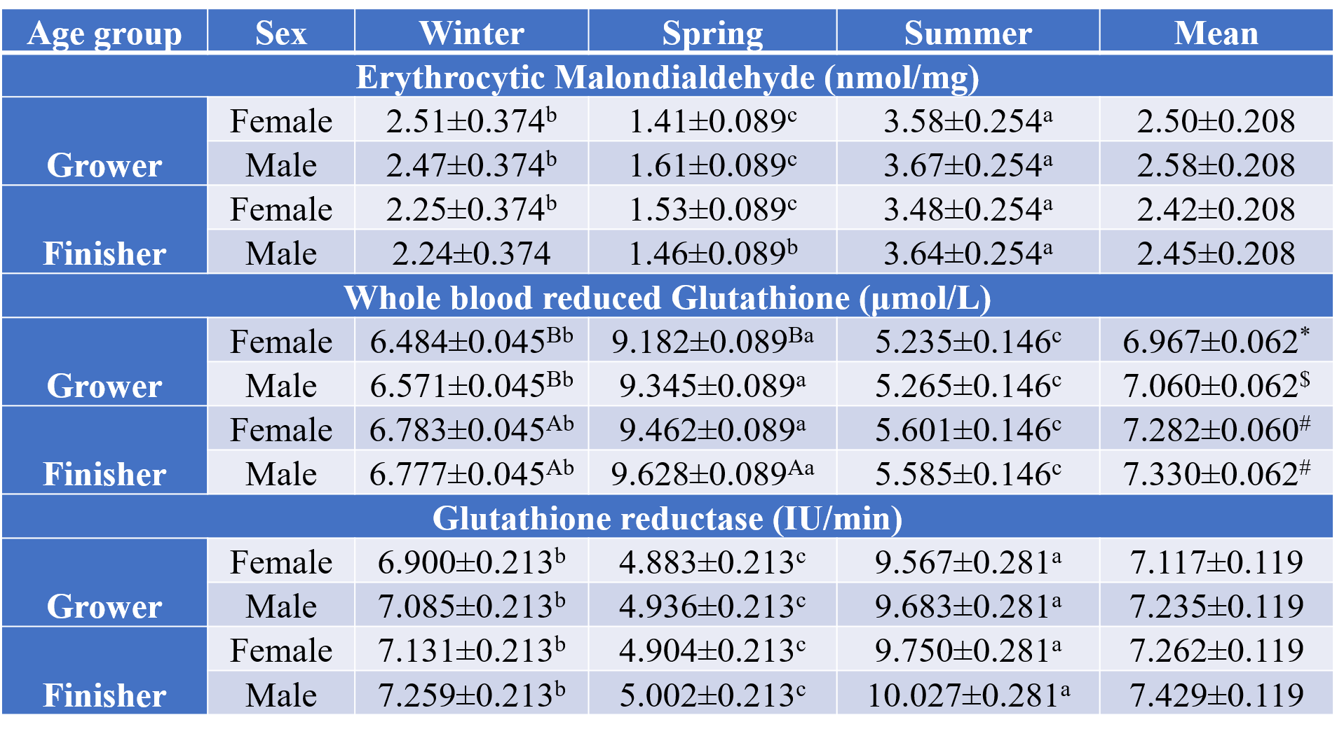
Table 2. Seasonal variations in hematological parameters. Hb, PCV, and TLC decreased, while neutrophils and the N:L ratio increased and lymphocytes decreased in winter and summer compared with spring (p < 0.05). Hb was measured following Dacie & Lewis (1975), PCV by the microhematocrit method, DLC using Giemsa-stained smears, and TLC using a hemocytometer. Data are presented as Mean ± SEM (n = 6). Different lowercase superscripts (a, b, c) denote significant differences among seasons (p < 0.05), while symbols (*, #, $) indicate significant differences among age groups (p < 0.05).

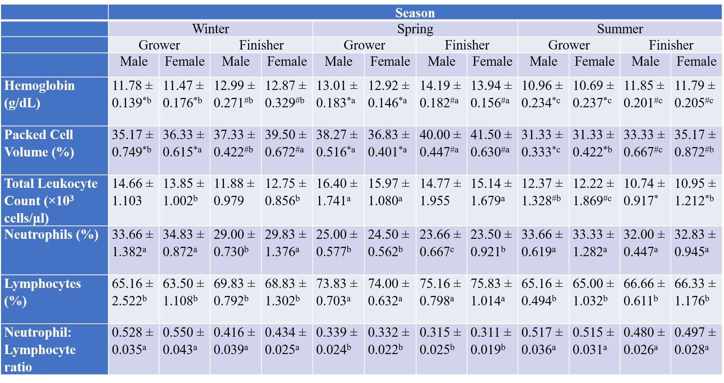
Table 3: Seasonal variations in metabolic enzyme activities. Activities of ALT, AST, GGT, and LDH were significantly elevated during both summer and winter, with the highest values recorded in summer. No significant seasonal variation was observed in ALP activity. Plasma levels of ALP, ALT, AST, GGT, and LDH were measured using Erba Mannheim kits on a semi-automatic chemistry analyser (Merck). Data are presented as Mean ± SEM (n = 6). The values with different lower-case letters (a, b, c) superscripts indicate significant difference at p < 0.05 between seasons.

