Emergence of Multidrug-Resistant Shigella flexneri in Captive Elephant Foot Lesions: Implications for Wildlife Health Management

ABSTRACT
The Asiatic elephant (Elephas maximus indicus) is an endangered species playing a vital role in wildlife conservation and management across India. Captive elephants are especially important for patrolling, eco-tourism, conflict mitigation and forest operations. However, foot disorders remain one of the most common health challenges affecting their welfare and working efficiency. Despite extensive use of captive elephants in Madhya Pradesh’s protected areas, no systematic scientific study had been conducted on foot affections. Therefore, the present study screened 59 captive Asiatic elephants across Kanha, Bandhavgarh, Panna, Pench and Satpura Tiger Reserves to assess foot health and associated pathogens over one year (April 2024–March 2025). During the investigation, Shigella flexneri was isolated from four foot-wound samples, predominantly from Bandhavgarh Tiger Reserve. The isolates were gram-negative, non-motile rods showing multidrug-resistant patterns, with resistance to Clindamycin, Penicillin-G, Gentamicin, Cefazolin and Cefoxitin, while remaining sensitive to Ciprofloxacin, Ceftriaxone, Imipenem, Meropenem and several other antibiotics. The MAR index (0.129) indicated notable antimicrobial exposure. This is the first documented report of Shigella flexneri isolated from foot wounds of captive Asiatic elephants, highlighting its pathogenic potential in causing inflammation, tissue destruction and delayed healing.
Keywords- Asiatic elephant, Conservation, Clindamycin, Penicillin-G, Madhya Pradesh.

INTRODUCTION
The Asiatic elephant is recognized as the largest living land animal in Asia (Shoshani and Eisenberg, 1982). The subspecies native to the Central Indian landscape is Elephas maximus indicus. Due to significant population decline, the species has been listed as Endangered on the International Union for Conservation of Nature (IUCN) Red List since 1986. Furthermore, it holds the status of a Schedule-I species under the Indian Wildlife (Protection) Act, 1972, which severely restricts commercial trade and limits ownership to those legally documented before the law's enactment. Despite these protections, captive elephants remain an indispensable component of modern wildlife management and conservation efforts in India.
They are extensively deployed for crucial tasks that directly support the in-situ conservation of tigers, including anti-poaching patrols, essential transportation in remote areas, communication support, and eco-tourism operations. A contemporary and vital role for trained captive elephants, known as koonkies, is in mitigating human-elephant conflict. They are strategically utilized for driving away crop-raiding wild herds from human settlements, offering a promising, non-lethal method of conflict resolution (Sarma et al., 2012). Elephants are massive animals, with body weights ranging from 2,000 to 3,500 kg, and possess proportionally heavy legs engineered to bear this immense load. A distinctive feature of elephant skeletal anatomy is the absence of a true marrow cavity in their bones. Instead, the central space is occupied by a network of dense cancellous (spongy) bone. While this tissue provides the site for haematopoiesis (blood cell formation), its dense structure also serves to remould the bone, making it significantly stronger for weight support compared to bones with a hollow marrow cavity (Csuti et al., 2001).
The elephant foot features a specialized integumentary covering that includes skin, toenails, and a cornified but flexible sole, often referred to as a "slipper." This structure is highly adapted for cushioning and weight distribution. Research by Fowler and Mikota (2006) demonstrated the remarkable plasticity of the elephant foot under load: as weight is applied, the digital cushion inside the foot compresses and pushes peripherally, causing the circumference of the foot just above the nails to increase by 7.0–9.7% (a change of 5.0–11.4 cm). This peripheral expansion simultaneously compresses the veins in the foot, aiding circulation. Given the substantial and constant biomechanical stress involved in supporting thousands of kilograms, the elephant foot is extremely vulnerable to health issues. A lack of ability to flex the foot is a major clinical sign indicating underlying pain or ankylosis (stiffening of the joint) within the structure. Consequently, foot affections represent one of the most serious and common health challenges faced by elephants in captivity, posing a significant management issue across all National Parks and Tiger Reserves where they are actively used.

MATERIALS AND METHODS
The proposed research on foot affections in captive Asiatic elephants was carried out over a period of one year, spanning from April 2024 to March 2025. The laboratory and diagnostic components of the work were executed at the School of Wildlife Forensic and Health, N.D.V.S.U., Jabalpur (M.P.). Field operations, including the selection and screening of animals, were conducted across five major protected areas in Madhya Pradesh, namely the Kanha Tiger Reserve (n=14), Bandhavgarh Tiger Reserve (n=15), Panna Tiger Reserve (n=15), Pench Tiger Reserve (n=8), and Satpura Tiger Reserve (n=7).

Selection of Animals and Screening
A total of 59 captive Asiatic elephants (Elephas maximus indicus) of either sex (30 male and 29 female) were selected for screening based on the presence of foot affections. The screening process involved a thorough physical examination of all elephants for evidence of foot lesions, including wounds, nail cracks, abscesses, podo-dermatitis, foot rot, split nails, and nail overgrowth, with all findings documented using a digital camera. Crucially, detailed historical data was collected from animal caretakers, treatment registers, and Wildlife Health Officers of the respective parks. This historical information covered key aspects of elephant management practices, such specifically the use and replacement schedule of leg chains, housing conditions, flooring type of enclosures and tethering sites, general hygiene and sanitation, and documented foot care and wound treatment protocols.

Categorization of Foot Affections
Foot affections were systematically categorized to ensure consistent assessment. They were broadly classified by the presence of a wound, abnormal cuticle growth, and nail cracks (major and minor). The severity of nail lesions was categorized into three levels mild, moderate, and severe—based on established veterinary welfare descriptions (Rutkowski et al., 2001; West, 2001; Wendler et al., 2019). Mild lesions included nail cracks that did not extend to the cuticles or expose underlying tissues, as well as overgrown cuticles attached to the nail. Minor issues like frayed cuticles, superficially fissured nail soles, abnormal nail surfaces, or narrow inter-nail spaces were categorized as care issues. Moderate pathological lesions were characterized by defects exposing underlying soft tissues, major nail cracks reaching the cuticles with inflammation, and fluid pockets in the soft tissue area. Severe lesions were defined by conditions such as "split nails" (major cracks from sole to cuticles, potentially damaging germinal tissue), the development of abscesses, purulent discharge, altered tissue beneath the cuticles, and substantial apical nail lesions exposing underlying tissue.

Materials and Sample Collection
A diverse array of materials was utilized for microbial isolation and identification. The required chemicals, reagents, and media predominantly supplied by HI Media—included Blood agar, Brain Heart Infusion Broth/Agar, Nutrient Agar/Broth, MacConkey Lactose Agar, Mueller Hinton Agar No. 2, specialized selective media like Eosin Methylene Blue agar, Xylose Lysine Deoxycholate agar, Cystine Lactose Electrolyte Deficient agar, and Baird Parker agar, along with antimicrobial discs and a Gram Staining Kit. The instruments used encompassed a deep freezer, various brands of microscopes (Magnus, Olympus), a refrigerated centrifuge (Remi Lab World), an incubator, a Vertical Laminar Flow hood (Esco, Secor), and the advanced BD Phoenix™ M50 automated system (Becton, Dickinson and Company) along with its associated NMIC/ID & PMIC/ID Panels and Nephelometer for automated bacterial identification and susceptibility testing. Samples were collected from all affected elephants, resulting in a total of 83 samples being taken, primarily consisting of swabs from pus, fluids, and wounds present on the foot lesions.
Result and Discussion
The present study uniquely reports the isolation of Shigella flexneri from foot wounds of captive Asiatic elephants, a finding for which no prior documentation exists in this species. A total of four isolates of Shigella flexneri were successfully obtained from the elephant population screened. The distribution of these isolates across the affected limbs included two from the right forelimb, one from the left hindlimb, and one from the right hindlimb. Geographically, the highest incidence was noted in the Bandhavgarh Tiger Reserve (n=03), with one additional isolate obtained from the Pench Tiger Reserve (n=01). All four isolates were directly linked to foot wounds of the captive Asiatic elephants. The initial identification of the isolates was based on characteristic colony morphology and microscopic features (Plate 02). Presumptive Shigella flexneri was observed as Gram-negative straight rods, confirmed to be non-motile, and classified as facultative anaerobic bacteria. Culturing on Eosin Methylene Blue (EMB) agar revealed colonies ranging in color from light pink to dark pink, with small to medium size (Plate 03), which is typical for lactose-non-fermenting organisms or weak fermenters like Shigella flexneri A critical finding of this research is the determined antimicrobial resistance profile of these novel isolates. The four Shigella flexneri isolates demonstrated resistance to several clinically important antibiotics: Clindamycin, Penicillin-G, Amikacin, Gentamicin, Cefazolin, Cefoxitin, and Ceftazidime (Table 04).
The Multi-Antibiotic Resistance (MAR) index calculated for these Shigella flexneri isolates was 0.129, suggesting a significant level of resistance within the tested panel. This multidrug-resistant nature raises significant concerns for therapeutic intervention and zoonotic potential, particularly given the close contact between captive elephants and human caretakers. In contrast, the isolates exhibited sensitivity to a wide spectrum of other antibiotics, including Cefoxitin, Piperacillin-Tazobactam, Ciprofloxacin, Ceftriaxone, Gentamycin, Cotrimoxazole, Tetracycline, Cefepime, Ceftizoxime, Cefotaxime, Imipenem, Amikacin, Meropenem, and Ampicillin (Table 01 and 02). It is important to note the conflicting sensitivity data where Cefoxitin, Amikacin, and Gentamicin appear in both the resistant and sensitive lists this suggests that the data in Table 04 may reflect the specific resistance pattern of the four novel isolates, overriding the general sensitivity pattern listed elsewhere. Furthermore, Levofloxacin was the only antibiotic found to have an intermediate level of efficacy. The presence of Shigella flexneri is pathologically significant. As reported by Rudel (2012), this bacterium is known to replicate within infected cells, a process that triggers inflammation, extensive tissue destruction, and necrosis. Furthermore, Shigella flexneri possesses mechanisms to evade host defenses; Bergounioux et al. (2012) described how Shigella flexneri interferes with apoptosis and DNA repair by inhibiting the p53 tumor suppressor protein through VirA-mediated degradation of calpain p53. The isolation of this potent pathogen from the foot wounds of Asiatic elephants indicates a potential source of severe, necrotizing infection contributing to the complex etiology of foot affections in these captive animals. Given the zoonotic nature of Shigella flexneri this discovery warrants further investigation into transmission routes and immediate revisions to the current foot care and biosecurity protocols in the tiger reserves.
Conclusion
This study successfully documented the prevalence and characteristics of foot affections in 59 captive Asiatic elephants across five major Tiger Reserves in Madhya Pradesh, highlighting these conditions as a critical management issue due to the elephants' unique biomechanics and intensive use in conservation efforts. The most significant finding is the first-ever isolation of Shigella flexneri} from the foot wounds of these elephants. Four isolates were identified, predominantly from Bandhavgarh Tiger Reserve, which demonstrated features of Gram-negative, non-motile rods on microscopy and culture. Alarmingly, these isolates showed a multidrug-resistant (MDR) profile with resistance to clinically important antibiotics, including Clindamycin, Penicillin-G, Amikacin, Gentamicin, Cefazolin, Cefoxitin, and Ceftazidime. This MDR finding, coupled with the known pathogenicity of S. flexneri its ability to cause tissue destruction, necrosis, and evasion of host defences suggests a severe and complicating factor in the chronic nature of captive elephant foot disease.
Table 01: Zone size interpretative chart for antibiotic sensitivity assay for Shigella flexneri (manually disc diffusion method)
S. No | Antibiotics | Symbol | Concentration of disc | Sensitive  (mm or more) | Intermediate (mm) | Resistant  (mm or less) | Disc diffusion method (mm) | Interpretation
1 | Cefoxitin | (CX) | 30 mcg | 18 | 15-17 | 14 | 24 | S
2 | Piperacillin Tazobactam | (PIT) | 100 mcg | 25 | 21-24 | 20 | 32 | S
3 | Ciprofloxacin | (CIP) | 5mcg | 21 | 18-20 | 17 | 22 | S
4 | Ceftriaxone | (CTR) | 30 mcg | 23 | 20-22 | 19 | 23 | S
5 | Gentamicin | (GEN) | 10 mcg | 18 | 15-17 | 14 | 18 | S
6 | Levofloxacin | (LE) | 5 mcg | 21 | 17-20 | 16 | 18 | IM
7 | Co-Trimoxazole | (COT) | 25 mcg | 16 | 11-15 | 10 | 22 | S
8 | Clindamycin | (CD) | 2 mcg | 21 | 15-20 | 14 | <10 | R
9 | Tetracycline | (TE) | 30 mcg | 15 | 12-14 | 11 | 25 | S
10 | Cefepime | (CPM) | 30 mcg | 25 | 19-24 | 18 | 30 | S
11 | Ceftizoxime | (CZX) | 30 mcg | 25 | 22-24 | 21 | 32 | S
12 | Amoxicillin Clavulanate | (AMC) | 30 mcg | 18 | 14-17 | 13 | 14 | IM
13 | Cefotaxime | (CTX) | 30 mcg | 23 | 15-22 | 22 | 26 | S
14 | Penicillin -G | (P) | 10unit | 29 | - | 28 | <10 | R
15 | Ceftazidime | (CAZ) | 10 mcg | 21 | 18-20 | 17 | 14 | R
16 | Imipenem | (IPM) | 10 mcg | 23 | 20-22 | 19 | 28 | S
17 | Amikacin | (AK) | 30 mcg | 18 | 15-17 | 14 | 22 | S
18 | Meropenem | (MRP) | 10 mcg | 22 | 19-21 | 18 | 28 | S
19 | Ampicillin | (AMP) | 10 mcg | 16 | 12-15 | 11 | 16 | S
(S=Sensitive, R=Resistance and IM=Intermediate)

Table 02: Antimicrobial resistance against Shigella flexneri
Shigella flexneri
Antibiotics | MIC | Interpretation
Amikacin | - | R
Gentamicin | - | R
Imipenem | - | -
Meropenem | - | -
Cefazolin | - | R
Cefoxitin | - | R
Ceftazidime | - | -
Cefotaxime | - | -
Cefepime | - | -
Cefoperazone- Sulbactam | - | -
Aztreonam | - | -
Ampicillin | - | -
Piperacillin | - | -
Amoxicillin Clavulanate | - | -
Piperacillin- Tazobactam | - | -
Colistin | - | -
Trimethoprim-Sulfamethazole | - | -
Chloramphenicol | - | -
Ciprofloxacin | - | -
Levofloxacin | - | -
Tetracycline | - | -
(S=Sensitive, R=Resistance and IM=Intermediate)

Table 03: Multidrug resistance pattern in Shigella flexneri isolates
No. of Shigella flexneri resistance | Cefoxitin | Piperacillin Tazobactam | Clindamycin | Amoxyclav Clavunic Acid | Penicillin -G | Ampicillin | Gentamicin | Cefazolin
Cefoxitin | R | 2R | 2R | 3R | 2R | R | 2R | 2R
Piperacillin Tazobactam | 2R | 4R | R | 4R | 3R | R | R | R
Clindamycin | 3R | 2R | 3R | 4R | 4R | R | 2R | R
Amoxyclav Clavunic Acid | 3R | 4R | R | 4R | 4R | R | 3R | 2R
Penicillin -G | 2R | 4R | 4R | 4R | 3R | R | 2R | 3R
Ampicillin | 3R | 3R | 4R | 4R | 2R | 4R | 2R | 3R
Gentamicin | 4R | 3R | 4R | 4R | 3R | R | 3R | R
Cefazolin | 3R | 2R | 3R | 4R | 2R | R | 2R | 4R
(S=Sensitive, R=Resistance and IM=Intermediate)

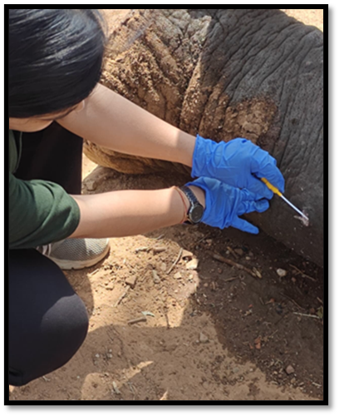
Plate 01: Foot examination of captive Asiatic elephant; collection of bacteriological swab sample from wound in sterilized swab from foot of captive Asian elephant

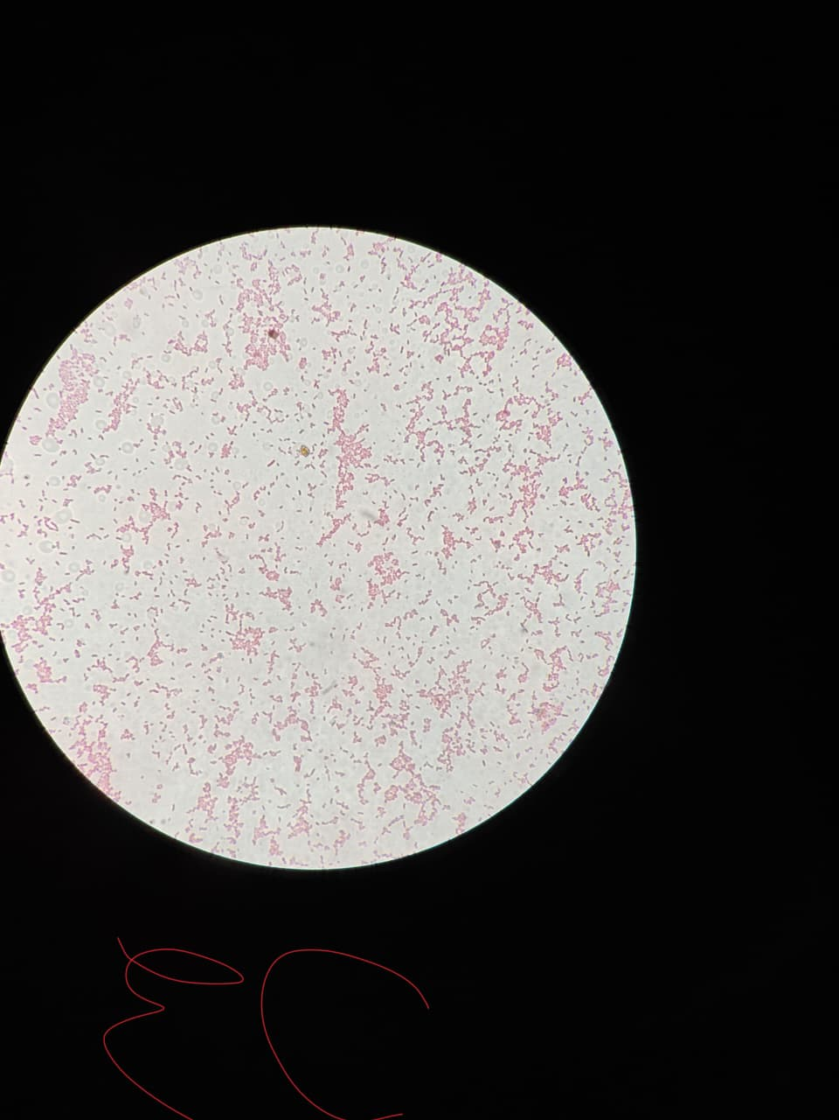

Plate 12: Gram negative rods suspected for Shigella flexneri (1000X)

Plate 02: Gram negative rods bacteria is Shigella flexneri (1000X)
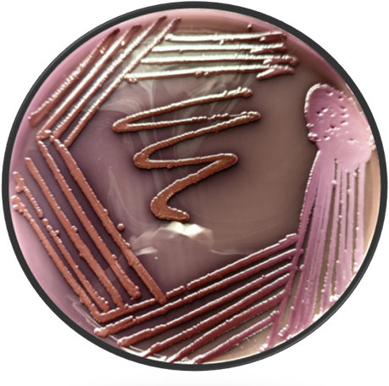

Plate 03: Growth of Shigella flexneri in Eosin Methylene Blue agar

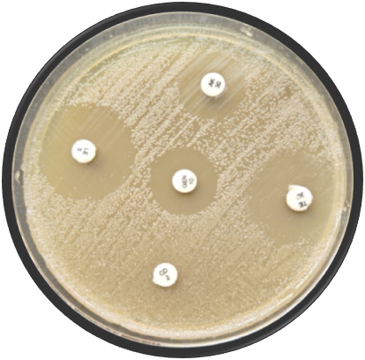

Plate 04: Multidrug susceptibility profile of Shigella flexneri
Reference
Bergounioux, J., Faudry, E., Sola-Landa, A., Mounier, J., Joly, B., & Dautry-Varsat, A. (2012). Calpain activation by the Shigella flexneri effector VirA regulates key steps in the formation and life of the bacterium’s epithelial niche. Cell Host & Microbe, 11(3), 240–252. https://doi.org/10.1016/j.chom.2012.01.013 .
Schiffmann, C. (2021). Posture abnormalities as indicators of musculoskeletal disorders in 12 zoo elephants – A visual guide. *Gajah*, *53*, 20–29. https://www.asesg.org/gajah/Gajah%2053/Gajah%2053%20(2021)%2020-29%20Schiffmann.pdf .
Csuti, B., Sargent, E. L., & Bechert, U. S. (2001). The elephant's foot: Prevention and care of foot conditions in captive Asian and African elephants. Iowa State University Press. https://www.wiley.com/en-us/The+Elephant%27s+Foot%3A+Prevention+and+Care+of+Foot+Conditions+in+Captive+Asian+and+African+Elephants-p-9780813828206 .
Mikota, S. K., Sargent, E. L., & Ranglack, G. S. (1994). Medical management of the elephant. Indira Publishing House. https://books.google.com/books/about/Medical_Management_of_the_Elephant.html?id=2_4tAAAACAAJ .
Sarma, K. K., Thomas, S., Gogoi, D., Sarma, M., & Sarma, D. K. (2012). Foot diseases in captive elephant. Intas Polivet, 13(2), 221-227. https://doi.org/10.1079/PV20120034.
Shoshani, J., & Eisenberg, J. F. (1982). Elephas maximus. Mammalian Species, 182(18), 1–8. https://doi.org/10.2307/3504045 .

