Original Research Article

Evaluating Changes in Jaggery Production Patterns Using Likert-Scale Responses from Northern India

ABSTRACT
This study analyses the changing dynamics of jaggery production in Muzaffarnagar district through Likert-scale responses and t-test analysis across nine blocks. The results highlight regional variations in how farmers perceive modernization, ODOP scheme (One District One Product) benefits, and environmental influences on jaggery production. Budhana, Morna, and Sadar-Kukda blocks recorded the strongest positive responses, with high mean scores (above 4.5) and significant t-statistics (P < 0.001), indicating substantial improvements in mechanization, hygiene, and packaging. Baghra, Shahpur, and Khatauli also showed positive but moderate progress, suggesting ongoing adaptation to modern methods. In contrast, Charthawal, Jansath, and Purquazi reflected near-neutral mean values (around 3.0), showing limited awareness and access to ODOP-linked interventions. The findings reveal a clear spatial divide, where industrially connected and policy-supported areas are advancing faster than traditional zones. Respondents across high-performing blocks noted that technological upgrades and improved market linkages have strengthened production efficiency and income stability. Environmental and seasonal challenges, such as temperature and humidity fluctuations, continue to affect production cycles, though their impacts are reducing with modernization. Overall, the study confirms that Muzaffarnagar’s jaggery sector is in a transitional phase shifting gradually from traditional manual processes toward mechanized, quality-oriented, and policy-driven production systems.
Keywords: Jaggery production; Likert scale; Modernization; Muzaffarnagar district; ODOP (One District One Product); Perception analysis.
1. INTRODUCTION
Jaggery, an unrefined sugar product obtained from sugarcane, holds significant economic and cultural value in India. Asia's largest jaggery market is located in Muzaffarnagar, which has long been known as a significant hub for the manufacture of Gur (jaggery). Muzaffarnagar is home to India's biggest jaggery market. It accounts for around 20% of India's total production of rural sweeteners. The sweet tag of GI was conferred to Muzaffarnagar Gur (Jaggery) in 2023 (National Bank for Agriculture and Rural Development). In India and Uttar Pradesh, jaggery, an age-old and traditional unrefined sweetener, is widely used. The main raw material used to make jaggery in this area is sugarcane, which makes up around 1.56 million hectares, or 52% of India's total cultivated area (Geographical Indications Registry, 2022). Historically, jaggery production in this region has relied on labour-intensive, small-scale methods, characterized by traditional kilns, minimal mechanization, and limited processing infrastructure. These conventional practices often constrain productivity, quality, and income potential. Farmers face challenges such as high dependency on manual labour, seasonal variability in production, inadequate storage, and restricted market access. Assessing how traditional production practices have evolved is crucial for understanding the impact of policy interventions and technological modernization on the region’s jaggery sector.
In recent years, modernization initiatives, especially under the One District One Product (ODOP) program, have targeted district-specific industries like jaggery to improve efficiency, quality, and market competitiveness. ODOP aims to enhance mechanization, promote hygienic production, improve packaging and storage, and provide better market linkages. Such interventions are designed to reduce manual labour dependency, diversify jaggery forms (e.g., powdered or cubed variants), improve shelf life, and stabilize producer incomes. However, the effectiveness of these initiatives varies across blocks due to differences in awareness, infrastructural readiness, and proximity to markets, making block-level evaluation essential for understanding the spatial distribution of modernization.
The present study uses a 13 - question survey instrument to capture farmer perceptions across nine blocks of Muzaffarnagar district of Western Uttar Pradesh, addressing critical dimensions of jaggery production dynamics as jaggery falls under the one district one product category for this district:
The study focuses on multiple dimensions of jaggery production in Muzaffarnagar district, including jaggery production trends, whether production has increased in recent years, shift in production period, or changes in timing compared to earlier years, use of advanced machinery, or adoption of modern equipment for processing, manual labour dependency, or reduction in reliance on manual workforce, availability of skilled labour, or changes in access to trained personnel, awareness of hygienic and packaged jaggery, or recognition of quality improvements, impact of seasonal climatic changes, or influence of temperature and humidity fluctuations, effect of the ODOP scheme, or the role of policy in supporting production, access to better market infrastructure, or improvements facilitating efficient trade, diversification of jaggery forms, or transition from traditional blocks to new formats, storage and packaging improvements, or effect on shelf life and product stability, quality of jaggery, or perceived improvements through better practices, and income variability, or changes in farmer earnings from jaggery production.
The influence of environmental and market factors is also significant. Seasonal temperature and humidity fluctuations affect sugarcane quality and production cycles. Modernized blocks report improved operational flexibility, enabling adaptation to such climatic changes, whereas less advanced regions remain vulnerable to environmental variability. Producer welfare is closely linked to modernization. Farmers in progressive blocks have experienced higher production, improved income levels, and better-quality outputs, demonstrating the combined impact of mechanization, ODOP support, market access, and hygienic practices. Conversely, farmers in slower-adopting regions report minimal income growth and limited market engagement, reflecting the need for targeted policy interventions and infrastructure development. Despite these observable changes, systematic evaluation of farmer perceptions regarding modernization, ODOP interventions, and regional disparities remains limited. By using Likert-scale surveys validated with t-test analysis, this study quantifies perceived changes across all 13 dimensions, providing a structured assessment of how technological adoption, policy initiatives, and environmental factors collectively influence jaggery production. The survey allows for nuanced insights into the coexistence of traditional practices and modernization, revealing areas of progress, stagnation, and the need for targeted interventions.
1.1. Why to use Likert scale?
Researchers can turn subjective opinions into quantifiable data for study by using the Likert scale, a popular method for evaluating attitudes or perceptions. It presents statements with answer possibilities that typically range from "Strongly Disagree" to "Strongly Agree" (Koo & Yang, 2025). Using a structured response format, the Likert scale is a popular rating system for assessing intangible concepts like attitudes, views, or perceptions (Joshi et al., 2015). It has been proposed that framing Likert-scale items in an interrogative manner instead of an aggressive one encourages respondents to think more critically about their responses, which reduces response biases like acquiescence bias and default response bias (Petty et al., 1987; Höhne, 2017). Conversely, (Norman, 2010) claimed that even in cases when sample sizes are small, variances are uneven, or distributions are not normal, parametric statistics can be used with Likert data. The resulting data can frequently be regarded as roughly continuous when several Likert items are averaged or added together to provide a composite score. This makes it possible to employ parametric tests like multiple regression analyses, Pearson's correlation coefficients, ANOVA, and the t-test (Carifio & Perla, 2008). In our case we have used t-test.
Many variables of interest are psychological or latent constructs that cannot be directly observed, which makes social science research difficult (Harwell & Gatti, 2001; Blanchard et al., 2014). Latent variables are underlying characteristics or behaviours that may be speculative or intrinsically unquantifiable (Bollen, 2002). Such factors are difficult to measure and depend on specific indicators that capture their distinguishing traits (Lautre & Fernandez, 2004). Researchers use manifest variables, which are measured using rating scales or rubrics, to evaluate a hidden variable (Harwell & Gatti, 2001). Self-confidence, motivation, and anxiety are a few examples of latent variables that are commonly assessed using self-report tools that use standardized rating scales. Eliciting objective responses that explicitly include or exclude certain possibilities is the goal of a rating scale (Garland, 1991; Albaum, 1997). The Likert scale is one of the most regularly used rating scales and is thought to be a straightforward and trustworthy way to record respondents' opinions (Royeen, 1985; Subedi, 2016). In comparison to alternative scaling techniques, respondents typically found Likert scales to be quicker to complete and easier to use (Van Laerhoven et al., 2004). The best statistical techniques for evaluating data derived from Likert scales are still up for debate, despite their widespread use (Knapp, 1990; Subedi, 2016).
The present research aims to assess block-level perceptions of jaggery production changes in Muzaffarnagar district, emphasizing technological adoption, labour dependency, production timing, hygienic processing, packaging, product diversification, market infrastructure, ODOP support, environmental impacts, and income trends. By evaluating responses to all 13 survey questions, the study identifies high-performing regions, highlights spatial disparities, and offers evidence-based insights for policymakers, industry stakeholders, and farmers. The findings contribute to understanding the transitional phase of the jaggery industry, where traditional methods coexist with modernization and policy-driven reforms, providing guidance for enhancing production efficiency, product quality, and income stability across the district.

2. METHODOLOGY
2.1 Study Approach and Location
The study employed a quantitative survey-based approach to evaluate changes in jaggery production patterns in Muzaffarnagar district, West Uttar Pradesh. A combination of multi-stage simple random sampling and judgmental sampling procedures were used to select respondents. The unit of observation consisted of households directly or indirectly engaged in jaggery production, including farm owners and workers associated with small jaggery producing units.
Primary data were collected from rural agrarian households across nine administrative blocks: Budhana, Baghra, Charthawal, Shahpur, Purquazi, Morna, Jansath, Khatauli, and Sadar-Kukda. The survey was conducted with a intention of capturing perceptions of changes in jaggery production practices, technological adoption, market awareness among jaggery producers, and income variations.
The respondents were primarily male (75%), with a majority having limited formal education. Participants were selected based on their active involvement in jaggery production, willingness to participate, and knowledge of local production and marketing processes.
2.2. Hypothesis Testing
Hypothesis testing is a basic method in statistical inference, and a statistical hypothesis is a statement about one or more populations (Lehmann, 2005; Stuart et al., 2008; Abramovich & Ritov, 2013; Casella & Berger, 2024). Based on sample data, it allows researchers to assess the degree of ambiguity surrounding a decision and identify which of two conflicting hypotheses is more likely (Krzywinski & Altman, 2013).
Hypothesis statement
- Null hypothesis (𝐻₀): There is no significant change in jaggery production patterns in the study area.
- Alternative hypothesis (𝐻₁): There is a significant change in jaggery production patterns.
2.3. Survey instrument
Step 1: Data collection
A structured questionnaire consisting of 13 perception-based statements was prepared to assess shifts in jaggery production patterns. The survey statements addressed key aspects of jaggery production, including: Production trends and seasonal shifts, technological adoption and machinery use, labour availability and dependency, awareness about hygiene, packaging, and market infrastructure, Impact of the One District One Product (ODOP) scheme, diversification of jaggery forms (e.g., jaggery powder, cubes) and changes in product quality and household income. The survey was voluntary with consent and proper ethics were maintained and participants were briefed that all the details will be anonymous, would not be shared with anyone and used for scientific purposes of this study only. Since, this study did not require formal ethical approval, for informed consent a principle of Helsinki for human studies was followed as appropriate (Prabhat et al., 2022).
Likert scales are a common rating format for surveys that rank quality from high to low or best to worst using five or seven levels (Allen & Seaman, 2007). Responses were recorded on a 5-point Likert scale: 1 = Strongly Disagree, 2 = Disagree, 3 = Neutral, 4 = Agree, 5 = Strongly Agree.
Surveys were conducted across 9 administrative blocks: Budhana, Baghra, Charthawal, Shahpur, Purquazi, Morna, Jansath, Khatauli, and Sadar-Kukda.
Step 2: Weighted mean score calculation
For each question in each block, a weighted mean score was computed to reflect the central tendency of perception responses. Weighted Mean Formula:
$$\overline{X}=\frac{\sum_{i=1}^{5}{w_{i}.f_{i}}}{\sum_{i=1}^{5}{f_{i}}}$$
Where
$w_{i}$=Likert scale weight (1-5)
$f_{i}$= Frequency of responses at each level
This produced a 13-item vector of weighted means per block, representing perceived change intensity in production patterns.

Step 3: One-sample t-test
To statistically test whether the observed mean scores indicate significant change, a one-sample t-test was performed for each block. Requirements for one sample t-test were kept into consideration like A random sample, independent observations, and a continuous (interval or ratio) test variable are required. It is assumed that there are no outliers and that the data are roughly normally distributed with homogeneous variances (Kent State University Libraries).
Null hypothesis (𝐻₀): There is no significant change in the jaggery production pattern. (i.e., mean response ≈ 3 = Neutral)
Alternative hypothesis (𝐻₁): There is a significant change in the production pattern. (i.e., mean response ≠ 3)
T-statistic formula:
$$t=\frac{\overline{X}- μ_{o}}{s/\sqrt{n}}$$
Where
$\overline{X}$ = Average weighted mean score across 13 questions
$μ_{o}$= 3: Expected mean under null hypothesis (neutral)
$s$ = Standard deviation of the 13 scores
$n$ = Number of questions
A p-value < 0.05 was considered statistically significant, indicating strong evidence that perceptions deviate from neutrality, and suggesting a change in the production pattern.
Step 4: Spatial visualization of significant regions
Based on the p-values, regions were classified as: Significant (p < 0.05): Suggesting change, Non-significant (p ≥ 0.05): Suggesting stability or no perceptible change. A choropleth map was created using GIS tools, where: Green shades represent significant regions (with gradation by p-value), Red indicates non-significant regions.
Step 5: Spatial visualization of question - wise perceptions
To identify which specific aspects of jaggery production were perceived to be changing across different regions, weighted mean scores were computed for each of the 13 questions individually for all 9 blocks. These scores were then mapped region-wise, producing 13 thematic maps, each corresponding to one question. Each map used a diverging choropleth scale centered at 3 (neutral) to effectively distinguish between agreement and disagreement. This allowed a visual interpretation of how strongly each component such as technological modernization, market behaviour, packaging trends, or awareness of government schemes was perceived to be changing in each region. These visualizations provided fine-grained spatial insights into the jaggery sector's transformation drivers.
Step 6: Analysis of regional patterns by using radar chart and one tail plots
In addition to spatial mapping, radar charts were generated for each region to represent the pattern of perception across all 13 questions. Each chart displays the region's weighted mean Likert score for each question on a polar axis. This helped in: Identifying the dimensions (questions) that received strong agreement or disagreement, indicating key drivers of change. Highlighting regional differences in perception structure, revealing whether certain regions viewed technological change, policy impact, or market adaptation more prominently than others. The radar charts provided a comparative visual profile of perceptual change, enabling a nuanced understanding of how jaggery production patterns are shifting on a region-specific basis.
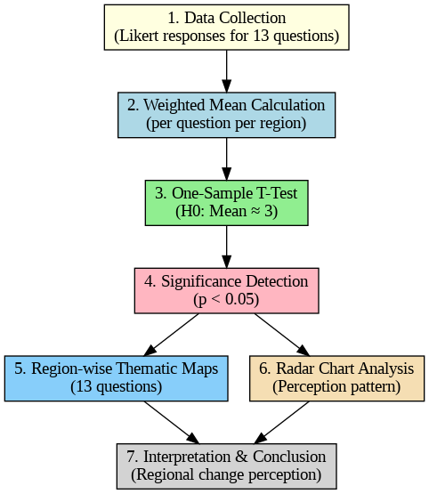
Fig. 1: Methodology followed for hypothesis testing
3. RESULTS AND DISCUSSION
3.1. Interpretation of Likert-Scale Results and t-Test Analysis
The Likert-scale analysis provides a quantitative measure of how strongly respondents perceive changes in jaggery production practices. Each statement (Q1 - Q13) reflects specific aspects of production dynamics such as technological adoption, labour dependency, climatic influence, packaging, and the impact of the ODOP scheme. A weighted mean closer to 5 indicates strong agreement with positive change, whereas values near 3 represent neutrality, and below 3 imply disagreement. The t-test further validates whether these perceptions differ significantly from a neutral stance (µ = 3).
1. Budhana Block With consistently high weighted means (mostly between 4.5 and 4.7) and a t-statistic of 8.83 (P < 0.001), Budhana exhibits strong evidence of positive change. Respondents overwhelmingly agreed that mechanization, improved packaging, and ODOP-driven modernization have redefined jaggery production. The strong response reflects Budhana’s role as a leading jaggery hub, where farmers have transitioned toward semi-mechanized gur units, and market connectivity has significantly improved. The null hypothesis (no change) is clearly rejected, affirming notable progress.
2. Baghra Block The weighted means range between 3.8 - 4.1, with a significant t-statistic of 6.21 (P < 0.001). Respondents here acknowledged change but with slightly lower intensity than Budhana. The findings suggest gradual adaptation to modern techniques and market reforms. Though mechanization has increased, small-scale producers still rely on traditional kilns and manual processes. Nevertheless, the null hypothesis is rejected, confirming perceptible positive transformation.
3. Charthawal Block Charthawal’s responses hover near 3.0, with a t-statistic of -0.19 (P = 0.85), indicating no significant change. Farmers in this block expressed neutrality, suggesting persistence of traditional practices, limited adoption of advanced machinery, and weaker exposure to ODOP interventions. The null hypothesis is not rejected, implying stagnant production practices and possibly constrained access to capital or market infrastructure.
4. Shahpur Block Shahpur presents a t-statistic of 3.34 (P = 0.006) and mixed mean scores between 2.6 - 3.8. Although moderate, the results indicate a significant perception of change. Respondents reported gradual modernization and improved marketing networks, albeit with continuing challenges such as labour shortage and climate-related production delays. The null hypothesis is rejected, but the change is partial and uneven across producers.
5. Jansath Block The weighted mean (~3.0) and t-statistic = 0.0 (P = 1.0) reveal no statistically significant difference from neutrality. This suggests no perceived change in production pattern. Producers in Jansath continue to follow traditional jaggery-making practices with minimal mechanization. Limited awareness about packaging and storage improvements may explain the unchanged perception. The null hypothesis is not rejected.
6. Morna Block With high means (around 4.2 - 4.7) and a t-statistic of 9.02 (P < 0.001), Morna shows very strong positive perception of change. Respondents identified substantial improvement in machinery use, ODOP-linked assistance, and hygiene practices. The area’s active jaggery markets and sugarcane availability likely accelerated these improvements. Hence, the null hypothesis is rejected, affirming clear transformation in production trends.
7. Purquazi Block Purquazi results (means near 3.0, t = 0.0986, P = 0.923) indicate no significant change. Producers continue to rely heavily on traditional processing, with limited technological or infrastructural development. Market isolation and small farm holdings could be contributing factors. The null hypothesis is not rejected, confirming stagnancy in production perception.
8. Khatauli Block Khatauli demonstrates a t-statistic of 11.79 (P < 0.001) with means around 3.4 - 3.7, suggesting a statistically strong perception of change. Respondents recognized improvements in processing technology, packaging, and diversification (e.g., powdered or cubed jaggery forms). As Khatauli is near industrial zones and trade routes, exposure to modernization is higher. The null hypothesis is rejected, signifying substantial progress.
9. Sadar - Kukda Block This block records one of the highest t-statistics (10.84, P < 0.001) with mean responses around 4.0 - 4.6, indicating highly significant transformation. Farmers here strongly agreed with statements on improved hygiene, storage, packaging, and marketing. Being closer to urban centres and having greater ODOP scheme visibility, Sadar-Kukda reflects a matured stage of modernization. The null hypothesis is rejected.
Table 1: Mean Likert-scale scores per question across nine blocks of Muzaffarnagar district, where B1 is Budhana, B2 is Baghra, B3 is Charthawal, B4 is Shahpur, B5 is Purquazi, B6 is Morna, B7 is Jansath, B8 is Khatauli an B9 is Sadar-Kukda
Ques. | B1 | B2 | B3 | B4 | B5 | B6 | B7 | B8 | B9
Q1 | 4.62 | 4.12 | 2.96 | 3.88 | 3.06 | 4.62 | 3.06 | 3.36 | 4.62
Q2 | 4.58 | 3.92 | 3.02 | 3.62 | 3.02 | 4.50 | 2.98 | 3.56 | 4.58
Q3 | 4.56 | 3.96 | 2.92 | 3.84 | 3.00 | 4.40 | 3.00 | 3.44 | 4.56
Q4 | 4.62 | 3.84 | 3.04 | 2.84 | 3.00 | 4.62 | 3.02 | 3.26 | 4.04
Q5 | 4.70 | 3.88 | 2.98 | 2.66 | 2.96 | 4.70 | 2.98 | 3.24 | 4.70
Q6 | 4.16 | 3.92 | 3.02 | 3.82 | 3.02 | 4.16 | 3.04 | 3.66 | 4.20
Q7 | 3.38 | 2.26 | 3.10 | 2.74 | 2.92 | 3.44 | 2.94 | 3.44 | 3.32
Q8 | 4.28 | 3.94 | 2.90 | 3.70 | 2.98 | 4.24 | 2.94 | 3.42 | 4.28
Q9 | 4.30 | 3.92 | 2.92 | 3.50 | 3.12 | 4.30 | 3.08 | 3.46 | 4.30
Q10 | 4.50 | 3.94 | 3.02 | 3.74 | 2.98 | 4.50 | 2.92 | 3.44 | 4.50
Q11 | 3.18 | 3.98 | 3.02 | 2.90 | 2.92 | 3.14 | 2.90 | 3.40 | 3.64
Q12 | 3.68 | 3.9 | 3.04 | 3.66 | 2.98 | 3.76 | 3.06 | 3.72 | 3.92
Q13 | 4.28 | 3.94 | 3.02 | 3.62 | 3.06 | 4.14 | 3.08 | 3.40 | 4.28

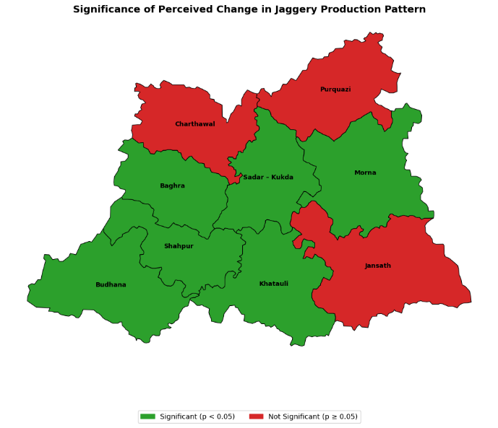
Fig. 2: Muzaffarnagar district map illustrating perception changes in jaggery production: green blocks indicate statistically significant change, while red blocks represent no significant change in producers’ perceptions.

3.2. Per question perception
The overall perception among respondents across the nine surveyed blocks indicates a strongly positive outlook toward the evolving jaggery industry in Muzaffarnagar district. Developmental blocks such as Budhana, Morna, and Sadar-Kukda consistently recorded the highest mean scores (above 4.5 on several items), reflecting substantial progress in production, mechanization, and income levels. Respondents from these regions noted that jaggery production has noticeably increased in recent years, with a parallel shift in the production period due to climatic adjustments and improved operational flexibility. The responses collectively affirm that technological and structural changes have begun to shape the traditional jaggery sector into a more dynamic and resilient system.
There is strong evidence of technological diffusion and modernization, as respondents largely agreed that the use of advanced machinery and hygienic practices has expanded, reducing manual labour dependency in most regions. In areas like Budhana and Morna, the ODOP initiative appears to have played a decisive role in enabling better market infrastructure and production practices. However, blocks such as Charthawal, Purquazi, and Jansath exhibited relatively neutral or moderate mean scores (around 3.0), implying slower adoption of technology or limited access to government support. These regional disparities point to a spatial divide in the modernization process, influenced by access to capital, awareness, and infrastructural readiness.
When considering environmental and market factors, respondents moderately agreed that seasonal climatic changes have affected jaggery production cycles. While modernization has mitigated some challenges, producers continue to experience the consequences of fluctuating temperature and humidity levels during key production months. Promisingly, a large proportion of respondents perceived that ODOP interventions and improved market linkages have supported production stability and diversification into newer jaggery forms such as powder and cube variants.
The responses to income, quality, and storage-related questions show an overall upward trend in producer welfare and product quality. Improved packaging and better hygiene practices have enhanced shelf life and consumer appeal. Meanwhile, producers in progressive regions reported that their income from jaggery has varied positively over the years, consistent with the district’s movement toward organized marketing and value addition. Taken together, the Likert-scale responses reveal a transitional phase in the jaggery sector where traditional production coexists with modernization and policy-driven transformation. The forthcoming heatmap (Figure 2) visually reinforces these regional contrasts and emerging positive patterns across the Muzaffarnagar district.
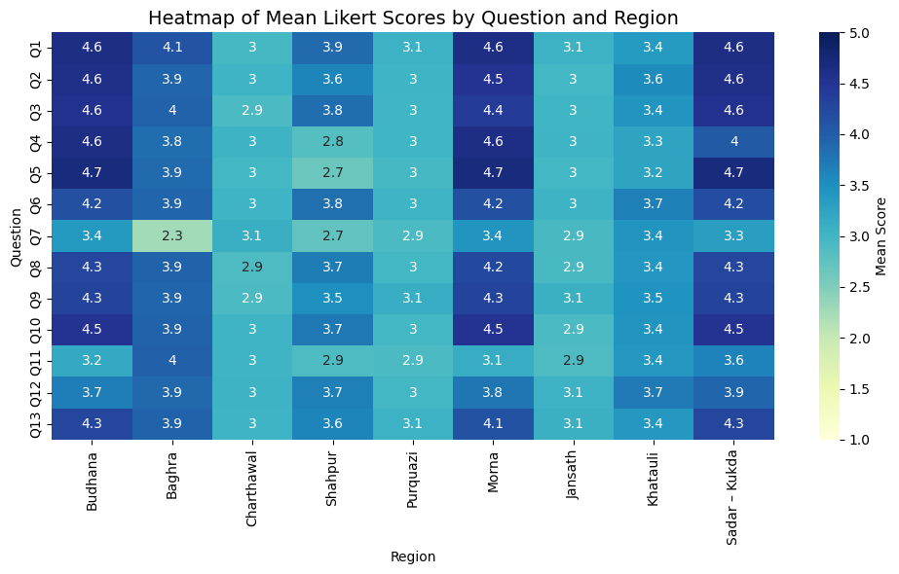
Fig. 3: Heatmap depicting the mean Likert-scale score per question across the nine blocks of Muzaffarnagar district, highlighting variations in jaggery producers’ perceptions.

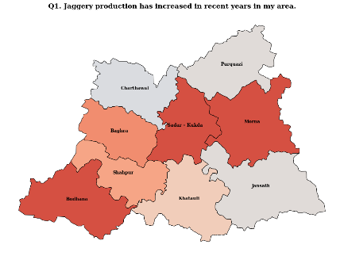 | 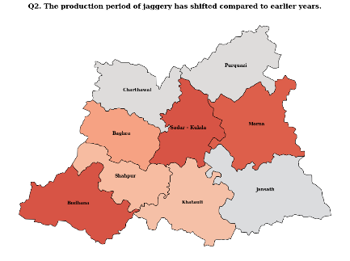 | 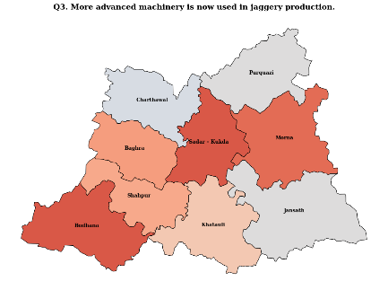
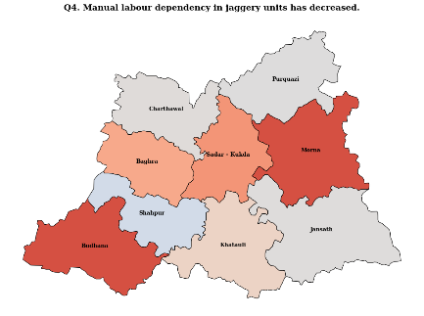 | 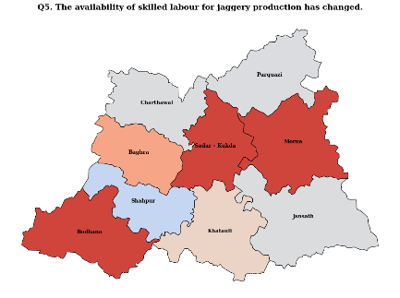 | 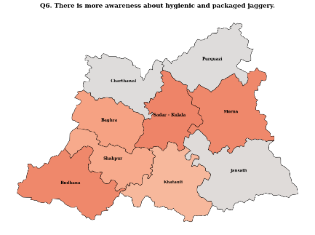
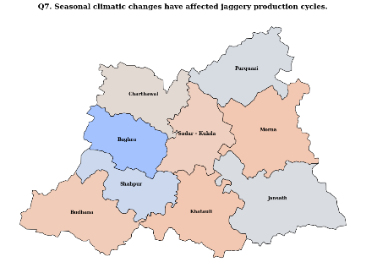 | 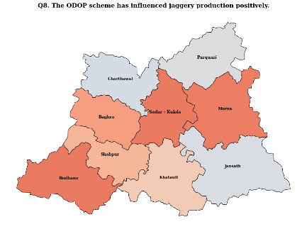 | 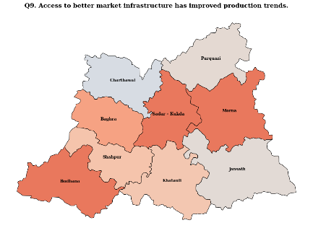
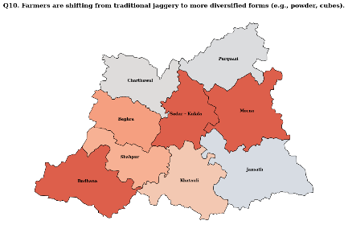 | 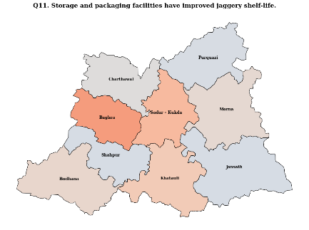 | 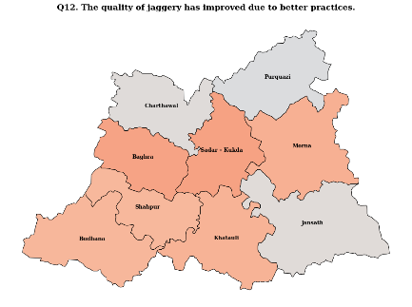
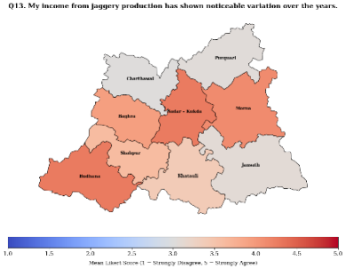

Fig. 4: Block-wise per-question perception responses showing jaggery producers’ views on production changes, technological adoption, and ODOP impact across Muzaffarnagar. All Muzaffarnagar maps use a consistent single-legend colour scheme for comparison.

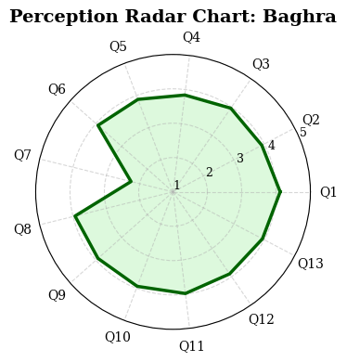 | 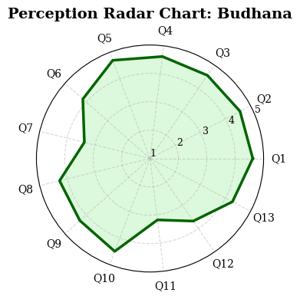 | 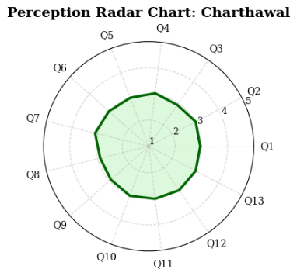
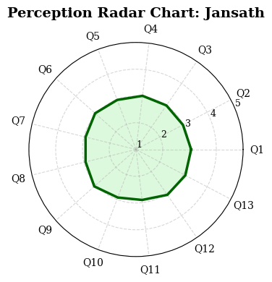 | 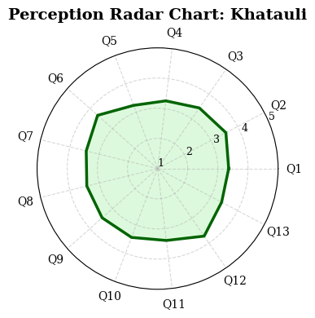 | 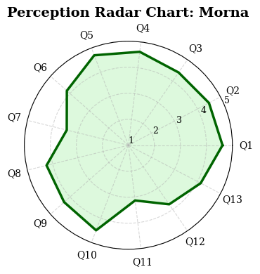
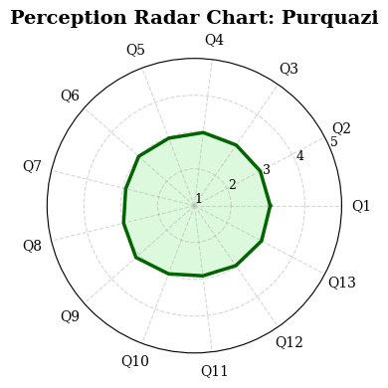 | 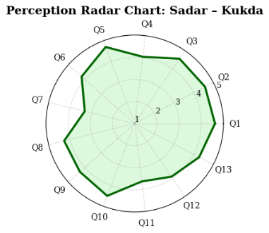 | 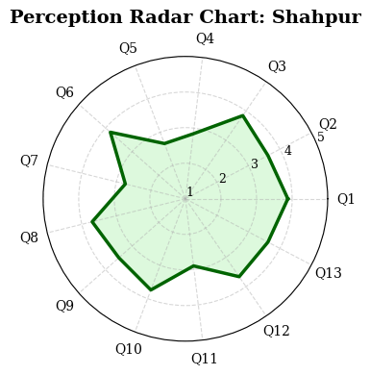
Fig. 5: Radar charts depicting per-question Likert-scale responses for jaggery production patterns across Muzaffarnagar blocks: (a) Baghra, (b) Budhana, (c) Charthawal, (d) Jansath, (e) Khatauli, (f) Morna, (g) Purquazi, (h) Sadar-Kukda, and (i) Shahpur.
The radar charts for each of the nine blocks of Muzaffarnagar offer a visual summary of perceived changes in jaggery production across 13 critical dimensions. Overall, Budhana, Morna, Sadar-Kukda, Khatauli, and Baghra exhibit consistently high mean scores (above 3.5 - 4.5) across most questions, reflecting strong agreement among respondents that production patterns have changed significantly in recent years. Questions related to increased production (Q1), technological adoption (Q3), reduced manual labour dependency (Q4), availability of skilled labour (Q5), and awareness of hygienic, packaged jaggery (Q6) generally score higher in these regions, indicating that modernization, mechanization, and policy interventions like ODOP are perceived as influential.
In contrast, blocks such as Charthawal, Jansath, and Purquazi show scores near the neutral midpoint (around 3.0), suggesting minimal or uncertain changes in production patterns; these blocks show particular weakness in responses on technological adoption, ODOP influence (Q8), and market infrastructure access (Q9). The radar charts also reveal that questions related to climatic impact (Q7) and income variation (Q13) show moderate variation across blocks, highlighting localized environmental and economic factors influencing production cycles. Additionally, responses on product diversification (Q10), storage and packaging (Q11), and quality improvements (Q12) demonstrate moderate-to-high scores in blocks with modernization trends, while traditional blocks lag, indicating a clear spatial differentiation in adoption of modern practices. Collectively, the radar plots provide a holistic view of jaggery production perceptions, visually distinguishing regions of significant change from those requiring targeted interventions, thereby emphasizing both progress and persistent gaps in Muzaffarnagar’s ODOP jaggery industry.
3.3. Block level t-test results of perceived changes in jaggery production patterns
The statistical analysis of Likert-scale responses across the nine surveyed blocks provides compelling insights into the regional disparities and overall transformation of the jaggery industry in Muzaffarnagar. Based on the one-sample t-test results, six blocks Budhana, Morna, Sadar-Kukda, Khatauli, Shahpur, and Baghra showed statistically significant positive deviations (P < 0.05) from the neutral test value, implying strong agreement among respondents regarding the positive impacts of modernization, ODOP policy interventions, and improved production practices. In contrast, Charthawal, Jansath, and Purquazi did not show statistically significant differences from the neutral value, indicating that respondents in these regions neither strongly agreed nor disagreed with the statements, possibly reflecting stagnation or slow progress in jaggery sector reforms.
The Budhana, Sadar-Kukda, and Morna blocks emerged as leading regions in terms of overall performance and modernization. Their mean scores (above 4.1) and extremely low p-values (P < 0.001) reflect high consensus among respondents that jaggery production has increased, mechanization has improved, and awareness of hygienic, packaged jaggery has grown substantially. The ODOP scheme seems to have been particularly effective in these regions, where access to improved market infrastructure and modern equipment is more visible. These findings corroborate the qualitative observations from the field, suggesting that technological diffusion and policy awareness are concentrated in high-performing areas.
In Shahpur and Khatauli, the t-statistics (3.34 and 11.78 respectively) were also statistically significant, though their mean scores hovered around the moderate range (3.4). This suggests that producers in these areas acknowledge progress but may still face operational bottlenecks possibly due to environmental variability or limited availability of skilled labour. The significance, despite moderate means, indicates a directional consensus that progress is happening, though not as strongly felt as in the top-performing blocks. Similarly, Baghra’s significant t-value (6.20) reinforces that jaggery producers there are optimistic about ongoing modernization, even if the transformation is still in progress.
On the other hand, Charthawal, Purquazi, and Jansath displayed non-significant t-values (P > 0.05), suggesting that respondents in these blocks held neutral views on most questions. Their mean scores (~3.0) indicate minimal perceptible improvement in production or market outcomes. These blocks may lack infrastructural support or have limited access to ODOP-linked benefits such as training, packaging facilities, or mechanization. This neutral stance might also reflect uncertainty about income variability, climatic impacts, or insufficient awareness regarding market diversification.
Overall, the t-test analysis validates the Likert-scale results, highlighting clear spatial differentiation within Muzaffarnagar’s jaggery industry. While the majority of regions exhibit statistically significant evidence of growth and modernization, a few remain static or uncertain. The statistically significant regions (Budhana, Morna, Sadar-Kukda, Khatauli, Shahpur, and Baghra) demonstrate tangible progress attributable to technological adoption and ODOP interventions, whereas the non-significant ones (Charthawal, Jansath, and Purquazi) underline the need for targeted policy action and infrastructure development to ensure balanced regional growth in the jaggery sector. All these findings can be visually represented by plotting one-tailed t-test graphs for each block, where the t-statistic for each region is compared against the critical t-value. Such plots will provide a clear, intuitive illustration of which blocks exhibit statistically significant changes in jaggery production patterns and which require further attention.
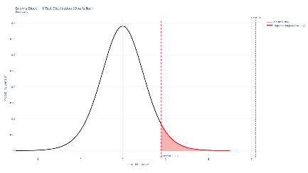  (a) | 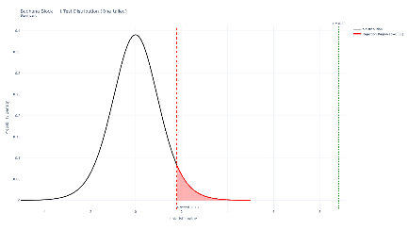  (b) | 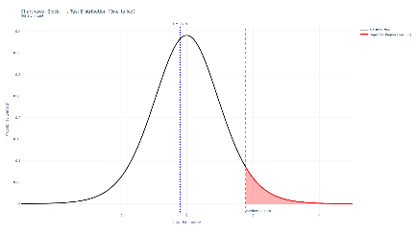  (c)
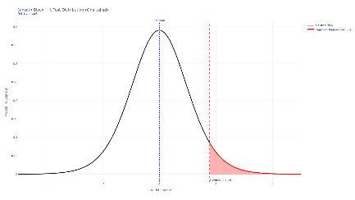  (d) | 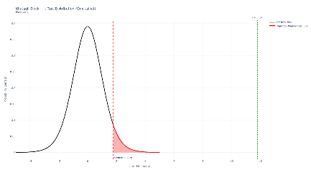  (e) | 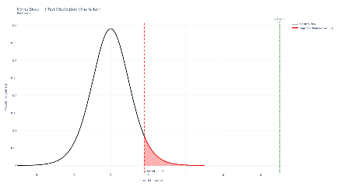  (f)
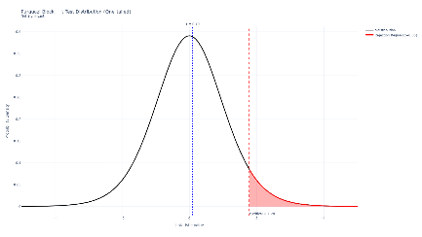  (g) | 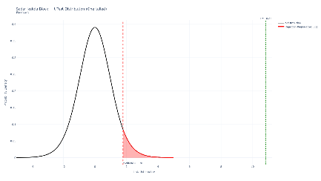  (h) | 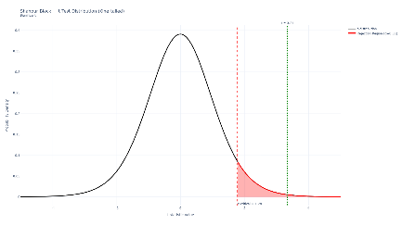  (i)
Fig. 6: One-tailed t-test visualization across Muzaffarnagar blocks showing t-values (Green), t-critical values (Red), t-distribution (Black), and rejection regions (Pink) for (a) Baghra, (b) Budhana, (c) Charthawal, (d) Jansath, (e) Khatauli, (f) Morna, (g) Purquazi, (h) Sadar-Kukda, and (i) Shahpur.
CONCLUSION
The results of this study clearly show that jaggery production in Muzaffarnagar district is undergoing a gradual but meaningful transformation. Farmers across most surveyed blocks recognize that changes in technology, packaging, and government support under the ODOP initiative are reshaping traditional practices. The evidence from Likert-scale ratings and t-test analysis indicates that modernization is not uniform across the district, but where it has taken root, it has brought visible benefits to producers and markets alike. Blocks such as Budhana, Morna, and Sadar-Kukda stand out as clear examples of successful modernization. Respondents from these areas strongly agreed that mechanization, improved hygiene, and better packaging have enhanced both productivity and market competitiveness. The consistently high mean values and significant t-statistics (P < 0.001) confirm strong confidence among producers that ODOP interventions have positively influenced their production environment. These findings reflect how government-led programs and better infrastructure can accelerate change in traditional agro-based industries.
Khatauli, Shahpur, and Baghra represent areas of partial transformation. Although these blocks showed statistically significant results, the average scores were slightly lower, suggesting that progress is ongoing but uneven. Challenges such as limited skilled labour, fluctuating climatic conditions, and capital constraints continue to slow full-scale modernization. Nevertheless, producers in these regions recognize the benefits of improved machinery, diversification into powder and cube jaggery, and greater market connectivity.
In contrast, Charthawal, Jansath, and Purquazi demonstrate slower progress, with no statistically significant changes from the neutral stance. Farmers here largely continue traditional jaggery-making practices, with minimal mechanization and limited awareness of new packaging or storage methods. The lack of significant improvement highlights persistent infrastructural gaps and low exposure to ODOP benefits. These findings point to the need for targeted interventions, capacity-building workshops, and better access to machinery to bridge the regional divide.
The broader implication of these results is that Muzaffarnagar’s jaggery industry is at a turning point. The coexistence of traditional and modern systems reflects a sector in transition where modernization and policy reforms are gradually reshaping production landscapes. Environmental challenges, such as seasonal variations in temperature and humidity, still pose obstacles, but improved mechanization and awareness have begun to reduce their impact. Farmers are increasingly recognizing that modernization enhances not only productivity but also income stability and product quality.
Overall, this study demonstrates that policy initiatives like ODOP, coupled with local adaptation, can lead to sustainable industrial growth. However, to ensure balanced development, attention must be given to lagging regions through financial support, training, and awareness campaigns. The findings emphasize that modernization in agro-processing is not just about technology it also depends on accessibility, education, and institutional support. If these gaps are addressed, Muzaffarnagar’s jaggery sector can continue evolving into a more efficient, equitable, and resilient rural industry.
COMPETING INTEREST STATEMENT
The authors declare that they have no known financial or non-financial competing interests that could have appeared to influence the work reported in this paper.

ETHICAL STATEMENT
The survey was voluntary with consent and proper ethics were maintained and participants were briefed that all the details will be anonymous, would not be shared with anyone and used for scientific purposes of this study only. Since, this study did not require formal ethical approval, for informed consent a principle of Helsinki for human studies was followed as appropriate.
REFERENCES
[1] Abramovich, F., & Ritov, Y. A. (2022). Statistical theory: A concise introduction. Chapman and Hall/CRC. https://doi.org/10.1201/9781003175407
[2] Albaum, G. (1997). The Likert scale revisited: An alternate version. Journal of the Market Research Society, 39(2), 331–348. https://doi.org/10.1177/147078539703900202
[3] Allen, I. E., & Seaman, C. A. (2007). Likert scales and data analyses. Quality Progress, 40(7), 64–65.
[4] Blanchard, R. D., Artino, A. R., Jr., & Visintainer, P. F. (2014). Applying clinical research skills to conduct education research: Important recommendations for success. Journal of Graduate Medical Education, 6(4), 619–622. https://doi.org/10.4300/JGME-D-14-00443.1
[5] Bollen, K. A. (2002). Latent variables in psychology and the social sciences. Annual Review of Psychology, 53(1), 605–634.
https://doi.org/10.1146/annurev.psych.53.100901.135239

[6] Carifio, J., & Perla, R. (2008). Resolving the 50-year debate around using and misusing Likert scales. Medical Education, 42(12), 1150 - 1152. https://doi.org/10.1111/j.1365-2923.2008.03172.x
[7] Casella, G., & Berger, R. (2024). Statistical inference. Chapman and Hall/CRC.
[8] Garland, R. (1991). The mid-point on a rating scale: Is it desirable? Marketing Bulletin, 2(1), 66–70. https://www.rangevoting.org/MB_V2_N3_Garland.pdf
[9] Geographical Indications Registry. (2022, November 30). Muzaffarnagar Gur (Jaggery) [G.I. Application No. 723]. Geographical Indications Journal, 166. Government of India, Office of the Controller General of Patents, Designs & Trade Marks.
[10] Harwell, M. R., & Gatti, G. G. (2001). Rescaling ordinal data to interval data in educational research. Review of Educational Research, 71(1), 105–131. https://doi.org/10.3102/00346543071001105
[11] Höhne, J. K. (2017). Question format, response effort, and response quality: A methodological comparison of agree/disagree and item-specific questions (Doctoral dissertation, Georg-August Universität, Göttingen, Germany).
[12] Joshi, A., Kale, S., Chandel, S., & Pal, D. K. (2015). Likert scale: Explored and explained. British Journal of Applied Science & Technology, 7(4), 396–403. https://doi.org/10.9734/BJAST/2015/14975
[13] Kent State University Libraries. (n.d.). SPSS tutorials: One sample t test. https://libguides.library.kent.edu/SPSS/OneSampletTest
[14] Knapp, T. R. (1990). Treating ordinal scales as interval scales: An attempt to resolve the controversy. Nursing Research, 39(2), 121–123. https://doi.org/10.1097/00006199-199003000-00019
[15] Koo, M., & Yang, S.-W. (2025). Likert-type scale. Encyclopedia, 5(1), 18. https://doi.org/10.3390/encyclopedia5010018
[16] Krzywinski, M., & Altman, N. (2013). Importance of being uncertain. Nature Methods, 10(9), 809–810. https://doi.org/10.1038/nmeth.2613
[17] Lautre, I. G., & Fernandez, E. A. (2004). A methodology for measuring latent variables based on multiple factor analysis. Computational Statistics & Data Analysis, 45(3), 505–517. https://doi.org/10.1016/S0167-9473(03)00037-9
[18] Lehmann, E. L., & Romano, J. P. (2005). Testing statistical hypotheses. Springer.
[19] National Bank for Agriculture and Rural Development. (n.d.). Muzaffarnagar Gur (Jaggery).
[20] Norman, G. (2010). Likert scales, levels of measurement and the “laws” of statistics. Advances in Health Sciences Education: Theory and Practice, 15(5), 625–632. https://doi.org/10.1007/s10459-010-9222-y
[21] Petty, R. E., Rennier, G. A., & Cacioppo, J. T. (1987). Assertion versus interrogation format in opinion survey questions enhances thoughtful responding. Public Opinion Quarterly, 51(4), 481–494.
[22] Prabhat, A., Kumar, A. & Bhardwaj, S.K. Prolonged Lockdown due to COVID-19 Alters Sleep–Wake Timings and Negatively Affects Self-esteem, Personality, Depression and Anxiety in College-Going Indian Students. Sleep Vigilance 6, 199–210 (2022). https://doi.org/10.1007/s41782-022-00200-9
[23] Royeen, C. B. (1985). Adaptation of Likert scaling for use with children. The Occupational Therapy Journal of Research, 5(1), 59–69. https://doi.org/10.1177/153944928500500104
[24] Stuart, A., Ord, K., & Arnold, S. (2008). Kendall's advanced theory of statistics: Volume 2A - Classical inference and the linear model (6th ed.). Wiley.
[25] Subedi, B. S. (2016). Using Likert type data in social science research: Confusion, issues and challenges. International Journal of Contemporary Applied Sciences, 3(2), 36–49. http://www.ijcar.net/assets/pdf/Vol3-No2-February2016/02.pdf
[26] Van Laerhoven, H., van der Zaag-Loonen, H., & Derks, B. H. F. (2004). A comparison of Likert scale and visual analogue scales as response options in children’s questionnaires. Acta Paediatrica, 93(6), 830–835. https://doi.org/10.1111/j.1651-2227.2004.tb03026.x

