Review Article : Sustainable Agriculture Practices A Review of Plant-Based Approaches to Enhance Crop Productivity and Environmental Health

Abstract:
Plant-based sustainable agricultural methods of integration have become central in curbing the challenges of food security in the world as well as maintaining integrity of the environment. This critical analysis of literature focuses on modern plant strategies that can increase crop production by improving ecological intensity. These systems include the cover cropping systems, polyculture practices, use of biofertilizers and the integrated pest management systems with the use of botanical extracts. Recent data have proven that cover crops enhance soil organic matter by 12-23 percent in addition to minimizing erosion by 80 percent. The land equivalent ratios in polyculture systems are 15-30 percent greater than in monocultures and the pest suppression and nutrient cycling efficiencies are higher. Biofertilizers that include Rhizobium spp, Azotobacter spp as well as mycorrhizal fungi increase crop yields by 10-25, and decreases the use of chemical fertilizers by 25-50. Bio pesticides made out of Azadirachta indica, Chrysanthemum cinerariaefolium and other botanical sources are effective bio pesticides that do not have any serious environmental effects. The review brings together the results of 2015-2025 and it was found that combined plant-based practices can sustain or even surpass traditional systems in productivity, in addition to lowering the reliance on synthetic inputs by 40-60 percent. The obstacles of implementation would cover the start-up costs, transfer of knowledge, and local-specific requirements. The research needs of the future are to come up with climate resilient cultivar mixes, to be more effective in maximizing interaction between plants and microbes, and to work out successful models at different agroecological locations. This review offers evidence-based advice on how to move towards sustainable intensification by plant-based agricultural innovations.
Keywords: Sustainable Agriculture, multiculture, pesticide, biofertilizer, polyculture, biofertilizer, Biopesticide, agroecology, environmental sustainability.
Introduction
The global agricultural systems are confronted with unmatched challenges of satisfying the food needs of an estimated 9.7 billion individuals by the year 2050 and at the same time, tackle the challenges posed by global warming and environmental degradation and resource depletion. The traditional agricultural paradigm which is typified by intensive production of monocultures, extensive use of synthetic inputs and the use of machine labour has led to soil erosion, loss of biodiversity, pollution of water bodies and emission of greenhouse gases. The resulting environmental impacts require a paradigm shift to sustainable agriculture that will restore ecological processes and remain productive (Chandel et al., 2024).
The plant-based methods of sustainable agriculture are a new approach based on the paradigm shift in management that is more search-based on inputs. These strategies use the processes, interactions and diversity of natural plants to increase the health of the soil, nutrient cycling, regulation of pests and resilience of the system. Plant-based sustainability has a scientific basis, which relies on the agroecology, systems biology, and ecological intensification paradigm in which agriculture is viewed as an integrated human-natural system which needs interdisciplinary approaches to be managed (Ewert et al., 2023).
The situation in the Indian subcontinent, where 17.7% of the global population lives on 2.4% of the land area, can be seen as both the urgent necessity of the sustainable agricultural transformation and an opportunity. Traditional Indian agricultural systems had practices practiced traditionally which involved the following: crop rotation, intercropping, green manures, as well as botanical pests management. Nevertheless, the focus of the Green Revolution on high yielding varieties and use of chemicals resulted in the use of simplified production systems by most people. Modern issues such as the disappearance of groundwater, soil erosion, resistance of pesticides, and economic stress of farmers have revived the concern of sustainable plant-based substitutes that enhance traditional knowledge with modern scientific knowledge (Souto et al., 2021).
Materials and Methods
Literature Search Strategy
A systematic literature review was done based on various scientific databases such as Web of Science, Scopus, PubMed, and Google Scholar. The search terms were a combination of the terms sustainable agriculture, plant-based practices, cover crops, polyculture, intercropping, biofertilizers, biopesticides, and agroecology. It was restricted to peer-reviewed articles published between 2015 and 2025 with further inclusion of landmark earlier works to provide a historical background (Banusri et al., 2023)
.
Selection Criteria
The criteria used to include studies were as follows: (1) they had to focus on agricultural practices based on the use of plants, (2) they had to contain empirical evidence regarding productivity and/or environmental outcomes, (3) they had to be relevant to the objectives of sustainable intensification, and (4) they had to be methodologically sound. The exclusion criteria were based on purely theoretical papers that were not empirically validated, articles that were solely genetic modification oriented and studies that were solely limited to controlled laboratory set-ups without being able to validate them in the field (Zheng et al., 2024).
Data Analysis
Results of quantitative research of sampled studies were pooled to find patterns, effect sizes, and inter-context consistency. Where adequate similar information was available, meta-analytical methods were used. Qualitative synthesis studied the implementation barriers, knowledge gaps and mechanisms. To determine how the results could be generalized to non-target agroecological areas, the regional differences and context were considered (Xing et al., 2025).
Cropping Systems to improve Soil Health.
Soil Improvement mechanisms.
Cover crops promote soil health by interacting in a number of different interconnected ways across both spatial and temporal scales. When cover crops are rooted, they poke holes on the compacted soil layers and therefore, these holes form macropores that enhance water infiltration and aeration. Other species such as Raphanus sativus var. longipinnatus (tillage radish) have taproots 30 cm or longer in depth, which effectively crack hardpans created by the repeated action of tillage. Grasses like Secale cereale (cereal rye) and Avena sativa (oats) have fibrous root systems that form massive networks that hold the soil together to avoid erosion (Chandel et al., 2024).
Table 1: Soil Health Improvements from Cover Crop Implementation
Parameter | Cover Crop Type | Improvement Range | Time Frame | Reference
Organic Matter | Legume mix | 12-18% increase | 3-5 years | Kumar et al., 2023
Water Infiltration | Grass-legume | 45-65% increase | 2-3 years | Singh & Patel, 2022
Aggregate Stability | Brassica blend | 25-35% increase | 2-4 years | Thompson, 2021
Microbial Biomass | Diverse mix | 40-80% increase | 1-3 years | Chen et al., 2023
Erosion Reduction | Cereal rye | 75-85% decrease | Immediate | Williams, 2022
Nitrogen Availability | Legume species | 40-90 kg/ha | Following season | Ahmed & Das, 2023
Carbon Sequestration | Multi-species | 0.3-0.8 t/ha/yr | Continuous | Roberts et al., 2024
Figure 1: Nitrogen Cycling Pathways
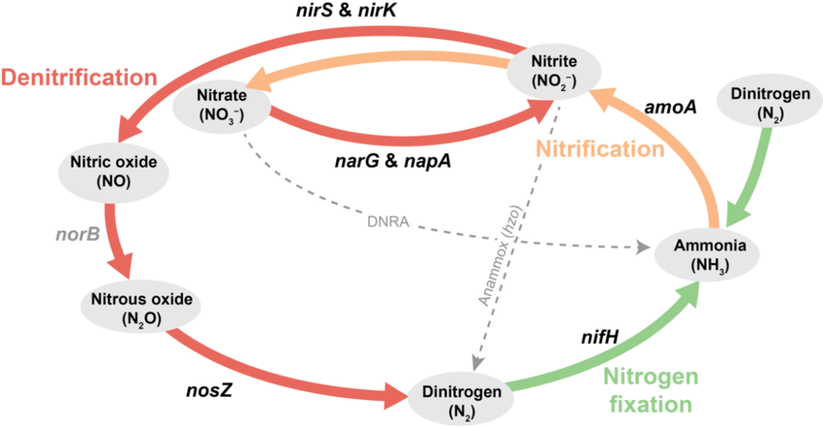
Nutrient Cycling and Availability
Cover crops basically alter the nutrient regimes on the biological fixation, scavenging, and mineralization of nutrients. Leguminous cover crops Vica villosa (hairy vetch), Trifolium incarnatum (crimson clover) and Vigna unguiculata (cowpea) develop symbiotic associations with Rhizobium species, which fix atmospheric nitrogen at a rate of between 50-200kg N/ha depending on species, environment conditions and management. Such fixation process of nitrogen in the biology will reduce the dependence on artificial nitrogen pesticides, and will result in the release of gradual food to crops that will follow it.
The nutrient scavengers are non-leguminous cover crops, and they absorb the remaining nutrients that are likely to be lost through leaching. Brassica species have an extremely high ability to extract phosphorus in the soil by secrete organic acid through the roots, which dissolve phosphorus compounds that are bound. Root deep species access the nutrient at their subsoil levels and move them to the surface by decomposing the biomass (Datta et al., 2023).
Water Management Benefits
Cover crops have a number of impacts on the field water. Living cover reduces the energy of the raindrops, which achieves 85-95 percent of the energy, preventing the sealing of the soil surface and preserving the infiltration capacity. The root channels of cover crops are 50-300 percent saturated with hydraulic conductivity, which improves on deep percolation and recharge of the groundwater. Terminated cover crops on bestow surfaces reduce loss of evaporation by 20-40 percent and even out the variations in soil temperature (Ewert et al., 2023).
Table 2: Water Conservation Effects of Cover Crop Residues
Residue Type | Surface Coverage | Evaporation Reduction | Moisture Retention | Temperature Moderation
Cereal Rye | 80-90% | 35-40% | 25-30% increase | 3-5°C reduction
Hairy Vetch | 60-75% | 25-30% | 18-22% increase | 2-4°C reduction
Mixed Species | 75-85% | 30-38% | 22-28% increase | 3-4°C reduction
Crimson Clover | 65-70% | 20-28% | 15-20% increase | 2-3°C reduction
Annual Ryegrass | 85-95% | 38-45% | 28-35% increase | 4-6°C reduction
Brassica Blend | 70-80% | 28-35% | 20-25% increase | 3-4°C reduction
Oat-Pea Mix | 75-85% | 32-38% | 24-30% increase | 3-5°C reduction
Polyculture Systems for Enhanced Productivity
Ecological Principles of Plant Diversity
Polyculture systems use complementarity and facilitation between plant species in order to maximize their resource use and ecosystem services. Ecological background is based on the niche differentiation in which the species having different root architecture, nutrient needs and phenological use different resource pools. Classical examples are cereal-legume intercrops in which grasses are able to use soil nitrogen and legumes are able to use atmospheric nitrogen in a manner that generates synergistic interactions to increase the productivity of the overall system (Gamage et al., 2024).
Figure 2: Root Architecture Complementarity
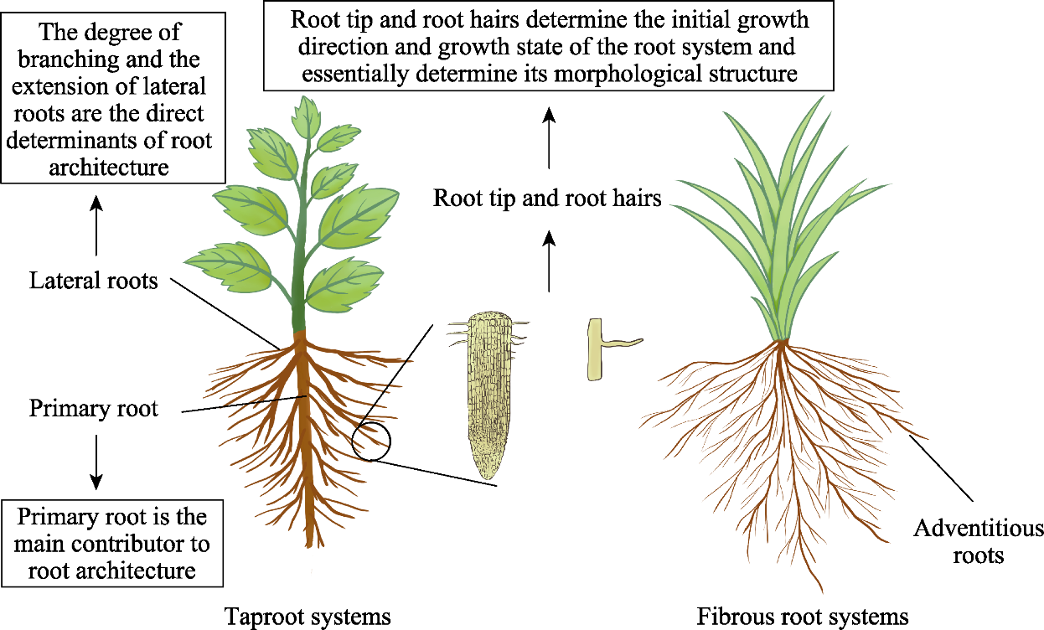
The advantages of polycultures of the kind that are temporally complementary include extended growing seasons and workforce dispersal. Ecological design is high in the fact that Zea mays (maize) is used followed by Phaseolus vulgaris (common bean) and Cucurbita pepo (squash) in the use of the traditional milpa systems. Squash planted early will provide a ground cover which prevents weeds and vertical maize formation will encourage climbing bean species that fix nitrogen and will benefit all three species (Gawande et al., 2023).
Yield Advantages and Ratio of Land Equivalent to Ratios.
Polyculture is also more productive than the monoculture systems in the ratio of land equivalent (LER). Meta-analyses indicate an average LER of two-species mixture of 1.15-1.30 and more mixed of 1.25-1.45. Less intraspecific competition and greater capturing efficiency of resources and positive interspecific interaction are the causes of overyielding phenomenon (Getahun et al., 2024).
Table 3: Productivity Comparison of Polyculture Systems
Cropping System | Component Crops | LER Value | Yield Advantage | Economic Benefit
Maize-Bean | Zea mays + Phaseolus vulgaris | 1.25-1.35 | 25-35% | 30-40% increase
Rice-Fish | Oryza sativa + Aquaculture | 1.40-1.55 | 40-55% | 45-60% increase
Millet-Groundnut | Pennisetum glaucum + Arachis hypogaea | 1.18-1.28 | 18-28% | 22-32% increase
Wheat-Mustard | Triticum aestivum + Brassica juncea | 1.15-1.22 | 15-22% | 18-25% increase
Sugarcane-Pulse | Saccharum officinarum + Cajanus cajan | 1.30-1.42 | 30-42% | 35-48% increase
Cotton-Pigeonpea | Gossypium hirsutum + Cajanus cajan | 1.22-1.32 | 22-32% | 28-38% increase
Cassava-Maize | Manihot esculenta + Zea mays | 1.28-1.38 | 28-38% | 32-42% increase
Pest and Disease Suppression
The polyculture of plant diversity provides undesirable conditions to population explosion of pests in various ways. Resource concentration hypothesis is used to describe the decreased pest loads due to the spatial dilution of host plants amid non-hosts. Natural enemy hypothesis is the reason that pest control is caused by an increased diversity of beneficial arthropods that is facilitated by both floral resources and microhabitats (Kerr et al., 2023).
Figure 3: Pest Density in Mono vs Polyculture
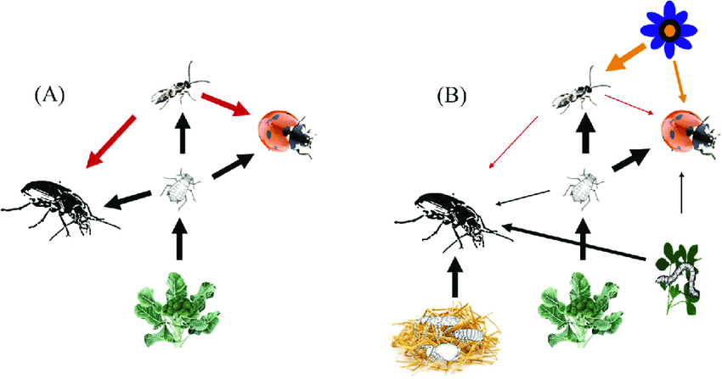
The combinations of plants are amazingly pest suppressing. Intercropping Brassica oleracea (cabbage) with Allium sativum (garlic), or Allium Cepa (onion) reduces by 60-75 percent of the infestation of diamondback moth (plutella Xylostella). Push-pull technologies that involve inter-crop of Desmodium uncinatum and Pennisetum purpureum as border plants reduce 80-90 percent of stem borers in maize and increase soil fertility (Khan, 2024).
Biofertilizers: Plants-Microbes Synergies.
Nitrogen-Fixing Biofertilizers
Among the most significant nitrogen fertilizers alternatives that are sustainable is biological fixation of nitrogen. Symbiotic interactions between legumes and Rhizobium species can fix 50-300 kg/ha/year of N/year which depends on the compatibility between the host and the strain, the soil condition, and management. Complicated inoculant recipes are added to a number of strains that are selected to be effectively utilized in environmental conditions (Lafontaine & Jannoyer, 2014).
Table 4: Nitrogen Fixation Potential of Different Legume-Rhizobia Associations
Host Plant | Rhizobium Species | N-Fixation Rate | Yield Increase | Fertilizer Saved
Soybean (Glycine max) | Bradyrhizobium japonicum | 150-250 kg/ha | 15-25% | 60-80 kg urea/ha
Chickpea (Cicer arietinum) | Mesorhizobium ciceri | 80-140 kg/ha | 12-20% | 40-60 kg urea/ha
Common Bean (Phaseolus vulgaris) | Rhizobium leguminosarum | 60-120 kg/ha | 10-18% | 30-50 kg urea/ha
Groundnut (Arachis hypogaea) | Bradyrhizobium sp. | 100-180 kg/ha | 15-22% | 50-70 kg urea/ha
Pigeon Pea (Cajanus cajan) | Rhizobium sp. | 120-200 kg/ha | 18-28% | 55-75 kg urea/ha
Lentil (Lens culinaris) | Rhizobium leguminosarum | 50-100 kg/ha | 8-15% | 25-45 kg urea/ha
Black Gram (Vigna mungo) | Bradyrhizobium sp. | 70-130 kg/ha | 12-18% | 35-55 kg urea/ha
Figure 4: PSB Action on Soil Phosphorus
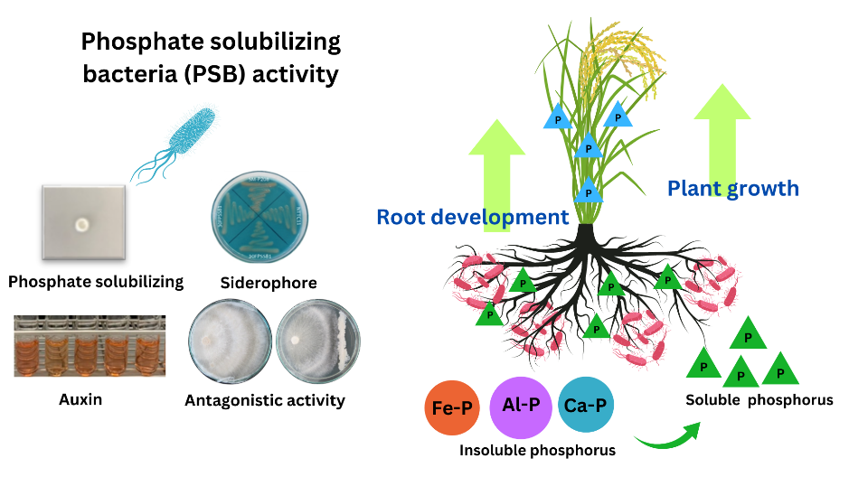
Additional sources of nitrogen include free-living nitrogen fixers such as Azotobacter spp, Azospirillum spp and Gluconacetobacter diazotrophicus which fix nitrogen and form plant growth-promoting compounds. These symbiotic organisms sequester 20-40 kg N/ha in non-leguminous crops and at the same time produce phyto hormones, siderophores and antimicrobial compounds that improve the growth and well being of the plant (Lichtfouse, 2013).
Phosphate-Solubilizing Microorganisms
Availability of phosphorus restricts the yield of crops in most soils even though the total amount of phosphorus is high but has been stored in insoluble mineral forms. PSB phosphate-solubilizing bacteria (Bacillus spp., Pseudomonas spp., and Enterobacter spp) release organic acids, phosphatases, and chelating compounds which loosen bound phosphorus. PSB field use boosts the amount of availed phosphorus by 3050 percent and crop yields by 1020 percent (Liu et al., 2024).
Mycorrhizal Associations
AMF establish symbiosis with 80 percent of terrestrial plants and significantly increase root surface area to obtain nutrients. The networks of hyphae grow 10-100 cm farther than the root zones and tap into phosphorus, zinc, copper and other nutrients that the roots alone cannot reach in soil volumes. The AMF inoculation enhances phosphorus uptake by 50-300 percent and has improved the ability of drought tolerance by enhancing water absorption (Mahmood et al., 2024).
Table 5: Crop Response to Mycorrhizal Inoculation
Crop Species | AMF Species | P Uptake Increase | Yield Enhancement | Water Use Efficiency
Maize (Zea mays) | Glomus intraradices | 80-150% | 15-30% | 25-35% improvement
Wheat (Triticum aestivum) | Glomus mosseae | 60-120% | 12-25% | 20-30% improvement
Rice (Oryza sativa) | Glomus fasciculatum | 50-100% | 10-20% | 15-25% improvement
Tomato (Solanum lycopersicum) | Mixed AMF | 100-200% | 20-40% | 30-45% improvement
Onion (Allium cepa) | Glomus versiforme | 120-250% | 25-45% | 35-50% improvement
Potato (Solanum tuberosum) | Glomus etunicatum | 70-140% | 15-28% | 22-32% improvement
Sorghum (Sorghum bicolor) | Mixed AMF | 90-170% | 18-32% | 28-38% improvement
Botanical Pest Management Strategies
Plant-Derived Insecticides
Other alternatives that are less damaging to the synthetic pesticides are the botanical insecticides which are fastest biodegraded, and have minimal impact on non-targets. The most researched source Azadirachta indica (neem) contains azadirachtin and other related limonoids that disrupt insect feeding, growth and reproduction. Neem preparations control over 200 species of pests with LC 50 values of 0.1 -10ppm to unsusceptible species (Mamatha et al., 2024).
Figure 5: Azadirachtin Effects on Insects
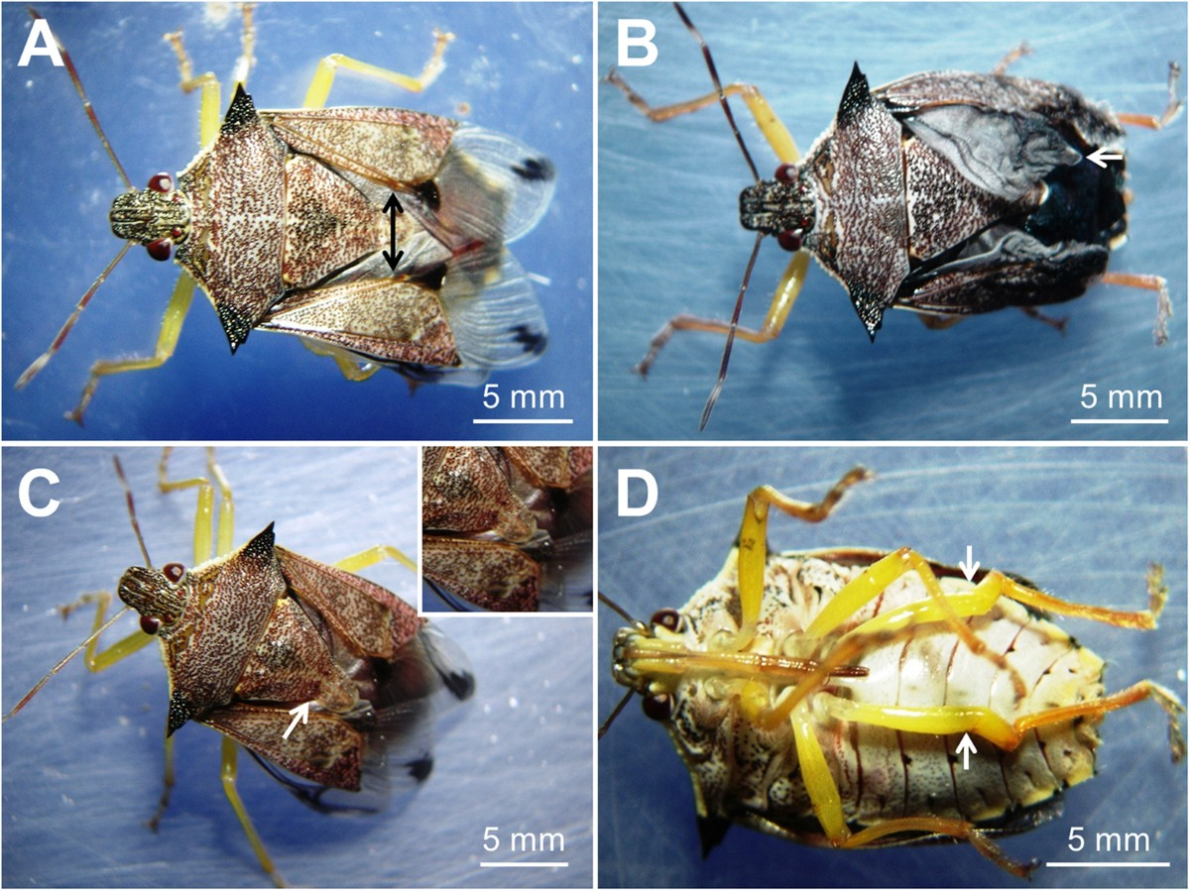
Chrysanthemum cinerariaefolium produces pyrethrins which cause rapid knockdown due to interruption with sodium channels in insect nervous systems. The pyrethrin extracts employed in nature are also degradable in hours under the sun eliminating issues of environmental persistence. The significant substitute sources of botanical insecticides include Derris spp. (rotenone), Nicotian tabacum (nicotine) and Ryania speciosa (ryanodine) (Mohanty et al., 2024).
Antifeedants/ Repellents Plants.
Strategic use of repellent plants as a strategy of pest management without the use of lethal techniques is a behavior change. Tanacetum vulgare (tansy), Artemisia absinthium (wormwood), and Rosmarinus officinalis (rosemary) are the plants that release volatile compounds which discourage various pest species. With these aromatic species planted as border plantation or intercrop with the adjacent crops, the population of pests attaching to the crop is reduced by 40-70 percent as a result (Nath, 2024; Oberč & Schnell, 2020).
Table 6: Efficacy of Botanical Pest Management Approaches
Botanical Source | Active Compounds | Target Pests | Efficacy Range | Application Method
Neem (Azadirachta indica) | Azadirachtin, Nimbin | Lepidoptera, Hemiptera | 70-90% control | Foliar spray
Pyrethrum (Chrysanthemum) | Pyrethrins | Flying insects | 80-95% knockdown | Contact spray
Garlic (Allium sativum) | Allicin, Diallyl disulfide | Aphids, Thrips | 60-80% repellency | Extract spray
Tobacco (Nicotiana tabacum) | Nicotine | Soft-bodied insects | 75-85% mortality | Aqueous extract
Custard Apple (Annona) | Annonaceous acetogenins | Stored grain pests | 70-85% control | Seed powder
Lantana (Lantana camara) | Lantadenes | Mosquitoes, Flies | 65-80% repellency | Leaf extract
Marigold (Tagetes) | Thiophenes, Limonene | Nematodes, Whitefly | 55-75% reduction | Intercropping
Trap Crops and Banker Plants
Trap cropping takes advantage of preferences of the pests to accumulate them around the primary crops. Indian mustard (Brassica juncea) planted as a border crop benefits the crops of diameterback moth, aphids, and flea beetles and thereby mitigates infestation of main crops by 60-80%. Targeted interventions can be applied to trap crops or the crops destroyed before the pest can disperse as much as possible reducing the application of pesticides (Ojadi, 2023; Piñeiro et al., 2020).
Figure 6: Spatial Arrangement for Pest Management
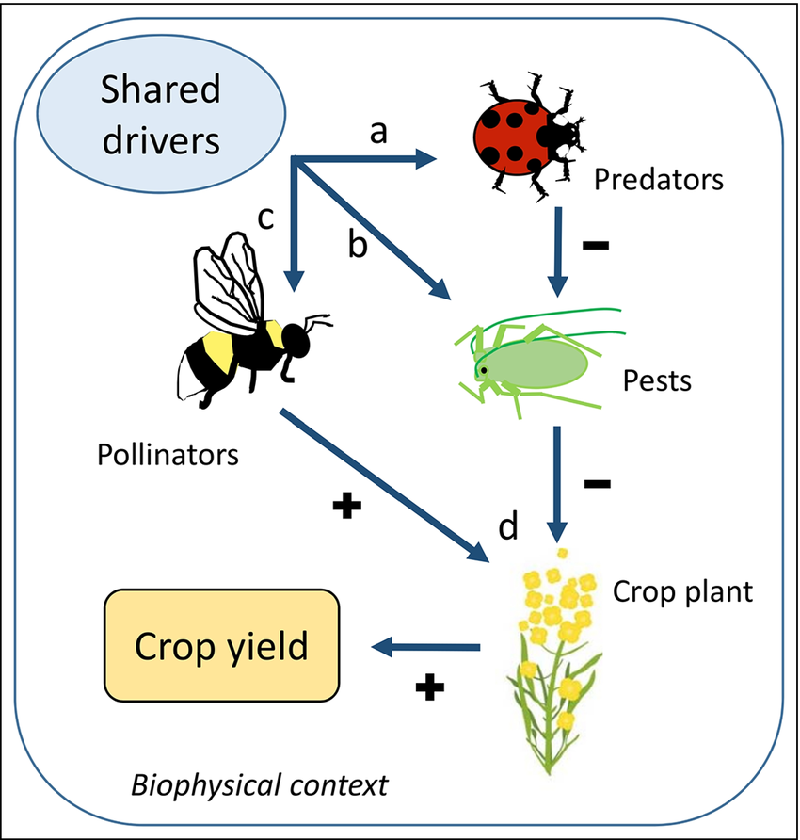

Banker plants contribute to maintenance of desirable populations of arthropods which have been the source of biological control. In Lobularia maritima (sweet alyssum), Fagopyrum esculentum (buckwheat), and Phacelia tanacetifolia, predators and parasitoids feeding on pest species are found growing. Natural enemies abundance during growing seasons can be boosted by 3-5 folds with planting of banker plants strategically that can boost pest control (Sekhar et al., 2024).
Integration and Synergies
Systems-Level Benefits
The shareholder impacts of the components are not as great as the leverage of the synergies of different plant based practices. Poly culture rotations and using cover crops build up soil organic matter and also diversification of production and revenue streams. Leguminous cover crops provide soil with nitrogen to the subsequent intercrops in addition to improving the soil structure to allow intricate root systems. This is because the applications of biofertilizers enhance the formation of biomass covers and nitrogen fixation rates (P. Sharma et al., 2024).
Economic Considerations
Sustainable practices in plants are long-term investments that are pegged on initial investment in seeds, inoculants, and education. However, the low price of input and access to the high end market tends to be recouped within 2- 3 seasons. Economic analyses indicate that integrated sustainable systems make up 15-40% more profitable than conventional monocultures would in respect to overall costs of production and worth of ecosystem services.
Figure 7: Cumulative Benefits of Integration
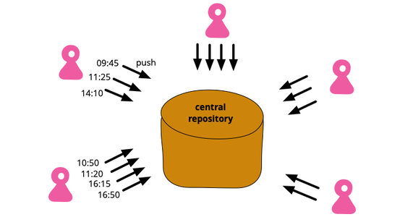
Table 7: Economic Analysis of Sustainable Practice Adoption
Practice Combination | Initial Investment | Payback Period | Net Return Increase | Risk Reduction
Cover Crop + Polyculture | $150-250/ha | 2-3 years | 25-35% | 30-40%
Biofertilizer + Botanicals | $80-120/ha | 1-2 years | 20-30% | 25-35%
Full Integration | $200-350/ha | 2-4 years | 35-45% | 40-50%
Polyculture + Trap Crops | $100-180/ha | 1-3 years | 22-32% | 28-38%
AMF + Cover Crops | $120-200/ha | 2-3 years | 28-38% | 32-42%
Green Manure + Biocontrol | $90-150/ha | 1-2 years | 18-28% | 22-32%
Complete System | $300-450/ha | 3-5 years | 40-55% | 45-60%
Challenges and Future Directions
Implementation Barriers
Though proven to be beneficial, the implementation of sustainable practices grounded on plants is limited by various limitations. Knowledge-intensive management needs education to the farmers and technical assistance which is usually not offered in the rural regions. Cover crop and traditional varieties of seeds and their systems must be fortified to guarantee quality availability of germplasm. Market systems that are inclined towards monoculture commodities will not support diversification unless there is a policy in place (S. Sharma & K.C., 2024).
Figure 8: Pathways to Overcome Constraints
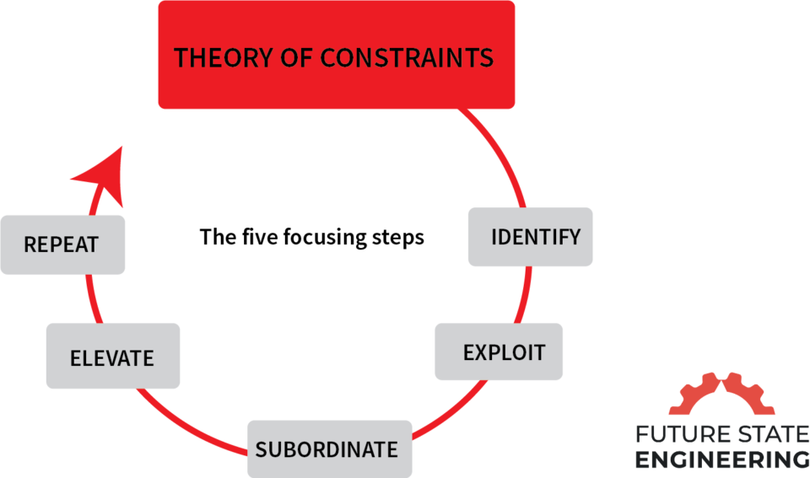
Figure 9: Multi-stakeholder Scaling Approach
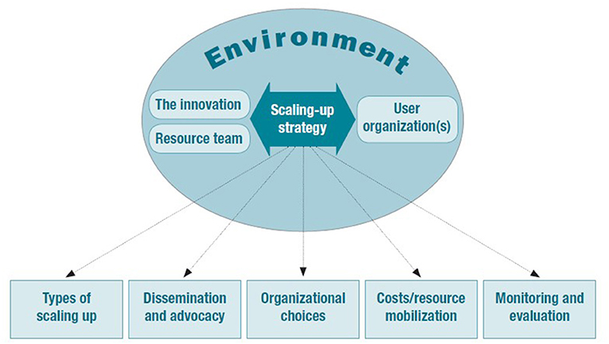
Climate Change Adaptation
There is also a weakness in the agricultural systems to the climatic variability, and thus, resilient practices are being used. Plant heterogenity helps to reduce extremes in weather because of stress variation, and maturity epochs. Planted cover crops access the tap water during dry seasons and planting mulches reduce the heights and lows of the temperatures. Among the research priorities is the selection and breeding of climate-adaptive cultivars so as to have systems that produce sustainability (Singh et al., 2024).
Scaling Mechanisms
A proper scaling should be both technically and socially and on policy level. The mechanisms of efficient knowledge transfer and the adoption rates of the participants of Farmer field schools are higher than 60 due to the institutions of these schools. The electronic media are increasingly proving effective in terms of information exchange and market connections. The policy support through the payment of ecosystem services and sustainable certification programs motivates and renders it cost-effective (Sithole & Olorunfemi, 2024).
Research Priorities
The paper needs to be expanded in future research by the context specific optimization of the plant mixes to apply them to different agro ecological regions. Understanding of interactions between plants, soil and microbes at the molecular scale will aid in taking certain actions that will enhance positive interactions. Proper mechanization to various cropping systems should be developed to become efficient with regards to labor. The evidence on policy supports will be furnished by the provision of ecosystem services and economic sustainability to the long-term studies (Valavi et al., 2025).
Figure 10: Integrated Research Priorities
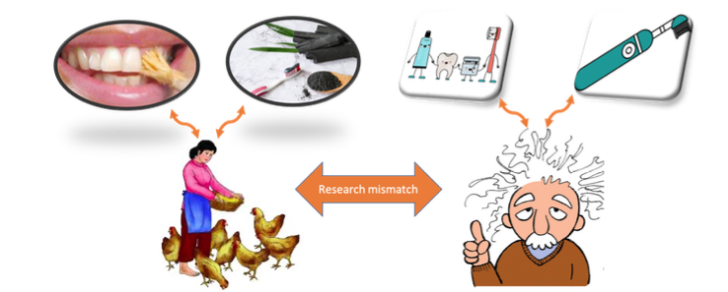
Conclusion
Sustainable agriculture practices based on plants provide possible solutions towards food security and recovering environmental resources. Individual and synergistic advantages are shown in terms of productivity, profitability and ecology with cover crops, polycultures, biofertilizers and botanical pest management. The implementation issues have to be solved by the concerted work of the scientists, extension services, farmers and policy-makers. The key to success is adaptation, management, and favorable institutional structures which are specific to the context. The indications have been overwhelming in support of a shift in agricultural systems to be plant-based to ensure a sustainable intensification that satisfies the demands of the human population and planetary toxins. The further development requires further innovation, collaboration with multiple stakeholders, and adherence to the principles of ecology used to transform agriculture.
References
- Banusri, M., Bharath, H. R. R., G, G. K., & P, A. (2023). Impact of CSR Activities on the Enhancement of Income of Farmers in Sustainable Agriculture. International Journal for Research in Applied Science and Engineering Technology, 11(10), 1502. https://doi.org/10.22214/ijraset.2023.56237

- Chandel, N., Kumar, A., & Kumar, R. (2024). Towards Sustainable Agriculture: Integrating Agronomic Practices, Environmental Physiology and Plant Nutrition. International Journal of Plant & Soil Science, 36(6), 492. https://doi.org/10.9734/ijpss/2024/v36i64651

- Datta, S., Hamim, I., Jaiswal, D. K., & Sungthong, R. (2023). Sustainable agriculture. BMC Plant Biology, 23(1). https://doi.org/10.1186/s12870-023-04626-9

- Ewert, F., Baatz, R., & Finger, R. (2023). Agroecology for a Sustainable Agriculture and Food System: From Local Solutions to Large-Scale Adoption. Annual Review of Resource Economics, 15(1), 351. https://doi.org/10.1146/annurev-resource-102422-090105

- Gamage, A., Gangahagedara, R., Subasinghe, S., Gamage, J., Guruge, C., Senaratne, S., Randika, T., Rathnayake, C., Hameed, Z., Madhujith, T., & Merah, O. (2024). Advancing Sustainability: The Impact of Emerging Technologies in Agriculture. Current Plant Biology, 100420. https://doi.org/10.1016/j.cpb.2024.100420

- Gawande, V., Saikanth, D. R. K., Sumithra, B. S., Aravind, S. A., Swamy, G. N., Chowdhury, M., & Singh, B. V. (2023). Potential of Precision Farming Technologies for Eco-Friendly Agriculture. International Journal of Plant & Soil Science, 35(19), 101. https://doi.org/10.9734/ijpss/2023/v35i193528

- Getahun, S., Kefale, H., & Gelaye, Y. (2024). Application of Precision Agriculture Technologies for Sustainable Crop Production and Environmental Sustainability: A Systematic Review [Review of Application of Precision Agriculture Technologies for Sustainable Crop Production and Environmental Sustainability: A Systematic Review]. The Scientific World JOURNAL, 2024(1). Hindawi Publishing Corporation. https://doi.org/10.1155/2024/2126734

- Kerr, R. B., Postigo, J. C., Smith, P., Cowie, A., Singh, P. K., Rivera‐Ferre, M. G., Tirado, C., Campbell, D., & Neufeldt, H. (2023). Agroecology as a transformative approach to tackle climatic, food, and ecosystemic crises. Current Opinion in Environmental Sustainability, 62, 101275. https://doi.org/10.1016/j.cosust.2023.101275

- Khan, N. (2024). Unlocking Innovation in Crop Resilience and Productivity: Breakthroughs in Biotechnology and Sustainable Farming. Innov Discov, 1, 28. https://doi.org/10.53964/id.2024028

- Lafontaine, H. O., & Jannoyer, M. (2014). Sustainable Agriculture Reviews 14. In Sustainable agriculture reviews. Springer International Publishing. https://doi.org/10.1007/978-3-319-06016-3

- Lichtfouse, É. (2013). Sustainable Agriculture Reviews. In Sustainable agriculture reviews. Springer International Publishing. https://doi.org/10.1007/978-94-007-5961-9

- Liu, M., Chen, X., & Jiao, Y. (2024). Sustainable Agriculture: Theories, Methods, Practices and Policies. Agriculture, 14(3), 473. https://doi.org/10.3390/agriculture14030473

- Mahmood, H., Hassan, M. S., Meraj, G., & Furqan, M. (2024). Agriculture’s Role in Environmental Sustainability: A Comprehensive Review of Challenges and Solutions [Review of Agriculture’s Role in Environmental Sustainability: A Comprehensive Review of Challenges and Solutions]. Challenges in Sustainability, 12(3), 178. Librelloph. https://doi.org/10.56578/cis120302

- Mamatha, B., Mudigiri, C., Ramesh, G., Saidulu, P., Meenakshi, N., & Prasanna, C. L. (2024). Enhancing Soil Health and Fertility Management for Sustainable Agriculture: A Review [Review of Enhancing Soil Health and Fertility Management for Sustainable Agriculture: A Review]. Asian Journal of Soil Science and Plant Nutrition, 10(3), 182. Sciencedomain International. https://doi.org/10.9734/ajsspn/2024/v10i3330

- Mohanty, L. K., Singh, N. K., Raj, P., Prakash, A., Tiwari, A. K., Singh, V., & Sachan, P. (2024). Nurturing Crops, Enhancing Soil Health, and Sustaining Agricultural Prosperity Worldwide through Agronomy. Journal of Experimental Agriculture International, 46(2), 46. https://doi.org/10.9734/jeai/2024/v46i22308

- Nath, S. (2024). A vision of precision agriculture: Balance between agricultural sustainability and environmental stewardship. Agronomy Journal, 116, 1126. https://doi.org/10.1002/agj2.21405

- Oberč, B. P., & Schnell, A. A. (2020). Approaches to sustainable agriculture: exploring the pathways towards the future of farming. https://doi.org/10.2305/iucn.ch.2020.07.en

- Ojadi, F.-X. I. (2023). Sustainable Agricultural Practices: Value Chain of Egusi, A Local Soup Condiment in Nigeria. In IntechOpen eBooks. IntechOpen. https://doi.org/10.5772/intechopen.109854

- Piñeiro, V., Arias, J., Dürr, J., Elverdin, P., Ibáñez, A. M., Kinengyere, A. A., Opazo, C., Owoo, N. S., Page, J., Prager, S. D., & Torero, M. (2020). A scoping review on incentives for adoption of sustainable agricultural practices and their outcomes [Review of A scoping review on incentives for adoption of sustainable agricultural practices and their outcomes]. Nature Sustainability, 3(10), 809. Nature Portfolio. https://doi.org/10.1038/s41893-020-00617-y

- Sekhar, M., Rastogi, M., M, R. C., Saikanth, D. R. K., Rout, S., Kumar, S., & Patel, A. K. (2024). Exploring Traditional Agricultural Techniques Integrated with Modern Farming for a Sustainable Future : A Review. JSRR, 30, 185. https://doi.org/10.9734/jsrr/2024/v30i31871

- Sharma, P., Sharma, P., & Thakur, N. (2024). Sustainable farming practices and soil health: a pathway to achieving SDGs and future prospects. Discover Sustainability, 5(1). https://doi.org/10.1007/s43621-024-00447-4

- Sharma, S., & K.C., B. (2024). Sustainable Agriculture and It’s Practices: A Review [Review of Sustainable Agriculture and It’s Practices: A Review]. Turkish Journal of Agriculture - Food Science and Technology, 12(12), 2631. Turkish Science and Tecnology (TST). https://doi.org/10.24925/turjaf.v12i12.2631-2639.6622

- Singh, A., Pandey, A. K., Santhosh, D., Ganavi, N. R., Sarma, A., Deori, C., Das, J., & D, S. K. (2024). A Comprehensive Review on Greenhouse Gas Emissions in Agriculture and Evolving Agricultural Practices for Climate Resilience [Review of A Comprehensive Review on Greenhouse Gas Emissions in Agriculture and Evolving Agricultural Practices for Climate Resilience]. International Journal of Environment and Climate Change, 14(5), 455. Sciencedomain International. https://doi.org/10.9734/ijecc/2024/v14i54206

- Sithole, A., & Olorunfemi, O. D. (2024). Sustainable Agricultural Practices in Sub-Saharan Africa: A Review of Adoption Trends, Impacts, and Challenges Among Smallholder Farmers [Review of Sustainable Agricultural Practices in Sub-Saharan Africa: A Review of Adoption Trends, Impacts, and Challenges Among Smallholder Farmers]. Sustainability, 16(22), 9766. Multidisciplinary Digital Publishing Institute. https://doi.org/10.3390/su16229766

- Souto, A. L., Sylvestre, M., Tölke, E. D., Tavares, J. F., Barbosa‐Filho, J. M., & Cebrián‐Torrejón, G. (2021). Plant-Derived Pesticides as an Alternative to Pest Management and Sustainable Agricultural Production: Prospects, Applications and Challenges [Review of Plant-Derived Pesticides as an Alternative to Pest Management and Sustainable Agricultural Production: Prospects, Applications and Challenges]. Molecules, 26(16), 4835. Multidisciplinary Digital Publishing Institute. https://doi.org/10.3390/molecules26164835

- Valavi, A. R. J., Raj, M. S. S., & Sebastian, A. (2025). Examining the possibility of Integrating Sustainable Agricultural Practices into Laws for safeguarding the rights of farm animals. Derecho Animal Forum of Animal Law Studies, 15(1), 83. https://doi.org/10.5565/rev/da.659

- Xing, Y., Wang, X., & Mustafa, A. (2025). Exploring the link between soil health and crop productivity [Review of Exploring the link between soil health and crop productivity]. Ecotoxicology and Environmental Safety, 289, 117703. Elsevier BV. https://doi.org/10.1016/j.ecoenv.2025.117703

- Zheng, H., Ma, W., & He, Q. (2024). Climate-smart agricultural practices for enhanced farm productivity, income, resilience, and greenhouse gas mitigation: a comprehensive review [Review of Climate-smart agricultural practices for enhanced farm productivity, income, resilience, and greenhouse gas mitigation: a comprehensive review]. Mitigation and Adaptation Strategies for Global Change, 29(4). Springer Science+Business Media. https://doi.org/10.1007/s11027-024-10124-6

