Original Research Article

Morphological Identification and Characterisation of High-Performance Morphotypes of Pterocarpus erinaceus for Reforestation in Northern Côte d'Ivoire

Abstract

Pterocarpus erinaceus is a species native to Africa, recognized for its high socio-economic potential. However, overexploitation has led to a reduction in its populations and the disappearance of high-performing morphotypes. The high-performance morphotypes that still exist are poorly documented, hence the interest of this study, which aims to identify and characterize them in order to provide plant material suitable for reforestation programmes. The study was conducted in the classified forests of Boundiali and La Palée. Following three (3) prospecting areas, a system of quadrats associated with transects was installed. The data collected was analyzed using descriptive statistics, then structured using principal component analysis, followed by ascending hierarchical classification. As a result, 123 morphotypes of interest were identified among the 865 trees listed, representing 14.22%, a relatively low rate. Zone 3 has a higher density of trees of interest than zones 1 and 2, estimated at 6.43 trees of interest per hectare. The trees of interest were grouped into three morphotypes. The first morphotype, composed of young trees, constitutes a genetic reservoir for future reforestation programs. The second morphotype is composed of slender individuals that may possess rare alleles inherited from large trees that have disappeared as a result of illegal logging. The third morphotype, consisting of dominant and mature trees, constitutes a seed bank and contributes to maintaining gene flow between generations. These different morphotypes will provide high-quality plant material and guide reforestation programs for the sustainable management of the species.

Keywords: Pterocarpus erinaceus; Identification; Morphological characterisation; Classified forest; Côte d'Ivoire

- Introduction
According to the Forest Code in Côte d'Ivoire, Law No. 2019-675 of 23 July 2019 (Article 1) defines a forest as any area of at least 0.1 hectares in a single block, containing forest trees whose crowns cover at least 30% of the surface area and which can reach a height of at least 5 metres when mature. This vegetation formation represents a dynamic and heterogeneous environment, exerting a direct or indirect effect on the soil, climate and water regime. The natural resource potential it contains is an important source of income for local populations.
Among these resources is Pterocarpus erinaceus, a deciduous tree that can reach a height of 15 to 25 metres (Duvall, 2008). This tree is of considerable social and economic importance. Its parts have many therapeutic properties and are used in the treatment of more than sixty ailments (Ouinsavi et al., 2021). Its wood is also highly prized, particularly for the manufacture of musical instruments such as the balafon, but also as timber for making furniture (beds, tables and parquet flooring) and decorative objects (Traoré and Martinez-Cortizas, 2023; Gérard et al., 2016). In addition, its leaves are used as fodder for livestock, particularly goats and sheep (Silué et al., 2014).
P. erinaceus is found in Africa in the Guineo-Sudanese and Sudano-Sahelian zones (Arbonnier, 2004; Ouédraogo et al., 2006). In Côte d'Ivoire, according to the national forest and wildlife inventory (IFFN) carried out from 2019 to 2020, the species is widely distributed in the northern half of the country, with a high concentration from V Baoulé (from Kpouebo to Bouaké), the contact zone between the forest domain in the south and the savannah in the north (Zon et al., 2022). It is reported in several classified forests. A classified forest is known to be an area whose boundaries and use are defined by regulations.
However, the events of the Ivorian crisis from 2002 to 2010 led to a significant deterioration of these areas, marked by the violation of forest boundaries and increased illegal exploitation of resources. Between 2010 and 2016, P. erinaceus was subject to intensive exploitation, with exports to China estimated at over US$400 million in 2014 (UN, 2014; Interpol, 2016; EIA, 2022). This sustained anthropogenic pressure has caused a significant decline in the various P. erinaceus populations, characterised by a decrease in mature individuals, a reduction in natural regeneration potential and worrying genetic erosion.
In this context, it appears essential to identify morphotypes with interesting morphological traits in order to develop plant material suitable for reforestation and restoration programs in classified forests. However, the lack of data on the morphological variability of P. erinaceus in northern Côte d'Ivoire limits the selection of high-performance reproductive material for reforestation. Hence, the interest of this work, which aims to identify and characterize the morphotypes of P. erinaceus that are likely to constitute high-performance plant material for reforestation programmes. More specifically, the aim is to: (i) identify the trees with the best morphological conformations in each surveyed area , and (ii) characterize the intra- and inter-population morphological variability that exists within this population of trees of interest.

- Materials and methods
  - Study site
The study was conducted in two classified forests located in northern Côte d'Ivoire, the Palée and Boundiali classified forests. The Boundiali classified forest, covering an area of 78,000 hectares, has two prospecting areas inventoried (Area 1 and Area 2). In the Palée classified forest, covering an area of 45,000 hectares, only one area was surveyed (Zone 3) (Figure 1). These two classified forests are situated in the Bagoué region, with its capital being the town of Boundiali, located 800 kilometers from Abidjan, the economic capital of Côte d'Ivoire. The climate of the Bagoué region is Sudanese, characterized by a long dry period from October to May and a rainy season with two peak rainfall periods, in June and September (Table 1). Temperatures in the region range from 21 to 35 °C. The landscape is marked by inselbergs reaching heights of 421 meters, as well as plateau areas. The vegetation of Bagoué is typical of Sudanese zones, with tree species such as iroko (Milicia excelsa), teak (Tectona grandis) and Vène wood (Pterocarpus erinaceus) being prevalent (Ministry of Agriculture and Rural Development, 2021).

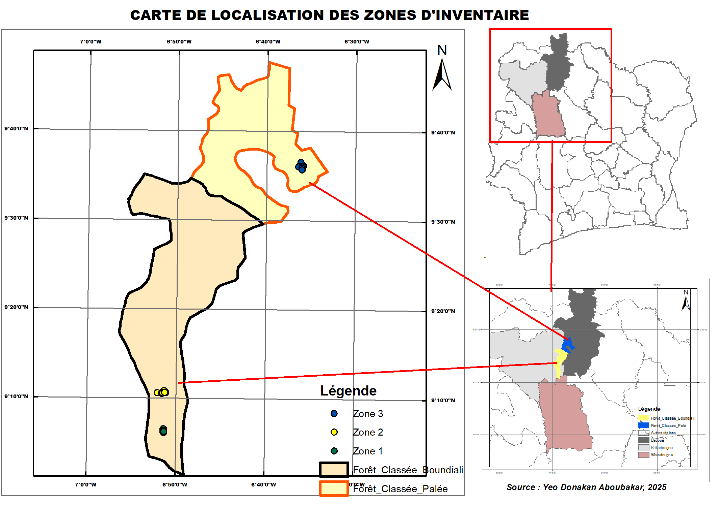
Fig.1 . Map of inventory areas

Table 1. Monthly rainfall in Boundiali from 2011 to 2020 (Source: Ministry of Agriculture and Rural Development, 2021)
Year | January | February | March | April | May | June | July | August | September | October | November | December | Total
2011 | 0 | 19.5 | 75.0 | 53.0 | 131.0 | 142.0 | 252.5 | 198.0 | 184.0 | 174.0 | 0.0 | 0 | 1,229.0
2012 | 0.0 | 8.6 | 42.8 | 140.1 | 165.8 | 136.7 | 180.1 | 319.0 | 211.6 | 108.4 | 46.7 | 41.1 | 1,400.9
2013 | 0.0 | 37.2 | 91.7 | 97.9 | 210.0 | 161.7 | 109.2 | 199.2 | 240.3 | 127.0 | 21.4 | 14.6 | 1,310.2
2014 | 0.0 | 30.8 | 66.0 | 257.1 | 168.4 | 227.9 | 87.9 | 358.9 | 255.0 | 123.1 | 134.4 | 0 | 1,709.5
2015 | 0.0 | 0.0 | 13.3 | 11.0 | 154.4 | 132.5 | 127.4 | 404.8 | 269.2 | 239.4 | 45.7 | 0.0 | 1,397.7
2016 | 31.6 | 10.2 | 18.4 | 142.9 | 126.0 | 99.6 | 290.5 | 277.3 | 186.4 | 21.9 | 27.1 | 0 | 1,231.9
2017 | 0.0 | 0.0 | 21.2 | 112.7 | 87.6 | 153.8 | 396.8 | 176.7 | 126.7 | 34.8 | 4.8 | 0 | 1,115.1
2018 | 0.8 | 30.2 | 52.6 | 85.3 | 145.5 | 265.9 | 474.5 | 236.5 | 425.4 | 180.3 | 45.7 | 0 | 1,942.8
2019 | 0.0 | 0.1 | 49.2 | 95.5 | 95.1 | 137.0 | 108.5 | 623.7 | 333.0 | 167.9 | 69.1 | 0 | 1,679.1
2020 | 0.0 | 0.5 | 95.8 | 70.9 | 121.9 | 180.6 | 300.7 | 261.3 | 133.6 | 1.3 | 0.0 | 0.0 | 1,166.6

  - Plant Material
The plant material used in this study initially consisted of all mature P. erinaceus trees found in each of the areas surveyed. Subsequently, only trees with good morphological conformation that could be of interest for exploitation were preselected.
  - Study Method
    - Method for identifying and selecting morphotypes
Adult P. erinaceus trees were identified using a quadrat system combined with transects. This involved identifying wooded and accessible hilltops, from which a 100 x 200 metre mother plot was established, constituting the zero quadrat of the inventory. From this point, transects were opened in the cardinal directions (north, south, west and east), descending from the summit until a natural obstacle such as a watercourse or the flank of a new summit was encountered. Along each trail, 100 x 200 metre quadrats were laid out at regular intervals of 100 metres. In each quadrat, P. erinaceus trees were listed and then coded. Trees selected through mass selection were given the symbol "+" added to their code. This selection consisted of retaining individuals with good morphological and health characteristics. Each tree was given a score based on its straightness, which had to be as straight as possible, the appearance of its trunk and crown, and finally, the absence of defects such as grooves, bumps, etc. The selected trees were subjected to morphometric measurements to characterise their morphotypes.
    - Data Collection
Data collection was carried out on all the selected trees. It consisted of taking several quantitative measurements. Seven (7) main variables were measured. The total height of the tree (Hato), measured from the base of the tree to the highest point of the living crown. The height of the trunk (HTrc) and the height of the first branch of the tree (HPBrch). The diameter of the tree at 1.3 m above the ground (DTrc); determined from the circumference using the formula:
$DHoup=\frac{C}{π}$ ; where D is the diameter and C is the circumference.
The north-south (EnNS) and east-west (EnOE) spans were measured using a tape measure, which made it possible to calculate the average crown diameter (DHoup) using the formula:
$DHoup=\frac{EnNS+EnOE}{2}$
    - Data analysis
The data collected was processed using R software version 4.4.3.
First, a Chi-square test was utilized to compare the proportions of selected trees among the different areas. Subsequently, an analysis of variance (ANOVA) was conducted to compare the average densities of identified and selected trees by area. Interpopulation diversity was evaluated using the Kruskal-Wallis test at a 5% threshold. If this test yield significance for each quantitative parameter, a post-hoc test was performed. Prior to these analyses were preceded by descriptive statistics were conducted on quantitative parameters , including mean, minimum, maximum, standard deviation and coefficient of variation.
The selected trees were then analyzed using principal component analysis (PCA), a commonly used tool in forestry to identify the variables that contribute most to morphological variability (Murariu, 2025). following this step , an ascending hierarchical classification (AHC), as conducted to group the trees based on their similarity using Ward's method applied to the Euclidean distance matrix (Legendre and Legendre, 2012).
- Results
  - Identification and distribution of individuals of interest of Pterocarpus erinaceus
The floristic inventory carried out in the three study areas identified 865 mature P. erinaceus trees. Of these, 123 trees, or 14.22%, were identified as being of interest for reforestation programmes (Table 2). The χ² test revealed a significant difference in the proportions of trees of interest and 'simple' trees in the three areas (p<0.001). In zone 1 of the Boundiali classified forest, the proportion of trees of interest is 9.68% (CI = [0.05; 0.18]), while in zone 2 it is 6.54% (CI = [0.04; 0.10]). The confidence intervals (CI) for zones 1 and 2 overlap, indicating that there are no statistically significant differences between their proportions of trees of interest. In contrast, zone 3 of the Palée classified forest has the highest proportion of trees of interest, at 22.22% (CI = [0.18; 0.27]). As the lower limit of the CI for zone 3 is higher than the upper limit for zones 1 and 2, this reveals a significant difference between zone 3 of La Palée and zones 1 and 2 of Boundiali.
Table 3 shows that the total density of trees inventoried in each zone is statistically different (F = 5.61; P = 0.008). Zone 2 of the Boundiali classified forest has the highest density of trees at 20.4 trees/ha. Zone 3 of the La Palée classified forest has a total tree density estimated at 11.2 trees/ha, while zone 1 has a tree density per hectare estimated at 7.75 trees/ha. The average density of trees of interest in the different zones is almost identical (F = 1.583; P = 0.225). However, zone 3 appears to have the highest density of trees per hectare, with an average of 1.50 trees of interest/ha. Zones 1 and 2 have densities of 1.25 trees of interest/ha and 1.30 trees of interest/ha, respectively.

Table 2. Proportion of Pterocarpus erinaceus trees identified in the different zones
Methods | Total | Zone 1 | Zone 2 | Zone 3 | P
Total tree | 865 | 93 | 367 | 405
Interest income trees (%) | 123 (14.22) | 9 (9.68) | 24 (6.54) | 90 (22.22) | <0.001
CI (95%) Interest trees | [0.12; 0.17] | [0.03; 0.16] | [0.04; 0.09] | [0.18; 0.26] | <0.001
Single trees (%) | 742 (85.78) | 84 (90.32) | 343 (93.46) | 315 (77.78) | <0.001
CI (95%) Single trees | [0.83; 0.88] | [0.84; 0.97] | [0.91; 0.96] | [0.74; 0.82] | <0.001
P: P-value of the chi-square test; CI: Confidence interval

Table 3. Density of Pterocarpus erinaceus trees identified in each zone
Zone | Zone 1 | Zone 2 | Zone 3 | F | P
Number of plots | 6 | 9 | 18
Number of trees | 93 | 367 | 405
Total tree density (ha) | 7.75^{b} | 20.4ª | 11.2^{b} | 5.61 | 0.008
Interest rate density | 1.12 ± 1.25 | 2 ± 1.30 | 2.5 ± 1.50 | 1.523 | 0.225
P: P. Value of ANOVA test; *numbers with different letters are statistically different
  - Structure and selection of tree diversity of interest in Pterocarpus erinaceus
    - Evaluation of intra- and inter-population diversity of trees of interest
Descriptive analysis of the various parameters (Table 4) evaluated shows that, for most of the parameters studied, no significant difference is observed between the three zones at the 5% threshold. Only trunk diameter (DTrc) shows a significant difference between the three zones (P = 0.043). Zone 3 includes trees with a larger average trunk diameter of 36.01 cm. The average trunk diameter in zones 1 and 2 is 31.86 cm and 29.84 cm, respectively. The coefficient of variation (CV) shows marked variability only for trunk diameter in zone 3 (CV = 31.88%), unlike zones 1 (CV = 19.09) and 2 (CV = 21.39%), where variability remains moderate (CV < 30%).
In zone 1, the trees have an average exploitable stem height (Hfut) of 5.90 m with a high variability estimated at 40.88%. As for the height of the first branch (HPBranch) and the total height (Hato), they are 5.07 m and 16.29 m, respectively, with variability between trees. For crown dimensions, there is variability between trees with coefficients of variation greater than 30% for the parameters north-south span (CV = 36.96%), west-east span (CV = 30.97%) and crown diameter (CV = 33.02%).
In zone 2, the trees have a total height (Hato) of 11.40 m, a stem height (Hfut) of 5.61 m and a first branch height (HPBranch) of 4.65 m. For these parameters, there is significant variability between trees. In fact, the coefficients of variation for each of the parameters are greater than 30% and are 34.78% for total height, 36.94% for usable stem height and 46.72% for first branch height, respectively. As for the crown, the trees vary relatively little in size. The west-east span and crown diameter have coefficients of variation that do not exceed 30%). However, there is variation in the north-south span (CV = 34.36%).
The trees in zone 3 have a total height, trunk height and height of the first branch estimated for each parameter at 13.23 m, 5.67 m and 4.46 m, respectively. The trees in this zone differ from each other in terms of these parameters, particularly with regard to the total height of the first branch, which has a high coefficient of variation (CV = 51.40%). As for the crown, the trees have the most developed crowns of the three zones surveyed. The average crown height is 8.38 m, while the north-south and west-east spans are 8.51 m and 8.24 cm, respectively. However, there is variability in these parameters between trees in this zone (CV < 30%).

Table 4 . Descriptive statistics for the parameters evaluated
Variables | Modalities | Zone 1 | Area 2 | Zone 3 | F | p
DTrc (cm) | Average | 31.87^{ab} | 29.84^{b} | 36.01ª | 6.29 | 0.043
DTrc (cm) | Min | 21.33 | 20.69 | 14.64 | 6.29 | 0.043
DTrc (cm) | Max | 42.02 | 44.25 | 58.57 | 6.29 | 0.043
DTrc (cm) | Standard deviation | 6.08 | 6.38 | 11.48 | 6.29 | 0.043
DTrc (cm) | CV (%) | 19.09 | 21.39 | 31.88 | 6.29 | 0.043
Hfut (m) | Average | 5.90ª | 5.61ª | 5.67ª | 0.169 | 0.919
Hfut (m) | Min | 4.10 | 3.00 | 2.50 | 0.169 | 0.919
Hfut (m) | Max | 12.00 | 11:00 | 12.00 | 0.169 | 0.919
Hfut (m) | Standard deviation | 2.41 | 2.07 | 1.74 | 0.169 | 0.919
Hfut (m) | CV (%) | 40.88 | 36.94 | 30.75 | 0.169 | 0.919
HPBranch (m) | Average | 5.07ª | 4.65ª | 4.46ª | 0.215 | 0.898
HPBranch (m) | Min | 2.10 | 1.60 | 1.90 | 0.215 | 0.898
HPBranch (m) | Max | 12.00 | 11.00 | 9.00 | 0.215 | 0.898
HPBranch (m) | Standard deviation | 2.81 | 2.17 | 1.52 | 0.215 | 0.898
HPBranch (m) | CV (%) | 55.39 | 46.72 | 34.01 | 0.215 | 0.898
Hato (m) | Average | 16.29ª | 11.40ª | 13.23ª | 4.094 | 0.129
Hato (m) | Min | 5.64 | 4.63 | 5.00 | 4.094 | 0.129
Hato (m) | Max | 31.64 | 18.60 | 57.73 | 4.094 | 0.129
Hato (m) | Standard deviation | 7.97 | 3.97 | 6.80 | 4.094 | 0.129
Hato (m) | CV (%) | 48.95 | 34.78 | 51.40 | 4.094 | 0.129
EnNS (m) | Average | 8.16ª | 7.71ª | 8.51ª | 0.801 | 0.67
EnNS (m) | Min | 1.60 | 4.30 | 1.80 | 0.801 | 0.67
EnNS (m) | Max | 11.40 | 14.10 | 16.90 | 0.801 | 0.67
EnNS (m) | Standard deviation | 3.01 | 2.65 | 3.49 | 0.801 | 0.67
EnNS (m) | CV (%) | 36.96 | 34.36 | 41.04 | 0.801 | 0.67
EnOE (m) | Average | 7.72ª | 8.08ª | 8.24ª | 0.001 | 0.9992
EnOE (m) | Min | 1.70 | 4.10 | 1.80 | 0.001 | 0.9992
EnOE (m) | Max | 10.06 | 12.50 | 15.50 | 0.001 | 0.9992
EnOE (m) | Standard deviation | 2.39 | 2.33 | 3.18 | 0.001 | 0.9992
EnOE (m) | CV (%) | 30.97 | 28.83 | 38.55 | 0.001 | 0.9992
Dhoupie (m) | Average | 7.94ª | 7.90ª | 8.38ª | 0.382 | 0.825
Dhoupie (m) | Min | 1.65 | 4.20 | 2.35 | 0.382 | 0.825
Dhoupie (m) | Max | 10.73 | 12.95 | 15.80 | 0.382 | 0.825
Dhoupie (m) | Standard deviation | 2.62 | 2.33 | 3.14 | 0.382 | 0.825
Dhoupie (m) | CV (%) | 33.02 | 29.51 | 37.52 | 0.382 | 0.825
Dtrc: Trunk diameter; Hfut: Stem height; HPBranch: Height of first branch; Hato: Total height; EnNS: North-South span; EnOE: West-East span; Dhoupie: Crown diameter; min: minimum; max: maximum; CV: Coefficient of Variation; p: p-value of the Kruskal-Wallis test; *means with different letters are statistically different

    - Evaluation of diversity factors
Principal component analysis (PCA) was conducted on all identified trees of interest . It was based on seven (7) variables measured on each tree of interest in every population (Table 5). In this population, the first two axes account for 76.65% of the variability. Axis 1 alone explains 50.19% of this variability. The variables trunk diameter (DTrc), north-south span (EnNS), west-east span (EnOE) and crown diameter (Dhoupie) are associated with axis 1 with respective correlations of 0.82, 0.91, 0.91 and 0.96. Axis 2 explains 26.46% of the variability and is linked to stem height (SH) and first branch height (FBH) with respective correlations of 0.8895 and 0.89.
    - Classification of individuals of trees of interest of Pterocarpus erinaceus
The ascending hierarchical classification (AHC) based on the Euclidean distance method organize the trees of interest of Pterocarpus erinaceus into three distinct morphological groups (Figure 2). The factorial map shows the distribution of each group in space (Figure 3). Group I consists of trees with the lowest averages for all parameters studied compared to the total population average. The total height (Hto) is 10.40 m, while the population average is 13.10 m. The stem height (Hfut) has an average of 5.00 m, compared to the overall population average of 5.67 m. The trunk diameter (DTrc) is 28.43 cm, while the total population average is 34.50 m. Group II is comprised of individuals with an average stem height (Hfut) of 9.09 m, higher than the total population average of 5.67 m. In addition, the individuals in this group have a greater height of the first branch (HPBranch = 8.5 m). However, these individuals have statistically smaller North-South spans (EnNS = 6.35 m), West-East spans (EnOE = 5.94 m) and crown diameters (Dhoupie = 6.14 m) compared to the total population. As for group III, the individuals are mature and dominant. They are characterised by a north-south span (EnNS = 11.62 m), a west-east span (EnOE = 10.98 m), a trunk diameter (Dtrc = 44.04 cm), and a total height (Hato = 16.13 m) that are greater than those of the overall population.

Table 5. Correlation between variables and the two main axes
 | Axis 1 | Axis 2
Variance | 3.51 | 1.85
% Variance | 50.19 | 26.46
Cumulative variance | 50.19 | 76.65
Variables
Dtrc | 0.82 | -0.0168
Hfut | 0.21 | 0.8895
HPBranch | 0.13 | 0.8916
Hato | 0.43 | 0.4222
EnNS | 0.91 | -0.1549
EnOE | 0.91 | -0.1794
Dhoupie | 0.96 | -0.1767
Dtrc: Trunk diameter; Hfut: Trunk height; HPBranch: Height of the first branch; Hato: Total height; EnNS: North-South span; EnOE: West-East span; Dhoupie: Crown diameter

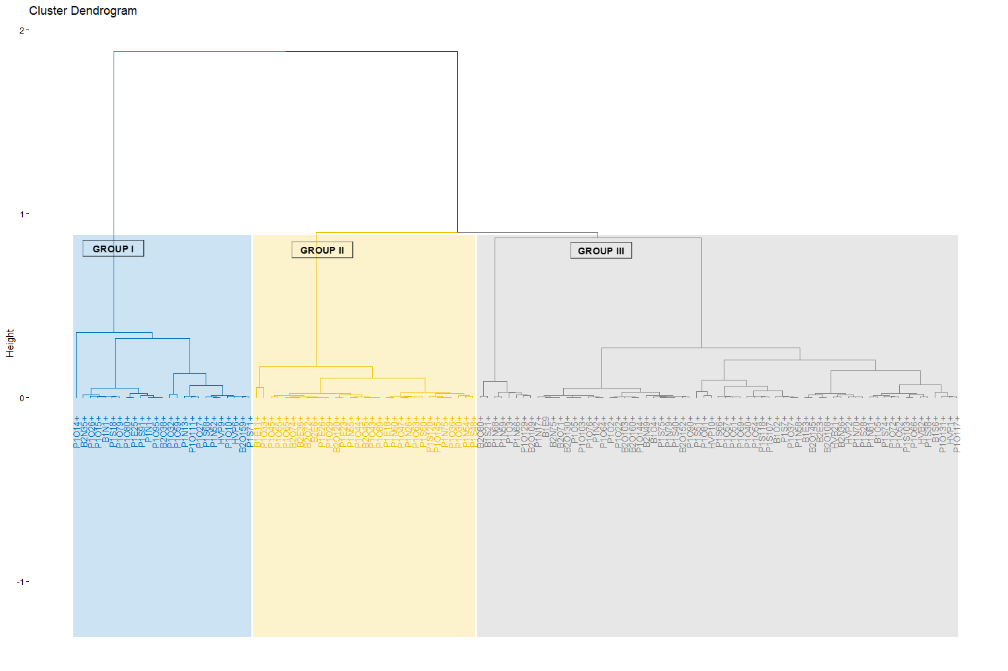
Fig 2 . Dendrogram of morphotypes of interest in P. erinaceus

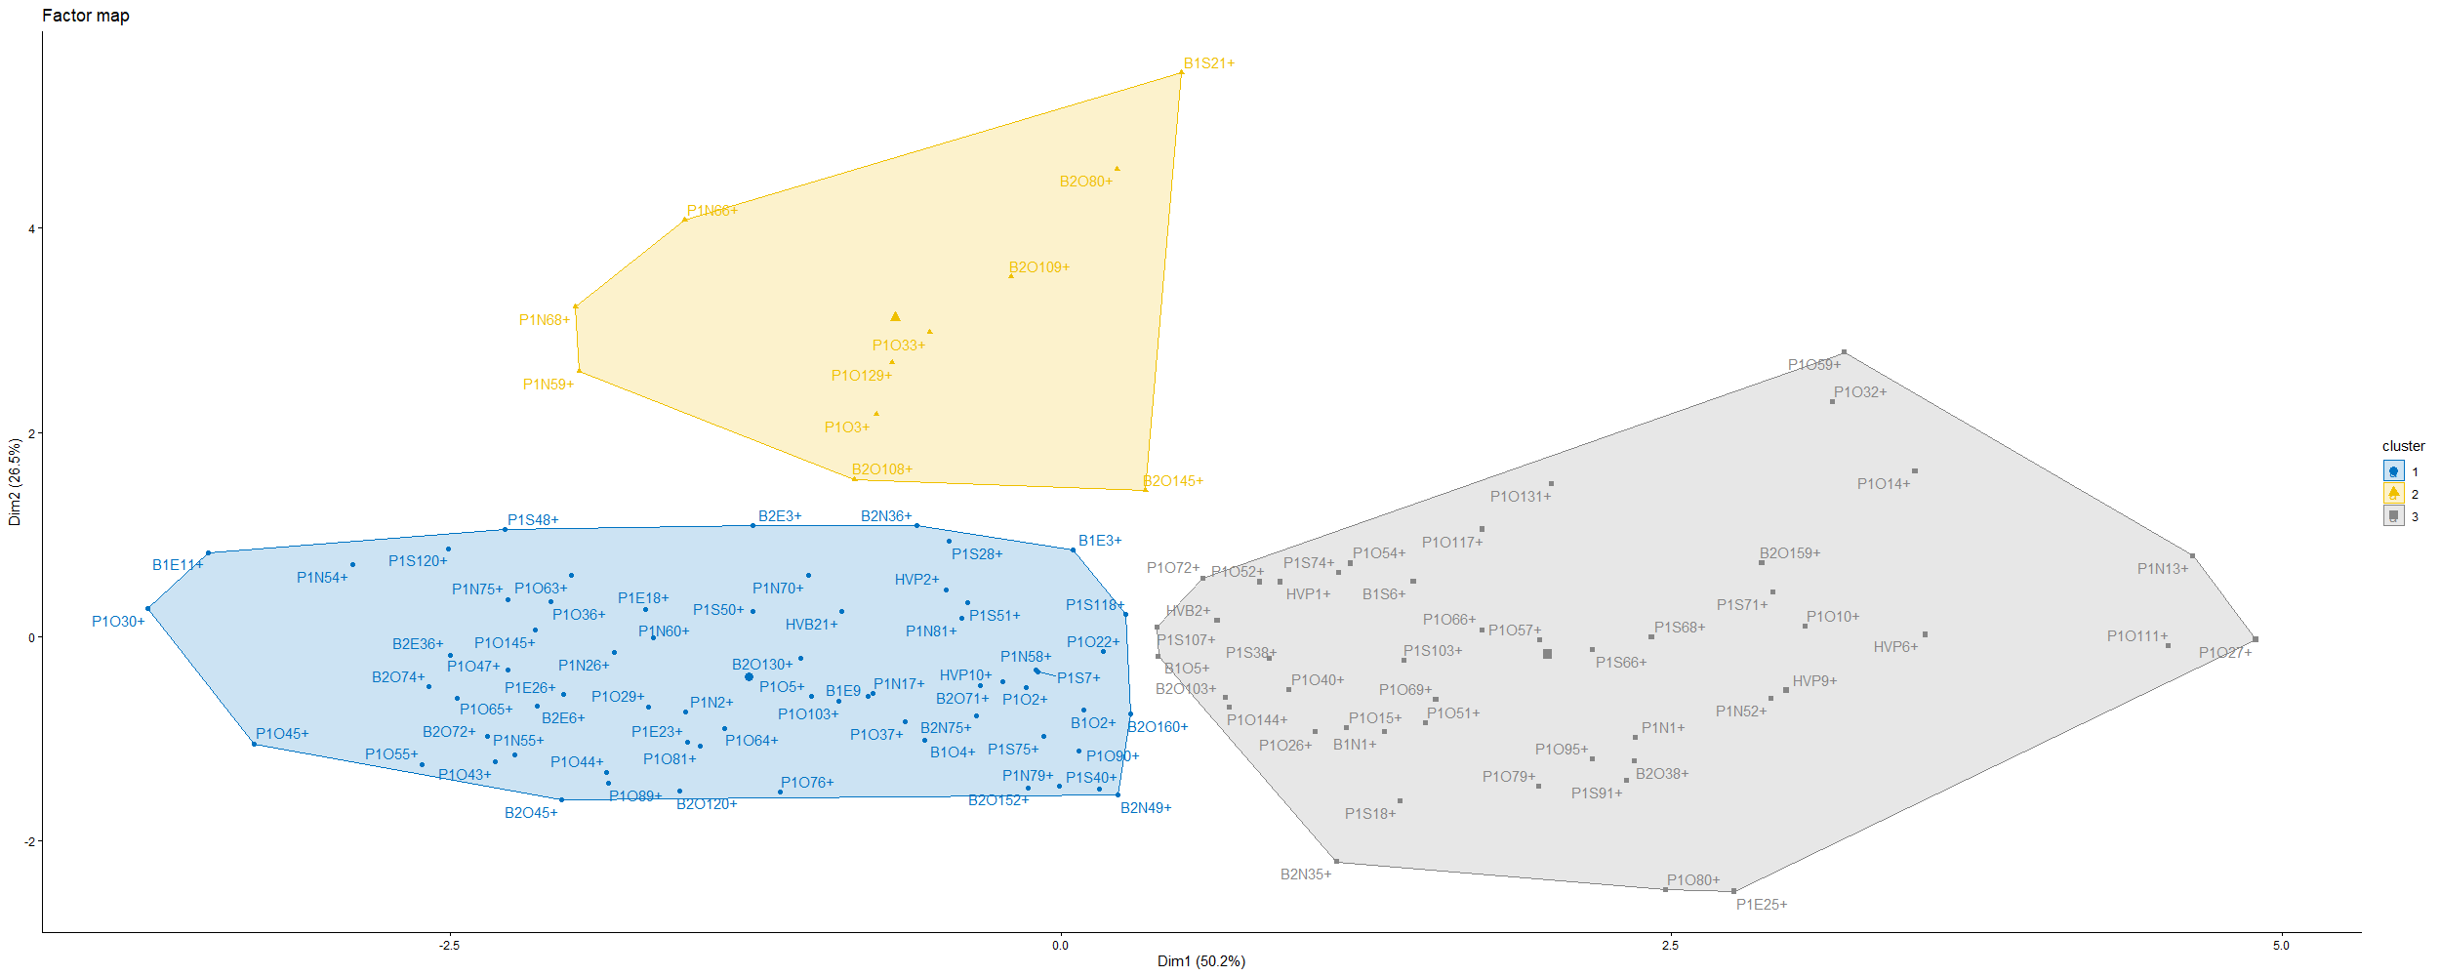
Fig 3. Factorial map of P. erinaceus interest morphotypes

Table 6. Characteristics of the groups formed by ascending hierarchical classification
 | v.test | Group average | Population mean | Group standard deviation | Population standard deviation | p-value
Group I
Hfut | -4.33 | 5.00 | 5.67 | 1.19 | 1.84 | <0.001
HPBranch | -4.58 | 3.87 | 4.55 | 1.12 | 1.76 | <0.001
Hato | -4.95 | 10.40 | 13.10 | 3.25 | 6.47 | <0.001
EnOE | -6.37 | 6.59 | 8.17 | 2.04 | 2.95 | <0.001
DCtrc | -6.83 | 28.43 | 34.50 | 7.92 | 10.57 | <0.001
EnNS | -7.08 | 6.37 | 8.33 | 1.89 | 3.29 | <0.001
Dhoupie | -7.16 | 6.48 | 8.25 | 1.77 | 2.94 | <0.001
Group II
HPBranch | 7.78 | 8.50 | 4.55 | 1.62 | 1.76 | <0.001
Hfut | 6.44 | 9.09 | 5.67 | 1.75 | 1.84 | <0.001
EnNS | -2.09 | 6.35 | 8.33 | 1.89 | 3.29 | 0.04
Dhoupie | -2.48 | 6.14 | 8.25 | 1.29 | 2.94 | 0.01
EnOE | -2.62 | 5.94 | 8.17 | 1.92 | 2.95 | 0.01
Group III
Dhoupie | 8.84 | 11.30 | 8.25 | 1.85 | 2.94 | <0.001
EnNS | 8.53 | 11.62 | 8.33 | 2.39 | 3.29 | <0.001
EnOE | 8.11 | 10.98 | 8.17 | 1.94 | 2.95 | <0.001
DCtrc | 7.71 | 44.04 | 34.50 | 7.25 | 10.57 | <0.001
Hato | 4.00 | 16.13 | 13.10 | 8.06 | 6.47 | <0.001
Dtrc: Trunk diameter; Hfut: Trunk height; HPBranch: Height of the first branch; Hato: Total height; EnNS: North-South span; EnOE: West-East span; Dhoupie: Crown diameter
- Discussion
The restoration of plant cover is crucial in combating climate change and the disappearance of certain species. This activity depends on many factors. Indeed, it is essential to have plant material of sufficient quality and quantity that is suited to the environment in question. Among the high-value species involved in this restoration is P. erinaceus. It is classified as an endangered species by the International Union for Conservation of Nature (Barstow, 2018), and the proportion of adult P. erinaceus plants with good conformation is relatively low, at 14.22%. This low rate could be explained by selective cutting in recent decades. This logging has led to the elimination of the best morphotypes and an erosion of genetic diversity. According to Degen et al. (2006) and Roque et al. (2023), selective logging is responsible for the loss and reduction of rare alleles responsible for characteristics that are desirable for reforestation programs. Between 2010 and 2016, Côte d'Ivoire was one of the main suppliers of P. erinaceus wood to Asian countries, including China (AEI, 2022). This trade was largely unregulated and clandestine, and the best-formed morphotypes were the most sought after. In addition, previous studies conducted by Goba et al. (2019) show that the overexploitation of P. erinaceus in Côte d'Ivoire has led to a regeneration deficit and an imbalance in the age classes of the different stands. This process has resulted in a decrease in adult reproductive morphotypes and difficulty in producing reforestation material adapted to the needs of the various reforestation programs.
Despite the loss of many morphotypes, there are a few morphotypes that have interesting characteristics in different areas. Area 3 has the highest density of trees of interest, with a density of 6.43 trees/ha. These trees of interest show diversity within each area, as evidenced by variation coefficients greater than 30% for most of the variables measured. This diversity allows the trees of interest to be structured into three morphotypes.
Group I has parameters lower than those of the populations of trees of interest. However, it is important. These trees include young individuals that represent an ideotype that could prove interesting for reforestation programs. They constitute a reservoir that ensures the maintenance of diversity and genetic adaptability in an environment that has been subject to intensive exploitation, in which large trees have been decimated (Ouedraogo et al., 2014; Goua et al., 2017). According to Adji et al. (2022), young P. erinaceus trees have structural characteristics that can be identified and selected, thus constituting a strategic core genetic resource for stabilizing natural populations and supporting restoration efforts.
Group II is characterized by slender morphotypes with a trunk and a significant first branching height. This characteristic could be attributed to an environment where competition for light was intense. Individuals in this group may have originated from the cohort that was forming before the overexploitation of P. erinaceus. The presence of large trees created competition for resources, including light, which promotes the upward growth of young plants (Sanneh, 2023). Studies show that P. erinaceus has a distribution dominated by young to medium-sized individuals in exploited areas in Togo. Thus, part of this cohort comes from the generation prior to massive overexploitation, and regeneration occurs in a more or less open environment (Adjonou et al., 2010; CITES, 2022). This group is of interest for reforestation, as the individuals are the direct descendants of certain large trees that have disappeared and may possess genes of interest that have been lost due to the disappearance of large P. erinaceus trees.
Group III is composed of mature and dominant individuals. These individuals are the last large trees that escaped the overexploitation of P. erinaceus. It is characterized by individuals with significant crown development, a feature of adult morphotypes described in several studies (Goba et al., 2019). This crown development makes these individuals the preferred producers and disseminators of seeds. They are responsible for the sexual reproduction of P. erinaceus and the flow of genes between generations. Studies of genetic diversity using microsatellites show that large trees are a reservoir of alleles that are crucial for the resilience of the species (Johnson et al., 2020). In addition, they have a morphology that is sought after by reforestation programs and are the current seed pool that could support reforestation programs for the restoration of this species' ecosystem.
- Conclusion
This studyaimed to identify and characterize morphotypes that could potentially be used in reforestation programs. It highlighted the low proportion of high-performance P. erinaceus plant material available for reforestation . Zone 3 of the Palée classified forest has a higher density of P. erinaceus trees of interest, that must be monitored and protected. These trees are structured into three morphological groups. The first group represents future potential for reforestation . The second group consists of individuals that are descendants of large trees that were victims of overexploitation and may contain certain lost alleles. The third group includes dominant trees that have survived illegal exploitation and are the main providers of seeds, ensuring genetic flow from generation to generation. These morphotypes are a basis for obtaining quality plant material for reforestation programs. However, further studies are needed to assess the genetic diversity of these morphotypes and evaluate the behavior of the offspring of successful morphotypes in nurseries.

Disclaimer (Artificial intelligence)
Option 1:
Author(s) hereby declare that NO generative AI technologies such as Large Language Models (ChatGPT, COPILOT, etc.) and text-to-image generators have been used during the writing or editing of this manuscript.

REFERENCES
- Adji, B. I., Akaffou, D. S., & Sabatier, S. (2022). Variation de la morphologie des unités de croissance chez Khaya senegalensis (Desr.) A. Juss. (Meliaceae) et Pterocarpus erinaceus Poir. (Fabaceae) selon l’habitat et le climat. Bois & Forêts des Tropiques, 354, 41–54. https://doi.org/10.19182/bft2022.354.a36768
- Adjonou, K., Ali, N., Kokutse, A. D., & Kokou, K. (2010). Étude de la dynamique des peuplements naturels de Pterocarpus erinaceus Poir. (Fabaceae) surexploités au Togo. Bois et Forêts des Tropiques, 306(1), 33–43.
- Arbonnier, M. (2002). Arbres, arbustes et lianes des zones sèches d’Afrique de l’Ouest (573 p.). Paris : Quae / CIRAD / MNHN.
- Barstow, M. (2018). Pterocarpus erinaceus. The IUCN Red List of Threatened Species 2018: e.T62027797A62027800. https://doi.org/10.2305/IUCN.UK.2018-2.RLTS.T62027797A62027800.en
- CITES – Côte d’Ivoire. (2022). Plan de gestion national de Pterocarpus erinaceus (bois de vène) en Côte d’Ivoire. Ministère des Eaux et Forêts, Autorité de Gestion CITES.
- Degen, B., Blanc, L., Caron, H., Maggia, L., Kremer, A., & Gourlet-Fleury, S. (2006). Impact of selective logging on genetic composition and demographic structure of four tropical tree species. Biological Conservation, 131, 386–401. https://doi.org/10.1016/j.biocon.2006.02.004
- Duvall, S.C. (2008). Pterocarpus erinaceus Pear. In D. Louppe, A. A. Oteng-Amoako, & M. Brink (Eds.), PROTA 7(1): Timbers / Lumber. Wageningen: PROTA. https://www.prota4u.org/database/protav8.asp?g=pe&p=Pterocarpus+erinaceus+Poir.
- Environmental Investigation Agency (EIA). (2022). Poached Timber — Forest crimes, corruption and ivory trafficking in the Malian rosewood trade. https://us.eia.org/wp-content/uploads/2022/05/EIA_US_Mali_Timber_report_0422_FINAL.pdf
- Gérard, J., Leban, J.-M., & Kames, J. (2016). Tropical Timber Atlas: Technological characteristics and uses of 283 tropical woods. International Tropical Timber Organization (ITTO). https://www.itto.int/files/itto_project_db_input_file/Project/ITTO_PD_533_09_Rev.2_(I)_ATLAS_2016_FR_EN_ES_web.pdf
- Goba, A. E., Koffi, K. G., Sié, R. S., Kouonon, L. C., & Koffi, Y. A. (2019). Structure démographique et régénération naturelle des peuplements naturels de Pterocarpus erinaceus Poir. (Fabaceae) des savanes de Côte d’Ivoire. Bois & Forêts des Tropiques, 341, 5–14. https://doi.org/10.19182/bft2019.341.a31750
- Goua, M., Tiébré, M. S., N’Da, K., & Traoré, D. (2017). Structure, dynamique et régénération de Pterocarpus erinaceus Poir. dans les savanes ivoiriennes : Implications pour la gestion durable. Journal of Applied Biosciences, 109, 10645–10657.
- Interpol. (2016). Law enforcement and the West African Rosewood trade: Understanding and changing international trade—the case of Pterocarpus erinaceus. Bissau Workshop, March 29–31, 2016.
- Johnson, B. N., Quashie, M. L. A., Chaix, G., Camus-Kulandaivelu, L., Adjonou, K., Segla, K. N., Kokutse, A. D., Ouinsavi, C., Bationo, B. A., Rabiou, H., Kokou, K., & Vignes, H. (2020). Isolation and characterization of microsatellite markers for the threatened African endemic tree species *Pterocarpus erinaceus* Poir. *Ecology and Evolution*, 10(23), 13403–13411. https://doi.org/10.1002/ece3.6944
- Legendre, P., & Legendre, L. (2012). Ecological data series. In P. Legendre & L. Legendre (Eds.), Numerical ecology (Developments in Environmental Modelling, Vol. 24, pp. 711–783). Elsevier. https://doi.org/10.1016/B978-0-444-53868-0.50012-5
- Ministère de l’Agriculture et du Développement Rural (MADER). (2021). Étude de faisabilité pour la mise en place de parcs agro-industriels et de centres d’agrégation et de services du projet de développement du pôle agro-industriel dans le nord de la Côte d’Ivoire (2PAI-NORD CI). CEFCOG / CAFEXI Consulting. https://www.afdb.org/sites/default/files/rapport-definitif-eies_boundiali_08102021_0.pdf
- Murariu, G., Dinca, L., & Munteanu, D. (2025). Trends and Applications of Principal Component Analysis in Forestry Research: A Literature and Bibliometric Review. Forests, 16(7), 1155. https://doi.org/10.3390/f16071155
- Nacoulma, B. M. I., Traoré, S. V., Ouédraogo, M., Traoré, S., Boussim, J. I., & Thiombiano, A. (2020). Isolation and characterization of microsatellite markers for Pterocarpus erinaceus using next-generation sequencing. Molecular Biology Reports, 47(12), 9539–9547.
- United Nations (UN). (2014). Final report of the Panel of Experts on Côte d'Ivoire (S/2014/266).https://www.un.org/ga/search/view_doc.asp?symbol=S/2014/266&Lang=F
- Ouédraogo, A., Thiombiano, A., Hahn-Hadjali, K., & Guinko, S. (2006). Assessment of the degradation status of stands of four woody species in the Sudanian zone of Burkina Faso. Sécheresse, 17(4), 485–491. https://doi.org/10.1684/SEC.2006.0058
- Ouédraogo, A., Thiombiano, A., Hahn, K., & Guinko, S. (2014). Regeneration of five threatened tree species in Burkina Faso: Implications for conservation. International Journal of Biodiversity and Conservation, 6(2), 103–114.
- Ouinsavi, C., Adigla, A. W., Houetchegnon, T., Akin, Y., & Dossou, J. (2021). Traditional uses of African rosewood (Pterocarpus erinaceus Poir.) through sociolinguistic groups and pathways of conservation in Benin. International Journal of Biodiversity and Conservation, 13(4), 200–213. https://doi.org/10.5897/IJBC2021.1509
- Roque, R. H., Sebbenn, A. M., Boshier, D. H., Filho, A. F., & Tambarussi, E. V. (2023). Logging affects genetic diversity parameters in an Araucaria angustifolia population: An endangered species in southern Brazil. Forests, 14(5), 1046. https://doi.org/10.3390/f14051046
- Segla, K. N., Kokutse, A. D., Adjonou, K., & Kokou, K. (2015). Variabilité des propriétés mécaniques du bois de Pterocarpus erinaceus en fonction de l’âge cambial. Journal of Tropical Forest Science, 27(3), 394–403. https://doi.org/10.19182/bft2015.324.a31266

- Silué, N., Fofana, J. I., Silué, S., Diarrassouba, N., Kouassi, A. F., & Kouakou, K. (2014). Identification des espèces ligneuses utilisées dans l’alimentation des bovins dans la région du Poro (nord de la Côte d’Ivoire). Agronomie Africaine, 26(3), 217–229. https://www.ajol.info/index.php/aga/article/view/110900
- Traoré, M., & Martínez-Cortizas, A. (2023). Color and chemical composition of timber woods (Daniellia oliveri, Isoberlinia doka, Khaya senegalensis, and Pterocarpus erinaceus) from southern Mali. Forests, 14(4), 767. https://doi.org/10.3390/f14040767
- Zon, D. S., Soro, B., Missa, K., Kakou, Y. S. C., Zouh, B. Z. F., Koné, Y. C., Lébri, M., Dié, A., & Dien, K. O. (2022). Avis de Commerce Non-Préjudiciable (ACNP) sur Pterocarpus erinaceus Poir. en Côte d’Ivoire. Autorité Scientifique CITES, Côte d’Ivoire. https://cites.org/sites/default/files/documents/ACNP_Pterocarpus_erinaceus_Cote_dIvoire_2022.pdf

