Impact of Combined Application Irrigation and Mulching on Soil and Leaf Nutrient Dynamics, Mango Yield, and Quality

Abstract
Soil moisture and nutrients are crucial for agricultural productivity, especially in arid and semiarid regions where they limit crop growth. To address the present problem a two-year field experiment (2017–19) evaluated the combined effects of drip irrigation (75% and 100% ETc) and mulching (with/without 100-µm silver polyethylene) on mango cv. Banganpalli in red sandy loam soil of Southern Telangana (16°30'N, 78°19'E; 550 m MSL). A 2×2 factorial randomized block design with five replications was employed. The 100% ETc + mulching treatment recorded the highest soil moisture (13.4–16.6% across BBCH-510 to BBCH-709), available soil N (222–315 kg ha⁻¹), leaf NPK (N: 0.82–1.11%, P: 0.19–0.22%, K: 0.74–0.91%), and fruit yield (89.11 kg tree⁻¹) 35.83% higher than 75% ETc without mulching. It also maximized internal O₂, minimized CO₂, delayed chlorophyll degradation (DA-index: 0.96–0.55 over 9 days storage), and extended shelf life to 13.73 days. Fertilizer use efficiency peaked at 89.11 kg kg⁻¹ under this treatment due to reduced nutrient leaching and enhanced uptake. Notably, 75% ETc + mulching yielded comparably to 100% ETc without mulching (75.78 vs. 75.18 kg tree⁻¹) while achieving 25% water savings and the highest water use efficiency (WUE). Results from present study suggested that the drip irrigation and mulching optimize resource efficiency and fruit quality under water-limited semi-arid conditions. The 75% ETc + mulching regime is recommended as a sustainable, high-yielding strategy for mango orchards.
KEY WORDS: Water use efficiency (WUE), nutrient use efficiency N&KUE, Soil moisture availability, DA-index

Introduction

Mango (Mangifera indica L.) is economically one of the most important fruit crop in India and is being grown in more than 87 countries in the world. In India, mango is economically one of the most important fruit crop in tropical and subtropical regions. India is world’s leading mango producer and it occupies 35.4 per cent (2.31 million ha) of total area among the fruit crops with 23.1 percent (22.35 million MT) production share. However, the average productivity (9.3 t ha⁻¹) of mango is very low compared to Utter Pradesh (17.63 t ha⁻¹); it indicates that, there is huge potential in increasing productivity of mango [1]. In Telangana mango occupies a prime position in cultivation among the fruit crops, i.e. 70 per cent of total fruit cultivated area and 56% of total production devoted to mango, but the average productivity of India and Telangana (9.7 t ha⁻¹ and 9.3 t ha⁻¹, respectively) is very low compared to Uttar Pradesh (India) and Bangladesh (17.0 t ha⁻¹ to 17.63 t ha⁻¹) and it indicating that, there is huge potential to increasing the productivity of mango [2]. However, the mango productivity has declined due to several biotic and abiotic factors. Out of several biotic and a-biotic factors responsible, optimum water management is one of the most important factors that significantly influence productivity and quality, even though mango trees are tolerant to drought and occasional flooding. Water stress during the critical stages of fruit growth and development is the main reason for low productivity [3]. In such situation, water management, especially during development stage plays an important role in improving yield and quality. However, the amount and quality of available irrigation water of the arid and semi- arid regions are being main limiting factors for productivity of mango [4].
As the water and land are the important, indispensable resources for agricultural development and economic up-gradation of any country cannot be regarded as available in abundance and free forever. The demand for these two resources will continue to grow due to ever enhancing population. Increasing the water shortage has caused us to investigate the sustainable use of irrigation water. For this, specific effective water-saving irrigation techniques without detrimentally affecting crop production need to be developed urgently. In this context a shift in focus is indispensable for the development of additional water resources along with the efficient use of already developed water resources [5]. As the mango is irrigated by basin and drip irrigation systems without any concern on crop water requirement and schedule; that has leads to inefficient utilization of available water and it must be converted from the basin irrigation system to drip irrigation with a proper scheduled manner, their by the water conserved and it would helps in increase the acreage with available water [6]. In addition to above the mulching is another important conservative cultural practice. As many studies have shown that mulches can improve soil qualities, weed control [7] and also helps in efficient water management under such situation, the drip irrigation along with mulching is the best practice which saves 25-30% irrigation water [8]. Sing et al. [9] suggested that, the irrigation requirement met through drip irrigation along with polyethylene mulch gave the 164 per cent greater yield compared to ring basin irrigation in guava. With an above brief background, an experiment was carried to on soil and leaf nutrient dynamics, mango yield, and quality of mango.
MATERIALS AND METHODS
The field experiment was conducted during two successive years (from 2017 to 18 and 2018 to 19 ??? was executed in the private mango orchard at Sathapur (Kollapur area, Nagarkurnool- Dist.) and the experimental farm is located at 16° 30' N latitude and 78° 19' E longitude at an elevation of 550 m above MSL, representing Southern Telangana zone, is mainly covered by red sandy soil, is locally known as 'Chelka soils'. The experimental soil was red sandy loam soil, with good drainage as well as moderate water holding capacity and the soil properties of experimental site mentioned in Table-1. Representative soil samples from the experimental plots were drawn from 0-45 cm depth from the wetting zone separately and dried under shade. The initial soil samples were used to determine its physical and chemical properties of soil before starting of experiment. The initial (Table 2) and final leaf analysis made by collecting of mango leaves (20-30) from the leaves situated at fourth and fifth position from terminal bud of recently matured shoots [10].

Experimental design and applications
The field experiment was conducted during June- 2017 to May-2018 and June-2018 to May-2019 was executed in the private mango orchard at Sathapur (Kollapur area) and the experimental farm is located at 16° 30' N latitude and 78° 19' E longitude at an elevation of 550 m above MSL representing Southern Telangana zone, is mainly covered by red sandy soil, is locally known as 'Chelka soils' and the soil properties are mentioned in Table 1.Experiment comprised of 40 number of uniform size healthy trees of mango cv. Banganpalli, 12 years old plants were selected and the plants were planted with spacing of 10x10 m. Two plants were selected for each treatment in each replication.
All plants were given similar cultural operations except irrigation and mulching. The application of recommended dose of fertilizers (RDF i.e.,1000:1000:1000 g of NPK and 50 kg of farm yard manure (FYM) plant⁻¹ year ⁻¹ for more than ten years old plants) are applied during third week of June i.e. half of doses of nitrogen, potassium, total FYM and phosphorus were applied. Another half dose of nitrogen and potassium was applied through soil, along with the micronutrients [ZnSO₄ (50 g) + FeSO₄ (25 g) + Borax (20g) + MgSO⁴ (30 g) tree⁻¹] are applied through foliar spray fruit at marble. Here, two levels M₀ and M₁ i.e. without mulch and with mulching, respectively), mulch with silver Poly Ethylene of 100-micron thickness were used and two levels of irrigation (I₁ -75% and I₂ 100% ETc through drip). Here is a bifactorial 2x2 design were used and There were two levels of irrigation as main plot and two levels of mulching in the sub plot together constituting four treatment combinations with five replications under factorial randomized block design (OPSTAT programme by COBS&H CCS HAU, Hisar; [11]). Duncan Multiple Range Test (DMRT) was used to distinguish means that were significantly different at P ≤ 0.05.
Taking into account the scheduling of irrigation at different levels of ETc and mulching were used in the treatment combination: I₁M₀-75% ETc + without mulching, I₁M₁- 75% ETc + with mulch, I₂M₀- 100% ETc + without mulching and I₂M₁- 100% ETc + with mulch. Irrigation was scheduled by calculating ET using pan evaporation measurements adjusted by crop coefficient. The experimental plots were irrigated by using drip irrigation system and the crop water requirement was calculated daily with the help of meteorological data recorded by meteorological observatory of KVK, Palem, Nagarkurnool, and PJTSAU-Telangana. The irrigation water requirement was estimated by A Pan evaporation method, where the daily water requirement was calculated using the formula [12]:
V = Ep. Kp. Kc. Sp. Sr. Wp [12]
Where,
V = Volume of water required (litters day⁻¹ plant⁻¹),
Ep = Pan evaporation as measured by Class-A pan evaporimeter mm day⁻¹.
Kc = Crop co-efficient (co-efficient depends but for fully grown plants is 0.85)
Kp = Pan co-efficient (0.7)
Sp = Plant to plant spacing (m) Sr = Row to row spacing (m)
Wp = Fractional wetted area (0.3 for wider spaced crops)
The initial (Table 1) and final leaf analysis made by collecting of mango leaves (20-30) from the leaves situated at fourth and fifth position from terminal bud of recently matured shoots [11].
Table 1: Methods to be used for soil, leaf and fruit analysis [13]
Soil analysis | Methods to be used
Organic carbon (%) | Modified Walkley and Black Method; Jackson
Available nitrogen (kg ha⁻¹) | Alkaline Potassium Permanganate method
Available phosphorous (kg ha⁻¹) | Olsen’s Method
Available potassium (kg ha⁻¹) | Flame photometry method
Leaf analysis | Methods to be used
Nitrogen (%) | Modified Kjeldahl's digestion method
Phosphorus (%) | Vanado-molybdo-phosphoric yellow colour method in nitric acid system
Potassium (%) | Flame photometric determination

Soil moisture content (%)
In order to study the soil moisture content under drip irrigation and conventional method, moisture content was determined using PDSR soil moisture sensor before starting the irrigation and the Soil moisture content was estimated at a lateral distance of 30 cm away from the emitter. Under conventional surface irrigation, soil moisture was recorded at 120 cm away from the tree trunk with the help of digital soil moisture meter. Average values of soil moisture were computed for different crop growth stages and the Measurement range: 0% to 50% moisture content of soil sample with 0.1% resolution.
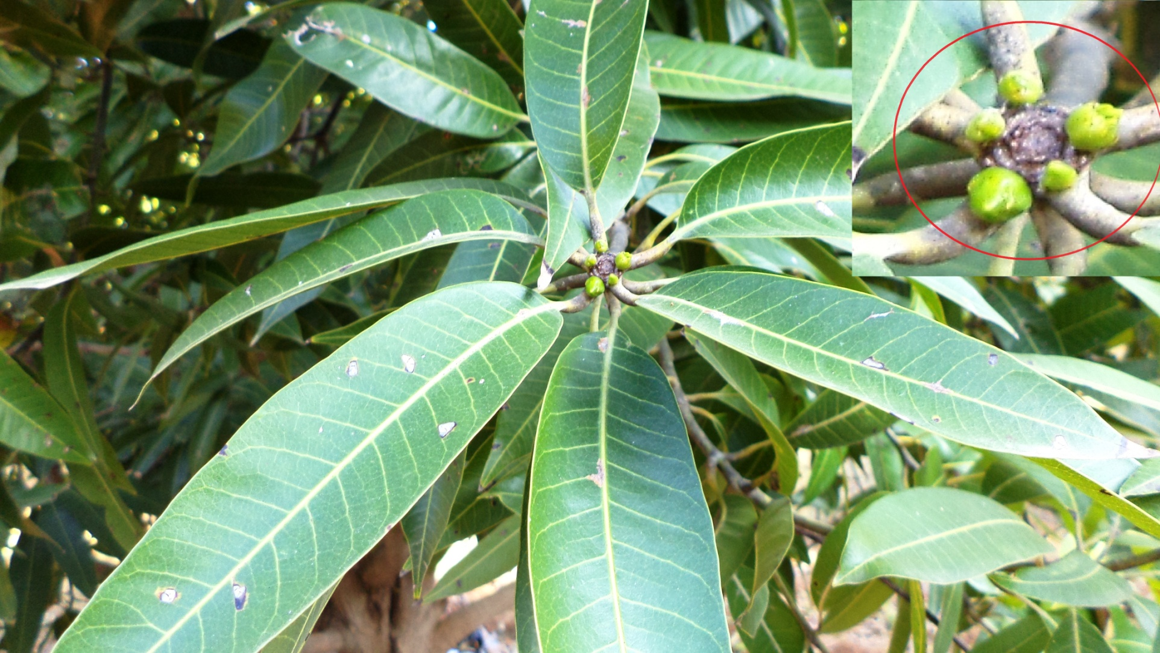 | 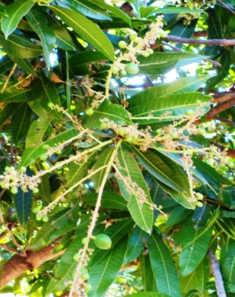 |  | 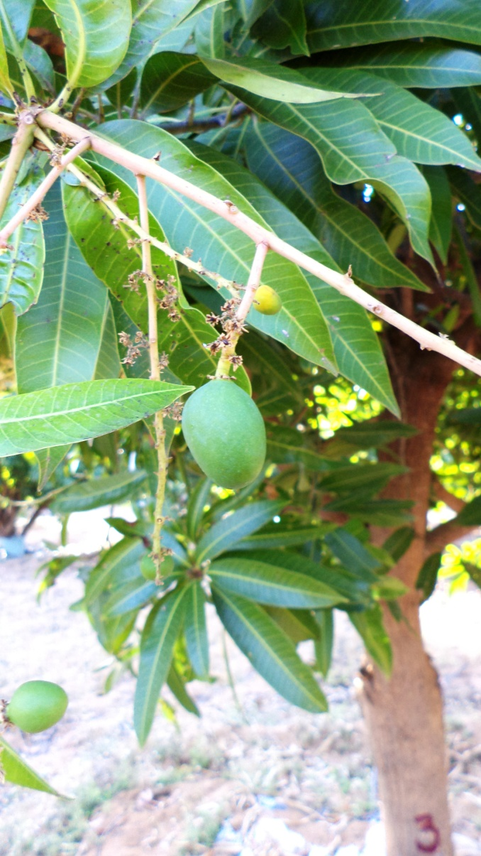 |  |  |  | 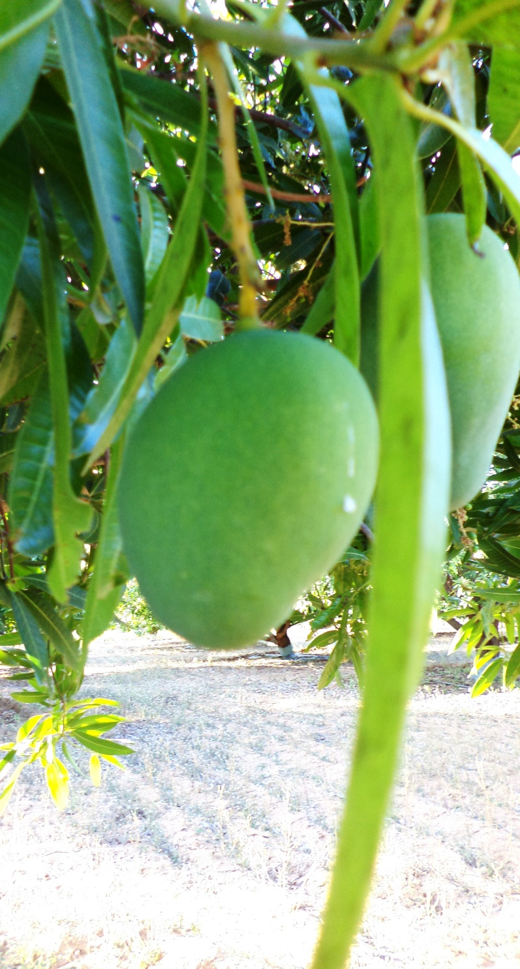
_{BBCH-510} | _{BBCH-619} |  | _{BBCH-701} |  |  | _{BBCH-703}
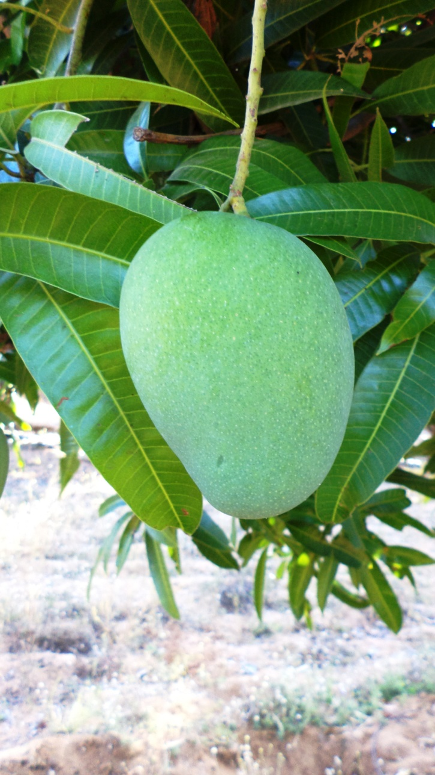 |  | 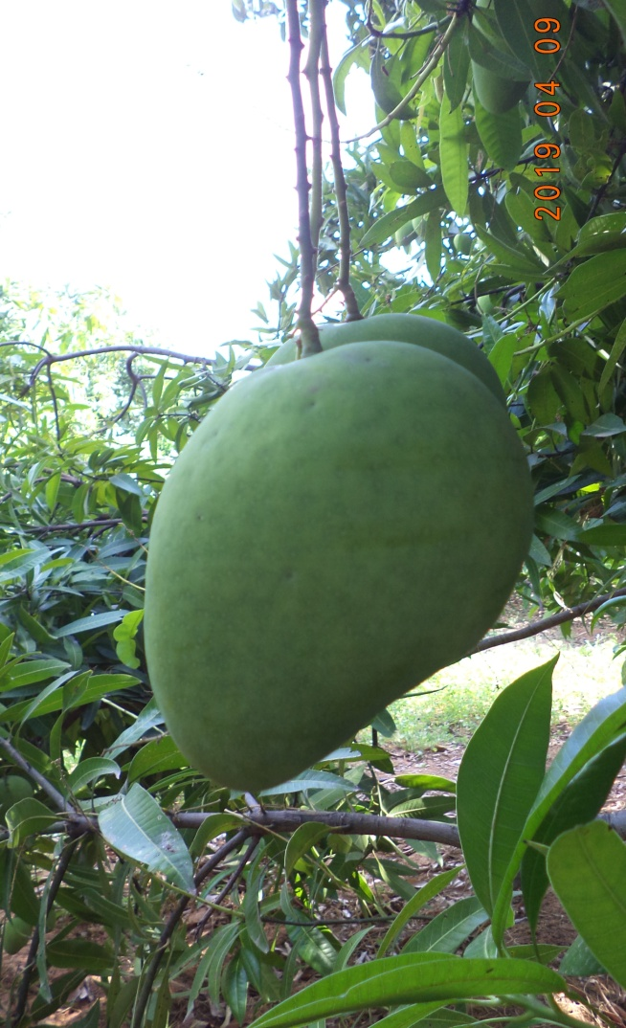 |  | 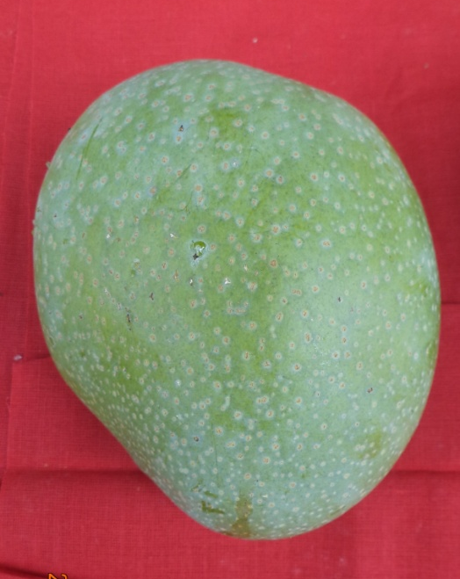
BBCH-705 |  | BBCH-709 |  |  | BBCH-800
Figure 1: Depiction of important phenophases in mango [14]
BBCH-510-Buds closed and covered with green or brownish scales.
BBCH-619-End of flowering: all petals fallen and fruit set.
BBCH-701-Fruits at 10% of final size, styles still visible (beginning of physiological fruit drop).
BBCH-703-Fruits at 30% of final size (end of physiological fruit drop).
BBCH-705-Fruits at 50% of final size.
BBCH-705-Fruits at 50% of final size.
BBCH-709-Fruits at standard cultivar size, shoulders fully developed.
BBCH-800-Physiological maturity: fruit fully developed, pulp creamy green in color.

DA-index
Changes in fruit color can be assessed using the DA-index (difference of absorbance index), which measures the level of chlorophyll-a in the fruit flesh just beneath the skin. Generally, DA-index values decrease with fruit ripening as chlorophyll-a degrades [15]. DA-index measurements were taken at three-day intervals.
Estimation of O₂ and Co₂ (% kg fresh mass⁻¹ hr⁻¹)
The PBI DAN sensor was used to estimate the O₂ and Co₂ (% kg fresh mass⁻¹ hr⁻¹) content and the estimations are made at three days’ interval by placing silicon Teflon septa on the plastic container. The instrument calibrated under open condition before starting the gas composition estimation, then, the needle of O₂ and C0₂ analyzer was inserted through septa and the gas composition was measured.
Water Use Efficiency (WUE kg m⁻³)
Water use efficiency (WUE) was computed from the following formula and has been expressed as kg m⁻³ water [16].
$$\text{ WUE =Y/TWA }$$Where;
Y- Yield (kg)
TWA- Total amount of water applied (m⁻³)
Fertilizer use efficiency (FUE kg kg⁻¹)
The word “efficiency” generally indicates “the level of output per unit of input.” Referred to the plant system, “efficiency” defines the “growth, physiological activity, yield or harvested yield (output) per unit of land, water, nutrient, or energy (input).” While focusing the attention on the nutrients, the term NUE is defined as “the plant growth, physiological activity, yield or harvested yield per unit of nutrient.” Even within this simple ratio, NUE has been defined in 18 different ways in diverse contexts which are primarily grouped in “Agronomic” (uptake efficiency) and “Physiological” (utilization efficiency) terms. The fertilizer use efficiency (FUE) was computed from the following formula and has been expressed as kg kg⁻¹ [17].

$${ \text{Fertilizer use efficiency }\text{(kg kg}}^{\text{-1}}\text{)=} {\text{Fruit yield in treated plant}}/{\text{the amount of Nutrient applied}}$$

RESULTS AND DISCUSSION
Impact of combined application of irrigation and mulching on soil and leaf nutrient dynamics of mango
Soil nutrient dynamics of mango
The interaction between irrigation and mulching treatments did not show significant differences on available nitrogen, phosphorus, and potassium (NPK) content across the various phenophases (BBCH703, 705 and 709). However, the highest available nitrogen (222–315 kg ha⁻¹), and lowest phosphorus (16.00–17.64 kg ha⁻¹), and potassium (286.45–317.03 kg ha⁻¹) were recorded with the application of 100% ETc combined with mulching. In contrast, the lowest available nitrogen (204–305 kg ha⁻¹), high phosphorus (20.97–23.08 kg ha⁻¹), and potassium (305.33–334.22 kg ha⁻¹) were observed in the treatment 75% ETc without mulching (Table 2).
In this study, the increased available nitrogen content with higher irrigation along with mulching may be attributed due to greater soil moisture availability (Figure 2). Additionally, mulches are effective in reducing nitrate leaching, improving soil physical properties, preventing erosion, regulating soil temperature, and enhancing water retention. These improved soil conditions likely enhanced biological activity [18, 19 and 20], which contributed to increased nitrogen availability. However, the lowest available P₂O₅ and K₂O were observed in plants treated with 100% ETc and mulching, possibly due to increased soil moisture availability (13–16%) (Figure 2). Higher soil moisture may have enhanced the solubilization of mineral nutrients [21], leading to improved fertilizer use efficiency (89.11 kg kg⁻¹) (Figure 9). This increased solubilization likely resulted in reduced available P₂O₅ and K₂O in the soil. Similar findings were reported in mango [22] and in litchi [23].

Table 2: Available of nitrogen content (kg ha⁻¹) different phenophases of fruit development

Treatments | Available of nitrogen content (kg ha⁻¹) |  |  | Available of phosphorus content (kg ha⁻¹) in |  |  | Available of potassium content (kg ha⁻¹)
Treatments | BBCH-703 | BBCH-705 | BCH-709 | BBCH-703 | BBCH-705 | BCH-709 | BBCH-703 | BBCH-705 | BCH-709
75% ETc+ without mulch | 204.3ª | 207.72 ª | 257.47 ª | 20.97 ª | 20.93 ª | 23.08 ª | 305.33 ª | 334.22 ª | 327.76
75% ETc+ with mulch | 210.7 ª | 212.74 ª | 262.55 ª | 19.76 ª | 17.87 ª | 19.95 ª | 294.29 ª | 315.44 ª | 325.85 ª
100% ETc+ without mulch | 197.9 ª | 211.83 ª | 254.47 ª | 18.4 ª | 17.29 ª | 21.33 ª | 290.5 ª | 322.24 ª | 325.9 ª
100% ETc+ with mulch | 225.8 ª | 222.65 ª | 268.36 ª | 17.64 ª | 16.00 ª | 17.53 ª | 286.45 ª | 311.5 ª | 317.03 ª
CD (p ≤ 0.05) | 28.37 | 7.49 | 41.10 | 2.16 | 3.30 | 6.18 | 9.42 | 15.36 | 9.15
Note: Letters indicate significant differences (p ≤ 0.05).
Table 3: Leaf NPK content (%) of mango cv. Banganpalli at different phenophases of fruit development.
Treatments | N (%) |  |  | P (%) |  |  | K (%)
Treatments | BBCH-703 | BBCH-705 | BCH-709 | BBCH-703 | BBCH-705 | BCH-709 | BBCH-703 | BBCH-705 | BCH-709
75% ETc+ without mulch | 0.73 ^{b} | 0.63 ^{c} | 0.67 ^{c} | 0.12 ^{c} | 0.12 ^{d} | 0.11 ^{c} | 0.75 ^{b} | 0.75 ª | 0.71 ª
75% ETc+ with mulch | 0.82 ª | 0.7^{b} | 0.74 ^{b} | 0.15 ^{b} | 0.16 ^{c} | 0.14 ^{b} | 0.75 ^{b} | 0.86 ª | 0.72 ª
100% ETc+ without mulch | 0.82 ª | 0.72 ^{b} | 0.73 ^{b} | 0.14 ^{b} | 0.19 ^{b} | 0.15 ^{b} | 0.76 ^{b} | 0.81 ª | 0.73 ª
100% ETc+ with mulch | 0.82 ª | 1.11 ª | 0.86 ª | 0.22 ª | 0.21 ª | 0.19 ª | 0.84 ª | 0.91 ª | 0.74 ª
CD (p ≤ 0.05) | 0.05 | 0.03 | 0.01 | 0.01 | 0.01 | 0.04 | 0.01 | 0.01 | 0.01
Note: Letters indicate significant differences (p ≤ 0.05)

Leaf nutrient dynamics of mango
The data revealed that there was significant difference among different irrigation and mulching treatment interactions with respect to leaf NPK content (%) (Table 3). Maximum leaf N (0.82-1.11 %) P (0.19-0.22%) K (0.74-0.91 %) was recorded with application of 100 % ETc along with mulching during different phenophases of fruit development where as the minimum leaf NPK (%) recorded in 75 % ETc + without mulching application. which might be due to the increased the soil moisture content (14.0-16.5 %) when compared to 75 % ETc + without mulching (9.3%) treatment (Figure 1). Further, when plants irrigated with 100 % ETc along with mulching has enhanced the nutrient use efficiency (Figure 8) due to synergistic effect of mulching and increased irrigation level. Further, the higher moisture regime might help mitigating the shrinkage of roots and increased in contact surface between the roots and soil solution, which resulted into greater absorption of available nutrients. This might have resulted in increased leaf NPK content in the present investigation. The similar findings are reported earlier by [24] and [25] in pomegranate. Similar was also results earlier reported [26] in sapota.

Impact of combined application of irrigation and mulching on moisture content of mango
The interaction between irrigation and mulching significantly affected soil moisture content during the BBCH-510, BBCH-619, BBCH-701, BBCH-703, BBCH-705, and BBCH-709 phenophases of fruit development (Figure 2). The highest soil moisture content was observed in the treatment 100% ETc combined with mulching, recording values of 14.7%, 14.3%, 15.7%, 16.6%, 14.4%, and 13.4% at BBCH-510, BBCH-619, BBCH-701, BBCH-703, BBCH-705, and BBCH-709 phenophases, respectively, followed by the I₁M₁ treatment. The lowest soil moisture content was recorded in the treatment with 75% ETc without mulching (I₁M₀), with values of 6.5%, 6.2%, 7.1%, 7.5%, 6.2%, and 6.0% at the respective phenophases.
The highest soil moisture content in the 100% ETc with mulching treatment can be attributed to daily drip irrigation at 100% ETc, which maintains moisture in the upper soil layers, combined with the effect of mulching. The higher moisture content under mulch treatments is likely due to polyethylene mulch significantly reducing soil drying and minimizing diurnal moisture fluctuations. This is primarily because daytime evaporation, the main cause of diurnal moisture variation in bare soil, is greatly reduced under mulch. Additionally, moisture that evaporates under the plastic mulch condenses on the underside of the polyethylene sheet and returns to the soil surface, effectively eliminating the diurnal cycling observed in bare soil. The synergistic effect of maximum irrigation and mulching led to improved soil moisture retention in this study. Similar findings have been reported [27] in and in sapota cv. Kalipatti [28].

Figure 2: Interaction effect of irrigation and mulching on soil moisture content (%) of mango (Data based on PDSR soil moisture sensor readings at BBCH 510 to 709)

Effect of combined application of irrigation and mulching on fruit yield of mango
The interaction between mulching and irrigation significantly affected fruit yield per tree. The highest yield was recorded with 100% ETc + mulching (89.11 kg tree⁻¹), followed by 75% ETc + mulching (75.78 kg tree⁻¹). The lowest yield was observed with 75% ETc without mulching (57.18 kg tree⁻¹). Application of 100% ETc + mulching increased fruit yield per tree by 35.83% compared to 75% ETc without mulching. The superior yield with 100% ETc + mulching was likely due to greater fruit weight and number per tree, driven by higher soil moisture availability (as measured by sensors) relative to the 75% ETc without mulching treatment (9.3% lower moisture). Elevated soil moisture enhanced mineral nutrient solubility, improving nutrient use efficiency (Figure 9). Continuous availability of water and nutrients throughout the crop cycle likely boosted photosynthesis, leading to greater accumulation of photosynthates and auxin-like substances. These promoted fruit physical development and increased fruit set, ultimately contributing to higher overall yield per tree.
Comparisons at the same irrigation level also revealed significant effects: 100% ETc + mulching produced 23.06% higher yield per tree than 100% ETc without mulching. Moreover, 100% ETc without mulching was statistically comparable to 75% ETc + mulching in terms of yield per tree. This indicates that 75% ETc + mulching had a pronounced positive effect, matching the performance of 100% ETc without mulching while achieving 25% water savings. Similar yield enhancements with combined irrigation and mulching have been reported previously: [29] in mango cv. Dashehari; in mango cv. Lat Sinduri [30]; in mango cv. Arka Anmol [31]. In bael [32]found that black polythene mulching combined with basin irrigation every 10 days minimized fruit drop and maximized yield, whereas mulching without irrigation led to higher fruit drop.

Figure 3: Interaction effect of irrigation and mulching on fruit yield (kg tree⁻¹) at final harvesting

Effect of combined application of irrigation and mulching on fruit quality of mango
Rate of respiration
The combined application of irrigation and mulching in the present study resulted in significantly higher internal oxygen and lower carbon dioxide levels (Figure 4&5). The maximum oxygen and minimum CO₂ content observed with 100% ETc irrigation plus mulching may be attributed to enhanced physiological activity, including greater photosynthate accumulation via increased stomatal conductance and CO₂ assimilation, facilitated by improved soil moisture and nutrient solubility. Furthermore, higher soil moisture likely promoted the translocation of synthesized assimilates from source to sink, leading to elevated sugar and ascorbic acid contents. The increased sugar levels may have contributed to greater fruit firmness, while the elevated ascorbic acid, acting as an antioxidant, likely reduced the respiration rate.

Figure 4: Interaction effect of irrigation and mulching on O₂ (% kg fresh mass⁻¹ h⁻¹) consumption of mango fruits after harvest.

Figure 5: Interaction effect of irrigation and mulching on Co₂ (% kg fresh mass⁻¹ h⁻¹) emission mango fruits after harvest.

DA index
The data revealed significant differences among the interactions of irrigation and mulching treatments with respect to the DA-index (Figure 6). On the day of harvest, the DA-index showed no significant differences. Thereafter, the DA-index varied significantly across the different irrigation and mulching interactions. The highest DA-index was observed with irrigation at 100% ETc combined with mulching (0.96, 0.74, and 0.55 on the 3rd, 6th, and 9th days of storage, respectively), whereas the lowest was recorded without mulching (I₁M₀) (0.57, 0.44, and 0.10 on the 3rd, 6th, and 9th days of storage, respectively). Higher irrigation levels combined with mulching significantly slowed chlorophyll degradation compared to other treatments. The synergistic effect of irrigation and mulching likely enhanced photosynthetic rates, promoting the production of antioxidants, sugars, and other essential compounds. These elevated levels of antioxidants, sugars, and compounds may have delayed chlorophyll degradation in the present study.

Figure 6: Interaction effect of irrigation and mulching on DA index mango fruits after harvest
Shelf life
A comparison of data on shelf life of mango cv. Banganpalli was significantly influenced by different irrigation and mulching treatments (Figure 7). Maximum number of shelf life was observed in 100% ETc along with mulching (13.73), where the minimum shelf life was recorded in 75 % ETc + without mulching (9.00). The maximum number of shelf life with application of 100% ETc along with mulching helped in mitigating the shrinkage of roots and increased in contact surface between the roots and soil solution in presence of favorable hydrothermal regimes. This might have resulted into efficient exploitation of available soil moisture and nutrients have resulted in increased rate of photosynthesis. The increased rate of photosynthesis might have increased fruit sugars other essential components, through increased carbon assimilation thus, probably had resulted in [33] higher amount sugars and ascorbic acid . These increased sugars and ascorbic acid might have resulted in increased cell wall integrity, fruit firmness, reduced chlorophyll degradation (Figure 6), and restricted respiration rate (Figure 4&5) in the present investigation. This ultimately increased the shelf life of mango fruits in the present investigation. Similar findings were earlier reported [34] in blueberry.

Figure 7: Interaction effect of irrigation and mulching on shelf life of mango (no. of days)

Effect of combined application of irrigation and mulching on water and fertilizer use efficiency of mango
Water use efficiency of mango (kg m⁻³)
The combined application of irrigation and mulching resulted in significant differences in water use efficiency (WUE) (Figure 8). The highest WUE was observed with 75% ETc irrigation combined with mulching, whereas the lowest was recorded with 75% ETc without mulching. In the present study, the 75% ETc + mulching treatment yielded the significantly highest WUE, primarily because mulching achieved the greatest yield per unit of water consumed. This elevated WUE under 75% ETc with mulching can be attributed to improved soil microclimate, a weed-free environment, reduced evaporation, and enhanced moisture availability. High soil moisture in the root zone increases nutrient solubility, leading to improved nutrient uptake by the plant. The resulting high soil moisture and nutrient availability promote earlier and better fruit growth and development through enhanced photosynthetic rates and efficient translocation of assimilates from leaves to fruits. Similar findings have been reported previously in mango cv. Dashehari [29] and in sapota cv. Kalipatti [26].

Figure 8: Interaction effect of irrigation and mulching on water use efficiency

Fertilizer use efficiency of mango (kg kg⁻¹)
The interaction of different irrigation and mulching has shown significant difference on fertilizer use efficiency of mango (Figure 9). Maximum fertilizer use efficiency was observed in application of mulching (89.11), whereas the minimum fertilizer use efficiency observed in without mulch condition (57.11). Present study suggests that, application of 100 % ETc along with mulching proven to higher fertilizer use efficiency compared to other treatments it may be due to the plastic mulch increase soil moisture by reducing loss of water through evaporation, increase fertilizer use efficiency by reducing loss of nutrients through leaching, surface run off or volatilization, eliminates weed growth at the vicinity of tree, thereby providing congenial environment for enhanced tree growth, fruit yield and quality, besides ameliorating leaf nutrient contents and water use efficiency in apple [35] and in guava cv. Lalit [36]. From our study the interaction of mulching along with 100% ETc has exerted 35.96 % higher FUE over 75 % ETc + without mulching.

Figure 9: Interaction effect of irrigation and mulching on fertilizer use efficiency

CONCLUSION

The combined application of drip irrigation and mulching significantly influenced soil and leaf nutrient dynamics, moisture retention, fruit yield, quality, shelf life, and resource use efficiency in mango cv. Banganpalli. The treatment with 100% ETc + mulching consistently emerged as superior, recording the highest soil moisture (13.4–16.6% across phenophases), maximum leaf NPK content (N: 0.82–1.11%, P: 0.19–0.22%, K: 0.74–0.91%), elevated available soil nitrogen (222–315 kg ha⁻¹), and optimal fruit yield (89.11 kg tree⁻¹)—a 35.83% increase over 75% ETc without mulching. This treatment also enhanced internal oxygen levels, reduced CO₂ accumulation, delayed chlorophyll degradation (highest DA-index during storage), and extended shelf life to 13.73 days.
Notably, 75% ETc + mulching achieved comparable yield to 100% ETc without mulching while conserving 25% irrigation water and registering the highest water use efficiency (WUE) due to reduced evaporation, weed suppression, and sustained root-zone moisture. Fertilizer use efficiency was maximized under 100% ETc + mulching (89.11 kg kg⁻¹), reflecting reduced nutrient losses and improved uptake under favorable hydrothermal regimes.
Overall, the synergistic effects of irrigation and mulching optimized soil–plant–water–nutrient interactions, promoting sustainable mango production. The 75% ETc + mulching regime offer a practical, water-efficient alternative without compromising yield or quality, making it highly recommendable for resource-constrained orchards. These findings align with prior reports in mango and other fruit crops, reinforcing the efficacy of integrated drip irrigation and mulching systems in enhancing productivity and input-use efficiency under semi-arid conditions.

REFERENCES
- NHB (National Horticulture Board), 2018. Indian Horticulture Database-2017. Ministry of Agriculture, Government of India 85, Institutional Area, Sector-18, Gurgaon - 122 015. Website : www.nhb.gov.in.
- Anonymous. Fruits. Indian Horticulture Database, National Horticulture Board, Ministry of Agriculture, Govt. of India; 2018. Available:http://nhb.gov.in.
- Ganeshamurthy AN, Rupa TR, Shivananda TN. Enhancing Mango Productivity through Sustainable Resource Management. Journal of horticultural science. 2018;13(1):1-31.
- Adak T, Kumar K, Singh VK, Singh Vinod Kumar, Singh AK. Effect of different soil moisture regimes on soil moisture rd dynamics, yield and quality in mango. In: Proceedings of 3 International Agronomy Congress on “Agriculture Diversification, Climate Change Management and Livelihoods”, held during November 26-30th, 2012 at IARI, New Delhi, India. 2012;1416-1418.
- Daniel PL, Eelco VB. Water Resources Planning and Management: An Overview. Water Resource Systems Planning and Management. 2017;1-49.
- Panigrahi P, Srivastava AK. Deficit irrigation (DI) scheduling for matured Nagpur mandarin (Citrus reticulata Blanco) trees of central India. Indian Journal of Soil Conservation. 2011; 39(2):149- 154.
- Ross OC. Reflective mulch effects on the grapevine environment, Pinot noir vine performance, and juice and wine characteristics. Dissertation, Lincoln University; 2010.
- Santosh K. Influence of Drip Irrigation and Mulch on Leaf Area Maximization, Water Use Efficiency and Yield of Potato (Solanum tuberosum L.). Journal of Agricultural Science. 2012;4(1):71-80.
- Singh K. Fall in Water Table in Central Punjab – How Serious? The PunjabState Farmers Commission, Chandigarh. 2006;13.
- Tandon, H. L. S. 1993. Methods of Analysis of Soils, Plants, Water and Fertilizers. Fertiliser Development and Consultation Organisation, New Delhi.
- Sheoran OP, Tonk DS, Kaushik LS, Hasija RC, Pannu RS. Statistical Software Package for Agricultural Research Workers. Recent Advances in information theory, Statistics & Computer Applications by D.S. Hooda & R.C. Hasija Department of Mathematics Statistics, CCS HAU, Hisar. 1998;139-143. 12.
- Shukla, K.N., Singh, P. K. and Singh, K. K. 2001. Crop water requirement under drip irrigation. Plasticulture Development Centre, GBPUAT, Pantnagar. Journal of Geoscience and Environment Protection. 5(7): 22-30.
- Jackson, M.L. (1967) Soil Chemical Analysis. Prentice Hall, Englewood cliffs, NJ.
- Vijay Krishna, G. 2019. Studies on the influence of plant bio regulators and chemicals on phenology, yield and quality of mango cv. Banganpalli. Ph.D., thesis submitted to SKLTSHU-Mulugu, College of Horticulture, Rajendranagar. p-30-55.
- Zhang, B., Zhang, B., Song, C. Z. and Ma, R. 2017. Determination of fruit maturity and its prediction model based on the pericarp index of absorbance difference (IAD) for peaches. PLoS One. 12(5): 1-11.
- Víctor, H. D. Z., Carmen, R. R. P., Baltasar, G. R., Saray, G. G. and Iván, F. G. T. 2019. Water use and fruit yield of mango (Mangiferaindica L.) grown in a subtropical Mediterranean climate, International Journal of Fruit Science, 19:2, 136-150.
- Srivastava, A. K. and Malhotra, S. K. 2017. Nutrient use efficiency in perennial fruit crops-A review. Journal of Plant Nutrition, 40(13), 1928–1953.
- Hooks, C. R. R. and Johnson, M. W. 2003. Impact of agricultural diversification on the insect community of cruciferous crops. Crop Protection. 22: 223-238.
- Mahmoud, I., El –Desouky, Sheren, A. and Abd El- Hamied. 2014. Improving growth and productivity of pomegranate fruit trees planted on sandy dunes slopes at baloza district using different methods of drip irrigation, organic fertilization, and soil mulching. Journal of Agriculture and Veterinary Science. 7(12): 86-97.
- Sarolia, D. K. and Bhardwaj, R. L. 2012. Effect of mulching on crop production under rainfed condition: A review. International Journal of Research in Chemistry and Environment. 2: 8-20.
- Barber, S.A.1995. Soil nutrient bioavailability: A mechanistic approach. John Wiley and Sons, New York.
- Dutta, P. and Kundu, S. 2012. Effect of bio-fertilizers on nutrient status and fruit quality of Himsagar mango grown in new alluvial zones of West Bengal. Journal of Crop and Weed. 8:72-74.
- Anubha, R., Lal, R. L., Uniyal, S. and Chand, S. 2013. Response of organic manures on growth, nutrient status and yield of Litchi (Litchi chinensis Sonn.) cv. Rose Scented. Progressive Horticulture. 45:126–131.
- Rad, P. M. R., Movahedi Naeini, S. A. R. and Pessarakli, M. 2011. Nutrient uptake, soil and plant nutrient content and yield components of wheat plants under different planting systems and various irrigation frequencies. Journal of Plant Nutrition. 1133-1143.
- Haneef, Mohd. Kaushik, R. A., Sarolia, D. K., Mordia, A. and Mahesh Dhakar. 2014. Irrigation scheduling and fertigation in pomegranate cv. Bhagwa under high density planting system. Indian Journal of Horticulture. 71(1): 45-48.
- Tiwari, K. N., Kumar, M., Santosh, D. T., Singh, V. K., Maji, M. K., and Karan, A. K. 2014. Influence of drip irrigation and plastic mulch on yield of sapota (Achras zapota) and soil nutrients. Irrigation and Drainage Engineering. 3: 116-117.
- Singh, R., Bhandari, A. R. and Thakur, B. C. 2004. Effect of mulching on in situ soil moisture, growth, yield and economics of plum fruit trees under rainfed condition of mid hills of Himalayas. Journal of the Indian Society of Soil Science. 52(4): 411-414.
- Tiwari, K. N., Mukesh Kumar, Vikas Kumar Singh and Santosh, D. T. 2016. Response of drip irrigation and plastic mulch on quality of sapota (Achras Zapota) fruits. International Journal of Agriculture, Environment and Biotechnology. 9(4): 699-710.
- Panigrahi, H. K., Narendra Agrawal, R., Agrawal, Saket Dubey and Tiwari, S. P. 2010. Effect of drip irrigation and polythene mulch on the fruit yield and quality parameters of mango (Mangifera indica L.). Journal of Horticultural Sciences. 5 (2): 140-143.
- Dinesh, K., Pandey, V. and Vishal, N. 2008. Effect of drip irrigation regimes on growth, yield and quality of mango hybrid Arka Anmol. Indian Jouran Horticulture. 65(4), December 2008: 409-412.
- Kumar, D., Pandey, V. and Nath, V. 2008. Effect of organic mulches and irrigation scheduling through drip on growth and yield of ‘Lal Sundari’ mango (Mangifera indica) in Eastern region of India. Indian Journal of Agricultural Sciences. 78(5): 385-388.
- Ghosh, S., Mahato, S. and Halder, S. 2020. Effect of mulching and supplementary irrigation on fruit set, fruit drop, fruit retention and yield of bael (Aegle marmelos Correa.). Journal of Crop and Weed Science. 16(3): 38-43.
- Borthakur, P. K. and Bhattacharyya, R. K. 1996b. Organic mulches in guava orchard. India Journal of Horticulture. 37: 43-44.
- David, L., Ehret1, Brenda Frey, Tom Forge and Tom Helmer. 2012. Effects of drip irrigation configuration and rate on yield and fruit quality of young high bush blueberry plants. HortScience. 47(3):414–421.
- Neilsen, G. H., Hogue, E. J., Forge, T. and Neilsen, D. 2003. Mulches and biosolids affect vigour, yield and leaf nutrition of fertigated high density apple. Journal of Horticultural Science, 38(1): 41-45.
- Prananath, B., Kanchan Kumar, Srivastava and Tarun Adak. 2017. Response of guava cv. Lalit to plastic mulch, fertigation and micro-nutrient spray under raised bed. Indian Journal of Agriculture and Allied Sciences. 3(4): 1-8.
There is no uniformity in the references. References should be rearranged according to the journal's format.

