Phytochemical Screening and Neuropharmacological Evaluation of Methanolic Seed Extract of Cassia obtusifolia in Albino Mice

ABSTRACT:
Neurodegenerative disorders (ND) are a significant cause of illness and death worldwide, especially among older adults. Individuals who suffer from these conditions frequently experience low quality of life, higher mortality, and social isolation. Additionally, 80% of people worldwide rely on plant-based medications. The paper aims to evaluate the phytochemical and neuropharmacological effects of cassia obtusifolia seeds by using albino mice. Phytochemical screening revealed the presence of flavonoids, glycosides, phenols, and tannins, all of which have pharmacological potential. The neuropharmacological study was carried out utilising two classic animal models: Eddy's hot plate method for central analgesic activity and the open field test for locomotor behaviour. The extract was given intraperitoneally in two doses: low and high. The results showed that the methanolic seed extract considerably increased the pain response time in the hot plate test and caused significant changes in the time spent in centre in the open field test as compared to the control group. In this evaluation, animals treated with diclofenac (10 mg/kg, I.P) had an evident increase in the latency time 0,30, 60, 90 minutes. For the groups treated with Methanolic extract (50 mg/kg and 200mg/kg plant extract), less effect was shown in the first 30 min. The results were statistically significant (p < 0.05), suggesting dose-dependent central nervous system action. The values are represented as mean ± standard error of mean (SEM), n=6. Statistical significance was analysed by one-way ANOVA. Finally, the methanolic extract of Cassia obtusifolia seeds showed strong neuropharmacological effects, which could be attributed to the synergistic action. These findings corroborate its traditional use and point to its potential in the development of herbal neurotherapeutics. In conclusion, the Methanolic extract of Cassia obtusifolia seeds exhibits significant neuropharmacological effects, including analgesic and anxiolytic activities, validating its ethnomedicinal use.
Keywords: Cassia obtusifolia, Neuropharmacology, Analgesic activity, Anxiolytic activity, Phytochemical screening, Herbal medicine.

INTRODUCTION
Neuropharmacology is the study of how medications affect the functioning of cells in the nervous system and the mechanisms by which these effects influence behaviour.
Neurodegenerative disorders (ND) are a significant cause of illness and death worldwide, especially among older adults. Neurodegenerative disease is an umbrella term used to describe neurological disorders due to the failure or malfunctioning of neurons in motor, sensory and cognitive systems (Shah et al., 2020; Aslam et al., 2024). With life expectancies rising, the prevalence of these diseases is expected to grow [World Health Organisation, Beyond the risk of pathological conditions, individuals over 60 often face natural declines in memory, attention, and multitasking abilities due to normal ageing. Importantly, cognitive impairment— whether linked to ND or not—can serve as an early indicator of potential motor decline or the onset of neuropsychiatric symptoms such as apathy and depression (1).
In every nation, mental, neurological, and behavioural diseases are prevalent and lead to great pain. Individuals who suffer from these conditions frequently experience low quality of life, higher mortality, and social isolation. The economic and societal repercussions of these illnesses are enormous (www.brain_dynamics.net/aboutus.php) (2).
Medicinal plants have long been an essential part of healthcare in many cultures, with a variety of bioactive chemicals that contribute to different pharmacological effects. Crude medicines, which are frequently utilised in their natural state to treat a variety of ailments, can be derived from these plants. The potential of medicinal plants in medication development and discovery has been acknowledged more and more by contemporary scientific research, especially when it comes to disorders for which there are few available treatments (Joty & Azad, 2024). Additionally, 80% of people worldwide rely on plant-based medications (WHO, 1996). Both literate and illiterate people in Nigeria and the majority of developing nations mostly use herbal remedies to cure a variety of illnesses. Even though mainstream medicine is available, alternative medical systems like Ayurveda, Sidda, Unani, and other tribal folklore medicines have made a substantial contribution to India's population's health (3)
This field is divided into two main branches:
- Molecular Neuropharmacology:
This branch explores the chemical interactions within the nervous system at a cellular and molecular level, such as how neurotransmitters and drugs interact with receptors.

- Behavioural Neuropharmacology:
This area examines how these chemical interactions influence behaviour, emotions, and cognitive processes, diverse applications and effects, shedding light on the effects of drugs on mental health and neurological disorders. Drugs that act on the central nervous system (CNS) are indeed integral to the treatment of numerous neurological and psychiatric disorders. These agents function by modifying neurotransmission within the CNS, targeting specific pathways to achieve therapeutic outcomes. (4)
Human-Centric Therapeutic Goals:
- Neurological Restoration: Developing drugs that not only manage symptoms but also promote neural regeneration and repair.
- Precision and Selectivity: Enhancing the ability of drugs to target specific receptors, minimising side effects and improving patient quality of life.
- Individualised Treatment: Leveraging genetic and biochemical profiles to create personalised medicine strategies for CNS disorders.
CNS-acting drugs have revolutionised medical practice by enabling effective management of previously debilitating conditions. The goal remains to refine these therapies further, ensuring they are not only potent but also "humanise" treatments by prioritising the well-being and dignity of patients. (5)

PATHOPHYSIOLOGY:(6)
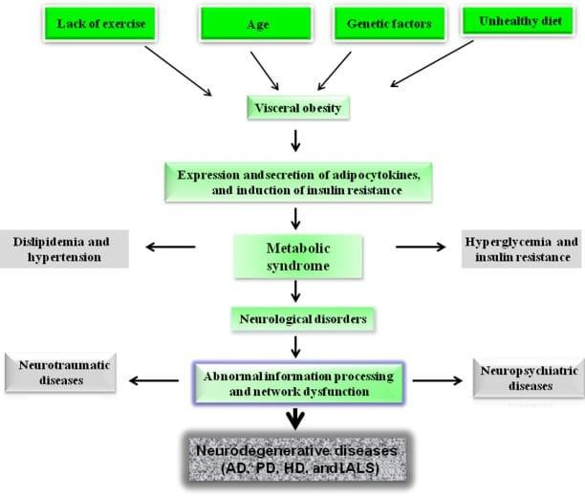
Figure 1. Pathophysiology of neuropharmacological diseases Causes:
A number of reasons can cause NDs, including ageing, which can cause AD and PD, genetic defects that affect the normal functioning of the central nervous system (CNS), which can cause Huntington's illnesses and Amyotrophic Lateral Sclerosis (ALS), and ageing itself. Age and specific genetic variations are recognised risk factors for neurological disorders. Gender, low levels of education, endocrine disorders, oxidative stress, inflammation, stroke, high blood pressure, diabetes, smoking, head trauma, depression, infections, cancers, vitamin deficiencies, immunological and metabolic disorders, and chemical exposure are some of the more likely causes of NDs. (7)

RESOURCES AND ADVANCES
  - THE STUDY AREA:
The Pulla Reddy Institute of Pharmacy’s Department of Pharmacology in Dundigal, Hyderabad, is where the study was carried out.

PLANT MATERIAL:
Cassia Obtusifolia seeds were collected in December 2024 from an online source, Telangana, India. After collection, authentication was carried out by the Botanical Survey of India, Room No. 228-238, Sultan Bazar, Koti, Hyderabad-50001.

PREPARATION OF CRUDE EXTRACT:
Large quantities of fresh Cassia obtusifolia seeds were gathered, shade-dried, and ground in a grinder. For additional research, the coarse powder was utilised. The extraction process, known as Soxhlet extraction, was carried out using methanol as the solvent. After filtering, the extract was kept for later examination.

EXTRACTION PROCESS OF CASSIA OBTUSIFOLIA SEEDS BY USING SOXHLET APPARATUS:
REQUIREMENTS AND EQUIPMENT: Cassia obtusifolia seeds, heating mantle, Soxhlet apparatus, round-bottom flask, and methanol.
PROCEDURE:
    - Cassia obtusifolia seeds were collected and dried.
    - Powder the dried seeds with the help of a blender.
    - 30 grams of powder were weighed.
    - The weighed powder sample was placed in the thimble.
    - Add 250 mL of methanol as a solvent to round round-bottom flask.
    - The round-bottom flask is placed on the heating mantle
    - The solvent comes into contact with the powdered drug, which was placed in the thimble.
    - After many cycles, the desired compound concentrated in the distillation flask.

    - The extracted solvent is filtered, heated and cooled.
    - Collect the extract.
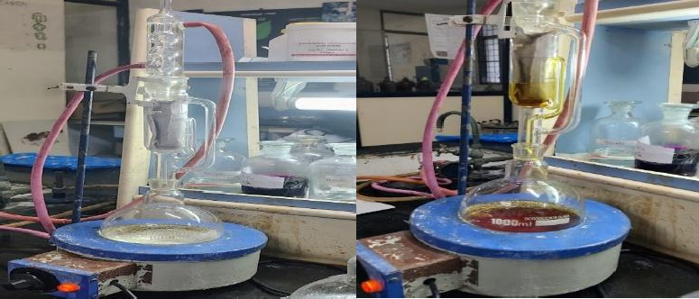
Figure 2: Extraction Process

- PHYTOCHEMICAL TESTS FOR CASSIA OBTUSIFOLIA BY USING METHANOLIC EXTRACT
Phytochemical screening refers to the preliminary analysis of plant materials to identify bioactive compounds such as flavonoids, saponins, tannins, terpenoids, glycosides, and phenolics. These naturally occurring compounds are responsible for a wide range of pharmacological activities, making them important for drug discovery and the development of herbal therapeutics (8).
The qualitative screening of phytochemicals involves classical methods that rely on colour change, precipitation, or froth formation using specific chemical reagents. For instance, Dragendorff’s, Wagner’s, and Mayer’s reagents are commonly used for detecting alkaloids; the Shinoda test for flavonoids; and the Salkowski and Liebermann-Burchard tests for steroids and terpenoids (9). These methods help confirm the presence of these bioactive compounds and act as a preliminary step before more advanced chromatographic or spectroscopic analysis (10).
Solvent extraction using polar or non-polar solvents like methanol, ethanol, chloroform, and water plays a crucial role in extracting specific groups of compounds. Methanol, being a polar solvent, is particularly effective in extracting a broad range of phytochemicals such as flavonoids, saponins, and glycosides (11).

The information gathered from phytochemical screening helps in validating the traditional use of medicinal plants and is essential for quality control and standardisation of plant-based formulations (12).

TEST FOR GLYCOSIDES:
- BRONTRAGERS TEST:
2ml of extract was boiled with a few drops of sulphuric acid for 15-20 minutes. Cool and filter the extract, add a few mL of chloroform to separate the organic layer. Then added ammonia and observed.

OBSERVATION:
Glycosides are indicated by colours such as red, pink and orange (13).

TEST FOR TANNINS:
- FERRIC CHLORIDE TEST:
One ml of extract was mixed with two ml of a 5% neutral ferric chloride solution.

OBSERVATION:
The dark blue colouring suggested the presence of tannins and phenolic compounds (14).

LEAD ACETATE TEST:
Add a few drops of a 10% lead acetate solution to 1 ml of plant extract.

OBSERVATION:
Phenolic compounds are indicated by a colour of yellow precipitate (13.1).

TEST FOR SAPONINS:
- FOAM TEST:
20 ml of distilled water and 5 ml of extract were combined, and the mixture was shaken in a graduated cylinder.

OBSERVATION:

Stable foam formation was interpreted as a sign that saponins were present (15).

TEST FOR STEROIDS AND TRITERPENES:
- SALKOWSKI TEST:
0.5 ml of each extract, 2 ml of chloroform was added, and then 3 ml of concentrated sulphuric acid was carefully added to form a layer. OBSERVATION:
A reddish-brown colouration at the interface indicates the presence of terpenoids (13.2).

TEST FOR FLAVONOIDS:
- SHINNODA TEST:
2ml of extract was mixed with a few fragments of magnesium turnings and conc. hydrochloric acid was added gradually after a few minutes, it was observed.

OBSERVATION:
The appearance of a pink or orange colour indicates the presence of flavonoids (15.1).

TEST FOR RESINS:
- 1 ml of various solvent extract was treated with a few drops of acetic anhydride solution, followed by one ml of conc. Sulphuric acid. OBSERVATION:
The colouration, ranging from orange to yellow that indicates the presence of resins (13.3)

TEST FOR ALKALOIDS:
- WAGNER TEST:
A few drops of Wagner reagent were added to 2 millilitres of extract.

OBSERVATION:
The presence of alkaloids is indicated by the production of a reddish-
brown precipitate (16).

DRAGENDORFF TEST:

1 ml of the extract was subjected to dragendroff’s reagent.

OBSERVATION:
The presence of alkaloids is indicated by the colour of the orange-red precipitate.

HAGERS TEST:
1ml of extract was subjected to Hager's reagent

OBSERVATION:
The presence of alkaloids is indicated by the yellow precipitate.

MAYERS TEST:
1 ml of the extract was subjected to Mayer's reagent.

OBSERVATION:
The presence of alkaloids is indicated by a yellowish or white precipitate (15.2).

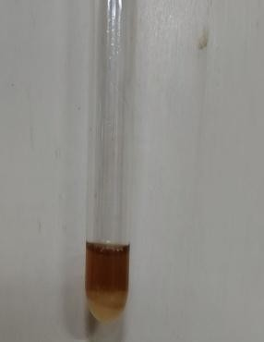
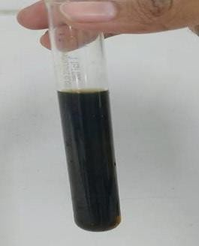
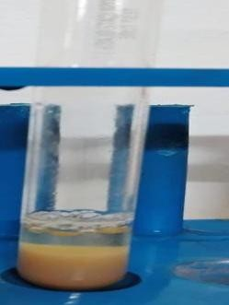
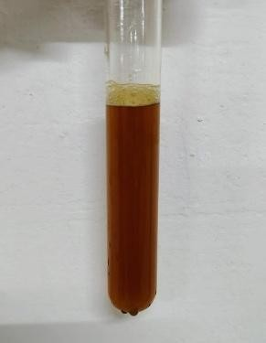
Glycoside Test Tannins Test Saponins Test


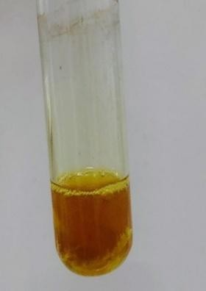
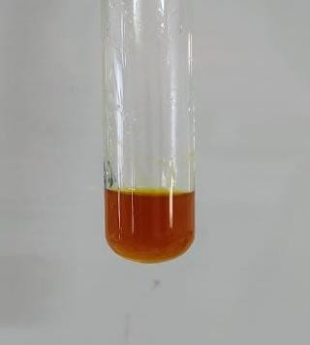
Steroids & Flavonoids Test Resins Triterpenes Test

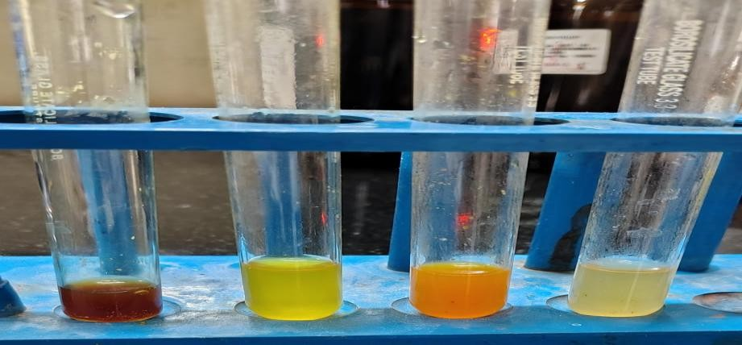
Alkaloids Test
Figure 3: Phytochemical Tests INVIVO METHODS:

EDDY’S HOT PLATE:
Procedure:
- Experimental animal’s mice were selected and divided into four groups.
- Designated as group 1, group 2, group 3 and group 4 for control, standard and test, respectively.
- The mice were used after 24 hours of fasting and allowed water only during the experiment.
- Each group received a particular treatment i.e.1st group treated with vehicle (gum acacia), The 2nd group was treated with standard drug (diclofenac 10mg/kg intraperitoneally), The 3rd group was treated with low dose of methanolic extract of cassia obtusifolia seed 50mg/kg, The 4th group was treated with high dose of methanolic extract of cassia obtusifolia seed 200mg/kg.
- All animals were individually weighed and gently placed on a hot plate, with the temperature maintained at 55 degrees Celsius.
- The latency period—defined as the time from when the animal was placed on the hot plate until the appearance of a nociceptive response such as paw licking or jumping—was recorded using a stopwatch. To prevent any tissue damage, a cut-off time of 15 seconds was set.

- The reaction times of animals were noted at 0,30,60, and 90 minutes intervals after administration of the drug and test product. (17)

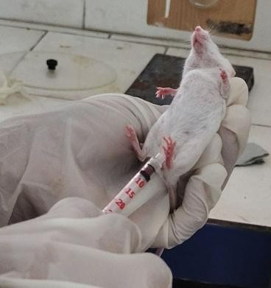

Figure 4: Route Of Administration (I.P.) & Eddy’s Hot Plate Apparatus

OPEN FIELD TEST:
Procedure:
The open field test is a widely used method for evaluating general locomotor activity, exploratory behaviour, and anxiety-related responses in rodents. In this study, the open field apparatus was constructed from plain wood and measured 45 cm × 45 cm × 20 cm. The floor consisted of a wooden sheet (45 cm × 45 cm), marked with a grid that divided the surface into sixteen equal squares.
- Mice were randomly assigned to four groups were treated. Experimental animal’s mice were selected and divided into four groups.
- Designated as group 1, group 2, group 3 and group 4 for control, standard and test, respectively.
- The mice were used after 24 hours of fasting and allowed water only during the experiment.

- Each group received a particular treatment i.e.1st group treated with vehicle (gum acacia), The 2nd group was treated with standard drug (Alprazolam 5mg/kg intraperitoneally), The 3rd group was treated with low dose of methanolic extract of cassia obtusifolia seed 50mg/kg, The 4th group was treated with high dose of methanolic extract of cassia obtusifolia seed 200mg/kg.
Thirty minutes post-treatment, each mouse—whether from the control or treated groups—was gently placed at the centre of the open field arena. The behaviour of each animal was then observed and recorded over a 5-minute session.
During the observation period, a hand-operated counter and a stopwatch were used to assess the following behavioural parameters:
- Number of entries and time spent in the central area of the field, which can reflect anxiety-like behaviour (less time in the centre may indicate increased anxiety).
- Time spent in the periphery and corners, as animals typically prefer these areas when anxious.
- Number of crossings (i.e., how many grid squares the mouse entered), used to estimate general locomotor activity or distance travelled.
- Rearing behaviour (standing on hind legs), which reflects exploratory activity.
- Assisted rearing, when the mouse stood on its hind legs and touched the wall with its forepaws, indicating vertical exploration.
This test setup provides a simple yet effective way to analyse behavioural changes, especially those influenced by anxiolytic or stimulant drugs. (18)

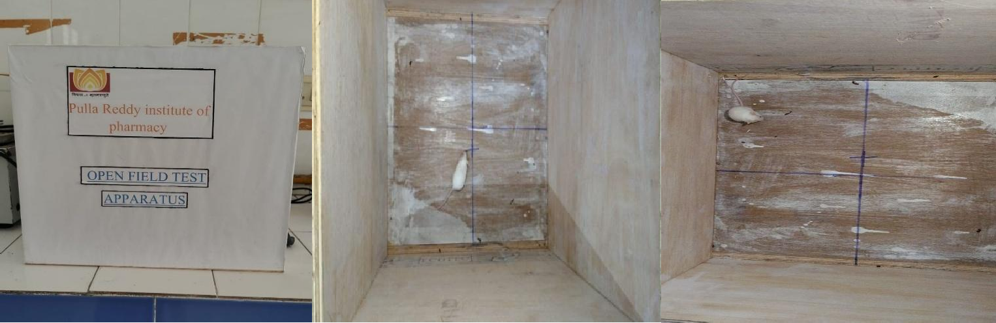
Figure 5: Open Field Test

RESULTS FOR PRELIMINARY PHYTOCHEMICAL TEST
table 1-

S.  NO | NAME OF THE  CHEMICAL TEST | METHANOLIC  EXTRACT
1. | GLYCOSIDES TEST:  - Brontrager's Test | +
2. | TANNINS TEST:  - Ferric Chloride Test  - Lead Acetate Test | +  +
3. | SAPONINS TEST:  - Foam Test | +
4. | STEROIDS AND TRITERPENES TEST:  - Salkowski Test | +
5. | FLAVONOIDS TEST:  - Shinoda Test | +
6. | RESINS TEST: | +
7. | ALKALOIDS TEST:  - Wagner’s Test  - Dragendroff’s Test  - Mayer’s Test  - Hager’s test | -  -  -  -

ANALGESIC ACTIVITY OF METHANOLIC EXTRACT OF CASSIA OBTUSIFOLIA SEEDS BY USING EDDY’S HOT PLATE METHOD:
In this evaluation, animals treated with diclofenac (10 mg/kg, I.P) had an evident increase in the latency time 0,30, 60, 90mins. For the groups treated with Methanolic extract (50 mg/kg and 200mg/kg plant extract), less effect was shown in the first 30 min. However, an increase in latency time was found in 60, 90 minutes. The diclofenac proved to be a potent analgesic, increasing the latency time within the time evolution and paw licking and jumping time were recorded.

TREATMENT | 0 MINS | 30 MINS | 60 MINS | 90 MINS
CONTROL | 8.00±0.365 | 8.50±0.619 | 9.10±0.654 | 10.10±1.01  3
STANDARD  (Diclofenac) | 10.16±0.74  9** | 12.80±1.37  6** | 13.16±0.40  1** | 14.16±0.40  1**
LOWDOSE50m  g/kg (cassia obtusifolia) | 9.40±0.509  * | 10.83±0.47  7* | 11.66±1.66  6* | 12.83±0.83  3*
HIGHDOSE200  mg/kg (cassia obtusifolia) | 10.00±0.74  9* | 11.83±0.90  9* | 12.83±0.70  3* | 13.16±1.01  3*

Table 2: mean and SEM values for Eddy’s hot plate method (Response Time)
The values are represented as mean ± standard error of mean (SEM), n=6. Statistical significance was analysed by one-way ANOVA. Significance was noted as P < 0.05.

Analgesic activity of methanolic extract of cassia obtusifolia seeds by using eddy’s hot plate

15

CONTROL
STANDARD
Response Time
10 COME 50 MG

COME 200 MG

5

0
0 MINS 30 MINS 60 MINS 90 MINS
Treatment Group

Figure 6: graphical representation of eddy’s hot plate

ANXIOLYTIC ACTIVITY OF METHANOLIC EXTRACT OF
CASSIA OBTUSIFOLIA SEEDS BY USING OPEN FIELD TEST:
In this evaluation, animals treated with Alprazolam (5 mg/kg, i.p.) had an evident anxiolytic activity in the time spent in centre. The groups treated with Methanolic extract (50 mg/kg and 200mg/kg plant extract) showed significant (p<0.05) results when compared to the control.

table 3-
TREATMENT GROUP | TIME SPENT  (MEAN AND SEM VALUE) | NO. OF  ANIMALS
CONTROL | 13.5±0.764* | 6
STANDARD  (Alprazolam) | 44.5±0.764* | 6
LOW DOSE  50mg/kg  (cassia obtusifolia) | 28.5±0.764* | 6
HIGH DOSE  200mg/kg  (cassia obtusifolia) | 36.8±0.792* | 6

The values are represented as mean ± standard error of mean (SEM), n=6. Statistical significance was analysed by one-way ANOVA. Significance was noted as *P < 0.05.
Evaluation of the Anxiolytic Activity of Cassia obtusifolia in Experimental Animals

Anxiolytic activity of the methanolic extract of Cassia obtusifolia seeds by using the open field test
TIME SPENT IN CENTRE (SEC)
50
40 CONTROL
30 STANDARD
20 COME 50mg
10 COME 200mg

0
CONTROL
STANDARD
COME 50 mg
COME 200 mg

TREATMENT GROUP

Figure 7: Graphical representation of open field

DISCUSSION
- The present study was aimed at evaluating the phytochemical and neuropharmacological potential of Cassia obtusifolia seed extracts using established in vivo models in albino mice. Based on the comprehensive review of literature, Cassia obtusifolia has been traditionally reported to possess various medicinal properties, including antioxidant, anti-inflammatory, and central nervous system (CNS)-related effects. However, detailed experimental evaluation of its neuropharmacological properties, especially in seed extracts, remained limited.
- Methanolic extraction via Soxhlet apparatus was employed, as methanol is an efficient solvent for extracting a broad range of phytoconstituents, especially polar compounds. Preliminary phytochemical screening revealed the presence of several active constituents, notably glycosides, flavonoids, and phenolic compounds. These constituents are often associated with neuropharmacological activities such as analgesic and anxiolytic effects, suggesting the potential of the extract for CNS modulation.
- For neuropharmacological evaluation, two validated in vivo models were selected: Eddy’s Hot Plate method for assessing central analgesic activity, and the Open Field Test (OFT) to evaluate exploratory behaviour and potential anxiolytic effects.
- In the Eddy’s Hot Plate test, the extract-treated groups (both low and high doses) showed a statistically significant (p < 0.05) increase in latency time for paw licking and jumping when compared to the control group. This confirms the central analgesic effect of the extract. Although the effect was slightly less than the standard drug diclofenac, it was notably consistent and dose-dependent, indicating potential central nervous system involvement.

- In the Open Field Test, mice treated with the extract showed a significant (p < 0.05) increase in locomotor activity and frequency of centre entries compared to the control group. These behavioural changes suggest a reduction in anxiety-like behaviour, indicating possible anxiolytic properties of the extract. Such effects are commonly attributed to the presence of flavonoids and glycosides, which may act through modulation of GABAergic or serotonergic neurotransmission.
- The statistically significant results from both tests support the neuropharmacological potential of Cassia obtusifolia seed extract. The findings validate the traditional use of this plant in CNS-related disorders and suggest its potential role in developing new herbal therapeutic agents for pain and anxiety management.
- Further studies involving isolation of individual active compounds, detailed mechanistic pathways, and long-term safety profiling are recommended to substantiate and extend these promising results.

CONCLUSION
The current study successfully evaluated both the phytochemical profile and neuropharmacological activities of Cassia obtusifolia seed extract. The preliminary phytochemical screening revealed the presence of various bioactive constituents such as flavonoids, phenols, tannins, saponins, and glycosides, which are known to possess pharmacological effects on the central nervous system (CNS). The in vivo behavioural models provided clear evidence of the extract's CNS activity: In Eddy’s hot plate test, the extract significantly increased the pain threshold (reaction time) in a dose-dependent manner, indicating central analgesic activity. In the Open Field Test, the extract decreased locomotor activity, rearing, and grooming behaviours, indicating CNS depressant and anxiolytic-like effects. The high-dose group showed more prominent effects compared to the low-dose group and control, though slightly less potent than the standard drug Alprazolam, confirming the extract’s pharmacodynamic potential. These effects may be attributed to the

modulation of neurotransmitter systems, particularly GABAergic and serotonergic pathways, by the active constituents present in the extract. The results thus support the traditional use of Cassia obtusifolia in herbal medicine for nervous system-related ailments. In conclusion, the Methanolic extract of Cassia obtusifolia seeds exhibits significant neuropharmacological effects, including analgesic and anxiolytic activities, validating its ethnomedicinal use.

REFERENCES
- Valeria Manera, Erika Rovini and Peter Wais- “Editorial: Early detection of neurodegenerative disorders using behavioural markers and new technologies: New methods and perspectives”- Frontiers in aging neuroscience DOI NO: 10.3389/fnagi.2023.1149886
- Kumaresan P Thirupathy, Asish Tulshkar, C Vijaya- “Neuropharmacological activity of Lippia nodiflora Linn” Journal of pharmacognacy Research - https://doi.org/10.4103/0974-8490.85007
- Tarique Hussain, Abdul Hafiz, Vishwakarma Ravi Kumar, Deepak Kumar and Imran Kazmi - “A Review - Study on Phytochemical and Neuropharmacological Effects of Cassia Tora Flowers”-Clinical Pharmacology and Biopharmaceutics- ISSN: 2167-065X
- Umesh kumar- “Neuropharmacological disorders: An outline to the general considerations” Journal of clinical/pharmaco-epidemiology research-DOI NO: http://doi.org/10.5281/zenodo.3066800
- Dr. D.K. SURESH – “study of phytochemical and neuropharmacological effect of cassia Tora flowers” -Rajiv Gandhi university of health sciences -reg no: 15PP058
- AA Farooqui – “Neurochemical aspects of neurological disorders” - science direct-https://doi.org/10.1016/B978-0-7.00016-1
- Balachandar Vellingiri - “An overview about neurological diseases in India – A theranostics approach”-science direct- https://doi.org/10.1016/j.ahr.2023.100177

- Patil, R.H., Patil, M.P., & Maheshwari, V.L. - “Phytochemical Screening and Chemical Characterization of the Bioactive Metabolites. In Apocynaceae Plants”- Springer. https://doi.org/10.1007/978-981-99- 5406-3-5
- Shaikh, J.R., & Patil, M.K.- “Qualitative tests for preliminary phytochemical screening: An overview”-International Journal of Chemical Studies, 8(2), 603–608. https://doi.org/10.22271/chemi.2020.v8.i2i.8834

10)Ali, M.M., | Ali, S.S., & Abdalaziz, M.N.- | “In-vitro | antimicrobial
activity and | phytochemical screening of | Cassia | obtusifolia”-
Advancement in Science and Technology Research, 3(1), 1–8. https://doi.org/10.25259/ASTR-3-2020
- Kumar, D., & Prakash, O. – “Contemporary methods for the extraction and isolation of natural products”- BMC Chemistry, 17(1), 1–15. https://doi.org/10.1186/s13065-023-00960- zbmcchem.biomedcentral.com
- Gafner, S., & Bergeron, C. – “Quality control of herbal drugs and preparations: The methods of pharmacognosy”- Pharmacognosy Reviews, 15(30), 1–10. https://doi.org/10.1016/j.phrs.2021.100040
- Mahmoud Mohamed Ali, Safa Suliman Ali and Mohamed N. Abdalaziz- “In-vitro antimicrobial activity and phytochemical screening of Cassia obtusifolia”- Advancement in science and technology research
-ISSN: 2437-1319
- Nagaraju Kancherla, Anusha Dhakshinamoothi, K Chitra, Ravi Babu Komaram- “Preliminary analysis of phytoconstituents and evaluation of anthelmintic property of cayratia auriculata (in vitro)”- MEDICA- a journal of clinical medicine- DOI NO: https://doi.org/10.26574/maedica.2019.14.4.350

- Junaid R Shaikh and MK Patil- “Qualitative tests for preliminary phytochemical screening: An overview”- international journal of chemical studies https://doi. Org / 10.22271/chemi.2020.v8.i2i.8834
- Ashish Phuyal, Pawan Kumar Ojha, Biswash Guragain and Narendra Kumar Chaudhary- “Phytochemical screening, metal concentration determination, antioxidant activity, and antibacterial evaluation of Drymaria diandra plant”- Beni-Suef University Journal of Basic and Applied Sciences- https://doi.org/10.1186/s43088-019-0020-1
- Md. Anisuzzaman, Md. Qamrul Ahsan, Md. Ruhul Kuddus, Mohammad Abdur Rashid- “pharmacological activities of senna obtusifolia linn.: A medicinal plant of Bangladesh”- Bangladesh pharmaceutical journal
- S.K. Kulkarni- “handbook of experimental pharmacology”
- Shah, S. A. A., Habib, N., Aziz, W., Khan, E. U., & Nadeem, M. S. A. (2020). Classification of control and neurodegenerative disease subjects using tree based classifiers. Journal of Pharmaceutical Research International, 32(11), 63–73.

COMPETING INTERESTS DISCLAIMER:
Authors have declared that they have no known competing financial interests OR non-financial interests OR personal relationships that could have appeared to influence the work reported in this paper.
- Aslam, R. M. N., Ain, N.-u., Ali, H., Muzammil, A., & Iqbal, A. (2024). A review on the role of neuroplasticity in neurodegenerative disorders and its possible pharmacological and non-pharmacological interventions. Asian Journal of Medicine and Health, 22(1), 72–86.
- Joty, F. A., & Azad, M. A. K. (2024). A systematic review of the impact of medicinal plants on cardiac health compared to standard pharmaceuticals available in Bangladesh. Journal of Advances in Medical and Pharmaceutical Sciences, 26(12), 50–58.

