Integrated Tourism-Based Homestay Service Quality: A Gap Analysis in the AEWO Mulyaharja Tourism Village
ABSTRACT
Aims: To identify the gaps in the quality of homestay services in the Agro Edu Wisata Organic (AEWO) area of Mulyaharja, Bogor City, against the Standard of Guesthouse Business established by the Ministry of Tourism and Creative Economy. In the context of Community-Based Tourism (CBT), homestays play a strategic role as accommodations that not only offer a place to stay but also cultural values and deep social interactions.
Study Design: This study is a qualitative research with a case study design.
Place and Duration of Study: The research was conducted at Agro Edu Wisata Organik (AEWO) Mulyaharja, Bogor, in 2024.
Methodology: The main informants are homestay owners selected purposively based on their active involvement in managing the homestay and a minimum of one year of experience. Data were collected through semi-structured in-depth interviews based on the five dimensions of SERVQUAL (reliability, responsiveness, assurance, empathy, physical evidence) and were analyzed thematically using deductive–inductive coding processes.
Results: The main strengths of the homestays lie in the dimensions of empathy and responsiveness, reflected in warm social interactions and personalized service from the homestay owners. Conversely, weaknesses appear in the dimensions of assurance, reliability, and physical evidence, such as the absence of written Standard Operating Procedures (SOPs), limited standard facilities, and minimal security guarantees for the service. Variations in service among homestays due to the lack of SOPs could potentially decrease tourist satisfaction and loyalty. These findings highlight a significant research gap related to the absence of SERVQUAL-based SOPs within community-based homestay settings, indicating the need for more structured policy interventions.
Conclusion: Managerially, this study recommends the development of culturally grounded SOPs rooted in local values, supported by training and capacity-building from local governments and higher education institutions to ensure consistent service quality and enhance the competitiveness of tourism villages. This step aims to improve the consistency of service quality and the competitive edge of homestays sustainably, without compromising the local community's cultural uniqueness.
Keywords: Homestay, Service Quality, Community-Based Tourism, Standard Operating Procedure
- INTRODUCTION
Community-based tourism is a form of tourism that seeks to empower local communities to manage tourism growth and achieve community goals related to sustainable economic, social, and environmental well-being (Kadir, Wulandari, & Hendratono, 2022). Village tourism has now become a sustainable development approach that integrates local potential with active community participation. This concept is known as Community-Based Tourism (CBT), which positions local people as the main actors in planning, management, and benefit distribution. According to The Responsible Tourism Partnership, stated that CBT allows tourists to experience authentic interactions while communities gain direct economic, social, and cultural benefits. In the context of CBT, homestays play an important role as they provide culturally immersive accommodation and opportunities for social interaction (Goodwin, 2011).
In 2023, West Java became the province with the highest number of domestic tourist trips in Indonesia, reaching 139,117,269 trips (BPS, 2024). Domestic tourists choose West Java because the province upholds the vision and mission of “Jabar Istimewa” (Special West Java) with flagship programs such as champion tourism, food security, and the development of the creative economy and MSMEs. Both the government and local communities are making optimal efforts to manage tourism development (Jabarprov, 2025). The high number of tourist visits in West Java has made the tourism sector a key contributor to the local economy. Consequently, communities are encouraged to develop sustainable rural-based tourism rather than conventional tourism.

The West Java Tourism and Culture Office recorded that Bogor City is among the top ten regencies/cities with the largest number of tourism areas in West Java (Open Data Jabar, 2025). According to the Head of the Bogor Tourism and Culture Office, Mr. Deni Humaedi, “The number of tourist villages was initially recorded at only 25 villages in 2019, increasing to 35 in 2020, then 40 in 2021, and by 2022 reaching 55 tourist villages” (Antara Kantor Berita Indonesia, 2023). One of Bogor’s leading tourist villages is Mulyaharja Tourism Village, which was listed among the top 300 nominees in the 2023 Indonesian Tourism Village Awards (ADWI) (Jadesta, 2025). Mulyaharja Subdistrict features a flagship program called Agro Edu Wisata Organik (AEWO) Mulyaharja, located in Kampung Ciharashas, Mulyaharja Subdistrict, South Bogor District, Bogor City, West Java.

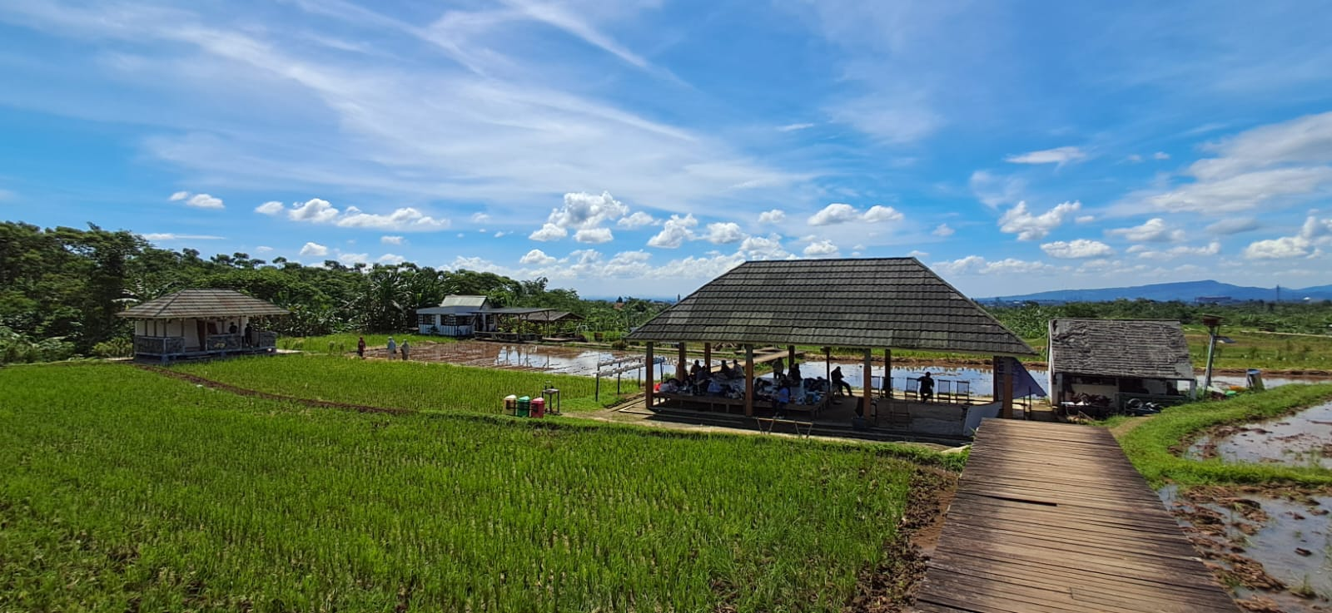 | 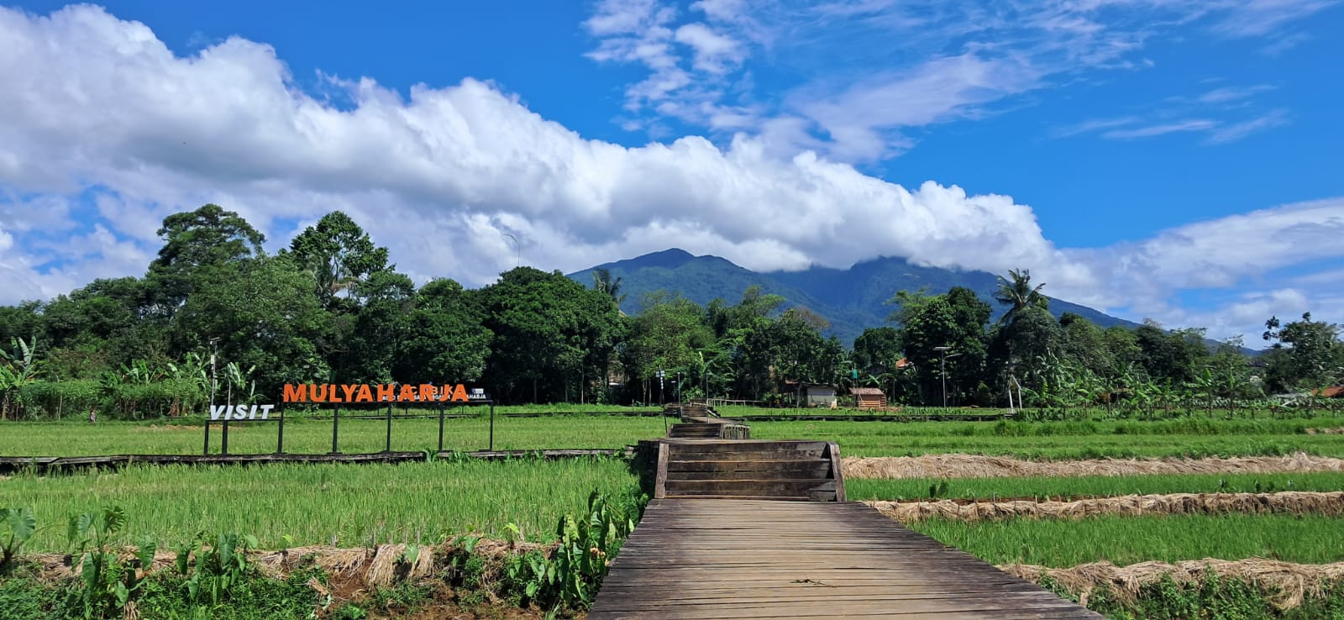 | 

Gambar 1. AEWO Mulyaharja (Sumber: Dokumentasi Peneliti, 2025)

Agro Edu Wisata Organik Mulyaharja is one of the natural tourist attractions in Bogor City that has been certified for Clean, Health, Safety, and Environment Sustainability (CHSE) (Kemenparekraf, 2022) and is oriented toward educational tourism, where visitors can enjoy recreation while learning. Research conducted by Kiswantoro et al. (2024) explains that homestay tourism village managers need to improve service quality based on health and CHSE protocols, communicate a positive image to guests through an integrated marketing communication mix, and enhance guest satisfaction and trust (Kiswantoro, et al., 2024). In addition to holding CHSE certification, this tourist destination offers added value through educational, cultural, and agricultural experiences supported by the uniqueness of local products, such as traditionally cultivated organic rice (using the 2-1 “jajar legowo” planting system), land plowing with buffaloes, simple tools (such as tin cans) to repel birds, and manual harvesting methods. These practices are transformed into tourist activities involving land processing, seedling, harvesting, and post-harvest learning experiences (Ghifari, Djuwendah, Rochdiani, & Qanti, 2024).
In terms of service quality, excellent service becomes an essential strategy to attract new customers, retain existing ones, prevent customer switching, and create a competitive advantage. Management that prioritizes high-quality service will positively impact tourist satisfaction. Service quality represents an effort to create comfort for tourists so that they experience added value beyond their expectations. Customer expectations are a key factor; if the perceived service quality meets or approaches tourist expectations, satisfaction will be achieved, and vice versa. When service quality is fulfilled, tourist satisfaction will be realized indirectly.

Economic activities in Kampung Mulyaharja are strongly supported by community participation. Efforts to improve residents’ economic conditions are carried out through local culinary production, the creation of tour packages, and the management of homestays integrated with Agro Edu Wisata Organik. Field observations show that the service quality of homestays managed by residents still varies greatly. The growing interest of tourists in staying at homestays demands the implementation of operational risk management to ensure sustainability. Homestays allow guests to interact closely with the hosts and experience the atmosphere of local wisdom (Susanto, et al., 2025). Some homestays provide adequate facilities, but many have yet to meet the basic standards of tourism service, such as room cleanliness, bed comfort, and host hospitality. Moreover, the absence of Standard Operating Procedures (SOPs) for service delivery remains a major factor contributing to the inconsistency in service quality among homestays.emphasize that many homestay owners and stakeholders still lack awareness regarding the importance of developing standardized management guidelines, resulting in inconsistent service practices and limited capacity to achieve sustainable community-based tourism (Muslin, Berliyanti, & Utha, 2023).

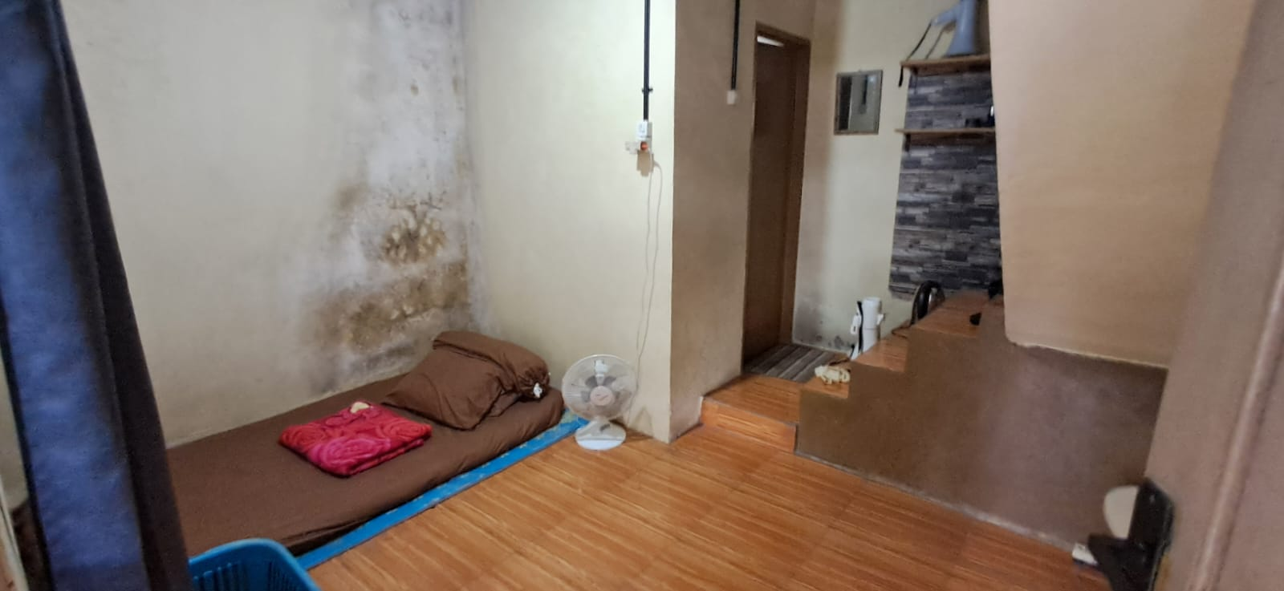 | 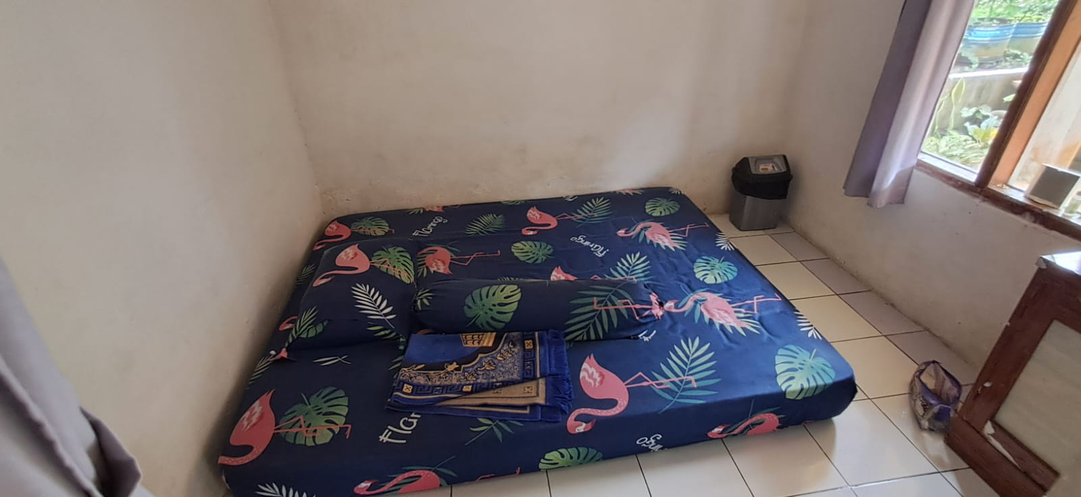 | 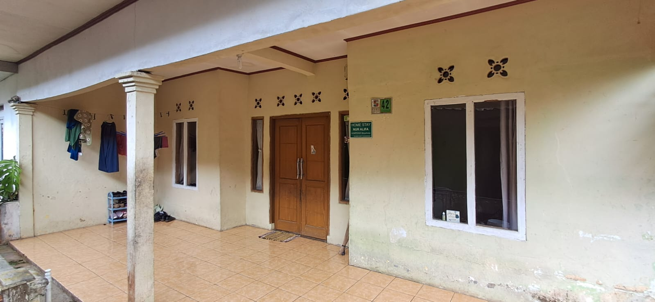
Gambar 2. Fasilitas Homestay (Sumber: Dokumentasi Peneliti, 2025)
The variation in service quality leads to uncertainty in the tourist experience, which ultimately affects their satisfaction and loyalty. Stated that inconsistent service can reduce tourist trust and damage a destination’s reputation (Sharma S. K., 2019). Similar issues occurred in India and Malaysia, which responded by establishing the Service Quality Framework and the ASEAN Homestay Standard to standardize the quality of community-based accommodation services (Wahyuni & Faisal, 2019).
To measure and improve the quality of homestay services, this study adopts the SERVQUAL model (Parasuraman, Zeithaml, & Berry, 1985). This model is one of the most widely used theories in service management, encompassing five key dimensions: reliability, responsiveness, assurance, empathy, and tangibles. In the homestay context, the SERVQUAL dimensions not only reflect the physical quality of the accommodation but also encompass the emotional interactions and cultural values experienced by tourists.
The SERVQUAL approach is reinforced by the Perceived Service Quality and Customer Satisfaction theories (Oliver, 1980), which state that tourists’ perceptions of service quality affect their level of satisfaction, which in turn influences revisit intention and word-of-mouth behavior. Within the CBT framework, this theory is crucial since tourist loyalty can serve as a driver of economic sustainability for rural communities.
Several previous studies have emphasized the importance of Standard Operating Procedures (SOPs) in homestay management. Found that effective training and well-designed SOPs can enhance service quality and strengthen the competitive position of homestays within the local tourism industry (Thakur, Khumar, Balodi, Dehal, & Atri, 2023). Prabawati also demonstrated that implementing basic service principles such as cleanliness, hospitality, and guest participation in local activities significantly improves guest satisfaction (Prabawati, 2017). Furthermore, operational risk management and the charm of local wisdom in tourist villages contribute positively to homestay user satisfaction (Susanto, et al., 2025).
However, in Indonesia particularly in the Bogor region there is currently no scientific study that specifically develops homestay SOPs based on the SERVQUAL theory within the CBT framework. This indicates the existence of an academic and practical gap that this research aims to address. Community-based tourism emphasizes the active participation of residents in developing inclusive and sustainable tourism destinations. Homestays are a flagship accommodation type in CBT because they not only provide lodging but also create spaces for social interaction and cultural exchange between tourists and residents. Rahmiati, Nugraha, and Prayoga stated that homestays in tourist villages have great potential to increase tourist satisfaction if managed according to proper service standards (Rahmiati, Nugraha, & Prayoga, 2023). In Malaysia, homestay programs have also been developed as an integral part of rural community development with central government support, including training and quality standardization.

Service quality is a key indicator of homestay success. The SERVQUAL model is the most commonly used framework for measuring service quality through its five primary dimensions: reliability, responsiveness, assurance, empathy, and tangibles. In addition, there are eight other dimensions of the homestay service experience, namely: culture, tour guide service, food and beverage, environment, cleanliness, accommodation, service, and accessibility (Kiswantoro, et al., 2023). Prabawati found that homestay service quality is measured through guest satisfaction with housekeeping services and the readiness of physical facilities, both of which directly contribute to guest satisfaction (Prabawati, 2017). Ardianto and Sugiarto further explained that homestays must manage service quality effectively for their customers (Ardianto & Sugiarto, 2022). The dimensions of Reliability, Assurance, Tangibility, Empathy, and Responsiveness have been applied to manage service quality in the hospitality industry.

The absence of standardized Standard Operating Procedures (SOPs) poses a major challenge in ensuring the quality of homestay services. Thakur emphasized the importance of developing the capacity of homestay managers through training and the implementation of SOPs to improve service consistency and tourism competitiveness (Thakur, Khumar, Balodi, Dehal, & Atri, 2023). SOPs play a crucial role in standardizing service expectations among various homestay providers, especially those operating at different scales and capacities. Ardianto and Sugiarto also stated that poorly managed homestay services affect tourists’ perceived risks, well-being, and their decision to revisit (Ardianto & Sugiarto, 2022). highlight that effective homestay management requires structured capacity-building, consistent service standards, and strong community involvement to ensure sustainable rural tourism development (Sianipar, Juliana, & Lemy, 2024).
Sharma developed a Service Quality Framework specifically for homestays in Sikkim, India, which focuses on community involvement, cleanliness, and local experiential approaches (Sharma S. K., 2019). To enhance the competitiveness of homestays, services need to be integrated with other tourism components such as local attractions, culinary experiences, culture, and accessibility. Wahyuni and Faisal demonstrated that the implementation of the ASEAN Homestay Standard in Nglanggeran Tourism Village, Yogyakarta encouraged synergy between SOPs, social interaction, and authentic tourist experiences (Wahyuni & Faisal, 2019). Research conducted by Sugiarto revealed that the growing appeal of homestays across destinations also brings potential risks due to unpreparedness and poor management capabilities (Sugiarto, et al., 2024).
Based on this background, this study aims to identify the gap between the quality standards of homestay services in the AEWO Mulyaharja area and the Tourist Lodge Business Standards set by the Ministry of Tourism and Creative Economy. Furthermore, this study seeks to bridge the gap by examining the application of service management theories contextualized within integrated tourism. There remains an open opportunity for future research on topics such as tourist satisfaction, loyalty, service quality, and operational risk mitigation in homestays within a unified research model. This will serve as a new finding for further studies (Kiswantoro, et al., 2023).
Through this approach, it is expected that a homestay service system will emerge that is not only high-quality and consistent but also reflects local values, empowers communities, and enhances the competitiveness of tourist villages at both regional and national levels.

- METHODOLOGY
This study employs a qualitative approach using a case study method, focusing on homestays in the AEWO Mulyaharja area. The research aims to examine homestay service quality using the SERVQUAL framework as the conceptual foundation, encompassing five dimensions: reliability, responsiveness, assurance, empathy, and tangibles.
The selection of key informants in this study utilized a purposive sampling technique, focusing on homestay owners who possessed relevant experience and were actively involved in managing homestay operations. The sample size in this study consisted of homestay owners selected through purposive sampling, with a total of 10 informants. This number is considered adequate for qualitative case study research, as the primary objective is to obtain rich, in-depth information rather than statistical generalization. The determination of the sample size followed the principle of information power, which suggests that smaller samples are acceptable when the study has a narrow aim, specific sample characteristics, a strong theoretical background, and high-quality interview data. Additionally, sampling was continued until data saturation was reached, indicated by the repetition of themes and the absence of new significant insights during consecutive interviews. This approach ensures that the sample size is both sufficient and methodologically justified for achieving comprehensive and credible findings.
The study used purposive sampling, a technique commonly applied in qualitative research to ensure that participants possess the specific knowledge and experience required to address the research objectives. A total of 10 homestay owners were selected based on three criteria:
- minimum of one year of operational experience,
- direct involvement in homestay management, and
- active participation in community-based tourism initiatives within AEWO Mulyaharja.
The sample size is considered sufficient as qualitative research prioritizes information power, meaning that smaller samples are acceptable when the aim is focused and participants are information-rich (Malterud, Siersma, & Guassora, 2016)
Data were collected over a period of May-June 2025, allowing the researcher to capture variations in homestay operations during weekdays, weekends, and peak visitation periods. Semi-structured in-depth interviews were conducted using an interview guide based on the five SERVQUAL dimensions (reliability, responsiveness, assurance, empathy, and tangibles). Each interview lasted between 45–90 minutes and was audio-recorded with the informants’ consent. Data collection relied on semi-structured in-depth interviews, allowing participants to provide detailed narratives of their service practices and management experiences. Triangulation through observation and documentation further strengthened the credibility of the findings. Thematic analysis was applied using a deductive–inductive process aligned with the SERVQUAL framework while remaining open to emergent themes relevant to the local context.
Data analysis was conducted thematically, following a deductive inductive coding process grounded in the SERVQUAL framework. The analysis stages included data reduction, data display, and iterative conclusion drawing. Furthermore, a stronger justification for the use of thematic analysis with a deductive-inductive approach is needed, for example, by emphasizing that this method was chosen because it can capture patterns of service experiences based on SERVQUAL dimensions while allowing for the emergence of new themes relevant to the local context. Thus, the selection of analytical tools not only aligns with the research objectives but also enhances the interpretive validity and transparency of the data analysis process.
The study employed thematic analysis, following the six-phase analytical framework developed by (Braun & Clarke, 2006), which is widely recognized for its flexibility and rigor in qualitative research. The analysis included:
- Familiarization with the data
Transcribing interviews, reading transcripts repeatedly, and noting initial observations.
- Generating initial codes
Coding meaningful segments related to SERVQUAL dimensions and contextual factors.
- Searching for themes
Organizing related codes into preliminary themes such as "service consistency issues," "local values in service delivery," and "facility limitations."
- Reviewing themes
Refining and validating themes to ensure coherence and relevance.
- Defining and naming themes
Finalizing theme definitions and linking them to the research objectives.
- Producing the final report
Synthesizing themes into narrative findings supported by direct quotes from informants.
The combination of deductive (SERVQUAL-based) and inductive (emerging from field data) coding ensured methodological rigor and allowed the findings to reflect both theoretical frameworks and local contextual nuances
To ensure validity, the study applied source triangulation and member checking. Ethical considerations were maintained through informed consent, confidentiality of informant identities, and formal approval from relevant institutions. Highlight that rigorous methodological procedures, such as the use of structured observations, interviews, and triangulated data collection, are essential to ensure the reliability and validity of homestay service quality assessments in tourism destinations. (Ardiansyah, Permatasari, & Superwiratni, 2023).
- RESULT AND DISCUSSION
Reliability: Service Accuracy and Management Consistency
The reliability dimension refers to the homestay’s ability to provide services accurately, on time, and consistently. Based on interview findings, most homestay owners rely on personal experience and intuition in managing daily operations. They strive to deliver timely services, such as preparing breakfast, readying rooms before guest arrival, and fulfilling additional guest requests. However, the absence of documented SOPs makes service consistency highly dependent on the individual capacity of each owner.
Several homestays whose owners have participated in tourism village service quality training demonstrate more standardized operational practices, such as recording reservations and checking facilities before guests arrive. This indicates that training and technical assistance can enhance service reliability. These findings highlight the importance of establishing SOPs and improving the managerial capacity of homestay operators to ensure dependable service quality.
Responsiveness: Quick Reactions but Lacking Structure
Homestay owners display a high level of responsiveness to guest requests. They are quick to assist guests in unexpected situations, such as providing extra blankets, arranging sudden transportation, or offering information about nearby tourist attractions. Because they live close to or even within the same house as the guests, hosts can provide direct and immediate attention.

However, not all homestays have a clear communication system in place, such as suggestion books, digital booking systems, or lists of additional services. The current spontaneous and personal responsiveness needs to be developed into a more systematic approach to ensure long-term reliability, especially when the owner is not present on site.
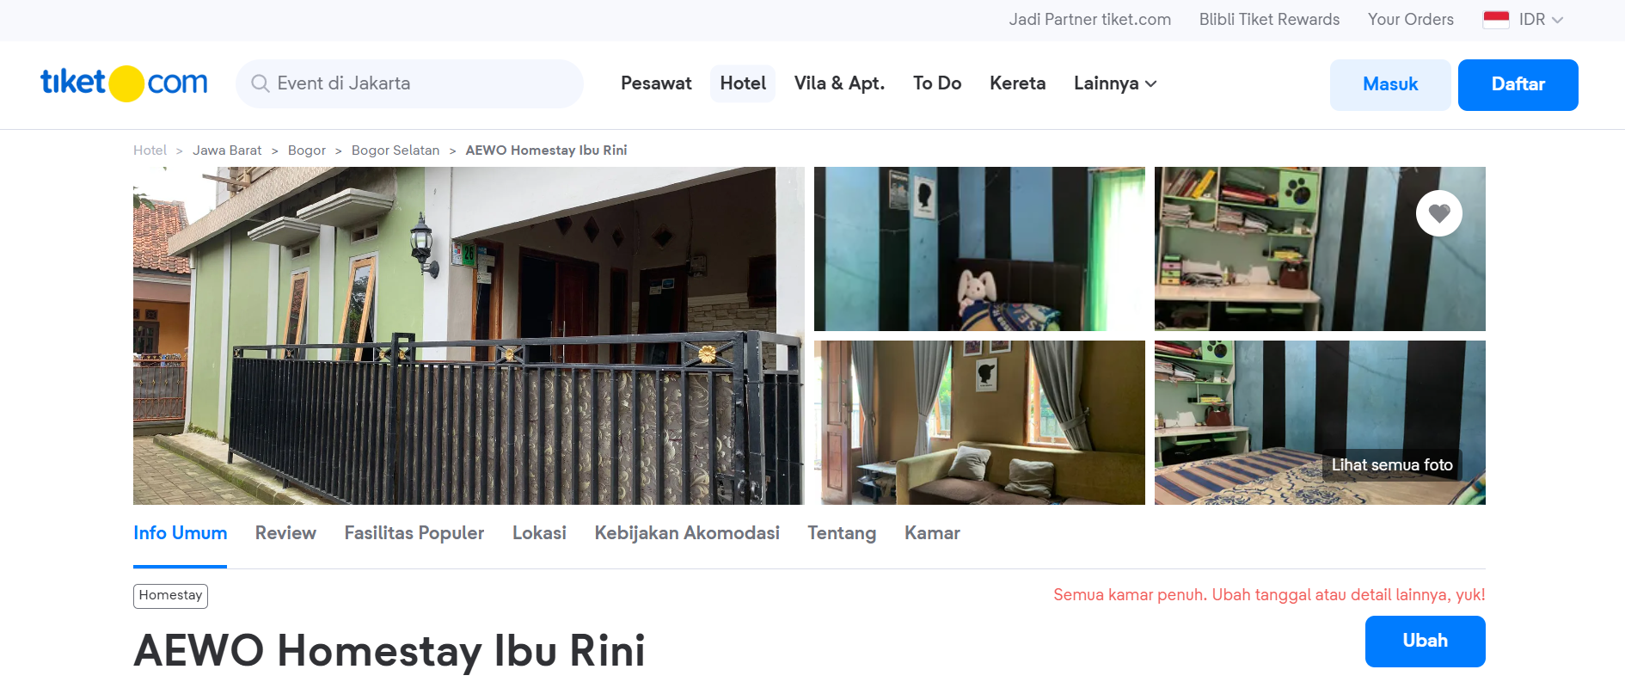
Gambar 3. Pemesanan Homestay melalui tiket.com (Sumber:https://www.tiket.com/hotel/indonesia/aewo-homestay-ibu-rini-510001667209826140)
Assurance: Limited Safety Standards and Service Quality
The assurance dimension reflects the homestay provider’s ability to create a sense of safety and trust among guests. The findings reveal that homestay owners have not yet established adequate assurance systems whether in terms of physical safety, price transparency, or guaranteed service quality.
Only a few homestay owners provide safety instructions or written information about facilities and services; most rely on informal communication and personal trust. This condition limits their ability to reach broader tourist segments, particularly those who expect higher levels of safety and professionalism. Within the SERVQUAL framework, the assurance dimension is critical in building long-term customer loyalty. Strengthening this aspect through basic hospitality training, written guest information, and risk management practices is therefore essential. Emphasize that service quality exerts a positive and significant influence on tourist satisfaction and Word of Mouth (WOM), indicating that homestays in tourism villages must enhance key service attributes such as cleanliness, orderliness, and supporting facilities to strengthen the overall visitor experience and foster positive behavioral outcomes. (Ukus, Sihombing, Utama, & Arrey, 2024)

Empathy: Strength in Social Interaction and Communal Values
Empathy emerges as the most prominent dimension in homestay services within AEWO Mulyaharja. Homestay owners demonstrate personal attention toward guests for example, by offering traditional local dishes, tailoring services to guest preferences, and accompanying tourists in outdoor activities. Such interactions create deep emotional connections and are among the main reasons guests report satisfaction.
(Dai, Chen, & Zheng, 2025) demonstrate that host–guest interaction and caring environmental elements significantly shape tourists’ emotional responses, which in turn strongly predict their attitudinal and behavioral loyalty highlighting the centrality of personalized, empathy-driven service in community-based homestay experiences.
In the context of Community-Based Tourism (CBT), empathy is a distinctive strength of homestays compared to commercial accommodations such as hotels or villas. Warm social interactions and strong local cultural values enhance the personal and authentic nature of service quality. However, this high level of empathy has not yet been integrated into a framework of service professionalism. Training in service ethics, cultural sensitivity, and effective communication is needed to maintain local warmth while ensuring professional standards. This aligns with the assertion of (Ijose & KC, 2025), who emphasize that the sustainability of community-based homestay initiatives depends on structured capacity-building and active community involvement to ensure consistent service delivery and equitable tourism benefits.

Tangibles: Limited Facilities and Visual Aesthetics
The tangibles dimension reveals a gap between homestay owners’ perceptions and tourists’ expectations. Although some homestays have undergone renovations or incorporated local design elements, many still lack attention to cleanliness, room aesthetics, and facility adequacy such as beds, bathrooms, and lighting.

Several homestays lack uniform furnishings, clean bed linens, or sufficient waste bins. This indicates that while host hospitality is high, physical comfort and visual presentation are often neglected. Yet, the tangible dimension represents the first impression that shapes tourists’ overall perception of service quality.

 | 
Gambar 4. Fasilitas Kamar Mandi (Sumber: Dokumentasi Peneliti, 2025)
Absence of SOPs and the Role of Local Values
The findings indicate that homestays in AEWO Mulyaharja lack written Standard Operating Procedures (SOPs); their management remains spontaneous and insufficiently documented. Interviews with homestay owners reveal that some are unaware of the importance of SOPs, while others feel incapable of developing them independently.

Local values such as gotong royong (cooperation), politeness, and the tradition of hospitality serve as the core foundation of the services provided. However, there have been no structured efforts to translate these cultural values into consistent SOPs that can be passed down across generations.

Implications and Theoretical Synthesis
The study’s findings demonstrate that empathy and responsiveness are the main strengths of homestays, whereas assurance and tangibles remain weaknesses. Within the SERVQUAL framework, this imbalance can influence tourists’ overall perception of service quality.

From a Community-Based Tourism (CBT) perspective, the results highlight that homestays function not only as accommodation providers but also as cultural agents for visitors. Therefore, a service management approach that integrates local values with professional standards is essential. For instance, developing culturally grounded SOPs and providing contextual training for homestay managers could serve as effective solutions.

This study reinforces the argument that applying the SERVQUAL model in the homestay context is not only relevant for measuring service quality but also for designing service improvement strategies that are sensitive to local values and resource limitations.
- CONCLUSION
This study highlights the importance of improving homestay service quality in the Agro Edu Wisata Organik (AEWO) Mulyaharja area by applying the SERVQUAL model contextualized within the Community-Based Tourism (CBT) framework. The findings indicate that the empathy and responsiveness dimensions are the main strengths of the homestays, as reflected in the hosts’ personal social interactions and high attentiveness to guest needs. Conversely, the assurance, reliability, and tangibles dimensions remain challenges, marked by the absence of written SOPs, limited standard facilities, and the lack of a safe and professional service system.

The absence of SOPs has led to inconsistencies in service quality among homestays, resulting in decreased tourist satisfaction and loyalty. In this context, homestays in AEWO Mulyaharja have not yet fully met the expectations of tourist segments that demand measurable and sustainable service standards. Nevertheless, homestays hold great potential as drivers of the local economy and as preservers of cultural heritage, especially if managed professionally without losing their local values.

Therefore, strategic actions are needed, including the formulation and implementation of homestay SOPs based on the five SERVQUAL dimensions and adapted to local cultural characteristics. Local governments, tourism village managers, and higher education institutions specializing in tourism should take an active role in providing training, mentoring, and infrastructure improvements to enhance service quality. Furthermore, integrating homestays with local attractions, culinary experiences, cultural activities, and agricultural education within structured tour packages is essential to strengthen their appeal and extend tourist stays.

This study opens opportunities for future research examining the relationship between service quality, satisfaction, loyalty, and the economic sustainability of homestays using quantitative or comparative approaches. With the right strategy, homestays can become a flagship accommodation model in inclusive and sustainable community-based tourism in Indonesia.

Ethical Approval:

As per international standards or university standards written ethical approval has been collected and preserved by the author(s).

Consent
As per international standards or university standards, Participants’ written consent has been collected and preserved by the author(s).

ACKNOWLEDGEMENTS
The author expresses sincere gratitude to the homestay owners in the AEWO Mulyaharja area who willingly served as informants in this study, as well as to all parties who provided support and assistance, making this research accomplished.
COMPETING INTERESTS
The authors declare that there is no conflict of interest in the research and publication of this article.

Authors’ Contributions

Baskoro Harwindito designed the research concept and framework and drafted the manuscript. Tonny Hendratono, Sugiarto, and Derinta Entas contributed to the development of the methodology, data collection and analysis, and manuscript revision. All authors have read and approved the final version of the manuscript.

References

- Antara Kantor Berita Indonesia. (2023). From Antaranews.com: https://www.antaranews.com/berita/3549054/pemkab-bogor-perbanyak-desa-wisata-demi-kejar-target-angka-kunjungan
- Ardiansyah, I., Permatasari, M., & Superwiratni. (2023). Developing Service Quality Strategy for Homestays in Mount Dempo Pagar Alam Regency Using IFAS and EFAS Method. BARISTA: JurnalKajian Bahasa dan Pariwisata, 136-146. https://doi.org/10.34013/barista.v10i02.1245
- Ardianto, E., & Sugiarto. (2022). A Conceptual Development of Risk and Well-Being in Homestay Tourism: Facing the Post Covid-19 Era. International JBHOST (Journal of Business on Hospitality and Tourism), 374-381.
- BPS. (2024). BPS. From bps.go.id: https://www.bps.go.id/id/statistics-table/2/MjIwMSMy/jumlah-perjalanan-wisatawan-nusantara-menurut-provinsi-tujuan.html.
- Braun, V., & Clarke, V. (2006). Using thematic analysis in psychology. Qualitative Research in Psychology, 77-101. https://doi.org/10.1191/1478088706qp063oa
- Dai, Q., Chen, J., & Zheng, Y. (2025). Assessing the impact of community-based homestay experiences on tourist loyalty in sustainable rural tourism development. Scientific Reports, 1-15.
- Ghifari, F., Djuwendah, E., Rochdiani, D., & Qanti, S. R. (2024). Keberlanjutan Agro Edu Wisata Organik (AEWO) Mulyaharja Kecamatan Bogor Selatan Kota Bogor. Mimbar Agribisnis : Jurnal Pemikiran Masyarakat Ilmiah Berwawasan Agribisnis , 132-145.
- Goodwin, H. (2011). Taking Responsibility for Tourism. Leeds: Goodfellow Publishers.
- Ijose, O. A., & KC, B. (2025). Community-Based Homestay as a Form of Sustainable Tourism in Nigeria. Sustainability, 1-24. https://doi.org/10.3390/su17115217
- Jabarprov. (2025). PORTALJABARPROVGOID. From jabarprov.go.id: https://www.jabarprov.go.id/tentang-jawa-barat/visi-misi-pemprov-jabar
- Jadesta. (2025). From jadesta.kemenparekraf.go.id: https://jadesta.kemenparekraf.go.id/desa/mulyaharja
- Kadir, I. A., Wulandari, L. W., & Hendratono, T. (2022). Pengembangan Batu Angus Sebagai Kawasan Geowisata Melalui Konsep Pariwisata Berbasis Masyarakat di Ternate. SCIENTIA: Journal of Multi Disciplinary Sciences, 86-98.
- Kemenparekraf. (2022). From https://chse.kemenparekraf.go.id/: https://chse.kemenparekraf.go.id/id/detail-tersertifikasi/11139-agro-eduwisata-organik-mulyaharja
- Kiswantoro, A., Sugiarto, Bahri, A. S., Hendratono, T., Susanto, D. R., Rohman, N., & Irawati, N. (2024). A Review of Risk Management in Homestays. Ganaya : Jurnal Ilmu Sosial dan Humaniora, 73-88.
- Kiswantoro, A., Sugiarto, Hendratono, T., Susanto, D. R., Damiasih, Rohman, N., & Maulana, R. (2023). A Bibliometric Analysis on Satisfaction and Loyalty in Homestay. Jurnal Manajemen Perhotelan dan Pariwisata, 78-90.
- Malterud, K., Siersma, V. D., & Guassora, A. D. (2016). Sample Size in Qualitative Interview Studies: Guided by Information Power. Qualitative Health Research, 1753-1760. https://doi.org/10.1177/1049732315617444
- Muslin, M., Berliyanti, D. O., & Utha, M. A. (2023). ANALYSIS OF HOMESTAY GUIDELINES AND STAKEHOLDER ENGAGEMENT AS COMMUNITY BASED TOURISM. Journal of Social Reserach, 997-1010. https://doi.org/10.55324/josr.v2i3.763
- Oliver, R. L. (1980). A Cognitive Model of the Antecedents and Consequences of Satisfaction Decisions. Journal of Marketing Research, 460-469.
- Open Data Jabar. (2025). From opendata.jabarprov.go.id: https://opendata.jabarprov.go.id/id/dataset/luas-kawasan-pariwisata-berdasarkan-kabupatenkota-di-jawa-barat
- Parasuraman, Zeithaml, V. A., & Berry, L. L. (1985). A Conceptual Model of Service Quality and Its Implications for Future Research. Journal of Marketing, 41-50.
- Prabawati, N. D. (2017). Quality of Houskeeper Services to Increase Guest Satisfaction in Pinge Rural Tourism Tabanan. World Conferece on Business and Management (pp. 451-460). Bali: THE PEOPLE AND GLOBAL BUSINESS ASSOCIATION.
- Rahmiati, F., Nugraha, R., & Prayoga, T. Z. (2023). Workshop on Tourism Service Quality for Tourist Satisfaction and Return Visits to Cikadu Tourism Village, Tanjung Lesung Buffer Zone. Asian Pacific Journal of Management and Education , 30-44.
- Santoro, G., Vrontis, D., Tharassou, A., & Dezi, L. (2018). The Internet of Things: Building a knowledge management system for open innovation and knowledge management capacity. Technological Forecasting and Social Change, 347-354.
- Sharma, A., Shin, H., Santa-Maria, M. J., & Nicolau, J. L. (2021). HOTELS’ COVID-19 INNOVATION AND PERFORMANCE . Annals of Tourism Research, 1-21.
- Sharma, S. K. (2019). An Assessment and Development of Service Quality Framework of Homestay in Sikkim. India: University Sikkim.
- Sianipar, R., Juliana, & Lemy, D. M. (2024). Fostering Rural Tourism through Effective Homestay Management in Tebing Tinggi Okura. JURNAL ILMIAH GLOBAL EDUCATION, 2724-2734.
- Sugiarto, Kiswantoro, A., Nursiana, A., Susanto, D. R., Wahjudi, J., Budhijono, F., & Sutrisno. (2024). EKSPLORASI CELAH PENELITIAN PARIWISATA BERKELANJUTAN BERBASIS MANAJEMEN RISIKO HOMESTAY. Jurnal Bina Manajemen, 145-170.
- Susanto, D. R., Sugiarto, Kiswantoro, A., Hendratono, T., Priyanto, S. H., Budhijono, F., & Rohman, N. (2025). Building Homestay User Loyalty with Operational Risk Management Mediated by Satisfaction. Jurnal Manajemen, 178-201.
- Thakur, A., Khumar, V., Balodi, P., Dehal, A., & Atri, M. (2023). Tourism Enhancement Through Homestay Schemes : A Study Case Of Himachal Prades. ACTA SCIENTIAE, 450-462.
- Ukus, F. W., Sihombing, I. H., Utama, I. P., & Arrey, M. E. (2024). Influence of Service Quality on Word of Mouth Mediated by Tourist Satisfaction at the Budo Tourism Village Homestay. Journal Ilmu Sosial Mamangan, 1-17. https://doi.org/10.22202/mamangan.v13i1.8201
- Wahyuni, R. B., & Faisal. (2019). Homestay Development With Asean Homestay Standard Approach In Nglanggeran Tourism Village, Yogyakarta, Indonesia. 1st International Conference One Belt, One Road, One Tourism (ICOBOROT 2018) (pp. 30-36). Palembang: Atlantis Press.
- Wilson, A., Zeithaml, V., Bitner, M. J., & Gremler, D. D. (2016). Service Marketing Integrating Customer Focus Across The Frim. Berkshire: MacGraw-Hill.

