Agricultural Credit, Production, and Livelihoods in South Asia: A Panel and Country-Specific Analysis of SAARC Nations

ABSTRACT

This paper investigates the role of agricultural credit in influencing agricultural production and agricultural GDP across SAARC countries over the period 2008–2023. Using panel econometric techniques with fixed effects and robust standard errors, as well as country-specific regressions, the study explores how credit interacts with key agricultural and livelihood indicators including rural population, employment in agriculture, arable land, fertilizer consumption, and rural electrification. Two models were estimated: one focusing on agricultural production and the other on agricultural GDP. The results indicate that credit has a limited or inconsistent effect on agricultural production but exerts a strong positive influence on agricultural GDP, suggesting its greater role in income support and livelihood stability than in direct productivity gains. Country-level heterogeneity underscores the importance of institutional quality, input delivery mechanisms, and structural constraints in shaping credit effectiveness. The study contributes to the literature by offering a comparative SAARC-wide perspective and highlights policy needs for improved credit targeting, integration with extension services, and resilience-building in rural financial systems.
Keywords-Agricultural credit, Agricultural production, Agricultural GDP, SAARC countries and Rural livelihoods.

INTRODUCTION
Agriculture continues to remain the backbone of South Asian economies, serving as both a source of food security and livelihood for millions. In the eight member countries of the South Asian Association for Regional Cooperation (SAARC), Afghanistan, Bangladesh, Bhutan, India, Maldives, Nepal, Pakistan, and Sri Lanka—the sector contributes significantly to GDP and employment, although with varying degrees of dependence. According to World Bank (2023) data, agriculture accounts for nearly 42% of total employment in South Asia in 2022, compared to the global average of just 26%, highlighting the sector’s disproportionate role in sustaining rural livelihoods (World Bank, 2023). In Afghanistan and Nepal, for example, more than 55% of the workforce remains engaged in agriculture, while in India, the figure stands at around 42% (FAO, 2023; World Bank, 2023). Despite rapid structural transformation and expansion of services and industry in the region, agriculture remains a critical livelihood sector for rural households, especially in fragile economies (IFAD, 2024).
Credit plays a pivotal role in sustaining and enhancing agricultural productivity in this context. Timely access to credit enables farmers to invest in improved seeds, irrigation systems, fertilizers, and mechanization, which are essential for coping with climate variability, fragmented landholdings, and rising input costs (Binswanger & Khandker, 1995; Akoijam, 2012). Data from the Reserve Bank of India (2023) indicate that agricultural credit disbursement has grown more than fivefold since 2008, while similar trends are observable in Bangladesh and Pakistan where specialized institutions and microfinance have expanded outreach to smallholders (ADB, 2023; IFAD, 2022; State Bank of Pakistan, 2023). Yet, concerns about credit quality, regional imbalances, and gender gaps in credit access persist across South Asia (ADB, 2025; IFAD, 2024). With the region being home to over 1.8 billion people, of which nearly 70% live in rural areas, the nexus between credit access, production outcomes, and livelihood transformation is both an economic and social imperative (FAO, 2023).
At the same time, South Asian agriculture faces mounting pressures from climate change, resource degradation, and rising population demand. The World Bank (2021) warns that agricultural GDP growth in the region has been slowing, averaging only 2.1% annually during 2010–2020, compared to above 3.5% in the early 2000s (World Bank, 2021). Enhancing credit penetration and efficient utilization becomes crucial for ensuring sustainable agricultural performance (Gulati & Bathla, 2002; Siankwilimba et al., 2025). However, the impact of agricultural credit is not uniform across countries, while India and Bangladesh have made progress in linking formal finance to smallholders, countries like Afghanistan and Bhutan still face institutional weaknesses, infrastructural bottlenecks, and low financial inclusion (FAO, 2023; Ali et al., 2021). Against this backdrop, this paper seeks to examine how agricultural credit influences production and livelihood outcomes across South Asia, using both panel data models and country-specific regression analyses over the period 2008–2023. The study provides new insights into the sectoral role of credit and its implications for rural livelihoods, while accounting for heterogeneities within the SAARC region.
The present study is grounded in two complementary strands of economic theory that explain how credit influences agricultural performance. First, the credit-as-investment perspective, rooted in classical growth and agricultural finance models (Binswanger & Khandker, 1995; Burgess & Pande, 2005), views credit as a productive input that relaxes capital constraints. Institutional credit enables farmers to purchase seeds, fertilizers, machinery, and irrigation, adopt improved technologies, and therefore raise output and productivity. Under this view, a positive relationship is expected between agricultural credit and both physical production and agricultural value added.
Second, the finance-led and consumption-smoothing perspectives emphasize the welfare channel. Access to credit stabilizes farm household income by mitigating seasonal and weather shocks, allowing consumption smoothing, and financing non-farm diversification (Schultz, 1964; Lewis, 1954; Akoijam, 2012). In this framework, credit affects livelihoods and agricultural GDP primarily through income and risk-management effects rather than direct productivity gains.
Together, these frameworks justify examining two dependent outcomes—agricultural production and agricultural gross value added (AGVA), and motivate robustness checks using lagged and alternative credit measures. Evidence consistent with the first view would indicate a productivity-enhancing role of credit, whereas dominance of the second would highlight its livelihood-supporting function within SAARC economies.

LITERATURE REVIEW
The role of agricultural credit in enhancing agricultural productivity and rural development has been extensively examined in both global and South Asian contexts. Credit is widely recognized as a crucial input that enables farmers to access improved technologies, irrigation facilities, quality seeds, and fertilizers, all of which are essential for enhancing agricultural productivity and resilience (Binswanger & Khandker, 1995; FAO, 2023). Institutional credit, in particular, mitigates liquidity constraints and allows timely investment in production cycles, thereby influencing both agricultural output and rural livelihoods.
Early empirical studies established the foundation for understanding the credit–productivity nexus. Taylor and Shonkwiler (1986) provided one of the earliest econometric insights by showing that agricultural credit programs significantly enhance farmers’ technical efficiency through improved access to productive inputs and reduction of liquidity constraints. Ray (1996) demonstrated that access to formal credit reduces reliance on informal moneylenders and promotes productive investment, while Burgess and Pande (2005) provided evidence that rural bank expansion in India significantly increased agricultural output and reduced rural poverty. Similarly, Iqbal et al. (2003) found that in Pakistan, agricultural credit exerted a strong positive impact on crop yields and farm incomes, emphasizing the importance of institutional finance in sustaining agricultural growth. In Bangladesh, Hossain et al., (2019) reported that credit availability improved crop yields and input efficiency, underlining the importance of credit access for smallholders.
Over time, researchers have expanded these insights by incorporating panel data and cross-country perspectives. Chavan (2007) examined rural credit trends in India and concluded that institutional lending was vital for increasing capital formation in agriculture. Kumar et al. (2010) found that while agricultural credit positively affected farm income, its influence on physical production varied, indicating the need for complementary policy interventions. Gulati and Bathla (2002) reinforced this argument, highlighting that credit’s effectiveness is maximized when supported by irrigation, fertilizer use, and technology adoption. Ali et al., (2021), analysing the SAARC region through panel regression, observed that agricultural credit tends to have a stronger effect on agricultural GDP than on physical production volumes, a finding consistent with the dual-model structure of the present study.
Recent research has shifted focus toward digitalization, sustainability, and climate resilience in agricultural finance. Xu & Wang (2023) found that digital financial inclusion significantly improved agricultural productivity and rural welfare by enhancing accessibility and reducing transaction costs. Similarly, Mughal et al., (2024) documented that fintech-driven lending platforms in Pakistan increased farmers’ access to short-term and seasonal credit, improving liquidity and reducing dependence on informal credit sources. Siankwilimba et al. (2025) emphasized that sustainable financial models targeting smallholders are increasingly central to promoting inclusive and environmentally resilient agricultural growth across Asia.
Further, Vippala and Rahut (2025) demonstrated that financial inclusion and credit infrastructure remain critical determinants of smallholder welfare and productivity in South Asia, especially when integrated with insurance, digital payments, and rural extension networks. Goffar, Bashar, and Rahman (2025) corroborated this by showing that agricultural value-chain financing, when effectively implemented, enhances both farm profitability and resilience to market shocks. Regional development institutions have also recognized these dynamics. The Asian Development Bank (2023) and the International Fund for Agricultural Development (2023) both highlight that credit-led rural financial deepening, especially through digital and inclusive finance is vital to post-COVID agricultural recovery and climate adaptation in South Asia.
Collectively, this literature demonstrates that while agricultural credit remains indispensable for improving productivity and rural livelihoods, its effectiveness depends on institutional design, accessibility, and integration with complementary agricultural services. However, a significant research gap persists in understanding comparative cross-country variations within South Asia, where structural constraints, credit delivery mechanisms, and institutional capacities differ substantially. The present study addresses this gap by using panel econometric models and country-specific regressions to disentangle the heterogeneous effects of credit on agricultural production and agricultural GDP across the SAARC region during 2008–2023.
Figure 1. Agricultural Credit Trends in SAARC Countries (2008–2023)
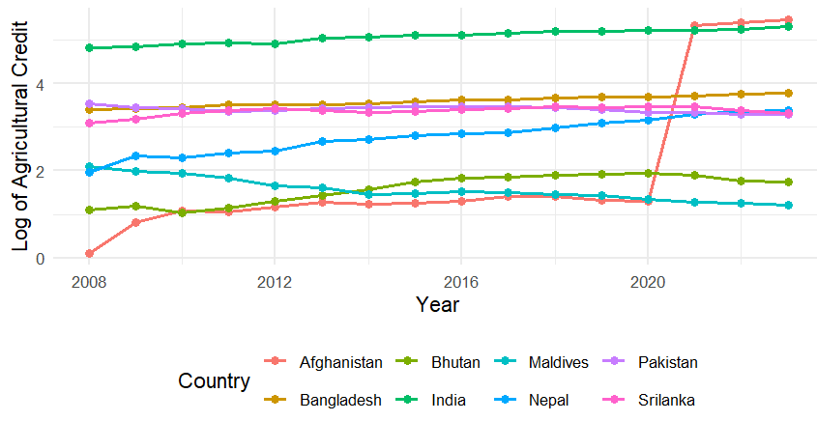
Note: Agricultural credit is shown in natural logarithmic form. Data sourced from FAOSTAT (2024) and World Development Indicators (World Bank).
Source-Author's computation
To visualize regional financial dynamics, Figure 1 plots the logarithm of agricultural credit from 2008–2023 across SAARC countries. The figure reveals a steady upward trend in credit expansion in India, Pakistan, and Bangladesh, while smaller economies such as Bhutan and the Maldives show relatively slower or volatile growth. This uneven trend supports the econometric premise that credit expansion alone cannot guarantee uniform productivity gains across structurally diverse economies.
Building upon these observed financial trends, the study develops a conceptual framework that links agricultural credit with two outcome channels, agricultural production and agricultural GDP (livelihood outcomes). The framework, shown in Figure 2, provides the theoretical basis for the empirical models discussed in the next section.

Fig 2- Conceptual Framework Linking Agricultural Credit, Production, and Livelihood Outcomes in SAARC Countries
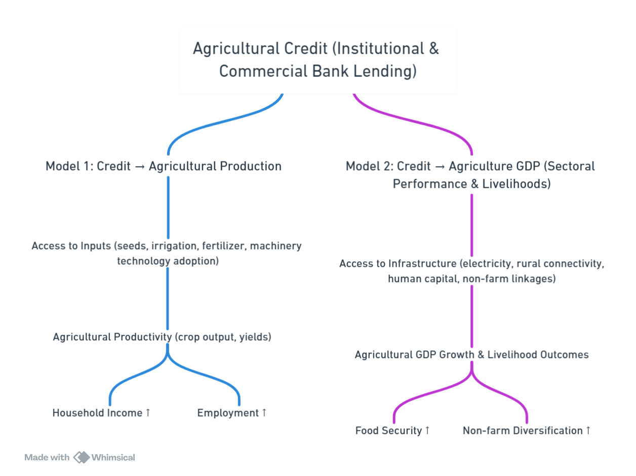
Note: The framework illustrates the hypothesized dual-channel impact of agricultural credit on agricultural production through access to inputs and technology adoption (Model 1), and on agricultural GDP and livelihood outcomes through infrastructure, rural connectivity, and non-farm linkages (Model 2).
Source: Author’s own creation, based on theoretical models and reviewed literature.
The empirical strategy that follows translates this conceptual framework into two econometric models—Model 1 capturing the production channel and Model 2 capturing the livelihood and value-added channel—to quantitatively assess the hypothesized relationships.
METHODOLOGY
This study investigates the relationship between agricultural credit, agricultural productivity, and livelihood indicators across the SAARC region using a panel data econometric framework. The analysis covers eight SAARC member countries Afghanistan, Bangladesh, Bhutan, India, Maldives, Nepal, Pakistan, and Sri Lanka, over the period 2008–2023. This period was selected to ensure consistency and the availability of comparable macroeconomic and agricultural indicators across all member states.
The dataset was compiled from multiple reliable sources. Agricultural credit data were obtained from FAOSTAT, while agricultural gross domestic product (GDP), access to electricity in rural areas, rural population, employment in agriculture, arable land, and fertilizer consumption were
sourced from the World Development Indicators (World Bank). These variables collectively capture financial access, demographic pressures, and structural constraints shaping agricultural performance in South Asia.
All monetary and production variables were transformed into natural logarithms to reduce skewness and allow the coefficients to be interpreted as elasticities. The choice of variables and their theoretical expectations followed established literature, including Binswanger & Khandker (1995), Burgess & Pande (2005), and FAO (2023).
Table 1. Description of Variables and Data Sources (2008–2023)
Variable Name | Description | Unit of Measurement | Source
ln (AgriProd) | Log of total agricultural production (index, base 2015 = 100) | Index | FAOSTAT / World Development Indicators (WDI)
ln (AGVA) | Log of agricultural gross value added (constant 2015 US$) | Constant 2015 US$ | World Bank (2024)
ln (Credit) | Institutional agricultural credit disbursed | Billion local currency units | National Central Banks / FAOSTAT
ln (RuralPop) | Log of rural population | Persons (thousands) | WDI (2024)
EmpAgriculture | Employment in agriculture | % of total employment | WDI (2024)
AgricultureGDP | Agriculture’s contribution to total GDP | % of GDP | WDI (2024)
ln (Arable Land) | Log of arable land area | Square kilometres / hectares | FAOSTAT / WDI
ln (FertCons) | Log of fertilizer consumption | kg per hectare of arable land | FAOSTAT / WDI
Access Electricity | Rural population with access to electricity | % of rural population | World Bank (2024)
Time Trend | Linear time trend variable (2008 = 1 … 2023 = 16) | Years | Author constructed
Note: All continuous variables are log-transformed except percentages and counts. Data compiled from FAOSTAT, World Bank, and national statistical offices.
Source: Author’s computation.

Table 2. Expected Signs of Explanatory Variables (A Priori Predictions)

Variable | Model 1: Agricultural Production | Model 2: Agricultural GDP | Expected Sign Justification
ln (Credit) | + | + | Credit improves access to inputs, liquidity, and investment (Binswanger & Khandker, 1995).
ln (Rural Pop) | – | + | Larger rural population reduces per-capita output but increases aggregate income (Gollin, 2010).
Emp_Agriculture | +/– | + | Ambiguous: more labour may raise production or reflect surplus employment (Lewis, 1954).
Agriculture GDP | + | — | Higher sectoral income supports reinvestment and modernization.
ln (Arable Land) | + | — | Land endowment expands cultivation potential.
ln (Fert Cons) | + | — | Fertilizer use enhances yields and productivity.
Access Electricity | — | + | Infrastructure supports mechanization and irrigation efficiency.
Note: “+/–” denotes ambiguous theoretical sign; “—” indicates variable not included in that model.
Source: Author’s computation based on prior literature (Binswanger & Khandker, 1995; Gollin, 2010; Lewis, 1954).
Two empirical models were developed. The first model (Model 1) focuses on agricultural production as the dependent variable, while the second model (Model 2) uses agricultural GDP (AGVA) to capture sectoral value-added and livelihood outcomes.
The working equations are specified as follows:
For Model 1 (Agricultural Production Function):
$$ln⁡(AgriProd)_{it}=α_{i}+β_{1}ln⁡(Credit)_{it}+β_{2}ln⁡(RuralPop)_{it}+β_{3}EmpAgriculture_{it}+β_{4}AgricultureGDP_{it}+β_{5}ln⁡(ArableLand)_{it}+β_{6}ln⁡(FertCons)_{it}+ε_{it}$$
For Model 2 (Agricultural GDP Function):
$$AgriGDP_{it}=α_{i}+γ_{1}ln⁡(Credit)_{it}+γ_{2}ln⁡(RuralPop)_{it}+γ_{3}EmpAgriculture_{it}+γ_{4}AccessElectricity_{it}+μ_{it}$$
Here, ln (AgriProd) and Agri GDP are the dependent variables, representing agricultural production and agricultural value-added, respectively.
The empirical estimation employed panel regression techniques, including Pooled Ordinary Least Squares (OLS), Fixed Effects (FE), and Random Effects (RE) estimators. Model selection was guided by three standard specification tests F-test (FE vs. Pooled OLS), Breusch–Pagan Lagrange Multiplier (LM) test (RE vs. Pooled OLS), and the Hausman test (FE vs. RE). In both models, the tests consistently supported the Fixed Effects specification, confirming unobserved country-specific heterogeneity.
A series of diagnostic tests were conducted to ensure the reliability and robustness of the panel estimations. The results revealed the presence of heteroskedasticity and serial correlation in both models, while the Pesaran CD test confirmed the absence of significant cross-sectional dependence, indicating that country-specific effects are largely independent. Model 1 exhibited moderate multicollinearity—mainly between population and land variables whereas Model 2 showed acceptable multicollinearity levels. The Augmented Dickey–Fuller (ADF) tests suggested that most variables were trend-stationary but non-stationary at level. To correct for these econometric violations, Driscoll–Kraay standard errors were employed in the panel regressions to account for heteroskedasticity, autocorrelation, and potential cross-sectional dependence (Hoechle, 2007). In addition, Newey–West heteroskedasticity and autocorrelation-consistent (HAC) corrections were applied in the country-specific OLS regressions to produce reliable and efficient estimates (Newey & West, 1987; Reed & Webb, 2010). Together, these diagnostic checks and robust corrections ensure that the empirical results are statistically sound, transparent, and consistent with best practices in applied panel econometrics.
RESULTS AND ANALYSIS
Model 1: Agricultural Production and Credit Linkages
Table 3-Panel Results
Dependent Variable: ln (Agri Prod) it ​
Variable | Estimate (Robust SE)
Constant | 1.4413 (0.7674)
ln (Credit)it | 0.0100 (0.0203)
ln (Rural Pop) it | −0.6629 (0.4726)
EmpAgriculture it​ | −0.0154 (0.0073) *
Agriculture GDP it​ | −0.00918 (0.00830)
ln (Arable Land) it | 1.7177 (0.5220) **
ln (Fert Cons) it ​ | −0.0290 (0.1100)
Significance level: *10%; **5%; ***1%
N | 128
R² | 0.6374
Adjusted R² | 0.6194
LM Test | 59.38(0.000)
Note-All estimates are based on fixed-effects panel regressions for eight SAARC countries over 2008–2023. Robust standard errors (Driscoll–Kraay correction) were applied to account for heteroskedasticity and serial correlation. *, **, and *** indicate significance at the 10%, 5%, and 1% levels, respectively.
Source- Author’s computation
The panel regression results for Model 1 (2008–2023) reveal a nuanced relationship between agricultural production and its determinants across SAARC economies. Agricultural credit (ln Credit) does not emerge as a strong or statistically significant driver of agricultural output. This suggests that while formal credit availability has expanded in the region, its actual deployment in productive agricultural activities remains limited. Consistent with Lakhan et al. (2020), much of agricultural credit in South Asia is diverted toward consumption or non-farm activities, particularly among smallholders with limited access to institutional finance.
Arable land (ln Arable Land) exhibits a significant positive effect, reaffirming that agricultural production in the region remains fundamentally land-dependent. However, population pressure and land fragmentation continue to constrain output, consistent with Gollin (2010), who emphasized diminishing marginal returns to land in developing agrarian systems. Fertilizer consumption (ln Fert Cons) shows mixed results, highlighting varying efficiency in input use across countries depending on subsidy regimes, soil conditions, and technological adoption.
Employment in agriculture (EmpAgriculture) appears negatively associated with output, aligning with the Lewis (1954) dual economy model. This reflects persistent underemployment and diminishing marginal productivity of labour in agriculture a defining feature of South Asia’s agrarian economies.
From a policy perspective, expanding credit access alone is insufficient. Rather, credit must be effectively targeted, monitored, and complemented with improved input delivery, land management, and extension services to translate financial access into sustained productivity gains.
Table 4-Country-Specific Results
Country | N | ln. credit (β ± SE) | ln.rural.pop (β ± SE) | emp. agriculture (β ± SE) | ln. arable. Land (β ± SE) | ln.fert.cons (β ± SE) | Constant (β ± SE)
Afghanistan | 16 | -0.043 (0.012) *** | -0.098 (0.641) | -0.036 (0.010) *** | -5.341 (8.430) | -0.443 (0.132) ** | 46.414 (55.199)
Bangladesh | 16 | -1.160 (0.321) *** | -38.382 (18.029) * | -0.008 (0.014) | -6.130 (2.883) * | 0.880 (0.287) ** | 376.851 (160.559) **
Bhutan | 16 | 0.212 (0.092) ** | 15.266 (15.507) | -0.013 (0.018) | -3.466 (2.596) | -0.376 (0.211) | -67.924 (86.330)
India | 16 | -0.175 (0.160) | -6.962 (6.583) | -0.021 (0.011) * | -34.561 (9.896) * | 0.478 (0.511) | 379.753 (115.568) ***
Maldives | 16 | 2.147 (0.920) ** | 3.302 (3.082) | -0.145 (0.084) | 6.987 (2.488) * | -0.091 (0.311) | -40.840 (19.208) *
Nepal | 16 | -0.095 (0.077) | 5.343 (1.634) *** | -0.091 (0.013) *** | -6.725 (2.446) | -3.169 (2.651) | -3.041 (10.206)
Pakistan | 16 | -0.076 (0.248) | 4.350 (1.302) *** | 0.022 (0.012) * | 4.351 (1.445) * | 0.565 (0.283) * | -67.725 (10.490) ***
Sri Lanka | 16 | -0.021 (0.093) | -0.224 (1.542) | -0.010 (0.010) | 26.852 (10.199) | -0.231 (0.100) | -3.570 (10.675)
Notes: Ordinary Least Squares (OLS) estimates with Newey–West heteroskedasticity and autocorrelation consistent (HAC) standard errors. Coefficients are followed by robust standard errors in parentheses. *, **, and *** denote significance at the 10%, 5%, and 1% levels, respectively.
Source- Author’s computation
Table 4 reports the country-specific results. The findings exhibit striking heterogeneity across the eight SAARC economies. Bangladesh and India show negative and statistically significant coefficients for credit, indicating that greater financial access has not translated into productivity gains in land-scarce, smallholder-dominated systems. This aligns with Shivaswamy et al. (2020), who observed that institutional lending in India favours large farmers, limiting efficiency impacts. By contrast, Bhutan and the Maldives show positive responses, suggesting that targeted, project-linked credit has supported small-scale production efficiency. Pakistan exhibits significant positive effects for both credit and land variables, underscoring the effectiveness of financial-input linkages maintained by institutions such as the Zarai Taraqiati Bank (Iqbal et al., 2003). Nepal and Afghanistan display weak or unstable credit effects, reflecting fragile rural credit markets and structural volatility.
To visualize the heterogeneity in the estimated effects of agricultural credit across SAARC countries, Figure 3 presents the coefficient estimates from the country-wise regressions for Model 1.
Fig-3 Country-wise Effect of Agricultural Credit on Production (Model 1)
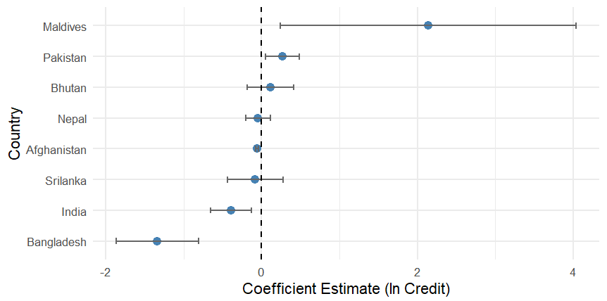
Note: Error bars indicate 95% confidence intervals (Newey–West robust SEs).
Source: Author’s computation.
Figure 3 complements these results by illustrating the coefficient estimates of agricultural credit (ln Credit) across the eight countries. The variation in sign and magnitude visually highlights the divergent institutional and structural conditions influencing the credit–production relationship. Countries like Bangladesh and India cluster on the negative side of the distribution, while Bhutan, Maldives, and Pakistan show positive or moderately strong effects. The figure thus reinforces the evidence that credit effectiveness is highly context-specific and contingent upon local agricultural structures, governance quality, and access to complementary inputs.
Taken together, Model 1 findings imply that merely expanding agricultural credit is insufficient for productivity gains. Policy efforts must focus on ensuring productive use of loans, improving targeting toward smallholders, and integrating financial access with land management, input delivery, and climate-resilient practices.
Model 2: Agricultural GDP and Livelihood Indicators
Table 3 reports the results for Model 2, where the dependent variable is agricultural GDP—a broader measure of sectoral value addition and income generation.
Table 5-Panel Results
Dependent Variable: Agriculture GDP it ​
Variable | Estimate (Robust SE)
Constant | −13.661 (4.503) **
ln (Credit)it | 1.641 (0.215) ***
ln (Rural Pop) it | 24.802 (5.945) ***
EmpAgriculture it​ | 0.151 (0.132)
Access Electricity it​ | −0.062 (0.024) **
Significance level: *10%; **5%; ***1%
N | 128
R² | 0.362
Adjusted R² | 0.302
LM Test | 276.070 (0.000)
Notes: Results are based on fixed-effects panel regressions for eight SAARC countries from 2008 to 2023. Driscoll–Kraay robust standard errors were employed to correct for heteroskedasticity, serial correlation, and potential cross-sectional dependence. *, **, and *** indicate significance at the 10%, 5%, and 1% levels, respectively.
Source- Author’s computation
The results show that agricultural credit (ln. Credit) exerts a strong and statistically significant positive effect on agricultural GDP across the SAARC region. This contrast with Model 1 indicates that while credit does not always enhance physical production, it boosts sectoral value-added and income flows, supporting the finance-led growth hypothesis proposed by Binswanger and Khandker (1995).
The positive and significant coefficient of ln.Rural.Pop suggests that rural demographic size contributes to agricultural GDP, possibly through scale effects and local demand linkages. However, this aggregate relationship may conceal persistent low per capita productivity, as larger rural populations often correspond with smaller landholdings and lower mechanization levels.
Interestingly, Access to Electricity has a negative and significant coefficient, suggesting that electrification alone does not guarantee productivity gains. This result resonates with World Bank (2018), which highlighted the “rural electricity paradox” in South Asia, high connection rates but unreliable, costly, and irregular supply that fails to power productive uses such as irrigation and storage.
Table 6-Country-Specific Results
Country | N | ln. credit (β ± SE) | ln.rural.pop (β ± SE) | emp. agriculture (β ± SE) | access. Electricity (β ± SE) | Constant (β ± SE)
Afghanistan | 16 | 1.505 (0.397) *** | 46.499 (23.795) | 1.090 (0.170) *** | 0.094 (0.027) *** | -379.895 (173.844) *
Bangladesh | 16 | -9.616 (5.259) * | -190.422 (82.515) ** | 0.371 (0.256) | -0.030 (0.014) * | 1561.970 (627.412) *
Bhutan | 16 | 2.115 (1.083) * | -561.445 (72.986) *** | 0.370 (0.086) *** | -0.114 (0.021) *** | 3174.159 (395.028) ***
India | 16 | -6.050 (5.487) | 237.947 (89.364) ** | 0.368 (0.134) ** | -0.055 (0.047) | -2094.002 (790.405) *
Maldives | 16 | -0.121 (2.319) | 4.160 (10.337) | 0.095 (0.135) | -0.145 (0.008) *** | -3.371 (58.747)
Nepal | 16 | 4.147 (4.112) | 70.162 (82.001) | 2.834 (0.545) *** | 0.077 (0.052) | -690.926 (585.150)
Pakistan | 16 | -10.486 (2.203) *** | 8.450 (36.273) | 0.534 (0.198) ** | 0.148 (0.109) | -45.104 (296.282)
Sri Lanka | 16 | -9.694 (3.108) ** | 49.811 (26.027) | 0.722 (0.132) *** | 0.127 (0.060) * | -351.691 (184.028) *
Notes: Ordinary Least Squares (OLS) regressions were estimated for each country using Newey–West heteroskedasticity and autocorrelation consistent (HAC) standard errors. Coefficients are followed by their robust standard errors in parentheses. *, **, and *** denote significance at the 10%, 5%, and 1% levels, respectively.
Source- Author’s computation
Table 6 presents the country-specific estimates and highlights further asymmetry. Afghanistan, Bhutan, and Nepal show positive and significant credit effects, suggesting that credit expansion effectively enhances sectoral GDP in emerging financial systems. Bhutan’s high elasticity indicates that even small, targeted programs can yield strong proportional gains when supported by sound policy design. In contrast, Bangladesh, Pakistan, and Sri Lanka show negative or weakly significant coefficients, consistent with issues of credit diversion and inefficiency in mature but administratively burdened systems. India’s insignificant negative coefficient may reflect a transition toward productivity and technology-driven growth rather than reliance on raw credit volumes. The positive and significant employment coefficients in Nepal and Sri Lanka imply that labour productivity gains are realized when credit is complemented by employment and infrastructure growth.
Figure 4 illustrates the country-wise coefficients of agricultural credit for Model 2, showing how credit affects agricultural GDP differently across countries.
Fig-4 Country-wise Effect of Agricultural Credit on Agricultural GDP (Model 2)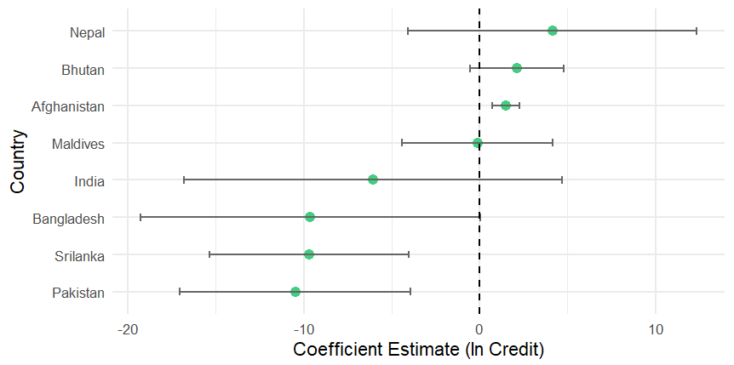
Note: Error bars indicate 95% confidence intervals (Newey–West robust SEs).
Source: Author’s computation.
Figure 4 visualizes these differences through a coefficient (forest) plot of credit effects on agricultural GDP. The graph clearly distinguishes the countries where credit expansion drives value-added growth (Afghanistan, Bhutan, Nepal) from those where the impact remains muted or negative (Bangladesh, India, Sri Lanka). The visual clarity of the figure supports the interpretation that credit in South Asia functions more as an income-support and livelihood-stabilizing mechanism than as a direct driver of physical production.
Table 6. Predicted versus Estimated Effects of the Explanatory Variables.
Variable | Expected Sign (Theory) | Observed Sign (Empirical Result) | Strength / Consistency
ln (Credit) | + | 0 / + (Model 1 weak; Model 2 strong +) | ***
ln (Rural Population) | + / – | – (Model 1); + (Model 2) | **
Employment in Agriculture | + / – | – (Model 1); + (Model 2) | *
Agriculture GDP | + | – (Model 1) | **
ln (Arable Land) | + | + (Model 1, significant) | ***
ln (Fertilizer Consumption) | + | + (weakly significant) | **
Access to Electricity | + | – (Model 2) | **
Time Trend | – | – (both models) | *
Note: The first column represents the a priori theoretical expectations derived from agricultural production and finance literature (Binswanger & Khandker, 1995; Burgess & Pande, 2005; Gulati & Bathla, 2002; FAO, 2023). The second column reports the observed empirical signs from the estimated models. “+/–” indicates theoretical ambiguity; “0” denotes statistically insignificant coefficients. Asterisks *, **, and *** denote weak, moderate, and strong empirical consistency respectively.
Source: Author’s computation based on Model 1 and Model 2 results.
To synthesize the results of both econometric models, Table 6 compares the theoretical predictions of each explanatory variable with the empirically observed signs from the estimations. The comparison shows that while institutional credit consistently aligns with theoretical expectations in influencing agricultural GDP, its role in physical production is weaker. Land and fertilizer variables retain their expected positive effects, while demographic and infrastructural factors show mixed results. This reinforces the conclusion that credit effectiveness depends on structural and policy complementarities across SAARC economies.
In summary, Model 2 demonstrates that while agricultural credit’s effect on output volume may be limited, its influence on income and sectoral value-added is substantial. When interpreted together, Models 1 and 2 suggest a dual role of credit: as a production enabler only under supportive structural conditions and as a livelihood stabilizer across most of the region. Effective policy must therefore integrate financial inclusion with infrastructure, technology, and extension systems tailored to country-specific agrarian contexts.
CONCLUSION
This study set out to assess the impact of agricultural credit on agricultural outcomes in SAARC countries between 2008 and 2023, applying two complementary econometric models. The first model examined the relationship between credit and total agricultural production, while the second model evaluated the contribution of credit to agricultural value added as a percentage of GDP. By combining panel data analysis with country-specific regressions, the paper provides a nuanced understanding of how institutional credit affects agricultural performance and livelihood security across diverse South Asian economies.
The findings reveal a dual role of agricultural credit. On the one hand, credit demonstrates only a weak and inconsistent effect on physical agricultural output. This suggests that production is influenced more heavily by structural factors such as land size, irrigation access, fertilizer use, and weather variability, which often outweigh the direct impact of credit inflows. On the other hand, agricultural credit shows a strong and statistically significant contribution to agricultural GDP, underlining its importance in supporting farm incomes, stabilizing rural livelihoods, and sustaining household consumption.
The heterogeneity across countries is also notable. In Pakistan and Sri Lanka, credit has a more visible impact on both output and agricultural value addition, reflecting relatively stronger institutional mechanisms and linkages between credit delivery and input use. By contrast, India and Bangladesh show weaker linkages, suggesting issues such as credit diversion, disguised unemployment in agriculture, and insufficient monitoring of loan utilization. Smaller economies like Bhutan, Maldives, and Nepal highlight unique structural constraints, including land scarcity and high dependence on external shocks, which dilute the production impact of credit.
Overall, the study concludes that agricultural credit in the SAARC region functions more as a tool for livelihood support than as a direct driver of productivity growth. This insight is critical for policymakers, as it implies that expanding credit availability alone is insufficient to transform agricultural output. Credit must be better targeted, integrated with complementary services, and linked to productive investments. Strengthening agricultural extension systems, ensuring affordable access to modern inputs, and leveraging digital finance to improve transparency and monitoring can significantly enhance the developmental impact of rural credit.
Finally, the study acknowledges certain limitations, such as the exclusion of variables like climate change shocks, irrigation infrastructure, crop diversification, and gendered access to credit, which may also influence outcomes. Future research should explore these dimensions and investigate how innovations like digital credit platforms, crop insurance, and climate-smart agriculture can improve the effectiveness of rural credit systems in South Asia.
In conclusion, while agricultural credit remains a cornerstone of rural financial policy, its true potential can only be realized when it is embedded within a broader framework of structural reforms, institutional strengthening, and technology-driven agricultural modernization.
Disclaimer (Artificial intelligence)
Option 1:
Author(s) hereby declare that NO generative AI technologies such as Large Language Models (ChatGPT, COPILOT, etc.) and text-to-image generators have been used during the writing or editing of this manuscript.
Option 2:
Author(s) hereby declare that generative AI technologies such as Large Language Models, etc. have been used during the writing or editing of manuscripts. This explanation will include the name, version, model, and source of the generative AI technology and as well as all input prompts provided to the generative AI technology
Details of the AI usage are given below:
1.
2.
3.

REFERENCES

- Akoijam, S. L. (2012). Rural credit: a source of sustainable livelihood of rural India. International journal of social economics, 40(1), 83-97.
- Ali, N., Hayat, U., Ali, S., Khan, M. I., & Khattak, S. W. (2021). Sources of agricultural productivity growth in SAARC countries: the role of financial development, trade openness and human capital.
- Asian Development Bank. (2023). Asian development outlook 2023: Reforms without borders. Manila: ADB. https://www.adb.org/publications/asian-development-outlook-2023
- Binswanger, H. P., & Khandker, S. R. (1995). The impact of formal finance on the rural economy of India. Journal of Development Studies, 32(2), 234–262. https://doi.org/10.1080/00220389508422363
- Burgess, R., & Pande, R. (2005). Do rural banks matter? Evidence from the Indian social banking experiment. American Economic Review, 95(3), 780–795. https://doi.org/10.1257/0002828054201242
- Chavan, P. (2007). Access to bank credit: Implications for rural poverty. Economic and Political Weekly, 42(31), 3219-3224.
- Food and Agriculture Organization of the United Nations. (2023). FAOSTAT statistical database. Retrieved September 15, 2025, from https://www.fao.org/faostat
- Goffar, M. A., Bashar, M. A., & Rahman, M. M. (2025). Agricultural Value Chain Financing and Its Impact on Rural Development. SAARC Journal of Agriculture, 23(1), 224-236.
- Gollin, D. (2010). Agricultural productivity and economic growth. In P. L. Pingali & R. E. Evenson (Eds.), Handbook of agricultural economics (Vol. 4, pp. 3825–3866). Elsevier. https://doi.org/10.1016/S1574-0072(09)04073-0
- Gulati, A., & Bathla, S. (2002). Institutional Credit to Indian Agriculture: Defaults and Policy Options. National Bank for Agriculture and Rural Development Mumbai Available at: https://www.nabard.org/demo/auth/writereaddata/File/OC%2023.pdf
- Hoechle, D. (2007). Robust standard errors for panel regressions with cross-sectional dependence. Stata Journal, 7(3), 281–312. https://doi.org/10.1177/1536867X0700700301
- Hossain, M., Malek, M. A., Hossain, M. A., Reza, M. H., & Ahmed, M. S. (2019). Agricultural microcredit for tenant farmers: Evidence from a field experiment in Bangladesh. American Journal of Agricultural Economics, 101(3), 692-709
- Iqbal, M., Ahmad, M., & Abbas, K. (2003). The impact of institutional credit on agricultural production in Pakistan. Pakistan Development Review, 42(4), 469–485.
- Kumar, A., Singh, K. M., & Sinha, S. (2010). Institutional credit to agriculture sector in India: Status, performance and determinants. Agricultural Economics Research Review, 23(2), 253–264.
- Lakhan, G. R., Channa, S. A., Magsi, H., Koondher, M. A., Wang, J., & Channa, N. A. (2020). Credit constraints and rural farmers’ welfare in an agrarian economy. Heliyon, 6(10).
- Lewis, W. A. (1954). Economic development with unlimited supplies of labour. The Manchester School, 22(2), 139–191. https://doi.org/10.1111/j.1467-9957.1954.tb00021.x
- Mughal, R., Ahmed, A., Khan, S. K., & Ali, A. (2024). Impact of Fintech & Monetary Policy on Liquidity Creation. IBT-JOURNAL OF BUSINESS STUDIES, 20(2), 124-140.
- Newey, W. K., & West, K. D. (1987). A simple, positive semi-definite, heteroskedasticity and autocorrelation consistent covariance matrix. Econometrica, 55(3), 703–708. https://doi.org/10.2307/1913610
- Ray, S. K. (1996). Land system and its reforms in India. Indian Journal of Agricultural Economics, 51, 220-237.
- Reed, W. R., & Webb, R. S. (2010). The PCSE estimator is good—just not as good as you think. Journal of Time Series Econometrics, 2(1), 1–18. https://doi.org/10.2202/1941-1928.1045
- Reserve Bank of India. (2023). Report on trend and progress of banking in India 2022–23. Mumbai: RBI. https://www.rbi.org.in
- Shivaswamy, G. P., Raghavendra, K. J., Anuja, A. R., KN, S., Rajesh, T., & HARISH, K. H. (2020). Impact of institutional credit on agricultural productivity in India: A time series analysis. The Indian Journal of Agricultural Sciences, 90(2), 412-417.
- Siankwilimba, E., Mumba, C., Hang'ombe, B. M., Faccia, A., Sizyoongo, M., Dzvimbo, M. A., ... & Chanda, M. (2025). Green banking innovation for smallholder farmers: a commentary on financial accessibility and sustainability. International Journal of Agricultural Sustainability, 23(1), 2553957
- Taylor, T. G., & Shonkwiler, J. S. (1986). Alternative stochastic specifications of the frontier production function in the analysis of agricultural credit programs and technical efficiency. Journal of Development Economics, 21(1), 149–160. https://doi.org/10.1016/0304-3878(86)90019-8
- Vippala, R., & Rahut, D. B. (2025). Smallholder viability and food security in South Asia: constraints and policy options. Frontiers in Sustainable Food Systems, 9, 1657409.
- World Bank. (2018). In the dark: How much do power sector distortions cost South Asia? Washington, DC: Author. https://openknowledge.worldbank.org
- World Bank. (2021). World Development Indicators. Washington, DC: Author. https://databank.worldbank.org/source/world-development-indicators
- World Bank. (2023). South Asia development update: Toward faster, cleaner growth. Washington, DC: Author. https://openknowledge.worldbank.org
- Xu, S., & Wang, J. (2023). The impact of digital financial inclusion on the level of agricultural output. Sustainability, 15(5), 4138.

