Gender, Social Entrepreneurship, and Livelihoods: Pathways of Transformation among Tribal Women in Gajapati District, Odisha, India

Abstract
This research investigates the state of social entrepreneurship among tribal women in Gajapati district, Odisha, India, with particular attention to six blocks named as Guma, Nuagada, R. Udayagiri, Mohana, Rayagada, and Kasinagar. Using primary data gathered from 200 respondents through surveys, interviews, and focus group discussions, the study looks at the nature of enterprises that women operate, the socio-economic obstacles they face, and the prospects for expanding these ventures. The findings indicate that tribal women are active in small-scale enterprises such as handicrafts, sal-leaf plate production, millet-based processing, tailoring, and petty trading. Despite their entrepreneurial efforts, they continue to struggle with restricted access to finance, low levels of literacy, weak institutional backing, and gender-related constraints. At the same time, positive openings are emerging through the support of self-help groups (SHGs), the gradual adoption of digital tools, and government livelihood programmes. Overall, the study highlights that social entrepreneurship holds considerable promise for improving the livelihoods of tribal women in the region, but its transformative impact depends on overcoming structural barriers through stronger policy interventions, capacity building, and inclusive institutional mechanisms.

Keywords: Social entrepreneurship, tribal women, livelihoods, empowerment, Gajapati district
1. Introduction
Social entrepreneurship is increasingly recognised as a pathway to inclusive and sustainable development (Datta & Gailey, 2012; Kabeer, 1999). Unlike conventional business models that prioritise profit, social enterprises attempt to balance financial sustainability with social objectives, making them particularly relevant in contexts marked by inequality and marginalisation (Seelos & Mair, 2005). In India, tribal women are often located at the intersection of both economic and social exclusion. Their participation in economic life is constrained by persistent poverty, limited access to education, inadequate infrastructure, and cultural norms that restrict their mobility and agency (Swain & Wallentin, 2009). Yet, in recent years, many of these women have begun to engage in micro and small-scale enterprises that are not only a source of household income but also act as platforms for building confidence, strengthening collective solidarity, and challenging entrenched gender hierarchies (Garikipati, 2008).
his study is conceptually guided by the Sustainable Livelihoods Framework (Chambers & Conway, 1992) and gender empowerment theory (Kabeer, 1999), which together explain how access to resources, agency, and institutional support shape women’s livelihood outcomes. By integrating these frameworks, the paper situates the experiences of tribal women entrepreneurs in Gajapati within broader debates on gendered livelihoods and social innovation.
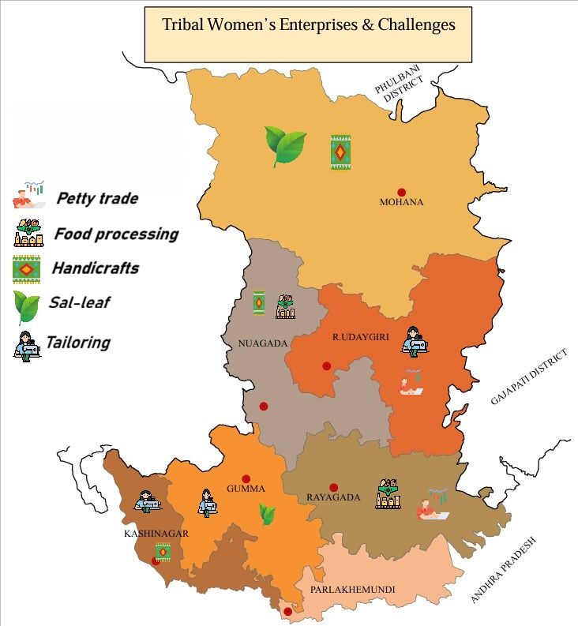
Figure 1: Map of Gajapati district, Odisha, showing six study blocks with tribal women’s enterprise types (tailoring, Sal-leaf products, handicrafts, food processing, petty trade) and key livelihood challenges.
As shown in Figure 1, the distribution of women’s enterprises across the six blocks illustrates the geographical concentration of livelihood activities and associated infrastructural constraints
Gajapati district in southern Odisha provides a rich ground for exploring these dynamics. The district is predominantly tribal, with communities such as the Saura and Kandha forming the majority of the population. Its geography—hilly terrain and scattered settlements—creates challenges for infrastructure, market connectivity, and public service delivery (Mishra, 2018). Poverty levels remain high, and livelihood opportunities are often confined to subsistence agriculture and forest-based activities. Despite these structural constraints, the district has witnessed the growth of women-led entrepreneurial ventures in areas such as handicrafts, sal-leaf products, tailoring, petty trade, and food processing (Acharya, 2018; Patnaik, 2016). These enterprises are small in scale, yet they demonstrate how tribal women adapt local resources, indigenous knowledge, and collective support structures to build viable income-generating activities.
Against this backdrop, this study examines the role of social entrepreneurship as a driver of livelihood transformation among tribal women in Gajapati. It seeks to identify the types of enterprises women are engaged in, the barriers that inhibit their growth, and the opportunities that can enable expansion and sustainability. By focusing on six blocks named as Guma, Nuagada, R. Udayagiri, Mohana, Rayagada, and Kasinagar, the research provides an in-depth understanding of how tribal women negotiate their socio-economic realities through entrepreneurship. At a broader level, it argues that social entrepreneurship has the potential not only to improve income and reduce vulnerability but also to enhance women’s agency, strengthen community institutions, and contribute to more inclusive patterns of development in Odisha (Naik & Panda, 2023).

2. Literature Review
Social entrepreneurship has increasingly been recognised as a meaningful strategy for addressing social inequalities and promoting sustainable livelihoods (Datta & Gailey, 2012; Seelos & Mair, 2005). Unlike conventional businesses that measure success only in terms of profit, social enterprises aim to achieve both financial viability and social good. This dual purpose makes them particularly relevant for communities that remain on the margins of mainstream development. For women in rural and tribal settings, participation in small-scale enterprises provides more than just an income stream; it offers an opportunity to gain confidence, build collective solidarity, and gradually reshape social norms that have long limited their agency (Kabeer, 1999). At the same time, the impact of entrepreneurship on empowerment is not automatic. It depends on a range of factors such as access to credit, training, institutional support, and the ability of women to exercise meaningful control over the resources they generate (Garikipati, 2012; Sanyal, 2009).
In the Indian context, women’s entry into entrepreneurial spaces has often been facilitated by self-help groups, microfinance programmes, and state-led livelihood missions (Swain & Wallentin, 2009; Deininger & Liu, 2013). These platforms have enabled large numbers of women to come together, share risks, and build a sense of community that goes beyond economic gain. Tribal women, who frequently face multiple layers of disadvantage due to poverty, low literacy levels, and geographical isolation, have found in these initiatives a pathway to greater social participation (Roy & Mohanty, 2020). In states like Odisha, self-help groups and collective enterprises have played a significant role in creating opportunities for tribal women to engage in activities such as handicrafts, food processing, and forest-based production (Acharya, 2018; Patnaik, 2016). However, challenges continue to exist. Many of these ventures remain small, with limited access to larger markets, technology, or formal financial systems (Biswal et al., 2023; Devi & Dhal, 2020). Gender roles within households and communities also shape the extent to which women can dedicate time and resources to entrepreneurial activities. In some cases, women face the additional burden of balancing domestic responsibilities with the demands of running a business, making the entrepreneurial journey even more challenging.
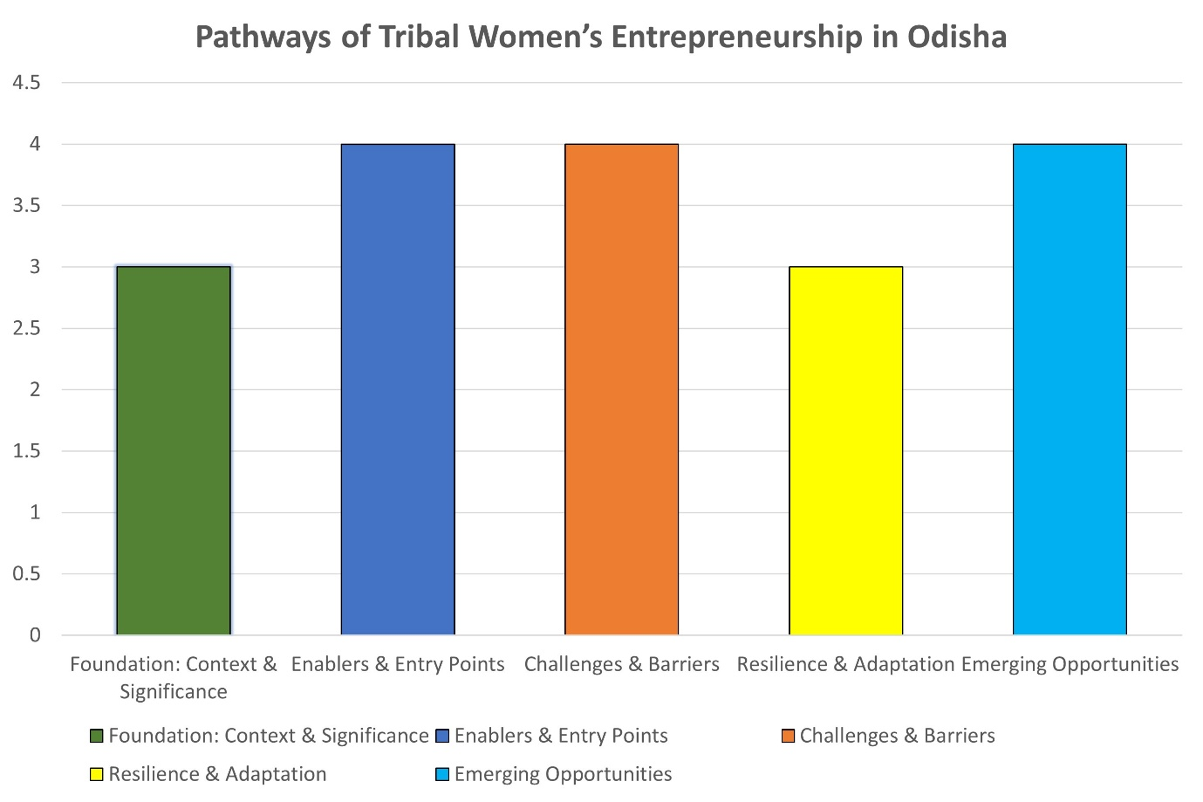
Figure 2: Pathways of Tribal Women’s Entrepreneurship in Odisha
Within Odisha, research has shown that tribal women are vital contributors to household and community economies, yet their enterprises often struggle to grow beyond subsistence levels (Mishra, 2018; Mohanty & Das, 2021). Structural issues such as weak institutional support, poor infrastructure, and the absence of strong market linkages mean that their work remains undervalued and under-rewarded. Regional disparities further compound these problems, with remote districts like Gajapati facing greater barriers than more developed parts of the state. Despite these obstacles, tribal women have demonstrated resilience by adapting traditional knowledge and resources to entrepreneurial activities, often supported by self-help groups and grassroots organisations (Pradhan & Patnaik, n.d.). New opportunities are also emerging in the form of government livelihood missions, digital tools, and collective marketing platforms that can help overcome some of the barriers (Dash, 2025; Pattanaik et al., 2025). What remains less explored, however, is how these women, particularly in Gajapati district, experience entrepreneurship as a process of transformation—both economically and socially. By focusing on this question, the present study seeks to fill an important gap in the literature and provide fresh insights into the gendered dynamics of livelihood transformation through social enterprises in a tribal context.
Recent studies emphasise that women’s entrepreneurship in tribal regions requires strong institutional ecosystems, including financial literacy, value-chain linkages, digital access, and collective ownership models (Joshi & Varghese, 2021; Thomas, 2022). Research from Jharkhand and Chhattisgarh shows that tribal women-led enterprises grow faster when supported by cooperatives and producer companies (Ekka & Baski, 2020; Minz, 2021). However, studies also warn that patriarchal household structures continue to affect mobility, market participation, and profit control (Kumar & Chauhan, 2023). In Odisha, although Mission Shakti has expanded entrepreneurship opportunities, limited evidence exists on how these interventions translate into empowerment for women living in geographically isolated blocks (Patel & Giri, 2019). The current study addresses this gap by providing empirical evidence from remote tribal clusters of the Gajapati district.
2.1 Theoretical Framework: Gender, Livelihoods, and Social Entrepreneurship
The study draws upon two interrelated theoretical perspectives. First, the Sustainable Livelihoods Approach (SLA) conceptualises livelihoods as shaped by the interaction of five types of capital—human, natural, social, physical, and financial—and mediated by institutional and policy contexts (Chambers & Conway, 1992; Scoones, 1998). This framework helps to understand how entrepreneurship serves as a strategy for diversifying income and strengthening resilience among tribal women. Second, gender empowerment theory (Kabeer, 1999) provides a lens to examine how social entrepreneurship influences women’s access to resources, agency, and achievements. It emphasises that empowerment involves not just income generation but also enhanced voice, decision-making, and social recognition. Combining these perspectives, the research conceptualises social entrepreneurship as both an economic and transformative social process that redefines gender relations while creating sustainable livelihoods.
3. Methodology
This study employed a mixed-methods approach to capture both the breadth and depth of tribal women’s experiences with social entrepreneurship in the Gajapati district (Naveen, 2023). By combining quantitative and qualitative techniques, the research was able to develop a comprehensive understanding of the opportunities and challenges that women encounter in their entrepreneurial journeys. The district was selected because of its high tribal population and the increasing participation of women in micro and small-scale enterprises. Within Gajapati, six blocks named as Guma, Nuagada, R. Udayagiri, Mohana, Rayagada, and Kasinagar were chosen to ensure geographical spread and representation of diverse socio-economic contexts.
The study area was intentionally selected because Gajapati is one of the most socio-economically backwards tribal-dominated districts in India, where livelihood diversification remains limited and women’s entrepreneurship has been minimally researched. Existing literature focuses largely on SHGs and microfinance in Odisha, while very few studies examine how social enterprises function in remote tribal blocks with poor market access and low literacy (Acharya, 2018; Naveen, 2023). Therefore, the originality of this study lies in mapping entrepreneurship pathways across six blocks and analysing how social enterprises enable both economic gains and socio-cultural transformation, which has not been systematically documented earlier.
The study covered a sample of 200 tribal women entrepreneurs selected through purposive sampling. Care was taken to include women from a range of enterprise types such as handicrafts, sal-leaf products, millet processing, tailoring, and petty trade. To enrich the dataset, the survey was complemented with qualitative inquiry involving in-depth interviews with 30 women entrepreneurs, who shared their individual stories, and 10 local officials, who provided policy and institutional perspectives (Patnaik, 2016).
Table 1. Socio-Economic Profile of Respondents (Profile of 200 tribal women respondents from six blocks of Gajapati district, Odisha.)

Category | Details Study
Age Distribution | 18–30 years: 30% | 31–45 years: 45% | 46 years & above: 25%
Education Level | No formal schooling: 20% | Primary: 35% | Secondary: 30% | Higher: 15%
Type of Enterprise | Handicrafts: 28% | Sal-leaf products: 24% | Millet processing: 18% | Tailoring & weaving: 15% | Petty trade: 15%
Marital Status | Married: 75% | Unmarried: 15% | Widowed/Separated: 10%
Average Monthly Income (INR) | Below 5,000: 40% | 5,001–10,000: 35% | Above 10,000: 25%

Data collection involved multiple tools.The research adopted a convergent mixed-methods design, integrating both quantitative and qualitative strands concurrently to gain complementary insights (Creswell, 2014). The quantitative component provided measurable trends on enterprise types, income levels, and access to resources, while the qualitative component offered narrative depth regarding personal experiences and social dynamics. (Zahra, S. A., Gedajlovic, E., Neubaum, D. O., & Shulman, J. M., 2009). For qualitative data analysis, interview and FGD transcripts were first transcribed verbatim and then subjected to thematic coding using an inductive approach. Emerging themes such as financial barriers, agency, community support, and market linkages were organised through constant comparison until conceptual saturation was achieved. NVivo software was used to manage coding and ensure inter-coder reliability. The research strategy combined purposive and snowball sampling to identify respondents across six blocks. (Bacq, S., & Janssen, F., 2011). Triangulation between surveys, interviews, and FGDs ensured the validity of findings and minimised bias. Structured questionnaires were used to gather information on socio-economic background, enterprise type, income levels, and barriers to entrepreneurship. In-depth interviews captured narratives of struggle, resilience, and transformation, while focus group discussions (FGDs) with self-help groups offered insights into collective dynamics, including decision-making and resource access. To provide a clear overview of the participants’ socio-economic characteristics, a profile of respondents is presented in Table 1, which summarises their age, education, marital status, enterprise type, and income categories. This profile helps situate the findings within the broader realities of women’s lives in the district.
Quantitative data were analysed using descriptive statistics to identify overall trends and patterns, while qualitative responses from interviews and FGDs were thematically coded to highlight recurring issues such as financial constraints, gender norms, market linkages, and institutional support (Garikipati, 2012). Ethical standards were strictly observed. Ethical clearance was obtained prior to fieldwork, and informed consent was taken from all participants, who were assured of confidentiality and voluntary participation. By combining complementary methods, ensuring rigour in analysis, and grounding the findings in a clearly profiled sample, the study provides a nuanced and trustworthy account of how tribal women in Gajapati engage in social entrepreneurship and how these ventures contribute to livelihood transformation.

4. Findings and Discussion
4.1 Types of Enterprises
The findings of the study highlight the diverse range of enterprises managed by tribal women in Gajapati district. A significant proportion of respondents were engaged in handicrafts and bamboo work (28%), sal-leaf plate making and minor forest produce processing (24%), millet-based food products (18%), tailoring and weaving (15%), and petty trade such as tea stalls and grocery shops (15%). These enterprises are small in scale but embedded in local traditions, often combining livelihood sustenance with cultural preservation (Acharya, 2018; Naik & Panda, 2023).
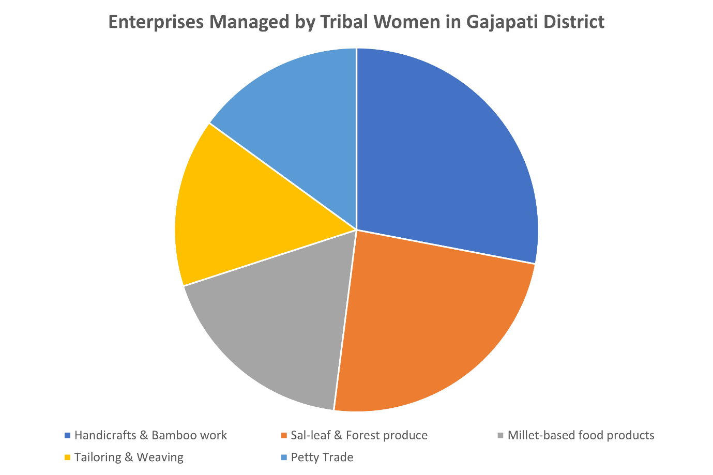
Figure 3: Enterprises Managed by Tribal Women in Gajapati District
Figure 3 highlights that handicrafts and forest-based processing dominate women’s enterprises, indicating the centrality of local resource utilisation in livelihood strategies.
These patterns align with findings from Mayurbhanj, Jharkhand, and Chhattisgarh, where women depend heavily on forest-based processing and handicrafts due to limited landholding, low capital, and cultural familiarity (Naveen, 2023; Minz, 2021). The dominance of sal-leaf and handicraft activity indicates that entrepreneurship is shaped by local resource availability rather than market demand, which explains why most enterprises remain small and seasonal. Unlike urban micro-enterprises, tribal women’s ventures show strong dependence on collective labour, informal supply chains, and locally negotiated pricing, revealing the structural constraints of operating in remote hilly regions.
4.2 Barriers to Growth
Despite their efforts, tribal women entrepreneurs face multiple barriers that limit the expansion of their enterprises. Financial constraints remain the most pressing challenge, with limited access to formal credit pushing many women towards moneylenders (Garikipati, 2008). Educational barriers compound these difficulties, as low literacy levels and the lack of managerial or business training restrict women’s ability to effectively manage and scale their ventures (Biswal et al., 2023). Weak market linkages further marginalise women entrepreneurs, as most depend on local markets and intermediaries (Roy & Mohanty, 2020). In addition, entrenched gender norms continue to influence women’s participation (Kabeer, 1999). Domestic responsibilities, childcare, and mobility restrictions mean that many women must balance entrepreneurial activities with household duties, often at the cost of business growth.
The findings suggest that constraints are not merely economic but structural and gendered. Limited mobility and domestic responsibilities reduce women’s ability to attend training, travel to markets, or negotiate prices—resulting in low profit margins despite high labour intensity. Similar patterns are seen in Madhya Pradesh, where women-run forest-based enterprises fail to scale due to middlemen control and poor transport connectivity (Kumar & Chauhan, 2023). This indicates that entrepreneurship in tribal areas cannot succeed only through microcredit; it requires market access, collective bargaining, and institutional procurement support.
4.3 Opportunities and Enablers
Amidst these challenges, the study also identified emerging opportunities that are enabling women to strengthen their entrepreneurial activities. A majority of respondents (70%) reported that self-help groups (SHGs) were their first entry point into entrepreneurship (Deininger & Liu, 2013). Government schemes such as Mission Shakti and the Odisha Livelihood Mission have introduced targeted training and financial assistance (Dash, 2025). Although still limited, digital tools are slowly expanding opportunities, with younger women beginning to use mobile banking and online marketing. Equally important is the role of community solidarity, as collective enterprises allow women to share risks, pool resources, and strengthen bargaining power (Sanyal, 2009).
Opportunity Area | Description / Evidence | Reference
Self-Help Groups (SHGs) | 70% of respondents reported SHGs as their first entry point into entrepreneurship. | Deininger & Liu (2013)
Government Schemes | Initiatives such as Mission Shakti and Odisha Livelihood Mission provide training and financial assistance. | Dash (2025)
Digital Tools | Younger women are slowly adopting mobile banking and online marketing, expanding business reach. | Field Data / Emerging Trends
Community Solidarity | Collective enterprises help women share risks, pool resources, and strengthen bargaining power. | Sanyal (2009)

Table 2: Emerging Opportunities Supporting Tribal Women’s Entrepreneurship
The slow adoption of digital tools shows a generational divide—young women use UPI and WhatsApp for informal sales, while older women depend on cash and local buyers. This signals a gradual shift from traditional trading to semi-digital micro-entrepreneurship. When linked with SHGs, these tools expand visibility and bargaining power, matching trends in rural Kerala and North-East India where WhatsApp-based craft marketing has increased women’s income and reduced exploitative intermediaries (Thomas, 2022).
4.4 Pathways of Transformation
The findings also point to significant transformative outcomes that extend beyond economic benefits. Household incomes increased by about 25% after women started their enterprises. Beyond financial gains, participation enhanced women’s voices in family and community decision-making, boosted confidence, and improved social recognition (Datta & Gailey, 2012). The intergenerational impact is also noteworthy: additional income has enabled families to invest more in children’s education, particularly for girls (Biswal et al., 2023; Mishra et al., 2024). Similar patterns have been documented in broader studies on microfinance and empowerment, which show that women’s economic participation fosters both social and cultural change (Swain & Wallentin, 2009).
From a broader theoretical perspective, these findings resonate with existing literature on gendered livelihoods and empowerment (Kabeer, 1999; Ellis, 2000). Social entrepreneurship operates as a livelihood diversification mechanism that not only enhances income but also expands women’s control over assets and decisions. This dual role—economic and social—illustrates the transformative potential of entrepreneurship in achieving gender-equitable development outcomes.
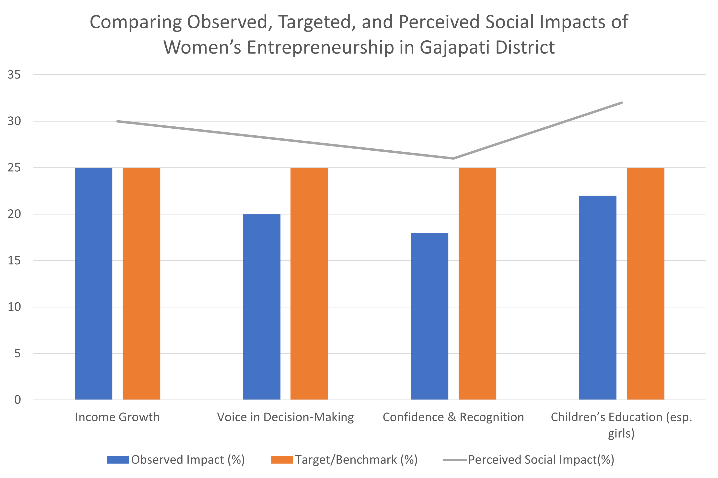
Figure 4: Observed vs. Target vs. Perceived Impacts of Social Entrepreneurship
The comparison in Figure 4 demonstrates a positive shift between observed and perceived livelihood outcomes, suggesting growing confidence and social recognition among women entrepreneurs.
While the findings align with similar studies on women’s entrepreneurship and empowerment in rural India (Datta & Gailey, 2012; Roy & Mohanty, 2020), they also highlight region-specific challenges such as limited infrastructure and market access unique to Gajapati’s geography.
Limitations: The study is geographically limited to six blocks of the Gajapati district, which may restrict the generalizability of results to other tribal areas. Future research should incorporate comparative case studies across different regions to strengthen external validity and capture broader variations in social entrepreneurship dynamics. (Mair, J., & Martí, I., 2006)
5. Policy Implication
Policy Implications: The results indicate that entrepreneurship success depends on market linkages, transport infrastructure, digital literacy, and gender-sensitive institutional support. SHG-based procurement, cooperative marketing, e-commerce onboarding, and community childcare centres can reduce women’s workload and enable enterprise growth.
6. Conclusion
The findings of this study underscore the critical role of social entrepreneurship as a driver of livelihood transformation among tribal women in Gajapati district. Although systemic barriers such as limited access to credit, weak market linkages, and entrenched gender norms continue to restrict growth, the resilience and determination of women entrepreneurs remain evident (Garikipati, 2012). Their ability to adapt traditional skills and local resources into income-generating ventures demonstrates both creativity and perseverance in the face of adversity.
At the same time, institutional support has played an important enabling role. Self-help groups (SHGs) have provided the initial platform for women to enter entrepreneurship, while state-led programmes like Mission Shakti and the Odisha Livelihood Mission have contributed training, financial assistance, and recognition (Dash, 2025; Acharya, 2018). These forms of support have not only enhanced women’s participation in economic activities but also created new pathways for empowerment and collective solidarity (Sanyal, 2009). The study suggests that building upon these foundations is essential for scaling up women-led enterprises and making them more sustainable.
To strengthen this process, several steps are recommended. First, expanding women’s access to affordable credit and financial literacy will help reduce dependency on moneylenders (Deininger & Liu, 2013). Second, stronger market linkages—particularly through cooperatives and e-commerce platforms—can connect women’s products with wider consumer bases and enhance profitability (Naik & Panda, 2023). Third, skill development programmes must be tailored to local resources and women’s specific needs (Mishra et al., 2024). Finally, gender-sensitive policies that directly address cultural barriers and domestic responsibilities are essential for creating an enabling environment (Mohanty & Das, 2021).
The evidence from Gajapati contributes to wider discussions on women’s entrepreneurship in India by highlighting how even small-scale ventures, when supported by community networks and inclusive policies, can generate significant socio-economic change (Datta & Gailey, 2012; Roy & Mohanty, 2020). Beyond livelihood support, social entrepreneurship has the potential to reshape women’s roles within families and communities, strengthen agency, and promote intergenerational benefits such as improved education for children (Kabeer, 1999). By centring the voices and enterprises of tribal women, development strategies can move towards more inclusive and sustainable outcomes that go beyond poverty reduction to foster genuine empowerment and social transformation.

Disclaimer (Artificial intelligence)

Option 1:

Author(s) hereby declare that NO generative AI technologies such as Large Language Models (ChatGPT, COPILOT, etc.) and text-to-image generators have been used during the writing or editing of this manuscript.

References
Acharya, S. (2018). Empowering tribal women through entrepreneurship: A study of self-help groups in Gajapati district of Odisha. Indian Research Journal of Extension Education, 18(2), 26–30.
Biswal, S. N., Mishra, S. K., & Sarangi, M. (2023). Does women’s empowerment influence multidimensional poverty? Empirical insight from rural Odisha of India. Pertanika Journal of Social Sciences & Humanities, 31(2), 821–839.
Datta, P. B., & Gailey, R. (2012). Empowering women through social entrepreneurship: Case study of a women’s cooperative in India. Entrepreneurship Theory and Practice, 36(3), 569–587. https://doi.org/10.1111/j.1540-6520.2010.00430.x
Dash, K. C. (2025). Impact of Mission Shakti in Odisha, India. Journal of Developing Societies, 41(2), 155–173. https://doi.org/10.1177/0169796X241234567
Deininger, K., & Liu, Y. (2013). Economic and social impacts of an innovative self-help group model in India. World Development, 43, 149–163. https://doi.org/10.1016/j.worlddev.2012.09.019
Devi, S. K., & Dhal, N. (2020). Socio-economic initiative of the government and its efficacy on tribal women. International Journal of Recent Technology and Engineering, 8(5), 1441–1446.
Garikipati, S. (2008). The impact of lending to women on household vulnerability and women’s empowerment: Evidence from India. World Development, 36(12), 2620–2642. https://doi.org/10.1016/j.worlddev.2007.11.008
Garikipati, S. (2012). Microcredit and women’s empowerment: Through the lens of time-use data from rural India. Development and Change, 43(3), 719–750. https://doi.org/10.1111/j.1467-7660.2012.01780.x
Kabeer, N. (1999). Resources, agency, achievements: Reflections on the measurement of women’s empowerment. Development and Change, 30(3), 435–464. https://doi.org/10.1111/1467-7660.00125
Mishra, B. (2018). Social exclusion and household poverty among the vulnerable tribal groups in Odisha. IASSI-Quarterly, 37(1), 90–107.
Mishra, S. P., Mishra, D. P., & Mohapatra, S. (2024). Women empowerment gaining right trajectory: A perspective from MSME, Odisha, India. Journal of Economics, Management and Trade, 30(3), 10–29. https://doi.org/10.9734/jemt/2024/v30i31111
Mohanty, B., & Das, S. (2021). Regional disparity and women in local government: Implications for sustainable development. In Women reinventing development: The Odisha experience (pp. 41–210). Routledge.
Naik, B., & Panda, S. (2023). Empowerment of tribal communities through innovation and entrepreneurship: A path to sustainable progress. International Journal of Research and Review, 10(11), 334–343.
Naveen, S. (2023). Tribal women empowerment through entrepreneurship: Evidence from Mayurbhanj District, Odisha. Frontiers in Sociology, 8, 1158770. https://doi.org/10.3389/fsoc.2023.1158770
Padhee, U. (2010). Implementation of the livelihood policies in extremist-affected areas: A case study of the Orissa Tribal Empowerment and Livelihood Programme in the Left-Wing Extremism (Naxalism) affected districts of Orissa state, India (Doctoral dissertation, University of Birmingham). https://etheses.bham.ac.uk/id/eprint/1234/
Patel, A., & Giri, J. (2019). Climate change, migration and women: Analysing construction workers in Odisha. Social Change, 49(1), 97–113. https://doi.org/10.1177/0049085718821731
Patnaik, C. P. (2016). Self-help group, micro entrepreneurship & women empowerment in Gajapati district of Odisha. International Journal of Innovative Research & Practices, 4(2), 55–61.
Pattanaik, K., Mohapatra, S. S., Jasmine, J., & Das, S. (2025). Gender-integrated sustainable livelihoods for rural India. In Women empowerment in agriculture: A pathway towards sustainable development (pp. 314–328). Springer. https://doi.org/10.1007/978-981-19-5678-9_20
Pradhan, S. K., & Patnaik, J. (n.d.). Entrepreneurial empowerment of tribal women through self-help groups in the Gajapati district of Odisha. Unpublished manuscript.
Roy, S., & Mohanty, R. P. (2020). Microfinance models in improving ‘quality of life’: Empirical analysis on Indian perspective. International Journal of Business Innovation and Research, 21(1), 23–55. https://doi.org/10.1504/IJBIR.2020.103456
Sanyal, P. (2009). From credit to collective action: The role of microfinance in promoting women’s social capital. American Sociological Review, 74(4), 529–550. https://doi.org/10.1177/000312240907400404
Swain, R. B., & Wallentin, F. Y. (2009). Does microfinance empower women? Evidence from self-help groups in India. International Review of Applied Economics, 23(5), 541–556. https://doi.org/10.1080/02692170903007540
Mair, J., & Martí, I. (2006). Social entrepreneurship research: A source of explanation, prediction, and delight. Journal of World Business, 41(1), 36–44
Zahra, S. A., Gedajlovic, E., Neubaum, D. O., & Shulman, J. M. (2009). A typology of social entrepreneurs: Motives, search processes, and ethical challenges. Journal of Business Venturing, 24(5), 519–532
Bacq, S., & Janssen, F. (2011). The multiple faces of social entrepreneurship: A review of definitional issues based on geographical and thematic criteria. Entrepreneurship & Regional Development, 23(5–6), 373–403

