Are Primary Health Centres Equally Distributed in Kerala? An Equity Analysis across Districts

Abstract: Equitable distribution of primary healthcare has been at the core of the achievements in Kerala’s public health. The paper analyses the distribution of Public Health centers (PHC) in the state using the 2024 25 district-level data. A multipronged statistical measure was implemented in the paper, such as descriptive statistics provided the PHC density baseline, correlation analysis evaluated the associations between PHC density and socio-demographic factors, Lorenz curves and Gini coefficients reflected inequality, and an index of vulnerability was made up so as to define structurally disadvantaged districts with regard to the distribution the PHCs in Kerala. The study shows that the average PHC density is 1.7 per 100,000 population, with Wayanadu the highest (2.85) and Kollam the lowest (1.20) districts. The PHC density shows a strong positive correlation with the Scheduled Tribe share and a moderate positive correlation with poverty and rurality. However, its relationship with literacy and the Scheduled Caste share shows weak correlation. Close to the equality line is the Lorenz curve, yielding a Gini coefficient of 0.15, indicating very low inequality in the distribution of PHCs in Kerala. However, the vulnerability index identifies Palakkad, Kollam, Idukki, and Wayanad as priority districts because of geographical disadvantages related to overlapping socio-demographic disadvantages. These results show that Kerala has achieved a fairly balanced PHC distribution and identified the districts where access is constrained due to demographic burdens. It is also necessary to reinforce initiatives targeting areas in need to boost equity in healthcare and ensure that Kerala continues to be seen as a beacon of primary healthcare in India.
Keywords: Public Health, Primary Health Center, Universal Health Coverage, Inequality, Vulnerability
1. Introduction
Over the last two decades, equity in health has become the central issue for health systems worldwide. According to the World Health Organization (WHO), equity in health refers to the lack of systematic disparities in health outcomes and access to healthcare services that cannot be avoided or that are otherwise unjust (World Health Organization, 2021). The significance of the even distribution of health infrastructure is also supported by the Sustainable Development Goals (SDG 3), which state that countries are bound to attain Universal Health Coverage by 2030 (Chiu & Fong, 2023).
Globally, inequalities in healthcare distribution are still acute. The World Bank (2021) reported that sub-Saharan Africa carries 24 percent of the entire disease burden in the world and has at the same time not found 3 percent of the health workforce in the world (Anyangwe and Mtonga, 2007). Similarly, OECD Health Statistics (2020) indicate that the density of physicians ranges from more than 5 per 1,000 population in countries such as Austria to less than 0.5 in low-income countries such as Niger (OECD, 2020). Such inequalities also carry over to primary health facilities, where accessibility and space distribution are even more uneven in so-called middle-income countries like Brazil (Travassos et al., 2002).
Inequality is also reported in the Indian context. The Sub-Centres, Primary Health Centres (PHCs) and Community Health Centres (CHCs) constitute the network of India, which is meant to offer decentralized care. According to the Rural Health Statistics (Government of India, 2022), the country had 24,935 PHCs, but the number per 1,000 population was 4.3 percent below the norm. The difference between the states of the country is also notable, that there is one PHC for 30,000 people in Tamil Nadu, whereas there is close to one PHC for 70,000 people in Bihar in 2021. Moreover, there are gaps in functionality too. In the National Sample Survey (2018), it was found that 55 percent of rural households use PHCs as their first point of care, but 25 percent have reported complaints about insufficient infrastructure and medicines.
Kerala is a model state known for its path to health, as it is situated on the southwestern coast of India. Kerala has a population of 35.3 million (Census of India, 2011) and is estimated to be 36.6 million in 2024, with a life expectancy of 75.3 (Sample Registration System, 202022), whereas the country’s average is 69 years. The infant mortality rate (IMR) of the state stands at 4 per 1000 born births (SRS, 2020), which is far below the all-India rate of 28. The level of literacy is nearly universal, with 96.2 percent being documented in 2021 (National Statistical Office, 2022). These successes are indicators of a long-term commitment to share the social welfare, education, and health since the 1960s.
However, below these aggregate indicators are intra-state differences. Accordingly, Rural Health Statistics of Kerala (Kerala Digital Health Mission, 2025) have registered more than 780 PHCs as of July 2025, although their distribution across the 14 districts is uneven. Considering the case of Ernakulam, whose population is projected at 3.55 million by 2024, it has 62 PHCs, and Idukki, which has only 1.11 million people, has 22 PHCs. This can be translated to 1.74 PHCs per every 100,000 in Ernakulam versus 1.98 in Idukki, indicating some variation even when the population is identified. In addition, Wayanadu and Idukki districts, which are dominated by tribal communities, recorded Scheduled Tribe quotas of 18.5 per cent and 15.4 per cent (Census of India, 2011), which were significantly more than that of the rest of the state (1.5 per cent), leading to a question of whether vulnerability is a characteristic of infrastructural distribution.
The problem is augmented by economic differences. According to the Economic Review of 2022, in some districts like Kasaragod and Idukki, the Below Poverty Line (BPL) households alone have up to 42-50 percent of the population, which is contrasted to below 33 percent in Ernakulam and Thiruvananthapuram. Rurality also represents another dimension, as 95.3 percent of Idukki's population is rural, and Ernakulam has a rural population below 32 percent (Government of Kerala, 2023). Such differences indicate that the equal allocation of PHCs cannot be evaluated solely on the basis of population ratios; socio-economic and geographic factors must also be addressed.
These inequities are also shaped by the historical development of Kerala's health system. Kerala had invested in a sparse system of primary health facilities since the 1960s, with community involvement and support from the local government (Kutty, 2000). The 1990s reforms of decentralization, especially the People Plan Campaign, increased the power of local governance bodies in running the health institutions (Elamon et al., 2004). Though such reforms increased accessibility, it has been shown that there are still disparities in staffing, infrastructure quality, and the availability of medicines (Sapkota et al., 2023). In urban areas, there are advantages from coexistence with both private hospitals and advanced government hospitals, whereas in remote rural and tribal areas, PHCs are strongly relied on, making fair distribution even more vital.
Compared to other South Indian states, Kerala has a relative advantage but also has its own limitations. In Tamil Nadu, effective PHC operations have historically been ensured by innovations such as 24-hour maternity services and referral linkages (Pandian et al., 2013). Karnataka, on the other hand, has invested more in secondary hospitals, leaving rural areas comparatively poorly covered (NITI Aayog, 2021). The success of Kerala is that it has a high concentration of PHCs, and, unlike Tamil Nadu, there is less information available on whether the facilities are allocated fairly to address the demand of vulnerable groups (Sankar et al., 2023).
From a policy perspective, Kerala’s strong performance at the macro level has, in many ways, addressed the micro-level inequalities. The National Health Mission (NHM, 2021) focuses on the distribution of resources, which are equally distributed, and there is still not much empirical research that considers intra-state distributions of PHCs based on some formal indicators, including Lorenz curves and Gini coefficients (Tao et al., 2014). Common health outcomes —such as mortality, morbidity, and immunization rates —rather than infrastructure have been considered in equity analysis. This implies the need to explore the spatial distribution of PHCs and whether it aligns with social vulnerability indicators, including caste, poverty, and rurality.

1.1 The Indian Healthcare System and PHCs
The health system in India is based on a three-tier system where the first and second tiers comprise sub-centres and primary health centres (PHCs) respectively, the third tier is occupied by Community Health Centres (CHCs), and the fourth tier is the district and tertiary hospitals (National Health Mission, 2021). More specifically, PHCs serve as the foundation of primary care delivery, particularly in rural and semi-urban areas. The PHCs are formed to serve about 30,000 inhabitants in plain areas and 20,000 in hilly or tribal areas (Government of India, Ministry of Health and Family Welfare, 2022). They also provide outpatient care, preventive and promotive services, maternal health programs, child health programs, and national health schemes implementation. Despite these design norms being considered, there is still a persistent challenge of equitable allocation of PHCs in India. The southeastern states, in particular, Kerala and Tamil Nadu, are showing even more favorable results in terms of PHC density; the states, like Bihar and Uttar Pradesh, are being seen as having lower in the number and functioning. Besides, intra-state inequality also exists in even-performing states due to unequal geography, economic variations, and socio-demographic heterogeneity (NITI Aayog, 2021).

1.2 Kerala as a Model State
Kerala has long been an attention of scholarly interest over what is popularly known as the “Kerala model of development”. A paradox brought out by this model is that at relatively low per capita income, the state has made spectacular results in literacy, life expectancy, maternal and child health, and social development (Kannan, 2005; Sen, 1997). Kerala has infant mortality rates and life expectancy rates as good as those of middle-income nations, and literacy rates are close to universal. These achievements have usually been traced to long-term government spending on health and education, strong community participation, and social reform movements that reduced disparities in access (Oommen, 1993).
However, success at the state level may conceal hidden inequities at the district level. The districts of Kerala are diverse in terms of geography, demography, and socio-economic composition. The southern coastal districts like Ernakulam and Thiruvananthapuram which are more urbanized, and have greater access to secondary and tertiary amenities, whereas in hilly districts like Idukki and Wayanad, there is a large population of tribal groups in remote settlements. The northernmost district, Kasaragod, has historically been rated as the poorest area and with inadequate infrastructure (Government of Kerala, State Planning Board, 2023). Thus, the question arises of whether PHC is fairly distributed across Kerala's districts in terms of population and vulnerability.
  - Social Determinants of Health in Kerala
The population of Kerala is diverse in terms of caste, tribe, income, literacy, and rural-urban status, all of which determine health vulnerability and infrastructure requirements. In districts like Palakkad and Kollam, Scheduled Castes (SCs) represent a considerable minority. Although SC populations are protected under the constitution, they are disadvantaged socio-economically, which could be translated into health inequities. Scheduled tribes (STs) are clumped in districts of Wayanadu, Idukki, and Kasaragod. Their isolation and lack of political influence frequently prevent access to healthcare services (Shabeer and Krishnan, 2017). The rurality is one of the determinants of access that remains critical. High rural population shares in the district create difficulties with transportation, topography, and connectivity, which add to the pressure on a higher density of the PHC network (Government of Kerala, State Planning Board, 2023). Although the literacy rate is generally high across Kerala, it varies slightly by district. In paradox, the highly literate and urbanized districts might actually have fewer PHCs than the population, based on the use of facilities and hospitals at higher levels (Kutty, 2000). The degree of poverty, measured as the percentage of Below Poverty Line (BPL) households, influences health-seeking behavior and reliance on government facilities. PHCs are usually more relied upon in districts with increased BPL prevalence (Oommen, 2014). These variables give an opportunity to consider PHC distribution through the prism of a social determinant.

1.4 Rationale and Research Gap
Even though Kerala is popularly touted as the healthcare success story in India, it has reasons to believe that healthcare infrastructure is being redistributed. There is isolation in tribal-dominated districts, an uneven distribution of poverty, and urbanized areas can help gain indirect benefits related to access to tertiary hospital services. In the absence of systematic equity analysis at the district level, the risk is that state averages will mask inequities experienced by marginalized groups. Some past studies of Kerala have focused on health outcomes rather than equity in infrastructure. Furthermore, descriptive studies exist, but there are few that rigorously use inequality measures (Lorenz curves, Gini coefficients) or composite measures with vulnerability mapping. This leaves a gap that, when we know Kerala is efficient in aggregate terms, but we do not know to what extent all the districts are equally benefiting.
2. Statement of the Problem
Kerala has been very popular for its health and human development, but the equitable distribution of healthcare infrastructure across districts has not been adequately explored. Although the state averages for life expectancy, infant mortality, and literacy indicate a well-functioning system, disparities in population structure, tribal concentration, poverty, and rurality across districts raise doubts about accessibility to Public Health Centres (PHCs). For example, other districts like Idukki and Wayanadu comprise more tribes and mostly rural settlements, whilst, Kasaragod has more poverty. Conversely, urbanized regions such as Ernakulam have the advantage of access to high-quality and superior-graded hospitals and even private facilities. An equal ratio of PHCs to population may thus mask disparities in access to the marginalized groups. In the absence of systematic equity analysis through instruments like Lorenz curves, Gini coefficients, and vulnerability mapping, the policy makers will run the risk of ignoring poorly served areas, thereby compromising the overall goal of Kerala, which can be included in health development.

3. Objectives of the Study
- To examine the relationship between PHC density and socio-demographic indicators (SC, ST, rural %, literacy, BPL).
- To measure inequality in PHC allocation using Lorenz curves and Gini coefficients.
- To construct a composite vulnerability index that identifies districts with structural disadvantages in healthcare access.

4. Research Methodology
The research design of this study is cross-sectional and quantitative, and will analyze equity in the distribution of Public Health Centre (PHCs) across districts in Kerala. The analysis is analytical and descriptive, incorporating measures of central tendency, inequality indices, and correlation methods.
  - Data Source
The data used in the paper covers PHC counts as of July 2025, projected population (2024), Scheduled Caste (SC) population percentage, Scheduled Tribe (ST) population percentage, Rural population percentage, Literacy rate, and Below Poverty Line (BPL) population percentage (Census of India, 2011).

4.2 Variables
Dependent variable: PHC density per 100,000 population
Equation: Dᵢ = ( Hᵢ / Pᵢ ) × 100,000
Where, Hᵢ = PHC count in district i, Pᵢ = population of district i
Independent variables: SC %, ST %, rural %, literacy, and BPL %.

4.3 Correlation Analysis
To measure the association between PHC density (D) and a variable (X): r(D, X) = Σ (Dᵢ − D̄)(Xᵢ − X̄) ÷ √[ Σ(Dᵢ − D̄)² × Σ(Xᵢ − X̄)² ]
where D̄ = mean PHC density, X̄ = mean of X.

4.4 Inequality Measurement
Lorenz curves plot the cumulative % of population vs. the cumulative % of PHCs.
Gini coefficient formula: G = (1 / 2μₕ) × Σ Σ wᵢ wⱼ | hᵢ − hⱼ |
Where, hᵢ = Hᵢ / Pᵢ (PHCs per person in district i),
wᵢ = Pᵢ ÷ ΣP (population share of district i)
μₕ = weighted mean of hᵢ
Interpretation: G = 0 → perfect equality
G = 1 → maximum inequality

4.5 Vulnerability Index
The Vulnerability Index was constructed by combining four components: Scheduled Caste (SC) percentage, Scheduled Tribe (ST) percentage, Below Poverty Line (BPL) percentage, and Public Health Centre (PHC) density. Each component was normalized using the min–max method, resulting in values ranging from 0 (least vulnerable) to 1 (most vulnerable) across districts. For PHC density, the transformation was reversed (1 − normalized PHC density), so that lower availability increased vulnerability. The final index was calculated as the simple average of the four normalized scores.
Normalization: Z̃ᵢ = ( Zᵢ − Min(Z) ) ÷ ( Max(Z) − Min(Z) )
Composite index: Vᵢ = ¼ × [ Z̃(SC)ᵢ + Z̃(ST)ᵢ + Z̃(BPL)ᵢ + (1 − Z̃(D)ᵢ) ]
Where, Z̃(SC)ᵢ = normalized SC %
Z̃(ST)ᵢ = normalized ST %
Z̃(BPL)ᵢ = normalized BPL %
Z̃(D)ᵢ = normalized PHC density
Range: 0 (least vulnerable) to 1 (most vulnerable).

5. Data Analysis and Discussion
5.1. Correlation between PHC Density and Socio-Demographic Indicators
Table 1. Kerala District-wise Demographic & PHC Data (2024–25)
Sl. No. | Districts | PHC Count  (As on 31.07.2025) | Projected Population (2024) | PHC per 1L | SC (%) | ST (%) | Rural (%) | Literacy Rate | BPL (%)
1 | Alappuzha | 35 | 2196214 | 1.59 | 9.46 | 0.31 | 46.03 | 0.96 | 49.73
2 | Ernakulam | 62 | 3556125 | 1.74 | 8.18 | 0.50 | 31.93 | 0.96 | 32.95
3 | Idukki | 22 | 1111540 | 1.98 | 13.12 | 5.03 | 95.31 | 0.92 | 49.51
4 | Kannur | 41 | 2707642 | 1.51 | 3.30 | 1.60 | 34.96 | 0.95 | 31.39
5 | Kasaragod | 21 | 1453294 | 1.44 | 4.08 | 3.74 | 61.06 | 0.90 | 42.51
6 | Kollam | 33 | 2750802 | 1.20 | 12.45 | 0.41 | 54.96 | 0.94 | 46.49
7 | Kottayam | 33 | 2042888 | 1.62 | 7.80 | 1.11 | 71.36 | 0.97 | 37.46
8 | Kozhikode | 48 | 3389141 | 1.42 | 6.45 | 0.49 | 32.84 | 0.95 | 41.22
9 | Malappuram | 65 | 4754774 | 1.37 | 7.50 | 0.56 | 55.83 | 0.94 | 43.15
10 | Palakkad | 45 | 3089967 | 1.46 | 14.37 | 1.74 | 75.90 | 0.89 | 49.99
11 | Pathanamthitta | 19 | 1182649 | 1.61 | 13.73 | 0.68 | 89.00 | 0.97 | 35.23
12 | Trivandrum | 79 | 3451050 | 2.29 | 11.30 | 0.81 | 46.33 | 0.93 | 50.01
13 | Thrissur | 64 | 3356313 | 1.91 | 10.39 | 0.30 | 32.83 | 0.95 | 39.64
14 | Wayanadu | 25 | 877602 | 2.85 | 3.99 | 18.52 | 96.15 | 0.89 | 51.68
Source: ¹Kerala Digital Health Mission, 2025,
²Projection of district-level annual population, IIPS, Mumbai, India.
³Census of India, 2011
Table 2. Correlation between PHC Density and Socio-Demographic Indicators
Indicator | Pearson r | Direction | Strength | Interpretation
Scheduled Caste (SC) % | –0.14 | Negative | Very Weak | SC % has no meaningful association with PHC density
Scheduled Tribe (ST) % | +0.76 | Positive | Strong | PHC density increases in tribal-dominated districts
Rural Population % | +0.36 | Positive | Moderate | Districts with larger rural shares have somewhat more PHCs
Literacy Rate | –0.36 | Negative | Moderate | More literate/urbanized districts tend to have fewer PHCs per capita
Below Poverty Line (BPL) % | +0.38 | Positive | Moderate | Poorer districts tend to receive more PHCs per capita
Source: Computed data
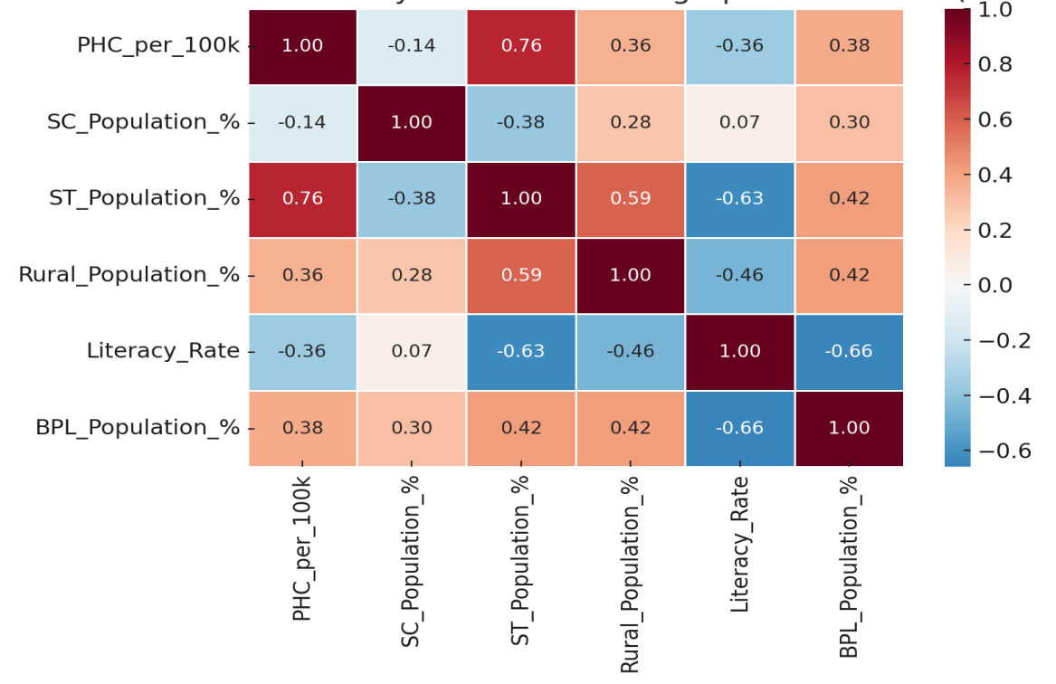
Fig.No.1. Correlation Matrix: PHC Density And Socio-Demographic Indicators (Kerala, 2024-25)
The correlation between PHC density and socio-demographic variables indicates how Kerala's health infrastructure aligns with the population's vulnerability. The table shows a strong positive correlation with the Scheduled Tribe population share (r = +0.76), with tribal-dominated districts like Wayanadu and Idukki having higher PHC density, suggesting that the higher density is intentional to meet tribal health requirements. Similarly, the positive, moderate correlation with Below Poverty Line households (r = +0.38) and the share of the rural population (r = +0.36) indicates that the poorer and more rural districts are, the better served by PHCs, which is in line with Kerala's pro-poor, welfare-based health policies. However, the analysis also highlights areas of concern, that the moderate negative relationship with the literacy rate (r = -0.36) suggests that more literate and urbanized districts such as Ernakulam and Thiruvananthapuram have fewer PHCs per capita, which may be due to the fact that in these areas, privatization depends more on the role of the providers and secondary or tertiary public hospitals. The very weak negative correlation with Scheduled Caste share (r = –0.14) indicates that SC-related vulnerabilities are not explicitly addressed in PHC allocation, unlike those of tribal populations. Hence, the table shows that PHC distribution is sensitive to certain vulnerabilities, but important equity gaps remain.

5.2. Lorenz Curve Analysis (Kerala, PHC Allocation per one Lakh)
Table 3. Lorenz Curve Table (Kerala, PHC Allocation per one Lakh)
Order | District (sorted by PHC per One Lakh) | Cumulative Population Share | Cumulative PHC Share
1 | Kollam | 0.08 | 0.06
2 | Malappuram | 0.21 | 0.17
3 | Kozhikode | 0.30 | 0.25
4 | Kasaragod | 0.34 | 0.28
5 | Palakkad | 0.43 | 0.36
6 | Kannur | 0.51 | 0.43
7 | Alappuzha | 0.57 | 0.48
8 | Pathanamthitta | 0.60 | 0.51
9 | Kottayam | 0.66 | 0.56
10 | Ernakulam | 0.75 | 0.64
11 | Thrissur | 0.85 | 0.74
12 | Idukki | 0.88 | 0.78
13 | Trivandrum | 0.98 | 0.92
14 | Wayanadu | 1.00 | 1.00
Source: Computed Data
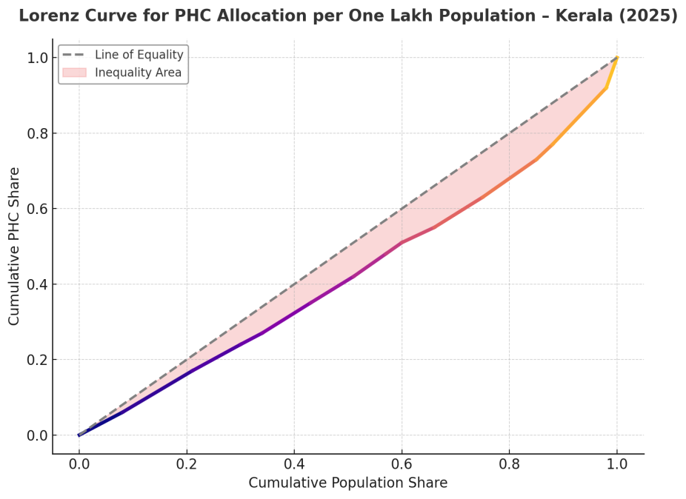
Fig. No. 2. Lorenz Curve of PHC Allocation across Kerala Districts
The Lorenz curve and cumulative distribution table provide valuable insights into the extent of inequality in the allocation of Public Health Centres (PHCs) across Kerala’s districts. Districts are ranked by PHC density, with Kollam having the lowest (1.20 per 100,000) and Wayanadu the highest (2.85 per 100,000). The cumulative distribution shows that the first half of the population, concentrated in districts with lower PHC density, accounts for slightly less than half of the PHCs. As an example, 48 percent of PHCs are covered when we have already reached Alappuzha, which covers approximately 57 percent of the population. On the other hand, the districts with a higher density of PHCs include Idukki, Thiruvananthapuram, and Wayanad, which provide a higher number of PHCs relative to their population proportions. The Lorenz Curve illustrates a slight deviation from the line of equality, indicating moderate disparity in the distribution of Primary Health Centres (PHCs) across Kerala’s districts. This is supported by the Gini coefficient value of 0.15, signifying a low level of inequality and reflecting Kerala’s relatively equitable access to primary healthcare services despite minor regional variations.. This indicates that Kerala has achieved a near-homogeneous distribution of PHCs relative to the population across the state's many districts. However, there are minor differences as well with the lowest-ranked districts (Kollam, Malappuram) and the highest ones (Wayanadu, Idukki), which should be taken into consideration in terms of regional needs despite the equity success.
5.3. Composite Vulnerability Index of Districts in Kerala Based on Socio-Demographic Indicators and PHC Density
Table 4. Composite Vulnerability Index and Ranks
District | Vulnerability Index | Rank (1 = Highest Vulnerability)
Palakkad | 0.710 | 1
Kollam | 0.644 | 2
Idukki | 0.642 | 3
Alappuzha | 0.555 | 4
Wayanadu | 0.516 | 5
Thiruvananthapuram | 0.502 | 6
Pathanamthitta | 0.476 | 7
Malappuram | 0.468 | 8
Kasaragod | 0.415 | 9
Kozhikode | 0.412 | 10
Thrissur | 0.405 | 11
Kottayam | 0.375 | 12
Ernakulam | 0.300 | 13
Kannur | 0.220 | 14
Source: Computed Data
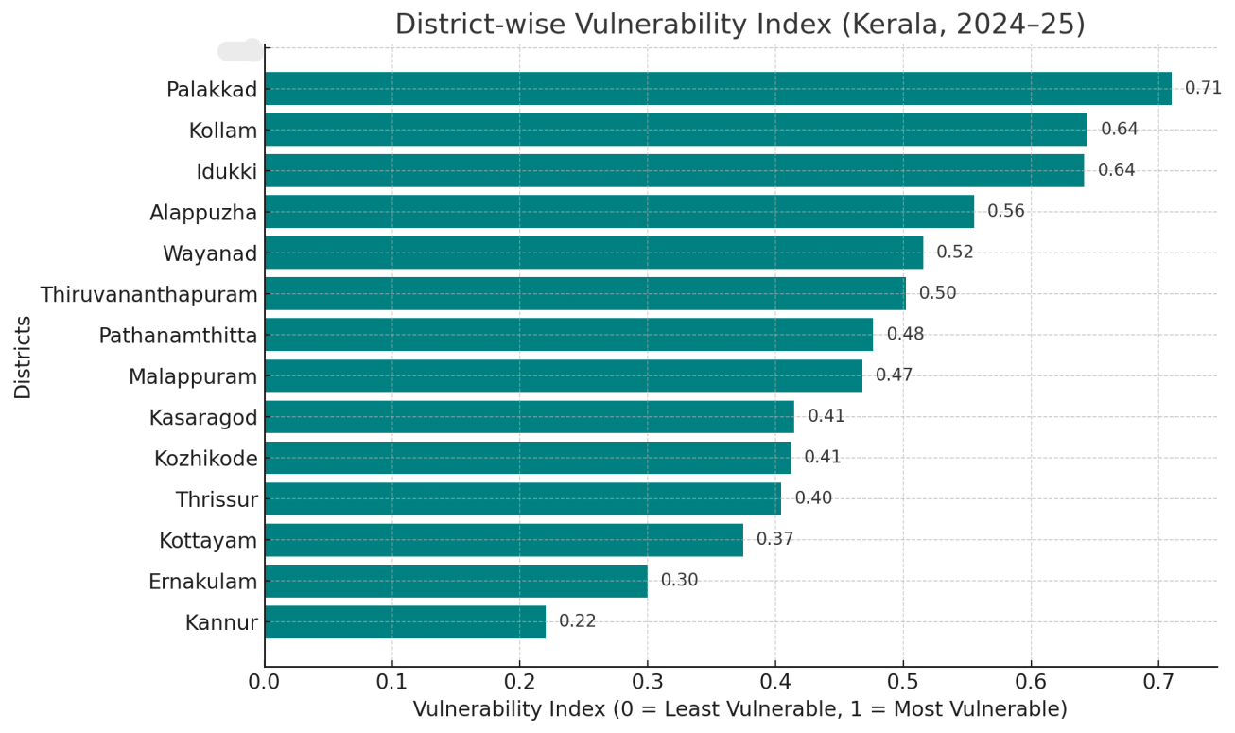
Fig.No.3. District-wise Vulnerability Index (Kerala, 2024-25)
The composite Vulnerability Index, comprising SC population Share, ST population Share, BPL population Share, and PHC density, depicts different trends across the districts of Kerala. Palakkad (0.71), Kollam (0.64), and Idukki (0.64) districts rank as the most vulnerable, reflecting the combined effect of high SC and BPL populations with comparatively lower PHC density. These districts can demonstrate that socio-demographic deprivation exacerbates healthcare access issues even in the absence of critically low numbers of facilities. Wayanadu is the district with the highest PHC density and the fifth-highest vulnerability score (0.52), due to a high proportion of Scheduled Tribes and high poverty levels. This shows that growth in demographic and economic factors can be more impressive than advances in infrastructure availability.
Districts like Kannur (0.22), Ernakulam (0.30), and Kottayam (0.38) are at the lower vulnerability use. These regions align with lower SC/ST ratios, average poverty rates, and adequate PHC access, decreasing their vulnerability to structural disadvantage. Mixed districts such as Thrissur, Kozhikode, and Kasaragod have relative stronger PHC delivery but continue to face the challenge of poverty or caste-based vulnerabilities. The table therefore highlights the areas where policy interventions should be given priority, and Palakkad, Kollam, Idukki, and Wayanad are the districts that need special attention to create justifiable access to health care.
6. Conclusion
This paper has investigated the equity of the Public Health Centre distribution in Kerala based on the PHC density, the socio-demographic correlation, and Lorenz curves and a composite vulnerability index. These results constitute evidence that although Kerala has exhibited a relatively fair distribution, there are still substantial structural weaknesses in such districts such as Palakkad, Kollam, Idukki, and Wayanadu. These regions have higher levels of marginalized populations and poverty, along with a lower density of PHCs, underscoring the importance of equity-based planning. On the other hand, other districts, including Kannur and Ernakulam, have greater socio-demographic benefits and access. The importance of addressing such disparities is to maintain the health equity gains in Kerala and ensure equitable access to healthcare.

COMPETING INTERESTS DISCLAIMER:
Authors stated that they have not known any competing interests such as financial or non-financial relationships or personal relationships that might have been perceived to have affected the work reported in this article.
Disclaimer (Artificial intelligence)
Author(s) hereby declare that generative AI technologies such as Large Language Models, etc. have been used during the writing or editing of manuscripts

7. References
Anyangwe, S. C., & Mtonga, C. (2007). Inequities in the global health workforce: the greatest impediment to health in sub-Saharan Africa. International journal of environmental research and public health, 4(2), 93-100.
Chiu, W. K., & Fong, B. Y. F. (2023). Sustainable development goal 3 in healthcare. In Environmental, social and governance and sustainable development in healthcare (pp. 33-45). Singapore: Springer Nature Singapore.
Elamon, J., Franke, R. W., & Ekbal, B. (2004). Decentralization of Health Services: The Kerala People’s Campaign. International Journal of Health Services, 34(4), 681–708. https://doi.org/10.2190/4l9m-8k7n-g6ac-wehn
Government of India, Ministry of Health and Family Welfare. (2022). Rural health statistics 2022. Government of India. https://main.mohfw.gov.in
Government of India, Ministry of Statistics and Programme Implementation. (2018). National Sample Survey, 75th round (2017–18). National Statistical Office. https://mospi.gov.in
Government of Kerala, Department of Health & Family Welfare. (2023). Rural health statistics, Kerala 2023. Government of Kerala.
Government of Kerala, State Planning Board. (2022). Economic review 2022. Government of Kerala. https://spb.kerala.gov.in
International Institute for Population Sciences (IIPS). (2022). Projection of District-Level Annual Population by Quinquennial Age-Group And Sex From 2012 To 2031 In India. IIPS. https://iipsindia.ac.in
Kannan, K. P. (2005). Kerala's turnaround in growth: Role of social development, remittances and reform. Economic and Political Weekly, 548-554.
Kerala Digital Health Mission. (2025). eHealth Kerala dashboard. Government of Kerala. https://dashboard.ehealth.kerala.gov.in
Kerala State Planning Board. (2023). Economic review 2023. Government of Kerala. https://spb.kerala.gov.in
Kutty, V. R. (2000). Historical analysis of the development of health care facilities in Kerala State, India. Health Policy and Planning, 15(1), 103–109. https://doi.org/10.1093/heapol/15.1.103
National Health Mission. (2021). National Health Mission annual report 2020–21. Ministry of Health and Family Welfare, Government of India. https://nhm.gov.in
NITI Aayog. (2021). Health systems for a new India: Building blocks—Potential pathways to reform. Government of India. https://www.niti.gov.in
OECD. (2020). OECD Health Statistics 2020. OECD. https://www.oecd.org/health/health-data.htm
Office of the Registrar General & Census Commissioner, India. (2011). Census of India 2011: Provisional population totals. Government of India. https://censusindia.gov.in
Oommen, M. A. (1993). Essays on Kerala economy. Oxford & IBH Publishing Company.
Oommen, M. A. (2014). Growth, inequality and well-being: revisiting fifty years of Kerala’s development trajectory. Journal of South Asian Development, 9(2), 173-205.
Pandian, J., Suresh, S., Desikachari, B., & Padmanaban, P. (2013). Increased utilization of primary health care centers for birthing care in Tamil Nadu, India: A visible impact of policies, initiatives, and innovations. Journal of Family Medicine and Primary Care, 2(4), 329. https://doi.org/10.4103/2249-4863.123781
Sankar, H., Joseph, J., Negi, J., Nair, A. B., & Nambiar, D. (2023). Monitoring the Family Health Centres in Kerala, India: Findings from a facility survey. Journal of Family Medicine and Primary Care, 12(12), 3098–3107. https://doi.org/10.4103/jfmpc.jfmpc_81_23
Sapkota, S., Dhakal, A., Rushton, S., Van Teijlingen, E., Marahatta, S. B., Balen, J., & Lee, A. C. (2023). The impact of decentralisation on health systems: a systematic review of reviews. BMJ Global Health, 8(12), e013317. https://doi.org/10.1136/bmjgh-2023-013317
Sen, A. K. (1997). Human capital and human capability. World development, 25(12), 1959-1961.
Shabeer, K. P., & Krishnan, C. (2017). Health Status of Tribal communities in Kerala. International Journal of Research in Economics and Social Science, 7 (6), 6, 17.
Tao, Y., Henry, K., Zou, Q., & Zhong, X. (2014). Methods for measuring horizontal equity in health resource allocation: a comparative study. Health Economics Review, 4(1). https://doi.org/10.1186/s13561-014-0010-x
Travassos, C., Viacava, F., Pinheiro, R., & Brito, A. (2002). Utilization of health care services in Brazil: gender, family characteristics, and social status. Revista panamericana de salud publica= Pan American journal of public health, 11(5-6), 365-373.
World Health Organization: WHO. (2021, July 7). Health equity. https://www.who.int/health-topics/health-equity#tab=tab_1

